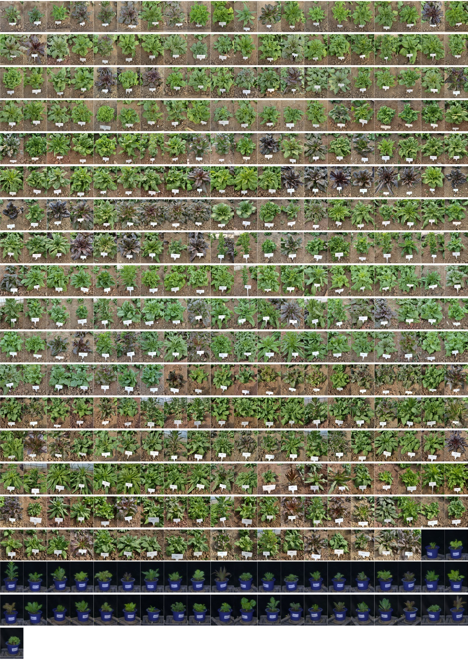
Fig. S1: Images of 2-month-old plants of 381 inbred progeny. The first 338 images show the 2-month-old plants transplanted in November 2022, and the remaining 43 images show the growth of 2-month-old plants transplanted in February 2021.

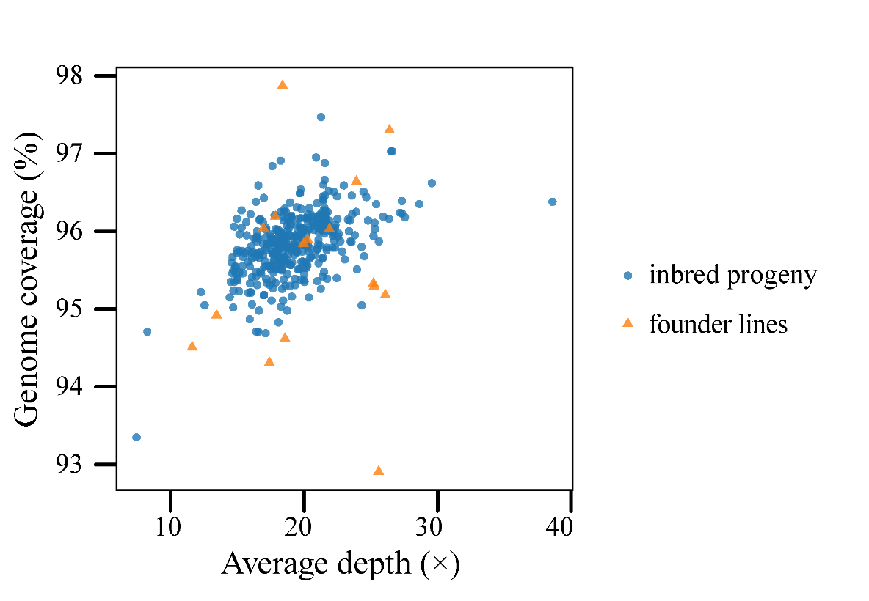
Fig. S2: Average mapping depths and average genome coverage rates for the MAGIC population.

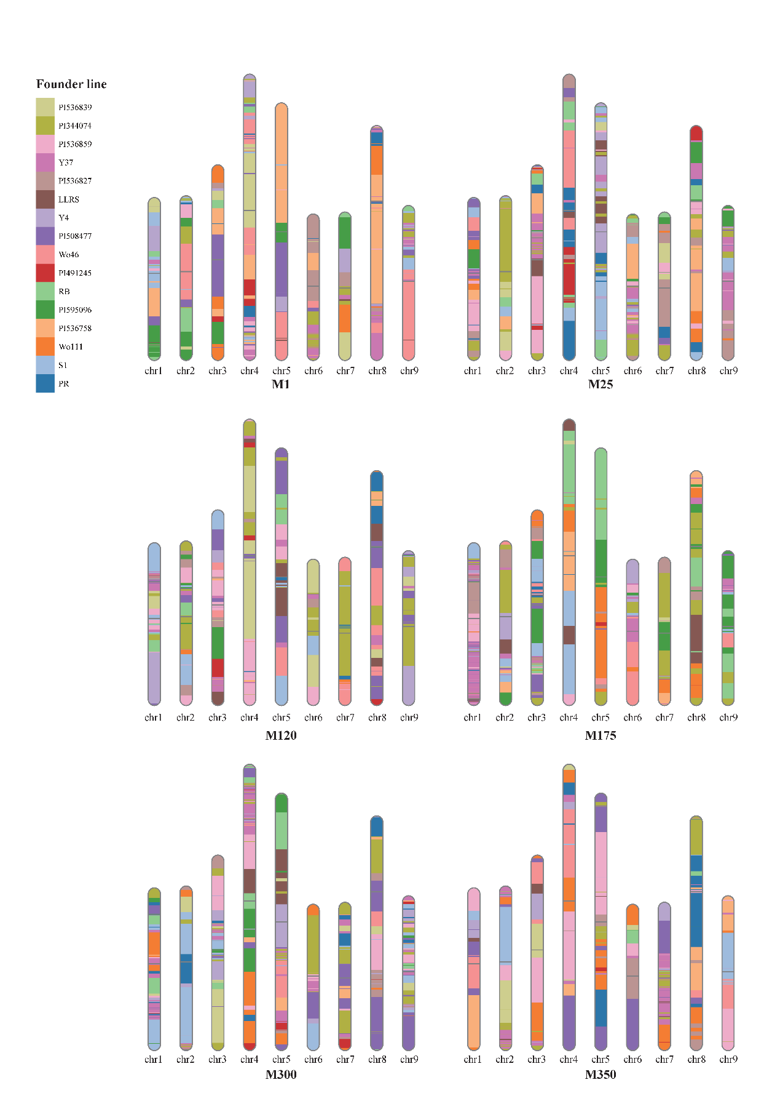
Fig. S3: Schematic diagram of the genomic bins of six representative inbred progeny.

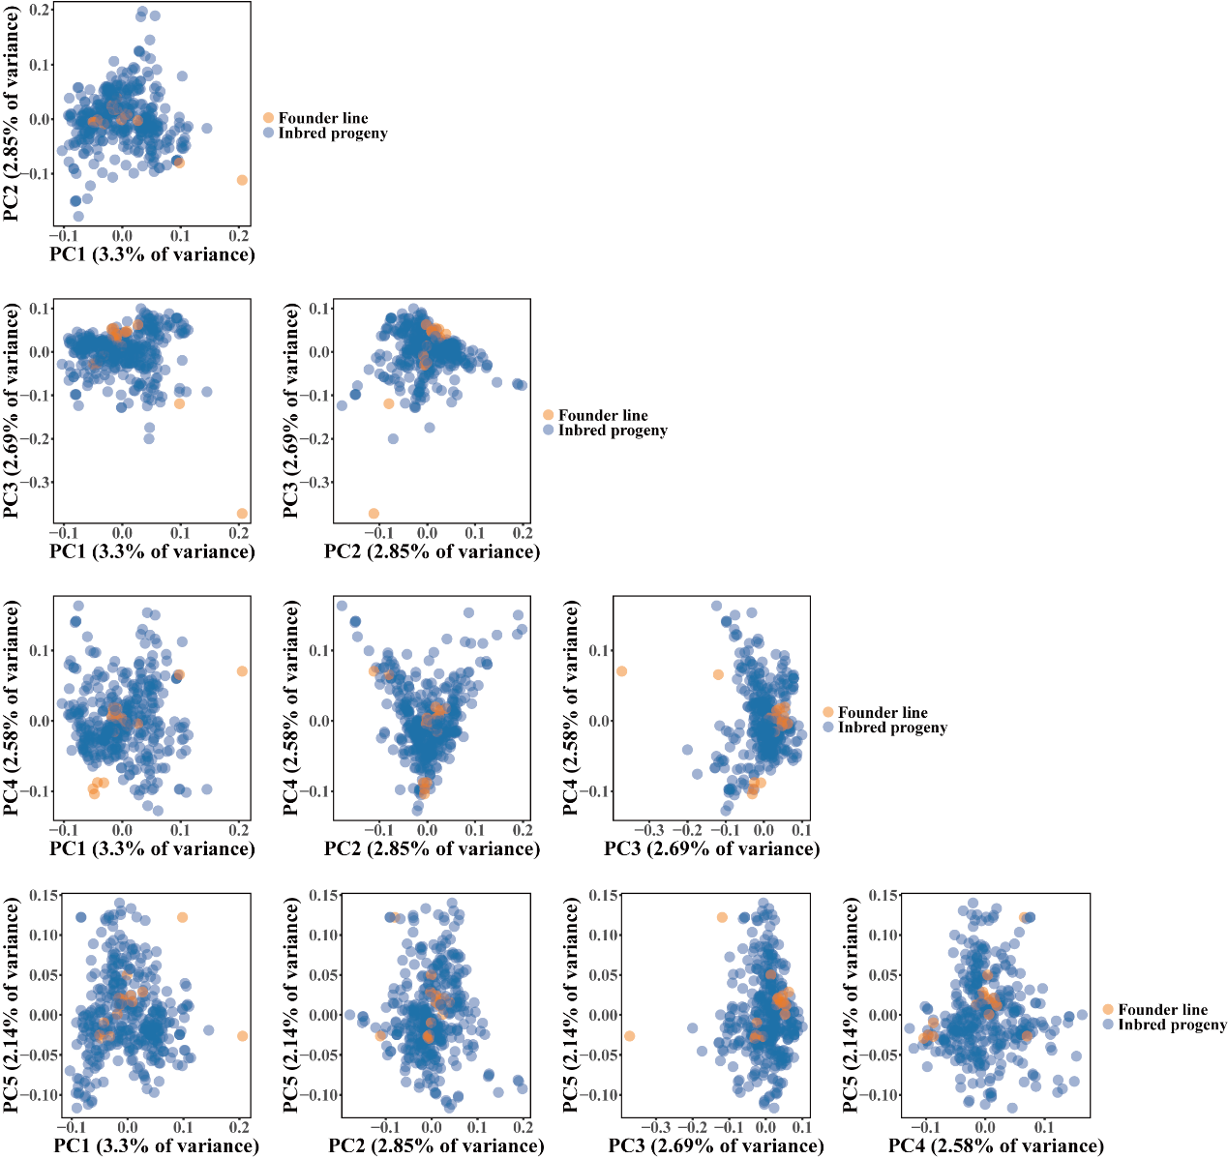
Fig. S4: PCA of the MAGIC population.

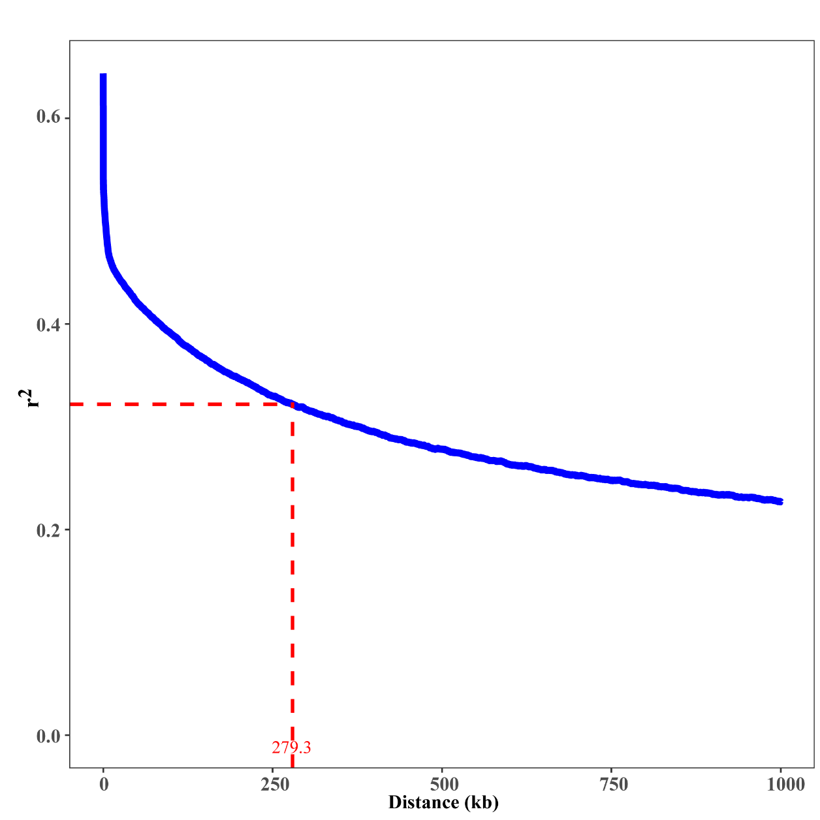
Fig. S5: Linkage disequilibrium (LD) decay distance for the MAGIC population.

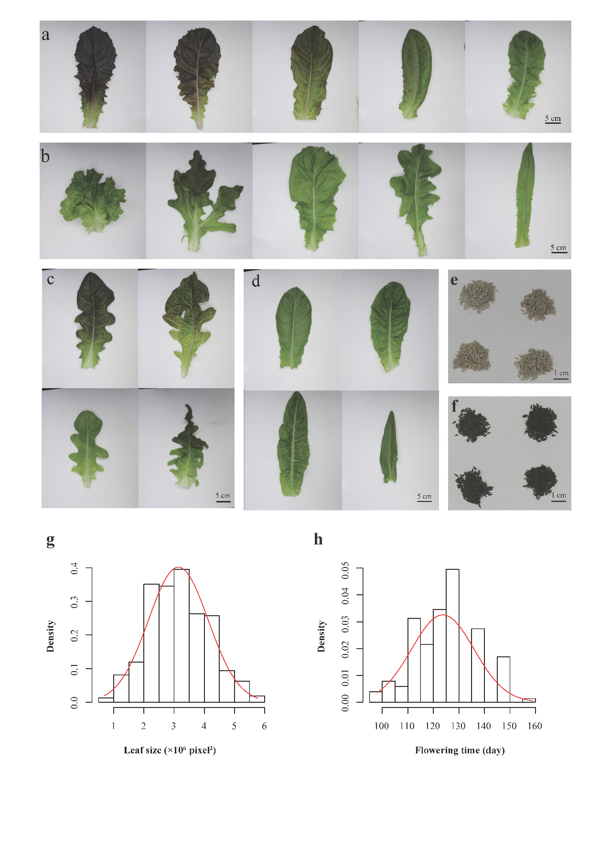
Fig. S6: Variations in leaf color, leaf shape, seed color, leaf size, and flowering time in the MAGIC population. a Red and green color of leaves from representative inbred progeny. Scale bar = 5 cm. b Different leaf shapes including lobed and non-lobed from representative inbred progeny. Scale bar = 5 cm. c Lobed leaves from representative inbred progeny. Scale bar = 5 cm. d Different leaf size from representative inbred progeny. Scale bar = 5 cm. e White seeds. Scale bar = 1 cm. f Black seeds. Scale bar = 1cm. g Distribution of leaf size in the MAGIC population. The Shapiro-Wilk test of leaf size suggested normal distribution p = 0.09, which exhibited. h Distribution of flowering time of the MAGIC population planted in November 2022. The Shapiro-Wilk test showed skew distribution (p = 2.84 ×10⁻⁷). The red lines in g and h represent the probability density of the normal distribution function.

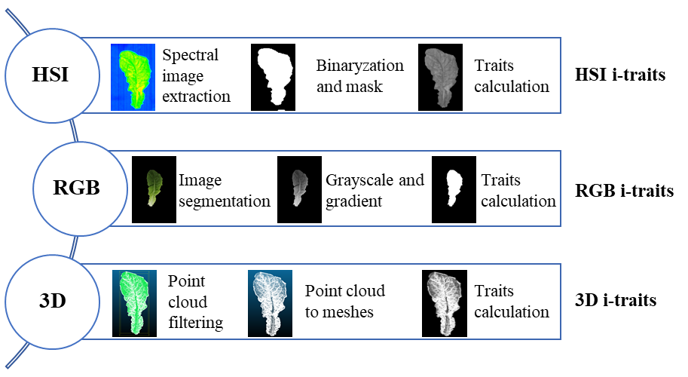
Fig. S7: Illustration of HSI, RGB imaging, and 3D scanning.

Fig. S8: GWAS of leaf, stem, and seed color in the MAGIC population. The black horizontal dashed lines in the Manhattan plots represent the suggestive genome-wide significant threshold. qLC6-8 loci were identified as being associated with leaf color through both i-traits and visual inspection. The details of i-traits can be found in Additional file 1: Table S5 and Table S6.

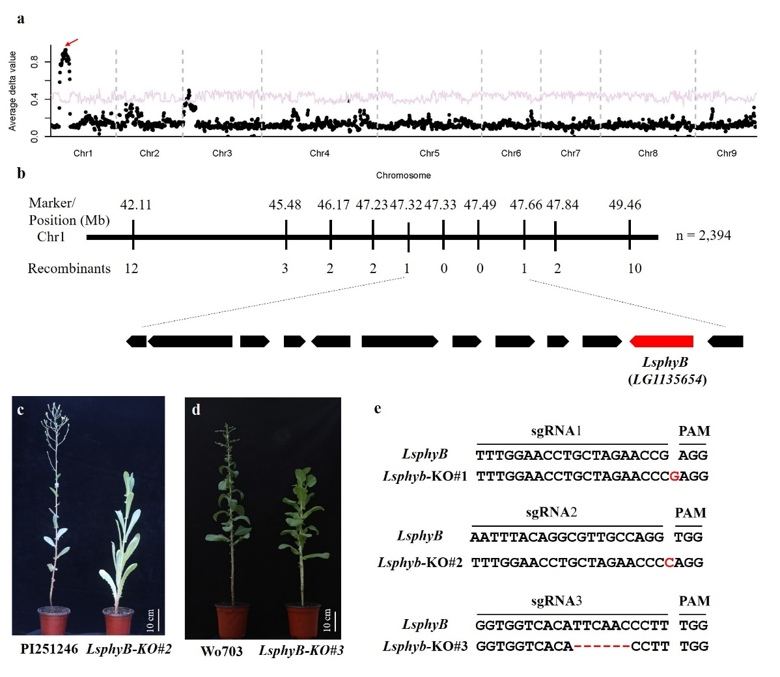
Fig. S9: Map-based cloning of the phyB gene. a BSR-seq of an F₅ segregating family derived from the cross Wo111 × CGN10978. The average delta value (y-axis) was plotted along the nine chromosomes of lettuce (x-axis). The red curve refers to a significant level of p = 0.05. The red arrow shows the locus for flowering time. b Fine mapping of the gene controlling flowering time. Twelve open reading frames are present in the candidate interval, including LsphyB (in red). c Knockout mutants of LsphyB in lettuce accession PI 251246 flowered late. d Knockout mutants of LsphyB in lettuce cultivars Wo703 flowered late. e Modified sequences of LsphyB in the three knockout mutants. The red letter refers to the inserted nucleotide, and dash lines indicate deleted sequences. sgRNA and PAM sequences are shown above the LsphyB sequences.

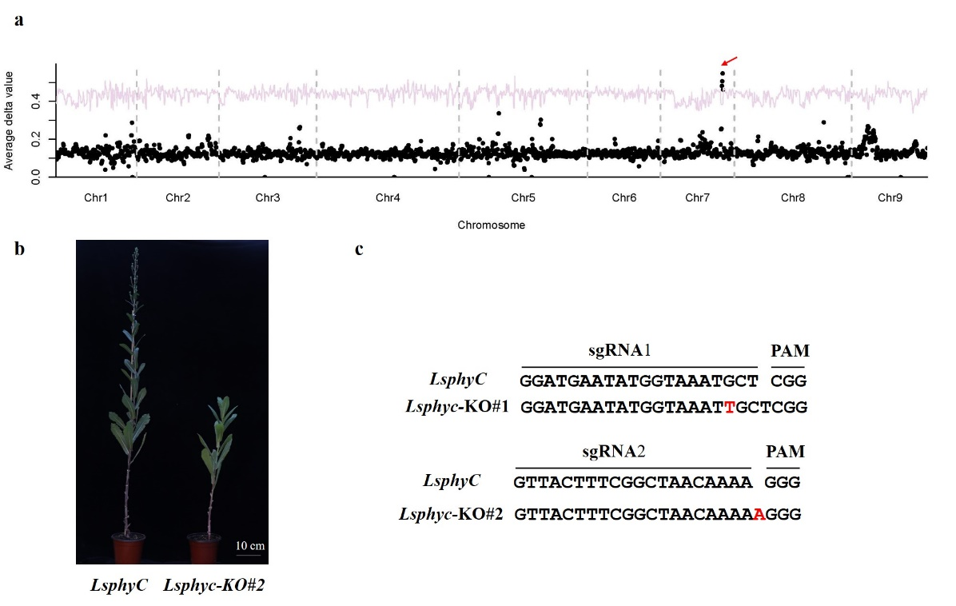
Fig. S10: Genetic mapping of the Lsphyc gene. a BSR-seq analysis of flowering time. The average delta value (y-axis) was plotted along the nine chromosomes of lettuce (x-axis). The red curve refers to a significant level of p = 0.05. The red arrow shows the locus for flowering time. b Knockout mutants of LsphyC in the accession PI251246 flowered late. c Modified sequences of Lsphyc in the two knockout mutants. The red letter refers to the inserted nucleotide. sgRNA and PAM sequences are shown above the LsphyC sequences.

Fig. S11: GWAS of leaf curvature, leaf area, lobed leaves, leaf width, leaf length, and tip shape in the MAGIC population. The black horizontal dashed line in the Manhattan plots represents the suggestive genome-wide significant threshold. Candidate genes controlling leaf shape are shown.

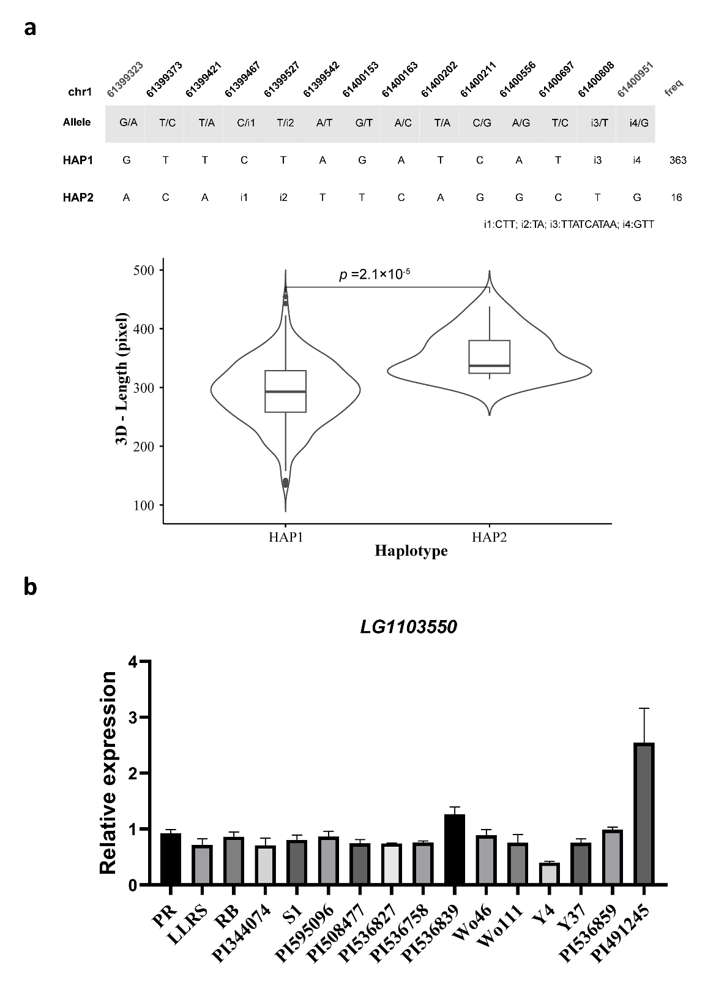
Fig. S12: The haplotype, phenotype, and expression of the leaf length candidate gene CDC48 (LG1103550). a The association between haplotype and phenotype of the leaf length (3D - Length) of the 381 inbred progeny. b Expression of CDC48 (LG1103550) among the 16 founder lines. The standard error of the expression is shown.

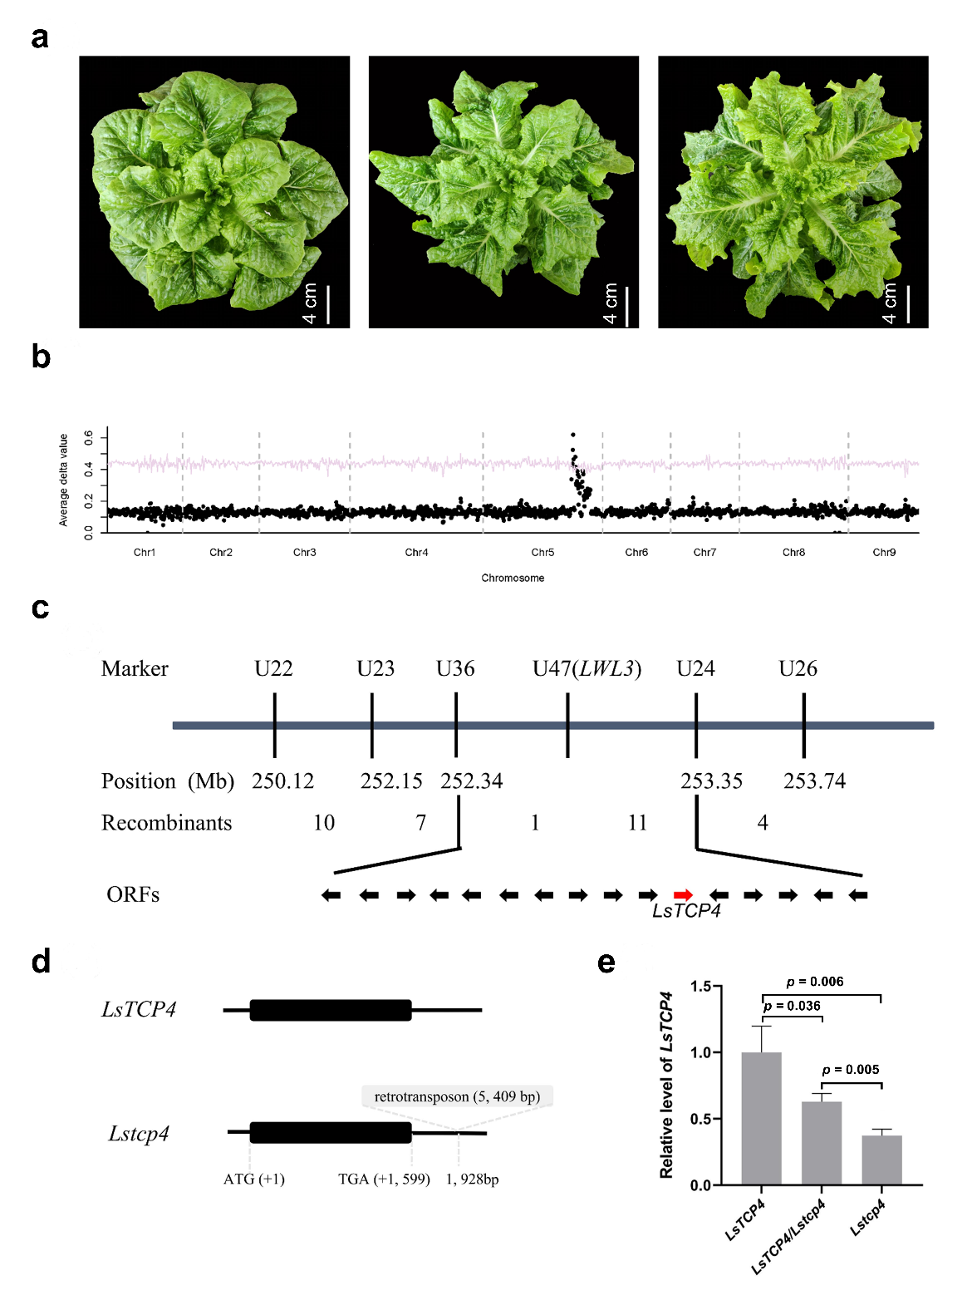
Fig. S13: Map-based cloning and identification of LsTCP4. a The three phenotypes from an F₅ segregating population derived from the cross S1 × Y37. From left to right, flat leaves, moderately wavy leaves, and wavy leaves. Scale bar = 4 cm. b BSR-seq analysis of leaf phenotype. The average delta value (y-axis) was plotted along the nine chromosomes of lettuce (x-axis). The red curve refers to a significant level of p = 0.05. c Fine mapping of the gene controlling wavy leaves. The number of recombinants was obtained from 3,400 individuals of the F₅ population. Sixteen open reading frames are present in the candidate interval including LsTCP4 (in red). d Schematic representation of the LsTCP4 and Lstcp4 alleles. The black box represents exon, and horizontal lines represent upstream and downstream sequences. e LsTCP4 expression in the three genotypes from the F₅ family. The statistical significance for gene expression differences were calculated using Student’s t test, and p-values are displayed above the error bars.

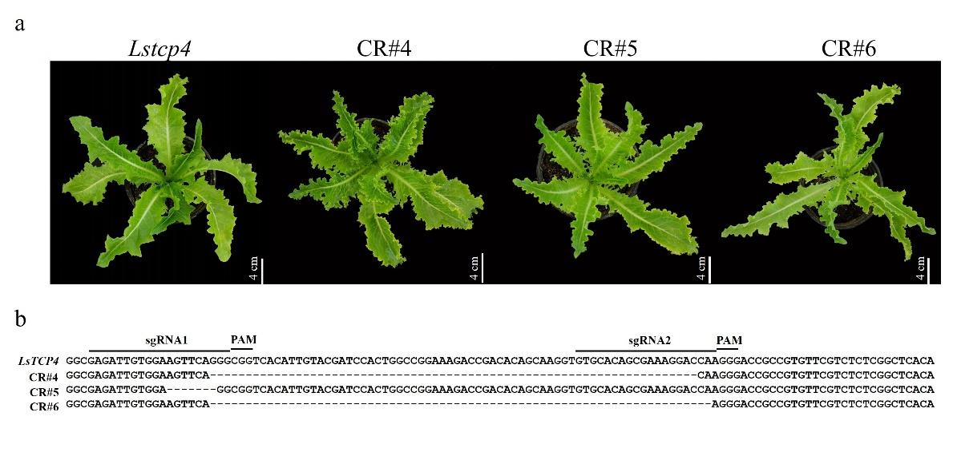
Fig S14: Partial functions of Lstcp4. a Three knockout mutants of Lstcp4. Knockout mutants in Lstcp4 genotype made leaves further more wavy, suggesting the Lstcp4 allele retains partial function. Scale bar = 4 cm. b Modified sequences of Lstcp4 in the three knockout mutants. sgRNA and PAM sequences are shown above the Lstcp4 sequences, and dash lines indicate deleted sequences.

