Review History
First round of review
Reviewer 1

Were you able to assess all statistics in the manuscript, including the appropriateness of statistical tests used?
No, I do not feel adequately qualified to assess the statistics.

Comments to author:
The manuscript by Cipta et al., entitled "Rewiring of SINE-MIR Enhancer Topology and Esrrb Modulation in Expanded and Naïve Pluripotency" reports integration of 3D genome topology (HiC and H3K27ac Hi-ChIP data), Esrrb TF binding sites (ChIP-seq), enhancers and transposable elements annotations and gene expression (RNA-seq) in a comparative analysis between expanded potential stem cell (EPSC, representing a totipotent 8-cell-like state) and naïve embryonic stem cell (ESC, representing a pluripotent ICM-like state). The study highlights chromatin 3D conformation differences between EPSC and ESC, showing a gain of loops anchored on H3K27ac decorated enhancers and enriched in SINE transposable elements in ESC compare EPSC. The main finding is that Esrrb TF contributes to enhancer-based loops in ESC through the recruitment of the Yy1 architectural protein. Yy1 and Esrrb can interact directly but the Yy1 motif is absent in SINE elements. Therefore, the mechanism by which this interaction might regulate enhancer-based loops remains unclear.

Major comments

1. The authors occasionally infer causation from correlation in this manuscript and overstate the conclusions. For example, "our 3D genome profiling demonstrated the importance of genome conformation, at the compartment, TAD and loop level, for regulating cell state identity" (line 148). The section does not entail functional experiments that provide biological meaning to "importance". Instead, the authors show how these different aspects of the 3D genome change during a cell state transition. Whether the changes matter is not known. Therefore, this statement needs to be toned down to reflect that 3D genome changes correlate with changes in cell state identity but the causality remains unknown.
2. The data show that Esrrb promotes MIR-enhancer-H3K27ac anchored loops and this involves Yy1. However, it is unclear how is the loss of loops link to gene deregulation in Esrrb depleted condition. The authors suggest an enhancer-promoter looping mechanism without directly addressing this point and remain elusive in the analysis about whether the contribution of the 3D chromatin in genes regulation is local (more contacts in a given domain/TAD containing enhancers and deregulated genes) or distal (specific long-range interaction / loop between enhancers and genes/promoters).
a. The authors need to provide a better description of their genomic analysis and be more precise about the scales. Ex line 254 "genes located near Esrrb-bound MIR", does it mean <1kb or <250kb? The same question applies to genes associated with loss of loops.
b. What is the nature of the loops detected as lost? Are the authors talking about specific enhancer-promoter loops or rather about a more global loss of loops in a topologically associated domain where MIR-enhancer and deregulated genes are? What are the sizes of lost loop? (long range loops vs short range loops). To what extend does Esrrb-mediated enhancer looping depend on Scc1/loop extrusion mechanism vs another long-range interaction mechanism? According to Fig S1B, there is a drastic change in compartments, with a large number of A compartments turning into B from EPSC to ESC. To what extend is the gain of loops in ESC vs EPSC shown in Fig 1F and Fig S1H/I correlated/associated with these compartment changes?
c. Figure 5 / RNA-seq analysis: It would be interesting to try an integrative analysis of RNA-seq and HiC/HiChIP differential loops and MIR-enhancer to test an enrichment/correlation between lost H3K27ac HiChIP loop in Esrrb depletion and downregulated genes of cluster C4 and C6 from Fig 5B.
3. The authors suggest that Esrrb-mediated looping has a regulatory function in gene expression. The challenge is that perturbation of a transcription factor will lead to changes in gene expression, but whether this is because of a looping function or something else is difficult to disentangle. It would be helpful if the authors can discuss this limitation when interpreting the data.
4. Is Yy1 deregulated in Esrrb-depleted conditions?
5. Is Yy1 the only architectural protein involved in Esrrb-mediated enhancer looping? Can the authors exclude the contribution of CTCF in their model?
6. On the mechanism and function of Esrrb:
a. Figure 3 and section 228 to 244 are mainly based on Esrrb ChIP-seq peak distribution comparisons between EPSC and ESC. Can the authors provide an analysis and comment on the difference in the number of peaks detected in EPSC and ESC. It seems that, despite Esrrb being expressed at similar level (Fig S3A), the number of detected peaks is 10x higher in ESC than in EPSC. Can the authors provide total numbers of reads and number of aligned reads for Esrrb ChIP-seq? How many peaks are detected in total in EPSC and in ESC? To what extend do they overlap? Are the detected peaks comparable with the one detected in Festuccia et al., 2021 (10.1242/dev.199604). How do they explain this binding difference if abundance of protein is unchanged between EPSC and ESC?
b. Are deregulated genes in Fig 5B direct targets of Esrrb? In EPSC and/or in ESC (compared with ChIP-seq binding sites)? For cluster C3 and C7, Esrrb seems to be involved in repression those genes, can the authors comment on a potential role of Esrrb in repression? Or is this an indirect effect?
c. The authors should discuss the choice and provide evidence for the specificity of DES towards Esrrb versus other transcription factors.
7. Basic quality control plots or tables are missing for all the sequencing data pertaining to this study:
a. HiC/ HiChiP: total number of reads, total number of aligned reads, total number of cis-contact for each samples and replicates, plot showing contact frequencies / distance (scaling plot as here : https://cooltools.readthedocs.io/en/latest/notebooks/contacts_vs_distance.html), total number of called loops… It should be mentioned in the method section if any normalisation (Obs/Exp) or balancing (ICE, KR..) has been applied. What is the resolution of HiC matrices used for the analysis/Pile-Up plots?
b. ChIP-seq / ATAC-seq: total number of reads, total number of aligned reads, global coverage comparison/correlation between samples and replicates (https://deeptools.readthedocs.io/en/develop/content/tools/plotCorrelation.html), total number of called peaks…
c. RNA-seq: total number of reads, total number of aligned reads
8. The authors should provide a scholarly review of the literature of genome folding during changes in cellular potency. The cell system employed here is used to model the potency states in the early embryo. It would therefore be appropriate to reference the Hi-C studies that have directly examined 3D genome folding in embryos, including Flyamer et al., 2017; Du et al., 2017; Ke et al., 2017; Gassler et al., 2017, Collombet et al., 2020, etc.

Minor comments:

1. The reference list is missing some papers referenced in the manuscript.
2. Figure 1D: number of Alu and MIR sites is missing.
3. Figure 1F : axis label (range in kb), HiC matrices resolution in kb (to add in method), number of loops plotted in the average and values of the color scale (contact probability values instead of high/low would be better) are missing.
4. Figure 1I should be plotted with the same graphic that Figure 1C and Figure S1L as it shows the same type of analysis.
5. FigS1H: axis label (range in kb) is missing, values of the color scale (contact probability values instead of high/low would be better) are missing.
6. FigS1I: axis label (range in kb) is missing, number of loops plotted is missing
7. FigS1J: Please specify how genes and loops anchored are associated? what is the resolution of the analysis (ex: minimal distance between loop anchor and TSS?). What it the meaning of the three stars (***)? Please specify which statistical test and what are the test hypothesis. It would be interesting to split up-reg genes and down-reg genes and to compare with random or non-deregulated genes. An odd ratio testing if de-regulated genes are enriched or not in the ESC / EPSC specific loops compare to non-dereg genes would be more informative.
8. Line 195-196: Direct comparison of Fig2B and FigS2B: conclusion/interpretation based on p.values comparison only is a misused of statistical tests (https://www.ncbi.nlm.nih.gov/pmc/articles/PMC5187603/), especially if the groups are not the same size. Can the authors:
a. specify which test are used and which hypothesis are tested in the figure legends or in the method section. (same comment for 1G, S3A, S3B, S3D, S4E, S5A, S5C…)
b. Merged figure 2B and figure S2B in a unique p.value heatmap (with the same color scale, and same min/max values for merged 2B and S2B)
c. Plot a second heatmap with the statistical values of enrichment (odds ratio for a Fisher exact test or Pearson residuals for a Chi2 test) and base their Compare observation/conclusion on these statistical values.
9. Figure 2C, line 196/197: The observation on the position of Esrrb motif is informative only if it is compared to other enriched motif (NR5a2, Myc, Max… from Fig2A). What is the importance regarding the binding or the function that a motif is positioned at the center?
10. Figure 2D: same comment than figure 2B, see comments 7a and 7c. Also, -log10(p.value) is more common than -ln(p.value)
11. Figure 2H is not commented in the results section. Legend of the color intensity is missing. How labelled proteins were selected? Is it an arbitrary selection? This figure does not show any interpretable results. Please explain or remove.
12. Figure 3D: number of sites in average is missing.
13. Figure 3R: Please define 'Esrrb-Yy1 co-bound MIR regulated genes'. What is this subset of genes? Are they defined with HiC loops? Proximity to binding sites? Please compare with 'control' genes, i.e. no associated with 'Esrrb-Yy1 co-bound MIR'.
14. Figure 5B: color scale is missing. Number of genes in each cluster would help to appreciate this result. Can you comment on the difference between C3 and C7 genes? Both seem to show genes up-reg in absence of Esrrb, but only C3 genes are differentially expressed in the EPSC-ESC transition.
15. Figure 5E: are ESC genes in cluster C4 from Figure 5B?
16. Line 327-329: 'It appears that during the transition from EPSC to ESC, PrE-associated genes were slightly upregulated': This does not correspond to the results shown in Fig5D or FigS5A.
17. Figure 5 F: please specify the values on the color scale, it is confusing which yellow or blue is high/low values. Please specify in legend or in methods the bins size and range of the reads quantification.
18. FigS5E: Same comment than Fig2B and Fig2D. Pvalue does not indicate whether an enrichment is strong or not. Please show the statistical value (odds ratio or Pearson residuals) when pvalue is significant, and show -log10(pvalue) as a supplementary information.
19. Line 344-345. Venn diagram shows a potential colocalization, not a correlation. Please show a scatter plot log2FC of ATA-seq reads vs log2FC of expression if you want to test for a correlation. If you want to test for colocalization, please perform an enrichment test validating that promoter of up-regulated genes are enriched in promoter with increased accessibility compared to promoter of genes that are not up-regulated (by Chi2 or Fisher exact test), and show statistical value and pvalue.
20. Line 373-374: Unclear whether Pou5f1 is really expressed in PrE-like cells, as it seems to be less expressed in d3ESC_DES cells compare to DMSO one, and even less expressed in the cluster 3 from Fig6A right panel, described as the cluster with strong PrE-like signature.

Reviewer 2

Were you able to assess all statistics in the manuscript, including the appropriateness of statistical tests used?
Yes, and I have assessed the statistics in my report.
Comments to author:
The authors provide valuable insights into the burgeoning field of transposable elements (TE) interactions with the 3D genome, an important but somehow understudied area in chromatin biology. They utilize a diverse set of omics techniques and technologies, including 3D genomics, epigenomics, CRISPR-based mass spectrometry, single-cell RNA sequencing, and blastoid culture, enriching the study's multi-dimensional analysis. The findings are potentially interesting to the broad genome research community. However, the manuscript suffers from thematic divergence. In the first section (Figures 1-3), Hi-C and H3K27 Hi-ChIP analyses identify SINE-MIR as the predominant TE at enhancer loop anchors, and the transcription factor Esrrb as crucial for maintaining these enhancer loops and preserving the naive state of embryonic stem cells (ESCs). In the subsequent section, the focus shifts to examining Esrrb's phenotypic roles during the transition from extended pluripotent stem cells (EPSCs) to ESCs. While the discovery that RLTR1B/-int and RMER16/-int can act as TE markers to differentiate primitive endoderm (PrE) from extraembryonic endoderm (XEN) is intriguing, the connection between these two sections remains tenuous. Although Esrrb is a common element in both parts, the initial emphasis of the second part appears to be on identifying Esrrb's targets, rather than elucidating its regulatory mechanisms in TE-enhancer interactions. Moreover, the precise function of Esrrb-MIR in PrE lineage determination is not clearly delineated. Although some experiments perturb Esrrb, the resultant cell fate alterations prevent a definitive conclusion about Esrrb's direct role in MIR and YY1 binding. More rigorous approaches are needed to reach to this interesting conclusion. Consequently, the attribution of loop changes to Esrrb loss is not compelling, given the confounding factor of altered cell identity. Despite very interesting topic, the current format is not ready for publication due to several concerns listed below.

1. Abstract: Clarify the terminology SINE, SINE-MIR, and Esrrb-MIR at their first mention to distinguish between them clearly and prevent confusion.
There are differences in MIR enrichment at enhancer loop anchors between EPSC and ESC. Fig1SL is informative, but the authors should also present the number of H3K27ac-positive MIRs in EPSC and ESC.
2. Given that loop number is sensitive to sequencing depth, the authors should clarify whether the sequencing depth is comparable across all libraries when comparing loop numbers in the main text.
3. Considering the authors' comprehensive study of how Esrrb modulates MIR, could they inhibit the activity of MIR by combining dCas9-KRAB with the gRNAs used in this study to investigate its role in PrE formation? Alternatively, the authors could discuss the potential results of such experiments.
4. Esrrb and Yy1 are physically interacting and they co-bind a subset of MIR. Although knockdown of Esrrb leads to reduced Yy1 binding as shown in Fig 3p and 3q, the authors also need to make a scatter plot to show whether Esrrb and Yy1 are positively correlated at the co-bound MIR loci.
5. RLTR1B/-int and RMER16/-int are enriched in cluster 3. It would be more convincing if the authors could present a heatmap plot illustrating increased accessibility in the 3dESC_siEsrrb group.(like the plots in Fig 3P and 3N)
6. In Fig 3K, in addition to the enrichment score, could the authors also provide quantification of the expression of SE-associated genes after Esrrb knockdown?
7.The P values should be calculated in Fig3R and FigS3i.
8.In Fig S1i, scores of each pileup Hi-C map should be shown in the plot.
9.There is a typo in Fig4 I. It should be μM rather than uM. In Fig5C, is the LogP Log10?
10. Line 111: Define "expanded state" explicitly in the manuscript, or provide citations if it is a pre-existing concept.
11. Line 108: Modify the claim that cell state identity is solely defined by the 3D genome. Suggest rephrasing to "distinct cell states exhibit specific 3D genome conformation."
12. Line 109: Soften the assertion regarding the understudied role of 3D genome conformation in cell state identity, noting that some studies (e.g., those on CTCF depletion) suggest pluripotency can be maintained despite changes in 3D genome structure.
13. Fig 1C: Alongside fold change, include p-values or FDR in the color representation to convey statistical significance clearly.
14. Line 167: Clarify what is meant by "less complex" regarding APA plots and ESC-specific loops. Discuss the context-dependent nature of these interactions rather than making broad comparisons of complexity or strength.
15. Fig 1I: Provide the p-value for the enrichment observed.
16. Fig 1C and 1I: Address the apparent discrepancies in enrichment between different loop sets and clarify the criteria for loop selection in these analyses.
17. Fig 1E and 1F: Specify the number of peaks and loops analyzed.
18. Line 190: Justify the choice of not using HiChIP loop anchors for certain analyses, and compare the results from HiC and HiChIP.
19. Line 202: Please cite recent studies on TE-associated proteomics.
20. Line 214: Specify the lineage induced by retinoic acid (RA) and provide references.
21. Fig 3F-3K: Address how to differentiate between changes due to Esrrb loss and those due to differentiation. Consider experiments that perturb Esrrb-MIR binding specifically, without affecting cell fate, to establish a direct regulatory mechanism. This is a major concern.
22. Line 277: Similar to Fig 3F-3K, determine whether the loss of YY1 binding is directly due to Esrrb loss or an indirect effect of altered cell fate. This is also a major concern.
23. Given that loop number is sensitive to sequencing depth, the authors should clarify whether the sequencing depth is comparable across all libraries when comparing loop numbers in the main text.

Reviewer 3

Were you able to assess all statistics in the manuscript, including the appropriateness of statistical tests used?
Yes, and I have assessed the statistics in my report.

Comments to author:
In this manuscript, Nadia Omega Cipta et al. utilize Hi-C and H3K27ac Hi-ChIP to systematically investigate the 3D genomic structure in EPSCs and naïve ESCs. They identified distinct 3D characteristics in the two cell states. Furthermore, they observed that MIR elements contribute to predicted enhancer loop topology and are frequently bound by the naïve pluripotent marker Esrrb. Following this, they found that Esrrb affects cell fate determination during the transition from the expanded-to-naïve state and reduced Esrrb leads to a higher proportion of primitive endoderm-like cells, resulting in increased blastoid formation.
Overall, the manuscript requires substantial improvement. Despite the impressive array of experiments and analyses performed, the manuscript failed to deliver a coherent and convincing biological story. The organization of the manuscript suffers from going into disjoint directions without providing incisive evidence for any of the major claims. Several conclusions, notably about MIR's functional role as enhancer, rest on weak or correlative patterns. Contradictory statements are also present throughout the text. Consequently, the manuscript needs in depth revisions before it can be published.

Major issues
1. The first and second halves of the manuscript are disjointed, lacking coherence. In the results section, from 'Cell state identity defined by 3D genome conformation' to 'Esrrb-Yy1 partnership regulates MIR', the authors study putative Esrrb-MIR enhancers in pluripotent stem cells (Figures 1-3). Then, they abruptly shift focus to study how the loss of Esrrb leads to biased cell fate determination without attempting to link this phenotype to changes in MIR enhancer activity (Figures 4-6). It appears that these two parts would be better separated into two manuscripts. As presented, the manuscript does not yield a significant advance in our understanding of the regulatory role of MIR elements in early embryonic development. The findings about Essrb also seem to represent an incremental advance in the pluripotency field and the biological relevance of the ESC/EPSC system for embryonic development is debatable (see point 3 below). As the authors themselves summarizes in Discussion (line 502): "Esrrb is a known reprogramming factor (Feng et al., 2009), and the contribution of MIR in this process is still unknown." We are left wondering: where is the significant advance then?
2. The authors need to further elucidate the role of MIR elements in ESCs. That seems the most viable path towards publication. Currently, the data only support the possibility that MIR elements may act as enhancers in ESCs, but their function remains unclear. Figure 3I showed that MIR can interact with some genes. However, the resolution of Figure 3I is too low to be persuasive. Some interaction points are near, but not directly on, MIR elements. The authors should provide a zoomed-in view of these areas. Moreover, they should consider validating the enhancer role of MIR elements by knocking out the MIR locus adjacent to Klf5 or other genes. They could also use dCas9-KRAB to suppress MIR elements to probe their function in ESCs, particularly since they have already designed apparently effective sgRNAs targeting MIR elements. Without additional evidence supporting a functional impact of MIRs, the biological advances are limited. The data presented do not support the conclusion that "SINE MIR as functional ESC enhancers under direct control of Esrrb" (line 441), or that "Esrrb-MIR enhancer interaction is crucial for the formation of loops that build a network of enhancers and super-enhancers regulating pluripotency genes" (Abstract).
3. In some sections, the authors claim that EPSCs are "8-cell-like" or "totipotent." The authors repeatedly use this idea to emphasize the pluripotent state of EPSCs is higher than that of naïve ESCs and that the transition from EPSCs to naïve ESCs is representative of what happens in vivo during embryonic development. The authors should be more cautious about such claim given ongoing debates on the subject 1. Several studies have shown that EPSCs are transcriptionally dissimilar from the 8-cell embryo 2-4. In fact, the authors' own data do not support the similarity between EPSCs and 8 cell embryos. In Figure 6G, the authors compared EPSCs and ESCs with in vivo embryos, excluding 8-cell stage embryos. It is unclear whether this exclusion was intentional. Although without 8 cell embryos, we could observe that EPSCs is very similar to the ground state of naïve ESCs which is similar to inner cell mass1. If authors truly believe that EPSCs is similar to 8 cell embryos, authors should add 8-cell embryos and new developed 2-cell like cells2-4 and morula-like cells5 in Figure 6G. It is especially contradictory when authors in this study used the H19 as the marker of EPSCs, which is expressed at blastocyst along DNA demethylation as an imprinted gene.

4. For the blastoid section, I believe there is no reliable blastoid formation protocol for EPSCs derived from Pentao Liu's lab, which the authors used in this study. Most groups used extended pluripotent stem (EPS) cells derived from Hongkui Deng's lab to generate the blastoids6-8. But even EPS-derived blastoids are defective9 . Therefore, the authors should approach the derivation of blastoids with caution. It is crucial that the blastoids are thoroughly characterized. As an example, the authors should perform immunostaining to identify three lineage markers in the blastoids.

More specific issues:
1. Figure S1 is critical and should be included as a main figure.
2. The authors define 5 types of boundary changes (complex, merge, shifted, split, and strength change) but they do not rationalize and define these changes in the Results section (line 131-133; Figure S1E).
3. In figure S1B, the switches from A compartments in ESCs to A compartments in EPSCs are labeled with two colors. What the meaning of these two colors?
4. In Figure 1B, the authors attempt to use PCA to demonstrate that EPSCs share similarities with 8-cell embryos in terms of 3D genomic structure. However, the authors have not detailed how they accounted for batch effects or their methodology. It is surprising that EPSCs, which is not similar to 8-cell embryos at transcriptional level, would resemble 8-cell embryos in their 3D genomic structure. To further support this conclusion, the authors should also provide specific examples. It's also interesting to know whether EPSC specific TADs are also specific in 8 cell embryo.
5. Line 161-162 and Figure 1C. Scale bar indicates up to log2fold change of 2; i.e. 4 fold enrichment which I would call a modest enrichment, not "highly enriched" as the authors states. Also enrichment analysis at the TE subfamily level would be desirable, especially for ERV groups which are composed of many diverse subfamilies with potentially very different regulatory activities. Similarly, SINE classes are composed of many subfamilies.
6. Fig 1D: I wonder whether the two plots have been inadvertently reversed? The bottom one shows the bimodal distribution expected for K27ac whereas the top one shows a unimodal peak I would expect for ATAC signal.
7. From Figures 1E to 1F, the authors illustrate that the ESC-MIR-enhancer loop anchors are less accessible and exhibit less complexity in EPSCs, which is expected since these anchors are specific to ESCs. So, what's the meaning of this panel? Figure2K also has the similar problem, in which authors only choose "ESC-MIR-enhancer loop anchors". Furthermore, signal differences between ESC and EPSC shown in Fig 1E and 1F are rather subtle and one wonders whether differences in data quality or sequencing depth could account for these?
8. Fig 1I: scale shows no positive log2fold change, which seems to imply no TE family is enriched, but some are depleted (e.g. L1). In addition, differences between ESC and EPSC look extremely subtle on this heatmap. Are these statistically significant?
9. Similarly, there are no statistics to test whether fold change shown in Fig 1J is significant for any of the SINE classes singled out. Overall, these data do not convincingly support the notion that "Alu/B1, B2, MIR, B4 are enriched in H3K27ac HihIP loop anchors" (line 178)
10. In Figure 2B and Figure S2B, the authors present the motif enrichment across transposable element (TE) families, yet they divide the information between two panels—one in the main text and the other in the supplementary figures. While I understand the authors' intention to highlight the Esrrb enrichment on MIRs, it must be noted that Esrrb's enrichment on Alu elements is more significant than that on MIRs. Separating these findings might mislead the readers.
11. In Figure 1H, the authors should use the adjusted p-value. My concern is that the term 'regulation of stem cell population maintenance' may not remain significant if the authors were to apply the adjusted p-value.
12. The authors need to provide more details about the design of the two MIR sgRNA used for perform the CAPTURE experiments. It seems it would be very difficult to broadly target MIRs with any single sgRNA given their extensive sequence divergence to each other and to the MIR consensus sequence. How many MIRs were predicted to be targeted with those two sgRNAs and how many of those overlap with the predicted MIR enhancers?
13. In Figure S3B, authors claimed that the protein level in 2 cell states are similar, but the it seems that there is no significance because there are only two biological replicates, which is not insufficient.
14. For siEsrrb experiment in EPSCs and ESCs in Figure 3E, authors need to show the RNA and protein levels of Esrrb in two cell states following siRNA treatment to confirm the down-regulation of Esrrb.
15. Some figures are missing content, such as Figures S3E, S3N, 4A, 4C, etc.
16. Regarding to super-enhancers, do MIR elements overlap with them?
17. In Figure 5, RNA-seq lacks biological replicates.
18. In Figure 5j, what's the meaning of "es"?
19. Figure 6G should be labelled as 6F, 6H as 6G, and 6I as 6H.
Reference:
1. Posfai, E. et al. Evaluating totipotency using criteria of increasing stringency. Nat Cell Biol 23, (2021).
2. Yang, M. et al. Chemical-induced chromatin remodeling reprograms mouse ESCs to totipotent-like stem cells. Cell Stem Cell 29, (2022).
3. Hu, Y. et al. Induction of mouse totipotent stem cells by a defined chemical cocktail. Nature 617, (2023).
4. Shen, H. et al. Mouse totipotent stem cells captured and maintained through spliceosomal repression. Cell 184, 2843-2859.e20 (2021).
5. Li, H. et al. In vitro generation of mouse morula-like cells. Dev Cell 58, 2510-2527.e7 (2023).
6. Fan, Y. et al. Generation of human blastocyst-like structures from pluripotent stem cells. Cell Discov 7, (2021).
7. Li, R. et al. Generation of Blastocyst-like Structures from Mouse Embryonic and Adult Cell Cultures. Cell 179, (2019).
8. Rivron, N. C. et al. Blastocyst-like structures generated solely from stem cells. Nature 557, (2018).
9. Liu, K. et al. Bilineage embryo-like structure from EPS cells can produce live mice with tetraploid trophectoderm. Protein Cell (2022) doi:10.1093/procel/pwac029.

Authors Response
Point-by-point responses to the reviewers’ comments:

Reviewer #1: The manuscript by Cipta et al., entitled "Rewiring of SINE-MIR Enhancer Topology and Esrrb Modulation in Expanded and Naïve Pluripotency" reports integration of 3D genome topology (HiC and H3K27ac Hi-ChIP data), Esrrb TF binding sites (ChIP-seq), enhancers and transposable elements annotations and gene expression (RNA-seq) in a comparative analysis between expanded potential stem cell (EPSC, representing a totipotent 8-cell-like state) and naïve embryonic stem cell (ESC, representing a pluripotent ICM-like state). The study highlights chromatin 3D conformation differences between EPSC and ESC, showing a gain of loops anchored on H3K27ac decorated enhancers and enriched in SINE transposable elements in ESC compare EPSC. The main finding is that Esrrb TF contributes to enhancer-based loops in ESC through the recruitment of the Yy1 architectural protein. Yy1 and Esrrb can interact directly but the Yy1 motif is absent in SINE elements. Therefore, the mechanism by which this interaction might regulate enhancer-based loops remains unclear.

We thank reviewer for highlighting our main findings. The interaction of Esrrb and Yy1 has not been reported before, despite existing Esrrb IP-MS (van den Berg et al. 2010, PMID: 20362541) and Yy1 IP-MS (Wang et al. 2018, PMID: 29503092) datasets. In our study, we confirmed this interaction by co-IP western blot and sequential ChIP. We also took interest of the rich Yy1 binding at TE sites.
Aside from Esrrb-Yy1 partnership, we want to emphasize that the enrichment of Esrrb on MIR is also a novel finding of this study.
In response to feedback from 2/3 reviewers regarding thematic divergence and the disjointed nature of our manuscript, we decided to remove the former Figures 4-6. While we have addressed your questions related to those figures in this rebuttal letter, please note that they are no longer included in the manuscript.
Instead, we have strengthened the link between Esrrb regulation of MIR with CRISPR inhibition and knockout experiments.

Major comments

1. The authors occasionally infer causation from correlation in this manuscript and overstate the conclusions. For example, "our 3D genome profiling demonstrated the importance of genome conformation, at the compartment, TAD and loop level, for regulating cell state identity" (line 148). The section does not entail functional experiments that provide biological meaning to "importance". Instead, the authors show how these different aspects of the 3D genome change during a cell state transition. Whether the changes matter is not known. Therefore, this statement needs to be toned down to reflect that 3D genome changes correlate with changes in cell state identity but the causality remains unknown.
We thank reviewer 1 for raising this point. We have followed up this study with a CRISPR inhibition experiment to demonstrate the importance of MIR. We saw changes of genes related to cell morphogenesis involved in differentiation (Figure S4E). Furthermore, using the same system we inhibited an example of MIR enhancer with H3K27ac-mediated interaction to its target gene in ESC, demonstrating its function in regulating the target gene expression. Furthermore, we showed that knockout of this MIR enhancer reduces gene expression and also affect cell proliferation. Following the newly provided result, we have revised the conclusion accordingly, and tone down the conclusion when causation is inferred and not supported by the data.

2. The data show that Esrrb promotes MIR-enhancer-H3K27ac anchored loops and this involves Yy1. However, it is unclear how is the loss of loops link to gene deregulation in Esrrb depleted condition. The authors suggest an enhancer-promoter looping mechanism without directly addressing this point and remain elusive in the analysis about whether the contribution of the 3D chromatin in genes regulation is local (more contacts in a given domain/TAD containing enhancers and deregulated genes) or distal (specific long-range interaction / loop between enhancers and genes/promoters).
Firstly, based on the H3K27ac HiChIP data after Esrrb knockdown, 984 Esrrb-bound MIR interacting genes lost H3K27ac loops. 115 Esrrb-bound MIR interacting genes are downregulated after Esrrb knockdown, and among them are 107 genes with lost H3K27ac loops. This means most Esrrb-bound MIRs looping genes with downregulated expression are associated with enhancer loop change. This result is shown in the current Fig. S3G.
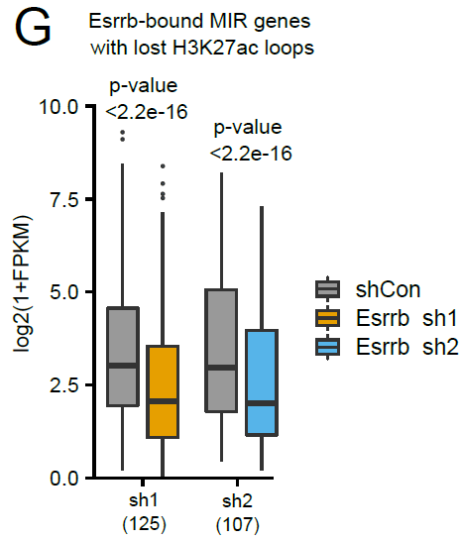
With regards to Esrrb-bound MIR interacting gene with H3K27ac loop lost, the distance between looping genes and MIRs are as such: 892 pairs <20kb, 233 pairs <50kb, 136 pairs <100kb, 100 pairs >100kb. The percentage is shown in the pie chart below. 981 pairs out of 1361 pairs (72.1%) are within TADs. Therefore, we saw more of a local contribution of the 3D chromatin in gene regulation by Esrrb on MIR.
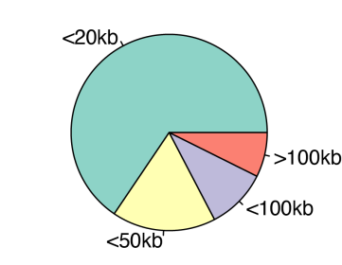

a. The authors need to provide a better description of their genomic analysis and be more precise about the scales. Ex line 254 "genes located near Esrrb-bound MIR", does it mean <1kb or <250kb? The same question applies to genes associated with loss of loops.
We apologize for the ambiguity. The correct term should be “Esrrb-bound MIR interacting genes”. We define the interaction by H3K27ac HiChIP loops. This means that one of the H3K27ac HiChIP loop anchor (±5kb region) are on MIR and bound by Esrrb, and the other anchor falls into a gene region (TSS to TES). We have now revised the text accordingly.

b. What is the nature of the loops detected as lost? Are the authors talking about specific enhancer-promoter loops or rather about a more global loss of loops in a topologically associated domain where MIR-enhancer and deregulated genes are? We are referring to specific enhancer-promoter loops. The lost H3K27ac loops after Esrrb knockdown are listed in Table S4.
What are the sizes of lost loop? (long range loops vs short range loops).
We have plotted the frequency distribution of H3K27ac lost loop after Esrrb knockdown. The majority of lost loops were below 20kb, and the largest lost loop was 1.8Mb. Hence, the majority of loops were short-range loops.
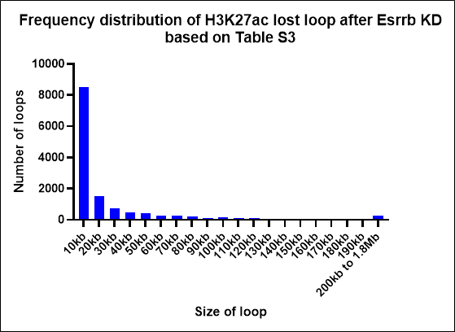

To what extend does Esrrb-mediated enhancer looping depend on Scc1/loop extrusion mechanism vs another long-range interaction mechanism?
By overlapping Esrrb ChIPseq and H3K27ac HiChIP, we identified 16885 Esrrb-mediated H3K27ac HiChIP loops, hereafter referred to as Esrrb-H3K27ac loops. To investigate the dependency of these loops with loop extrusion mechanism, we overlapped Esrrb-H3K27ac loops with CTCF and Rad21 ChIP-seq peaks. There were 4178/16885 (24.7%) and 3716/16885 (22%) loops with both anchors enriched with CTCF and Rad21 peaks, respectively. This means a large majority of Esrrb-H3K27ac loop anchors are not bound by CTCF and Rad21.
Based on Micro-C data after CTCF or Rad21 acute depletion (Hsieh et al., 2022 (PMID: 36471071)), there were 6568 or 7759 chromatin loops lost. Among those lost loops, 415 or 411 loops overlapped with Esrrb-H3K27ac loops. This means only a small subset (2.45% or 2.43%) of Esrrb-mediated chromatin loops are potentially affected by CTCF or Rad21 lost.
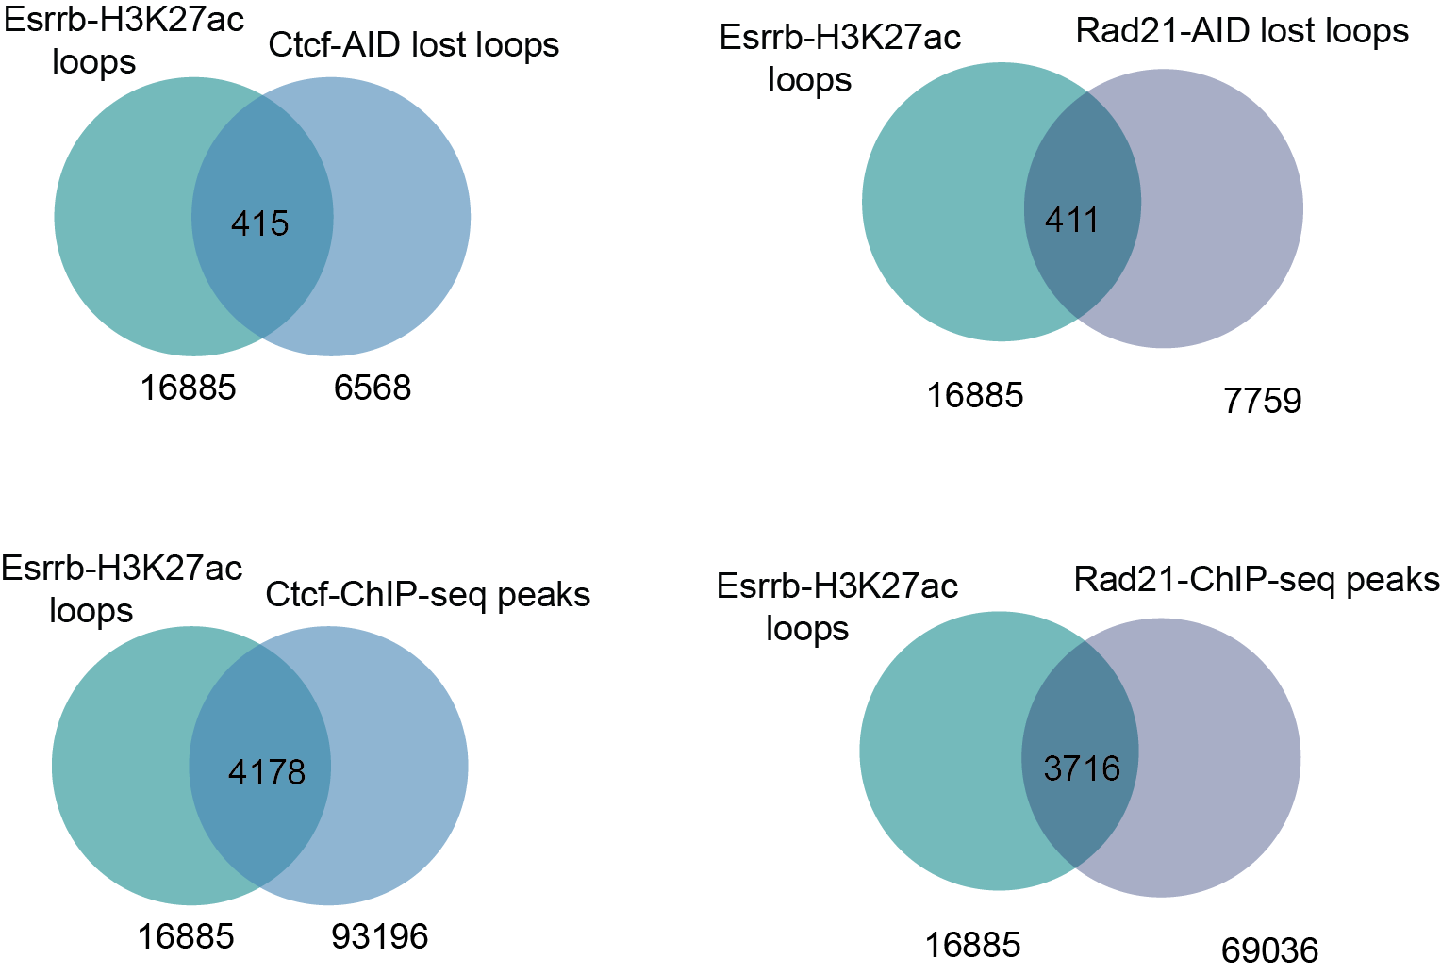

According to Fig S1B, there is a drastic change in compartments, with a large number of A compartments turning into B from EPSC to ESC. To what extend is the gain of loops in ESC vs EPSC shown in Fig 1F and Fig S1H/I correlated/associated with these compartment changes?
The number of differential loops between ESC and EPSC are as such: 6322 ESC-specific and 4472 EPSC-specific.
Among these loops, only 498/6322 (7.8%) of ESC-specific, and 417/4472 (9.3%) of EPSC-specific have at least one loop anchor enriched in the differential compartments. The number of differential loops enriched in the differential compartments is broken down as following:
 | B-to-A (EPSC to ESC) | A-to-B (EPSC to ESC) | A-to-A (EPSC to ESC) | B-to-B (EPSC to ESC) | Total
ESC-specific | 52 | 283 | 134 | 29 | 498
EPSC-specific | 13 | 279 | 100 | 25 | 417

We agree with Reviewer 1’s observation that a large number of A compartments turned into B from EPSC to ESC. However, only 283/6322 (4.5%) ESC-specific loops were found in the A-to-B compartment switch. Therefore the compartment changes were not so highly correlated with the loop changes.

c. Figure 5 / RNA-seq analysis: It would be interesting to try an integrative analysis of RNA-seq and HiC/HiChIP differential loops and MIR-enhancer to test an enrichment/correlation between lost H3K27ac HiChIP loop in Esrrb depletion and downregulated genes of cluster C4 and C6 from Fig 5B.
Cluster C4 and C6 refers to downregulated genes in 3dESC under siEsrrb and inhibitor (DES) condition. We have done integrative analysis of these gene clusters with Esrrb-bound MIR interacting genes with lost H3K27ac loops upon Esrrb knockdown. The results showed 19 and 44 gene overlap, with P-values <0.05. This means that the downregulated genes in 3dESC with Esrrb knockdown or inhibition are correlated with loss of H3K27ac enhancer loops.

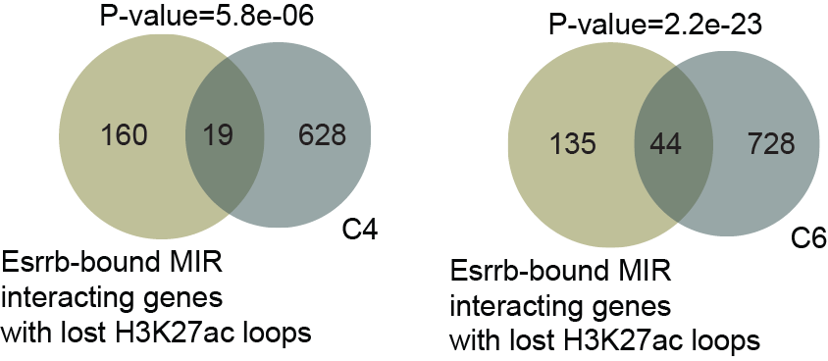

3. The authors suggest that Esrrb-mediated looping has a regulatory function in gene expression. The challenge is that perturbation of a transcription factor will lead to changes in gene expression, but whether this is because of a looping function or something else is difficult to disentangle. It would be helpful if the authors can discuss this limitation when interpreting the data.
We acknowledge that knockdown of a transcription factor will lead to changes in gene expression, which may or may not be caused by looping function. Moreover, Esrrb is one of the important pluripotency genes, loss of which will cause change of cell state. Based on a study with similar focus on Oct4-TAD (PMID: 34038708), they used acute Dox-induced Oct4 depletion approach to demonstrate that a large number of boundaries are reorganized upon OCT4 depletion, while the cell status remain unchanged (no effect on NANOG expression, structuring factors, or histone modification). To disentangle whether Esrrb-mediated looping is a direct contributor to changes in gene expression, an acute degradation system is better suited.
We have now discussed this limitation in the discussion section.

4. Is Yy1 deregulated in Esrrb-depleted conditions?
We have measured Yy1 expression by qPCR and western blot, and determined that Yy1 is not deregulated in Esrrb shRNA knockdown condition. This means that reduction of Yy1 binding on MIR is not caused by reduced availability of Yy1.
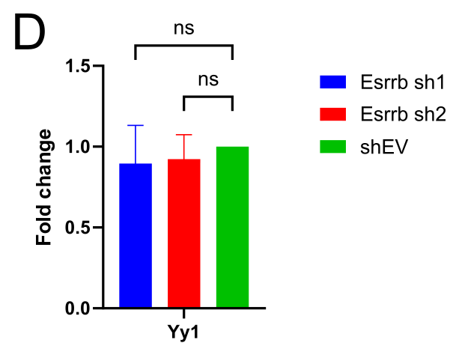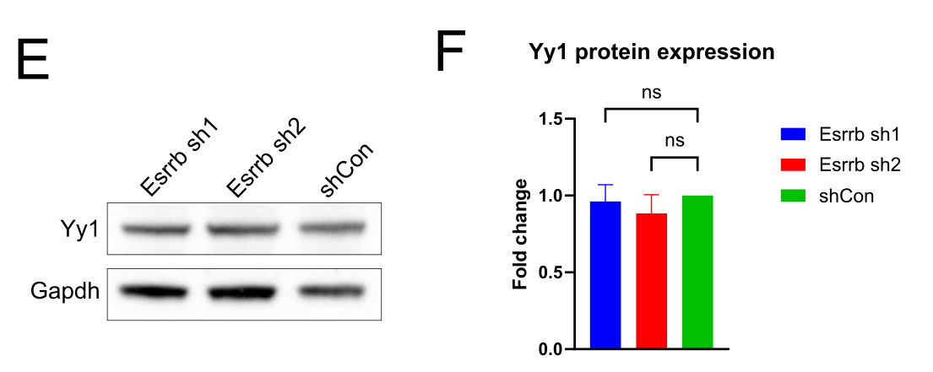

5. Is Yy1 the only architectural protein involved in Esrrb-mediated enhancer looping? Can the authors exclude the contribution of CTCF in their model?
Using the public ChIP-seq data, we have done the mESC factor peaks enrichment on Esrrb-mediated H3K27ac loop anchors,
We have inspected several structural protein and transcription factor binding peaks enrichment in the Esrrb-mediated H3K27ac loop anchors. We applied Fisher exact test, and showed the significant ones in the heatmap below. The color intensity indicates the odds ratio.
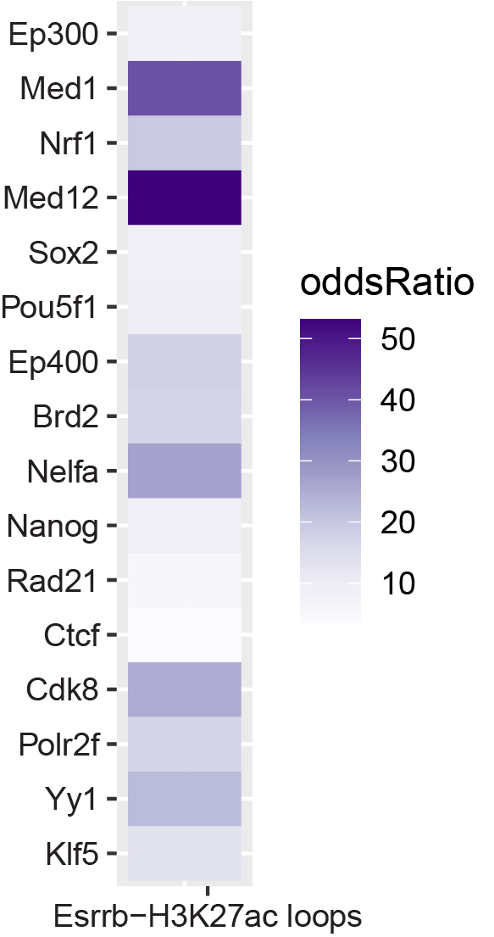
Structural proteins Ctcf and Rad21 binding were found to be low. Therefore it is likely that CTCF and Rad21 is not involved in Esrrb-mediated enhancer looping.
On the other hand, we noted that the binding of Mediators complex of RNA Pol II transcription (Med1, Med12) was enriched.

6. On the mechanism and function of Esrrb:
a. Figure 3 and section 228 to 244 are mainly based on Esrrb ChIP-seq peak distribution comparisons between EPSC and ESC. Can the authors provide an analysis and comment on the difference in the number of peaks detected in EPSC and ESC. It seems that, despite Esrrb being expressed at similar level (Fig S3A), the number of detected peaks is 10x higher in ESC than in EPSC. Can the authors provide total numbers of reads and number of aligned reads for Esrrb ChIP-seq?

The number of total reads and aligned reads are provided in the table below:
 | Total reads | Uniquely mapped reads | Number of called peaks
ESC-Esrrb | 74737723 | 46657455 (62.43%) | 103197
ESC-input | 91874143 | 58507993 (63.68 %) | 103197
EPSC-Esrrb-rep2 (passage 20) | 43521937 | 20496104 (47.09%) | 8699
EPSC-input-rep2 (passage 20) | 33654192 | 18001055 (53.49%) | 8699
EPSC-Esrrb-rep1 (passage 5) | 39325691 | 19864815 (50.51%) | 27020
EPSC-input-rep1 (passage 5) | 35286112 | 19349900 (54.84%) | 27020
ESC-Esrrb rep2 | 48492164 | 22691409 (46.79%) | 35459
ESC-Input rep2 | 36712068 | 19235648 (52.40%) | 35459

The sequenced reads differ largely between the ESC rep1 and the rest (EPSC rep2, EPSC rep1, and ESC rep2) Esrrb ChIP-seq libraries. This was because the first and last 3 libraries (gray shading) were conducted in different batches and sequenced using different machines. However, the sequencing depth shouldn’t affect the peak identification too much because the input for each sample is sequenced together in the same lane with similar depth. Every sample is compared to its own input to detect the peaks.
On another note, we have performed the EPSC-Esrrb ChIP-seq at different passage numbers, rep1 (P5) and rep2 (P20). The 2 libraries were prepared at the same batch and sequenced together, and we saw a decreased number of Esrrb peaks at a later passage. Therefore, the number of Esrrb peaks in EPSC was affected by the passage number.

How many peaks are detected in total in EPSC and in ESC? To what extend do they overlap? Are the detected peaks comparable with the one detected in Festuccia et al., 2021 (10.1242/dev.199604).
The detected Esrrb peak numbers for ESC and EPSC-rep1 (P5), EPSC-rep2 (P20) were 103197, 27020, and 8699, respectively. The peaks overlap between EPSC and ESC are shown in the venn diagram below. Over 90% of EPSC Esrrb peaks were also present in ESC. These shared peaks only make up 23.9% and 8.2% of Esrrb peaks in ESC.
The number of Esrrb peaks identified in Festuccia et al., 2021 (GSE152186) is 16503, with 15857 (96%) overlapping with our dataset. We have also checked the overlap of our Esrrb-peaks and the Esrrb-peaks identified in GSE90893 (71915 peaks), with 45000 (62.5%) peaks overlapping with our dataset. Therefore, our Esrrb ChIP-seq datasets are comparable with other published datasets.
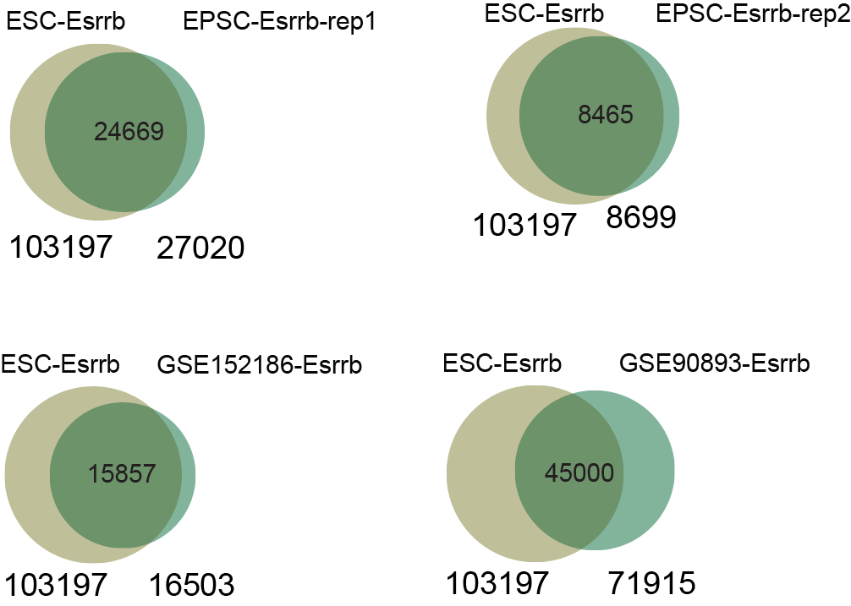

How do they explain this binding difference if abundance of protein is unchanged between EPSC and ESC? Despite unchanged protein abundance, we saw increased accessibility of Esrrb motif in ESC, specifically on MIR (Fig 2D). This increased accessibility may explain why more sites are bound by Esrrb in ESC.

b. Are deregulated genes in Fig 5B direct targets of Esrrb? In EPSC and/or in ESC (compared with ChIP-seq binding sites)? For cluster C3 and C7, Esrrb seems to be involved in repression those genes, can the authors comment on a potential role of Esrrb in repression? Or is this an indirect effect?
The majority of deregulated genes are direct targets of Esrrb. In total, 4311 genes (65%) among all the clusters are direct targets of ESC-Esrrb ChIP peaks. 1127 genes (17%) among all the clusters are the direct targets of EPSC-Esrrb peaks. The percentage of each cluster of genes overlapped with the Esrrb peaks (ESC and EPSC) is shown in the figure below.
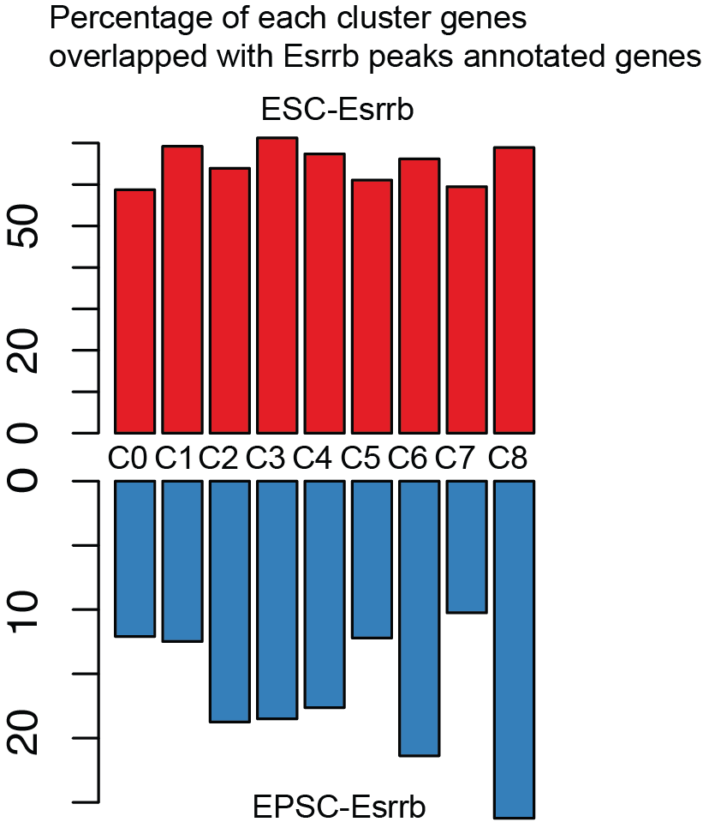

In the 3dESC, we saw that C3 and C7 genes were upregulated in Esrrb knockdown or inhibition condition. Since we did not inspect each gene individually, we can only conclude that loss of Esrrb allows those genes to be upregulated. This could be due to direct repression by Esrrb, or an indirect effect caused by dysregulation of other genes.

c. The authors should discuss the choice and provide evidence for the specificity of DES towards Esrrb versus other transcription factors.
DES has been demonstrated to suppress coactivator binding and transcription by acting as inverse agonist for Esrrb, Esrra and Esrrg (Tremblay et al., 2010, PMID: 11297507). We chose this chemical because the effect of DES on Esrrb has been demonstrated in in-vitro (trophoblast stem cell) culture. The same study found no significant DES activity on a large series of nuclear receptors, other than the ERR (estrogen-related receptor) family. Among the 3 ERR family members, Esrrb is the major isoform expressed in ESC, while Esrrg is not expressed at all.
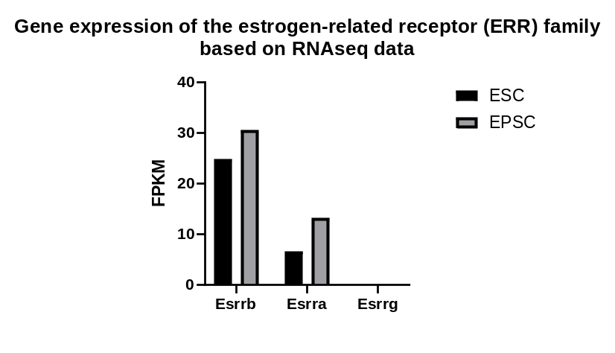
We acknowledge that there might be unspecificity of DES action with Esrra.
Since there is no available dataset of Esrra ChIPseq performed in ESC, we are not able to determine Esrra targets in mouse ESC, and test whether these targets were downregulated by DES treatment. However Esrra is not typically known as major regulator of ESC. The results we obtained from the DES treatment experiment was largely in agreement with siEsrrb result. Therefore we think that despite the unspecificity, the effect we saw can be attributed to inhibition of Esrrb.

7. Basic quality control plots or tables are missing for all the sequencing data pertaining to this study:
a. HiC/ HiChiP: total number of reads, total number of aligned reads, total number of cis-contact for each samples and replicates, plot showing contact frequencies / distance (scaling plot as here : https://cooltools.readthedocs.io/en/latest/notebooks/contacts_vs_distance.html), total number of called loops… It should be mentioned in the method section if any normalisation (Obs/Exp) or balancing (ICE, KR..) has been applied. What is the resolution of HiC matrices used for the analysis/Pile-Up plots?

We have now summarized the requested information in the table below. We will also provide them to the reader as Table S1.

Hi-C | ESC-rep1 | EPSC-rep1 | ESC-rep2 | EPSC-rep2
SequencedReads | 1,085,329,657 | 1,122,874,860 | 1,108,616,342 | 984,673,208
TotalContacts | 707,684,248 | 661,585,220 | 685,870,223 | 601,509,264
IntraChromosomalReads | 650,947,496 | 545,522,508 | 622,115,066 | 555,516,041
IntraLongRangeReads(>=20Kb) | 310,419,575 | 327,597,767 | 306,464,668 | 275,721,930
IntraShortRangeReads(<20Kb) | 340,527,921 | 217,924,741 | 315,650,398 | 279,794,111
InterChromosomalReads | 56,736,752 | 116,062,712 | 63,755,157 | 45,993,223
Total loop number | 13,489 | 11,565 | 12,839 | 14,948

Smoothed P(s) curves showing contact frequencies/distance for each sample are shown in the following figure. It displayed trend is expected, with the contact frequency in the Hi-C maps decreases very strongly with genomic distance. Matrix-balancing normalization (Iterative Correction) was performed when doing the binning step to generate the .mcool file. The pile-up analysis used a 10 kb resolution.
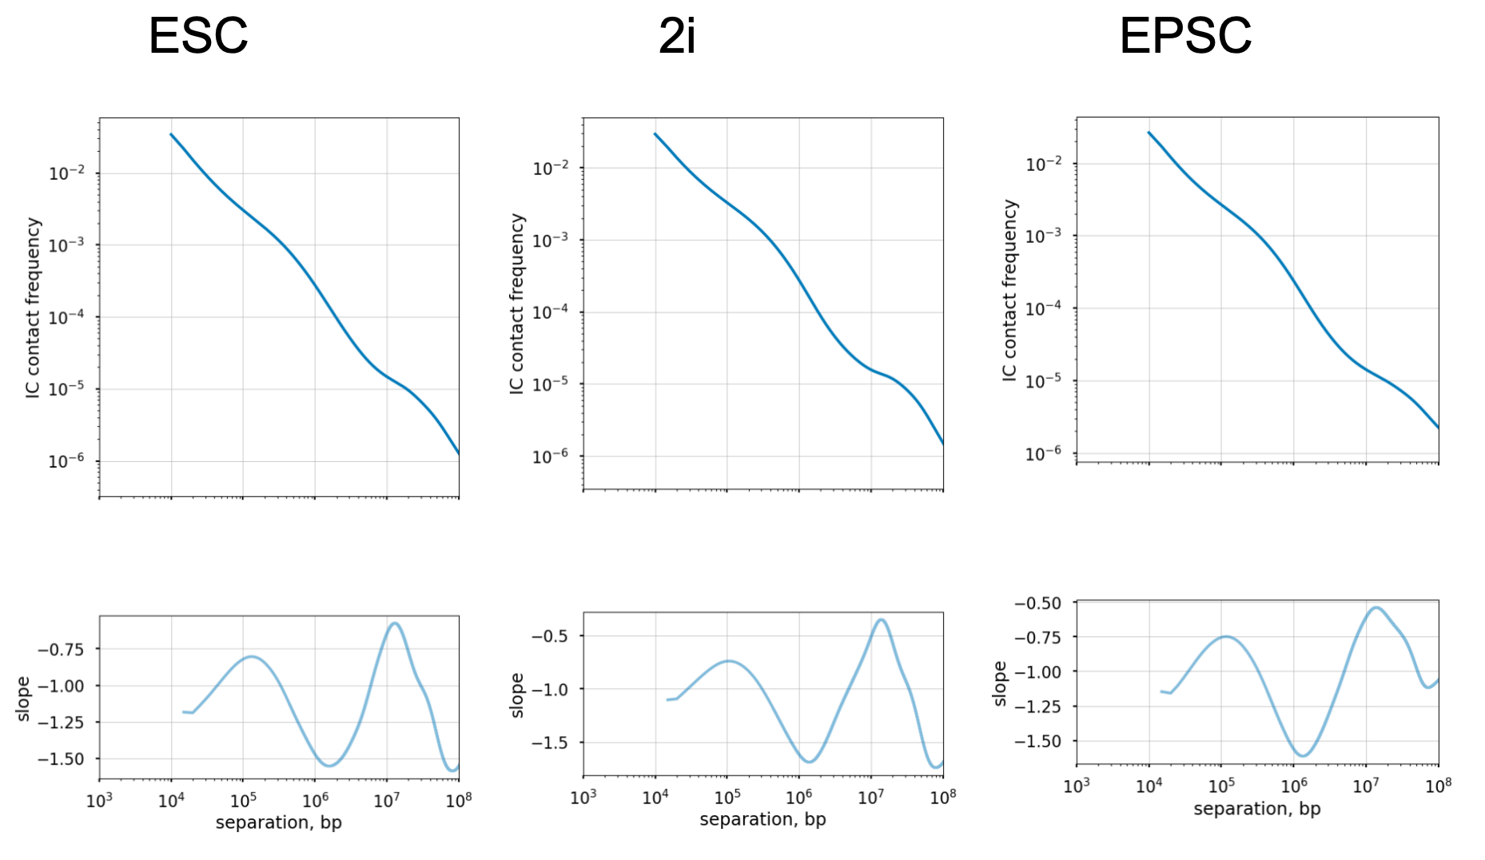

b. ChIP-seq / ATAC-seq: total number of reads, total number of aligned reads, global coverage comparison/correlation between samples and replicates (https://deeptools.readthedocs.io/en/develop/content/tools/plotCorrelation.html), total number of called peaks…

ATAC-seq
sample | UniqueMappedReads | UniqueMappingRatio | Multimapped reads | Multi mapping ratio | TotalReadsNumber
1_ES | 45,728,321 | 78.51% | 3,199,802 | 5.49% | 58,247,793
2_ES | 37,904,956 | 78.08% | 2,598,737 | 5.35% | 48,547,157
5_EPSC | 45,696,536 | 72.75% | 4,053,473 | 6.45% | 62,815,464
6_EPSC | 38,571,805 | 73.94% | 3,293,211 | 6.31% | 52,166,037

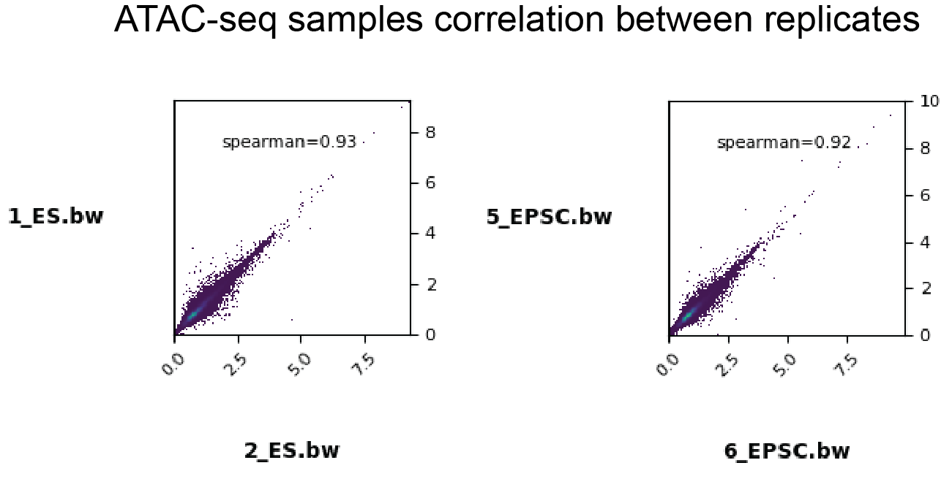
This showed that both replicates are highly correlated.

sample | UniqueMappedReads | UniqueMappingRatio | Multimapped reads | Multi mapping ratio | TotalReadsNumber
1dESC | 23187724 | 61.26% | 5630793 | 14.88% | 37852561
2dESC | 28383574 | 59.69% | 7455569 | 15.68% | 47548798
3dESC_DES | 20142929 | 61.26% | 5146411 | 15.65% | 32878678
3dESC_DMSO | 24644745 | 60.90% | 7199770 | 17.79% | 40468648
3dESC_siEsrrb | 22545134 | 61.76% | 5892295 | 16.14% | 36503391
3dESC_siNT | 24407534 | 58.40% | 7893137 | 18.89% | 41795751
3dESC | 28783859 | 60.76% | 7346942 | 15.51% | 47375280
EPSC_DES | 26735565 | 59.54% | 6496111 | 14.47% | 44907163
EPSC_DMSO | 23158511 | 58.81% | 5867580 | 14.90% | 39375706
EPSC_siEsrrb | 23557770 | 59.27% | 7813071 | 19.66% | 39749568
EPSC_siNT | 27114222 | 59.80% | 9307422 | 20.53% | 45343374
EPSC | 31238760 | 60.40% | 8854573 | 17.12% | 51723175

ChIP-seq
sample | UniqueMappedReads | UniqueMappingRatio | Multimapped reads | Multi mapping ratio | TotalReadsNumber
E14_H3K27Ac_12 | 41343025 | 73.72% | 1441402 | 2.57% | 56084202
E14_H3K27Ac_Input_13 | 30615755 | 65.83% | 1179166 | 2.54% | 46508616
EPSC_H3K27Ac_20 | 21664837 | 65.01% | 879993 | 2.64% | 33324637
EPSC_H3K27Ac_I_25 | 22574570 | 46.30% | 993510 | 2.04% | 48753312

c. RNA-seq: total number of reads, total number of aligned reads

EPSC and ESC
sample | UniqueMappedReads | UniqueMappingRatio | Multimapped reads | Multi mapping ratio | TotalReadsNumber
EP_12 | 28963952 | 88.48% | 2020450 | 6.17% | 32735798
EP_19 | 30057255 | 88.04% | 2096721 | 6.14% | 34139374
EP_7 | 34501326 | 88.59% | 2421321 | 6.22% | 38942877
ES_16 | 28810228 | 87.89% | 2115090 | 6.45% | 32781030
ES_2 | 35013235 | 87.80% | 2691114 | 6.75% | 39878573
ES_4 | 29961387 | 86.58% | 2308238 | 6.67% | 34607011
Esrrb knockdown in ESC and EPSC
sample | UniqueMappedReads | UniqueMappingRatio | Multimapped reads | Multi mapping ratio | TotalReadsNumber
shEV_E14_LS | 18917005 | 85.23% | 849776 | 3.83% | 22194094
Esrrb_sh1_E14_LS | 19746379 | 84.28% | 898676 | 3.84% | 23430027
Esrrb_sh2_E14_LS | 23355941 | 84.28% | 1058249 | 3.82% | 27712503
EPSC_Esrrb_sh1 | 30236896 | 74.84% | 2074177 | 5.13% | 40400830
EPSC_Esrrb_sh2 | 31927081 | 76.03% | 2198516 | 5.24% | 41992437
EPSC_shEV | 29385878 | 75.65% | 1898637 | 4.89% | 38845049
EPSC to ESC transition
sample | UniqueMappedReads | UniqueMappingRatio | Multimapped reads | Multi mapping ratio | TotalReadsNumber
EPSC_rep1 | 34414907 | 90.64% | 1374564 | 3.62% | 37969808
EPSC_rep2 | 28459007 | 90.63% | 1062548 | 3.38% | 31399687
ESC1d_rep1 | 34123286 | 91.14% | 1248831 | 3.34% | 37438891
ESC1d_rep2 | 30726655 | 90.49% | 1246457 | 3.67% | 33956763
ESC2d_rep1 | 36629044 | 91.09% | 1307040 | 3.25% | 40210251
ESC2d_rep2 | 35687152 | 89.62% | 1742022 | 4.37% | 39822370
ESC3d_rep1 | 42131651 | 89.81% | 1846856 | 3.94% | 46909521
ESC3d_rep2 | 26589494 | 89.62% | 1253347 | 4.22% | 29669628
Esrrb knockdown in EPSC and 3dESC (rep1)
sample | UniqueMappedReads | UniqueMappingRatio | Multimapped reads | Multi mapping ratio | TotalReadsNumber
EPSC_DES | 36612918 | 91.34% | 1288372 | 3.21% | 40082552
EPSC_DMSO | 30533877 | 91.31% | 1037720 | 3.10% | 33440685
EPSC_siEsrrb | 37417974 | 91.18% | 1312751 | 3.20% | 41036112
EPSC_siNT | 32645749 | 91.19% | 1163027 | 3.25% | 35801324
ESC3d_DES | 33066869 | 89.90% | 1289418 | 3.51% | 36783773
ESC3d_DMSO | 34969264 | 90.55% | 1421974 | 3.68% | 38617817
ESC3d_siNT | 31626212 | 90.61% | 1139634 | 3.27% | 34901900
ESC3d_siEsrrb | 26370295 | 89.54% | 980681 | 3.33% | 29452138
Esrrb knockdown in EPSC and 3dESC (rep2)
sample | UniqueMappedReads | UniqueMappingRatio | Multimapped reads | Multi mapping ratio | TotalReadsNumber
EPSC_DES | 58384352 | 67.93% | 1773600 | 2.06% | 85944092
EPSC_DMSO | 63844601 | 71.91% | 1928574 | 2.17% | 88781769
EPSC_siEsrrb | 62929626 | 74.17% | 1890212 | 2.23% | 84846724
EPSC_siNT | 61263160 | 74.58% | 1776654 | 2.16% | 82147808
ESC3d_DES | 50531956 | 65.70% | 1644487 | 2.14% | 76911677
ESC3d_DMSO | 53855850 | 67.43% | 1827668 | 2.29% | 79867162
ESC3d_siEsrrb | 59064009 | 73.14% | 1966417 | 2.43% | 80756583
ESC3d_siNT | 55704394 | 73.00% | 1755912 | 2.30% | 76309361

8. The authors should provide a scholarly review of the literature of genome folding during changes in cellular potency. The cell system employed here is used to model the potency states in the early embryo. It would therefore be appropriate to reference the Hi-C studies that have directly examined 3D genome folding in embryos, including Flyamer et al., 2017; Du et al., 2017; Ke et al., 2017; Gassler et al., 2017, Collombet et al., 2020, etc.
We have now included a comprehensive review in the introduction (paragraph 1).
“Development of highly sensitive HiC-methods allows probing into the 3D genome organization in early embryos. During mouse early embryonic development, 3D genome structuring into topologically associated domains (TADs) and loops gradually occur (Ke et al., 2017; Du et al., 2017). Inspection at the allelic level showed that this structuring was parental-specific and associated with repressive H3K27me3 histone mark prior to the 64-cell stage (Flyamer et al. 2017; Collombet et al., 2020). Formation of such structures is affected by DNA replication (Ke et al., 2017) and loop extrusion by cohesin (Gassler et al., 2017). Despite advances in highly sensitive and low-input methodologies, experimental perturbations are typically still hindered by the low cell number of early embryonic stages, and therefore the in-vitro cell models are useful.”

Minor comments:

1. The reference list is missing some papers referenced in the manuscript.
We have checked for missing references and added them into the list

2. Figure 1D: number of Alu and MIR sites is missing.
The number of Alu-derived enhancer loop anchors and MIR-derived enhancer loop anchors were 1254 and 175. This has now been added to the figure legend.

3. Figure 1F : axis label (range in kb), HiC matrices resolution in kb (to add in method), number of loops plotted in the average and values of the color scale (contact probability values instead of high/low would be better) are missing.
The HiC matrices were generated with 10kb resolution and axis range +/- 100kb. This detail has now been added into the Method section. The number of loops plotted is 192. We also noted that the title of former Fig1F should be the MIR-enhancer derived ESC-HiC loops, the same as in former Fig 1E. We apologize for the wrong title and have corrected accordingly. We have also revised the values of the color scale and add in the axis range as below.
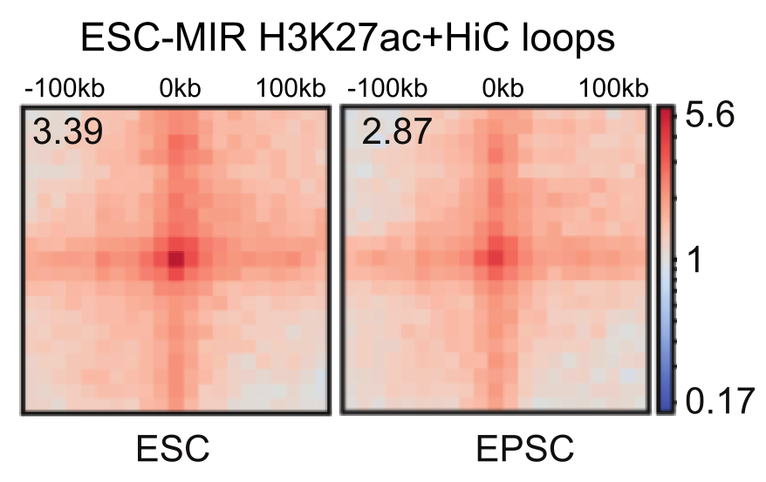

4. Figure 1I should be plotted with the same graphic that Figure 1C and Figure S1L as it shows the same type of analysis.
We have now replaced the graphic of former Figure 1I as such:
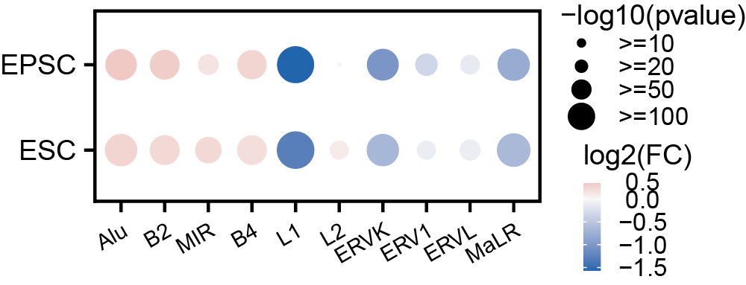

5. FigS1H: axis label (range in kb) is missing, values of the color scale (contact probability values instead of high/low would be better) are missing.
We have revised the values of the color scale and add in the axis range as below
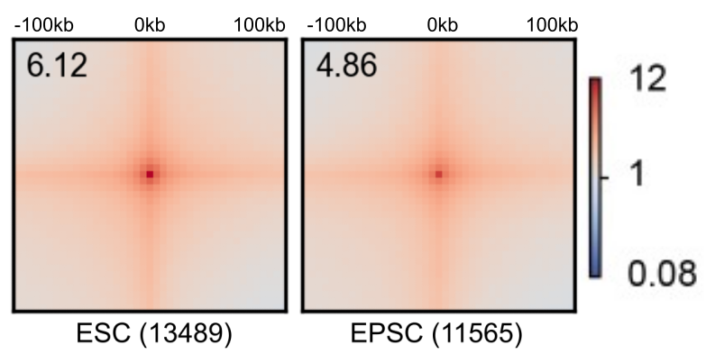

6. FigS1I: axis label (range in kb) is missing, number of loops plotted is missing
We have revised the values of the color scale and add in the axis range as below
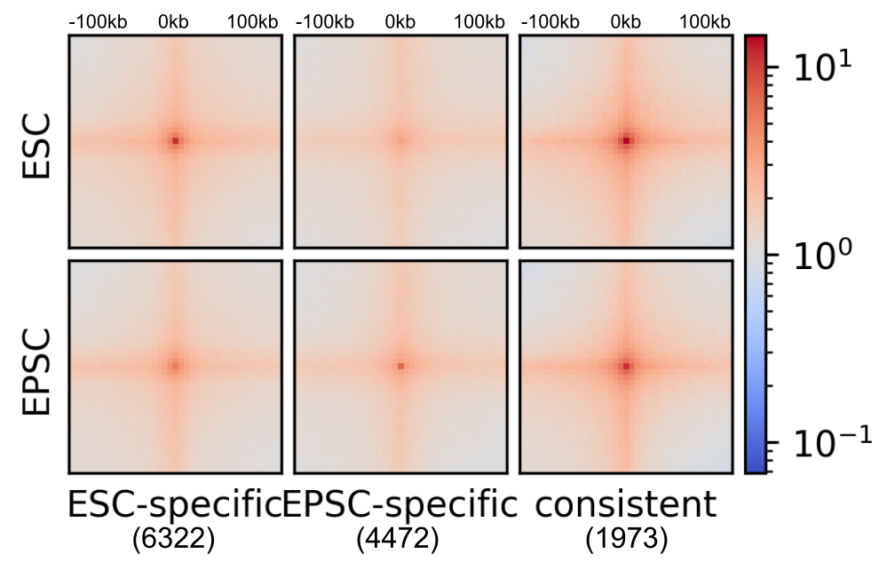

7. FigS1J: Please specify how genes and loops anchored are associated? what is the resolution of the analysis (ex: minimal distance between loop anchor and TSS?). What it the meaning of the three stars (***)? Please specify which statistical test and what are the test hypothesis. It would be interesting to split up-reg genes and down-reg genes and to compare with random or non-deregulated genes. An odd ratio testing if de-regulated genes are enriched or not in the ESC / EPSC specific loops compare to non-dereg genes would be more informative.
The genes enriched in the loop anchors were defined by the overlap between the gene regions (TSS to TES) and loop anchor regions (±5kb resolution).
Three stars (***) signifies a p-value < 0.001. Based on Fisher’s exact test, the upregulated genes in EPSC compared to ESC are significantly located at the EPSC-specific or consistent loops.

8. Line 195-196: Direct comparison of Fig2B and FigS2B: conclusion/interpretation based on p.values comparison only is a misused of statistical tests (https://www.ncbi.nlm.nih.gov/pmc/articles/PMC5187603/), especially if the groups are not the same size. Can the authors:
a. specify which test are used and which hypothesis are tested in the figure legends or in the method section. (same comment for 1G, S3A, S3B, S3D, S4E, S5A, S5C…)
For former Fig2B and S2B, the motif enrichment is performed using Homer, which used binomial test to compute the p-value.
For former Fig S3A and S3B, unpaired T-test was used to test for significance.
For former Fig S3D, S5A, and S5C, one-way ANOVA was used to test for significance.
For former Fig S4E, two-way ANOVA was used to test for significance.
These informations are now added in the figure legend.

b. Merged figure 2B and figure S2B in a unique p.value heatmap (with the same color scale, and same min/max values for merged 2B and S2B)
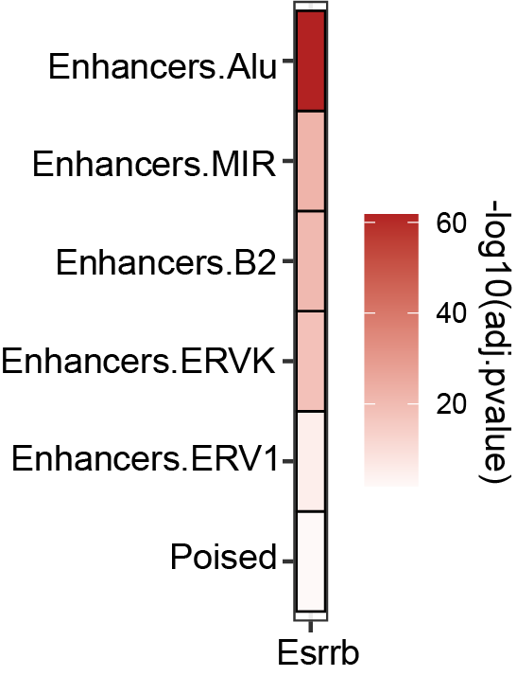
We have now merged former Fig 2B and S2B, and presented them as a single figure.

c. Plot a second heatmap with the statistical values of enrichment (odds ratio for a Fisher exact test or Pearson residuals for a Chi2 test) and base their Compare observation/conclusion on these statistical values.
A chi-Square test has been performed to evaluate whether there is a significant association between Esrrb motif appearance and different types of enhancers. The resulting p-value was <1e-16. The Pearson residuals has been shown as requested in the following plot. It indicates that the Esrrb motif contributes positively (means positive association) to the enhancer-MIR, -Alu, and -ERVK, but not to the poised enhancers (negative association).

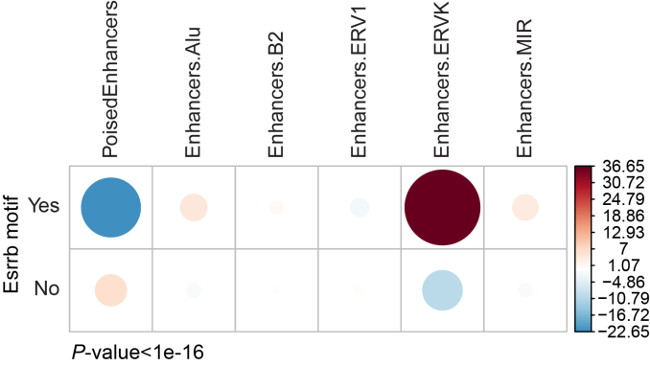

9. Figure 2C, line 196/197: The observation on the position of Esrrb motif is informative only if it is compared to other enriched motif (NR5a2, Myc, Max… from Fig2A).
The Esrrb (GRGACCTTGG) and Nr5a2 (TGACCTTGGG) motifs are similar and are both found in the conserved region of the MIR consensus sequence. On the other hand, the Nanog motif (TTAAATGAGT) is located in the variable region of the MIR consensus sequence. It's worth noting that many other TF motifs, such as Myc, Max, Ncoa3, Klf, and Mbd3a, are not found in the MIR consensus sequence.
What is the importance regarding the binding or the function that a motif is positioned at the center?
We have clarified the importance of this in the main text as such: “Moreover, motif density analysis on MIR-enhancer sequences showed that Esrrb motif is positioned at the center, specifically at the 86-97 bp of the MIR consensus sequence (Fig. 3C), which falls under the highly conserved 65 bp core-SINE (Gilbert et al. 1999) region (Fig. S3B). This indicated that Esrrb motif has been conserved through evolutionary selection, implying a biologically functional role.”
To emphasize the positioning of Esrrb within the conserved core-SINE region, we have added Figure S3B.
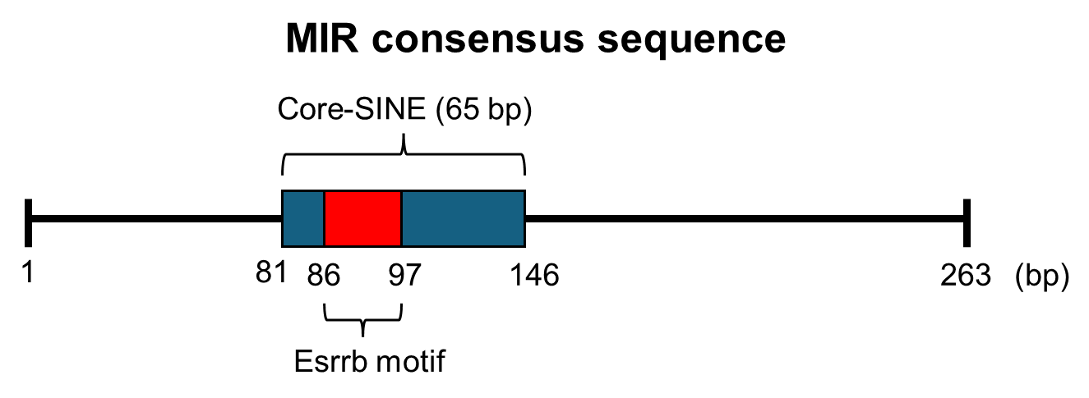
10. Figure 2D: same comment than figure 2B, see comments 7a and 7c. Also, -log10(p.value) is more common than -ln(p.value)
The genes enriched in the loop anchors were defined by the overlap between the gene regions (TSS to TES) and loop anchor regions (±5kb resolution).
We have now presented the plot in -log10(p.value) scale. The motif enrichment is performed using Homer, which used binomial test to compute the p-value. This information is now added to the figure legend.
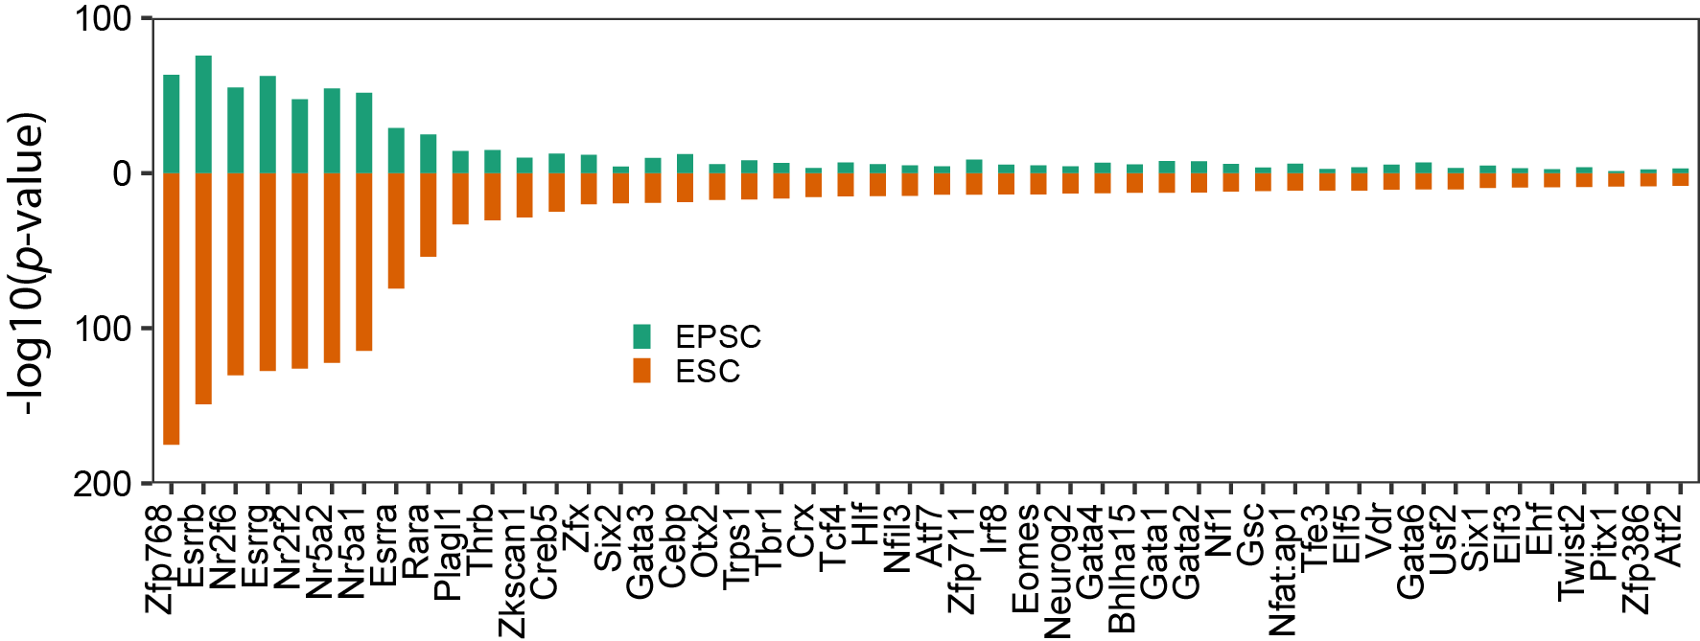

11. Figure 2H is not commented in the results section. Legend of the color intensity is missing. How labelled proteins were selected? Is it an arbitrary selection? This figure does not show any interpretable results. Please explain or remove.
We thank reviewer 1 for pointing this out. We have now rectified this oversight. The figure is now explained in the result section as such “Protein-protein interaction network showed a cluster of core pluripotency genes (Pou5f1, Sox2, Esrrb, Nr0b1) enriched on MIR in ESC state, but not in the differentiated state (Fig, 2H).” We have also included the legend of the color intensity, representing the abundance ratio of the differentially identified proteins.
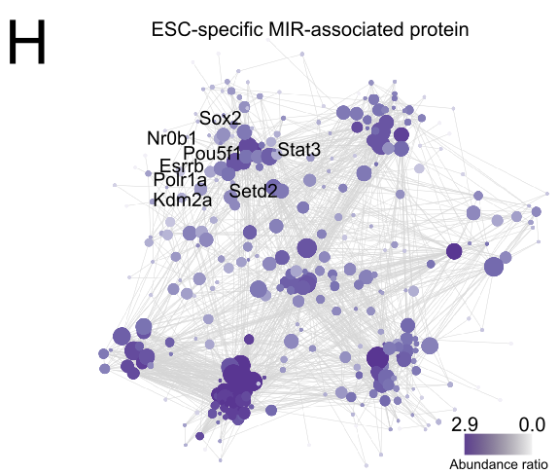

12. Figure 3D: number of sites in average is missing.
The number of ESC-MIR-enhancer and EPSC-MIR-enhancer is 1053 and 417. This information has now been added to the former Figure 3D.
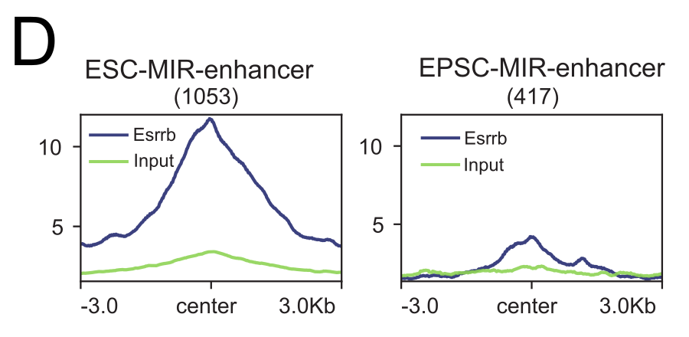

13. Figure 3R: Please define 'Esrrb-Yy1 co-bound MIR regulated genes'. What is this subset of genes? Are they defined with HiC loops? Proximity to binding sites? Please compare with 'control' genes, i.e. no associated with 'Esrrb-Yy1 co-bound MIR'.
Esrrb-Yy1 co-bound MIR-regulated genes were defined as those genes with H3K27ac loops with the Esrrb-Yy1 co-bound MIRs. According to the Fisher's exact test, the genes looping with Esrrb-Yy1 co-bound MIRs significantly overlapped with downregulated genes after Esrrb or Yy1 knockdown. On the other hand, the control genes, defined by the genes located around 100kb-200kb distance from the Esrrb-Yy1 bound MIRs, did not show significant enrichment in the differentially expressed genes.

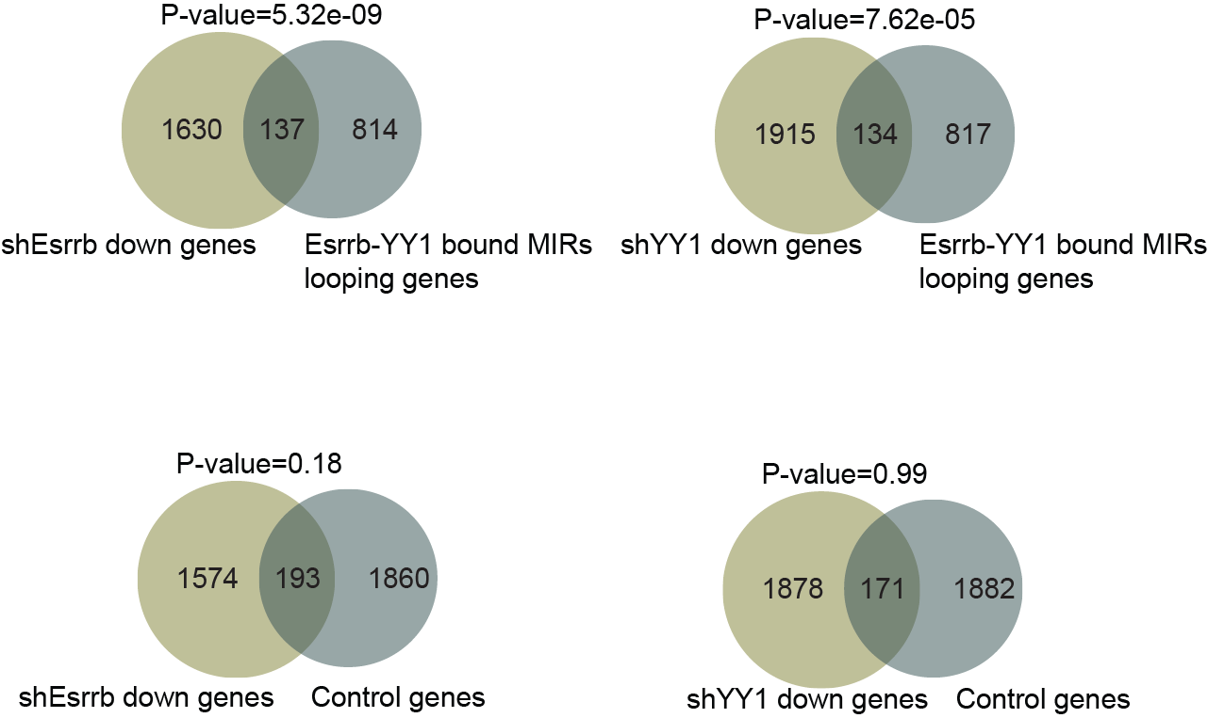

14. Figure 5B: color scale is missing. Number of genes in each cluster would help to appreciate this result. Can you comment on the difference between C3 and C7 genes? Both seem to show genes up-reg in absence of Esrrb, but only C3 genes are differentially expressed in the EPSC-ESC transition.
We have now added in the color scale. The color represents row-scaled FPKM values (Z-score).
The number of genes in each cluster are as such; C0 (819), C1 (825), C2 (870), C3 (400), C4 (647), C5 (262), C6 (772), C7 (985), C8 (1052). The list of genes is available as supplementary table.
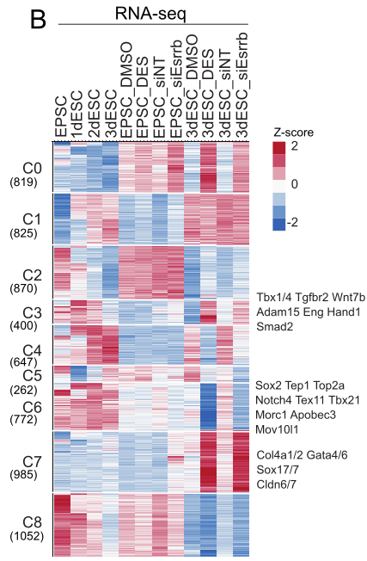
C3 genes were initially expressed in the EPSC, then gradually upregulated, then downregulated again during the transition to 3dESC. The genes represented by this cluster are associated with early embryonic development. C7 genes were not initially expressed, and were not upregulated by the transition, but upregulated more specifically in response to loss of Esrrb. This is the cluster with many PrE genes upregulated, in line with our observation that PrE-like cells appear more in the 3dESC with Esrrb knockdown or inhibition.

15. Figure 5E: are ESC genes in cluster C4 from Figure 5B?
Genes associated with pluripotency (ESC genes) are enriched in C1 instead. C1 represents cluster of genes that are completely absent in EPSC. Therefore, we think it makes sense to have ESC genes enriched in this cluster.
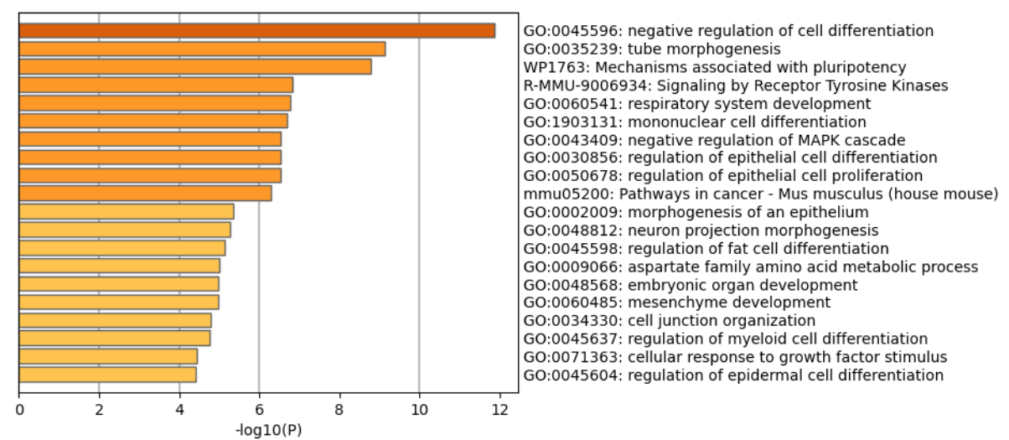
C4 consist of many metabolic process genes (amino acid, pyruvate, etc.). C4 represent genes that are strongly upregulated in 3dESC, a state of ESC with mixed PrE signature. Therefore the 3dESC represent a more differentiated state, where the cells are exiting naïve pluripotency. During the differentiation, metabolic changes occur (reviewed by Tyurin-Kuzmin et al., 2020, PMID: 32564731), which may be the reason we see upregulation of metabolic genes.
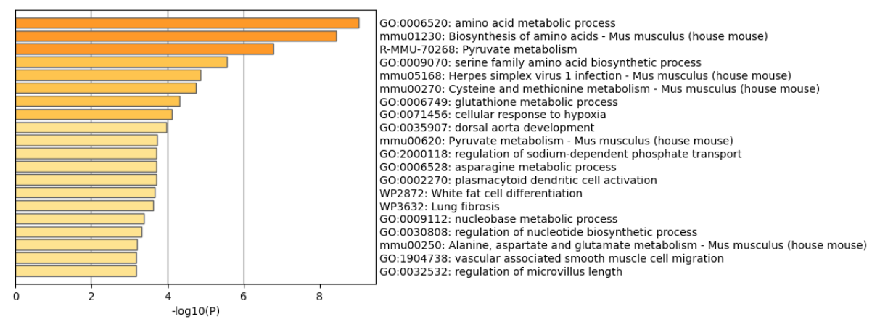

16. Line 327-329: 'It appears that during the transition from EPSC to ESC, PrE-associated genes were slightly upregulated': This does not correspond to the results shown in Fig5D or FigS5A.
Due to very high upregulation of PrE-associated genes in the DES and siEsrrb condition, the scale bar range becomes very broad. As such, the slight upregulation during EPSC to ESC was not noticeable. in the plot below, we removed the DES and siEsrrb datapoints, to show that there is indeed an upregulation trend.
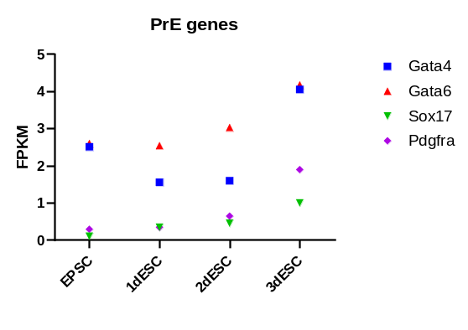
Additionally, we have performed qPCR to confirm the result obtained from RNAseq data. As expected, expression of Gata4, Gata6, Sox17 and Pdgfra showed an upregulation trend.
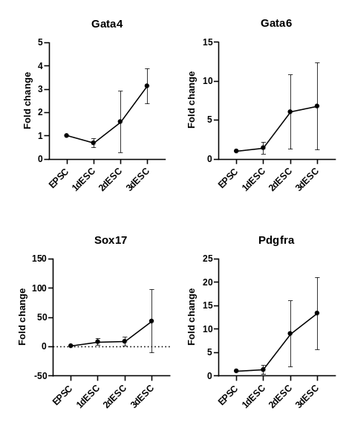
17. Figure 5 F: please specify the values on the color scale, it is confusing which yellow or blue is high/low values. Please specify in legend or in methods the bins size and range of the reads quantification.
The color represents the Z-scored ATAC-seq signal. Each row represents a peak, and the heatmap shows all the differential peaks. The brighter the color, the stronger the signal. We have now specified this in the legend.

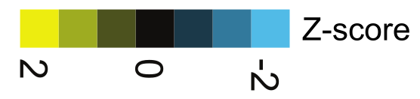

18. FigS5E: Same comment than Fig2B and Fig2D. Pvalue does not indicate whether an enrichment is strong or not. Please show the statistical value (odds ratio or Pearson residuals) when pvalue is significant, and show -log10(pvalue) as a supplementary information.
Figure S5E is meant to show the top significantly enriched motifs for each cluster. According to p-value ranking, the Gata motifs are the top enriched motifs in the Cluster 3.

19. Line 344-345. Venn diagram shows a potential colocalization, not a correlation. Please show a scatter plot log2FC of ATA-seq reads vs log2FC of expression if you want to test for a correlation. If you want to test for colocalization, please perform an enrichment test validating that promoter of up-regulated genes are enriched in promoter with increased accessibility compared to promoter of genes that are not up-regulated (by Chi2 or Fisher exact test), and show statistical value and pvalue.
This comment refers to former Fig 5H, Fig 5I, and Fig S5F. We have now rephrased the description of these figures as such: “Increased accessibility overlapped with upregulated genes (Fig. 5H), with a notable increase in accessibility observed for numerous PrE- and EMT-related genes. (Fig. 5I, Fig. S5F).”

Below is the Fisher exact test result. Now the p-value and odds ratio has been added.

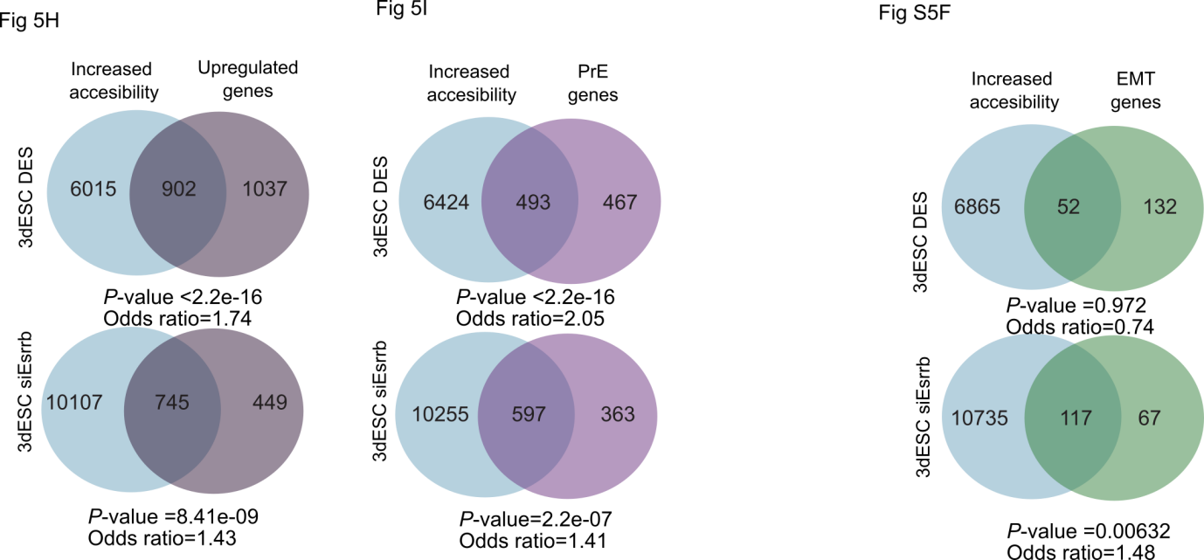

20. Line 373-374: Unclear whether Pou5f1 is really expressed in PrE-like cells, as it seems to be less expressed in d3ESC_DES cells compare to DMSO one, and even less expressed in the cluster 3 from Fig6A right panel, described as the cluster with strong PrE-like signature.
In Figure S6D and Figure 6B, we have shown the Pou5f1 expression in the PrE-like cells. It is correct that the 3dESC_DES cells has lower Pou5f1 expression compared to 3dESC_DMSO. We want to highlight that in contrast to 3dESC_DMSO, 3dESC_DES has a new cluster of PrE-like cells which express PrE genes.
Below is the expression of Pou5f1 in the E4.5 blastocyst. Pou5f1 is the marker of ICM/EPI lineage, and it has higher expression in EPI than PE/TE lineage. But it also has some weak expression in the PE lineage. As such, the expression of Pou5f1 (Oct4) in PE lineage is not something extraordinary.
We have now removed the sentence “These PrE-like cells co-expressed Pou5f1 (Oct4) and other PrE marker genes”.
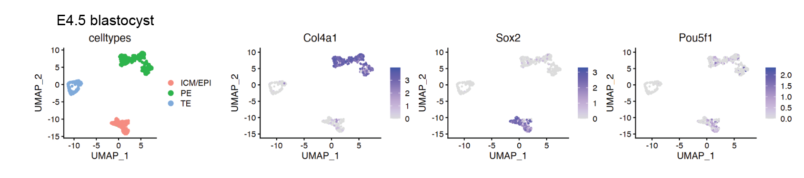

Reviewer #2: The authors provide valuable insights into the burgeoning field of transposable elements (TE) interactions with the 3D genome, an important but somehow understudied area in chromatin biology. They utilize a diverse set of omics techniques and technologies, including 3D genomics, epigenomics, CRISPR-based mass spectrometry, single-cell RNA sequencing, and blastoid culture, enriching the study's multi-dimensional analysis. The findings are potentially interesting to the broad genome research community. However, the manuscript suffers from thematic divergence. In the first section (Figures 1-3), Hi-C and H3K27 Hi-ChIP analyses identify SINE-MIR as the predominant TE at enhancer loop anchors, and the transcription factor Esrrb as crucial for maintaining these enhancer loops and preserving the naive state of embryonic stem cells (ESCs). In the subsequent section, the focus shifts to examining Esrrb's phenotypic roles during the transition from extended pluripotent stem cells (EPSCs) to ESCs. While the discovery that RLTR1B/-int and RMER16/-int can act as TE markers to differentiate primitive endoderm (PrE) from extraembryonic endoderm (XEN) is intriguing, the connection between these two sections remains tenuous. Although Esrrb is a common element in both parts, the initial emphasis of the second part appears to be on identifying Esrrb's targets, rather than elucidating its regulatory mechanisms in TE-enhancer interactions. Moreover, the precise function of Esrrb-MIR in PrE lineage determination is not clearly delineated. Although some experiments perturb Esrrb, the resultant cell fate alterations prevent a definitive conclusion about Esrrb's direct role in MIR and YY1 binding. More rigorous approaches are needed to reach to this interesting conclusion. Consequently, the attribution of loop changes to Esrrb loss is not compelling, given the confounding factor of altered cell identity. Despite very interesting topic, the current format is not ready for publication due to several concerns listed below.

We appreciate Reviewer 2’s feedback and are glad to hear that our manuscript may be of interest to the broader genome research community.
In response to feedback from 2/3 reviewers regarding thematic divergence and the disjointed nature of our manuscript, we decided to remove the former Figures 4-6. While we have addressed your questions related to those figures in this rebuttal letter, please note that they are no longer included in the manuscript.
Instead, we have strengthened the link between Esrrb regulation of MIR with CRISPR inhibition and knockout experiments.

1. Abstract: Clarify the terminology SINE, SINE-MIR, and Esrrb-MIR at their first mention to distinguish between them clearly and prevent confusion.
We have now clarified the terminology in the Abstract. We mentioned that MIR is a family of SINE, and removed the use of “SINE-MIR”. We replaced “Esrrb-MIR” with “Esrrb and MIR”, to avoid unnecessary terminology. We hope that these changes improves the clarity of the Abstract.

There are differences in MIR enrichment at enhancer loop anchors between EPSC and ESC. Fig1SL is informative, but the authors should also present the number of H3K27ac-positive MIRs in EPSC and ESC.
The number of H3K27ac-positive MIRs in EPSC and ESC is 417 and 1053, respectively. This information has now been added to the main text.

2. Given that loop number is sensitive to sequencing depth, the authors should clarify whether the sequencing depth is comparable across all libraries when comparing loop numbers in the main text.

We have now summarized the Hi-C library QC metrics in the table below:
Hi-C | ESC-rep1 | EPSC-rep1 | ESC-rep2 | EPSC-rep2
SequencedReads | 1,085,329,657 | 1,122,874,860 | 1,108,616,342 | 984,673,208
TotalContacts | 707,684,248 | 661,585,220 | 685,870,223 | 601,509,264
IntraChromosomalReads | 650,947,496 | 545,522,508 | 622,115,066 | 555,516,041
IntraLongRangeReads(>=20Kb) | 310,419,575 | 327,597,767 | 306,464,668 | 275,721,930
IntraShortRangeReads(<20Kb) | 340,527,921 | 217,924,741 | 315,650,398 | 279,794,111
InterChromosomalReads | 56,736,752 | 116,062,712 | 63,755,157 | 45,993,223
Total loop number | 13,489 | 11,565 | 12,839 | 14,948

The Hi-ChIP library QC metrics are summarized in the table below:
 | H3K27ac_HiChIP_shEV | H3K27ac_HiChIP_Esrrb_sh1 | H3K27ac_HiChIP_Esrrb_sh2
number of sequencing pairs | 361323036 | 354922876 | 315245318
number of uniquely mapped pairs (MAPQ >= 30) | 295230324 | 285434250 | 253828740
number of pairs after duplicate removal | 237613664 | 225625558 | 209187834
number of intrachromosomal pairs | 111199505 | 105038627 | 96576687
number of short-range intrachromosomal pairs | 54459817 | 52109691 | 44717330
number of long-range intrachromosomal pairs | 56739688 | 52928936 | 51859357
number of interchromosomal pairs | 7601725 | 7768515 | 8013002
Called Loops | 21645 | 12593 | 6430

The sequencing depth is comparable across all the libraries. The library QC metrics will be provided as Table S1.

3. Considering the authors' comprehensive study of how Esrrb modulates MIR, could they inhibit the activity of MIR by combining dCas9-KRAB with the gRNAs used in this study to investigate its role in PrE formation? Alternatively, the authors could discuss the potential results of such experiments.
We have performed CRISPRi of MIRs using the MIR sgRNAs (sg22 and sg23). We could detect reduced Esrrb binding at MIR, and also downregulation of Esrrb-MIR regulated genes, with the term “cell morphogenesis involved in differentiation” enriched (Fig. S4B, D, E). Therefore, it is possible the ESC with inhibited MIR is less prone to differentiation. However, such a possibility still needs to be confirmed with experimental data.

4. Esrrb and Yy1 are physically interacting and they co-bind a subset of MIR. Although knockdown of Esrrb leads to reduced Yy1 binding as shown in Fig 3p and 3q, the authors also need to make a scatter plot to show whether Esrrb and Yy1 are positively correlated at the co-bound MIR loci.
The scatter plot is shown below. The plot shows that Esrrb and Yy1 bindings are positively correlated at the co-bound MIR loci. We have now introduced this plot in the main Fig. 5H.
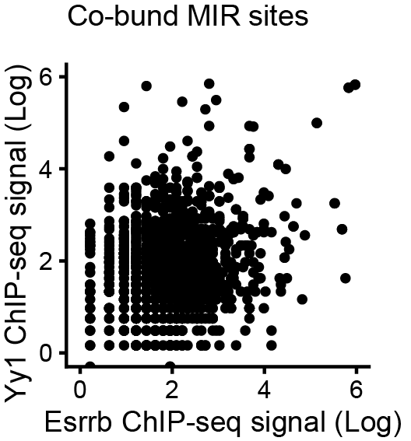

5. RLTR1B/-int and RMER16/-int are enriched in cluster 3. It would be more convincing if the authors could present a heatmap plot illustrating increased accessibility in the 3dESC_siEsrrb group.(like the plots in Fig 3P and 3N)
RLTR1B exhibits a clear increase in ATAC-seq signal in 3dESC_siEsrrb compared to siNT. While most RMER16 elements are not located at accessible peak regions, the signal on the RMER16 is not significantly changed.

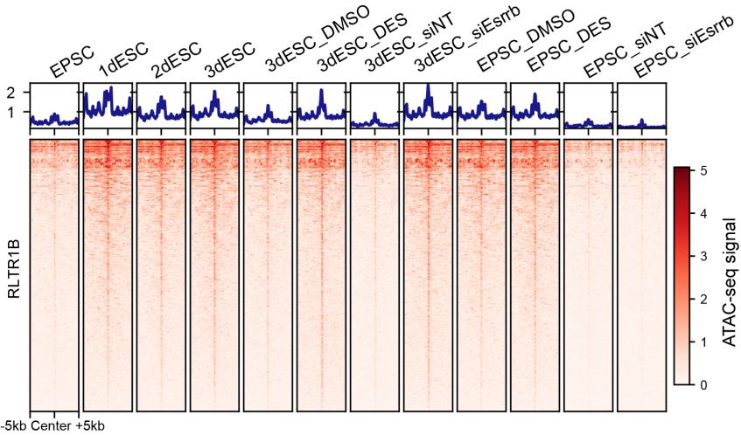

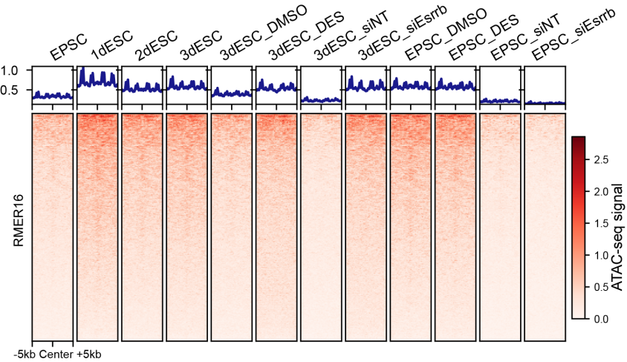

6. In Fig 3K, in addition to the enrichment score, could the authors also provide quantification of the expression of SE-associated genes after Esrrb knockdown?
The number of SE-associated genes in ESC were significantly found among the downregulated genes after Esrrb knockdown (p-value= 7.7e-5). Meanwhile, this trend was not found in EPSC (P-value=0.68).

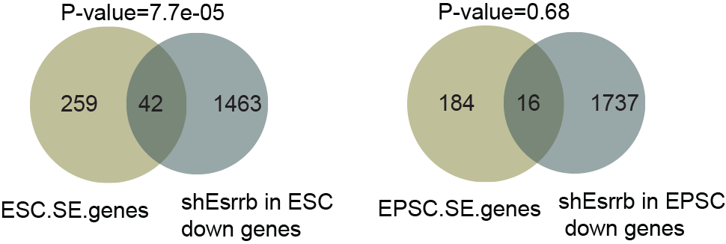

7.The P values should be calculated in Fig3R and FigS3i.
Fig S3i: P-value <2.2e-16 ; P-value <2.2e-16
This information has now been added to the figures

With regards to Fig 3R, we have changed the plot to the following venn diagram.

Esrrb-Yy1 co-bound MIR regulated genes were defined as those genes with H3K27ac loops with the Esrrb-Yy1 co-bound MIRs. According to the Fisher's exact test, the genes looping with Esrrb-YY1 bound MIRs significantly overlapped with downregulated genes after Esrrb or Yy1 knockdown. On the other hand, the control genes, defined by the genes located around 100kb-200kb distance from the Esrrb-Yy1 bound MIRs, did not show significant enrichment in the differentially expressed genes.

8.In Fig S1i, scores of each pileup Hi-C map should be shown in the plot.
We have now added in the scores of each pileup Hi-C map
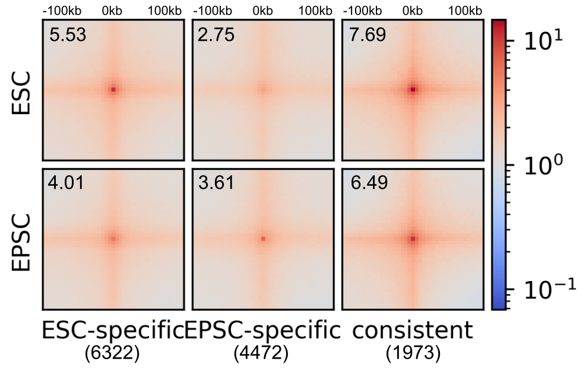

9.There is a typo in Fig4 I. It should be μM rather than uM.
We have now rectified the label using the correct symbol (μM rather than uM)
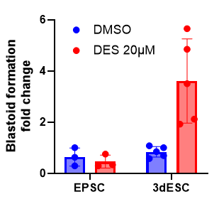
In Fig5C, is the LogP Log10?
We would like to clarify that LogP represents log10 of p-value. This has now been added to the figure legend for clarity.

10. Line 111: Define "expanded state" explicitly in the manuscript, or provide citations if it is a pre-existing concept.
The concept of expanded potential stem cell (EPSC) state is mentioned in the Introduction as such: “Expanded potential stem cells (EPSC), on the other hand, maintain extraembryonic potential in vitro (Yang et al. 2017a).” The citation here refers to the Liu Pentao’s lab EPSC. The EPSC used in our study is based on the media formulation used in that publication.

11. Line 108: Modify the claim that cell state identity is solely defined by the 3D genome. Suggest rephrasing to "distinct cell states exhibit specific 3D genome conformation."
We thank Reviewer 2 for the suggestion. We have now changed the phrasing accordingly.

12. Line 109: Soften the assertion regarding the understudied role of 3D genome conformation in cell state identity, noting that some studies (e.g., those on CTCF depletion) suggest pluripotency can be maintained despite changes in 3D genome structure.
We have now changed the phrasing to “The role of 3D genome conformation, especially at TEs, in establishing cell state identity has been less explored”. Aside from toning down the assertion, we note that the TE conformation, which is a central focus of this study, has been less explored.

13. Fig 1C: Alongside fold change, include p-values or FDR in the color representation to convey statistical significance clearly.
We have now revised the figure as requested. The significance test was carried by a combination of bionomial test and hypergeometric test, and then the combined p-values were corrected with false discovery rate (FDR). The FDR values were added into the figure legend.

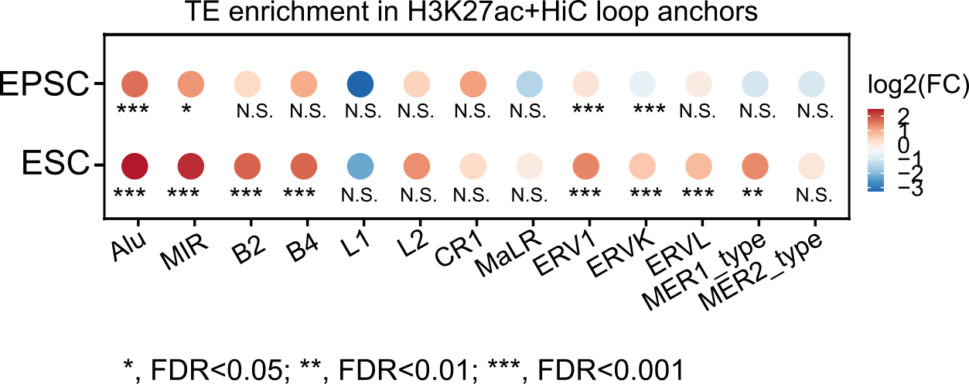

14. Line 167: Clarify what is meant by "less complex" regarding APA plots and ESC-specific loops. Discuss the context-dependent nature of these interactions rather than making broad comparisons of complexity or strength.
By “less complex”, we meant that there were less frequent interactions surrounding ESC-MIR loops in the EPSC state. This was evident from the less intense signal at the center of the APA plot. By “ESC MIR enhancer loops”, we meant a subset of HiC loops with H3K27ac ChIP signal and MIR at their anchors, that is only found at ESC state.
We have now rephrased the sentence as such, to improve clarity: “Furthermore, the interaction occurring at ESC-MIR-enhancer loop anchors was less frequent in EPSC, indicating diminished importance of these loops in the higher potency state”

15. Fig 1I: Provide the p-value for the enrichment observed.
The fold change value is calculated by comparing the loop counts of each transposable element (TE) family to the average loop counts of 100 times randomly sampled sequences with the same number of that TE family. The p-value is calculated using a one-sample t-test.

family | ESC (p-value) | EPSC (p-value)
Alu | 9.09E-147 | 5.23E-137
B2 | 2.27E-123 | 2.79E-121
MIR | 5.77E-94 | 2.56E-54
B4 | 8.15E-121 | 8.85E-118
L1 | 6.69E-203 | 1.39E-197
L2 | 3.12E-45 | 2.75E-06
ERVK | 1.12E-145 | 1.23E-140
ERV1 | 1.11E-44 | 1.02E-64
ERVL | 2.42E-56 | 6.30E-48
MaLR | 3.28E-159 | 1.39E-145

We have re-plotted Fig 1I as such, to include the p-value information.

16. Fig 1C and 1I: Address the apparent discrepancies in enrichment between different loop sets and clarify the criteria for loop selection in these analyses.
First, we want to identify any TE family that is specifically enriched in the chromatin loops located at the enhancer regions (enhancer-derived Hi-C loops). These TEs, highly or specifically enriched in the cell type, may be involved in the chromatin structure or chromatin looping. While there is some overlap between Hi-C loops and enhancer loops, Hi-C cannot capture the entire enhancer-promoter loops mediated by H3K27ac. Next, we conducted H3K27ac HiChIP, which could provide us with information about enhancer-promoter loops, offering more insight into TE involvement in the E-P loops. Furthermore, we want to explore whether these TEs involved in high-order chromatin structure or looping are cell-type-specific, which may be functional in the cell-state transition.
For SINE family (Alu, B2, MIR, B4) and L1, the analysis result of both approaches concurs. For ERV1, ERVK, ERVL, and MaLR, H3K27ac HiChIP analysis showed differences from the HiC approach. This suggests that inspecting loop using integrative approach may not be the best for these classes of TE.

17. Fig 1E and 1F: Specify the number of peaks and loops analyzed.
We have now specified the number of peaks and loops analyzed. In Fig 1E, the number of MIR-derived enhancer loop anchors is 175. In Fig1F, the number of MIR-derived enhancer Hi-C loops is 192.
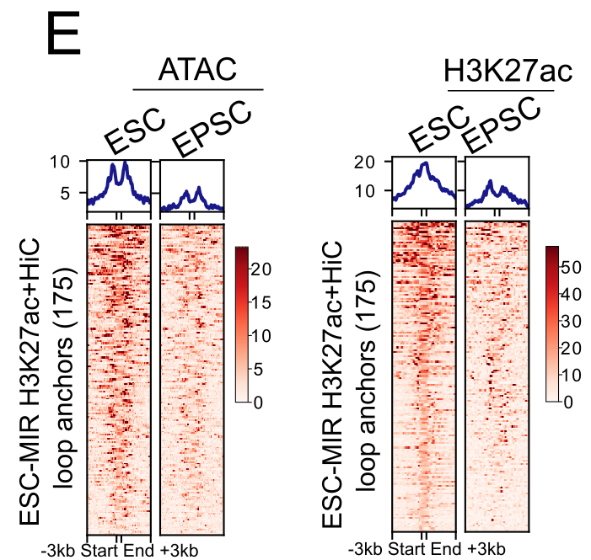
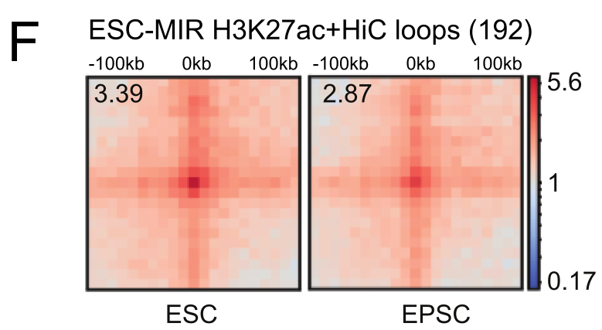

18. Line 190: Justify the choice of not using HiChIP loop anchors for certain analyses, and compare the results from HiC and HiChIP.
We want to know whether integrative analysis of HiC+H3K27ac ChIPseq and H3K27ac HiChiP are supporting one another. Both approaches result in Esrrb as top and 2nd rank enriched motifs, respectively. However, Klf family member (Klf5, Klf3, Klf4) motifs only appeared in the integrative HiC analysis result. Zfp768 motif only appeared when H3K27ac HiChIP analysis was used. These examples indicate that there are differences between the two approaches.
The fact that Esrrb motif was found to be enriched in both approaches gave us the confidence of the involvement of Esrrb on MIR.

19. Line 202: Please cite recent studies on TE-associated proteomics.
Line 202 is in the Results section, where we stated “Next, we utilized CAPTURE2.0 (Liu et al. 2020), a CRISPR-based affinity purification method, to profile the MIR-specific proteomics landscape in ESC (Fig. 2E).” To avoid confusions, we think that reference to other studies is better suited in the Introduction. We have now included recent studies on TE-associated proteomics in the Introduction section instead.

20. Line 214: Specify the lineage induced by retinoic acid (RA) and provide references.
Retinoic acid is a widely used compound to induce neural lineage differentiation from pluripotent stem cells (reviewed in Soprano et al., 2007, PMID: 17368312).
In our experiment, addition of RA for 48h decreased Oct4 gene expression and increased the expression of neural lineage marker Pax6 and Gbx2. We provide the qPCR data as shown below, and included this data in Fig S2M.
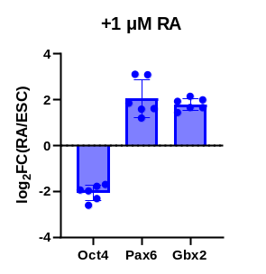

21. Fig 3F-3K: Address how to differentiate between changes due to Esrrb loss and those due to differentiation. Consider experiments that perturb Esrrb-MIR binding specifically, without affecting cell fate, to establish a direct regulatory mechanism. This is a major concern.
In our revised work, we have used CRISPRi to inhibit MIR (Fig. S4B-E). We showed the CRISPR inhibition of MIRs were associated with loss of Esrrb, downregulation of Esrrb-MIR regulated genes, which were associated with differentiation. Next, we showed that CRISPRi of Klf5-MIR result in reduced Esrrb binding (Figure 4J) and reduced Klf5 gene expression (Figure 4H), indicating a direct regulation of Klf5 gene by Esrrb through MIR.

22. Line 277: Similar to Fig 3F-3K, determine whether the loss of YY1 binding is directly due to Esrrb loss or an indirect effect of altered cell fate. This is also a major concern.
We thank reviewer 2 for raising this point. We understand the concern, as it is challenging to decouple the direct effect of factor loss or the indirect consequences of altered cell fate. As one of the core pluripotency factor, knockdown of Esrrb change cell fate into a differentiated state. Firstly, we confirmed that knockdown of Esrrb do not perturb Yy1 mRNA as well as protein expression. Thus, the loss of YY1 binding on MIR was not caused by reduced availability.
To decouple the effect of Esrrb loss from the indirect effect of altered cell fate, we decided to knockdown Esrrb in ESC supplemented with 2i molecules (1 µM PD0325901 and 3 µM CHIR99021), hereafter termed as 2iESC. Loss of Esrrb can be tolerated by ESC in this culture condition (Festuccia et al., 2021. PMID: 34397088). In the figure below, we show no overt phenotypic changes in 2iESC after shEsrrb.
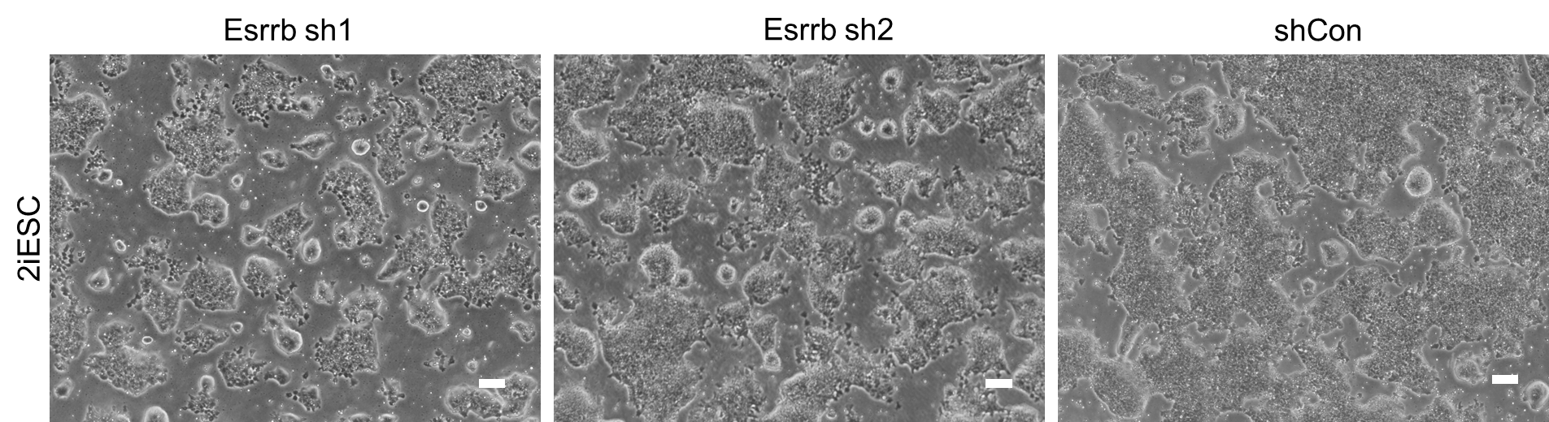

Additionally, we confirmed that KD of Esrrb reduced Oct4 and Nanog expression in ESC, but not in 2iESC. Meanwhile, Yy1 expression is not perturbed in both conditions.

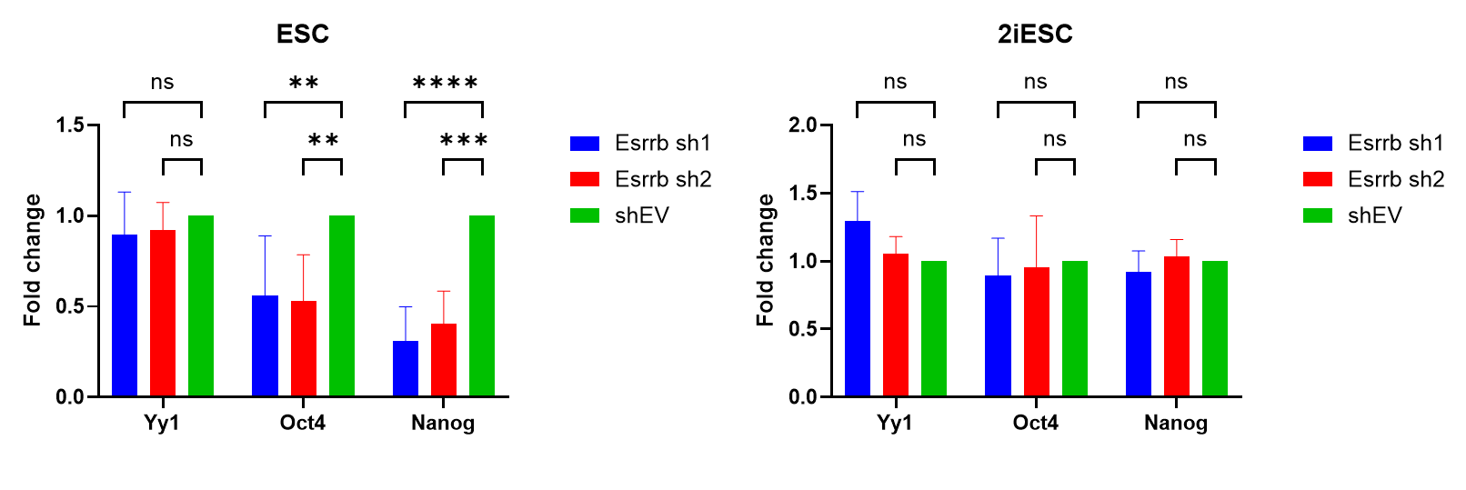
Thus, we performed Yy1 ChIP-seq on these cells. On Yy1-bound MIR, we saw reduced Yy1 binding after shEsrrb. This reduction was significant, based on Wilcoxon rank sum test. This result mirrors the trend seen in ESC. Therefore, we confirmed that Yy1 binding on MIR was lost upon Esrrb loss, even when cell fate is unaltered.
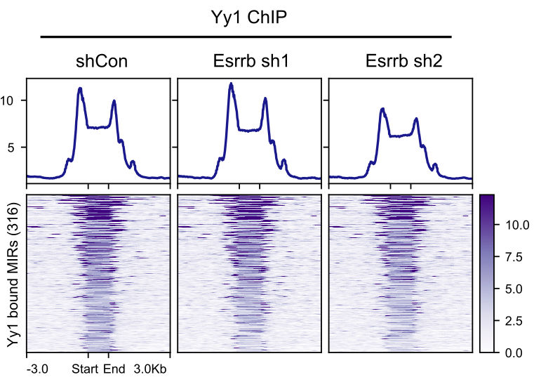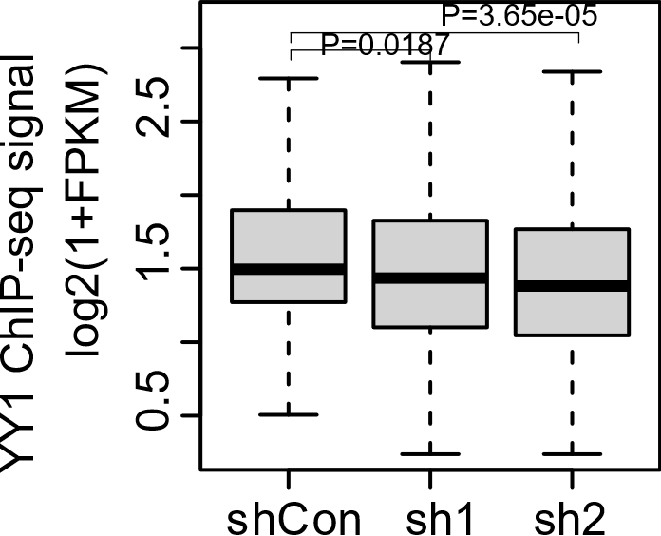

23. Given that loop number is sensitive to sequencing depth, the authors should clarify whether the sequencing depth is comparable across all libraries when comparing loop numbers in the main text.
We have now summarized the sequencing depth and other QC metrics of each library in Table S1. Please see our answer to your question 2. We have also stated in the main text that the sequencing depth is comparable across all libraries. We also provided Figure S1F, showing comparable sequencing read types between EPSC and ESC.
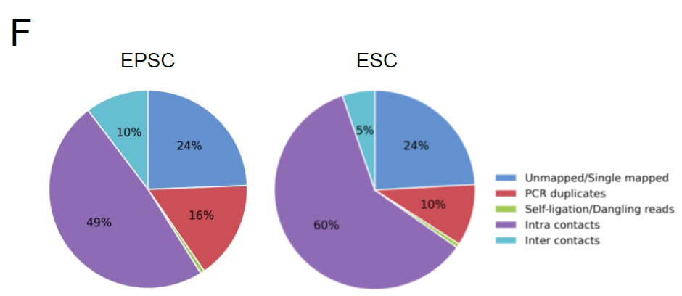

Reviewer #3: In this manuscript, Nadia Omega Cipta et al. utilize Hi-C and H3K27ac Hi-ChIP to systematically investigate the 3D genomic structure in EPSCs and naïve ESCs. They identified distinct 3D characteristics in the two cell states. Furthermore, they observed that MIR elements contribute to predicted enhancer loop topology and are frequently bound by the naïve pluripotent marker Esrrb. Following this, they found that Esrrb affects cell fate determination during the transition from the expanded-to-naïve state and reduced Esrrb leads to a higher proportion of primitive endoderm-like cells, resulting in increased blastoid formation.
Overall, the manuscript requires substantial improvement. Despite the impressive array of experiments and analyses performed, the manuscript failed to deliver a coherent and convincing biological story. The organization of the manuscript suffers from going into disjoint directions without providing incisive evidence for any of the major claims. Several conclusions, notably about MIR's functional role as enhancer, rest on weak or correlative patterns. Contradictory statements are also present throughout the text. Consequently, the manuscript needs in depth revisions before it can be published.

We would like to thank Reviewer 3 for the constructive criticism. We have improved our manuscript as described below.
In response to feedback from 2/3 reviewers regarding thematic divergence and the disjointed nature of our manuscript, we decided to remove the former Figures 4-6. While we have addressed your questions related to those figures in this rebuttal letter, please note that they are no longer included in the manuscript.
Instead, we have strengthened the link between Esrrb regulation of MIR with CRISPR inhibition and knockout experiments.

Major issues
1. The first and second halves of the manuscript are disjointed, lacking coherence. In the results section, from 'Cell state identity defined by 3D genome conformation' to 'Esrrb-Yy1 partnership regulates MIR', the authors study putative Esrrb-MIR enhancers in pluripotent stem cells (Figures 1-3). Then, they abruptly shift focus to study how the loss of Esrrb leads to biased cell fate determination without attempting to link this phenotype to changes in MIR enhancer activity (Figures 4-6). It appears that these two parts would be better separated into two manuscripts. As presented, the manuscript does not yield a significant advance in our understanding of the regulatory role of MIR elements in early embryonic development. The findings about Essrb also seem to represent an incremental advance in the pluripotency field and the biological relevance of the ESC/EPSC system for embryonic development is debatable (see point 3 below). As the authors themselves summarizes in
Discussion (line 502): "Esrrb is a known reprogramming factor (Feng et al., 2009), and the contribution of MIR in this process is still unknown." We are left wondering: where is the significant advance then?
First of all, we would like to take the opportunity to highlight our main findings. Firstly, we want to emphasize that the enrichment of Esrrb on MIR enhancer loop anchors, guided by motif analysis, and then validated by proteomics pulldown and ChIP-seq, is a novel finding of this study. Secondly, the interaction of Esrrb and Yy1 has not been reported before, despite existing Esrrb IP-MS (van den Berg et al. 2010, PMID: 20362541) and Yy1 IP-MS (Wang et al. 2018, PMID: 29503092) datasets. In our study, we confirmed this interaction by co-IP western blot and sequential ChIP. We also took interest of the rich Yy1 binding at TE sites, leading us to probe its binding dependency on Esrrb.
In the former Figure 4-6, we aim to recapitulate the increased MIR involvement that’s seen in EPSC versus ESC. Assuming that EPSC is the earlier state, a simple media switch to ESC should give us this effect. When checking the accessibility status of MIRs, we indeed saw increased ESC-MIR accessibility in the 3dESC compared to EPSC.
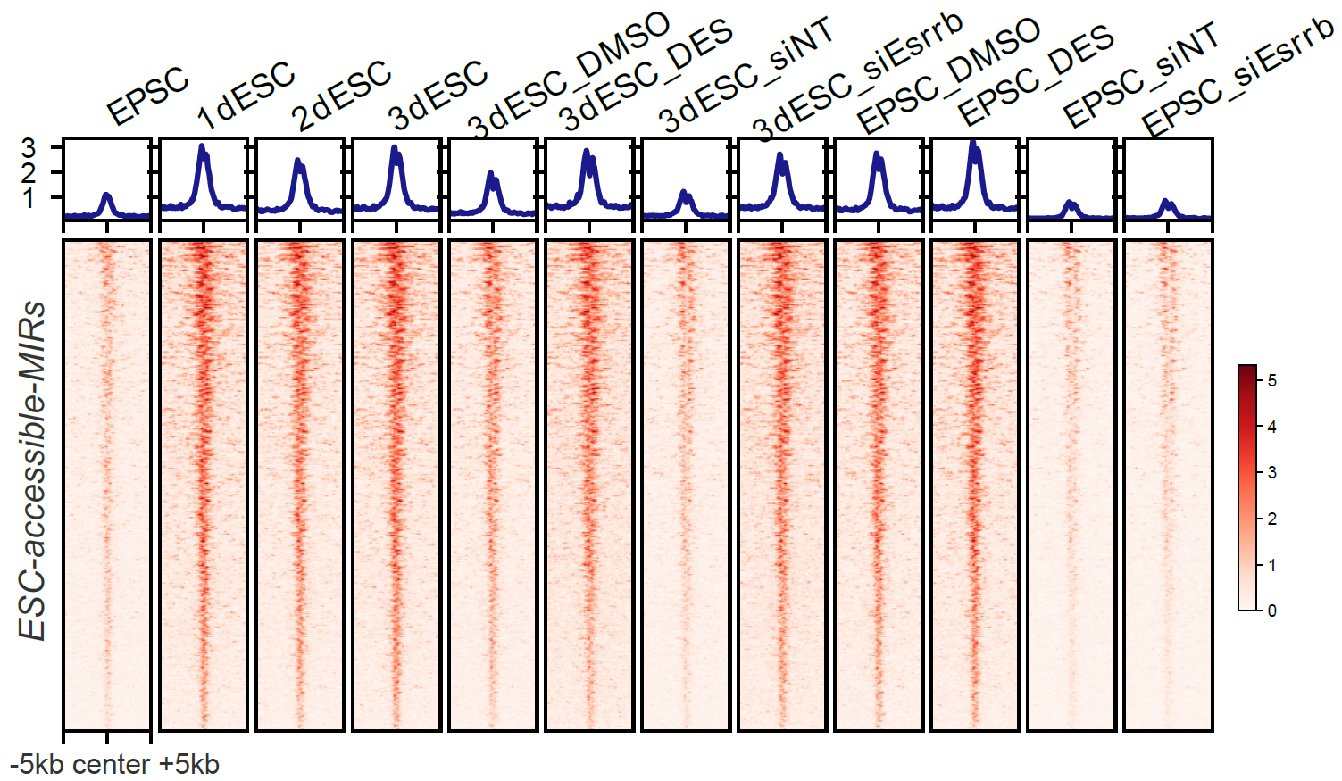
We found that the 3dESC is a mixed state with PrE-like signatures, inciting further exploration into its blastoid formation capabilities.
The discussion line 502 meant to convey that our study is limited to the role of Esrrb-regulated MIR in naïve potency state, but did not probe into the reprogramming process, which is also known to be regulated by Esrrb. Therefore, we imply that the Esrrb utilization of MIR during reprogramming is still unexplored.

2. The authors need to further elucidate the role of MIR elements in ESCs. That seems the most viable path towards publication. Currently, the data only support the possibility that MIR elements may act as enhancers in ESCs, but their function remains unclear. Figure 3I showed that MIR can interact with some genes. However, the resolution of Figure 3I is too low to be persuasive. Some interaction points are near, but not directly on, MIR elements. The authors should provide a zoomed-in view of these areas. Moreover, they should consider validating the enhancer role of MIR elements by knocking out the MIR locus adjacent to Klf5 or other genes. They could also use dCas9-KRAB to suppress MIR elements to probe their function in ESCs, particularly since they have already designed apparently effective sgRNAs targeting MIR elements. Without additional evidence supporting a functional impact of MIRs, the biological advances are limited. The data presented do not support the conclusion that "SINE MIR as functional ESC enhancers under direct control of Esrrb" (line 441), or that "Esrrb-MIR enhancer interaction is crucial for the formation of loops that build a network of enhancers and super-enhancers regulating pluripotency genes" (Abstract).
We have included works to elucidate the role of MIR elements in ESC. We used dCas9 to inhibit MIR, where we could see downregulation of genes involved in differentiation (Fig. S4B-D). To show a specific example, we targeted Klf5-MIR, and saw reduced Klf5 expression, indicating regulatory function (Fig. 4G-J). Additionally, knockout of Klf5-MIR resulted in reduced proliferation (Fig. 4K-O).

3. In some sections, the authors claim that EPSCs are "8-cell-like" or "totipotent." The authors repeatedly use this idea to emphasize the pluripotent state of EPSCs is higher than that of naïve ESCs and that the transition from EPSCs to naïve ESCs is representative of what happens in vivo during embryonic development. The authors should be more cautious about such claim given ongoing debates on the subject 1. Several studies have shown that EPSCs are transcriptionally dissimilar from the 8-cell embryo 2-4.
In-house analysis of our EPSC and Liu lab’s EPSC showed similarity to 8-cell stage (see our response to the next question). However, given the ongoing uncertainty, we have now toned down the assertion that the EPSC represents the 8-cell-like or totipotent-like state. We limit our statements to comparing 2 different potency states of in-vitro cell models.

In fact, the authors' own data do not support the similarity between EPSCs and 8 cell embryos. In Figure 6G, the authors compared EPSCs and ESCs with in vivo embryos, excluding 8-cell stage embryos. It is unclear whether this exclusion was intentional. This is because in the Fig 6G we want to point towards the emergent of PrE-like cells, instead of highlighting the 8-cell-like state of EPSC.

Although without 8 cell embryos, we could observe that EPSCs is very similar to the ground state of naïve ESCs which is similar to inner cell mass1. If authors truly believe that EPSCs is similar to 8 cell embryos, authors should add 8-cell embryos and new developed 2-cell like cells2-4 and morula-like cells5 in Figure 6G.
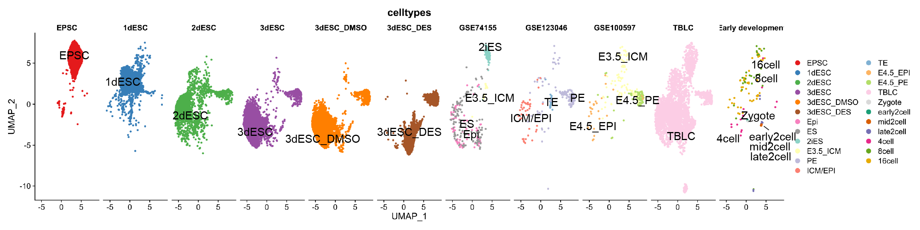
We have now added more datasets as requested. TBLC (2-cell like) data was obtained from GSE168728. Other early development stages data was obtained from GSE45719.
From this UMAP, we think EPSC shares more similarity with 8-cell and 16-cell stages than other development stages (2 cell, 4 cell, zygote).

It is especially contradictory when authors in this study used the H19 as the marker of EPSCs, which is expressed at blastocyst along DNA demethylation as an imprinted gene.
H19 is one of the marker used by Liu’s lab, when they first characterized their EPSC (Yang et al. 2017, PMID: 29019987). Therefore we used the same gene to characterize our EPSC.
We have now added Axin1 as another functional marker gene of EPSC. Overexpression of Axin1 in ESC is sufficient to induce EPSC characteristics (Yang et al. 2017). We have confirmed by Western blot that expression of Axin1 is increased in our EPSC.
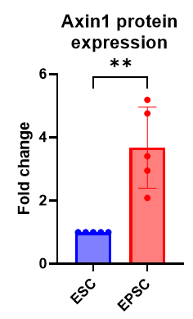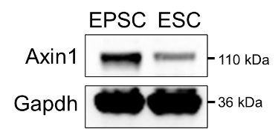

4. For the blastoid section, I believe there is no reliable blastoid formation protocol for EPSCs derived from Pentao Liu's lab, which the authors used in this study. Most groups used extended pluripotent stem (EPS) cells derived from Hongkui Deng's lab to generate the blastoids6-8. But even EPS-derived blastoids are defective9 . Therefore, the authors should approach the derivation of blastoids with caution. It is crucial that the blastoids are thoroughly characterized. As an example, the authors should perform immunostaining to identify three lineage markers in the blastoids.
We have adopted blastoid formation protocol by Nicolas Rivron’s group (Kagawa et al. 2020, PMID: 34856602) and verified that their protocol is also applicable for EPSC from Liu’s lab.
We have now provided the immunostaining result of the blastoid that we generated in Fig. S1E. We detected OCT4 at the ICM-like portion, and CDX2 at the trophectoderm-like layer. GATA6 was detected from the ICM-like and trophectoderm-like layer of the blastoid.
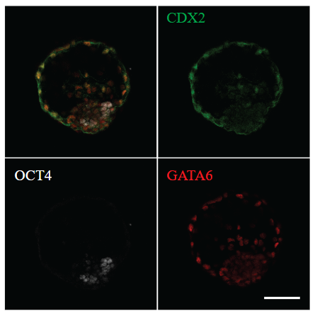

More specific issues:
1. Figure S1 is critical and should be included as a main figure.
We have now shifted plots from Figure S1 to the main Figure 1. As such, Figure 1 now describes the general 3D genome features of EPSC versus ESC. The plots with the focus on TE-enhancers (former Figure 1) are now in Figure 2.

2. The authors define 5 types of boundary changes (complex, merge, shifted, split, and strength change) but they do not rationalize and define these changes in the Results section (line 131-133; Figure S1E).
Changes in TAD boundaries can be classified into 5 types. Complex, split, and merge boundary changes are considered to be a major change, as they cause the most disruptive changes, while shifted and strength changes are considered to be minor changes (Cresswell et al., 2020, PMID: 32211023). We have now added this description and its reference to the main text.

3. In figure S1B, the switches from A compartments in ESCs to A compartments in EPSCs are labeled with two colors. What the meaning of these two colors?
The colors represent six different types of compartment transitions. Within compartment A, we distinguish between high-strength to low-strength (dark red, n=108) and low-strength to high-strength (light red, n=110) transitions. There are 44 transitions from compartment A-to-B, and 923 transitions from compartment B-to-A. Within compartment B, we distinguish between high-strength to low-strength (light green, n=26) and low-strength to high-strength (dark green, n=87). These details are now added to the figure legend.
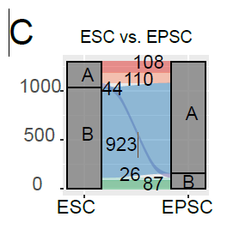

4. In Figure 1B, the authors attempt to use PCA to demonstrate that EPSCs share similarities with 8-cell embryos in terms of 3D genomic structure. However, the authors have not detailed how they accounted for batch effects or their methodology. It is surprising that EPSCs, which is not similar to 8-cell embryos at transcriptional level, would resemble 8-cell embryos in their 3D genomic structure. To further support this conclusion, the authors should also provide specific examples. It's also interesting to know whether EPSC specific TADs are also specific in 8 cell embryo.
According to Yang et al. 2017 (PMID: 29019987) and our analysis, EPSC significantly expresses 8-cell markers and EPSC has higher similarity with the 8-Cell stage than other early development stages. The PCA plot for Hi-C data is created using the contact matrix of total chromatin loops. The batch effect is eliminated using Combat based on the contact matrix. Additionally, the overall correlation of the EPSC Hi-C contact matrix is closer to the 8-Cell stage than to other early developmental stages. The Venn diagram shows the overlap between EPSC-specific TADs and 8-Cell stage TADs.

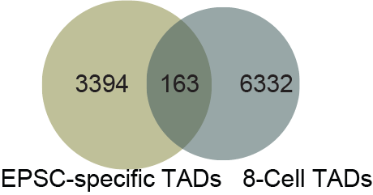

In the figure below, we show the TADs for EPSC-specific example genes Tbx21 and Eomes (10kb resolution).
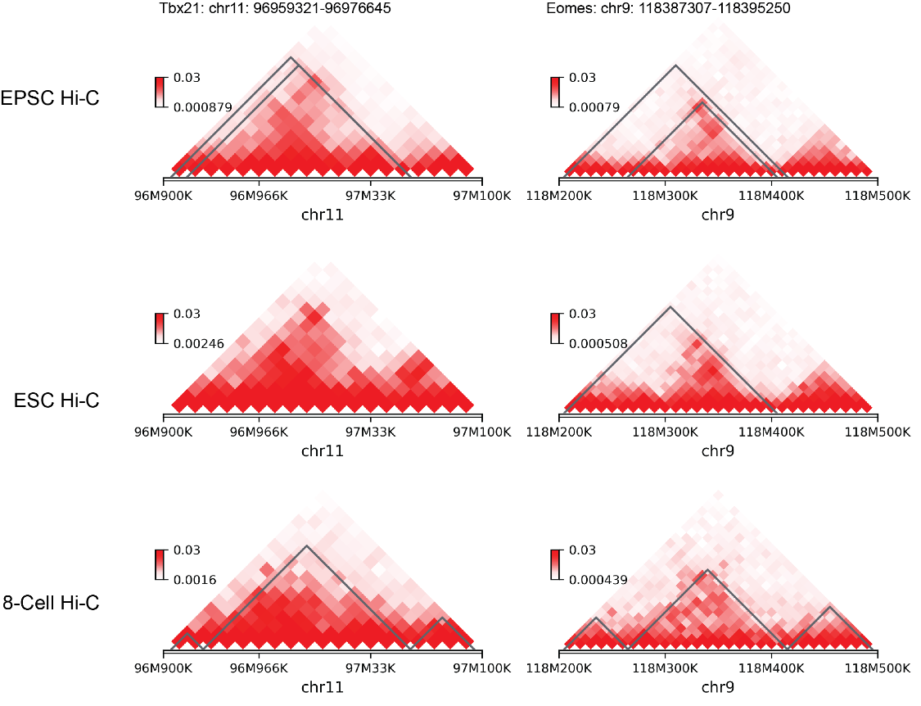

5. Line 161-162 and Figure 1C. Scale bar indicates up to log2fold change of 2; i.e. 4 fold enrichment which I would call a modest enrichment, not "highly enriched" as the authors states.
We have now toned down the statement from “highly enriched” to “up to 4-fold enriched”. This is to give the readers a more exact information.
Also enrichment analysis at the TE subfamily level would be desirable, especially for ERV groups which are composed of many diverse subfamilies with potentially very different regulatory activities. Similarly, SINE classes are composed of many subfamilies.
Here is the result of the TE level enrichment analysis. Out of a total of 340 TEs tested, those with less than 1000 occurrences in the genome and fewer than 10 overlaps with enhancer-loop anchors were filtered out. This left us with 45 TEs, which are shown in the plot below. We want to focus on the TE family level to observe any enrichment patterns, and zooming in to the TE subfamily level could lead to low overlap numbers.
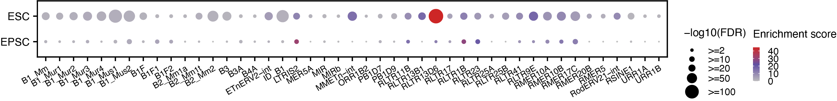

6. Fig 1D: I wonder whether the two plots have been inadvertently reversed? The bottom one shows the bimodal distribution expected for K27ac whereas the top one shows a unimodal peak I would expect for ATAC signal.
Typically, the H3K27ac and ATAC samples in their peak regions show a distribution as in the plot below.
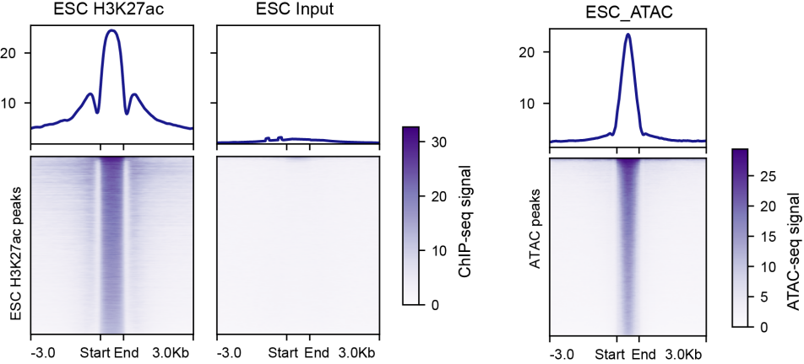
The reason MIR and Alu show different profiles than usual is because we consider the orientation of these elements. Some ATAC peaks are located at the start site, while some peaks are located at the end site of the TEs, leading to the bimodal distribution for the ATAC-seq signal.
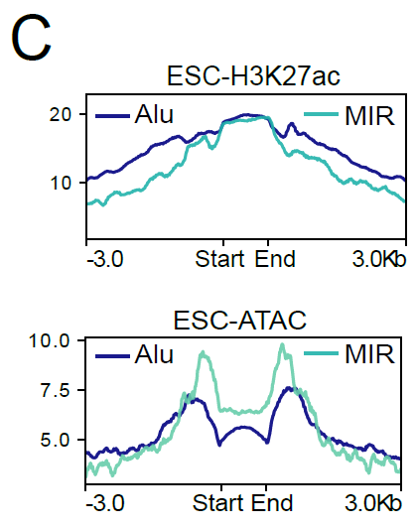

7. From Figures 1E to 1F, the authors illustrate that the ESC-MIR-enhancer loop anchors are less accessible and exhibit less complexity in EPSCs, which is expected since these anchors are specific to ESCs. So, what's the meaning of this panel? Figure2K also has the similar problem, in which authors only choose "ESC-MIR-enhancer loop anchors".
We apologize for the mistake in the labelling. These peaks are not chosen based on ESC-specific peaks; these are just the peaks in ESC. We want to show whether these TE-enriched ESC peaks maintained the same signal as common peaks after ESC became EPSC, or if they were lost after the cell state transition. EPSC is derived from ESC after the addition of small molecules, and we want to investigate whether the pre-existing ESC peaks, especially those mediated by TE, undergo any changes after they become EPSC.

Furthermore, signal differences between ESC and EPSC shown in Fig 1E and 1F are rather subtle and one wonders whether differences in data quality or sequencing depth could account for these?

Firstly, we determined that the quality of our EPSC and ESC Hi-C data were similar in terms of the unmapped reads, PCR duplicates, self-ligation, intra-contacts and inter-contacts
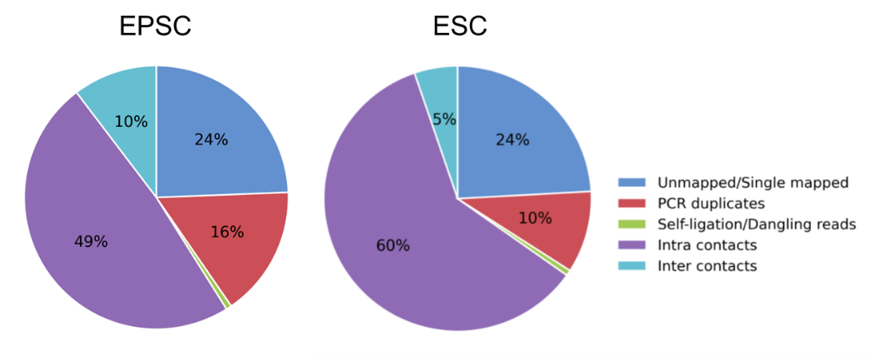

We have now summarized the data quality and sequencing depth in the table below:
Hi-C | ESC-rep1 | EPSC-rep1 | ESC-rep2 | EPSC-rep2
SequencedReads | 1,085,329,657 | 1,122,874,860 | 1,108,616,342 | 984,673,208
TotalContacts | 707,684,248 | 661,585,220 | 685,870,223 | 601,509,264
IntraChromosomalReads | 650,947,496 | 545,522,508 | 622,115,066 | 555,516,041
IntraLongRangeReads(>=20Kb) | 310,419,575 | 327,597,767 | 306,464,668 | 275,721,930
IntraShortRangeReads(<20Kb) | 340,527,921 | 217,924,741 | 315,650,398 | 279,794,111
InterChromosomalReads | 56,736,752 | 116,062,712 | 63,755,157 | 45,993,223
Total loop number | 13,489 | 11,565 | 12,839 | 14,948

The sequencing depth are comparable between the 2 cell states. Therefore, we think that the signal differences did not come from the differences in data quality.

8. Fig 1I: scale shows no positive log2fold change, which seems to imply no TE family is enriched, but some are depleted (e.g. L1). In addition, differences between ESC and EPSC look extremely subtle on this heatmap. Are these statistically significant?

We have re-plotted former Figure 1I as below. The red color means positive enrichment compared to random background. The fold change value is calculated by comparing the loop counts of each transposable element (TE) family to the average loop counts of 100 times randomly sampled sequences with the same number of that TE family. The p-value is calculated using a one-sample t-test.

family | ESC (p-value) | EPSC (p-value)
Alu | 9.09E-147 | 5.23E-137
B2 | 2.27E-123 | 2.79E-121
MIR | 5.77E-94 | 2.56E-54
B4 | 8.15E-121 | 8.85E-118
L1 | 6.69E-203 | 1.39E-197
L2 | 3.12E-45 | 2.75E-06
ERVK | 1.12E-145 | 1.23E-140
ERV1 | 1.11E-44 | 1.02E-64
ERVL | 2.42E-56 | 6.30E-48
MaLR | 3.28E-159 | 1.39E-145

9. Similarly, there are no statistics to test whether fold change shown in Fig 1J is significant for any of the SINE classes singled out. Overall, these data do not convincingly support the notion that "Alu/B1, B2, MIR, B4 are enriched in H3K27ac HihIP loop anchors" (line 178)
Any TE enriched in the ESC or EPSC H3K27ac HiChIP loops is based on the former Fig 1I results. The red color means the positive enrichment compared to random background. The fold change value is calculated by comparing the loop counts of each transposable element (TE) family to the average loop counts of 100 times randomly sampled sequences with the same number of that TE family. Red color means that the enrichment is higher than the random background. From the figure, we can see that SINE elements are the positively enriched transposable elements (TEs). That's why we only show the SINE class in former Figure 1J. Former Figure 1J shows the fold-change of the percentage of specific loops mediated by each TE family in ESCs compared to EPSCs.

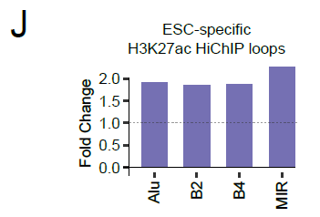

10. In Figure 2B and Figure S2B, the authors present the motif enrichment across transposable element (TE) families, yet they divide the information between two panels—one in the main text and the other in the supplementary figures. While I understand the authors' intention to highlight the Esrrb enrichment on MIRs, it must be noted that Esrrb's enrichment on Alu elements is more significant than that on MIRs. Separating these findings might mislead the readers.
We thank Reviewer 3 for raising this point. We have now merged Fig 2B and Fig S2B and presented them as a single figure.

11. In Figure 1H, the authors should use the adjusted p-value. My concern is that the term 'regulation of stem cell population maintenance' may not remain significant if the authors were to apply the adjusted p-value.
Below is the adjusted p-value as requested. After calculating for the adjusted p-value, we found the term ‘regulation of stem cell population maintenance’ to be not significant. When the input gene number is low and the enriched GO terms are also low, after correction of p-values, they easily become insignificant.

Description | -LogP | -Log(q-value)
Wnt signaling pathway and pluripotency | 2.165824756 | 0.237
chromatin organization | 2.656045907 | 0.414
regulation of stem cell population maintenance | 2.210557708 | 0.245
blastocyst formation | 2.167356544 | 0.237
regulation of MAPK cascade | 4.029876983 | 0.947

The following GO enrichment analysis was performed using PANTHER which use Fisher exact test and with False Discovery Rate (FDR) correction. The terms has been shown in the following table and bar plot.

GO biological process complete | (P-value) | (FDR)
primary metabolic process (GO:0044238) | 8.91E-11 | 3.41E-07
response to leukemia inhibitory factor (GO:1990823) | 6.40E-05 | 1.21E-02
maintenance of cell number (GO:0098727) | 7.78E-05 | 1.44E-02
nuclear receptor-mediated steroid hormone signaling pathway (GO:0030518) | 8.23E-05 | 1.48E-02
nucleosome disassembly (GO:0006337) | 1.32E-04 | 2.09E-02
nuclear receptor-mediated signaling pathway (GO:0141193) | 3.52E-04 | 4.22E-02

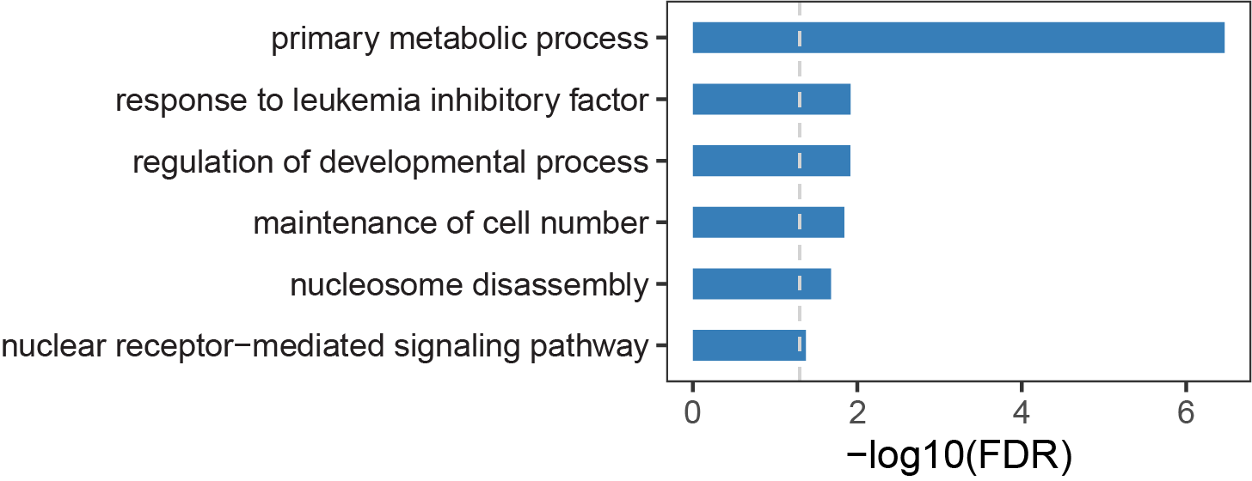

We have now replaced former Figure 1H with this new GO term plot. Despite this change, the enriched term ‘regulation of developmental process’ is particularly relevant to our study, due to the distinct developmental stages represented by ESC and EPSC.

12. The authors need to provide more details about the design of the two MIR sgRNA used for perform the CAPTURE experiments. It seems it would be very difficult to broadly target MIRs with any single sgRNA given their extensive sequence divergence to each other and to the MIR consensus sequence. How many MIRs were predicted to be targeted with those two sgRNAs and how many of those overlap with the predicted MIR enhancers?
We took the following steps to design the MIR sgRNAs.
- We obtained the MIR consensus sequence from the Dfam database (https://www.dfam.org/browse?name_accession=MIR). We selected the consensus sequences of all MIR subfamilies (MIR, MIRb, MIRc, and MIR3).
- We used the CRISPOR webtools to design sgRNA for each consensus sequence.
- We used Bowtie to identify MIR positions that the sgRNA targeted with a maximum of 3 mismatches.
- We selected the top sgRNAs which could target the most MIR sequences across all MIR subfamilies. The number of targeted MIRs are shown in the bar plot below. The chosen MIR sgRNA22 and sgRNA23 were marked with red and green stars, respectively.
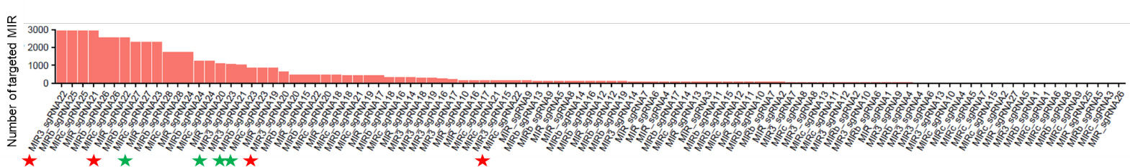
- We only took into account the MIR sequences which ended with NGG for each sgRNA.
- We used Bowtie to map the sgRNA to the mouse genome (mm9) to identify the regions potentially targeted by the sgRNA. We checked for off-target sequences and ensured that the selected sgRNAs aren’t targeting evolutionarily close transposon classes using a tool called Cas-offinder, using 2bp mismatches as a threshold. (http://www.rgenome.net/cas-offinder/)

We have now included these details in the Method section.

We have confirmed by Cas9 ChIP-seq that the sg22- and sg23-guided Cas9-peaks were enriched on MIR (n= 5775), as shown in Fig. S2K.
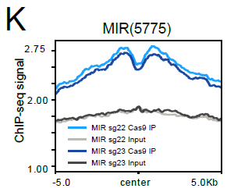

To check for specificity, we inspect whether Cas9-peaks were enriched on non-MIR sites. We used another TE (MERVL) as non-MIR sites control. As shown below, MIR-Cas9 ChIP signal is low or absent in MERVL sites.

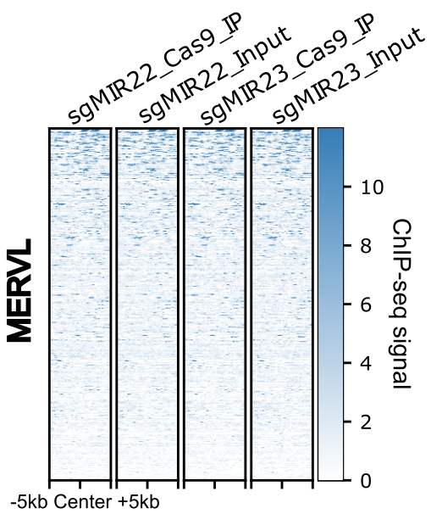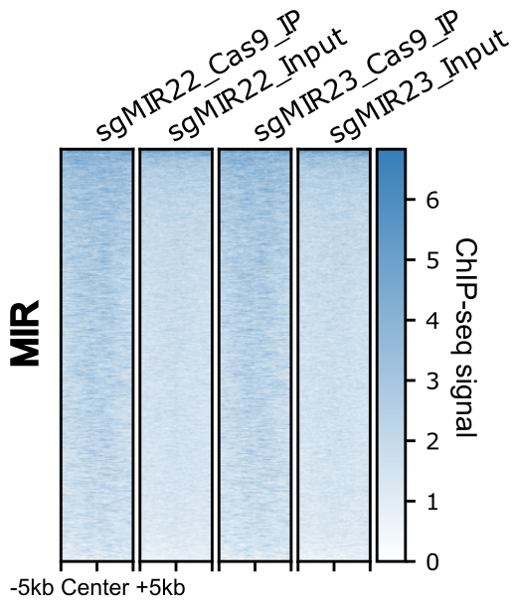

In the mouse genome, there are 121,596 annotated MIR sequences. As such, our sgRNAs were only targeting a minimal fraction (4.75%) of all MIR sequences. We attributed the low number of targetable MIRs to their extensive sequence divergence to each other and to the MIR consensus sequence, and also the short length of MIR. The PAM motif of dCas9 (NGG) must also be present for successful targeting, adding further constraints.

13. In Figure S3B, authors claimed that the protein level in 2 cell states are similar, but the it seems that there is no significance because there are only two biological replicates, which is not insufficient.
We have included more replicates. The western blot was performed 3 independent times. We concluded that the Esrrb protein expression is not significantly different between EPSC and ESC.
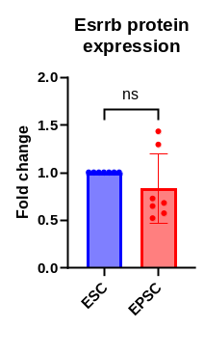

14. For siEsrrb experiment in EPSCs and ESCs in Figure 3E, authors need to show the RNA and protein levels of Esrrb in two cell states following siRNA treatment to confirm the down-regulation of Esrrb.
We have now included the changes in RNA and protein levels of Esrrb following siRNA knockdown.
Our RT-qPCR data showed a 50% reduction of Esrrb mRNA expression in EPSC, and 85% reduction in ESC.
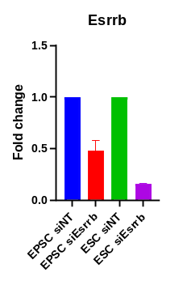
Our western blot result is in accordance with the RT-qPCR data. We detected a near complete reduction of Esrrb in the ESC, and a less dramatic reduction in the EPSC.

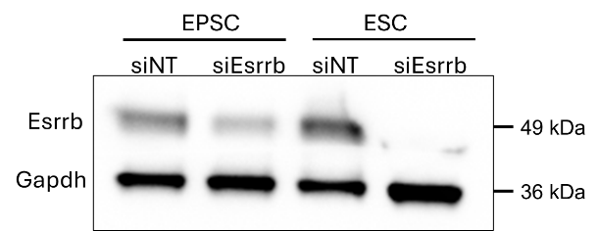

15. Some figures are missing content, such as Figures S3E, S3N, 4A, 4C, etc.
We have checked with editors that the figures we submitted are complete. We have also double-confirmed that the PDF we uploaded are not missing any figures.

16. Regarding to super-enhancers, do MIR elements overlap with them?
Around 40.63% of ESC-SEs have at least one MIR site, and approximately 13.65% of ESC-SEs have more than 2 MIR sites. For EPSC-SE, around 21.74% of SEs have at least one MIR site, and 10.63% of SEs have more than two MIR sites.

17. In Figure 5, RNA-seq lacks biological replicates.
We have now generated another replicate of the RNAseq data. We were able to observe similar trend between the 2 replicates, as seen from the PCA plot below.
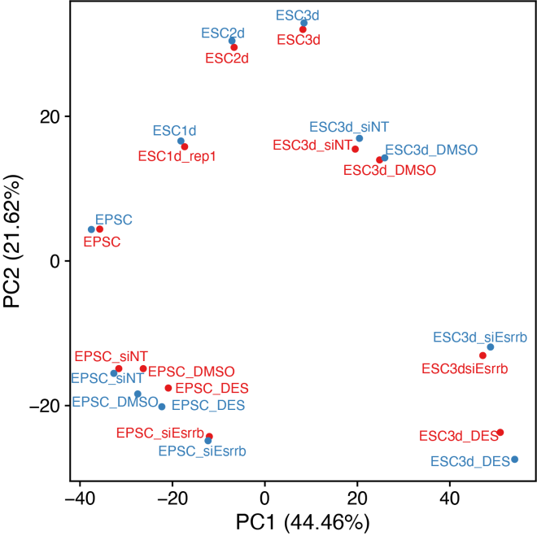

18. In Figure 5j, what's the meaning of "es"?
ES stands for Enrichment Score.

19. Figure 6G should be labelled as 6F, 6H as 6G, and 6I as 6H.
We apologize for the mistakes. We have now checked for the figure labelling to ensure correctness.

Reference:
1. Posfai, E. et al. Evaluating totipotency using criteria of increasing stringency. Nat Cell Biol 23, (2021).
2. Yang, M. et al. Chemical-induced chromatin remodeling reprograms mouse ESCs to totipotent-like stem cells. Cell Stem Cell 29, (2022).
3. Hu, Y. et al. Induction of mouse totipotent stem cells by a defined chemical cocktail. Nature 617, (2023).
4. Shen, H. et al. Mouse totipotent stem cells captured and maintained through spliceosomal repression. Cell 184, 2843-2859.e20 (2021).
5. Li, H. et al. In vitro generation of mouse morula-like cells. Dev Cell 58, 2510-2527.e7 (2023).
6. Fan, Y. et al. Generation of human blastocyst-like structures from pluripotent stem cells. Cell Discov 7, (2021).
7. Li, R. et al. Generation of Blastocyst-like Structures from Mouse Embryonic and Adult Cell Cultures. Cell 179, (2019).
8. Rivron, N. C. et al. Blastocyst-like structures generated solely from stem cells. Nature 557, (2018).
9. Liu, K. et al. Bilineage embryo-like structure from EPS cells can produce live mice with tetraploid trophectoderm. Protein Cell (2022) doi:10.1093/procel/pwac029.

Second round of review
Reviewer 1
The authors made a great effort to address each point with transparency and clarity. The new experiment utilizing the CRISPR approach to inhibit and deplete the distal MIR-enhancer is a strong addition, providing substantial support for the model. The enrichment analysis conducted to address my major comment 5 is particularly interesting. The presence of Mediator complex proteins Med1 and Med12 strongly advocates for their contribution to the enhancer-promoter loop. This could be further highlighted by inclusion in the supplementary figures.
I believe this study provides some insight into the still poorly understood role of genome architecture in gene expression regulation, as well as the role of transposable elements as guides to the stage-specific activation of enhancer-promoter (E-P) regulatory networks.
However, I still have concerns regarding the lost loops in the H3K27ac Hi-ChIP upon Esrrb depletion. These points require clarification before the manuscript can be considered ready for publication.
1. Resolution Details: What is the resolution of the Hi-ChIP matrices? Additionally, what are the resolution(s) used for loop calling? (These two pieces of information are missing from the Methods section.)
2. Loop Size Distribution: Could you provide the distribution of sizes (distance between anchors) for all detected loops in both the control and Esrrb KD conditions?
3. Loop Examples: Please show some examples of the <10kb distant loops, which are indicated as highly frequent in the attached frequency distribution plot from your response to the reviewers. A genome browser view displaying the HiChIP matrices with highlighted loops would clarify the nature of those loops.
CRISPRi and KO of Klf5-MIR:
• Do you observe an enrichment of Esrrb and YY1 binding at the promoters of deregulated genes in both shEsrrb and shYY1 conditions? The same question applies to promoters of Esrrb-YY1 bound MIRs looping genes as defined in Figure 5I.
Figure Corrections and Clarifications:
• Figure S1B and C: There is a discrepancy between the figure label (Axin2) and the figure legend (Axin1).
• Figure 1 F and G: please use same color code.
• Figure 4E: The legend is unclear. Could you specify whether the graph represents the average number of H3K27ac loops per super-enhancer?
• Figure 5I: This figure lacks a text legend. I would appreciate seeing the overlap of down-regulated genes in both Esrrb KD and YY1 KD. Moreover, a Venn diagram showing the overlap between up-regulated genes and Esrrb-YY1 bound MIRs looping genes would be more informative.
As a general comment on the figures, the manuscript would benefit from relocating some figures from the main to the supplementary figures or splitting certain figures (e.g., Figure 3, currently spanning from A to P). From a purely aesthetics standpoint, reducing the number of figures, aligning them consistently, and using a uniform font size or color code for legends would enhance the overall readability and visual appeal of the manuscript.

Reviewer 3
Following the revisions, this manuscript has shown significant improvement. The removal of the later sections has made the manuscript structure more concise and focused. The authors have demonstrated that MIR elements are essential for specific genes involved in differentiation and embryonic development. Additionally, they provide strong experimental evidence that the Esrrb-MIR element near KLF5 is crucial for the proliferation of human embryonic pluripotent cells.
Overall, this revised version is suitable for publication in Genome Biology. However, I have a few remaining questions and suggestions for clarification:
1. In line 160, why do the authors associate Axin2 downregulation with a characteristic of EPSCs? What reference supports this claim?
2. In line 179, could the authors perform a GO analysis of A-to-B and B-to-A compartment genes to clarify their respective functions?
3. In Figure 2C, please include H3K27ac and ATAC signals in EPSCs for direct comparison.
4. In line 227, the authors should explicitly explain why they chose to study MIR rather than Alu.
5. In Figure 2I, is the title correct?
6. In Figure 3B, Esrrb appears to be more significantly enriched at Alu. Do MIR and Alu elements share the same Esrrb binding motif? If so, the authors might reconsider emphasizing Esrrb binding exclusively on MIR, as Esrrb-Alu could also play a functional role.
7. In line 352, does MIR-CRISPRi repress KLF5, Klf5, Trim25, and Esrrb?
8. In line 373, it’s intriguing that Klf5-MIR has a phenotype in mESCs, whereas MIR-dCas9 does not. Could this be because MIR-dCas9 cannot target KLF5-MIR? Further explanation on this point would be appreciated.

Authors Response
Point-by-point responses to the reviewers’ comments:

Reviewer reports:

Reviewer #1: The authors made a great effort to address each point with transparency and clarity. The new experiment utilizing the CRISPR approach to inhibit and deplete the distal MIR-enhancer is a strong addition, providing substantial support for the model. The enrichment analysis conducted to address my major comment 5 is particularly interesting. The presence of Mediator complex proteins Med1 and Med12 strongly advocates for their contribution to the enhancer-promoter loop. This could be further highlighted by inclusion in the supplementary figures.
We thank Reviewer 1 for acknowledging our efforts, and are grateful for the suggestions, which have helped improve our manuscript.
We have now included the said enrichment analysis into the supplementary figure (Figure S7) and highlighted the exclusion of CTCF and Rad21, and the involvement of Med1 and Med12 in the Esrrb-mediated H3K27ac loop anchors.
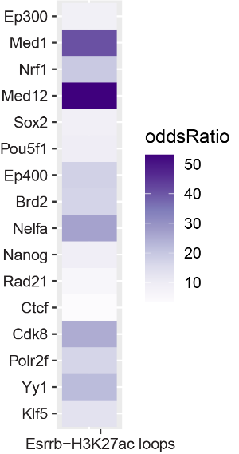
I believe this study provides some insight into the still poorly understood role of genome architecture in gene expression regulation, as well as the role of transposable elements as guides to the stage-specific activation of enhancer-promoter (E-P) regulatory networks.
However, I still have concerns regarding the lost loops in the H3K27ac Hi-ChIP upon Esrrb depletion. These points require clarification before the manuscript can be considered ready for publication.
We thank Reviewer 1 for acknowledging the potential contribution of our study to the field. We have now addressed the remaining concerns below.
1. Resolution Details: What is the resolution of the Hi-ChIP matrices? Additionally, what are the resolution(s) used for loop calling? (These two pieces of information are missing from the Methods section.)
The resolution of the HiChIP matrices is 10kb. The resolution used for HiChIP loop calling is 5kb. We have now added this information in the Methods section.
2. Loop Size Distribution: Could you provide the distribution of sizes (distance between anchors) for all detected loops in both the control and Esrrb KD conditions?
Below we provide the distribution of sizes for all detected loops in both the control and Esrrb KD conditions. Both control and Esrrb KD conditions display similar loop size distributions.
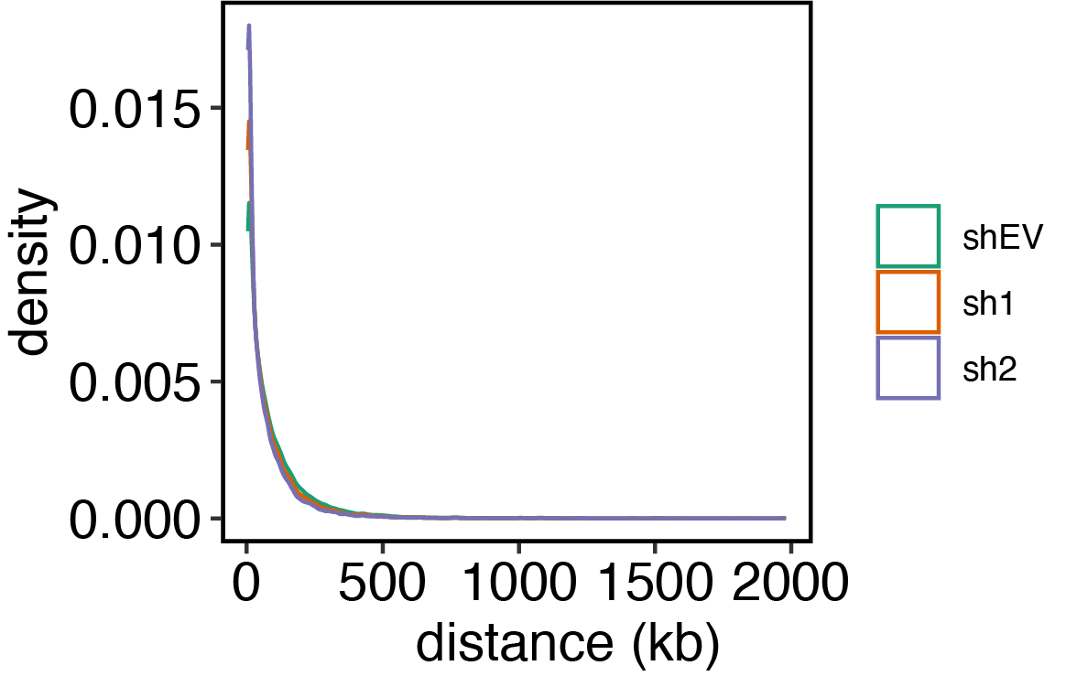
3. Loop Examples: Please show some examples of the <10kb distant loops, which are indicated as highly frequent in the attached frequency distribution plot from your response to the reviewers. A genome browser view displaying the HiChIP matrices with highlighted loops would clarify the nature of those loops.
Below are 3 examples of the <10kb distant loops, which were lost after Esrrb knockdown. The loop anchor of the loops were involving MIR. After Esrrb knockdown, the expression of Ybx2, Igsf21, and Adap2 were downregulated by 51.3%, 62.9% and 43%, respectively.
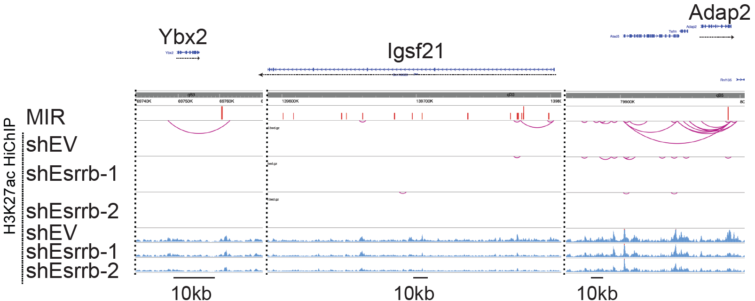

CRISPRi and KO of Klf5-MIR:
* Do you observe an enrichment of Esrrb and YY1 binding at the promoters of deregulated genes in both shEsrrb and shYY1 conditions? The same question applies to promoters of Esrrb-YY1 bound MIRs looping genes as defined in Figure 5I.
We observed an enrichment of Esrrb at the promoters of down and up genes after Esrrb and YY1 knockdown. YY1 binding was found lesser at the down genes, but higher at the up genes. This indicates that YY1 may be repressive for some genes it co-bind with Esrrb.
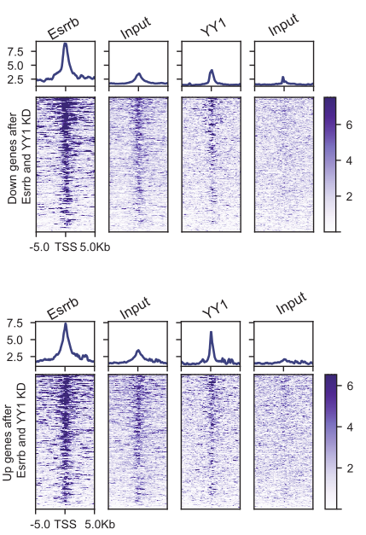
At the promoters of Esrrb-YY1 bound MIR looping genes, we observed enrichment of both Esrrb and YY1, further supporting the role of Esrrb-YY1 in establishing the E-P loops through MIR.
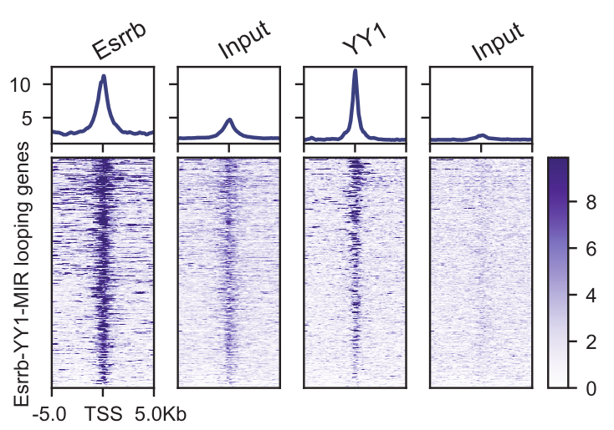
Figure Corrections and Clarifications:
* Figure S1B and C: There is a discrepancy between the figure label (Axin2) and the figure legend (Axin1).
Axin2 is a downregulation marker gene for EPSC, as reported by Yang et al., 2019 (PMID: 30617351, Nature Protocols), and we corroborated this finding using RT-qPCR (Figure S1A). We have now cited this publication in the main text. The same research group also identified Axin1 as an upregulation marker gene for EPSC, whose overexpression in ESC confers expanded potential (Yang et al., 2017, PMID: 29019987, Nature). We replicated this result using Western blot, as shown in Figures S1B and S1C. Thus, Axin2 and Axin1 serve as markers for EPSC, with Axin2 being downregulated and Axin1 upregulated. The tankyrase inhibitor XAV939, a component of the EPSC medium, stabilizes Axin1 by inhibiting its ubiquitination, while inhibiting Axin2, a well-characterized Wnt downstream target. Therefore, the figure label is accurate as presented. To avoid confusion, we have added more information in the figure legend S1a. The figure legend now reads as follows:
“a, Characterization of EPSC upregulation marker (H19) and downregulation marker (Axin2) genes expression by RT-qPCR. b, Western blot showing the expression of Axin1 (EPSC upregulation marker) protein in EPSC and ESC.”
* Figure 1 F and G: please use same color code.
We have changed the color code in Figure 1F to conform to Figure 1G.

* Figure 4E: The legend is unclear. Could you specify whether the graph represents the average number of H3K27ac loops per super-enhancer?
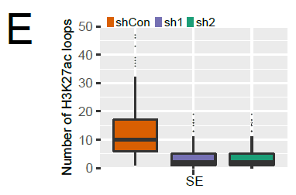
The graph depicts the number of loops located at each SE, presented as boxplot. We have now specified the legend of former Figure 4E (current Figure 5E) as follows: “e. Distribution of H3K27ac-mediated chromatin loops at super-enhancers (SE) in control and Esrrb knockdown conditions. The boxplot summarizes the distribution of the number of loops and displays the median value for each group.”

* Figure 5I: This figure lacks a text legend.
We apologize for the mistake. The figure legend has now been corrected.
I would appreciate seeing the overlap of down-regulated genes in both Esrrb KD and YY1 KD.
There were 524 common downregulated genes between Esrrb and Yy1 KD conditions. We have now added this in Fig. S6G.
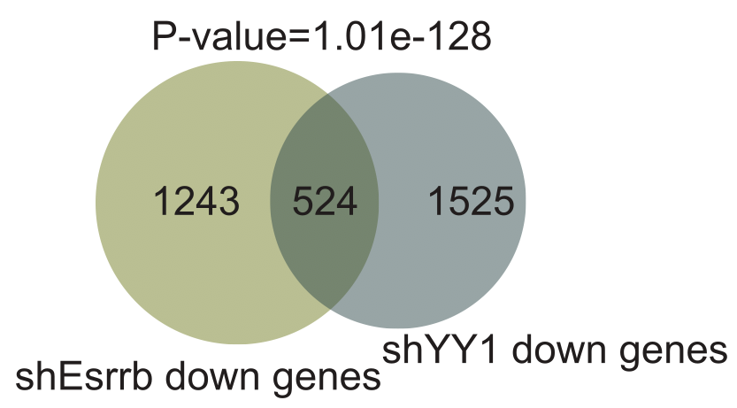
Moreover, a Venn diagram showing the overlap between up-regulated genes and Esrrb-YY1 bound MIRs looping genes would be more informative.
We have now included this section where we discussed the overlap between upregulated genes and Esrrb-YY1 bound MIRs looping genes.
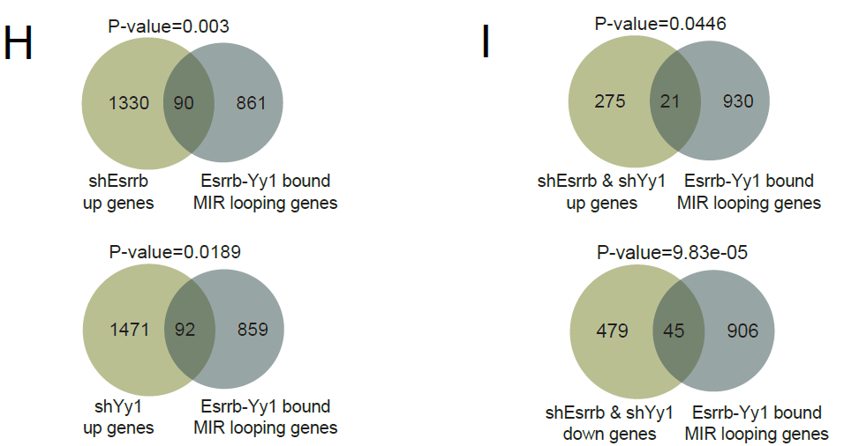
“We further investigated whether the Esrrb-Yy1 regulation through MIR could be repressive by examining genes upregulated upon Esrrb or Yy1 knockdown. A total of 90 and 92 Esrrb-Yy1 MIR looping genes were upregulated upon Esrrb and Yy1 knockdown, respectively (Fig. S6H). When considering genes upregulated in both Esrrb and Yy1 knockdown conditions, the overlap with Esrrb-Yy1 MIR looping genes reduced to 21 (Fig. S6I). In contrast, the downregulated gene set showed 45 overlapping genes with Esrrb-Yy1 MIR looping genes and with a higher statistical significance (Fig. S6I). These suggest that the action of Esrrb-Yy1 on MIR is more likely activatory than repressive.”

As a general comment on the figures, the manuscript would benefit from relocating some figures from the main to the supplementary figures or splitting certain figures (e.g., Figure 3, currently spanning from A to P). From a purely aesthetics standpoint, reducing the number of figures, aligning them consistently, and using a uniform font size or color code for legends would enhance the overall readability and visual appeal of the manuscript.
We have reorganized our figures as described below and enhanced their consistency to ensure better readability.
- Figure 1B, 1E, and 1J were moved to supplementary Figure S1
- Figure 2A and 2H-J were moved to a new supplementary figure (Fig S2).
- Figure 3 was split into 2 figures. Fig 3A-3I will remain as Figure 3, while Figure 3J-P are now the new Figure 4.
- Figure 4 was split into 2 figures. Figure 4A-F are now Figure 5. Figure 4G-O are now Figure 6.

Reviewer #3: Following the revisions, this manuscript has shown significant improvement. The removal of the later sections has made the manuscript structure more concise and focused. The authors have demonstrated that MIR elements are essential for specific genes involved in differentiation and embryonic development. Additionally, they provide strong experimental evidence that the Esrrb-MIR element near KLF5 is crucial for the proliferation of human embryonic pluripotent cells.
Overall, this revised version is suitable for publication in Genome Biology. However, I have a few remaining questions and suggestions for clarification:
We thank reviewer 3 for acknowledging our efforts to improve the manuscript. To clarify, the work was conducted in mouse ESC, not human. We have addressed the remaining questions and suggestions as below.
1. In line 160, why do the authors associate Axin2 downregulation with a characteristic of EPSCs? What reference supports this claim?
Axin2 is a downregulation marker gene for EPSC, as reported by Yang et al., 2019 (PMID: 30617351, Nature Protocols), and we corroborated this finding using RT-qPCR (Figure S1A). The publication suggests that high H19 and no Axin2 expression serves as a convenient readout for the conversion of ES cells to EPSCs and as an EPSC molecular signature. We have now cited this publication in the main text.
The same research group also identified Axin1 as an upregulation marker gene for EPSC, whose overexpression in ESC confers expanded potential (Yang et al., 2017, PMID: 29019987, Nature). We replicated this result using Western blot, as shown in Figures S1B and S1C. Thus, Axin2 and Axin1 serve as markers for EPSC, with Axin2 being downregulated and Axin1 upregulated. The tankyrase inhibitor XAV939, a component of the EPSC medium, stabilizes Axin1 by inhibiting its ubiquitination, while inhibiting Axin2, a well-characterized Wnt downstream target.
2. In line 179, could the authors perform a GO analysis of A-to-B and B-to-A compartment genes to clarify their respective functions?
We performed a GO analysis of genes located within differential compartments. There were 98 unique genes within the compartment which underwent the A-to-B switch (44 transitions), and 439 unique genes for the B-to-A switch (923 transitions). The enriched GO terms are now shown in the current Fig. S1H and described in the main text.
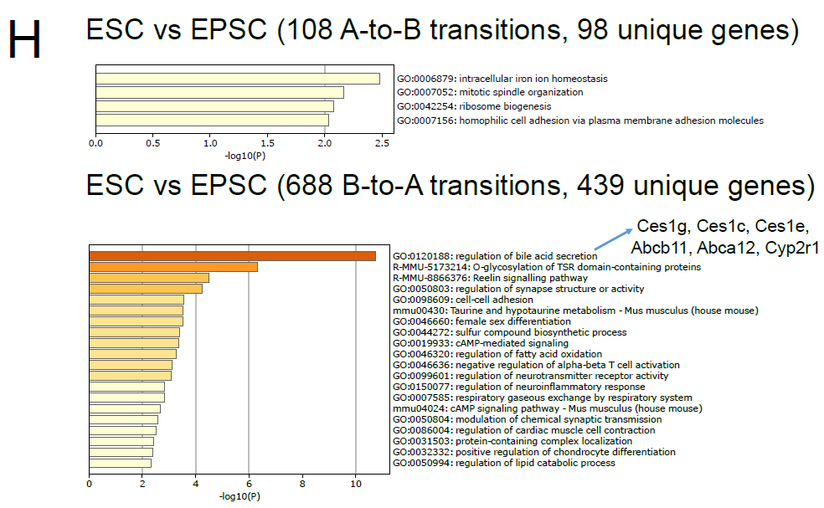
We identified only 4 GO terms enriched from the A-to-B switch gene set. Among those, an iron ion homeostasis gene Hmox1 (HO-1), also known for promoting ESC differentiation (Petrone et al. 2018, PMID: 34056710), becomes B-compartmentalized.
In the B-to-A switch gene set, we saw an enrichment of genes related to bile acid and lipid metabolism, for example Carboxylesterase (Ces) and ATP-binding cassette (ABC) family members. Cyp2r1, a vitamin D hydroxylase, was also found in the top-enriched GO. Interestingly, a study revealed that vitamin D treatment together with inhibition of histone methyltransferase MLL1 enhances the extraembryonic differentiation capacity of ESC (Zhang et al., 2019, PMID: 31775036). Additionally, activation of a nuclear receptor involved in lipid metabolism in ESCs can enhance their potency, enabling blastoid formation (Wong et al., 2024, PMID: 39562549). Therefore, our compartment analysis supports that these metabolic genes may become activated in EPSCs and contribute to their expanded potential.
3. In Figure 2C, please include H3K27ac and ATAC signals in EPSCs for direct comparison.
We have now included H3K27ac and ATAC signals of Alu and MIR in EPSCs in the current Fig 2B (former figure 2C). Both Alu and MIR were less enriched in the EPSC compared to ESC.
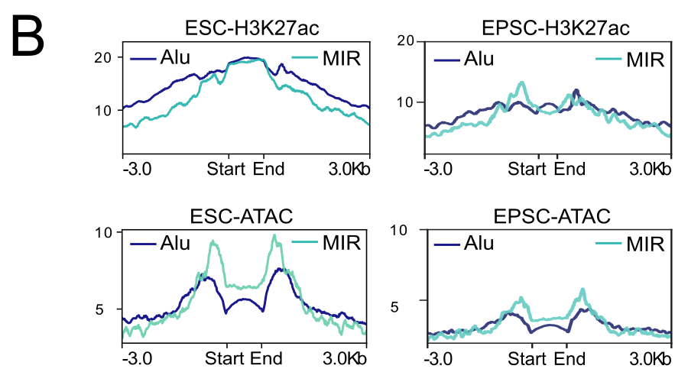
4. In line 227, the authors should explicitly explain why they chose to study MIR rather than Alu.
We are intrigued by the fact that despite its much lesser number, MIR (n= 156,938) was more accessible compared to B1/Alu (n= 630,940). Secondly, our SINE enrichment analysis on H3K27ac HiChIP loop anchors showed higher enrichment of MIR than Alu in ESC (Figure S2C). These reasons have now been written into the main text.
5. In Figure 2I, is the title correct?
Former Figure 2I (now Figure S2C), was mistakenly titled as “ESC-MIR H3K27ac HiChIP loops”. We have now corrected the title and the Figure legend as such: ”c, Fold enrichment of SINE elements in H3K27ac HiChIP loop anchors of ESC compared to EPSC.”
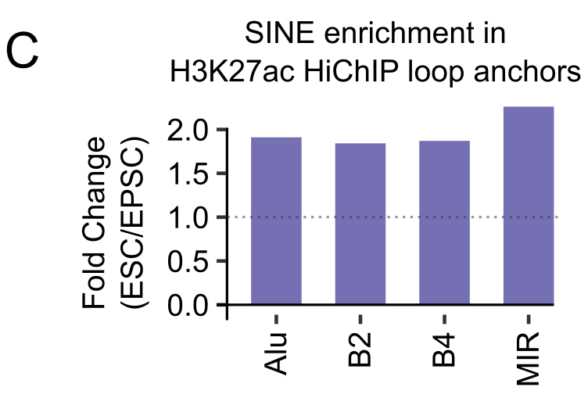
6. In Figure 3B, Esrrb appears to be more significantly enriched at Alu. Do MIR and Alu elements share the same Esrrb binding motif? If so, the authors might reconsider emphasizing Esrrb binding exclusively on MIR, as Esrrb-Alu could also play a functional role.
In Figure 3B, we use the known Esrrb motif as input to show Esrrb motif enrichment in enhancer MIR or Alu. So the input motif is the same for both. We have performed a de-novo motif discovery analysis and found that MIR and Alu do not share the same Esrrb motif.
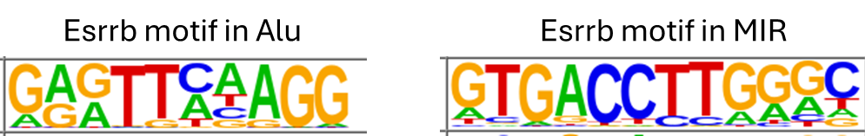
We do see more Esrrb binding at B1/Alu than MIR, which is expected given that Alu is more abundant (Alu = 630,940 loci; MIR = 156,938 loci) and also possesses Esrrb motif. However, as shown in Figure 4E, despite Alu outnumbering MIR by >4-fold, the odds of Esrrb binding are higher for MIR. While we do not rule out the potential functional role of Esrrb-Alu interactions, the scope of this study is focused on Esrrb-MIR for the reasons mentioned above.
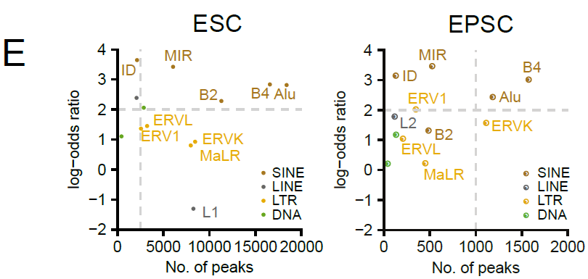

7. In line 352, does MIR-CRISPRi repress KLF5, Klf5, Trim25, and Esrrb?
Klf5, Trim25 and Esrrb were not among the genes downregulated by CRISPRi of MIR by sg22 and sg23 (Figure S4D).
Gene name | FPKM CRISPRi sgMIR22 | FPKM CRISPRi sgMIR23 | FPKM CRISPRi sgScrmbl | Fold change (sgMIR22/sgScrmbl) | Fold change (sgMIR23/sgScrmbl) | Average Fold Change | Significant? (p-value <0.05, FC≤0.5)
Klf5 | 65.9927 | 14.7909 | 42.2456 | 1.56 | 0.35 | 1.06 | no
Trim25 | 15.9316 | 10.7423 | 11.5105 | 1.38 | 0.93 | 0.95 | no
Esrrb | 46.456 | 71.4717 | 79.4661 | 0.58 | 0.90 | 0.74 | no

Based on the Cas9 ChIP-seq data, we do not see a Cas9 binding peak on the Klf5-MIR, Trim25-MIR and Esrrb-MIR. Therefore, CRISPRi with MIR sg22 or sg23 did not target those 3 MIRs.
As mentioned in the previous revision round, due to the extensive sequence divergence among MIR elements, our broad-targeting MIR sgRNAs designed based on MIR consensus sequence were only capable of targeting a minimal fraction (4.75%) of all MIR sequences. As a result, the effect of MIR inhibition may be obscured if the sgRNAs do not target the key MIRs with regulatory role in ESC. Additionally, some MIRs may perform other regulatory function, such as an insulator (Wang et al. 2015). Targeting the non-enhancer MIRs with CRISPRi machinery may not yield any result. Therefore, a more targeted sgRNA design approach, exemplified by Klf5-MIR sgRNAs, offers a better approach in unraveling the function of individual MIRs.
We have now included this limitation in the Discussion section.
8. In line 373, it's intriguing that Klf5-MIR has a phenotype in mESCs, whereas MIR-dCas9 does not. Could this be because MIR-dCas9 cannot target KLF5-MIR? Further explanation on this point would be appreciated.
Please see our response to question 7.

Reviewer #4: Following the revisions, this manuscript has shown significant improvement. The removal of the later sections has made the manuscript structure more concise and focused. The authors have demonstrated that MIR elements are essential for specific genes involved in differentiation and embryonic development. Additionally, they provide strong experimental evidence that the Esrrb-MIR element near KLF5 is crucial for the proliferation of human embryonic pluripotent cells.
Please see our response to Reviewer #3’s comments
Overall, this revised version is suitable for publication in Genome Biology. However, I have a few remaining questions and suggestions for clarification:
1. In line 160, why do the authors associate Axin2 downregulation with a characteristic of EPSCs? What reference supports this claim?
2. In line 179, could the authors perform a GO analysis of A-to-B and B-to-A compartment genes to clarify their respective functions?
3. In Figure 2C, please include H3K27ac and ATAC signals in EPSCs for direct comparison.
4. In line 227, the authors should explicitly explain why they chose to study MIR rather than Alu.
5. In Figure 2I, is the title correct?
6. In Figure 3B, Esrrb appears to be more significantly enriched at Alu. Do MIR and Alu elements share the same Esrrb binding motif? If so, the authors might reconsider emphasizing Esrrb binding exclusively on MIR, as Esrrb-Alu could also play a functional role.
7. In line 352, does MIR-CRISPRi repress KLF5, Klf5, Trim25, and Esrrb?
8. In line 373, it's intriguing that Klf5-MIR has a phenotype in mESCs, whereas MIR-dCas9 does not. Could this be because MIR-dCas9 cannot target KLF5-MIR? Further explanation on this point would be appreciated.

Third round of review
Reviewer 1
In their manuscript, Cipta and colleagues nicely demonstrate the contribution of transposable elements from the MIR family in wiring enhancers and promoters with the co-binding of transcription factor Esrrb and architectural protein Yy1. They provide an interesting example of the coupling between 3D genome architecture and gene expression regulation network during the fine-tuning of early development transcriptional programs, in a well-executed integrative genomic study. I approve the publication of this manuscript.
Minor legend comment:
Figure 7 – i) I guess legend of last venn diagram should be ‘Control genes’ instead of ‘Esrrb-Yy1 bound MIR looping genes’

Reviewer 3
After this round of revisions, there appear to be no major outstanding issues, and the manuscript seems ready for publication in Genome Biology. However, a few points still require attention.
1. In line 218, the authors emphasize the importance of MIR by stating: “Both TE families were decorated with H3K27ac enhancer histone marks; however, despite its smaller size, MIR (n=156,938) was more accessible than B1/Alu (n=630,940) in ESC.” There is no direct causal relationship between the number of TEs and their accessibility, and it appears that the y-axis in the corresponding figure represents mean accessibility.
2. In Figure S2C, the y-axis depicts the fold change (ESC/EPSC), indicating that MIR enrichment in H3K27ac HiChIP loop anchors is specific to ESCs; it is unclear why “ESC-specific” was removed from line 236.
3. In Figure 3C, please clarify whether the motif shown in the upper panel is the Esrrb motif or the base frequency of MIR; if it is the Esrrb motif, it would be beneficial to also include the base frequency of MIR at the corresponding positions to provide a clear comparison.
4. There are a few minor typos and corrections that need to be addressed. In line 162, “Fig. 1C” should be “Fig. 1B,” and in line 166, “Fig. 1D” should be “Fig. 1C.” In Figure 7I, “shEsrrb down genes” and “shYy1 down genes” should be “shEsrrb up genes” and “shYy1 up genes,” respectively, in the lower Venn plots.

Authors Response
Point-by-point responses to the reviewers’ comments:

Reviewer reports:
Reviewer #1: In their manuscript, Cipta and colleagues nicely demonstrate the contribution of transposable elements from the MIR family in wiring enhancers and promoters with the co-binding of transcription factor Esrrb and architectural protein Yy1. They provide an interesting example of the coupling between 3D genome architecture and gene expression regulation network during the fine-tuning of early development transcriptional programs, in a well-executed integrative genomic study. I approve the publication of this manuscript.
We are pleased that Reviewer 1 approve the publication of this manuscript.
Minor legend comment:
Figure 7 - i) I guess legend of last venn diagram should be 'Control genes' instead of 'Esrrb-Yy1 bound MIR looping genes'
Yes, this was an oversight. We have now corrected the legend to ‘Control genes’.
Reviewer #3: After this round of revisions, there appear to be no major outstanding issues, and the manuscript seems ready for publication in Genome Biology. However, a few points still require attention.
We are pleased that Reviewer 3 thinks that this manuscript is ready for publication after addressing a few minor issues.
1. In line 218, the authors emphasize the importance of MIR by stating: "Both TE families were decorated with H3K27ac enhancer histone marks; however, despite its smaller size, MIR (n=156,938) was more accessible than B1/Alu (n=630,940) in ESC." There is no direct causal relationship between the number of TEs and their accessibility, and it appears that the y-axis in the corresponding figure represents mean accessibility.
Reviewer 1 raises a valid point that there is no direct causal relationship between the number of TEs and their accessibility, and that Fig. 2B represents only the mean accessibility. Therefore, we removed the number of the MIR and Alu loci and the statement “despite its lesser number,” from the sentence.
The sentence now reads as: “Both TE families were decorated with H3K27ac enhancer histone mark, whereas MIR was more accessible than B1/Alu in ESC (Fig. 2B)”.
2. In Figure S2C, the y-axis depicts the fold change (ESC/EPSC), indicating that MIR enrichment in H3K27ac HiChIP loop anchors is specific to ESCs; it is unclear why "ESC-specific" was removed from line 236.
Figure S2C shows enrichment of each SINE family in H3K27ac HiChIP loop anchors of ESC compared to EPSC, hence the y-axis title “Fold change (ESC/EPSC)”. We removed the word “ESC-specific” to prevent misconception that the graph represents only ESC-specific loops, when in fact all H3K27ac-mediated loops were considered.
We have now amended the sentence as such for more clarity: “Among these SINEs, MIR was the most enriched in the H3K27ac-mediated enhancer loops in ESC compared to EPSC (Fig. S2C).”
3. In Figure 3C, please clarify whether the motif shown in the upper panel is the Esrrb motif or the base frequency of MIR; if it is the Esrrb motif, it would be beneficial to also include the base frequency of MIR at the corresponding positions to provide a clear comparison.
Figure 3C is showing the result of a motif density analysis. The upper panel shows the Esrrb motif position within the MIR consensus sequence. The lower panel shows the frequency of Esrrb motif on all MIR sequences. The known Esrrb motif shown in the upper panel was used as the input to discover the position and motif frequency. Therefore, this analysis does not provide the number of base frequency. We hope this answers the question, but if not please elaborate further.
4. There are a few minor typos and corrections that need to be addressed. In line 162, "Fig. 1C" should be "Fig. 1B," and in line 166, "Fig. 1D" should be "Fig. 1C." In Figure 7I, "shEsrrb down genes" and "shYy1 down genes" should be "shEsrrb up genes" and "shYy1 up genes," respectively, in the lower Venn plots.
Thank you for spotting these mistakes. We have now corrected line 162 and line 166.
In Figure 7I, the downregulated genes of either shEsrrb (left) or shYy1 (right) were overlapped with Esrrb-Yy1 bound MIR looping genes (top row) and Control genes (bottom row). The legend for bottom right plot was mislabelled and now has been rectified to “Control genes”.
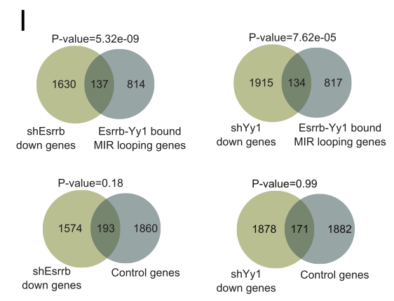

Fourth round of review
Reviewer 3
The authors have addressed my comments, and the manuscript is ready for publication.

