ADDITIONAL FILE 2 FOR:

Engineering Novel CRISPRi Repressors for Highly Efficient Mammalian Gene Regulation
Andrew Kristof¹, Krithika Karunakaran¹, Christopher Allen¹, Paula Mizote¹, Sophie Briggs¹, Zixin Jian¹, Patrick Nash¹ & John Blazeck^{1,*}
¹ School of Chemical and Biomolecular Engineering, Georgia Institute of Technology, Atlanta, Georgia, 30332, USA

* To whom correspondence should be addressed.
Tel: +1 (404)-385-4718; Email: john.blazeck@chbe.gatech.edu

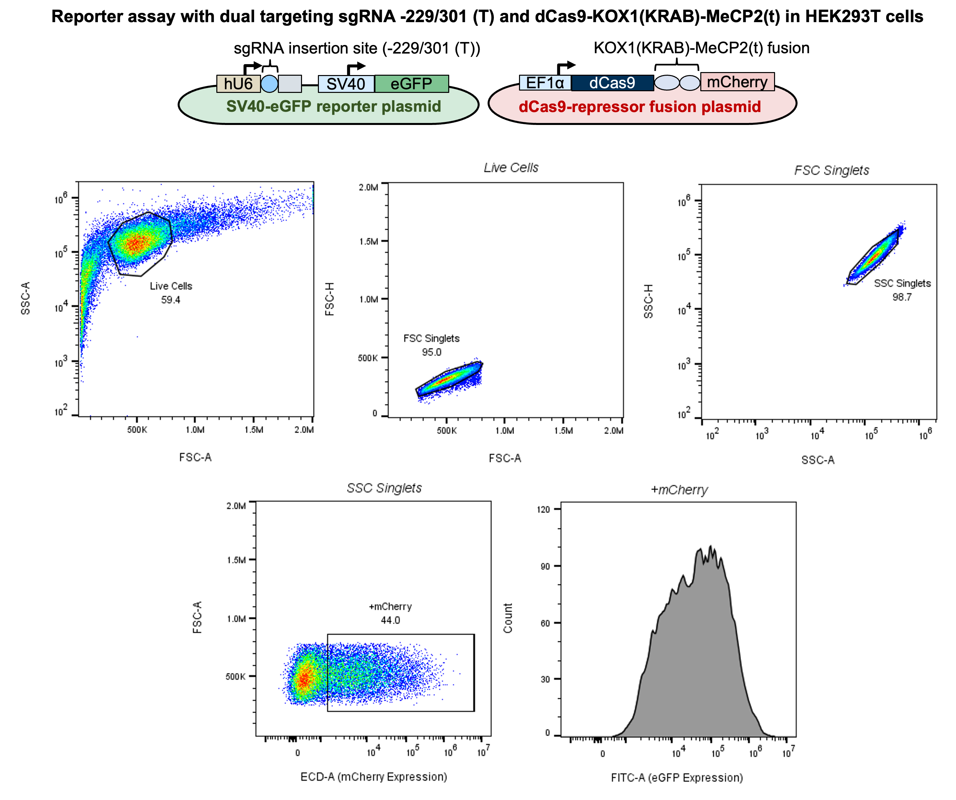

Supplementary Figure S1. Schematic of the design and gating strategy for SV40-eGFP reporter knockdown assays. To perform these experiments, cells were co-transfected with two plasmids: (1) Reporter plasmid (highlighted in green) containing a sgRNA targeting the adjacent SV40-eGFP cassette and (2) dCas9-repressor plasmid (highlighted in red) containing a candidate CRISPRi effector (example included is the dCas9-KOX1(KRAB)-MeCP2(t) fusion) driven by the elongation factor 1-alpha promoter (EF1α) and a P2A-mCherry cassette enabling gating of dCas9+/mCherry+ cells. A dual-targeting sgRNA, -229/-301(T), was used in all eGFP reporter assays, unless otherwise noted. When performing flow cytometry to measure knockdown efficiency, cells from each sample were first gated for single, live cells. After this, cells with above-background mCherry signal (+mCherry, indicating expression of dCas9-repressor fusions ) were isolated for further analysis. Mean eGFP fluorescence intensity was then measured from this final population (+mCherry) to quantify the degree of eGFP knockdown.

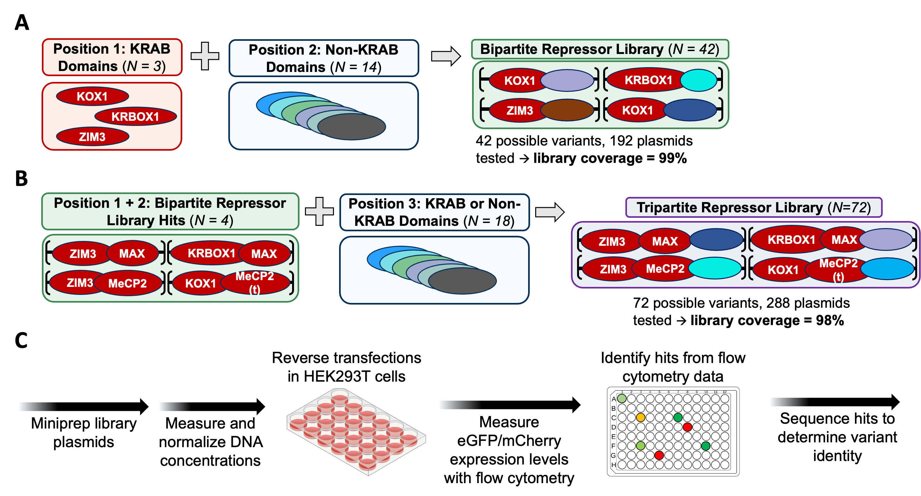

Supplementary Figure S2. Design and methods for screening bipartite and tripartite repressor variants. (A-B) Strategy for assembling (A) bipartite and (B) tripartite dCas9-repressor fusion libraries. All screened domain combinations were attached to the C-terminal end of dCas9 and generated by pooled Golden Gate Assembly. (C) Schematic of the workflow used for identifying top-performing dCas9-repressor fusions from libraries. Plasmids containing assembled dCas9-repressor fusions were isolated and purified, quantified by UV-Vis spectroscopy, and normalized to 100 ng/µL. Next, individual library plasmids, alongside the SV40-eGFP reporter plasmid, were co-transfected in HEK293T cells in 96-well plates. 72 hours post-transfection, cells were assayed via flow cytometry to measure output from the eGFP reporter (proxy for repressor activity) and mCherry marker (identifier for transfection efficiency) to determine library hits. Top-performing plasmids were then sequenced to determine variant identity before follow-up testing.

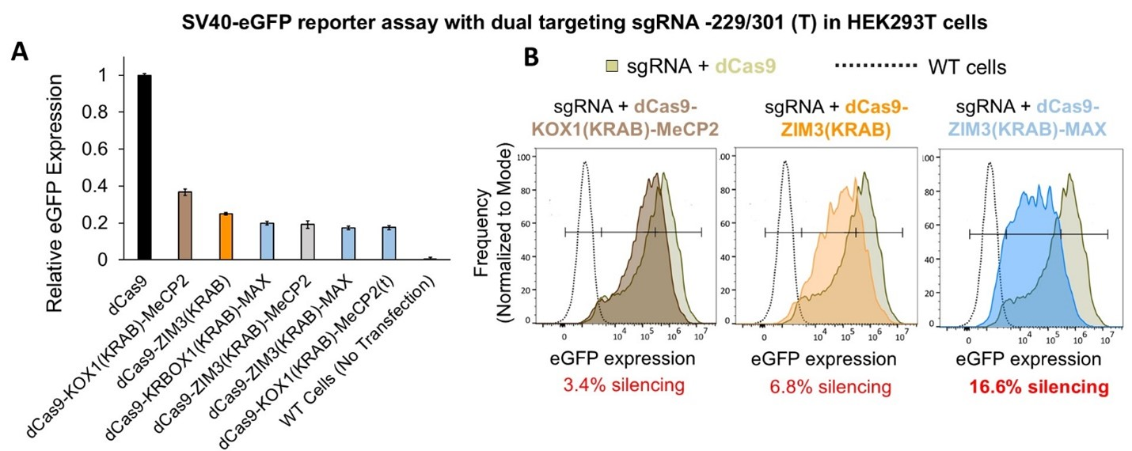
Supplementary Figure S3. Gene silencing achieved by improved bipartite repressor domains. (A) Comparison of top-performing prior CRISPRi platforms and novel bipartite repressor variants in HEK293T cells. Indicated dCas9-repressor fusions and eGFP reporter construct (with alternative sgRNA -313(T) targeting the SV40 promoter) were co-transfected and samples were assayed 72h later using flow cytometry. Wild type (WT) cells indicate level of complete eGFP silencing. (B) Histograms showing the distribution of eGFP fluorescence for current “gold standards” and one novel variant, KOX1(KRAB)-MeCP2(t) compared to cells expressing only dCas9 (solid line, tan population) and WT cells (dashed line, white population). Percent silencing for each dCas9-repressor fusion was quantified by assessing the number of cells in each population overlapping the WT cells population.

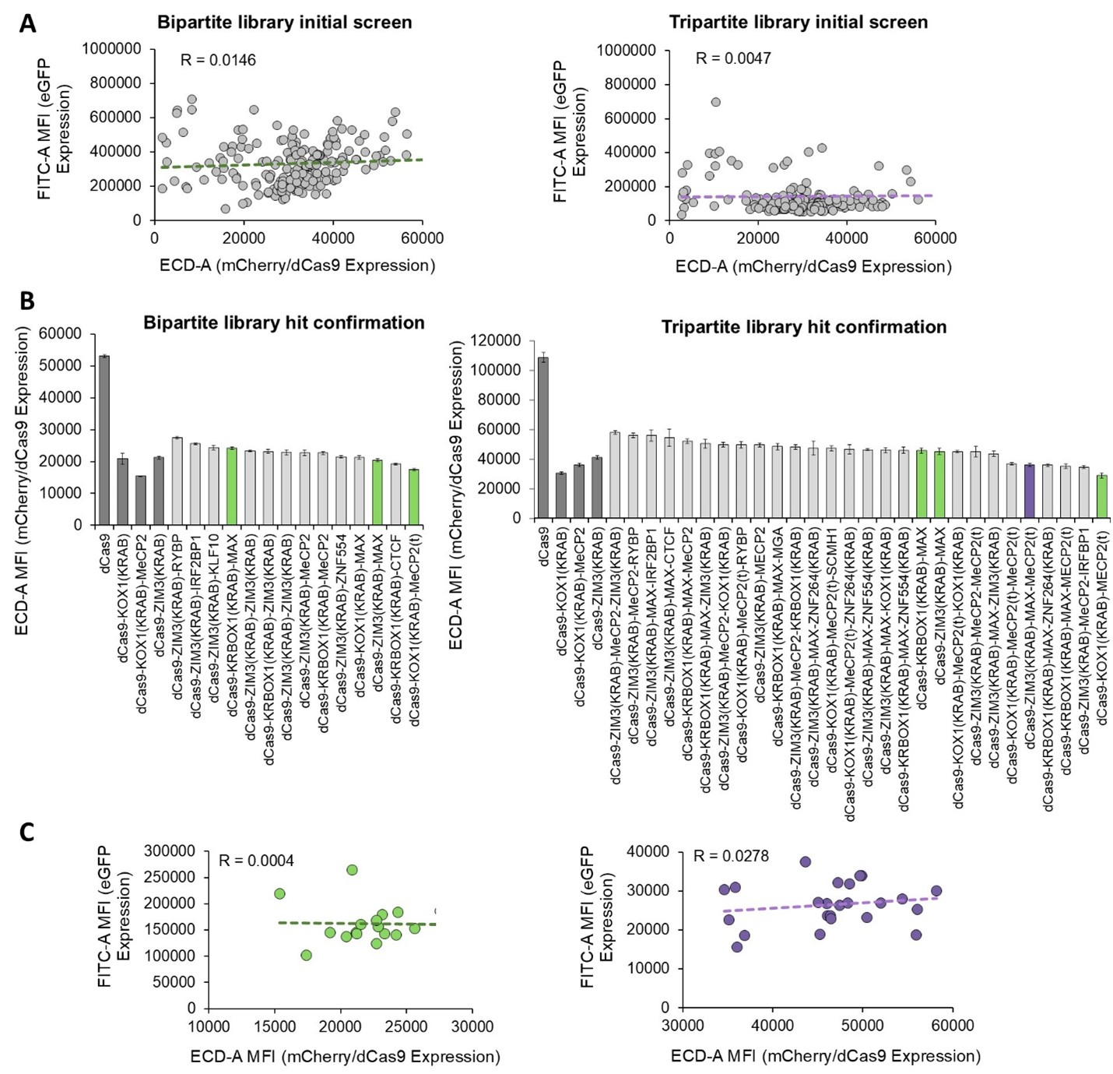
Supplementary Figure S4. Expression levels of dCas9-repressor fusions discovered in screening experiments. (A) Correlation between eGFP (indicating gene knockdown efficiency) and mCherry (representing dCas9-repressor expression levels) in bipartite and tripartite library screens performed in HEK293T cells. Data points denote mean fluorescence intensities for both markers. (B) Comparison of expression levels observed in HEK293T cells from “hits” obtained from bipartite and tripartite screens. Bars denote mean + s.e.m. of mCherry mean fluorescence intensity for n = 6 biologically independent transfections. Variants isolated and utilized in further experimentation are highlighted in green (bipartite variants) and purple (tripartite variant) bars, respectively. (C) Correlation between knockdown efficiency and endogenous expression levels for top-performing bipartite (green points) and tripartite (purple points) “hits” quantified in library screening. Points represent the mean expression level (mCherry) and associated eGFP expression achieved by each repressor re-evaluated from libraries using n = 6 independent transfections. Pearson’s correlation coefficients (R) are included for each group.
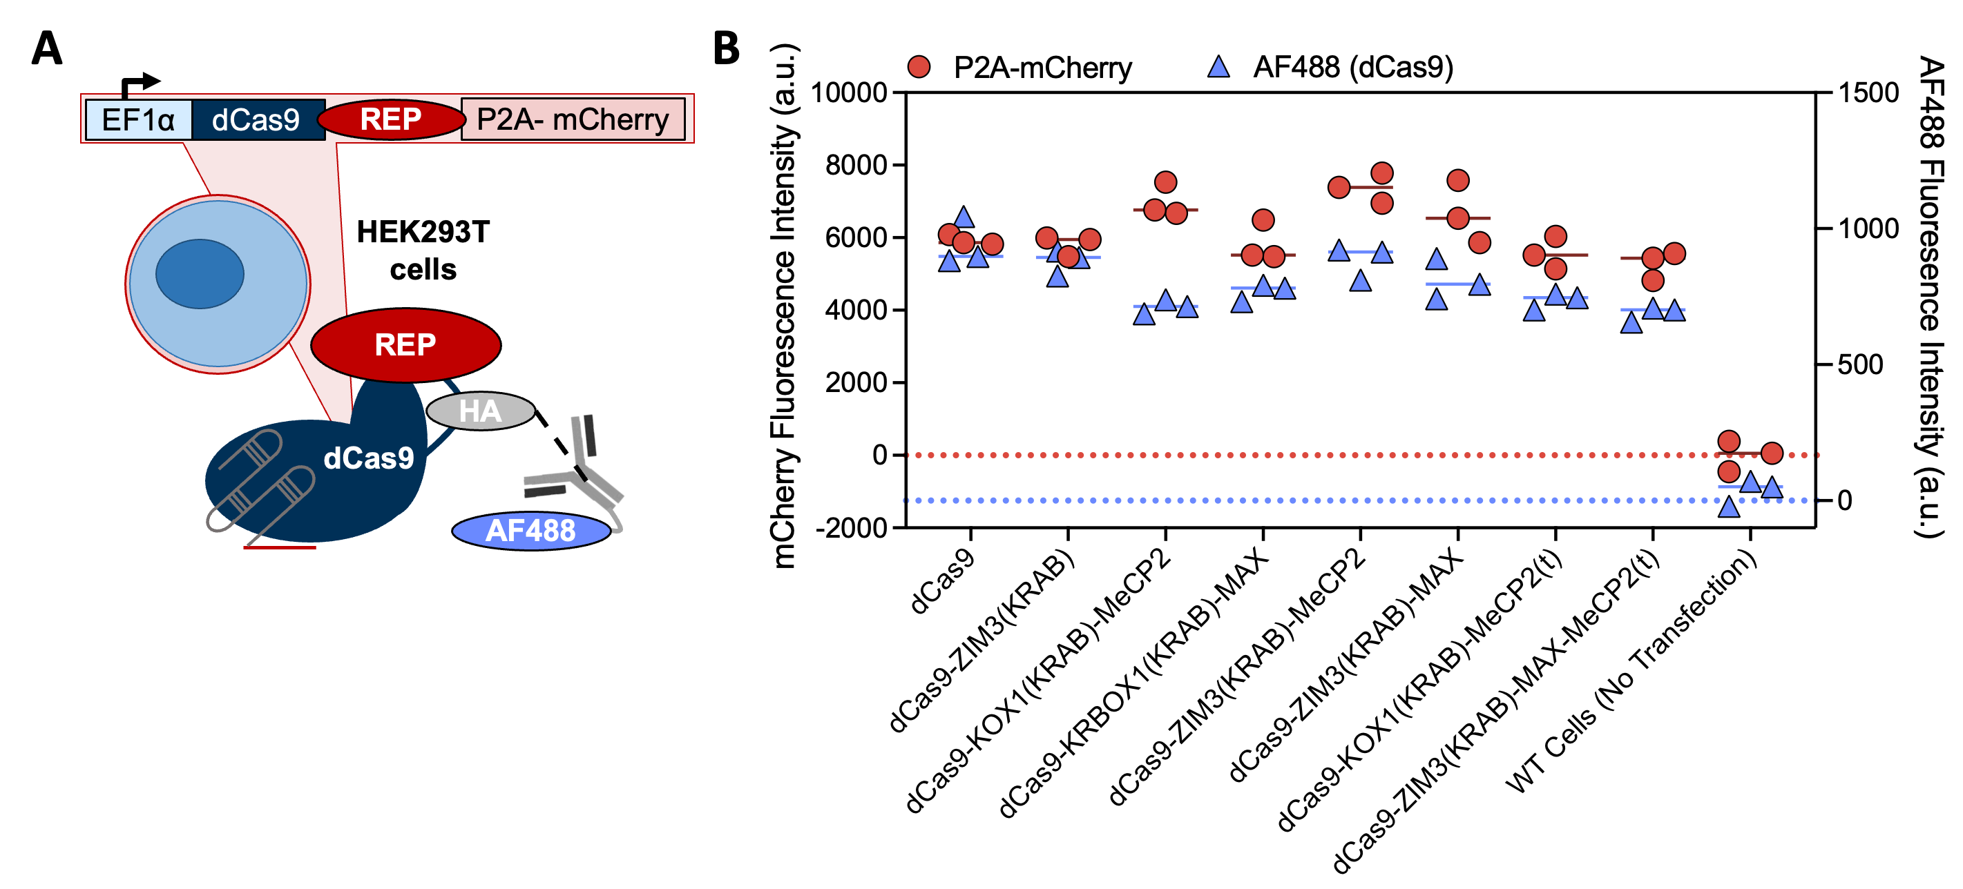
Supplementary Figure S5. Characterization of dCas9-repressor fusion expression levels using immunofluorescence staining. (A) Design of experimental procedure used to assess dCas9 expression levels in transfected cells. Two simultaneous approaches were used: (1) measuring P2A-mCherry (light red rectangle) expression, which is co-expressed on plasmids encoding dCas9-repressor fusions and, (2) staining dCas9 directly with an antibody (conjugated with AF488) that specifically binds the HA-tag (gray oval) embedded in the G/S rich-linker (black line) connecting dCas9 to a repressor domain of interest (REP, red oval). (B) Comparison of immunofluorescence and P2A-coexpression approaches for quantifying dCas9 expression levels. HEK293T cells were transfected with dCas9-repressor fusions and stained 72 hours later with anti-HA-AF488 conjugated antibodies to mark dCas9-repressor fusions. All conditions were transfected without sgRNAs. AF488 (blue lines/points) and P2A-mCherry (red lines/points) fluorescence intensities were simultaneously measured via flow cytometry. Lines denote the mean of n = 3 biologically-independent transfections/stains; each replicate is presented as an individual point.

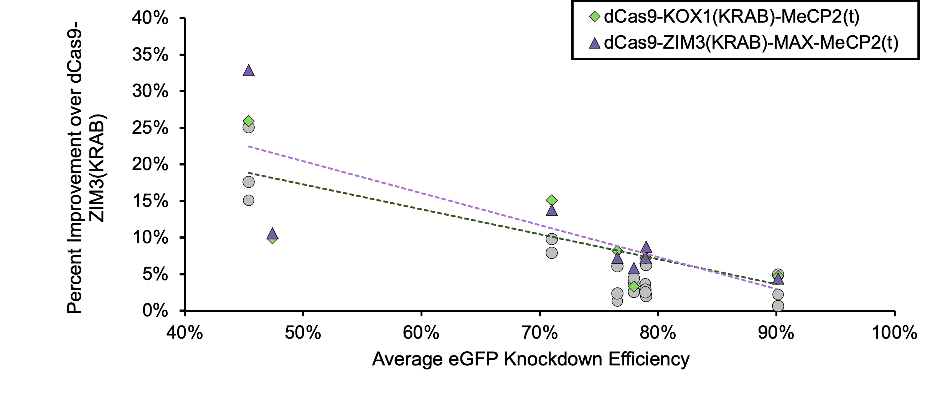Supplementary Figure S6. Correlation between knockdown improvement over dCas9-ZIM3(KRAB) and relative sgRNA strength for dCas9-KOX1(KRAB)-MeCP2(t) (green diamonds), dCas9- ZIM3(KRAB)-MAX-MeCP2(t) (purple triangles) and all other tested variants (gray circles). Data represents the mean values across n = 3 biological replicates.

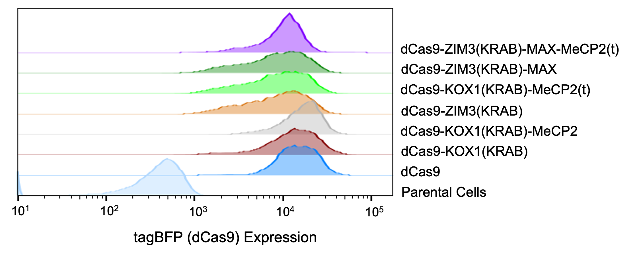
Supplementary Figure S7. Distribution of dCas9-repressor fusion expression levels (marked by T2A-tagBFP fluorescence signal) within A549 stable cell lines.

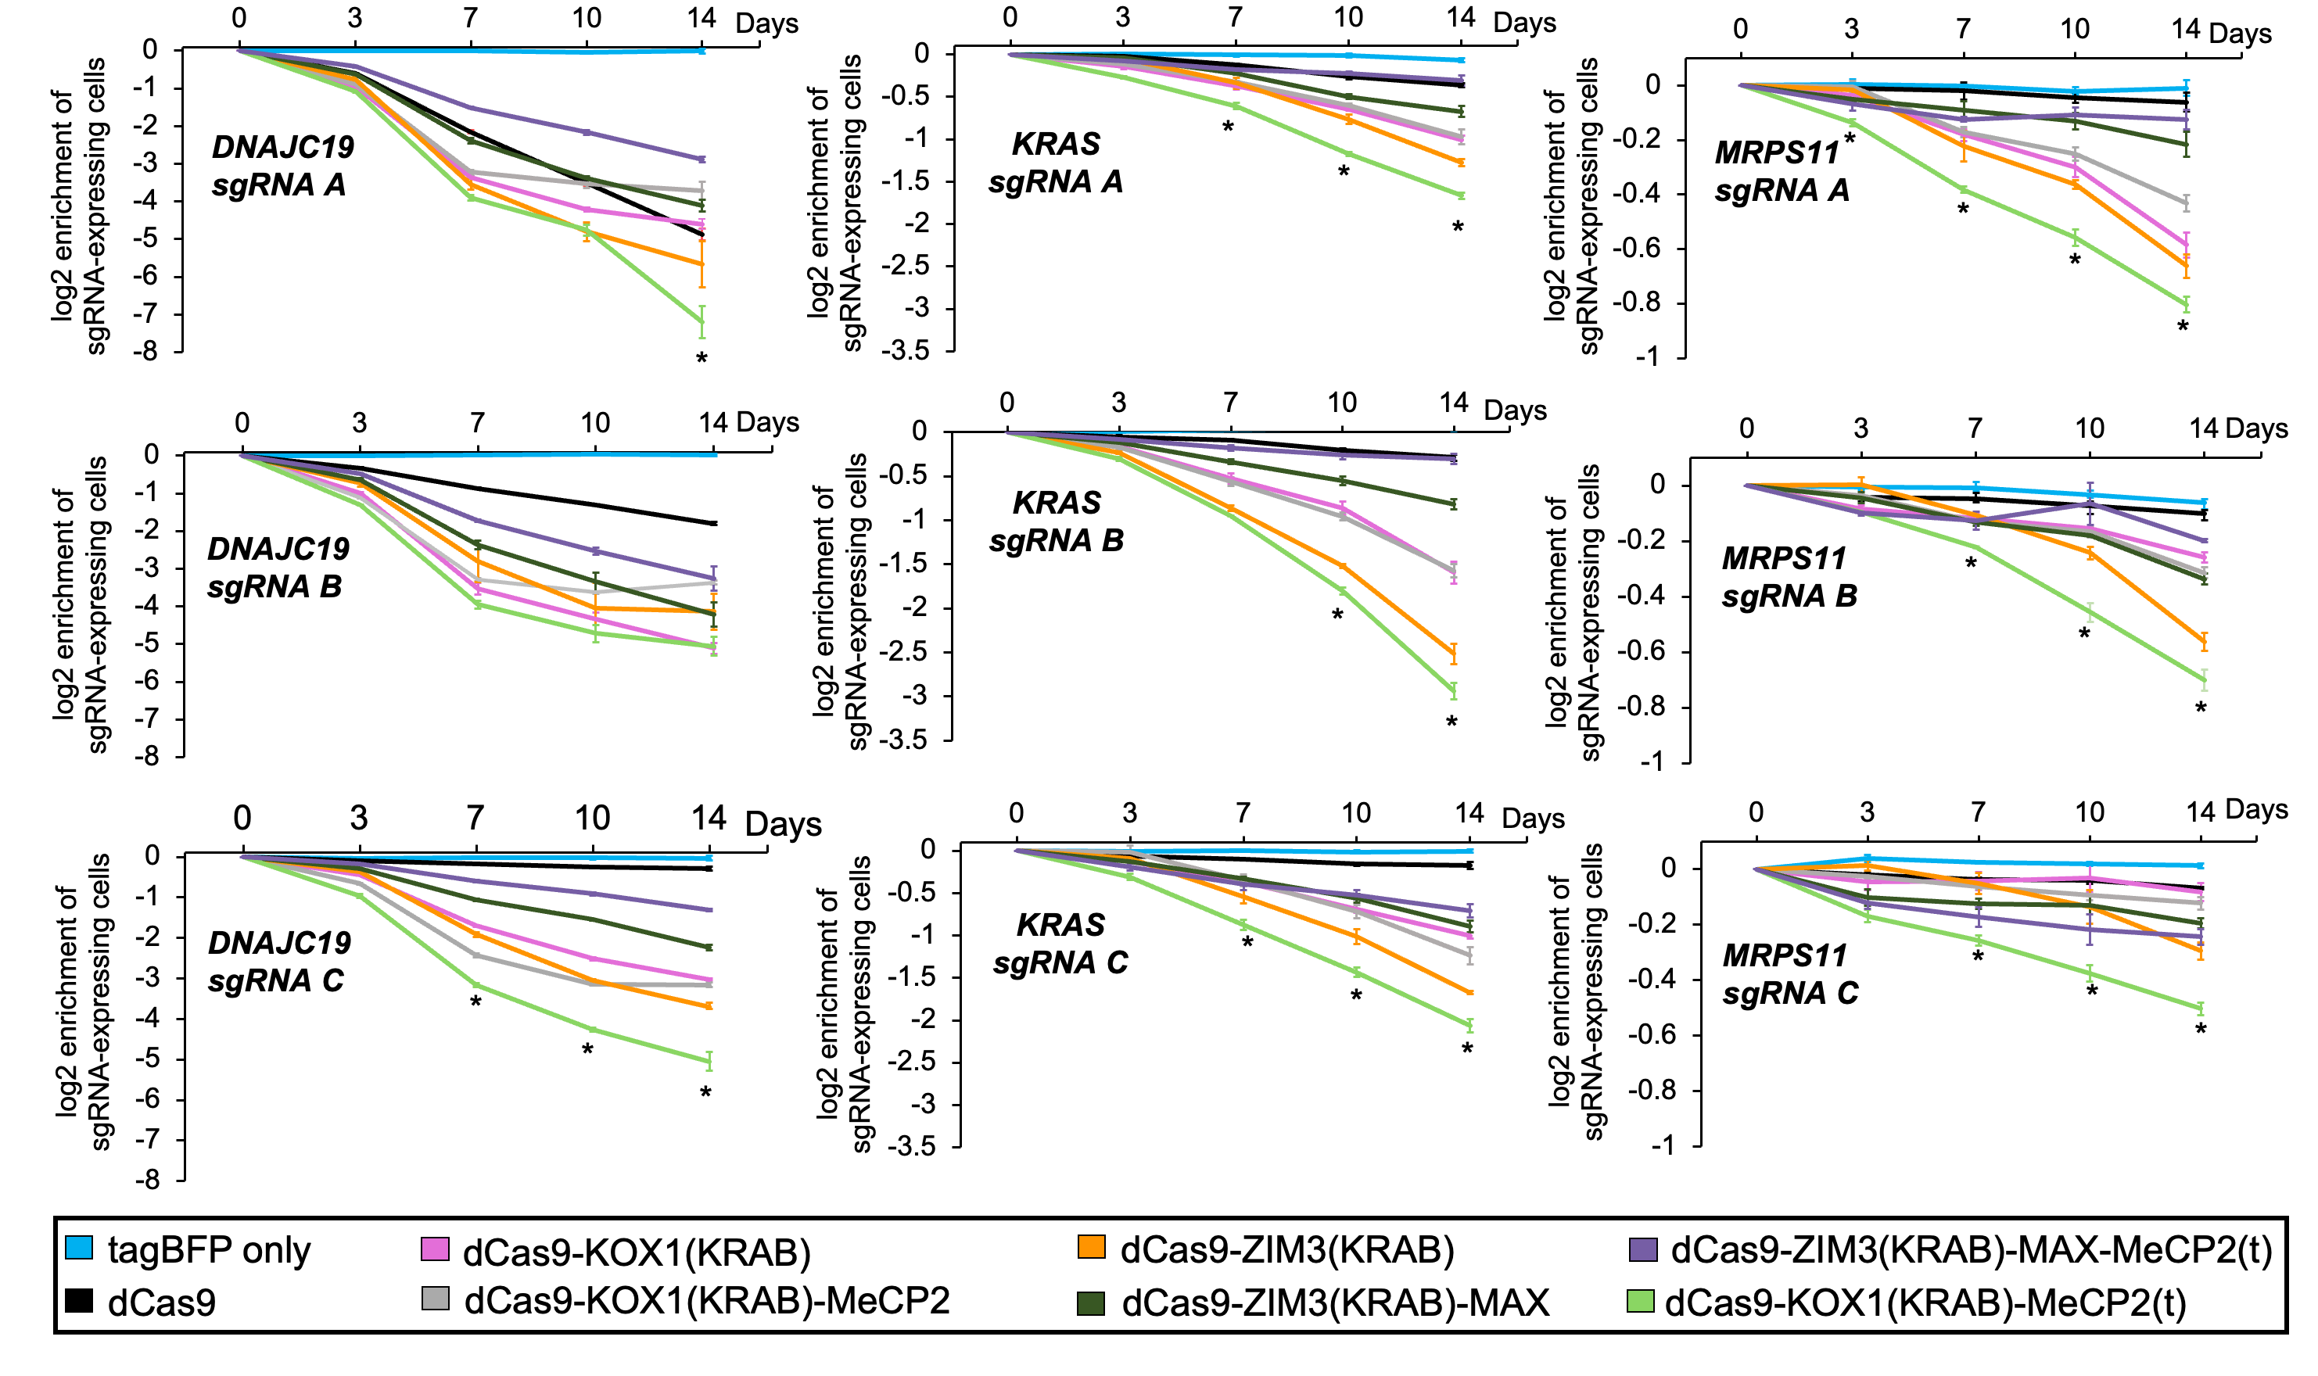

Supplementary Figure S8. Depletion of A549 cells stably expressing dCas9-repressor fusions alongside sgRNAs targeting essential genes (DNAJC19, KRAS, and MRPS11). Growth defects induced by CRISPRi-mediated essential gene knockdown were quantified by measuring the ratio of eGFP-positive cells (containing sgRNA and dCas9-repressor fusion) to eGFP-negative cells (expressing dCas9-repressor fusions only) using flow cytometry over a 14-day time course. Individual points and error bars denote the mean + s.e.m. of n = 3 independent transductions (cell cultures) for each condition. All statistical annotations compare the effectors dCas9-ZIM3(KRAB) (orange line) and dCas9-KOX1(KRAB)-MeCP2(t) (green line). *P < 0.05 by Tukey’s honestly significant difference (HSD) test.

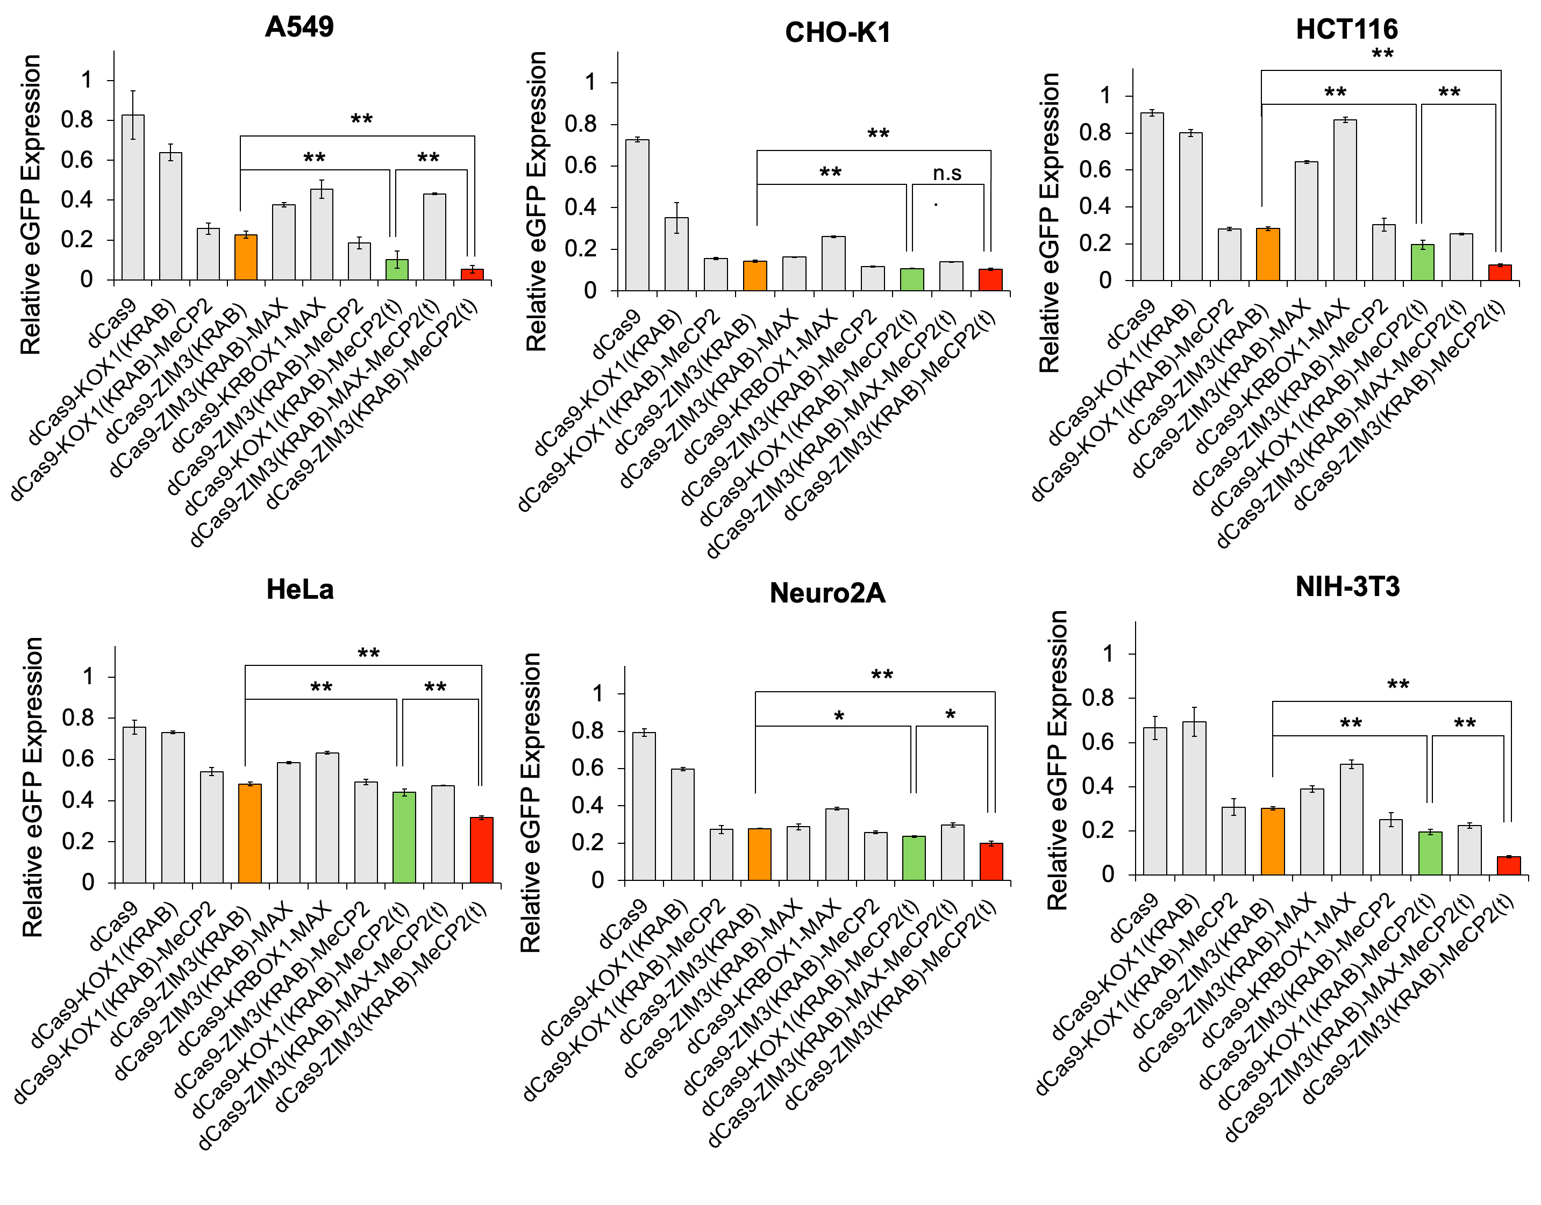
Supplementary Figure S9. Quantification of knockdown efficiencies of canonical and novel dCas9-repressor fusions in six mammalian cell lines using eGFP reporter assays. Cells were co-transfected with plasmids encoding dCas9-repressor fusions and the SV40-eGFP cassette, and expression levels (mean eGFP fluorescence intensities) were measured 3 days post-transfection using flow cytometry to quantify resultant gene knockdown efficiency. Data for each cell line is normalized to mean eGFP expression generated when co-transfecting dCas9 (without repressor domains) with a non-targeting sgRNA. All plots presented as mean ± s.e.m. of n = 3 biologically independent transfections (cell cultures). **P < 0.01 and *P < 0.05 by Tukey’s honestly significant difference (HSD) test for comparisons between dCas9-ZIM3(KRAB)-MeCP2(t) (red bars), dCas9-ZIM3(KRAB) (orange bars), and dCas9-KOX1(KRAB)-MeCP2(t) (light green bars).

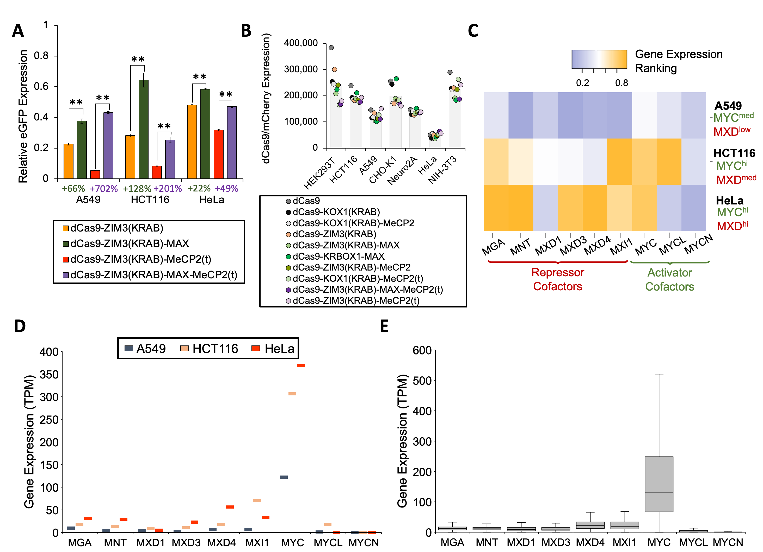
Supplementary Figure S10. MAX-containing repressors exhibit variable activity correlating with MYC-MAX family protein-protein interactions. (A) Comparison of dCas9-repressor fusions (with and without MAX) in A549, HCT116, and HeLa cells using reporter knockdown assays. Numbers below MAX-containing fusions (green, purple bars) show percent change (worsening) of knockdown efficiency compared to fusions without MAX (orange, pink bars). Data represents mean + s.e.m. of n = 3 independent transfections. **P < 0.01 and by Tukey’s honestly significant difference (HSD) test. (B) CRISPRi effector expression levels in mammalian cell line panel as quantified by P2A-mCherry fluorescence intensity. All dCas9-repressor fusion constructs were driven by the EF1α promoter. Individual points denote the mean of n = 3 biological replicates for each cell line (various colors). (C) Heat map showing relative RNA expression levels of MAX-interacting co-factors that function as repressors (red labels) and activators (green labels). Gene expression values were quantified by ranking the RNA abundances (TPM normalization) observed in each cell line compared to all 1431 cell lines represented in curated transcriptomic data from the DepMap database. Large values (orange fill) denote high relative expression, whereas small values (blue fill) represent low relative expression. (D) Endogenous gene expression levels of MAX-associating protein co-factors in HeLa, HCT116, and A549 cell lines. (E) Visualization of MYC-MAX protein family expression levels across 1431 unique human cell lines. In each box plot, the dividing line denotes the median gene expression, the box illustrates the interquartile range (IQR), and whiskers show 1.5X the IQR. All data for (D) and (E) curated from from the DepMap database.
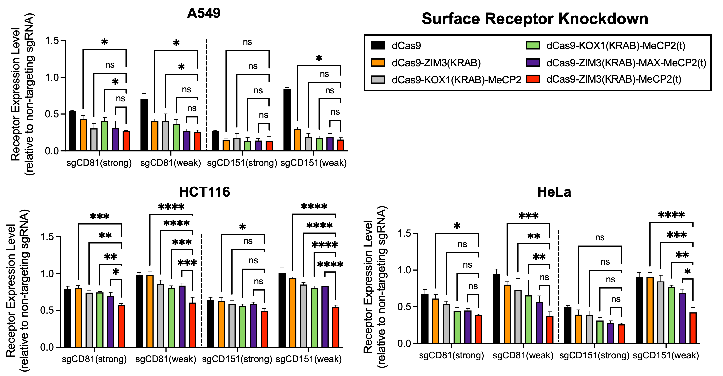

Supplementary Figure S11. Knockdown of surface markers CD81 and CD151 by various dCas9-repressor fusions in HCT116, A549, and HeLa cells. Surface marker expression levels were quantified by staining cells co-transfected with CRISPRi effectors and the indicated targeting sgRNAs with BV421-conjugated antibodies (72 hours post-transfection) and measuring resultant BV421 mean fluorescence intensities using flow cytometry. Expression levels are normalized by the mean BV421 mean fluorescence intensity measured in cells co-expressing the identical repressor and a non-targeting sgRNA. Individual points represent the mean ± s.e.m. of n = 3 biologically independent replicates. ****P < 0.0001, ***P < 0.001, **P < 0.01, and *P < 0.05 by Tukey’s honestly significant difference (HSD) test.

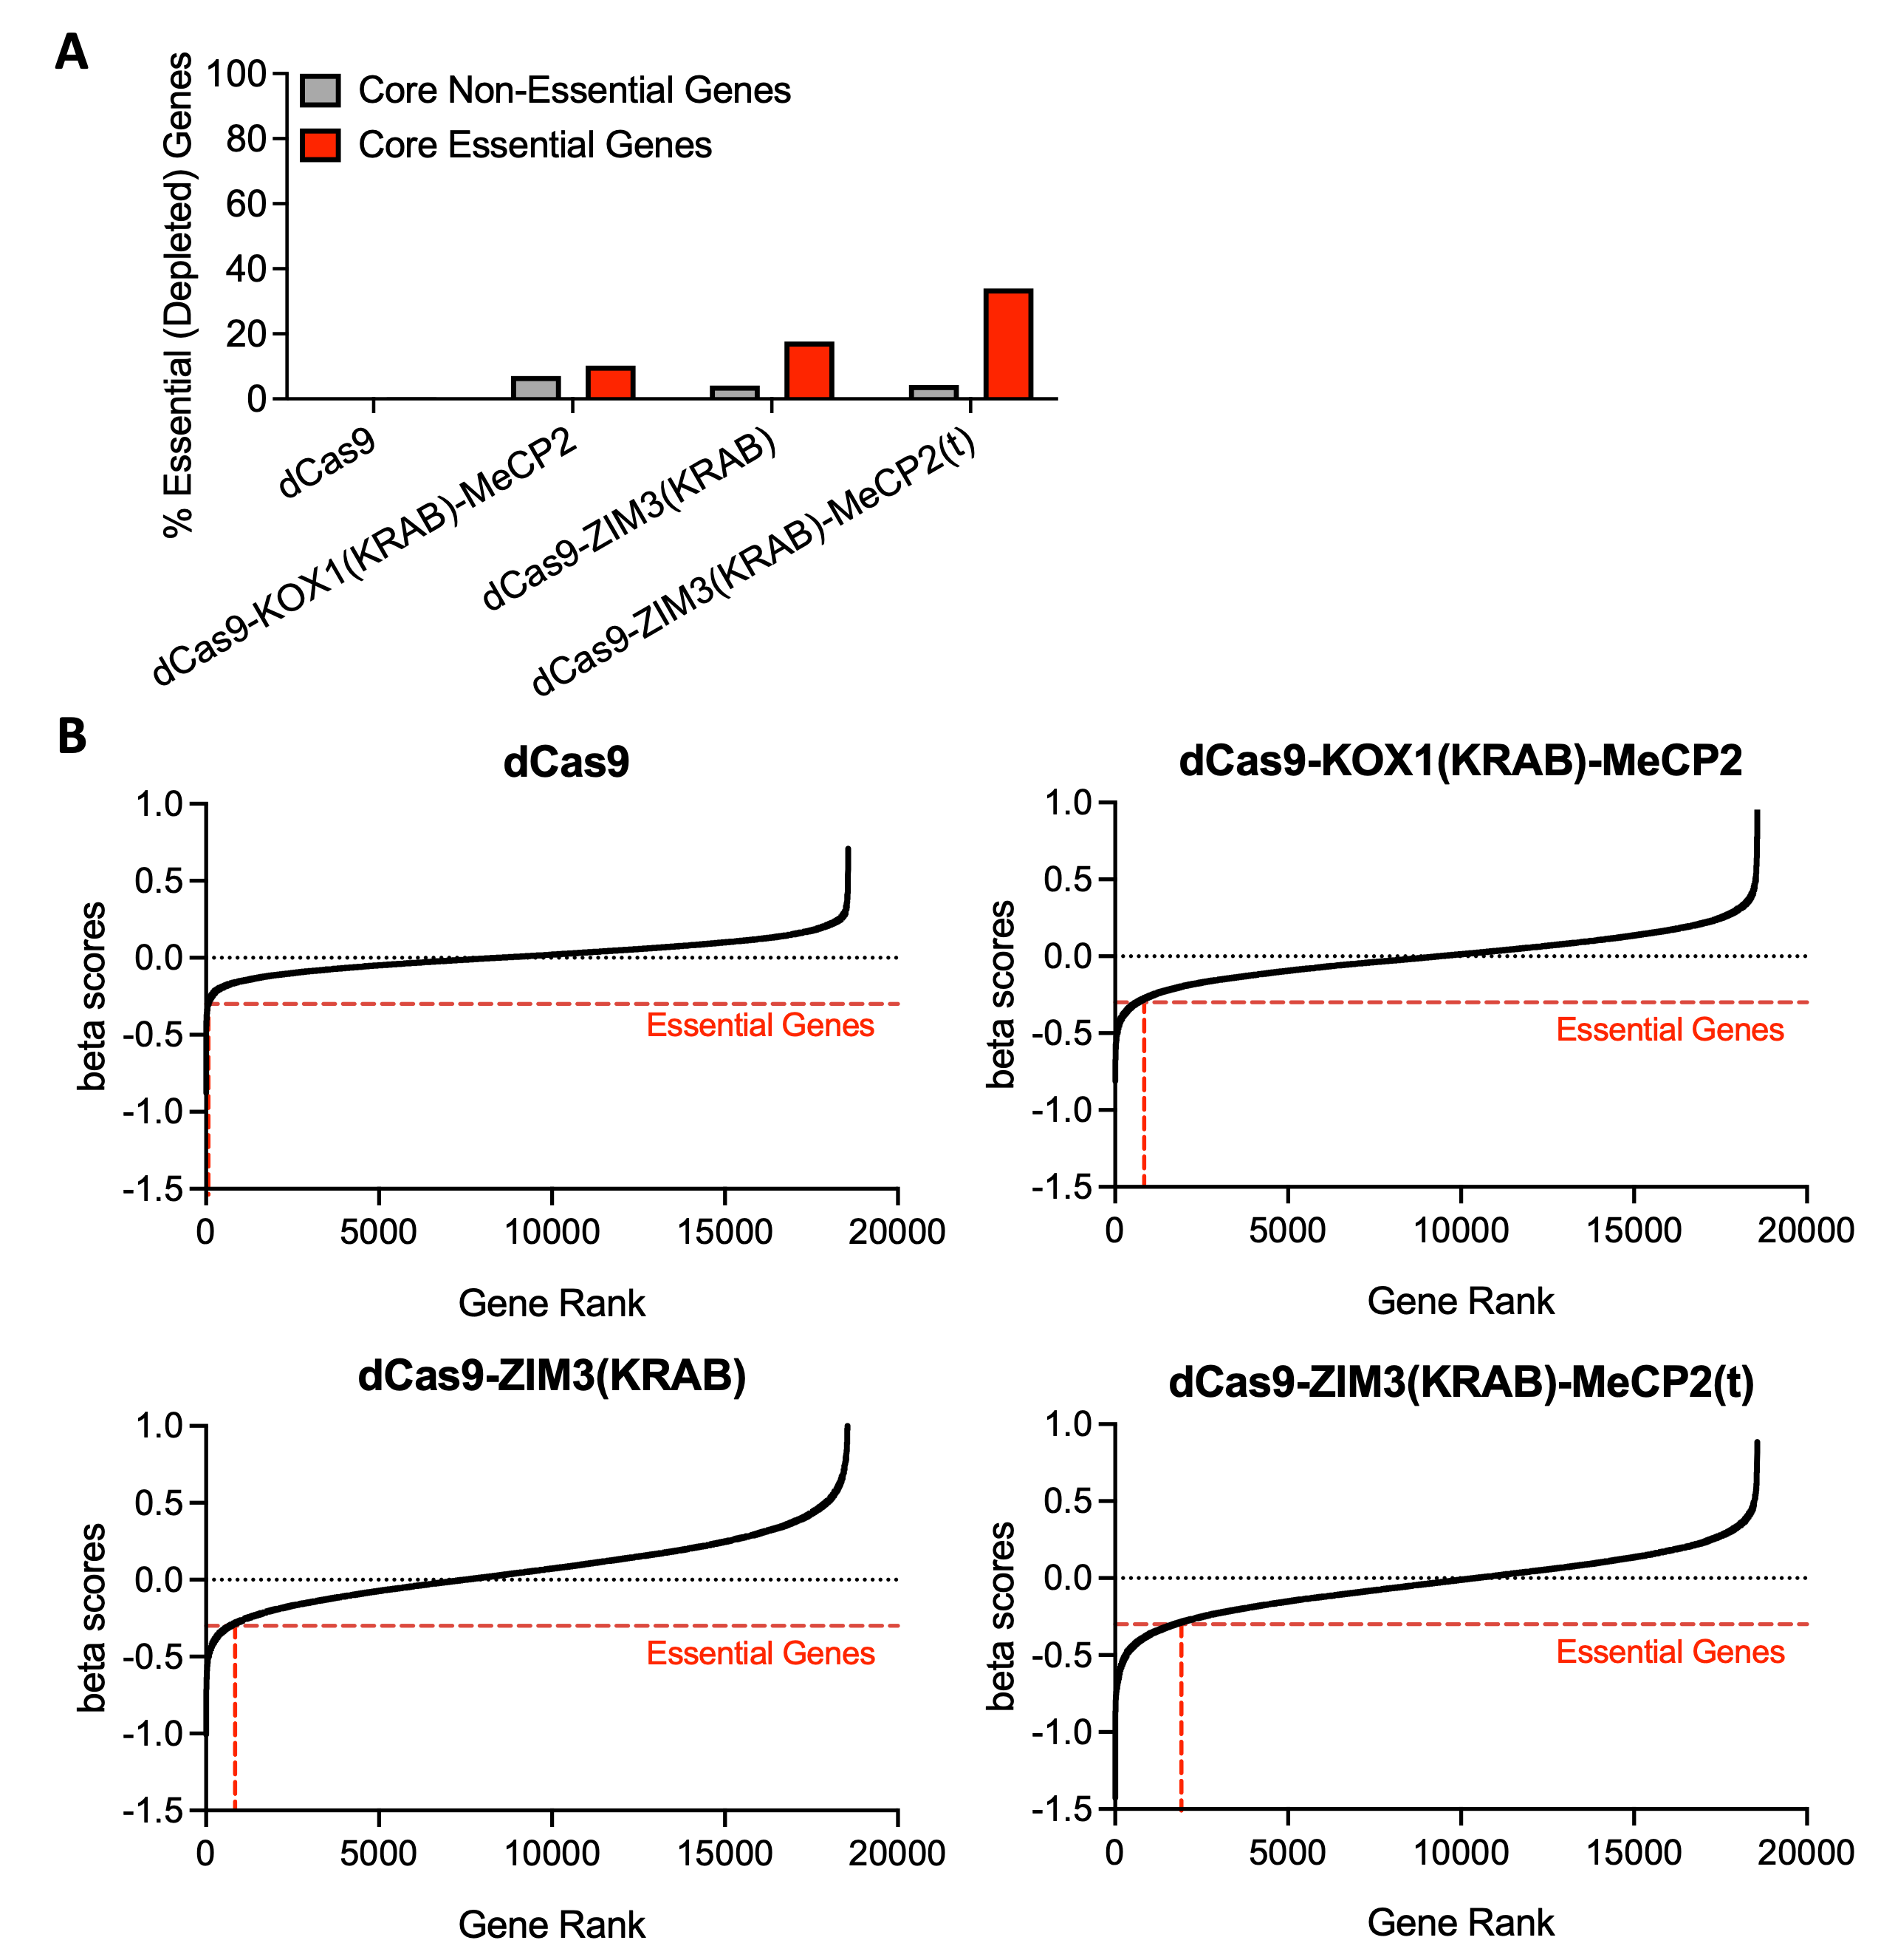
Supplementary Figure S12. dCas9-ZIM3(KRAB)-MeCP2(t) enhances the identification and discovery of essential genes in genome-wide CRISPRi screens. (A) Percentages of previously annotated pan-cancer core essential genes (red bars, N = 215) and non-essential genes (gray bars, N = 542) called as ‘essential genes’ (i.e., significantly depleted due to negative effects on cell proliferation) during CRISPRi dropout screening for 21 days with HCT116 cells stably expressing the indicated dCas9-repressor fusions. Genes with Wald-adjusted p-values < 0.05 and beta scores < -0.3 (as computed by MAGeCK pipeline for n = 2 biological replicates) were deemed as “essential”. A higher percentage of depletion for these core essential genes is desired, as is lower percentage of depletion for non-essential core genes, as seen with the dCas9-ZIM3(KRAB)-MeCP2(t) repressor screen. (B) Gene-level representation (beta) scores for all evaluated genes in HCT116 genome-wide screens. Beta scores < 0 indicate negatively selected (depleted) genes, whereas beta scores > 0 denote positively selected (enriched) genes. Essential genes were called if they had Wald-adjusted p-values < 0.05 and beta scores < -0.3 as quantified by the MAGeCK pipeline with n = 2 independent biological replicates (cell cultures).

