Additional file 1
Fig S1. The forest plots of the eight independent lead SNPs in the NPC meta-GWAS. The odds ratio (OR), 95% confidence interval (CI) and P value for each SNP were calculated by logistic regression and combined using fixed-effect meta-analysis. The frequency of the indicated effective allele for each SNP is shown for each study sample and the combined sample.
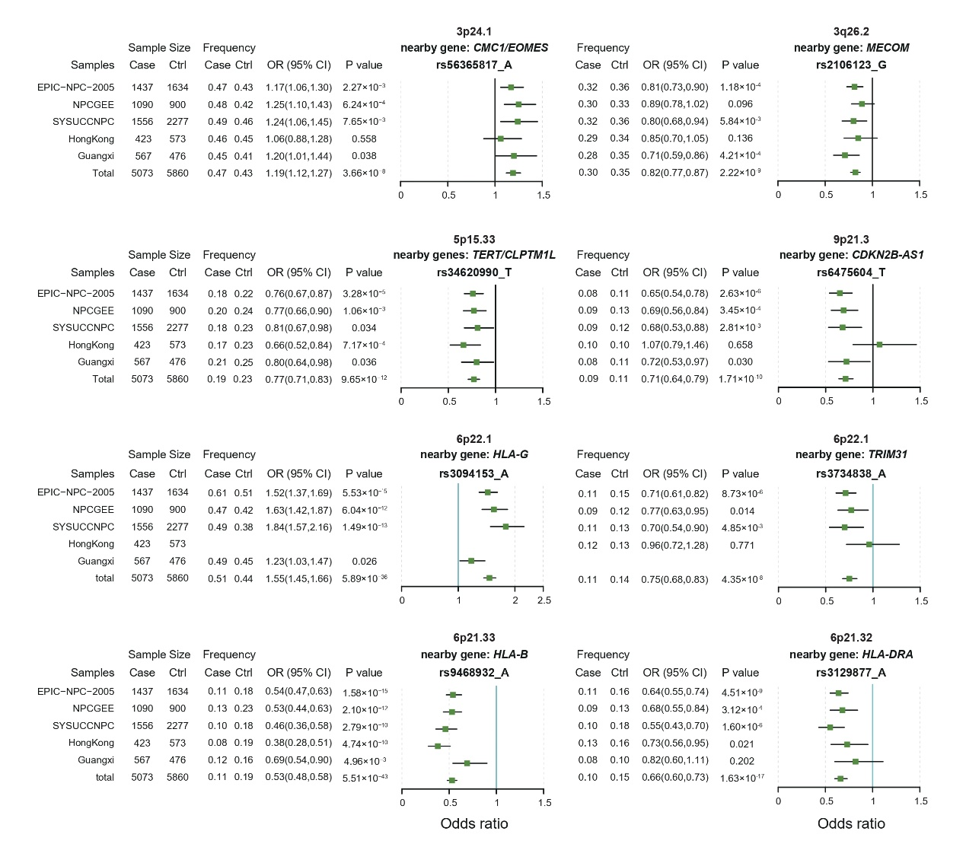

Fig S2. The UMAP plots showing the normalized expression level of the classical markers for the six major cell types including T and NK cells, B cells, epithelial cells, myeloid cells, fibroblasts and endothelial cells.
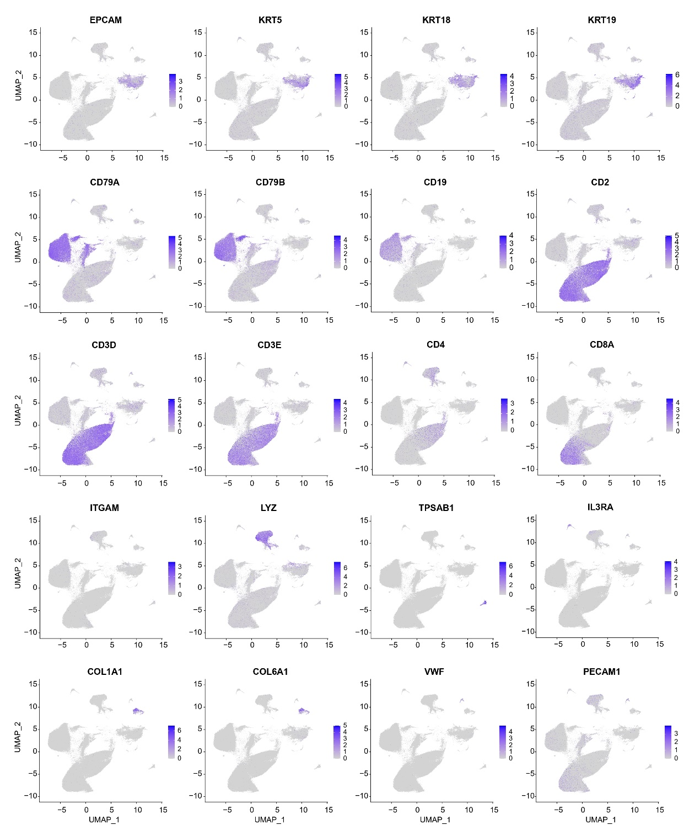

Fig S3. T and NK cells, B cells, and myeloid cells were assigned to 23 cell subtypes according to the expression of the marker genes. The UMAP plots show the distribution of cell subtypes for T and NK cells (a), B cells (c), and myeloid cells (e). The dot plots demonstrate the average expression of the specific markers among the cell subtypes for T and NK cells (b), B cells (d), and myeloid cells (f). The dot size represents the expression percentage and the dot color represents the scaled expression level.
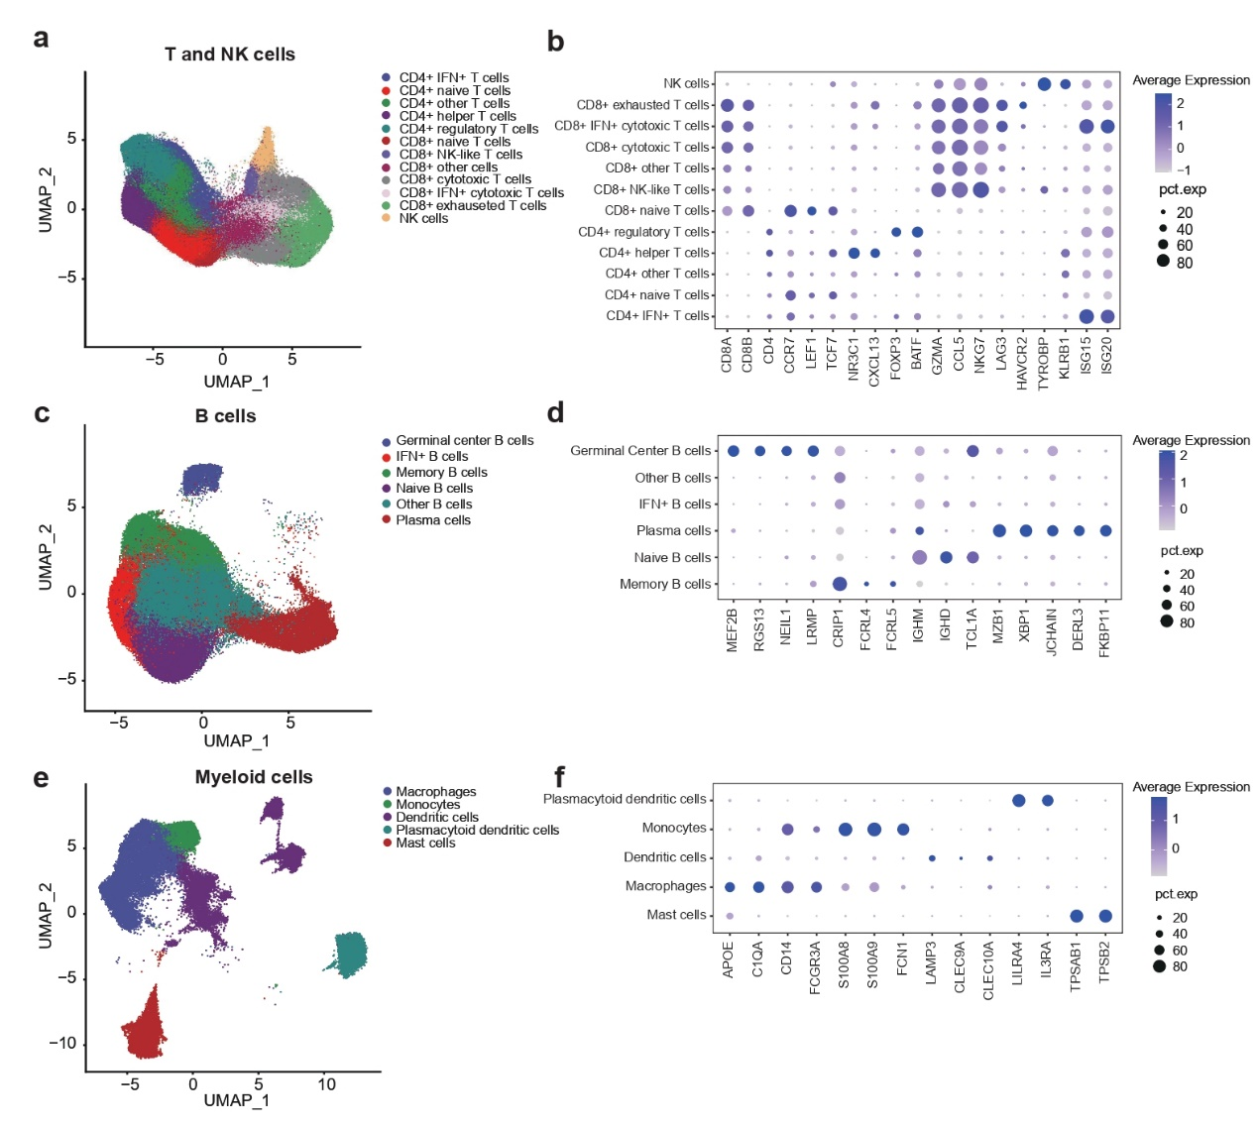

Fig S4. The heatmap showing the inferred large-scale copy number variations (CNVs) in epithelial cells. The inferred CNV patterns of the epithelial cells from the normal tissues are shown in the sample bars in dark blue and the NPC tumor tissue is shown in the sample bars in brown. The order of the cells is sorted by the cluster results. The NPC tumor sample P16 from the study of Liu. Y et.al is presented as an example. For the heatmap inside, each row along the y-axis represents a cell and each column along the x-axis represents a chromosome region containing 100 genes. Amplifications are marked in red, and deletions are marked in blue.
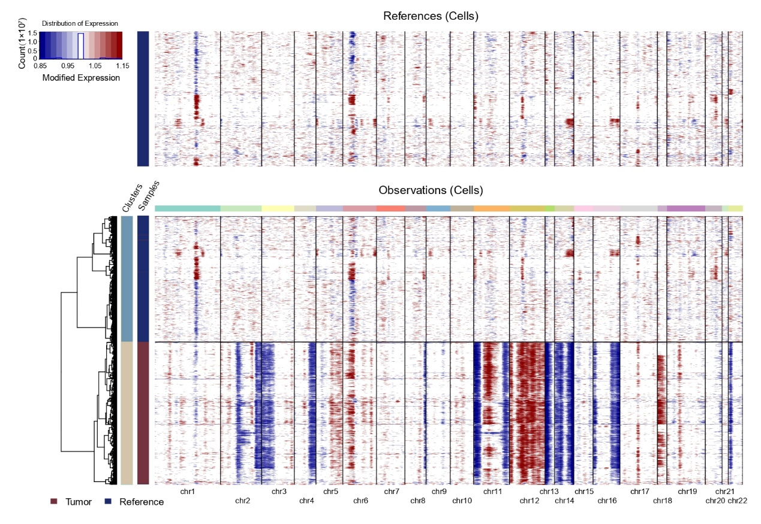
Fig S5. The cell type enrichment results using each of the four 10 × Genomics datasets. a. The cell type enrichment results estimated by using LDSC, MAGMA, and RolyPoly with the HLA region included. The bars represent the maximum -log10 transformed P values of the association using the three methods. The dashed lines denote a significant threshold of P = 0.05. The significantly associated cell types in any one method are labeled in red and the significantly associated cell types in two methods are labeled in purple. b. The cell type enrichment results estimated by using LDSC, MAGMA, and RolyPoly with the HLA region excluded.
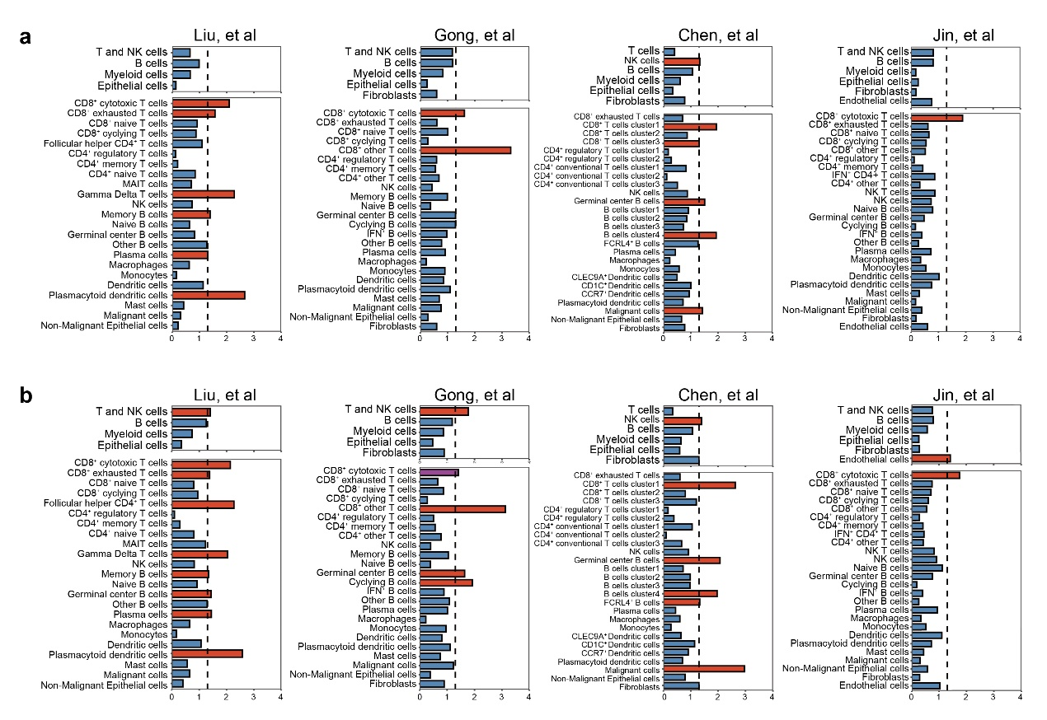
Fig S6. The dot plot demonstrates the expression level of the classical markers in the Smart-seq2 dataset. The dot size represents the proportion of cell expression and the dot color represents the expression level for each marker in the corresponding cell types.
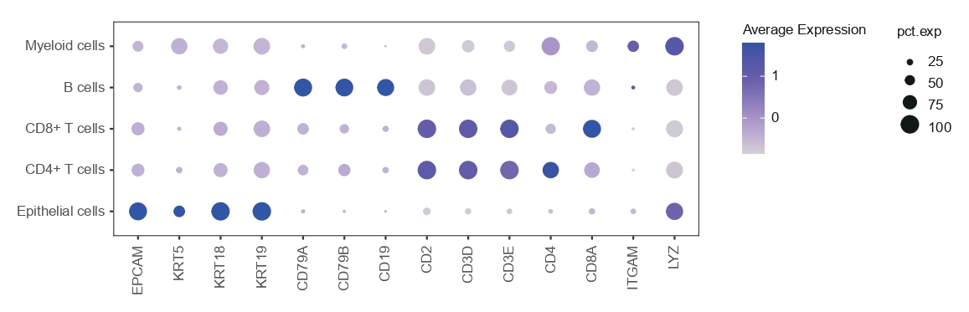
Fig S7. The heritability enrichment for NPC risk in five histone markers modification regions (H3K36me3, H3K4me3, H3K4me1, H3K27ac, and H3K9ac) and the open chromatin regions (DHS) of the tissues from nine categories from the ENTEX and RoadMap database, with the HLA region excluded in the analysis. The y-axis represents the significance strength (-log10(P)), and the color indicates the categories of tissue origin. The dashed line denotes the significant threshold (P = 0.05). The significant tissues are labeled by larger dots.
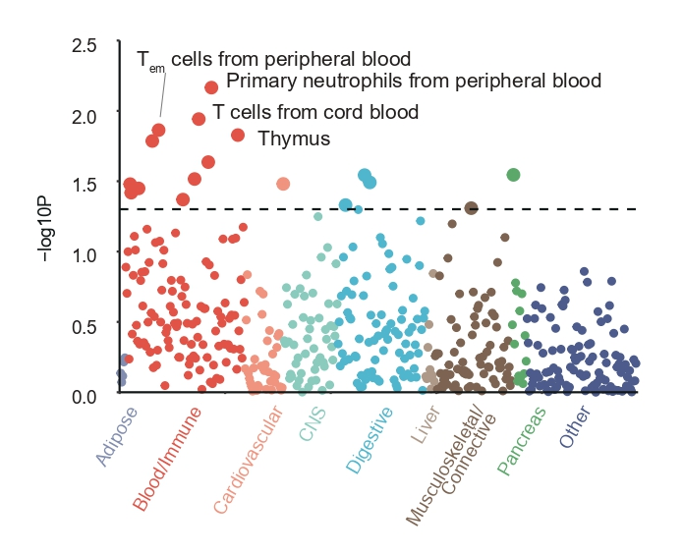

Fig S8. The tissue type enrichment results of NPC susceptibility in 54 tissues from GTEx (v8) and in NPC tumor tissues. These results were estimated by LDSC, MAGMA, and RolyPoly, with the HLA region excluded in the analysis. The bar plot shows the strongest association (-log10(P)) among the three methods. The color indicates the number of methods in which the tissue was significantly enriched.
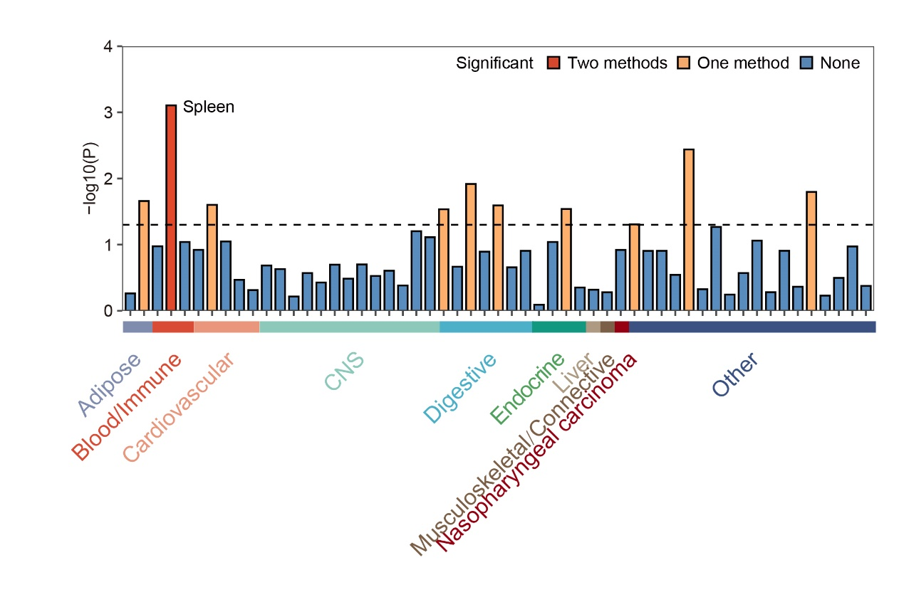

Fig S9. The cellular proportions of the 89 NPC bulk tissues imputed by CIBERSORTx for six major cell types (the upper panel) and 27 cell subtypes (the lower panel).
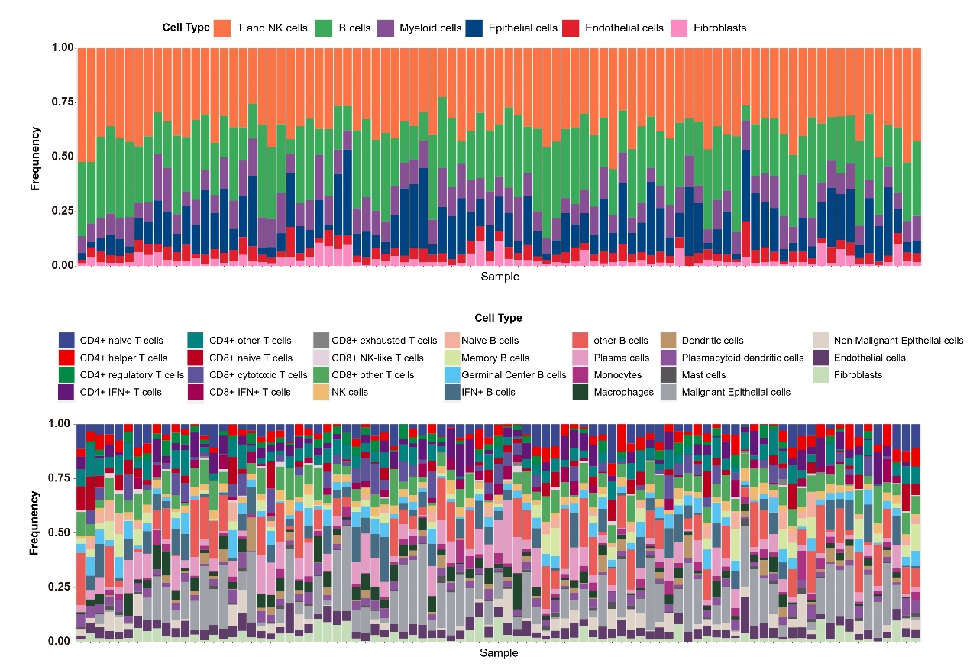

Fig S10. The correlation matrix plot showing the Pearson correlation of cell proportions imputed by CIBERSORTx of six major cell types (the left panel) or 27 cell subtypes (the right panel) in the NPC bulk tissues.
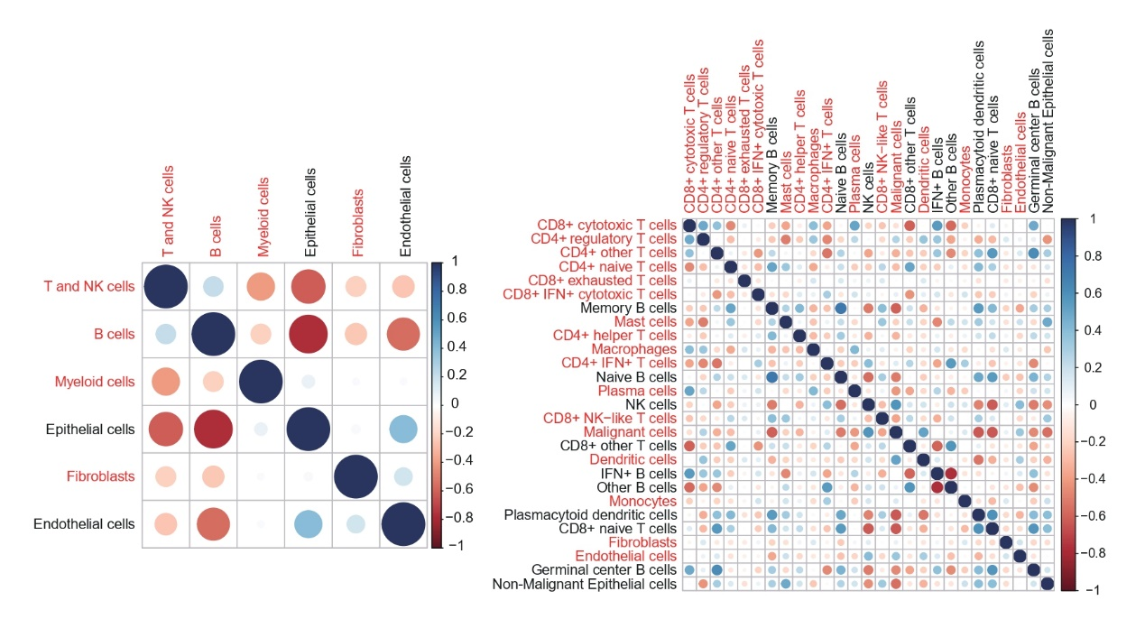

Fig S11. The results of pathway enrichment analysis of 234 genes identified in E-MAGMA and H-MAGMA. The 34 significant IPA canonical pathways with an FDR-adjusted P value (P_{adj}) < 0.01 and an enrichment ratio > 5% (the number of genes overlapped/the number of genes in the gene set) in different pathway categories are shown. The bar plot in the upper panel shows the significant strength (-log10 transformed P_{adj}), and the dot plot in the lower panel shows the categories of the pathway.
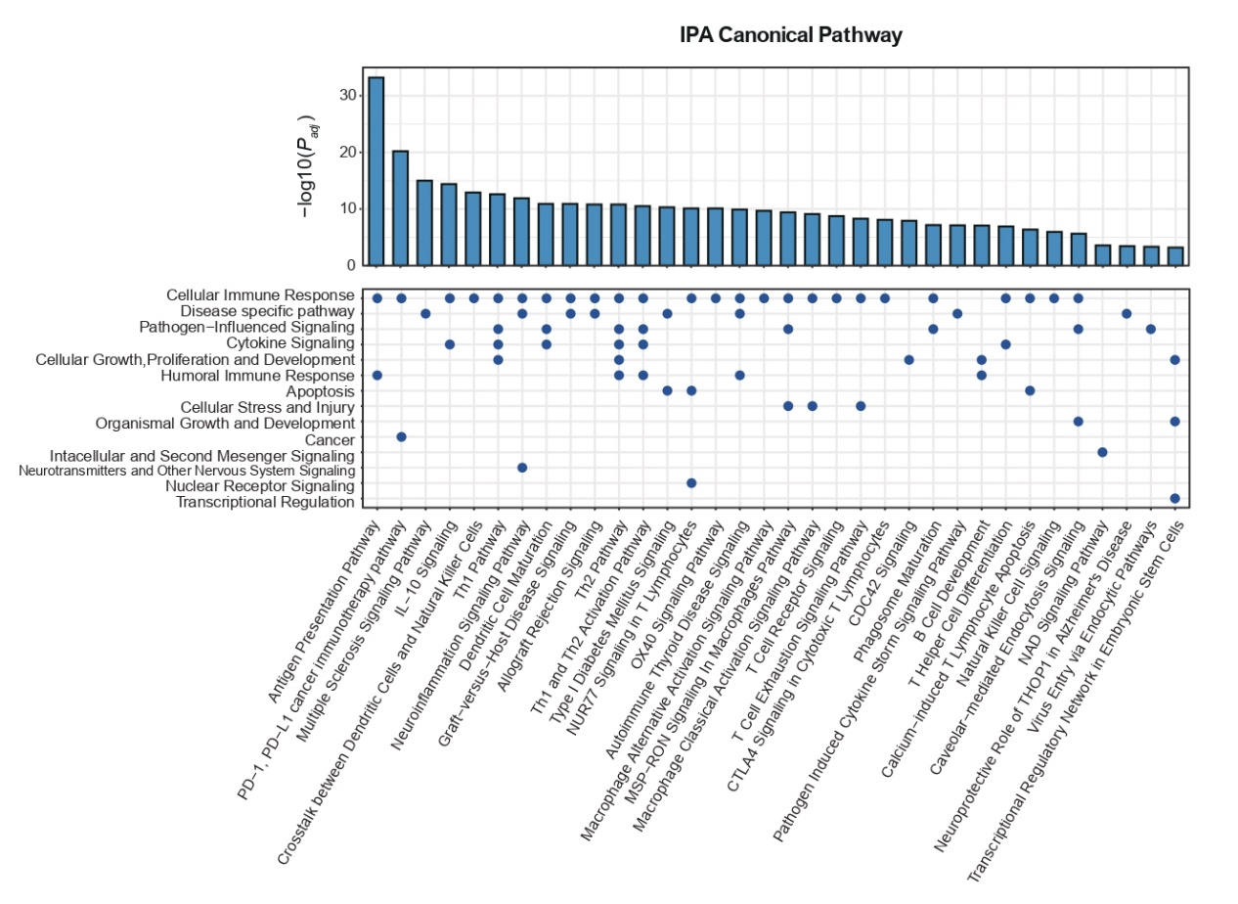
Fig S12. The results of gene set enrichment analysis of 234 genes identified in E-MAGMA and H-MAGMA. A total of 99 significant GO-terms with P_{adj} < 0.01 and enrichment ratio > 5% are shown. The y-axis represents the -log10 transformed P_{adj}, and the x-axis represents the enrichment ratio. The dots in different colors denote the significant GO terms in different categories, and the most significant GO term within each category is labeled.
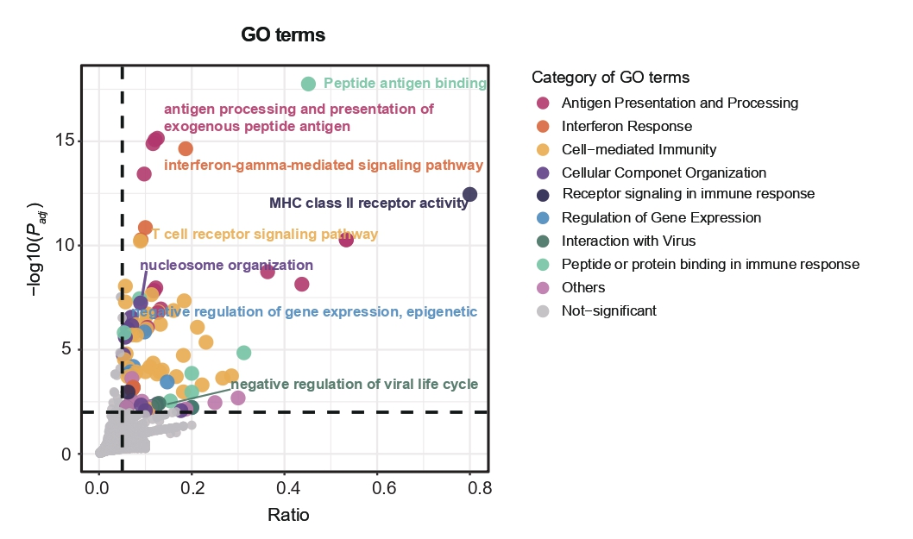
Fig S13. The associations between EOMES expression in T cells and the genotypes of three other functional SNPs rs75831157 (a), rs7633786 (b) and rs60425255 (c) from the ImmuNexUT database.
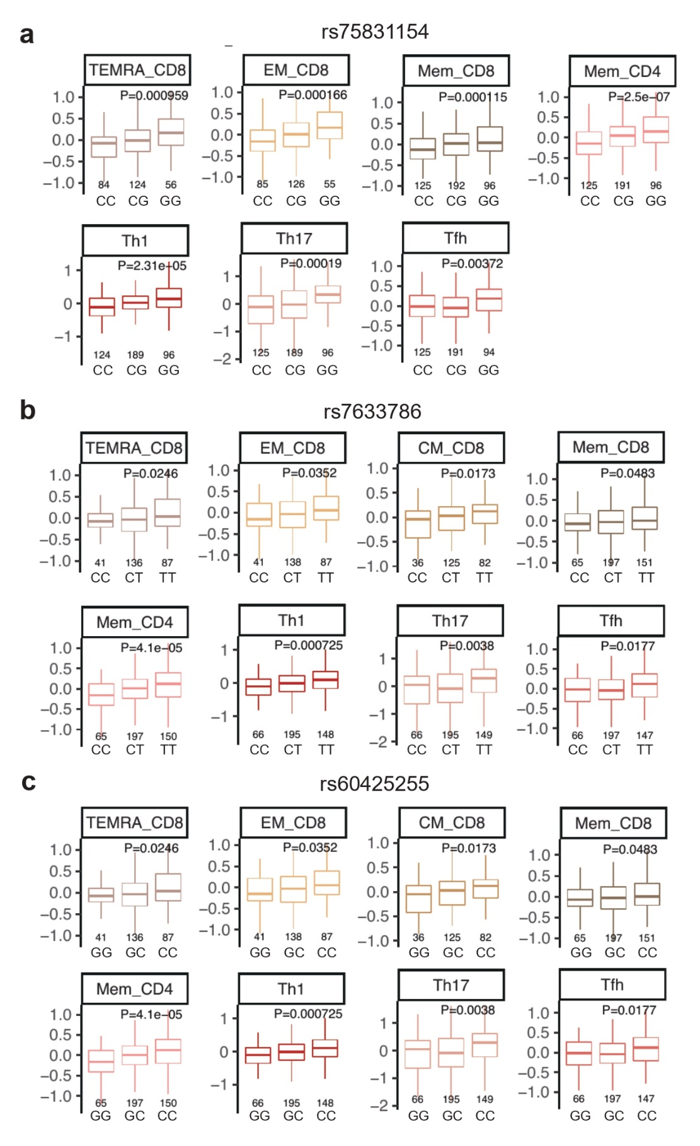
Fig S14. The boxplot showing the results of differentially binding analysis using ChIP-seq data (H3K4me1, H3K4me3, and H3K27ac) from 127 cell types and tissues from Roadmap as well as from the NPC cell lines. The 127 cell types and tissues from Roadmap as well as the NPC cell lines were grouped into eleven categories according to their tissue of origin. The fold-change relative to input between T cells and other categories of cells was compared for the two regions and P value was calculated by using “DiffBind” package.
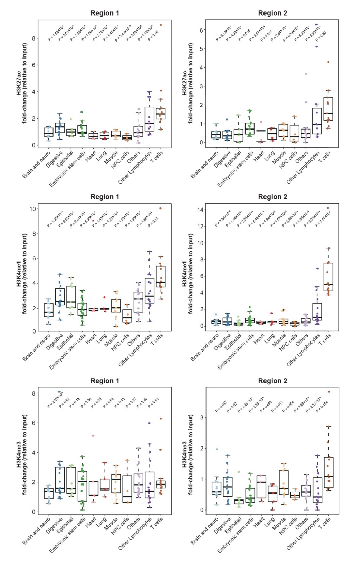

Fig S15. The protein abundance of EOMES in Jurkat T cells and NPC C666-1 cells detected by western blotting.
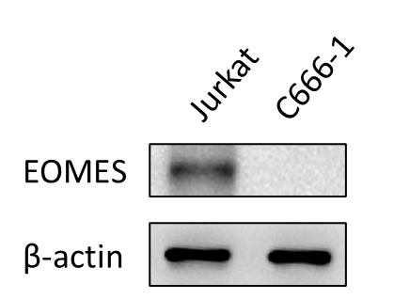

Fig S16. The boxplots showing CD8⁺ T cell fractions imputed by CIBERSORTx among the samples with high EOMES and low EOMES expression in two NPC bulk datasets (N = 89 on the left panel and N = 113 on the right panel). A two-sided Wilcoxon rank sum test was used to calculate P values.
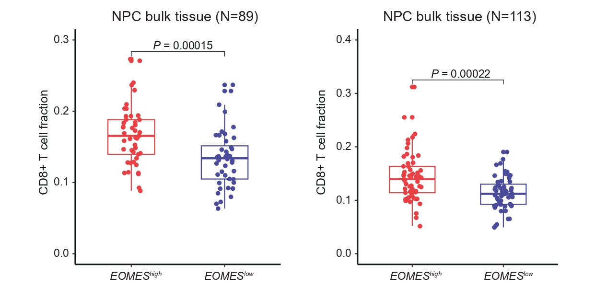

Fig S17. The Spearman correlation between the expression level of EOMES and the five exhaustion markers in two NPC bulk tissue datasets (a) N = 113[57] and (b) N = 89[33].
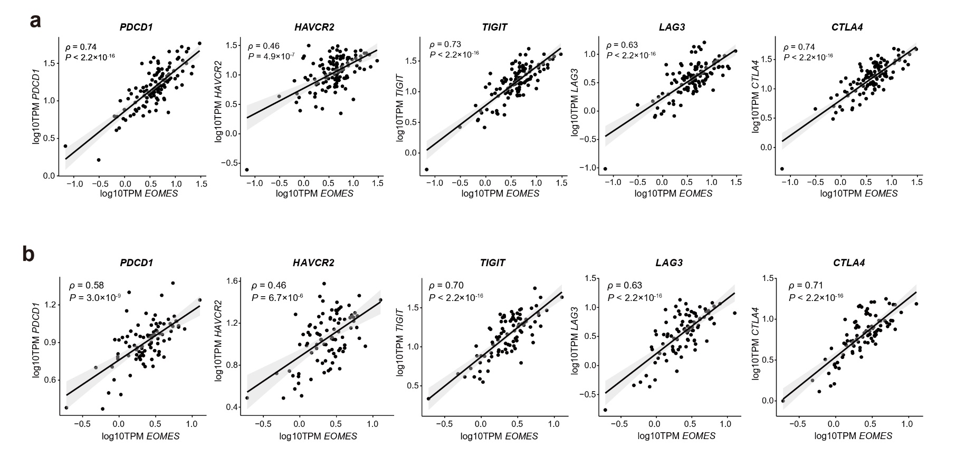

Table S1: Demographic information for the five samples in the GWAS analysis
Study | Cases (Patients with NPC) |  |  |  | Controls (Subjects without cancer)
Study | N | Males | Females | Age (IQR) | N | Males | Females | Age (IQR)
EPIC-NPC-2005 | 1437 | 1050 | 387 | 45(38-54) | 1634 | 1163 | 471 | 49(42-57)
NPCGEE | 1090 | 799 | 291 | 47(41-56) | 900 | 654 | 246 | 47(41-55)
SYSUNPC | 1556 | 1139 | 417 | 43(37-51) | 2277 | 1404 | 873 | 62(58-69)
Hong Kong | 423 | 321 | 102 | 53(45-60) | 573 | 349 | 224 | 51(40-58)
Guangxi | 567 | 405 | 162 | 47(38-54) | 476 | 332 | 144 | 47(38-54)

Table S2: The lead SNPs identified in the meta-GWAS of nasopharyngeal carcinoma.
SNP | CHR | BP | cytoband | nearby gene | A1 | A2 | EAF cases | EAF ctrl | OR (95% CI) | P value
rs56365817 | 3 | 28272478 | 3p24.1 | CMC1/EOMES | A | T | 0.47 | 0.43 | 1.19(1.12,1.27) | 3.66×10⁻⁸
rs2106123 | 3 | 169057657 | 3q26.2 | MECOM | G | A | 0.30 | 0.35 | 0.82(0.77,0.87) | 2.22×10⁻⁹
rs34620990 | 5 | 1338523 | 5p15.33 | TERT/CLPTM1L | T | TG | 0.19 | 0.23 | 0.77(0.71,0.83) | 9.65×10⁻¹²
rs6475604 | 9 | 22052734 | 9p21.3 | CDKN2B-AS1 | T | C | 0.09 | 0.11 | 0.71(0.64,0.79) | 1.71×10⁻¹⁰
rs3094153 | 6 | 29838880 | 6p22.1 | HLA-G | A | G | 0.51 | 0.44 | 1.55(1.45,1.66) | 5.89×10⁻³⁶
rs3734838 | 6 | 30080231 | 6p22.1 | TRIM31 | A | G | 0.11 | 0.14 | 0.75(0.68,0.83) | 4.35×10⁻⁸
rs9468932 | 6 | 31264823 | 6p21.33 | HLA-B | A | G | 0.11 | 0.19 | 0.53(0.48,0.58) | 5.51×10⁻⁴³
rs3129877 | 6 | 32408597 | 6p21.32 | HLA-DRA | A | G | 0.10 | 0.15 | 0.66(0.60,0.73) | 1.63×10⁻¹⁷
CHR: the chromosome of the SNP. BP: the physical position of the SNP in the hg19 genome.
A1: the effective allele in the association. A2: the other allele in the association. EAF: effective allele frequency.
OR: odds ratio. 95% CI: 95% confidence interval. The ORs, 95% CI and P values were calculated by fixed-effect meta-analysis.

Table S3: Conditional regression analysis of the HLA locus by GCTA-COJO identified four independent SNPs.
CHR | SNP | BP | cytoband | nearby gene | Effective Allele | OR (95% CI) | P | OR_J (95% CI) | P_J
6 | rs3094153 | 29838880 | 6p22.1 | HLA-G | A | 1.55(1.45,1.66) | 5.89×10⁻³⁶ | 1.54(1.44,1.65) | 4.20×10⁻³⁴
6 | rs3734838 | 30080231 | 6p22.1 | TRIM31 | A | 0.75(0.68,0.83) | 4.35×10⁻⁸ | 0.69(0.63,0.77) | 4.65×10⁻¹²
6 | rs9468932 | 31264823 | 6p21.33 | HLA-B | A | 0.53(0.48,0.58) | 5.51×10⁻⁴³ | 0.53(0.49,0.58) | 1.43×10⁻⁴⁰
6 | rs3129877 | 32408597 | 6p21.32 | HLA-DRA | A | 0.66(0.60,0.73) | 1.63×10⁻¹⁷ | 0.68(0.62,0.75) | 3.80×10⁻¹⁵
CHR: the chromosome of the SNP. BP: the physical position of the SNP in the hg19 genome.
OR: odds ratio. 95% CI: 95% confidence interval. The ORs, 95% CI and P values were calculated by fixed-effect meta-analysis.
OR_J: the odds ratio in the joint analysis. P_J: the P value in the joint analysis. The OR_J, 95% CI and P_J were estimated by joint regression analysis of the four SNPs by using GCTA-COJO[103].

Table S4: The single-cell transcription datasets used in the analysis.
Platform | Datasets | NPC tissues | Cell Numbers | Non-malignant NP tissue | Cell Numbers | Lymph node metastasis tissues | Cell Numbers
10 × Genomics | Jin SL et.al[28] | 16 | 143876 | 7 | 49260 | / | /
10 × Genomics | Chen YP et.al[29] | 15 | 109254 | 1 | 10230 | / | /
10 × Genomics | Liu Y et.al[26] | 10 | 69030 | 0 | 0 | / | /
10 × Genomics | Gong LQ et.al[27] | 11 | 40746 | 3 | 17444 | / | /
Smart-seq2 | Jin SL et.al[28] | 3 | 650 | / | / | 3 | 742

Table S5: The cell markers used for the cell annotation.
Platform | Group | Cell type | Marker
10× Genomics | major cell types | Epithelial cells | EPCAM, KRT5, KRT18, KRT19
10× Genomics | major cell types | T and NK cells | CD2, CD3D, CD3E, CD4, CD8
10× Genomics | major cell types | B cells | CD79A, CD79B, CD19
10× Genomics | major cell types | Myeloid cells | ITGAM, LYZ, TPSAB1, IL3RA
10× Genomics | major cell types | Fibroblasts | COL1A1, COL6A1
10× Genomics | major cell types | Endothelial cells | VWF, PECAM
10× Genomics | cell subtypes | CD4⁺IFN⁺ T cells | CD4, ISG15, ISG20
10× Genomics | cell subtypes | CD4⁺ naïve T cells | CD4, CCR7, LEF1, TCF7
10× Genomics | cell subtypes | CD4⁺ helper T cells | CD4, NR3C1 CXCL13
10× Genomics | cell subtypes | CD4⁺ regulatory T cells | CD4, FOXP3, BATF
10× Genomics | cell subtypes | CD4⁺ other T cells | CD4
10× Genomics | cell subtypes | CD8⁺ naïve T cells | CD8, CCR7, LEF1, TCF7
10× Genomics | cell subtypes | CD8⁺ NK-like T cells | CD8, GNLY, NKG7, TYROBP, KLRB1
10× Genomics | cell subtypes | CD8⁺ cytotoxic T cells | CD8, GZMA, CCL5, NKG7
10× Genomics | cell subtypes | CD8⁺IFN⁺ cytotoxic T cells | CD8, ISG15, ISG20, GZMA, CCL5
10× Genomics | cell subtypes | CD8⁺ exhausted T cells | CD8, HAVCR2, LAG3
10× Genomics | cell subtypes | CD8⁺ other T cells | CD8
10× Genomics | cell subtypes | NK cells | TYROBP, KLRB1, FCER1G
10× Genomics | cell subtypes | Germinal center B cells | MEF2B, RGS13, NEIL1, LRMP
10× Genomics | cell subtypes | Memory B cells | CRIP1, FCRL4, FCRL5
10× Genomics | cell subtypes | Naïve B cells | IGHM, IGHD
10× Genomics | cell subtypes | Plasma cells | MZB1, XBP1, JCHAIN, DERL3, FKBP11
10× Genomics | cell subtypes | IFN⁺ B cells | ISG15, ISG20
10× Genomics | cell subtypes | Other B cells | CD79A, CD79B, CD19
10× Genomics | cell subtypes | Macrophages | APOE, C1QA, FCRG3A
10× Genomics | cell subtypes | Monocytes | S100A9, S100A8, FCN1
10× Genomics | cell subtypes | Dendritic cells | LAMP3, CLEC9A, CLEC10A, CPVL
10× Genomics | cell subtypes | Plasmacytoid dendritic cells | IL3RA, LILRA4
10× Genomics | cell subtypes | Mast cells | TPSAB2, TPSB2
Smart-seq2 | major cell types | Myeloid cells | LYZ, ITGAM
Smart-seq2 | major cell types | B cells | CD79A, CD79B, CD19
Smart-seq2 | major cell types | CD8⁺ T cells | CD2, CD3D, CD3E, CD8
Smart-seq2 | major cell types | CD4⁺ T cells | CD2, CD3D, CD3E, CD4
Smart-seq2 | major cell types | Epithelial cells | EPCAM, KRT5, KRT18, KRT19

