Supporting Information

Enrichable cross-linkers for mapping direct protein interactions

Ting Wu, Hang-Xu Zhou, Jing Tian, Rong Zhou, Shangwei Huangfu, Bi-Kun Jin, Anna Sablina, Fangfang Zhou, Hongli Chen, ShiBing Tang, Long Zhang, Bing Yang

Contents
Supplementary Figures 1
Fig. S1. Process of biotin labeling by click chemistry. 1
Fig. S2. Spike-in experiment for evaluating efficiency of cross-linked peptide enrichment. 2
Fig. S3. CCK-8 analysis of cell viability under treatments of cross-linker. 3
Fig. S4. Comparison of TIC before and after biotin enrichment. 5
Fig. S5. ePDES2 mediated cross-linking and control. 6
Fig. S6. FAIMS fractionation and analysis of identified TPX interactome. 7
Fig. S7. Comparison of the number of identified ePDES1 and ePDES2 cross-linking peptides from TXN1 samples by biotin enrichment and IMAC enrichment. 8
Fig. S8. Representative high-quality tandem mass spectra of identified TXN1 Cys32 cross-linked peptides. 9
Fig. S9. Tandem mass spectra of cross-linked TXN1/PRDX1 complex. 10
Fig. S10. The mass spectra of identified cross-linking peptides between TXN1 and AMPK1, AMPK2 and CypA, respectively. 11
Fig. S11. TXN1 has no influence in AMPK1/2 activation and kinase activity. 12
Fig. S12. Double Knockout of AMPK1 and 2 slightly increase the level of oxidized Trx1 in mouse MEF cells. 13
Fig. S13. Validation of protein interactions between TXN1 and its binding proteins. 14
Fig. S14. STRING score of identified TXN1 interacting proteins. 15
Fig. S15. KEGG and GO functional analysis of identified core proteins cross-linked to TXN1 by BVSB, PDES, ePDES1 and ePDES2 simultaneously. 16
Fig. S16. NBD tagged ePDES2 can penetrate into all spaces within the cell. 17
Fig. S17. ePDES1 and ePDES2 successfully trapped multiple endogenous interacting proteins of TXN1 with NLS in live cell. 18
Fig. S18. Ratio of proteins with nuclear location in identified TXN1 interacting proteins. 19
Fig. S19. Subcellular fractionation of nucleus revealed the specific localizations of HA-tagged TXN1-NLS and identified endogenous interacting proteins. 20
Fig. S20. Capturing direct interacting proteins and substrates of TXN2 in mitochondria. 21
Fig. S21. Subcellular fractionation of mitochondria revealed the specific localizations of overexpressed TXN2 and identified endogenous interacting proteins. 23
Fig. S22. Overall subcellular distribution of all identified TXN1 and TXN2 active sites Cys cross-linked interacting proteins by XL-MS. 24
Supplementary Notes 25
Supplementary Note 1. Synthesis of ePDES1 and ePDES2. 25
Supplementary Note 2. Synthesis of AZPA. 34
Supplementary Note 3. Synthesis of ePDMS. 37
Supplementary Note 4. Synthesis of ePDES-NBD. 43

Supplementary Figures
Fig. S1. Process of biotin labeling by click chemistry. The alkyne group of both ePDES1 and ePDES2 reacted with biotin-PEG3-azide to covalently label biotin group to the backbone of both cross-linkers.

Fig. S2. Spike-in experiment for evaluating efficiency of cross-linked peptide enrichment.

Fig. S3. CCK-8 analysis of cell viability under treatments of cross-linker.

Fig. S4. Comparison of TIC before and after biotin enrichment. (a) The TIC of input sample from TXN1 cross-linking complexes by ePDES1 in three technical repeats. (b) The TIC of biotin enriched sample from TXN1 cross-linking complexes by ePDES1 in three technical repeats. (c) The TIC of input sample from TXN1 cross-linking complexes by ePDES2 in three technical repeats. (d) The TIC of biotin enriched sample from TXN1 cross-linking complexes by ePDES2 in three technical repeats.

Fig. S5. ePDES2 mediated cross-linking and control. (a) The structure of non-reactive ePDMS and ePDES2. (b) Western blot analysis showed that ePDES2 can capture interacting proteins of TXN1 in living cells, but not ePDMS. (c) No cross-linked peptides were identified in negative control experiments.

Fig. S6. FAIMS fractionation and analysis of identified TPX interactome. (a) Number of identified ePDES1 and ePDES2 cross-linking peptides through IMAC enrichment without Lambda phosphatase treatment by single shot or FAIMS fractionation. (b) Venn showed number of overlapped ePDES1 cross-linking peptides and ePDES2 cross-linking peptides with FAIMS fractionation. (c) Number of all identified TPX Cys61 and Cys95 cross-linked peptides in our study. (d) KEGG analysis of all identified TPX interacting proteins.

Fig. S7. Comparison of the number of identified ePDES1 and ePDES2 cross-linking peptides from TXN1 samples by biotin enrichment and IMAC enrichment. (a) Number of identified ePDES1 cross-linking peptides through biotin enrichment in three technical repeats. (b) Venn showed number of identified ePDES1 cross-linking peptides with IMAC enrichment in three technical repeats. (c) Number of identified ePDES2 cross-linking peptides through biotin enrichment in three technical repeats. (d) Venn showed number of identified ePDES2 cross-linking peptides with IMAC enrichment. (e-f) Comparison the number of identified ePDES1 (e) and ePDES2 (f) cross-linking peptides through two kinds of enrichment methods.
Fig. S8. Representative high-quality tandem mass spectra of identified TXN1 Cys32 cross-linked peptides. (a) Tandem mass spectrum of inter-protein cross-linked peptide between TXN1 active Cys32 and TXND17 Cys43. (b) Tandem mass spectrum of inter-protein cross-linked peptide between TXN1 Cys32 and TXND12 Cys66.
Fig. S9. Tandem mass spectra of cross-linked TXN1/PRDX1 complex. (a) Tandem mass spectrum of inter-protein cross-linked peptide between TXN1 active Cys73 and PRDX1 Cys173. (b) Tandem mass spectrum of inter-protein cross-linked peptide between TXN1 active Cys32 and PRDX1 Cys173.

Fig. S10. The mass spectra of identified cross-linking peptides between TXN1 and AMPK1, AMPK2 and CypA, respectively. (a) TXN1 Cys73 was cross-linked with AMPK2 Cys382 by ePDES2. (b) TXN1 Cys73 was cross-linked with AMPK1 Cys185 or AMPK2 Cys174 by ePDES2. (c) TXN1 Cys73 was cross-linked with CypA Cys52 by ePDES2.

Fig. S11. TXN1 has no influence in AMPK1/2 activation and kinase activity. After knock down TXN1 with shRNAs, there were no changes in phosphorylation levels of AMPK1/2 T172 and their well-known substrates, including Raptor and ULK1.

Fig. S12. Double Knockout of AMPK1 and 2 slightly increase the level of oxidized Trx1 in mouse MEF cells. (a) Workflow of detecting the redox state of Trx1 under different treatments. (b) Western blot analysis showing that the oxidized Trx1 was slightly increased in AMPK1 and 2 double knockout cells in all three biological repeats.

Fig. S13. Validation of protein interactions between TXN1 and its binding proteins. Western blot analysis showing the interaction between TXN1 and SERA (a), CypA (b), MEPCE (c) and NOSIP (d).

Fig. S14. STRING score of identified TXN1 interacting proteins.

Fig. S15. KEGG and GO functional analysis of identified core proteins cross-linked to TXN1 by BVSB, PDES, ePDES1 and ePDES2 simultaneously.

Fig. S16. NBD tagged ePDES2 can penetrate into all spaces within the cell. (a) Structure and chemical synthesis process of ePDES2-NBD. (b-c) The results of confocal microscopy observation show that the whole living cells treated with NBD-ePDES2 can emit a faint green fluorescence(b), while the cells treated with DMSO do not have fluorescence(c) BF represents the bright field view.
Fig. S17. ePDES1 and ePDES2 successfully trapped multiple endogenous interacting proteins of TXN1 with NLS in live cell. (a-b) Western blot showed ePDES1 (a) and ePDES2 (b) trapping multiple endogenous interacting proteins of TXN1-NLS in live cell. (c-d) Venn diagram showed number of identified cross-linking peptides of ePDES1 (c) and ePDES2 (d) common in three technical replicates.

Fig. S18. Ratio of proteins with nuclear location in identified TXN1 interacting proteins. Total 51.22% of proteins from all identified original TXN1 Cys73 (with no NLS) cross-linked proteins, 60.60% of all identified TXN1-NLS Cys73 cross-linked proteins, and 68.32% of identified unique TXN1-NLS Cys73 cross-linked proteins have nuclear location annotation in Uniprot database.

Fig. S19. Subcellular fractionation of nucleus revealed the specific localizations of HA-tagged TXN1-NLS and identified endogenous interacting proteins. Western blot analysis demonstrated that TXN1-NLS was predominantly localized in the nucleus. Among the identified interacting proteins, the selected unique proteins TXNIP and CH60 were also detected in the nucleus. HA antibody was used for detection of TXN1-NLS. Histone H3 and β-tubulin were detected as nucleus and cytosol marker, respectively.

Fig. S20. Capturing direct interacting proteins and substrates of TXN2 in mitochondria. (a-b) Western blot showed ePDES1 (a) and ePDES2 (b)trapping multiple endogenous interacting proteins of TXN2 in live cell. (c) Ratio of identified mitochondrial proteins cross-linked to TXN2 active Cys90, the location information extracted from Uniprot database. (d) Biological function analysis of identified interacting proteins cross-linked to TXN2 Cys90. (e) Tandem mass spectrum of cross-linking peptides between PRDX3 Cys229 and TXN2 Cys90.

Fig. S21. Subcellular fractionation of mitochondria revealed the specific localizations of overexpressed TXN2 and identified endogenous interacting proteins. Western blot analysis indicated that TXN2 was specifically localized in the mitochondria. Notably, the selected unique interacting proteins EEF2 and CH60 were found to localize within the mitochondria. His-tag antibody was used for detection of overexpressed TXN2. COX IV and β-tubulin were detected as mitochondria and cytosol marker, respectively.

Fig. S22. Overall subcellular distribution of all identified TXN1 and TXN2 active sites Cys cross-linked interacting proteins by XL-MS. The subcellular distribution was gotten from DeepLoc 2.1 and KEGG analysis of different clusters were annotated.

Supplementary Notes

Supplementary Note 1. Synthesis of ePDES1 and ePDES2.
Scheme 1. Synthesis of ePDES1. Sonogashira coupling of 5-iodobenzene-1,3-diamine and ethynyltrimethylsilane produced compound 1. After condensation with 2-chloroethane-1-sulfonyl chloride under basic condition, compound 2 was obtained. The protective group TMS was cleaved by KF, which generated the desired product 3.

Scheme2. Synthesis of ePDES2. Condensation of methyl 3,5-diaminobenzoate with 2-chloroethane-1-sulfonyl chloride under basic condition produced compound 4, which was hydrolyzed by LiOH to convert into the corresponding carboxylic acid 5. After amidation, the desired product 6 was obtained.
General information. All commercially available reagents and solvents (ACS grade) were purchased from commercial sources and used without further purification. Reactions were monitored by thin-layer chromatography (TLC) carried out on Merck silica gel 60 F-254 thin layer plates using UV light for visualization and an ethanolic solution of phosphomolybdic acid under heat or powdered iodine for developing. Flash column chromatography was generally performed on silica gel (200-300 mesh). LC-MS analyses were performed on the Agilent 1200 HPLC/MCD electrospray mass spectrometer in positive/negative ion mode. The scan range was 100−1000d. The yields refer to chromatographically homogeneous materials. The ¹H and ¹³C NMR spectra were recorded on a Bruker AV-500 or AV-400 spectrometer using CDCl₃ or DMSO-d₆ as solvent. The chemical shifts (δ) are reported in ppm and coupling constants (J) in Hz. The following abbreviations were used to explain the multiplicities: s = singlet, d = doublet, t = triplet. HRMS (High-resolution mass spectra) were conducted by a an Applied Biosystems Q-STAR Elite ESI-LC-MS/MS mass spectrometer under the condition of electrospray ionization (ESI).

Compound 1. A combination of 5-iodobenzene-1,3-diamine (468 mg, 2.0 mmol), (PPh₃)₂PdCl₂ (34 mg, 0.048 mmol), CuI (13 mg, 0.068 mmol) and ethynyltrimethylsilane (1.57 g, 16.0 mmol) in 2.0 mL triethylamine and 8.0 mL dry THF was stirred at ambient temperature overnight. After the completion of the reaction, the supernatant was decanted and the insoluble was washed with THF, the combined organic solution was concentrated under reduced presssure. The desired product was isolated by silica column chromatography to yield compound 1 as brown solid (370 mg, 91% yield). ¹H NMR (500 MHz, CDCl₃) δ 6.24 (2H, br d, J = 1.6 Hz), 5.99 (1H, br t, J = 1.6 Hz), 0.22 (9H, s). MS Calcd for C₁₁H₁₇N₂Si 205.12 [M+H]⁺, found 204.82.

Compound 2. 2-chloroethane-1-sulfonyl chloride (689 mg, 4.23 mmol) was added into a mixture of 1 (369 mg, 1.81 mmol), pyridine (760 mg, 9.61 mmol) and catalytic amount of DMAP (47 mg, 0.38 mmol) in 8 mL DCM being cooled to 0 ºC. The reaction mixture was allowed to warm to room temperature and stirred overnight. The mixture was washed with 1M HCl (2×) and sat. NaHCO₃ (2×) respectively, then brine, dried over anhy. Na₂SO₄, solvent was removed under reduced pressure, the desired product was isolated by silica column chromatography as yellow oil (360 mg, 52% yield). ¹H NMR (500 MHz, DMSO-d₆) δ 10.22 (2H, br s), 7.10 (1H, br t, J = 1.9 Hz), 6.84 (2H, d, J = 1.9 Hz), 6.78 (2H, dd, J = 16.4, 9.9 Hz), 6.14 (2H, d, J = 16.4 Hz), 6.09 (2H, d, J = 9.9 Hz), 0.22 (9H, s).

Compound 3. To a stirred solution of 2 (350 mg, 0.91 mmol) in 4.4 mL DMF was added 0.9 mL aqueous KF (119 mg, 2.05 mmol) at ambient temperature. The reaction mixture was stirred at room temperature for 4 h, then diluted with sat. NH₄Cl and extracted with EA. The organic phase was dried over anhydrous Na₂SO₄ then concentrated to dryness. The residue was purified by silica column chromatography to obtained the desired product as pail yellow oil. (250 mg, 88% yield). ¹H NMR (500 MHz, CDCl₃) δ 7.06 (1H, bt t, J = 1.9 Hz), 7.00 (2H, d, J = 1.9 Hz), 6.82 (2H, br s), 6.56 (2H, dd, J = 16.5, 9.9 Hz), 6.37 (2H, d, J = 16.5 Hz), 6.05 (2H, d, J = 9.9 Hz), 3.11 (1H, s). ¹³C NMR (125 MHz, CDCl₃) δ 137.7, 134.7, 129.4, 124.5, 119.4, 111.7, 81.9, 79.0. HRMS Calcd for C₁₂H₁₃N₂O₄S₂ 313.0311 [M+H]⁺, found 313.0293.

Compound 4. 2-chloroethane-1-sulfonyl chloride (2.16 g, 13.24 mmol) was added into a mixture of methyl 3,5-diaminobenzoate (1.0 g, 6.02 mmol), pyridine (2.38 g, 30.10 mmol) and catalytic amount of DMAP (147 mg, 1.20 mmol) in 30 mL DCM being cooled to 0 ºC. The reaction mixture was allowed to warm to room temperature and stirred for 4.5 h. The mixture was washed with 1M HCl (2×) and sat. NaHCO₃ (2×) respectively, then brine, dried over anhy. Na₂SO₄, solvent was removed under reduced pressure, the desired product was isolated by silica column chromatography as yellow solid (1.28 g, 62% yield). ¹H NMR (500 MHz, DMSO-d₆) δ 10.34 (2H, s), 7.43 (2H, d, J = 1.9 Hz), 7.30 (1H, t, J = 1.9 Hz), 6.77 (2H, dd, J = 16.4, 9.9 Hz), 6.14 (2H, d, J = 16.4 Hz), 6.08 (2H, d, J = 9.9 Hz), 3.82 (3H, s). MS Calcd for C₁₂H₁₅N₂O₆S₂ 347.04 [M+H]⁺, found 347.00.

Compound 5. A solution of 4 (1.28 g, 3.70 mmol) in 18.5 mL THF was cooled to 0 ºC, then an aqueous solution (18.5 mL) of LiOH (354 mg, 14.78 mmol) was added dropwise. The reaction mixture was warmed to room temperature and stirred overnight. pH was adjusted to 3~4 by the dropwise addition of 1 M HCl at 0 ºC and THF was removed under reduced pressure, the aqueous solution was extracted with 10% MeOH/DCM (5×), the combined organic phase was dried over anhy. Na₂SO₄, then concentrated to dryness to obtain the desired product as off-white solid (1.21 g, 98% yield). ¹H NMR (500 MHz, DMSO-d₆) δ 13.09 (1H, br s), 10.28 (2H, s), 7.41 (2H, d, J = 1.9 Hz), 7.27 (1H, t, J = 1.9 Hz), 6.76 (2H, dd, J = 16.4, 9.9 Hz), 6.14 (2H, d, J = 16.4 Hz), 6.08 (2H, d, J = 9.9 Hz).

Compound 6. A combination of 5 (960 mg, 2.89 mmol), HATU (1.65 g, 4.34 mmol), triethylamine (585 mg, 5.78 mmol) and propargylamine (160 mg, 2.89 mmol) in 15 mL dry DMF was stirred at room temperature overnight. The mixture was diluted with EA, then washed with brine (3×), dried over anhy. Na₂SO₄, after concentration, the desired product was isolated by silica column chromatography as yellow oil, which was solified on standing (255 mg, 24% yield). ¹H NMR (500 MHz, DMSO-d₆) δ 10.24 (2H, s), 8.90 (1H, t, J = 5.4 Hz), 7.23 (2H, br d), 7.18 (1H, br t), 6.77 (2H, dd, J = 16.4, 9.9 Hz), 6.14 (2H, d, J = 16.4 Hz), 6.07 (2H, d, J = 9.9 Hz), 3.98 (2H, dd, J = 5.4, 2.2 Hz), 3.12 (1H, t, J = 2.2 Hz). ¹³C NMR (125 MHz, DMSO-d₆) δ 165.8, 138.8, 136.4, 136.0, 128.4, 114.0, 113.1, 81.4, 73.1, 28.8. HRMS Calcd for C₁₄H₁₆N₃O₅S₂ 370.0526 [M+H]⁺, found 370.0526 [M+H]⁺.

¹H NMR of ePDES1.

¹³C NMR of ePDES1.

¹H NMR of ePDES2.

¹³C NMR of ePDES2.

Supplementary Note 2. Synthesis of AZPA.
Scheme 3. Synthesis of (2-(6-azidohexanamido)ethyl)phosphonic acid (AZPA).

General information. 6-Azido-hexanoic acid (7, 93.1 μl, 0.64 mmol) was added to thionyl chloride (6.0 ml) at 0 °C and the mixture was heated to 50°C with stirring for 2 hours. Thionyl chloride was removed in vacuo, and the crude product 8 was used directly in the next step.
To a solution of (2-Aminoethyl)phosphonic acid (100 mg, 0.8 mmol) and NaOH (300 mg) in H₂O (1 ml) at 0 °C, a solution of compound 8 in THF (4.0 mmol) was added slowly. The reaction mixture was stirred for 3 hours at 0 °C. Then the pH of the mixture was adjusted to 1-2 by adding 1 M HCl. The solvent was removed and the resulting residue was dissolved in MeOH and filtered. the filtrate was collected and purified to obtain compound 9 with a yield of 54%. ¹H NMR (500 MHz, Methanol-d₄) δ 3.44 (dt, J = 10.8, 7.5 Hz, 2H), 3.29 (t, J = 6.9 Hz, 2H), 2.21 (t, J = 7.5 Hz, 2H), 1.96 (dt, J = 18.3, 7.8 Hz, 2H), 1.72 – 1.52 (m, 4H), 1.51 – 1.30 (m, 2H). ¹³C NMR (126 MHz, MeOD) δ 174.68, 50.88, 35.41, 33.84, 28.21, 25.95, 24.98. ESI-HRMS Calculated for Chemical Formula: C₈H₁₈N₄O₄P [M+H]⁺: 265.1066, Found: 265.0948.

¹H NMR of AZPA
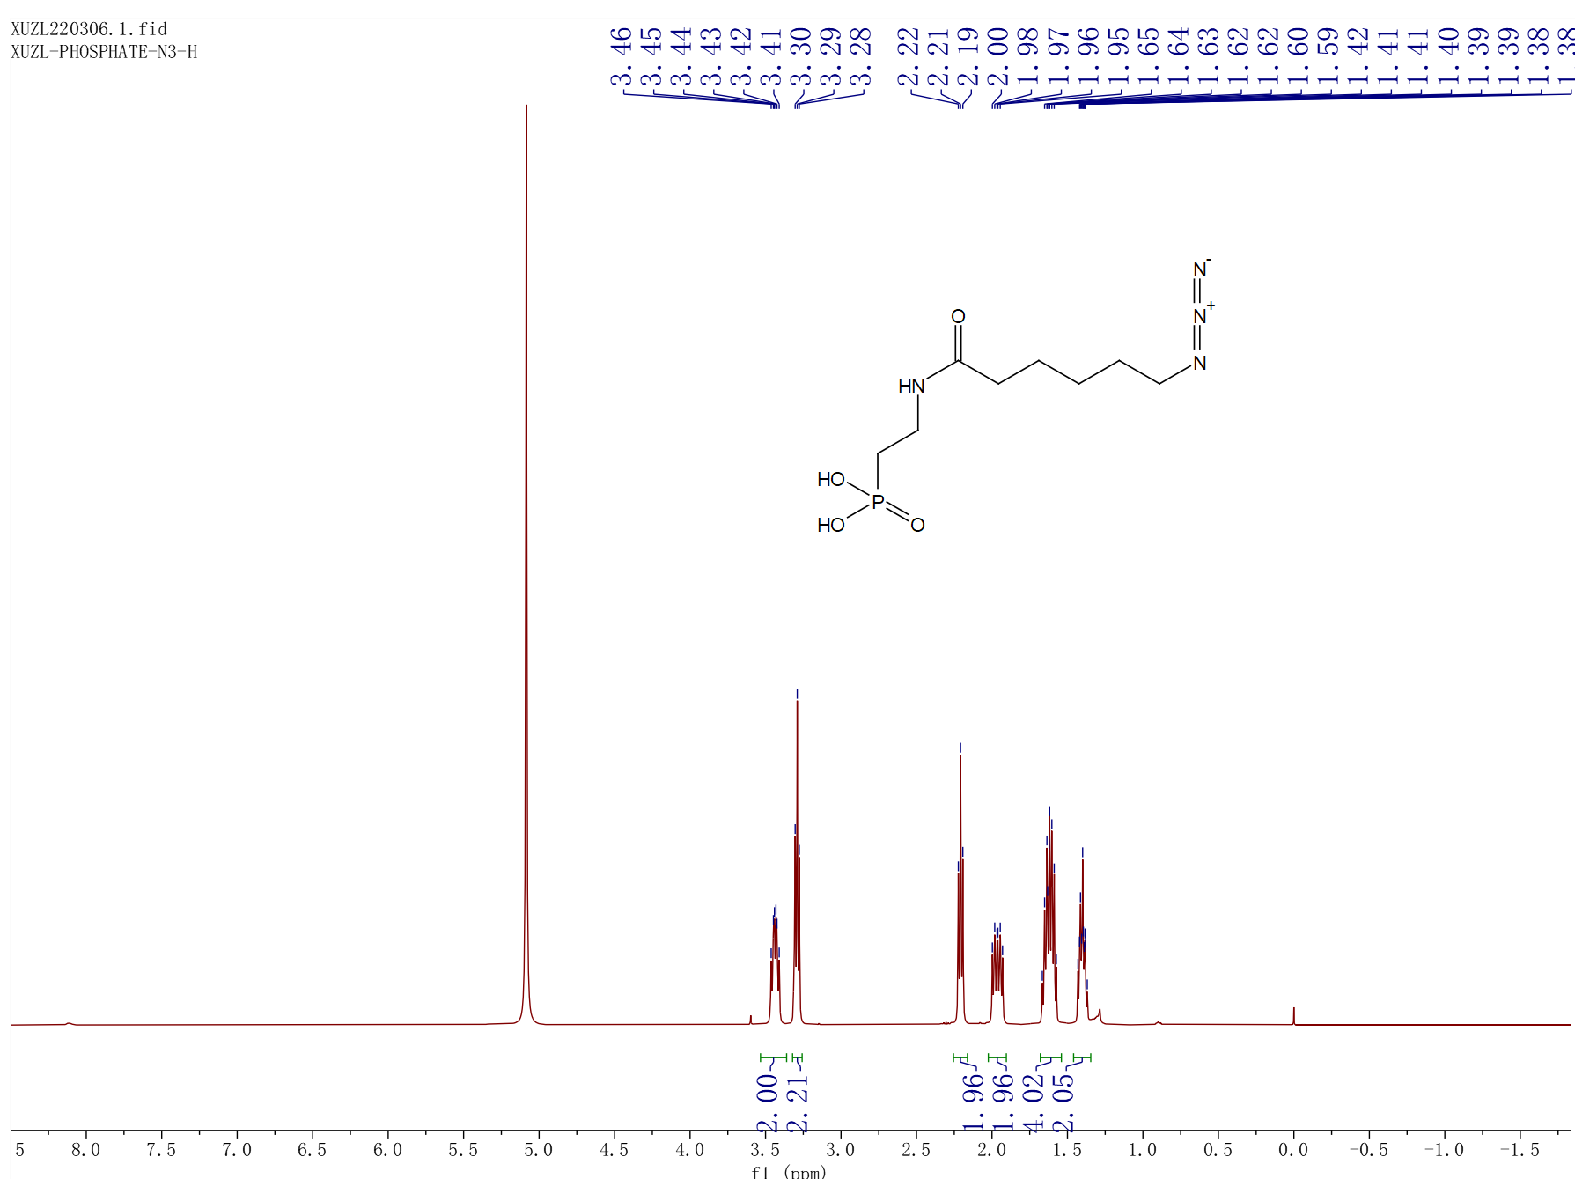

¹³C NMR of AZPA

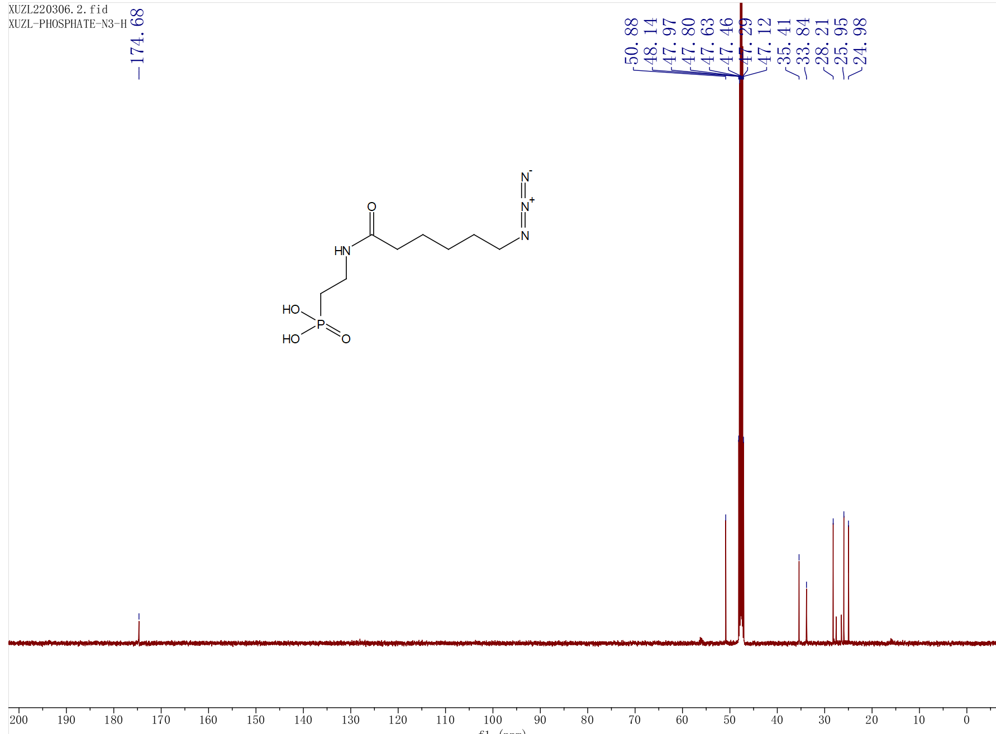

Supplementary Note 3. Synthesis of ePDMS.
Scheme 4. Synthesis of ePDMS. Condensation of methyl 3,5-diaminobenzoate with methanesulfonyl chloride under basic conditions produced compound 7. The compound 7 was hydrolyzed by LiOH to convert into the corresponding carboxylic acid that reacted with 3-aminopropyne under amidation conditions to produce the desired product ePDMS.

Compound 7. To a stirred solution of methyl 3,5-diaminobenzoate (665 mg, 4.00 mmol, 1.0 equiv) in 40 mL DCM was added pyridine (949 mg, 12.00 mmol, 3.0 equiv). The mixture was cooled to 0 ºC then methanesulfonyl chloride (957 mg, 8.40 mmol, 2.1 equiv) was added dropwise. The reaction mixture was allowed to warm to room temperature and stirred for 6 hours. After the reaction was completed, the crude product was obtained by filtration. The solid was washed with DCM (2×) and MTBE (2×) to give the pure product (895 mg, 69% yield). ¹H NMR (500 MHz, DMSO-d₆) δ 10.09 (2H, s), 7.54 (2H, s), 7.39 (1H, s), 3.84 (3H, s), 3.02 (6H, s). MS Calcd for C₁₀H₁₄N₂NaO₆S₂ 345.02 [M+Na]⁺, found: 344.90.
Compound ePDMS. A solution of 7 (895 mg, 2.78 mmol, 1.0 equiv) in 14 mL THF was cooled to 0 ºC, then an aqueous solution (14 mL) of LiOH (266 mg, 11.12 mmol, 4.0 equiv) was added dropwise. The reaction mixture was warmed to room temperature and stirred for 4 hours. pH was adjusted to 2~3 by the dropwise addition of 1 M HCl at 0 ºC and THF was removed under reduced pressure, the aqueous solution was extracted with EA (2×), the combined organic phase was washed with H₂O (2×) and brine (2×), then dried over anhy. Na₂SO₄, then concentrated to dryness to obtain the desired product as pink solid (855 mg, 99% yield) which can be directly used in the next step.

A mixture of intermediate acid (882 mg, 2.86 mmol, 1.0 equiv), HATU (1.63 g, 4.30 mmol, 1.5 equiv), N, N-Diisopropylethylamine (1.85 g, 14.32 mmol, 5.0 equiv) and propargylamine (237 mg, 4.30 mmol, 1.5 equiv) in 30 mL EA was stirred for 8h at room temperature. The mixture was extracted with ethyl acetate (2×), then washed with H₂O (2×) and brine (3×), dried over anhy. Na₂SO₄. After concentration, the desired product was isolated by silica column chromatography, which was further washed with DCM (1×) and MTBE (2×) to give the product as white solid (405 mg, 41%). ¹H NMR (500 MHz, DMSO-d₆) δ 9.99 (2H, s), 8.96 (1H, s), 7.28 (2H, s), 7.24(1H, s) 4.02 (2H, dd, J = 5.7, 2.5 Hz), 3.13 (1H, s), 3.05 (6H, s). ¹³C NMR (126 MHz, DMSO) δ 166.20, 139.86, 136.92, 113.97, 113.70, 81.68, 73.42, 29.03. HRMS Calcd for C₁₂H₁₅N₃O₅S₂ 346.0526 [M+H]⁺, found: 346.0527.

NMR spectra
¹H NMR of compound 7.
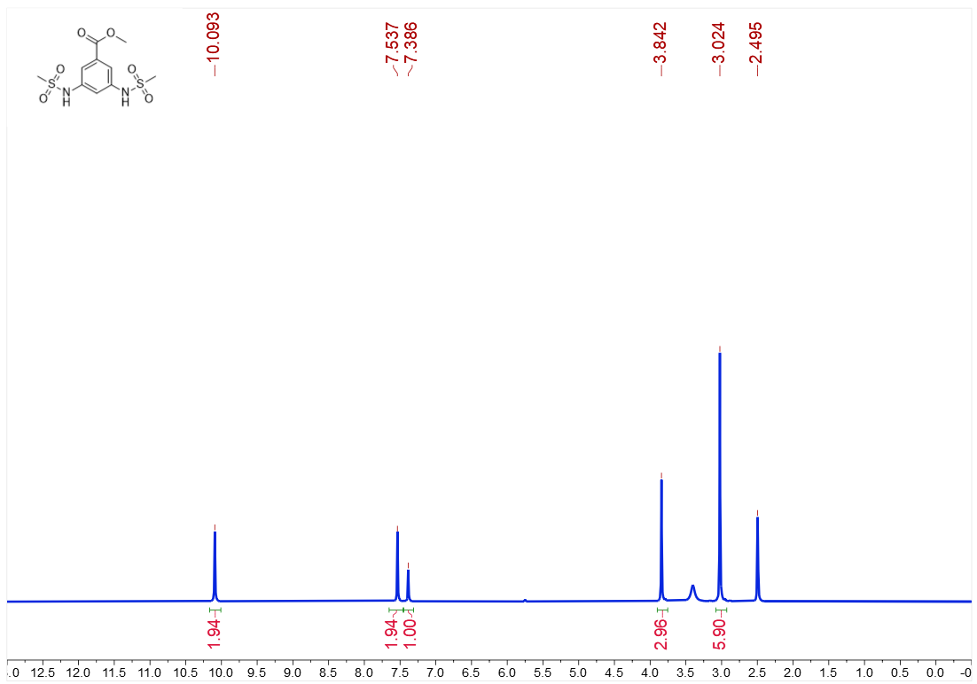

¹H NMR of ePDMS.
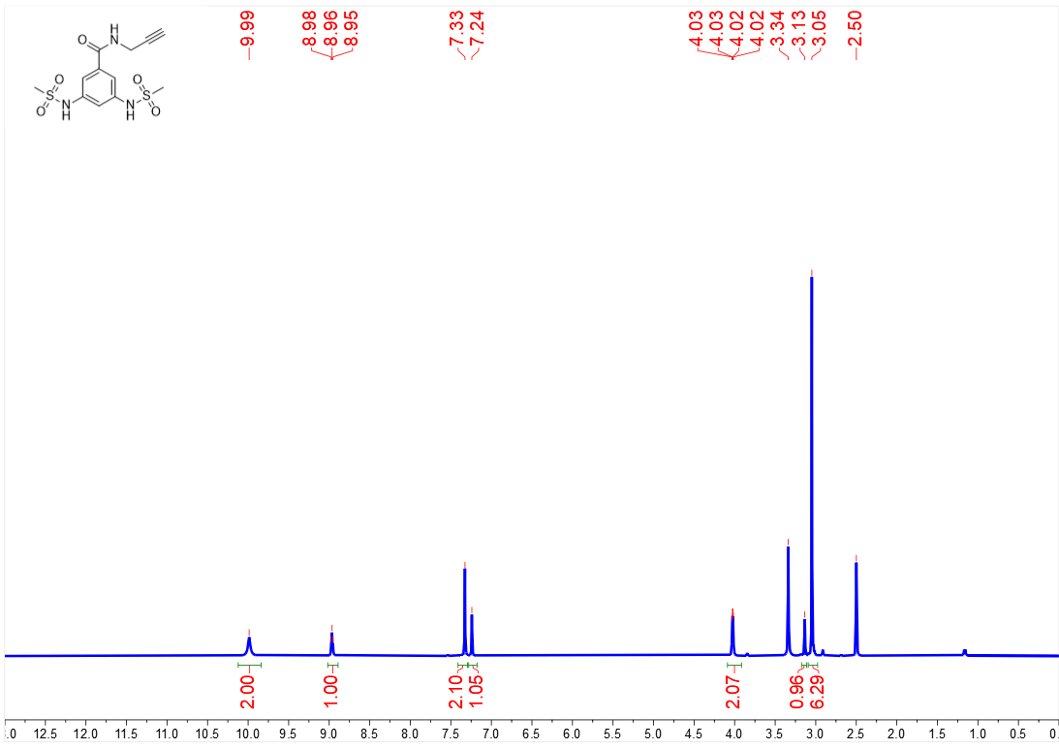

¹³C NMR of ePDMS.
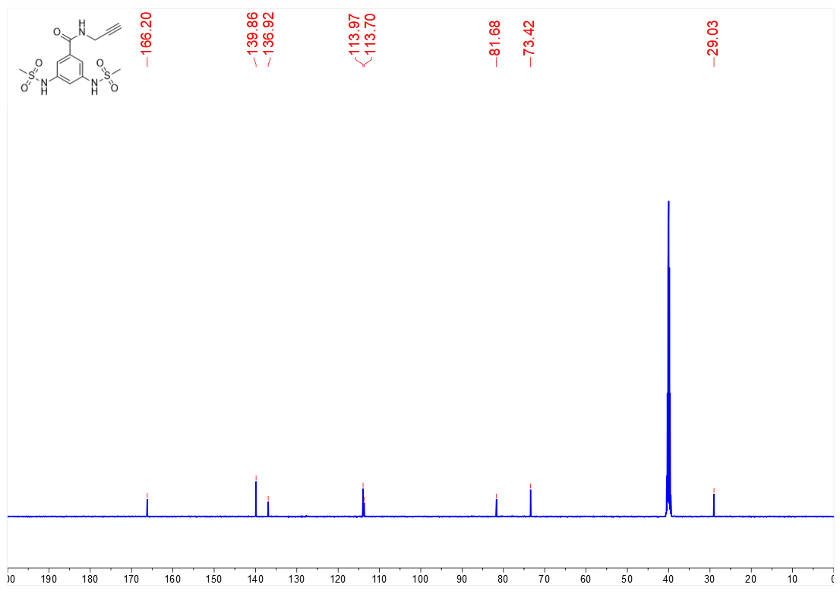

Supplementary Note 4. Synthesis of ePDES-NBD.

Scheme 5. Synthesis of ePDES-NBD. Nucleophilic substitution of 8 with 2-(2-(2-Azidoethoxy)ethoxy)ethan-1-amine under basic conditions produced 9. The compound 9 reacted with ePDES2 under click-chemistry reaction conditions to produce the desired product ePDES-NBD.

Compound 9. To a stirred solution of 2-(2-(2-azidoethoxy)ethoxy)ethan-1-amine (100 mg, 0.57 mmol, 1.0 equiv) in 6 mL ACN were added 8 (137 mg, 0.69 mmol, 1.2 equiv) and K₂CO₃(238 mg, 1.72 mmol, 3.0 eq). Then the reaction mixture was warmed to 60 ºC and stirred for 8.5 hours. After the reaction was completed, ACN was removed under reduced pressure concentration, the aqueous solution was extracted with DCM, the combined organic phase was washed with H2O (3×) and brine (2×), then dried over anhy. Na₂SO₄, the desired product was isolated by silica column chromatography to yield compound 9 as yellow oil (162mg, 84%). ¹H NMR (500 MHz, Chloroform-d) δ 8.48 (d, J = 8.6 Hz, 1H), 6.87 (s, 1H), 6.19 (d, J = 8.5 Hz, 1H), 3.89 (t, J = 5.1 Hz, 2H), 3.82–3.59 (m, 8H), 3.43 (t, J = 4.9 Hz, 2H). MS Calcd for C₁₂H₁₅N₇O₅ 337.11, found: 338.03 [M+H]⁺ and 360.00 [M+Na]⁺.
Compound ePDES-NBD. To a stirred solution of 9 (50 mg, 0.15 mmol, 1.0 equiv) in 1.2 mL DMF and 0.4 ml H₂O were added ePDES2(66 mg, 0.18 mmol, 1.2 equiv), Cu₂SO₄ •5H₂O (11mg, 0.04 mmol, 0.3 eq) and L-Ascorbic Acid Sodium Salt (38 mg, 0.19 mmol, 1.2 equiv). Then the reaction mixture was warmed to room temperature and stirred for 12 hours. After the reaction was completed, the aqueous solution was extracted with EA, the combined organic phase was washed with H2O (2×) and brine (3×), then dried over anhy. Na₂SO₄, the desired product was isolated by silica column chromatography to yield compound ePDES-NBD as reddish brown oil (66mg, 62%).

¹H NMR (500 MHz, Methanol-d₄) δ 8.45 (d, J = 8.8 Hz, 1H), 7.94 (s, 1H), 7.25 (s, 3H), 6.66 (dd, J = 16.5, 9.9 Hz, 2H), 6.34 (d, J = 8.9 Hz, 1H), 6.22 (d, J = 16.5 Hz, 2H), 6.00 (d, J = 9.9 Hz, 2H), 4.57 (s, 2H), 4.53 (d, J = 5.0 Hz, 2H), 3.86 (s, 2H), 3.72 (s, 2H), 3.60 (s, 6H). ¹³C NMR (126 MHz, MeOD) δ 168.97, 146.07, 145.46, 145.45, 140.40, 138.43, 137.64, 136.85, 128.76, 125.23, 115.21, 114.61, 71.53, 71.51, 70.38, 69.80, 51.37, 49.63, 36.23. HRMS (ESI), m/z for C₂₆H₃₁N₁₀O₁₀S₂⁺ [M+H]⁺, Calcd: 707.1661, found: 707.1655.

¹H NMR of Compound 9.
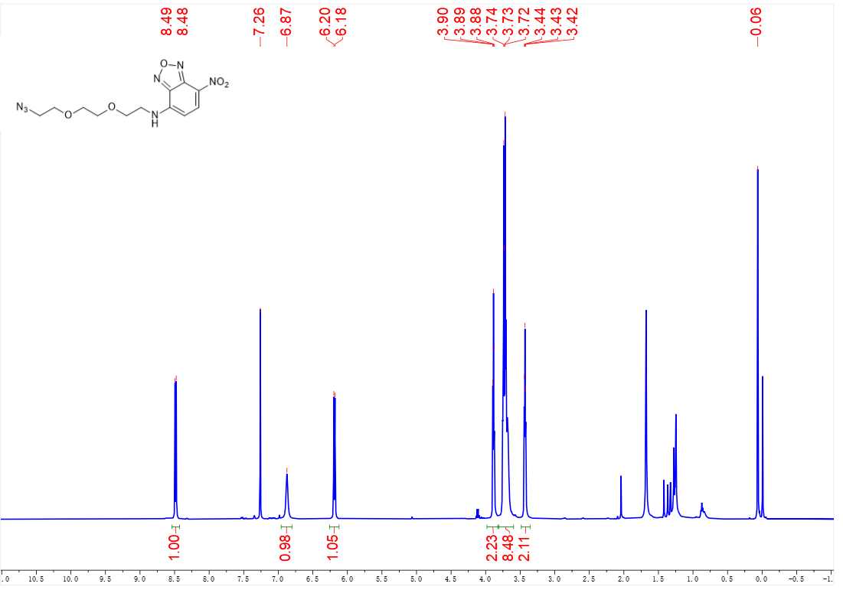

¹H NMR of ePDMS-NBD.
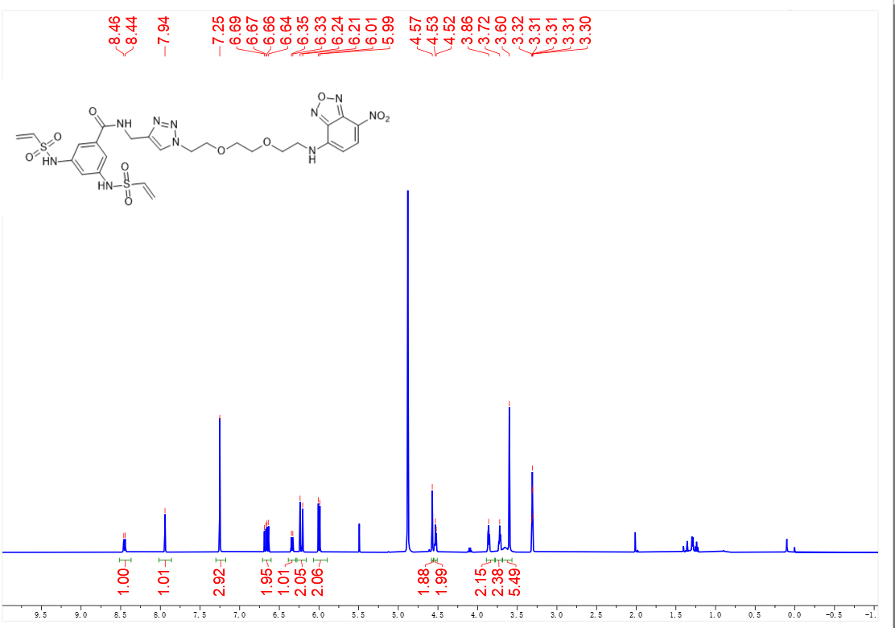

¹³C NMR of ePDMS-NBD.
