Fig. S1.

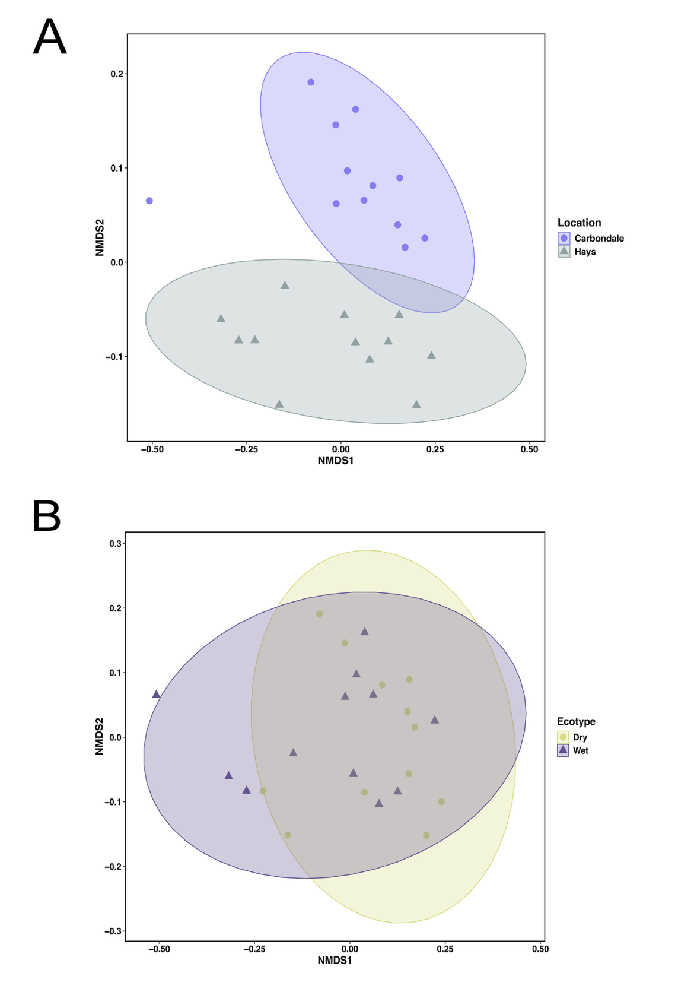
Fig. S1 Impact of (A) two locations and (B) two ecotypes on rhizosphere metabolites composition of Andropogon gerardii. NMDS ordinations were obtained from Bray-Curtis similarity matrix.

Fig. S2.
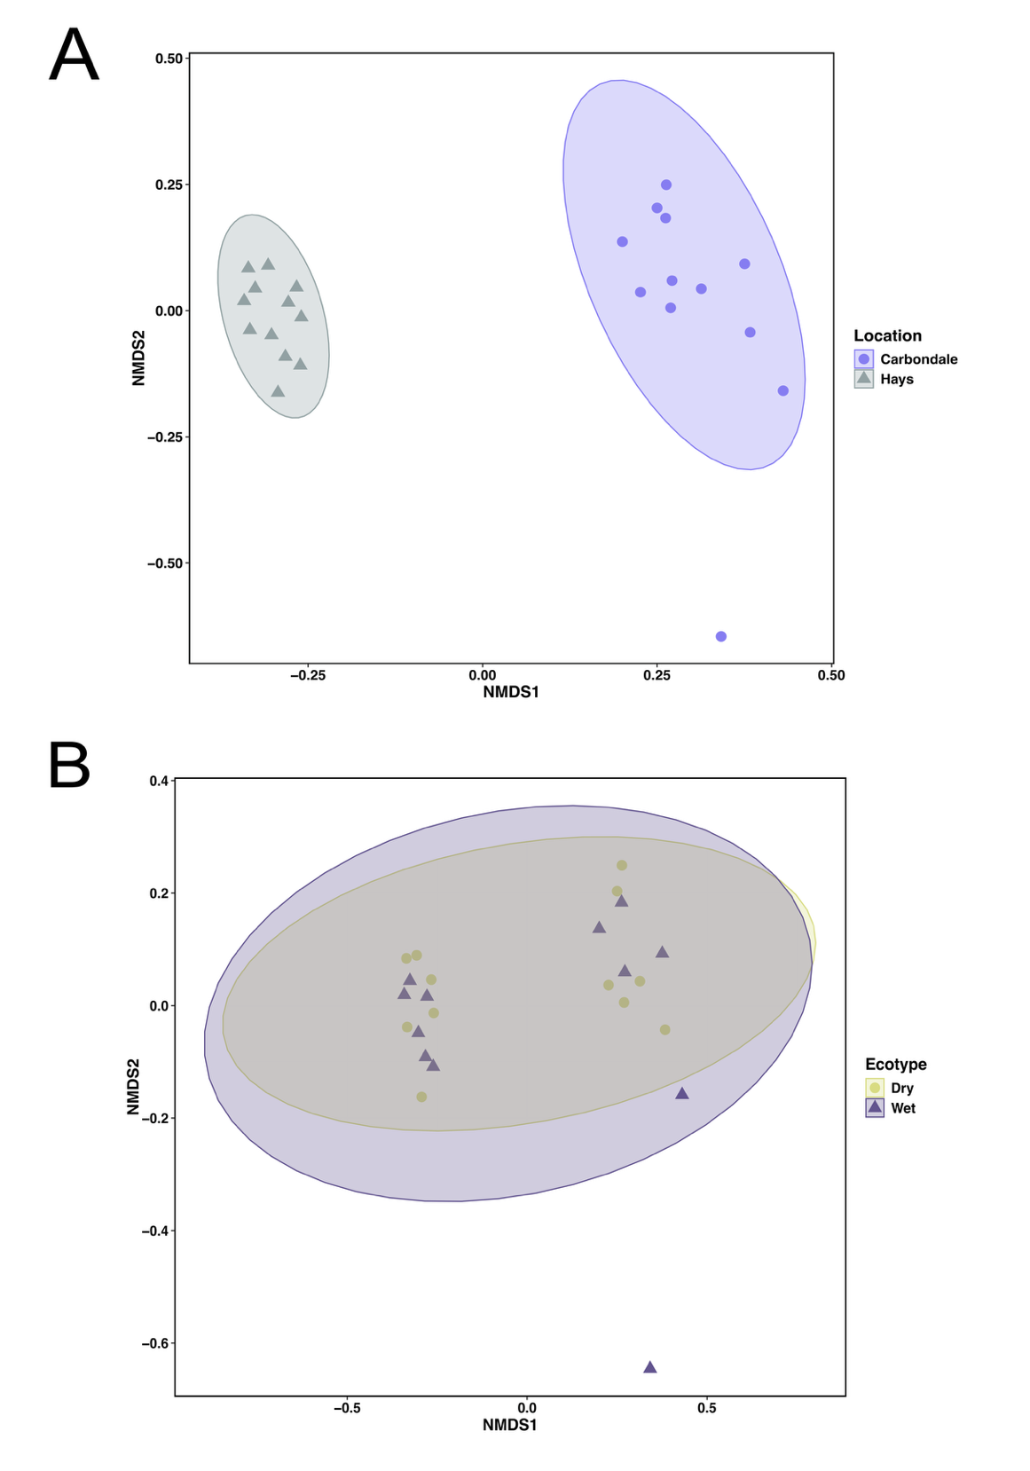
Fig. S2 Impact of (A) two locations and (B) two ecotypes on microbiome composition of Andropogon gerardii. NMDS ordinations were obtained from Bray–Curtis similarity matrix.

Fig. S3.

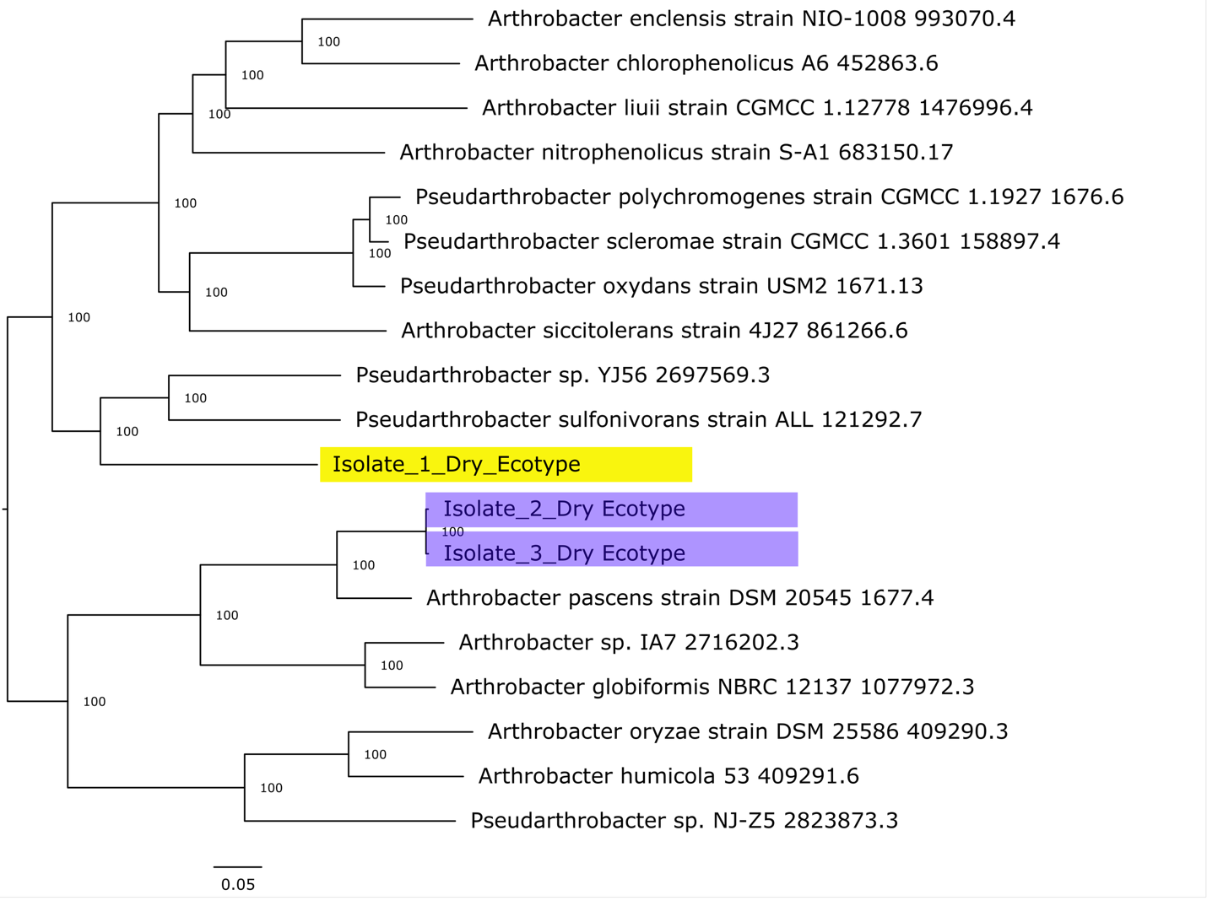

Fig. S3 Phylogenomic tree of the three draft genomes of interest with the potential to utilize a part of the carnitine biosynthesis pathway (trimethylamine-N-oxide (TMAO), trimethylamine (TMA), and trimethyllysine (TML).

