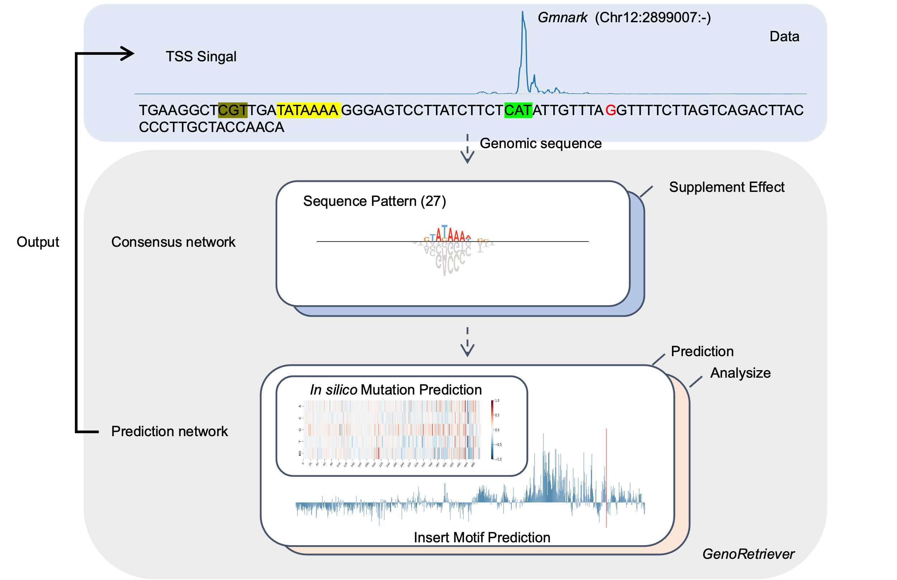
Fig S1. Overview of the GenoRetriever analytical workflow. Genomic DNA sequences are first processed by two consensus networks that distill (i) key promoter motifs and (ii) supplementary sequence effects. The resulting fixed weights are passed to the encoder of the prediction network, which outputs a base-resolution signal profile for transcription-start-site (TSS) activity and enables mechanistic interpretation of each sequence feature. Virtual saturation mutagenesis and in-silico motif insertions can then be applied to guide precise promoter editing. The schematic uses the promoter of GmNARK as an illustrative example.

Fig S2. Architecture of the GenoRetriever deep learning model.
a The consensus network extracts key information from genomic sequences. In stage 1 it identifies core sequence motifs, and in stage 2 it captures additional supplementary effects beyond those motifs. b The prediction network then uses these distilled features to accurately forecast transcription initiation signals during mechanistic analysis. c The architecture details of each module, including the specific layers, kernel sizes and attention mechanisms employed in each network component.

Fig S3. Characteristic response curves for nine novel motifs and eight Inr sequence patterns. Out of the 27 patterns identified by the motif consensus network, this figure displays the nine previously uncharacterized motifs (left panel) and eight Inr (right panel). Each panel shows the pattern logo and its average response curve over a 1 kb window centered on the pattern’s peak position.

Fig S4. Relationship between average TSR expression and the effect size of different sequence patterns. The x-axis shows the mean TPM of each transcription-start site region (TSR) across the eight Williams 82 tissues. The y-axis reports the median effect size exerted by each class of sequence pattern (short Inr, long Inr, or motif) on those TSRs.

Fig S5. qPCR validation of TF genes knockdown efficiency in soybean hairy roots. We identified these soybean TF copies and used them as RNA-interference targets. Relative expression levels of target genes in RNAi lines compared to control roots. Data represent mean ± SD from three biological replicates. Statistical significance was determined by Student’s t-test (***p < 0.001).

Fig S6. Tissue-level dissection of motif-specific regulation a Motif effect versus tissue specificity. Each dot represents one transcription-start-site (TSS) in Williams 82. The x-axis shows the log10-transformed mean TPM of that TSS across the eight assayed tissues, and the y-axis gives its coefficient of variation (CV) after normalization. Dot colour encodes the effect size of the focal motif on that TSS: darker hues indicate stronger predicted influence. b Expression profiles of TSSs most strongly governed by each motif. For the same motif, the heat-map displays the top 25 % of TSSs ranked by effect size. Rows correspond to individual TSSs, columns to the eight soybean tissues. Cell color reflects the log10-scaled TPM; deeper colors denote higher expression.

Fig S7. The phylogenetic tree for the seven crop species using single-copy orthologous genes.
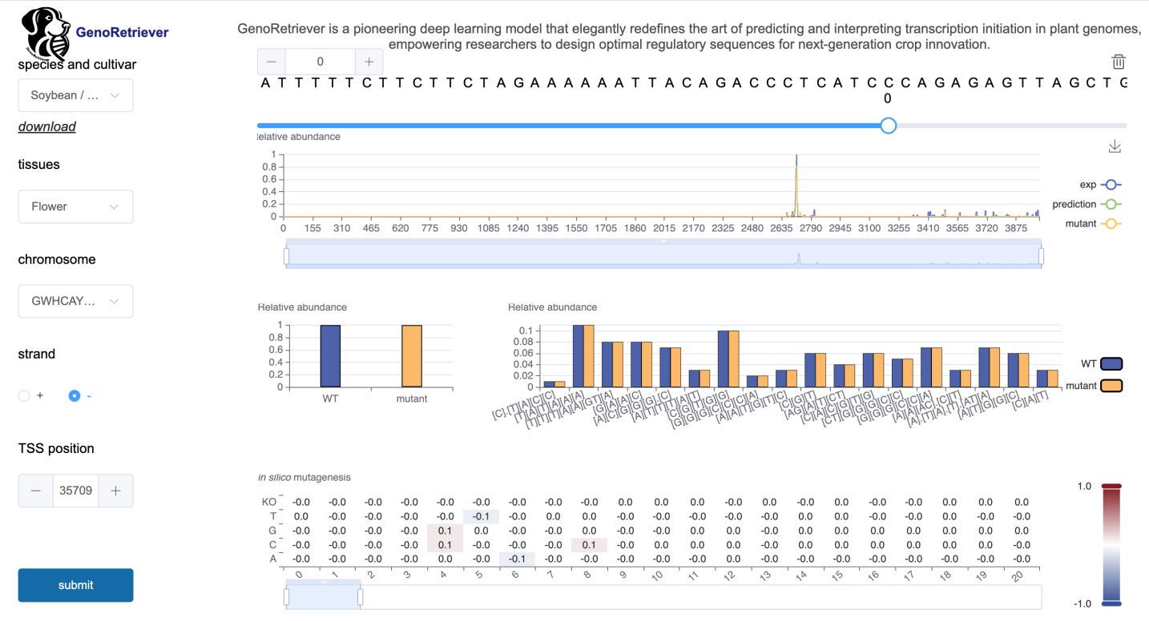
Fig S8. User interface of the GenoRetriever web server and module descriptions. The GenoRetriever web server provides an intuitive platform for exploring transcription start site profiles and predicting sequence edits.

