Benchmarking deep learning methods for biologically conserved single-cell integration

Supplementary Figures
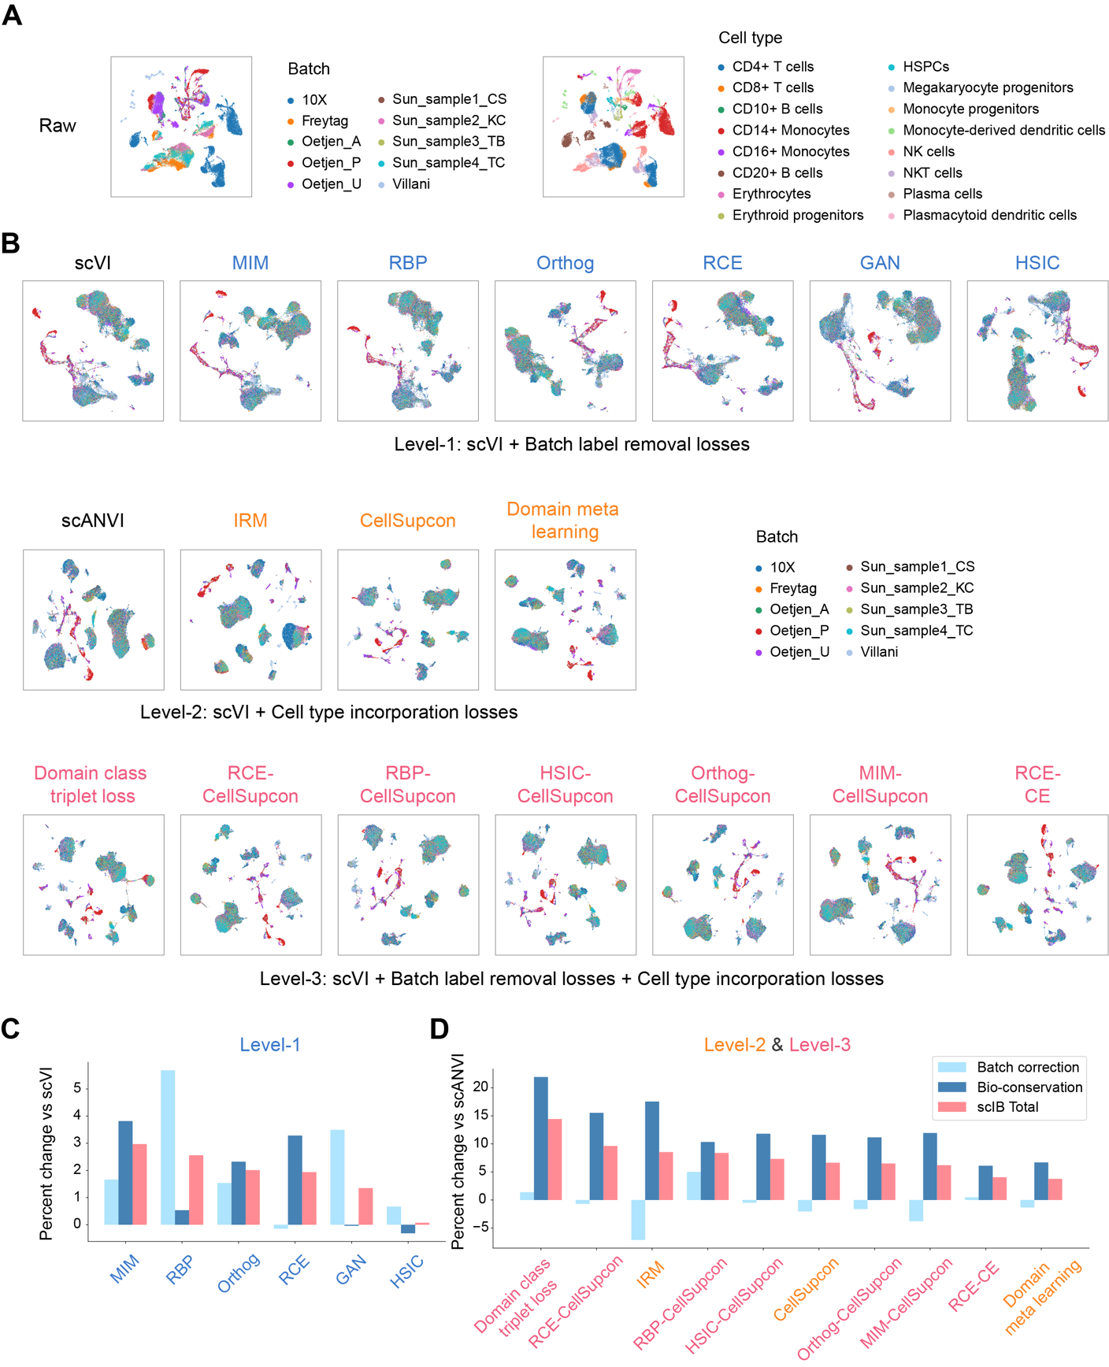
Fig.S1 Evaluation of multi-level loss functions for single-cell integration on immune dataset. A UMAP visualization of the immune dataset before integration, colored by batch label (left) and cell type (right). B UMAP visualization of the integration result of immune dataset across three-level methods, colored by batch label. C-D Comparison of scIB metrics for integration results of immune dataset across level-1 (C) and level-2/level-3 (D) methods, with scVI and scANVI as baselines, respectively. Bars represent the average percentage margins for different scores, with error bars indicating the standard error of the mean. Methods are ranked in descending order based on their total scIB scores.
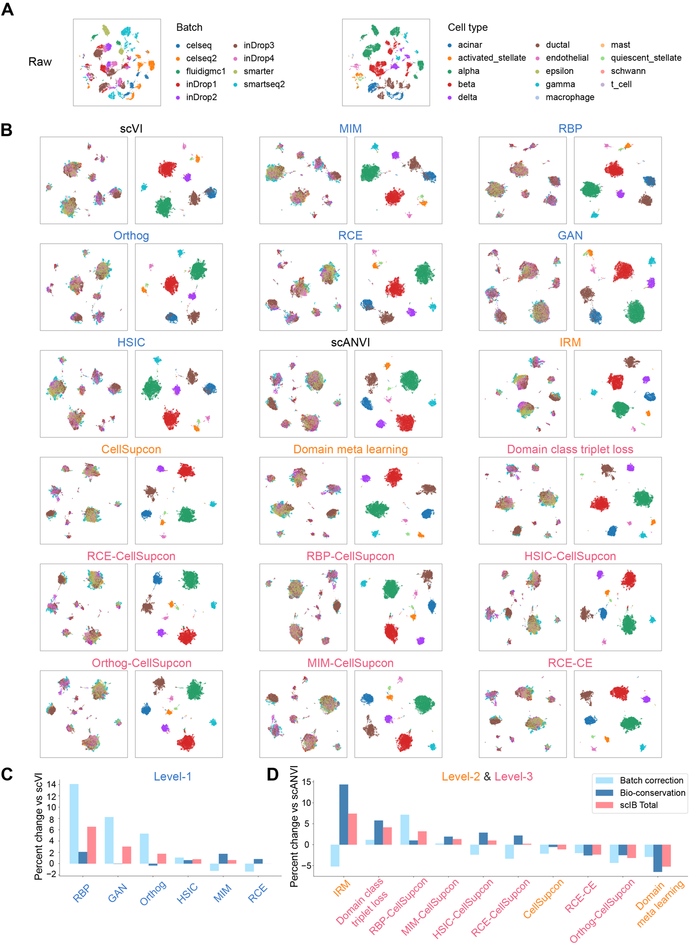
Fig.S2 Evaluation of multi-level loss functions for single-cell integration on pancreas dataset. A UMAP visualization of the pancreas dataset before integration, colored by batch (left) and cell type (right). B UMAP visualization of the integration result of pancreas dataset across three-level methods, with cells colored by batch label (left) and by cell type (right) for each method. C-D Comparison of scIB metrics for integration results of pancreas dataset across level-1 (C) and level-2/level-3 (D) methods, with scVI and scANVI as baselines, respectively. Bars represent the average percentage margins for different scores, with error bars indicating the standard error of the mean. Methods are ranked in descending order based on their total scIB scores.
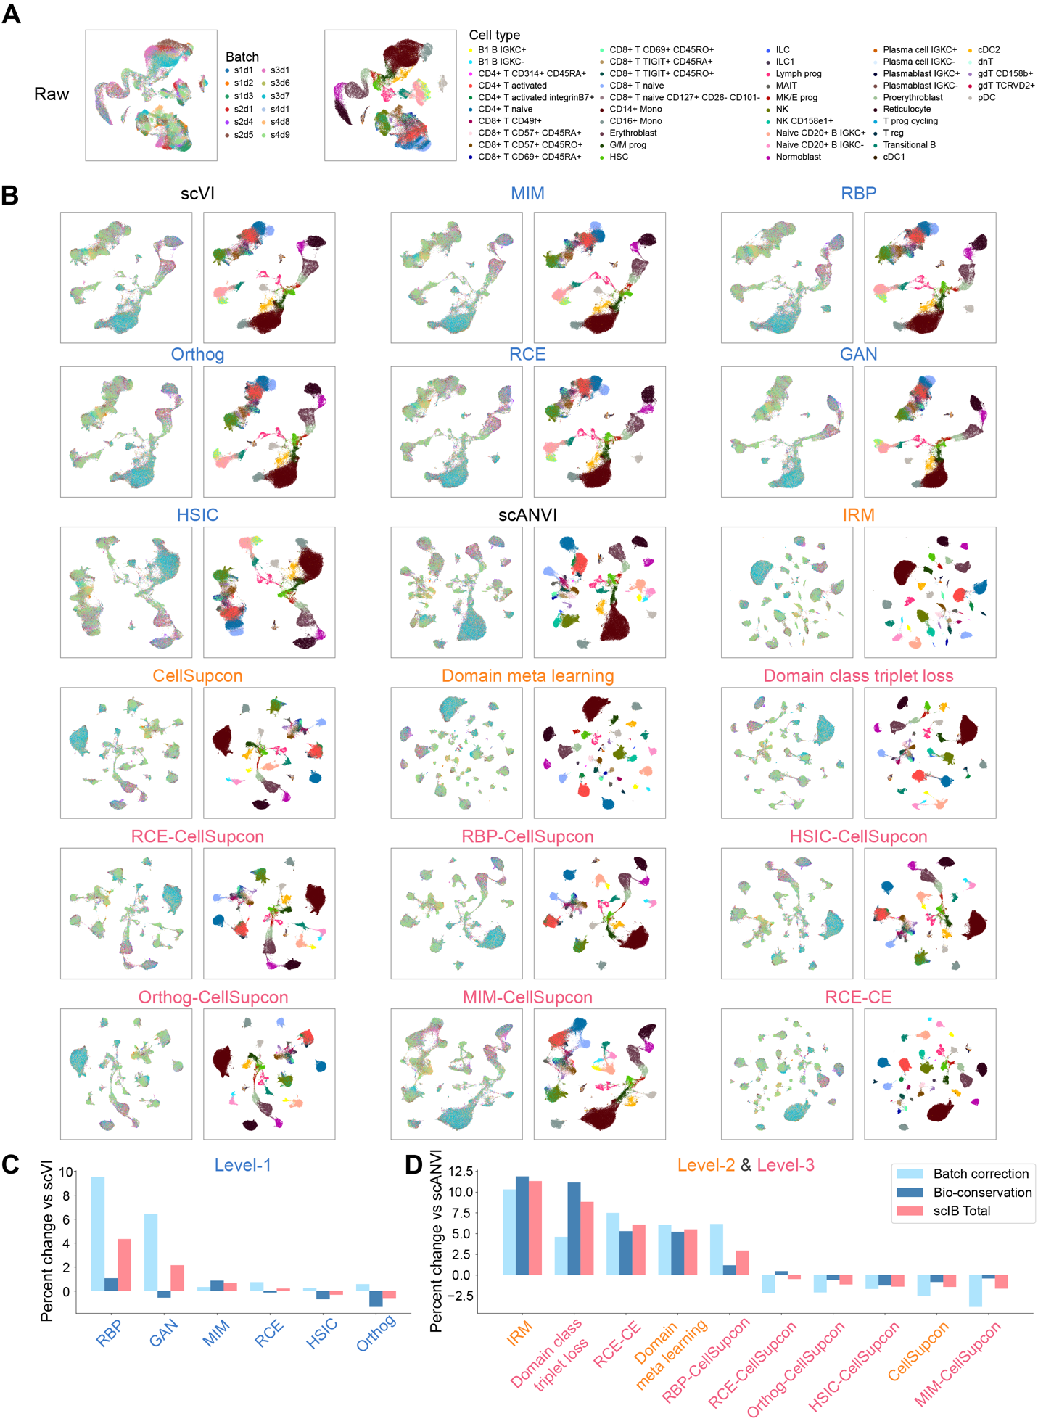
Fig.S3 Evaluation of multi-level loss functions for single-cell integration on BMMC dataset. A UMAP visualization of the BMMC dataset before integration, colored by batch (left) and cell type (right). B UMAP visualization of the integration result of BMMC dataset across three-level methods, with cells colored by batch label (left) and by cell type (right) for each method. C-D Comparison of scIB metrics for integration results of BMMC dataset across level-1 (C) and level-2/level-3 (D) methods, with scVI and scANVI as baselines, respectively. Bars represent the average percentage margins for different scores, with error bars indicating the standard error of the mean. Methods are ranked in descending order based on their total scIB scores.
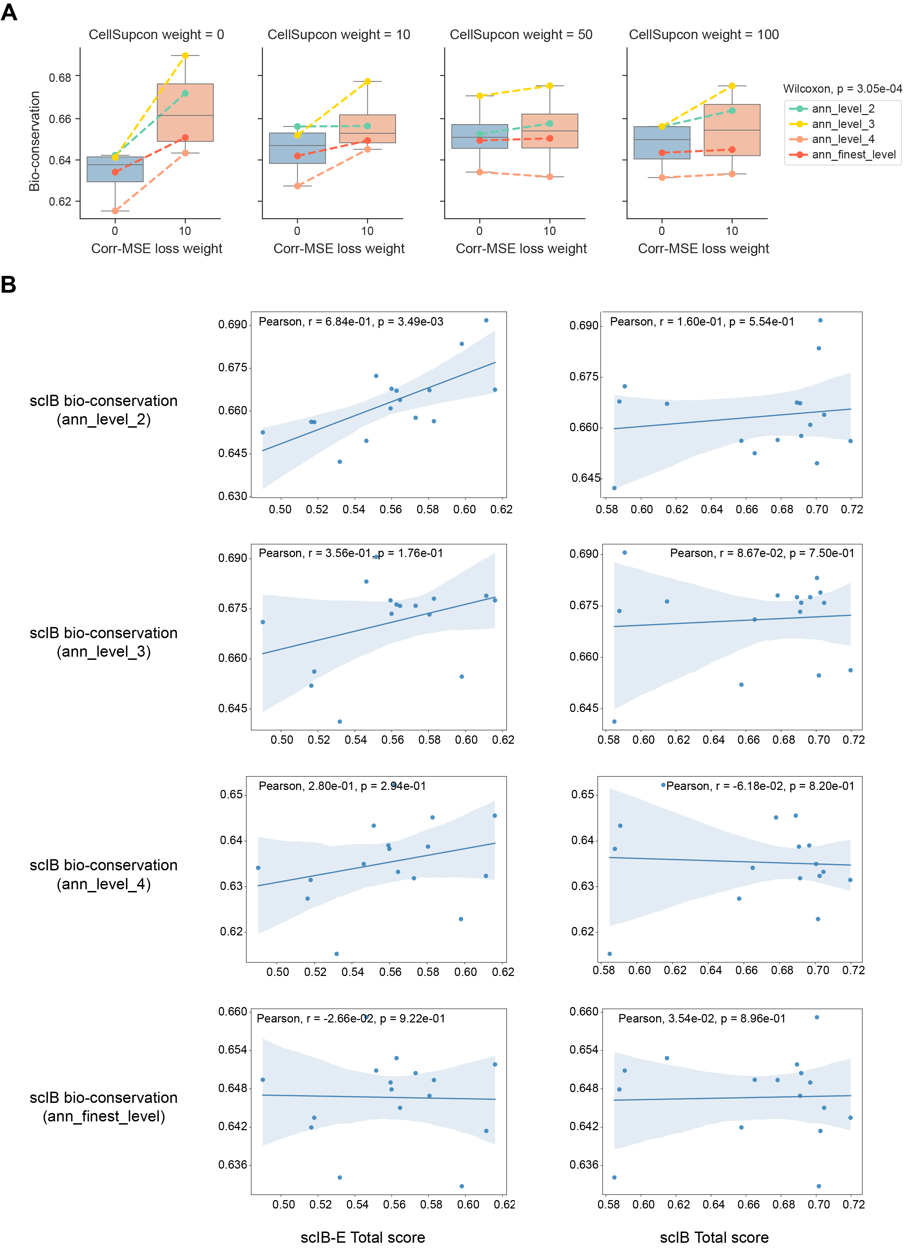
Fig.S4 Extended scIB metrics for intra-cell-type biological conservation evaluation. A Paired boxplots showing bio-conservation scores of integration results with and without Corr-MSE loss at different cell annotation levels of HLCA dataset, across varying CellSupcon loss weights. Colored lines represent different cell annotation levels. B Scatter plots showing the Pearson’s correlation between scIB-E total scores (left) and scIB total scores (right) of HLCA dataset integration results using level-1 cell annotation, across paired bio-conservation scores estimated by different level cell annotations, with p-values labeled. Statistical significance was assessed using a paired Wilcoxon test in (A), with p-values labeled.
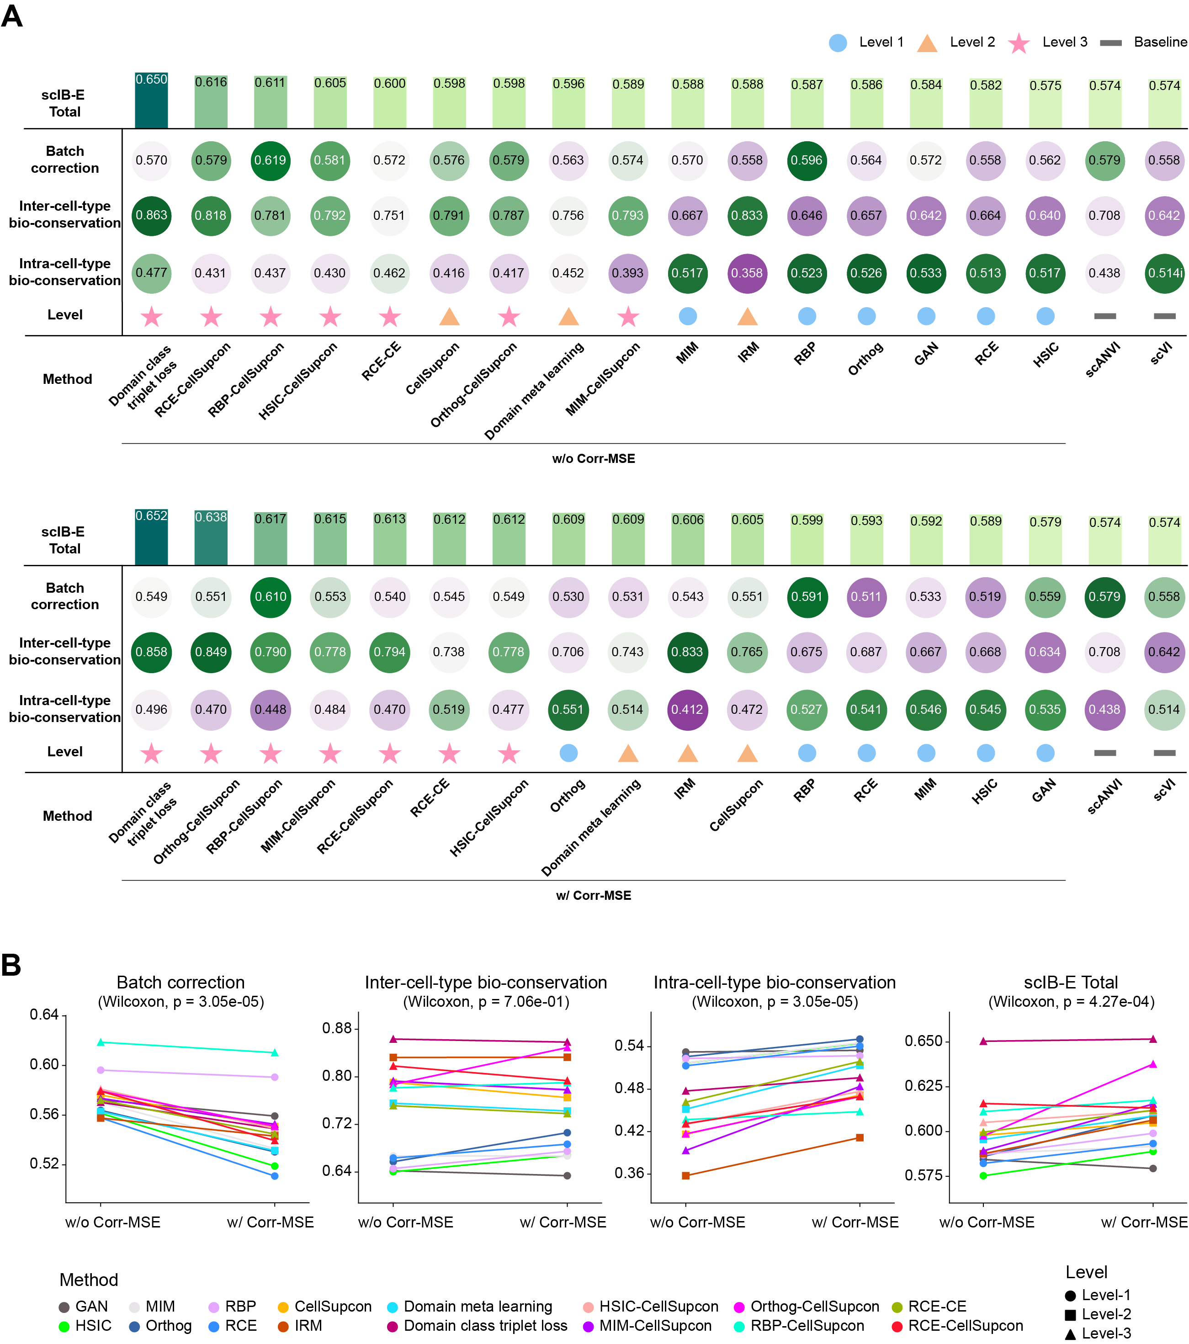
Fig.S5 Assessing multi-level loss functions for single-cell integration using scIB-E metrics on immune dataset. A Tables summarizing the scIB-E scores of the immune dataset for multi-level loss functions, as described in Fig. 2. Results are shown without Corr-MSE loss (top) and with Corr-MSE loss (bottom). Methods are ranked in descending order by total score, with a score of 1 indicating optimal performance. B Paired line plots illustrating scIB-E metrics on immune dataset for batch correction, inter-cell-type biological conservation, intra-cell-type biological conservation, and total score, evaluated with and without Corr-MSE loss across multi-level loss functions. Colors represent distinct methods, and shapes denote different levels. Statistical significance was assessed using a paired Wilcoxon test, with p-values labeled.

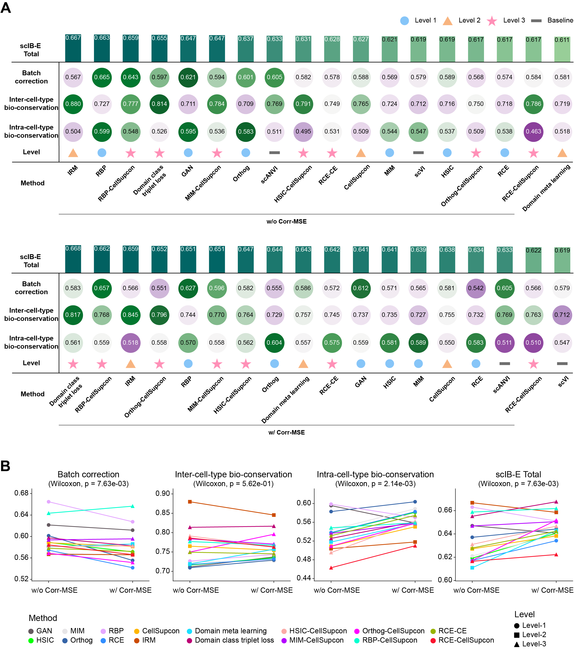
Fig.S6 Assessing multi-level loss functions for single-cell integration using scIB-E metrics on pancreas dataset. A Tables summarizing the scIB-E scores of the pancreas dataset for multi-level loss functions, as described in Fig. 2. Results are shown without Corr-MSE loss (top) and with Corr-MSE loss (bottom). Methods are ranked in descending order by total score, with a score of 1 indicating optimal performance. B Paired line plots illustrating scIB-E metrics on pancreas dataset for batch correction, inter-cell-type biological conservation, intra-cell-type biological conservation, and total score, evaluated with and without Corr-MSE loss across multi-level loss functions. Colors represent distinct methods, and shapes denote different levels. Statistical significance was assessed using a paired Wilcoxon test, with p-values labeled.

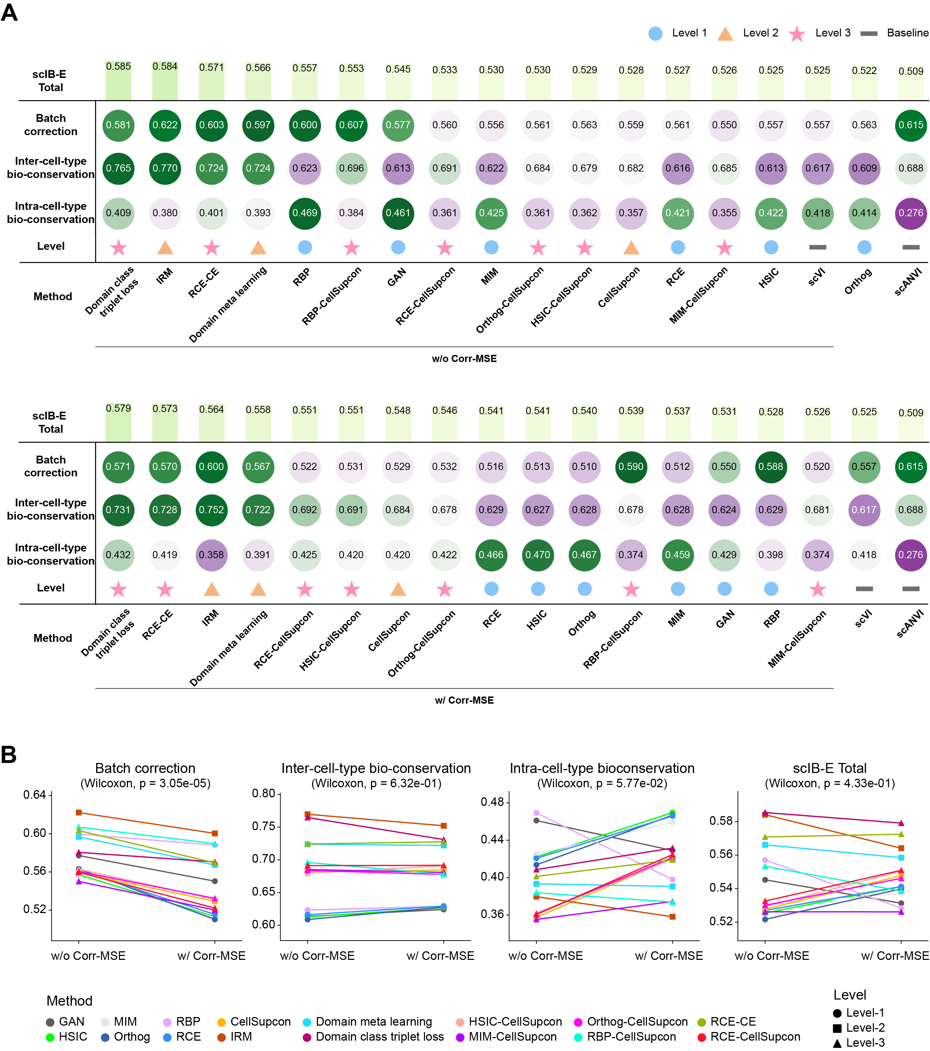
Fig.S7 Assessing multi-level loss functions for single-cell integration using scIB-E metrics on BMMC dataset. A Tables summarizing the scIB-E scores of the BMMC dataset for multi-level loss functions, as described in Fig. 2. Results are shown without Corr-MSE loss (top) and with Corr-MSE loss (bottom). Methods are ranked in descending order by total score, with a score of 1 indicating optimal performance. B Paired line plots illustrating scIB-E metrics on BMMC dataset for batch correction, inter-cell-type biological conservation, intra-cell-type biological conservation, and total score, evaluated with and without Corr-MSE loss across multi-level loss functions. Colors represent distinct methods, and shapes denote different levels. Statistical significance was assessed using a paired Wilcoxon test, with p-values labeled.
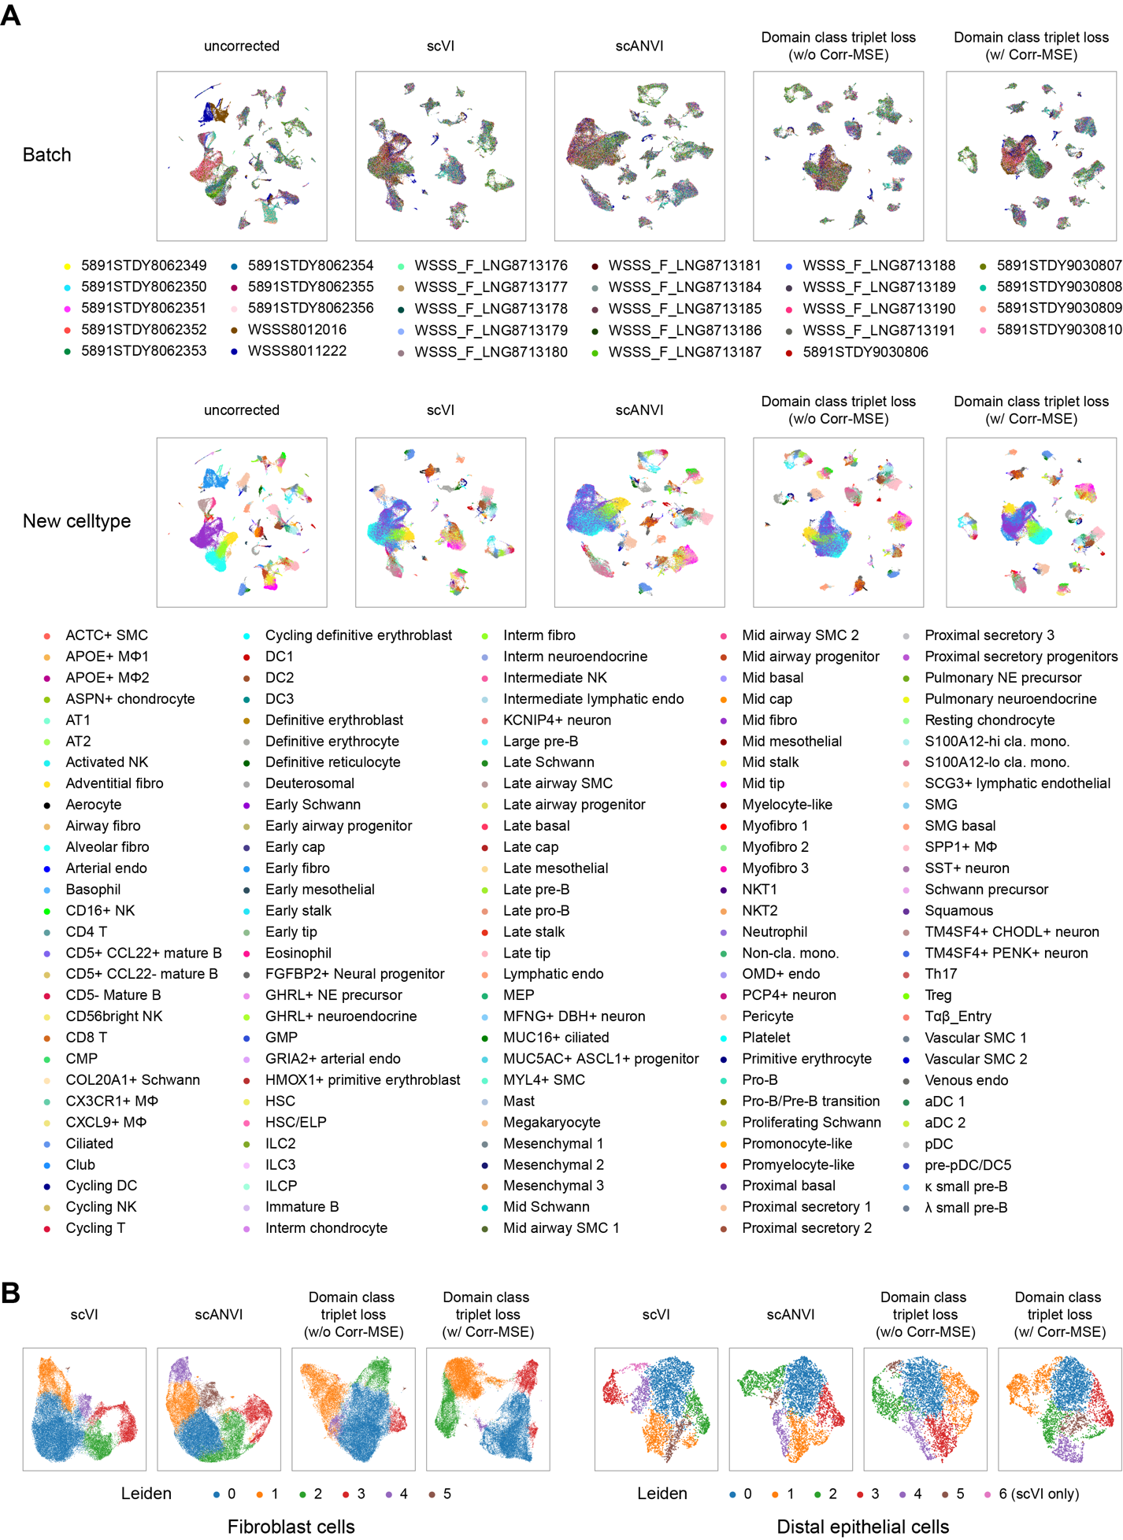
Fig.S8 Assessing single-cell integration methods for comprehensive biological conservation. A UMAP visualization of the Human Fetal Lung Cell Atlas as in Fig. 6A, cells are colored by fine-grained cell-type annotations. B UMAP visualization of fibroblast (left) and distal epithelial cells (right) as in Fig. 6C, colored by Leiden clustering labels.

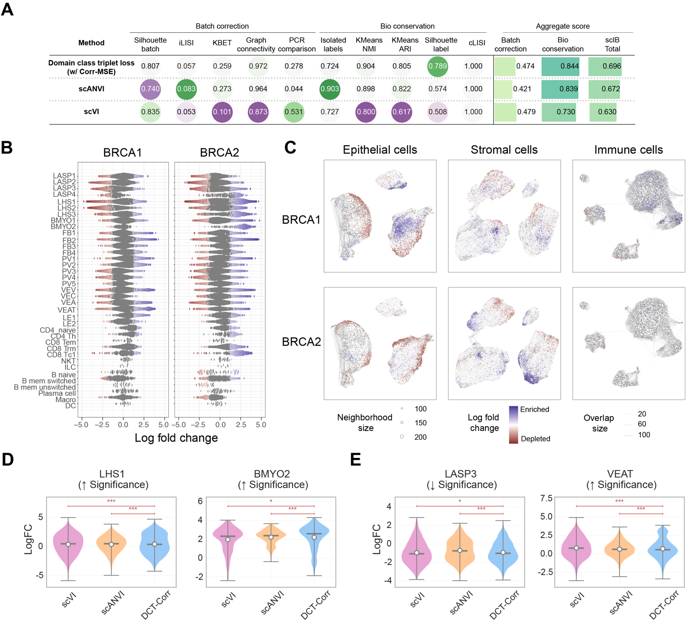
Fig.S9 Performance evaluation and differential abundance analysis on the HBCA dataset for BRCA carriers. A Table summarizing the scIB metrics for the HBCA integration results, comparing the performance of the Domain Class Triplet loss with Corr-MSE (DCT-Corr) method against scVI and scANVI baselines. B Beeswarm plot showing the log fold change of cell abundance across all subclusters for the BRCA1 and BRCA2 carrier comparisons. C UMAP visualizations of the three major cellular compartments (epithelial, stromal, and immune cells), with neighborhoods colored by their log fold change to show enrichment (red) or depletion (blue) of cell populations in BRCA1 and BRCA2 carriers. D-E Comparison of log fold changes for significantly altered subpopulations in BRCA1 (D) and BRCA2 (E) carriers, evaluated across the integrated embeddings from scVI, scANVI, and DCT-Corr. Upward (↑) and downward (↓) arrows indicate a significant increase or decrease in cell abundance, respectively. Statistical significance is denoted by asterisks (*p < 0.05, **p < 0.01, ***p < 0.001).

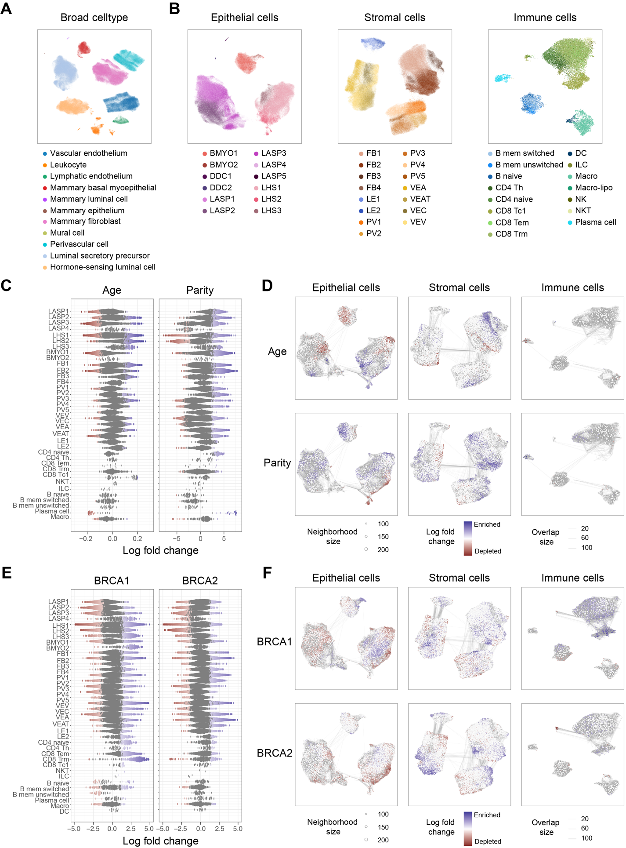
Fig.S10 Visualization of the HBCA dataset integration and differential abundance analysis using scVI. A UMAP visualization of the integrated HBCA dataset using the scVI method, with cells colored by broad cell-type annotations. B UMAP projections from the scVI integration showing detailed subcluster annotations within the epithelial, stromal, and immune compartments. C, E Beeswarm plots illustrating the log fold change of cell abundance across subclusters for age and parity (C) and BRCA1/BRCA2 (E) comparisons from the differential abundance analysis on the scVI embeddings. D, F UMAP visualizations of the three main cellular compartments from the scVI integration, with neighborhoods colored by their log fold change to show enrichment or depletion of cell populations in the age and parity (D) and BRCA1/BRCA2 (F) analyses.

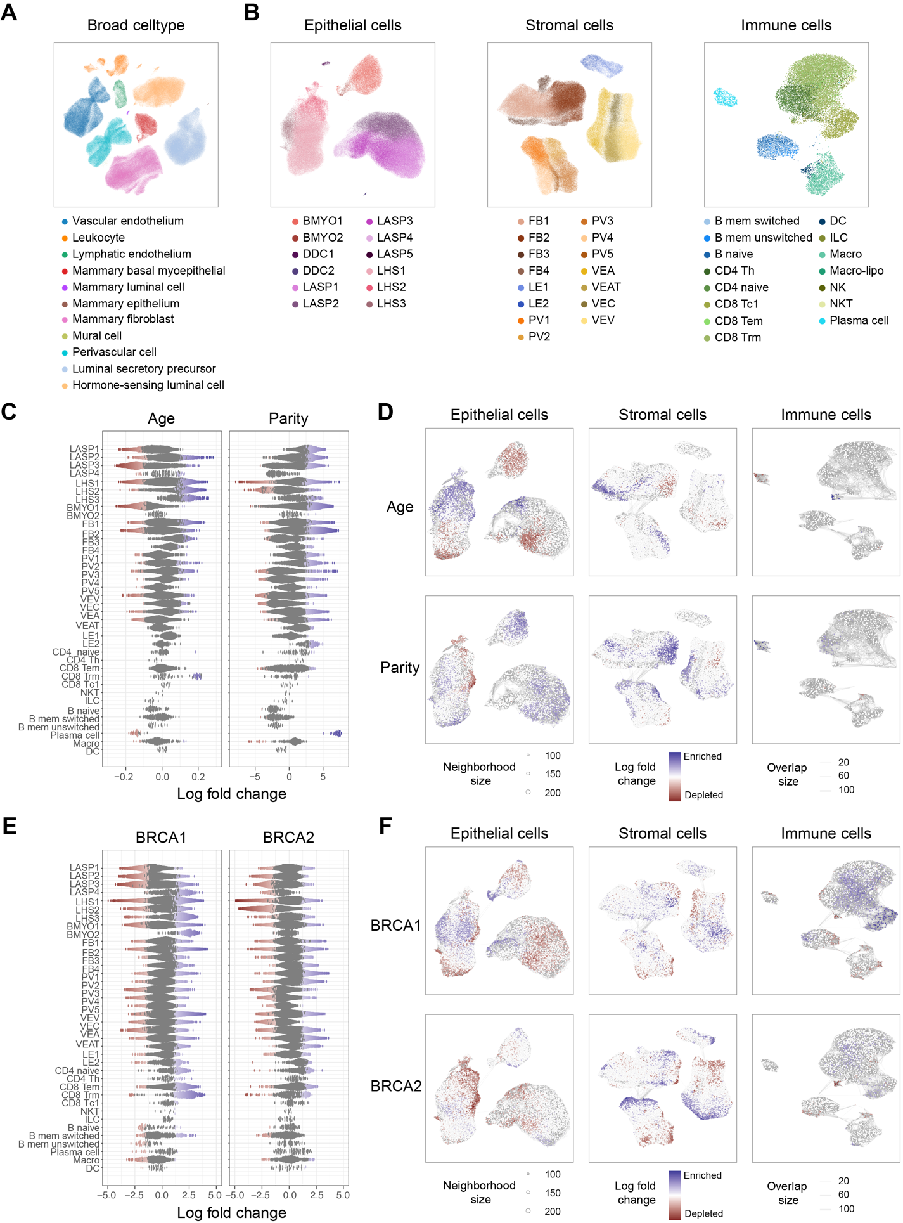
Fig.S11 Visualization of the HBCA dataset integration and differential abundance analysis using scANVI. A UMAP visualization of the integrated HBCA dataset using the scANVI method, with cells colored by broad cell-type annotations. B UMAP projections from the scANVI integration showing detailed subcluster annotations within the epithelial, stromal, and immune compartments. C, E Beeswarm plots illustrating the log fold change of cell abundance across subclusters for age and parity (C) and BRCA1/BRCA2 (E) comparisons from the differential abundance analysis on the scANVI embeddings. D, F UMAP visualizations of the three main cellular compartments from the scANVI integration, with neighborhoods colored by their log fold change to show enrichment or depletion of cell populations in the age and parity (D) and BRCA1/BRCA2 (F) analyses.

