Supplementary Figures
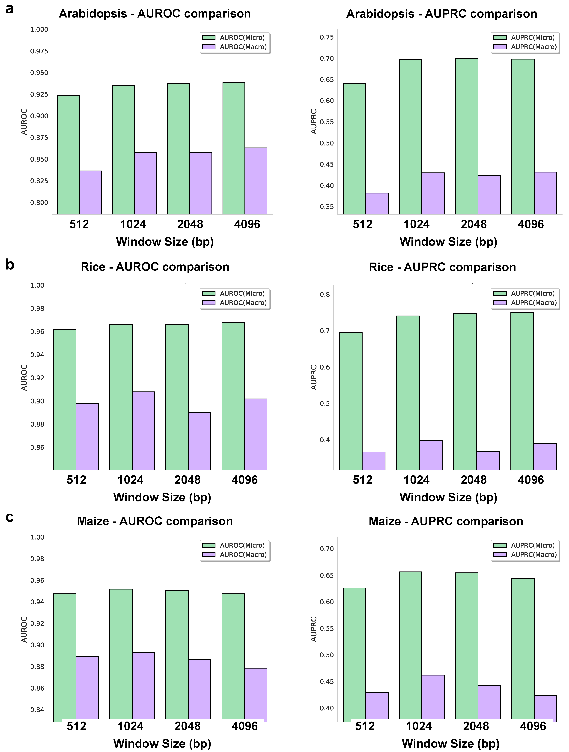
Fig. S1 The effect of different input window lengths on the prediction performance of three species. (a-c) represent Arabidopsis, Rice, and Maize, respectively. Each species includes two bar charts: Left figure: AUROC as a function of window length (512 bp, 1 kb, 2 kb, 4 kb), showing two statistical measures (Micro and Macro) represented by two-colored bars. Right figure: AUPRC as a function of window length, showing two statistical measures (Micro and Macro) represented by two-colored bars.
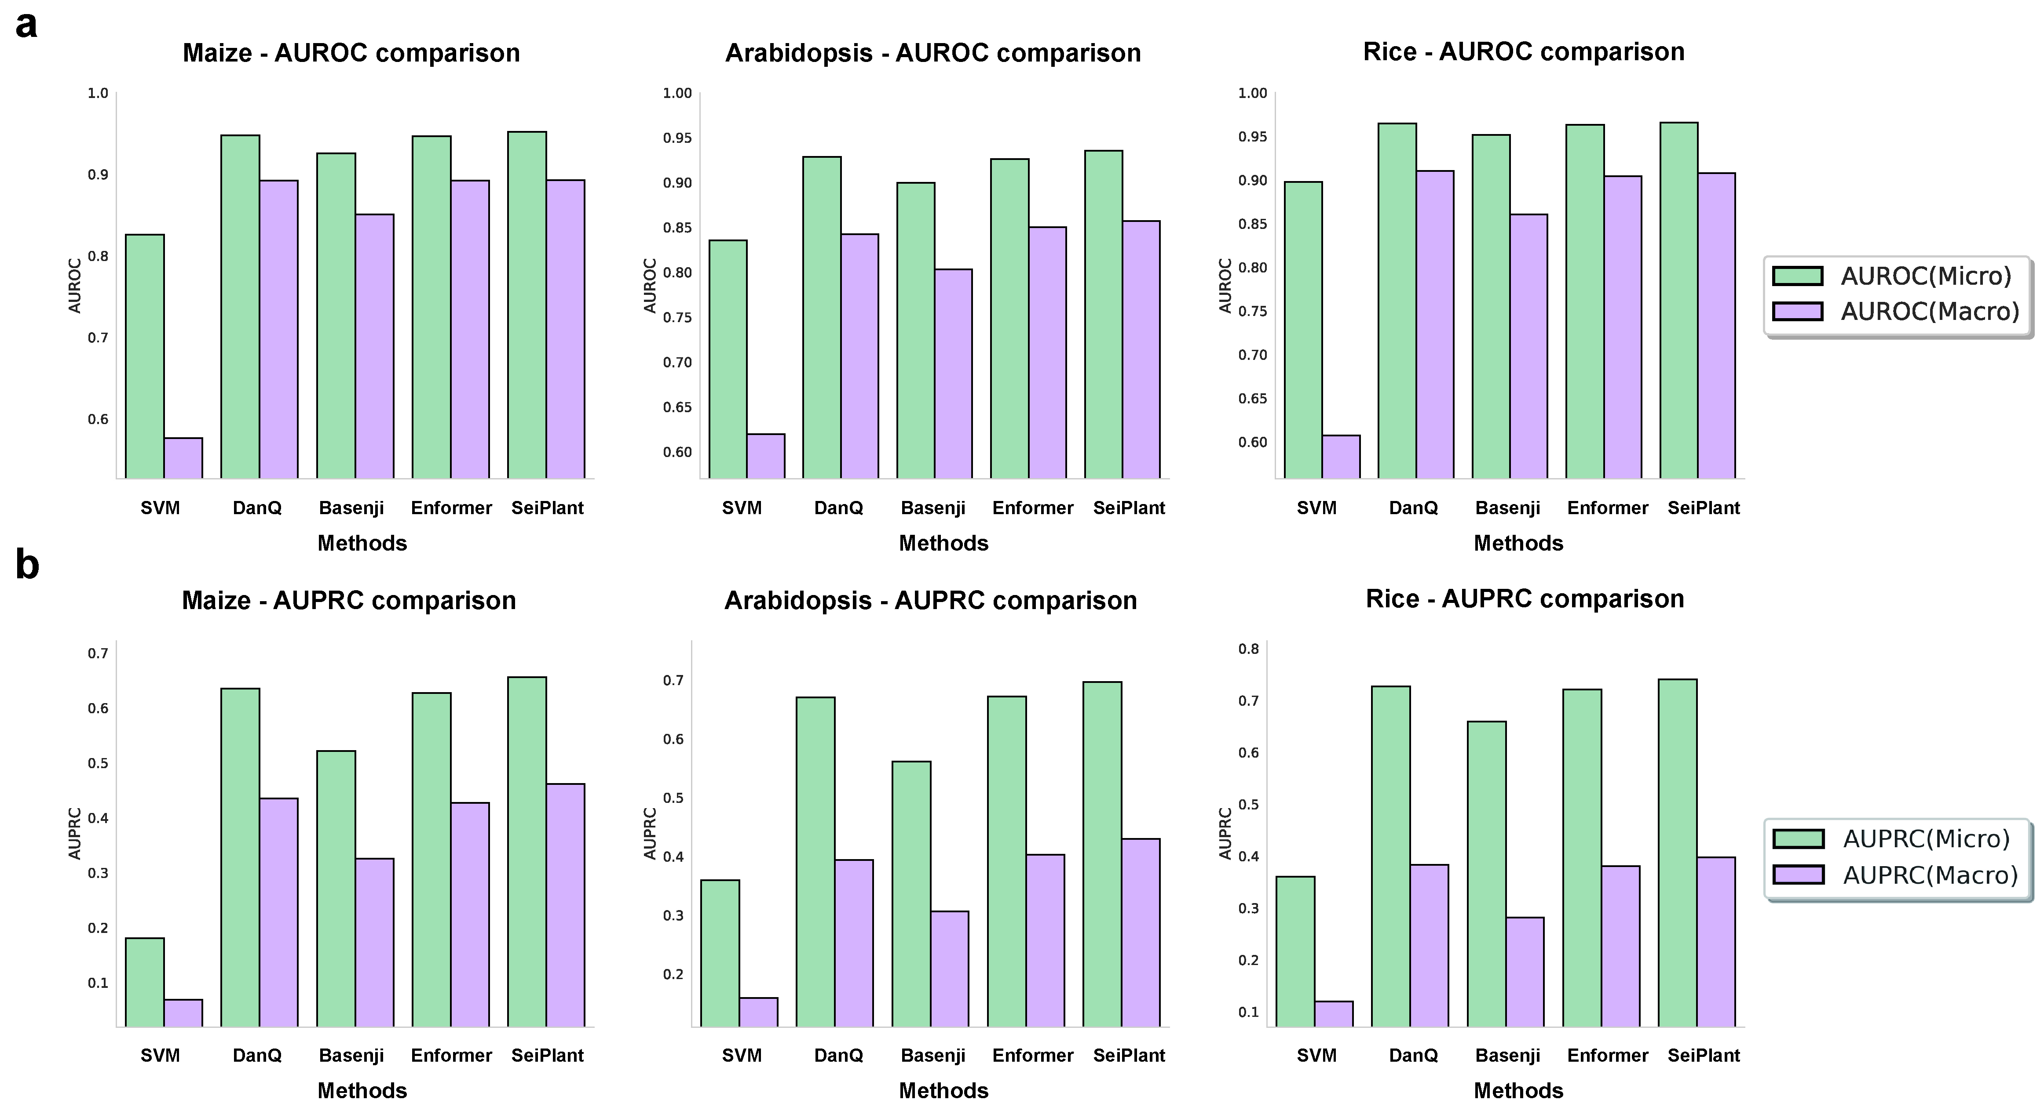
Fig. S2 Comparison with representative models (1 kb input window). (a-b) Comparison of indicator differences between species using different methods, including SVM(QHistone), DanQ, Basenji, Enformer, SeiPlant. Each method displays two types of statistics, Micro and Macro (two-colored columns).

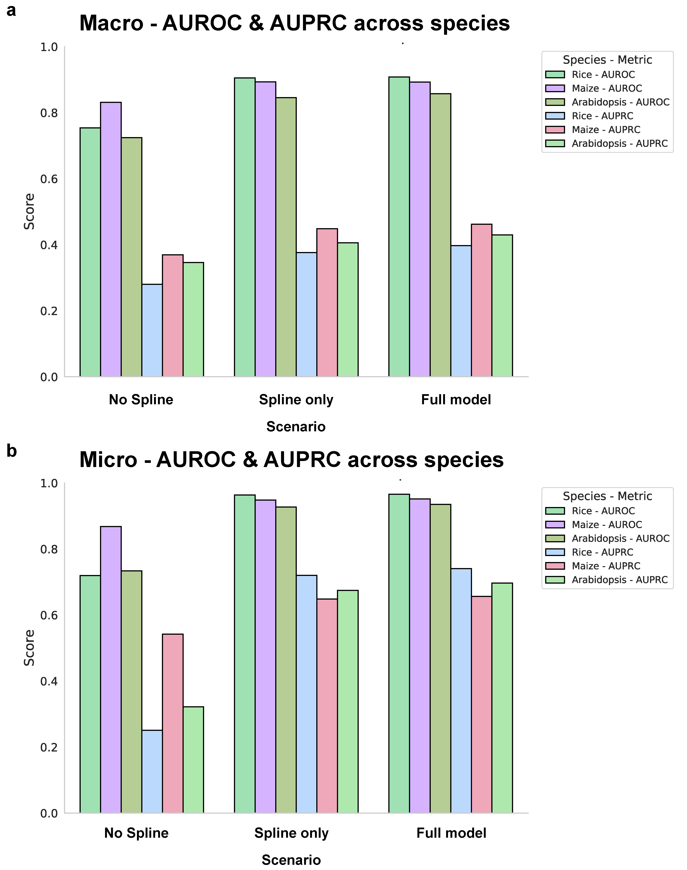
Fig. S3 SeiPlant architecture ablation experiment. (a-b) The bar chart shows the AUROC and AUPRC (Macro and Micro statistics) of three species (Rice, Maize, and Arabidopsis) under three model configurations (No Spline, Spline only, and Full model).

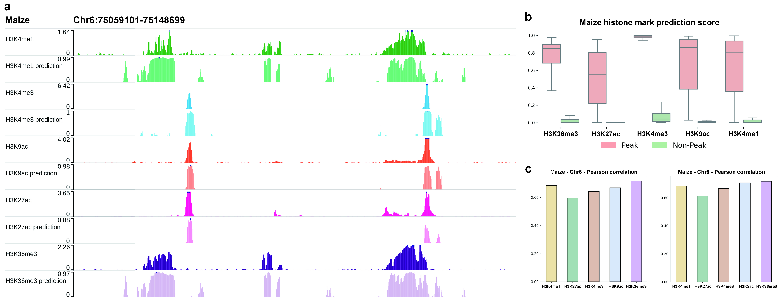
Fig. S4 Quantitative evaluation of chromatin signal predictions in Maize. (a) Predicted and experimental signal tracks for representative histone marks in Maize (Chr6:75059101–75148699). (b) The distribution Boxplot of prediction scores for peak and non-peak regions across five histone marks in Maize. (c) Pearson correlation coefficients between predicted and experimental signals across test and validation chromosomes for each histone mark in Maize.

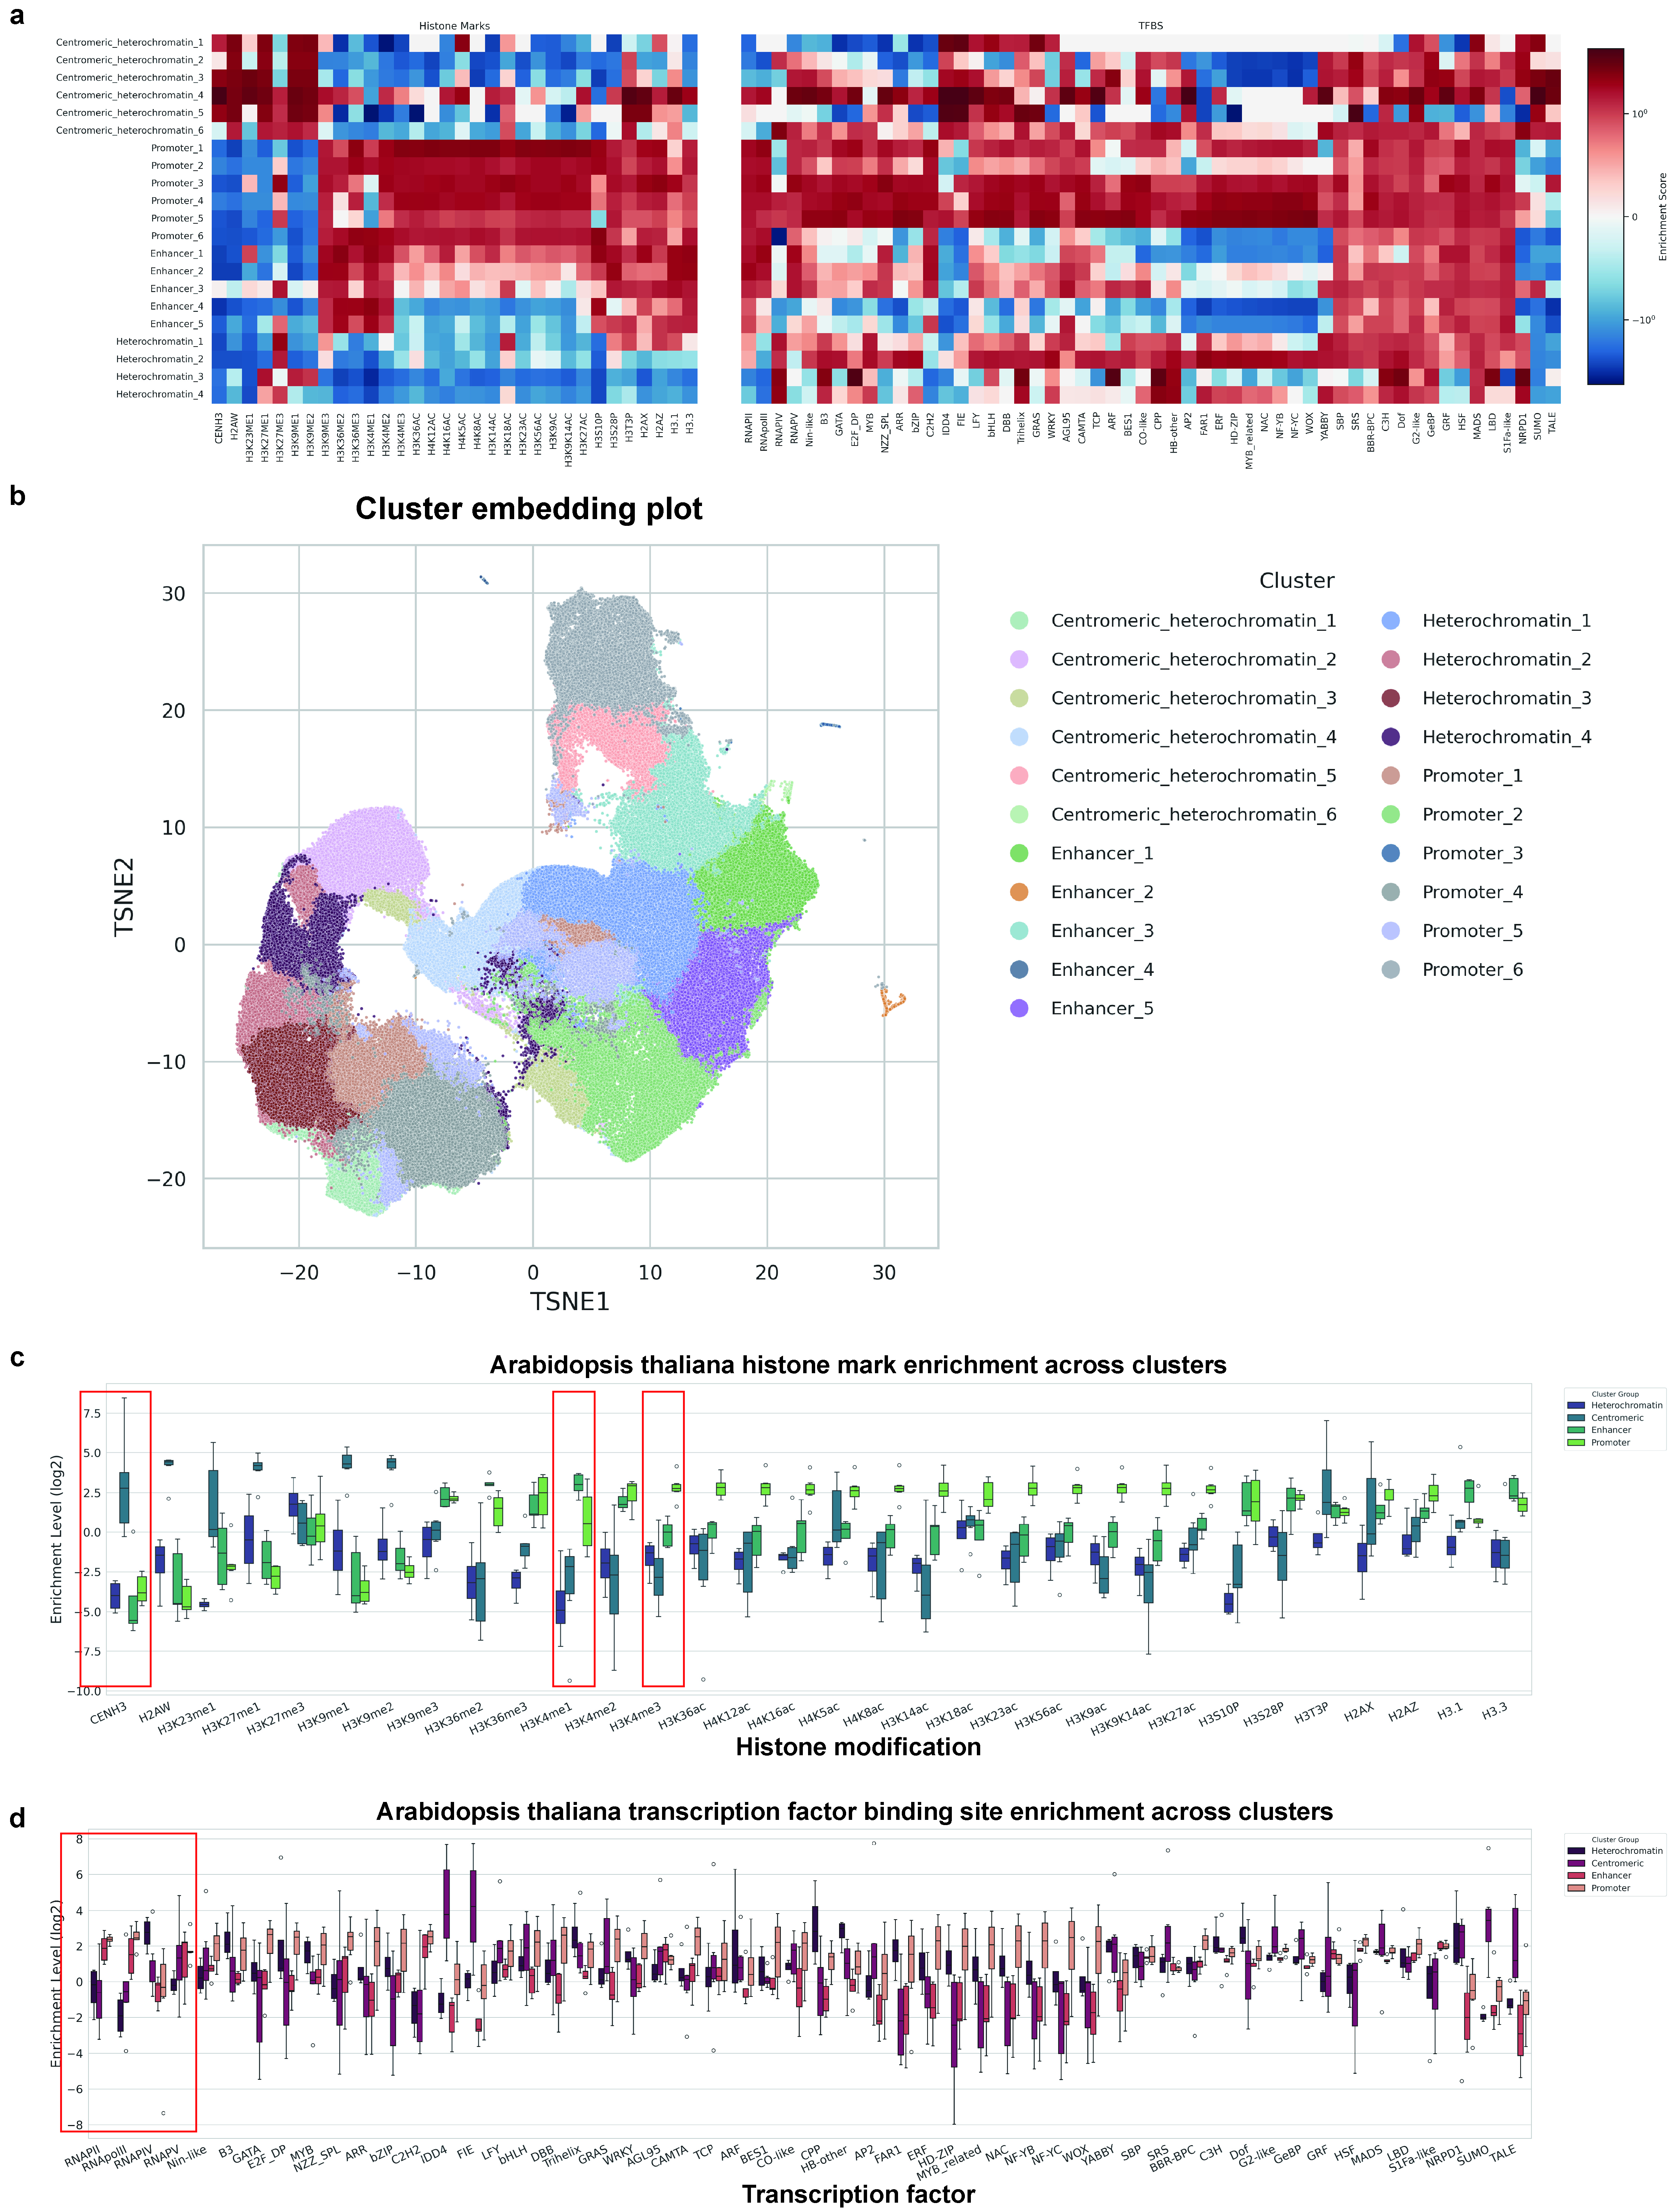
Fig. S5 Functional annotation of chromatin states based on predicted regulatory profiles in Rice. (a) Heatmap of chromatin signal spectra for different sequence classes, showing the true enrichment of each class of sequence with multiple chromatin features. (b) TSNE projection of predicted chromatin profiles in Rice using the species-specific model. Each point represents a 1,024-bp genomic window colored by cluster assignment, corresponding to distinct chromatin states. (c) Boxplots of histone modification enrichment (log₂ scale) across different genome sequence clusters. (d) Boxplots of transcription factor binding site enrichment (log₂ scale) across different genome sequence clusters.

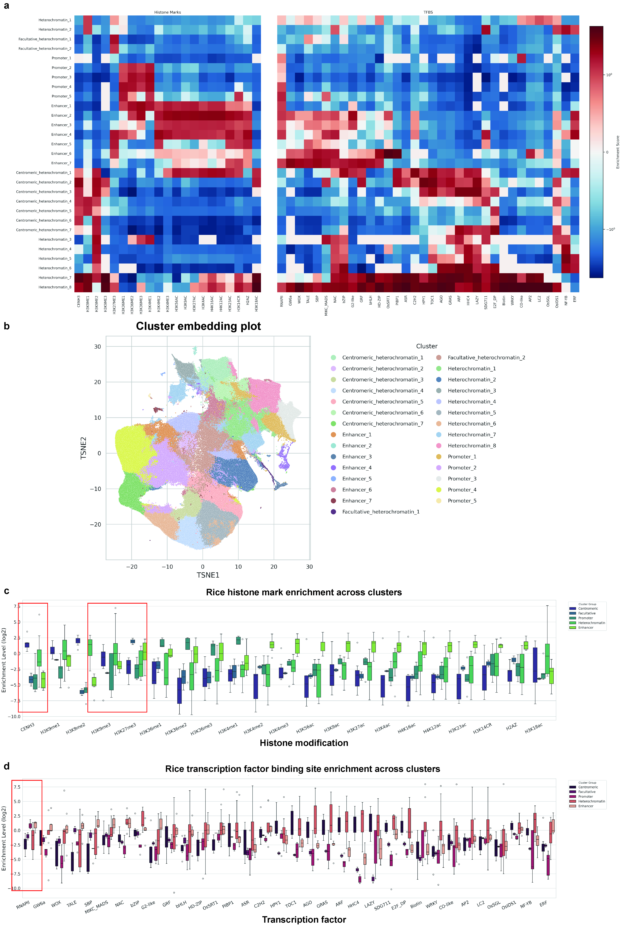
Fig. S6 Functional annotation of chromatin states based on predicted regulatory profiles in Arabidopsis. (a) Heatmap of chromatin signal spectra for different sequence classes, showing the true enrichment of each class of sequence with multiple chromatin features. (b) TSNE projection of predicted chromatin profiles in Arabidopsis using the species-specific model. Each point represents a 1,024-bp genomic window colored by cluster assignment, corresponding to distinct chromatin states. (c) Boxplots of histone modification enrichment (log₂ scale) across different genome sequence clusters. (d) Boxplots of transcription factor binding site enrichment (log₂ scale) across different genome sequence clusters.

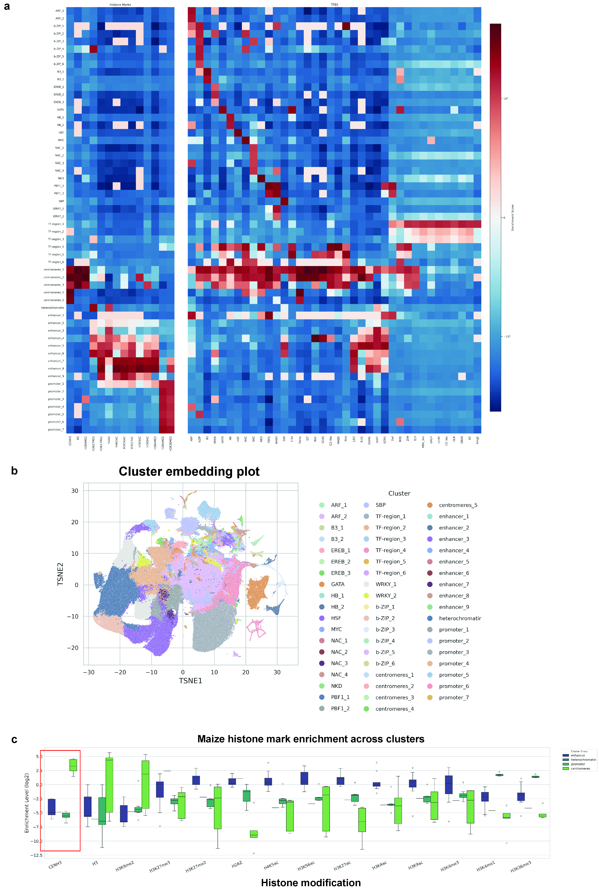
Fig. S7 Functional annotation of chromatin states based on predicted regulatory profiles in Maize. (a) Heatmap of chromatin signal spectra for different sequence classes, showing the true enrichment of each class of sequence with multiple chromatin features. (b) TSNE projection of predicted chromatin profiles in Maize using the species-specific model. Each point represents a 1,024-bp genomic window colored by cluster assignment, corresponding to distinct chromatin states, among them, specific clusters are enriched in association with specific transcription factors (e.g., certain clusters are rich in a certain type of TF binding site).
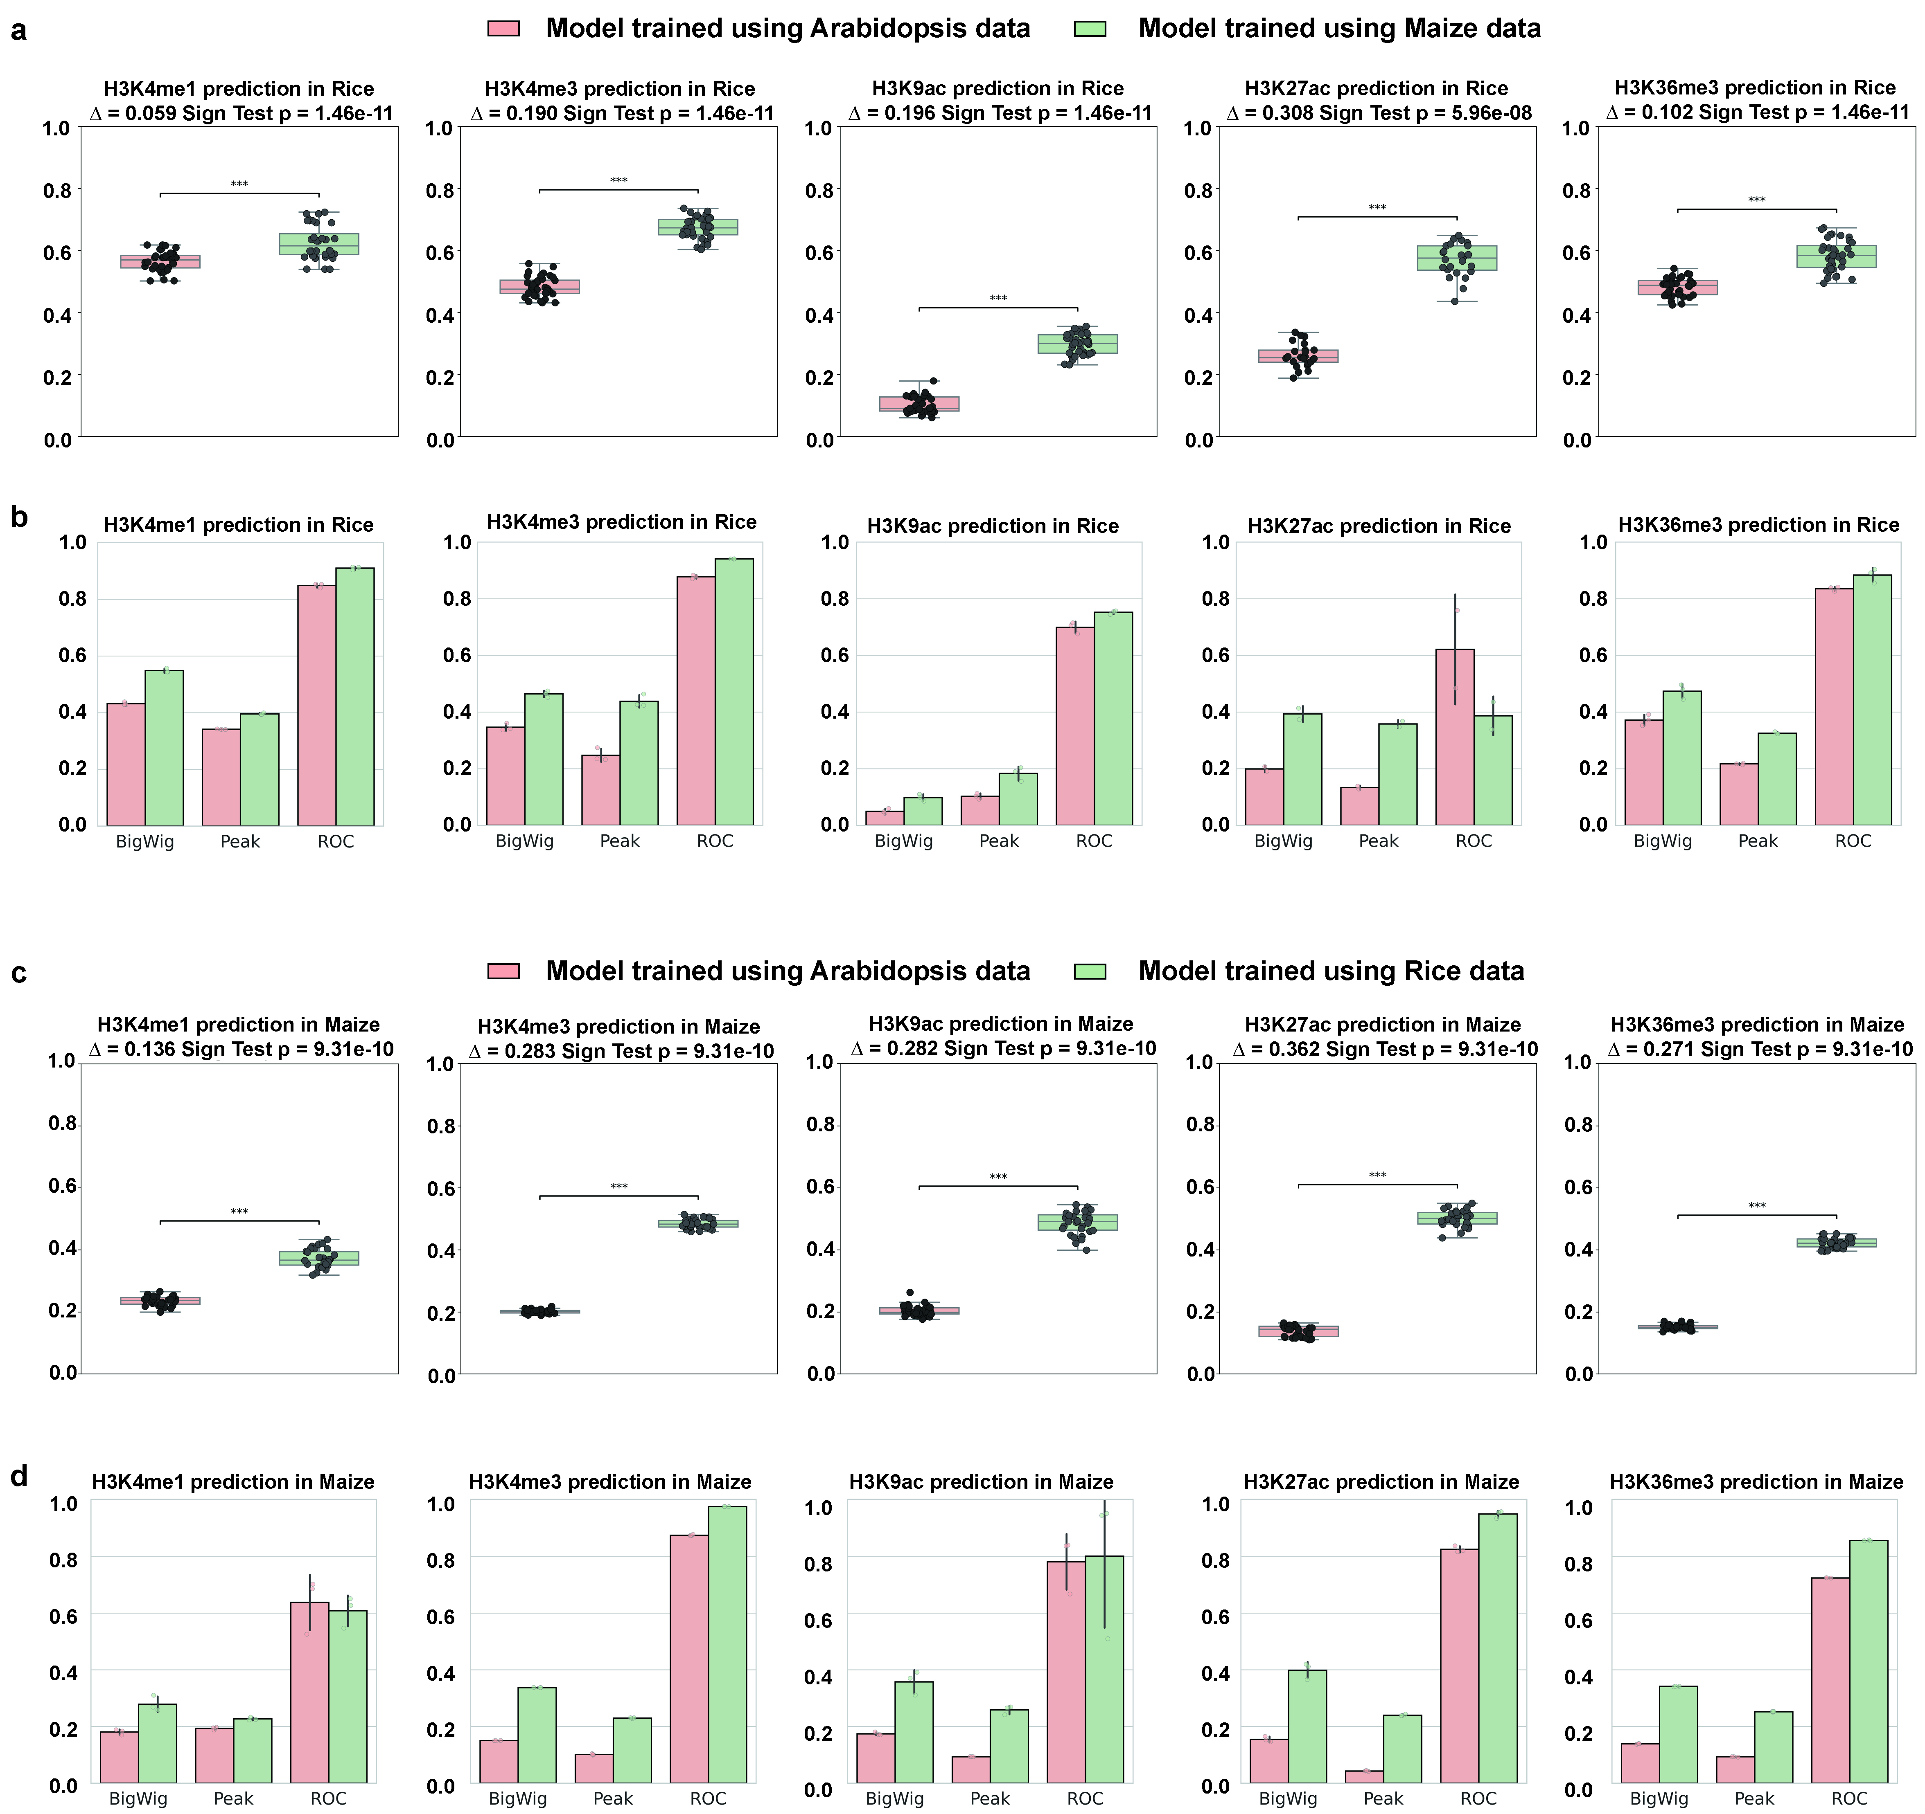
Fig. S8 Cross-species prediction performance comparison between models trained on different plant species across five histone marks. (a) Boxplots showing chromosome-level Pearson correlation coefficients between predicted and experimentally measured signals in rice, for five histone marks (H3K4me1, H3K4me3, H3K9ac, H3K27ac, H3K36me3). Models were trained using Arabidopsis data (orange) or Maize data (green). Black dots represent individual chromosomes. Brackets indicate median differences (Δ) and paired sign-test p-values. (b) Bar plots summarizing prediction performance for the same five histone marks in rice. Metrics include BigWig signal correlation, Peak classification, and ROC classification. (c) Boxplots showing chromosome-level Pearson correlation coefficients in maize for five histone marks. Models were trained using Arabidopsis thaliana data (orange) or rice data (green). (d) Bar plots summarizing prediction performance for the same five histone marks in maize. Metrics include BigWig signal correlation, Peak classification, and ROC classification.

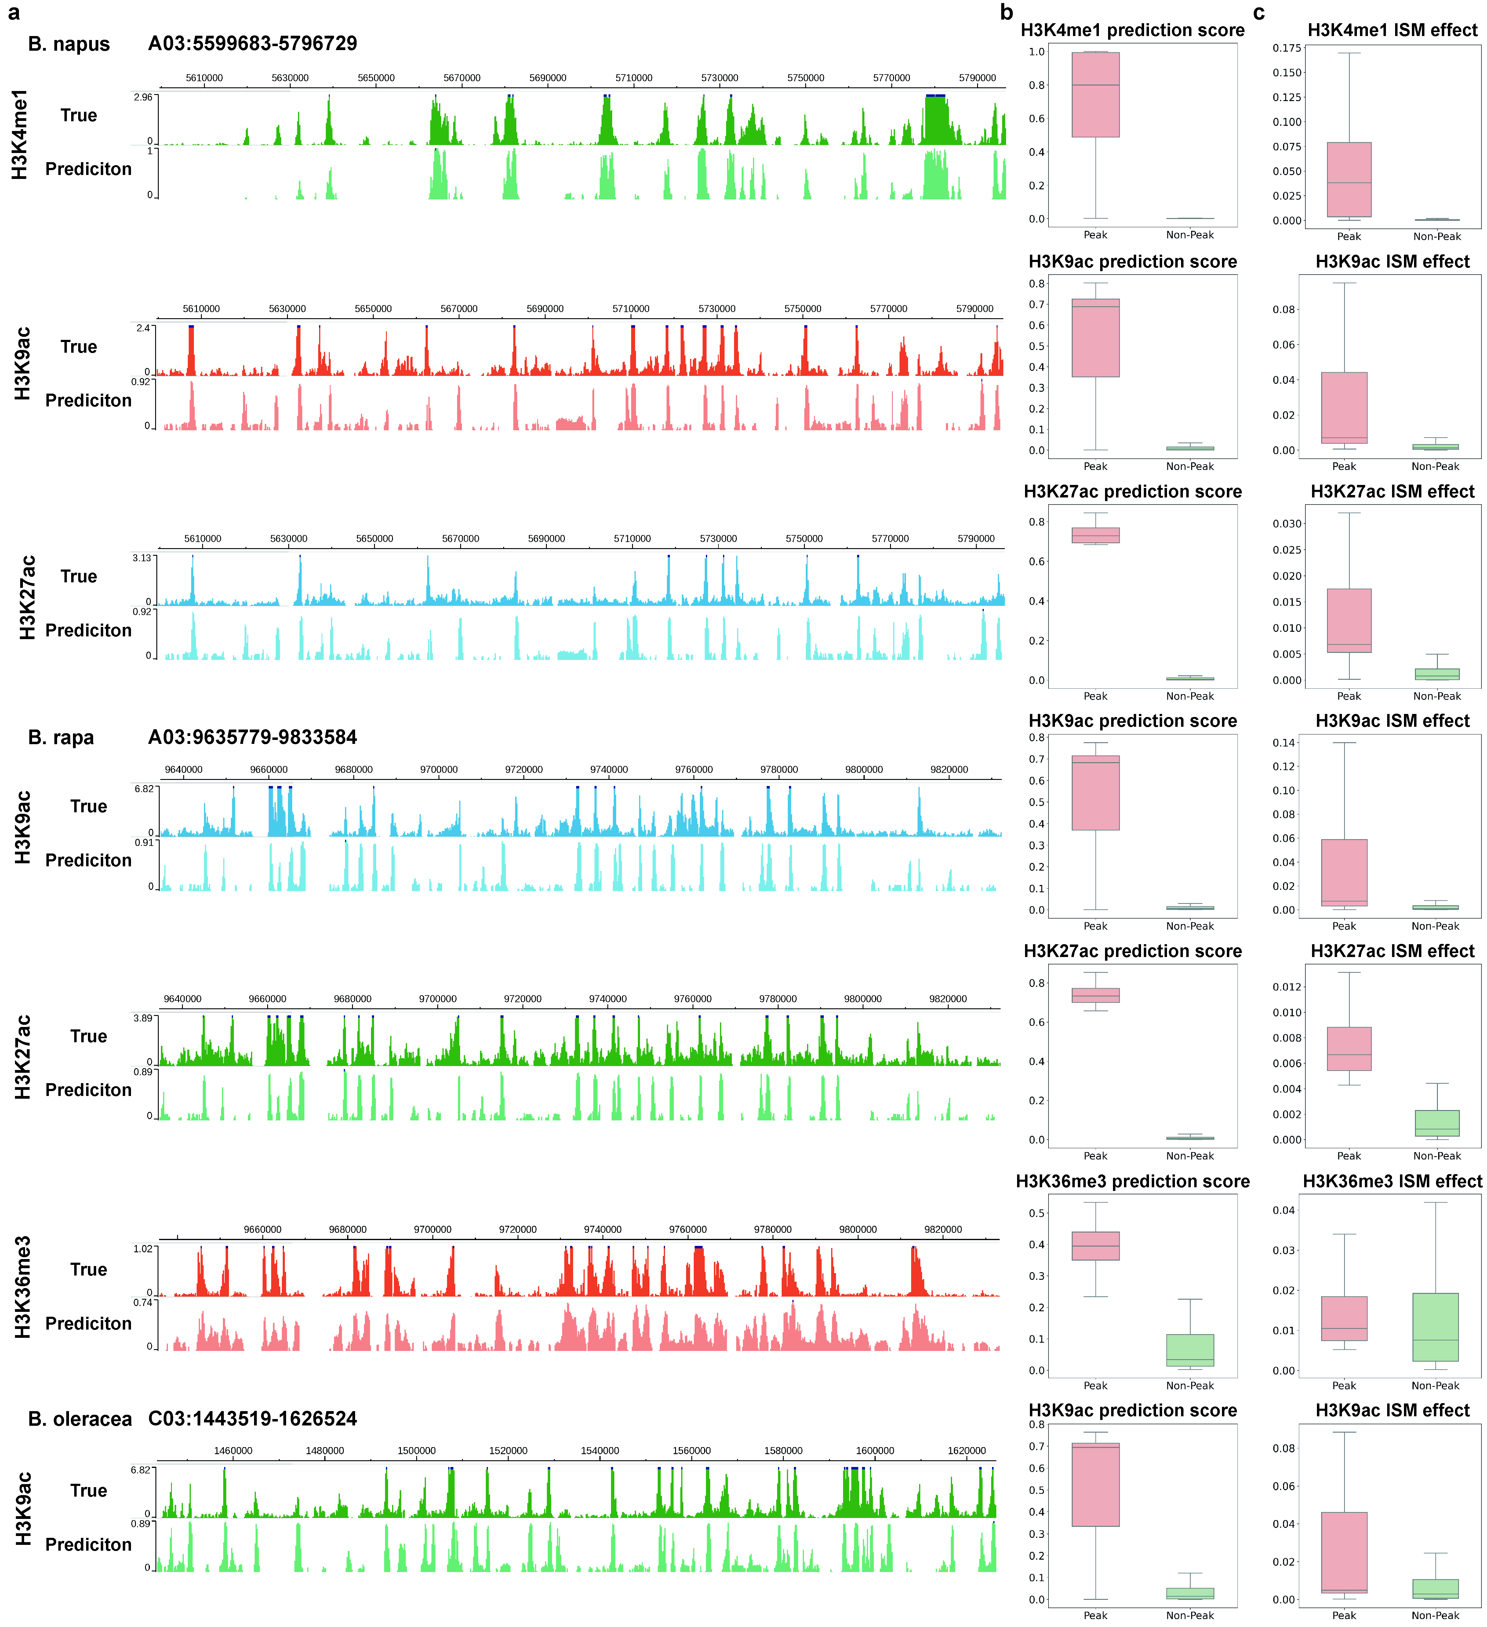
Fig. S9 Representative predictions and quantitative summaries for histone modifications in Brassicaceae species. (a) Genome browser–style visualization comparing the true ChIP-seq signal (True) and the model-predicted signal (Prediction) for multiple histone modifications across selected genomic intervals in Brassica napus, Brassica rapa, and Brassica oleracea. (b) Boxplots of prediction scores for Peak versus Non-Peak regions for different histone modifications. (c) Boxplots of in silico mutation (ISM) effects for Peak versus Non-Peak regions for the same set of histone modifications as in (b). ISM quantifies the impact of single-nucleotide perturbations on the predicted signal. Boxplot elements are the same as in (b).

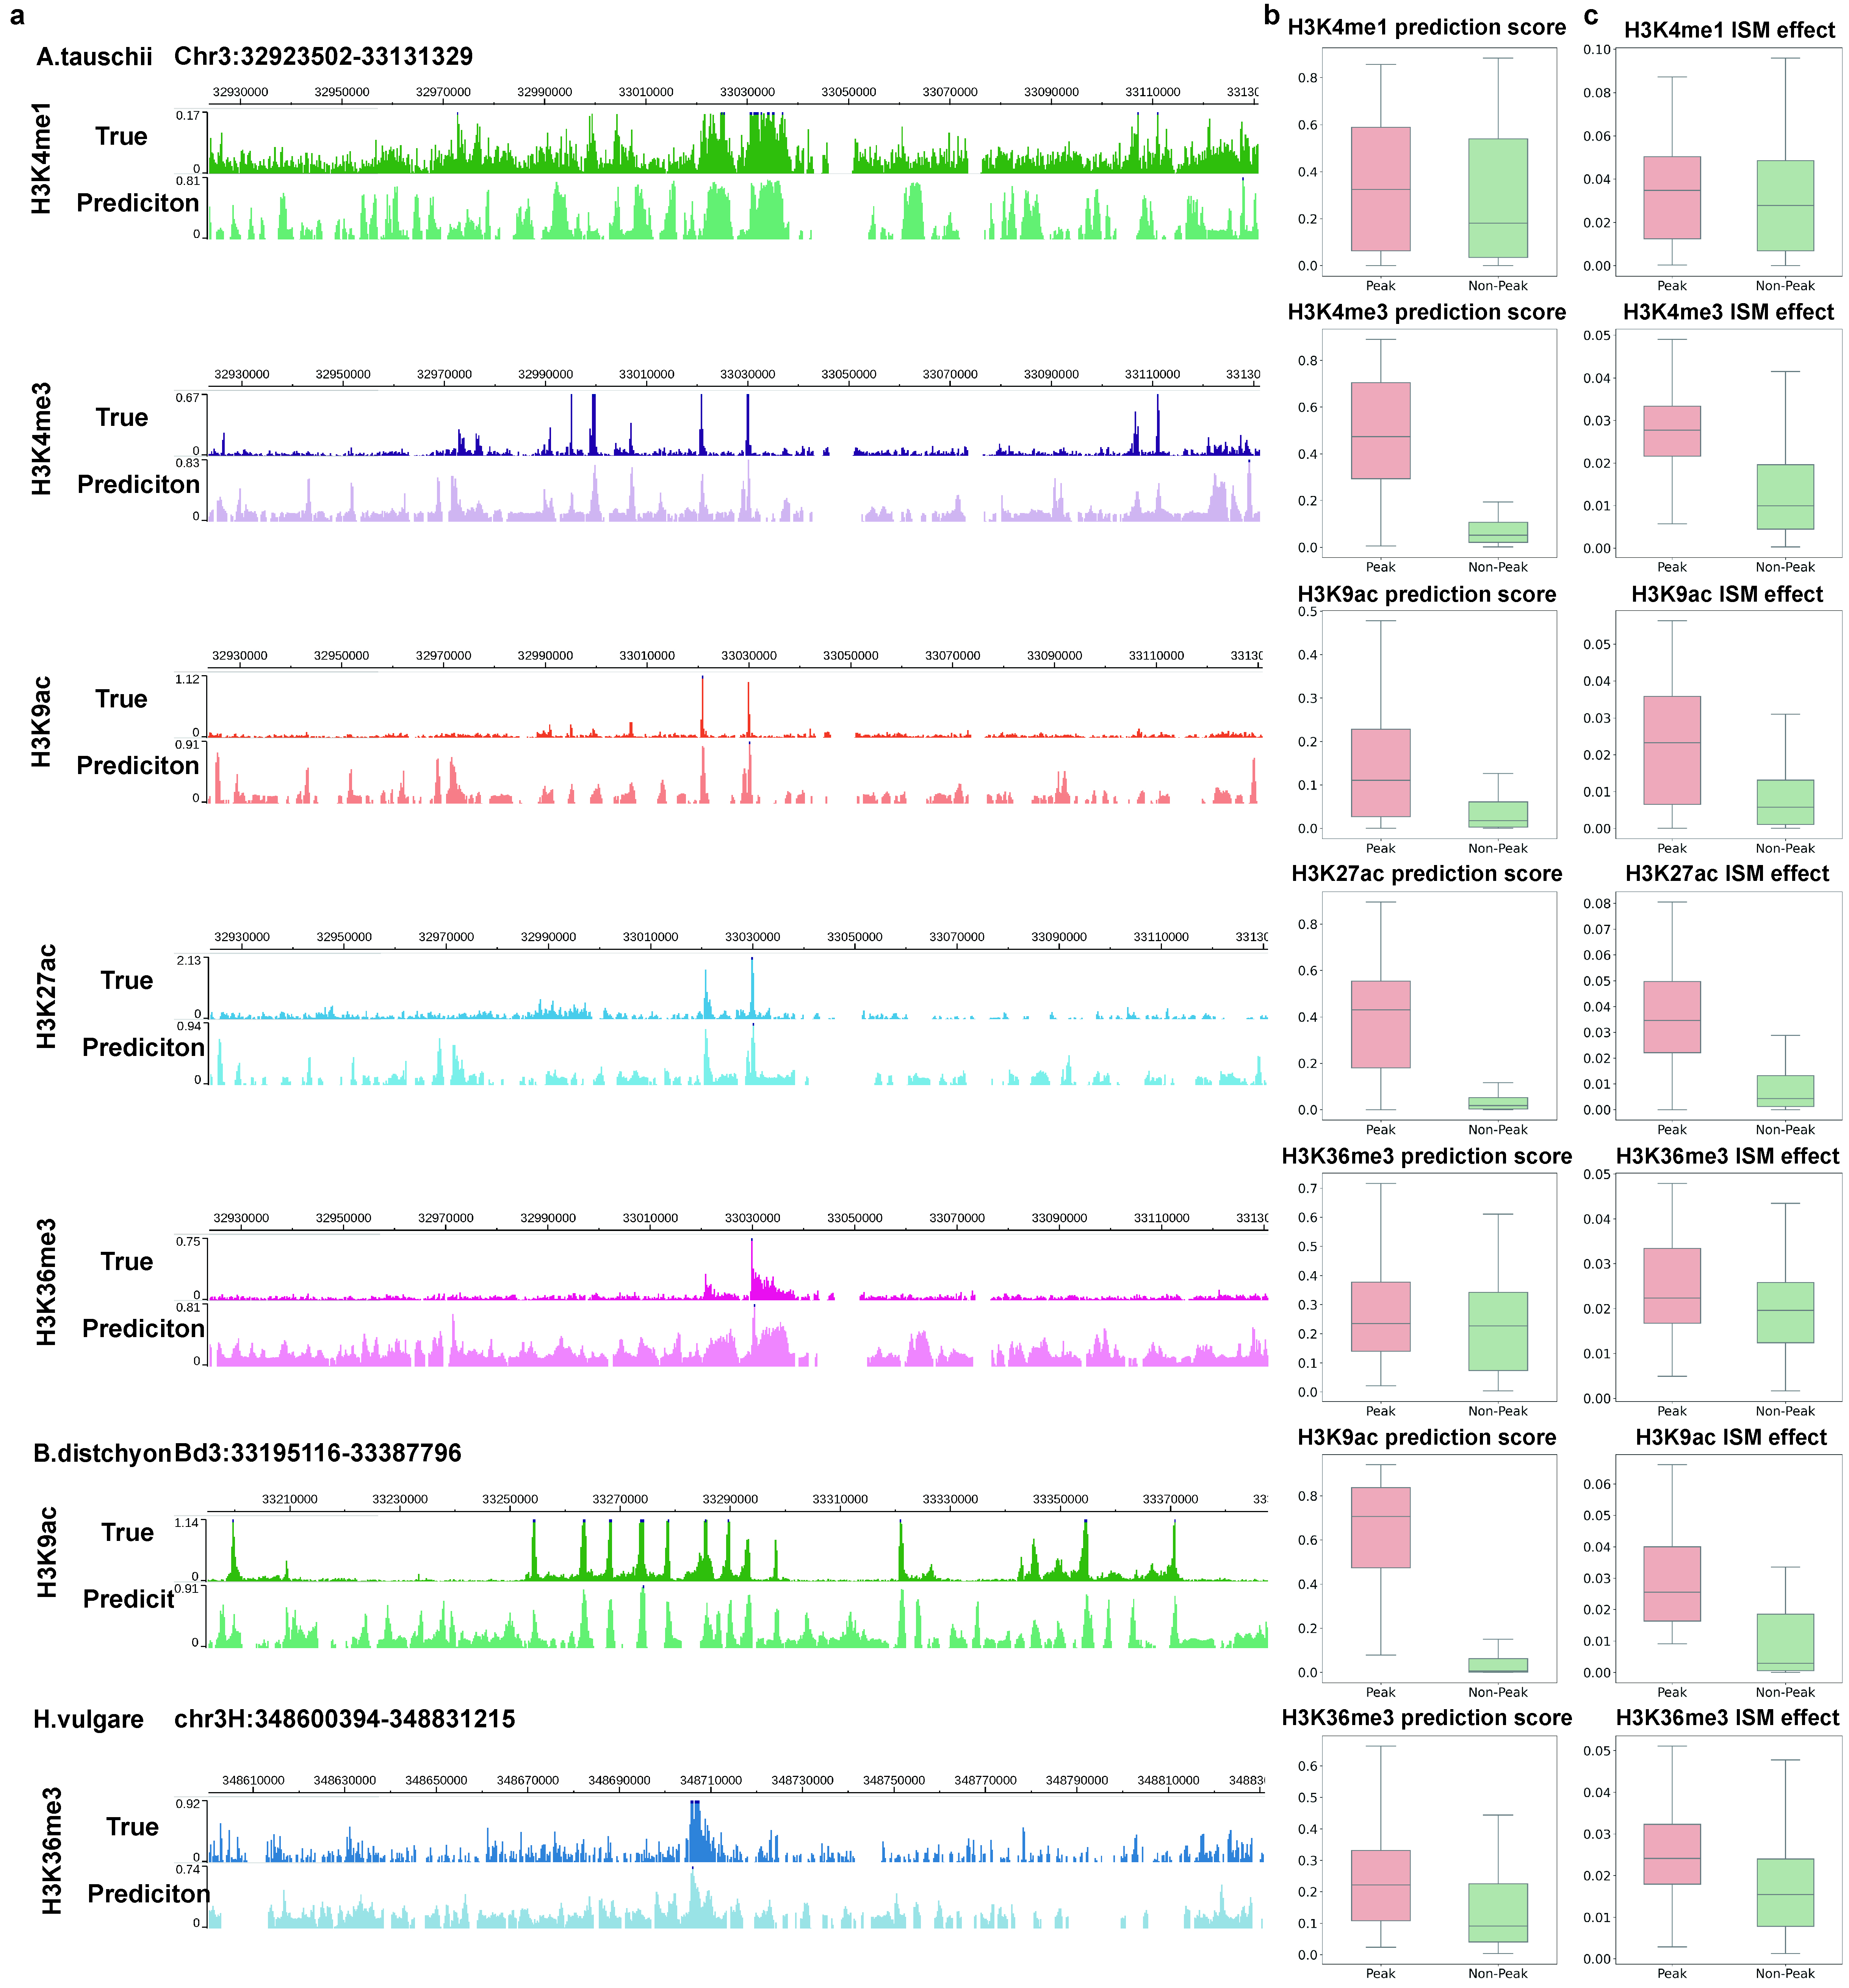
Fig. S10 Representative predictions and quantitative summaries for histone modifications in Poaceae species. (a) Genome browser–style visualization comparing true ChIP-seq signal (True) and model-predicted signal (Prediction) for multiple histone modifications across selected genomic intervals in Aegilops tauschii, Brachypodium distachyon, and Hordeum vulgare. (b) Boxplots of prediction scores for Peak versus Non-Peak regions for different histone modifications. (c) Boxplots of in silico mutation (ISM) effects for Peak versus Non-Peak regions for the same set of histone modifications as in (b). ISM quantifies the impact of single-nucleotide perturbations on the predicted signal. Boxplot elements are the same as in (b).

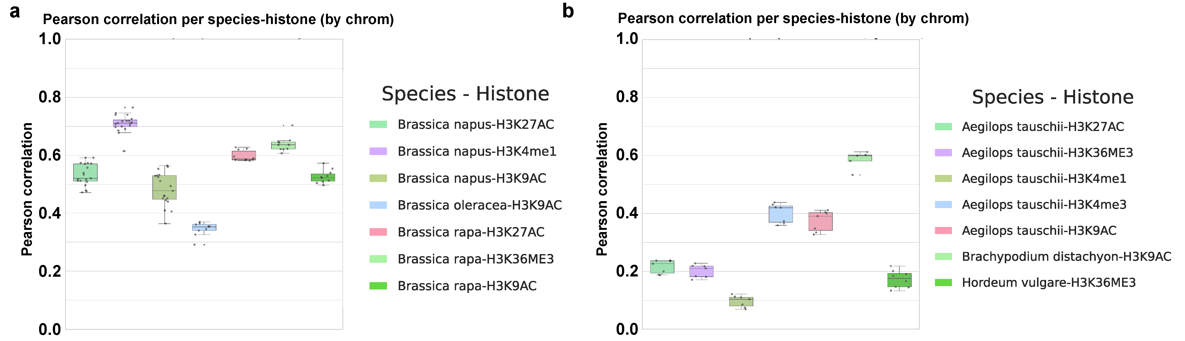
Fig. S11 Per-chromosome prediction accuracy for additional histone modifications in representative Brassicaceae and Poaceae species. (a) Boxplots of Pearson correlation between predicted and ChIP-seq signals of representative Brassicaceae species, computed per chromosome. (b) Boxplots of Pearson correlation between predicted and ChIP-seq signals of representative Poaceae species, computed per chromosome.

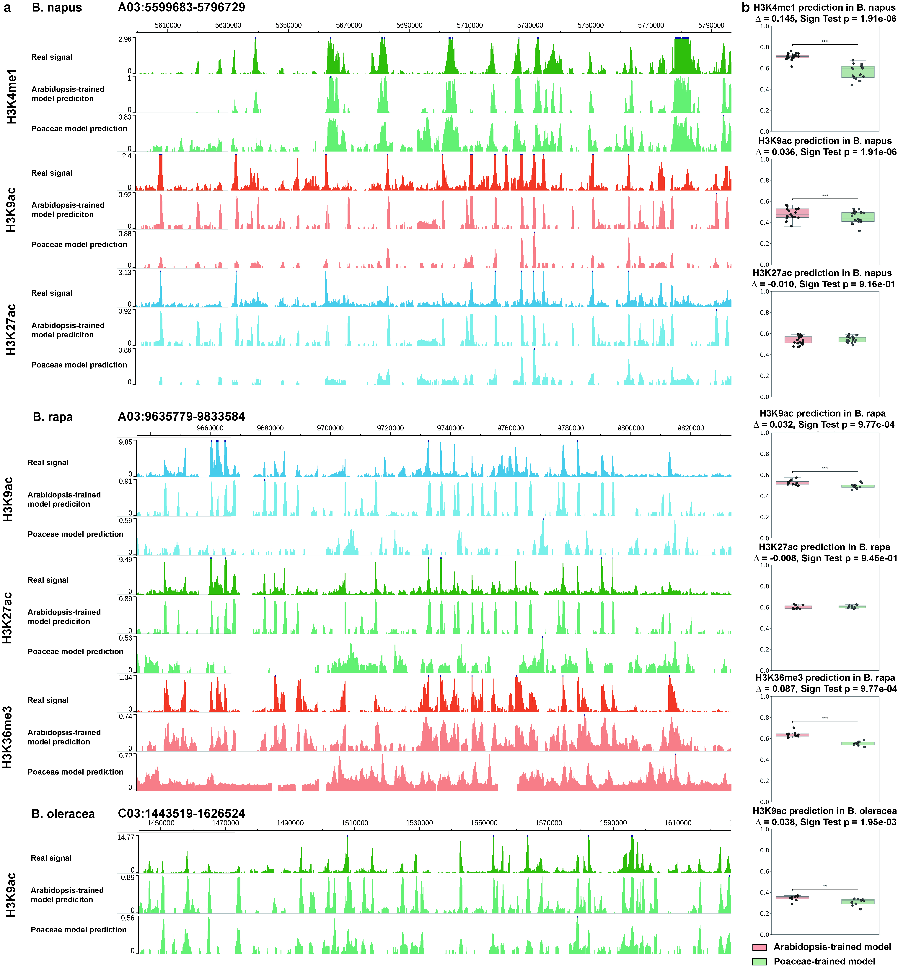
Fig. S12 Cross-family versus within-family prediction on Brassicaceae targets. (a) Boxplots of Pearson correlation between predicted and ChIP-seq signals of representative Brassicaceae species, computed per chromosome. Genome-browser tracks for representative genomic intervals in Brassicaceae species, for each histone modification, three stacked tracks are shown: Real signal (ChIP-seq), Arabidopsis-trained model prediction (within-family), and Poaceae-trained model prediction (cross-family). (b) Boxplots summarizing per-chromosome Pearson correlation between predicted and measured signals for the same species–mark combinations shown in (a). Colors distinguish model sources (Arabidopsis-trained vs Poaceae-trained). Brackets annotate the median difference (Δ) and paired sign-test p-value for each comparison.

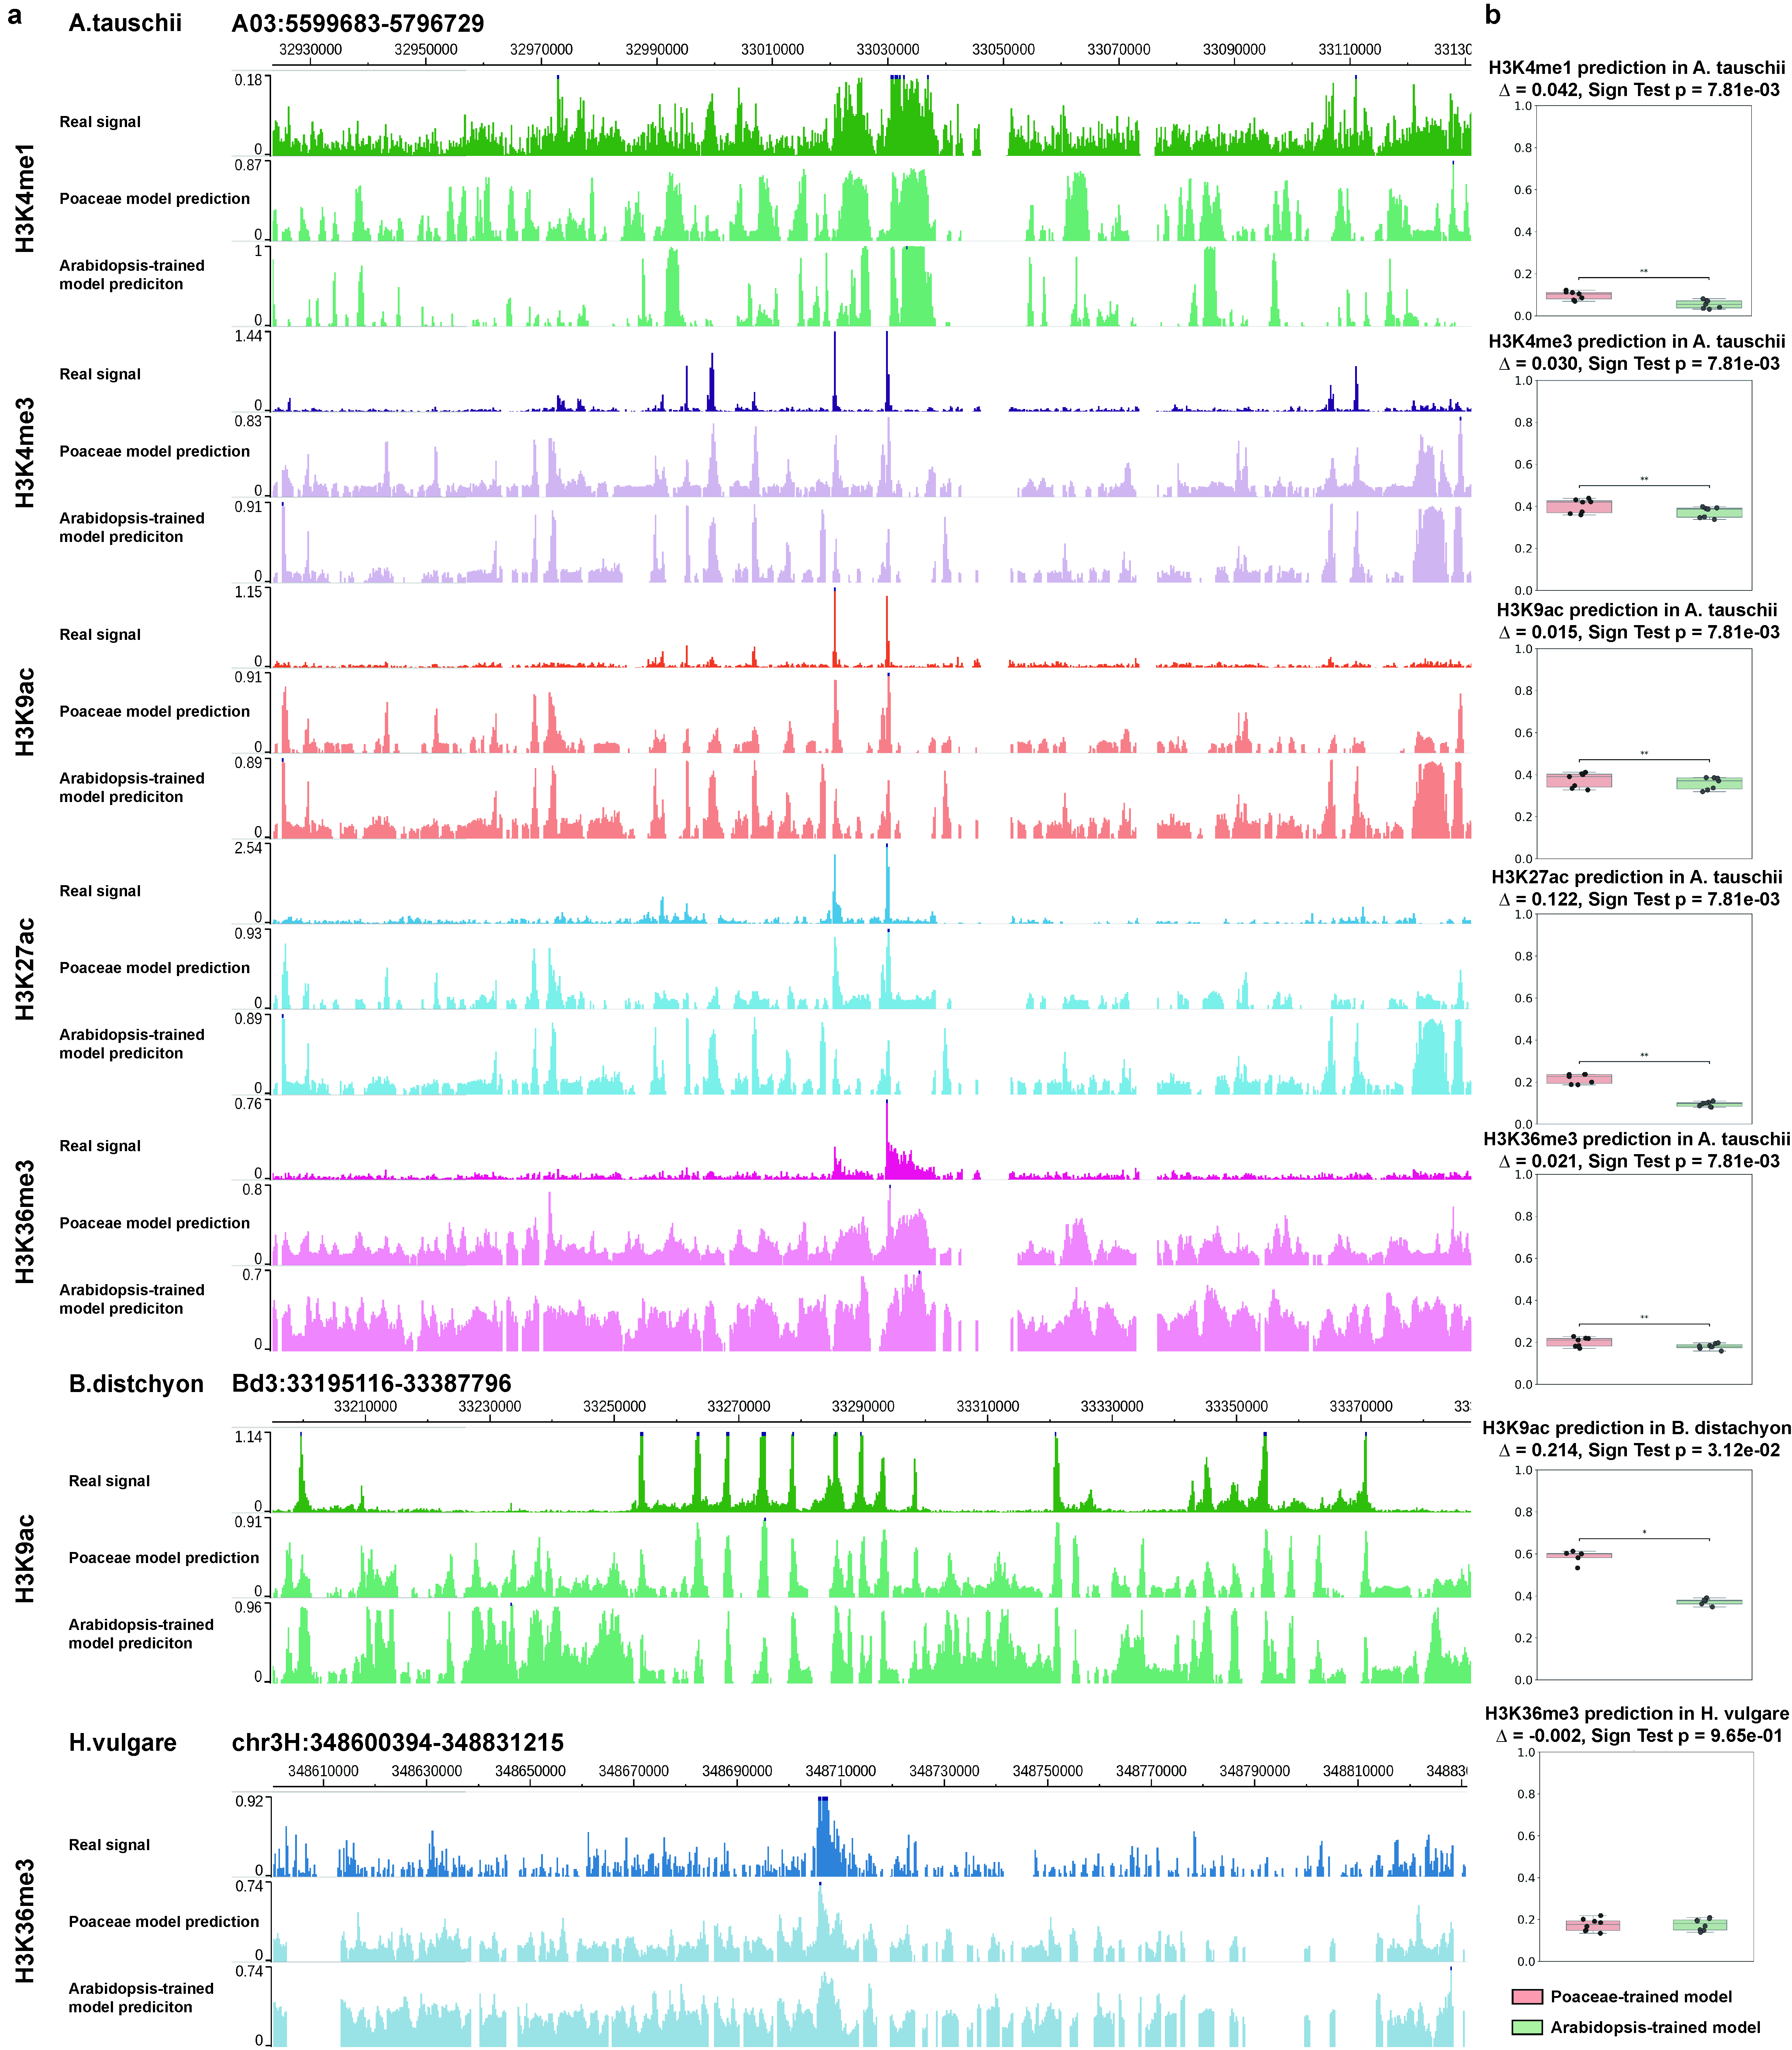
Fig. S13 Cross-family versus within-family prediction on Poaceae targets. (a) Genome-browser style tracks for representative intervals in Poaceae species. For each histone modification, three stacked tracks are shown: Real signal (ChIP-seq), Poaceae-trained model prediction (within-family for Poaceae panels), and Arabidopsis-trained model prediction (cross-family). (b) Boxplots summarizing per-chromosome Pearson correlation between predicted and measured signals for the species–mark combinations displayed in (a).

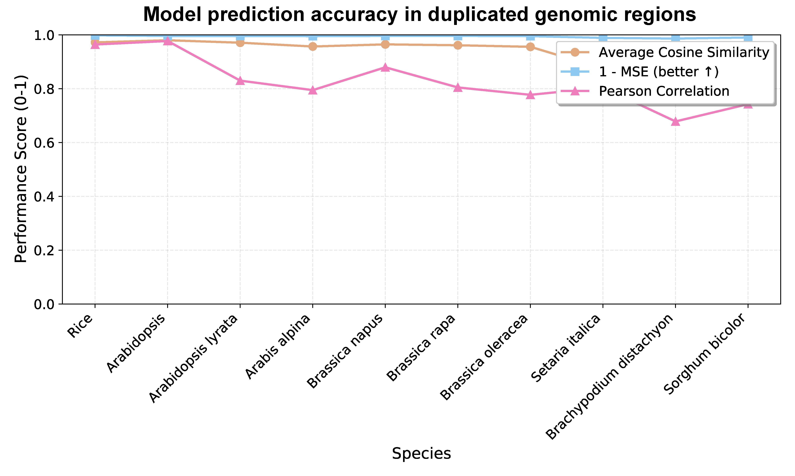
Fig. S14 Prediction Consistency on Duplicated Genomic Regions Across Plant Species. The line chart showing the consistency of predictions for pairs of repetitive regions within genomes across multiple plant species. Pairs of repetitive regions were identified within each species’ genome using BLASTN self-alignment; prediction signals were generated for paired regions using their respective homologous models, and similarities were aggregated within each species. The three curves in the figure represent three metrics: average cosine similarity (orange dots), 1−MSE (blue squares), and Pearson correlation coefficient (red triangles).

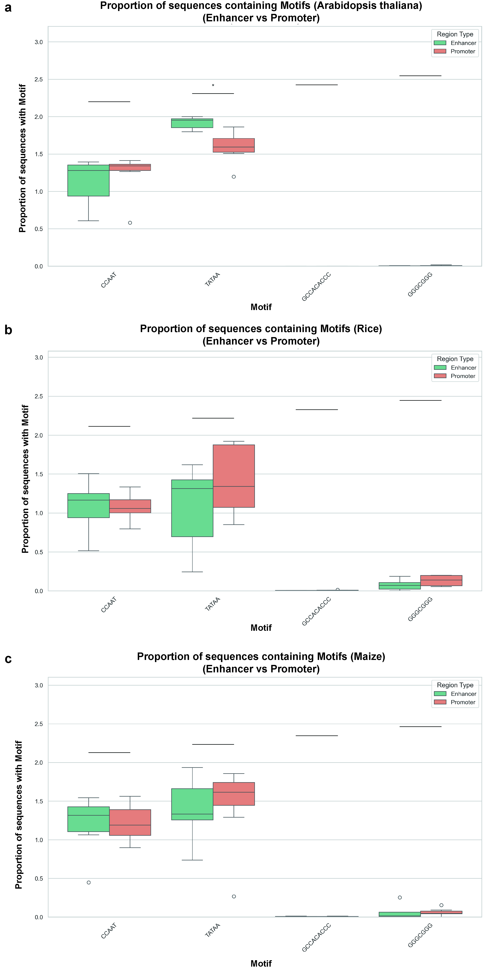
Fig. S15 Motif occurrence between promoter- from enhancer-labeled clusters across species. (a–c) Boxplots showing the proportion of sequences containing canonical promoter-associated motifs (e.g., TATA-box, CCAAT-box) and GC-rich motifs in clusters annotated as Enhancer (green) or Promoter (orange) for Arabidopsis (A), Rice (B), and Maize (C). For each motif, the proportion was computed within every cluster, and the distribution across clusters of the same region type is summarized by boxplots (center line = median; box = interquartile range, IQR; whiskers = 1.5×IQR; points = outliers).

