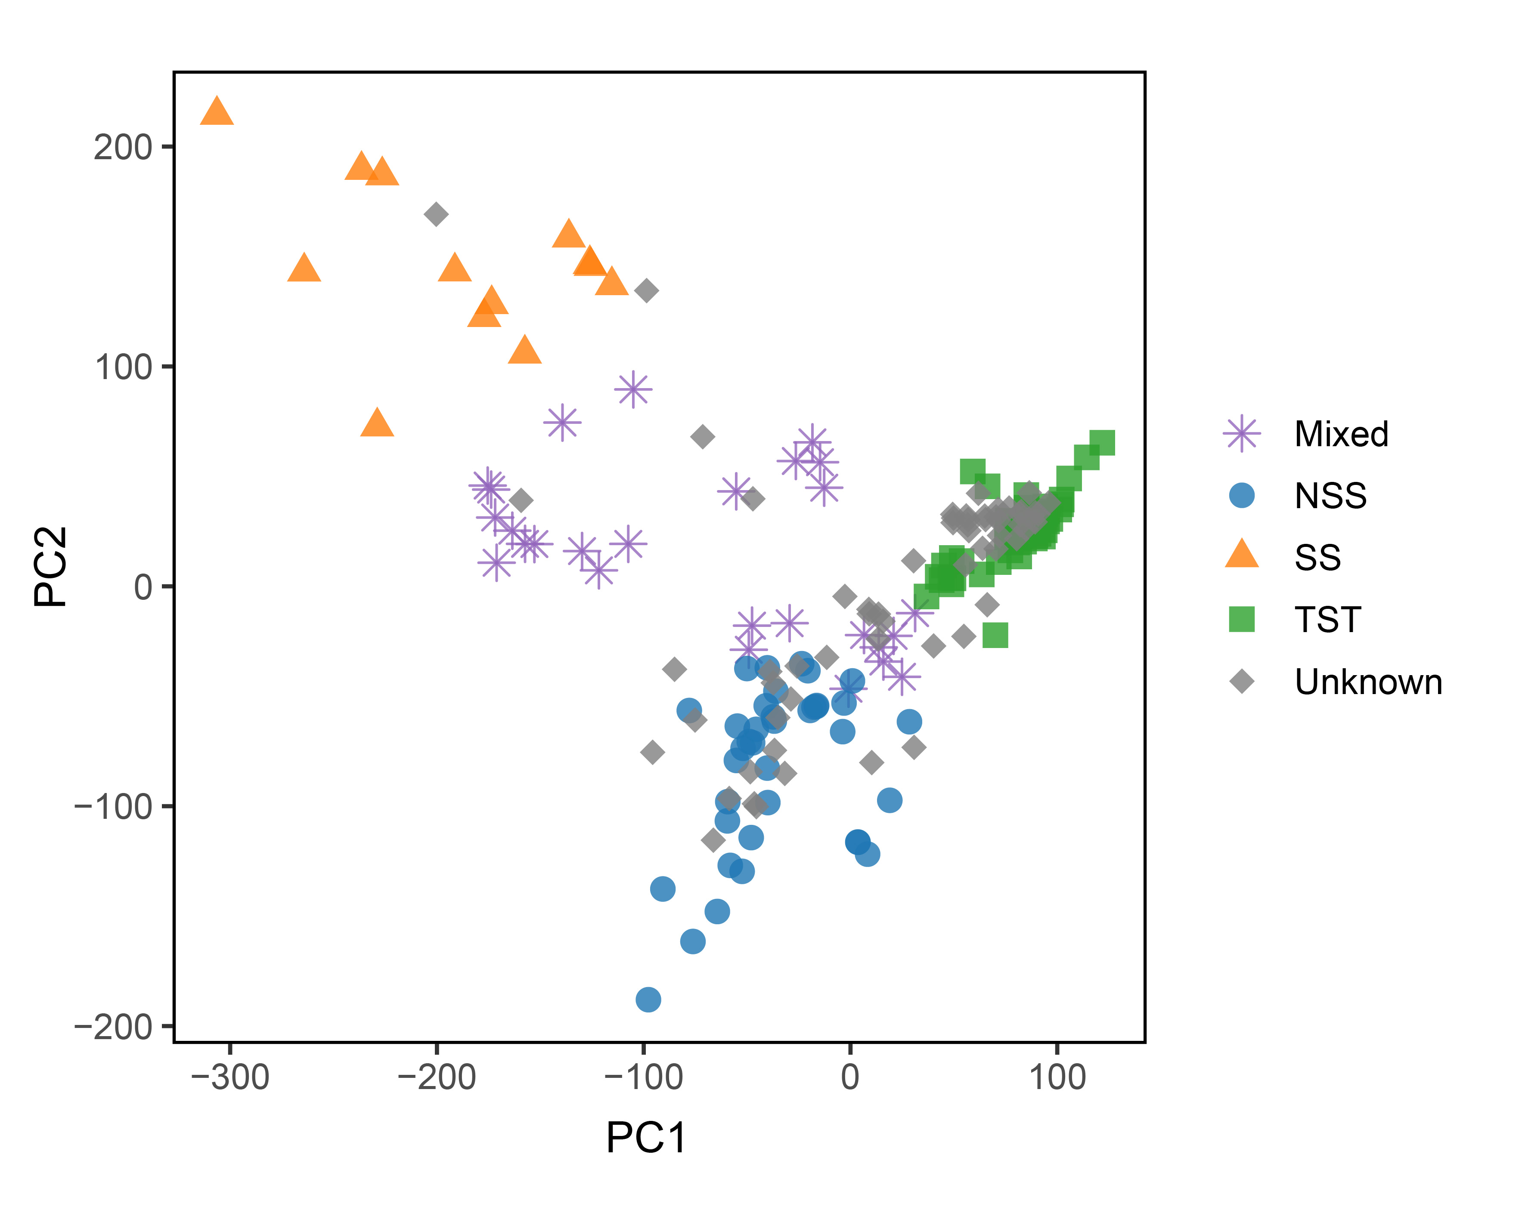
Fig. S1. Principal component analysis (PCA) of 197 maize inbred lines.
Samples are plotted along PC1 (x-axis) and PC2 (y-axis) and colored by subgroup: Mixed (purple asterisks), NSS (blue circles), SS (orange triangles), TST (green squares), and Unknown (gray diamonds).

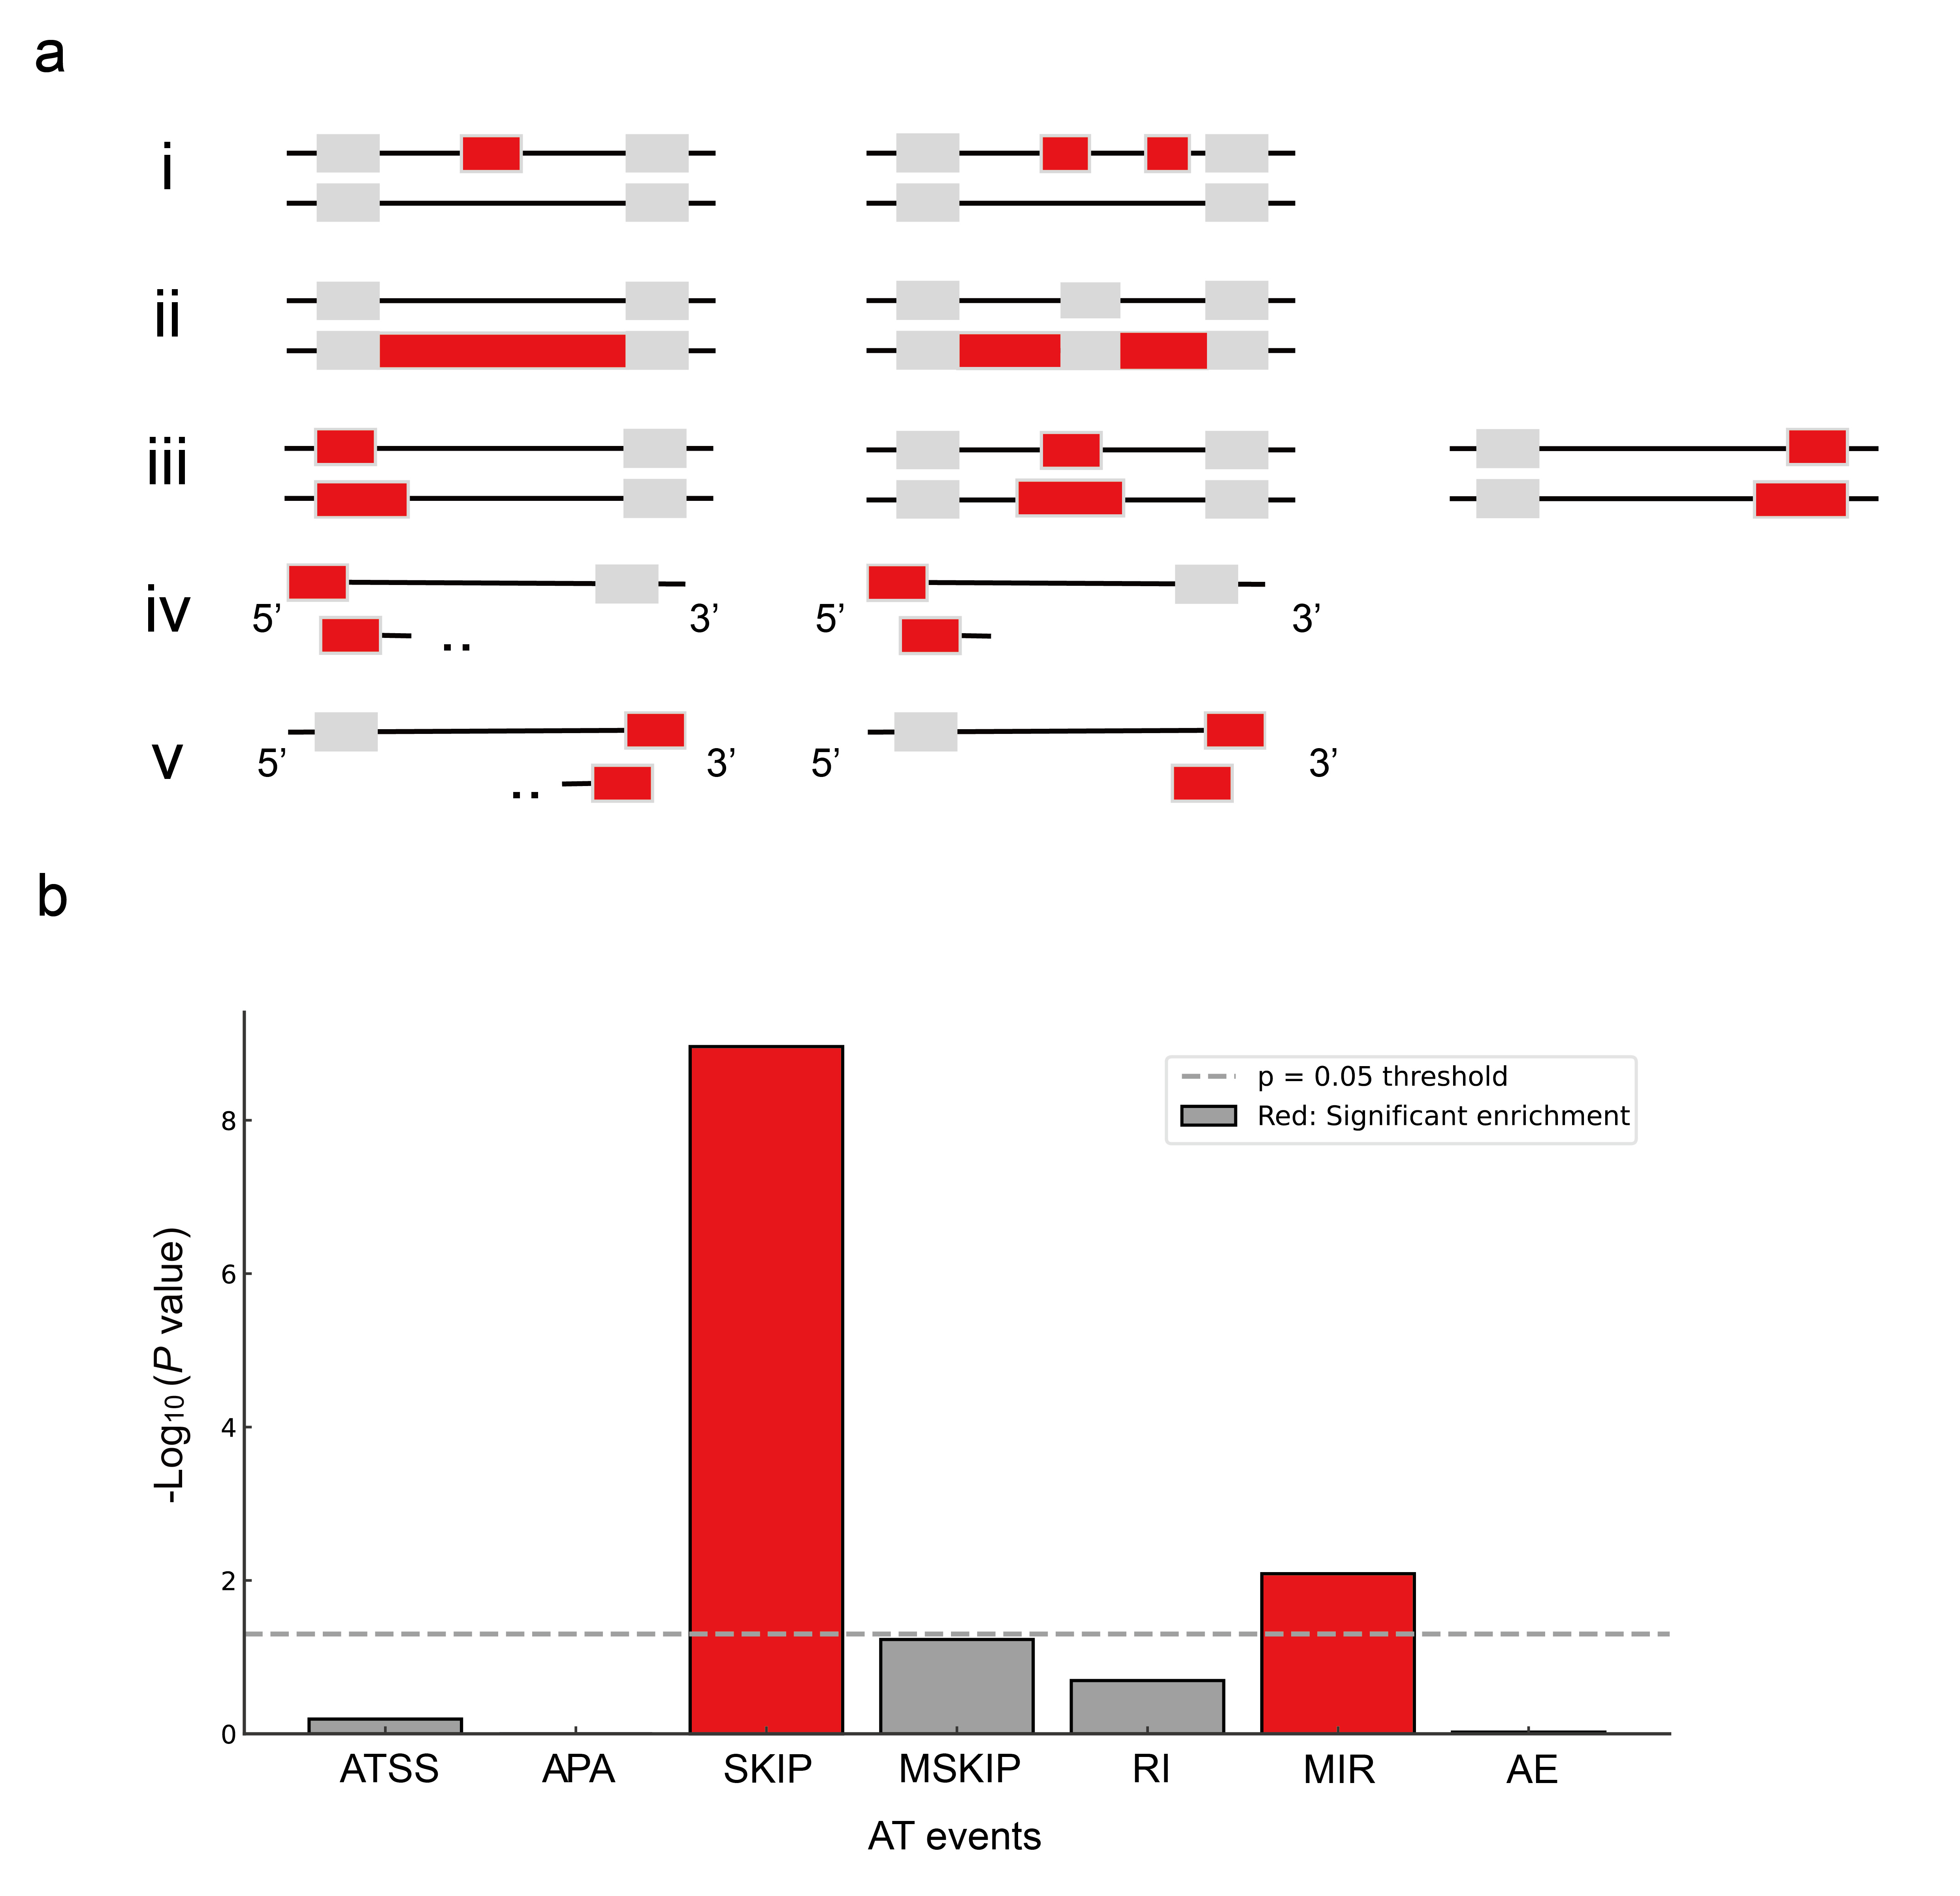
Fig. S2. Classification and enrichment of alternative transcripts events. a Categories of alternative transcripts events identified by pairwise transcript comparison using ASprofile: (i) Exon skipping (SKIP) and multiple exons skipping (MSKIP); (ii) Retention of intron (RI) and multiple intron retention (MIR); (iii) Alternative exon (AE); (iv) Alternative transcription start site (ATSS); and (v) alternative polyadenylation (APA). Alternatively, spliced features are shown in red. b Enrichment of AT event categories among DATGs. Significantly enriched types (P < 0.05, odds ratio > 1) are shown as red bars; non-significant type are shown in gray.
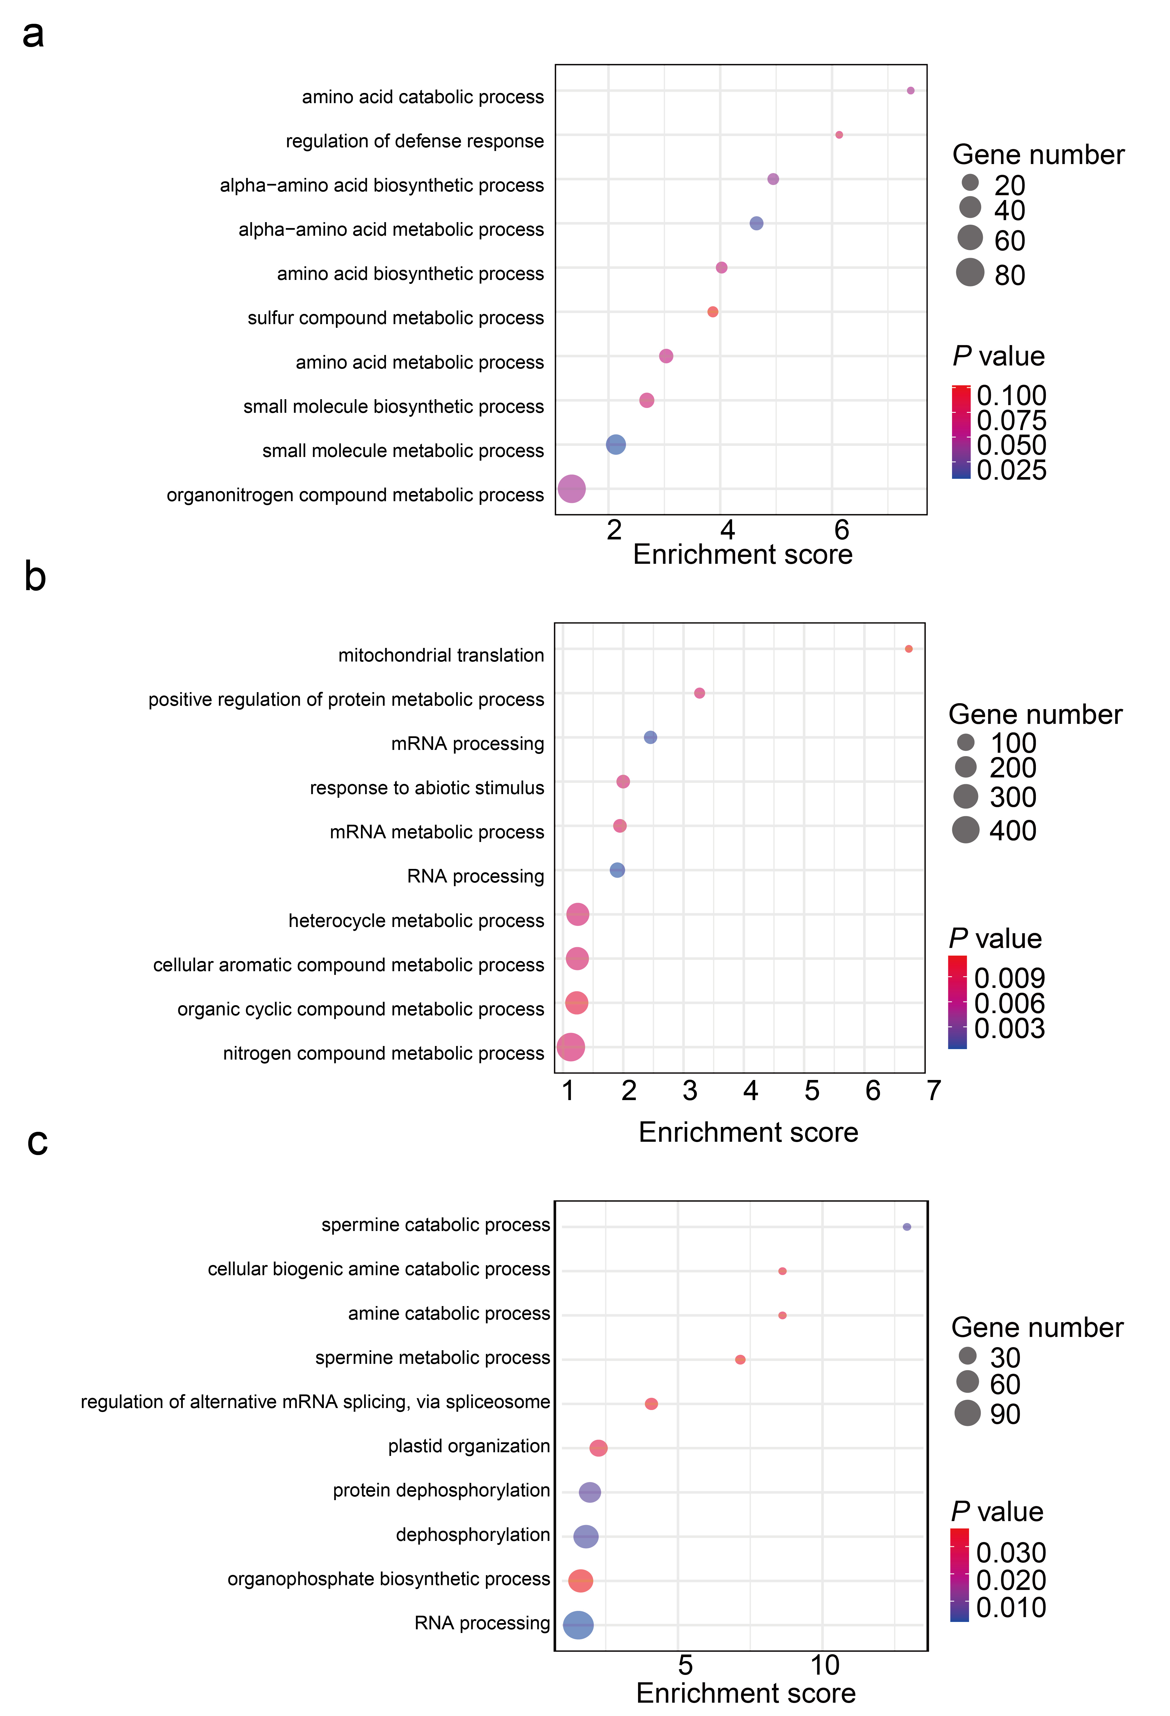
Fig. S3. GO enrichment analysis of conserved and maize-specific DATs. a Analysis of cross-species conserved DATs. b Analysis of maize-unique functional DATs. c Analysis of maize-unique non-functional DATs. For all plots, dot size corresponds to the number of genes per GO term; color indicates the significance level (‑log₁₀ FDR-adjusted P value, with red indicating higher significance).

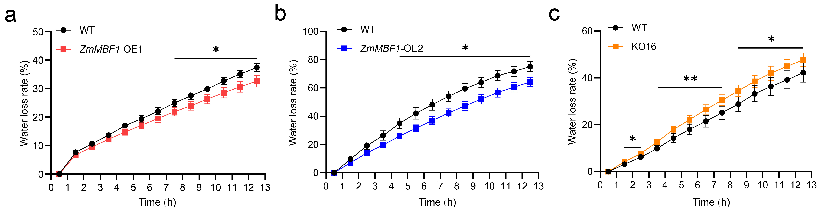
Fig. S4. Water loss assay of detached leaves from ZmMBF1 transgenic lines. a-c Detached leave water loss over time in ZmMBF1-OE1 (a), ZmMBF1-OE2 (b) and KO16 (c). Data represent mean ± SD (n = 3). Significant differences are indicated as *, P < 0.05 and **, P < 0.01 (Student’s t-test).

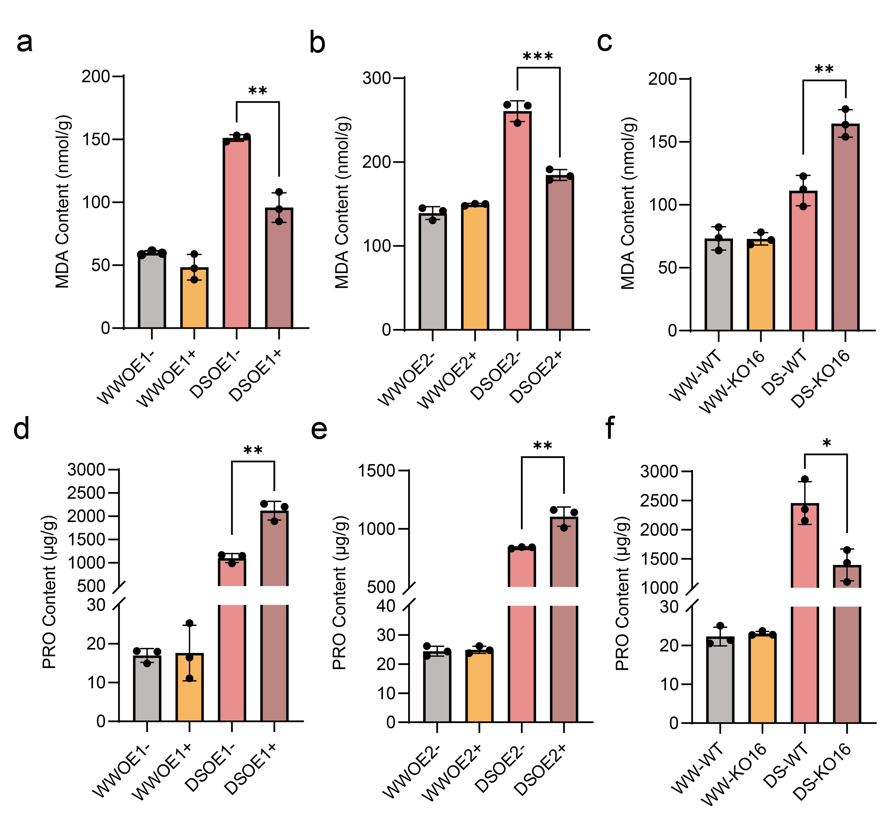
Fig. S5. MDA and PRO contents of ZmMBF1 transgenic lines. a-c MDA content in ZmMBF1-overexpressing (a,b) and knockout lines (c) under WW and DS conditions. d-f PRO content in ZmMBF1-overexpressing (d,e) and knockout lines (f) under WW and DS conditions. Data are shown as mean ± SD (n = 3). Significant differences are indicated as *, P < 0.05 and **, P < 0.01 and ***, P < 0.001 (Student’s t-test).
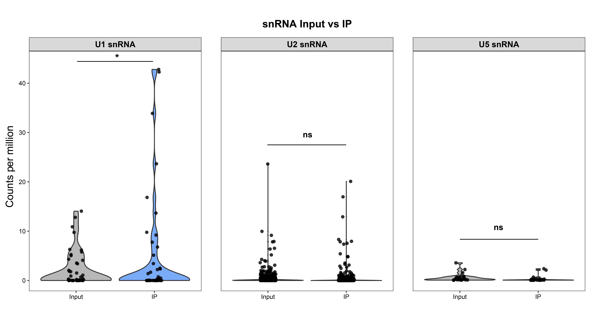
Fig. S6. Enrichment of U1, U2 and U5 snRNAs in IP versus Input samples. Violin plots show the distribution of counts per million (CPM) values for U1 snRNA (left panel), U2 snRNA (middle panel), and U5 snRNA (right panel) between Input (gray) and IP (blue) samples. Each point represents an individual snRNA locus. The y-axis represents the normalized expression level. Statistical significance was assessed by an unpaired t-test (P < 0.05).
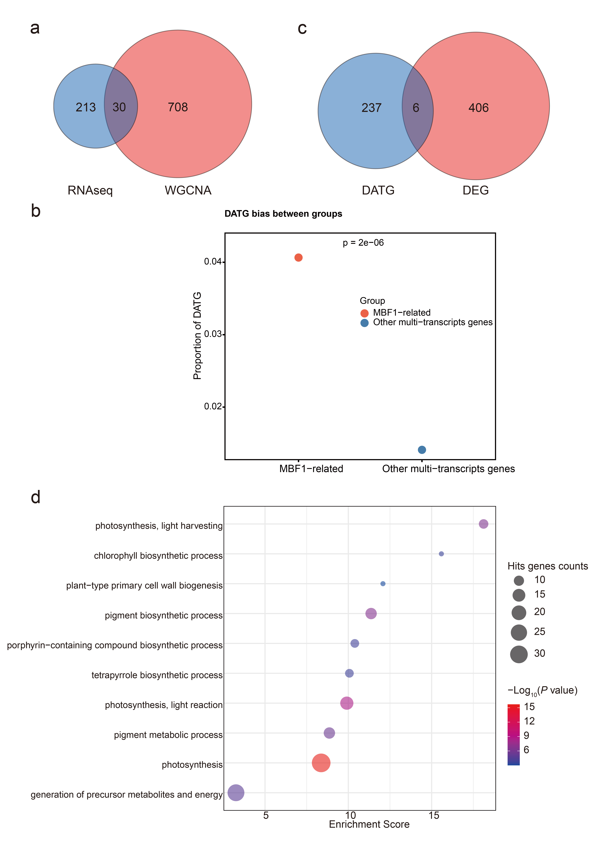
Fig. S7. RNA-seq analysis of ZmMBF1 knockout mutants. a Venn diagram showing the overlap between genes from the associated WGCNA module and differentially expressed alternative transcript genes (DATG) identified by RNA-seq within the same module. b Proportion of DATG among ZmMBF1-associated multi-transcript genes compared to other multi-transcript gene sets. Each point represents one group, the P value (Fisher’s exact test) is shown above. c Venn diagram of overlap between DATG and differentially expressed genes (DEG). d GO enrichment analysis of DATG. Dot size corresponds to gene count per term; color indicates significance (-Log₁₀ adjusted P value; red indicates higher significance).

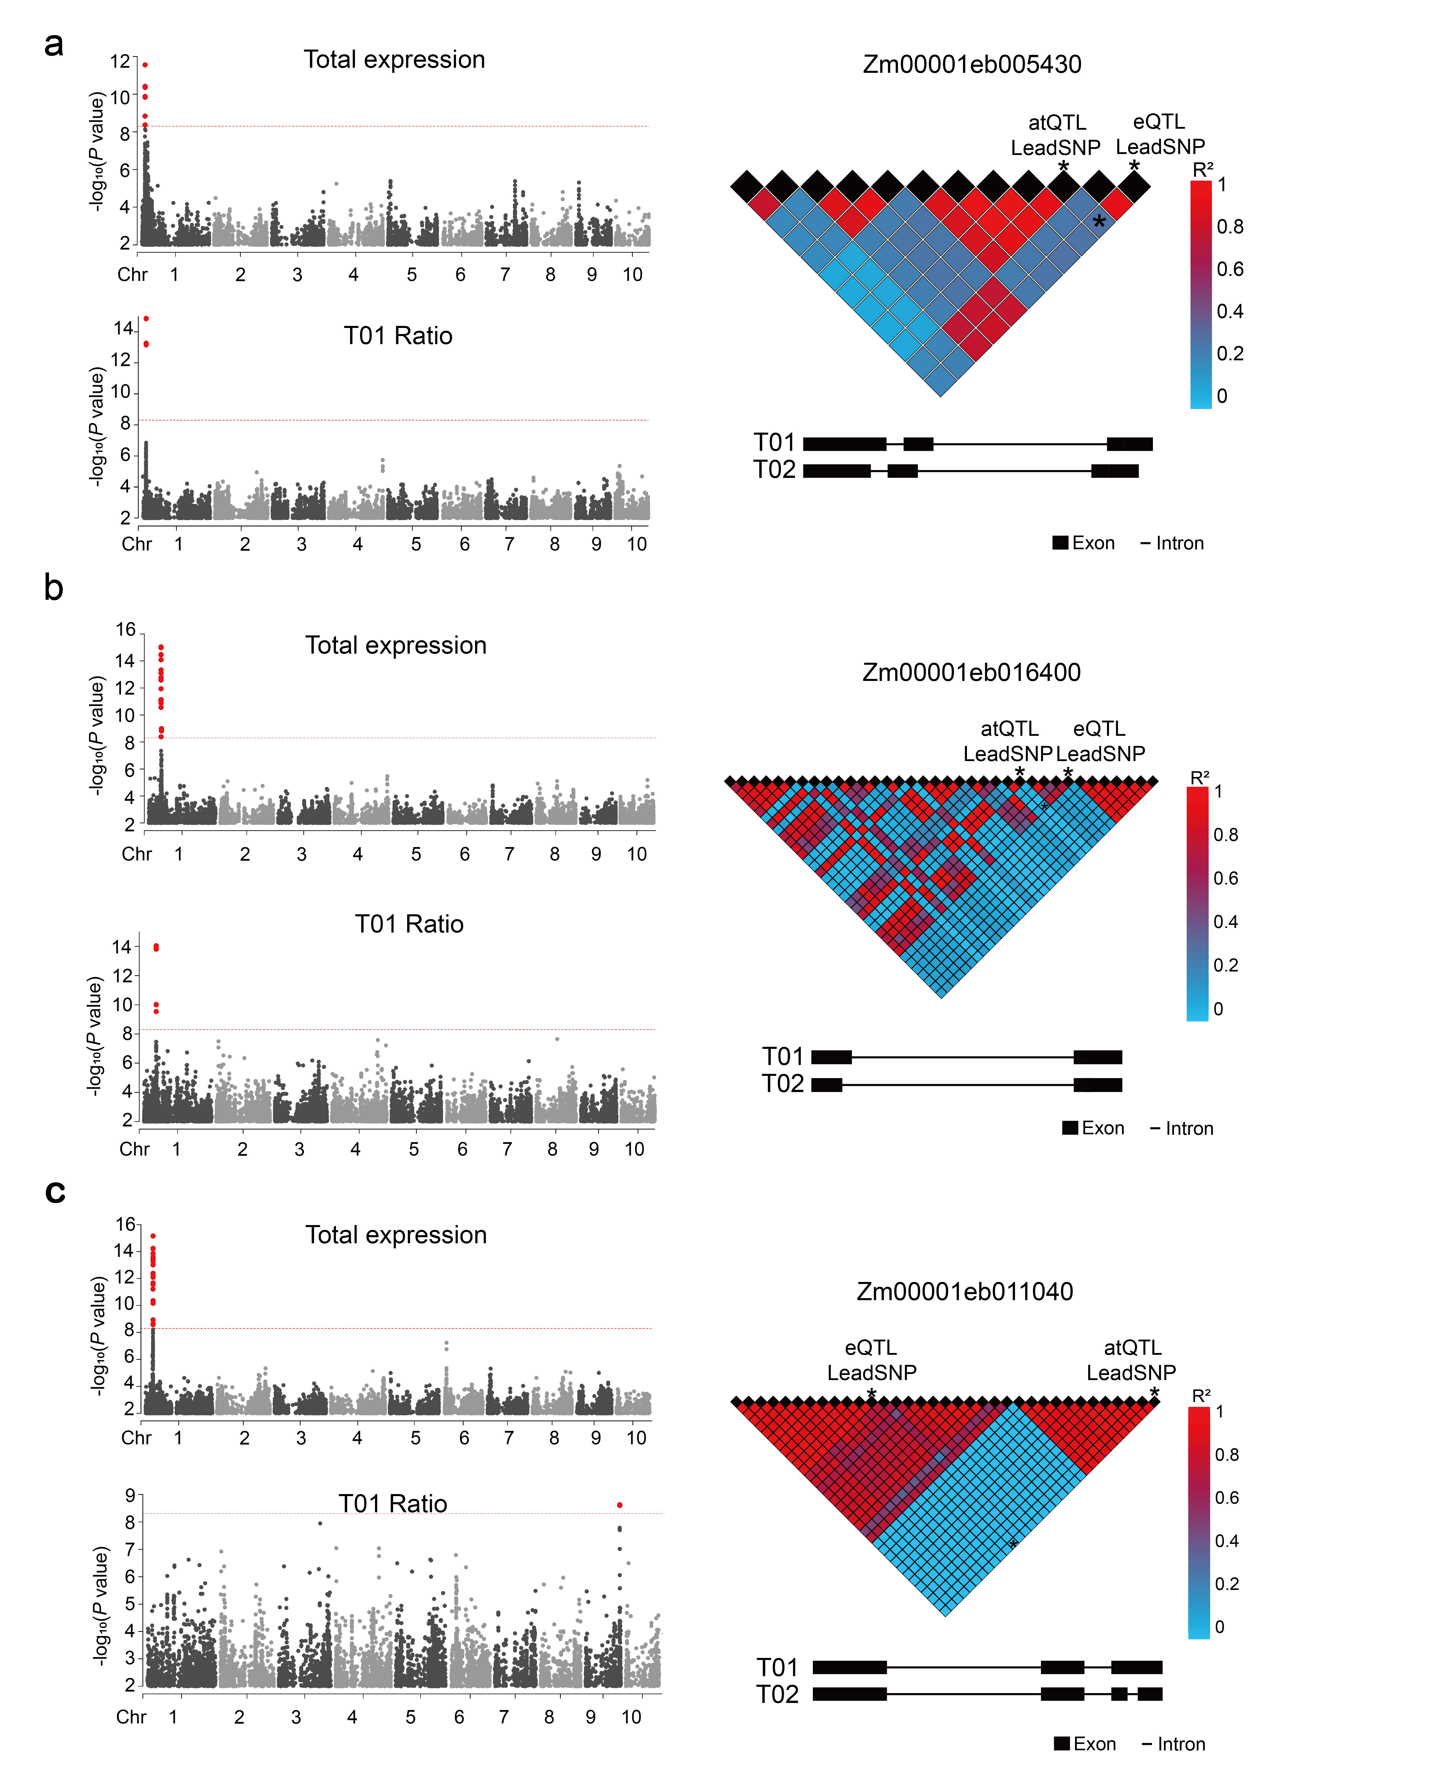
Fig. S8. Three patterns of relationships between eQTLs and atQTLs. a Co-localized eQTL and atQTL with high linkage disequilibrium (LD R² > 0.1, geneID: Zm00001eb005430). b Co-localized eQTL and atQTL with low linkage disequilibrium (LD R² ≤ 0.1, geneID: Zm00001eb016400). c Non-co-localized eQTL and atQTL (geneID: Zm00001eb011040). Each example is presented in four panels: the top and bottom panel show the Manhattan plots for the eQTL and atQTL, respectively, with chromosomal position on the x‑axis and −log₁₀(P) on the y‑axis (red points indicate signals above the significance threshold of 5 × 10⁻⁹) . The middle panel shows the gene structure (exons as black boxes, introns as lines; transcript variants T01 and T02 are indicated). The right panel displays an LD plot of SNPs associated with atQTL or eQTL, with the lead SNP marked by an asterisk (*);color gradient from red (R² = 1) to blue (R² = 0) indicates LD strength.
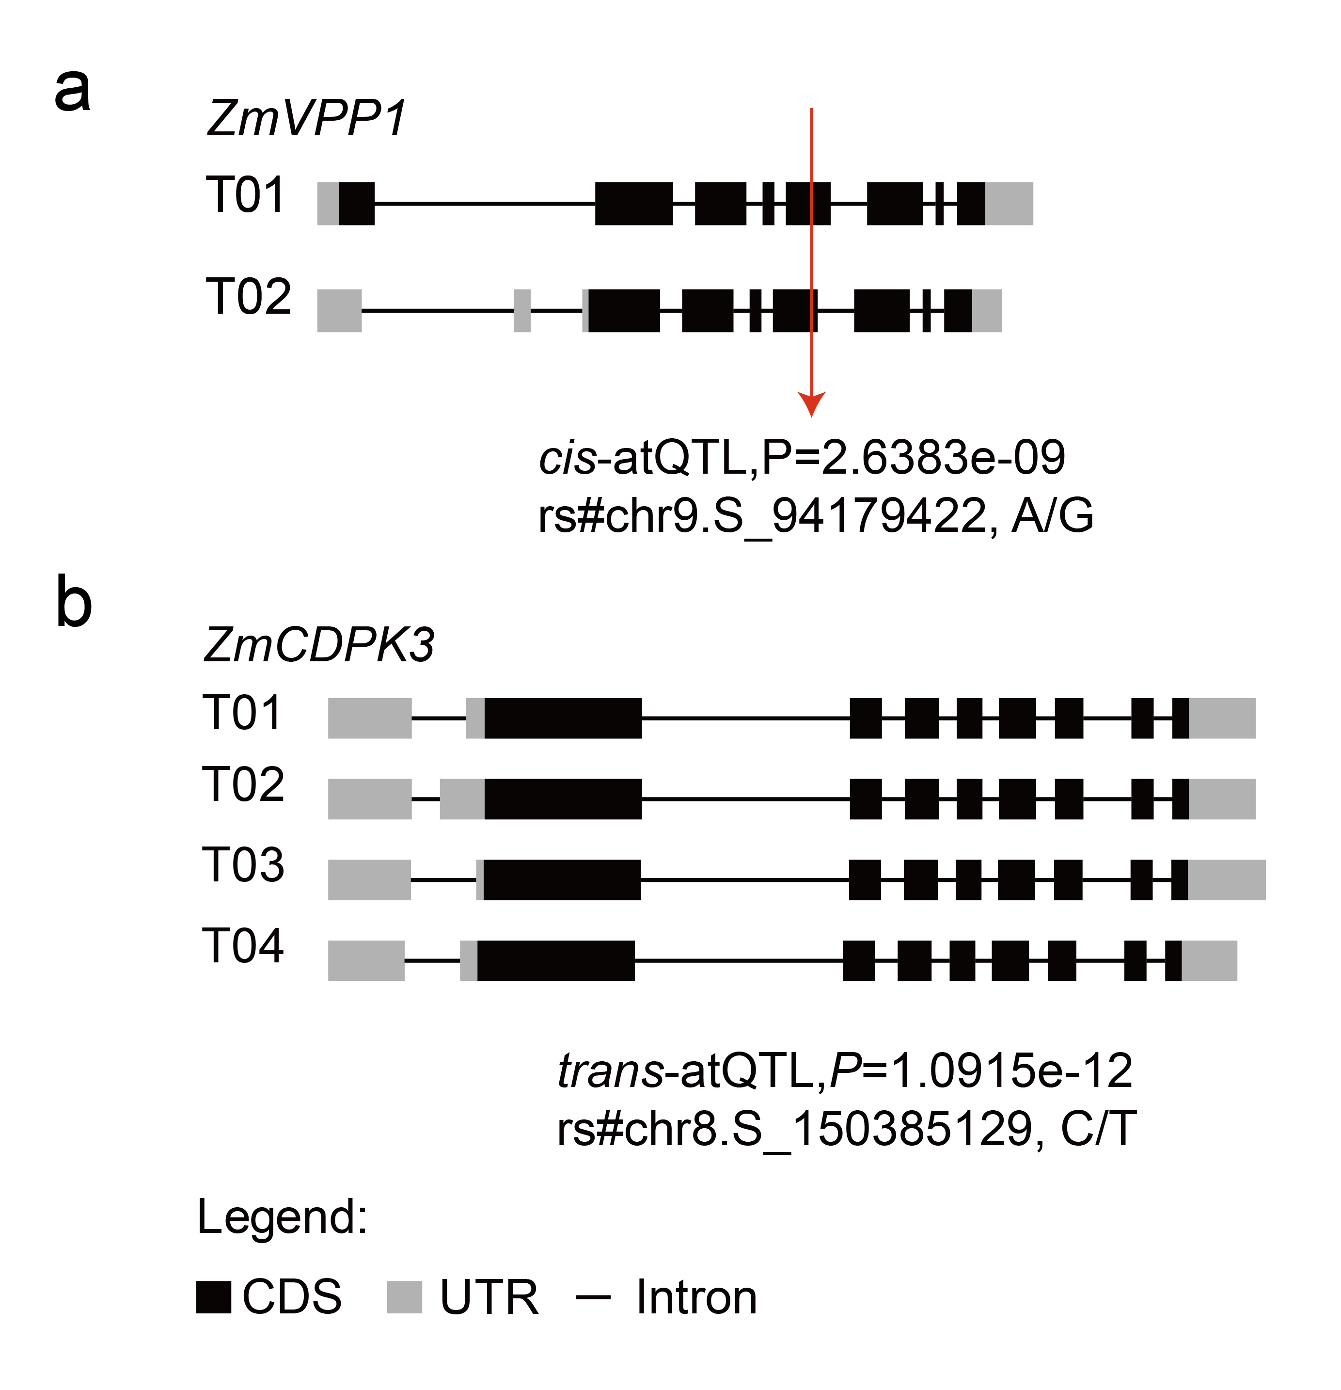
Fig. S9. Examples of alternative transcripts events and associated QTLs in maize. a A SKIP event between transcript variants T01 and T02 of the ZmVPP1 gene. This event is linked to a cis-atQTL represented by SNP rs#chr9.S_94179422 (A/G; P = 2.6383e⁻⁹). b Complex alternative transcripts events involving multiple transcript variants (T01-T04) of the ZmCDPK3 gene, associated with a trans-atQTL represented by SNP rs#chr8.S_150385129 (C/T; P = 1.0915e⁻¹²). In both panels, coding sequences (CDS) are shown as black boxes, untranslated regions (UTR) as light gray boxes, and introns as lines.

Fig. S10. The relationship between UA-rich element composition and percent spliced in (PSI). a U nucleotide proportion. b A nucleotide proportion. c U+A nucleotide proportion. Each subfigure contains two panels. The left panel is a bar chart showing PSI values across proportion groups (x-axis); different letters above bars denote statistically significant differences (Tukey HSD test, P < 0.05). The right panel displays a distribution plot: individual points (or density hexbins for large datasets, n > 10,000) are shown along with a linear regression trend line (red). The correlation coefficient (R) and its P-value are indicated in the top left corner.
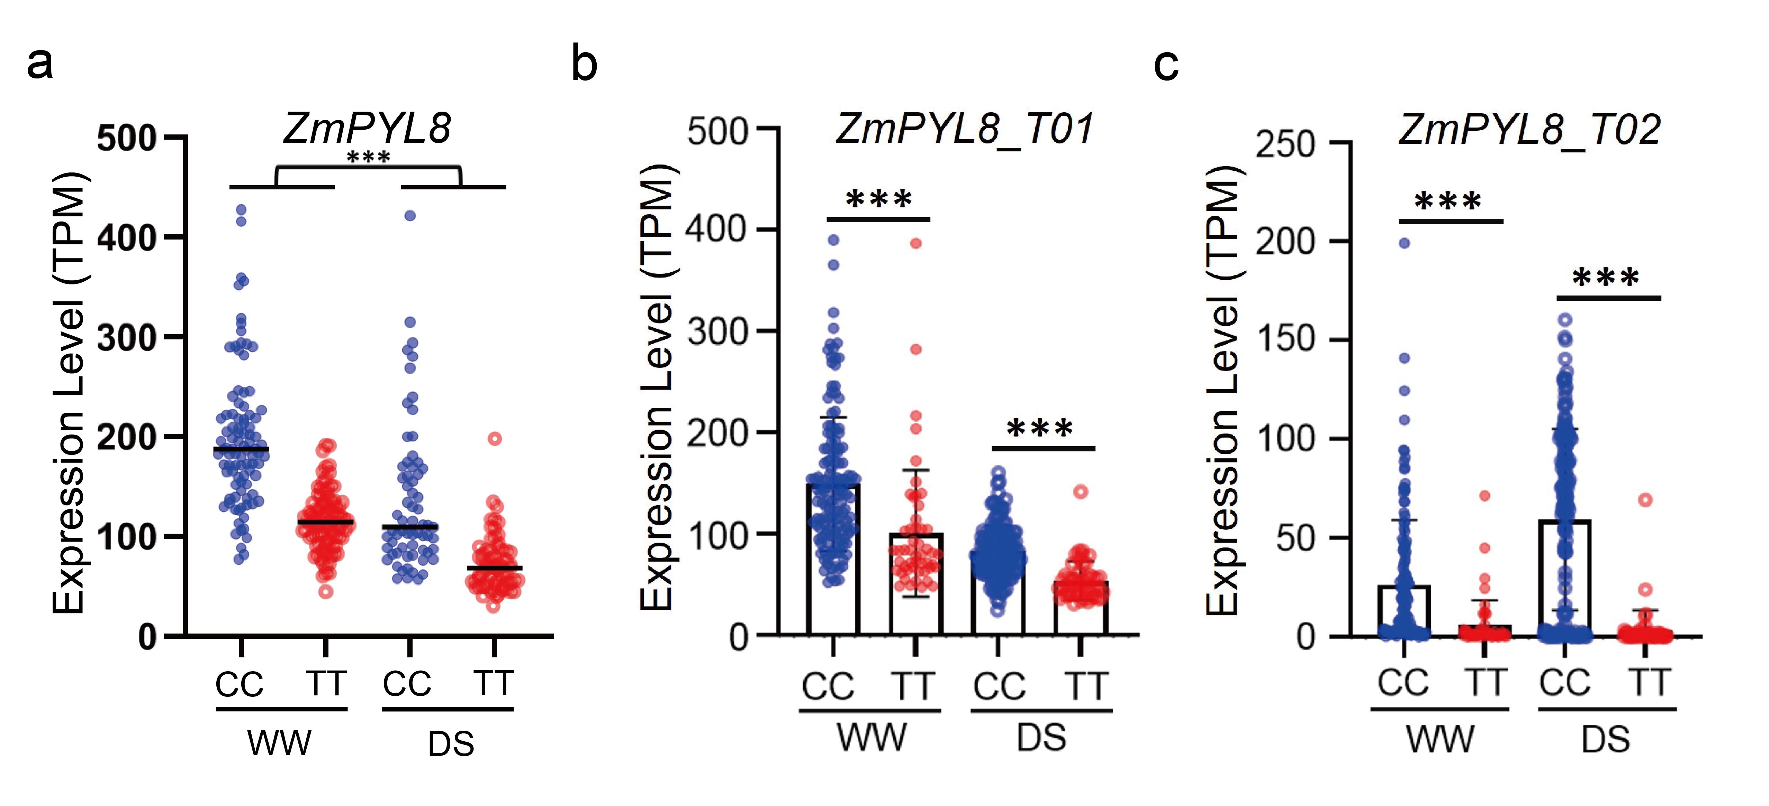
Fig. S11. Expression of ZmPYL8 alternative transcripts in different genotypes under well-watered and drought-stressed conditions. a Total expression of ZmPYL8 under WW and DS. b Expression of ZmPYL8_T01 under WW and DS. c Expression of ZmPYL8_T02 under WW and DS conditions. Data a to c are shown as mean ± SD (n > 3). Significant differences are indicated as ***, P < 0.001 (Student’s t-test).

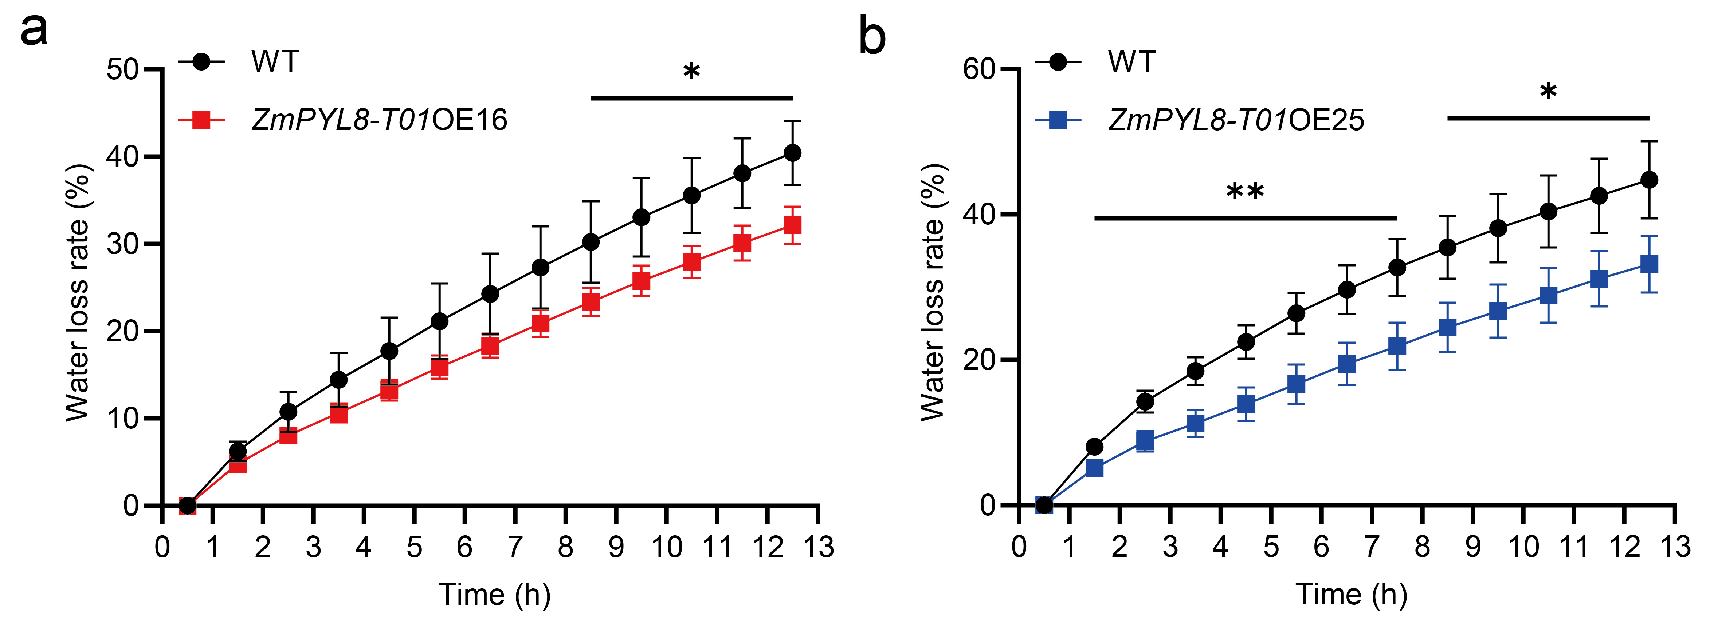
Fig. S12. Water loss assay of detached leaf from ZmPYL8_T01-overexpressing lines. a,b Detached leave water loss over time in ZmPYL8_T01OE16 (a) and ZmPYL8_T01OE25 (b). Data represent mean ± SD (n ≥ 3). Significant differences are indicated as *, P < 0.05 and **, P < 0.01 (Student’s t-test).

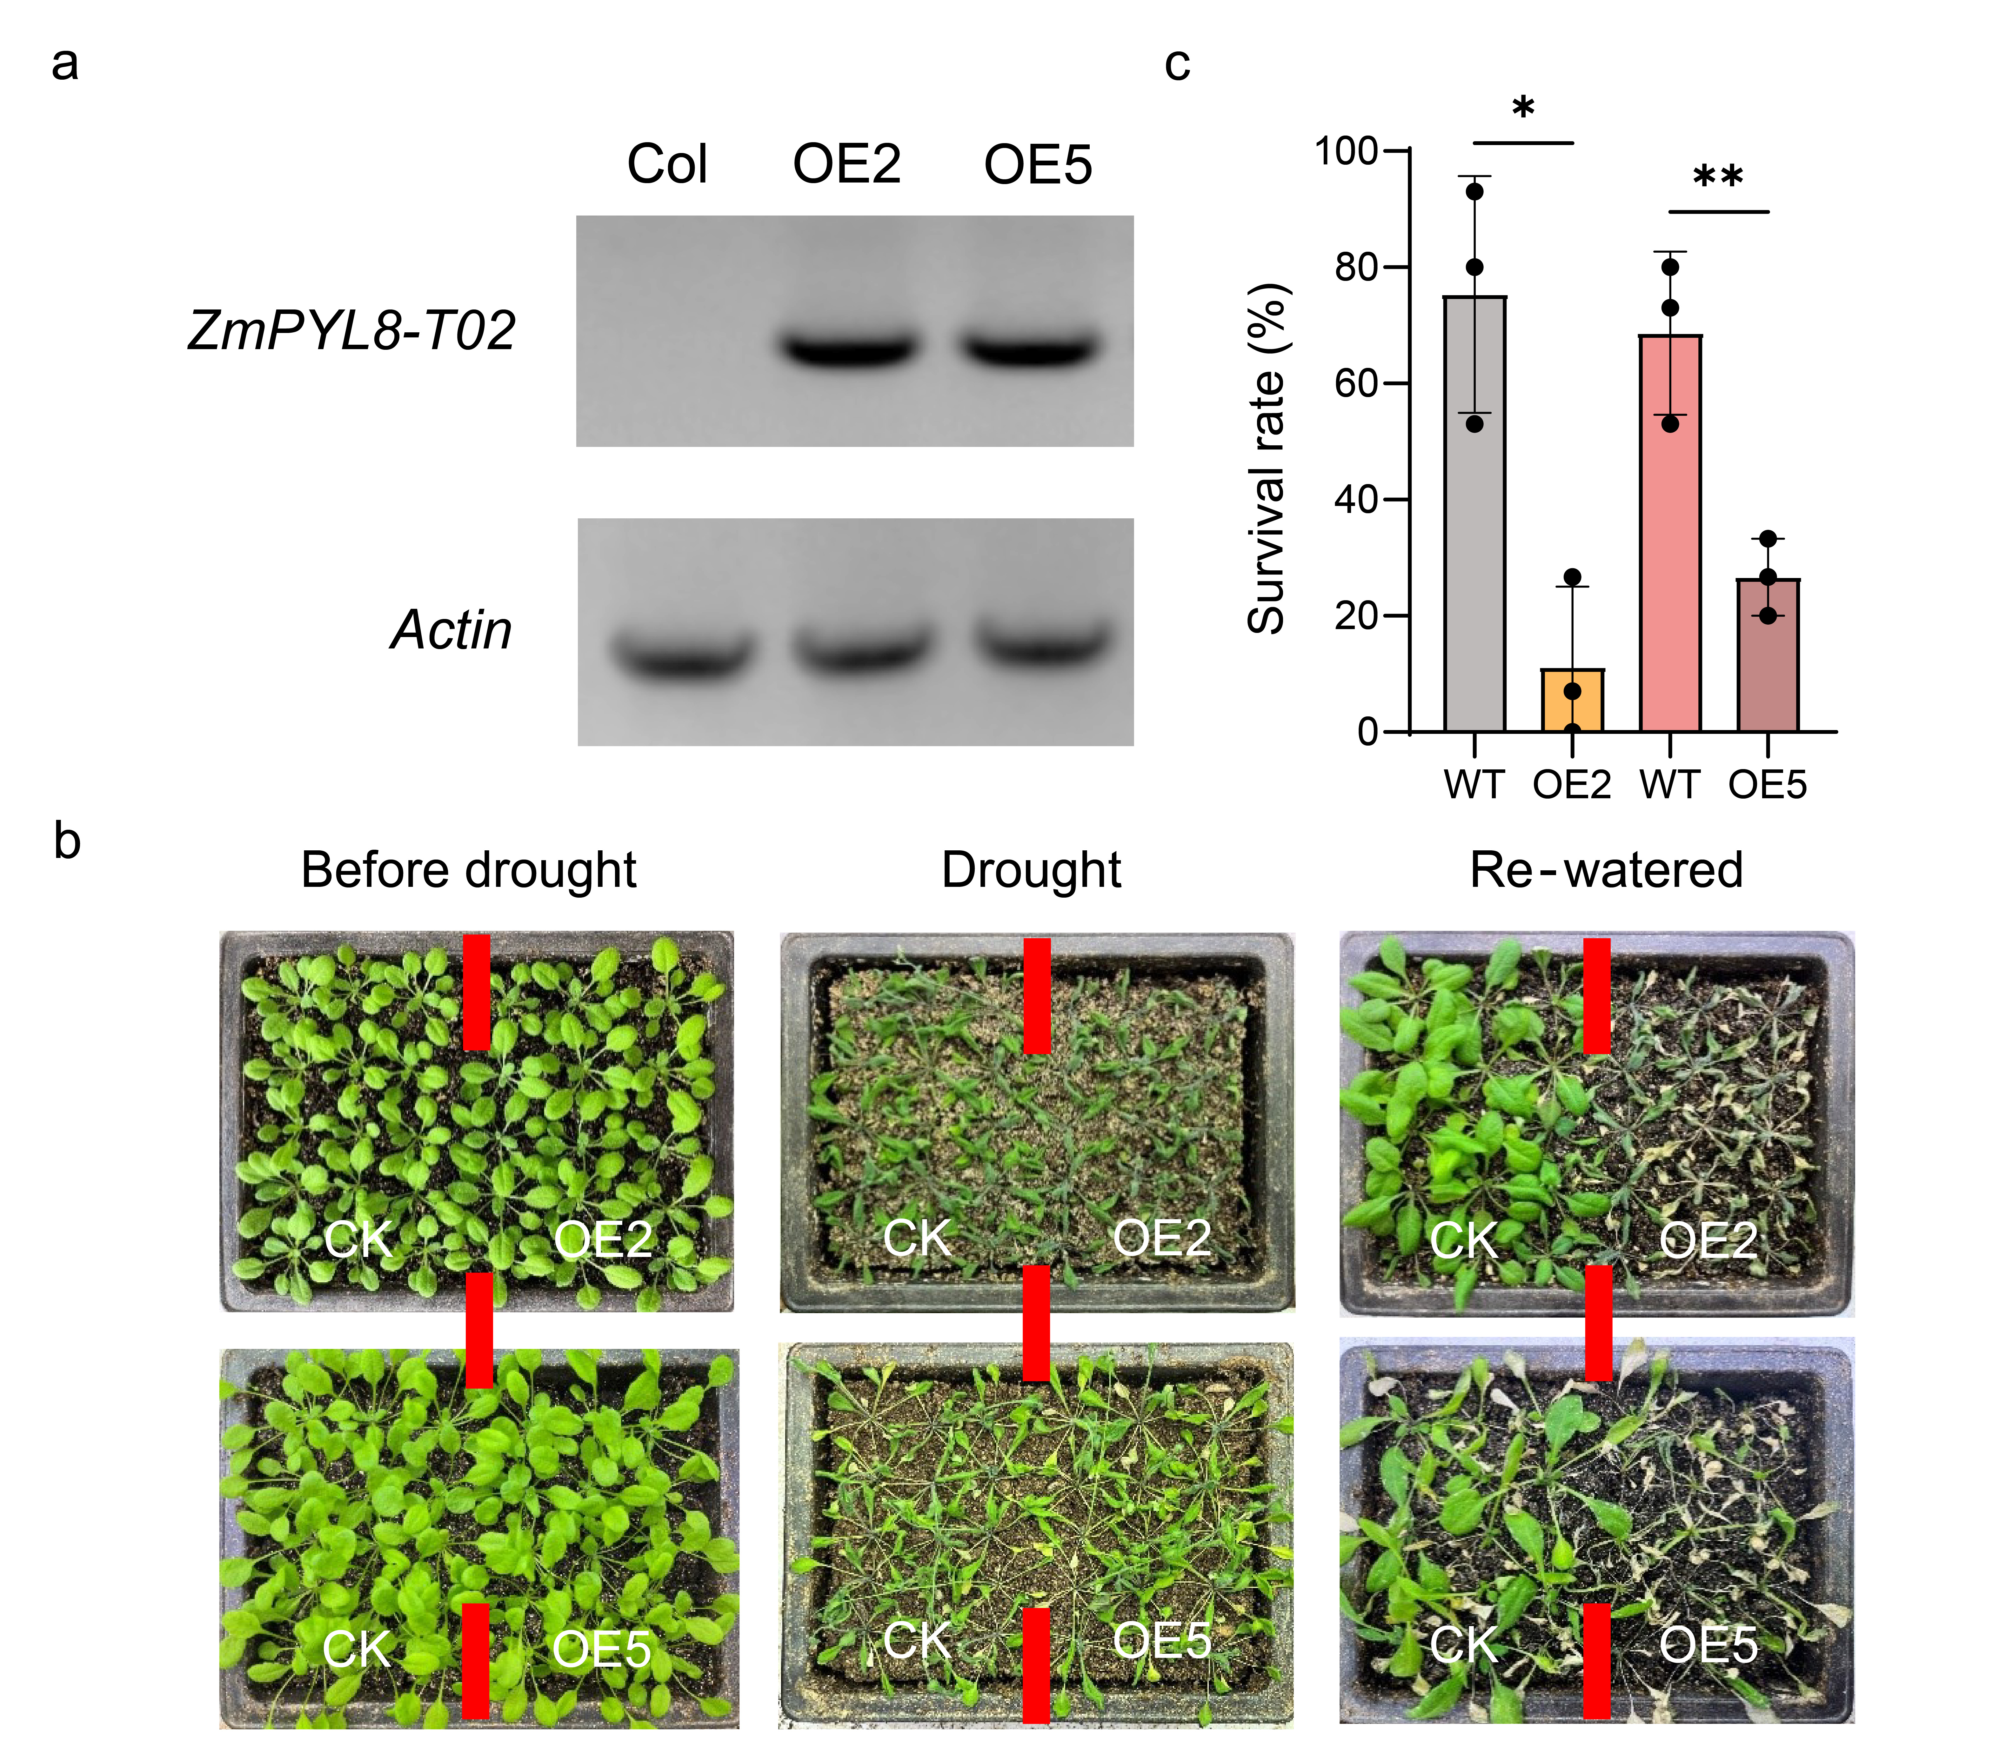
Fig. S13. Overexpression of ZmPYL8_T02 in Arabidopsis reduced drought tolerance. a RT-PCR analysis confirms the overexpression of ZmPYL8_T02 in two independent transgenic lines (OE). Arabidopsis Actin7 was used as control. b Drought-tolerant phenotypes of the two ZmPYL8_T02-overexpressing lines. Three-week-old plants were subjected to dehydrated for 2 weeks, re-watered for 3 days and then phenotyping. c Survival rates of ZmPYL8_T02OE2 and ZmPYL8_T02OE5 transgenic plants following drought stress. Data represent mean ± SD (n = 3). Significant differences are indicated as *, P < 0.05 and **, P < 0.01 (Student’s t-test).

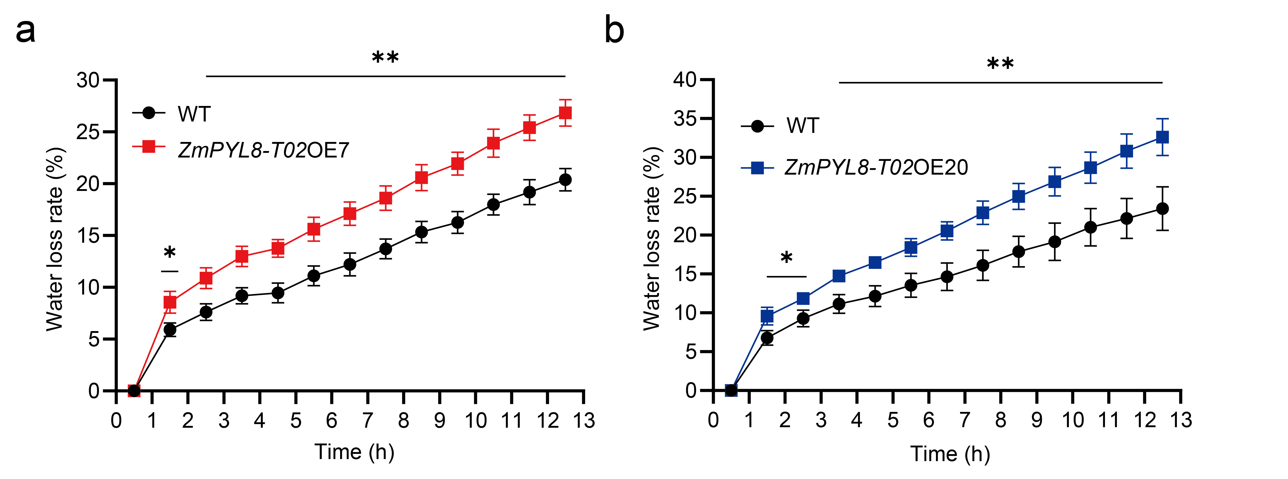
Fig. S14. Water loss assay of detached leaf from ZmPYL8_T02-overexpressing lines. a-b Detached leave water loss over time in ZmPYL8_T02OE7 (a) and ZmPYL8_T02OE20 (b). Data represent mean ± SD (n ≥ 3). Significant differences are indicated as **, P < 0.01 (Student’s t-test).

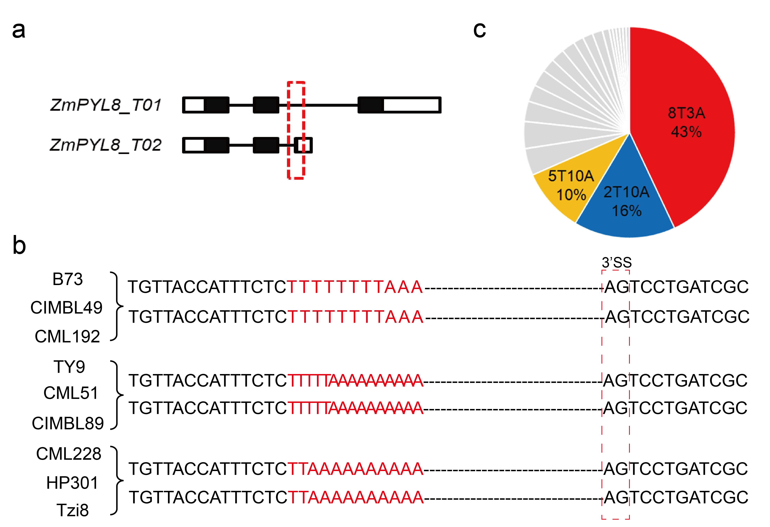
Fig. S15. Analysis of UA-rich sequence variation. a Gene structure of ZmPYL8_T01 and ZmPYL8_T02. Regions of intronic variation are highlighted in red. b Examples of resequencing comparisons from relevant maize populations. Differences in UA-rich sequences are marked in red. c Proportion of the three major UA-rich sequence types.
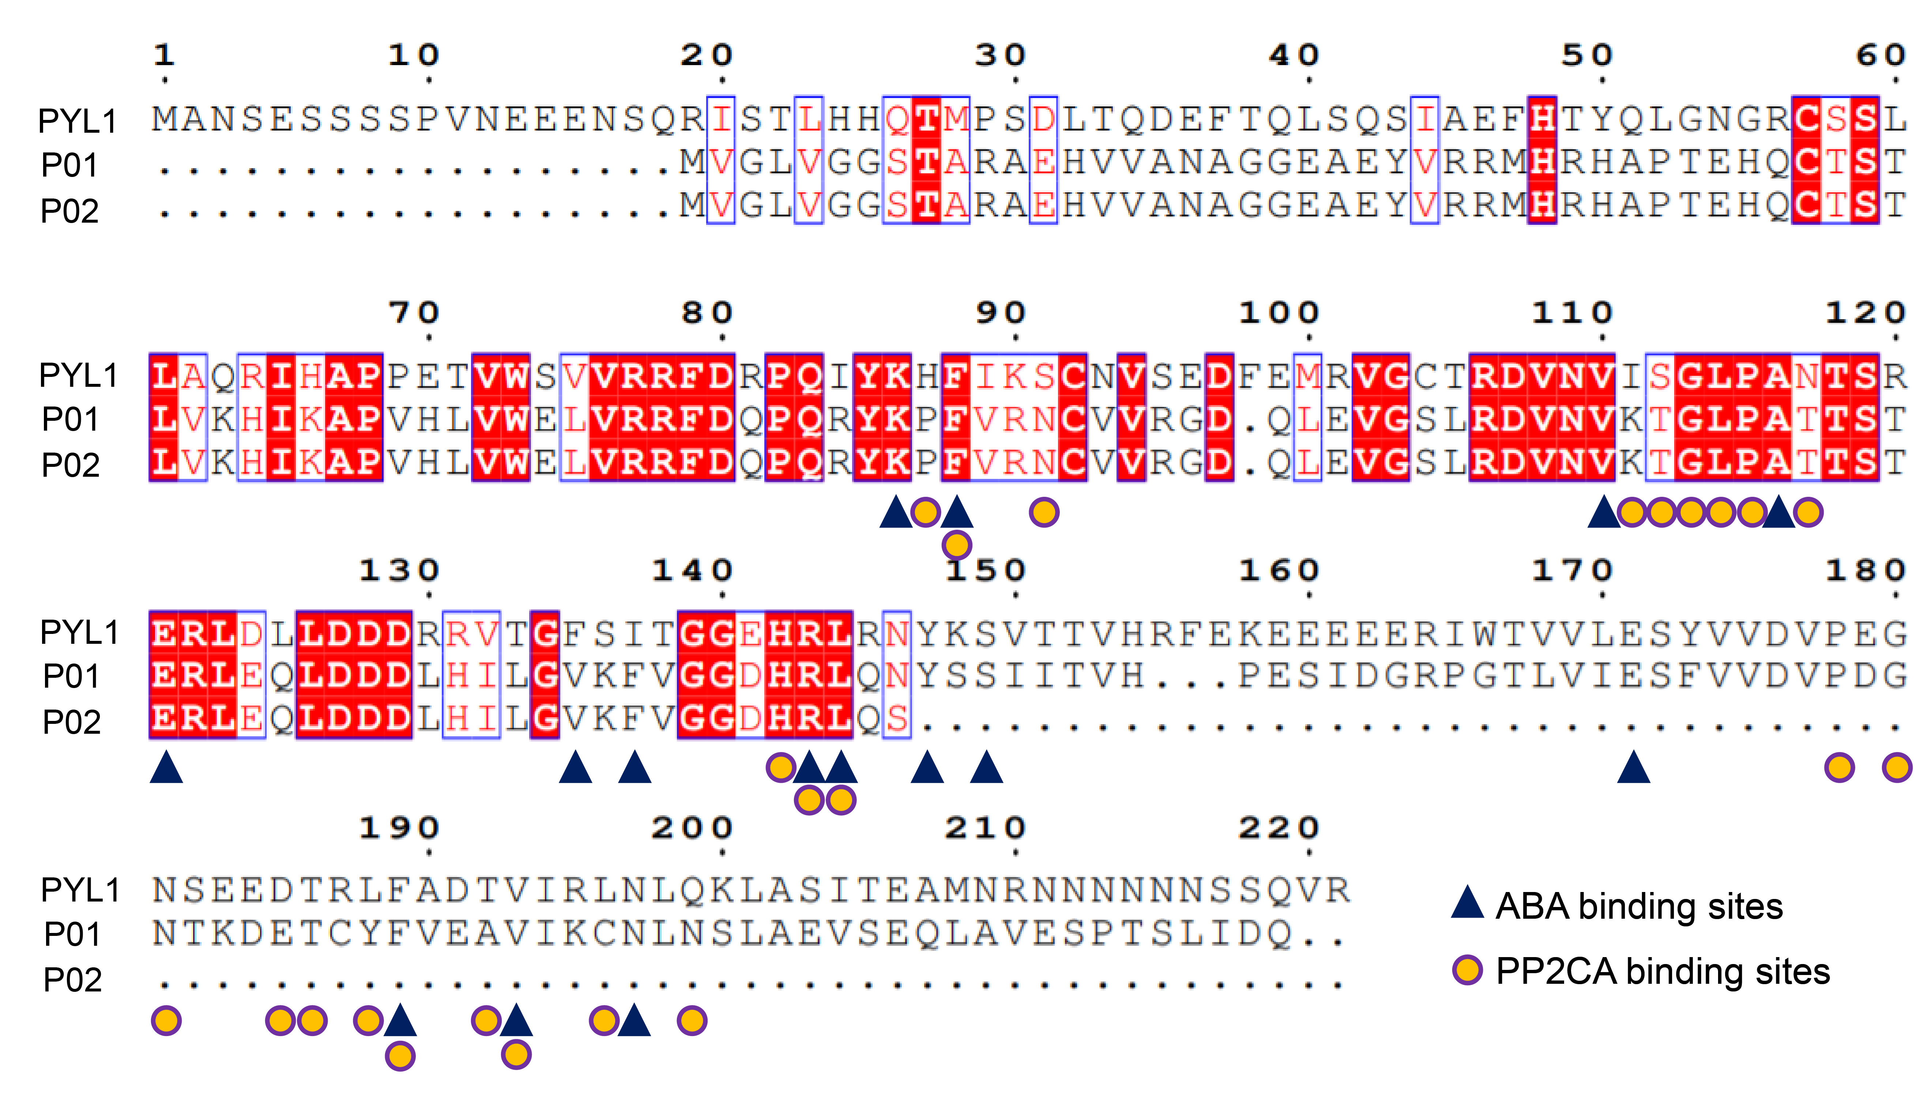
Fig. S16. Protein sequence alignment of PYL1, ZmPYL8_P01 and ZmPYL8_P02. The graph shows the sequence comparison between Arabidopsis PYL1 and maize PYL8 proteins. Triangles and circles indicate the positions of absent ABA binding and PP2C binding sites, respectively.

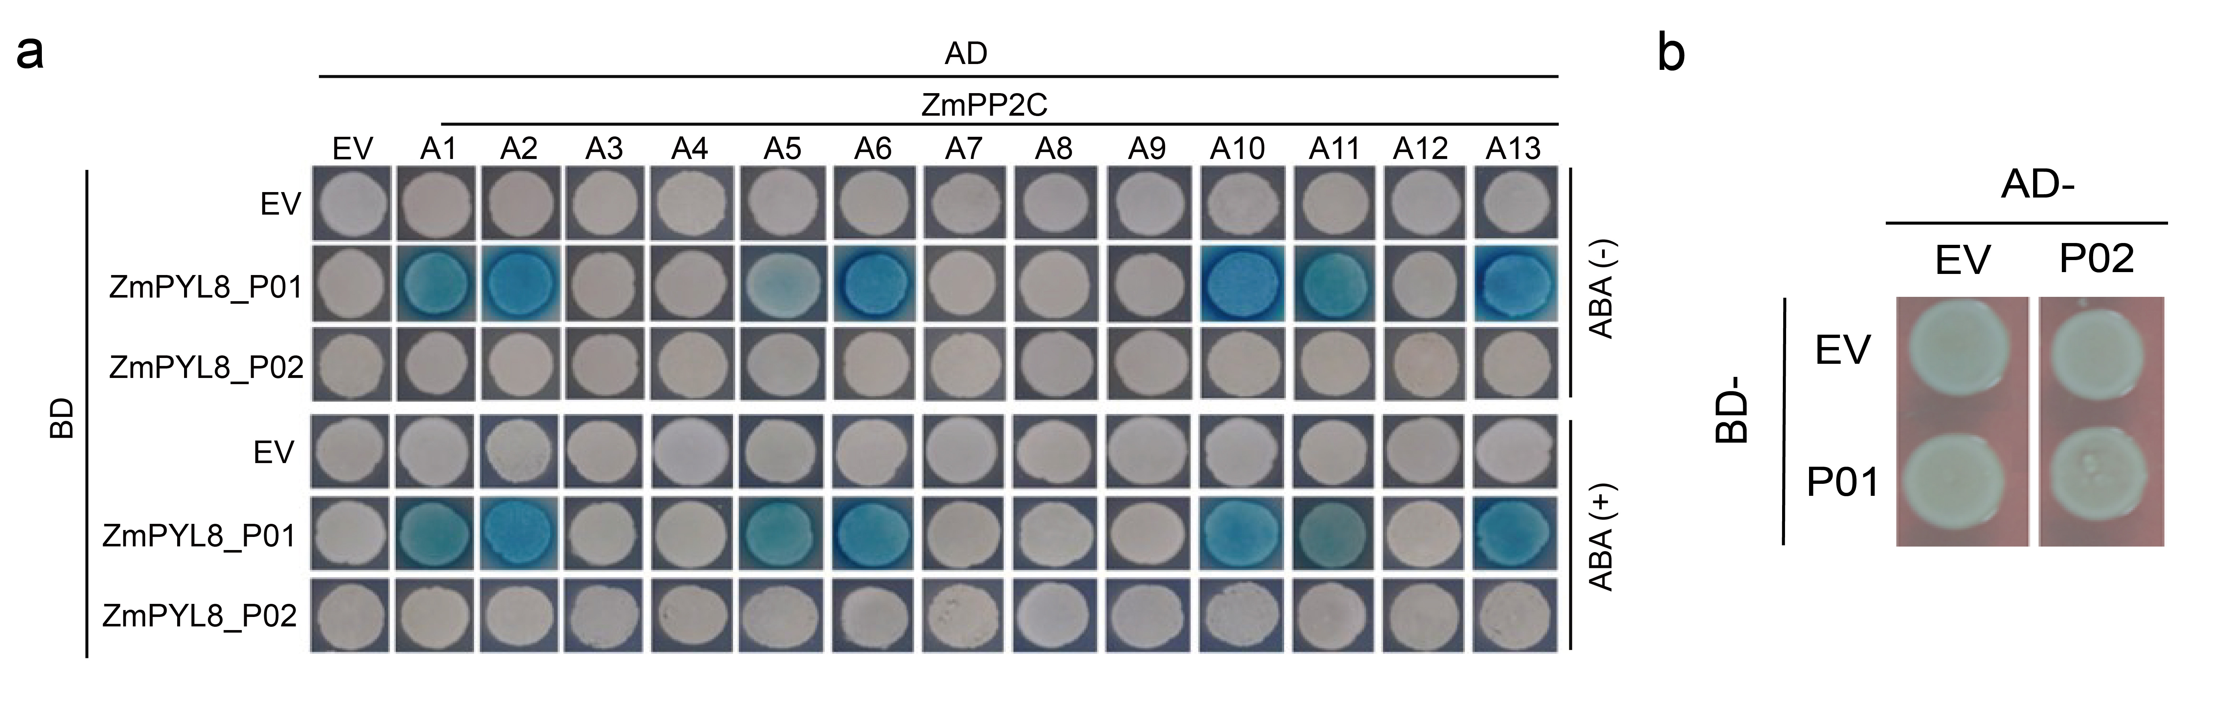
Fig. S17. Yeast two hybrid assays of ZmPYL8_P01 and P02. a Interaction assays between ZmPYL8 proteins and members of the ZmPP2CA family (1-13) in the presence or absence of ABA. b Interaction assay between ZmPYL8_P02 and ZmPYL8_P01.
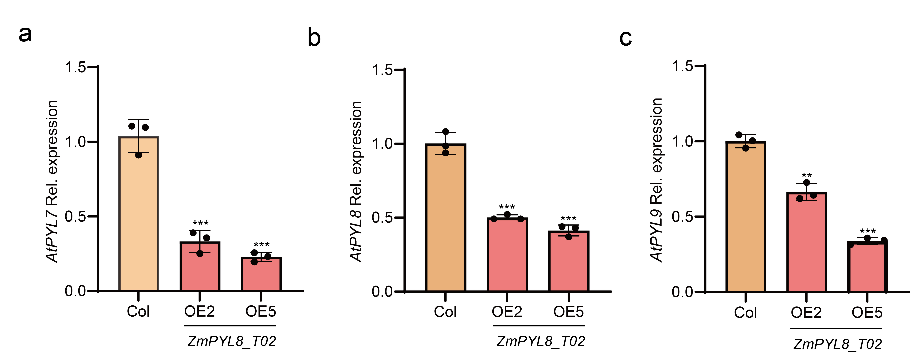
Fig. S18. Overexpression of ZmPYL8_T02 suppresses the expression of Arabidopsis homologous PYL genes. a-c RT-qPCR analysis of AtPYL7 (a), AtPYL8 (b) AtPYL9 (c) expression in ZmPYL8_T02-overexpressing plants. Data represent mean ± SD (n = 3). Significant differences are indicated as **, P < 0.01 and ***, P < 0.001 (Student’s t-test).

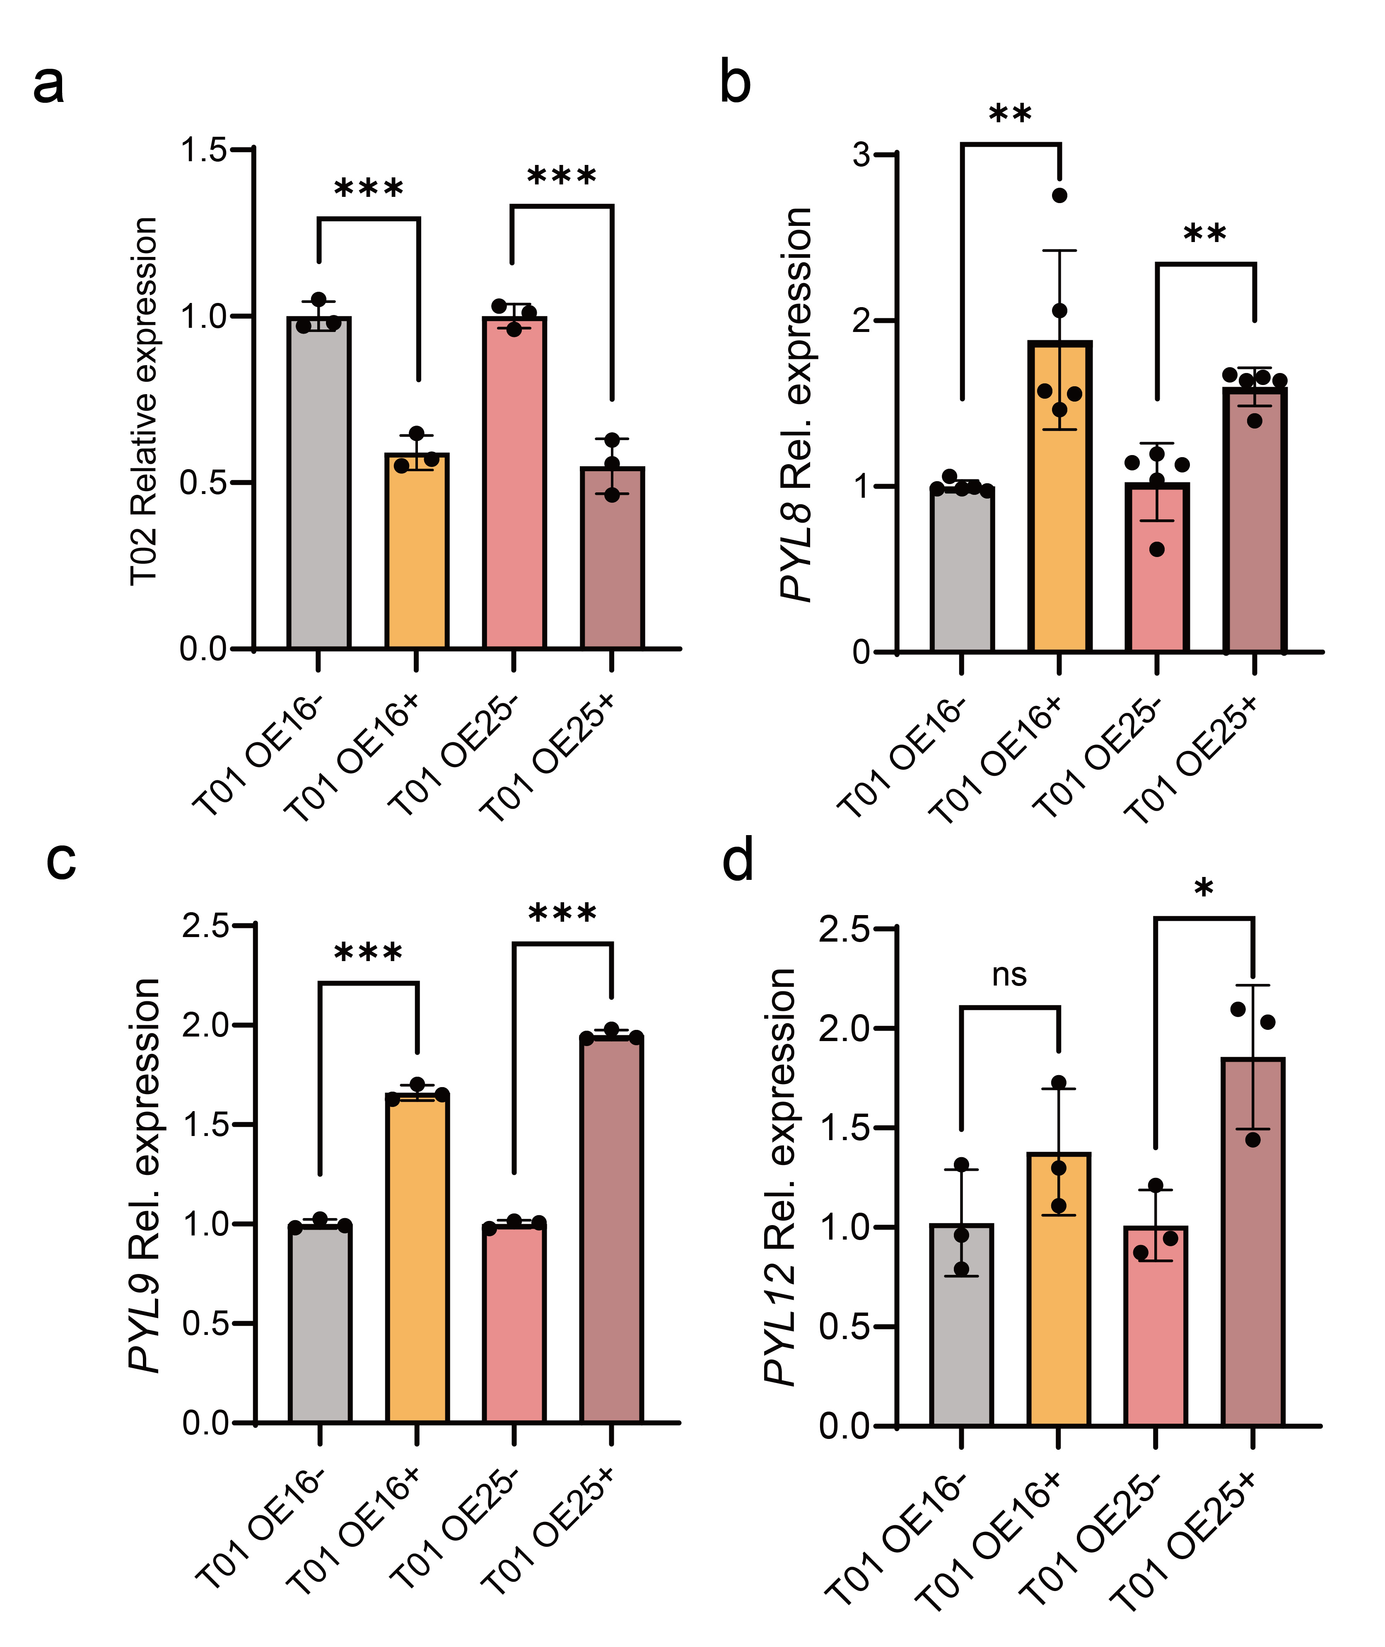
Fig. S19. Expression levels of homologous PYL genes in ZmPYL8_T01-over expressing plants. a RT-qPCR analysis of ZmPYL8_T02 expression in ZmPYL8_T01-overexpressing plants. b-d RT-qPCR analysis of ZmPYL8 (b), ZmPYL9 (c) and ZmPYL12 (d) expression in ZmPYL8_T01-overexpressing plants. Data represent mean ± SD (n ≥ 3). Significant differences are indicated as *, P < 0.05 and **, P < 0.01 and ***, P < 0.001 (Student’s t-test).
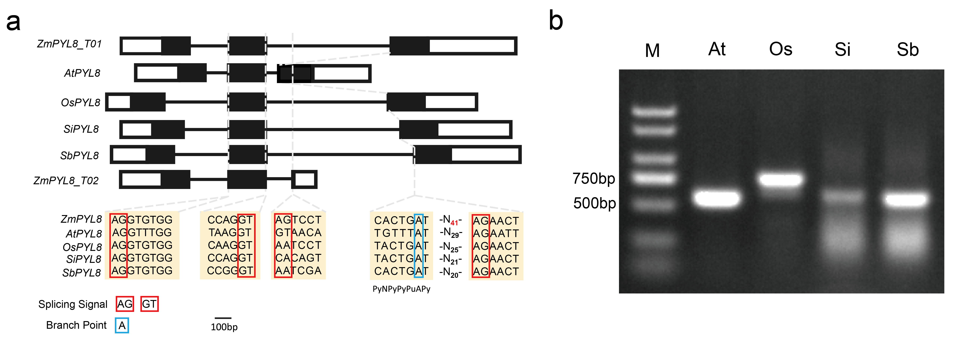
Fig. S20. The phenomenon of alternative splicing in PYL8 genes are caused by maize-specific intron sequences. a Analysis of intron features was performed on the sequences of ZmPYL8 and its immediate homologs. The figure shows the gene structures of PYL8 from maize, Arabidopsis, rice, millet and sorghum. The black boxes indicate exons and the black lines indicate introns. The splicing signal of ZmPYL8 contains the conserved AG-GT sequence and the branch point contains the conserved “A” base, scale 100bp. b PCR amplification maps of PYL8 in different crops. The gelatin diagrams from left to right are 2000 Marker (M), AtPYL8 (567bp, At), OsPYL8 (630bp, Os), SiPYL8 (618bp, Si) and SbPYL8 (594bp, Sb).

