Supplementary Figures
Fig S1. Population structure of the CUBIC panel, composition of high- and low-CV i-traits, developmental stage stratification, PCA clustering, and correlation result of i-traits.
Fig S2. The mean absolute Pearson correlation coefficient among all genome-wide SNP markers, all i-traits, and all agronomic traits.
Fig S3. Overall variance composition of all i-traits in whole phases and three different time phases.
Fig S4. The heritability of 67 i-traits across 18 time points.
Fig S5. Basic characteristics of dynamic QTL across the entire growth period.
Fig S6. The expression profile of ZmGalOx1 (a) and BRD1 (b) in B73.
Fig S7. ZmGalOx1 validation results of 67 i-traits at 11 time points between the knockout and the wild-type across three maize varieties, Jing724, Jing92 and JingKe968.
Fig S8. Interaction ratios across 18 time points.
Fig S9. The influence of different haplotypes at the chr1.s_253261589 locus on the plant height (PH) effect of the chr4.s_238082533 locus throughout the entire growth period.
Fig S10. Local Manhattan plot and gene structure of ZmEBF4.
Fig S11. Expression profile of ZmEBF4 in B73.
Fig S12. EMS mutation detail of ebf4.
Fig S13. Phenotype analysis of ZmEBF4 EMS mutation and WT in Xiangyang.
Fig S14. Comparison of correlation coefficients among three phases across all parameters.
Fig S15. Narrow-sense heritability and PVE attributable to different QTL categories.
Fig S16. Comparison of genetic relatedness of parental lines between the hybrids with high and low heterosis.
Fig S17. Ontogenic model: a spatiotemporal three-dimensional genetic architecture model for complex traits.
Fig S18. Receiver Operating Characteristic (ROC) curve evaluating the performance of the maize whole-plant segmentation model.
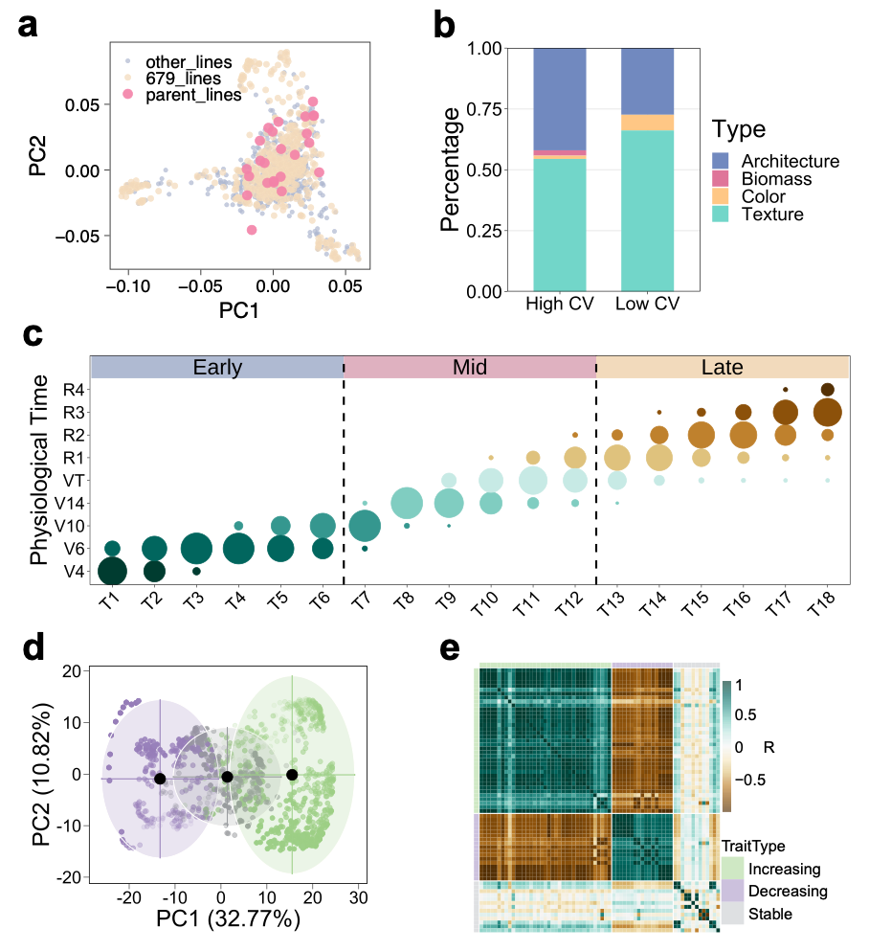
Fig S1. Population structure of the CUBIC panel, composition of high- and low-CV i-traits, developmental stage stratification, PCA clustering, and correlation result of i-traits. a, Distribution of 679 randomly sampled inbred lines in the original 1428 CUBIC population. b, Stacked bar chart of i-trait types in high- and low-CV groups. c, Distribution of physiological stages of all individuals in each period. d, PCA of all i-trait in 18 time point, different growth pattern was denoted distinct color. e, Correlation heatmap of all i-traits.

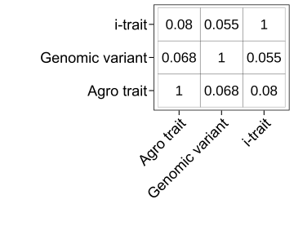
Fig S2. The mean absolute Pearson correlation coefficient among all genome-wide SNP markers, all i-traits, and all agronomic traits.

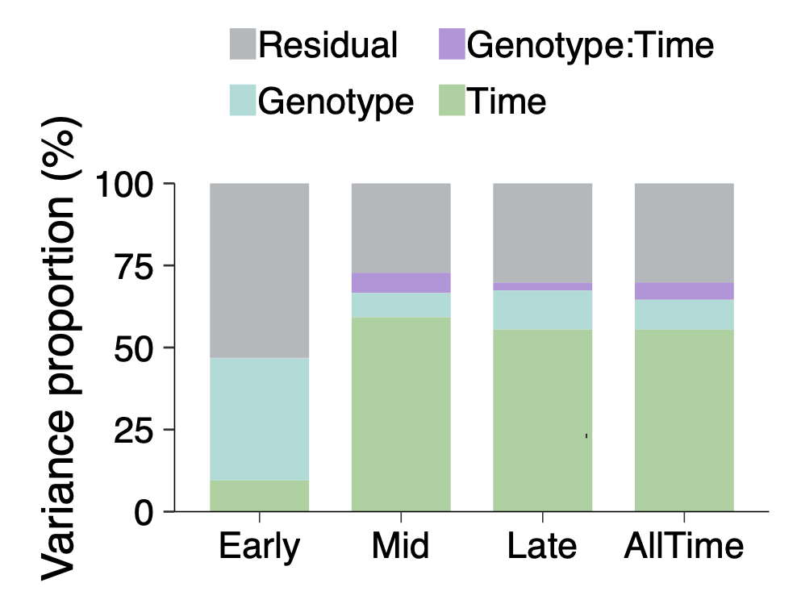
Fig S3. Overall variance composition of all i-traits in whole phases and three different time phases.

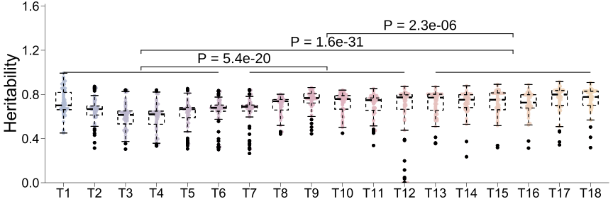
Fig S4. The heritability of 67 i-traits across 18 time points. The comparison is among three developmental stages, Early (T1-T6), Mid (T7-T12) and Late (T13-T18), the test method of significance is Wilcoxon-Mann-Whitney with two-tailed approach.

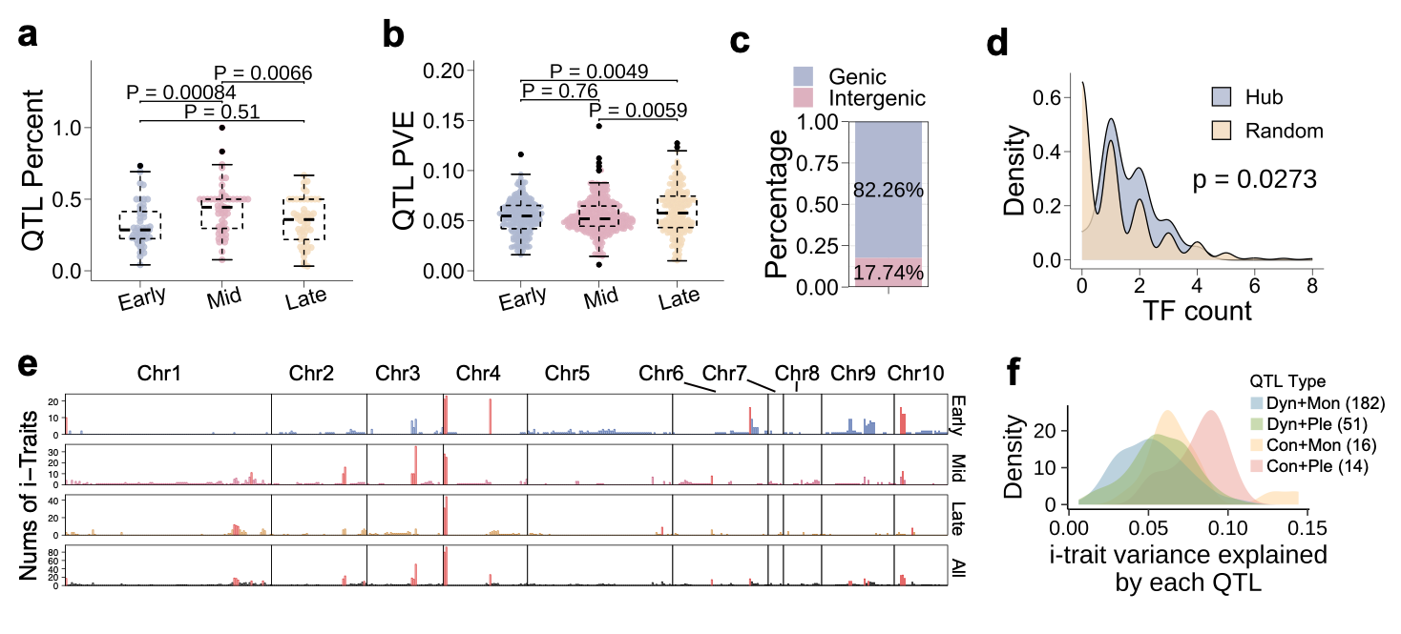
Fig S5. Basic characteristics of dynamic QTL across the entire growth period. a, Comparison of the proportion of QTL in three phases for each i-trait, each phase has 67 data points. b, Comparison of the PVE of QTL in three phases. c, The percentage of QTL overlapping genic and intergenic regions. d, Comparison of the number of known maize TFs between QTL hotspots and random regions. e, Genome-wide QTL distribution for all i-traits from three stages and all phases. The 1-Mb sliding window was used to evaluate the QTL counts per location, the hotspot was identified as genomic intervals ranked in the top 5% by QTL number and marked by red color. f, Proportion of original QTL, consensus QTL, and unique QTL. The test method of significance is Wilcoxon-Mann-Whitney with two-tailed approach. TF denotes Transcription factor.
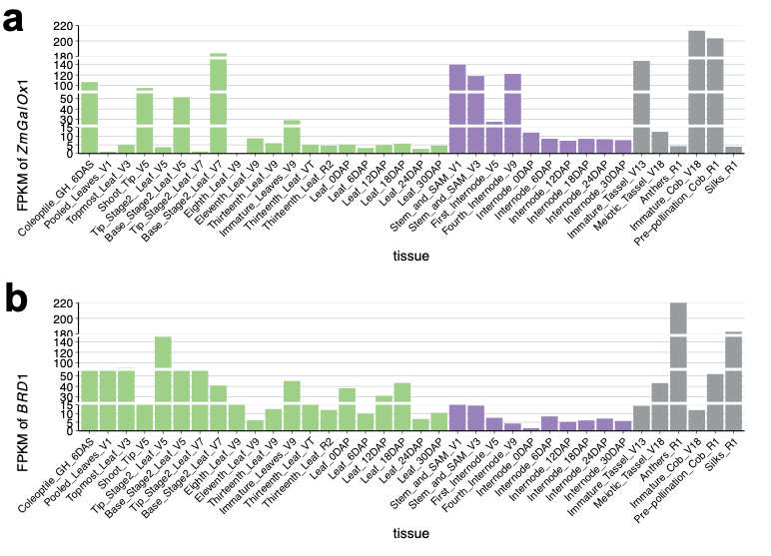
Fig S6. The expression profile of ZmGalOx1 (a) and BRD1 (b) in B73. The different color denotes the tissue type.

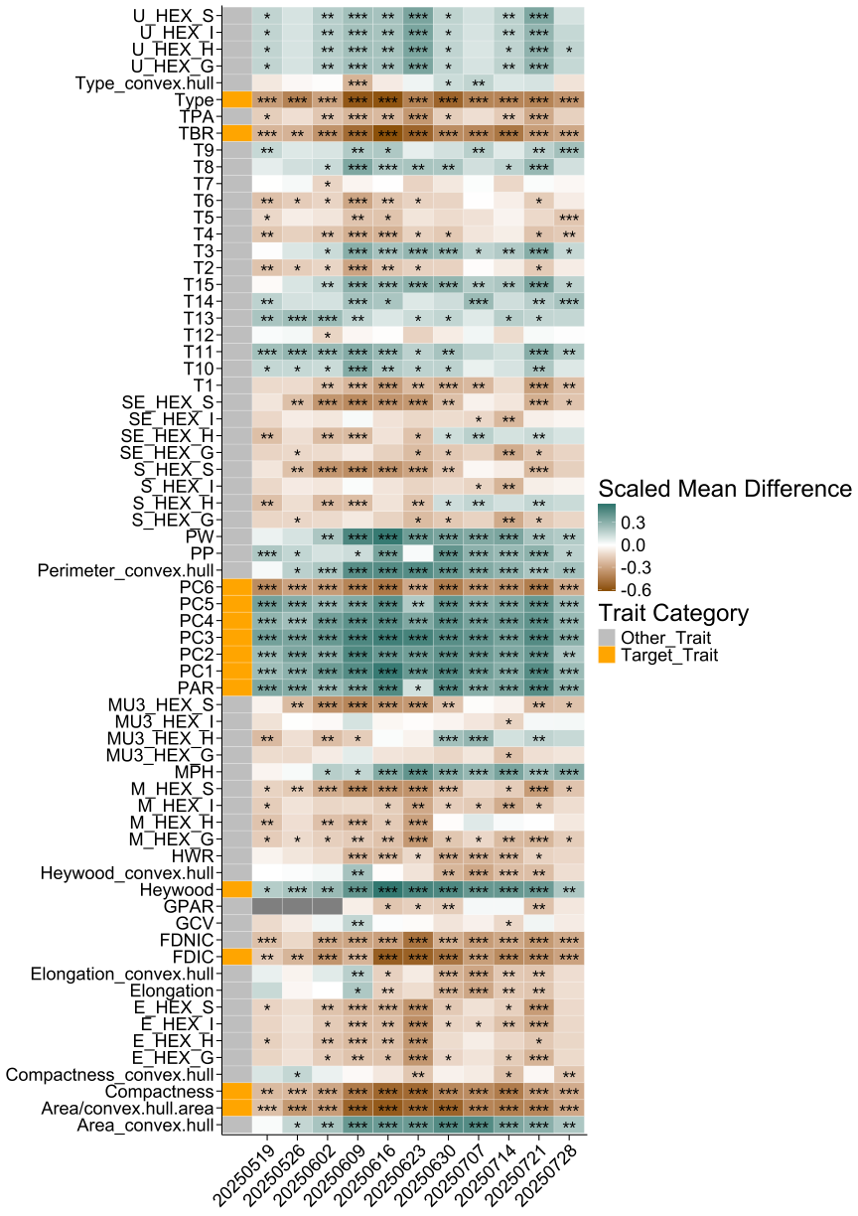
Fig S7. ZmGalOx1 validation results of 67 i-traits at 11 time points between the ZmGalOx1-KO^{Jing724} and the wild-type Jing724. The X-axis represents the specific dates of i-trait measurement from May 19 to July 28, 2025 at Wuhan from China, and the y-axis lists the 67 i-traits, with the first column indicating the trait category. Traits highlighted in orange are those associated with ZmGalOx1 by GWAS. The heatmap fill color indicates the normalized mean phenotypic value difference between ZmGalOx1-KO^{Jing724} and the wild-type Jing724. Asterisks denote significant differences between the knockout and wild-type groups, ‘*’ denotes p<=0.05, ‘**’ denotes p<=0.01, ‘***’ denotes p<=0.001. The test method of significance is Student's t-test with two-tailed approach.

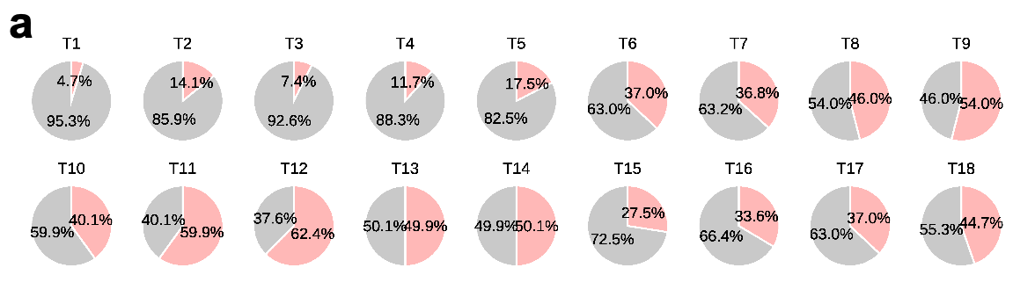
Fig S8. Interaction ratios across 18 time points. a, Proportion of significant interaction and non-significant proportion at 18 periods, red indicates the proportion of significant interactions.

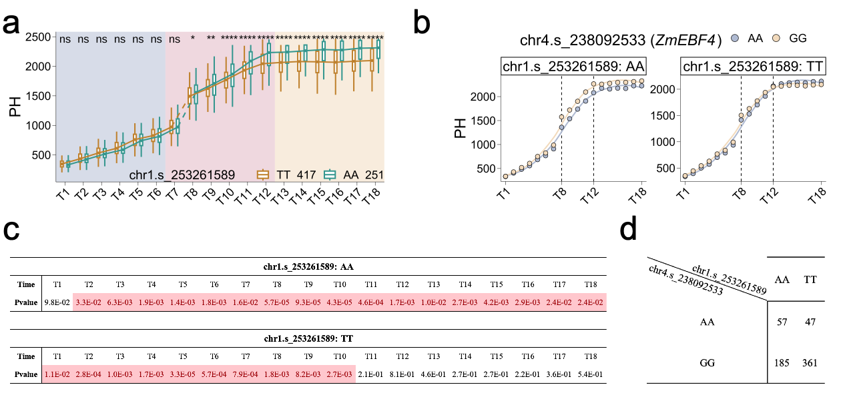
Fig S9. The influence of different haplotypes at the chr1.s_253261589 locus on the plant height (PH) effect of the chr4.s_238082533 locus throughout the entire growth period. a, The haplotypic effects of chr1.s_253261589 on PH trait across 18 time points. b, The haplotypic effects of chr4.s_238082533 (ZmEBF4) on PH trait across 18 time points under distinct genotype background of chr1.s_253261589 (Chr1 QTL). c, P-values from the significance tests of the two haplotypes of chr4.s_238082533 on plant height under distinct genotype background of chr1.s_253261589 (Chr1 QTL), highlighted boxes denote significant time point (p<=0.05). d, The inbred lines count for the four haplotypes formed by chr1.s_253261589 and chr4.s_238082533. The Wilcoxon-Mann-Whitney with two-tailed method was used to evaluate the significance.

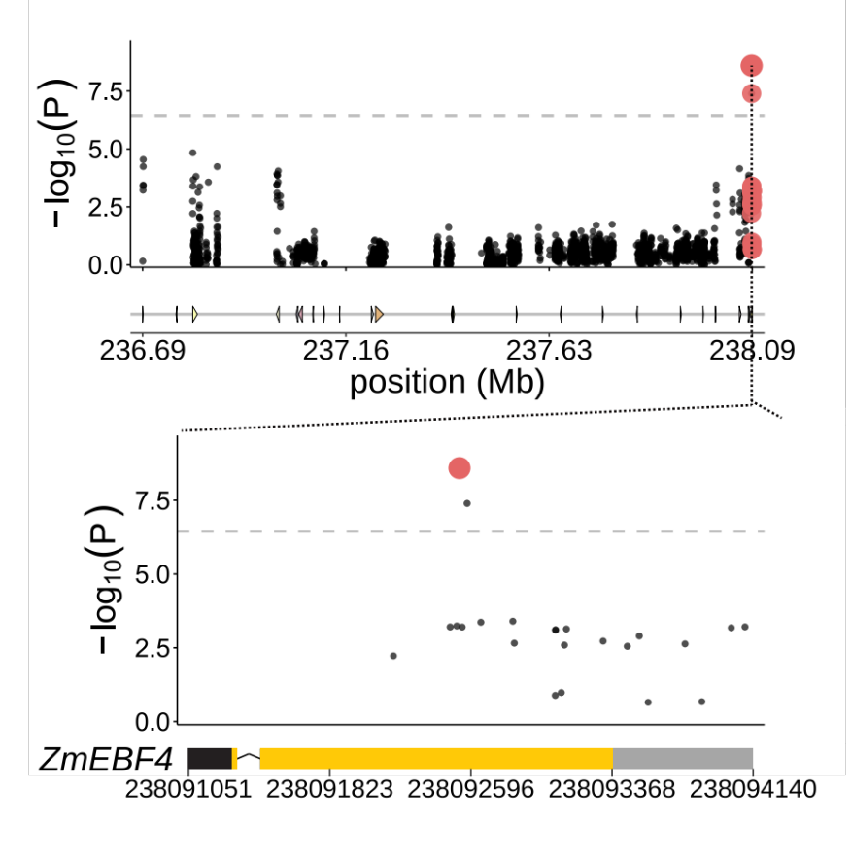
Fig S10. Regional Manhattan plot and gene structure of ZmEBF4. The GWAS signals within the most significant QTL for plant height at T5 and the GWAS signals within the gene region of ZmEBF4.

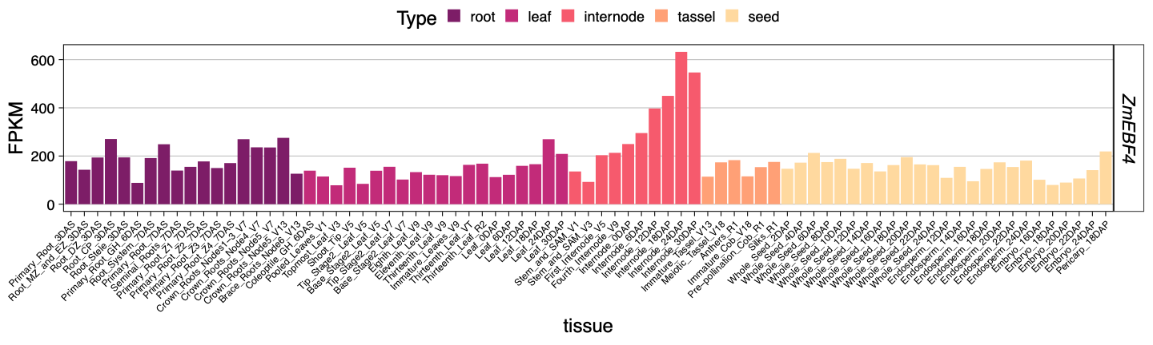
Fig S11. Expression profile of ZmEBF4 in B73. The expression profile information of ZmEBF4 in B73. Different colors denote distinct tissues.

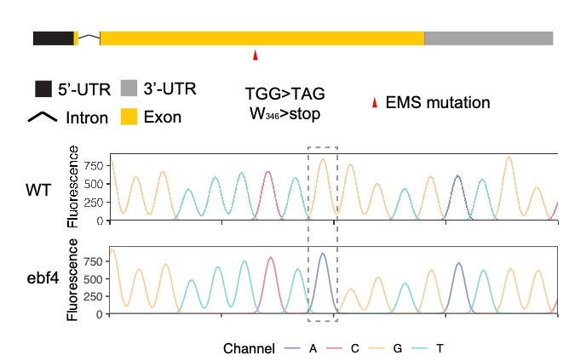
Fig S12. EMS mutation information of ebf4. Gene structure of ZmEBF4 and partial sequence alignment of ZmEBF4 in B73 WT and mutant line. The grey dashed box marks the mutation site in ZmEBF4.

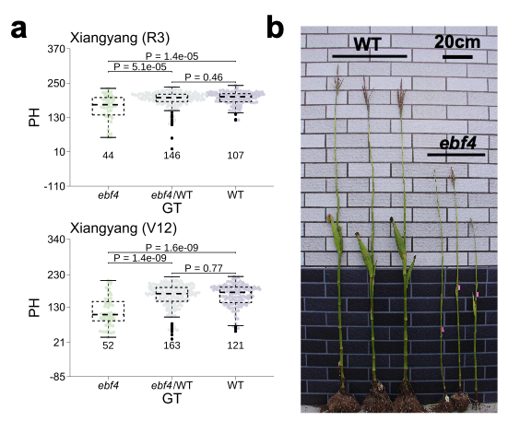
Fig S13. Phenotype analysis of ZmEBF4 EMS mutation line and WT in Xiangyang. a, Comparison of PH among mutant, and WT on V7 or R3 at Xiangyang. PH denotes plant height. b, Field-grown picture of WT and mutant in Xiangyang. Scale bar corresponds to 20cm.

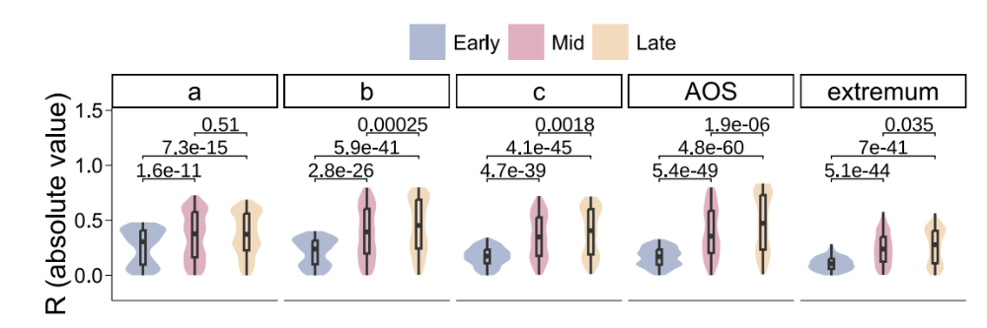
Fig S14. Comparison of correlation coefficients between growth traits and i-traits in different stages.

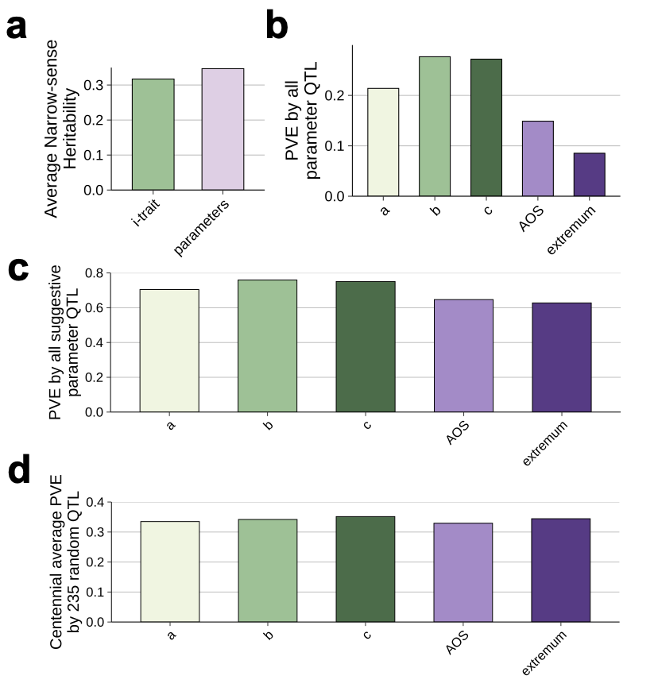
Fig S15. Narrow-sense heritability and PVE attributable to different QTL categories. a, The average narrow-sense heritability of i-traits and growth parameters. b, The phenotypic variation explained (PVE) of five parameters jointly explained by all parameter’s QTLs. c, The PVE of five parameters jointly explained by all parameter’s suggestive QTLs. The suggestive detected QTL was derived using a suggestive threshold (p≤3.9×10-5). d, The average PVE of five parameters jointly explained by randomly sampled 235 SNPs over 100 iterations.

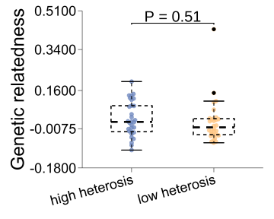
Fig S16. Comparison of genetic relatedness of parental lines between the hybrids with high and low heterosis.

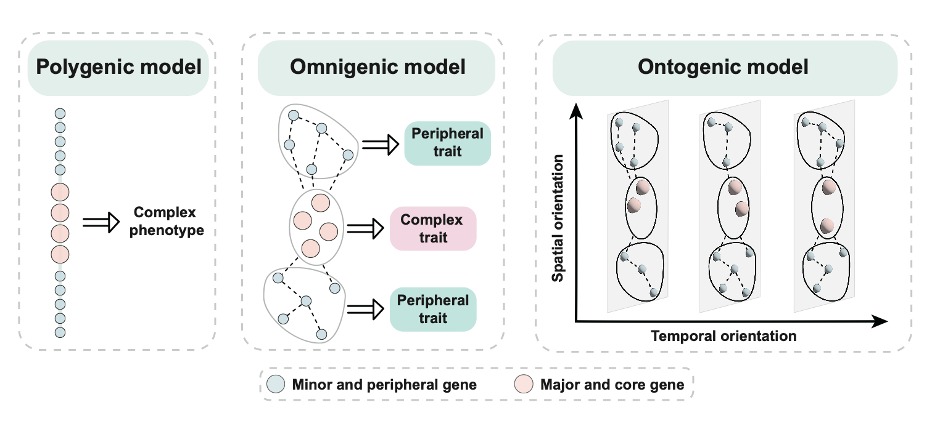
Fig S17. Ontogenic model: a spatiotemporal three-dimensional genetic architecture model for complex traits. Spatial orientation represents dimensions of diverse phenotypic traits, while temporal orientation corresponds to the developmental timeline for an organism.

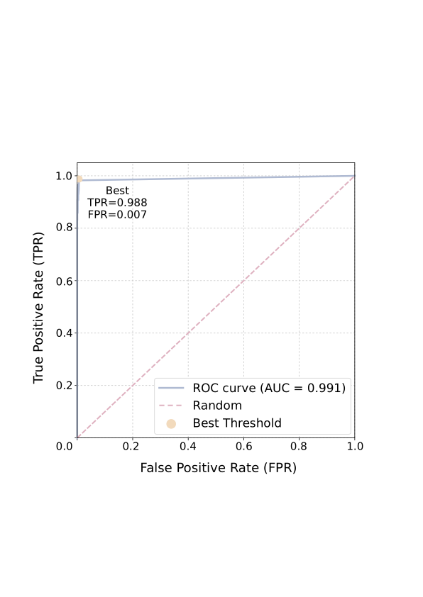
Fig S18. Receiver Operating Characteristic (ROC) curve evaluating the performance of the maize whole-plant segmentation model. The blue line represents the ROC curve, with an area under the curve (AUC) of 0.991, indicating excellent discrimination between plant pixels (positive samples) and background/noise (negative samples). The yellow point marks the optimal threshold where the Youden index (TPR – FPR) is maximized, corresponding to a high true positive rate (TPR = 0.988, proportion of correctly identified plant pixels) and a minimal false positive rate (FPR = 0.007, proportion of background pixels incorrectly classified as plant). The pink dashed line indicates the performance of a random classifier (AUC = 0.5).

