Description of Additional file 2.

Fig. S1 Population structure analysis of 298 individuals of Juglans regia.
Fig. S2 STRUCTURE results under the subsampling design.
Fig. S3 Mutational load and loss-of-function (LoF) variants were analyzed in six groups of Juglans regia using the Tibetan reference genome and Chandler 2.0 reference genome.

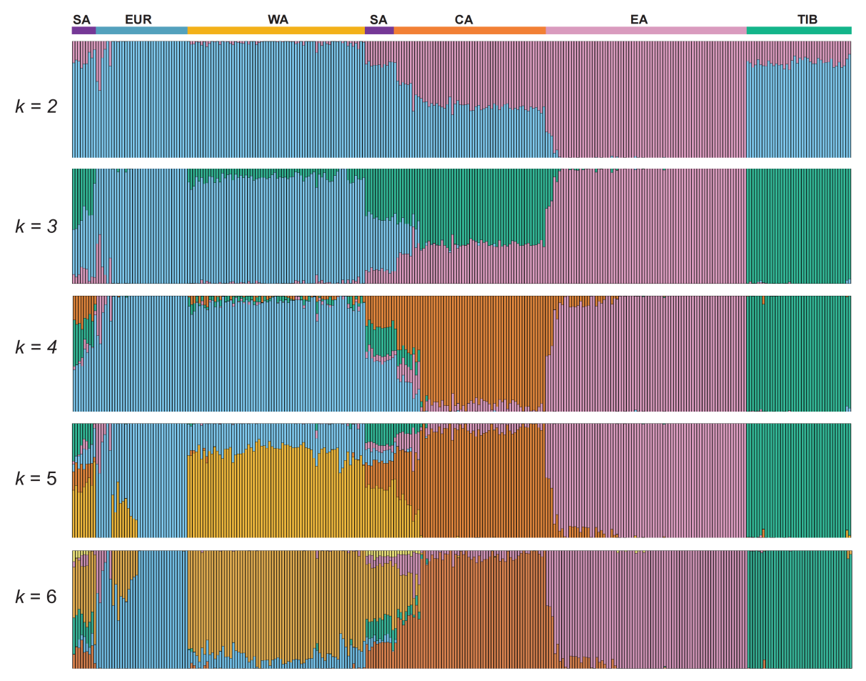
Fig. S1 Population structure analysis of 298 individuals of Juglans regia. Genetic structure inferred using STRUCTURE v.2.3.4 [1] with ParamSet2 (the alternative ancestry prior (POPALPHA = 1), a small ALPHA value (ALPHA = 0.25), and uncorrelated allele frequency model (FREQSCORR = 0)). The y-axis represents the q-value, and the x-axis shows each individual. Color coding: Europe (EUR, blue), West Asia (WA, yellow), Central Asia (CA, orange), East Asia (EA, pink), Tibet (TIB, green), and South Asia (SA, purple).

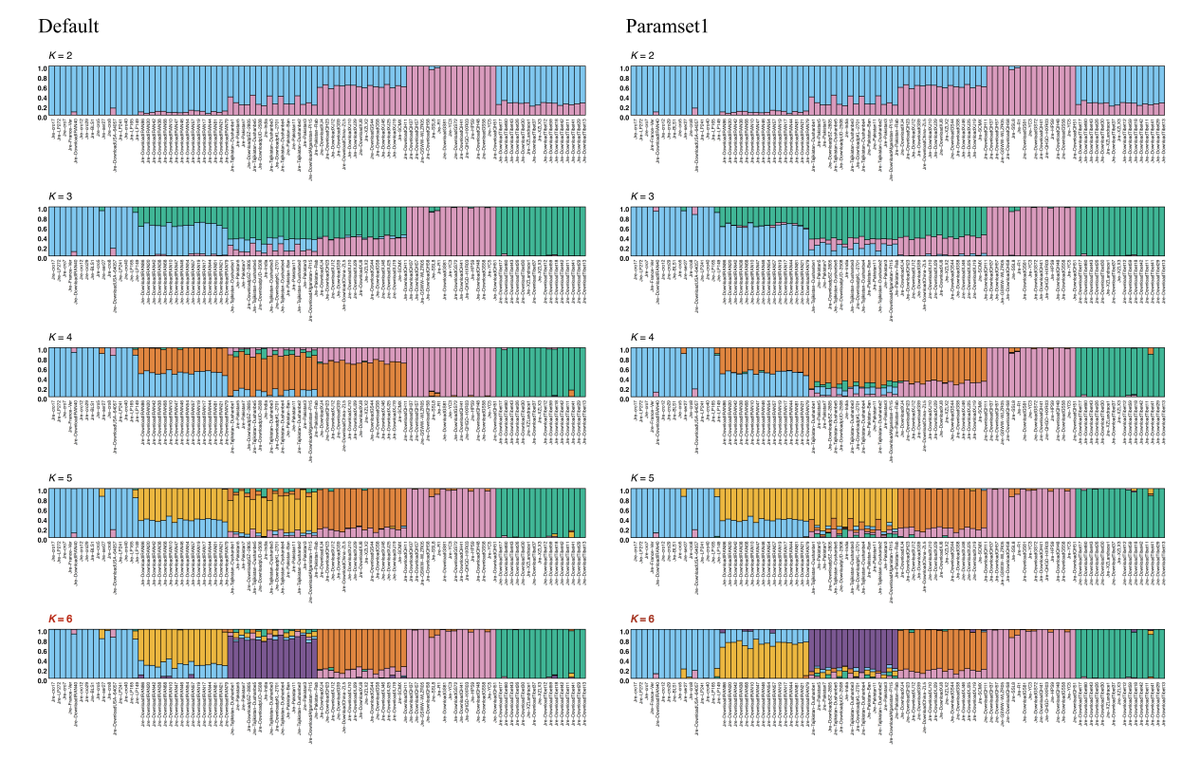
Fig. S2 STRUCTURE results under the subsampling design. Subsampling analysis was performed by randomly selecting 16 individuals from each of the six populations (including South Asia), yielding a total of 96 samples. Under the default parameter settings, the optimal was K = 6. Under the alternative parameterization (ParamSet1: the alternative ancestry prior, with POPALPHA = 1 and a smaller initial ALPHA value, under the F model), the optimal was also K = 6.

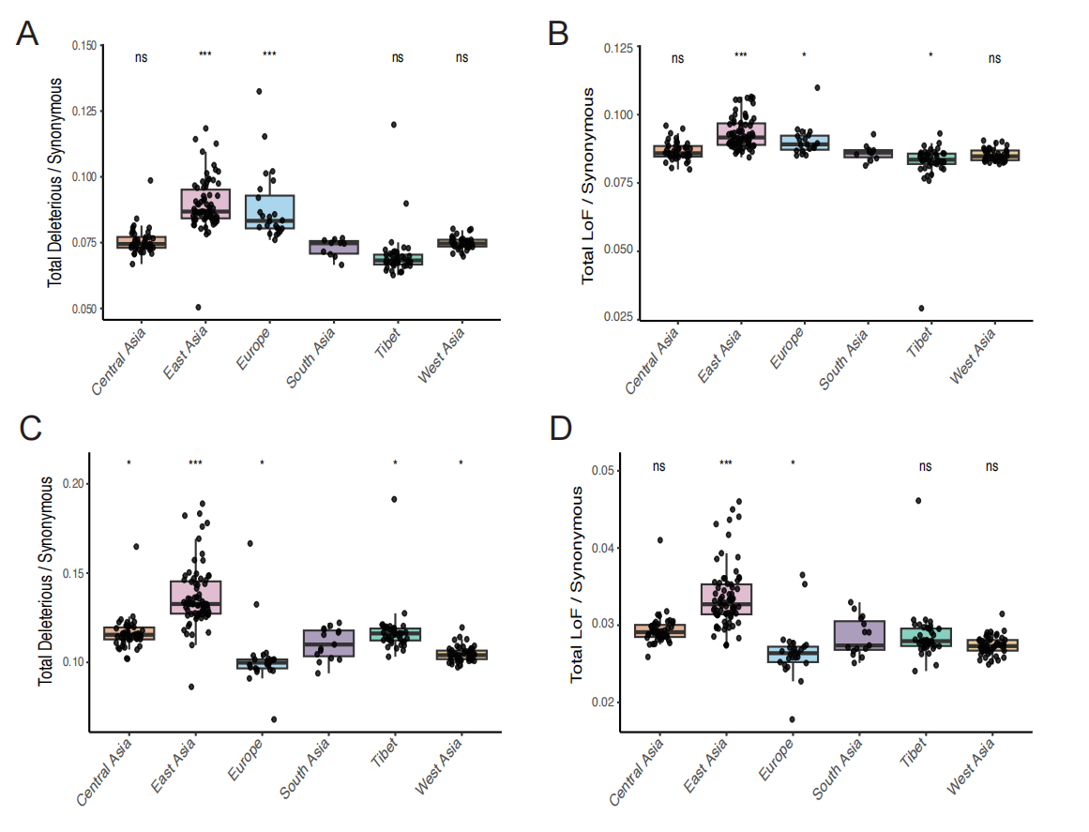
Fig. S3 Mutational load and loss-of-function (LoF) variants were analyzed in six groups of Juglans regia using the Tibetan reference genome (A-B) [35] and Chandler 2.0 reference genome (C-D) [36]. The ratios of derived deleterious variants (A, C) and LoF variants (B, D) to synonymous variants were calculated for each individual. p-values were derived using t-tests comparing each group to “South Asia”, with significance levels indicated as “***” p < 0.001, “**” p < 0.01, “*” p < 0.05, “ns” p > 0.05.

