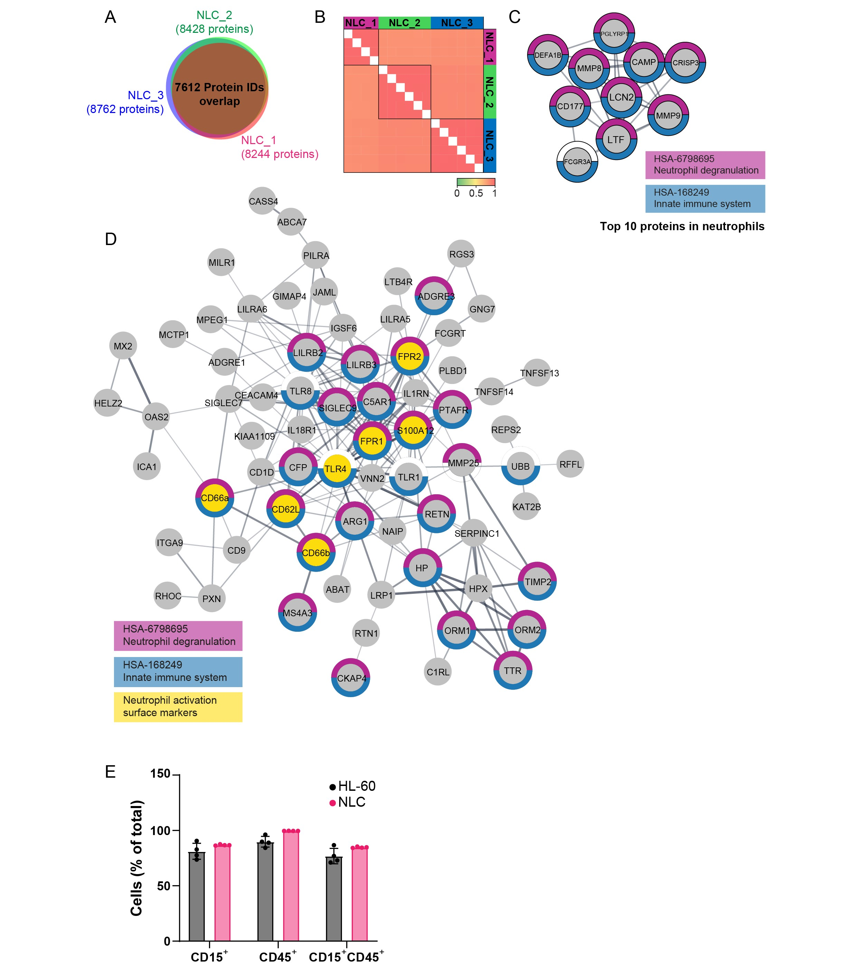
Fig S1. Characterization of primary neutrophils and differentiated neutrophil-like cells. A) Venn diagram of protein IDs quantified in three independent NLC proteome analyses. B) Pearson correlation coefficients for protein quantifications of three independent NLC proteome analysis. Color bar represents coefficient values from 0 to 1. C) STRING network of 10 top highly abundant proteins in neutrophils versus NLCs. D) STRING network of 144 proteins uniquely quantified in NLCs and neutrophils. Proteins with specific functions are highlighted: neutrophil degranulation (magenta), innate immune system (blue), and neutrophil activation surface markers (yellow). E) Flow cytometry analysis of CD15 and CD45 staining in HL-60 cells and NLCs. Bar plot represents CD15⁺ and CD45⁺ cell population from gated live cells.
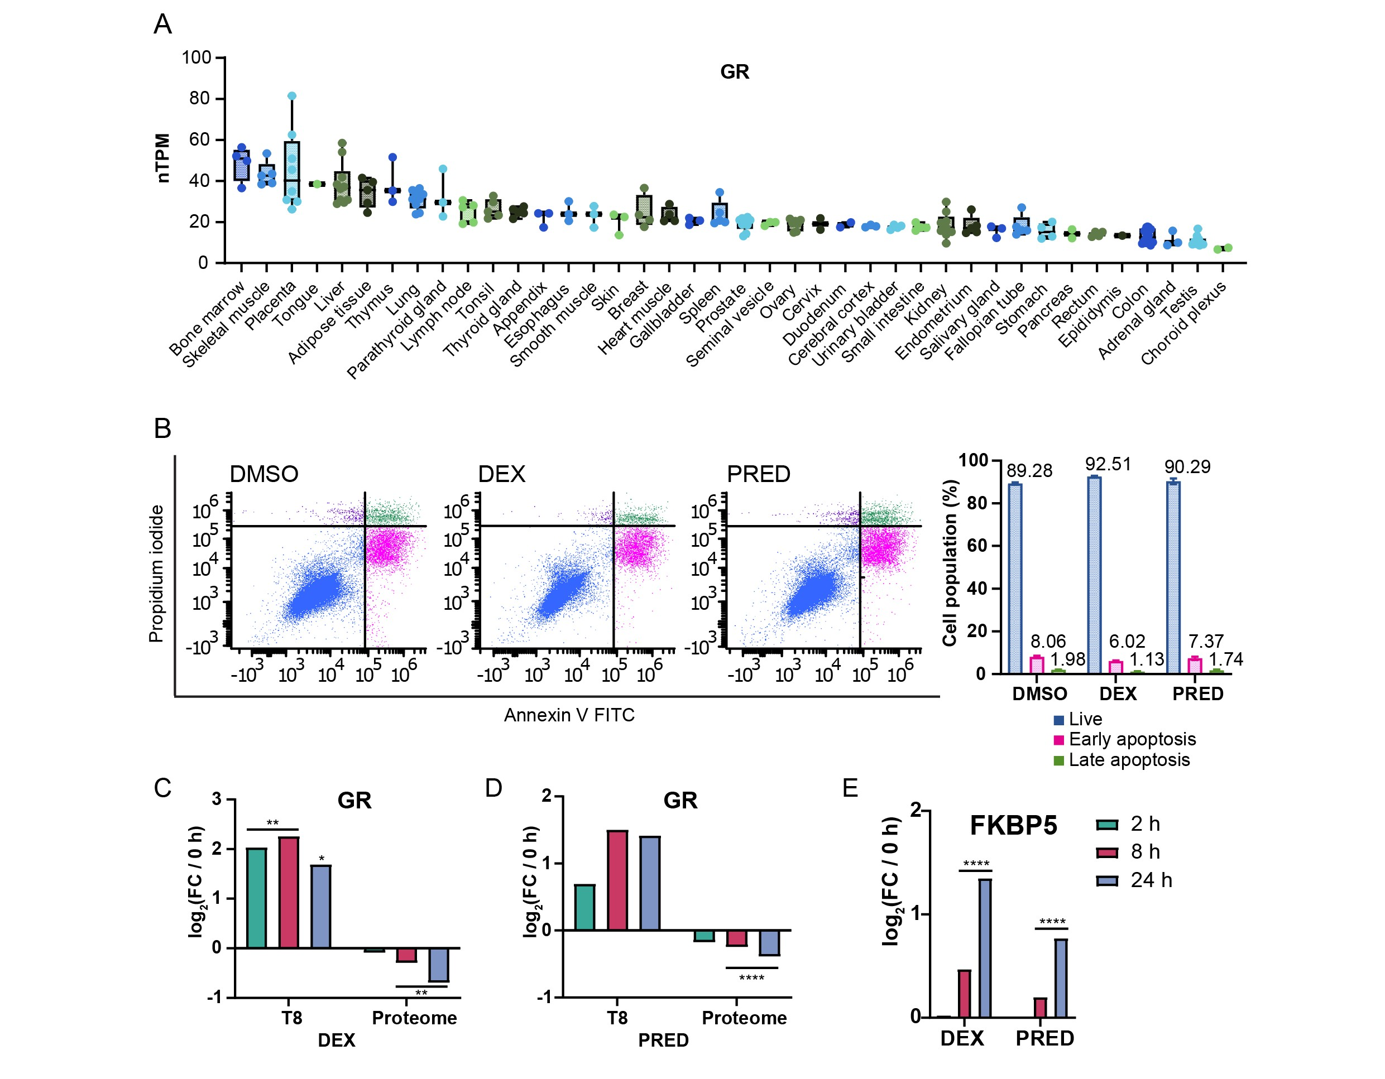
Fig S2. Effects of glucocorticoids on neutrophil-like cells. A) GR mRNA levels represented as normalized transcript per million (nTPM) in human tissues. RNA-seq data was acquired from the Human Protein Atlas (HPA). B) Apoptosis assay of NLCs after 24-hour treatment of DEX or PRED. Cells were stained with propidium iodide and annexin V, then analyzed with flow cytometry. Bar plot represents live, early apoptosis, and late apoptosis cell populations from gated live cells. C-D) Bar plots showing log₂ transformed fold changes of GR phosphorylation at Thr-8 and pan-protein level after DEX (C) or PRED (D) treatments in NLCs. E) Bar plots showing log₂ transformed fold changes FKBP5 protein level after DEX or PRED treatments in NLCs. One-way ANOVA with Tukey's HSD correction was used. FC: fold-change.

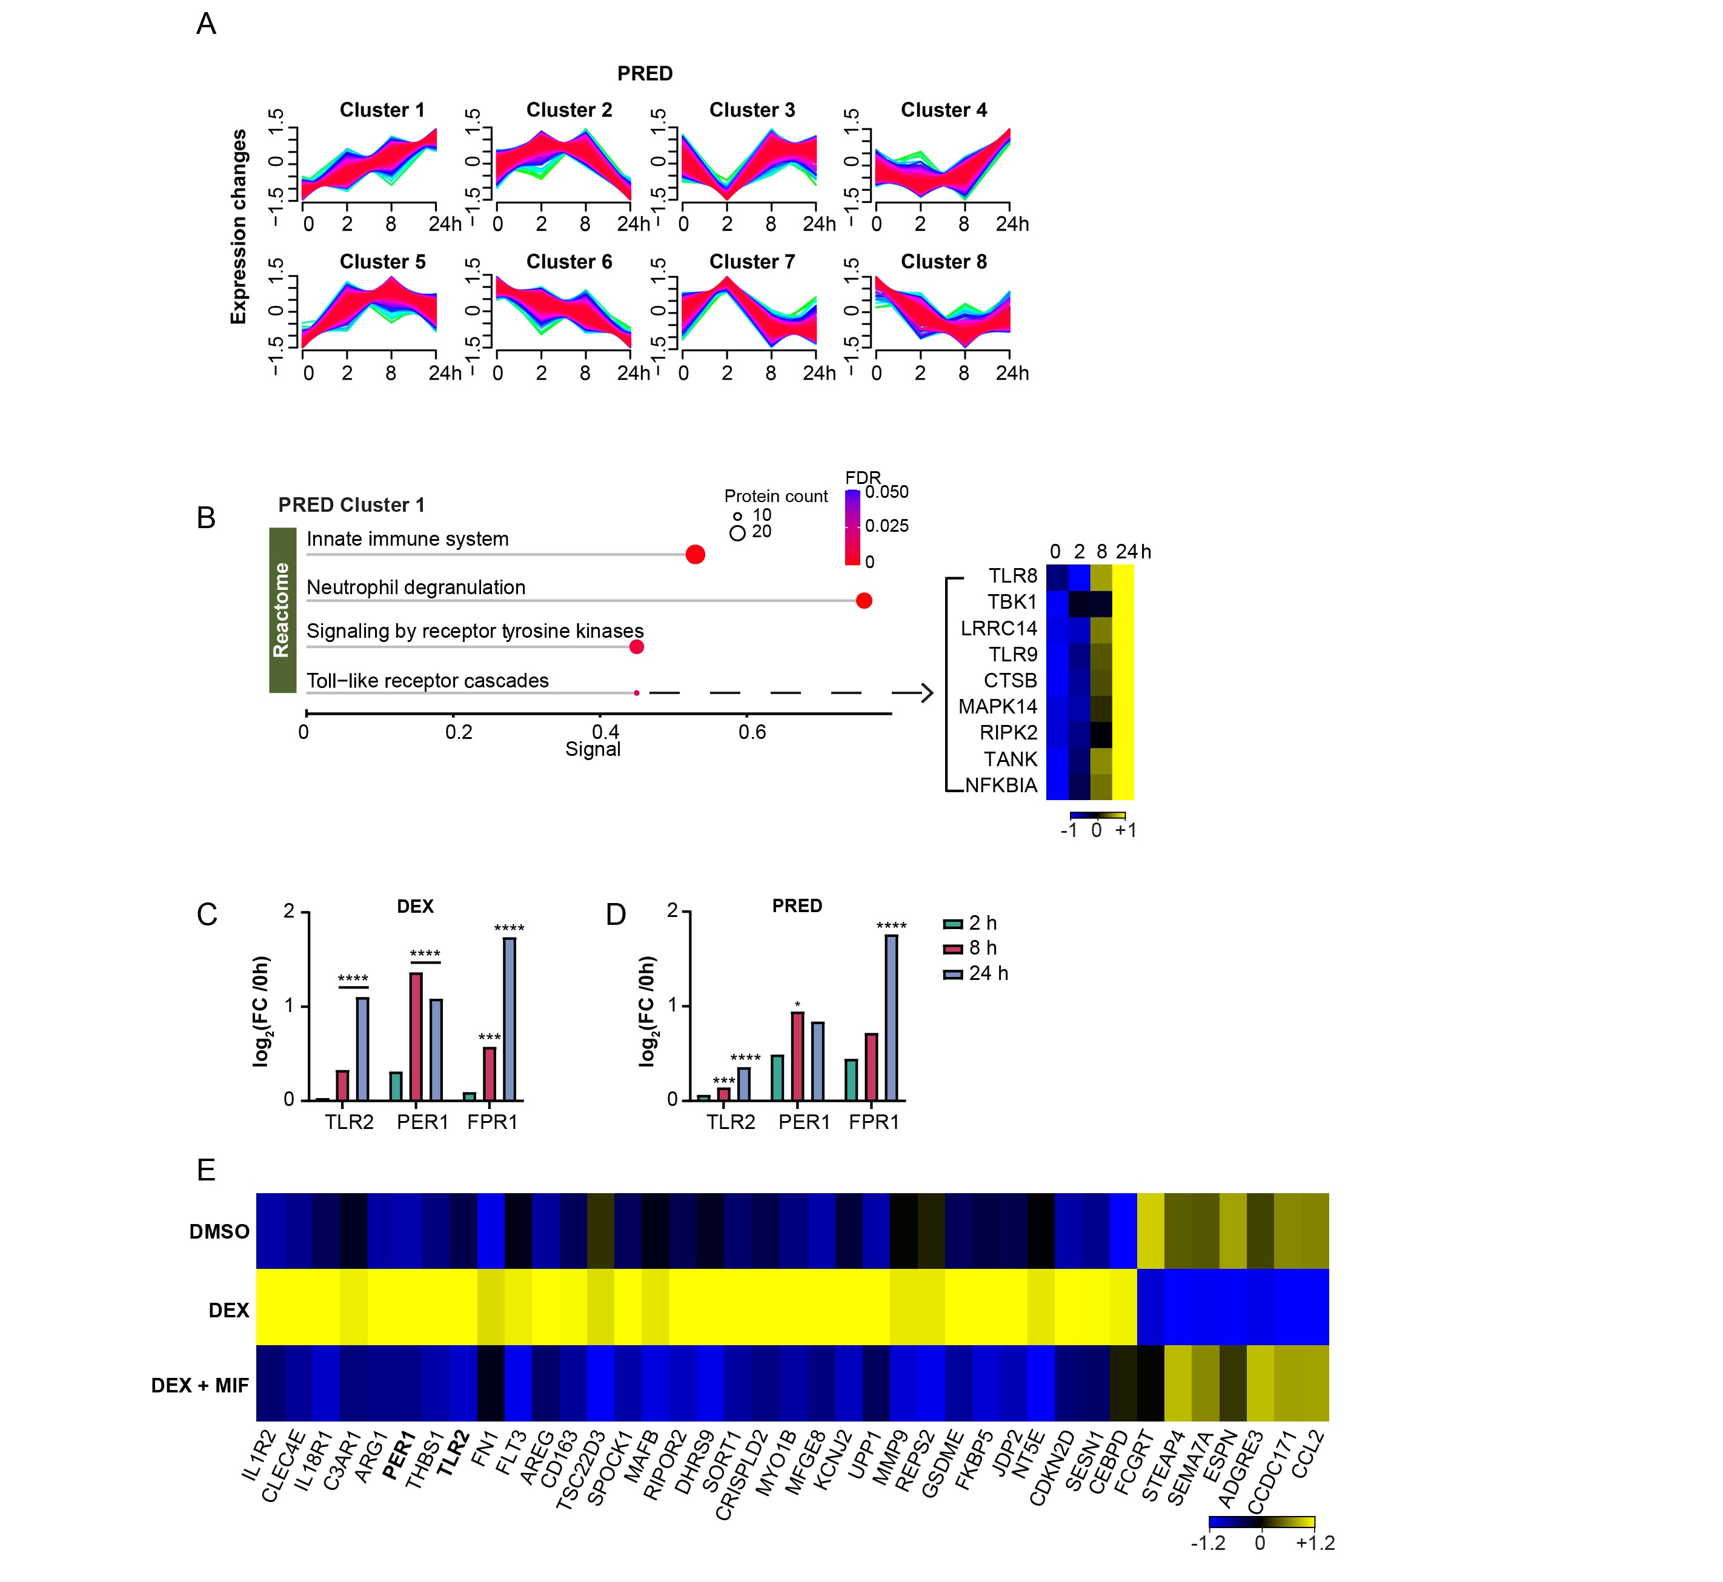
Fig S3. Proteomic regulation induced by glucocorticoids in neutrophil-like cells. A) Soft clustering analysis with statistically significant proteins (adjusted p-value < 0.05, one-way ANOVA with Tukey's HSD correction) after PRED treatment in NLCs. Mfuzz clustering package was used with fuzzification factor m = 1.5 and cluster number 8. B) Functional enrichment of proteins in cluster 1 using STRING analysis after PRED treatment. Dot size represents the number of proteins and dot color represents FDR values. Heatmap represents proteins in TLR cascades with z-scored log₂ transformed label-free quantification, colors showing z scores between -1 and 1. C-D) Bar plots showing log₂ transformed fold changes of TLR2, PER1, and FPR1 protein levels after DEX (C) or PRED (D) treatments. E) Heatmap representing proteins with statistically significant differences from proteome (adjusted p-value < 0.05 and log₂FC > |1|) in either DEX or DEX+MIF treatment compared to DMSO control. One-way ANOVA with Tukey's HSD correction was used. Log₂ transformed label-free quantification was averaged by median of each condition, z-scored, and represented in colors ranging from -1.2 to 1.2. FC: fold-change.
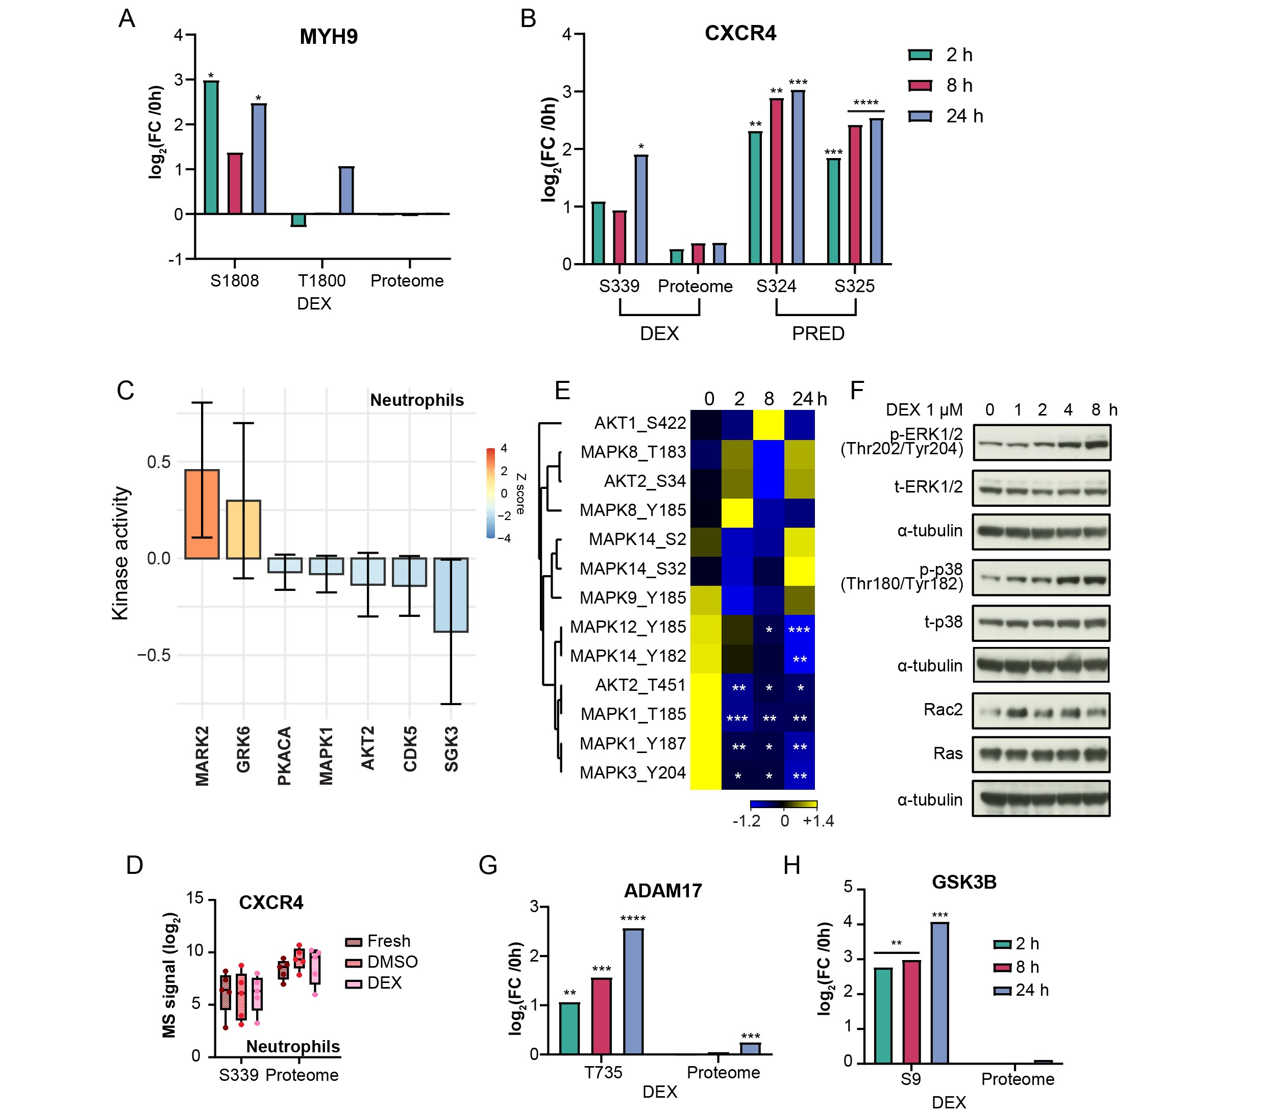
Fig S4. Protein phosphorylation changes after glucocorticoid treatments. A-B) Bar plots showing log₂ transformed fold changes of MYH9 (A) and CXCR4 (B) phosphorylation and protein levels after DEX treatment in NLCs. C) Kinase activity analysis of 2-hour DEX-treated neutrophils using the RoKAI app. D) Box plots showing individual log₂ transformed label-free quantification of CXCR4 serine phosphosites in neutrophils. E) Heatmap representing phosphorylated MAPK and AKT proteins after DEX treatment. Statistically significant phosphosites (adjusted p-value < 0.05 and log₂FC > |1|) are marked compared to DMSO control. One-way ANOVA with Tukey's HSD correction was used. Log₂ transformed label-free quantification was averaged by median of each condition, z-scored, and represented in colors ranging from -1.2 to 1.4. F) Immunoblotting analysis of MAPK signaling proteins after time-dependent treatment of 1 µM DEX (1, 2, 4, 8 hours). G-H) Bar plots showing log₂ transformed fold changes of ADAM17 (G) and GSK3B (H) phosphorylation and protein levels after DEX treatment in NLCs. One-way ANOVA with Tukey's HSD correction was used. FC: fold-change.
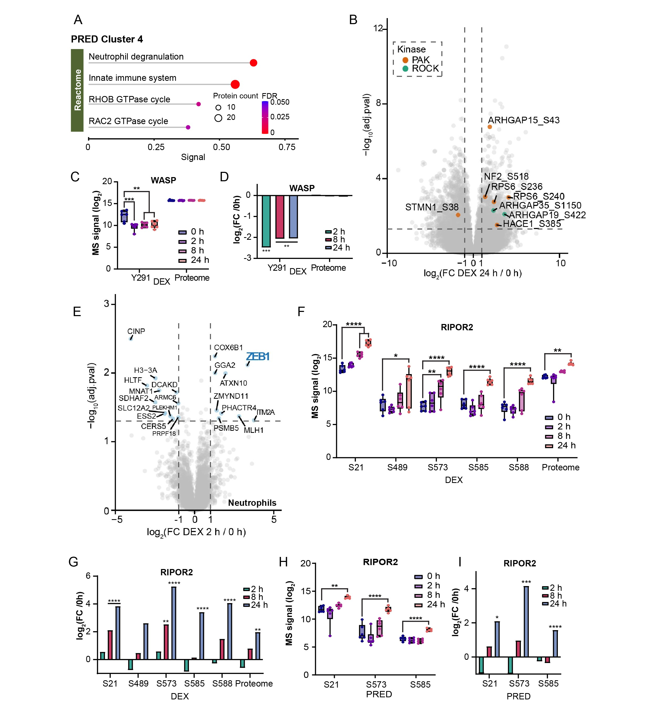
Fig S5. Rho GTPase-related phosphorylation reprogramming by glucocorticoids. A) Functional enrichment of proteins in cluster 4 using STRING analysis after PRED treatment in NLCs. Dot size represents the number of proteins and dot color represents FDR values. B) Volcano plot comparing phosphorylation expressions of 24-hour DEX treatment versus 0-hour control in NLCs using one-way ANOVA with Tukey's HSD correction. Dots highlighted in orange are substrates of PAKs and dots in green are substrates of ROCKs. C, F) Box plots showing individual log₂ transformed label-free quantification of WASP (C) and RIPOR2 (F) phosphorylation and protein levels after DEX treatment in NLCs. D, G) Bar plots showing log₂ transformed fold changes of WASP (D) and RIPOR2 (G) phosphorylation and protein expressions after DEX treatment in NLCs. E) Volcano plot comparing protein levels of 2-hour DEX treatment versus DMSO control in neutrophils using one-way ANOVA with Tukey's HSD correction. Blue dots represent proteins with statistically significant differences (adjusted p-value < 0.05 and log₂FC > |1|). H) Box plots showing individual log₂ transformed label-free quantification of RIPOR2 serine phosphosites after PRED treatment in NLCs. I) Bar plots showing log₂ transformed fold changes of RIPOR2 serine phosphorylation after PRED treatment in NLCs. One-way ANOVA with Dunnett’s multiple comparisons test was used for box plot analysis and one-way ANOVA with Tukey's HSD correction was used for bar plot analysis. FC: fold-change.
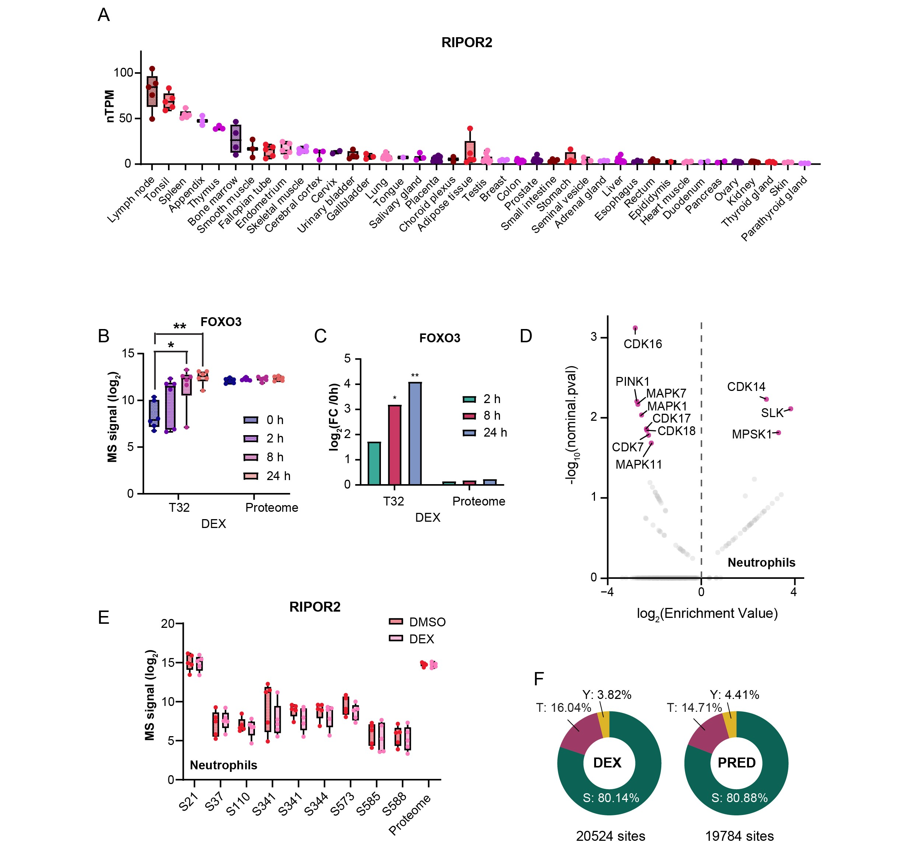
Fig S6. Effects of glucocorticoids on RIPOR2 phosphorylation. A) RIPOR2 mRNA levels represented as normalized transcript per million (nTPM) in human tissues. RNA-seq data was acquired from the Human Protein Atlas (HPA). B) Box plots showing individual log₂ transformed label-free quantification of FOXO3 phosphorylation and protein levels after DEX treatment. C) Bar plots showing log₂ transformed fold changes of FOXO3 phosphorylation and protein levels after DEX treatment. One-way ANOVA with Dunnett’s multiple comparisons test was used for box plot analysis and one-way ANOVA with Tukey's HSD correction was used for bar plot analysis. D) Fisher enrichment analysis of DEX-treated neutrophils using the Kinase Library. Differential phosphorylation was selected for serine/threonine kinases with percentile rank of 15 and nominal p-value of 0.05. E) Box plots showing individual log₂ transformed label-free quantification of RIPOR2 phosphorylation and protein levels after DEX treatment in neutrophils. F) Pie charts showing the proportion of serine (S), threonine (T), and tyrosine (Y) in phosphoproteome after DEX and PRED treatments in HL-60 cells and NLCs. FC: fold-change.

