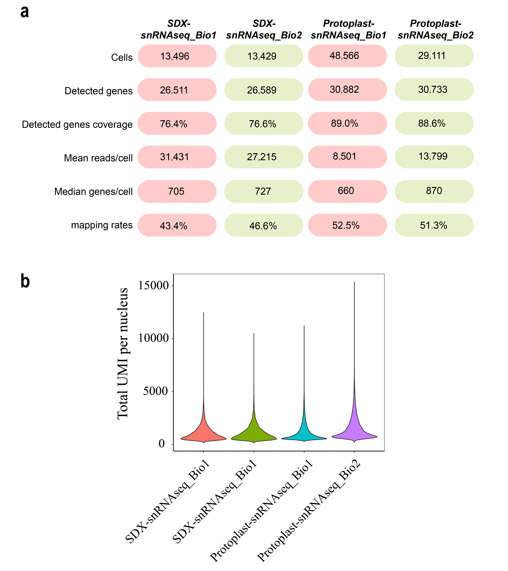
Fig. S1. SnRNA-seq sequencing metrics for biological replicates. a Summary of statistics for snRNA-seq replicates (SDX-snRNA_Bio1/Bio2 and Protoplast-snRNA_Bio1/Bio2): nuclei captured cells, median genes per nucleus, detected genes coverage, and genome mapping rates. b Number of UMIs per nucleus in the two replicates (SDX-snRNA_Bio1/Bio2 and Protoplast-snRNA_Bio1/Bio2).

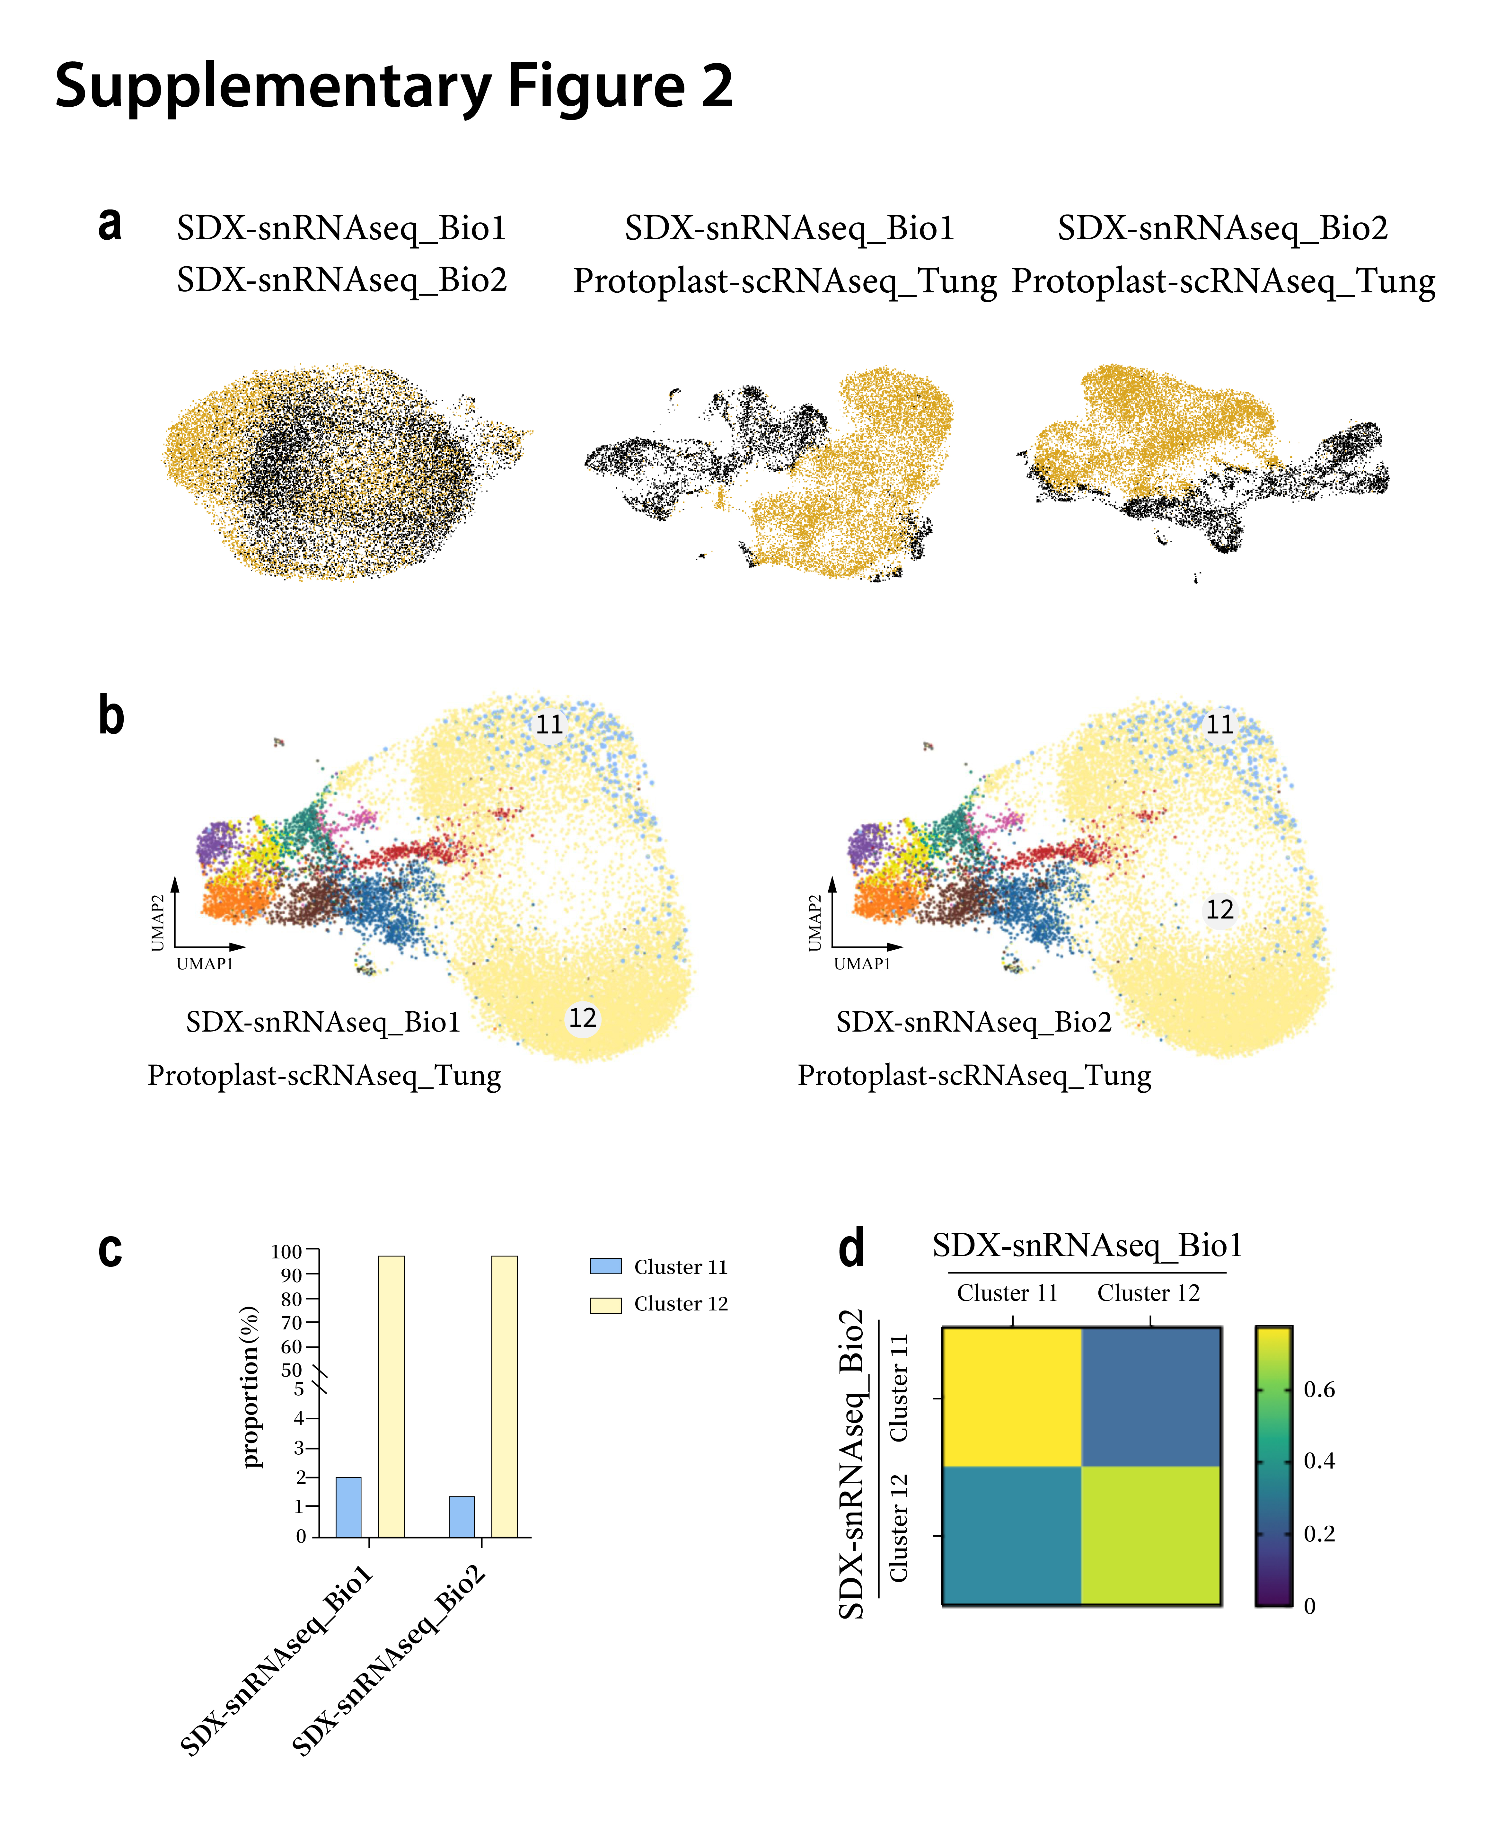
Fig. S2. Reproducibility between two replicates of SDX-snRNAseq. a Integration and clustering of two biological replicates (n=2) in SDX-snRNAseq, demonstrating high reproducibility across xylem cell populations. b Side-by-side UMAP plots of protoplast-scRNAseq and SDX-snRNAseq replicates. c Quantification of cell type proportions from SDX-snRNAseq. d Reproducibility of SDX-snRNAseq replicates assessed by MetaNeighbor.

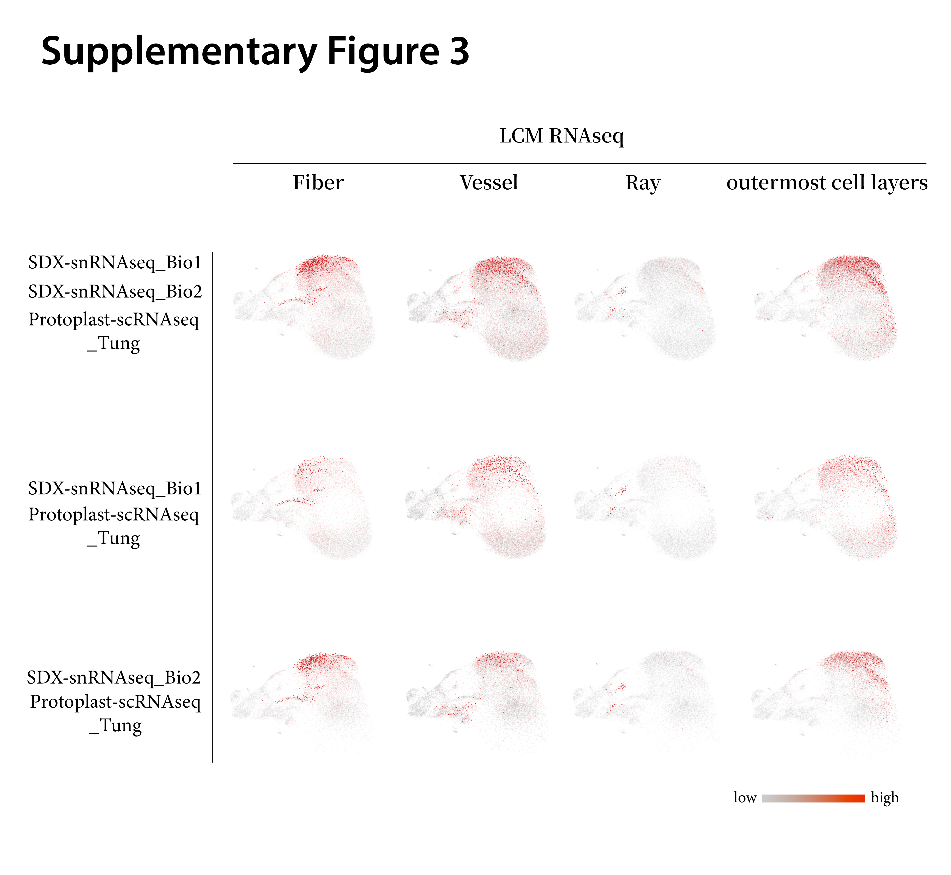
Fig. S3. Correlation map between LCM-captured fiber, vessel, ray parenchyma, outermost cell layer and two SDX-snRNAseq replicates. Color intensity (deep red = high correlation) reflects transcriptional concordance.

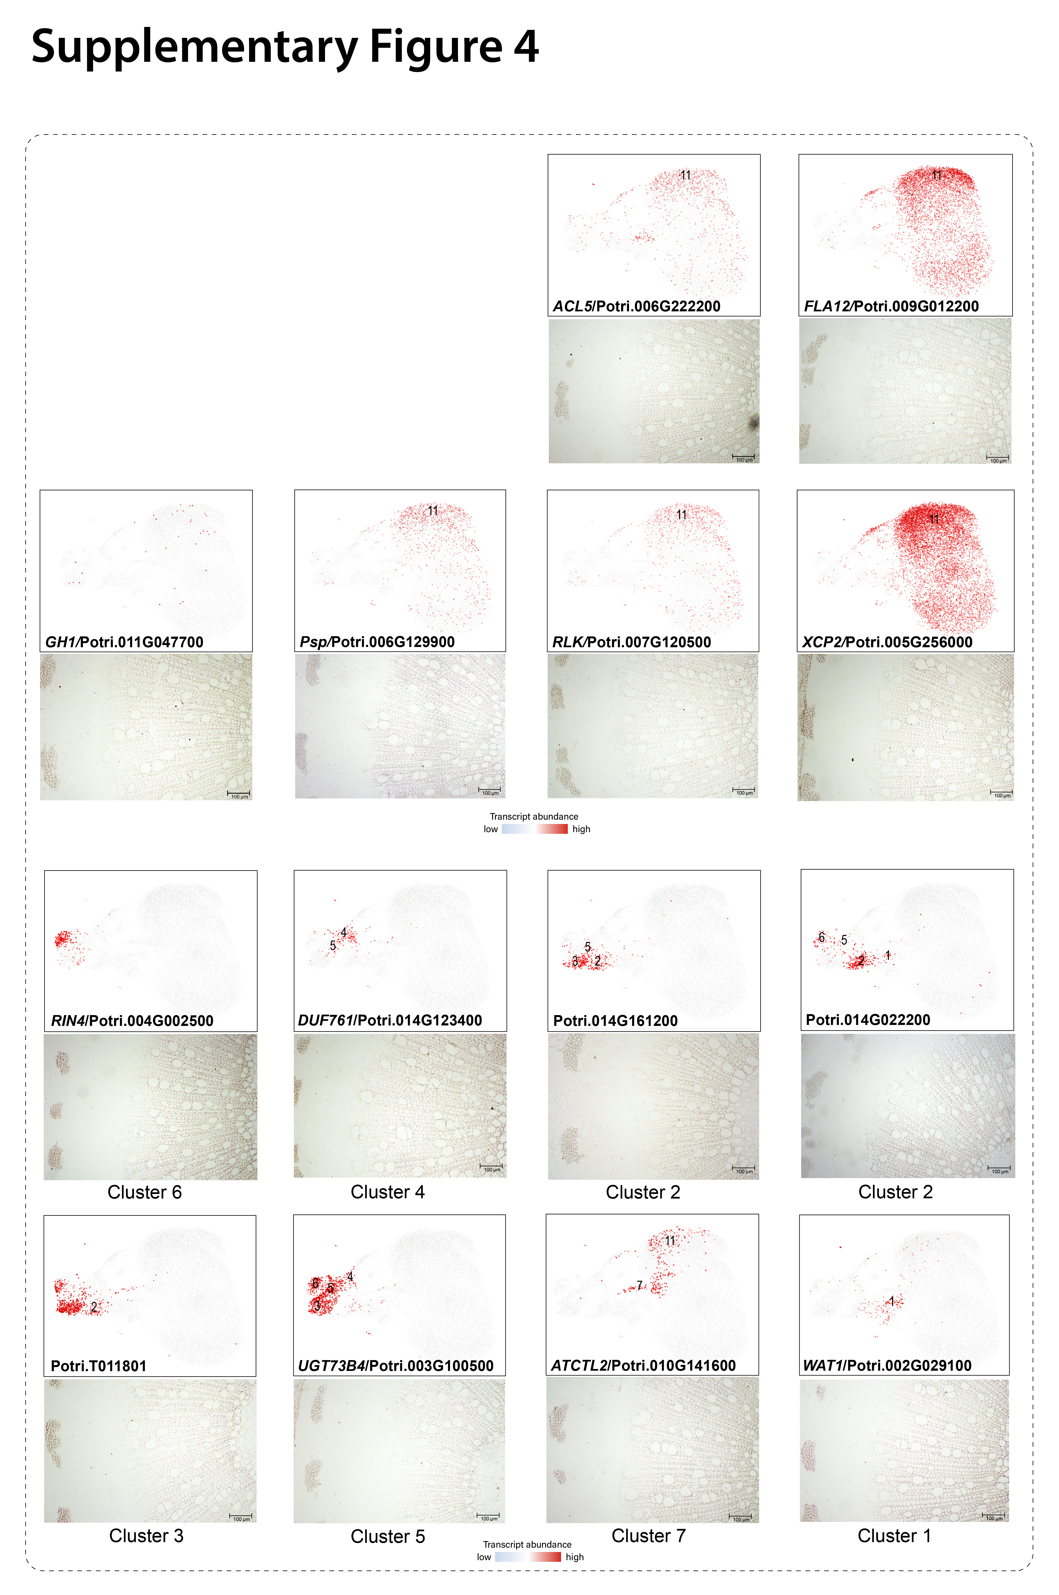
Fig. S4. RNA in situ hybridization images using sense probes for 14 genes. Color intensity (deep red = high correlation) reflects transcriptional concordance. Scale bars: 100 μm.

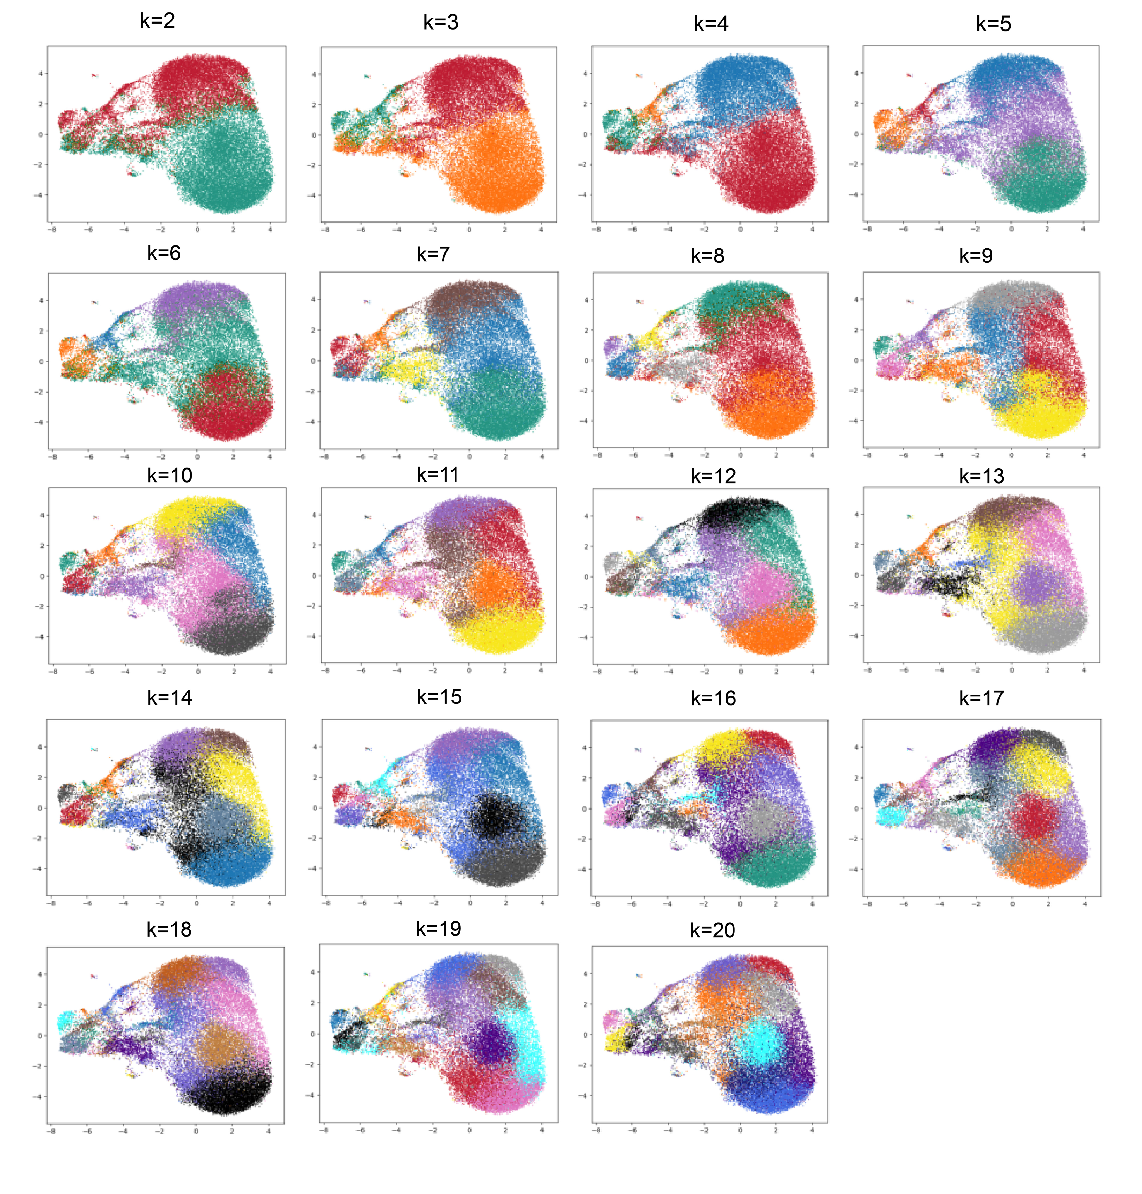
Fig. S5. Cluster number determination for integrated xylem transcriptomes. UMAP projections with K-means clustering (K=2-20).

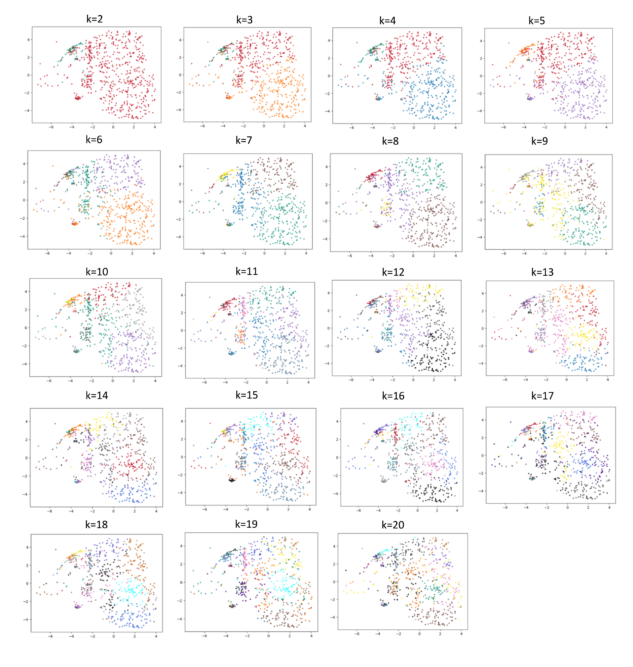
Fig. S6. K-means cluster robustness validation in subsampled scRNA-seq and SDX-snRNA-seq data. UMAP projections of subsampled cells from integrated protoplast-scRNAseq and SDX-snRNAseq datasets across K-means clusters (K=2-20). Subsampling ensures balanced representation and computational tractability.

