Additional file 2: Supplemental figures

Fig. S1: Conceptualization of the study workflow.
Each ancient sample available is mapped to reference species from a given genus being studied. From comparing mapping statistics between reference species, the quality of the sample regarding the species of interest in particular is evaluated. If a sample is of low quality, it is discarded. If it is of high quality, it will be analyzed if a MAG can be constructed, which can inform a pangenomic analysis comparing ancient and modern isolates. High quality samples are also used to create a phylogenetic tree, into which medium quality samples are placed. In the end an evolutionary analysis is conducted from the pangenomic and phylogenetic analysis, which in this study is described for S. mutans.
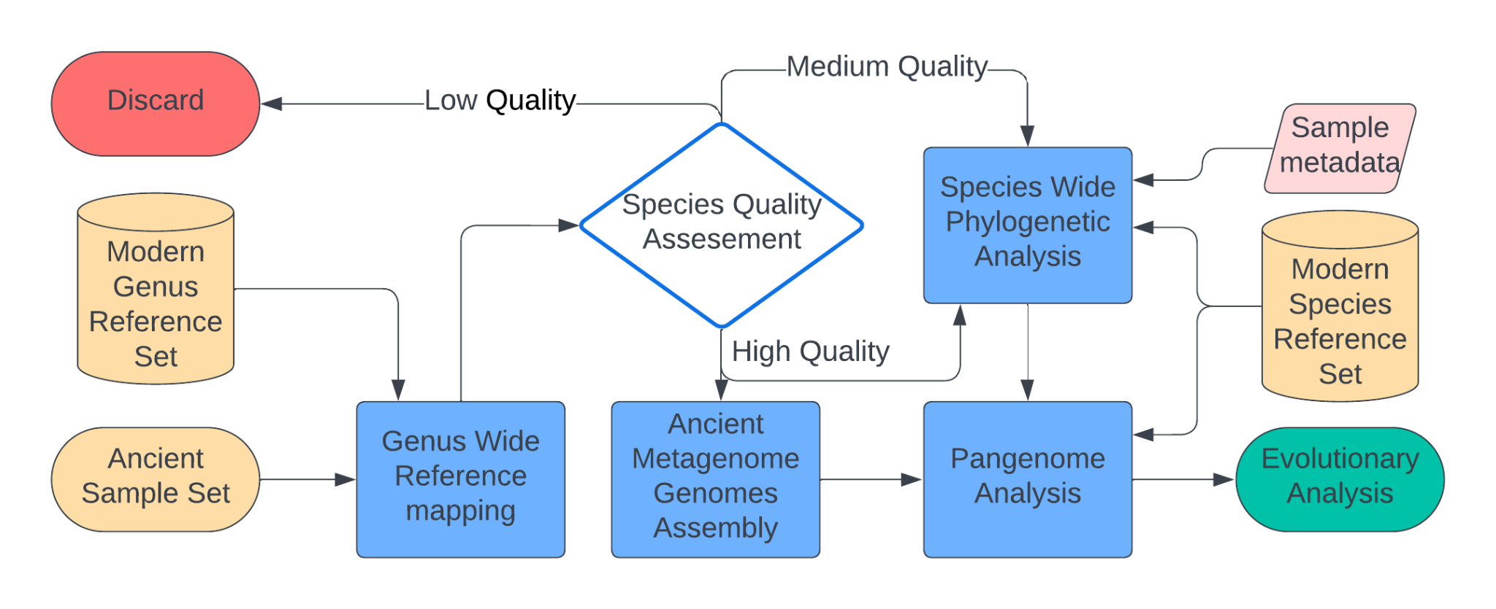

Fig. S2: Haplotype chunk sharing matrix. Heatmap showing average haplotype chunk sharing rates (indicated by cell color) between donor (columns) and recipient (rows) genomes. Row dendrogram shows inferred fineSTRUCTURE clustering hierarchy for recipient genomes. Side bar and label colours indicate the five high level fineSTRUCTURE clusters (ancient S. mutans genomes highlighted in black).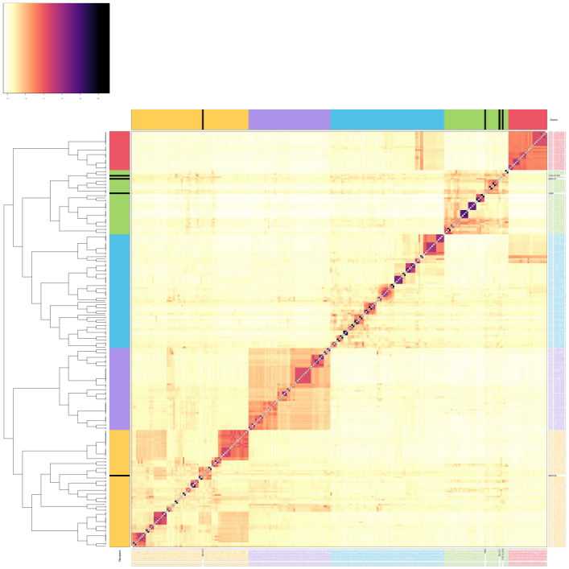

Fig. S3: Phylogenetic tree created using RAXml-NG with 200 bootstraps and midpoint rooting based on the shared core genome between modern isolates and high-quality ancient samples. There is an agreement between phylogenetic topology and fineSTRUCTURE clusters, but low bootstrap support for the deep clusters.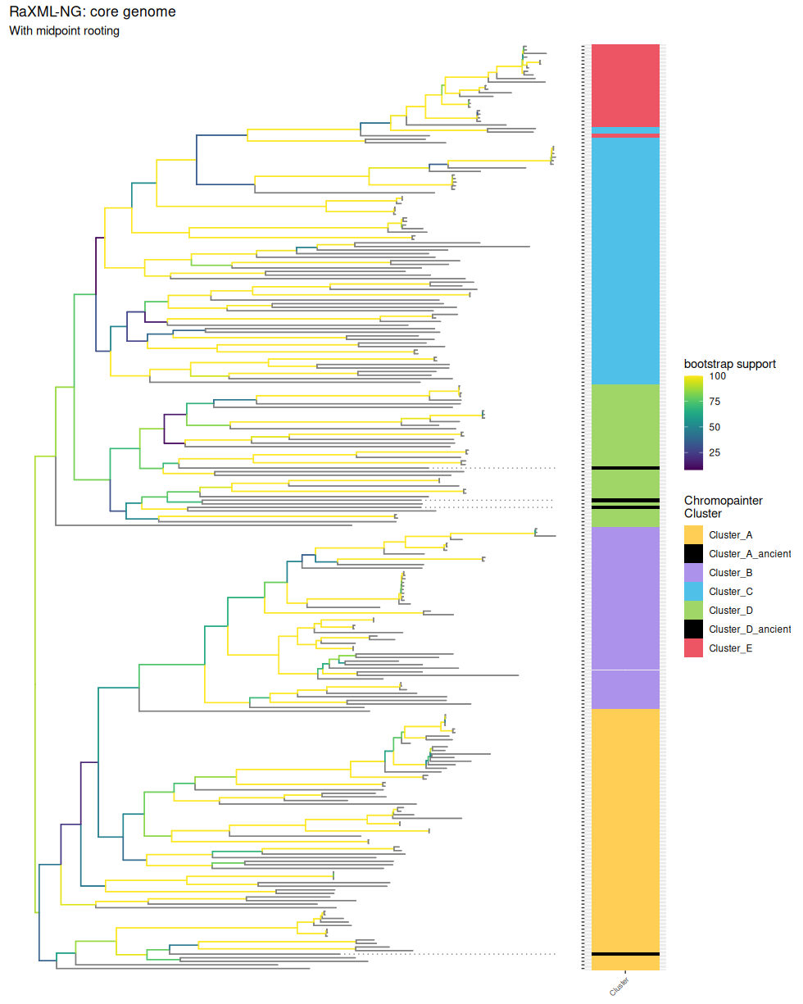

Fig. S4: Phylogenetic tree for the modern isolates and high-quality ancient samples using Gubbins, with a heatmap of recombination across the shared core genome. ChromoPainter cluster, Sampling sourcing metadata and serotype is added in columns between the tree and the heatmap.The ancient samples are highlighted with dotted lines in the phylogenetic tree. There is a connection between phylogeny and patterns of recombination, but not with any of the metadata associated with the samples. The overall rate of recombination to mutation was estimated ~25%.
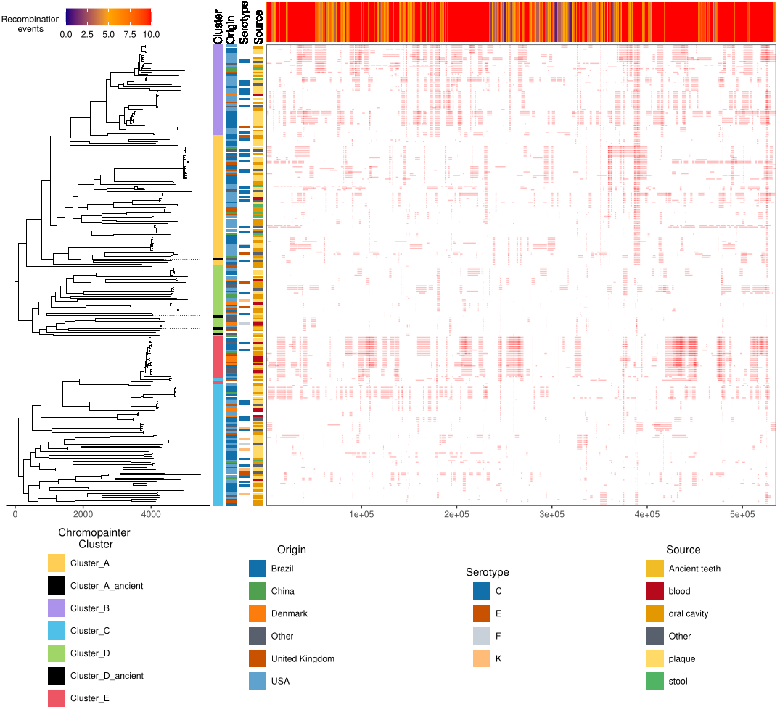

Fig. S5: Comparison between the three phylogenetic tree methods used in this study evaluated by bootstrap support. The Gubbins tree used the RaXML-NG core genome final tree as a starting tree, while the second RaXML-NG tree used the masked core genome from Gubbins as input instead of the shared core genome-wide
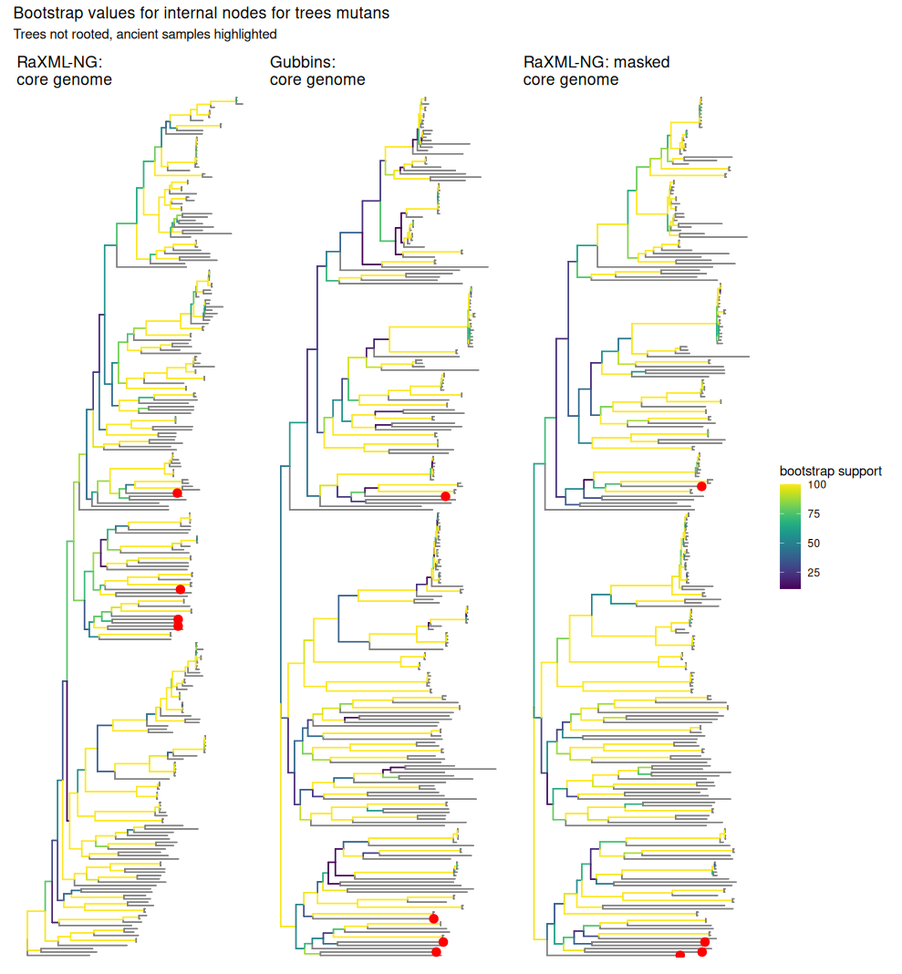

Fig. S6. A-V
A-U: Phylogenetic placement likelihood weight ratio distribution of 22 ancient samples using EPA-ng on the phylogenetic tree used in this study, marked by line color and line thickness. The four high coverage and clonal ancient samples that were used beside the modern assemblies to define the tree have their tip labels shown. The placement likelihood of S. troglodytae is also included in V, which was used to infer the rooting of the tree.
A:
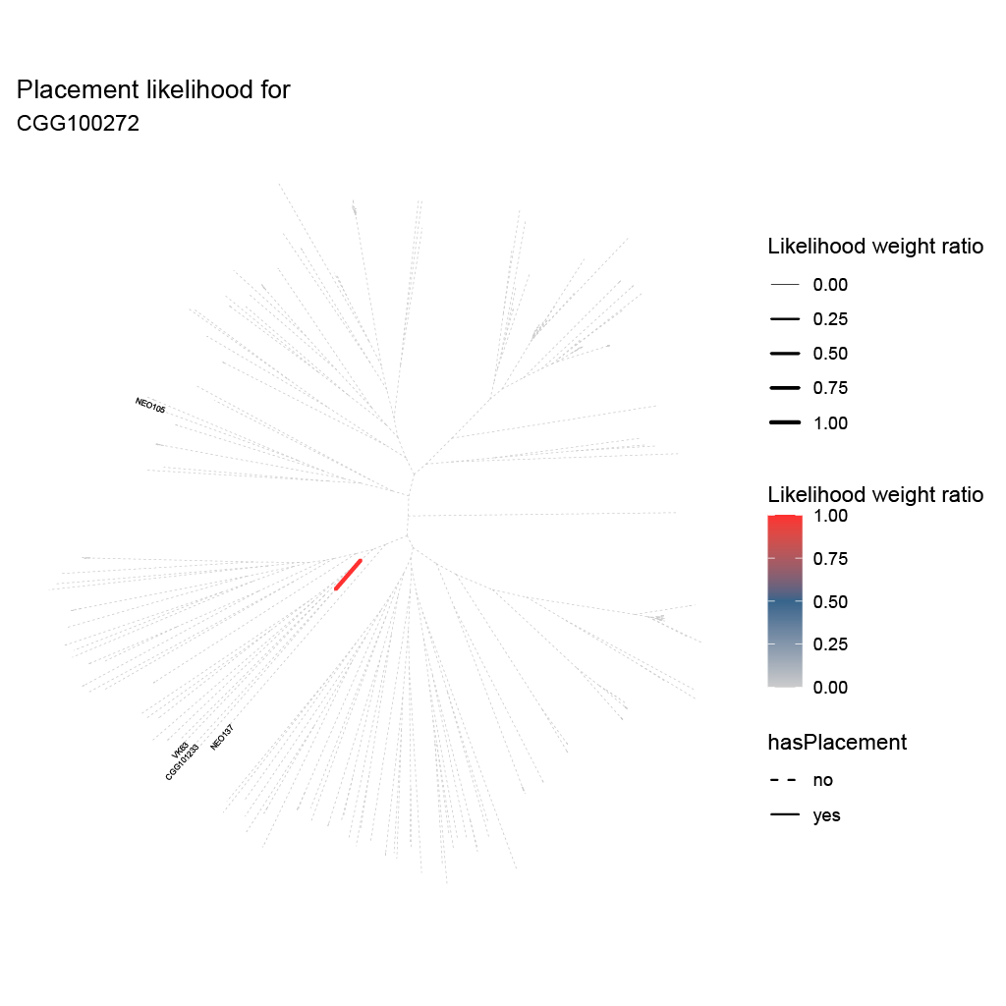

B:
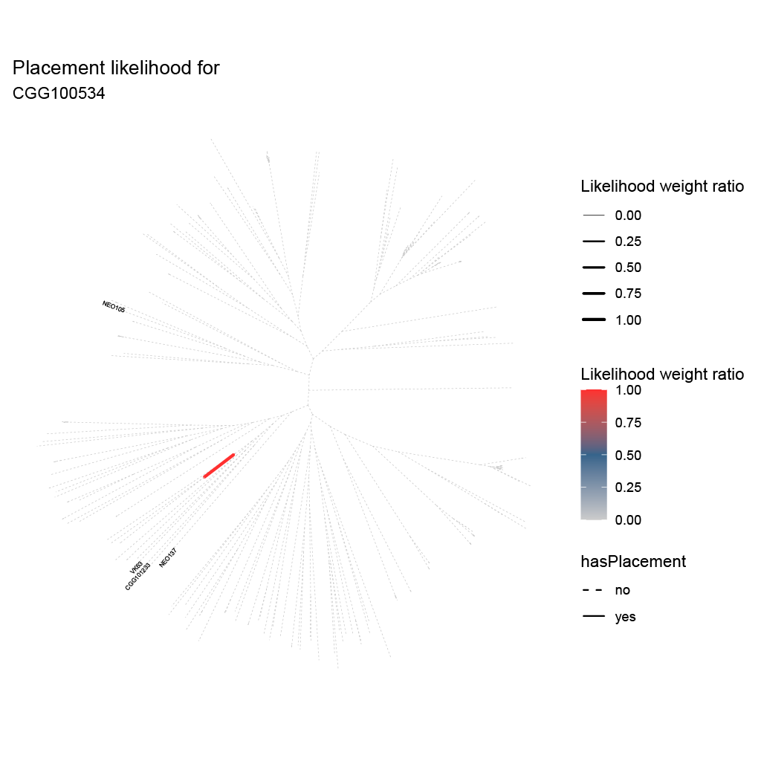

C:
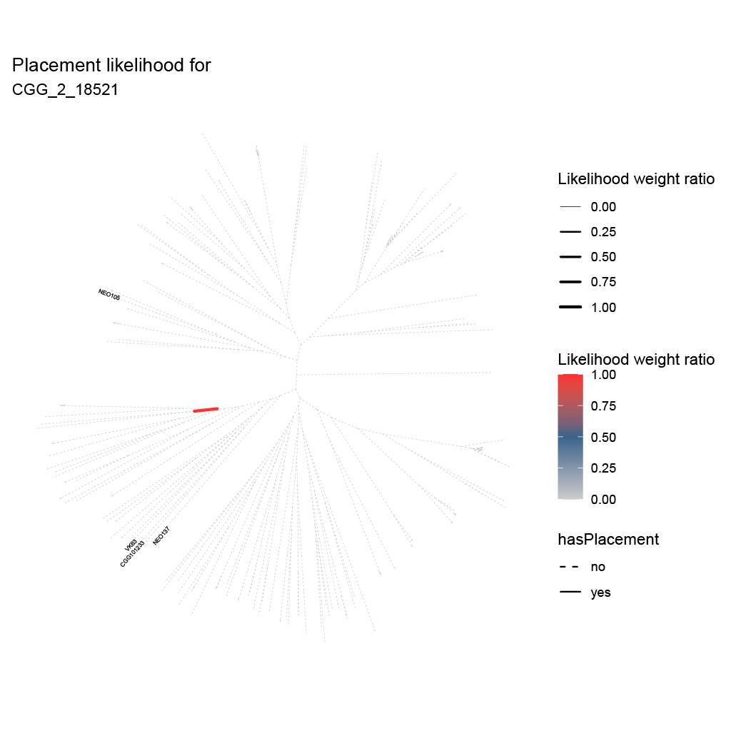

D:
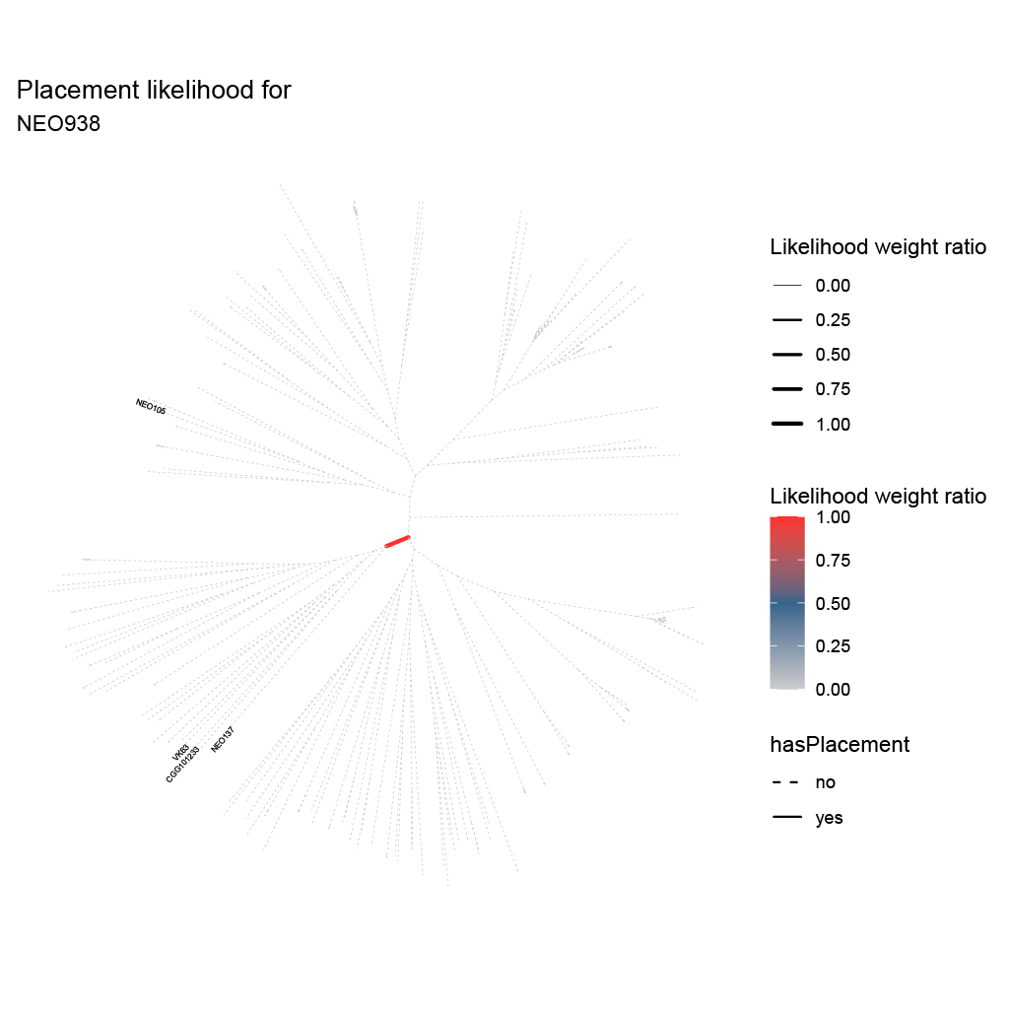

E:
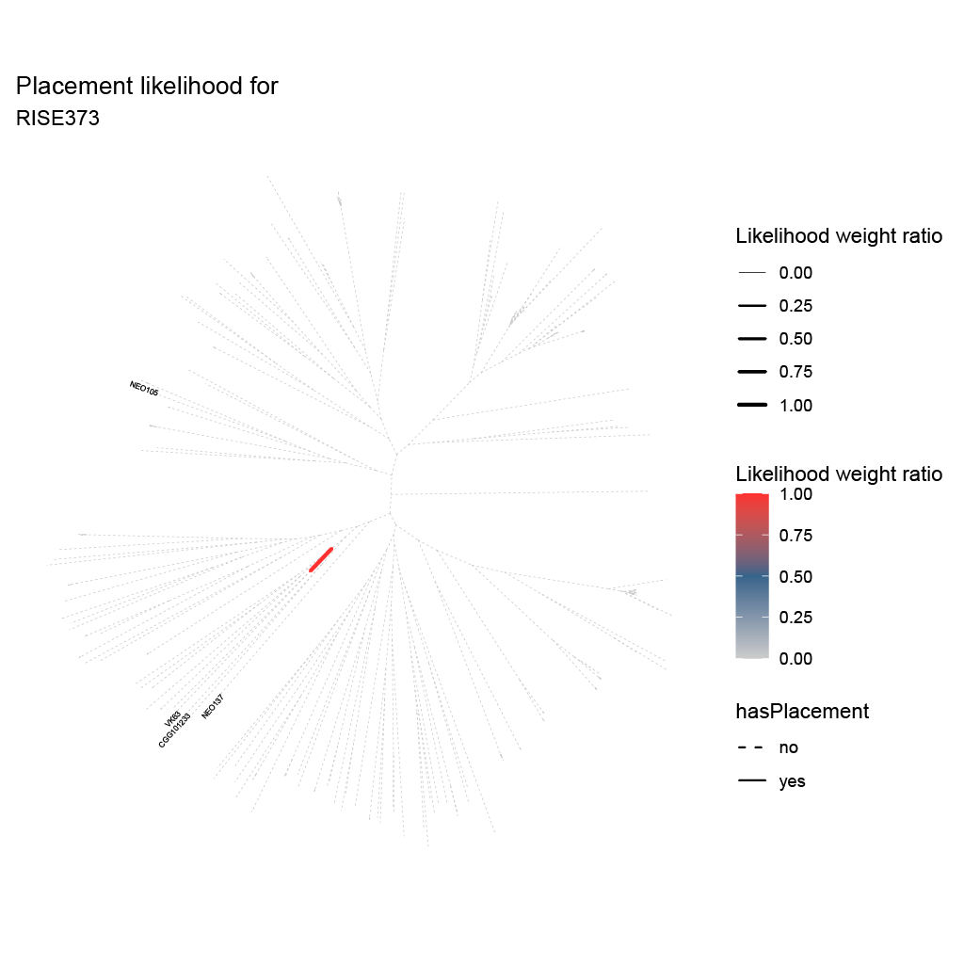

F:
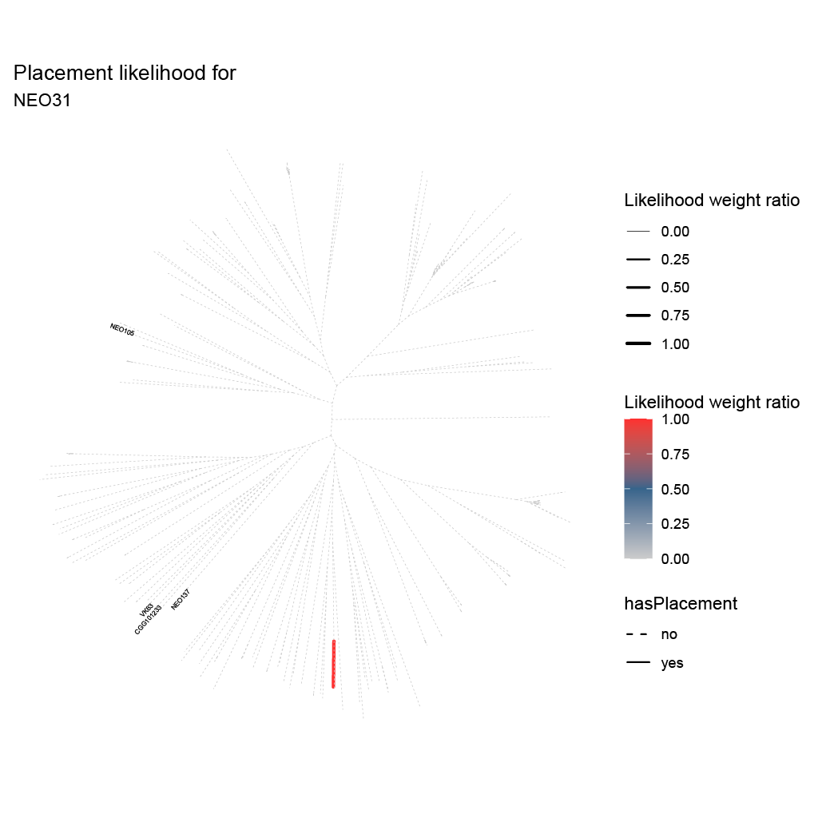

G:
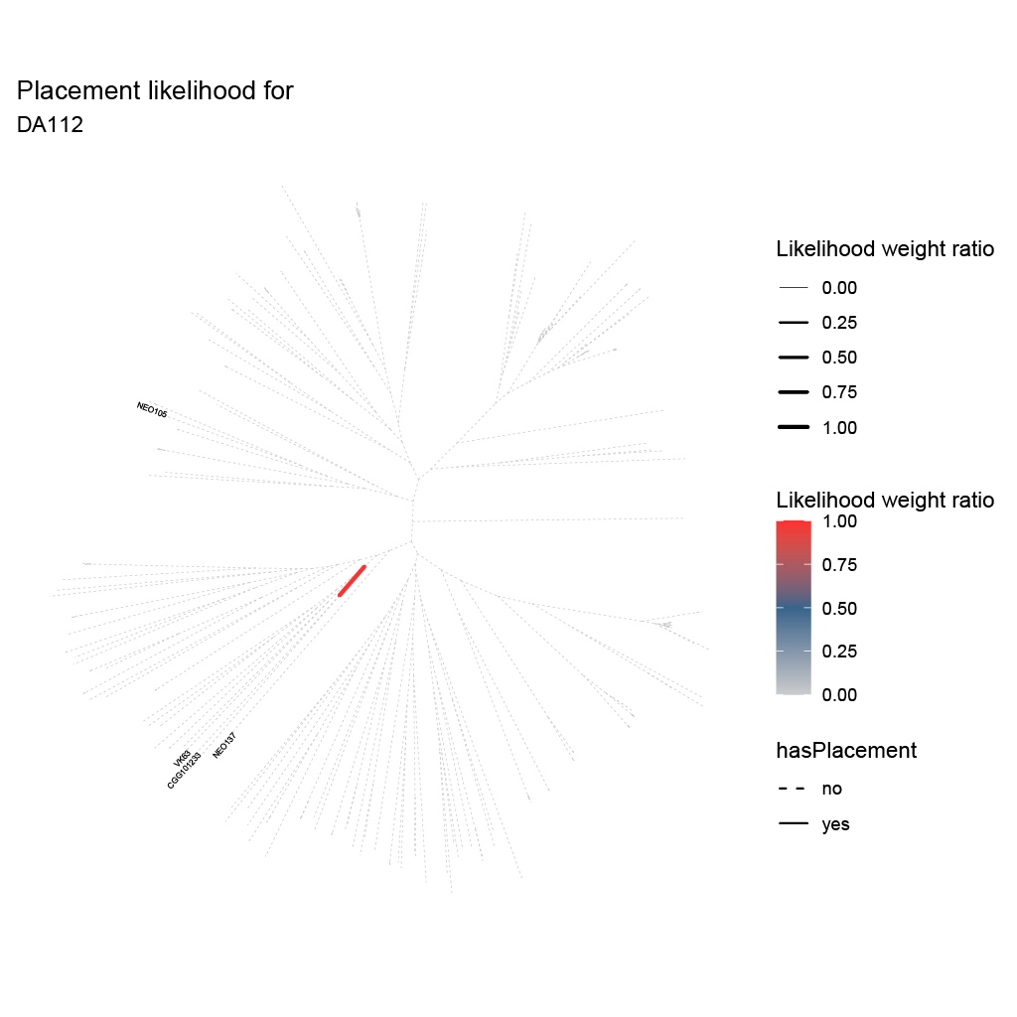

H:
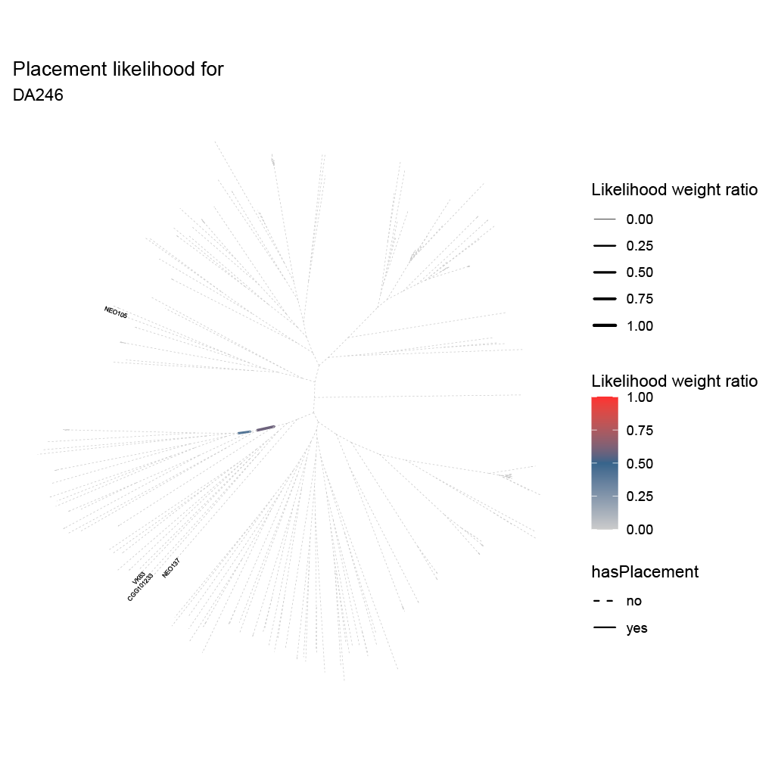

I:
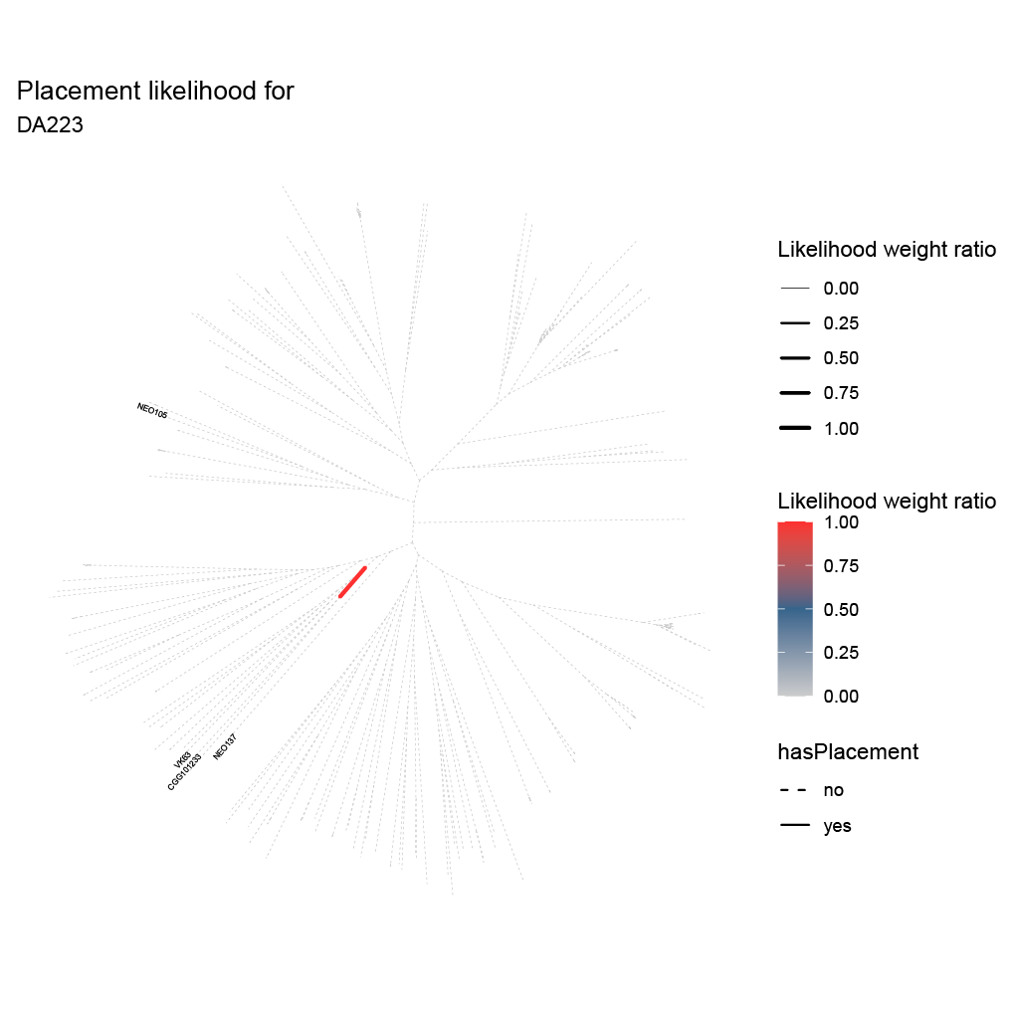

J:
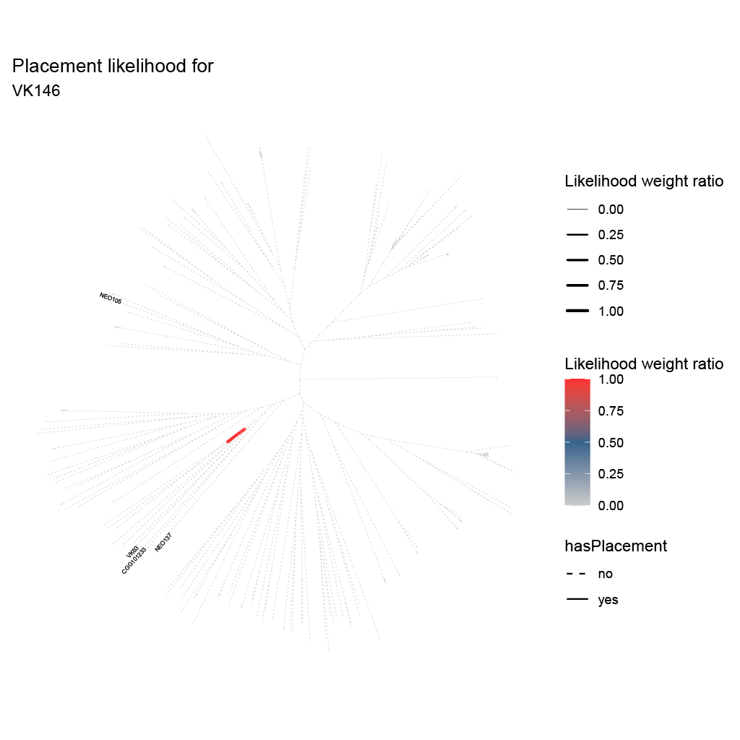

K:
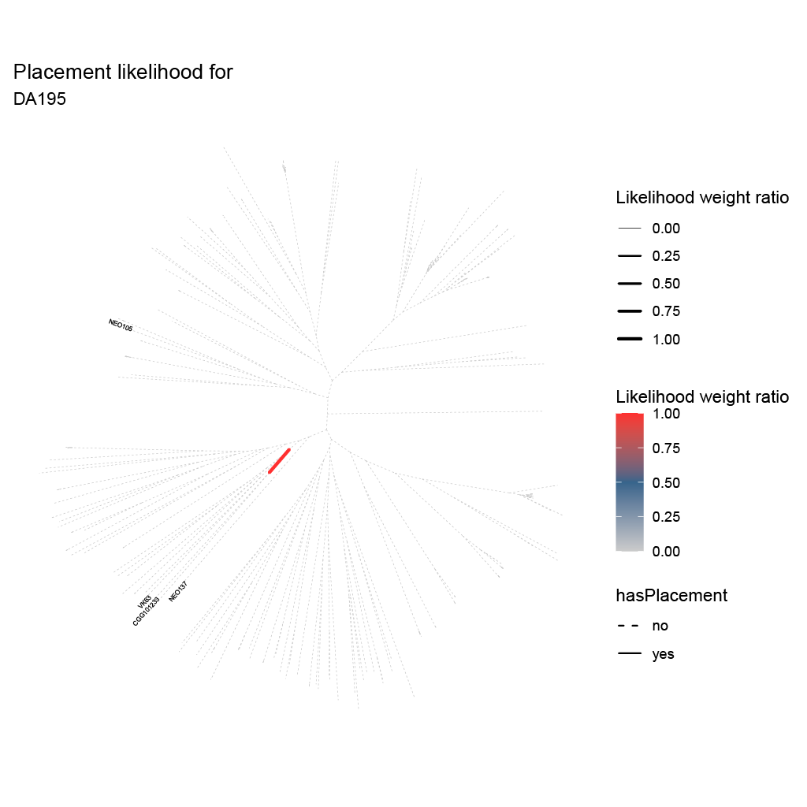

L:
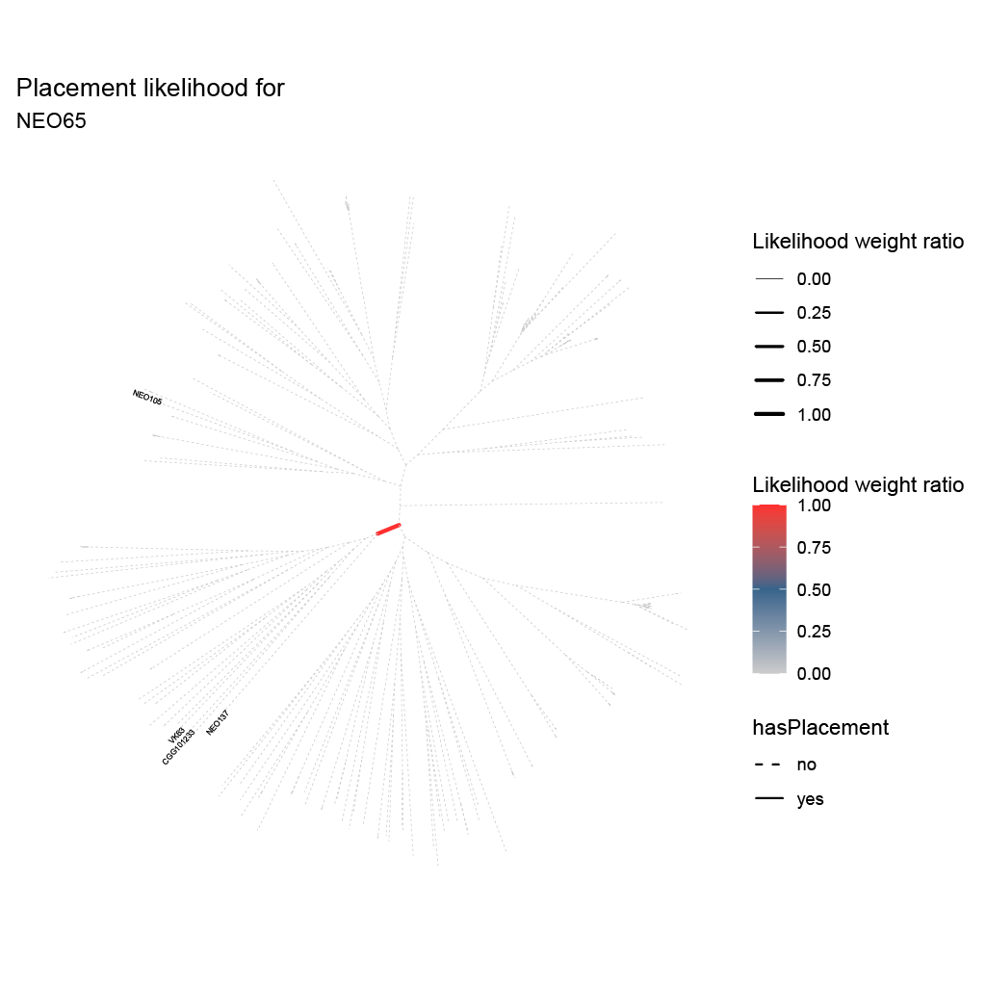

M:
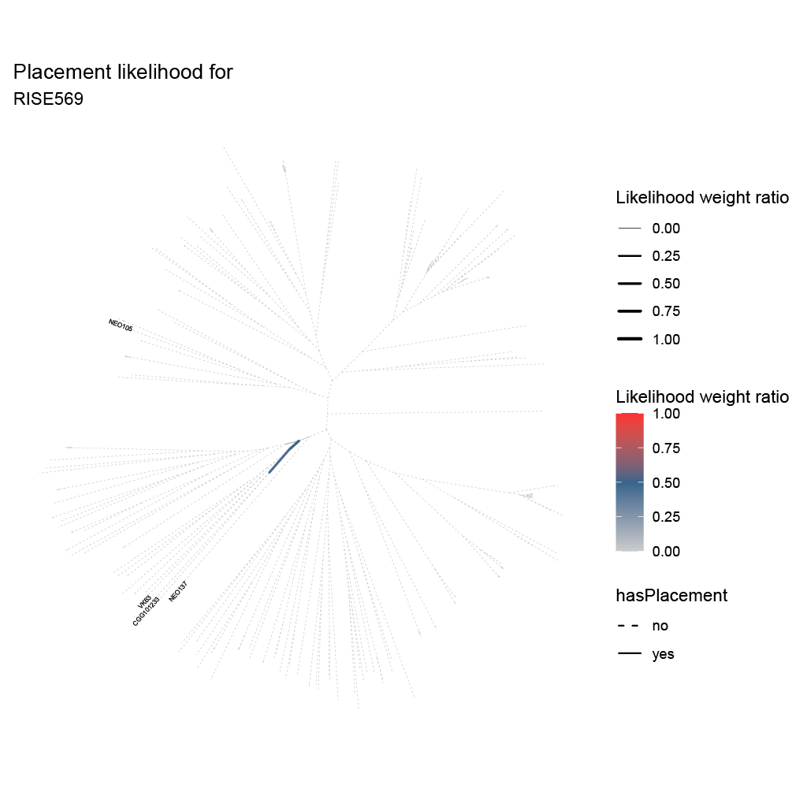

N:
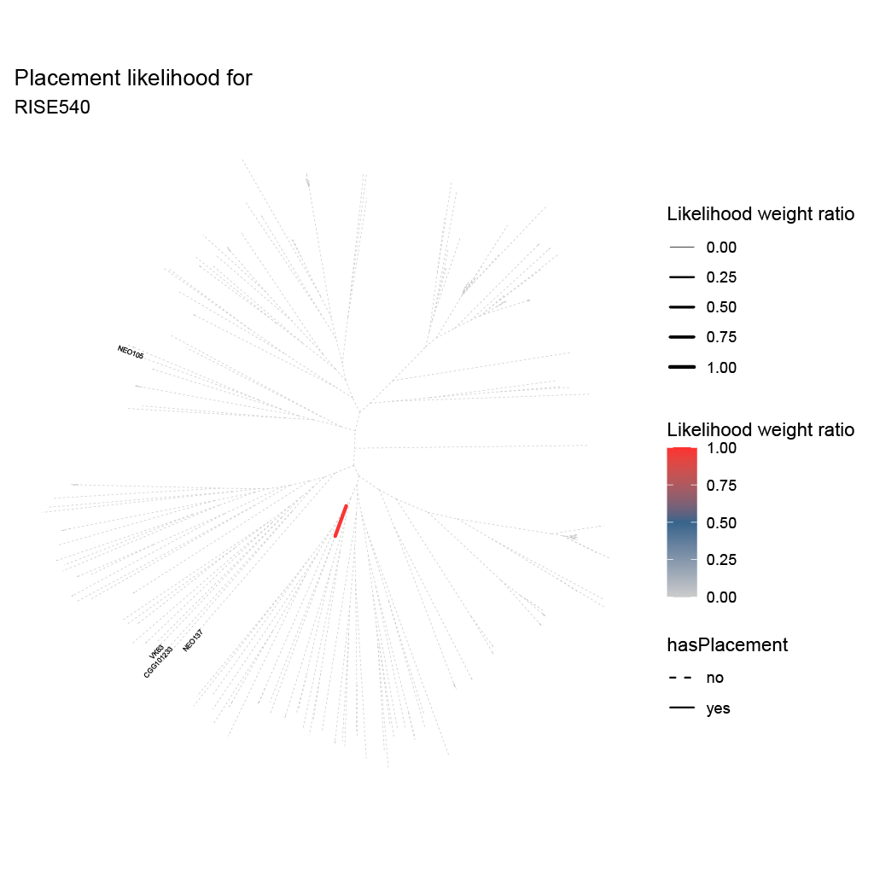

O:
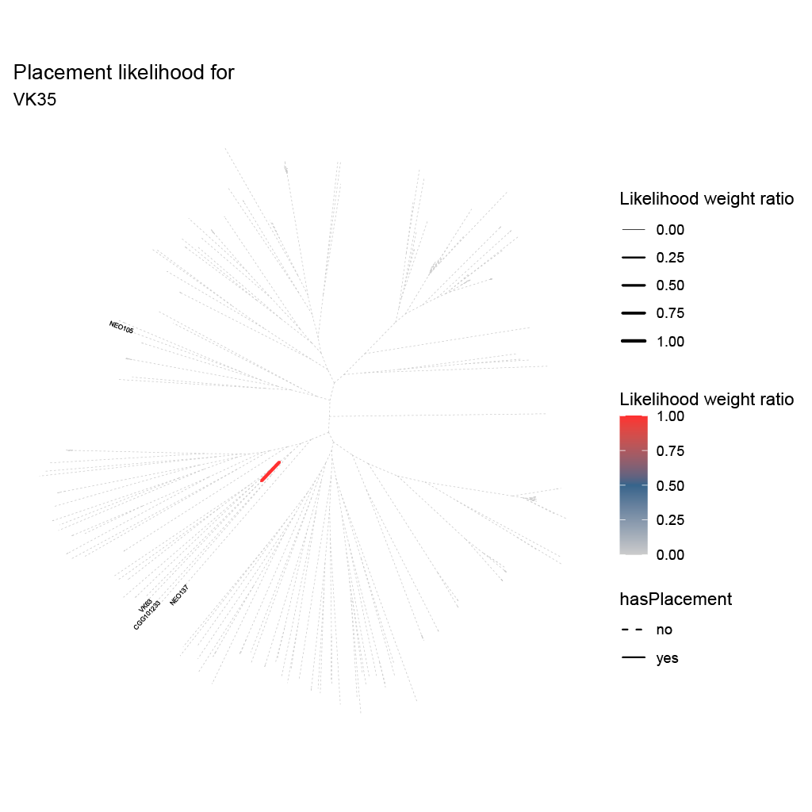

P:
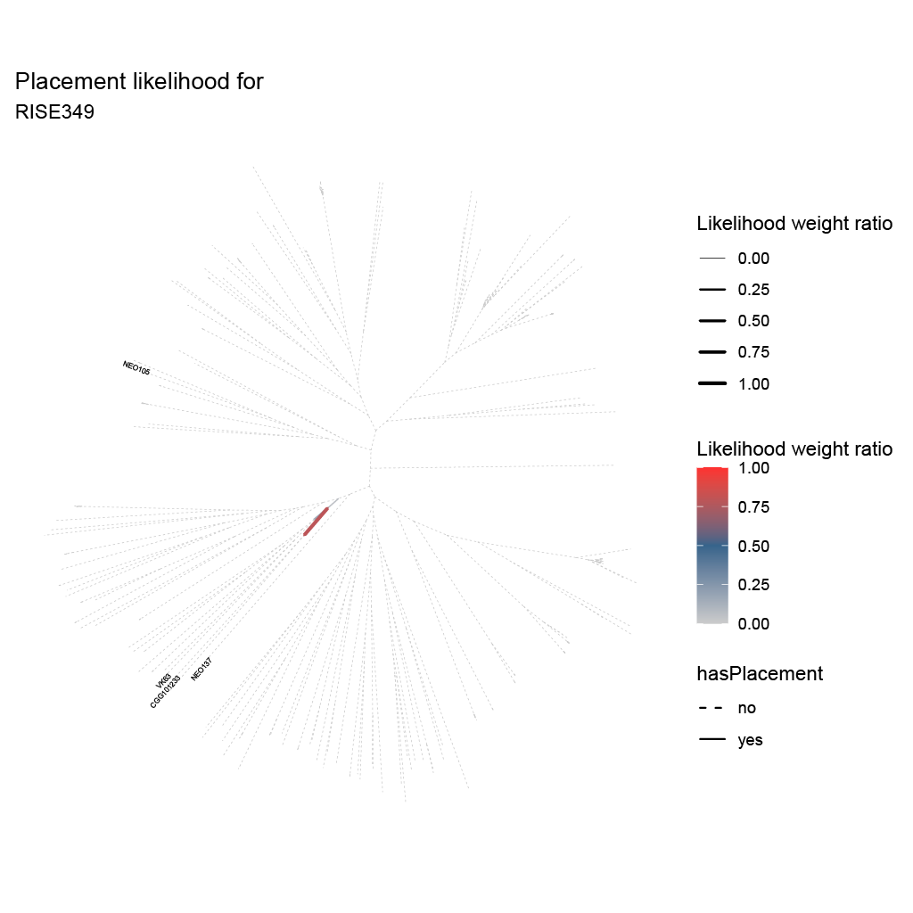

Q:

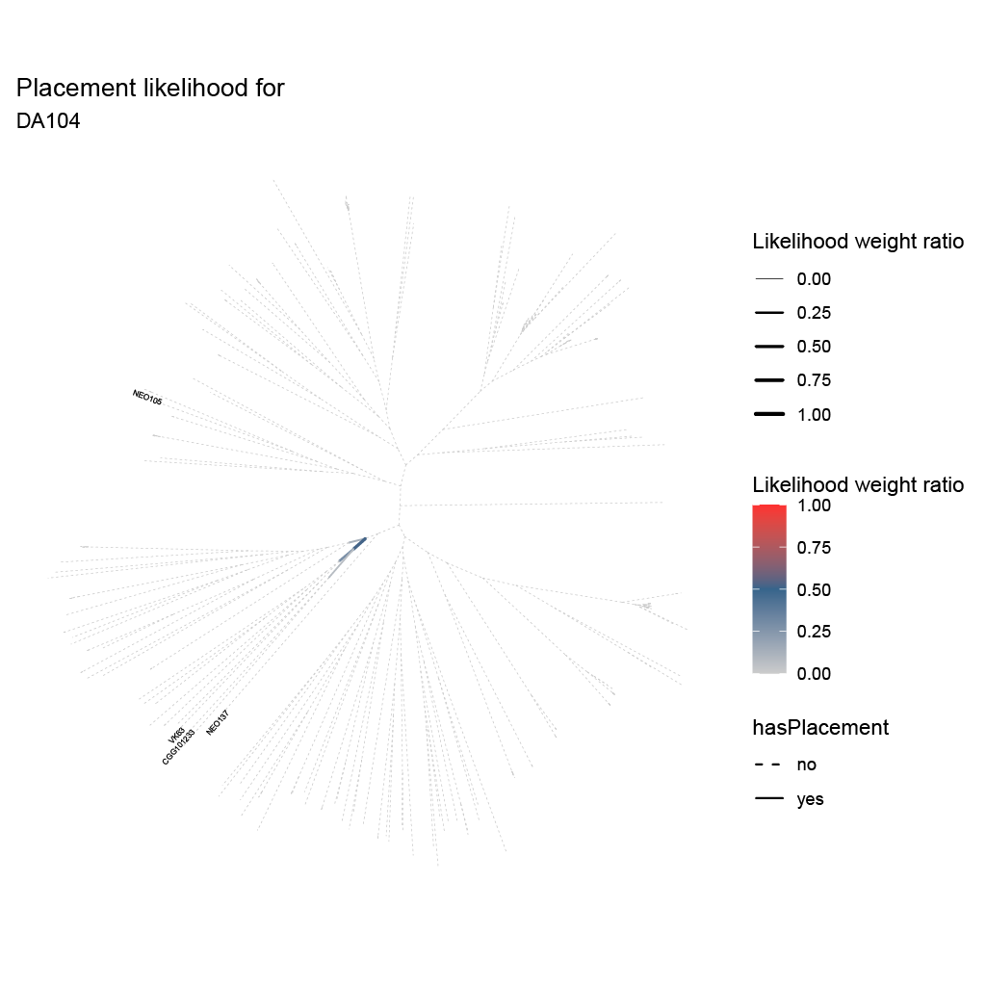

R:
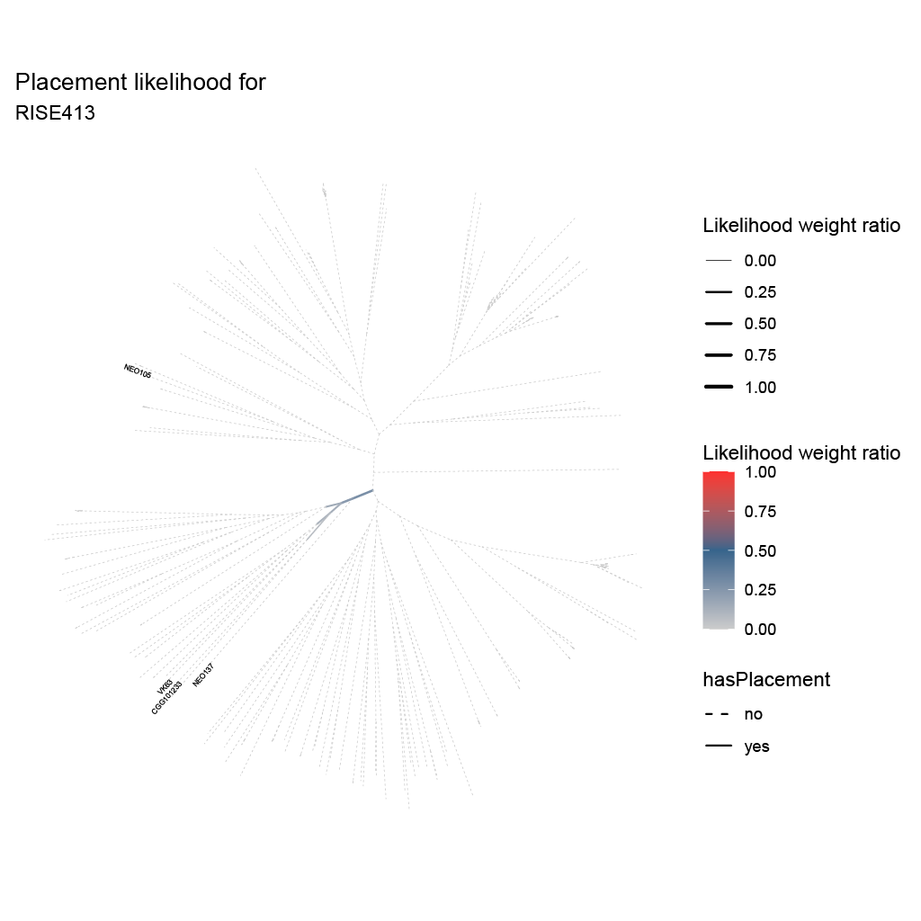

S:
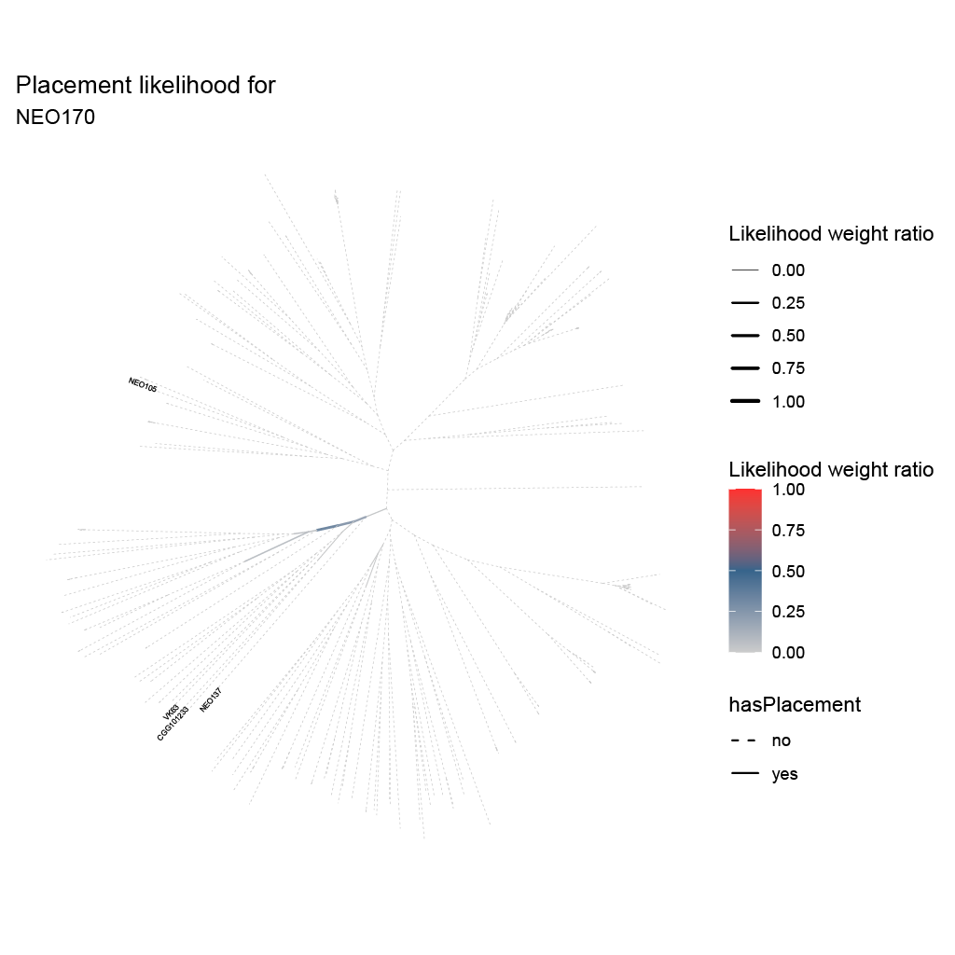

T:
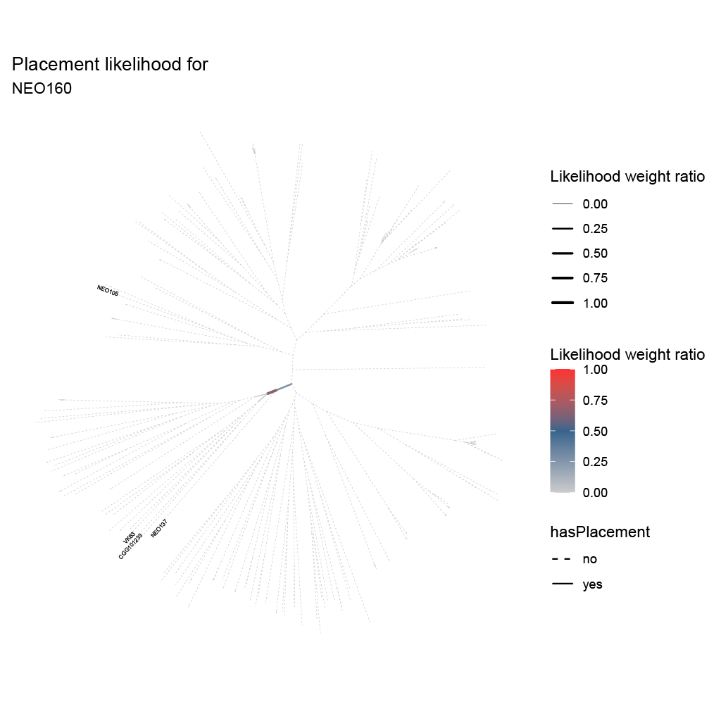

U:
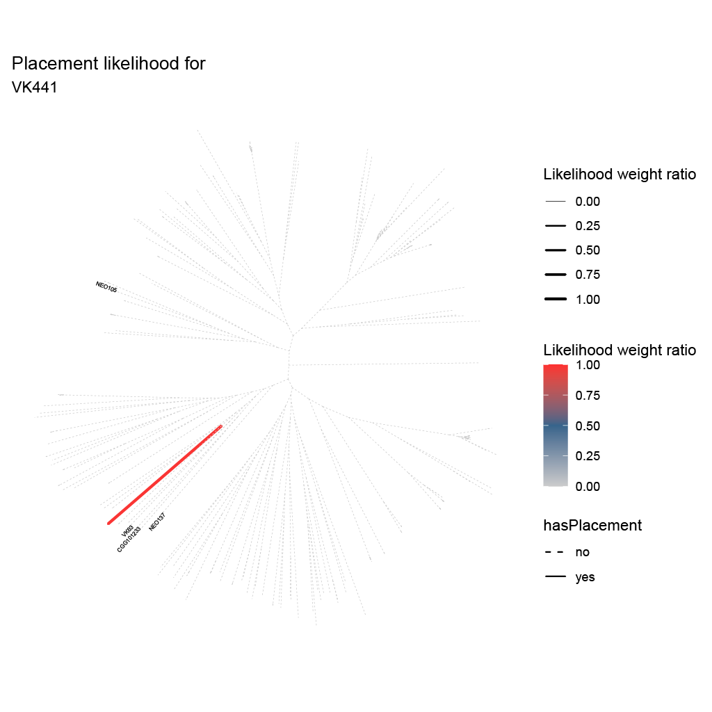

V:
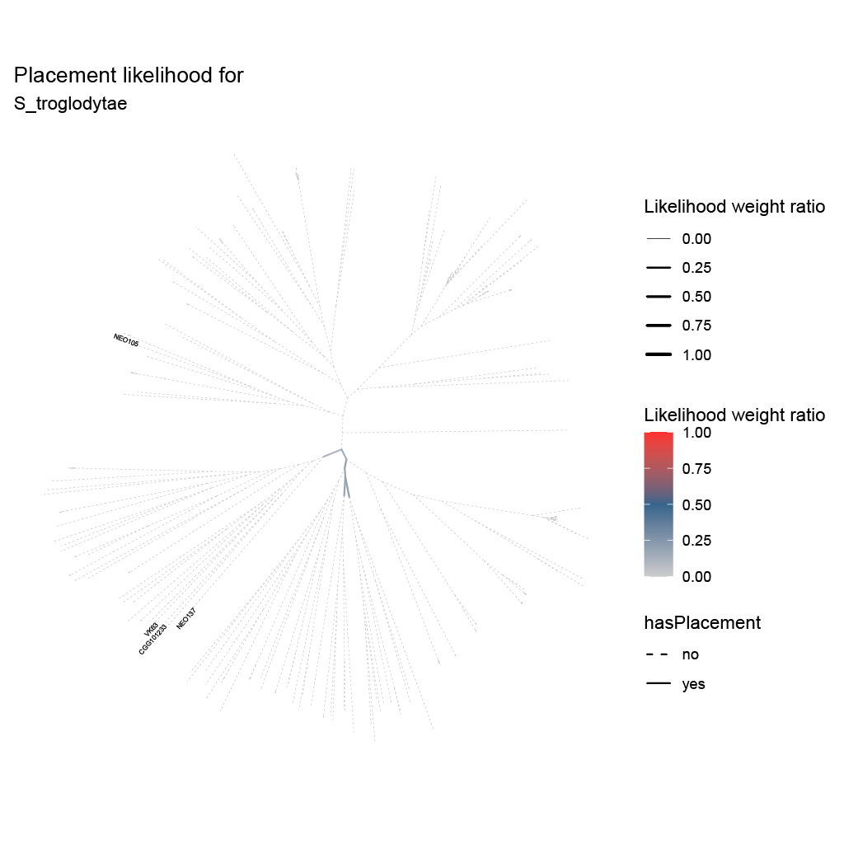

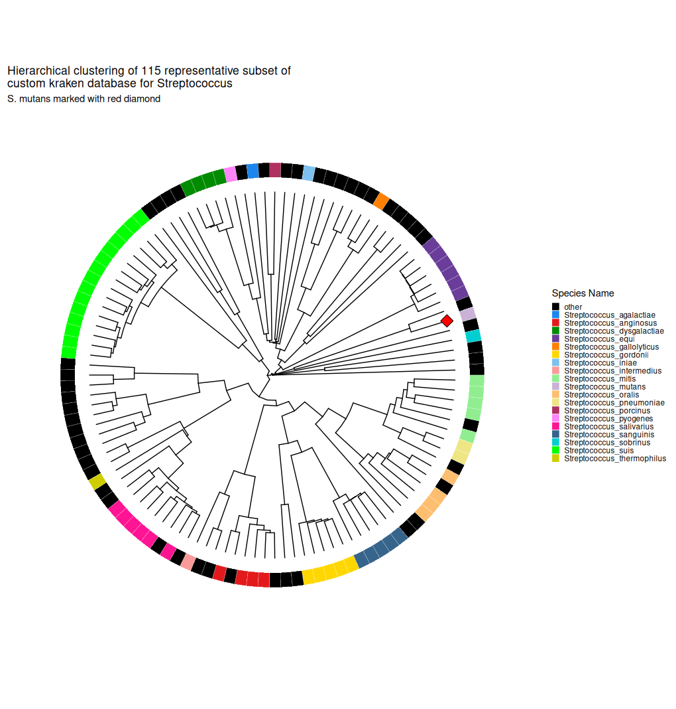
Fig. S7: Neighbour-joining tree of representative species genomes of the genus Streptococcus, inferred using pairwise distance matrix obtained from fastANI. The S. mutans reference genome used in this study is marked by a red diamond.

Fig. S8 A-G. Percentage of reference covered by mapping an ancient sample against 115 modern samples from the genus Streptococcus, coloured by ANI. The references are sorted in a neighbour-joining tree, with species name on the left and the NCBI RefSeq assembly name on the right.
A:
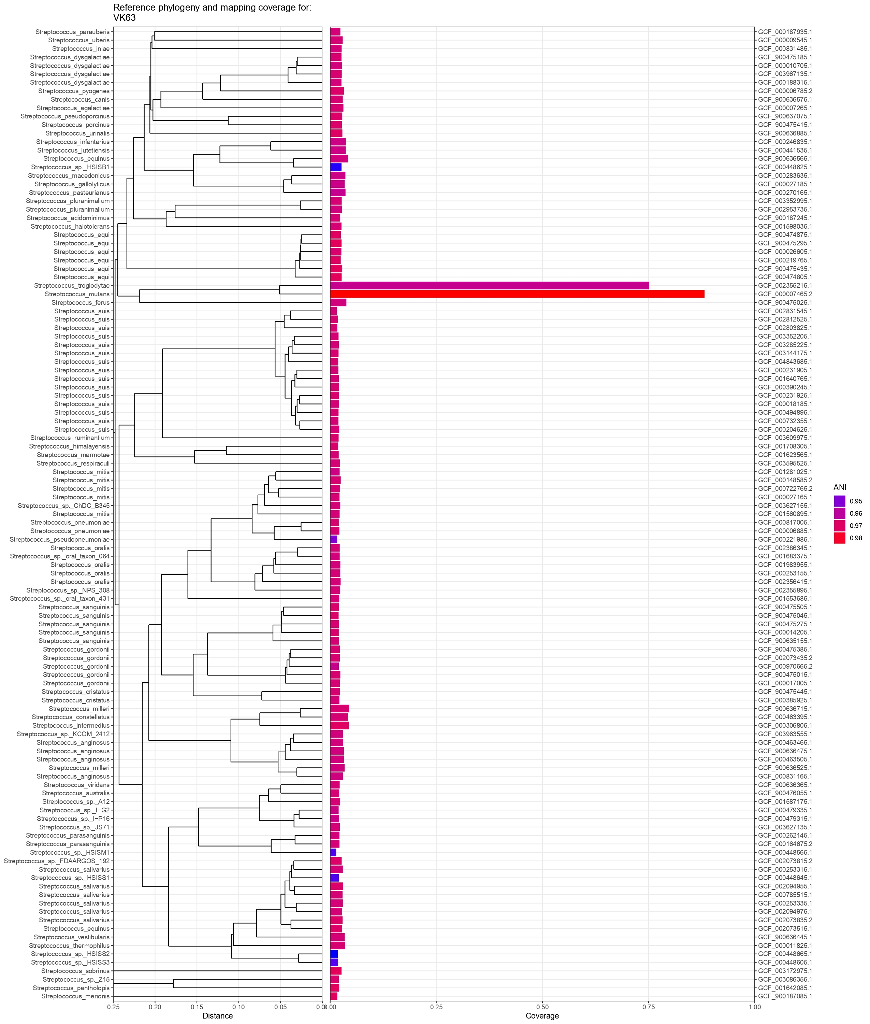

B:
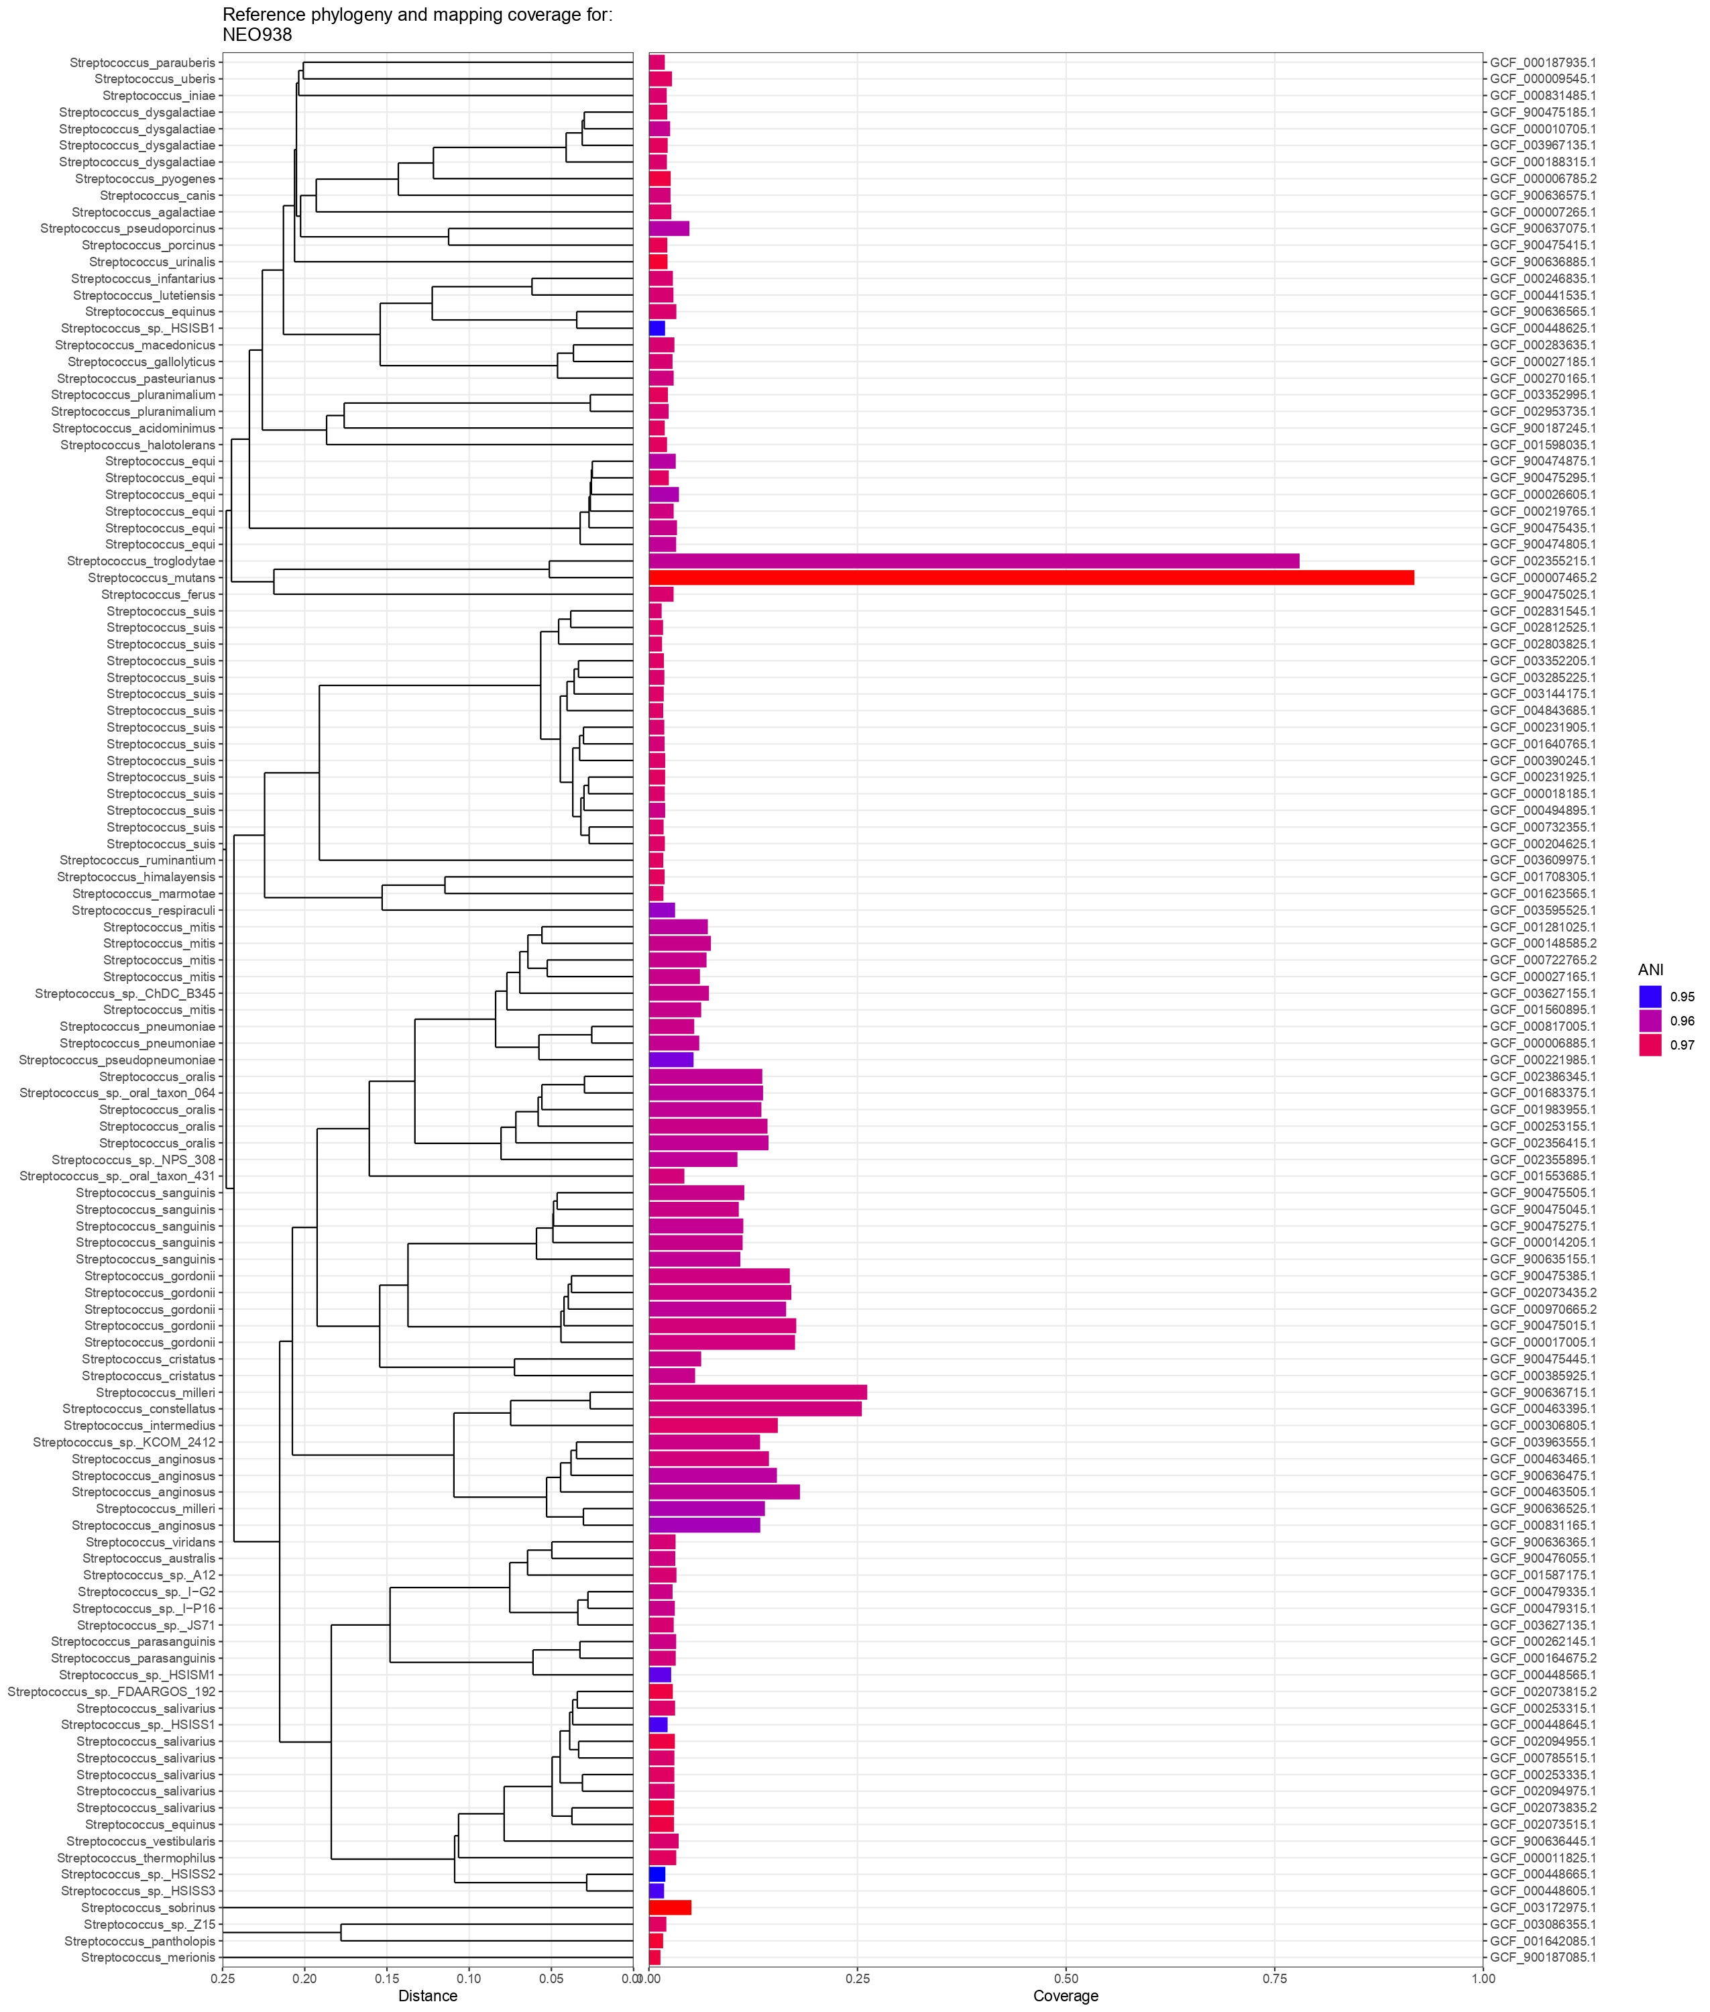

C:
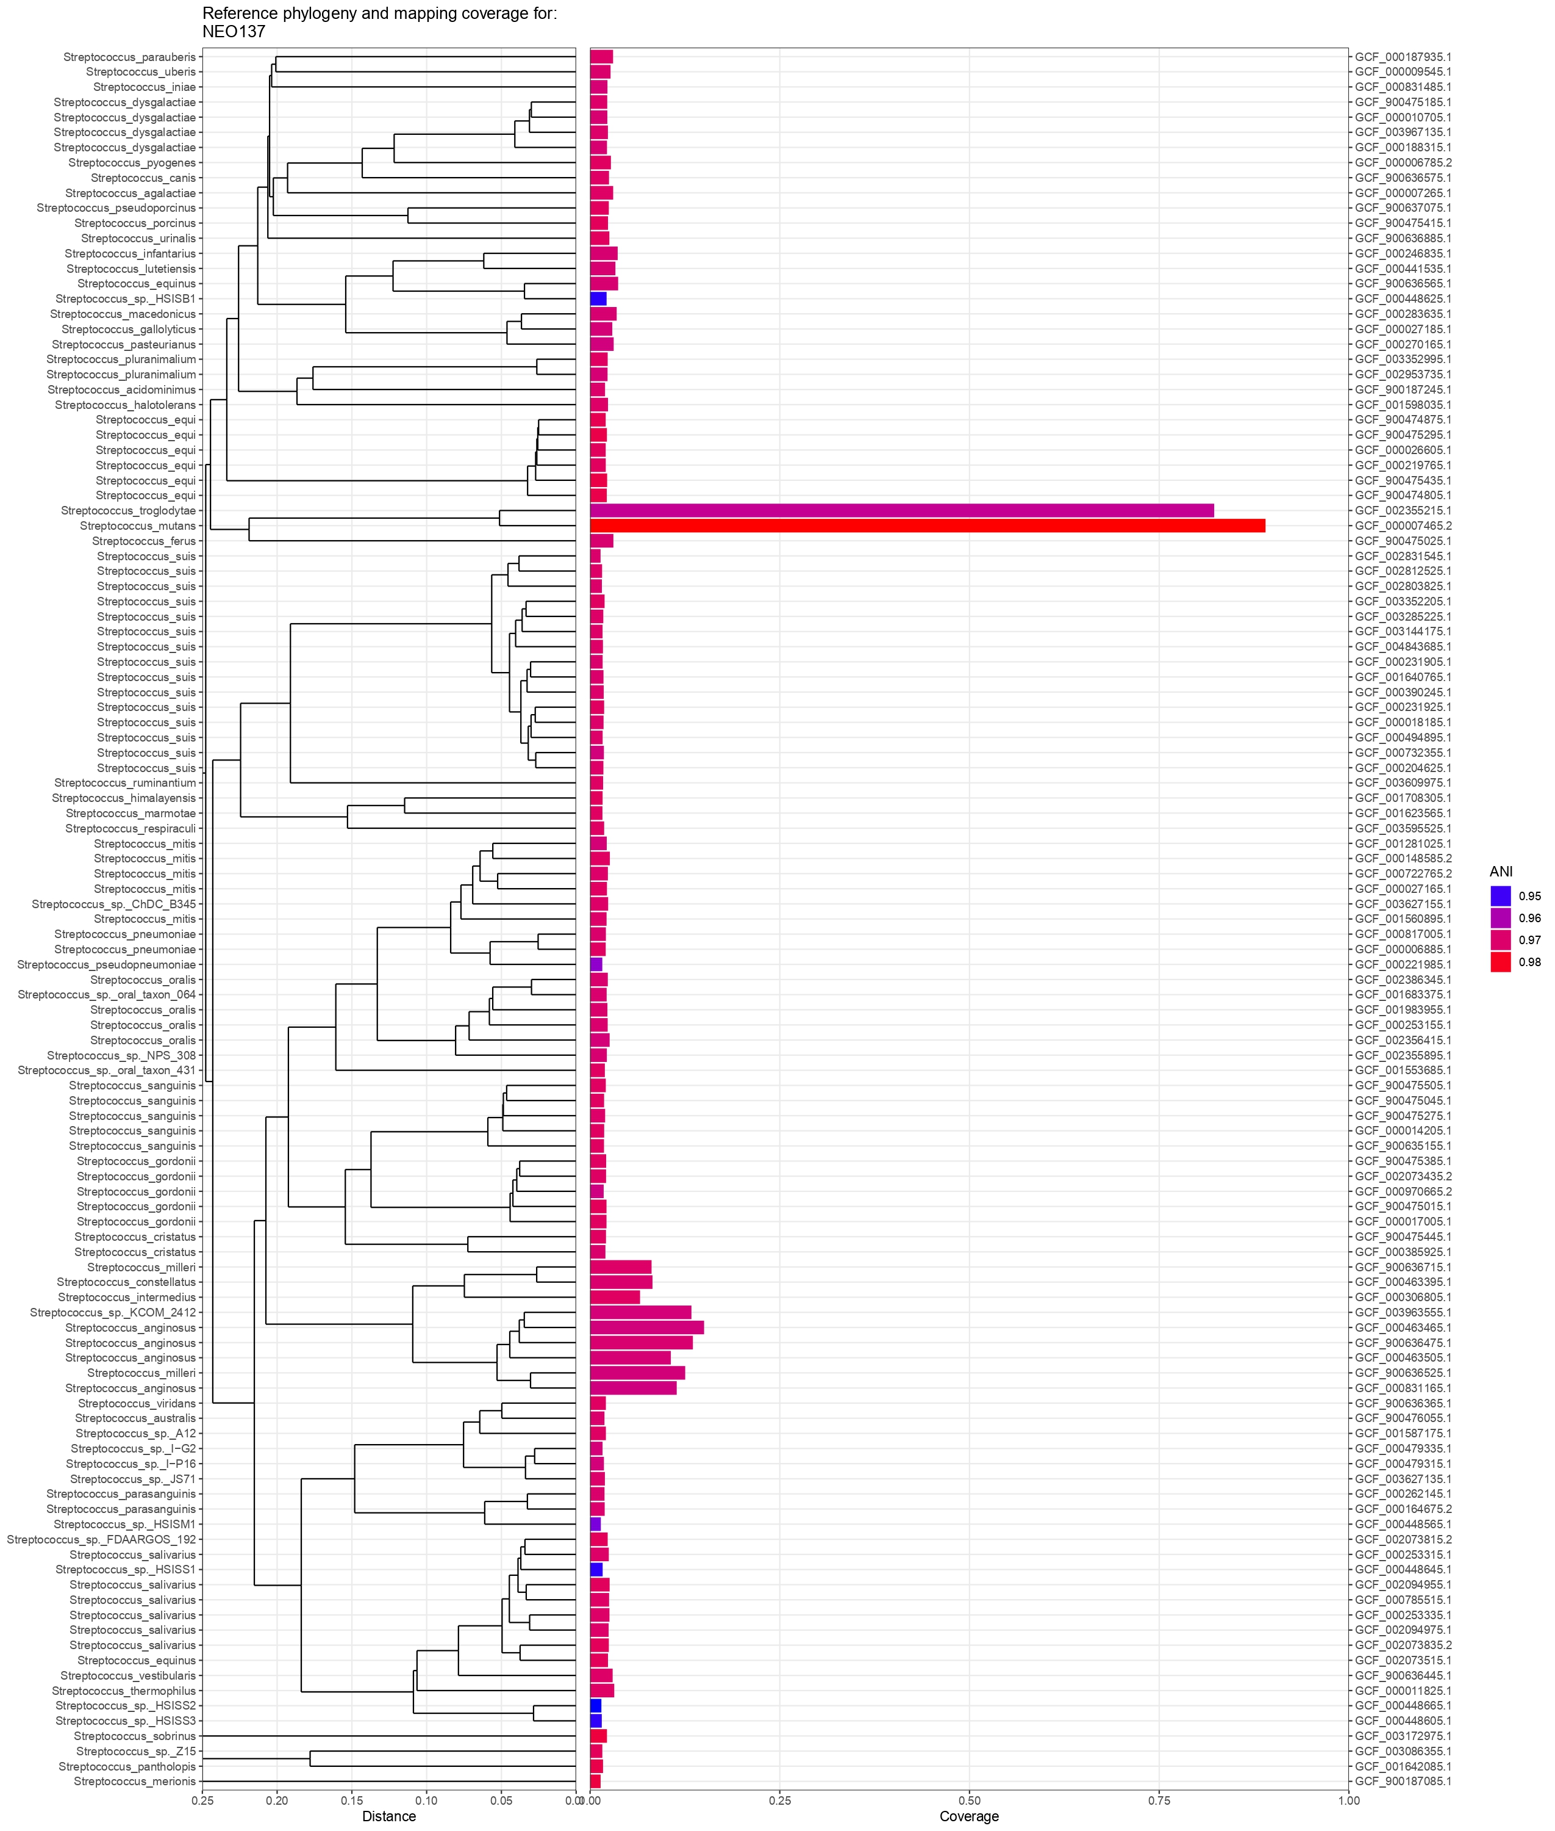

D:
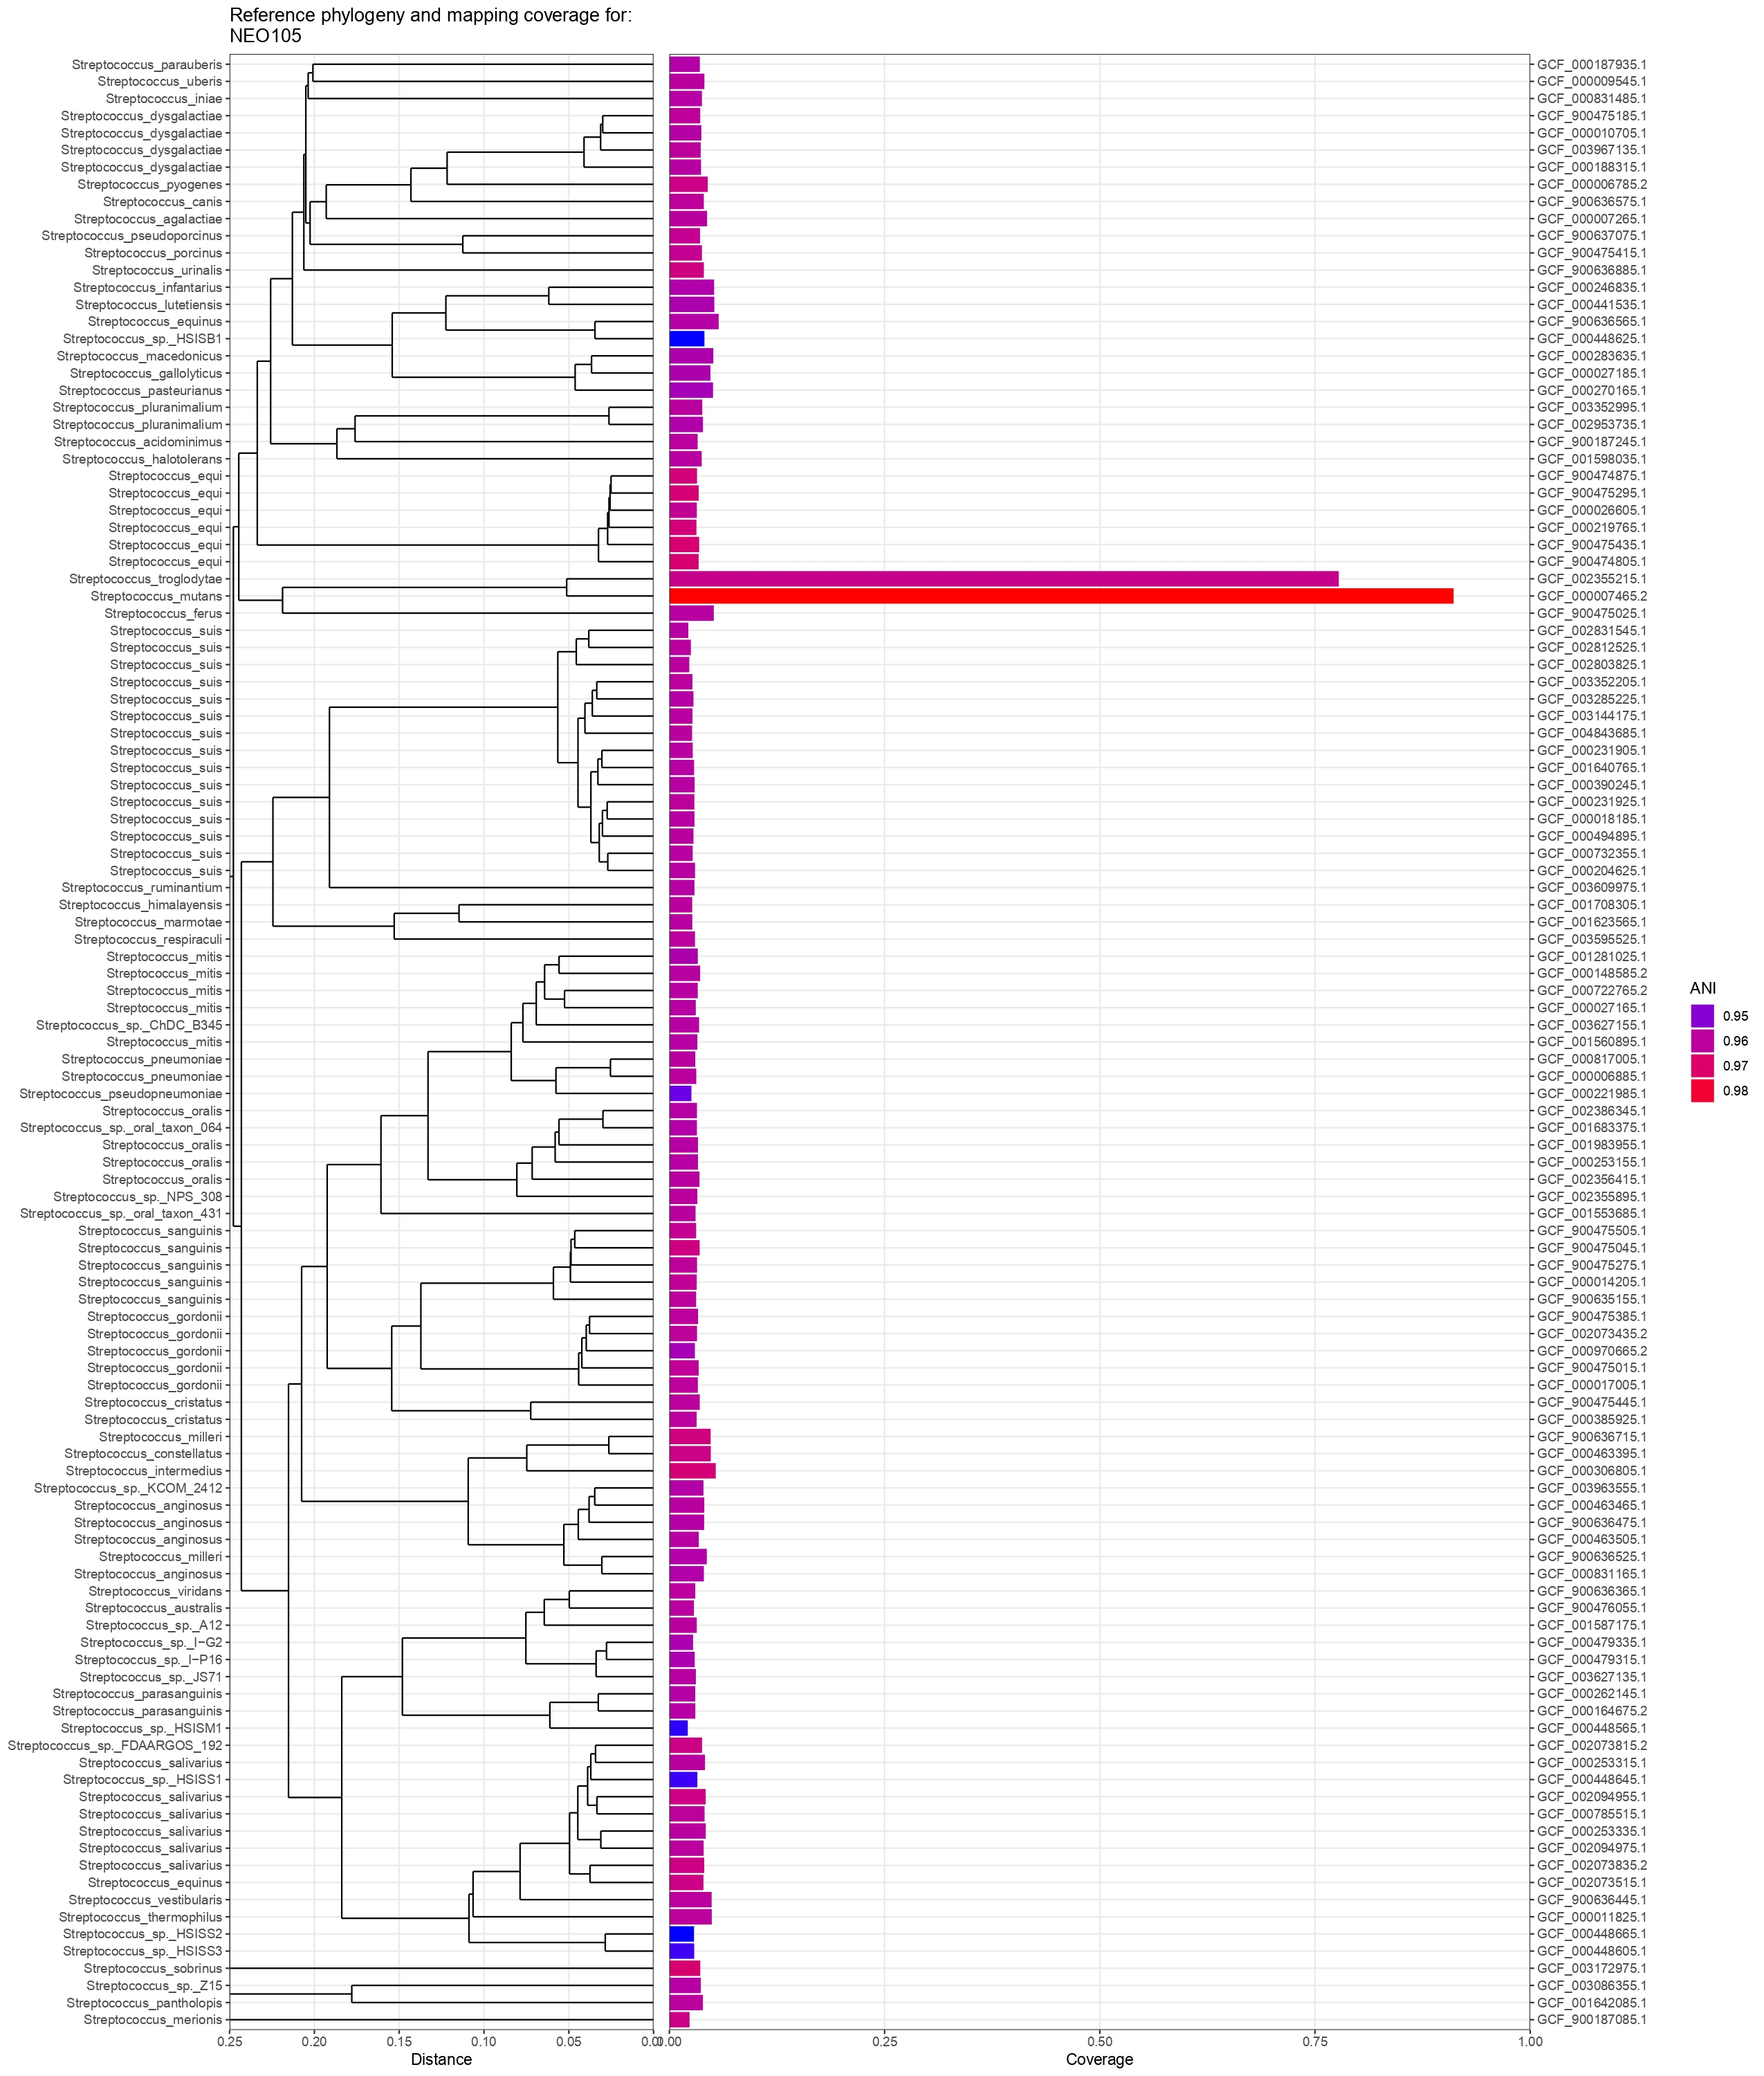

E:
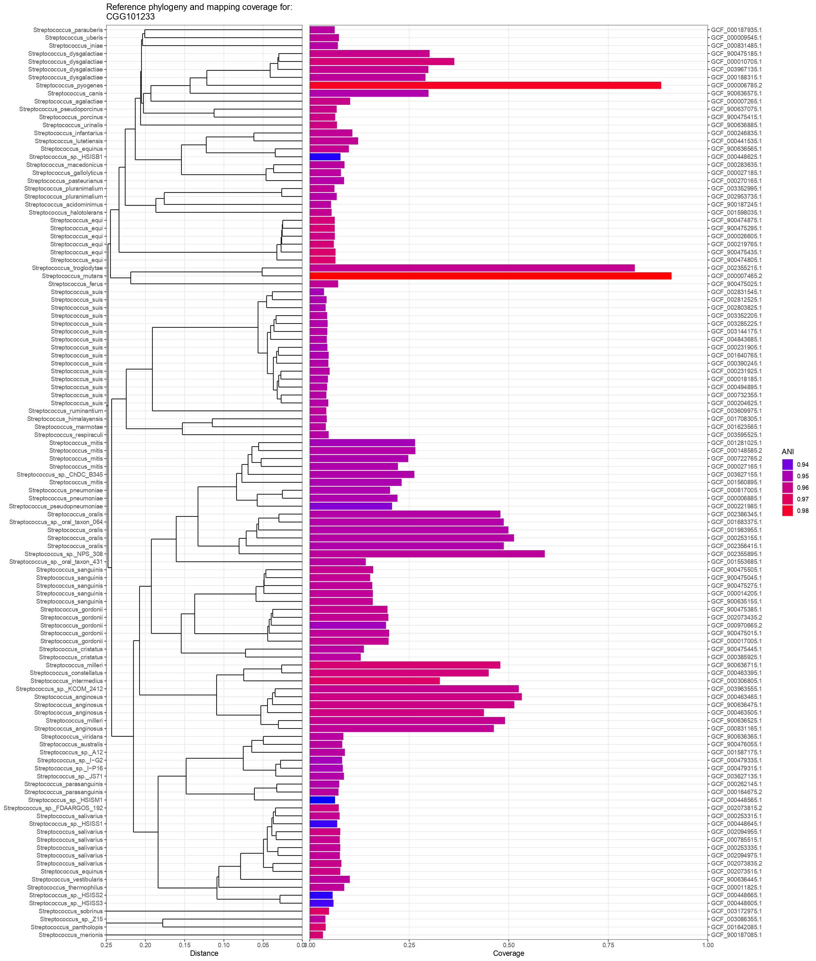

F:
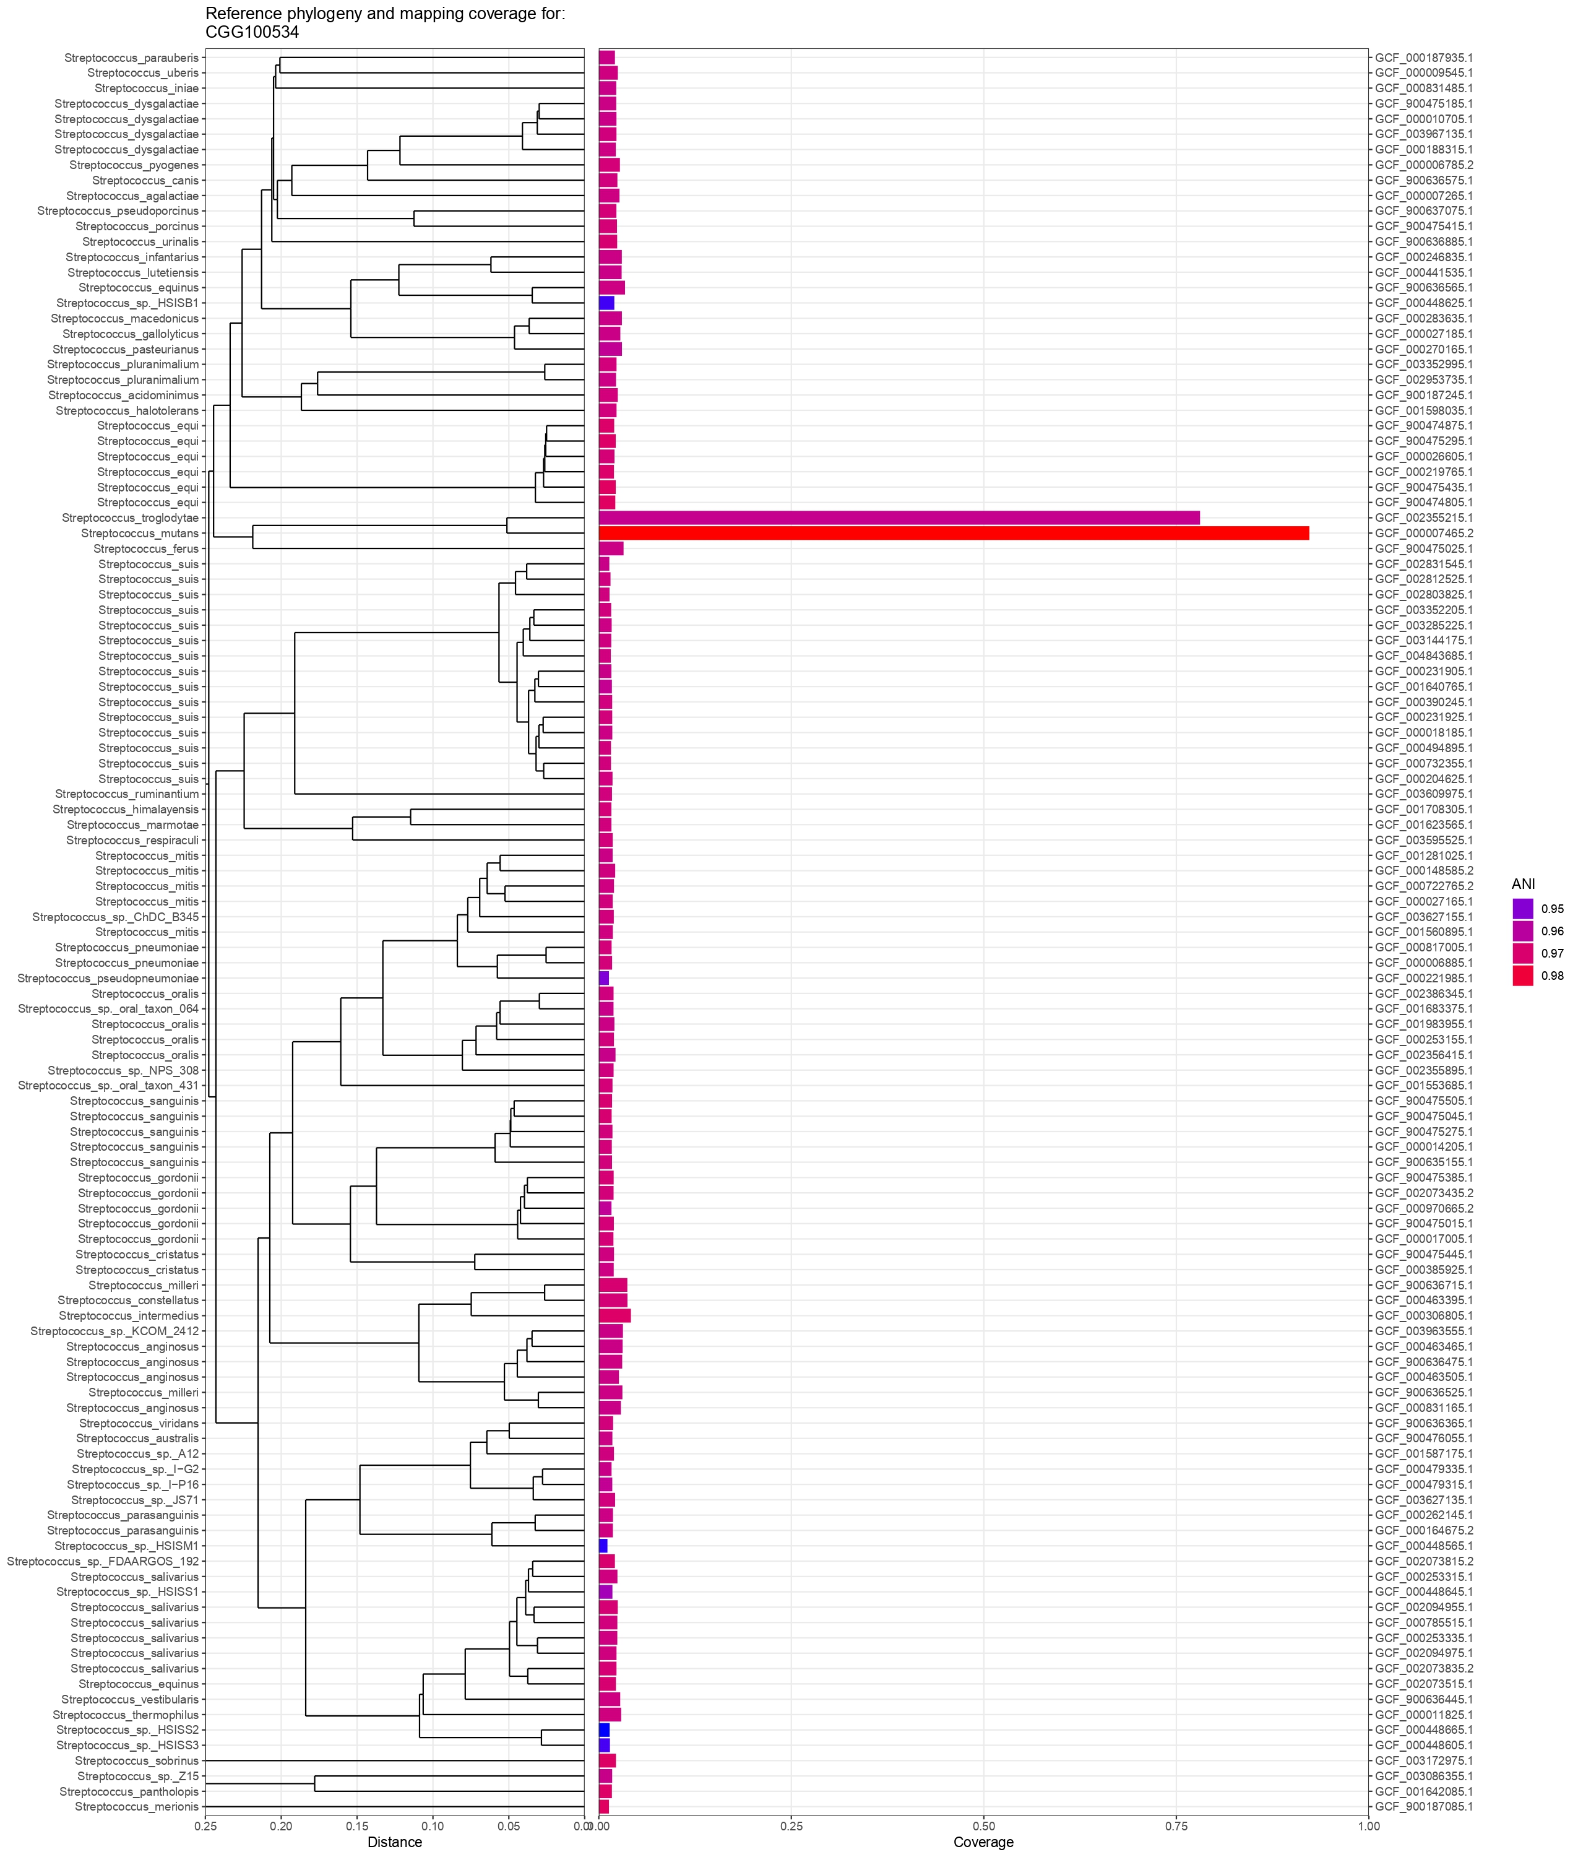

G:

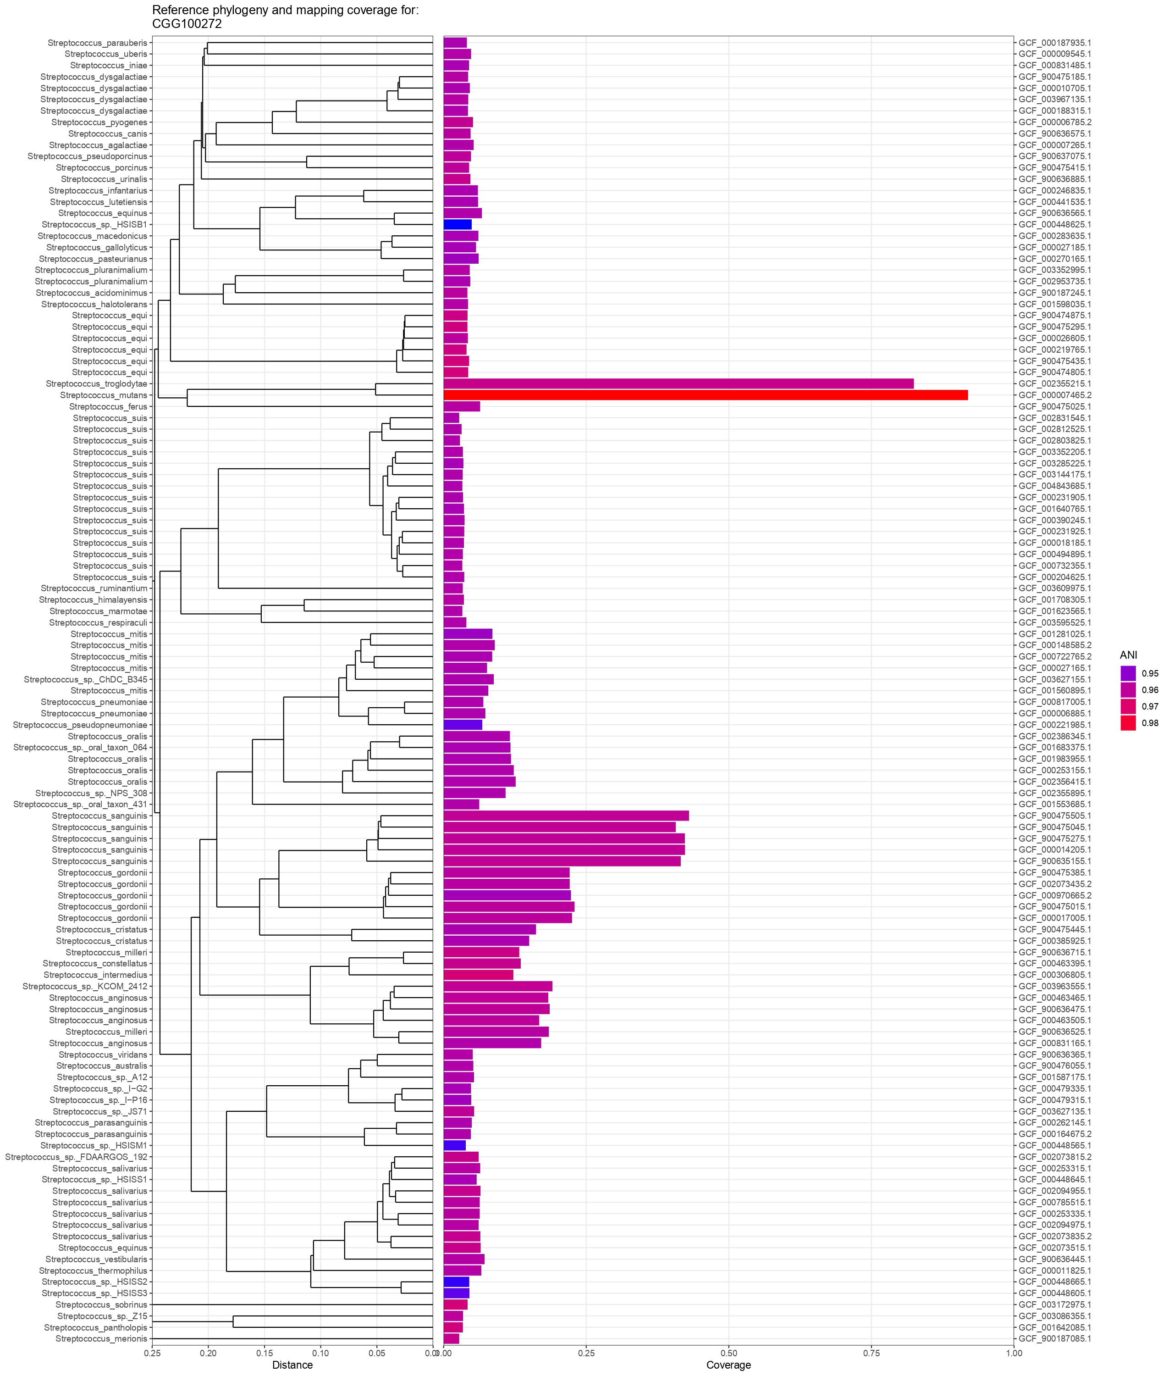

Fig. S9: Assembly statistics for the 7 MAGs created in this study comparing the performance of different assembly strategies with a 2.5kb contig cutoff.
total_length: length of all contigs in MAG ( the length of S. mutans reference GCF_009738105.1 is 2.08mb).
num_contigs: number of contigs in MAG.
N50: Sequence length of the shortest contig at 50% of the total assembly length.
percent_completion: completion of the MAG calculated by the number of single-copy core genes associated with the domain the MAG belongs to. A completion of 80% is the usual threshold for a MAG to be complete.
100-red: 100 – percentage redundancy, where redundancy is quantified by single-copy core genes which are found to have more than one copy.
percent_redundancy: see above.
GC_content: The amount of bases in the MAG that are either Guanine or Cytosine.

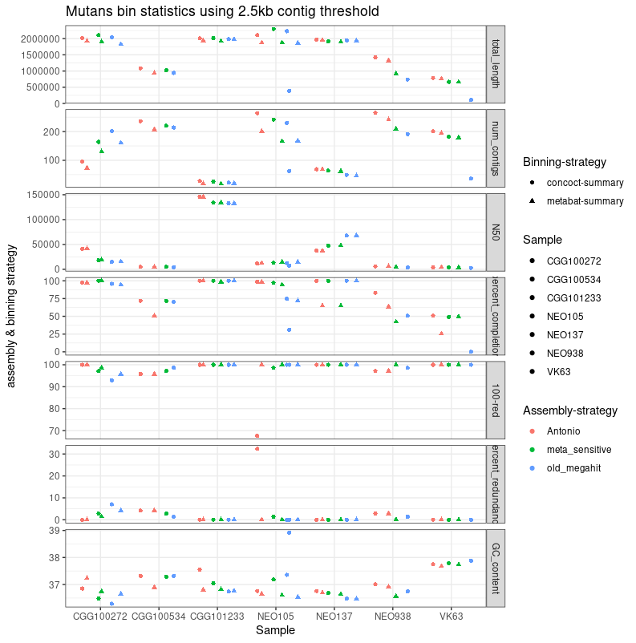

Fig. S10: Assembly statistics for the 7 MAGs created in this study comparing the performance of different assembly strategies as in Fig. S8 changed to have a 1kb contig cutoff.
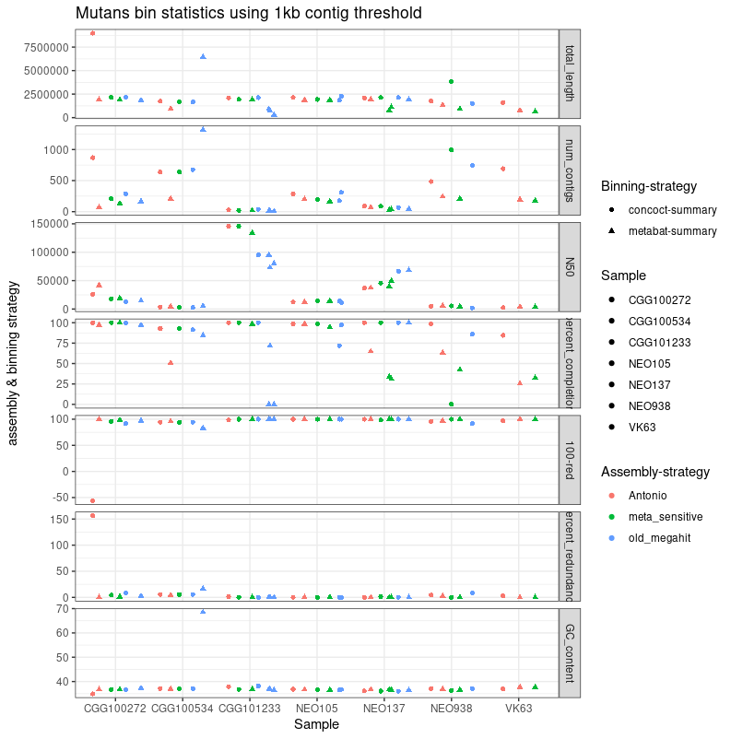

Fig. S11 A-H: Anvi’o visualization of the 7 ancient MAGs.
Each layer in these circular plots represents a statistics for each contig. The contigs are clustered together in a tree by 4-mer frequencies.
The green layer represents the GC content.
The black layers describe the number of reads from each library in the sample which can be mapped to the contig.
The outermost black layer (damage) describes the average local damage for each read used to assemble this contig as calculated through metaDMG
The familiarity layer is a binary layer which describes whether a gene cluster annotated within the contig can be found in any of the other 6 MAGs through a pangenome analysis before manual refinement is started.
Any contig marked as contaminant is mapped to the NCBI database of genes, to confirm that these cannot be mapped to S. mutans.

A: CGG100272, First Iteration
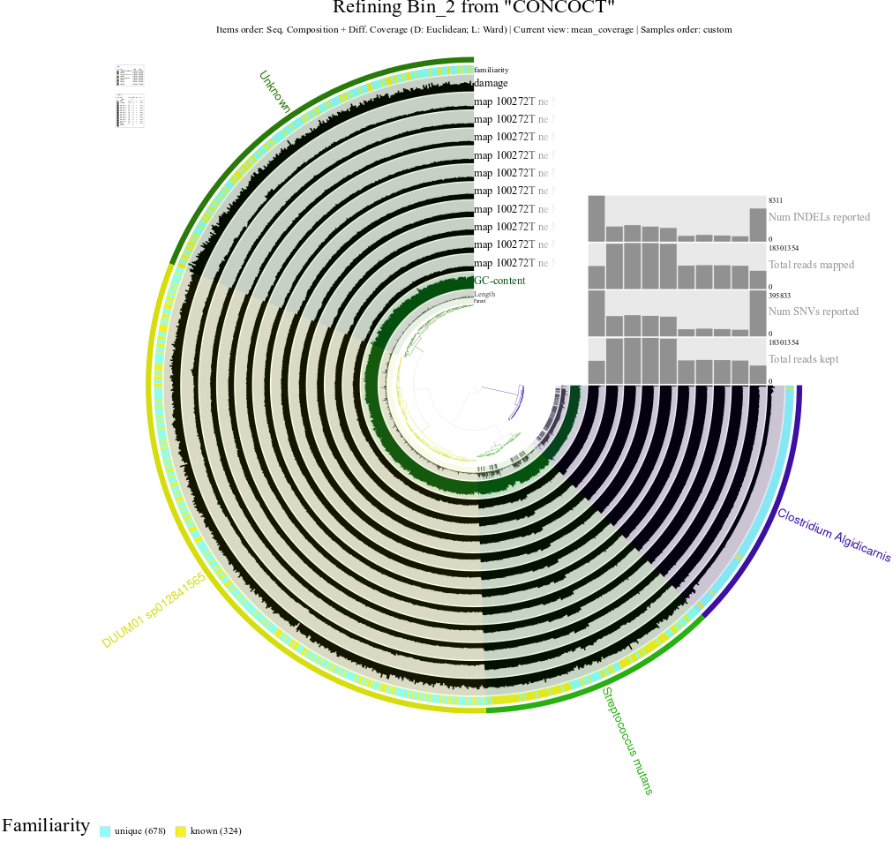

B: CGG100272: Second Iteration
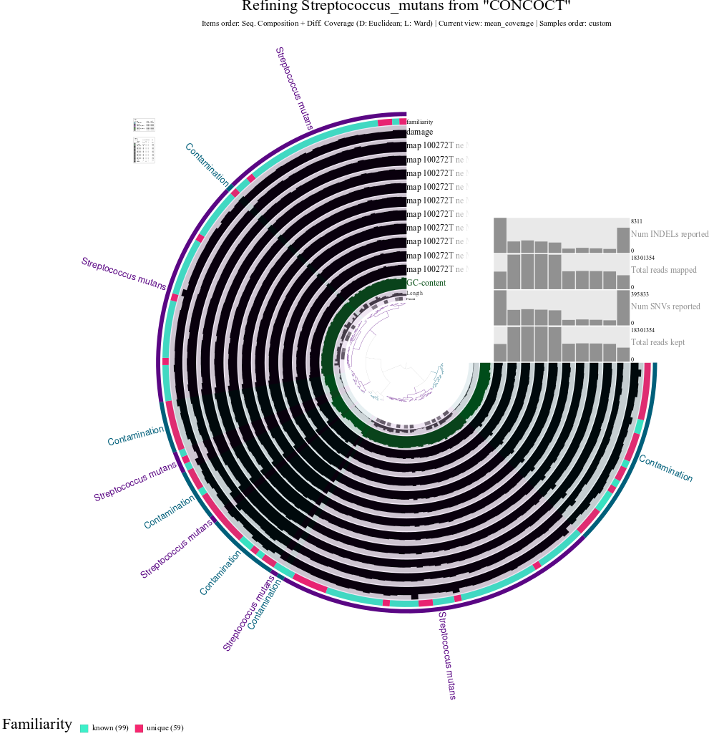

C: CGG100534
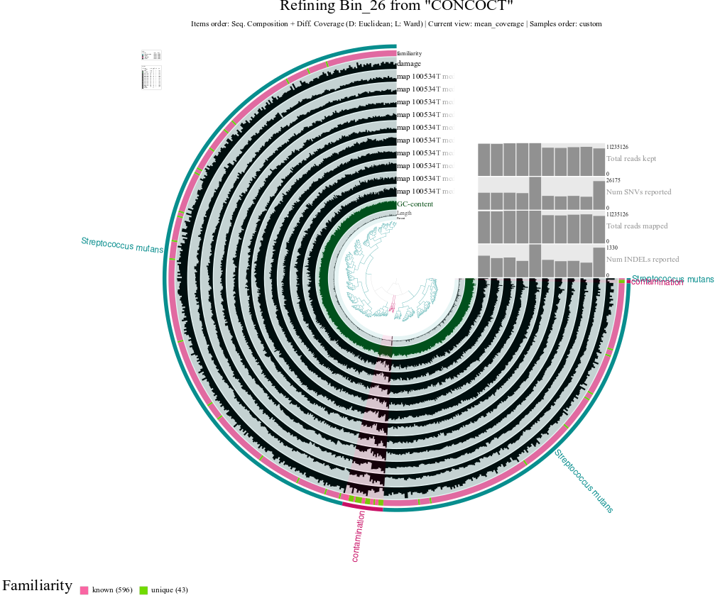

D: CGG101233
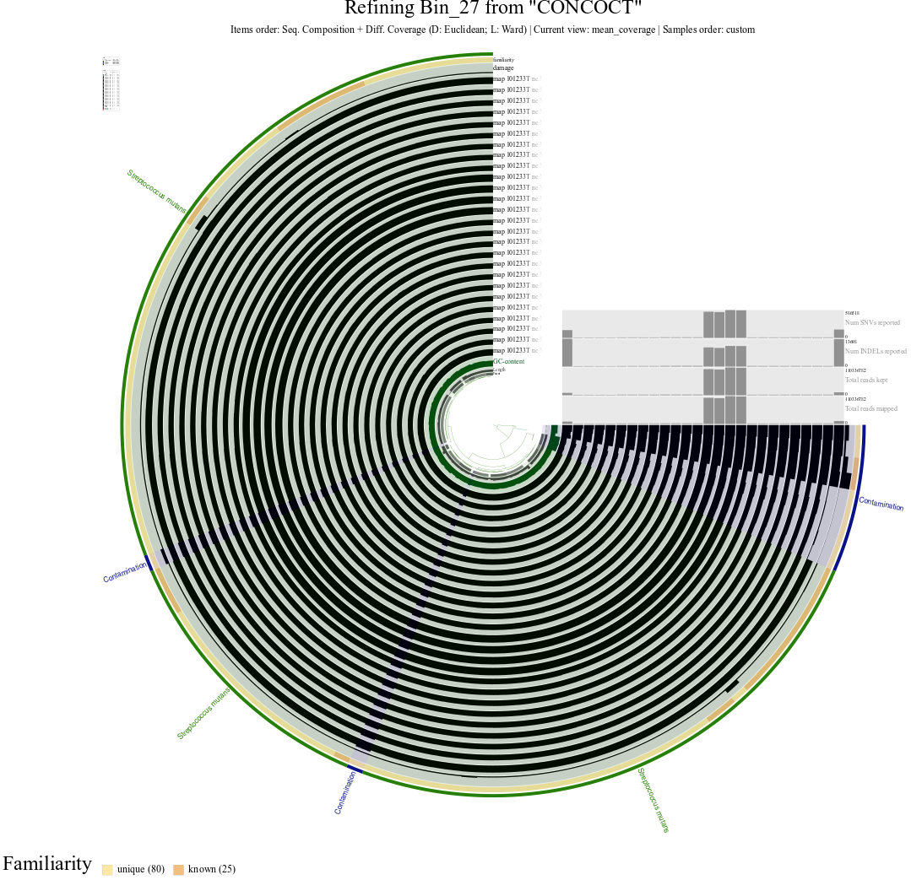

E: NEO105
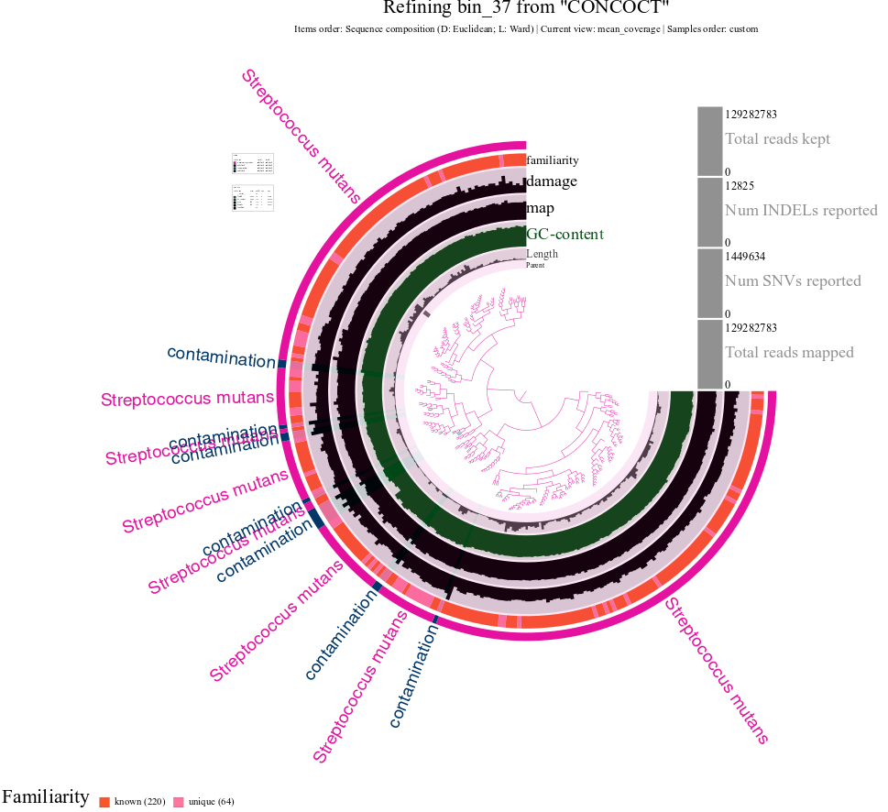

F: NEO137
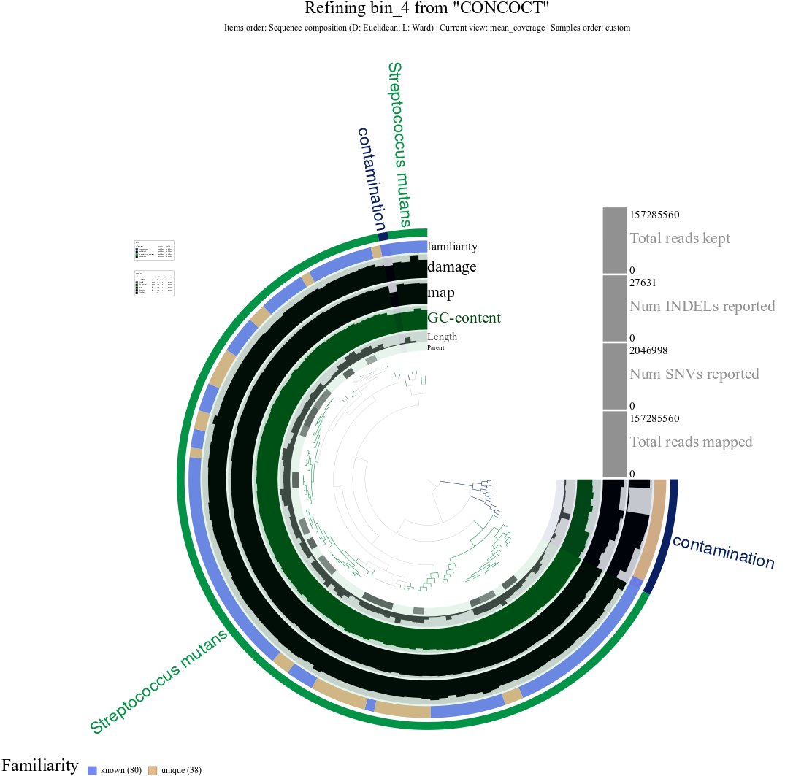

G: NEO938
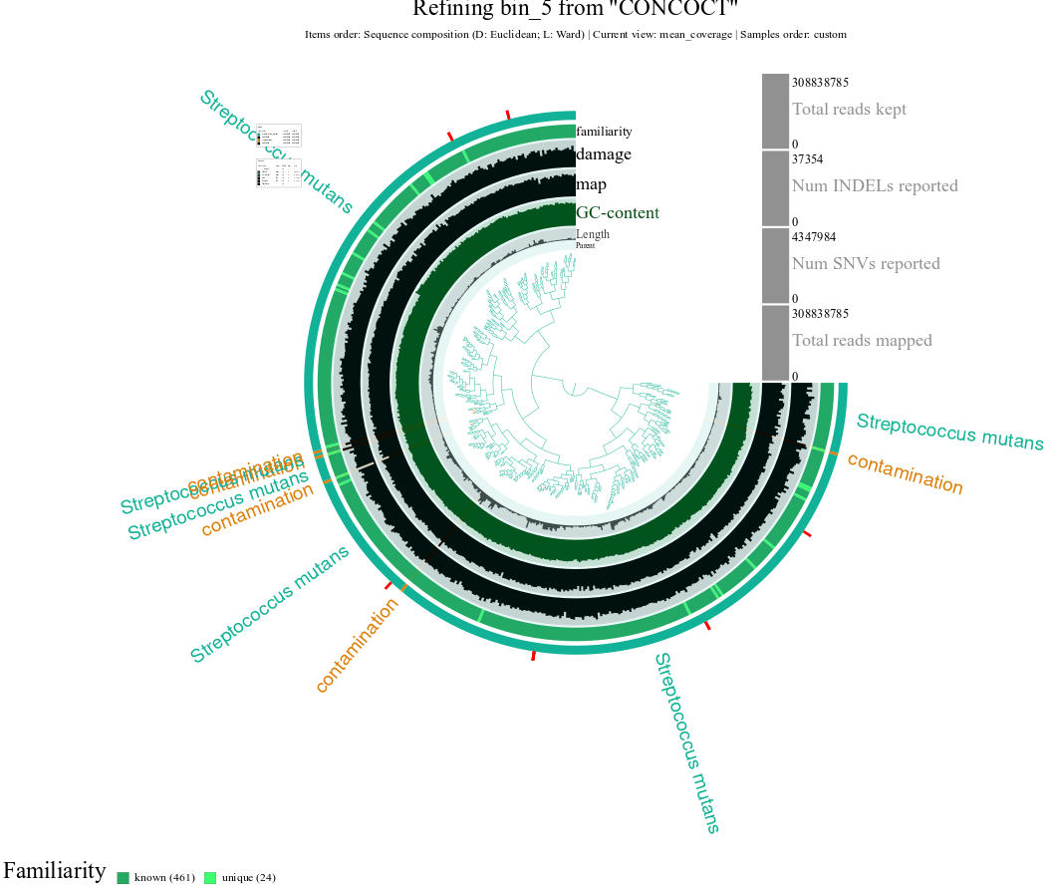

H: VK63
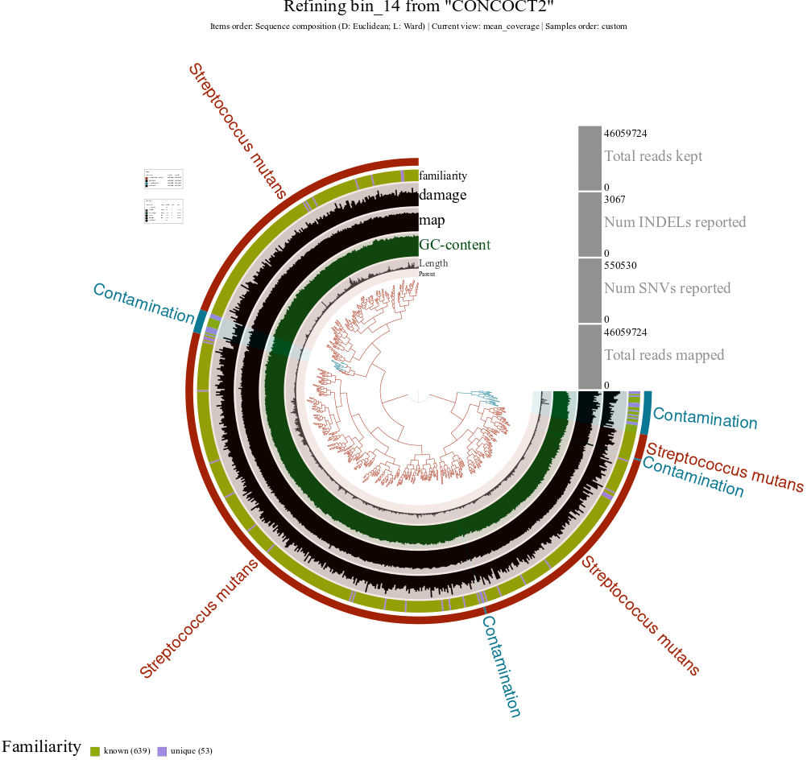

Fig. S12: Pangenomic analysis of the seven S. mutans MAGs, 10 modern S. mutans isolates, and 15 modern isolates from across the Streptococcus genus. Focusing on gene cluster coverage against metabolic modules from KEGG, there were 6 modules which differed in gene cluster recruitment between the genomes. As is visualized in the figure, 4 of the MAGs differ from the modern S. mutans, which coincidently are the lowest quality MAGs assembled in this study.
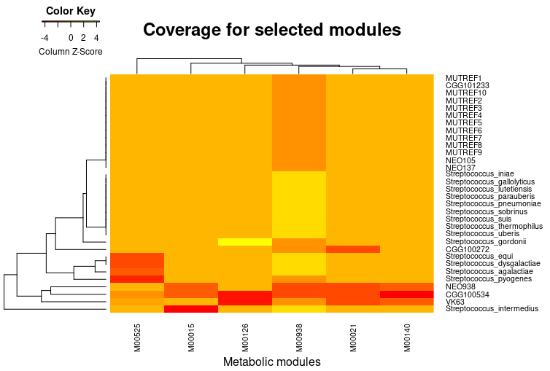

Fig. S13: The comG/comY operon conveys competency for internalizing DNA from the surrounding environment. Reference mapping shows drops in coverage among ancient samples along the region expressing genes in this operon, which suggests that this operon could have looked very different in ancient S. mutans.
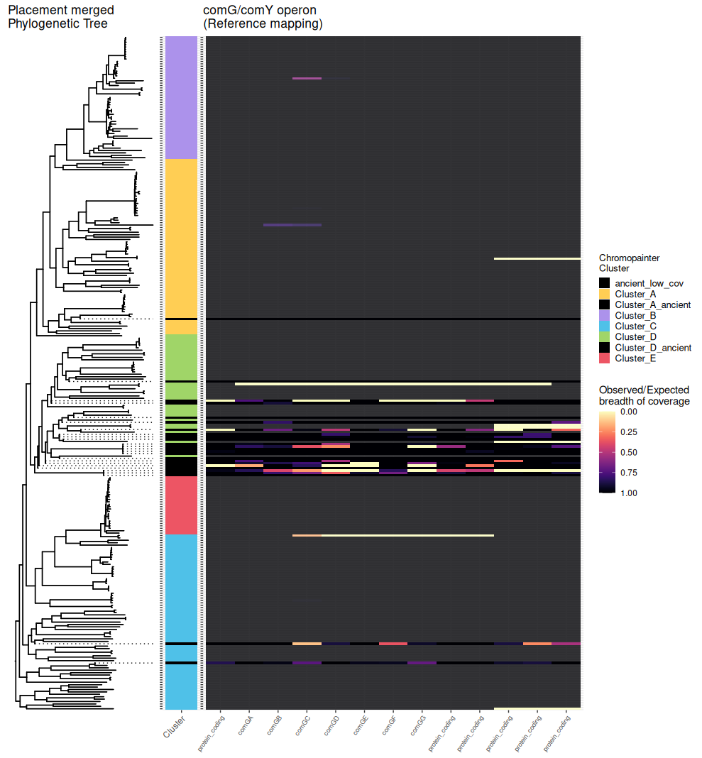

Fig. S14: Comparison between reference mapping results and BAKTA annotation for selected genes.
In pangenomics, different methods impart different biases. Reference mapping constraints which genes can be examined by whatever is present in the reference being mapped against, but results derived from reference mapping are generally more trustworthy.
Usually, if a gene can be found through both methods, they will show up in the same pattern, with the general rule that a gene might be missing due to missing gene content in the MAG (msmE).
Other genes might have high genetic variation, which will make it difficult for gene annotators to detect them (gtfC, gtfB). In other cases still, genes might be in regions that make them difficult to be picked up in a MAG, such as if they are present in more copies along the genome (mubX and mubY)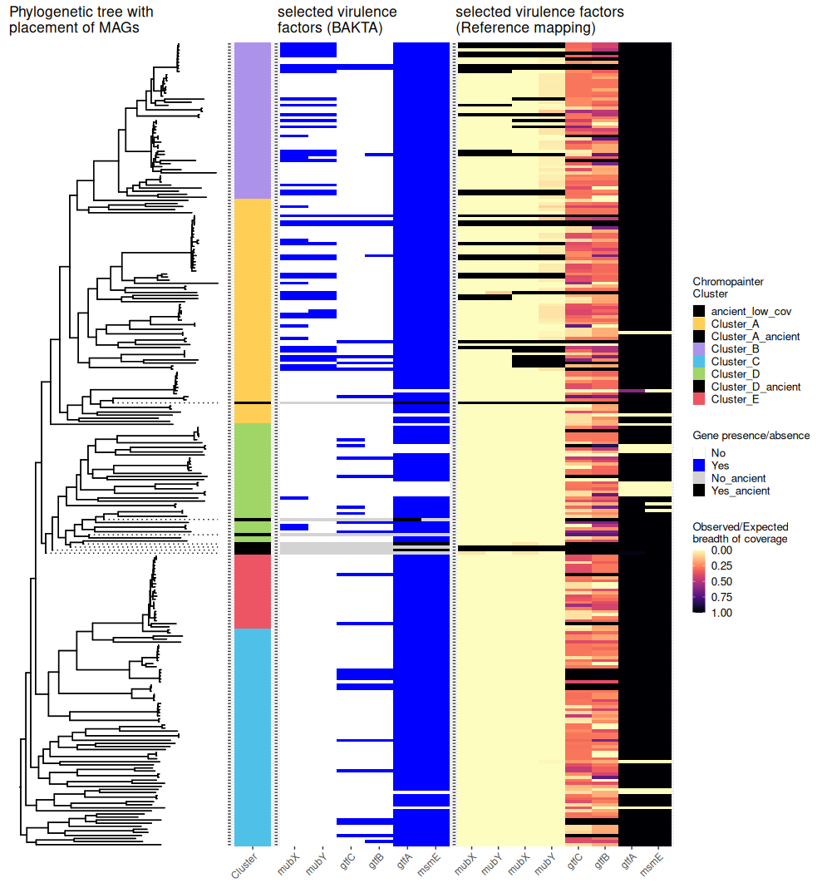

Fig. S15: Phylogenetic tree including 3 placements for the ancient samples for which MAGs were assembled, compared with the ChromoPainter clustering and bakta gene annotation.
The bakta annotations have been sorted by rarity among the modern isolates and seven MAGs.
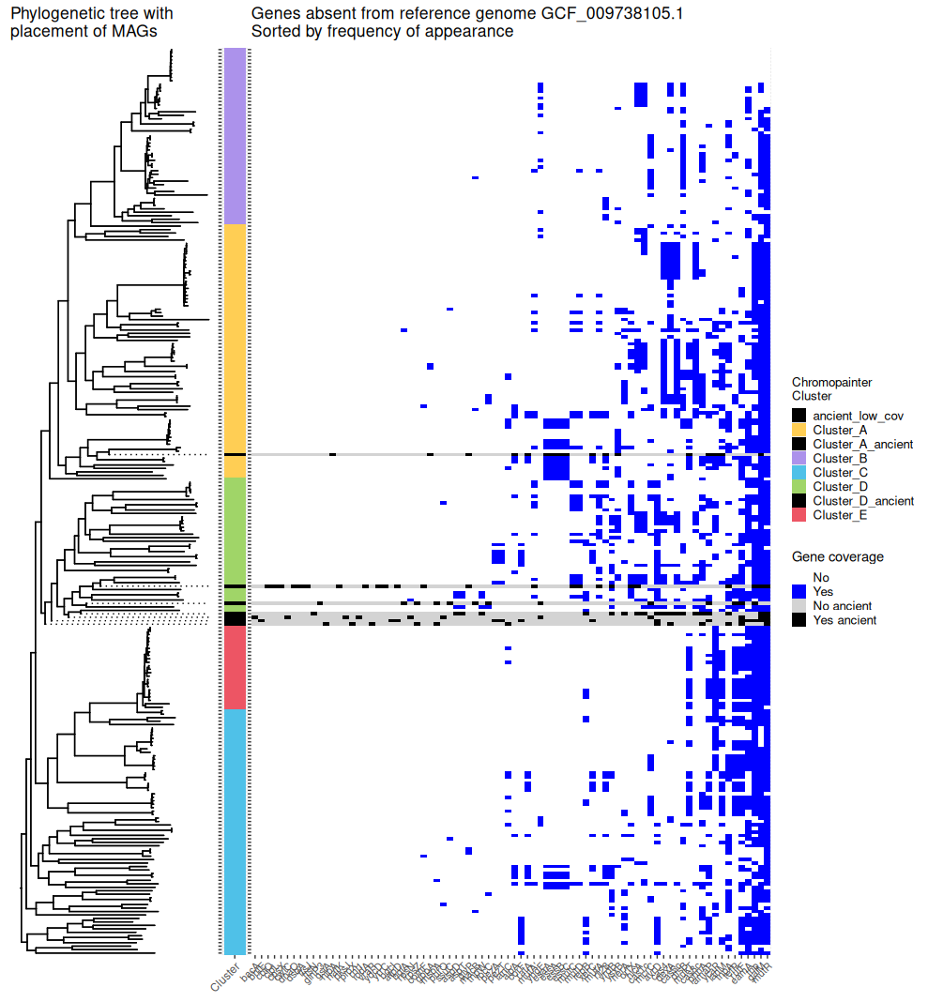

Fig. S16: Phylogenetic tree including 3 placements for the ancient samples for which MAGs were assembled, with heatmap showing presence of bakta genes described as bacteriocins in (Lemos et al., 2019)⁷ not found in the S. mutans reference genome GCF_009738105.1. Every MAG has coverage for at least one of the bacteriocins included here.
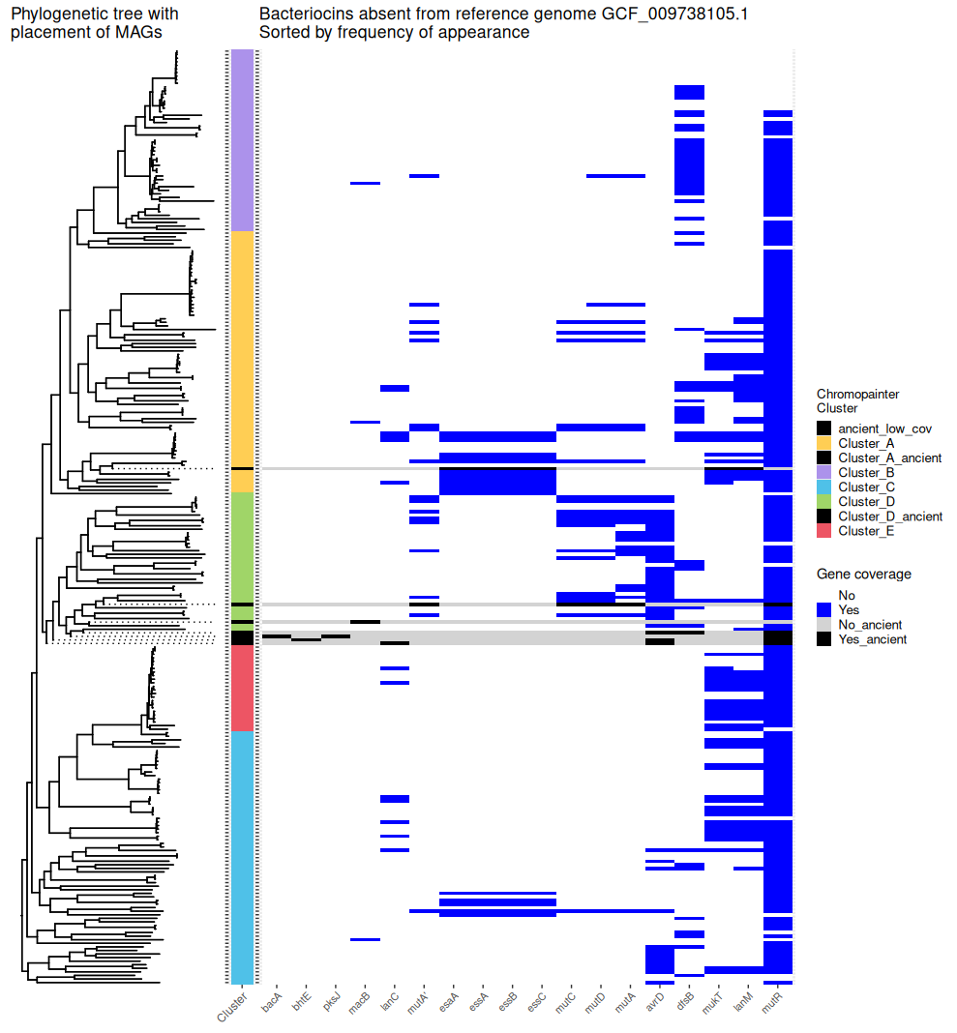

Fig. S17: A visualization of the gunc output for NEO105 created by the “gunc plot” function⁶¹, which shows how the genes are assigned to taxonomic lineages down to genus level, where some assigned to different genera end up being assigned to the same contigs.
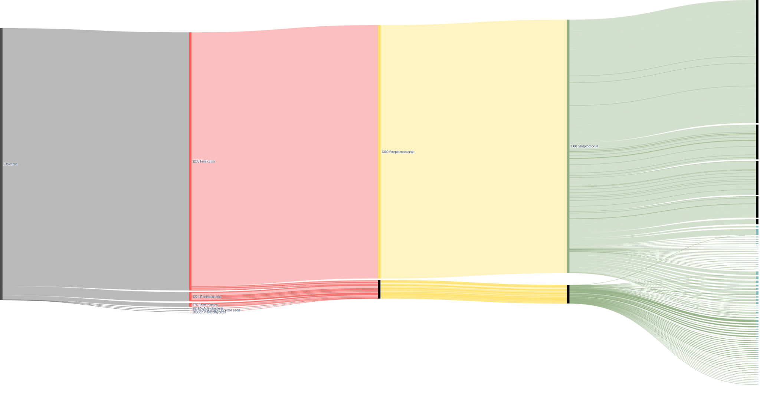

Fig. S18: Comparison of phylogenetic tree computed on the Gubbins masked MSA for S. mutans using IQ-tree and RaxML-NG where we have done midpoint rooting of both trees. IQ-tree computes sCF values for each branch, most of the values of which for the deep clades lie between 50 and 75, with higher or lower values in the end. This is in contrast to the bootstrap values for our final tree as computed by RaXML-NG, where there is generally lower support, the deeper you go in the tree.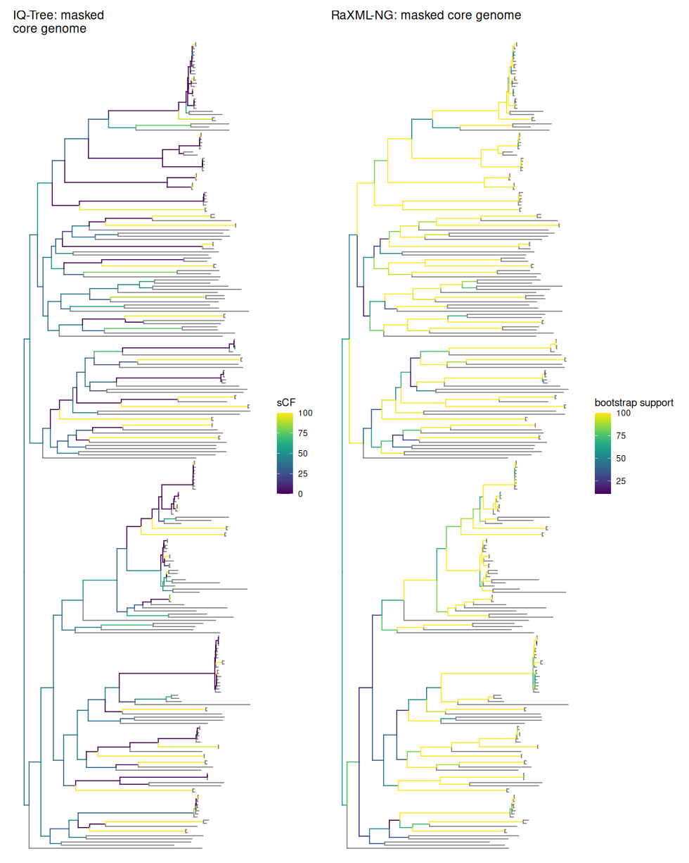
Fig. S19: root-to-tip linear regression analysis of the phylogenetic tree created by Gubbins after rerooting to maximise root-to-tip correlation. Here, the oldest ancient sample NEO137 was redefined as basal to all other S. mutans. The tips are colored based on their age using a red-blue color scale, whereas the tips where we do not have sample dates are colored green. The p-value is calculated through 10000 permutation tests
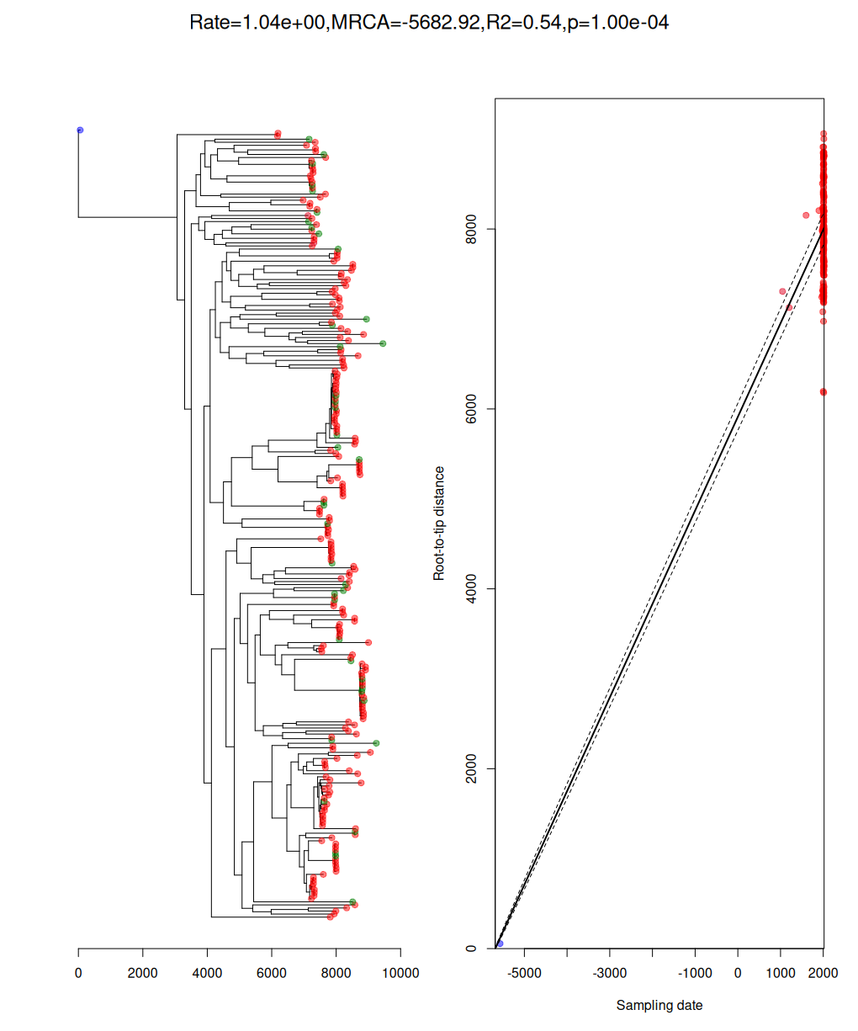
Fig. S20: Trace plots for Bactdate model parameters through 1000 samples of the 10.000 iterations of Markov-Chain Monte Carlo random sampling on the posterior distribution for the clock model using the recombination corrected phylogenetic tree computed through Gubbins. Several metrics do not converge on a stable value throughout the sampled iterations.
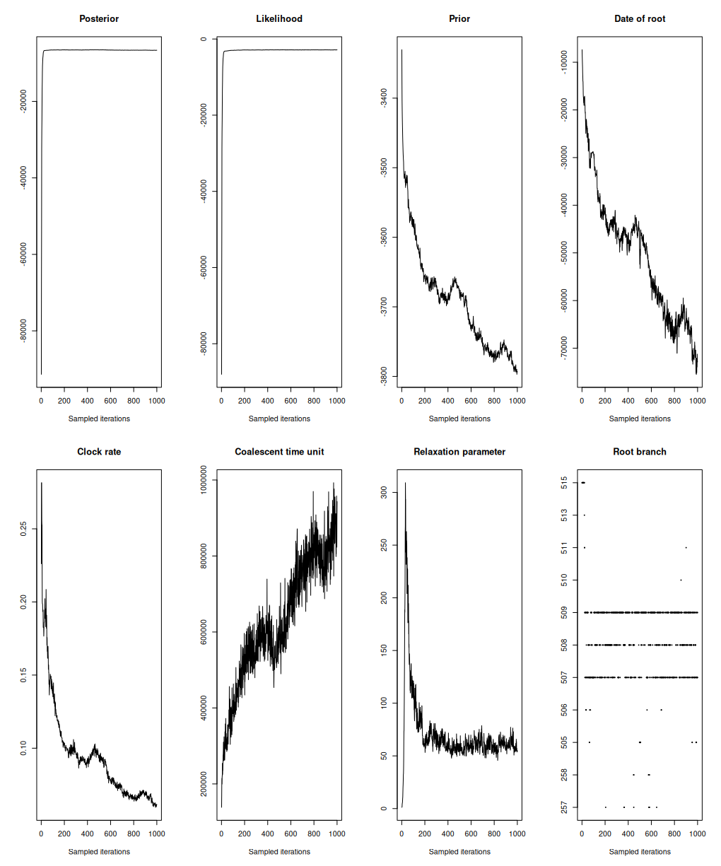

Fig. S21: Crown of the tooth for CGG101233 with yellow arrow pointing towards evidence of caries lesion
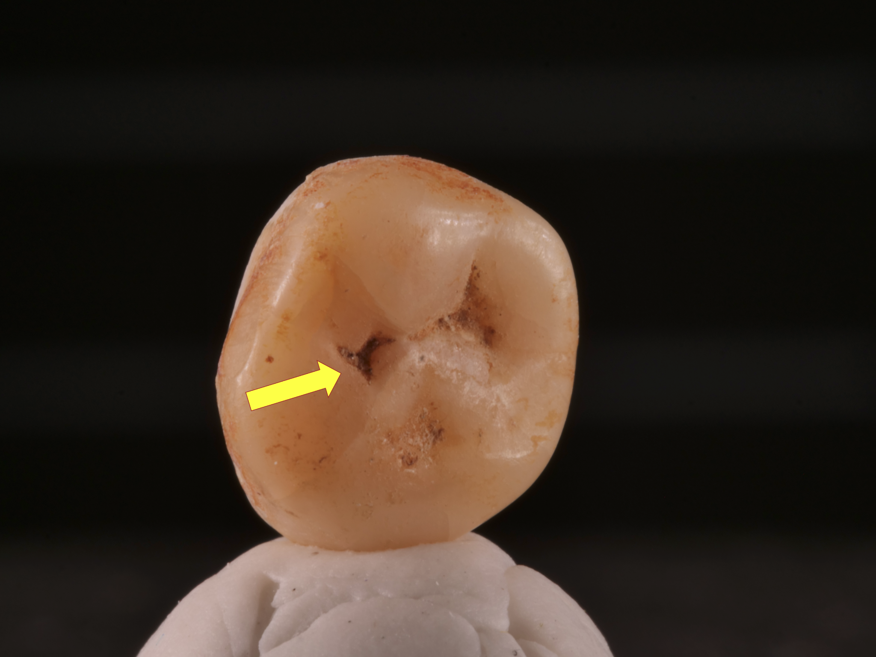

Fig. S22: Fortified citadel of Shahr- I Gholgholah
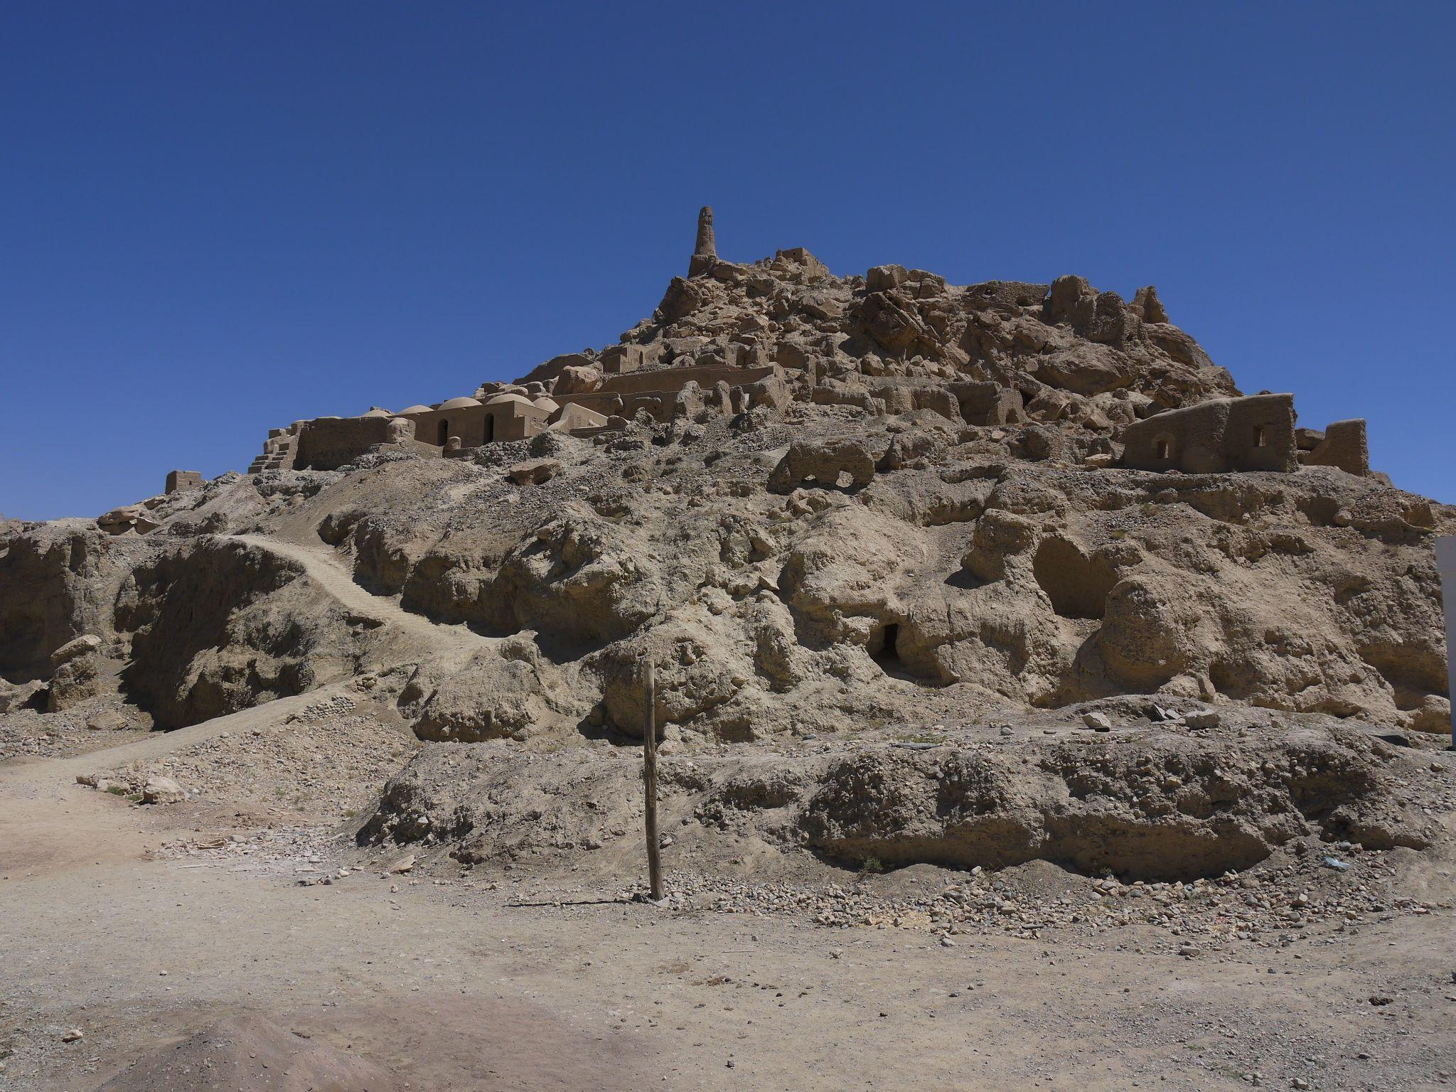

Fig. S23: Human bone pile from excavation no. 2 at Shahr‐ i Gholgholah
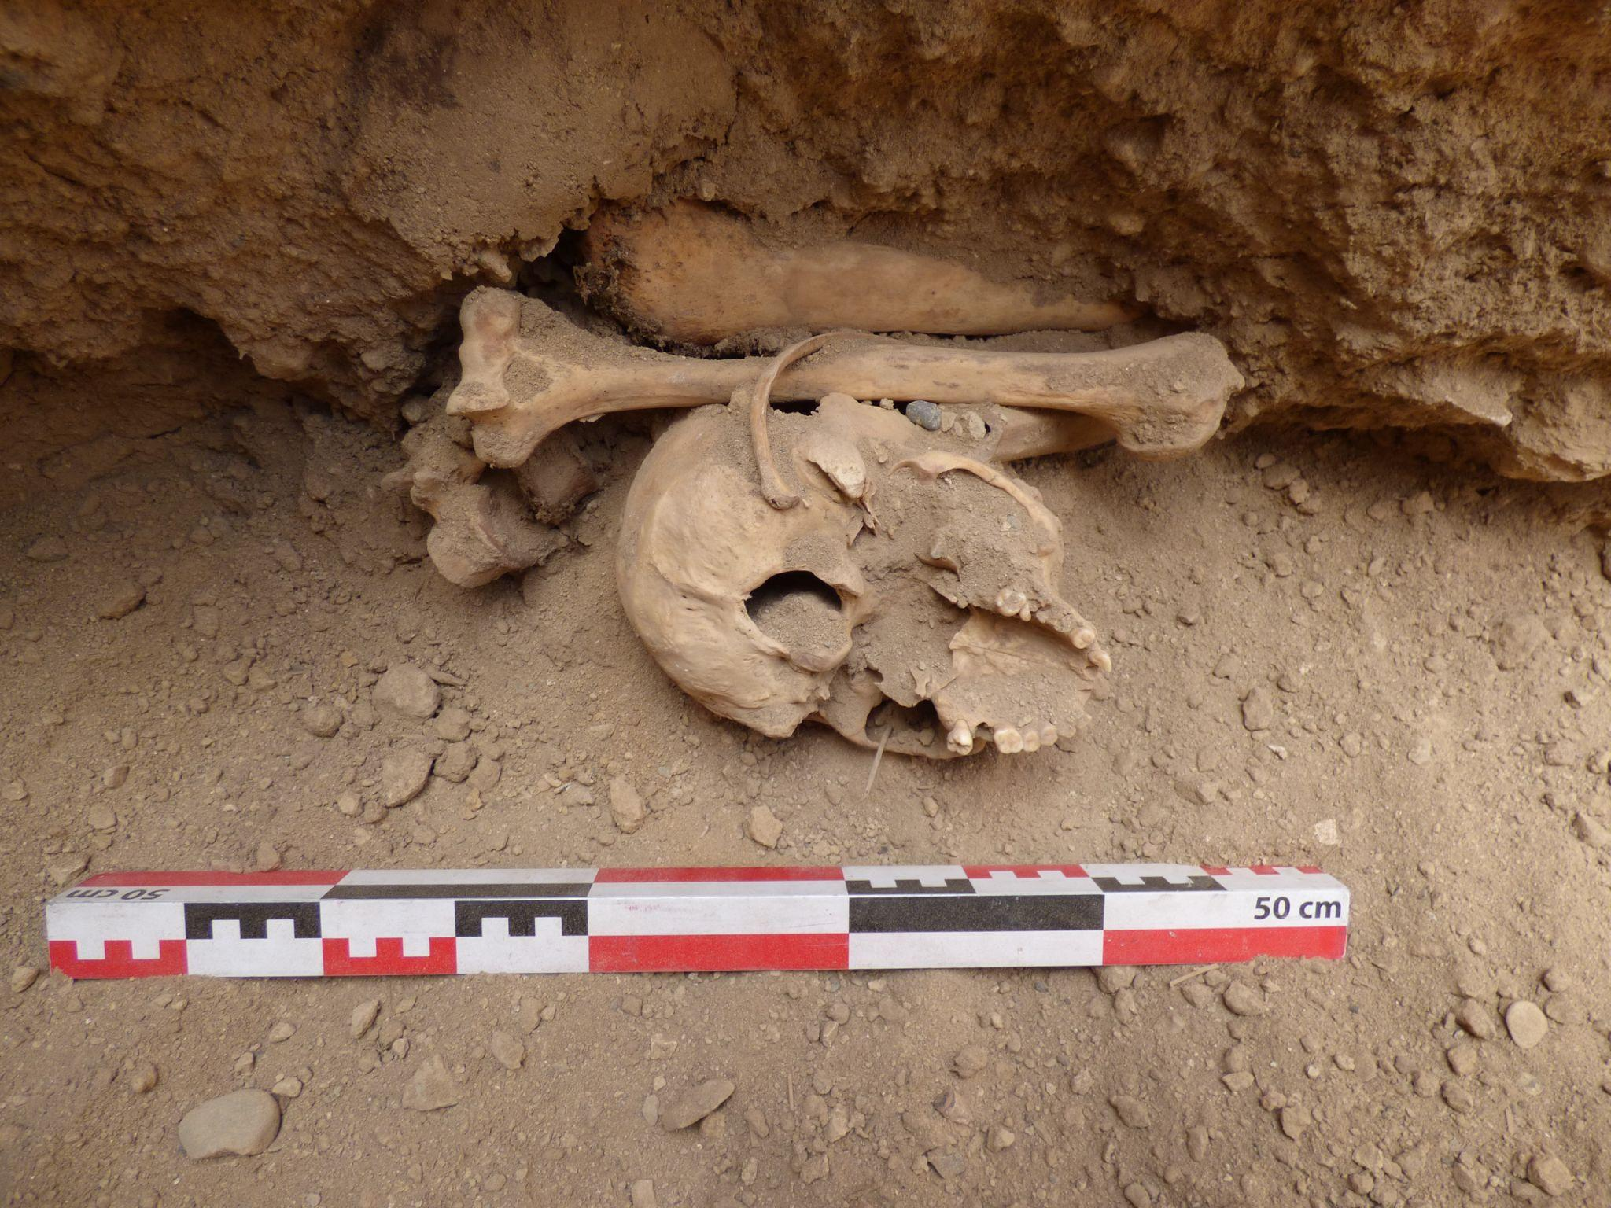

Fig. S24: Location of Kültepe Sareyn
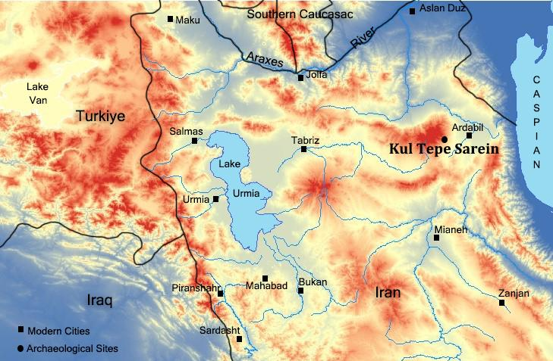

Fig. S25: Remains of the disturbed human skeleton, locus 182
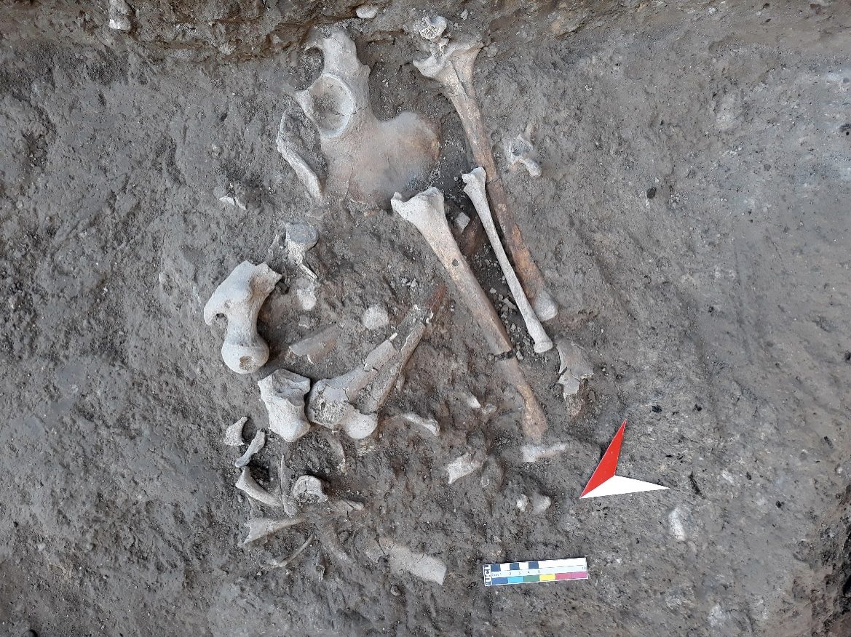

Fig. S26: Iron Age pottery from the upper layer of the burial 182
