Supplementary information for
ImmuSeeker: Deep mining of immune-related gene family signatures through lineage reconstruction
Limin Jiang¹, Ivy Hurwitz², Lukasz S. Wylezinski^{3,4}; Michael K. Racke⁵; Fengyao Yan¹, Fei Ye¹, Quanhu Sheng⁶, Shuguang Leng⁷, Cecilia P. Chung⁸, C. Michael Stein⁹, Chung-I Li¹⁰, Naresh Kumar¹, Michele Ceccarelli¹, Steven F. Baker^{11,12}, Douglas J. Perkins^{2,13}, Charles F. Spurlock, III*^{3,4,14}, Leng Han*¹⁵, Yan Guo*¹

¹Department of Public Health Sciences, University of Miami, Miami, FL 33136, USA
²Center for Global Health, University of New Mexico, Albuquerque, NM 87131, USA
³Decode Health, Inc., Nashville, TN 37203, USA
⁴ Department of Medicine, Vanderbilt /University School of Medicine, Nashville, TN 37203, USA
⁵ Quest Diagnostics, Secaucus, NJ 07094, USA
⁶Department of Biostatistics, Vanderbilt University Medical Center, Nashville, TN 37212, USA
⁷Department of Internal Medicine, University of New Mexico, Albuquerque, NM 87131, USA
⁸Department of Rheumatology, University of Miami, Miami, FL 33136, USA
⁹Department of Pharmacology, Vanderbilt University School of Medicine, Nashville, TN 37203, USA
¹⁰Department of Statistics, National Cheng Kung University, Tainan 701401, Taiwan
¹¹Infectious Disease Program, Lovelace Biomedical Research Institute, Albuquerque, NM 87108, USA
¹²Department of Molecular Genetics & Microbiology, University of New Mexico, Albuquerque, NM 87131, USA
¹³University of New Mexico-Kenya Global Health Programs, Kisumu and Siaya, Kenya
¹⁴ Wagner School of Public Service, New York University, New York, NY 10012, USA
¹⁵Department of Biostatistics and Health Data, Indiana University, IN 46202 USA
*Corresponding authors: Charles F. Spurlock, III (chase@decodehealth.ai), Leng Han (lenghan@iu.edu), Yan Guo (yxg835@med.miami.edu)

Evaluation of ImmuSeeker on a COVID-19 cohort
The COVID-19 dataset comprises 15 hospitalized patients with PCR-confirmed SARS-CoV-2 infections, recruited from the University of New Mexico Hospital between April 23, 2020, and December 14, 2021. RNA sequencing (RNA-seq) was performed on mRNA isolated from peripheral blood mononuclear cells (PBMCs) collected at multiple time points (days 0, 1, 2, 3, 6, 9, and 14) following study enrollment. This cohort was used to assess the performance of ImmuSeeker in terms of its consistency and to investigate discrepancies in detected HLA alleles across different methods.
First, we evaluated the zygosity detection consistency of ten HLA typing tools for HLA-A, HLA-B, and HLA-C using data from all 15 patients (Fig. S1A and Additional file 5: Table S4). Each HLA gene is expected to yield two candidate alleles at the one-field resolution level: identical alleles indicate homozygosity, while distinct alleles denote heterozygosity. Consistency across all time points for a given patient was visualized using a color-coded scheme: green for consistent calls, red for inconsistencies, and gray when no allele was detected. The hla-polysolver consistently assigned HLA-A*01, HLA-B*07, and HLA-C*01 alleles across all samples, necessitating further discussion to understand this outcome. Excluding hla-polysolver, our results show that ImmuSeeker achieved the highest consistency rate (97.8%) among nine other methods, demonstrating its robustness in allele detection.
Next, we compared the detected alleles across the ten tools for HLA-A, HLA-B, and HLA-C. Consistency was defined as the overlap rate between detected allele pairs. The comparative results for each gene are presented in Fig. S1B, Fig. S1C, and Fig. S1D. ImmuSeeker exhibited high concordance with other methods for HLA-A, HLA-B and HLA-C.
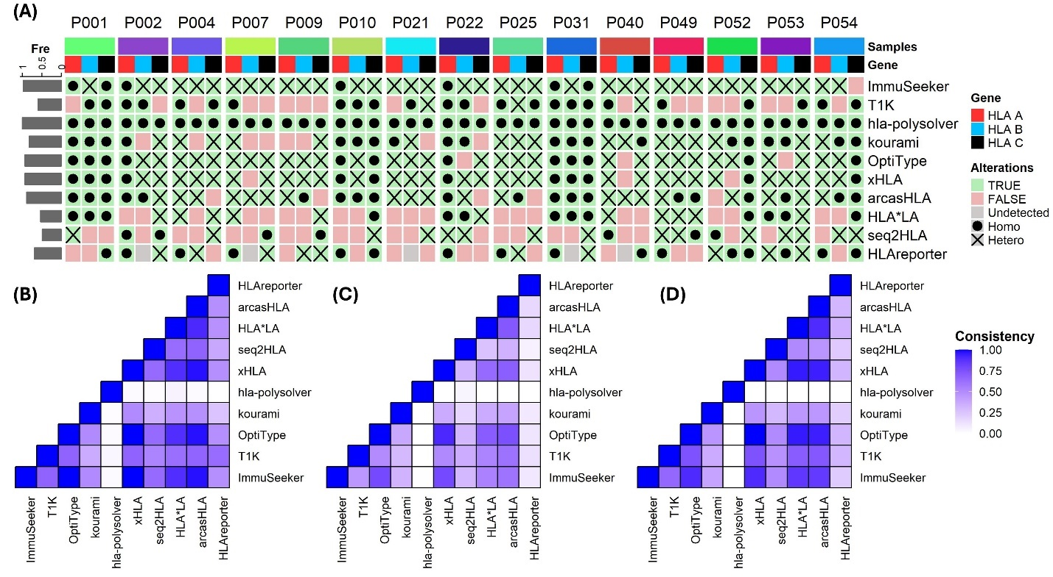
Fig. S1. Results from the COVID-19 cohort. (A). A heatmap representation of zygosity inference differences among the evaluated tools. (B-D). Consistency heatmaps depicting the detected HLA alleles across different tools for HLA-A, HLA-B, and HLA-C.
Evaluation of ImmuSeeker’s running time and memory usage
To assess the computational efficiency of ImmuSeeker, we evaluated its running time and memory consumption across different sequencing depths data. We generated reduced-depth sequencing datasets by subsampling reads at 20%, 40%, 60%, and 80% of the total read count from A549 mock-infected data. These datasets were processed using ten HLA typing tools on an Ubuntu 20.04.6 system equipped with dual 24-core Intel Xeon E5 Gold 5220R processors, 64 GB of RAM, and a 2.20 GHz CPU.
Memory usage (Fig. S2A) and execution time (Fig. S2B) were measured using the /usr/bin/time command. The results indicate that ImmuSeeker requires higher memory compared to tools such as hla-Polysolver, arcasHLA, HLAreporter, seq2HLA, and xHLA. However, it achieves shorter runtimes compared to the other eight tools evaluated, demonstrating a significant advantage in computational speed.
The increased memory consumption is primarily due to ImmuSeeker’s comprehensive alignment strategy, which maps all reads within the HLA gene regions to the IPD-IMGT/HLA database. Given the high sequence similarity among HLA alleles, this process generates a substantial number of intermediate alignments, resulting in greater computational overhead. Future development efforts will focus on improving the tool’s memory efficiency to enhance scalability for large-scale datasets.
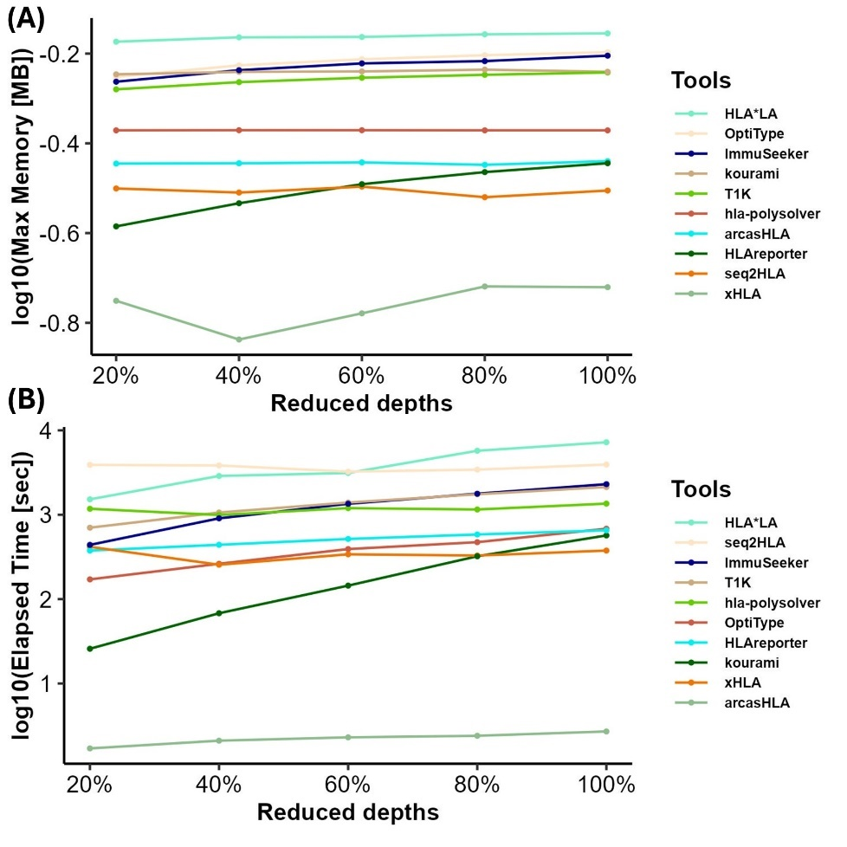
Fig. S2. Comparison of memory usage and running time. (A) Analysis of maximum memory usage across varying sequencing depths data. (B) Evaluation of execution time across varying sequencing depths data.
Evaluation of allele-specific TPM estimation across read-assignment strategies
Accurately estimating allele-specific TPM is indeed a critical component of HLA expression quantification, particularly in the presence of extensive sequence similarity among alleles. To evaluate TPM estimation, we implemented four complementary read-assignment strategies:
- Full-based assignment: Each read is assigned to all alleles to which it maps.
- Fractional-based assignment: For a read mapping to k alleles, a fractional weight of 1/k is added to each allele.
- Unique-based assignment: Only reads that uniquely map to a single allele are counted; ambiguous reads are discarded.
- EM-based probabilistic assignment: Allele abundances are iteratively estimated using an Expectation–Maximization framework, with ambiguous reads reassigned probabilistically based on current allele abundance estimates.
Because no publicly available bulk RNA-seq dataset provides experimentally validated allele-specific TPMs across a broad range of HLA alleles, we assessed the reliability of TPM estimation through internal consistency analysis. Using an autoimmune disease cohort of 226 samples, we applied the four TPM strategies and computed pairwise Pearson correlation coefficients for alleles detected in at least 50 samples. A total of 56 alleles (24 one-field and 32 two-field) met this criterion. Results for the one-field and two-field alleles are presented in Fig. S3 and Fig. S4, respectively.
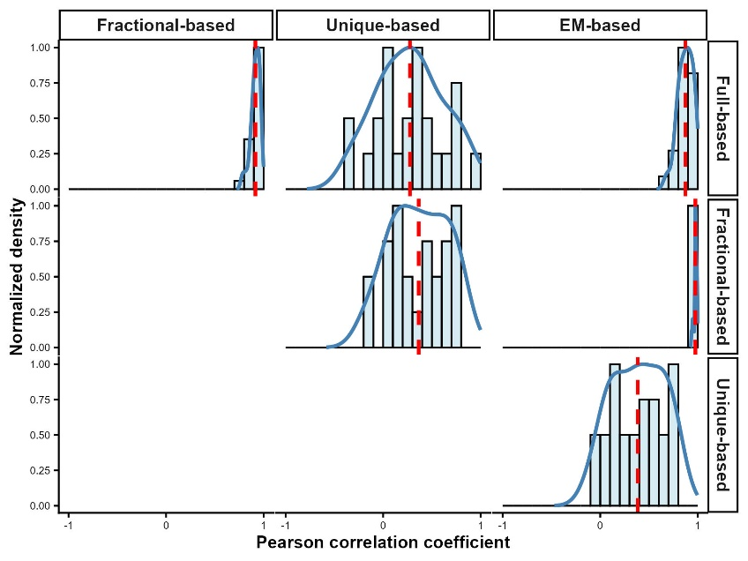
Fig. S3. Pairwise Pearson correlation analysis of TPM estimates across four read-assignment strategies (full-based, fractional-based, unique-based, and EM-based) for 24 one-field HLA alleles detected in ≥50 samples. The red dashed line indicates the mean correlation coefficient for each method pair. Overall, one-field alleles exhibit high consistency across quantification strategies, with EM-based, fractional-based, and full-based TPMs showing the strongest agreement.
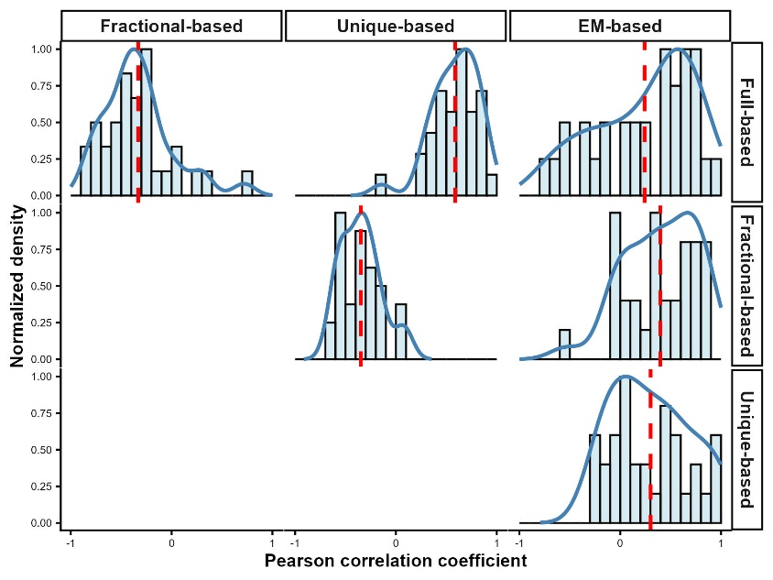
Fig. S4. Pairwise Pearson correlation analysis of TPM estimates across four read-assignment strategies for 32 two-field HLA alleles detected in ≥50 samples. The red dashed line indicates the mean correlation coefficient for each method pair. In contrast to one-field alleles, TPM estimates for two-field alleles show substantial divergence across methods, reflecting the high sequence similarity and extensive read ambiguity that challenge allele-specific TPM quantification at higher resolution.
Our analysis revealed three key findings: (1) Unique-based TPMs exhibited slightly lower correlations with other quantification strategies. This reduction reflects the systematic exclusion of ambiguous reads, highlighting that the handling of multi-mapping reads has a measurable impact on TPM estimation. (2) Correlations among TPM estimates were substantially higher at the one-field level than at the two-field level. For one-field alleles, EM-based TPMs demonstrated the highest overall consistency, with mean Pearson correlations of 0.976 with fractional-based TPMs and 0.876 with full-based TPMs. Fractional-based and full-based TPMs were also strongly correlated (mean r = 0.915), indicating that when ambiguous reads are retained, TPM quantification is generally robust at the one-field resolution. (3) At the two-field allele resolution, TPM estimates diverged markedly across quantification strategies. Except for the unique-based method, which lacked sufficient read support for reliable comparison, EM-based TPMs achieved only modest maximum correlations (mean r = 0.396 with fractional-based TPMs and 0.241 with full-based TPMs).
This divergence reflects the high sequence similarity among alleles within the same one-field group, which leads to extensive read ambiguity and increased uncertainty in assigning reads to specific two-field alleles. As a result, TPM values at the two-field resolution become highly sensitive to the quantification strategy used.
Given these findings, we selected the full-based TPM strategy for downstream analyses. HLA alleles, particularly at the two-field resolution, share nearly identical sequences, causing a large fraction of reads to map to multiple alleles. Approaches that exclude or heavily downweight these ambiguous reads (unique-based or fractional-based) lead to unstable estimates, increased variance, and systematic underestimation of total expression. In contrast, full-based assignment retains all observed reads, providing the most stable, robust, and biologically interpretable estimate of overall HLA expression. This strategy is especially appropriate for our downstream applications, which focus on capturing total allelic expression patterns rather than resolving minimal sequence differences between highly similar alleles.

