Supplemental information

Proteogenomic decoding of chemotherapy resistance in patients
with triple-negative breast cancer
Dong Ki Lee^{1,†}, Min Hwan Kim^{2,†}, Yumi Hwang³, Seul-Gi Kim⁴, Won-Ji Ryu³, Geon-Uk Kim³, Hyun Myoung Yun³, Shin Young Park³, Jeong Dong Lee³, Hyun Ju Han³, Gun Min Kim², Kyung-Hee Kim⁵, Jong Bae Park⁶, Min Jung Kim⁷, Ja Seung Koo⁸, Jee Ye Kim⁹, Hyung Seok Park⁹, Seung Il Kim⁹, Heon Yung Gee¹, Seho Park^{9,*}, Joohyuk Sohn^{2,*}
Table of contents
Supplementary Methods……....…………………………………………………………………...3
Supplementary Table…………………………………………………………………………….14
Supplementary Figures…………………………………………………………………………...15

Supplementary Methods
Whole-exome sequencing (WES)
Tumor DNA was extracted from fresh-frozen biopsies and matched leukocyte germline DNA from blood samples. Libraries were prepared using the Twist Human Core Exome kit (Twist Bioscience, San Francisco, CA, USA), followed by paired-end sequencing on the Illumina NovaSeq platform (Illumina, San Diego, CA, USA).

RNA sequencing
Poly-A RNA was isolated from 1 μg of total RNA using oligo(dT)-attached magnetic beads and processed with the Illumina TruSeq Stranded mRNA Sample Prep Kit. After mRNA fragmentation, first- and second-strand cDNA synthesis was performed using SuperScript II reverse transcriptase and DNA Polymerase I, respectively. Sequencing was performed on an Illumina NovaSeq 6000 platform with 2×100 bp paired-end reads (Macrogen, Seoul, South Korea). RNA-seq for the TNBC cell line with and without ITGB8 overexpression was performed (Macrogen, Seoul, South Korea) using the NovaSeqX platform (Illumina, San Diego, USA).

Somatic and copy-number variant calling
Somatic variants were called using paired tumor and blood normal from WES data. Strelka2 and Mutect2 were used for somatic variant calling. The called variants were filtered using GATK VariantFiltration (v 4.1.0) with parameters window 35, cluster 3, FS >30.0, and QD <2.0. We retained single nucleotide variants (SNVs) and indels called by any callers. SNVs and indels were merged for tumor and normal sequence depth using a 10X coverage cutoff. The remaining variants were annotated using annovar (v 10.24.2019). Using WES data, somatic mutations were called by comparing tumor DNA against matched blood normal DNA. Germline mutations were called by comparing normal WES data against the reference genome. The copy number information was mapped to genes using Hg38.109.20211119.ncbiRefSeq. For somatic copy-number alteration (CNA) analysis, bam files were processed using the cnvkit package to derive log₂ tumor-to-normal copy-number ratios. Gene-level copy-number values were retrieved and significant CNAs in the cohort were called using GISTIC 2.0. A threshold of ±0.3 was applied to the log₂ copy-number ratio to identify gene-wise gain or loss of copy number, respectively. Each gene of every sample was assigned a threshold copy-number level that reflected the magnitude of its deletion or amplification. The integer values ranged from −2 to 2, where 0 means no amplification or deletion of magnitude greater than the threshold parameters described above. Amplifications are represented by positive numbers: 1, amplification above the amplification threshold; 2, amplification larger than the arm-level amplifications observed in the sample. Deletions are represented by negative numbers: −1, deletion beyond the threshold; −2, deletions greater than the minimum arm-level copy number observed in the sample.

Proteomics data generation and analysis
Proteins were extracted using sodium dodecyl sulfate buffer and ultrasonication (S220, Covaris), digested using S-Trap columns (Protifi, Fairport, NY, USA), and labeled with tandem mass tag (TMT) 11-plex reagents. The labeled peptides were fractionated using mid-pH reverse-phase high performance liquid chromatography, and phosphopeptides were enriched using iron-nitrilotriacetic acid immobilized metal affinity chromatography. Peptides were analyzed via liquid chromatography-tandem mass spectrometry using a Q Exactive HF-X Orbitrap mass spectrometer (Thermo Fisher Scientific, Waltham, MA, USA). Mass spectra were converted to the mzML format (ProteoWizard, Palo Alto, CA, USA) and searched against the human UniProt database using FragPipe. Proteins and phosphoproteins identified were filtered at 1% false discovery rate. TMT-based quantification was normalized to a global reference. Batch effects were corrected using ComBat, and missing values were imputed with DreamAI.

Transcriptome-proteome correlation analysis
To assess the concordance between transcriptomic and proteomic profiles, we performed gene-wise correlation analysis across all genes quantified in both datasets (n=9,410). For each gene, Spearman’s rank correlation coefficient (ρ) was calculated between RNA-seq and protein abundance values measured in baseline tumor samples. Among 9,410 genes quantified at both levels, 8,576 genes (93.8%) exhibited positive RNA–protein correlations, and 5,665 genes (62.0%) showed statistically significant positive correlations (P < 0.01), with a median correlation coefficient of ρ = 0.49. These findings are consistent with previous multi-omics studies reporting moderate RNA–protein concordance in cancer tissues.
To identify biological pathways associated with concordant or discordant RNA–protein relationships, GSEA was performed using Kyoto Encyclopedia of Genes and Genomes (KEGG) pathway annotations. Genes were ranked by their Spearman correlation coefficients (from most negative to most positive), and enrichment scores were calculated using the GSEA software (v4.3.2). Normalized enrichment scores (NES) were used to assess pathway-level associations.

Gene set variation analysis (GSVA) of transcriptomic and proteomic data
To compare pathway activity across transcriptomic and proteomic layers, GSVA was performed using the Hallmark gene sets from the Molecular Signatures Database (MSigDB v7.5.1). Both RNA and protein expression matrices were z-score normalized across samples prior to analysis to ensure comparability. GSVA was conducted for all samples using the GSVA R package (v1.48.2) with default parameters to generate pathway activity scores for each omics layer.
To evaluate the degree of pathway discrimination among NMF-defined clusters, the standard deviation (SD) of GSVA scores was calculated across clusters for each data type, and Levene’s test was conducted.

Pathway comparison according to GRK2 PTM-SEA score
To examine pathway differences associated with GRK2 activity, tumors were stratified into GRK2-high and GRK2-low groups based on the normalized enrichment score (NES) from the post-translational modification set enrichment analysis (PTM-SEA). Samples with NES > 2 were defined as GRK2-high, reflecting strong enrichment of GRK2-associated phosphosite signatures, whereas those with NES ≤ 2 were classified as GRK2-low. For each group, gene set variation analysis (GSVA) was performed using Hallmark gene sets on the z-score normalized proteomic dataset to estimate pathway activity scores. Differences in GSVA scores between GRK2-high and GRK2-low tumors were evaluated using an unpaired two-tailed Student’s t-test. Pathways with P < 0.05 were considered statistically significant. Data were visualized as mean ± standard deviation.

Measurement of tumor-stroma ratio (TSR)
The 4μm-thick H&E-stained tumor tissue slides from both initial core biopsies and post-neoadjuvant chemotherapy surgeries were analyzed for tumor-stroma ratio (TSR) evaluation. The tumor tissue slides were reviewed by breast cancer expert pathologist Ja Seung Koo. Initially, the entire tissue slide was visually inspected to identify areas with representative TSR. The tumor and stroma areas were evaluated using a 10× magnification light microscope. TSR scoring was performed by visually estimating the stroma area relative to the tumor cells. The TSR was expressed as the percentage of the stroma area in relation to the total tumor area for each section.

Table S1. Baseline clinical characteristics of TNBC patients in this study
Clinical variables |  | n=50 | %
Age (median, range) |  | 48 (25-78)
Sex | Female | 50 | 100%
Neoadjuvant regimen | AC-weekly paclitaxel | 36 | 72%
 | AC-docetaxel | 6 | 12%
 | weekly paclitaxel/carboplatin-AC | 6 | 12%
 | FEC-docetaxel | 2 | 4%
cT stage | T2 | 46 | 92%
 | T3 | 2 | 4%
 | T4 | 2 | 4%
cN stage | N0 | 29 | 58%
 | N1 | 8 | 16%
 | N2 | 7 | 14%
 | N3 | 6 | 12%
ypT stage | ypT0 | 20 | 40%
 | ypTis | 2 | 4%
 | ypT1 | 20 | 40%
 | ypT2 | 6 | 12%
 | ypT3 | 2 | 4%
ypN stage | ypN0 | 42 | 84%
 | ypN1 | 4 | 8%
 | ypN2 | 2 | 4%
 | ypN3 | 2 | 4%
Germline BRCA1/2 | BRCA1 mutation | 7 | 14%
 | BRCA2 mutation | 3 | 6%
 | No pathogenic mutation detected | 33 | 66%
 | Not available | 7 | 14%
pCR | No | 31 | 62%
 | Yes | 19 | 38%
Recurrence | No | 43 | 86%
 | Yes | 7 | 14%

Supplementary Figures
Fig S1. CONSORT diagram summarizing patient enrollment, treatment, and sample collection in the triple-negative breast cancer (TNBC) cohort.

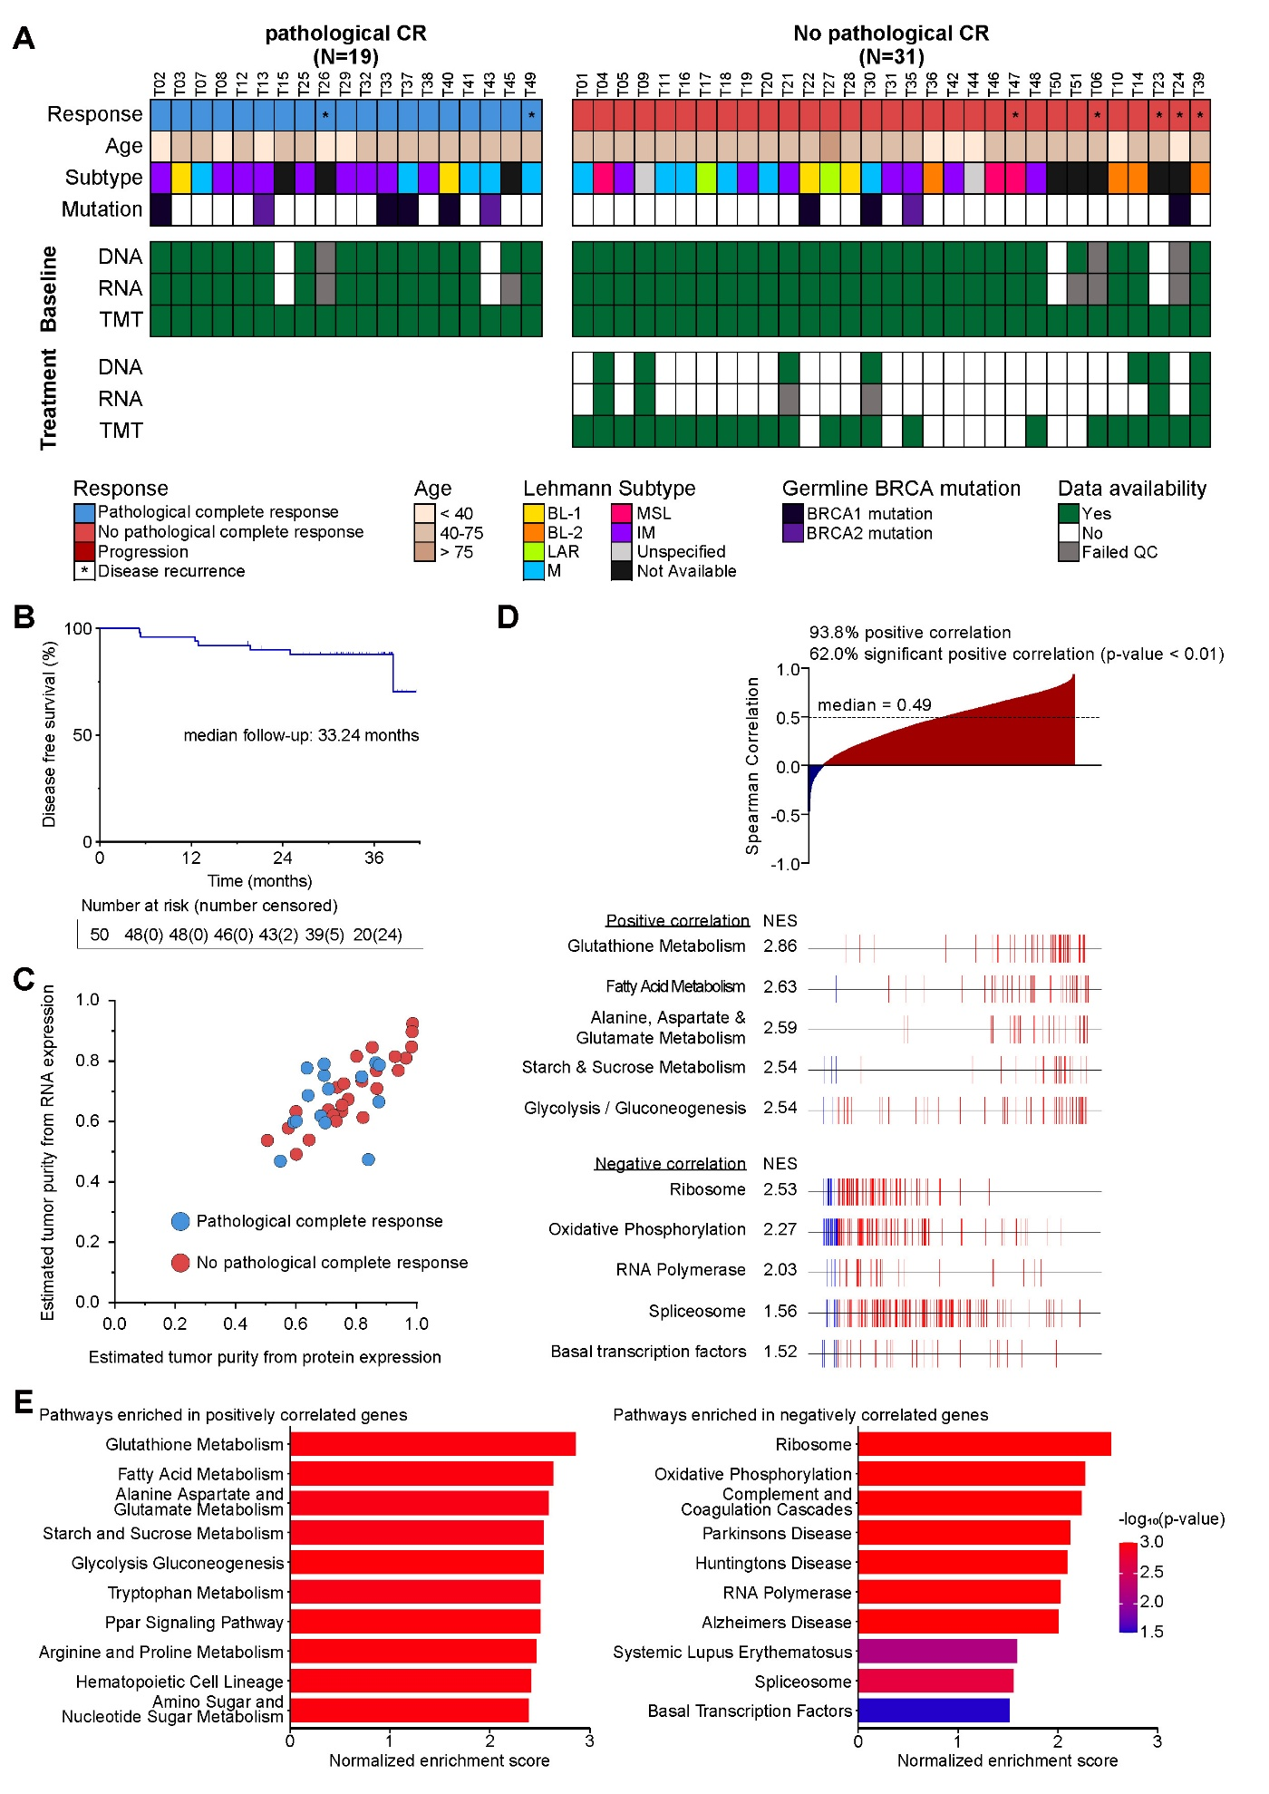
Fig S2. Overview of proteogenomic analysis, clinical outcomes, and pathway correlations in patients with TNBC. (A) Comprehensive summary of available proteogenomic datasets for a cohort of 50 patients diagnosed with TNBC. Annotation tracks indicate patient age, tumor subtypes classified according to the Lehmann classification, and germline BRCA mutation status. Patients are grouped based on achieving pathological complete response (pCR, n=19) or not (non-pCR, n=31). Availability of DNA (whole-exome sequencing (WES)), RNA (RNA-seq), and protein (tandem mass tag (TMT)) data are indicated for each patient. (B) Kaplan–Meier disease-free survival curve for the entire cohort with a median follow-up duration of 33.24 months. (C) Correlation plot comparing tumor purity estimates derived from proteomics and transcriptomics data. (D) Gene-wise spearman rank correlation coefficients for mRNA-protein pairs (n=9,140), ranked from most negative to most positive (top panel). Overall, 93.8% of genes (n=8,573) exhibited a positive correlation, with 62.0% (n=5,667) demonstrating significant positive correlations (P < 0.01). For the gene set enrichment analysis (GSEA) shown in the middle and bottom panels, genes were ranked according to their Spearman correlation coefficients, and GSEA was performed the Kyoto Encyclopedia of Genes and Genomes (KEGG) pathways annotations. The middle panel highlights genes from pathways significantly enriched among positively correlated genes, while the bottom panel shows pathways enriched in negatively correlated genes. (E) Bar plots presenting the top KEGG pathways enriched among positively correlated genes (left panel) and negatively correlated genes (right panel).

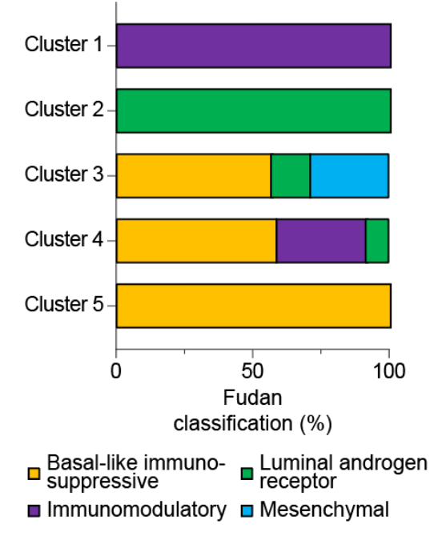
Fig S3. Comparison of NMF-defined proteogenomic clusters with Fudan TNBC classification. Each tumor in the cohort was assigned to one of the four Fudan transcriptomic subtypes—immune-modulatory (IM), basal-like immunosuppressive (BLIS), mesenchymal (MES), and luminal-androgen receptor (LAR)—based on RNA-seq profiles. The stacked bar plots show the proportion of Fudan subtypes within each NMF-defined cluster.

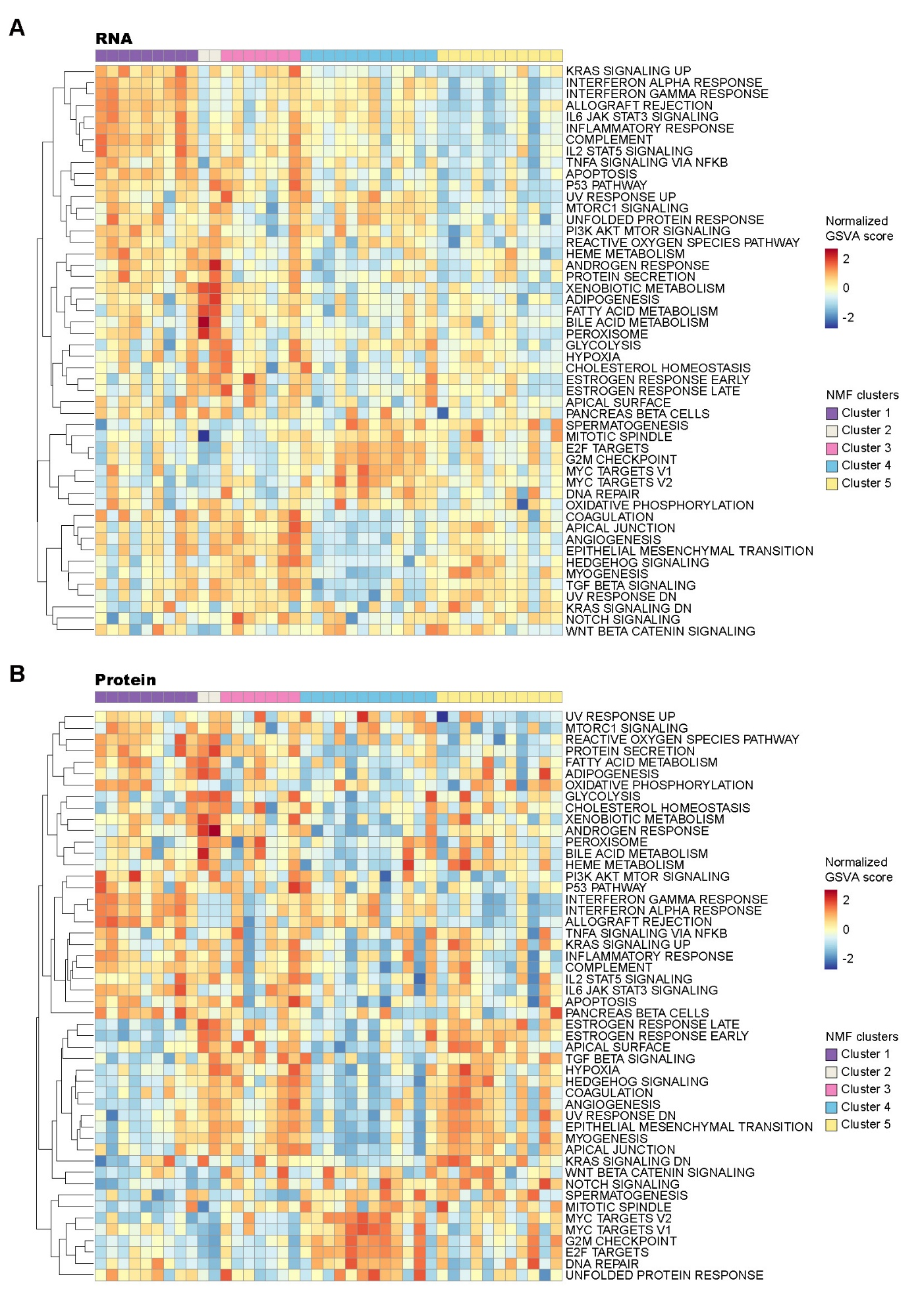
Fig S4. Gene set variation analysis (GSVA) of transcriptomic and proteomic profiles stratified by NMF clusters. (A) GSVA based on z-score normalized RNA sequencing data showing Hallmark pathway enrichment across the five NMF-defined clusters. (B) GSVA based on z-score normalized global proteomics data showing corresponding pathway activity across the five NMF-defined clusters.

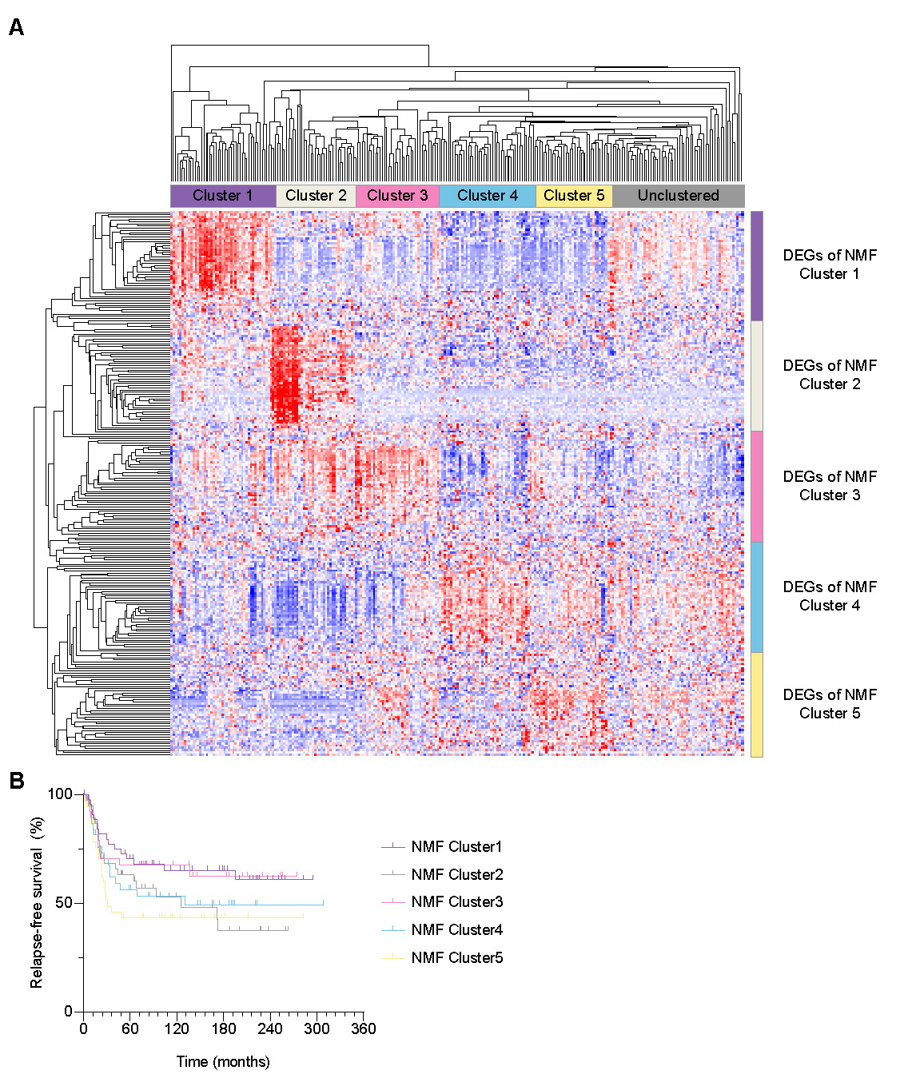
Fig S5. External validation of the proteogenomic TNBC classification in the METABRIC cohort. (A) K-means clustering of METABRIC TNBC tumors (n = 258) using DEGs derived from the five NMF-based proteogenomic clusters. Differentially expressed genes (adjusted P < 0.05 and |log₂ fold change| > 1) from each NMF cluster were applied to the METABRIC TNBC dataset. Of the 258 TNBC tumors, 197 (76.3%) were assigned to one of the five clusters. (B) Kaplan–Meier curves for relapse-free survival (RFS) analysis of the five TNBC clusters in the METABRIC cohort.

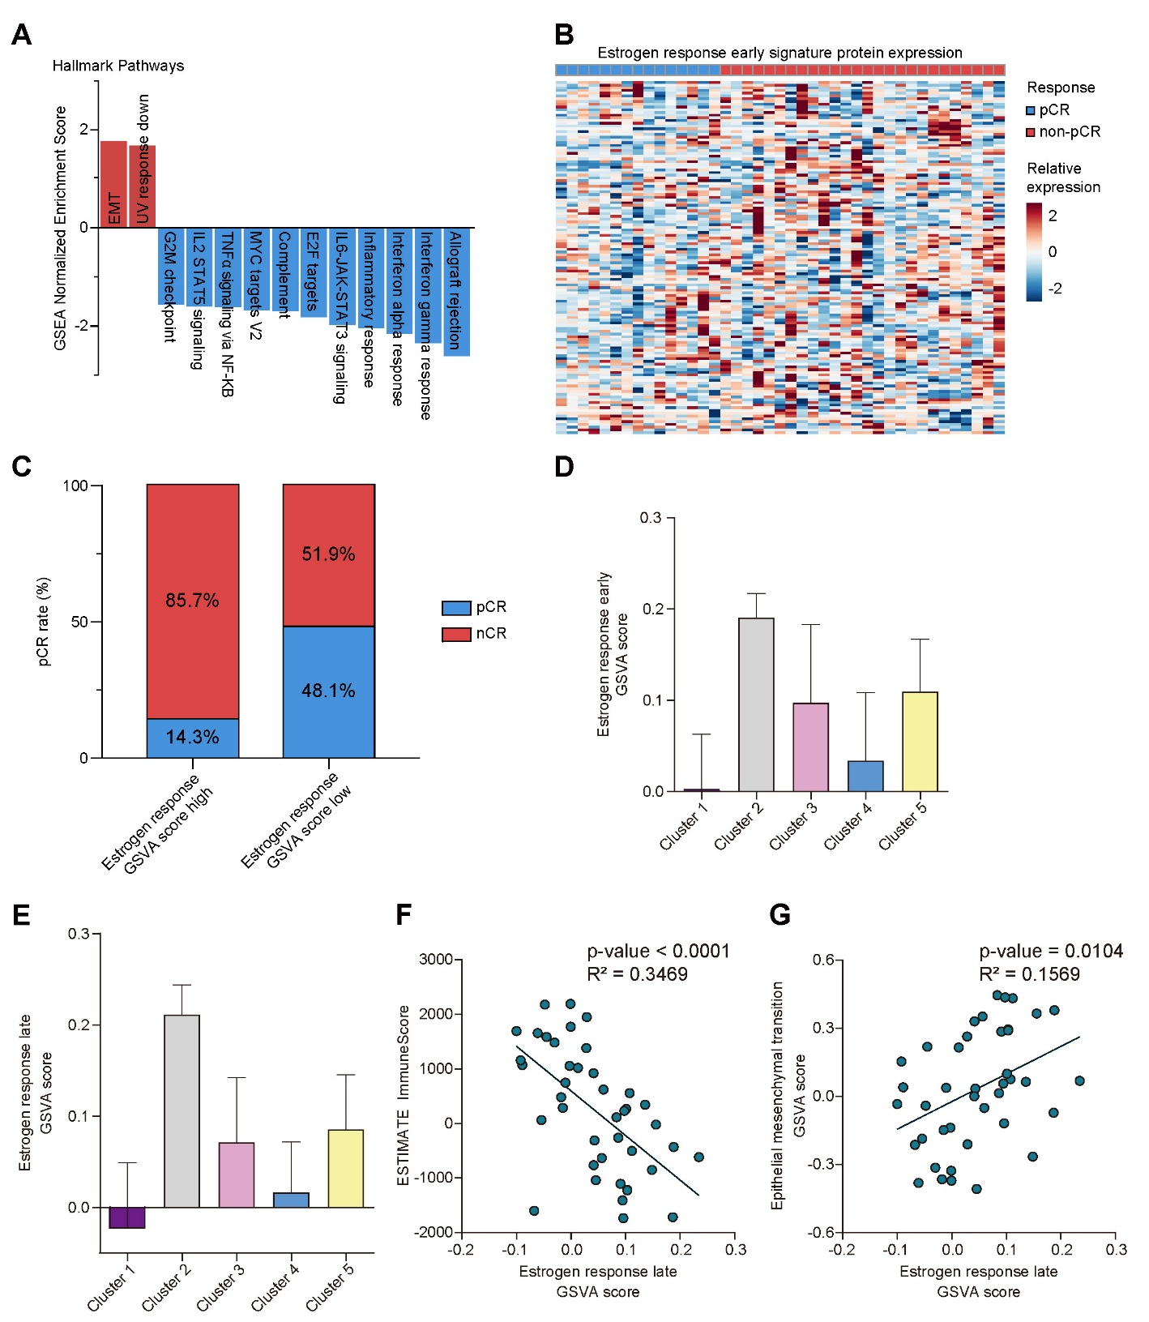
Fig S6. Estrogen response gene signature across NMF clusters and correlation with immune and epithelial-to-mesenchymal transition (EMT) signatures. (A) Bar plot illustrating significantly enriched signaling pathways identified by RNA-seq-based GSEA (defined by FDR < 0.05). Pathways enriched in non-pCR tumors are indicated in red, while pathways enriched in pCR tumors are in green. (B) Heatmap displaying protein expression of all genes within the early estrogen response signature, comparing non-pCR and pCR tumors. (C) Pathological complete response (pCR) rates stratified by estrogen response GSVA score (high: enrichment score > 0.1; low: ≤ 0.1). Tumors with higher estrogen response GSVA scores had lower pCR rates (P = 0.0328). (D) Bar plot showing the protein GSVA score of estrogen response early gene signature across NMF clusters. (E) Bar plot showing the protein GSVA score of estrogen response late gene signature across NMF clusters. (F) Dot plot showing the correlation between estrogen response late GSVA scores and ESTIMATE immune scores. (G) Dot plot showing the correlation between estrogen response late and EMT GSVA scores.

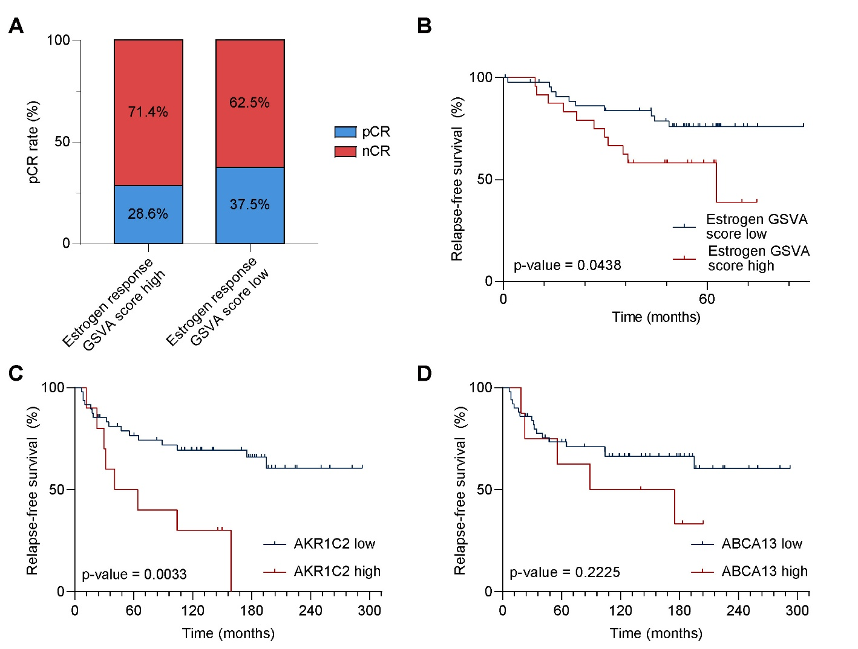
Fig S7. External validation of resistance-associated biomarkers in independent TNBC proteogenomic datasets. (A) Pathological complete response (pCR) rates stratified by estrogen response GSVA score (high: enrichment score > 0.1; low: ≤ 0.1) in the Cancer Discovery TNBC cohort (Anurag et al., 2022). (B) Kaplan-Meier analysis of relapse-free survival (RFS) in the Cell Reports TNBC cohort (Gong et al., 2022), comparing patients with high versus low estrogen response GSVA scores. (C) In the METABRIC TNBC immunomodulatory (IM) subtype cohort, elevated AKR1C2 expression correlated with worse RFS (P = 0.0033). (D) Kaplan-Meier analysis of RFS by ABCA13 expression in the METABRIC TNBC IM subtype cohort showed a trend towards worse survival in the high expression group, although it did not reach statistical significance (P = 0.2225).
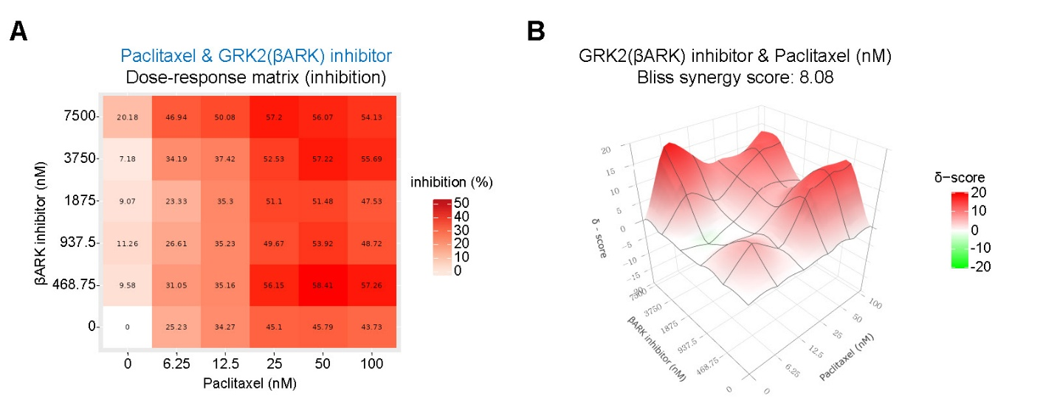
Fig S8. Synergistic inhibition in MDA-MB231 cells with combined paclitaxel and GRK2 (βARK) inhibitor treatment. (A) Dose-response matrix showing percent inhibition in MDA-MB231 cells treated for 72 hours with various concentrations of paclitaxel and GRK2 (βARK) inhibitor. (B) Three-dimensional surface plot representing the Bliss synergy scores calculated from the dose-response data. The positive Bliss synergy score (8.08) indicates a synergistic effect between paclitaxel and GRK2 (βARK) inhibitor.
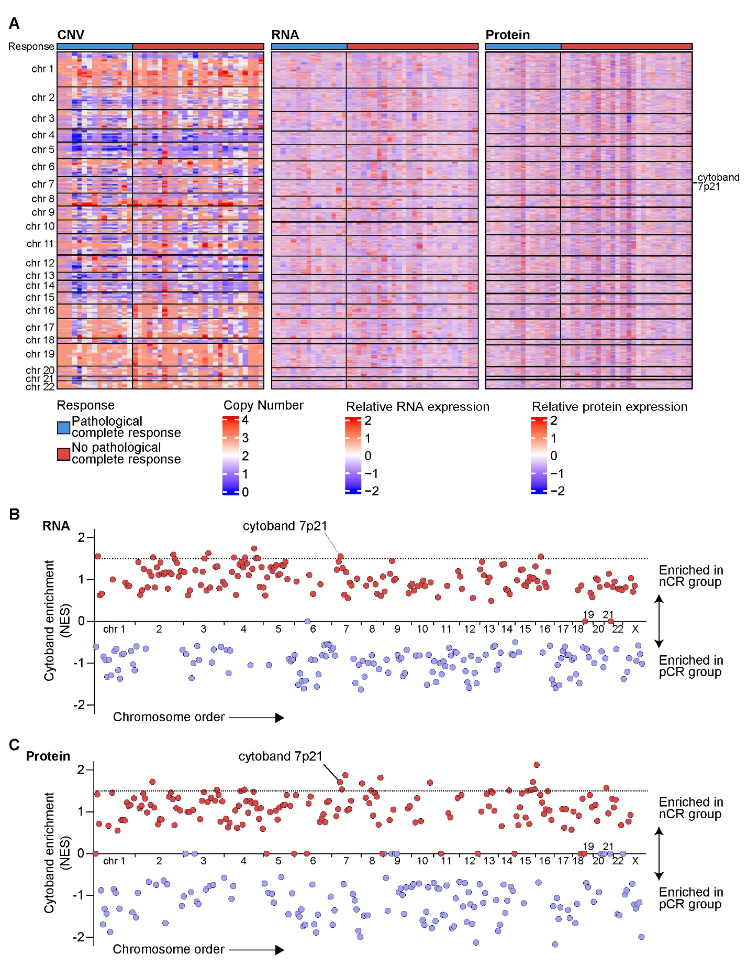
Fig S9. Chromosome-specific copy number, RNA, and protein expression patterns associated with pathologic response status in TNBC: Cytoband enrichment analysis by pCR and non-pCR groups. (A) Heatmaps of copy number alteration, relative RNA expression, and relative protein expression across chromosomes, stratified by pCR and non-pathological complete response (nCR) groups. (B) Dot plot depicting GSEA normalized enrichment scores (NES) for RNA expression at each cytoband. The x-axis displays chromosome order, and the y-axis indicates NES. Positive NES values (red) represent cytobands enriched in the nCR group, while negative NES values (green) indicate enrichment in the pCR group. (C) Dot plot depicting GSEA NES values for protein expression at each cytoband. Notably, cytoband 7p21 was enriched in the nCR group in both RNA and protein expression analyses.

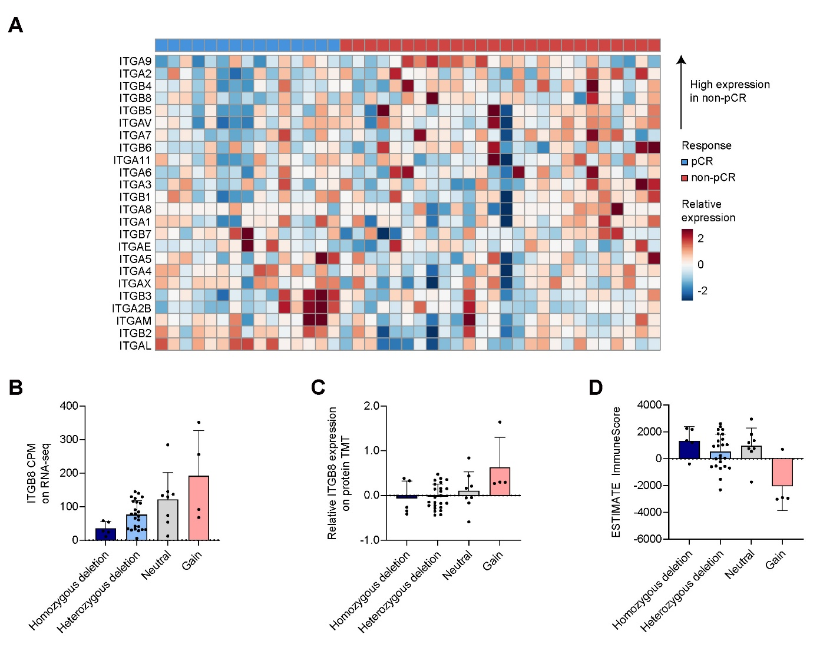
Fig S10. Integrin gene expression and immune contexture associated with chemotherapy response and ITGB8 copy number status in TNBC. (A) Heatmap showing normalized protein expression levels of integrin family genes in baseline tumor samples, stratified by pathological response status (pCR vs. non-pCR). Integrins are arranged by higher relative expression in non-pCR tumors. (B) ITGB8 RNA expression (counts per million, CPM) from RNA-seq data stratified by ITGB8 copy number status. (C) ITGB8 protein expression measured by TMT proteomics according to ITGB8 copy number status. (D) ESTIMATE immune scores grouped by ITGB8 copy number status.

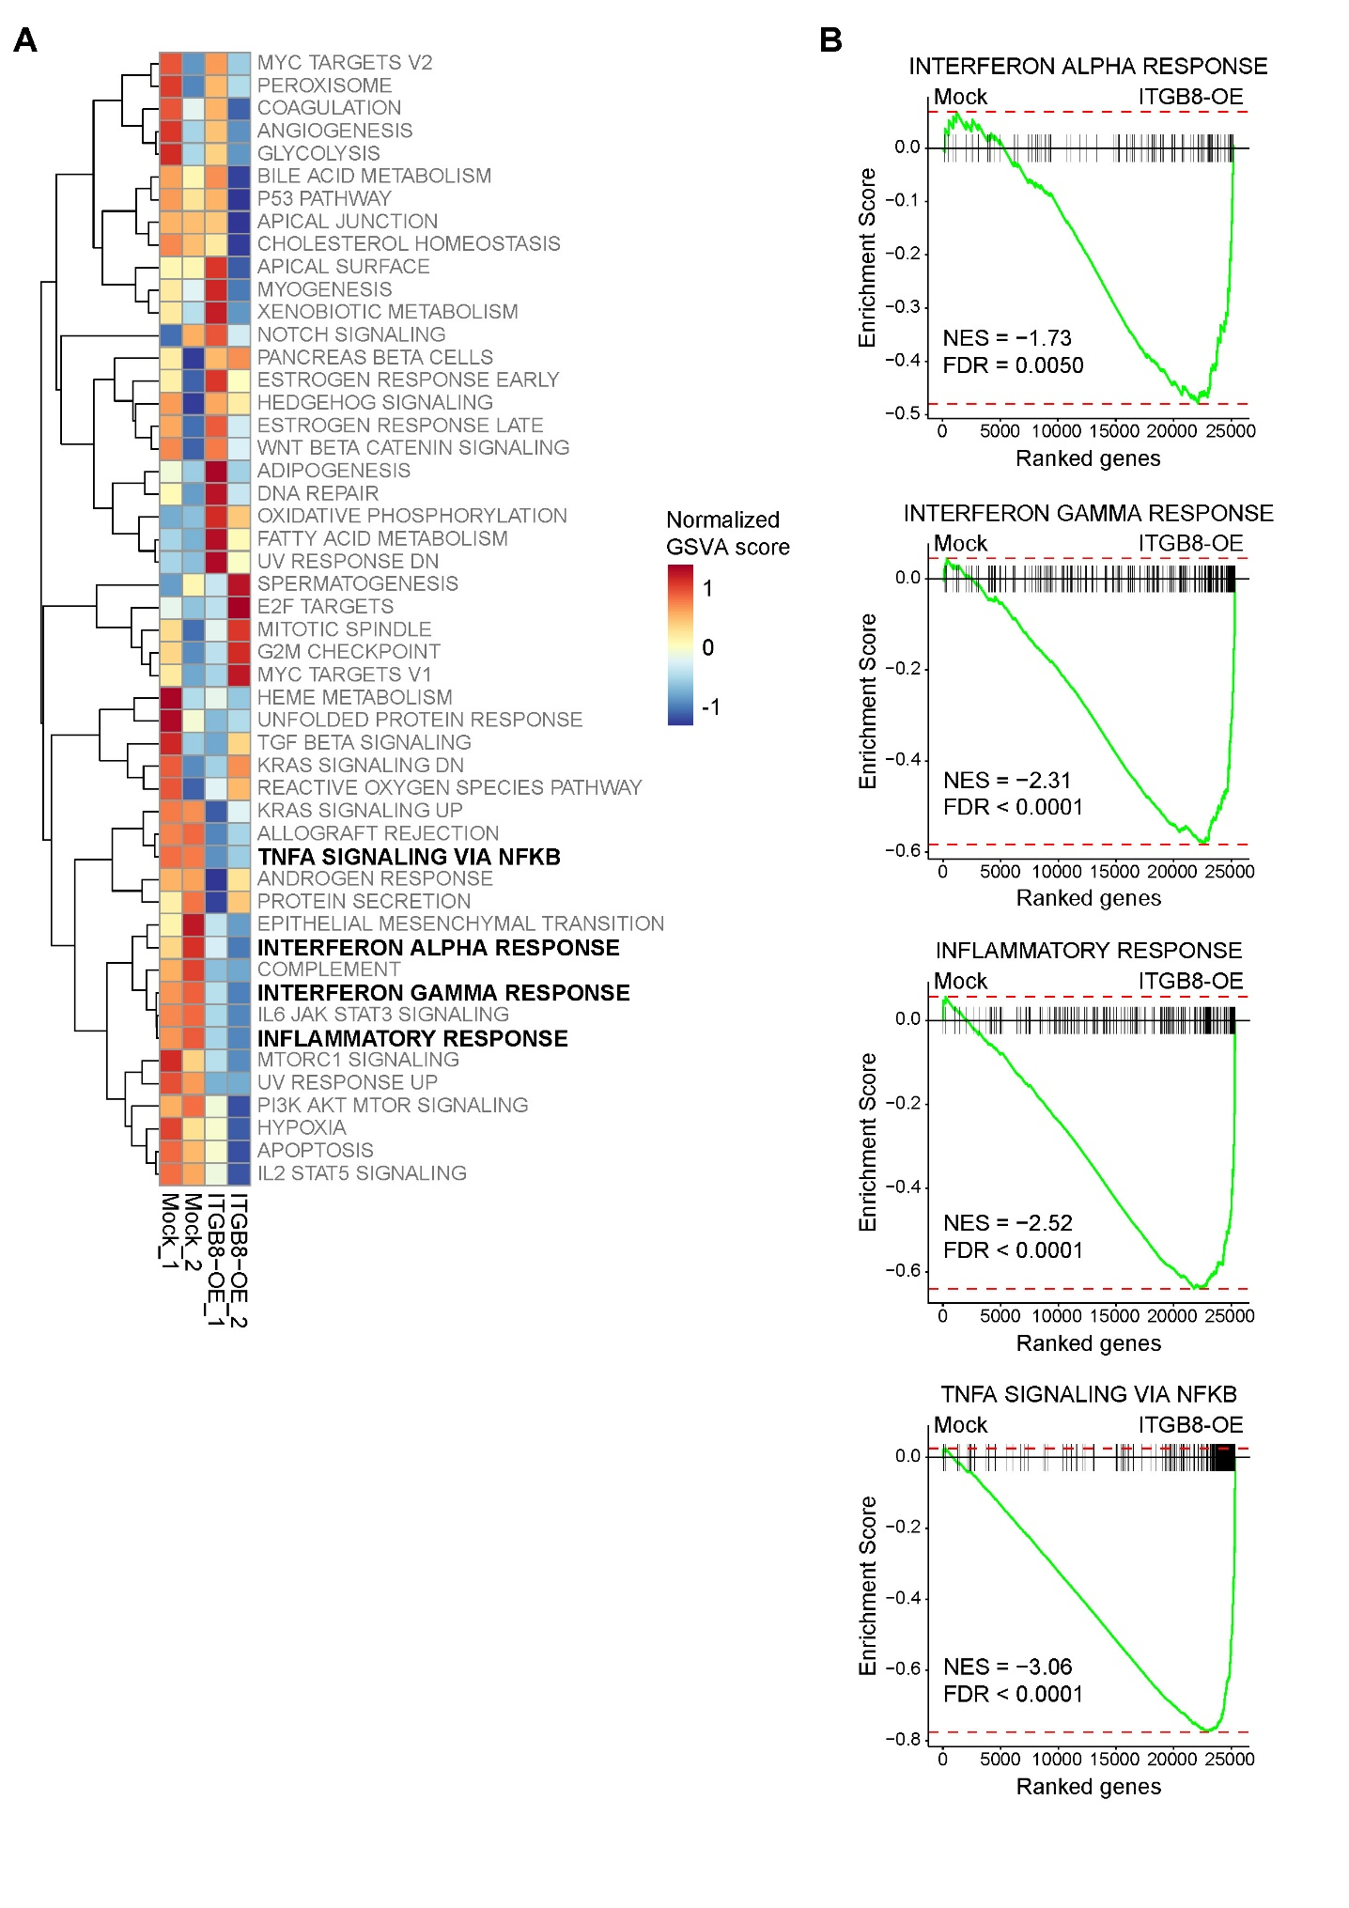
Fig S11. Transcriptomic impact of ITGB8 overexpression in MDA-MB-468 TNBC cells. (A) GSVA of RNA-sequencing data from two biological replicates each of mock (pEGFP)-transfected control and ITGB8-overexpressing (ITGB8-OE) MDA-MB-468 cells. GSVA of the Hallmark pathways reveals downregulation of inflammatory and immune response pathways, including TNF-alpha signaling via NF-kB, interferon alpha response, and interferon gamma response upon ITGB8 overexpression. (B) GSEA comparing ITGB8-OE versus mock samples showing significantly negative NES for interferon alpha response (NES = −1.73, FDR = 0.0050), interferon gamma response (NES = −2.31, FDR < 0.0001), inflammatory response (NES = -2.52, FDR < 0.0001), and TNF-alpha signaling via NF-kB (NES = -3.06, FDR < 0.0001) in ITGB8-OE cells compared to mock.

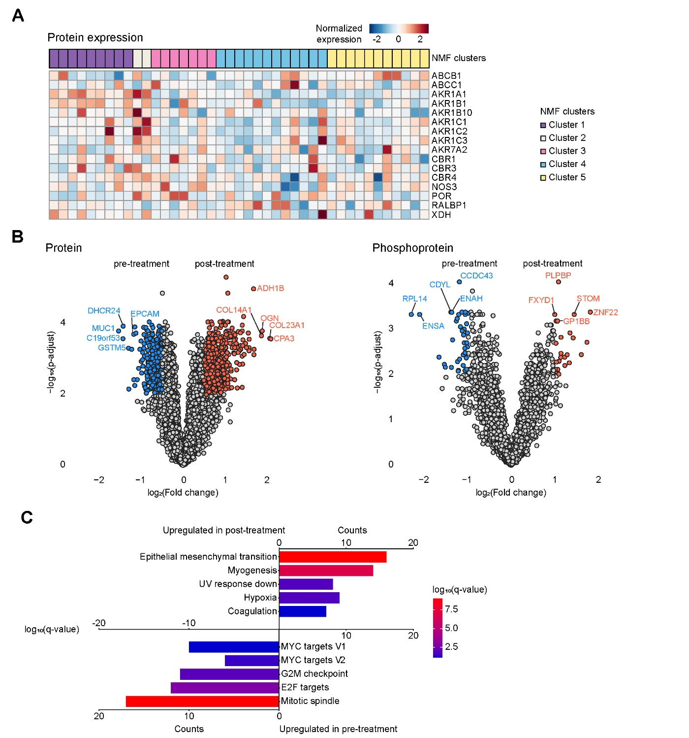
Fig S12. Proteomic and phosphoproteomic changes associated with chemotherapy resistance in TNBC. (A) Heatmap showing protein expression of xenobiotic metabolism-related genes across the TNBC cohort, stratified by the NMF cluster. (B) Volcano plots illustrating differentially expressed proteins (left) and phosphoproteins (right) between post-treatment and baseline tumor samples. Notable differentially expressed features are highlighted. (C) Bar plot showing the enriched Hallmark pathways in differentially expressed genes (DEGs) between post-treatment and baseline samples in RNA-seq expression data. The top five gene signatures are described.

Fig S13. Cell viability assay of barasertib and chemotherapy combination treatment in TNBC cells. Bar plot showing relative cell viability of HCC1937 and MDA-MB231 cells treated with (A) doxorubicin (0.12nM) or (B) carboplatin (100μM) in combination with barasertib (10nM) for 72 hours in the in vitro MTT assay. The results are from three biologic replicates, and the error bars indicate SEM. (C) The light microscope images (left) and the relative cell viability assay (right) of cancer organoid from a TNBC patient (SBO-72) treated with paclitaxel (30nM), barasertib (10nM), and their combination.
*P < 0.05 **P < 0.005 ***P < 0.0005 by Student’s t test

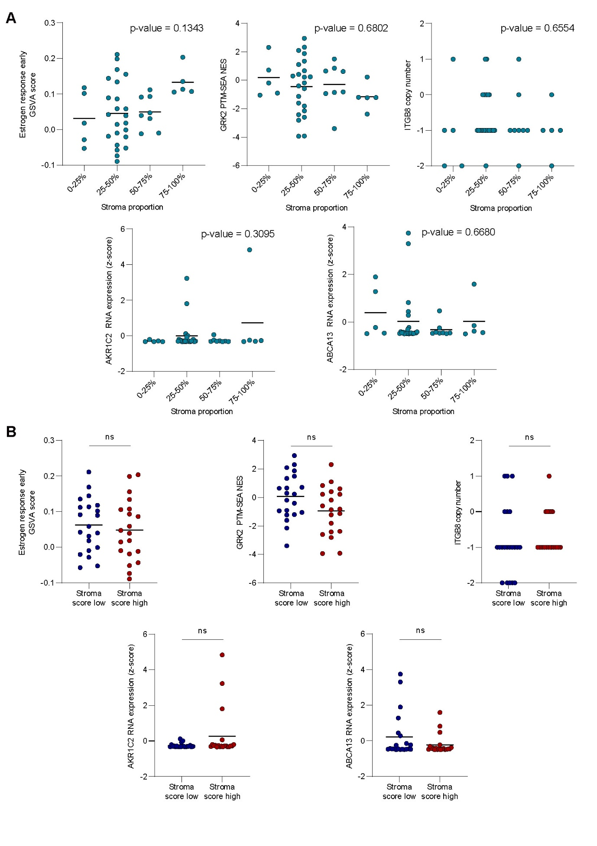
Fig S14. Assessment of stromal content and its effect on key resistance-associated factors in TNBC. (A) Expression of five key resistance factors—estrogen response signature (GSVA score), GRK2 PTM-SEA normalized enrichment score (NES), ITGB8 copy number, AKR1C2 RNA expression, and ABCA13 RNA expression—according to pathologist-assessed stromal proportion (≤25%, 26-50%, 51-75%, > 75%). No significant association was observed between stromal proportion and any resistance factor. (B) Comparison of the same resistance features between tumors with low versus high ESTIMATE stromal scores. No significant differences were identified across groups, and substantial intra-group variability remained, indicating that stromal content did not confound the relationship between these molecular features and chemotherapy response.

