Supplementary Figures
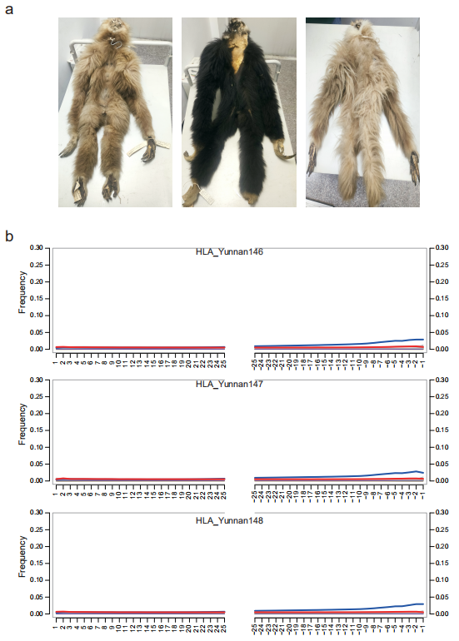
Fig. S1. Nucleotide deamination patterns of three Yunnan lar gibbons. a Photos of three Yunnan white-handed gibbon specimens, from left to right: HLA_Yunnan146, HLA_Yunnan148, HLA_Yunnan147. b Plots show the frequency of C>T (red) and G>A (blue) substitutions. The frequency of C>T substitutions is lower than that of G>A substitutions, which may be related to the library preparation method. The ratio (about 2-3% of the reads) is consistent with the age of the sample.

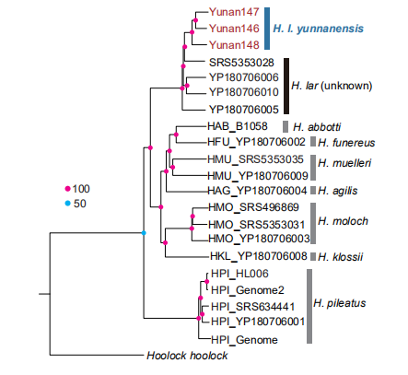
Fig. S2. Neighbor-Joining phylogeny from nuclear genome SNPs. Colored dots on nodes indicate the bootstrap values.

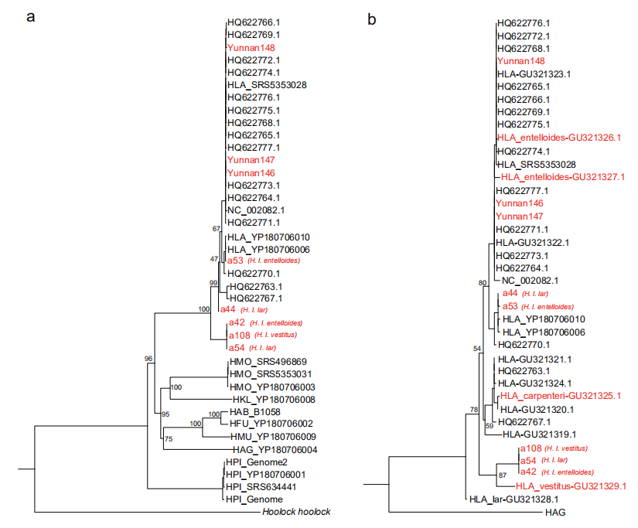
Fig. S3. Maximum-likelihood tree reconstructed from complete mitochondrial genomes (a) and cytb gene (b). Individuals with confirmed geographic origins are shown in red, and node labels represent bootstrap values.

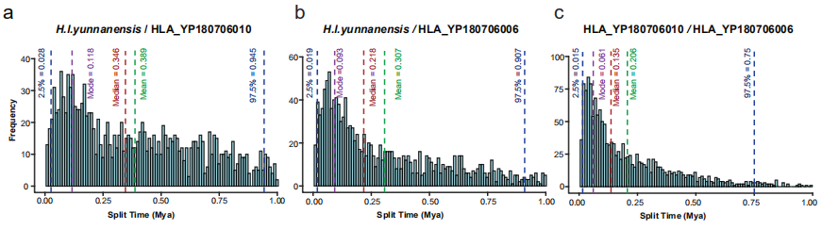
Fig. S4. Divergence time. Coal-HMM estimation of divergence time between H. l. yunnanensis, HLA_YP180706006 and HLA_YP180706010. The vertical lines represent (from left to right): the 2.5% quantile (blue), mode (purple), median (red), mean (green), and 97.5% quantile (blue) of the posterior distribution of divergence times.

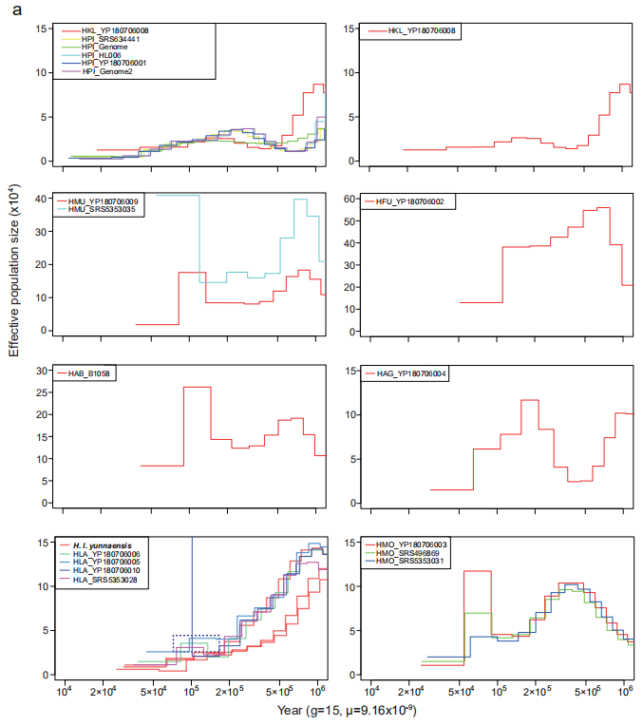
Fig. S5. Demographic history of all individual gibbons reconstructed using the MSMC2. The generation length (g) and the neutral mutation rate per generation (μ) were assumed to be 15 years and 9.16$×$10⁻⁹. The blue dashed box indicates a subset of H. lar individuals that exhibit evidence of mild population expansion.
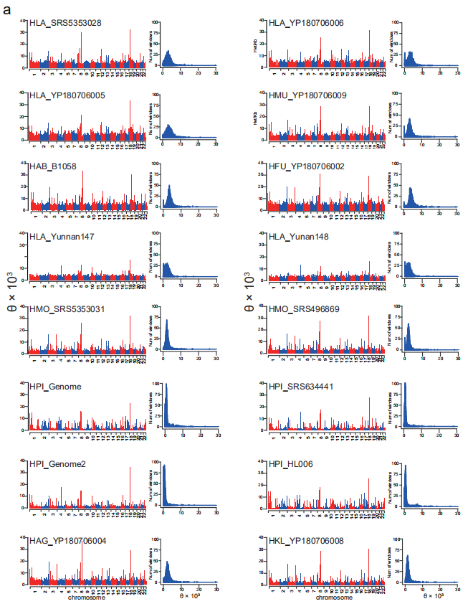
Fig. S6. Genome-wide distributions of heterozygosity in all individuals. In each panel: left, example bar plots showing heterozygosity in non-overlapping 1 Mb windows across the autosomal genome; right, histograms of per-window heterozygosity. Subspecies identities for H. lar specimens are provided in Additional file 2: Tables S3 and S4, where individuals labeled as "H. lar" indicate uncertain subspecies identity, while specific subspecies names denote confirmed taxonomic assignments.

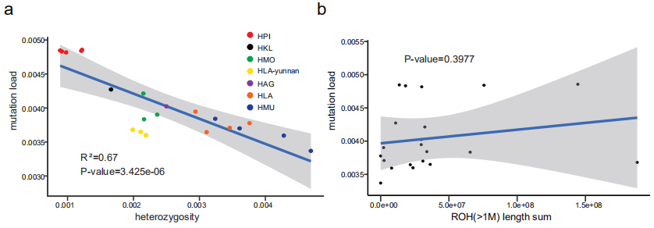
Fig. S7. Linear model based on the mutations load and heterozygosity (a) as well as the Runs of Homozygosity (ROH) (b), for all 21 gibbon individuals was analyzed. The R-squared value and the p-value indicate a significant negative correlation between mutations load and heterozygosity, while no significant correlation was observed with ROH. Colors represent different species/lineages: red - H. pileatus (HPI_Genome2, HPI_Genome, HPI_SRS634441, HPI_YP180706001, HPI_HL006); black - H. klossii (HKL_YP180706008); green - H. moloch (HMO_SRS496869, HMO_SRS5353031, HMO_YP180706003); yellow - H. l. yunnanensis (HLA_Yunnan146, HLA_Yunnan147, HLA_Yunnan148); purple - H. agilis (HAG_YP180706004); orange - H. lar of uncertain subspecies (HLA_YP180706005, HLA_YP180706006, HLA_YP180706010, HLA_SRS5353028); blue - Bornean gibbons (HMU_YP180706009, HMU_SRS5353035, HAB_B1058, HFU_YP180706002).

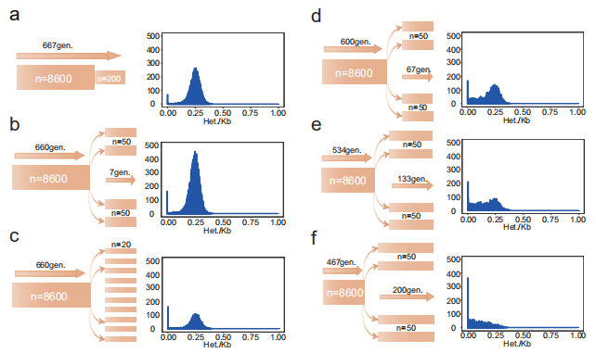
Fig. S8. Demographic models and corresponding distributions of window-based heterozygosity under six simulation scenarios. Panels a–f each show (left) the demographic model used in the simulation and (right) the resulting frequency distribution of heterozygosity across non-overlapping 1 Mb windows. a bottleneck ~100 years ago with no subsequent subdivision; b bottleneck ~100 years ago followed by subdivision into four subpopulations; c bottleneck ~100 years ago followed by subdivision into ten subpopulations; d bottleneck ~1,000 years ago with four subpopulations; e bottleneck ~2,000 years ago with four subpopulations; f bottleneck ~3,000 years ago with four subpopulations.

