Review History
First round of review
Reviewer 1

Comments to author:

In this manuscript, the authors introduce editABLE, an online tool designed to computationally aid in the design of base editing and prime editing strategies. The authors also demonstrate the application of this tool to design edits for correcting a pathogenic variant in the PKD1 gene, which is responsible for autosomal dominant polycystic kidney disease (ADPKD). Adenine base editing was tested in vitro as part of their demonstration. The topic is timely and interesting, as there is growing demand for CRISPR-Cas editing tools across various research fields. However, there are several major concerns that limit the novelty and utility of this manuscript:
1. Limited Scope of Editing Tools
While the authors mention that there are multiple editing strategies available, including base editing, prime editing, twin prime editing, and integrases, the editABLE tool is limited to the first two—base editing and prime editing. Expanding the tool to incorporate other emerging strategies, such as twin prime editing, would significantly enhance its utility.
2. Narrow Selection of CRISPR-Cas Orthologs for Base Editing
The tool only accounts for base editors that use Cas9 with NGG or NGN PAM recognition. However, numerous CRISPR-Cas orthologs have been developed and are widely used for base editing, such as SpRY, which has a near-PAM-less requirement (NRN or NGN). While including every individual editor is impractical, incorporating commonly used and broadly applicable editors like SpRY would greatly improve the tool's relevance and applicability.
3. Limitations in Prime Editing Design
Prime editing is inherently more complex than base editing, requiring precise customization of pegRNA designs, including variations in PBS (primer binding site) and RTT (reverse transcription template) lengths. However, the tool oversimplifies prime editing design, providing a single pegRNA with fixed PBS (14 bp) and RTT (14 bp) lengths, which may not be optimal for many experimental contexts. When I tested the tool's Prime Editing Design feature, I found it to be overly simplified and lacking the flexibility needed for practical applications. Additionally, the website directs users to the "PrimeDesign portal" for advanced usage. Unfortunately, this link (https://primedesign.pinellolab.partners.org/) is currently inaccessible, further reducing the utility of the tool for prime editing applications. Ensuring flexibility in pegRNA design and access to linked resources is essential for improving the tool's functionality.
Overall, while the tool addresses an important need and has potential, these limitations must be addressed to maximize its impact and utility for the research community.

Reviewer 2

Comments to author:
The paper includes a novel tool that aims at providing computationally validated CRISPR editors and guides RNAs based on user provided sequence data. The authors demonstrate the utility of the tool by applying it to ADPKD, identifying specific editing tools across the landscape of ADPKD mutations.
I think that the paper is too preliminary for publication.
Major:
----
1) There are dozens of papers about computational tools related to CRISPR editors. I expect to see an extensive review of these previous studies and extensive discussion about the need and advantages of the new tool in the light of the previous tools. If the format of the paper does not allow such a long review, you should put it in the supplementary.
2) To evaluate the tool, I expect to see large scale analysis of examples and not only one or two of them. The analysis should convince that the tool has advantages over previous tools.
3) The tool does not provide estimations of on-target and off-target efficiency.
4) The tool is based on a relatively old paper (PMID: 25184501) while according to my experience the performances of this previous study are low and there are better tools. This previous study is not clearly discussed and cited in the paper.
5) The authors should provide in the examples reported in the paper also the off-target predictions.

Authors Response
Point-by-point responses to the reviewers’ comments:

Dear Editor and Reviewers,

We thank the Editor and both Reviewers for their thoughtful and constructive critiques. In this revision, we have substantially expanded the scope of EditABLE to incorporate additional editing strategies (including Bxb1-integrase insertions and PRIME-Del deletions), clarified our treatment of PAM-flexible Cas9 orthologs, and integrated advanced prime editing design features directly into the tool. We have also broadened our review of existing computational editing tools and updated the on-target prediction algorithm. These suggested revisions strengthen the novelty, utility, and accessibility of EditABLE, directly addressing the Reviewers’ concerns while reinforcing the tool’s role as a comprehensive gateway tool for genome editing.

The primary gap that EditABLE fills in the genome editing community is the lack of a gateway tool for selecting the best genome editing strategy for a given mutation. As the Reviewers point out, dozens of tools exist for selecting guide RNAs that include many different PAM varieties and approaches. But the need for a gateway platform that compiles these individual editing and guide RNA design tools together is missing. This gap has been noted in several recent studies. For example, Jasieniecka and Domingues (2025) reviewed more than 45 tools spanning sgRNA design, off-target scoring, and related workflows, and concluded that there is a need for “integrated platforms that combine functionalities, reducing reliance on fragmented workflows” (1). Similarly, in the study Unlocking the Potential of CRISPR Tools and Databases for Precision Genome Editing, Saraswat and Ranjan (2025) surveyed major CRISPR tools and described their functionalities, including guide RNA design, off-target predictions, genome-wide screens, and data visualization. This study underscored the same gap, calling for more integrated, gateway CRISPR platforms (2). Together, these reviews demonstrate that while many specialized solutions exist, there is strong consensus that integrated, multitasking platforms like EditABLE are necessary and timely.

One very recent manuscript that was published last month (August 2025) has shown that other groups are already taking steps to address this gap in knowledge as outlined in the above review articles of providing a gateway tool for the gene editing community (3). In this publication, the authors describe, CRISPR-GPT, a plain language tool for generating guide RNAs for genome editing experiments. However, CRISPR-GPT lacks several functionalities, including some of the weaknesses with our previous version of EditABLE as outlined bThey the Reviewers in our original submission to Genome Biology. For example, CRISPR-GPT does not include functionality for large deletions or insertions. Based on helpful Reviewer feedback, we incorporated both functionalities into the new, revised form of EditABLE detailed in this resubmission. The other potential weaknesses with CRISPR-GPT are that use of large AI models is inherently prone to hallucinations and that these models are a black box. In contrast, the algorithms underlying EditABLE are clearly detailed in Supplementary Figure 1, providing transparent insights into how the tool works while also giving us the chance to continually update the tool as the CRISPR genome editing field continues to advance.

Using the helpful feedback from Reviewers, EditABLE is now a user-friendly gateway tool designed to be used by both novice and advanced users alike to fill the critical gap in the genome editing field of needing an integrated, multitasking platform with a well-defined, transparent algorithm.

Please see below our point-by-point responses in red:

Reviewer #1
In this manuscript, the authors introduce EditABLE, an online tool designed to computationally aid in the design of base editing and prime editing strategies. The authors also demonstrate the application of this tool to design edits for correcting a pathogenic variant in the PKD1 gene, which is responsible for autosomal dominant polycystic kidney disease (ADPKD). Adenine base editing was tested in vitro as part of their demonstration. The topic is timely and interesting, as there is growing demand for CRISPR-Cas editing tools across various research fields. However, there are several major concerns that limit the novelty and utility of this manuscript:

- Limited Scope of Editing Tools

While the authors mention that there are multiple editing strategies available, including base editing, prime editing, twin prime editing, and integrases, the EditABLE tool is limited to the first two—base editing and prime editing. Expanding the tool to incorporate other emerging strategies, such as twin prime editing, would significantly enhance its utility.

We appreciate the Reviewer’s suggestion regarding the scope of EditABLE. The original prime editing paper by Anzalone et al. (2019) demonstrated the capacity for precise small-scale modifications, specifically insertions as large as ~44 bp and deletions as large as ~80 to ~100 bp (4). EditABLE currently leverages prime editing for edits within these ranges. However, as noted, this leaves a gap for larger insertions and deletions.

In response, we have expanded EditABLE in two ways:

  - Large Insertions with Integrases/Twin Prime Editing Technology:
We updated the EditABLE web tool (EditABLE-app.stanford.edu) and algorithm to add functionality for large integrations using a prime editing-mediated BxbI integrase. Pandey et. al shows that using prime editing to insert Bxb1 attachment sites, followed by Bxb1 integrase-mediated integration, results in efficient site-specific large DNA integration, outperforming traditional prime-editing which is only efficient for insertions up to 44bp (4–6). Since prime editing is most efficient with insertion sizes up to 44 bp, EditABLE continues to use prime editing for insertions up to 44 bp and switches to prime editing-mediated BxbI integrase for insertions larger than 44 bp. By integrating this strategy into EditABLE, we now provide users with an option for larger insertions, to complement prime editing.
  - Large Deletions with PRIME-Del:
We also updated EditABLE to include support for large deletions that exceed the size that can be efficiently performed with standard prime editing. PRIME-Del, a strategy introduced by Choi et al. (2021), which employs paired pegRNAs to generate predictable and efficient kilobase-scale deletions, is a very efficient technology for large deletions, so we selected this for EditABLE given the spirit of being a gateway tool. Although the Reviewer in their critique above specifically requested that we add twin prime editing, PRIME-Del offers higher efficiency and accuracy compared to twin prime editing for deletion applications. As Choi and colleagues explain, “We reasoned that a pair of pegRNAs could be used to specify not only the sites that are nicked but also the outcome of the repair, potentially enabling programming of deletions longer than 100 bp. Here we demonstrate that this strategy, which we call PRIME-Del, induces the efficient deletion of sequences up to 10 kb in length with much higher precision than observed or expected with either the Cas9/paired-gRNA or PE3 strategies” (7).

Incorporating PRIME-Del into EditABLE provides researchers with seamless access to large-deletion capabilities directly within the tool.

We have now included examples and illustrations in Supplementary Note 2. By expanding beyond base and prime editing to include Bxb1-site and integrase insertions and PRIME-Del for deletions, EditABLE now supports a broader set of editing strategies. We believe that these additions directly address the Reviewer’s concern and ensure that EditABLE remains aligned with emerging advances in the genome editing field while still serving as a gateway tool.

- Narrow Selection of CRISPR-Cas Orthologs for Base Editing

The tool only accounts for base editors that use Cas9 with NGG or NGN PAM recognition. However, numerous CRISPR-Cas orthologs have been developed and are widely used for base editing, such as SpRY, which has a near-PAM-less requirement (NRN or NGN). While including every individual editor is impractical, incorporating commonly used and broadly applicable editors like SpRY would greatly improve the tool's relevance and applicability.

We acknowledge the Reviewer’s concern that EditABLE appears to account only for base editors using Cas9 with NGG or NGN PAM recognition. We agree with the Reviewer that numerous CRISPR-Cas orthologs have been developed and are widely used for base editing, including SpRY.

In response, we would like to clarify that EditABLE already incorporates SpRY within its algorithm. The Reviewer appears to have missed this as the details of EditABLE’s PAM selection process are shown in Supplementary Figure 1.
Because EditABLE is a gateway tool, it is designed to give the user the most efficient tool available for their intended edit. Therefore, EditABLE defaults to the standard SpCas9 editor, which utilizes an NGG PAM. If an NGG PAM cannot be found, it searches for NGN PAMs instead using the SpCas9-NG editor. Lastly, in cases where neither NGG and NGN sites are available, EditABLE defaults to the SpCas9-spRY editor using NRN or NYN PAMs. As NRN PAMs have been shown to be more efficient than NYN PAMs, we also start by searching for NRN before switching to NYN with the SpCas9-spRY editor (8). The rationale for taking this approach for the EditABLE algorithm is that for many genomic target sites, SpCas9 (NGG) generally exhibits the highest on-target editing efficiency, followed by SpCas9-NG, and then SpCas9-spRY. For example, one paper showed that at the C-MYC-GGG locus, SpCas9 (NGG) editors demonstrated 70-80% editing efficiency, SpCas9-NG editors demonstrated 50-60% editing efficiency, and SpCas9-spRY editors demonstrated 40-50% editing. (8)

Therefore, the EditABLE algorithm already incorporates the near PAMless SpCas9-spRY editor. We apologize for the lack of clarity. In response, we updated the main text to make this clearer.

- Limitations in Prime Editing Design

Prime editing is inherently more complex than base editing, requiring precise customization of pegRNA designs, including variations in PBS (primer binding site) and RTT (reverse transcription template) lengths. However, the tool oversimplifies prime editing design, providing a single pegRNA with fixed PBS (14 bp) and RTT (14 bp) lengths, which may not be optimal for many experimental contexts. When I tested the tool's Prime Editing Design feature, I found it to be overly simplified and lacking the flexibility needed for practical applications. Additionally, the website directs users to the "PrimeDesign portal" for advanced usage. Unfortunately, this link (https://primedesign.pinellolab.partners.org/) is currently inaccessible, further reducing the utility of the tool for prime editing applications. Ensuring flexibility in pegRNA design and access to linked resources is essential for improving the tool's functionality. Overall, while the tool addresses an important need and has potential, these limitations must be addressed to maximize its impact and utility for the research community.

We thank the Reviewer for their praise that EditABLE addresses “an important need.” We also thank them for highlighting the importance of having the ability to modify prime editing designs in a gateway tool. As noted, prime editing requires careful optimization of parameters, including primer binding site (PBS) length, reverse transcription template (RTT) length, and nicking distance, to achieve optimal efficiency. The original prime editing design guidelines, established by Anzalone et al. (2019), emphasized that pegRNA performance can vary widely depending on these parameters (4). For example, when they tested the ability of PE1 to introduce transversion point mutations at four additional genomic sites, editing efficiency was shown to vary based on PBS length, with maximal editing efficiencies ranging from 0.7 to 5.5% across these sites.

In response, we have implemented two major updates to EditABLE:

  - Updated and Restored PrimeDesign Access:

The PrimeDesign algorithm, which allows users to customize the PBS and RTT lengths, is already integrated into EditABLE. However, the PrimeDesign website that the Reviewer lists (https://primedesign.pinellolab.partners.org/) was maintained by the Pinello Lab but is no longer being maintained by them so the link doesn't work. We have now updated and re-hosted the PrimeDesign algorithm through our own Google Cloud account, so that we are not reliant on external labs for access. The new website link for accessing PrimeDesign is: https://prime-design-222753790581.us-east4.run.app
  - Direct Integration of PrimeDesign Functionalities:

To further improve usability and avoid the need for an external website, we also integrated PrimeDesign directly into EditABLE. Our updated EditABLE website (editable-app.stanford.edu) still gives a default output using the standard PBS and RTT length of 14 bp, which may be ideal for novice users, whereas the direct integration of PrimeDesign now provides the option for more advanced users to adjust PBS length, RTT length, and nicking distance, to explore alternative pegRNA spacers while also visualizing predicted secondary structures without needing to go to a separate website.

Reviewer #2

The paper includes a novel tool that aims at providing computationally validated CRISPR editors and guides RNAs based on user provided sequence data. The authors demonstrate the utility of the tool by applying it to ADPKD, identifying specific editing tools across the landscape of ADPKD mutations. I think that the paper is too preliminary for publication.

Major:
----
- There are dozens of papers about computational tools related to CRISPR editors. I expect to see an extensive review of these previous studies and extensive discussion about the need and advantages of the new tool in the light of the previous tools. If the format of the paper does not allow such a long review, you should put it in the supplementary.

We appreciate the Reviewer’s request for a more extensive review of prior computational tools related to CRISPR editors.

In response, we would like to clarify that we did include such a review in the supplement (Supplementary Table 1, reproduced below), which compares EditABLE’s features against existing guide RNA design tools. This table highlights the key dimensions where EditABLE differs, with primary references selected to represent the tools most similar in scope and functionality.

In response to the Reviewer’s feedback, we have further expanded Supplementary Table 1 to include a broader set of studies and references and to contextualize EditABLE’s role relative to the wide range of existing computational tools. These additions ensure a comprehensive overview of prior work and a clearer articulation of the advantages of EditABLE as a “gateway” tool that integrates multiple editing strategies into a single accessible platform.

Feature | EditABLE | PnB Designer | Benchling | Prime  Design | CHOPCHOP | Cas-OFFinder | CRISPOR | CRISPick | GenCRISPR sgRNA Design Tool | CRISPR GPT
Customize base editing window | ✓ | ✓ | X | X | X | X | X | X | X | ✓
Customize PAM selection | ✓ | ✓ | ✓ | ✓ | ✓ | ✓ | ✓ | ✓ | ✓ | ✓
Predict off-target and on-target editing efficiency. | ✓ | X | ✓ | X | ✓ | ✓ | ✓ | ✓ | ✓ | ✓
Visualize prime editing guide RNAs | ✓ | X | X | ✓ | X | X | X | X | X | ✓
Visualize base editing guide RNAs (editing window, PAM, bystander edits) | ✓ | X | X | X | X | X | X | X | X | ✓
Identify and visualize base editing bystander edits | ✓ | X | X | X | X | X | X | X | X | X
Links to Addgene pages for plasmids for recommended editors and guide RNAs | ✓ | X | X | X | X | X | X | X | X | X
Step-by-step cloning protocol to experimentally validate guide RNAs for base and prime editing. | ✓ | X | X | X | X | X | X | X | X | ✓
Guides users on which editing technology to use (prime, base, integrases, etc.) | ✓ | X | X | X | X | X | X | X | X | X
Identify reagents for large deletions using PRIMEdel | ✓ | X | X | X | X | X | X | X | X | X
Identify editing reagents for large insertions with BxbI integrases | ✓ | X | X | X | X | X | X | X | X | X
Supplementary Table 1. Full list of EditABLE features compared to existing guide RNA design tools. Although several web-based tools exist for each feature, only the primary references are shown. This table describes 10 relevant computational CRISPR tools covering base editing, prime editing, off-target prediction, PAM flexibility, editing outcome analysis, and guide cloning resources. Most existing tools focus on one or a few dedicated functions, for example, CHOPCHOP emphasizes flexible gRNA design and PAM selection, Cas-OFFinder provides fast off-target searches, CRISPOR offers combined design and scoring, CRISPResso focuses on outcome analysis, PegFinder targets prime editing and PrimeDEL focuses on large deletions. CRISPR-GPT allows users to design guide RNAs in plain English, but it does not include capabilities for PRIME del or integrase-mediated insertions (3). In contrast, EditABLE integrates tasks and acts as a gateway interface, increasing the accessibility and streamlining processes. This directly addresses the needs outlined by several recent reviews, including Jasieniecka & Domingue (2025) and Saraswat & Ranjan (2025), which call for “integrated platforms that combine functionalities, reducing reliance on fragmented workflows” (1,2).

- To evaluate the tool, I expect to see large scale analysis of examples and not only one or two of them. The analysis should convince that the tool has advantages over previous tools.

We thank the Reviewer for emphasizing the importance of large-scale evaluation to demonstrate the advantages of EditABLE.

In response, we would like to clarify that such analyses were already included in the Supplement. Specifically, Supplementary Note 2 provides multiple examples of input and output from EditABLE under a range of editing contexts (base editing with different PAMs, prime editing, mouse and human disease mutations, and clinically relevant variants such as the sickle cell mutation and Hutchinson–Gilford progeria syndrome). These examples are presented with screenshots of expected outputs to illustrate the tool’s scalability and robustness. We apologize that this was not clear previously.

In addition, Supplementary Table 4 contains a batch input dataset and Supplementary Table 5 shows the corresponding large-scale output from that batch input, both directly downloaded from EditABLE. This further demonstrates EditABLE’s ability to handle multiple simultaneous edits.

- The tool does not provide estimations of on-target and off-target efficiency.

We thank the Reviewer for highlighting this important aspect of a genome editing tool. We would like to clarify that EditABLE did provide on-target and off-target efficiency estimates for base editing. We apologize that this was not clear previously. These are displayed in the user interface under the “Predicted Editing Efficiency” and “Off-Target Summary” sections as well as in the examples in the Supplement.

In response, we have attached a screenshot below, with these parts boxed in red.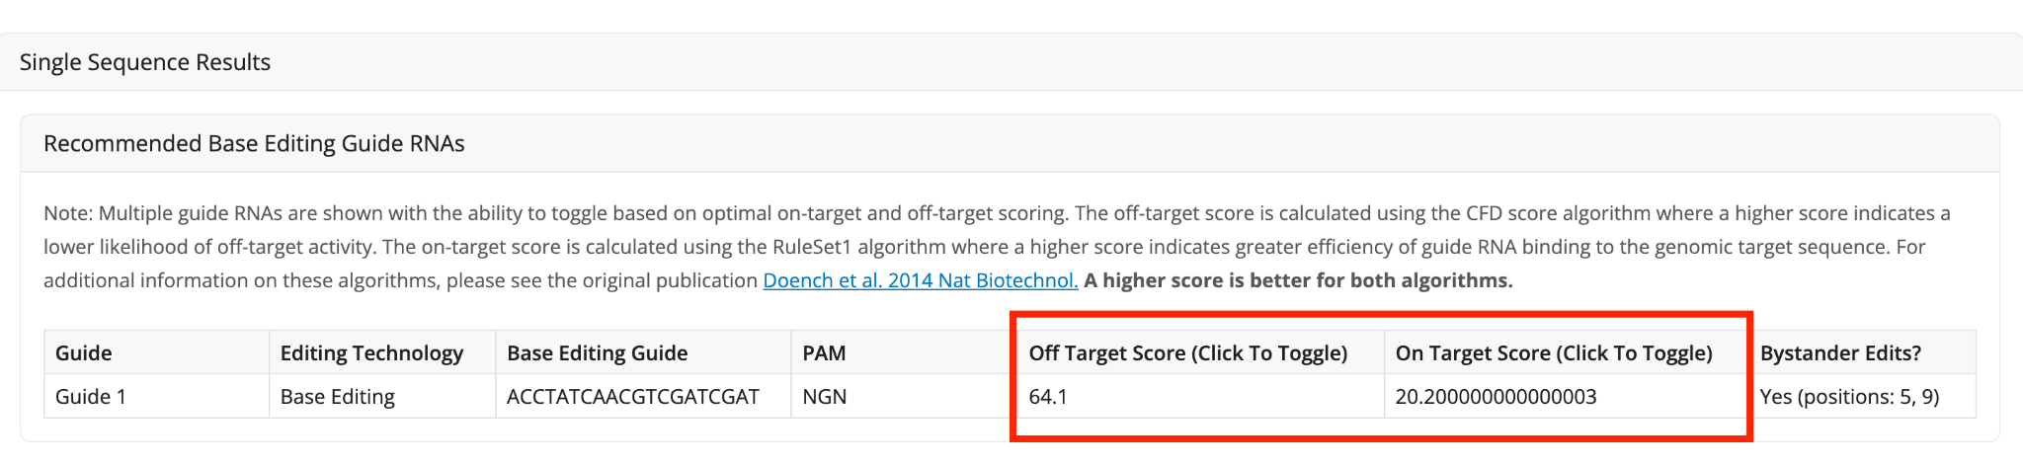
For prime editing, on-target and off-target predictions are not included. This reflects the fact that accurate prediction of prime editing outcomes remains highly complex. Prime editing outcomes depend on multiple factors, including pegRNA spacer design, primer binding site (PBS), reverse transcription template (RTT), and chromatin context, which together make models unreliable. Other commonly used tools similarly do not provide prime editing efficiency predictions, highlighting that this is a broader challenge in the field.

Recent work has introduced early machine learning models such as Easy-Prime, PRIDICT2, PrimeNet, and DeepPrime, which attempt to predict prime editing efficiency. However, these approaches remain limited in scope (e.g., restricted to specific pegRNA types, edit sizes, or cell contexts) and are not yet robust enough for seamless integration into a gateway platform like EditABLE. We have also clarified this point in the manuscript.

- The tool is based on a relatively old paper (PMID: 25184501) while according to my experience the performances of this previous study are low and there are better tools. This previous study is not clearly discussed and cited in the paper.

We thank the Reviewer for bringing this to our attention. We acknowledge that the Rule Set 1 algorithm from Doench et al. (2014) is now outdated for on-target efficiency prediction (9). In response, we have updated EditABLE to incorporate Rule Set 3 (RS3) from DeWeirdt et al. (2022), which has demonstrated improved performance in on-target efficiency prediction (10). Importantly, RS3 is a machine-learning model with a gradient boosting framework from LightGBM and has tracrRNA identity features, a step up from the logistic regression algorithm of Rule Set 1 or even the Gradient-boosted regression trees of Rule Set 2. RS3 was developed with 46,526 unique context sequences from 7 datasets a much larger dataset than the 1841 sgRNAs for 9 genes that Rule Set 1 was developed on (11). Due to this, RS3 is superior to Rule Set 1 or 2 for sgRNA activity predictions. This superiority is quantitatively supported by Rule Set 3 significantly outperforming all other models, including Rule Set 2, with a t-test p-value of less than 0.002, indicating a high statistical confidence in its improved prediction capabilities (10).
Regarding EditABLE’s off-target scoring algorithm, although the gene editing community has largely shifted to newer machine-learning models for on-target activity prediction (e.g. RS3), widely used web tools still rely on the original 2016 off-target scoring methods (MIT/CFD) as their default (e.g. CHOPCHOP, CRISPOR) (9).

In response, integrating RS3 into our platform for on-target predictions while continuing to use the CFD algorithm for off-target predictions aligns EditABLE with current best practices in the field.

- The authors should provide in the examples reported in the paper also the off-target predictions.

Thank you for your helpful feedback, we agree that this is an important part for this study, and we have already integrated this into EditABLE. We apologize that this was not clear previously. See screenshot below showing the off-target prediction on the website. Off-target predictions are also shown in the examples in Supplementary Note 2.

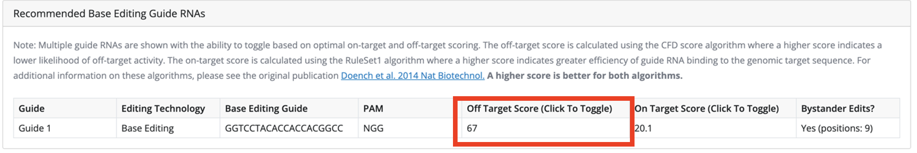

References

1. Jasieniecka A, Domingues I. CRISPR-Cas9 and Its Bioinformatics Tools: A Systematic Review. Curr Issues Mol Biol. 2025 Apr 27;47(5):307.
2. Saraswat P, Ranjan R. Unlocking the potential of CRISPR tools and databases for precision genome editing. Front Plant Sci. 2025 July 21;16:1563711.
3. Qu Y, Huang K, Yin M, Zhan K, Liu D, Yin D, et al. CRISPR-GPT for agentic automation of gene-editing experiments. Nat Biomed Eng [Internet]. 2025 July 30 [cited 2025 Nov 12]; Available from: https://www.nature.com/articles/s41551-025-01463-z
4. Anzalone AV, Randolph PB, Davis JR, Sousa AA, Koblan LW, Levy JM, et al. Search-and-replace genome editing without double-strand breaks or donor DNA. Nature. 2019 Dec 5;576(7785):149–57.
5. Anzalone AV, Gao XD, Podracky CJ, Nelson AT, Koblan LW, Raguram A, et al. Programmable deletion, replacement, integration and inversion of large DNA sequences with twin prime editing. Nat Biotechnol. 2022 May;40(5):731–40.
6. Pandey S, Gao XD, Krasnow NA, McElroy A, Tao YA, Duby JE, et al. Efficient site-specific integration of large genes in mammalian cells via continuously evolved recombinases and prime editing. Nat Biomed Eng. 2024 June 10;9(1):22–39.
7. Choi J, Chen W, Suiter CC, Lee C, Chardon FM, Yang W, et al. Precise genomic deletions using paired prime editing. Nat Biotechnol. 2022 Feb;40(2):218–26.
8. Zhang W, Yin J, Zhang-Ding Z, Xin C, Liu M, Wang Y, et al. In-depth assessment of the PAM compatibility and editing activities of Cas9 variants. Nucleic Acids Res. 2021 Sept 7;49(15):8785–95.
9. Doench JG, Fusi N, Sullender M, Hegde M, Vaimberg EW, Donovan KF, et al. Optimized sgRNA design to maximize activity and minimize off-target effects of CRISPR-Cas9. Nat Biotechnol. 2016 Feb;34(2):184–91.
10. DeWeirdt PC, McGee AV, Zheng F, Nwolah I, Hegde M, Doench JG. Accounting for small variations in the tracrRNA sequence improves sgRNA activity predictions for CRISPR screening. Nat Commun. 2022 Sept 6;13(1):5255.
11. Chen L, Liu G, Zhang T. Integrating machine learning and genome editing for crop improvement. aBIOTECH. 2024 Feb 29;5(2):262–77.

Second round of review
Reviewer 1
Thanks to the authors for the revised manuscript. It includes additional features such as Bxb1-integrase insertions, PRIME-Del deletions, and PAM-flexible Cas9 orthologs, continuing to leverage and build upon the existing prime editing platform. I will defer to the editor to determine whether the manuscript now meets the standard for publication in Genome Biology.

Reviewer 2

The following are the current comments:

- The following link does not work (example 3)

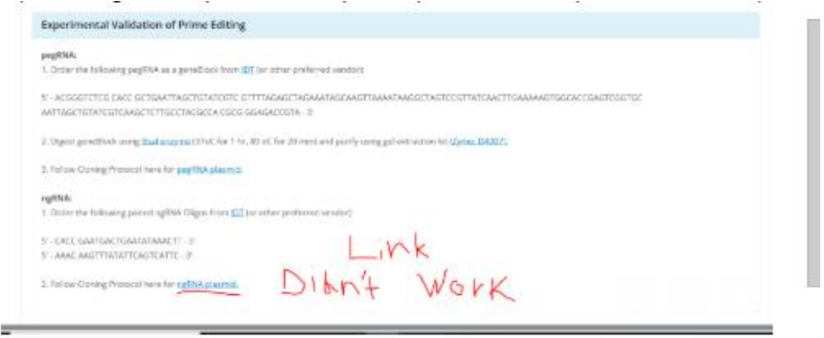

2) it is not clear to me why the following tool for on/off target efficiency for prime editing is not used: https://www.nature.com/articles/s41596-025-01244-7
3) They did not compare their tool to beditor
4) In the table in the supplementary they claim that they provide prediction of efficiency

Authors Response
Point-by-point responses to the reviewers’ comments:

Dear Editor and Reviewers,

We thank the Editor and Reviewers for their thoughtful re-review of our manuscript following our resubmission as a major revision. In response to our resubmission, the Editor wrote “the reports [from Reviewers] are broadly favorable, so we remain interested in publishing the manuscript.”

However, the Editor also wrote that “several issues raised by Referee #2 in this round require further clarification and correction before we can make a firm commitment to publication. In particular, we recommend that you add comparison(s) with PRIDICT and ePRIDICT for on and off target efficiency assessment, as well as beditor. In addition, please resolve the concerns raised about the claim of providing efficiency predictions in Supplementary Table 1. Finally, we note that the speed and responsiveness of the associated web application is problematic and we ask that you ensure the website loads reliably. Referee #2’s comment about the non functional link in Supplementary Example 3 might be linked to this as well. When revising your manuscript, please ensure that all the points raised by both referees are addressed.”

In this rebuttal, we have included point-by-point responses to both Reviewers below in red:

Reviewer #1

“Thanks to the authors for the revised manuscript. It includes additional features such as Bxb1-integrase insertions, PRIME-Del deletions, and PAM-flexible Cas9 orthologs, continuing to leverage and build upon the existing prime editing platform. I will defer to the editor to determine whether the manuscript now meets the standard for publication in Genome Biology.”

We thank the Reviewer for commending our newly added features and improvements to EditABLE, including adding compatibility for Bxb1-integrase insertions, PRIME-Del deletions, and PAM-flexible Cas9 orthologs and building upon the existing prime editing platform.

Reviewer #2

- The following link does not work (example 3)
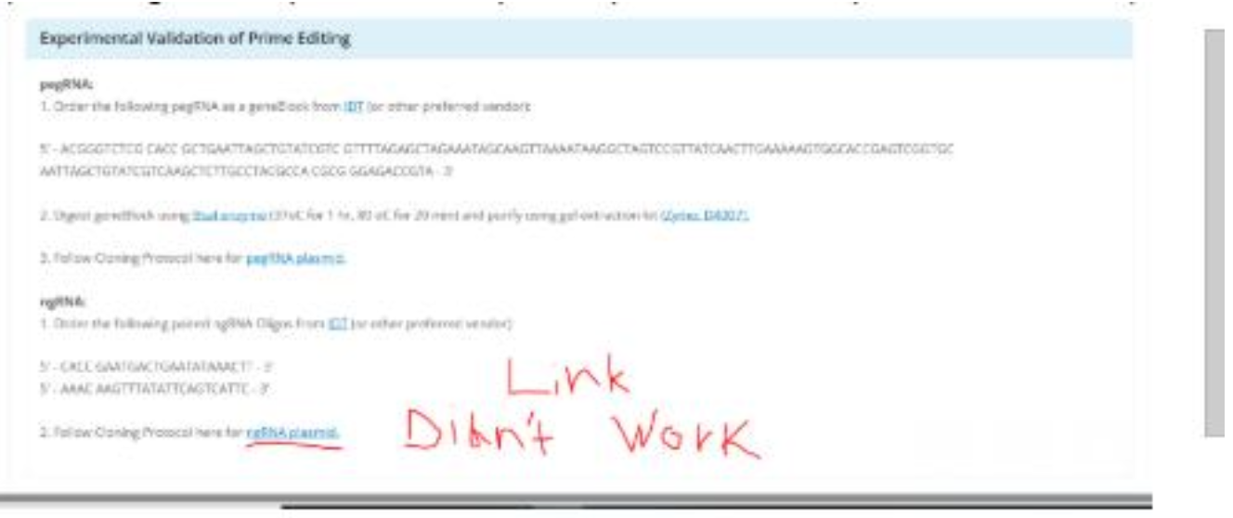

We thank the Reviewer for noting this issue. We have corrected the link and confirmed the new link works across multiple browsers. Please clear your web cache before accessing the EditABLE web app (editable-app.stanford.edu) to ensure the corrected version of the site loads.

- It is not clear to me why the following tool for on/off target efficiency for prime editing is not used: https://www.nature.com/articles/s41596-025-01244-7

We thank the Reviewer for citing this helpful publication, which details two machine learning models (PRIDICT2.0, ePRIDICT) for predicting the most efficient prime editing guide RNAs (1).

In our previous version of EditABLE, we did not include on-target and off-target predictions for prime editing. Our reasoning for this was that accurate prediction of prime editing outcomes is highly complex as prime editing outcomes depend on multiple factors, including prime editing guide RNA spacer design, primer binding site (PBS), reverse transcription template (RTT), and chromatin context. However, as the Reviewer points out, recent work has introduced machine learning models such as PRIDICT2 and ePRIDICT, which despite their limitations, are currently some of the best computational tools available for predicting prime editing outcomes in silico.

Therefore, we agree with the Reviewer that directly integrating PRIDICT2.0 and/or ePRIDICT into the EditABLE web tool would significantly improve EditABLE’s functionality. We believe integration of PRIDICT2.0 and/or ePRIDICT improves functionality for advanced users without compromising accessibility for novice/intermediate users or altering EditABLE’s role as a gateway tool for the genome editing community. This integration into EditABLE is now complete and can be accessed by clicking the “Predict Efficiency with PRIDICT 2.0” button shown in orange below within the EditABLE web tool (accessible at editable-app.stanford.edu). This integration is also shown in a newly created Supplementary Figure 6.
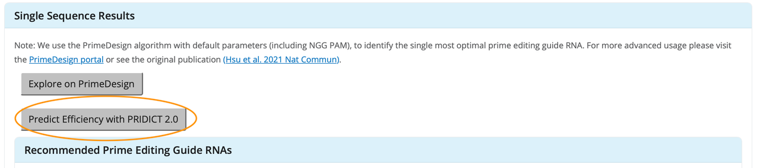
After clicking the button, the PRIDICT 2.0 webtool appears, which includes an option to use PRIDICT2.0 or ePRIDICT for prime editing guide RNA predictions. Adding PRIDICT 2.0 integration directly into the EditABLE web application now gives advanced users the choice of using PrimeDesign, PRIDICT 2.0, or ePRIDICT for optimizing prime editing guide RNA design.
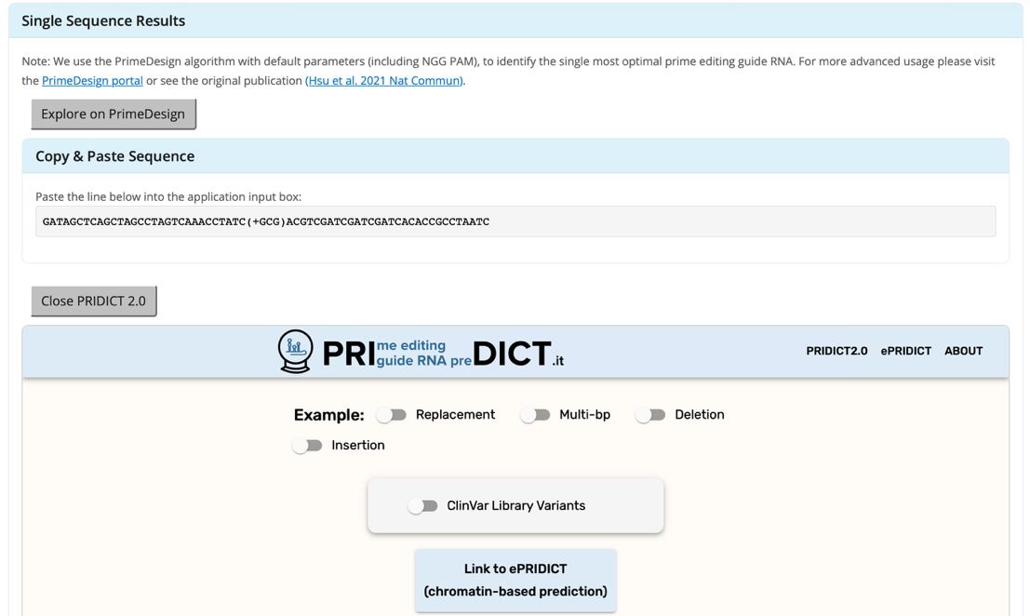
- They did not compare their tool to bEditor

We thank the Reviewer for this helpful suggestion. We agree that adding a comparison of EditABLE vs. bEditor would strengthen the manuscript by more clearly defining EditABLE’s role within the landscape of available computational tools for predicting genome editing outcomes. Therefore, we have added bEditor to the comparison table shown in Supplementary Table 1. We also added comparisons to PRIDICT2.0 and ePRIDICT to Supplementary Table 1 in accordance with the Reviewer’s feedback above.

- In the table in the supplementary they claim that they provide prediction of efficiency.

We thank the Reviewer for highlighting this important distinction. For base editing, EditABLE calculates an on-target efficiency score using the RuleSet3 algorithm and an off-target efficiency score using the CFD score algorithm. EditABLE allows advanced users to rank guide RNAs based on the on-target and off-target scores generated by these algorithms. However, we agree with the Reviewer that this is not the same as predicting the on-target or off-target editing efficiencies on an absolute scale from 0% to 100%. Therefore, we have amended both Supplementary Table 1 and the main manuscript text to clarify this point.

In Supplementary Table 1, we changed the row that previously wrote “Predicts on-target and off-target editing efficiency” to “Ranks guide RNAs based on predicted on-target and off-target efficiency scores.” This change now makes it clear that EditABLE’s capabilities include guide RNA ranking based on predicted on-target and off-target scores, but that these capabilities do NOT include absolute predictions of on-target or off-target efficiencies.

References

1. Mathis N, Marquart KF, Allam A, Krauthammer M, Schwank G. Systematic pegRNA design with PRIDICT2.0 and ePRIDICT for efficient prime editing. Nat Protoc. 2025 Aug 14. doi:10.1038/s41596-025-01244-7

