Additional file 1: Supplemental Figures
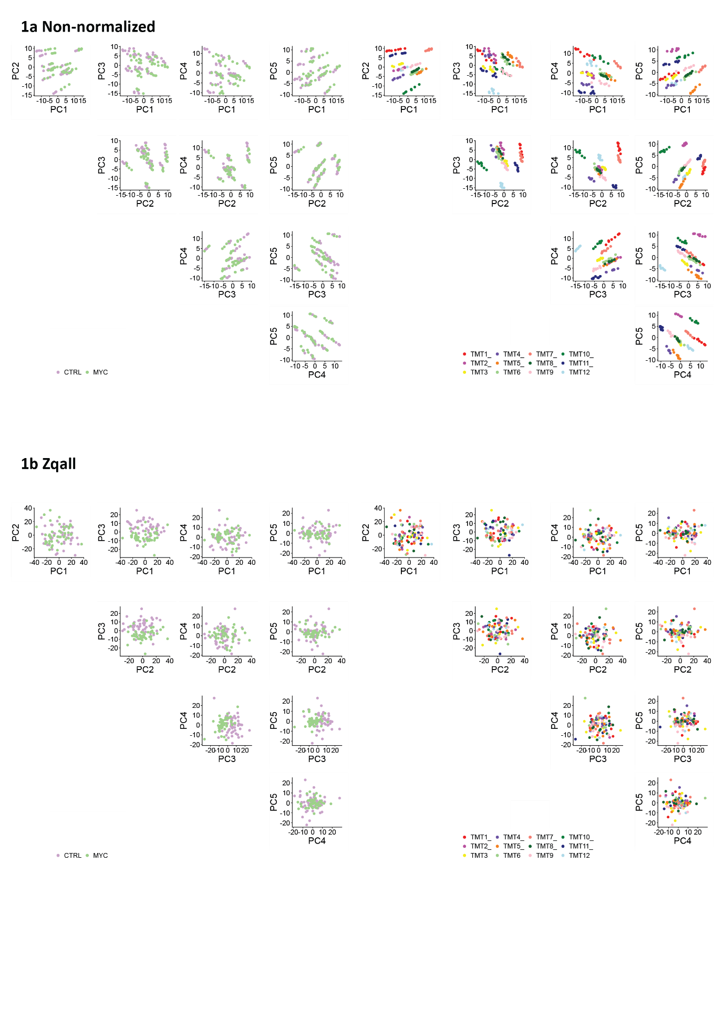
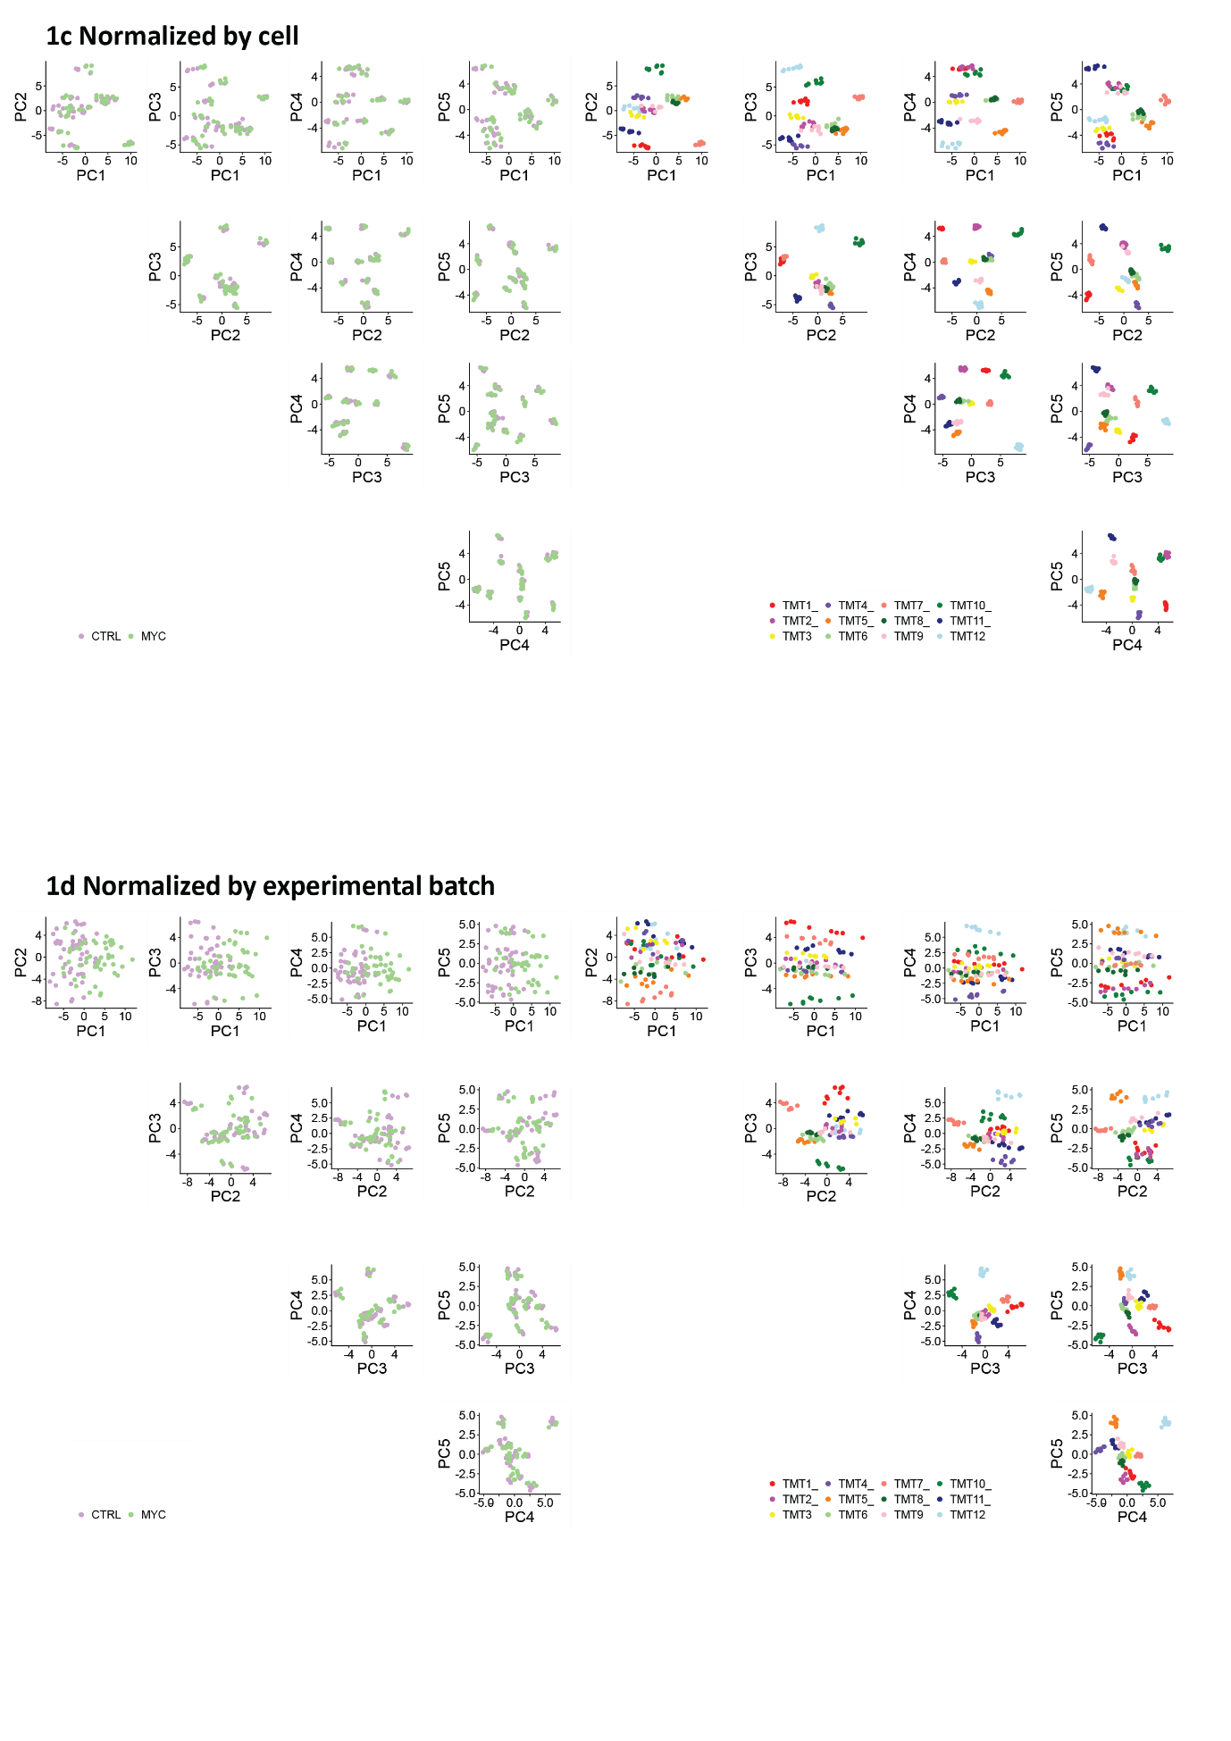

Fig. S1. PCA of single-cell proteomics data normalized by different criteria. 1a. PCA representing non-normalized single-cell proteomics data, showing the separation of cells labelling the TMT batches on the right and the cellular type on the left. The first principal component (PC1) explained 15.3% of the total variance, while PC2, 3, 4 and 5 accounted for an additional 11.7%, 10.8%, 10.4% and 8.6%, respectively. 1b. PCA separation of single-cell proteomics data when using the Zqall values, showing the separation of cells based on TMT batches on the right and based on cell type on the left. This figure is a general overview of the PCAs shown in Figure 2. The PC1 explained 26.5% of the total variance, while PC2, 3, 4 and 5 accounted for an additional 18.1%, 8%, 6.1% and 4.2%, respectively. 1c. PCA representing the distribution of single-cardiomyocytes data normalized by cell, showing the separation of cells when labelling TMT batches on the right and labelling the cell type on the left. The PC1 explained 15.6% of the total variance, while PC2, 3, 4 and 5 accounted for an additional 11.7%, 10.3%, 9% and 8.1%, respectively.1d. PCA representing the distribution of single-cell proteomics data normalized by experimental batch, showing the separation of cells when highlighting the TMT batches on the right and the cell type on the left. The PC1 explained 21.6% of the total variance, while PC2, 3, 4 and 5 accounted for an additional 13.5%, 8%, 7.3% and 6.4%, respectively.

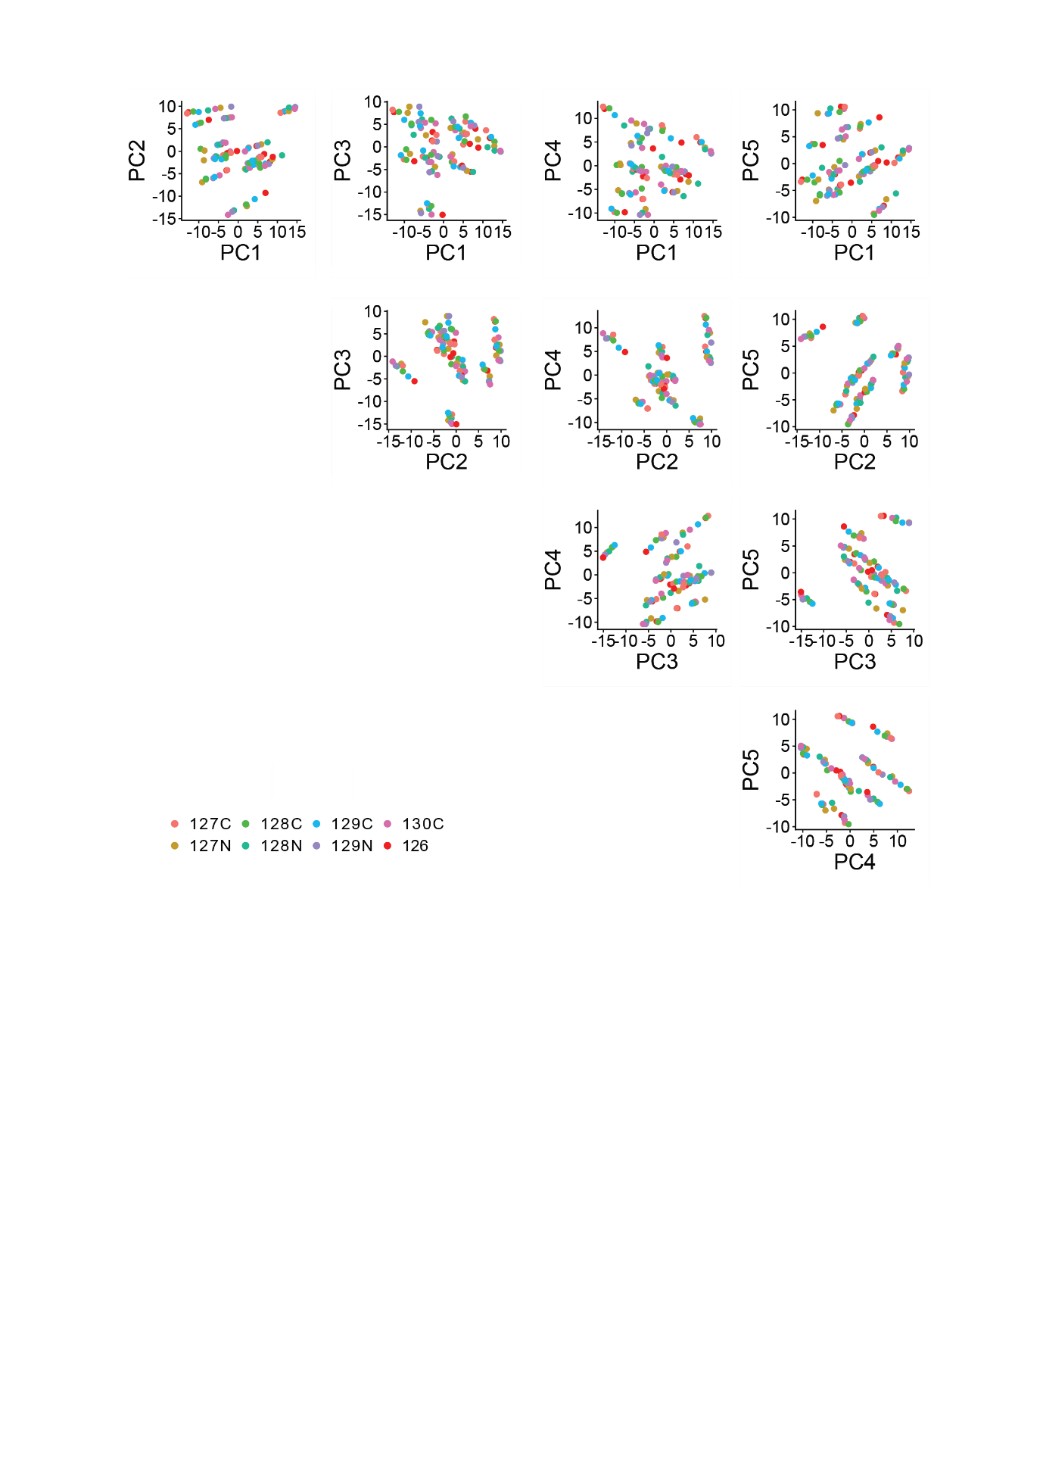
Fig. S2. PCA of non-normalized single-cell proteomics data. PCA representing non-normalized single-cell proteomics data, showing the separation of cells labelling the TMT channels. The first principal component (PC1) explained 15.3% of the total variance, while PC2, 3, 4 and 5 accounted for an additional 11.7%, 10.8%, 10.4% and 8.6%, respectively.

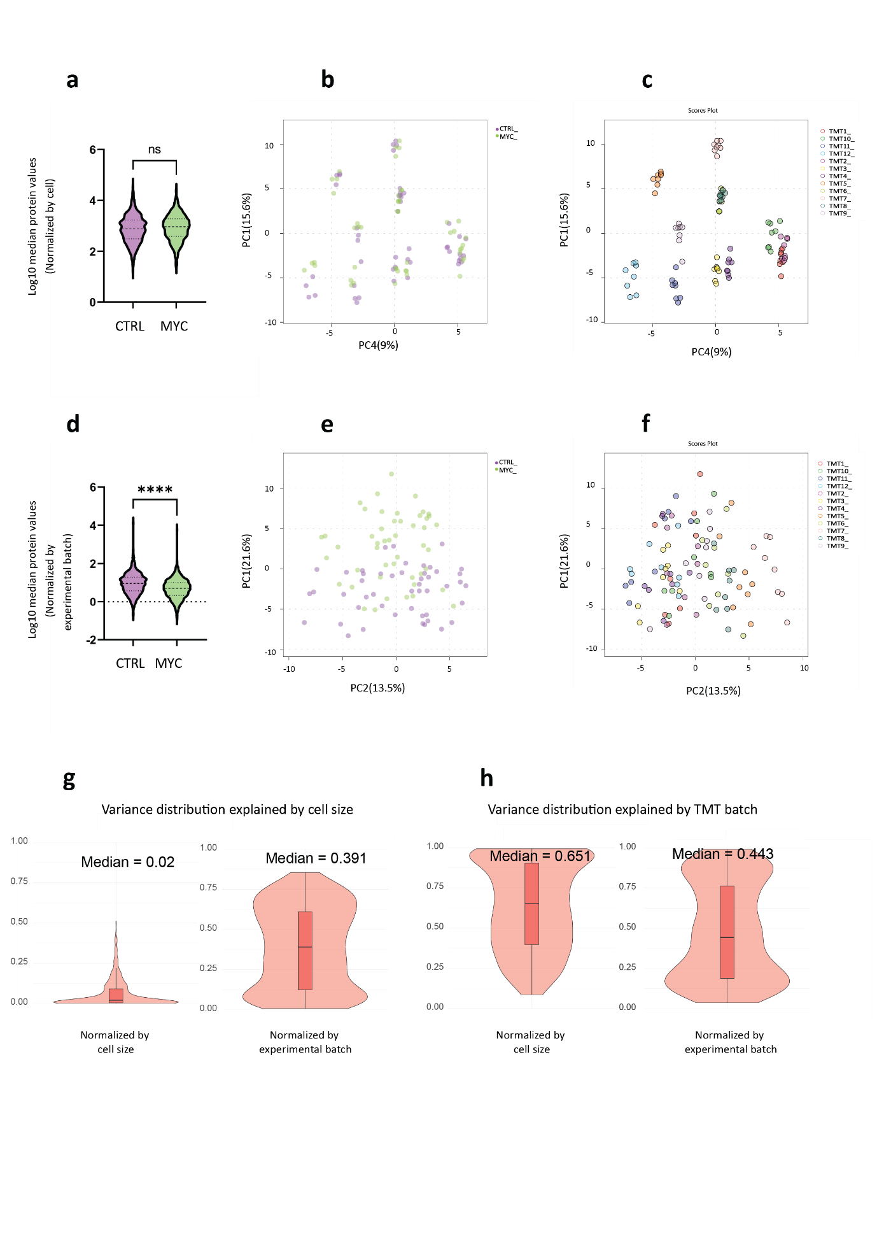

Fig. S3. Normalizing strategies for analysing mass spectrometry-based single-cell proteomics data. 3a. Violin plot showing the log10 transformed median values of proteins in control and Myc-overexpressing cardiomyocytes when data are normalized by each cell. 3b. PCA distribution of cells based on protein expression values normalized by cell, highlighting the cell type as control and Myc-overexpressing cardiomyocytes. 3c. PCA distribution of cells based on protein expression values normalized by cell, highlighting the TMT where each cell belongs to. 3d. Violin plot showing the log10 transformed median values of proteins in control and Myc-overexpressing cardiomyocytes when data are normalized by each experimental batch. 3e. PCA representing the separation of cells when data are normalized by experimental batch, highlighting the type of cardiomyocyte as control and Myc-overexpressing ones. 3f. PCA representing the distribution of cells based on the protein values normalized by the experimental batch and highlighting the TMT where each cell belongs to. In this analysis, 12 different 10-plex TMTs were used. PERMANOVA analysis when normalizing by cell shows that F-value=0.704 and p-value=0.765. PERMANOVA analysis after applying experimental batch normalization shows that F-value=8.6 and p-value=0.001. 3g. Limma analysis has been applied to analyze the influence of the cell size on the variance of protein values when data are normalized by cell or normalized by experimental batch. 3h. Limma analysis has been applied to analyze the influence of TMT batches on the variance of protein values when data are normalized by cell or normalized by experimental batch. For the cases where explained variance is close to 0, p-value based on permutation test is computed to evaluate whether the explained proportion is significantly different from 0. In the case of data normalized by cell, p-value 0.05 (p-value = 0.97 (cell size)).

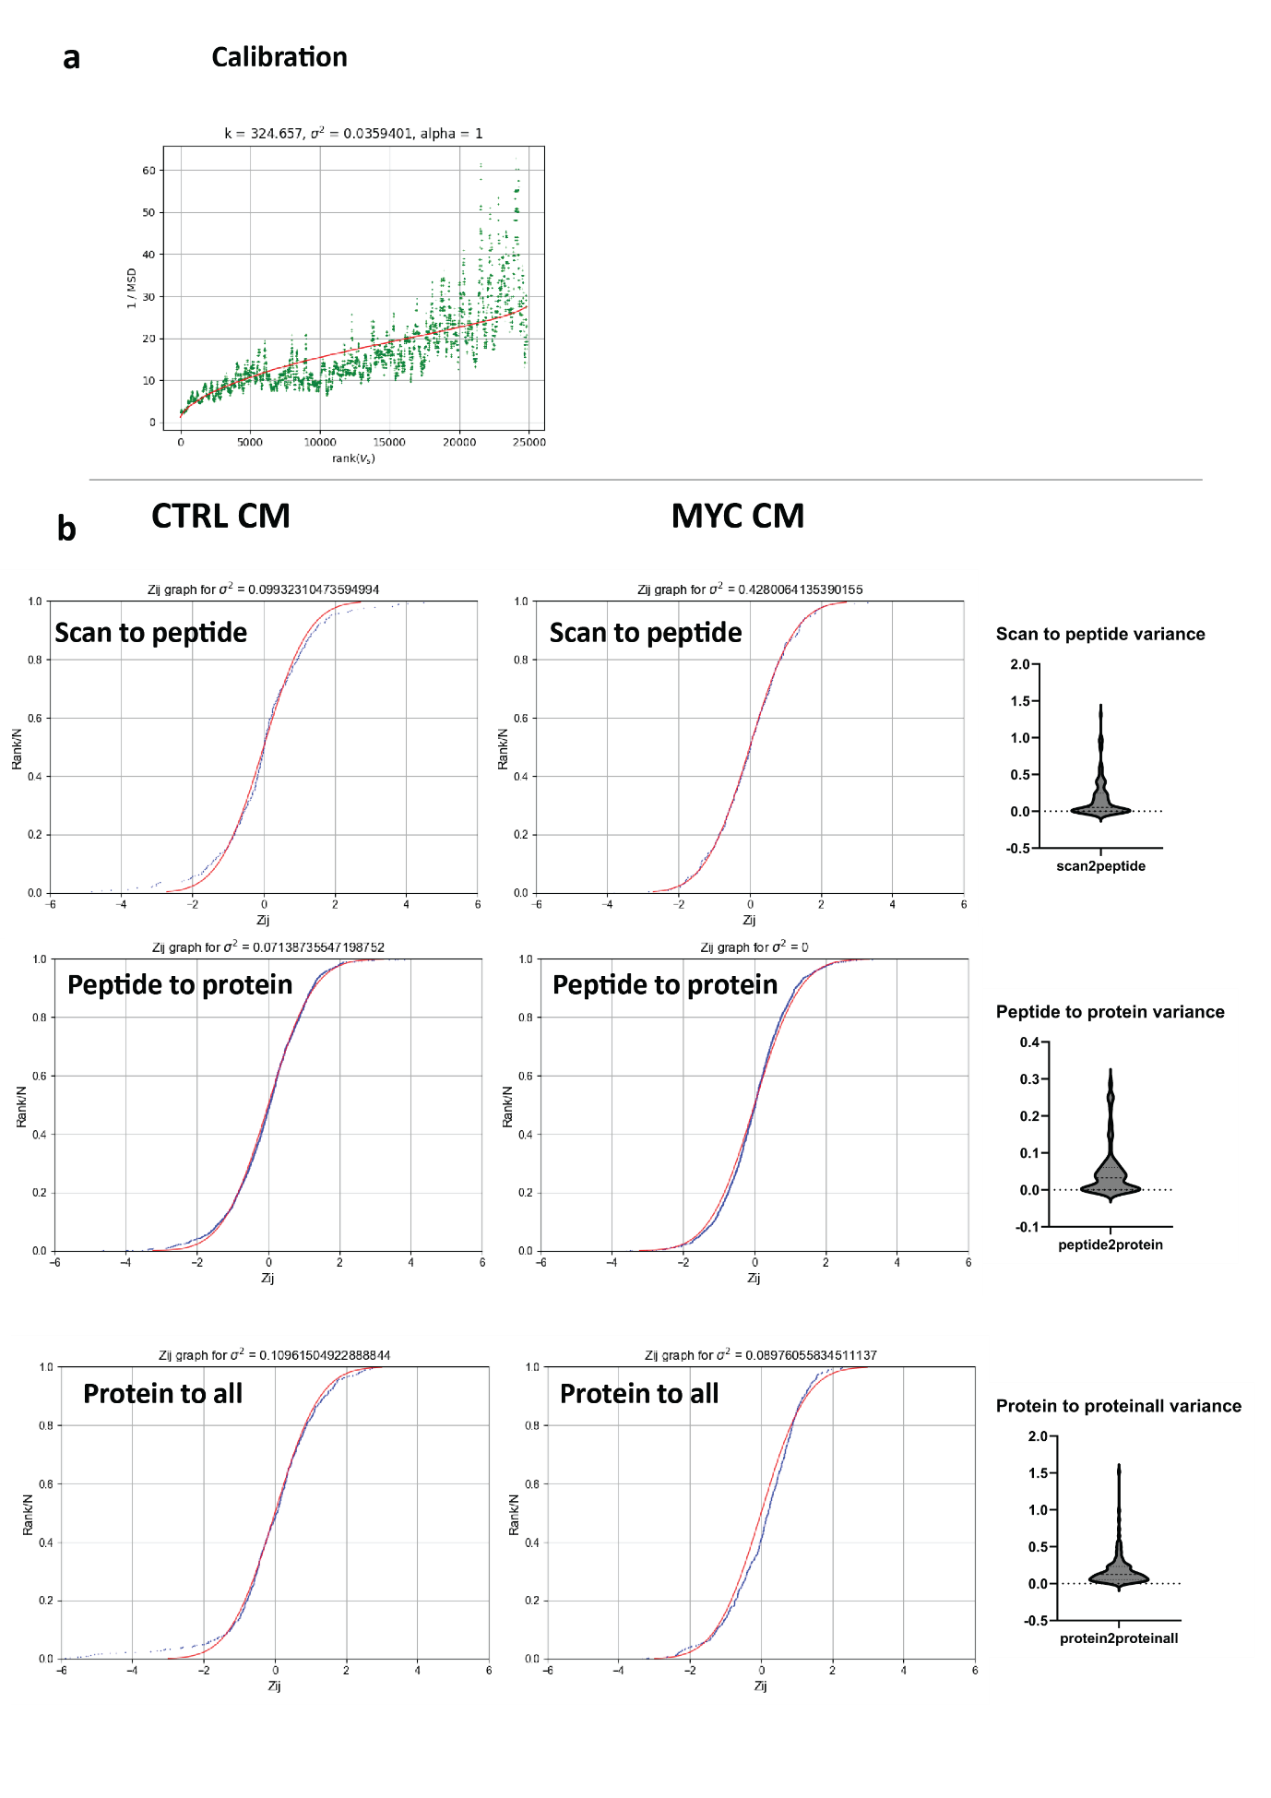

Fig. S4. Performance of iSanXoT for modelling single-cell proteomics data. 4a. Calibration of variance. As shown in this representative case, the iSanXoT calibration model is able to fit the variance distribution of the data as a function of reporter ion intensity. Red: calibrated curve; green: inverse of mean squared deviation (MSD). For further details consult iSanXoT documentation. 4b. Representative examples of the cumulative distribution of Z values (blue lines) corresponding to scan (PSMs of each peptide) to peptide, peptide to protein and protein to all integrations for the individual cells. The graphs show good agreement with the expected null hypothesis (standard distribution N(0,1), red line). Distribution of variance throughout the entire dataset is shown in violin plots for each of the integration levels. (CTRL CM=control cardiomyocyte; MYC CM= Myc-overexpressing cardiomyocyte).

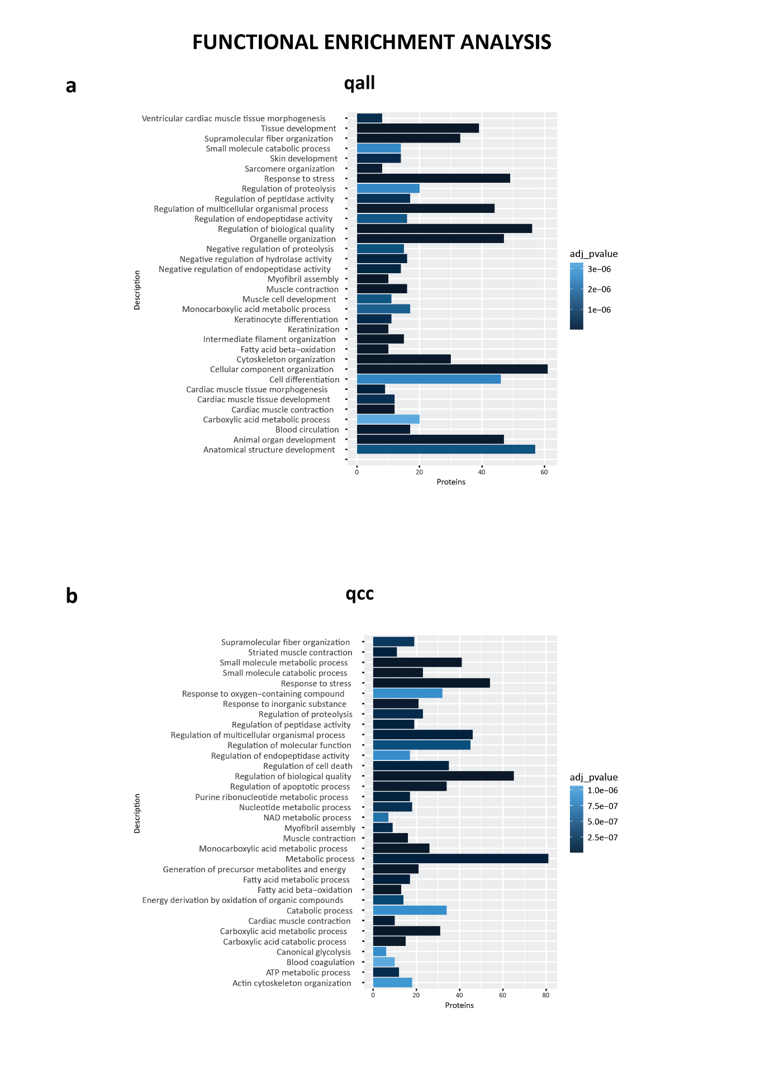

Fig. S5. Functional analysis of proteins discriminating between control and Myc-overexpressing cardiomyocytes. 5a. Box plot representing the top 35 biological processes selected based on the rank-adjusted FDR- p-value. The input proteins for the GO analysis are the ones with the VIP scores higher than 1.5 extracted out of the five first components of the PLS-DA analysis shown in Figure 4c. 5b. Box plot representing the top 35 biological processes selected based on the ranked adjusted FDR -p-value. The input proteins of the GO analysis are the ones with the VIP scores higher or equal to 1.5 extracted out of the first five components of the PLS-DA analysis shown in Figure 5c.

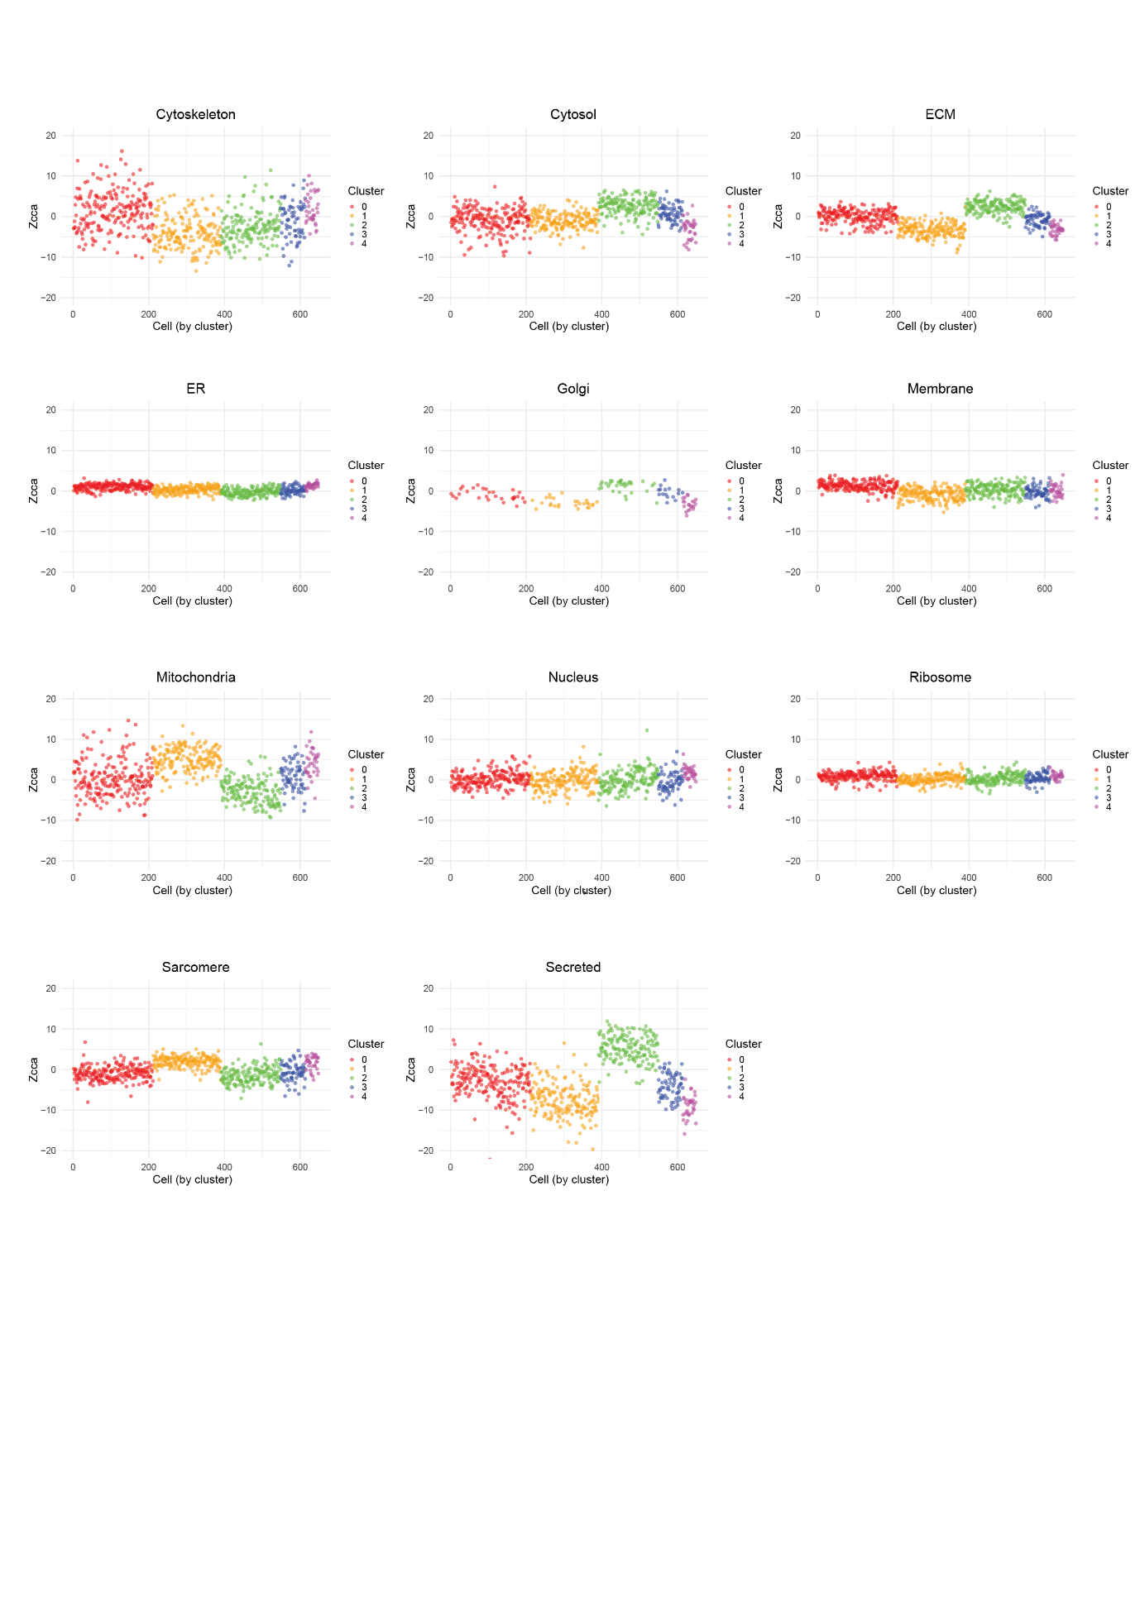
Fig. S6. Variation of Zcca values across clusters. Scatter plots representing the Zcca values per cell in each of the studied clusters. (ECM = extracellular matrix; ER = endoplasmic reticulum).

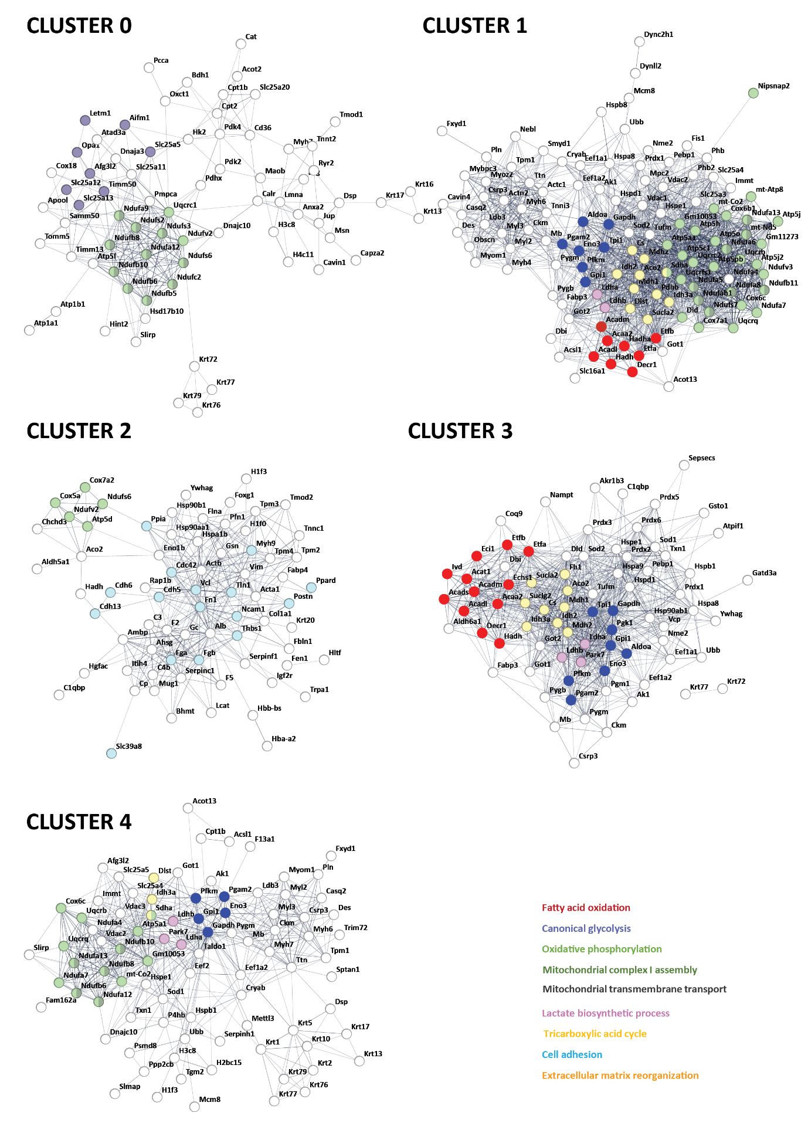

Fig. S7. Interactome network of cluster markers defined by UMAP analysis. These networks are composed by the protein markers of each cluster represented in Figure 7 and were constructed using the STRING webtool. The selected markers are the ones reported with an area under the curve (AUC) value higher than 0.6 as a result of the SEURAT workflow. The highlighted groups in the network correspond to the biological processes related with metabolism detected by STRING containing the largest number of proteins or the most informative processes.

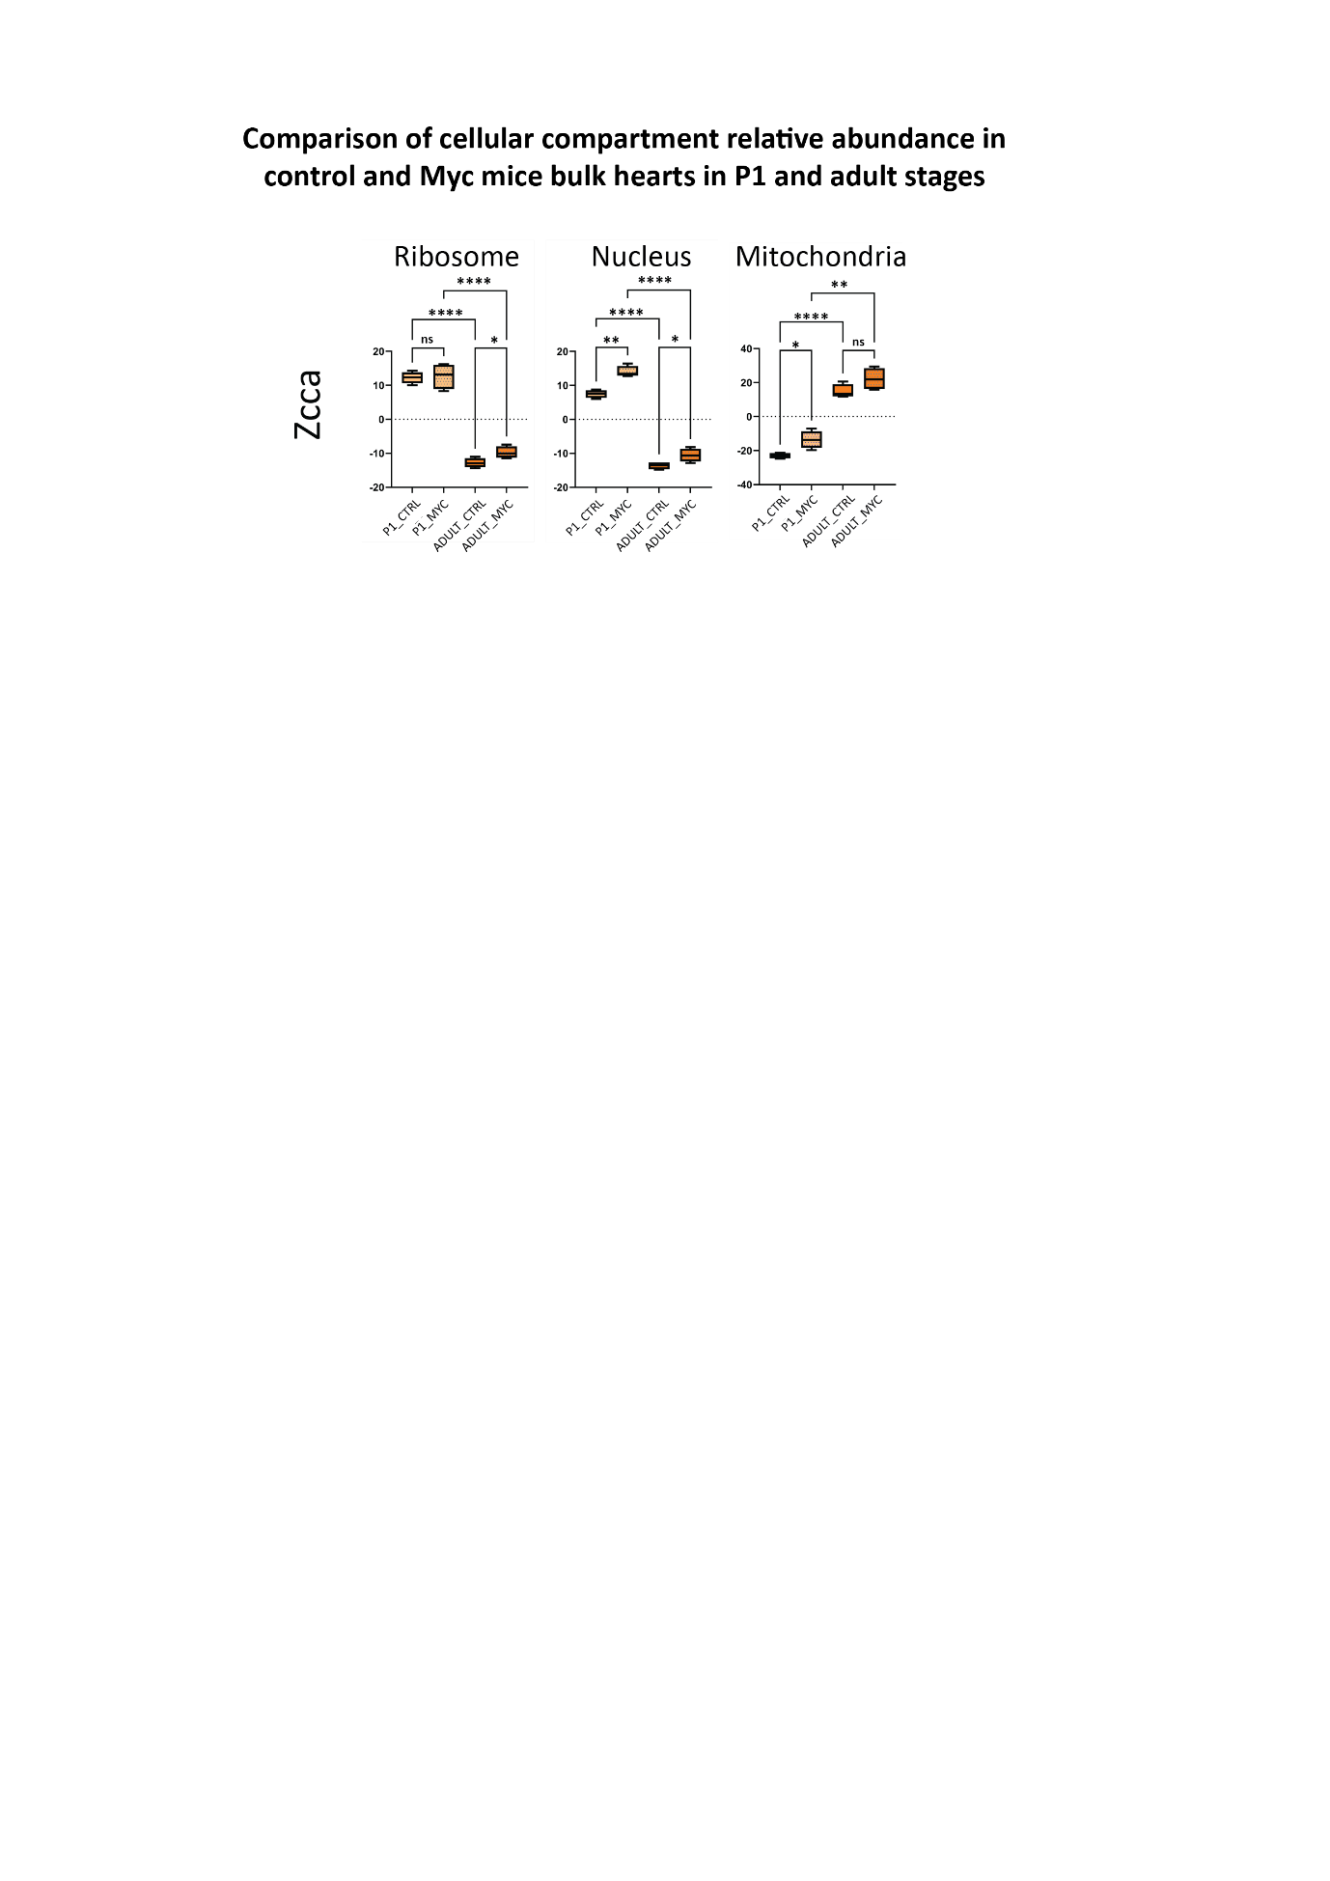

Fig. S8. Evaluation of cellular compartments in P1 and adult stages of Myc-overexpressing hearts respect to control hearts. Ribosomal, nuclear and mitochondrial compartments are compared in P1 and adult stages comparing control and Myc-overexpressing hearts (n=4 mice per sample type). Data were analyzed using Student’s t-test (*: p<0.05; **: p<0.01; ****: p<0.0001). Box plots represent the median, first and third quartiles, with whiskers extending to the minimum and maximum values.

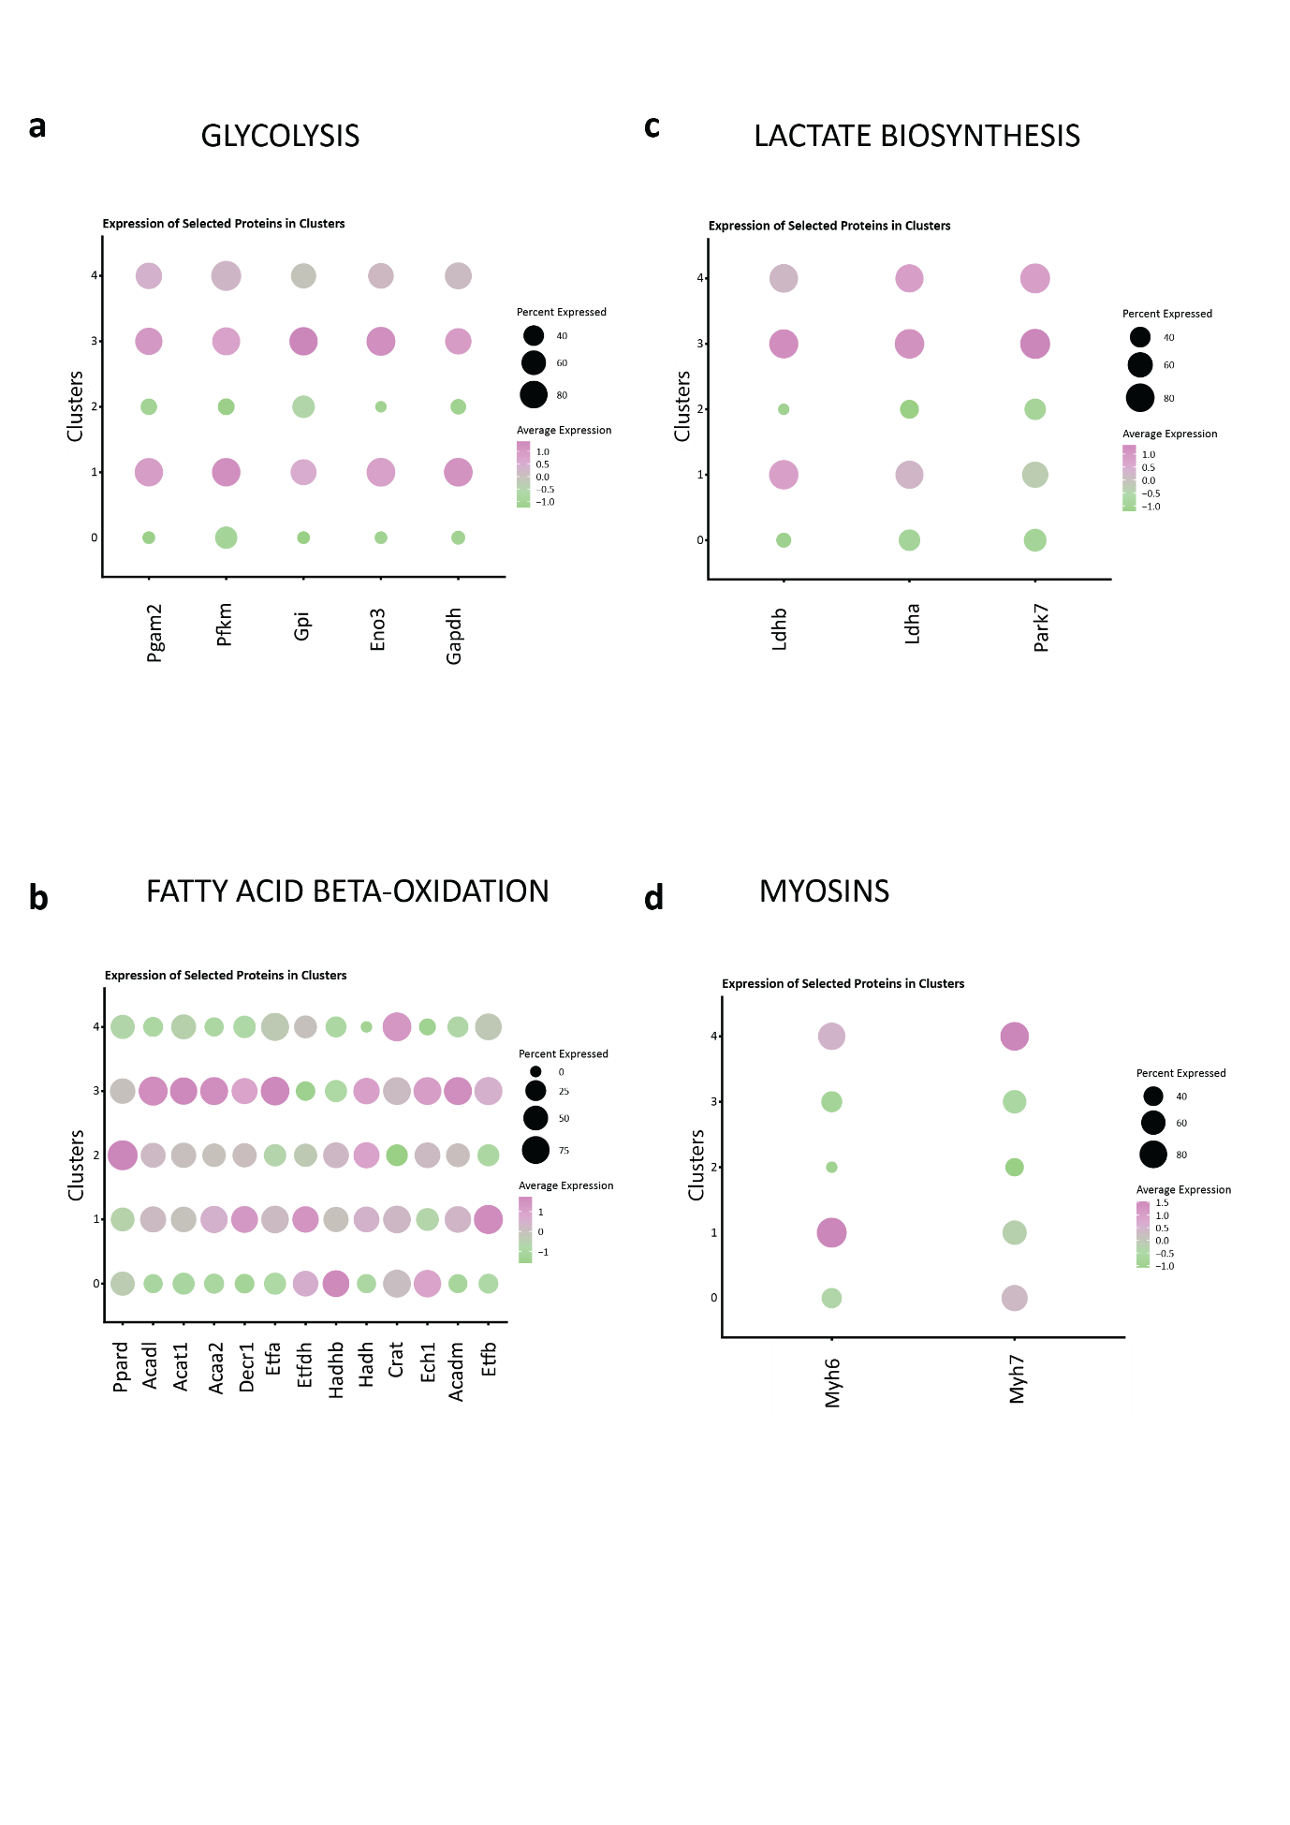

Fig. S9. Relative abundances of selected protein markers related to immaturity found in the clustering analyses. 9a. Glycolysis-related proteins found as markers of cluster 4 are represented in this graph along the 5 studied clusters found in Figure 7. 9b. Representation along the studied clusters of the relative expression of fatty acid beta-oxidation related proteins shown as discriminant in Figure 5. 9c and 9d. Representation of other markers of cluster 4. Lactate biosynthetic process related proteins (9c) and Myosin 7 and Myosin 6 (9d) are represented in the five studied clusters obtained from Figure 7. Circle color code represents the average expression and the circle size represents the percentage of cells where each protein was quantified along the studied cells.

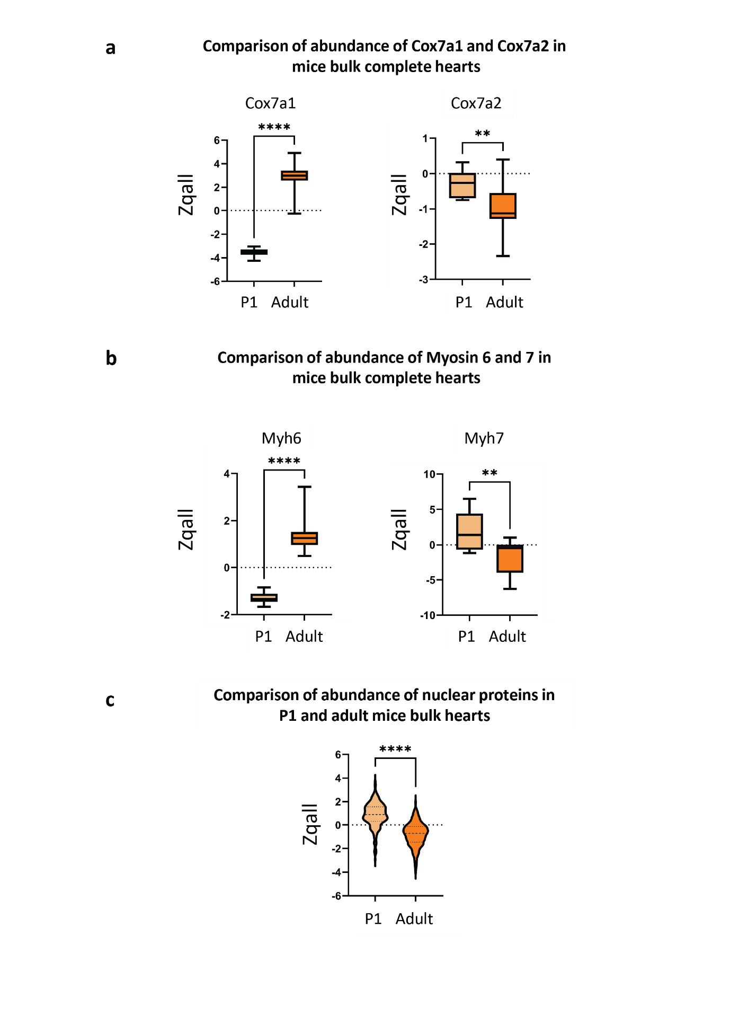

Fig. S10. Abundance levels of Myosins, Cox7a and nuclear proteins in bulk mice heart analyses. 10a. Differential abundance levels of Cox7a1 and Cox7a2 in P1 and adult mice hearts. 10b. Comparison between myosin 7 and 6 abundance levels in P1 and adult mice hearts. 10c. Comparison of abundance of nuclear proteins in P1 and adult mice hearts (n=8 in P1 samples and n=16 in adult samples; 265 proteins are used for nuclear analysis). Data were analyzed using Student’s t-test (**: p<0.01; ****: p<0.0001). Box plots represent the median, first and third quartiles, with whiskers extending to the minimum and maximum values.

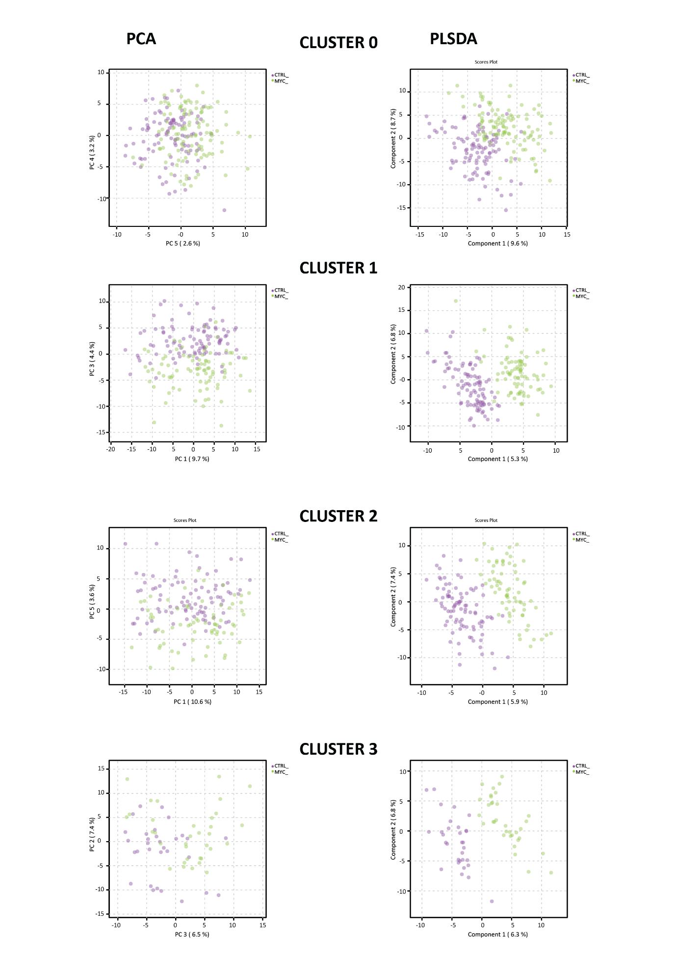
Fig. S11. Multivariate analysis showing the intracluster separation of control and Myc-overexpressing cardiomyocytes. PCA and PLS-DA analyses were performed within the cell population composing each cluster using Zqcc and Zcca values of the entire dataset.

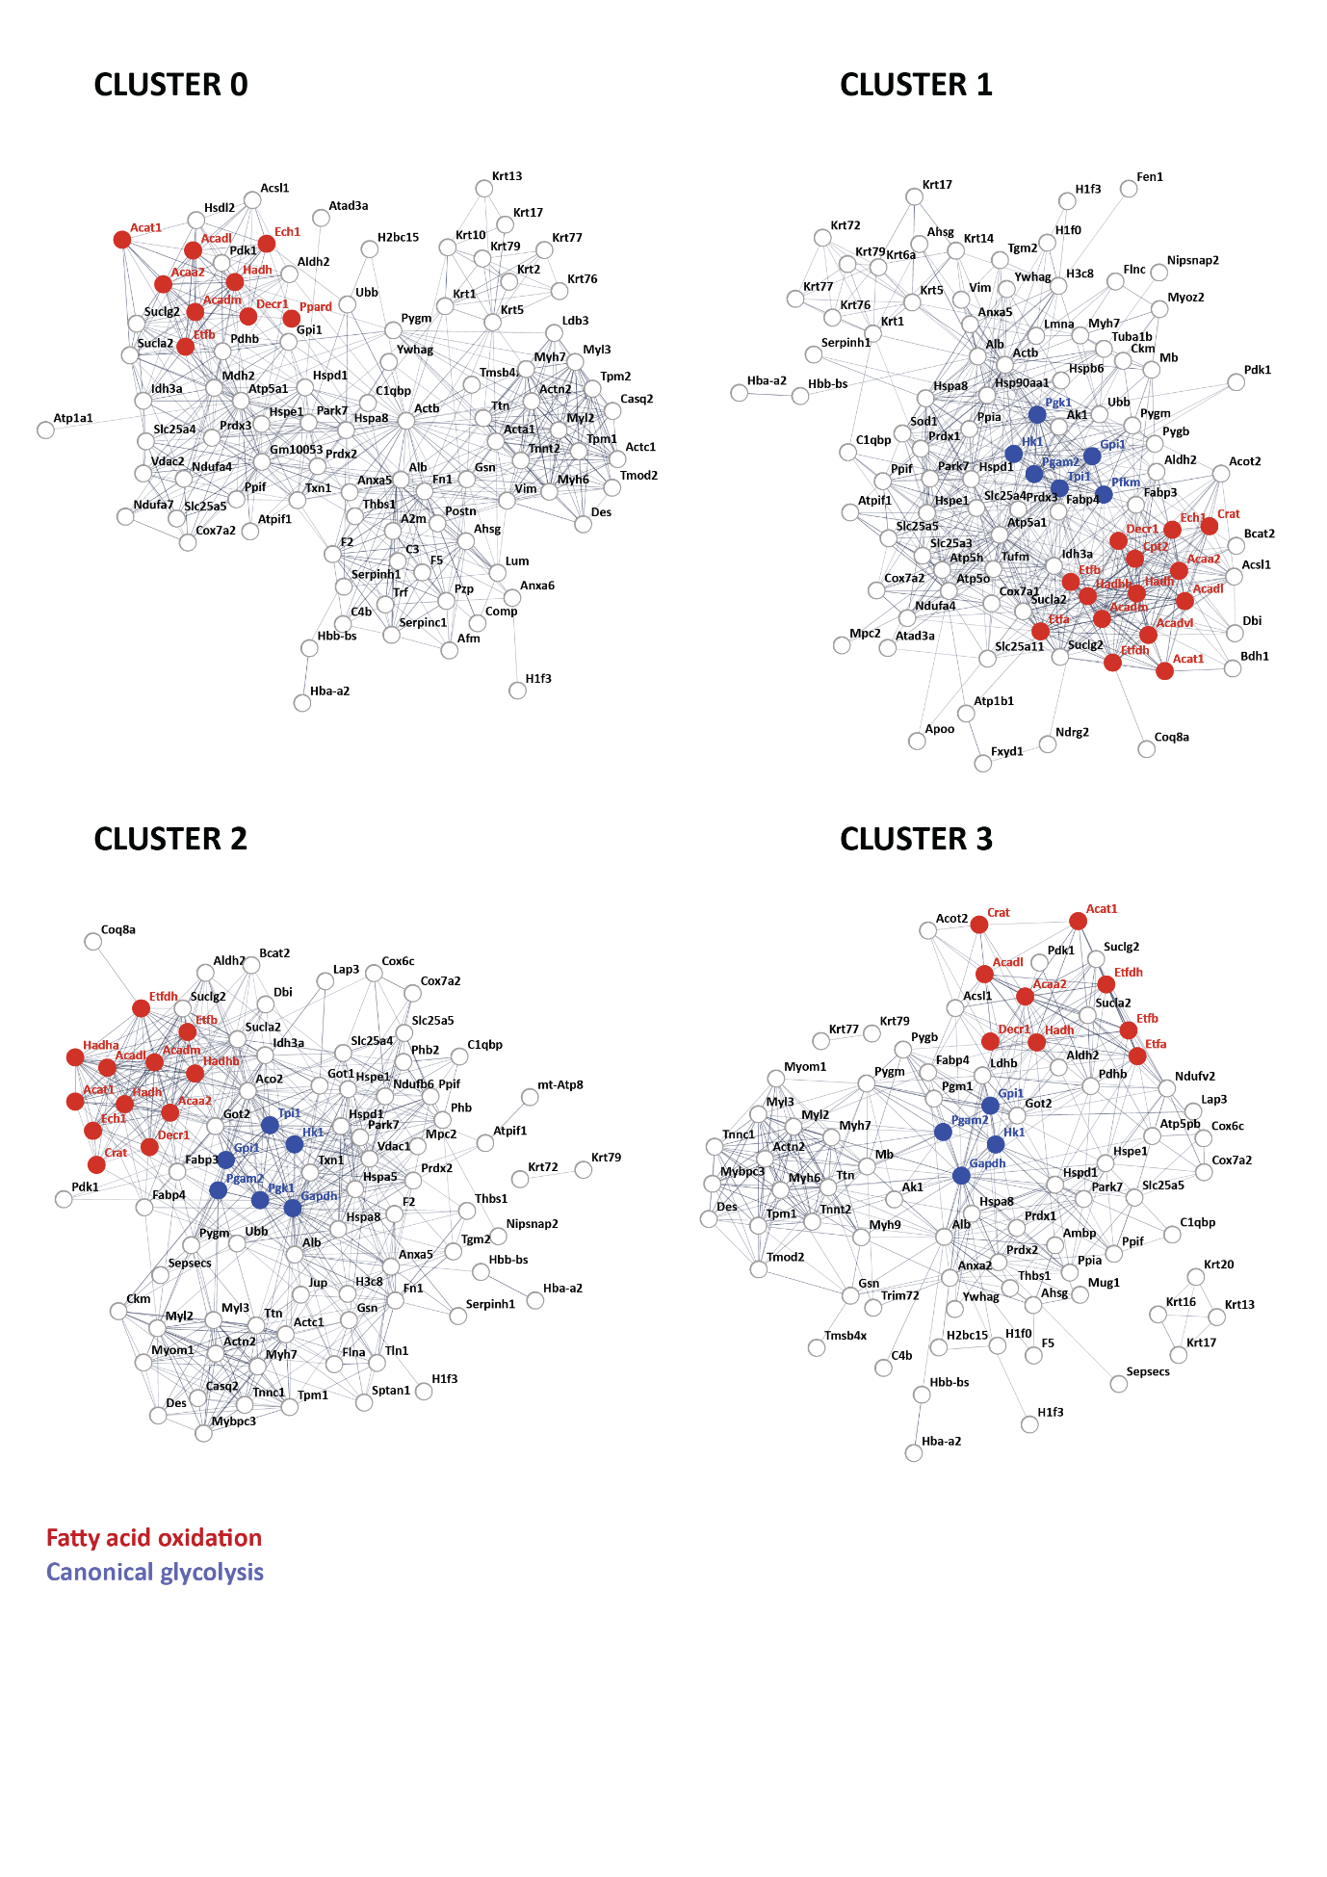

Fig. S12. Proteins discriminating control and Myc-overexpressing cardiomyocytes within each cluster based on the PLS-DA analysis shown in Fig. S11. Representation of discriminant proteins for distinguishing control and Myc-overexpressing cardiomyocytes within each cluster. The top ranked proteins according to their PLS-DA VIP score obtained out of the first five principal components of the PLS-DA analysis (VIP score ≥ 1.5) shown in Fig. S11 have been selected. Fatty acid beta-oxidation and canonical glycolysis categories are highlighted in the network in red and blue, respectively.

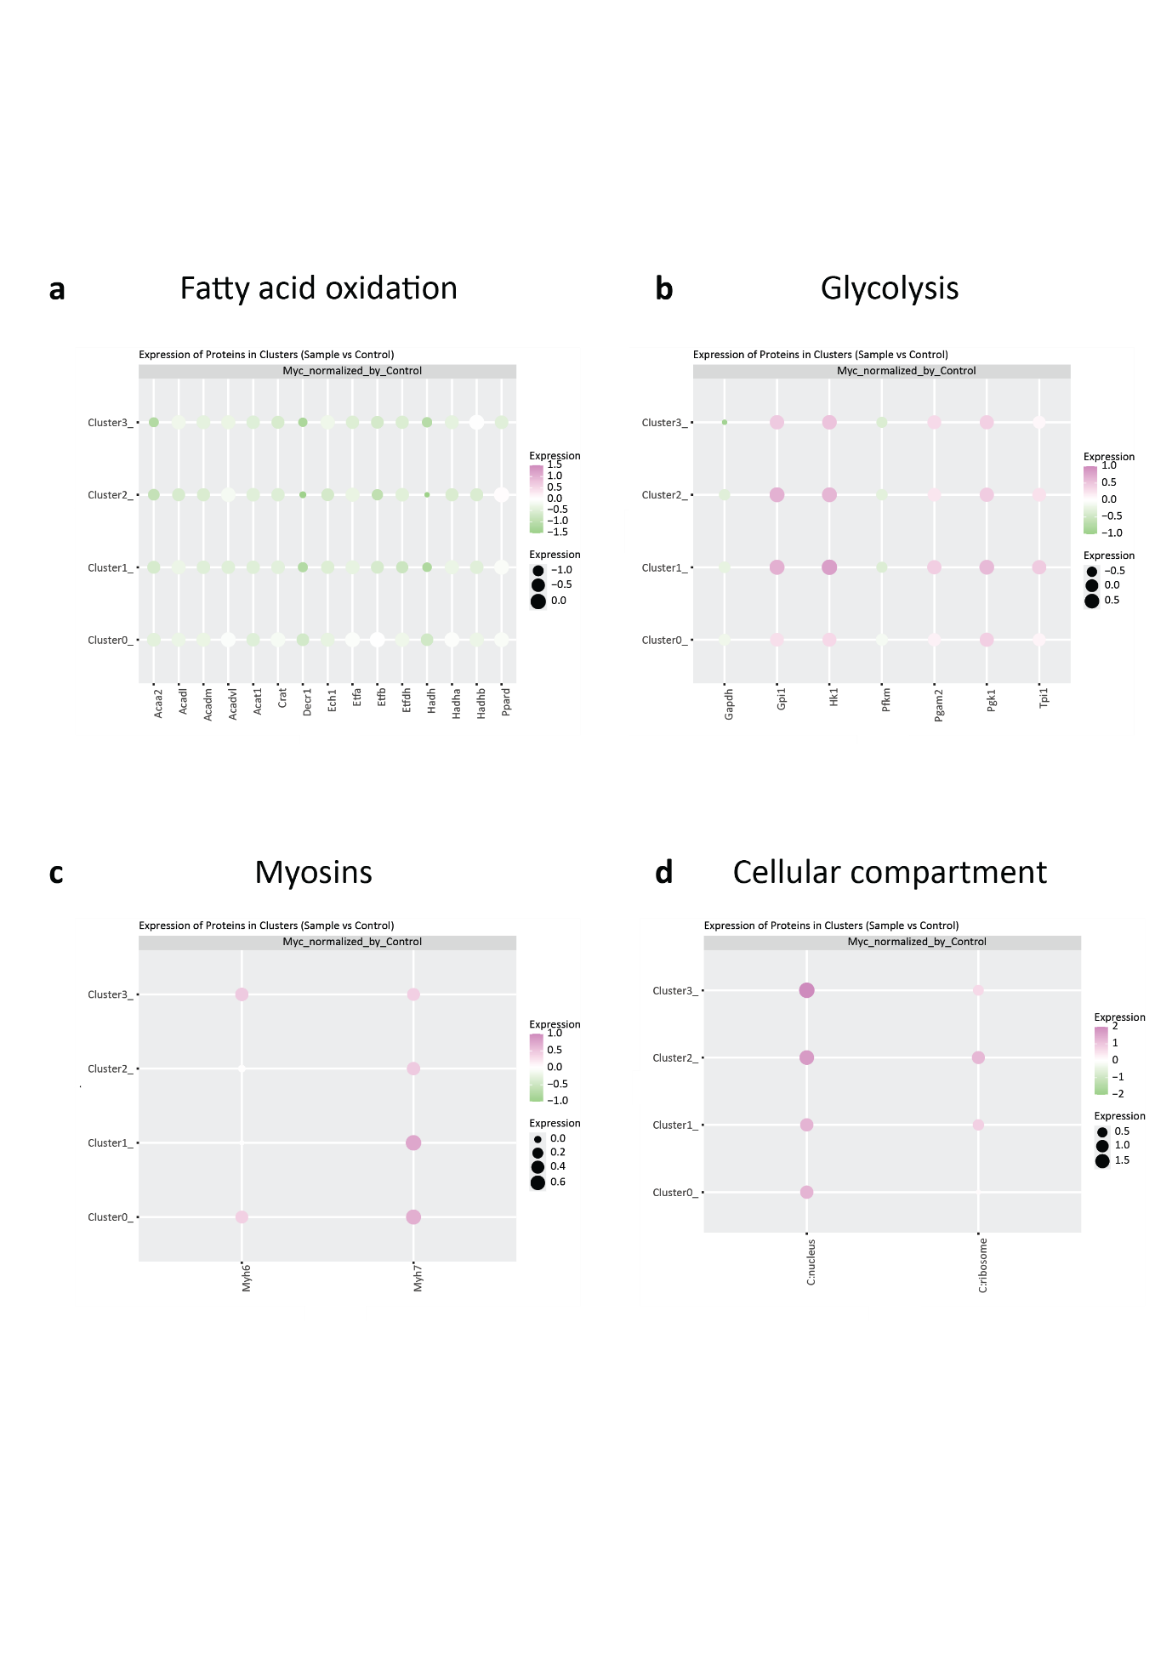

Fig. S13. Dot plot representing the differential abundance of protein and subcellular compartments within each cluster in the subpopulation of Myc-overexpressing cardiomyocytes respect to control ones. The graphs show fatty acid beta-oxidation (a), canonical glycolysis (b), myosins (c) and cellular compartments markers (d). Proteins in a and b are all the proteins of each category extracted out of the PLS-DAs represented in Figs. S11 and S12.

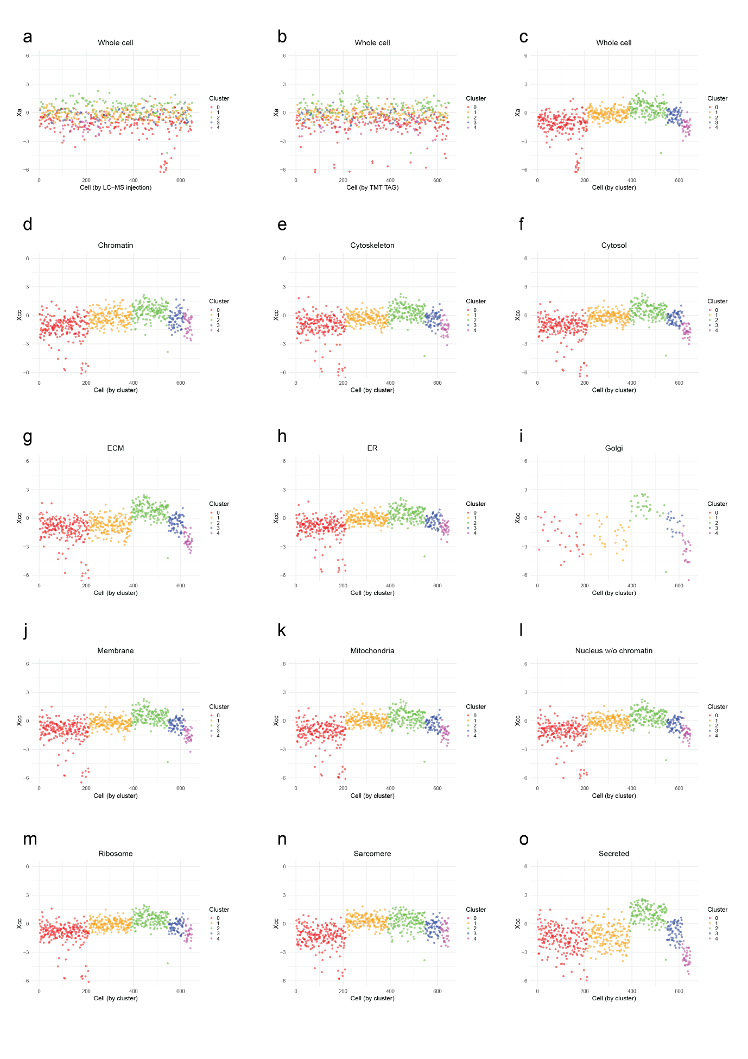

Fig. S14. Distribution of total cell and of cellular compartment protein abundances across clusters. The protein abundances of each cellular compartment cc (Xcc) are the weighted averages of the non-normalized relative abundances of their proteins expressed in log2 scale. They are computed by integrating from the protein level to the cellular compartment level using iSanXoT. Similarly, the total cell protein abundance (Xa) is the weighted average of the non-normalized quantitative values of the cellular compartments (Xcc), and is obtained by integrating from the cellular compartment level to the grand mean level (all) using iSanXoT. Note that in panel a the cells are ranked according to the order in which they were analyzed by LC-MS, to show the absence of technical bias. Panel b shows the distribution of cells by increasing TAG type (126, 127N, 127C, 128N, 128C, 129N, 129C, 130C), showing a distribution of cells along the representation indicating that the clustering is not influenced by TAG type. In the rest of panels (c-o) the cells are ranked by clusters. (ECM = extracellular matrix; ER = endoplasmic reticulum).

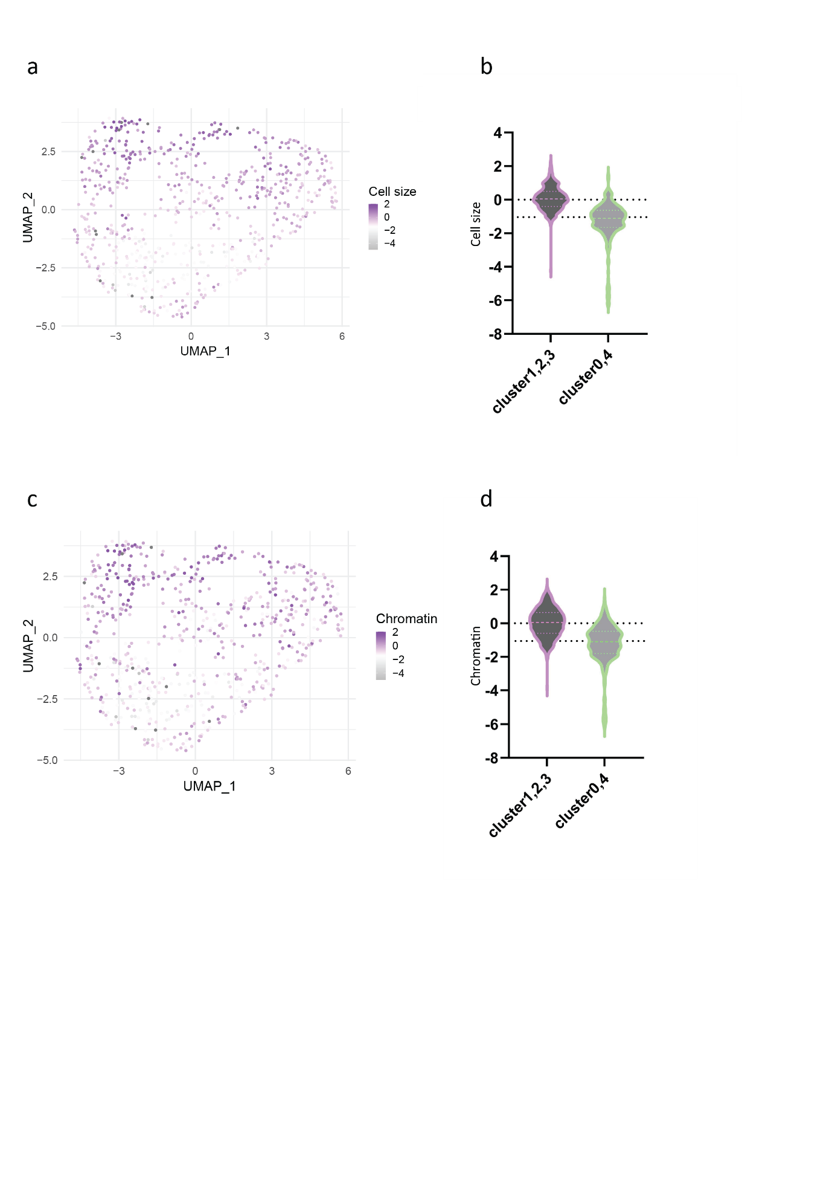
Fig. S15. Detailed representation of cell size and chromatin variation along clusters. 15a. UMAP representation highlighting the cells by the overall log2 protein amount (cell size). 15b. Violin plots representing the compilation of cells log2 protein amounts in the two more similar groups. 15c. UMAP representation highlighting the cells by the overall log2 protein amount corresponding to the chromatin category. 15d. Violin plots representing the compilation of cells log2 chromatin values in the two more similar groups. Cell size is defined by the whole cell Xa values and chromatin is defined by the Xcc correspondent values.

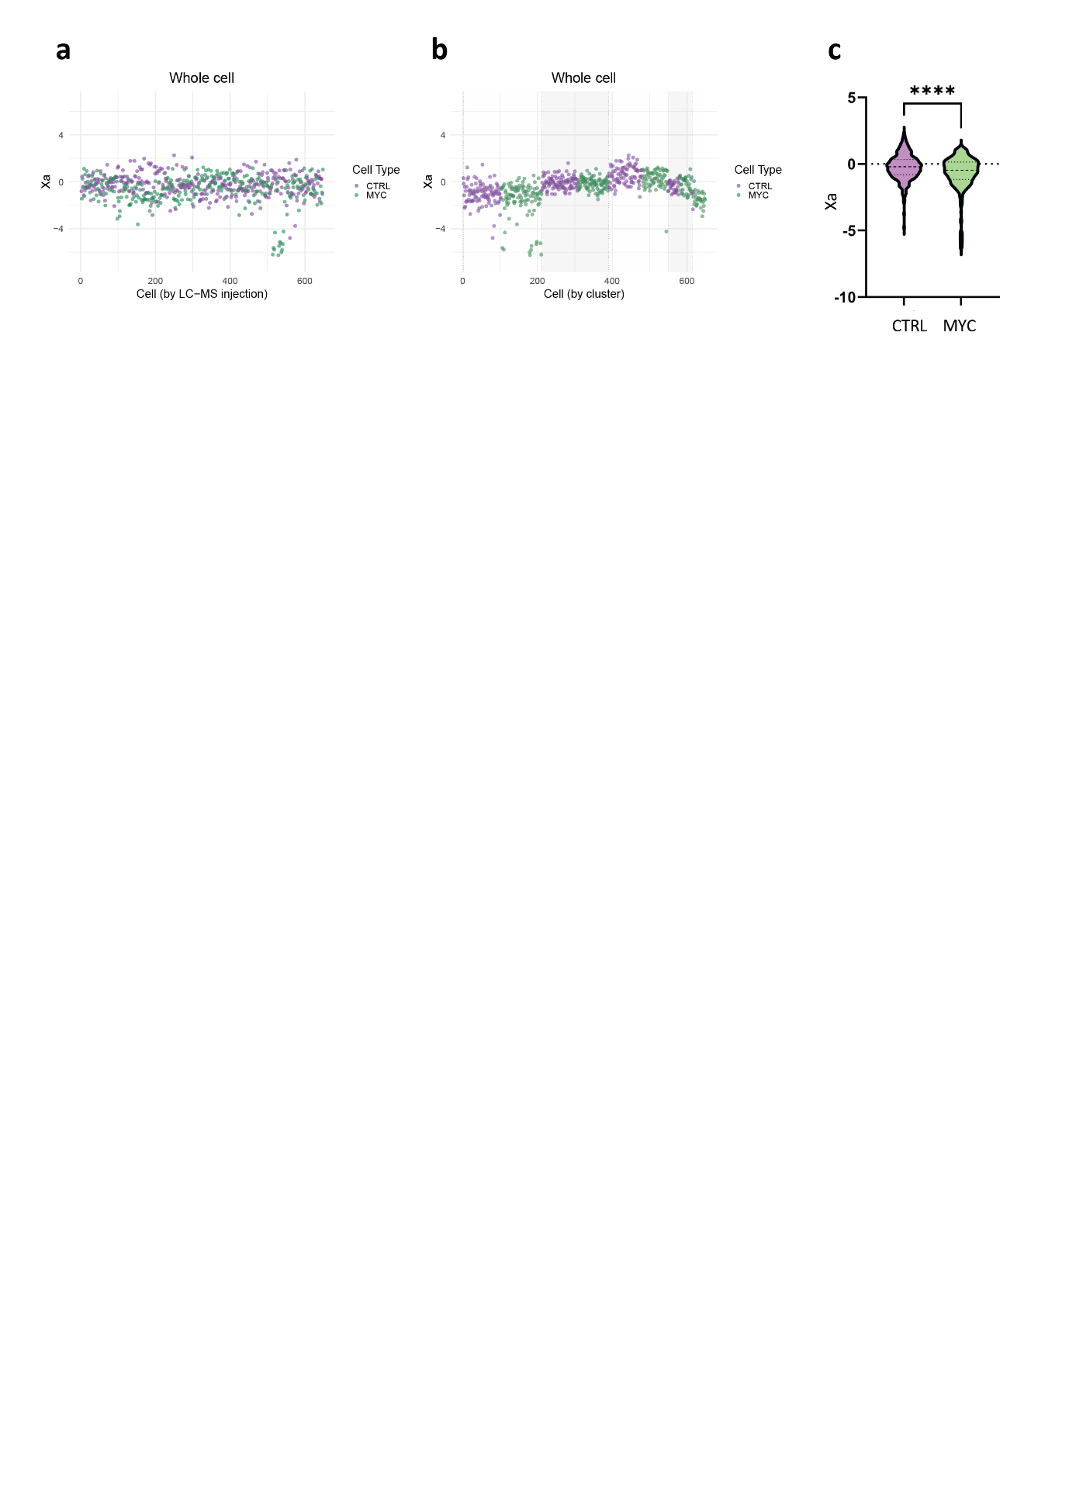

Fig. S16. Distribution of total cell protein abundances distinguishing control and Myc-overexpressing cardiomyocytes. The weight-averaged protein abundance of each cell, expressed in log2ratios (Xa), is represented along control and Myc-overexpressing cardiomyocytes. In panel a the cells are ranked according to the order in which they were analyzed by LC-MS. In panel b, cells are sorted based on the cluster they belong to. Panel c represents a violin plot showing the distribution of cellular size based on the Xa value in control and Myc-overexpressing cardiomyocytes. In all cases, control cells are represented in violet and Myc-overexpressing cardiomyocytes in green.

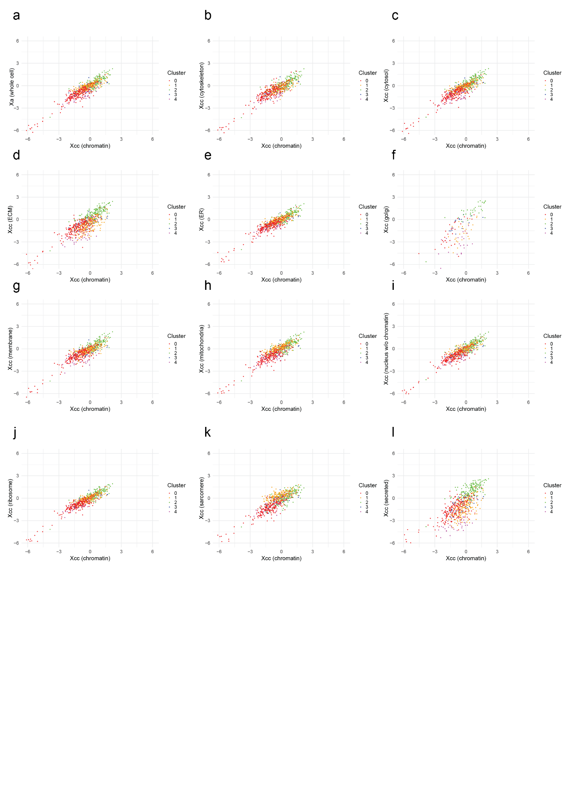
Fig. S17. Correlation between total cell or cellular compartment protein abundances
vs chromatin protein abundances. Chromatin Xcc values are correlated with the total cell protein abundance (Xa values) (a) and with the rest of cellular compartments (Xcc values) (b-l). (ECM = extracellular matrix; ER = endoplasmic reticulum).
 | FACS ISOLATION | MANUAL ISOLATION
Average number proteins/cell | 473 | 461
Average number peptides/cell | 1352 | 1326
Percentage of missing values | 76% | 76%
Proteins present in at least 70% cells | 348 | 358
Proteins present in 100% cells | 32 | 223
Table S1: QC metrics comparing FACS and MANUAL isolation methods for single-cardiomyocytes.

Measure | 1 comps | 2 comps | 3 comps | 4 comps | 5 comps
Accuracy | 0.691 | 0.903 | 0.909 | 0.927 | 0.930
R2 | 0.307 | 0.579 | 0.623 | 0.676 | 0.727
Q2 | 0.267 | 0.546 | 0.581 | 0.593 | 0.598
Table S2: PLS-DA cross validation details for Figure 4c.

Measure | 1 comps | 2 comps | 3 comps | 4 comps | 5 comps
Accuracy | 0.785 | 0.907 | 0.938 | 0.934 | 0.937
R2 | 0.463 | 0.664 | 0.709 | 0.761 | 0.792
Q2 | 0.416 | 0.624 | 0.665 | 0.691 | 0.694
Table S3: PLS-DA cross validation details for Figure 5c.

Cellular compartment | Protein accession | Protein description
C:chromatin | P27661 | Histone H2AX OS=Mus musculus OX=10090 GN=H2ax PE=1 SV=2
C:chromatin | P10922 | Histone H1.0 OS=Mus musculus OX=10090 GN=H1-0 PE=2 SV=4
C:chromatin | P62806 | Histone H4 OS=Mus musculus OX=10090 GN=H4c1 PE=1 SV=2
C:chromatin | P15864 | Histone H1.2 OS=Mus musculus OX=10090 GN=H1-2 PE=1 SV=2
C:chromatin | P43274 | Histone H1.4 OS=Mus musculus OX=10090 GN=H1-4 PE=1 SV=2
C:chromatin | P68433 | Histone H3.1 OS=Mus musculus OX=10090 GN=H3c1 PE=1 SV=2
C:chromatin | P10853 | Histone H2B type 1-F/J/L OS=Mus musculus OX=10090 GN=H2bc7 PE=1 SV=2
C:chromatin | P43277 | Histone H1.3 OS=Mus musculus OX=10090 GN=H1-3 PE=1 SV=2
C:chromatin | P0C0S6 | Histone H2A.Z OS=Mus musculus OX=10090 GN=H2az1 PE=1 SV=2
C:chromatin | P10854 | Histone H2B type 1-M OS=Mus musculus OX=10090 GN=H2bc14 PE=1 SV=2
Table S4. Proteins included in the chromatin category. Identified histone proteins are included in the chromatin category.

Cluster | Chi-squared | df | p-value
0 | 41.53 | 76 | 0.9996
1 | 28.117 | 73 | 1
2 | 21.241 | 79 | 1
3 | 12.138 | 45 | 1
4 | 4.2857 | 10 | 0.9335

Table S5. Chi-squared analysis of the TMT batch effect in clusterization of data. Effect of TMT batches in the clusterization of data in SEURAT was evaluated with contingency tables and the calculation of the Chi-squared test to evaluate the significance of the association between each cluster and TMT batches. Df= degrees of freedom.

