Somatic mobility of transposons is explosive and shaped by distinct integration biases in Arabidopsis thaliana

Heena Ambreen, Basile Leduque, Leandro Quadrana, R. Keith Slotkin, Alexandros Bousios, Hans-Wilhelm Nützmann

Supplementary Figures

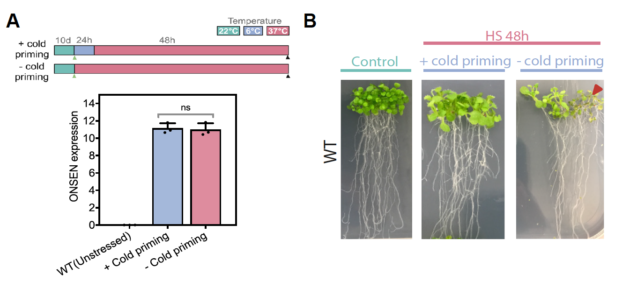

Fig. S1. A. Schematic illustrating experimental conditions adopted for evaluating the effect of cold priming on ONSEN transcription upon subsequent heat stress induction. Sampling points have been indicated by green (control) and black (heat-stressed) arrowheads in the schematic. Relative expression level (mean ± s.d. plotted) of ONSEN in wild-type Arabidopsis (Col-0) seedlings with and without cold priming (n=3). Student t-test applied to evaluate level of significance (ns: non-significant). B. Plant phenotype studied for effect of cold priming prior to HS. Necrotic plant tissue indicated by red arrowhead.

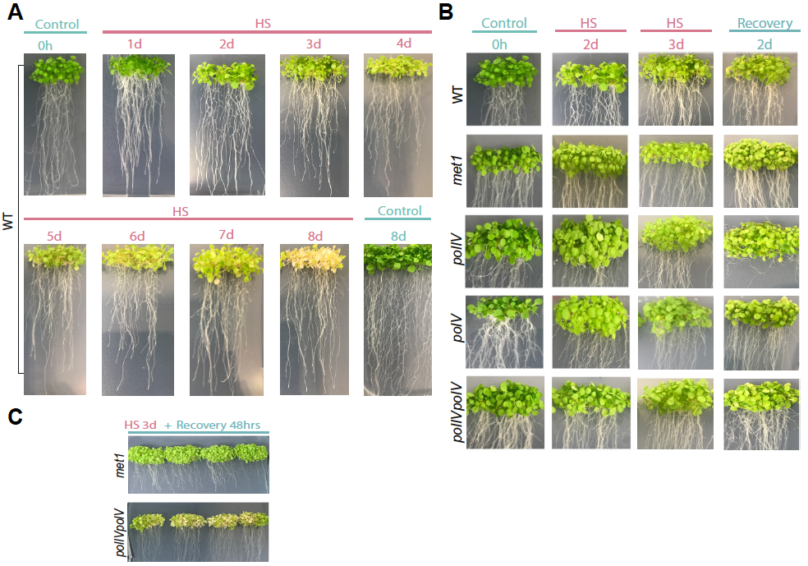

Fig. S2. Effect of variable heat stress regimes on health of Arabidopsis seedlings. Plant phenotype studied for A. Prolonged HS extending up to 8 days using wild type seedlings. B. Short duration HS applied to both wild and mutant Arabidopsis genotypes. Seedlings exposed to heat stress for up to 3d followed by a 2-day recovery phase are shown. C. Phenotype of met1 and polIVpolV mutant seedlings post 3d HS and recovery phase.

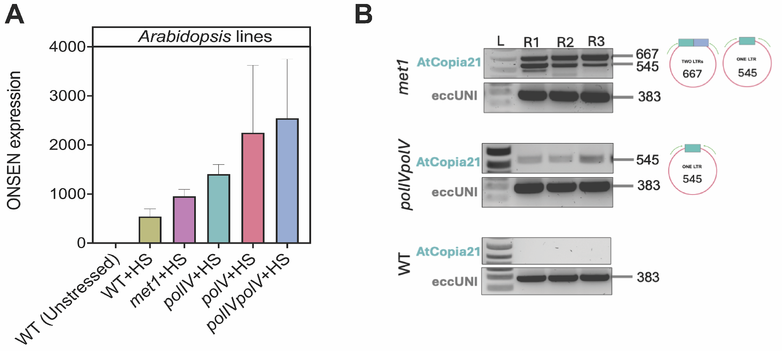

Fig. S3. A. ONSEN qRT-PCR expression profiles at 48hrs HS in WT and epigenetic mutants of Arabidopsis, normalized to unstressed WT tissues. Mean of fold changes has been plotted (n=3). B. Inverse PCR profiles for detection of eccDNA of AtCOPIA21 in A. thaliana lines – met1, polIVpolV, and WT with 3 replicates (R1-R3) each. L: 1kb⁺ DNA ladder. Leaf tissues from ~100 seedlings were pooled for each replicate. The expected size for two and one LTR products of AtCOPIA21 has been indicated. eccDNA molecule (eccUni), universally observed in Arabidopsis tissues [47] has been used as a positive control. Uncropped gel images are provided in Additional file 3.

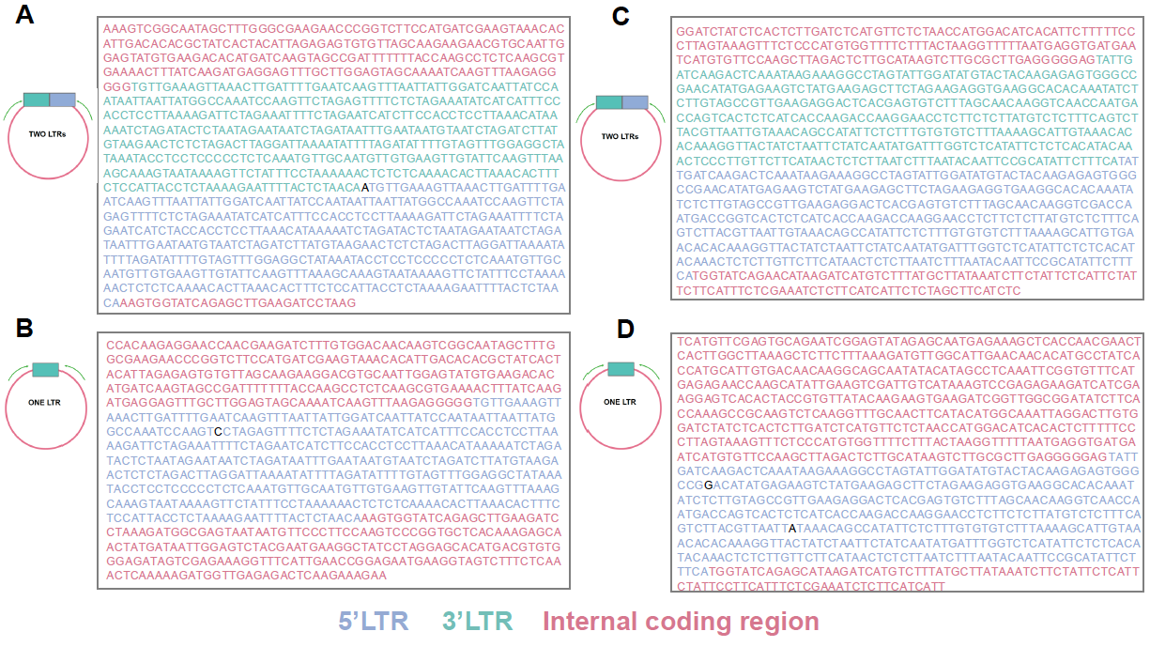

Fig. S4. Sequence analysis of two LTR and one-LTR extrachromosomal DNA products of ONSEN (A, B) and EVADE (C, D). 5’LTR (blue), 3’LTR (green) and Internal coding region (red) are colour coded. Variable nucleotides that did not aligned with the reference sequence are shown in black.

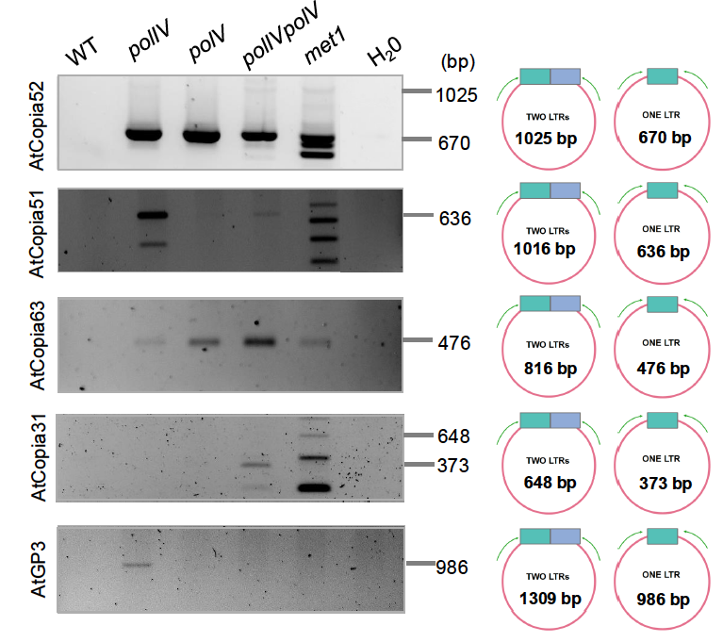

Fig. S5. Inverse PCR analysis of eccDNA products of selected epigenetically induced TE families in A. thaliana lines. Expected product size for two and one LTR copies have been indicated. Uncropped gel images are provided in Additional file 3.

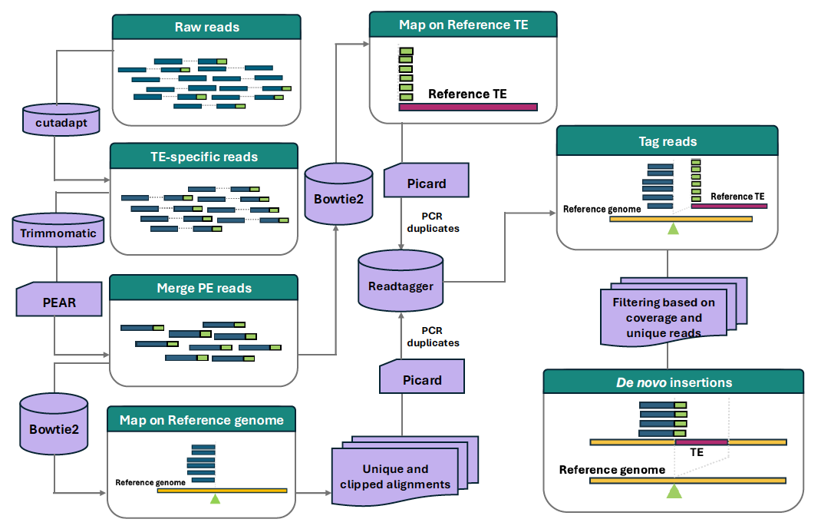

Fig. S6. Bioinformatics pipeline “deNOVOEnrich” designed to identify and map de novo somatic and non-reference segregating insertions from TEd-seq short-read data. The extremity region of the transposon (from primer site to 5’ end) was used as a bait to harness TE-specific reads from the sequenced library, which were quality filtered. The paired-end reads were merged to create long DNA contigs which were mapped separately onto the reference genome and TE. Alignments on the reference genome were filtered to retain uniquely mapped and soft-clipped reads. Soft-clipped reads spanning the insertion site in reference genome wherein their clipped portion showed high homology to the targeted TE were tagged and retained for further analysis. All insertion sites were classified as de novo somatic insertions and non-reference segregating insertions based on coverage and PCR duplication information. De novo somatic insertions were determined based on their characteristically low coverage, defined as having 5 or fewer supporting reads at the new insertion site with a maximum of four unique reads (defined by distinct stop sites). The non-reference segregating insertions were identified using a coverage threshold of ≥30, with at least five unique reads and a minimum of three of these unique reads supported by at least three PCR duplicates each. The threshold coverage cut-offs for defining somatic and non-reference segregating insertions were derived by analysing the distribution of read coverage support for each TE family (Refer to Fig. S7-S9).

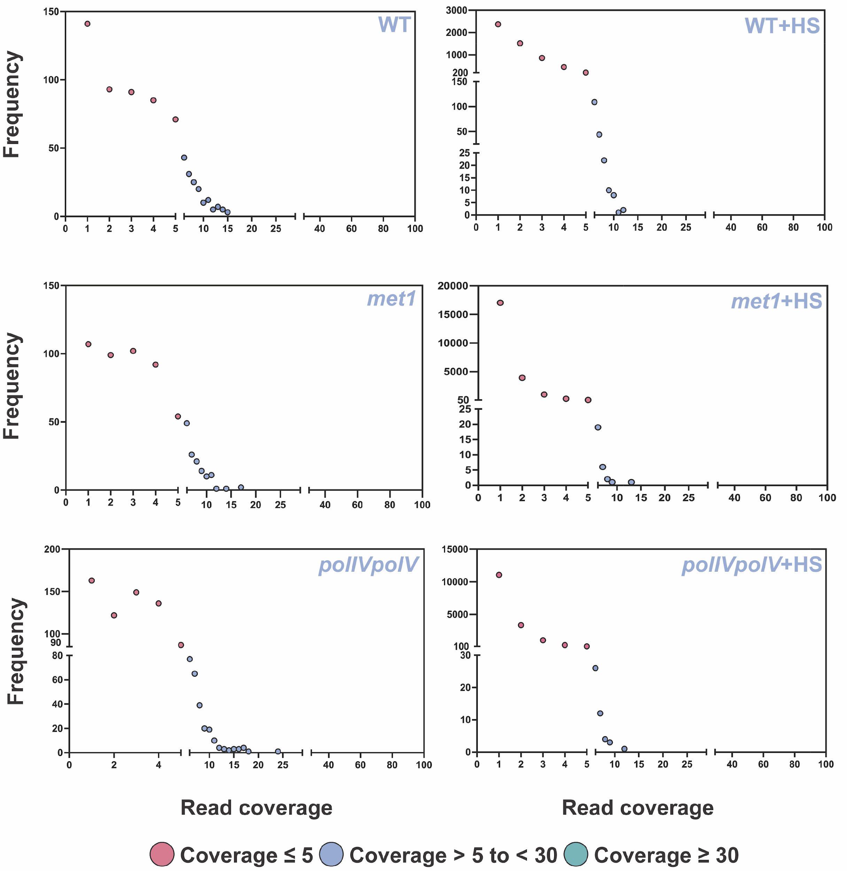

Fig. S7. Read coverage support for somatic (<=5 reads) and non-reference segregating (>=30) insertions for ONSEN. Insertions with coverage of >5 and <30 were not further analysed, because of their ambiguous status as somatic or non-reference segregating.

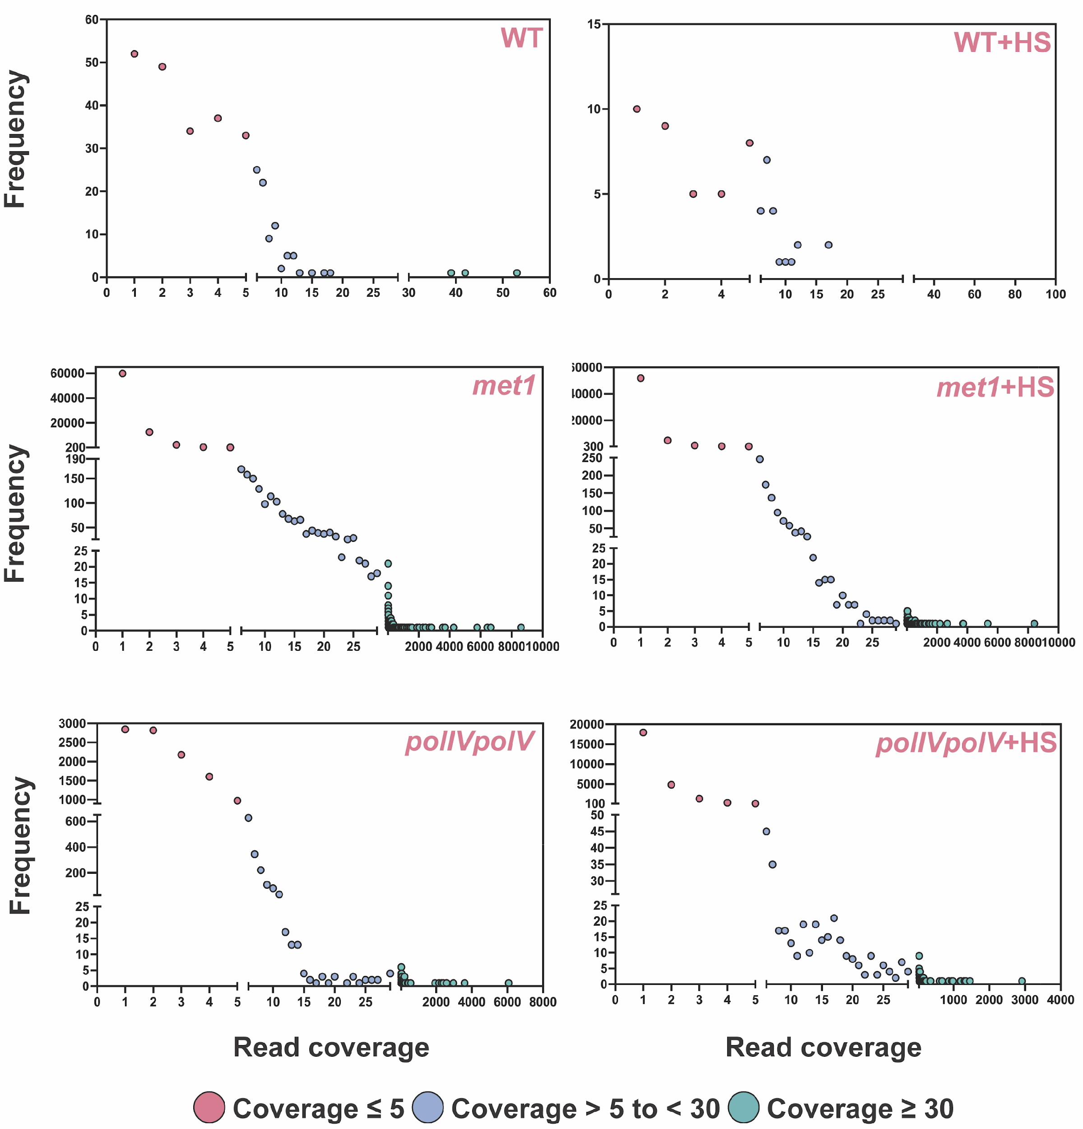

Fig. S8. Read coverage support for somatic (<=5 reads) and non-reference segregating (>=30) insertions for EVADE. Insertions with coverage of >5 and <30 were not further analysed, because of their ambiguous status as somatic or non-reference segregating.

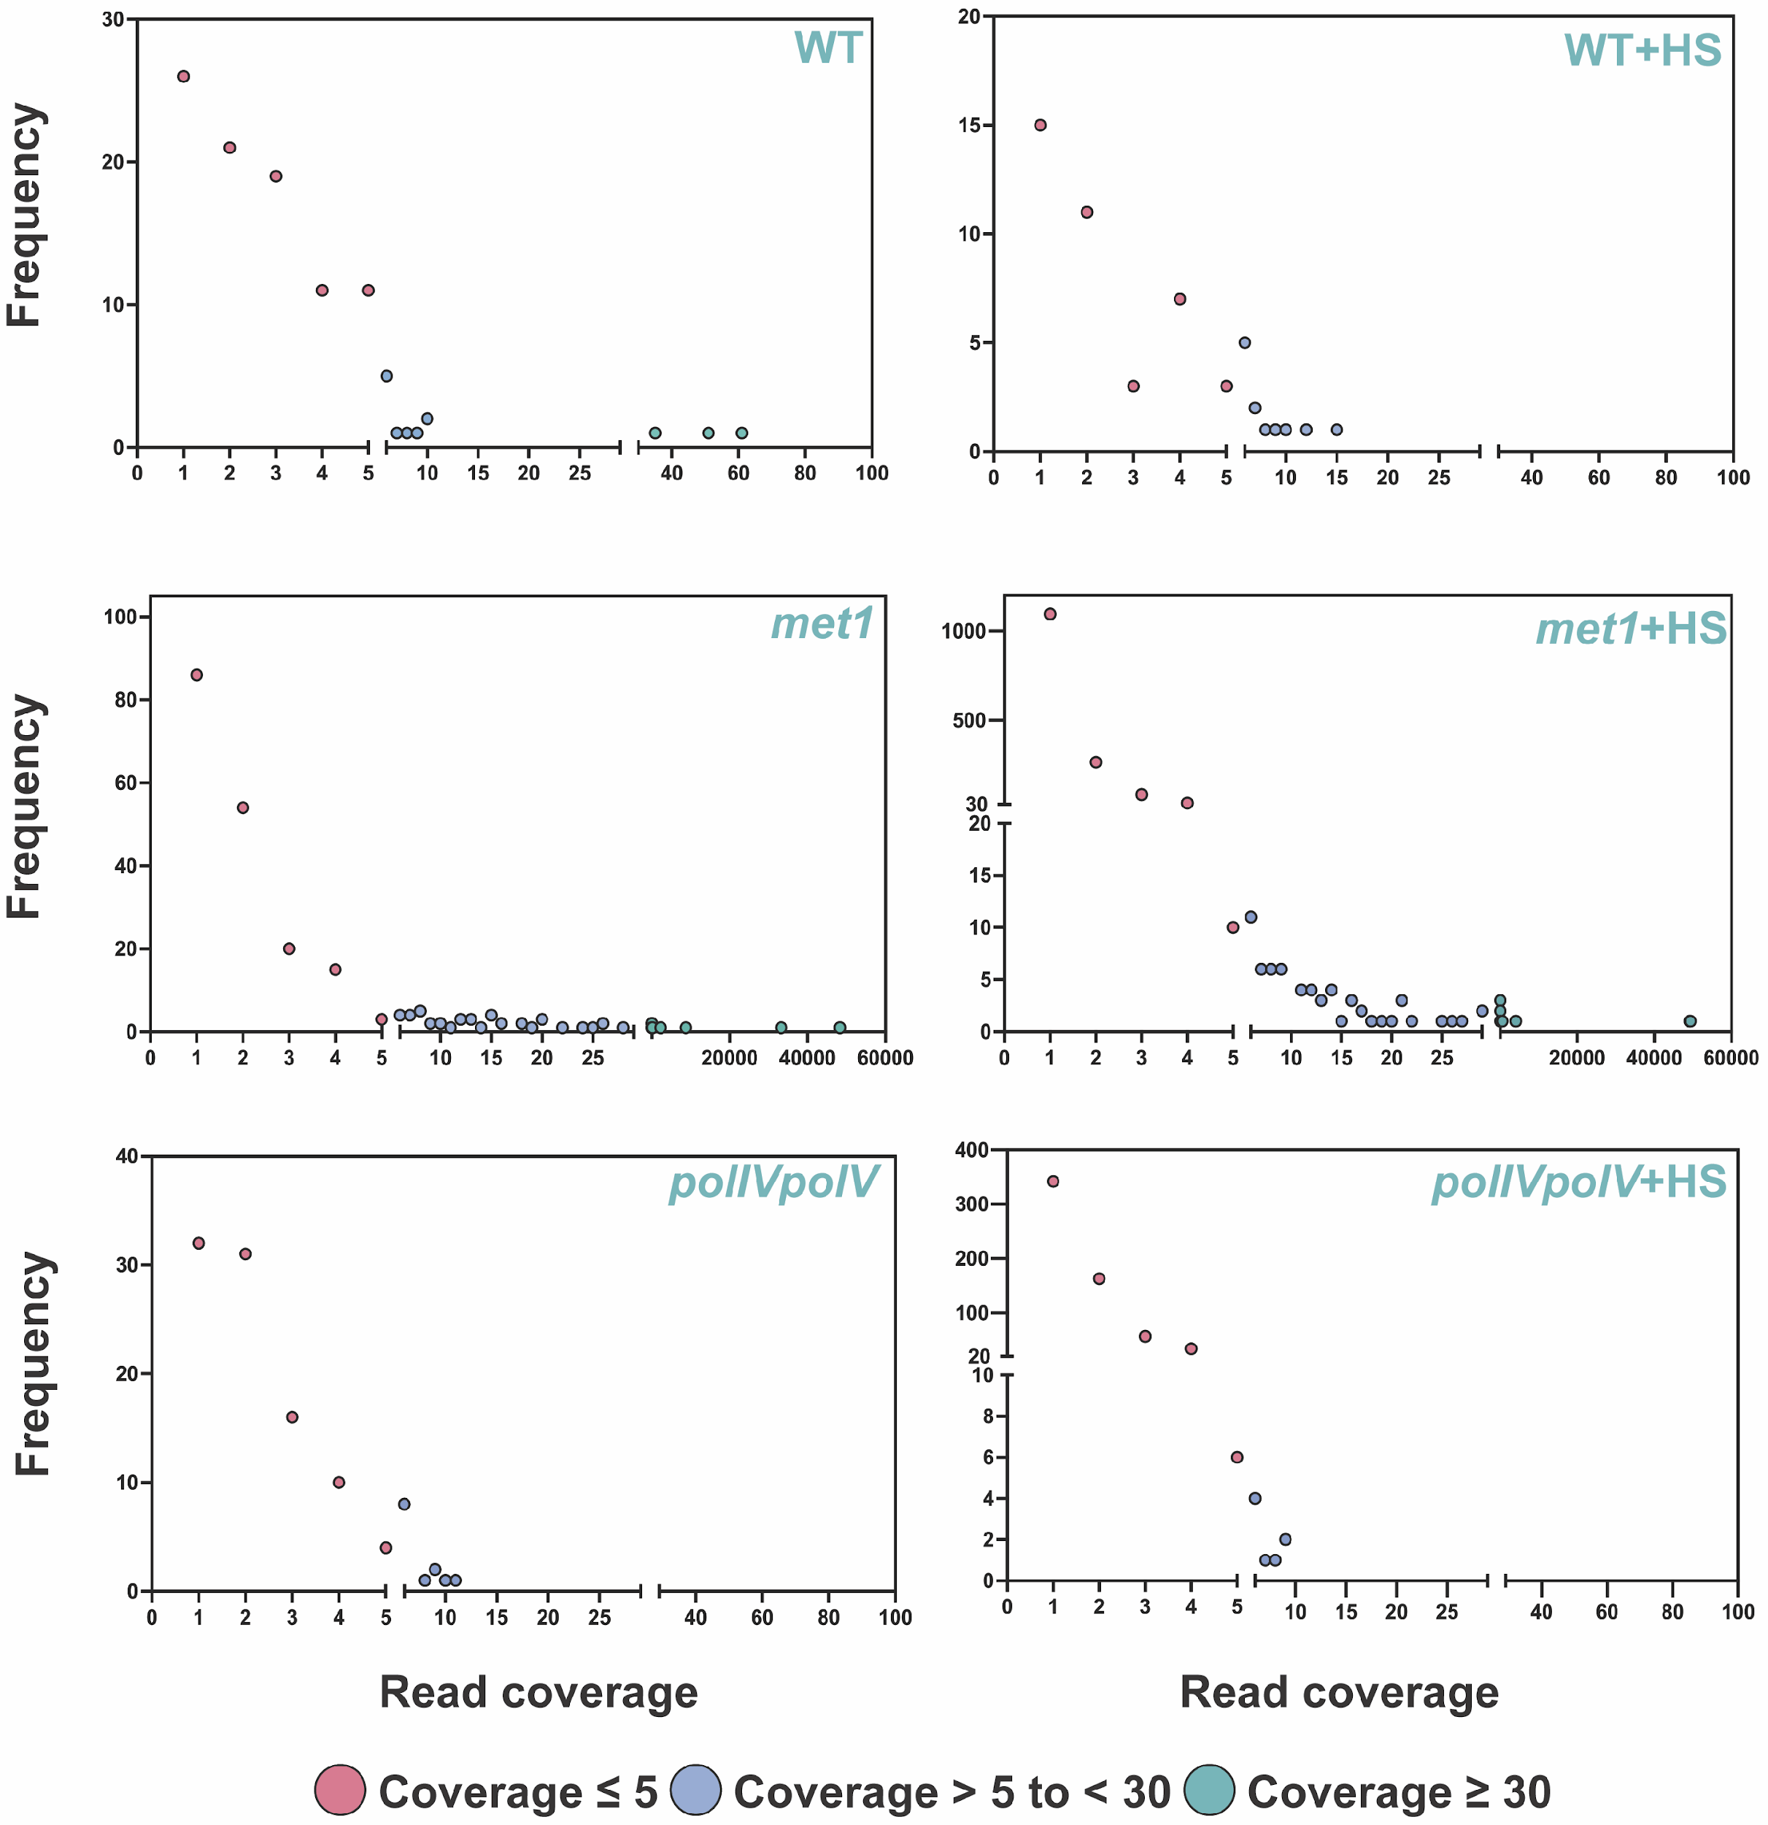

Fig. S9. Read coverage support for somatic (<=5 reads) and non-reference segregating (>=30) insertions for AtCOPIA21. Insertions with coverage of >5 and <30 were not further analysed, because of their ambiguous status as somatic or non-reference segregating.

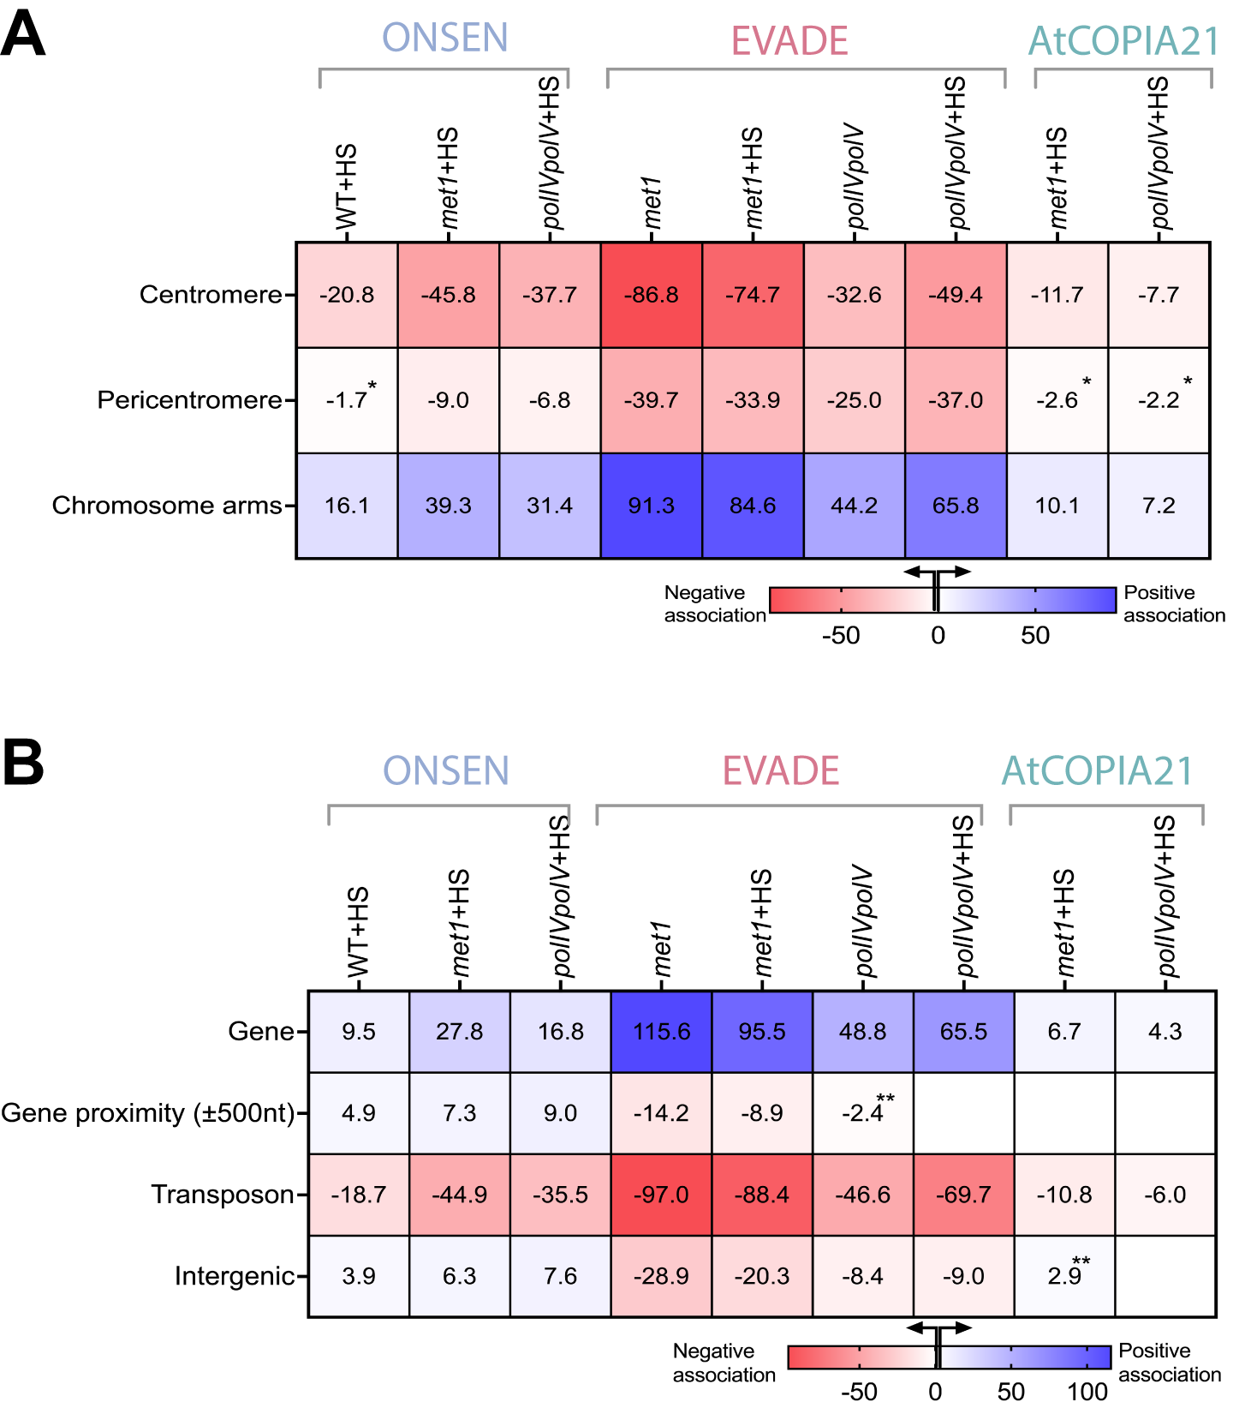

Fig. S10. Heatmap depicting permutation Z-scores representing the strength of association between somatic insertions and various genomic features. A. Association with broad chromosomal regions: centromere, pericentromere and chromosomal arms. B. Association with genomic contexts: Genes, 500bp windows proximal to genes, reference TEs and intergenic regions. Positive associations are shown by blue gradient while negative association represented by red gradient. Significance is denoted as follows: *p<0.05, **p<0.01 and unless otherwise indicated, all other associations are significant at p<0.001. Empty blocks show samples with non-significant associations.

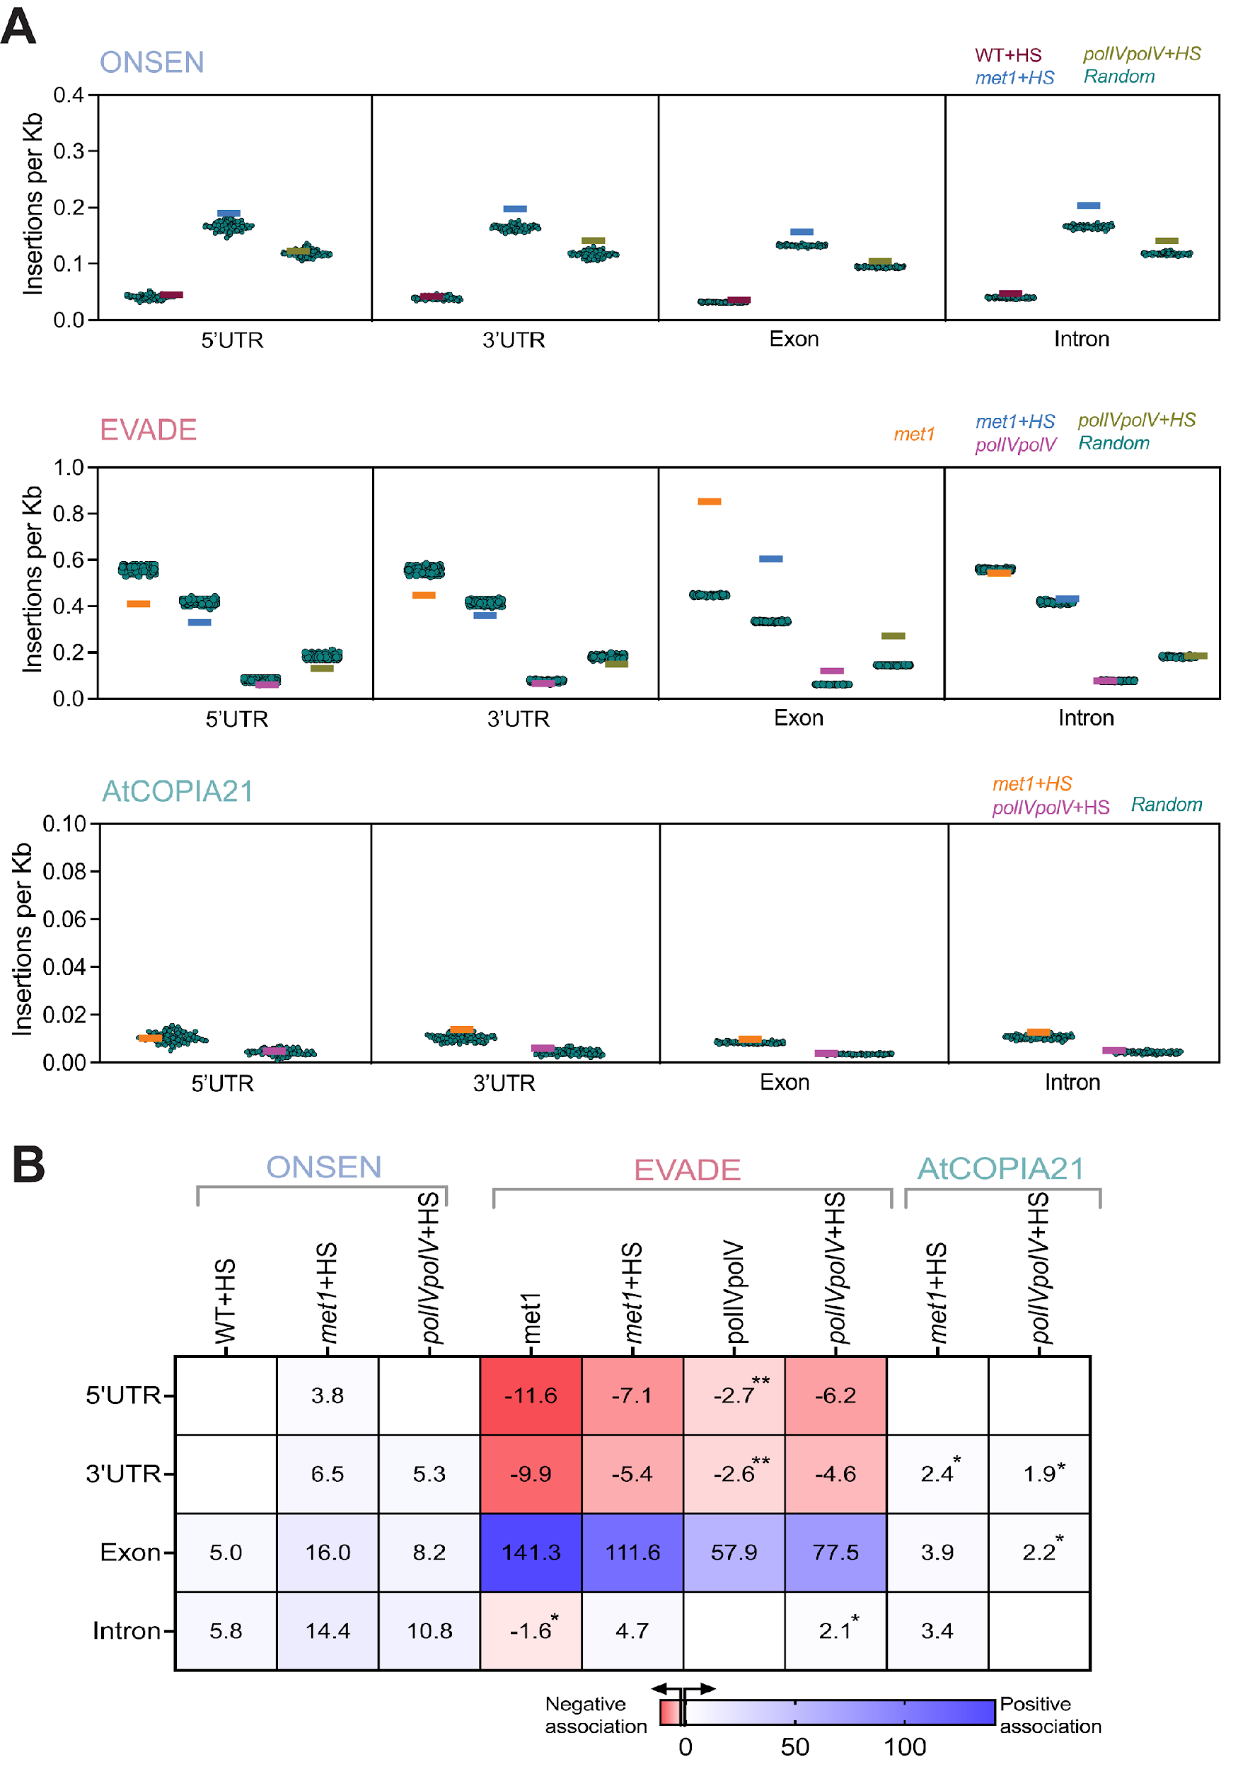

Fig. S11. A. Density of de novo somatic insertions per kilobase (Kb) across genic features including 5’UTR, 3’UTR, exon, and intron for ONSEN, EVADE and AtCOPIA21. Coloured horizontal lines represent observed values, while teal-green dots indicate expected values for an equal number of randomized insertions. B. Heatmap depicting permutation Z-scores representing the strength of association between somatic insertions and genic components presented in A. Positive associations are shown by blue gradient while negative association represented by red gradient. Significance is denoted as follows: *p<0.05, **p<0.01 and unless otherwise indicated, all other associations are significant at p<0.001. Empty blocks show samples with non-significant associations.

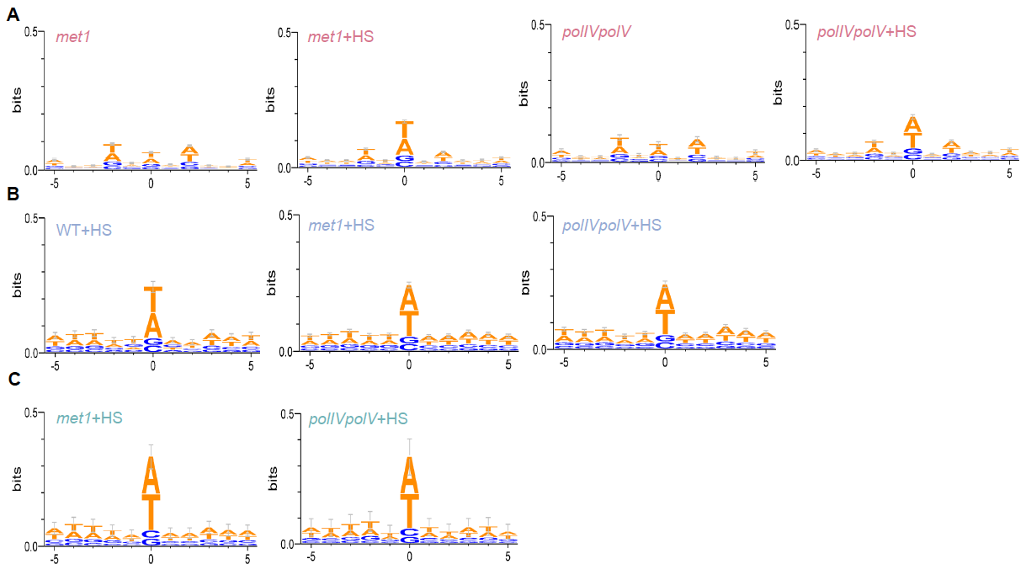

Fig. S12. Sequence logo generated using 5bp up- and down-stream of predicted insertion sites of de novo somatic transposition events of the three TE families, EVADE (A, red), ONSEN (B, blue) and AtCOPIA21 (C, green).

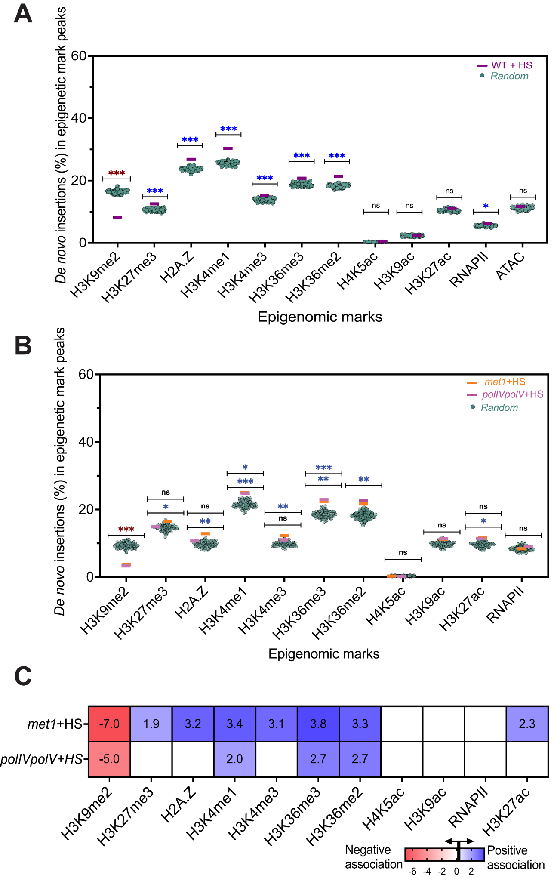

Fig. S13. A. Proportion of de novo ONSEN insertions in the peak regions of different epigenomic marks and chromatin accessibility - ATACseq in heat-stressed WT tissue. B. Proportion of de novo insertions of AtCOPIA21 in the peak regions of different epigenomic marks. Coloured horizontal lines represent observed values while teal-green dots indicate expected values for the randomized insertions. Permutation test was applied to evaluate level of significance (***p<0.001; **p<0.01; *p<0.05; ns – nonsignificant). Positive association marked by blue asterisk while negative association shown by red asterisk. Two significance bars shows that samples had variable significance values. C. Heatmap depicting Z-score representing the strength of association between somatic insertions of AtCOPIA21 and epigenomic marks, computed through permutation tests. Positive association shown by blue gradient while negative association are represented by red gradient. Empty blocks show samples with non-significant associations.

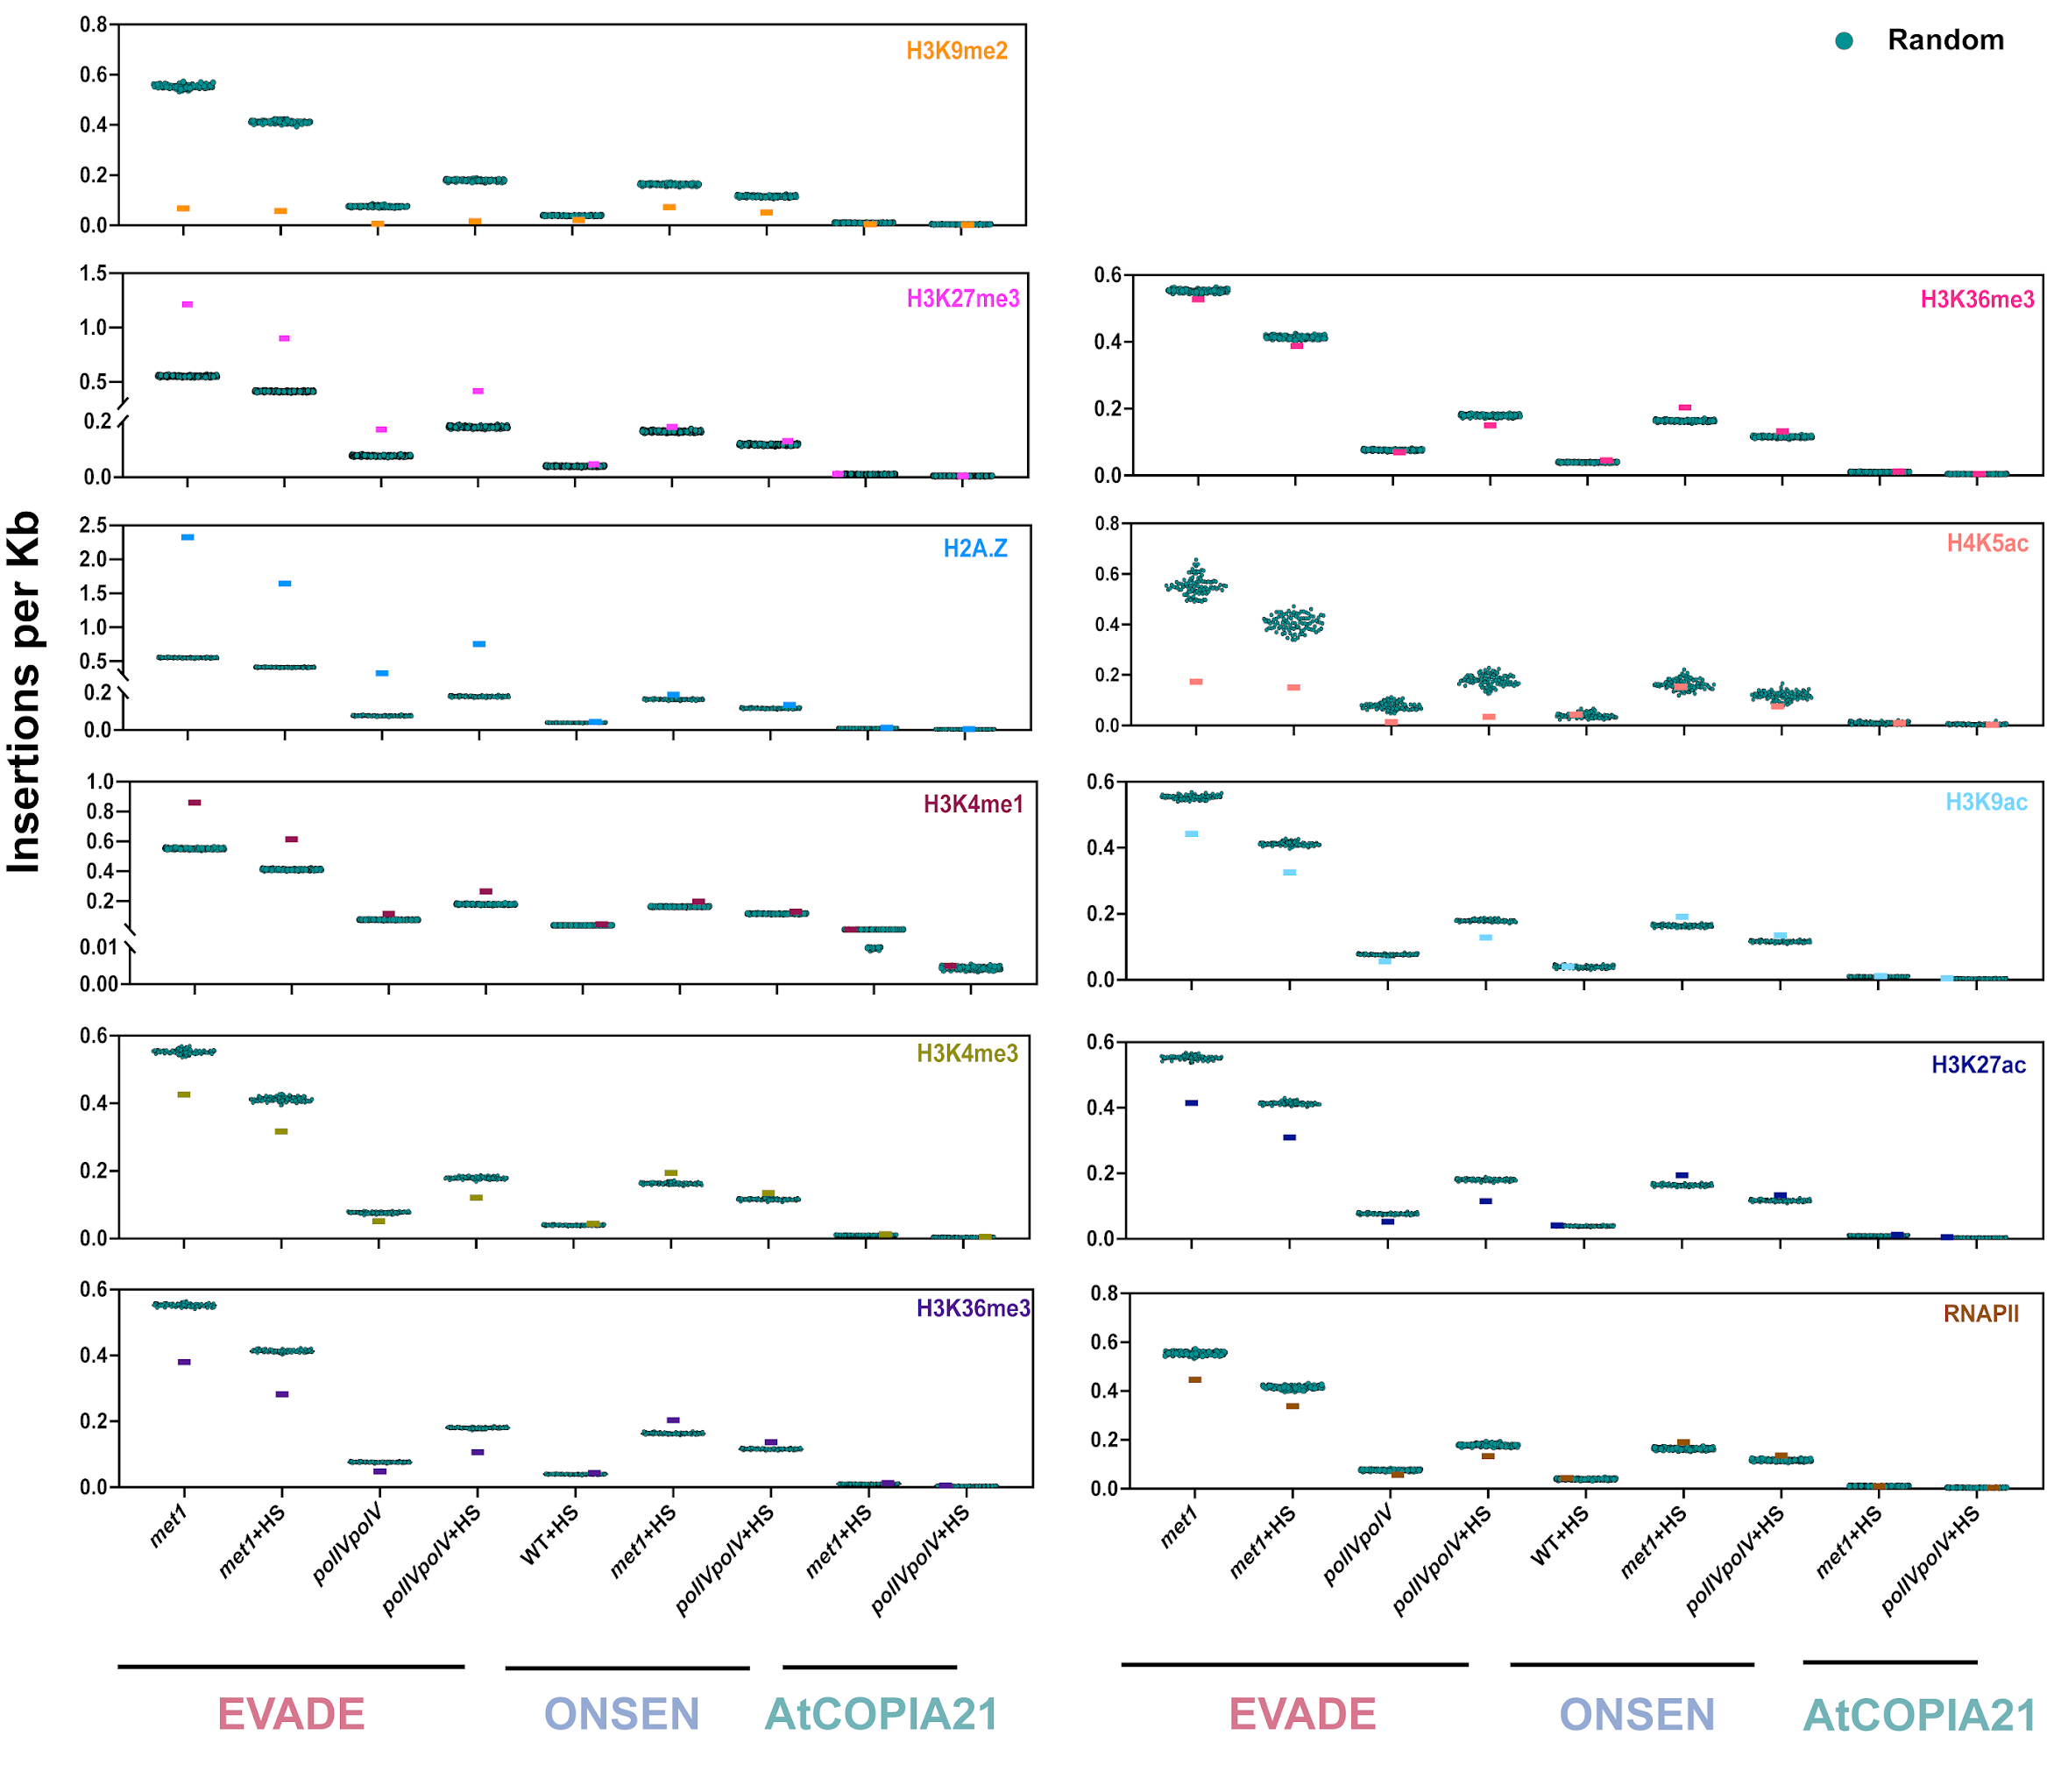

Fig S14. Density of de novo somatic insertions of EVADE, ONSEN and AtCOPIA21 per kilobase (Kb) across each epigenomic feature. The horizontal bar represents the observed insertions per Kb of the epigenomic feature while teal green dots show random insertions. Epigenomic feature names are indicated in each panel and are color-coded.

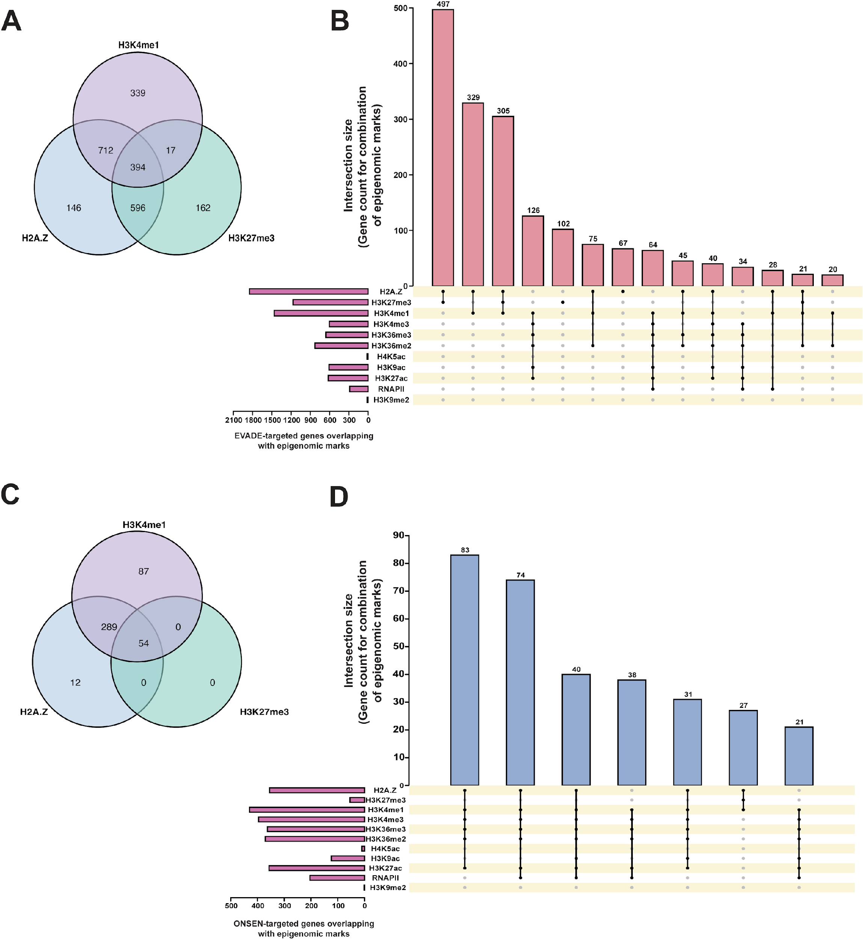
Fig S15. Venn diagrams illustrating the overlap between EVADE-targeted (A) and ONSEN-targeted (C) genes with three epigenomic marks – H2A.Z, H3K27me3 and H3K4me1. Upset plots summarizing the intersection of EVADE-targeted (B) and ONSEN-targeted (D) genes with all studied epigenomic marks. The total number of genes with specific epigenomic mark is shown through histogram on lower left panel (pink) while the genes sharing different epigenomic marks is shown on top panel. Overlapping datasets with a minimum of 20 genes are shown.
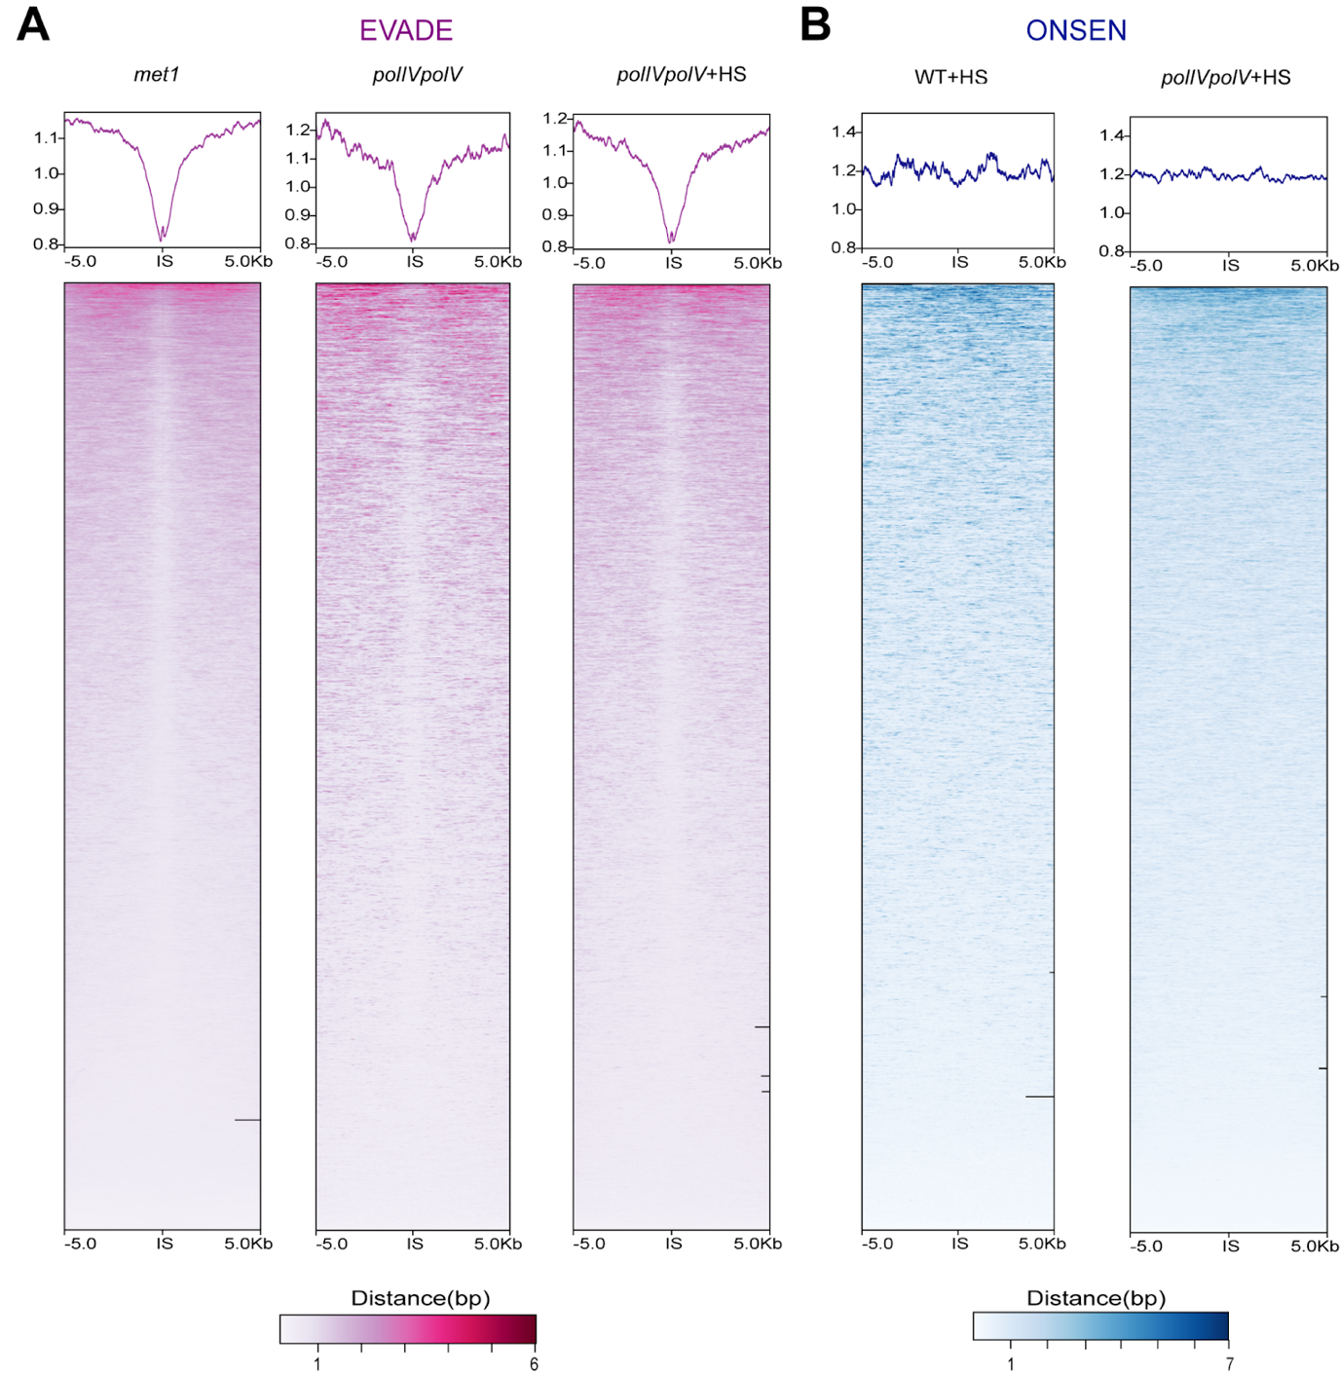
Fig. S16. Metagene and heatmap profiles capturing open chromatin at and around (± 5kb flanking region) the insertion sites (IS) of EVADE (A) and ONSEN (B) integration events in different genetic backgrounds and treatments, generated using ATACseq data.

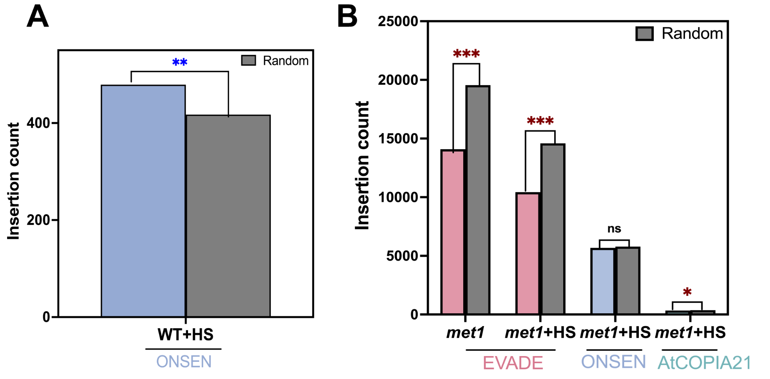
Fig. S17. Absolute counts of de novo somatic insertions of ONSEN in 5,135 GbM genes (A), and EVADE, ONSEN and AtCOPIA21 insertions in met1 hypoDMRs (B). Observed values are compared with the expected values from randomized insertions. Permutation test was applied to evaluate level of significance (***p<0.001; **p<0.01, *p<0.05, ns - non-significant). Positive association marked by blue asterisk while negative association shown by red asterisk.
Note: For GbM, only ONSEN insertions in WT, whereas for hypoDMRs, EVADE, ONSEN and AtCOPIA21 insertions in met1 genotype are shown based on the relevance of these datasets. GbM is maintained in WT but disrupted in met1, while hypoDMRs are essentially generated due to loss of CG methylation in met1 mutant.

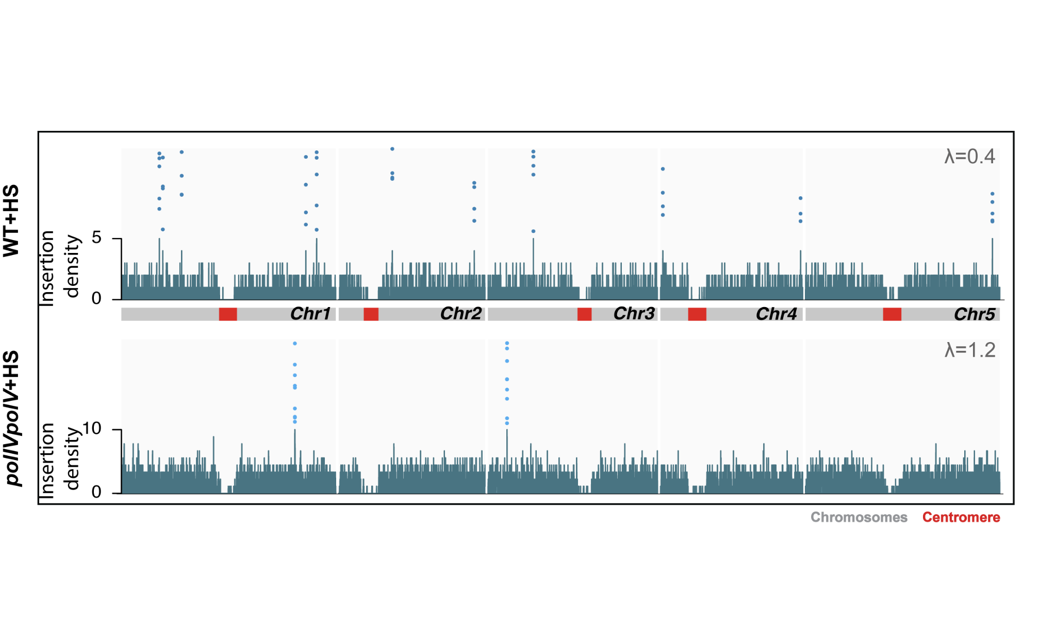
Fig. S18. Distribution of insertion hotspots of ONSEN over Arabidopsis genome. Each dot represents an independent insertion event in a 10kb hotspot window. Insertion density plotted for 10 kb genomic windows shown in lower panel. The expected number of insertions per 10 kb bin (λ) under null hypothesis has been indicated for each sample.

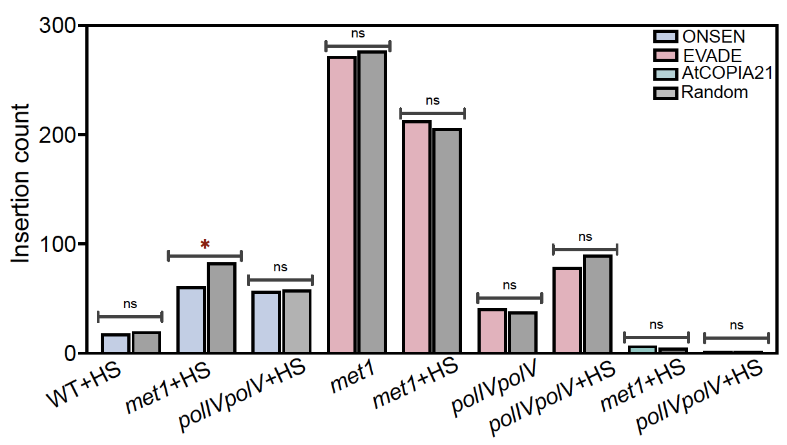

Fig. S19. De novo somatic insertions of the three TE families overlapping with KNOT regions. Permutation test was applied to evaluate level of significance (*p<0.05; ns - non-significant). Red asterisk indicate negative association signifying depletion of insertions in KNOT regions.

Supplementary Information 1
Non-reference segregating insertions in Arabidopsis mutants
In addition to de novo somatic insertions that are generated and detected within a single generation, our pipeline also captured non-reference segregating insertions based on the high read coverage of the TE-genome junctions (≥30 reads, see Methods) (Figure 2A,B). In our experimental setup, these insertions could have only occurred in the two rounds of seed propagation prior to the experiments. For ONSEN, the seedlings or their parental lines were never subjected to heat-stress up to the point of the TEd-seq library preparation, so no insertions were identified, which matches our expectations. In addition, no insertions were observed in wild-type plants for EVADE and AtCOPIA21, underscoring the lack of spontaneous TE mobilization and also the low FDR in our approach. We identified, however, several non-reference segregating insertions for EVADE, especially in met1 with (185) and without (284) heat-stress (Fig. S20A). Fewer insertions were observed in polIVpolV (164 and 105 respectively) (Fig. S20A), which is consistent with an overall lower transposition capacity of EVADE in polIVpolV compared to met1 (Figure 2E). We captured AtCOPIA21 segregating transpositions only in met1, with 22 (no-stress) and 8 (heat-stress) detected insertions (Fig. S20A). For validation of the genomic sites of non-reference segregating insertions, we randomly selected four TE integration sites (FTEins_1-4). Primers were designed from the 3’ end of the TE sequence and the putative flanking genomic site to capture the 3’ break junction of the TE insertion (Fig. S20B; Additional file 2: Table S5). We validated four segregating insertions in non-stressed met1 plants (Fig. S20C).

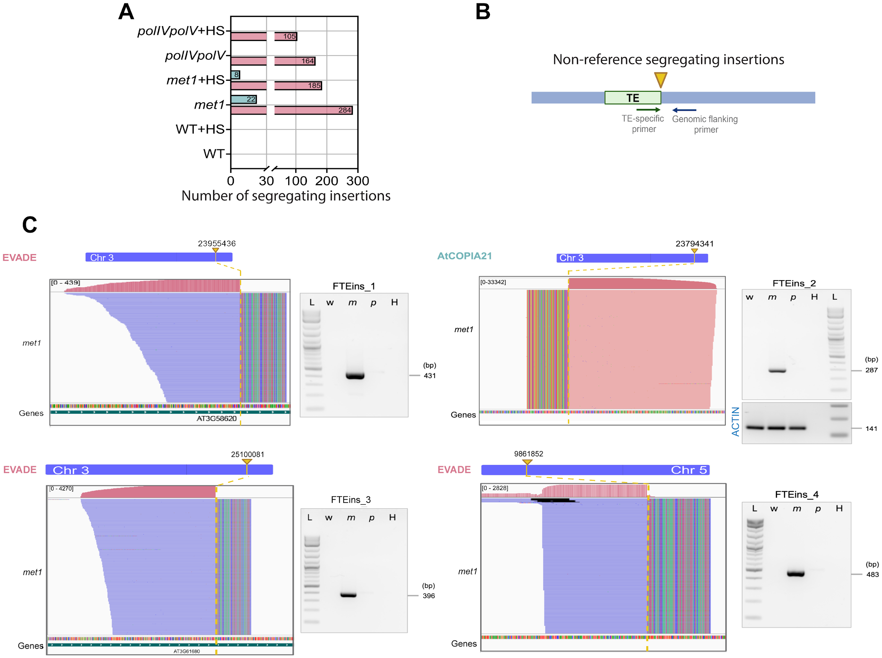

Fig. S20. A. Number of segregating TE insertions for EVADE (red) and AtCOPIA21 (green) in wild-type (WT), met1 and polIVpolV with and without heat-stress. B. Primer positions (one extending from TE end and other from flanking genomic regions) used for validating segregating transposon insertions. New TE insertion site in the genome has been indicated by inverted yellow arrow. C. IGV plots showing position and read coverage at the insertion site of four non-reference segregating TE insertion sites of EVADE and AtCOPIA21 (FTEins_1-4). The rainbow portion of the alignment symbolic for soft-clipped bases corresponds to the TE sequence. Gel profiles for integration site detection by PCR is shown on the right with their expected size indicated. w, wild type; m, met1; p, polIVpolV; H, water (negative control); L, 1kb plus DNA ladder (NEB). Amplification from Actin used as control. Uncropped gel images are provided in Additional file 3.

