Supplementary Materials of “CIT-Lasso: A scalable approach beyond guilty by association for identifying causal variants from genome-wide summary statistics”

Table S1: Conditional independence test via CIT-Lasso consistently identifies more loci and enables prioritization of putative causal variants. We applied the proposed method to three major meta-analyses of AD genetic studies from 2019 to 2022. Finally, we performed a meta-analysis of 10 AD genetic studies from 2017-2022. We report the number of identified loci and the number of identified proxy variants per loci.

Source of summary statistics | Jansen et al. (2019) | Schwartzentruber et al. (2021) | Bellenguez et al. (2022) | Meta-analysis of 10 studies
 | Number of loci
Marginal Association Test | 23 | 28 | 42 | 51
CIT-Lasso | 35 | 31 | 68 | 82
CIT- SuSiE | 1 | 17 | 37 | 57
CIT-Marginal | 12 | 9 | 61 | 70
 | Number of proxy variants per locus
Marginal Association Test | 19.3 | 18.8 | 15.8 | 18.8
CIT-Lasso | 3.3 | 1.6 | 2.3 | 2.6
CIT- SuSiE | 4 | 1.53 | 1.4 | 1.4
CIT-Marginal | 12.3 | 12.7 | 4.3 | 6.2

Table S2: Comparison between KnockoffZoom (Sesia et al. 2020) and CIT-Lasso.
 | KnockoffZoom | CIT-Lasso
Input data | Individual genotype data | Summary statistics: p-values and direction of effect (or Z-scores) and LD matrix
Knockoff construction | Hidden Markov Model (HMM) knockoffs | Second-order group knockoffs by maximizing entropy
Number of simultaneous knockoffs | Single knockoff | Multiple knockoffs for improved power when number of signals is small.
Generate knockoffs | Generate and store individual knockoffs | Generate and store knockoff Z-scores
Sparse regression | Individual data-based lasso regression via packages bigstatsr and bigsnpr | Summary statistics-based lasso regression via BASIL
Knockoff test statistics | Compute test statistics based on regression coefficients
Selection of variants | Apply multi-layers knockoff filter | Apply modified variant-level group knockoffs filter
Output | Selected regions with various sizes | Selected catching sets
Total time for analyzing UKB data | 288 hours (reported by Sesia et al. 2020) | <15 mins
Peak memory | 200 GB (reported by Sesia et al. 2020) | 9.1 GB

Fig S1. Genome-wide simulation study – power stratified by marginal p-value, regression coefficient and variant MAF. Power is calculated as the ratio of identified variants to total variants within the stratified causal set. This set includes causal variants where -log10(marginal p-value), regression coefficient, or variant MAF exceed the target threshold.
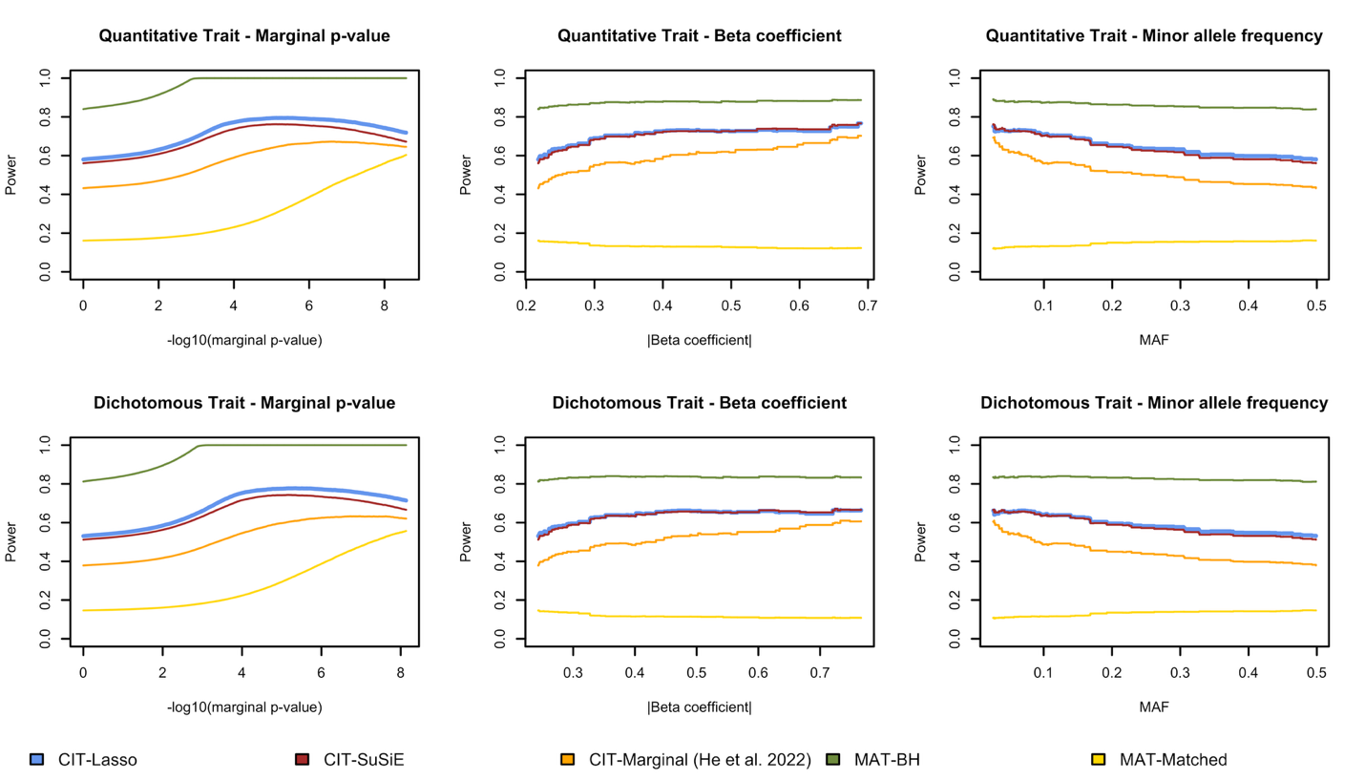

Fig S2: Meta-analysis of Alzheimer’s disease genetic studies via marginal association tests. We present the Manhattan plot from conventional marginal association tests. For the marginal association tests (top panel), the dotted line presents the conventional genome-wide p-value threshold of $5×{10}^{-8}$. P-values and W statistics are truncated at ${10}^{-50}$ for better visualization. The results are based on p-values calculated via the proposed meta-analysis strategy with optimal weights combining the ten studies. Variant density is shown at the bottom of plot (number of variants per 1Mb).
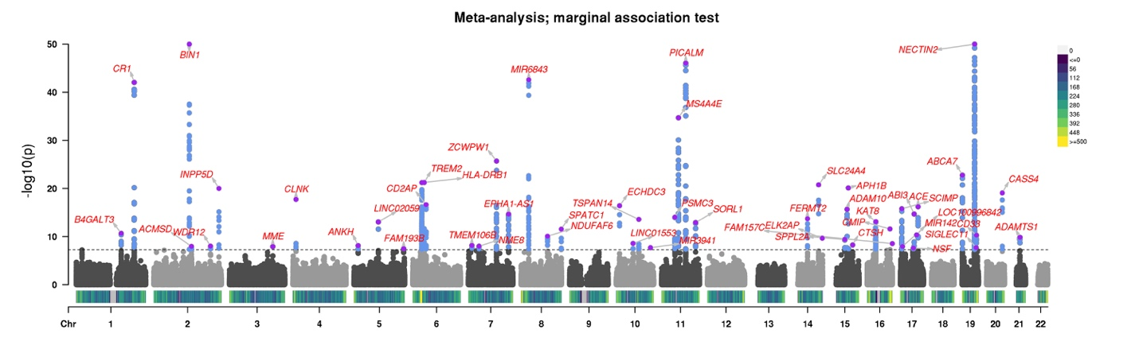

Fig S3. Fine-mapping with directly genotyped data vs. imputed data when the MPRA and CRISPR validated variants are typed. We compare marginal association test (MAT), MAT followed by SuSiE fine-mapping, and CIT-lasso. Different colors represent different catching/credible sets (for CIT-Lasso, they represent independent conditional causal effects). The legend presents the genes that each catching/credible set potentially regulates, mapped by the cS2G method. The red dotted lines represent the p-value threshold of $5×{10}^{-8}$ and FDR threshold of 0.10 for MAT and CIT-lasso respectively.
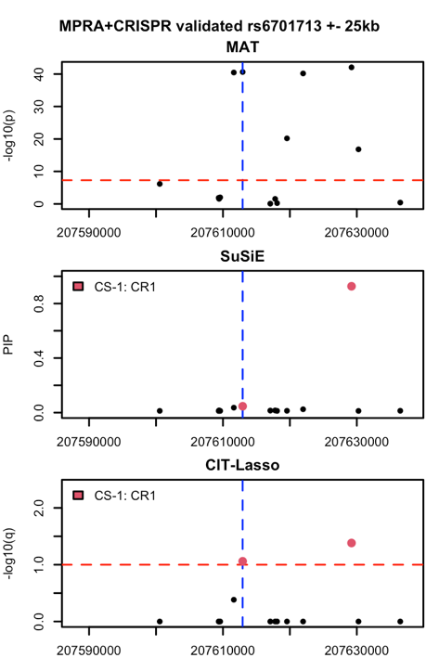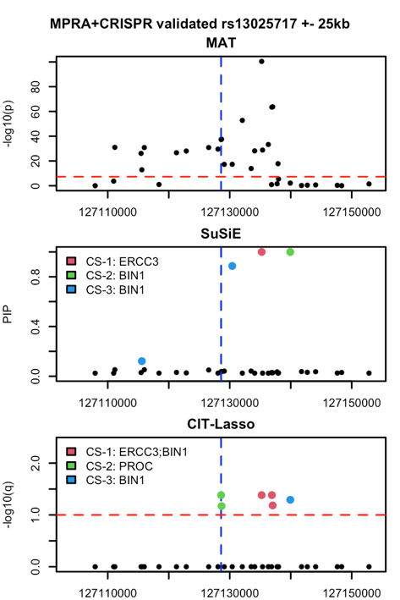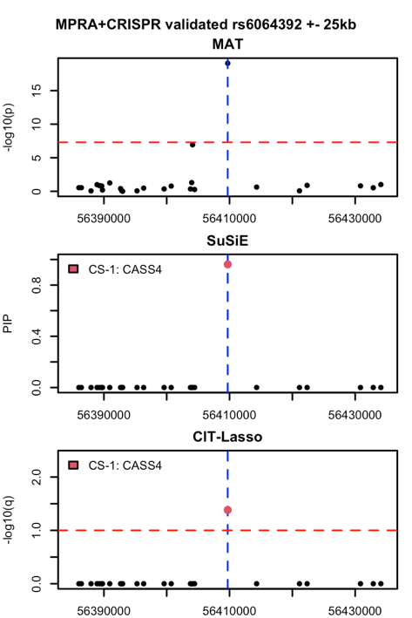
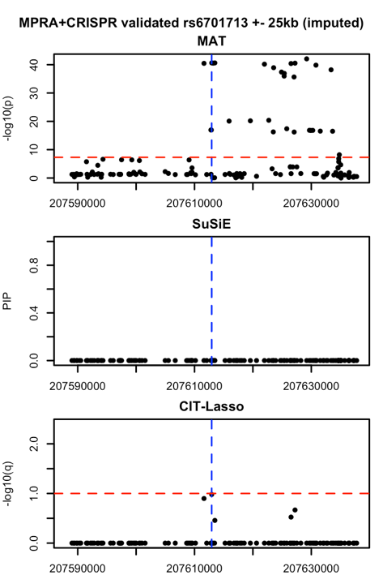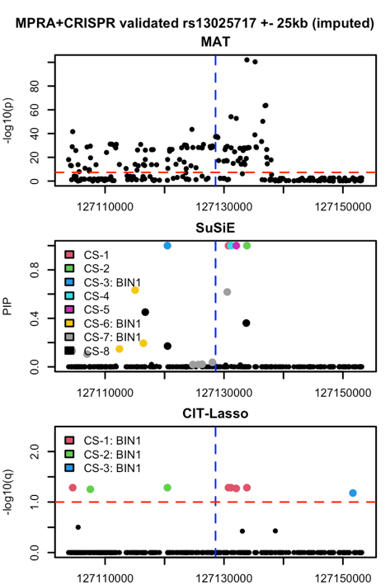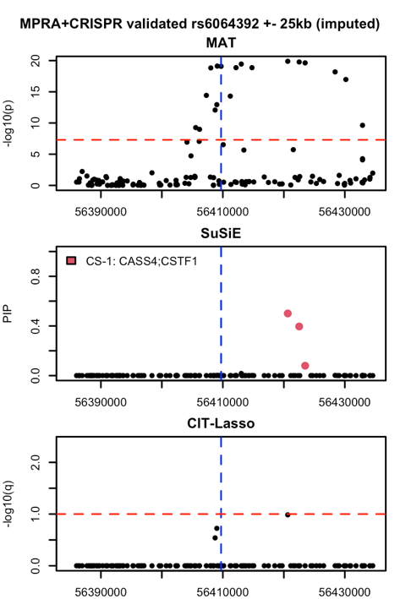

Fig S4. Fine-mapping with directly genotyped data vs. imputed data when the MPRA and CRISPR validated variants are not genotyped. We compare marginal association test (MAT), MAT followed by SuSiE fine-mapping, and CIT-lasso. Different colors represent different catching/credible sets (for CIT-Lasso, they represent independent conditional causal effects). The legend presents the genes that each catching/credible set potentially regulates, mapped by the cS2G method. The red dotted lines represent the p-value threshold of $5×{10}^{-8}$ and FDR threshold of 0.10 for MAT and CIT-lasso respectively.
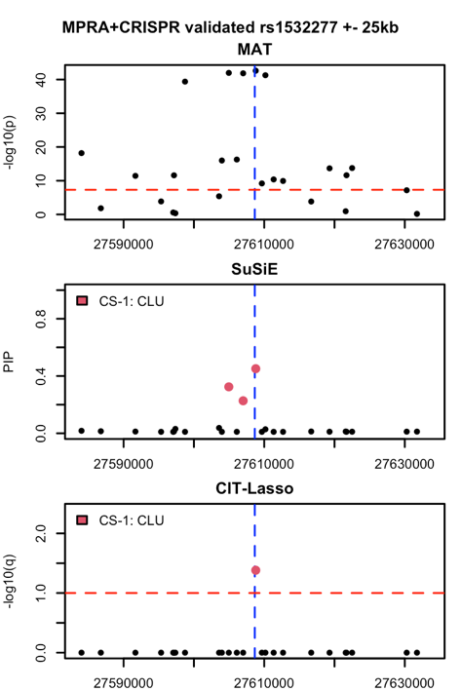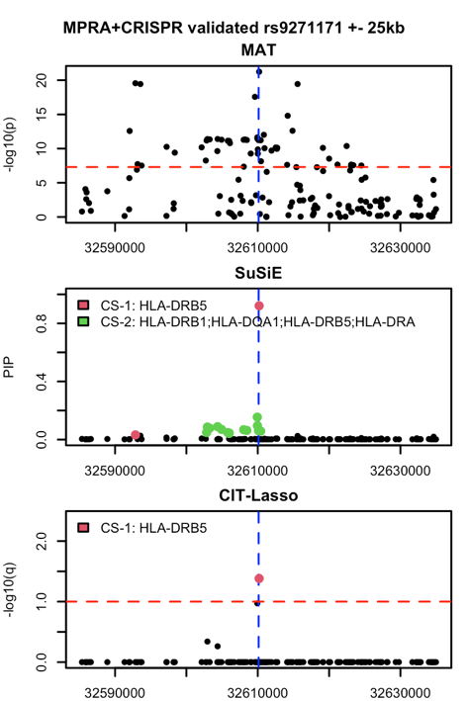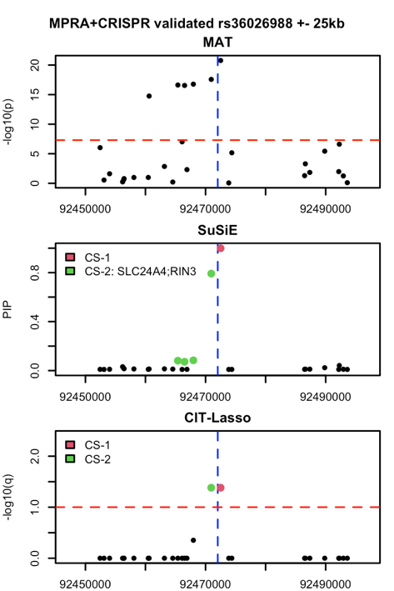
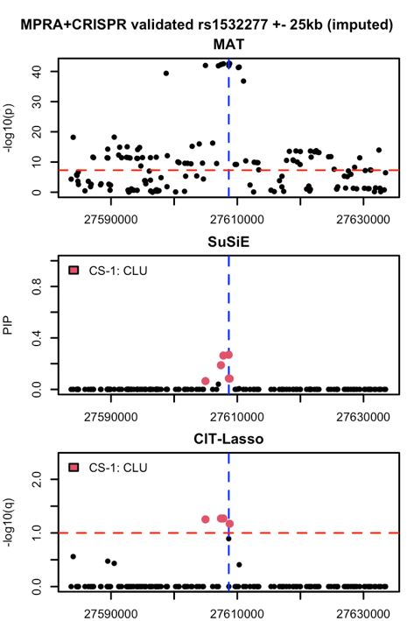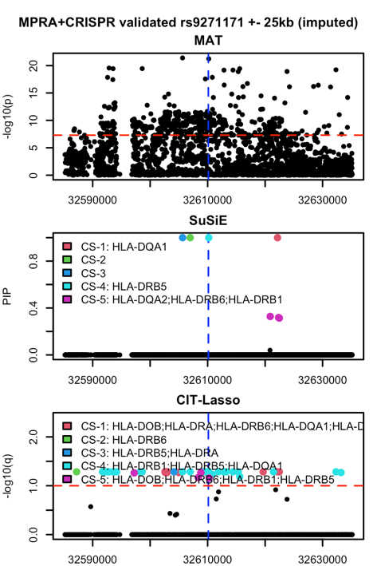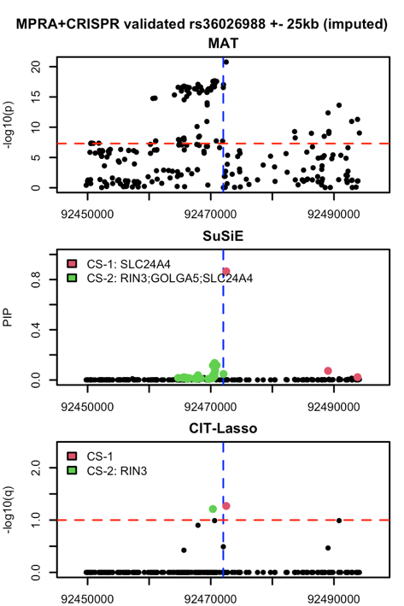

Fig S4 (continue). Fine-mapping with directly genotyped data vs. imputed data when the MPRA and CRISPR validated variants are not genotyped. We compare marginal association test (MAT), MAT followed by SuSiE fine-mapping, and CIT-lasso. Different colors represent different catching/credible sets (for CIT-Lasso, they represent independent conditional causal effects). The legend presents the genes that each catching/credible set potentially regulates, mapped by the cS2G method. The red dotted lines represent the p-value threshold of $5×{10}^{-8}$ and FDR threshold of 0.10 for MAT and CIT-lasso respectively.
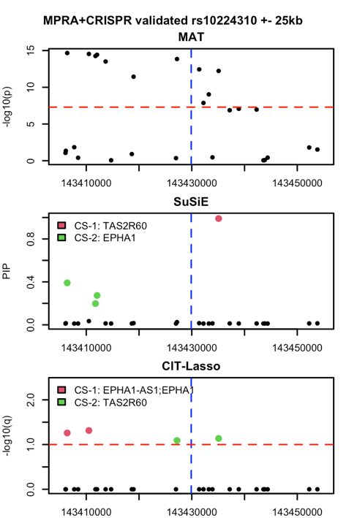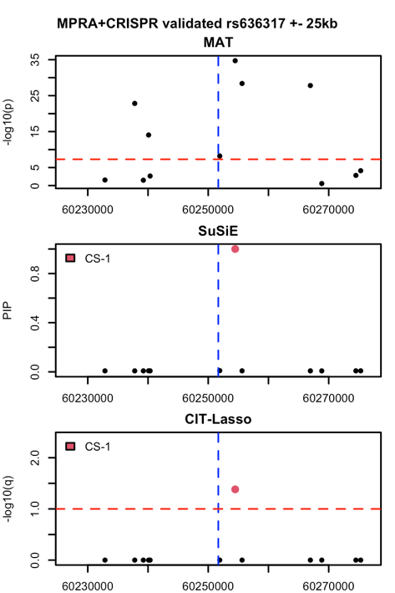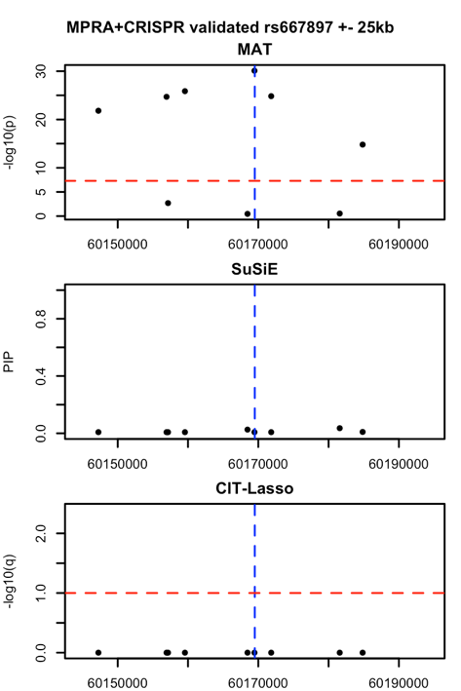
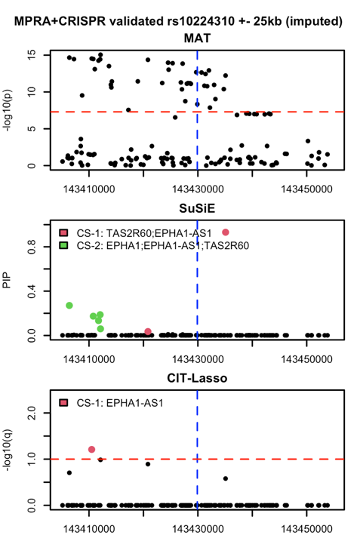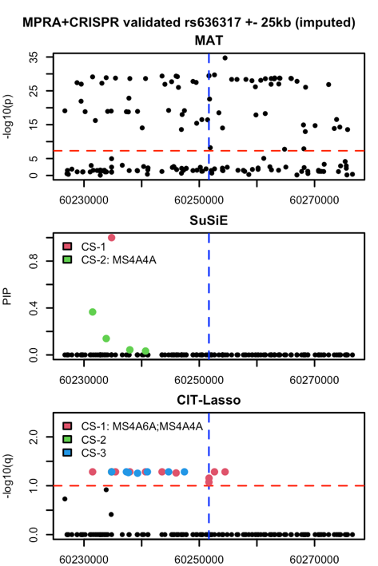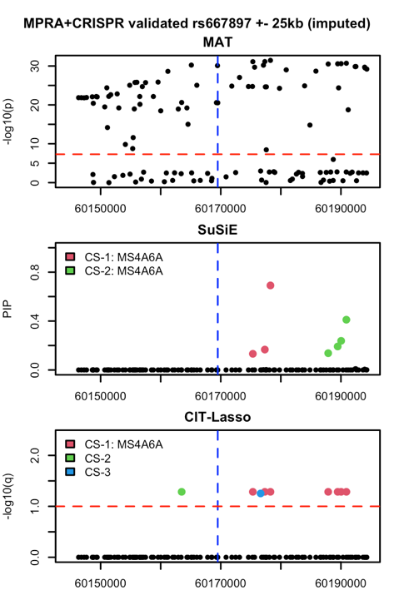

Fig S5. Additional variants identified by CIT-Lasso ($p≥5×10^{-8}$) have concordant z-scores and directions of effects across 10 studies. Left panel: we compute the spearman correlation of Z-scores between each pair of studies. Right panel: for each identified variant, we compute and present the proportion of studies with same direction of effect as in the meta-analysis.
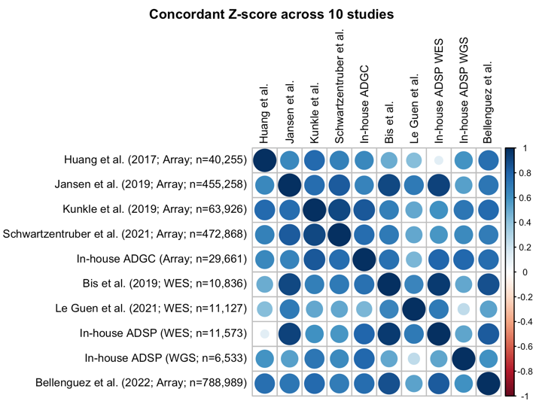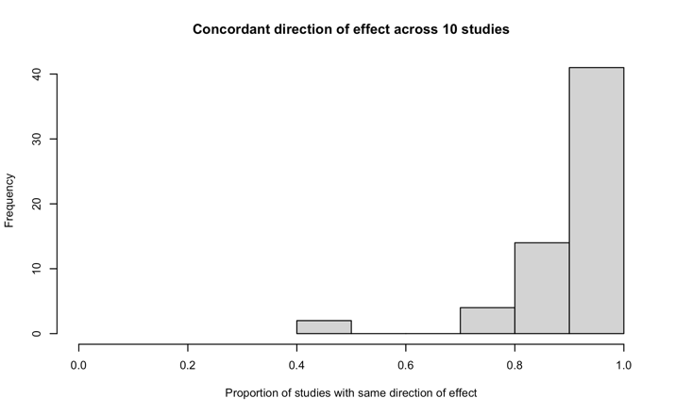

Fig S6. CIT-Lasso identifies conditionally independent effects that regulate distinct genes. Left panel: Histogram of the number of conditionally independent effects (CIE) per locus. Right panel: for identified variants that can be mapped to cS2G genes, we present the number of identified variants per locus, number of identified conditional independent effects per locus and the number of corresponding cS2G genes. Each bar presents a locus. The loci are ordered by the number of identified variants. APOE locus is excluded for better visualization. The correlation between number of identified conditional independent effects and number of corresponding cS2G genes is 0.81.
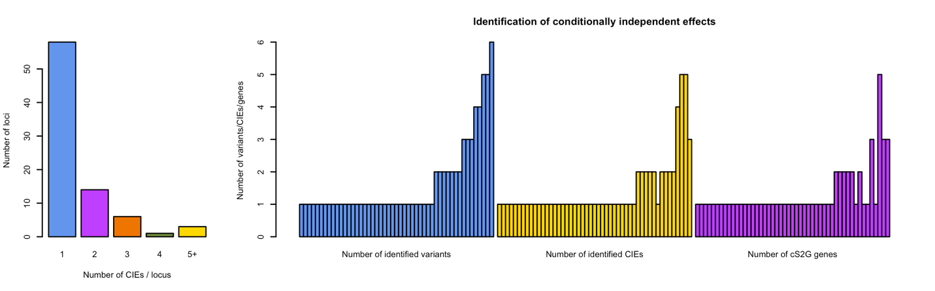

Fig S7. Additional fine-mapping examples for BIN1, PTK2B and HLA-DRB1. We compare marginal association test (MAT), MAT followed by SuSiE fine-mapping, and CIT-lasso. Different colors represent different catching/credible sets (for CIT-Lasso, they represent independent conditional causal effects). The legend presents the genes that each catching/credible set potentially regulates, mapped by the cS2G method. The red dotted lines represent the p-value threshold of $5×{10}^{-8}$ and FDR threshold of 0.10 for MAT and CIT-lasso respectively.
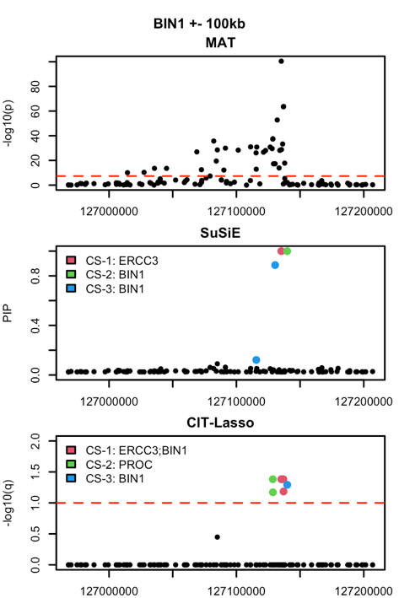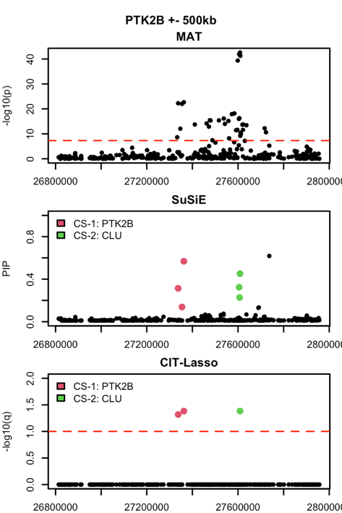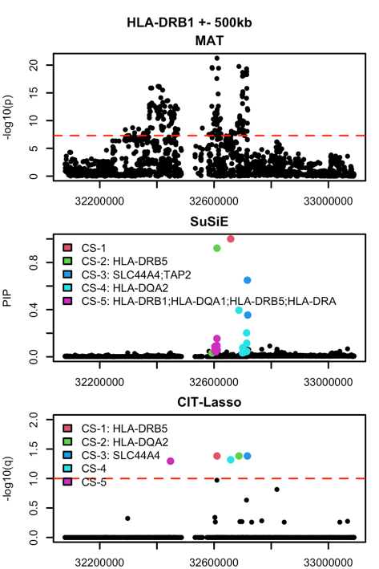

Fig S8. Average power and FDR over 200 replications with respect to different target FDR levels.
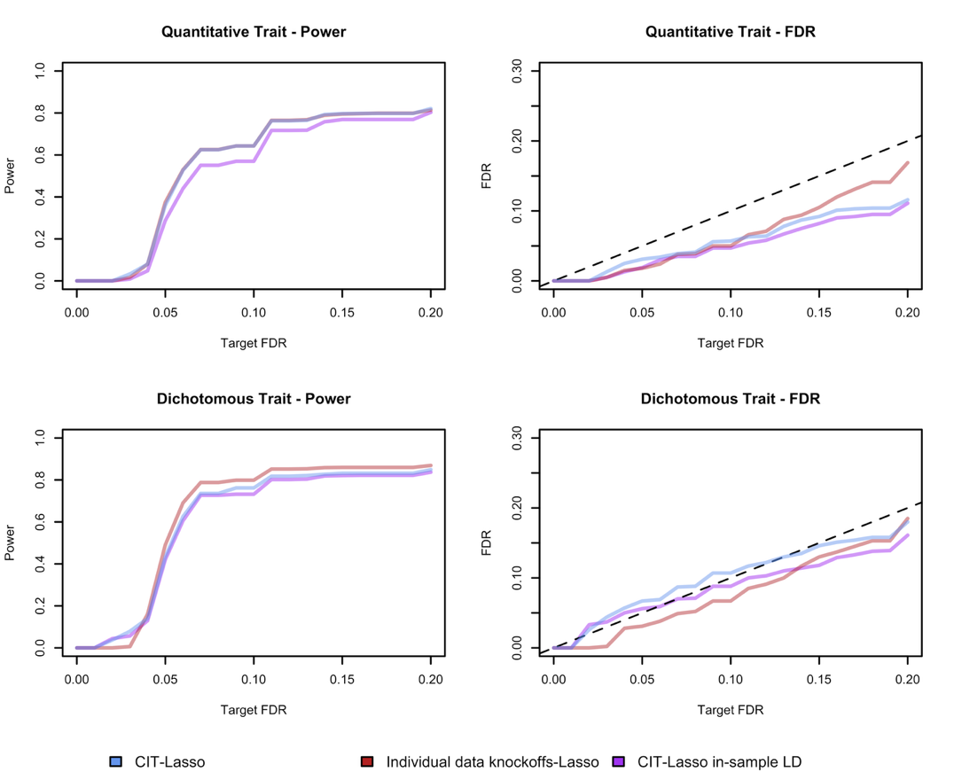

Proof of the variant-level group knockoffs filter
To provide variant level interpretation given group knockoffs, we consider the hypotheses:
$$H_{0}:Y⊥G_{j}|G_{-g_{k}}$$
where $g_{k}$ represents the group in which the $j$-th variant resides; $G_{-g_{k}}$ are the genotypes for all variants across the genome except variants in $g_{k}$. For notational simplicity, we prove the case when $M=1$ where $κ_{j}∈\left\{0,1\right\}$. The extension to $M>1$ follows the analogous argument for multiple simultaneous knockoffs.
For a target FDR of $α$, we aim to find $t_{α}$ such that
$$E\left\{FDP\left(t_{α}\right)\right\}=E\left\{\frac{\#\left\{j∈H_{0} | κ_{j}=1,τ_{j}≥t_{α}\right\}}{1∨\#\left\{j | κ_{j}=0,τ_{j}≥t_{α}\right\}}\right\}≤α$$
The existing proof of FDR control of the knockoff filter does not apply here because we are using group knockoffs. We consider a decomposition of the FDP corresponding to a partition of the variants such that the conventional knockoff filter can be applied to each partition. To achieve this, we assign all variants to an $L×K$ matrix, where each column corresponds to one group and each row contains only one variable from each group. For each column, we rank variable within a group by $τ_{j}$ and assign them in descending order. This way $\#\left\{j∈R_{l}, j∈H_{0} | κ_{j}=0,τ_{j}≥t_{α}\right\}=0$ for any $l>ϕ\left(t_{α}\right)=\max_{k}{\#\left\{j∈g_{k}\right|τ_{j}≥t_{α}\}}$, where $j∈R_{l}$ means the $j$-th variant is in the $l$-th row. For the feature statistic defined by $T_{j}^{m}=\left|{\hat{β}}_{m,j}\right|$ where ${\hat{β}}_{m,j}$ is the coefficient estimate from lasso regression, we have the following lemma.
Lemma. (1) Suppose $Y⊥G_{g_{k}}|G_{-g_{k}}$, then $κ_{j}\sim unif\left\{0,1\right\}$ conditional on $τ_{j}$ for all $j∈g_{k}$; (2) Suppose $Y⊥G_{g_{k}}|G_{-g_{k}}$ and $Y⊥G_{g_{k^{'}}}|G_{-g_{k^{'}}}$, $k≠k^{'}$, then $κ_{j}⊥κ_{j^{'}}|τ_{1},…,τ_{p}$ for any pairs $j∈g_{k}$ and $j^{'}∈g_{k^{'}}$, $k≠k^{'}$.
Proof to (1): By the definition of group knockoffs,
$$y⊥\left({\tilde{G}}_{g_{k}},{\tilde{G}}_{-g_{k}}\right)|G_{g_{k}},G_{-g_{k}}.$$
Since $y⊥G_{g_{k}}|G_{-g_{k}}$,
$$y⊥\left(G_{g_{k}},{\tilde{G}}_{g_{k}},{\tilde{G}}_{-g_{k}}\right)|G_{-g_{k}}$$
$$⇒y⊥\left(G_{g_{k}},{\tilde{G}}_{g_{k}}\right)|G_{-g_{k}},{\tilde{G}}_{-g_{k}}$$
By the definition of group knockoffs,
$$\left(G_{g_{k}},{\tilde{G}}_{g_{k}}\right)|G_{-g_{k}},{\tilde{G}}_{-g_{k}}\sim \left({\tilde{G}}_{g_{k}},G_{g_{k}}\right)|G_{-g_{k}},{\tilde{G}}_{-g_{k}}$$
where $\text{\sim }$ denotes equality in distribution. Therefore,
$$\left(G_{j},{\tilde{G}}_{j},G_{g_{k}\backslash j},{\tilde{G}}_{g_{k}\backslash j},G_{-g_{k}},{\tilde{G}}_{-g_{k}},y\right)\sim \left({\tilde{G}}_{j},G_{j},{\tilde{G}}_{g_{k}\backslash j},G_{g_{k}\backslash j},G_{-g_{k}},{\tilde{G}}_{-g_{k}},y\right)$$
Subsequently,
$$T_{j}^{0}=\left|{\hat{β}}_{0,j}\right|\sim \left|{\hat{β}}_{1,j}\right|=T_{j}^{1}|τ_{1},…τ_{p}$$
$$⇒κ_{j}\sim unif\left\{0,1\right\}|τ_{1},…τ_{p}$$
for all $j∈g_{k}$.
Proof of (2): It suffices to prove
$$\left(T_{j}^{0},T_{j}^{1},T_{j^{'}}^{0},T_{j^{'}}^{1}\right)\left|τ_{1},…τ_{p}\sim \left(T_{j}^{1},T_{j}^{0},T_{j^{'}}^{0},T_{j^{'}}^{1}\right)\right|τ_{1},…τ_{p},$$
and
$$\left(T_{j}^{0},T_{j}^{1},T_{j^{'}}^{0},T_{j^{'}}^{1}\right)|τ_{1},…τ_{p}\sim \left(T_{j}^{0},T_{j}^{1},T_{j^{'}}^{1},T_{j^{'}}^{0}\right)|τ_{1},…τ_{p}$$
The first equality in distribution holds by the same argument for (1) and the fact that swapping $G_{g_{k}}$ and ${\tilde{G}}_{g_{k}}$ does not change $T_{j^{'}}^{1}$ and $T_{j^{'}}^{0}$ when $j^{'}∈g_{k^{'}}$, $k≠k^{'}$. The second equality in distribution can be proved similarly. Then we have
$$\left(T_{j}^{0},T_{j}^{1},T_{j^{'}}^{0},T_{j^{'}}^{1}\right)|τ_{1},…τ_{p}\sim \left(T_{j}^{1},T_{j}^{0},T_{j^{'}}^{1},T_{j^{'}}^{0}\right)|τ_{1},…τ_{p}$$
$$⇒κ_{j}⊥κ_{j^{'}}|τ_{1},…,τ_{p}, j∈g_{k}, j^{'}∈g_{k^{'}}, k≠k^{'}$$
if $y⊥G_{g_{k}}|G_{-g_{k}}$ and $Y⊥G_{g_{k^{'}}}|G_{-g_{k^{'}}}$.
In genetic studies, the groups are defined by LD where variants in high correlation reside in the same group. It may be safe to assume that $Y⊥G_{j}|G_{-g_{k}}⇔Y⊥G_{g_{k}}|G_{-g_{k}}$. Under this additional assumption, the lemma above shows that ${\left\{k_{j}\right\}}_{j∈R_{l},j∈H_{0}}$ are i.i.d. coin flips conditional on $\left\{τ_{j}\right\}$. With this lemma, we look at decomposition of FDP as follows:
$$FDP\left(t_{α}\right)=\frac{\#\left\{j∈H_{0} | κ_{j}=1,τ_{j}≥t_{α}\right\}}{1∨\#\left\{j | κ_{j}=0,τ_{j}≥t_{α}\right\}}=\sum_{l=1}^{ϕ\left(t_{α}\right)}{\frac{\#\left\{j∈R_{l}, j∈H_{0} | κ_{j}=0,τ_{j}≥t_{α}\right\}}{1∨\#\left\{j | κ_{j}=0,τ_{j}≥t_{α}\right\}}}=\sum_{l=1}^{L}{I\left\{ϕ\left(t_{α}\right)≥l\right\}\frac{1+\#\left\{j∈R_{l} | κ_{j}=1,τ_{j}≥t_{α}\right\}}{1∨\#\left\{j | κ_{j}=0,τ_{j}≥t_{α}\right\}}×\frac{\#\left\{j∈R_{l}, j∈H_{0} | κ_{j}=0,τ_{j}≥t_{α}\right\}}{1+\#\left\{j∈R_{l} | κ_{j}=0,τ_{j}≥t_{α}\right\}}}≤\sum_{l=1}^{L}{\frac{I\left\{ϕ\left(t_{α}\right)≥l\right\}+\#\left\{j∈R_{l} | κ_{j}=1,τ_{j}≥t_{α}\right\}}{1∨\#\left\{j | κ_{j}=0,τ_{j}≥t_{α}\right\}}×\frac{\#\left\{j∈R_{l}, j∈H_{0} | κ_{j}=0,τ_{j}≥t_{α}\right\}}{1+\#\left\{j∈R_{l}, j∈H_{0} | κ_{j}=1,τ_{j}≥t_{α}\right\}}}$$
For any fixed ${\left\{v_{l}\right\}}_{1≤l≤L}$, $\sum_{l=1}^{L}{v_{l}}=1$, if we choose stopping time
$$t_{α}=\min\left\{t>0 | \frac{I\left\{ϕ\left(t\right)≥l\right\}+\#\left\{j∈R_{l} | κ_{j}=1,τ_{j}≥t\right\}}{1∨\#\left\{j | κ_{j}=0,τ_{j}≥t\right\}}≤\frac{α}{1.93}v_{l}, ∀1≤l≤L\right\}$$
Then we have
$$E\left\{FDP\left(t_{α}\right)\right\}≤\sum_{l=1}^{L}{\frac{α}{1.93}v_{l}E\left\{\frac{\#\left\{j∈R_{l}, j∈H_{0} | κ_{j}=0,τ_{j}≥t_{α}\right\}}{1+\#\left\{j∈R_{l}, j∈H_{0} | κ_{j}=1,τ_{j}≥t_{α}\right\}}\right\}}≤\frac{α}{1.93}\sum_{l=1}^{L}{v_{l}E\left\{\sup_{t}{\frac{\#\left\{j∈R_{l}, j∈H_{0} | κ_{j}=0,τ_{j}≥t_{α}\right\}}{1+\#\left\{j∈R_{l}, j∈H_{0} | κ_{j}=1,τ_{j}≥t_{α}\right\}}}\right\}}≤\frac{α}{1.93}\sum_{l=1}^{L}{v_{l}}×1.93=α$$
where $\left\{\sup_{t}{\frac{\#\left\{j∈R_{l}, j∈H_{0} | κ_{j}=0,τ_{j}≥t_{α}\right\}}{1+\#\left\{j∈R_{l}, j∈H_{0} | κ_{j}=1,τ_{j}≥t_{α}\right\}}}\right\}≤1.93$ is by Katsevich and Sabatti (2019) if ${\left\{k_{j}\right\}}_{j∈R_{l},j∈H_{0}}$ are i.i.d. coin flips conditional on $\left\{τ_{j}\right\}$.¹⁵ Note that the above is true for any ${\left\{v_{l}\right\}}_{1≤l≤L}$, $\sum_{l=1}^{L}{v_{l}}=1$. Ideally, we would like to find the optimal ${\left\{v_{l}\right\}}_{1≤l≤L}$ such that $t_{α}$ is minimized. While the optimal solution is unknown, we consider two practical solutions:
Solution 1. Intuitively, $v_{l}$ represents the budget that we assign to each row. For rows with potentially more discoveries, we should assign a larger budget. We achieve this by letting
$$v_{l}=\frac{\sum_{j∈R_{l}}{τ_{j}}}{\sum_{j}{τ_{j}}}, t_{α}=\min\left\{t>0 | \frac{I\left\{ϕ\left(t\right)≥l\right\}+\#\left\{j∈R_{l} | κ_{j}=1,τ_{j}≥t\right\}}{1∨\#\left\{j | κ_{j}=0,τ_{j}≥t\right\}}≤\frac{α}{1.93}v_{l}, ∀1≤l≤L\right\}$$
Here $v_{l}$ is a function of ${\left\{τ_{j}\right\}}_{1≤j≤p}$. Since the proof is conditioning on the magnitude ${\left\{τ_{j}\right\}}_{1≤j≤p}$, $v_{l}$ is considered as a fixed value.
Solution 2. We note that each
$$\frac{I\left\{ϕ\left(t\right)≥l\right\}+\#\left\{j∈R_{l} | κ_{j}=1,τ_{j}≥t\right\}}{1∨\#\left\{j | κ_{j}=0,τ_{j}≥t\right\}}≤\frac{α}{1.93}v_{l}, ∀1≤l≤L$$
is a sufficient condition, and the FDR control holds for any ${\left\{v_{l}\right\}}_{1≤l≤L}$, $\sum_{l=1}^{L}{v_{l}}=1$. A weaker condition is given by summing up all terms on the left-hand side and right-hand side:
$$\sum_{l=1}^{L}{\frac{I\left\{ϕ\left(t\right)≥l\right\}+\#\left\{j∈R_{l} | κ_{j}=1,τ_{j}≥t\right\}}{1∨\#\left\{j | κ_{j}=0,τ_{j}≥t\right\}}}≤\sum_{l=1}^{L}{\frac{α}{1.93}v_{l}}$$
which is equivalent to
$\frac{ϕ(t)+\#\left\{j∈R_{l} | κ_{j}=1,τ_{j}≥t\right\}}{1∨\#\left\{j | κ_{j}=0,τ_{j}≥t\right\}}≤\frac{α}{1.93}$.
The corresponding filter is
$t_{α}=\min\left\{t>0|\hat{FDP}\left(t\right)=\frac{ϕ\left(t\right)+\#\left\{j∈R_{l} | κ_{j}=1,τ_{j}≥t\right\}}{1∨\#\left\{j | κ_{j}=0,τ_{j}≥t\right\}}≤\frac{α}{1.93}\right\}$.
This stopping time serves as a lower bound for the optimal choice of ${\left\{v_{l}\right\}}_{1≤l≤L}$, $\sum_{l=1}^{L}{v_{l}}=1$. Meanwhile, since ${\left\{v_{l}\right\}}_{1≤l≤L}$ can be arbitrary as long as $\sum_{l=1}^{L}{v_{l}}=1$, this stopping time should not be far from the one given by the optimal ${\left\{v_{l}\right\}}_{1≤l≤L}$.
Similar to the discussion by Sesia et al. (2020), the correction of the FDR level by the factor 1.93 is required in the proof for technical reasons, although we have observed in numerical simulations that this may be practically unnecessary.¹³ At target FDR=0.10, Solution 1 exhibits FDR=0.042 and Solution 2 exhibits FDR=0.079 without the 1.93 factors in our genome-wide simulations studies. Based on our extensive simulation studies and real-data applications, we believe that it may be safe to apply the filter even without the 1.93 factor to avoid an unjustified power loss while retaining provable guarantees.

