Supplementary Materials for
The howler monkey genome provides new insights into the distinctive howling and folivorous adaptations of New World monkeys
Ningyawen Liu ^{1,2,3,4†}, Xinglong Zhang ^{5†}, Jin-Jin Zhang ¹, Yong-Xuan Chen ^{1,2}, Xiao-Lin Zhuang ¹, Sheng Wang ¹, Yi-Zheng Lu ^{1,2}, David N Cooper ⁶, Wu Chen ⁷, Meng-Ting Luo ⁵, Tai-Cheng Zhou ^{5*}, Michael Hiller ^{8,9,10*}, Dong-Dong Wu ^{1,3,4*}
1. State Key Laboratory of Genetic Evolution & Animal Models, Kunming Natural History Museum of Zoology, Kunming Institute of Zoology, Chinese Academy of Sciences, Kunming 650201, China.
2. University of Chinese Academy of Sciences, Beijing 100049, China.
3. National Resource Center for Non-Human Primates, Kunming Primate Research Center, and National Research Facility for Phenotypic & Genetic Analysis of Model Animals (Primate Facility), Kunming Institute of Zoology, Chinese Academy of Sciences, Kunming 650107, China.
4. KIZ-CUHK Joint Laboratory of Bioresources and Molecular Research in Common Diseases, Kunming Institute of Zoology, Chinese Academy of Sciences, Kunming 650201, China.
5. Central Laboratory, The Affiliated Hospital of Yunnan University, Yunnan University, Kunming 650021, China.
6. Institute of Medical Genetics, School of Medicine, Cardiff University, Cardiff CF14 4XN, UK.
7. Guangzhou Zoo & Guangzhou Wildlife Research Center, Guangzhou 510070, China.
8. LOEWE Centre for Translational Biodiversity Genomics, Senckenberganlage 25, Frankfurt 60325, Germany.
9. Senckenberg Research Institute, Senckenberganlage 25, Frankfurt 60325, Germany.
10. Institute of Cell Biology and Neuroscience, Faculty of Biosciences, Goethe University, Max-von-Laue-Str. 9, Frankfurt 60438, Germany.
† These authors contributed equally to this work
*Corresponding author. Email: Tai-Cheng Zhou (zhoutc@ynu.edu.cn); Michael Hiller (michael.hiller@senckenberg.de); Dong-Dong Wu (wudongdong@mail.kiz.ac.cn)

Supplementary Methods
Biochemical reagents
DMEM (VivaCell, C3113-0500), 10% fetal bovine serum (FBS; VivaCell, C2910-0500), 1% penicillin-streptomycin (VivaCell, C3420-0100), and 0.25% trypsin-EDTA (NCM Biotech, C100C1) were used for cell culture. Expression plasmids were synthesized by Tsingke Biotechnology. Lipofectamine 3000 (Invitrogen, L3000015) was applied for transfection. For protein extraction and quantification, RIPA buffer (NCM Biotech, WB3100) supplemented with protease inhibitor cocktail (Solarbio, P6730) and the BCA Protein Assay Kit (Thermo Fisher, 23225) with bovine serum albumin (BSA) as standard were used. SDS-PAGE and Western blotting employed 5× SDS-PAGE loading buffer (Solarbio, P1040), 10% Tris-Glycine gels (Solarbio, P1223), PVDF membranes (Millipore, IPVH00010), and transfer buffer (Proteintech, PR20010). Primary antibodies included anti-FBP1 (mouse monoclonal, Proteintech, 68446-1-Ig, 1:5000), anti-V5 tag (mouse monoclonal, 1:2500), and anti-β-actin (rabbit polyclonal antibody, Proteintech, 20536-1-AP, 1:5000). HRP-conjugated secondary antibodies were goat anti-rabbit IgG (Proteintech, RGAR001, 1:3000) and goat anti-mouse IgG (Proteintech, RGAM001, 1:2000). Signal detection was performed with the Ultrasensitive ECL Kit (Proteintech, PK10003). Fructose-1,6-bisphosphatase activity was measured using the Fructose-1,6-Bisphosphatase Activity Kit (Abcam, ab273329) in a 96-well clear plate. AMP (MCE, 61-19-8) was employed as the inhibitory agent in the fructose-1,6-bisphosphatase 1 enzyme activity inhibition assay.
Supplementary Figures
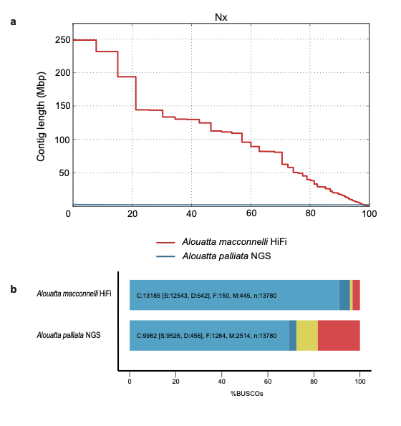
Fig. S1 High quality genome assembly of A. macconnelli. (a) Comparison of genome assemblies between our howler monkey (A. macconnelli) assembly and the previous Illumina-based assemblies (A. palliata, NGS). Plots comparing the sorted contig sizes (Y-axis) vs. the proportion (expressed as a percentage) of the assembly they cover (X-axis) for the leaf-eating primate assemblies and the previous Illumina-based assemblies. (b) Comparison of assembly completeness in coding genes, using the BUSCO primate gene sets (primates_odb10).

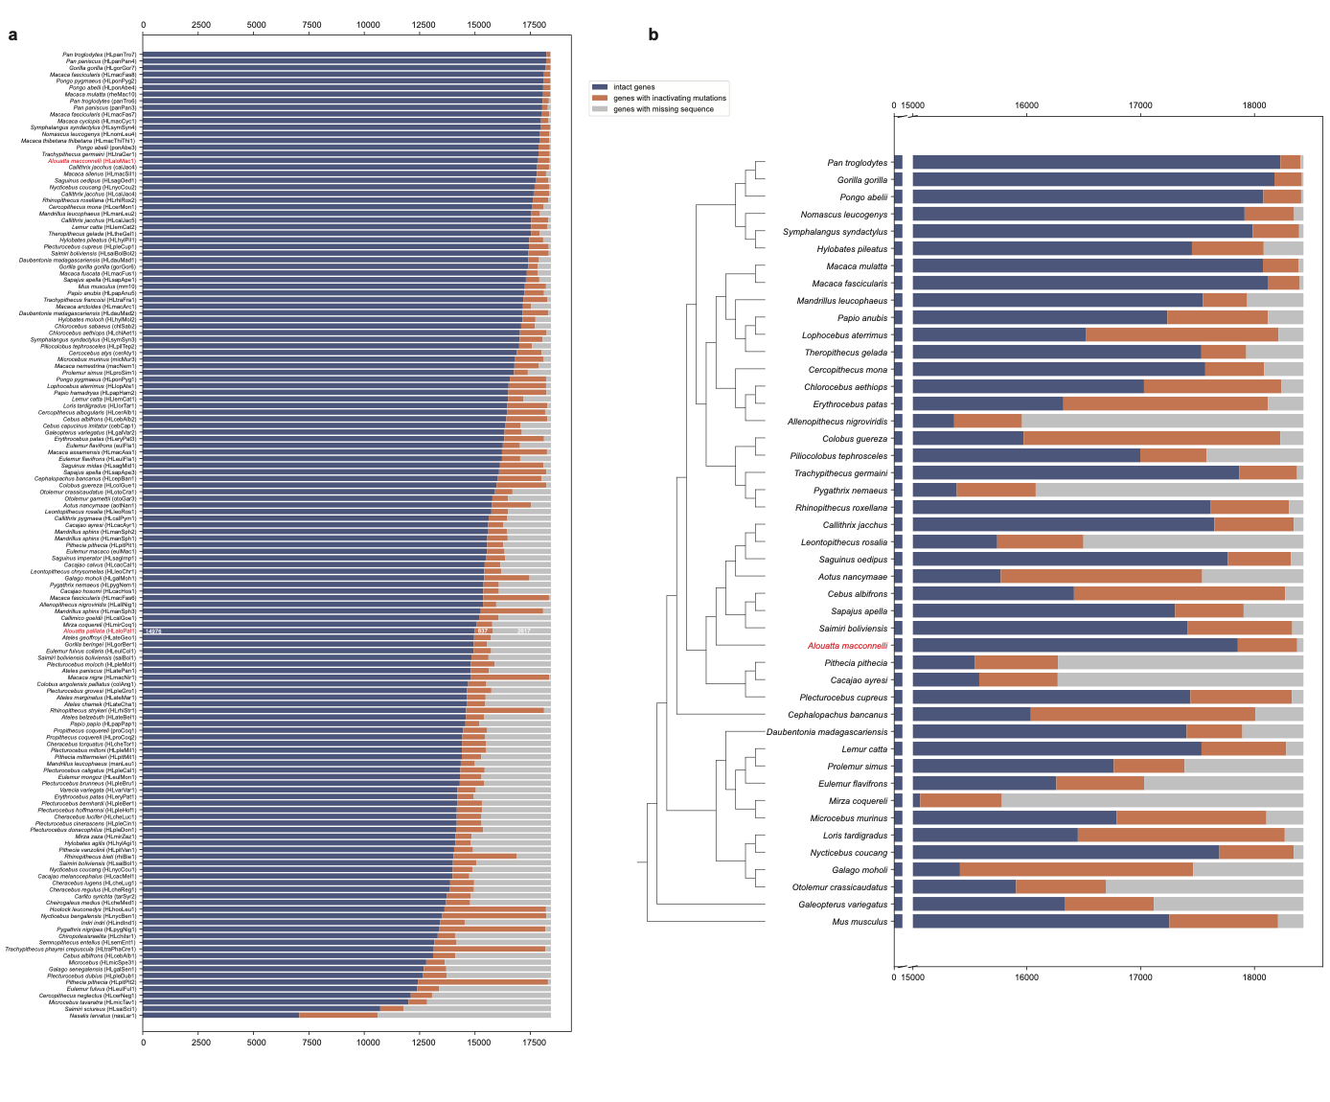
Fig. S2 Status of 18,430 ancestral placental mammalian genes across primate genomes.
(a) TOGA results for 146 species, including 144 primates and 2 outgroups (flying lemur and mouse), were obtained from https://genome.senckenberg.de/download/TOGA/human_hg38_reference (accessed in May 2025). The status of 18,430 ancestral placental mammal genes in each assembly is as inferred by TOGA. Genes are classified into those that have an intact reading frame (blue), those that have inactivating mutations (orange), and those that have missing portions of coding regions due to assembly gaps or fragmentation (gray). Species are ordered by the number of intact genes in each genome. Among them, the newly sequenced A. macconnelli and the Illumina-based A. palliata are highlighted in red.
(b) Left: Phylogeny of the 43 non-human primates and 2 outgroup species analyzed in this study. Right: Classification of 18,430 ancestral placental mammal genes in the species shown in the phylogeny. The newly sequenced genome, A. macconnelli, is highlighted in red font.

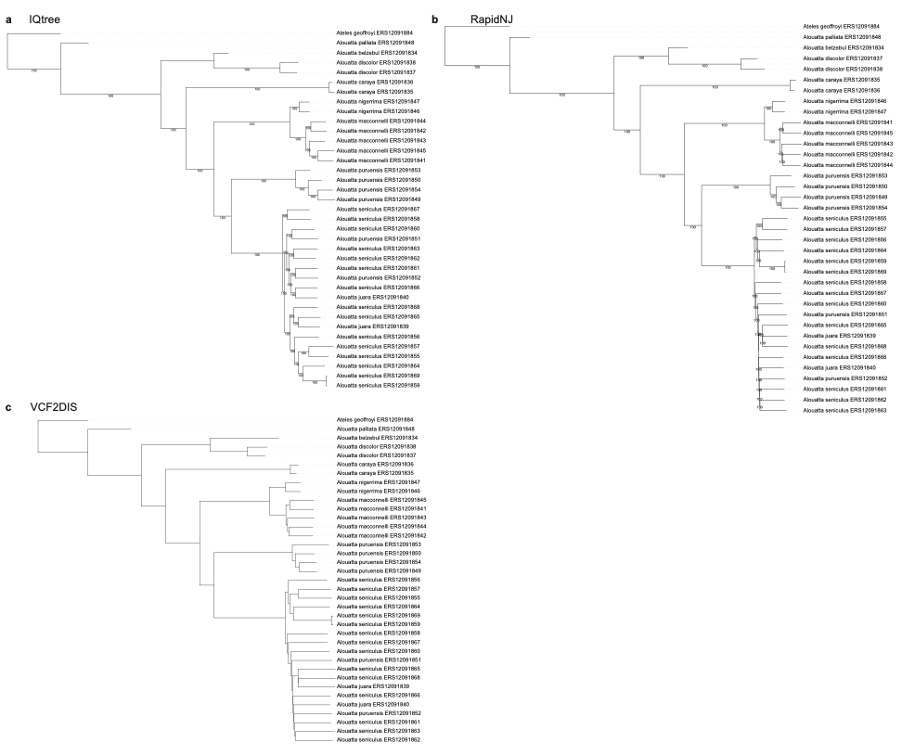
Fig. S3 Phylogenetic trees of Alouatta inferred by concatenation-based methods. Different software, IQTREE (a), RapidNJ (b), and VCF2DIS (c) were used to infer phylogenetic relationships.

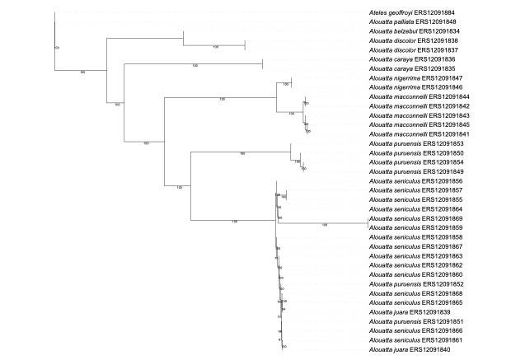
Fig. S4 Phylogenetic trees of Alouatta constructed using coalescent-based approaches.

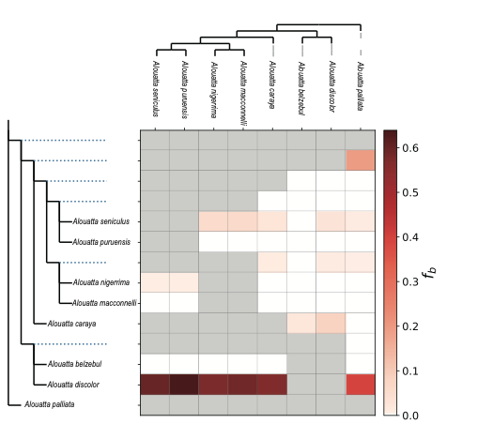
Fig. S5 Results of Fbranch for the Alouatta data set by Dsuite.

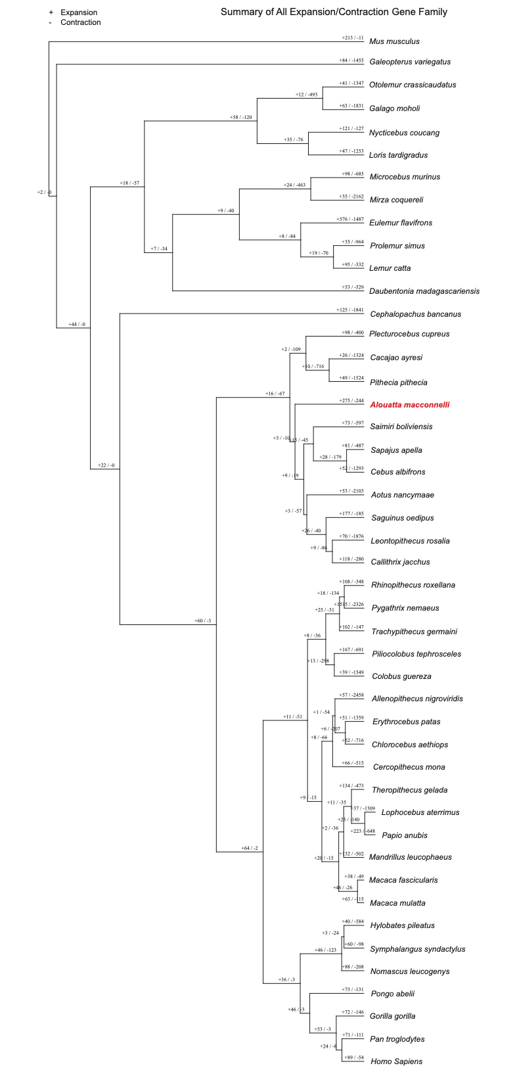
Fig. S6 Summary of all expansion/contraction gene family results.

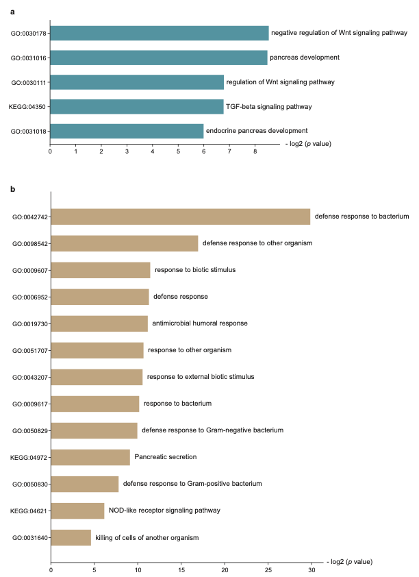
Fig. S7 Enrichment analysis of lost genes and genes associated with accelerated regions. (a) Genes associated with accelerated regions were enriched in development related processes. (b) Lost genes were found to be enriched in digestion and immunity related processes. The bar is ranked by -log₂ (p value).

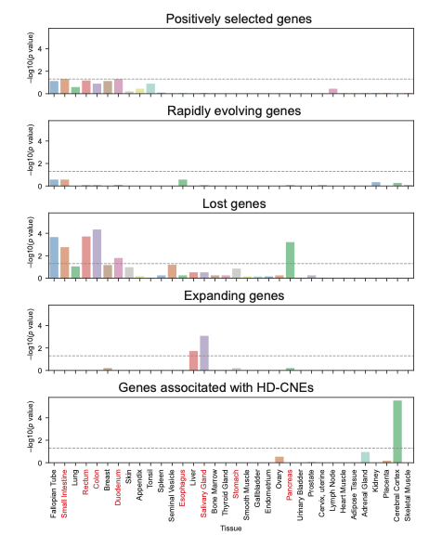
Fig. S8 Tissue-specific enrichment analysis of genes with different genetic changes. Each panel from top to bottom illustrates the enrichment significance -log₁₀ (p value) of five gene categories: positively selected genes, rapidly evolving genes, lost genes, expanding genes, and genes associated with HD-CNEs across various tissues. The horizontal dashed line denotes the statistical significance threshold (p value = 0.05, corresponding to -log₁₀ (p value) ≈ 1.3). Tissue types are aligned along the x-axis, with gastrointestinal and digestive-related tissues highlighted in red font.

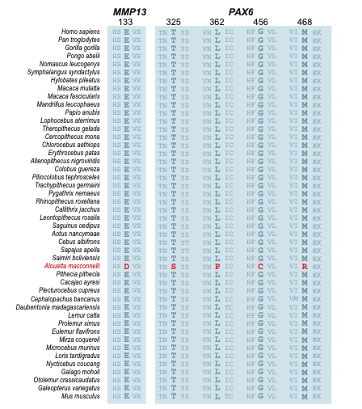
Fig. S9 Positive selection in development genes of howler monkey. Alignment of primate amino acid sequences of MMP13 and PAX6 shows amino acid substitutions that likely evolved under positive selection in the howler monkey branch (Bayes empirical Bayes posterior probabilities > 0.5). The howler monkey is highlighted in red.

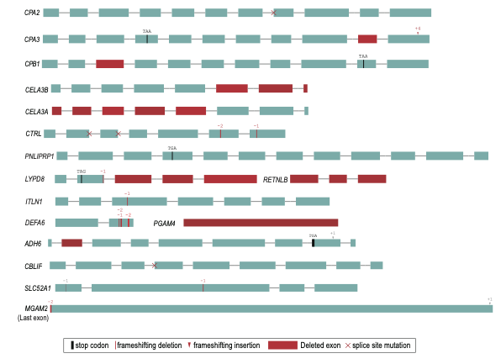
Fig. S10 Visualization of exon-intron structure of lost genes associated with the process of digestion, nutrient absorption, and immunity in howler monkey. Premature stop codons are shown as black vertical lines; frameshifting deletions are denoted as red vertical lines, and frameshifting insertions are shown as red arrowheads. Deleted exons are shown in red. Donor or acceptor splice site mutations are indicated as a cross at the exon boundaries.

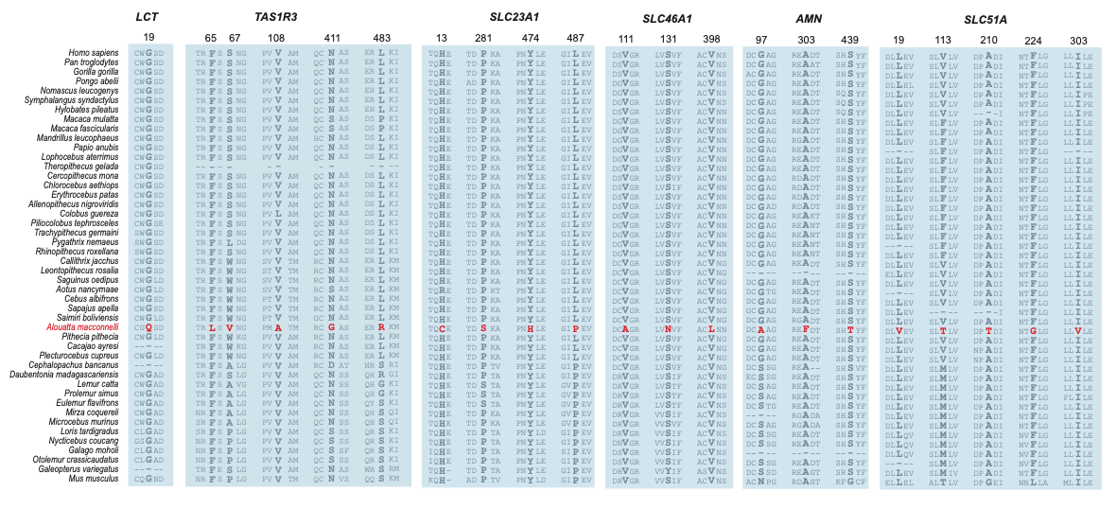
Fig. S11 Positive selection in nutrient absorption genes in howler monkey. Alignment of primate amino acid sequences of LCT, TAS1R3, SLC23A1, SLC46A1, AMN, and SLC51A show amino acid substitutions that likely evolved under positive selection in the howler monkey branch (Bayes empirical Bayes posterior probabilities >0.5). The howler monkey is highlighted in red.

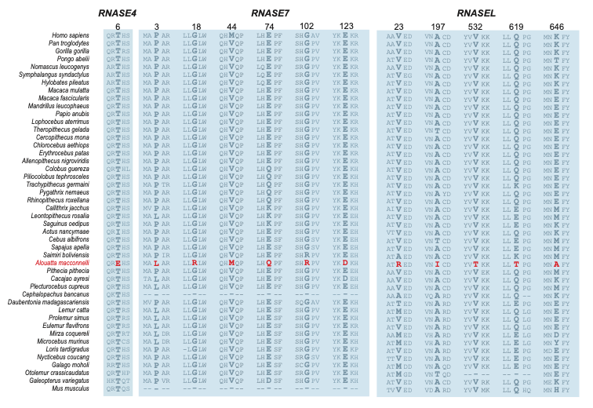
Fig. S12 Positive selection in immune genes in howler monkey. Alignment of primate amino acid sequences of RNASE4, RNASE7, and RNASEL. Candidate amino acid substitution in howler monkey is shown in background color. The howler monkey is highlighted in red.

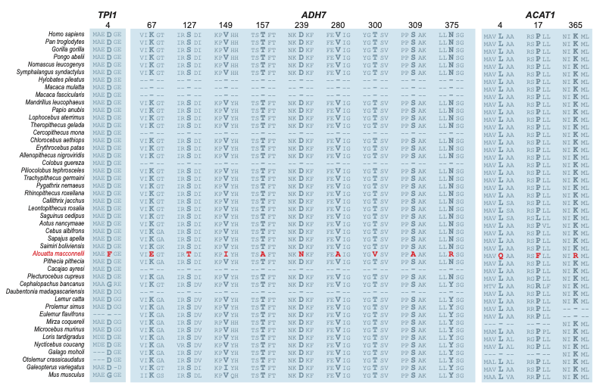
Fig. S13 Positive selection in energy metabolism genes in howler monkey. Alignment of primate amino acid sequences of TPI1, ADH7, and ACAT1 show amino acid substitutions that likely evolved under positive selection in the howler monkey branch (Bayes empirical Bayes posterior probabilities >0.5). The howler monkey is highlighted in red.

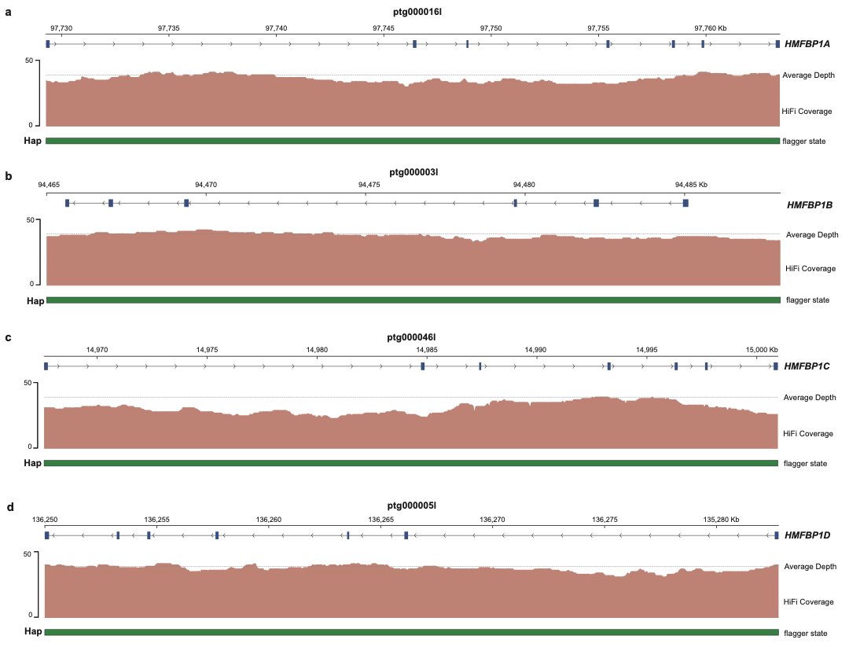
Fig. S14 Validation of FBP1 gene duplications in the howler monkey genome.
(a-d) Visualization of HiFi read alignments and HMM-Flagger annotations for the four FBP1 paralogs: HMFBP1A (a), HMFBP1B (b), HMFBP1C (c), and HMFBP1D (d). In each panel, the tracks from top to bottom display: genomic coordinates, the annotated gene structure, the visualization of PacBio HiFi read alignments (mapping depth), and the HMM-Flagger states. The integration of expected HiFi read-depth profiles and structurally correct HMM-Flagger annotations confirms the absence of local assembly errors, demonstrating that these four copies represent true biological duplications rather than assembly artifacts (such as uncollapsed haplotypes).

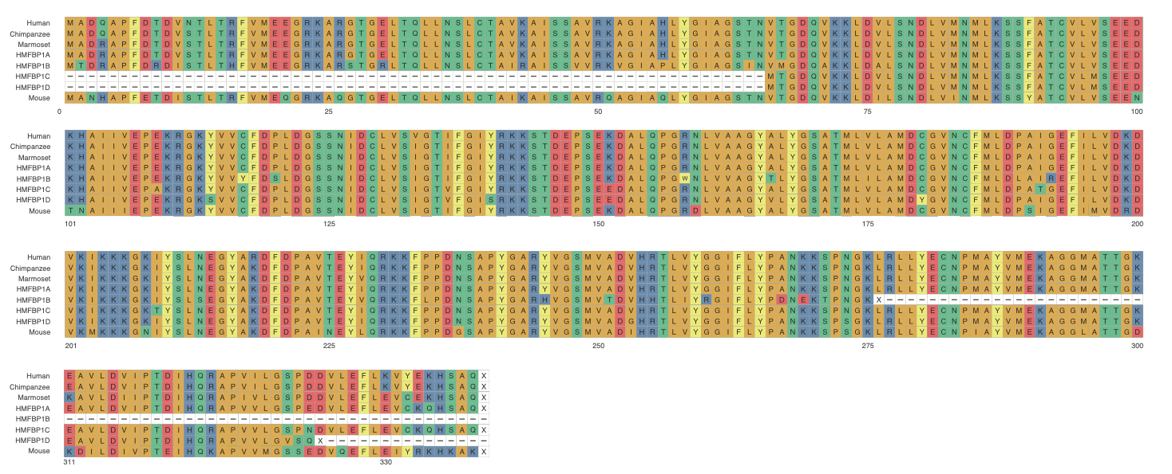
Fig. S15 Gene duplications in FBP1 genes in howler monkey. Alignment of primate amino acid sequences of FBP1.

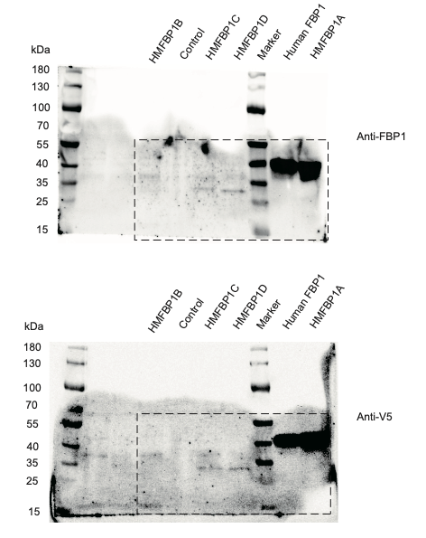
Fig. S16 FBP1 gene copies from the howler monkey are overexpressed in the HepG2 cell line.
The predicted molecular weights of the proteins are Human-FBP1, 36.85 kDa; HMFBP1A, 36.77 kDa; HMFBP1B, 30.46 kDa; HMFBP1C, 29.87 kDa; and HMFBP1D, 28.11 kDa. While Human-FBP1 and HMFBP1A correspond to full-length proteins, HMFBP1B, HMFBP1C, and HMFBP1D are truncated copies with reduced molecular sizes. Dashed boxes indicate the target bands.

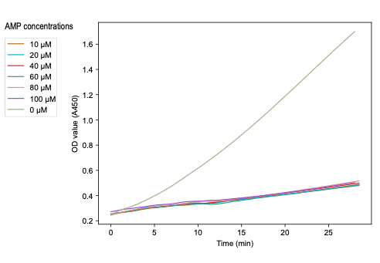
Fig. S17 Inhibition of HMFBP1A FBPase activity by AMP at different concentrations. FBPase activity of HMFBP1A was measured in the presence of AMP at increasing concentrations (0, 10, 20, 40, 60, 80, and 100 μM).

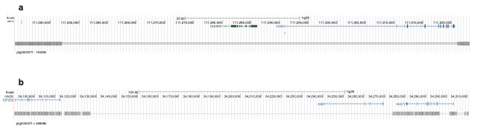
Fig. S18 Deletion of the CHIA locus and the ASIP locus in the A. macconnelli genome. UCSC Genome Browser screenshots show pairwise alignment chains between human (hg38) and A. macconnelli. A ~70-kb and ~147-kb deletion spans the entire (a) CHIA locus and (b) ASIP locus, respectively, in A. macconnelli.

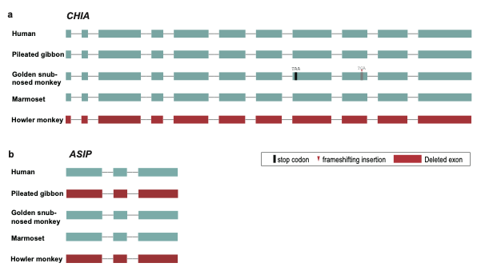
Fig. S19 Comparative exon-intron structure visualization of CHIA and ASIP across primates. Gene structures of (a) CHIA and (b) ASIP from human, pileated gibbon, golden snub-nosed monkey, marmoset, and howler monkey are shown. Premature stop codons are shown as black vertical lines, frameshifting insertions are shown as red arrowheads, and deleted exons are shown in red.

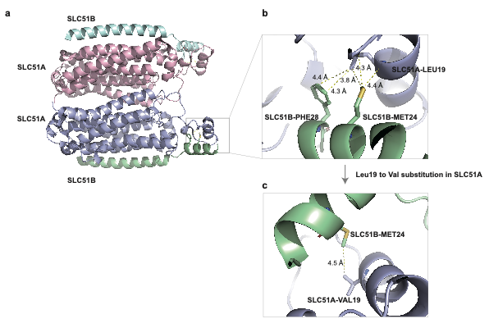
Fig. S20 Structural basis for the SLC51A-SLC51B heterotetramer interface.
(a) Overall ribbon representation of the SLC51A-SLC51B heterotetrameric complex (PDB ID: 9UO2). The SLC51A subunits are colored in light blue and light pink, while the SLC51B subunits are colored in pale green and pale cyan. The black boxed area highlights the inter-subunit interaction interface.
(b) Detailed close-up view of the ancestral interaction network. In the ancestral state, Leu19 of SLC51A forms strong hydrophobic contacts with residues Phe28 and Met24 of the neighboring SLC51B subunit. Yellow dashed lines indicate specific inter-atomic distances (in Å).
(c) Structural modeling of the mutant Val19 complex using AlphaFold3 (AF3). The substitution of the smaller valine residue (Val19) results in significant structural alterations at the interface: the interaction with SLC51B Phe28 is completely lost, and the contact with Met24 is weakened, as evidenced by increased inter-atomic distances.

