Long-read metagenomics and methylation-based binning support the discovery of antibiotic resistance gene–host associations in complex communities

Melina Markkanen^{1,2}*, Heidi Putkuri³, Dovydas Kičiatovas^{2,3}, Ville Mustonen^{2,3}, Marko Virta^{1,2}, Antti Karkman^{1,2}*

¹Department of Microbiology, University of Helsinki, Helsinki, Finland
²Multidisciplinary Center of Excellence in Antimicrobial Resistance Research, University of
Helsinki, Helsinki, Finland
³Department of Computer Science, Department of Organismal and Evolutionary Biology, University of Helsinki, Helsinki, Finland

*Corresponding authors: melina.markkanen@helsinki.fi, antti.karkman@helsinki.fi

List of Supplementary Figures:

Fig. S1. Sequence logos of synthetic community
Fig. S2. UMAP ordination of methylomes of wastewater communities
Fig. S3. Bacterial composition of the wastewater community
Fig. S4. erm(F) genome bins in different wastewater samples
Fig. S5. PCoA of bacterial composition in wastewater
Fig. S6. Composition of the Bacteroidales order in wastewater communities
Fig. S7. Genetic contexts of blaOXA-129
Fig. S8. Genetic contexts of sul1-9
Fig. S9. Random Forest classifier predictions

Supplementary Results

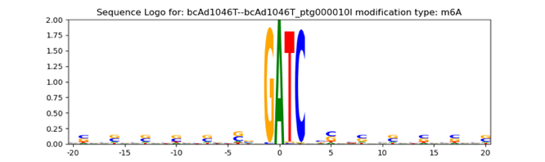
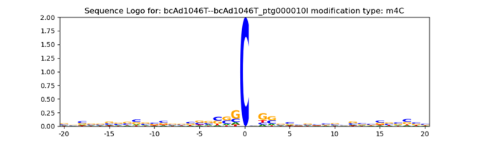
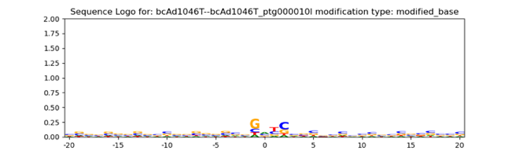
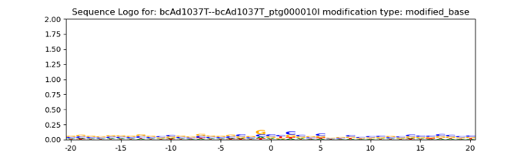
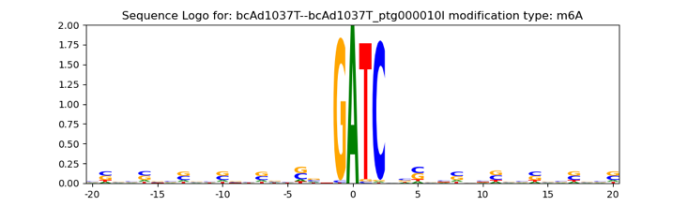
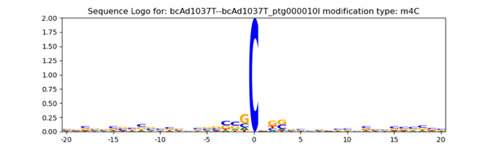
Aeromonas caviae (chrom)

Sphingobacterium spiritivorum (chrom)
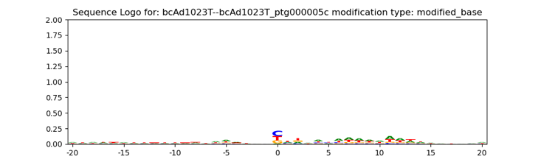
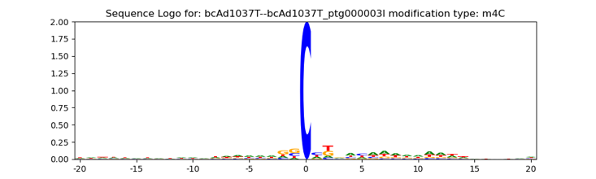
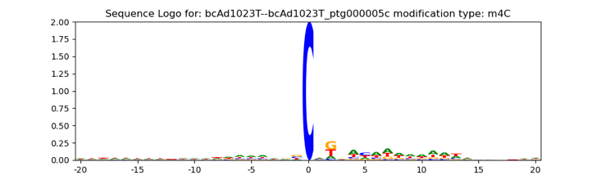
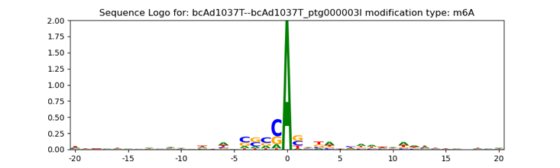
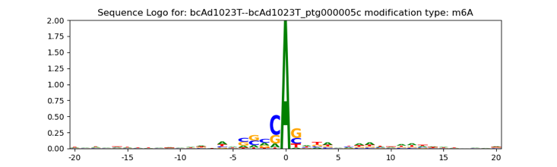
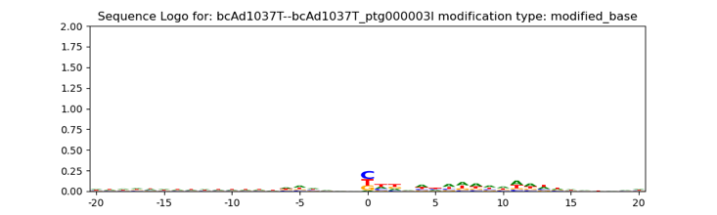
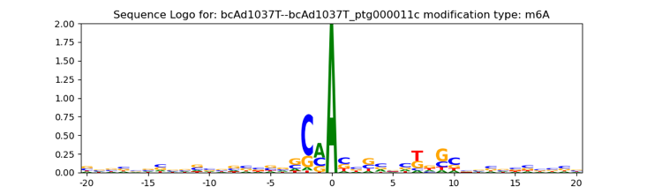
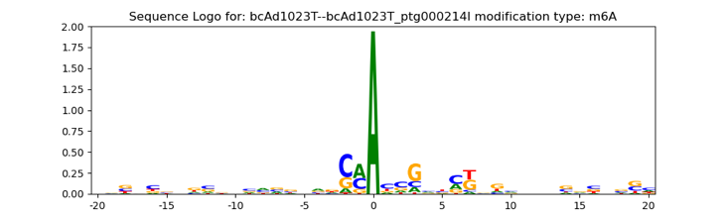
Pseudomonas_E chlororaphis (chrom)
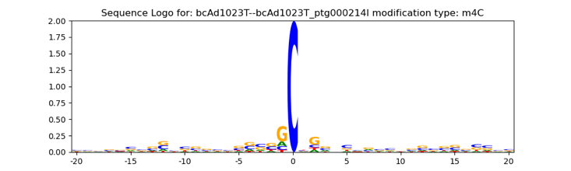
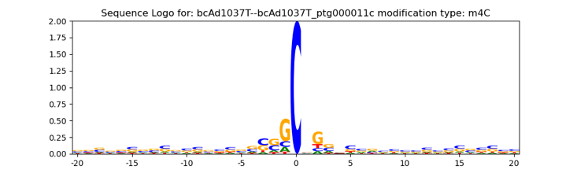
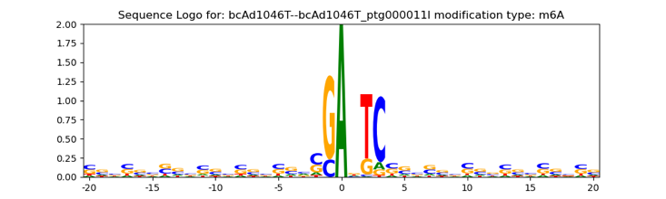
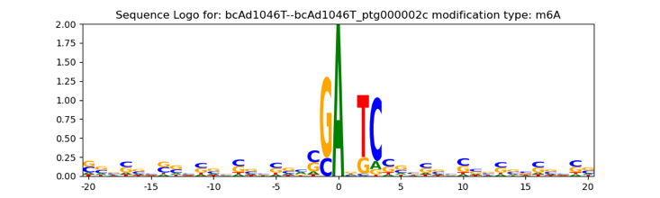
Azospirillum brasilense_B
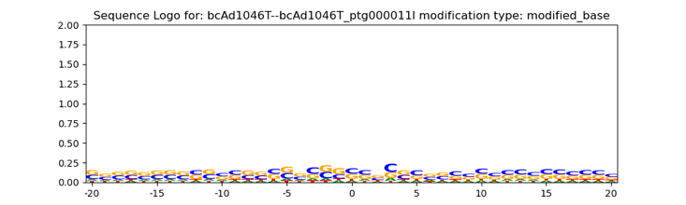
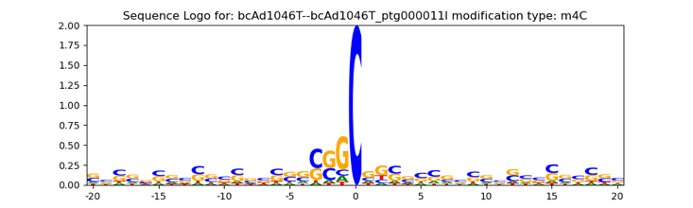
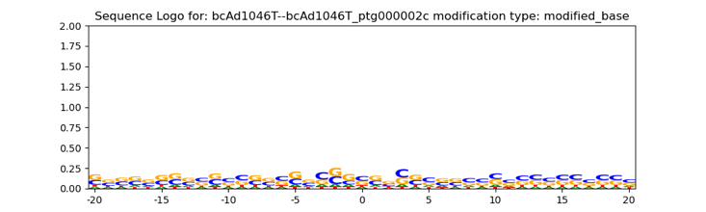
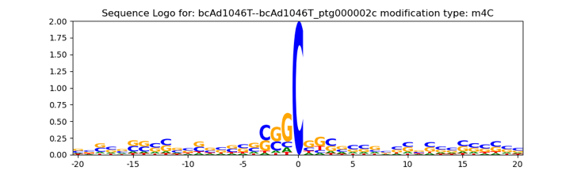
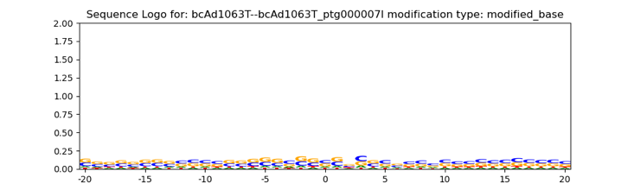
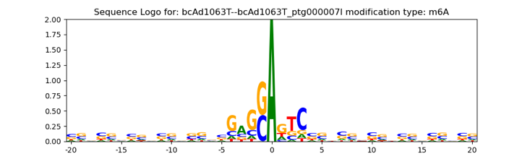
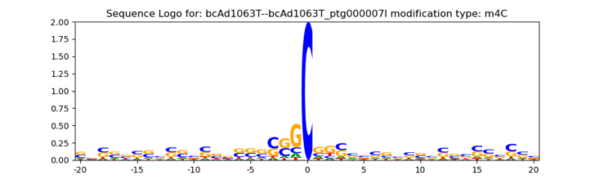
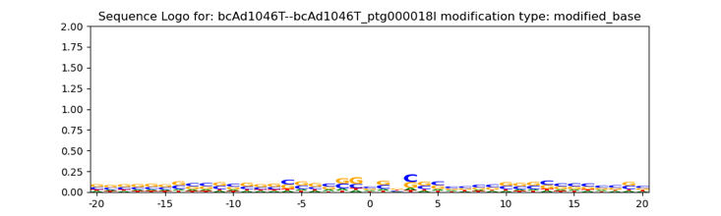
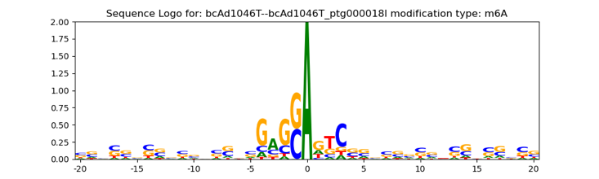
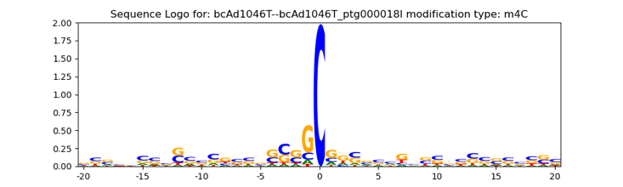
Azorhizobium caulinodans

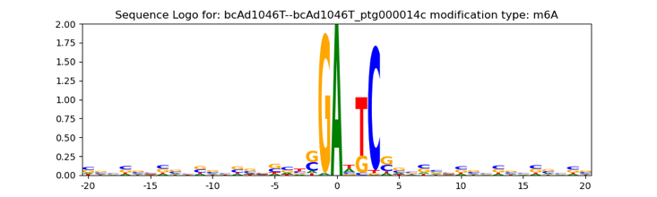
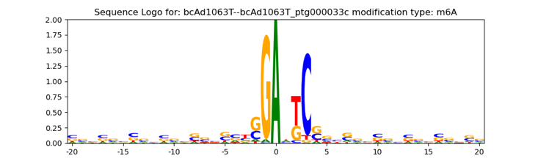
Paracoccus denitrificans (chrom, plas)

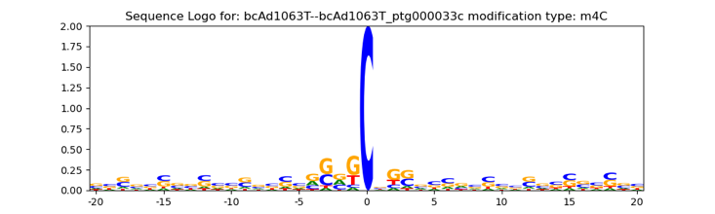
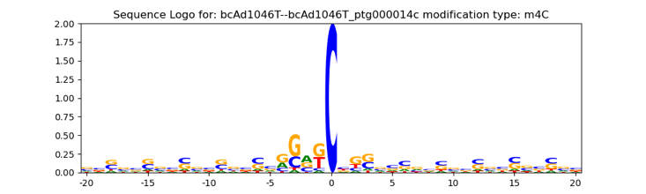

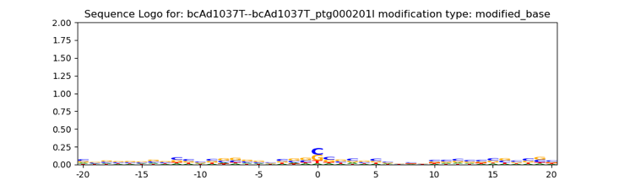
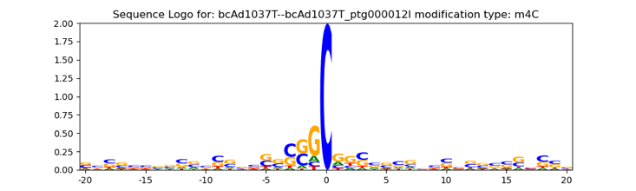
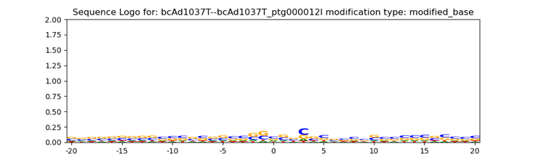
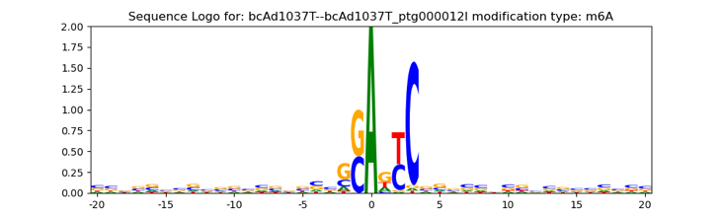
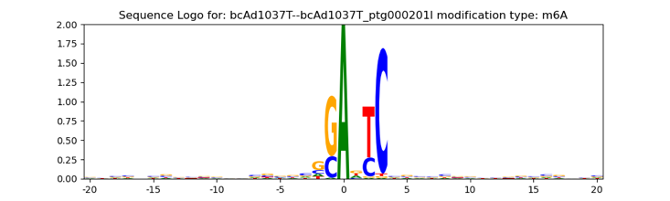
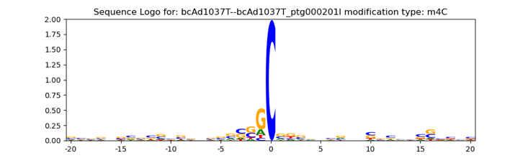
Sphingobium yanoikuyae (chrom, plas2)

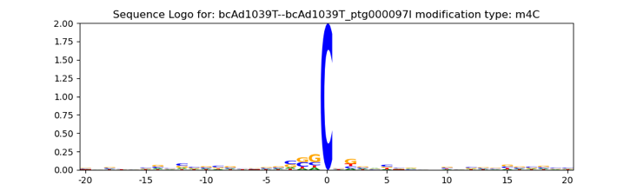
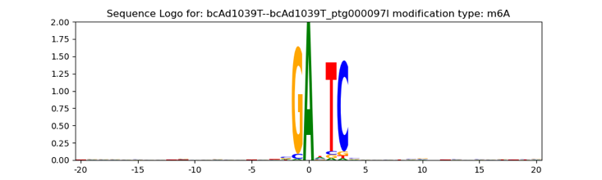
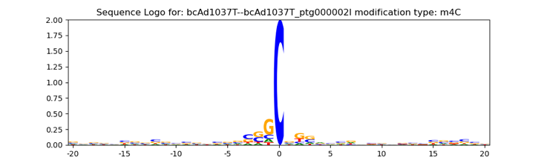
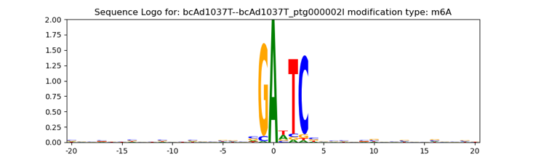
Agrobacterium tumefaciens (chrom2, plas)

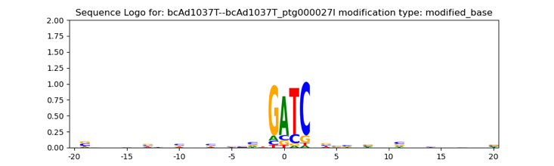
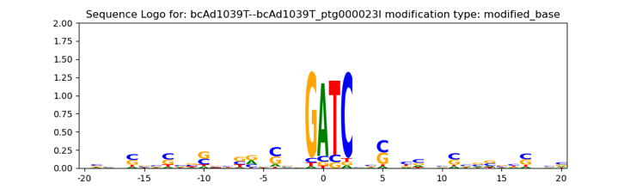
Morganella morganii (chrom)
Fig. S1. Sequence logos of contigs included in synthetic community bins and MAGs (Fig. 1, Additional file 1: Table S2). Sequence logos of two example contigs are shown. The examples were selected based on the following criteria: contigs from separate samples and different genetic elements, if applicable (chromosomes (chrom1-2) or plasmids (plas1-2)).

A. B. C.
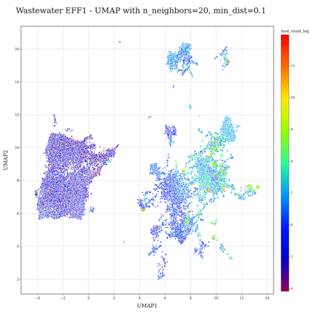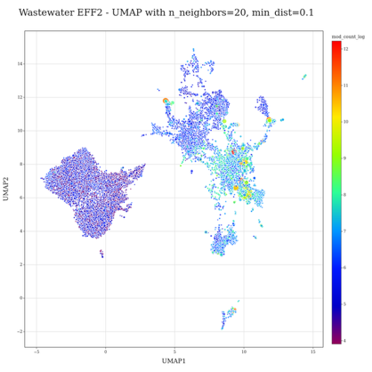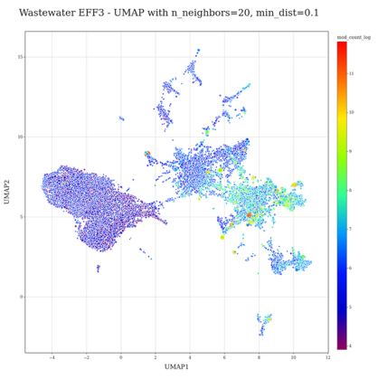
D. E. F.
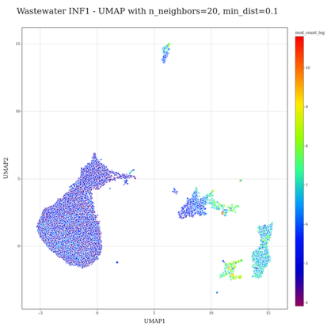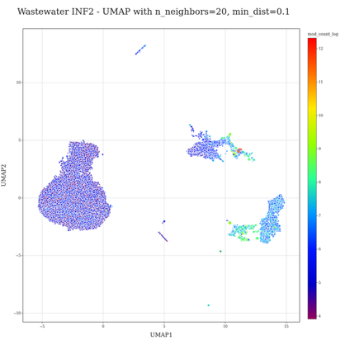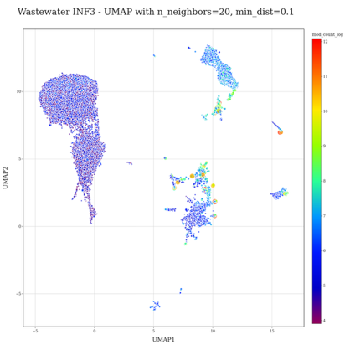
G. H. I.
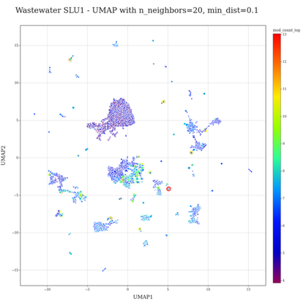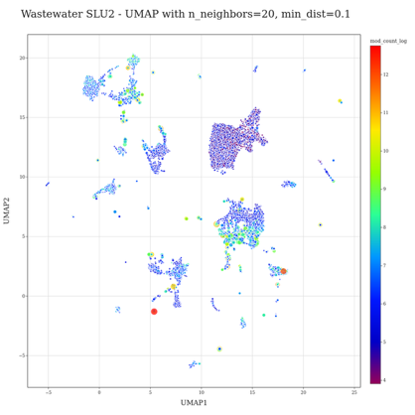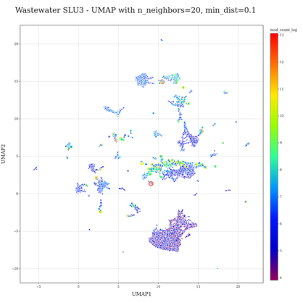
Fig. S2. UMAP ordination of methylomes of wastewater communities. The heatmap color encoding denotes the number of detected base modifications per contig. A logarithmic transformation was applied to the modification count data to reduce skewness. The dot size indicates the contig length, which is square root transformed. In A-F, the included data is shown with a rectangle with a dotted line, while in G-I, all data except those contigs within the cluster a marked with a red solid rectangle.

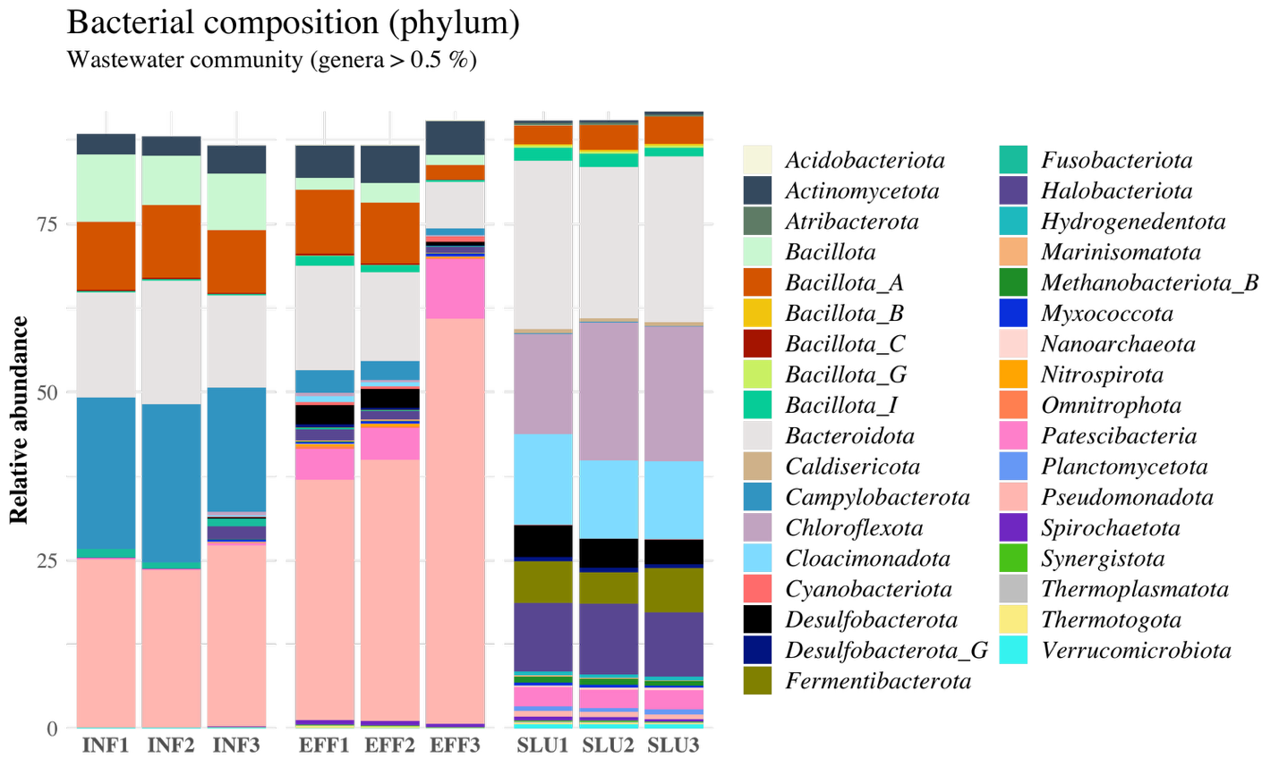
Fig. S3. Bacterial composition of wastewater communities. Genera with less than 0.5 % relative abundance computed by Sylph (Shaw et al. 2025) were filtered out from the visualization. Phylum-level taxa are shown.

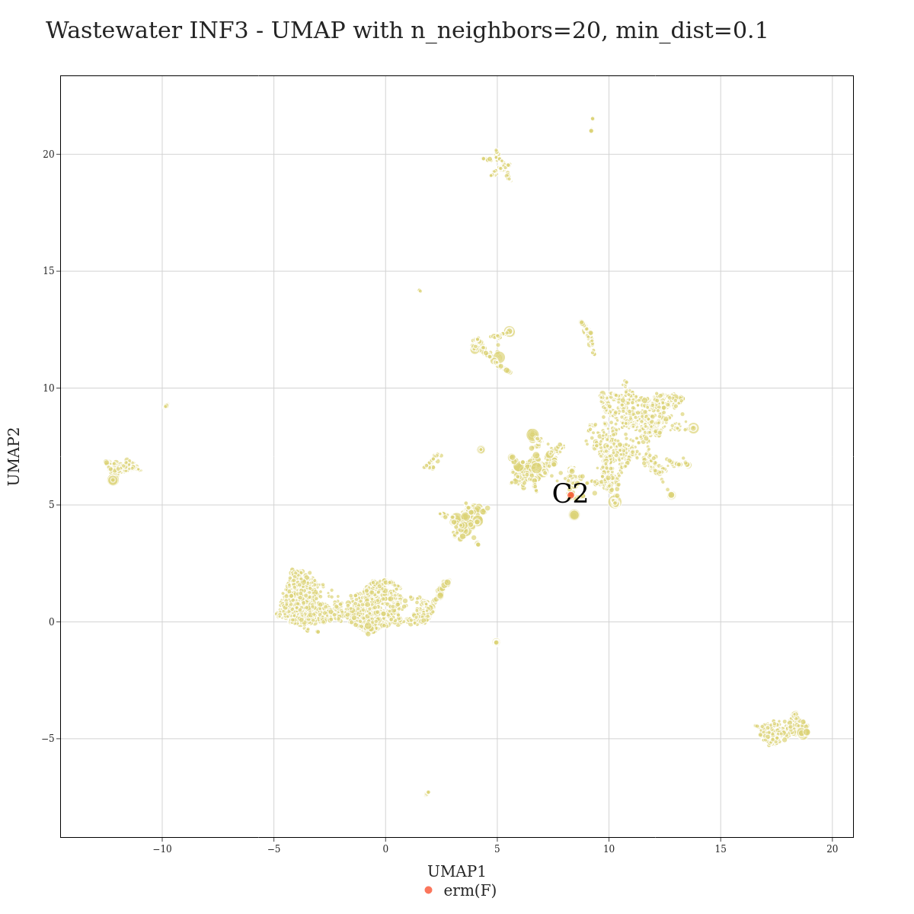
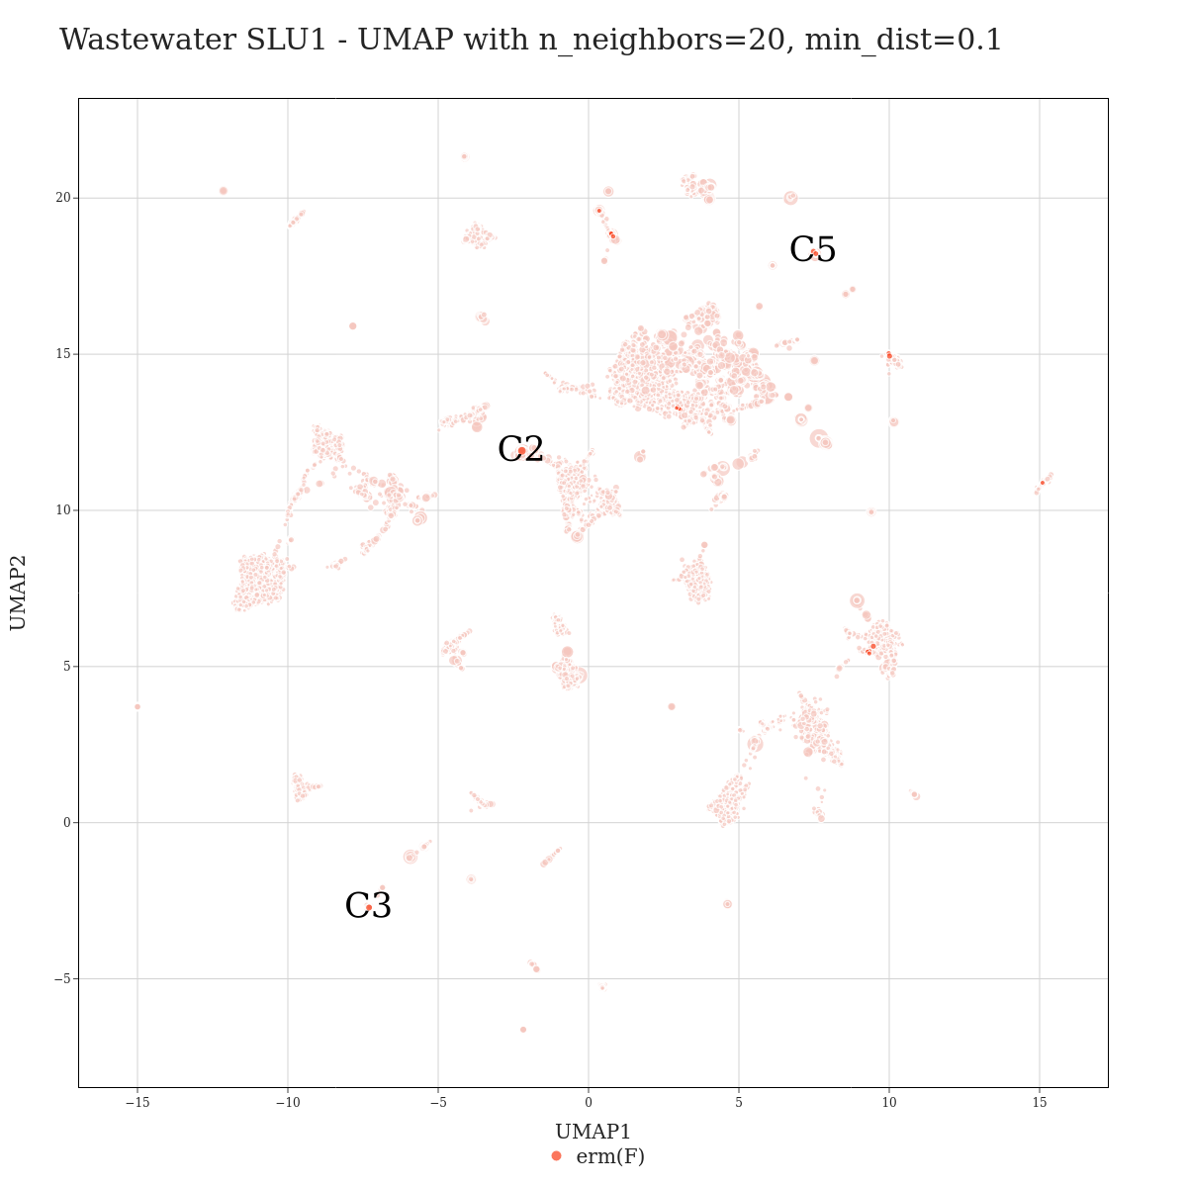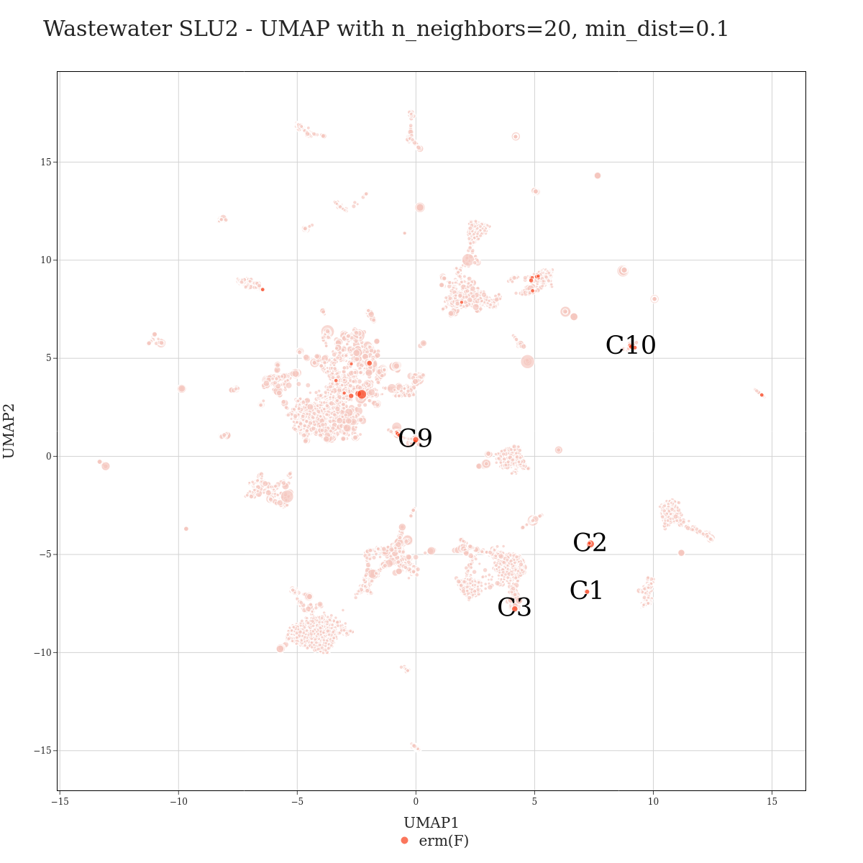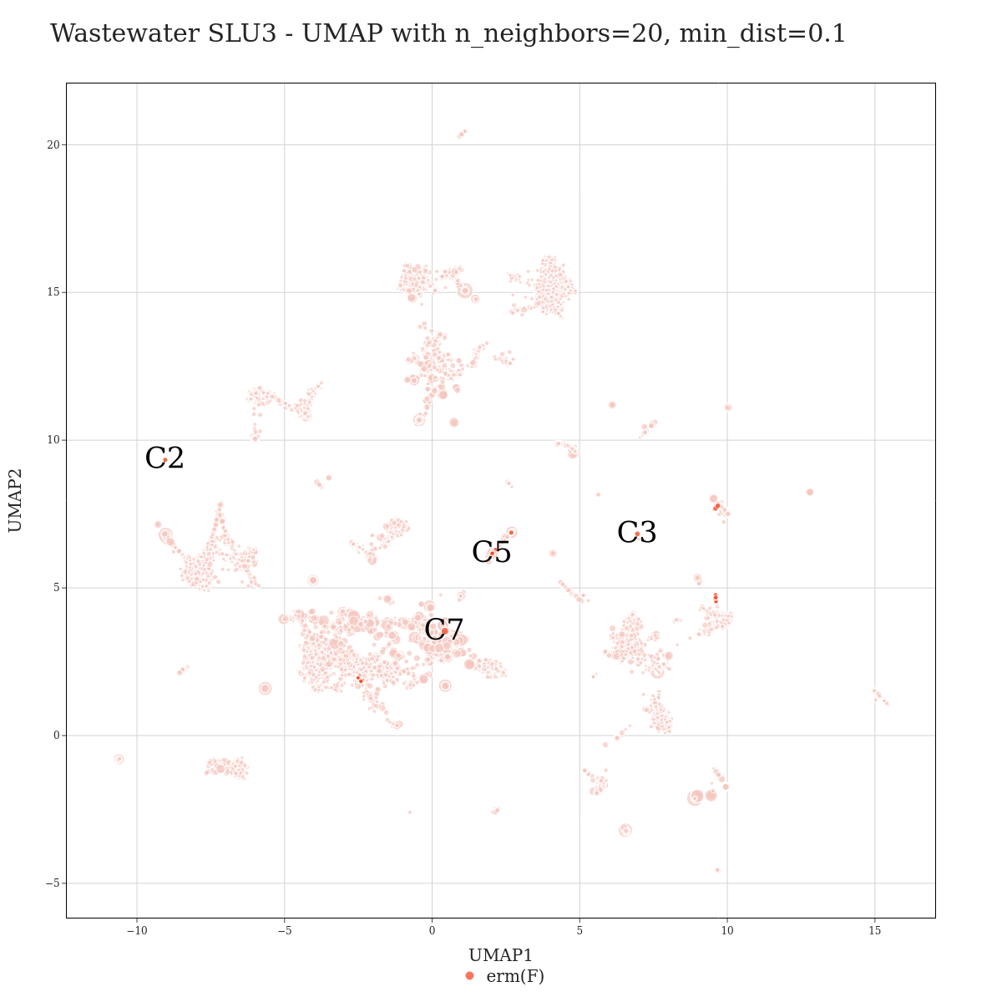
Fig. S4. erm(F) bins in different wastewater samples. The plot on the top row represents influent sample INF3, while the bottom row plots show the UMAP visualization of the metagenomic contigs of sludge samples SLU1, SLU2, and SLU3. In all plots, the pure red colored data points denote contigs with the erm(F) gene. The other dots (pale yellow or pink) represent non-erm(F) contigs. Contigs clustering together with each erm(F) contigs were combined into bins, and the labels of the bins are displayed on the plots.

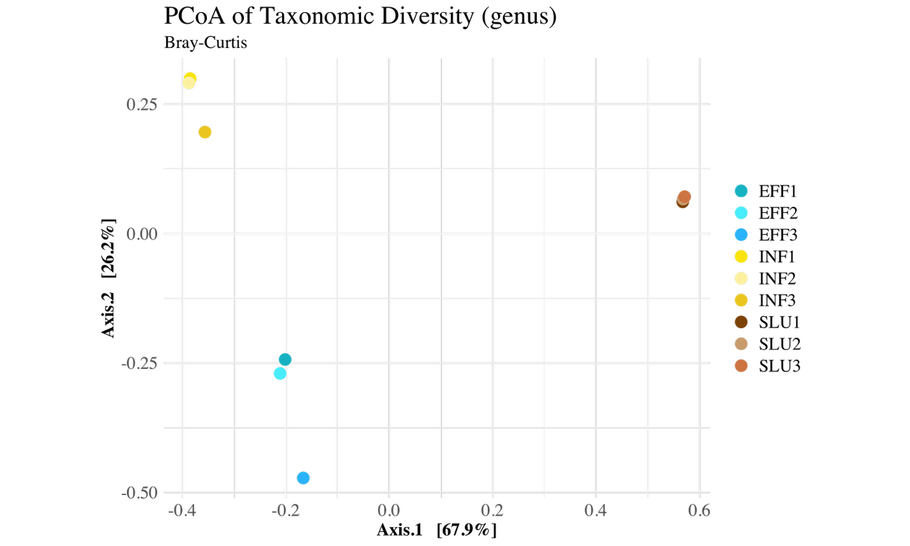
 | Df | Sumofsqs | R2 | F | Pr(>F)
Model | 2 | 2.05630 | 0.92591 | 37.493 | 0.005 **
Residual | 6 | 0.16453 | 0.07409
Total | 8 | 2.22083 | 1.00000

Fig. S5. Principal Coordinates Analysis (PCoA) of bacterial composition in wastewater. Ordination was plotted with genus-level relative abundances generated by Sylph (Shaw et al. 2025) using Bray-Curtis dissimilarity by the vegan package (Oksanen et al. 2020). Microbial community composition differed significantly between the sample types (p = 0.005, highly significant (p < 0.01)). F = 37.493: A high F-statistic suggested strong separation between groups. About 92.6% of the variation in Bray-Curtis distances is explained by sample type (Permutation test for adonis under reduced model, Permutation: free, Number of permutations: 999).

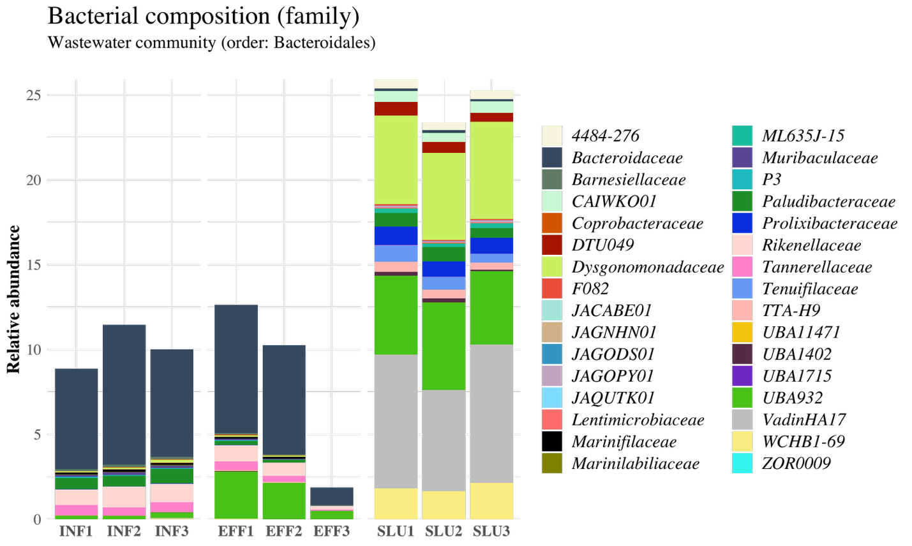
Fig. S6. Composition of the Bacteroidales order in wastewater communities computed with Sylph (Shaw et al. 2025). Family-level taxa are shown.

Identification of newly recognized hosts for integron‑encoded established ARGs

Two genome bins assigned to Simplicispira sp. (INF1-C3, INF3-C5) were identified as newly described blaOXA-129 gene carriers in influent wastewater by two separate samples. Comparative genomics analysis on the blaOXA-129 carrying Simplicispira sp. genome bins, unbinned sequences from the wastewater and previously described references (Enterobacter hormaechei (FJWZ01000025) and Pseudomonas aeruginosa (CP031449.2)) (Valiatti et al. 2024; Liu et al. 2010) revealed both shared and unique features of the integron cassette arrays and the blaOXA-129 flanking region within different hosts (Fig. S7, Additional file 1: Table S9). The integrases of Simplicispira sp. were dissimilar to those in E. hormaechei and P. aeruginosa which in turn resembled each other (Fig. S7). However, according to BLAST search against public sequence databases, similar integron integrase genes to those in Simplicispira sp. are found in various other taxa including Klebsiella and Acidovorax (data not shown). While aminoglycoside ARG aadA was found in the integron cassette arrays of both E. hormaechei and Simplicispira sp., the remaining numerous attC site flanked gene cassettes in the array of the latter host contained genes encoding proteins of unknown function. Another notable difference between the context regions of the clinical E. hormaechei and of P. aeruginosa and those in Simplicispira sp. was the presence of IS6 family IS6100 transposases flanking the integron cassette in the former and their absence in the latter, pointing to a greater potential for mobilization of the cassettes in the reference strains (Johansson et al. 2023) (Fig. S7).

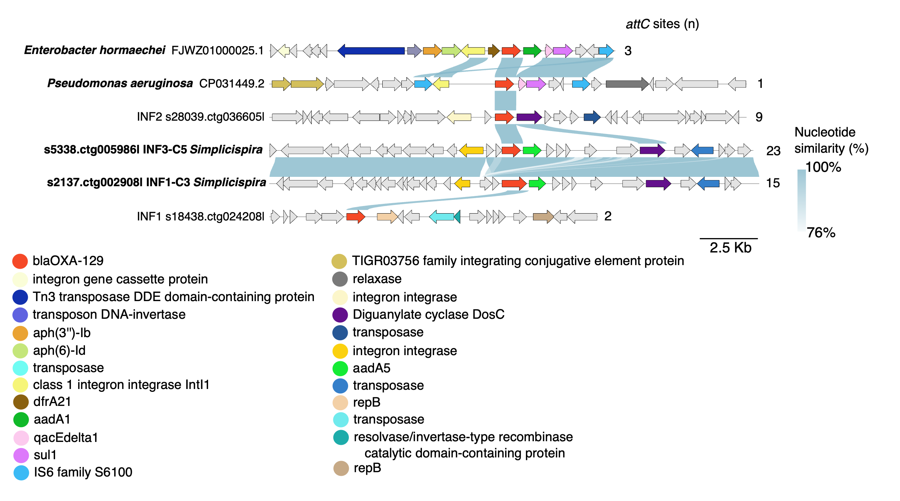
Fig. S7. Genetic contexts (10 Kb upstream and downstream) of blaOXA-129 (shown in red) in the methylation-based genome bins (Simplicispira sp.) and unbinned contigs. Sequences of previously described blaOXA-129 encoding strains of Enterobacter hormaechei (FJWZ01000025.1) and Pseudomonas aeruginosa (CP031449.2) are included as references.

High-quality genome bins of JAUCQB01 sp. (class Phycisphaerae) carrying sul1-9 (SLU2-C4, SLU3-C1) were recovered from two separate sludge samples. Variant sul1-9 differs from its closest relative sul1-2 by an 11 bp long tail and one nucleotide substitution. Exploring the sul1-9 contexts of the sequences of this study and of the previously reported hosts of Escherichia coli (CP026207.1) and Salmonella enterica (AY963803.6) revealed a shared integron gene array structure for all the examined sequences (Fig. S8, Additional file 1: Table S10). Moreover, similarly to the blaOXA-129 encoding integron gene cassettes, IS6 family IS6100 transposase genes were detected in all investigated sequences including both reference sequences from public databases as well as the newly described sul1-9 hosts of JAUCQB01 sp. and unbinned contig characterized in this study (Fig. S8). In contrast to the E. coli and S. enterica reference strains, no additional ARGs were present in the integron cassettes of this study (Fig. S8). However, unlike for the reference strains, no attC sites were reported for the sequences of this study (Fig. S8).
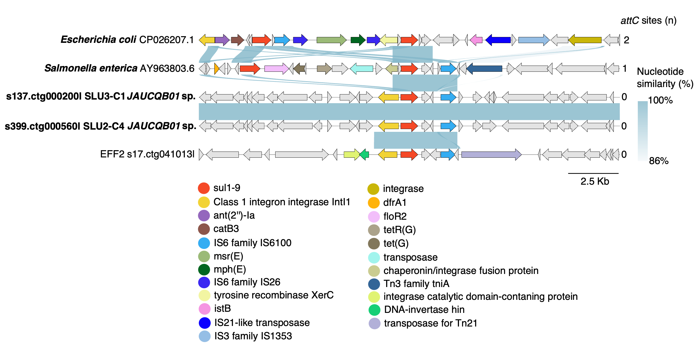
Fig. S8 Genetic contexts of sul1-9 (shown in red) in the genome bins (JAUCQB01 sp., class Phycisphaerae) resolved by methylation-based binning and unbinned contigs with no resolved taxonomical identity. Escherichia coli (CP026207.1), and Salmonella enterica (AY963803.6) encoding sul1-9 are included as reference strains for the comparative genetic analysis of 10 Kb upstream and downstream flanking region of sul1-9 gene.

A. B.

Fig. S9. Random Forest classifier predictions for the taxonomic labels of the metagenomic contigs using the high-dimensional methylation matrix. Predictions are shown for A. Train Set and B. Test Set.

