Fig. S1 Trait factor screening and canonical axes projection in RDA analysis.
Fig. S2 Parental lines and phenotypic analysis of the QTL mapping hybrid population.
Fig. S3 Marker density and collinearity analysis of the genetic map.
Fig. S4 Phenotypes of four candidate gene knockout lines within the QTL interval.
Fig. S5 PtoAG1 and its natural variation AG1^{In/Del} influences the distribution and local adaptation of Populus.
Fig. S6 Sequence alignment and domain analysis of AG1^{In} and AG1^{Del} genotypes.
Fig. S7 Phylogenetic analysis of homologous genes of the HD-ZIP family in Populus trichocarpa, Arabidopsis thaliana and Oryza sativa with Chr7.86 and transactivation assay of PtoAG1 in yeast cells.
Fig. S8 The characterizations of stem in PtoAG1 overexpression transgenic Populus alba × Populus glandulosa.
Fig. S9 Schematic diagram of editing targets for knockout lines Line1 and Line34.
Fig. S10 Characterizations of AG1^{ID} genotype overexpression lines in Populus.
Fig. S11 Morphology and physiology characteristics under drought stress of 55 cm tall transgenic plants and WT.
Fig. S12 Transcriptomic analysis of PtoAG1 and downstream binding assays.
Fig. S13 Morphology and expression characteristics of PtoRR12-OE and PtoAREB3-OE lines.
Fig. S14 The interaction assays between PtoAREB3, PtoRR12 and PtoSnRK2.2 and ABA treatment assays for WT plants.
Fig. S15 qPCR analysis and population transcriptome analysis of PtoSnRK2s and PtoAREBs.
Fig. S16 Morphology and physiology characteristics under drought stress of the ptomyb84 mutants and WT.
Fig. S17 Homology inference analysis among five Populus species.
Fig. S18 The full uncropped Gels and Blots image.

Fig. S1 Trait factor screening and canonical axes projection in RDA analysis. A, Standardized total effect size of precipitation, temperature, elevation and drought, calculated by summing the direct and indirect effects derived from the best Piecewise SEM. B, Mantel test and correlation analysis of 19 environmental variables and geographic information for RDA analysis. Five red variables indicate non-redundant variables. C, Environmental variables used in the gradient forest modeling. Variables were ordered by ranked importance. Gray column, uncorrelated environment variables (Pearson's |r| < .8). D, The first two canonical axes (RDA1 and RDA2) of the RDA of variation among 302 accessions. Each canonical axis represents a linear combination of environmental variables.

Fig. S2 Parental lines and phenotypic analysis of the QTL mapping hybrid population. A, Phenotypic characteristics of parental lines for the hybrid population under field and greenhouse conditions. Male parent, LM50; Female parent, 1236. Bar, 15 cm. B, Correlation analysis of 11 growth traits in the hybrid population. C, 3D visualization of the PCA analysis of 11 growth traits, representing the first three PC components.

Fig. S3 Marker density and collinearity analysis of the genetic map. A, Density of 9,675 bin markers derived from 87,562 SNPs across 19 chromosomes after binning. B, Collinearity analysis was conducted between the 19 linkage groups and the 19 chromosomes of the Populus tomentosa reference genome [Tianshui]. ρ denotes the collinearity rate.

Fig. S4 Phenotypes of four candidate gene knockout lines within the QTL interval. A, Phenotypic comparison between the four candidate gene knockout lines and wild-type (WT) plants. Bar, 15 cm. B, Height of 2-mo-old plants. Error bar represent SD values of 3 biological replicates. Two-tailed paired t-tests, ***P < 0.001.

Fig. S5 PtoAG1 and its natural variation AG1^{In/Del} influences the distribution and local adaptation of Populus. A, Association testing of phenotypes (four growth traits and principal component 1 (PC1)) and 91 variants in qAG1. The x-axis represents the position in the genome. B, Geographic distribution of 302 P. tomentosa accessions (circles) where colors represent the natural variation AG1^{In/Del}. The red dotted ellipse indicates the Weihe Basin region. C, left bottom represents the frequency distribution of two genotypes AG1^{In/Del} of PtoAG1 in three geographic populations. The box plots represent the differences among 302 P. tomentosa accessions in three geographical populations (upper left) and two genotypes (lower right), respectively. D, Putative sweep regions around PtoAG1 locus were evaluated by different summary statistics. The bar denotes the location of the PtoAG1 gene. The statistics were calculated separately for accessions from three geographic populations. southern, S; northeastern, NE; northwestern, NW. Genetic differentiation (Fst), nucleotide diversity (π), and Tajima’s D test for the presence of a selective sweep.

Fig. S6 Sequence alignment and domain analysis of AG1^{In} and AG1^{Del} genotypes. The conserved HD, ZIP motif are indicated by blue arrows and green arrows, respectively; red boxed region indicates the EAR motifs; the red arrows indicate the frameshift mutation AG1^{In/Del}; orange boxed region indicates CPSCE motif.

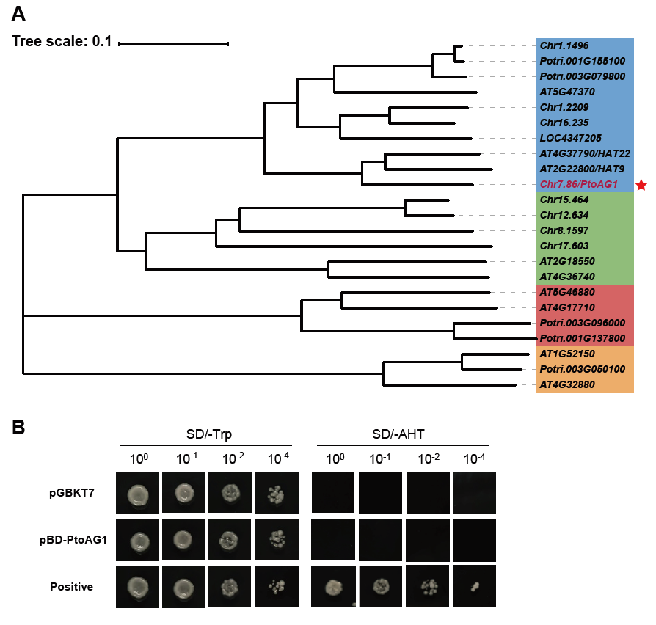
Fig. S7 Phylogenetic analysis of homologous genes of the HD-ZIP family in Populus trichocarpa, Arabidopsis thaliana and Oryza sativa with Chr7.86 and transactivation assay of PtoAG1 in yeast cells. A, HD-ZIP II subfamily proteins are indicated in blue. HD-ZIP I subfamily proteins are indicated in green. HD-ZIP Ⅳ subfamily proteins are indicated in red. HD-ZIP Ⅲ subfamily proteins are indicated in orange. B, The full length of PtoAG1 was fused in frame with the GAL4 DNA-binding domain in pGBKT7 and transformed into yeast strain Y2H. The vector pGBKT7 was used as a negative control.

Fig. S8 The characterizations of stem in PtoAG1 overexpression transgenic Populus alba × Populus glandulosa. A, Stem diameter of internodes 3, 8, and 15 in 2-month-old plants. Bar, 5 mm. B, Xylem layers in internodes 8 and 12 of the stem. C, Cytological observations of stem cross sections of 8th and 12th internodes with toludine blue. Black dots indicate xylem cell layers. Error bars represent SD of 3 independent measurements. Two-tailed paired t-tests, *P < 0.05, **P < 0.01, ***P < 0.001.

Fig. S9 Schematic diagram of editing targets for knockout lines Line1 and Line34. T1 and T2 denote the positions of two editing targets. The CRISPR/Cas9 genome editing system induced deletions of 168 bp and 186 bp between the two targets in the Line1 knockout line, while a 171 bp deletion between the two targets was caused in the Line34 knockout line.

Fig. S10 Characterizations of AG1^{ID} genotype overexpression lines in Populus. A, Phenotype of 8wk WT and AG1^{ID}-OE transgenic lines (OE-1, OE-2) after transfer to soil. Bar, 15 cm. B, Height and stem diameter of 2-mo-old plants. Error bars represent SD of 3 independent measurements. Two-tailed paired t-tests; ns, no significance.

Fig. S11 Morphology and physiology characteristics under drought stress of 55 cm tall transgenic plants and WT. A, The phenotype of plants under average soil relative water content (SRWC) was 65%, 22%. Bars, 15 cm. B, stem RWC and stem water potential of plants. Error bar represent SD values of 3 biological replicates. Two-tailed paired t-tests, *P < 0.05, **P < 0.01, ***P < 0.001. ns, no significance.

Fig. S12 Transcriptomic analysis of PtoAG1 and downstream binding assays. A, Volcano plots representing the fold-change of DEGs in the comparison groups of WT versus ptoag1 (P＜0.05, |log₂FC| ≥ 1). Gray dots represent genes without significant changes in expression. Two independent experiments were performed for each sample. B, KEGG analysis of DEGs. C, Genes related to cytokinin synthesis and signal transduction pathways in DEGs and their fold changes in expression. D, Genes related to abscisic acid synthesis and signal transduction pathways in DEGs and their fold changes in expression. E, Enriched DNA motif identified in PtoAG1 binding sites. E-value = 1.6e-1266. F, The KEGG analysis of DNA affinity purification sequencing (DAP-seq) for PtoAG1. G, EMSA of AG1^{Del} binding to DNA probes of the PtoAREB3 and PtoRR12 promoters in vitro. The probe was biotin-labeled fragments of the PtoAREB3 and PtoRR12 containing the motif, whereas the cold probe was unlabeled probe (5-, 50-fold molar excess). Protein concentration was 2 µg/µL. H and I, No regulatory interaction exists between PtoAG1 and PP2Cs in the Y1H assay and the Y2H assay.

Fig. S13 Morphology and expression characteristics of PtoRR12-OE and PtoAREB3-OE lines. A, The phenotype of PtoRR12-OE plants under average soil relative water content (SRWC) 68%, 19%. Bars, 15 cm. B, The phenotype of PtoAREB3-OE plants under average soil relative water content (SRWC) 61%, 24%. Bars, 15 cm. C, Expression profiles and correlation analysis between PtoAG1 and RR homologs based on 6-year cambial transcriptome data.

Fig. S14 The interaction assays between PtoAREB3, PtoRR12 and PtoSnRK2.2 and ABA treatment assays for WT plants. A, Y1H assays indicated that PtoAREB3 cannot bind directly to the promoters of PtoRR12 and PtoRR12 cannot bind directly to the promoters of PtoAREB3. B, PtoRR12 and PtoAREB3 cannot interact in Y2H assays. C, Detection of phosphorylation status of PtoAREB3^{S266A} by PtoSnRK2.2. PtoSnRK2.2-GST was incubated with PtoAREB3^{S266A}-GST in a kinase buffer at 30°C for 30 min. D, PtoSnRK2.2 interacts with PtoRR12 in yeast cells. E, Bimolecular fluorescence complementation assay (BiFC) showing interactions of PtoSnRK2.2 with PtoRR12 in Nicotiana benthamiana leaf cells. YFP signals were visualized using confocal microscopy. Bars, 25 μm. F, PtoRR12 inhibits the kinase activity of PtoSnRK2.2 in vitro. The phosphorylated bands were quantified using ImageJ. G, Immunoblot analysis showing an upshift of PtoAREB3 in phos-tag gels. Following 100 μM ABA treatment for 2 hours, phosphorylated PtoAREB3 protein levels were reduced in PtoRR12-OE lines. Total proteins were extracted from plants treated with 100 μM ABA or mock control for 2 h. PtoAREB3 and GAPDH separated on standard SDS-PAGE gels (without Phos-tag) were detected as loading controls. H, Relative expression levels of PtoAG1 and PtoAREB3 in WT. 1-mo-old plants were treated with 50 μM ABA for 1, 2, 4, 6 and 12, followed by total RNA extraction. I, Relative expression levels of PtoRR12 in WT, ptoag1 and PtoAG1-OE. 1-mo-old plants were treated with 100 μM ABA for 0.5, 1, 2, 4, and 8 h, followed by total RNA extraction. 3 independent experiments were performed for each sample. Data represent means SD of 3 independent experiments. Error bars are overlaid by symbols when not visible.

Fig. S15 qPCR analysis and population transcriptome analysis of PtoSnRK2s and PtoAREBs. A, Dynamic transient expression profiles of PtoSnRK2s under ABA, dehydration, and fluridone+dehydration conditions (0-24 h). B and C, Correlation analysis of population-level transcriptomics (transcriptome data of a germplasm population consisting of 50 Populus tomentosa individuals before and after drought stress) showed coordinated PtoSnRK2.2 and PtoAREB3 induction during drought and post-recovery dynamics.

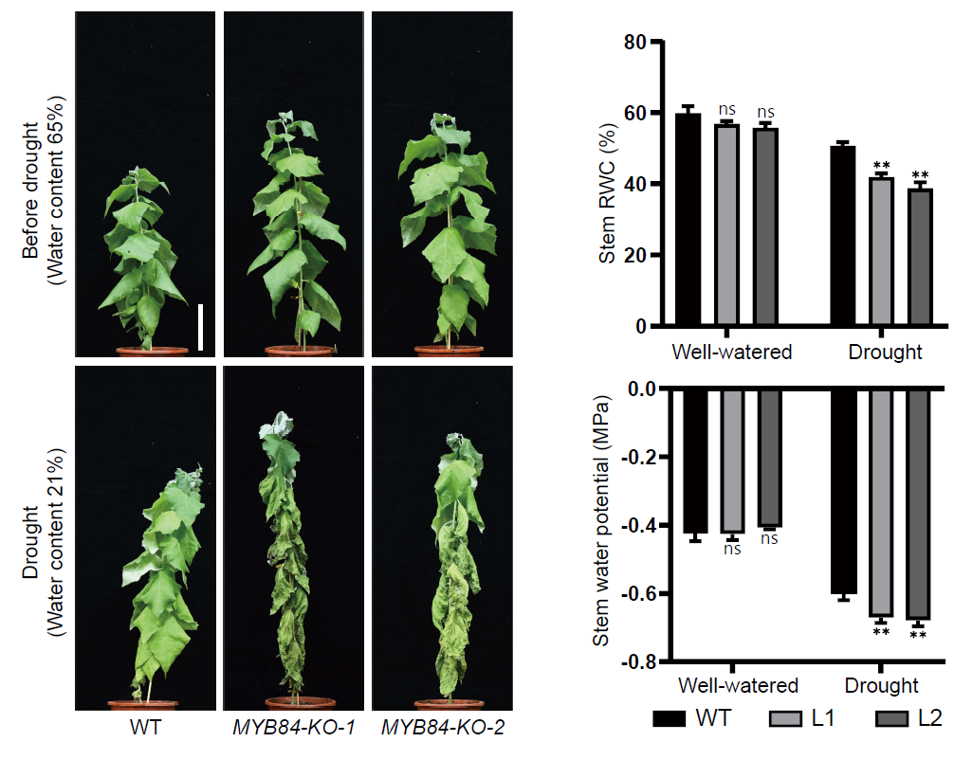
Fig. S16 Morphology and physiology characteristics under drought stress of the ptomyb84 mutants and WT. A, The phenotype of plants under average soil relative water content (SRWC) was 65%, 21%. Bars, 15 cm. B, stem RWC and stem water potential of plants. Error bar represent SD values of 3 biological replicates. Two-tailed paired t-tests, *P < 0.05, **P < 0.01. ns, no significance.

Fig. S17 Homology inference analysis among five Populus species. Blue connections represent MYB84 orthologs and orange connections represent AG1 orthologs. The physical distance on the left represents the total distance of the selected fragments.

Fig. S18 The full uncropped Gels and Blots image.

