Additional File 2: Supplementary information for ERVmancer: a phylogeny-guided framework for decoding human endogenous retrovirus regulatory mechanisms in health and disease

Supplemental Table Legends
Table S1. Metadata on the 3043 HERVs used by ERVmancer with at least one intact GAG, Pol/RT, or ENV protein, their hg19 genomic locations, and the closest gene to the HERV. HERV names are from HERVd.
Table S2. Metadata on the spontaneous lymphoblastoid cell lines from Multiple Sclerosis patients and healthy controls.
Table S3. Metadata on the CCLE breast cancer cell lines.
Table S4. Metadata for primers used in Fig. 4.

S1 Methods
The parallel ERVmancer assignment steps
ERVmancer uses two parallel methods to assign originator HERVs: a step using hashed k-mer tables, and a step using Bowtie2 multimapping assignments. These parallel approaches result in a more accurate tree assignment. After the initial Bowtie2 HERV read selection, the k-mer step removes more false positives (Fig. S5A) but tends to assign reads further from the leaves compared to the multimapping approach (Fig. S5B). This pattern is due to the k-mer step relying on the smaller, less informative 31 bp k-mers for assignment. In contrast, Bowtie2, by considering information across the entire read, tends to assign reads lower down in the tree (Fig. S5B). However, the multimapping step does not filter false positives, as it does not consider if the read also aligns to non-HERV regions. Therefore, the final read counts are generated by removing all reads which are filtered in the k-mer step, and then assigning the read to the tree to the lowest LCA assignment between the k-mer and Bowtie2 multimapping approaches. This approach yields the most specific LCA assignment while minimizing false positive mappings (Fig. S5A,B).
Examining alternative strategies for HERV quantification
Our initial attempts to solve the issue of quantification of HERV expression used clustering and consensus approaches. First, we applied CD-Hit-EST to cluster fragments of length 75bp from the 3,043 annotated HERVs and grouped these clusters as potential biomarkers. However, the resulting clusters lacked the necessary granularity for effective biomarker development or discovery, and their high heterogeneity prevented the construction of biologically meaningful consensus sequences.
Next, we explored a consensus-based alignment-informed approach using MAFFT to align every possible HERV pair, yielding ~4.7 million pairwise alignments. While homology was frequently observed between individual pairs, it did not extend consistently across groups of related HERVs, again precluding the derivation of accurate consensus sequences or coherent clusters.
Given these limitations, we turned to a phylogenetic approach. This framework offers a sliding scale of resolution, uniquely mapped reads can be directly assigned to specific HERVs, while reads from highly homologous regions can be placed at the most informative internal nodes. In doing so, the phylogenetic method preserves biological interpretability within the context of the inherent uncertainty of highly homologous reads.

Supplemental Figures
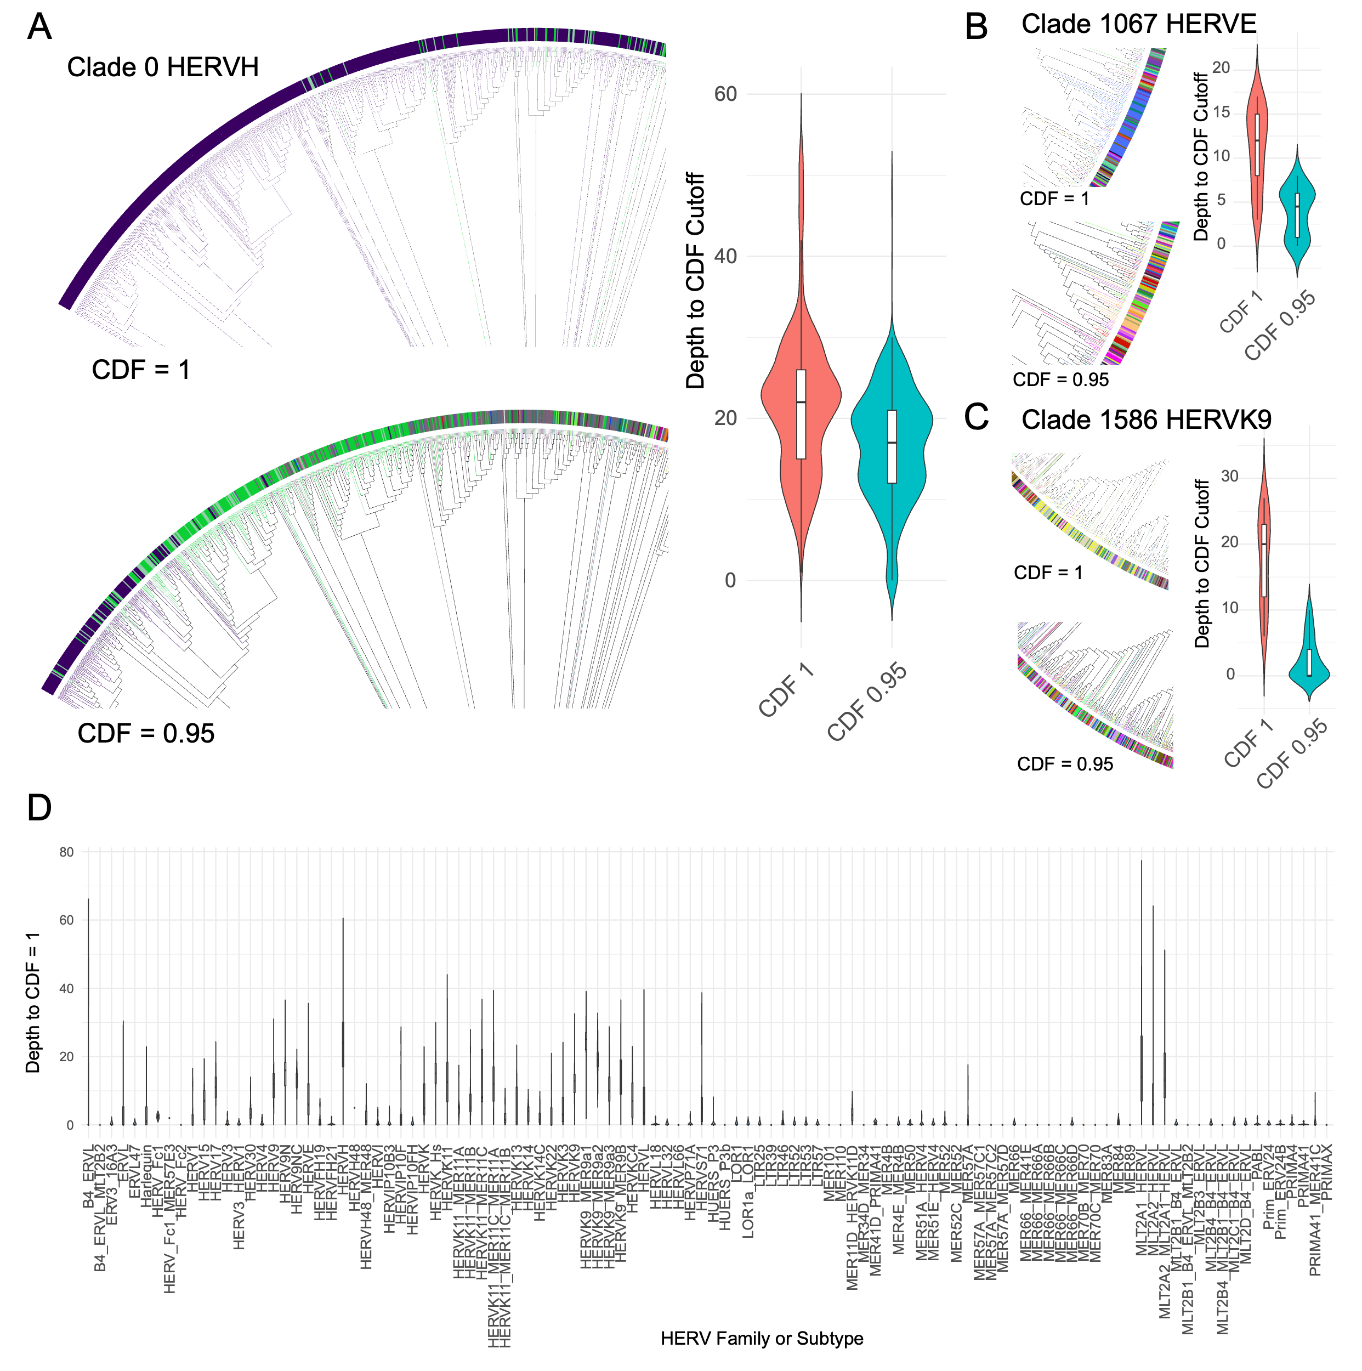
Fig. S1. CDF specific patterns across HERV families and clades. (A) Left: Slice of the tree comparing the first numbered clade (Clade 0) containing HERVH colored by a CDF cutoff of 1 (top) vs a CDF cutoff of 0.95 (bottom). Right: The depth (y-axis) from the HERV leaf to the specified CDF cutoff for HERVH when using CDF cutoff of 1 vs. 0.95 (x-axis). (B) Left: Comparison of Clade 1067 containing HERVE colored at CDF cutoff of 1 (top) and CDF cutoff of 0.95 (bottom). Right: Depth (y-axis) to reach the specified CDF (x-axis) for HERVE. (C) Left: Comparison of Clade 1586 containing HERVK9 at CDF cutoff of 1 (top) vs a CDF cutoff of 0.95 (bottom). Right: Depth (y-axis) to reach the specified CDF (x-axis) for HERVK9. (D) Violin plots showing depth (y-axis) each HERV family or subtype (x-axis) requires for reaching a CDF of 1.
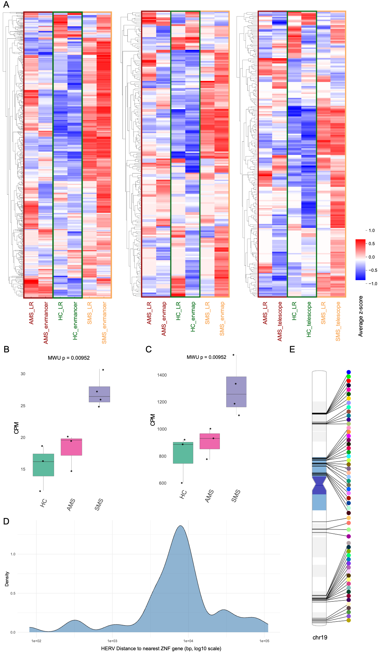

Fig. S2. MS-specific HERV expression patterns. (A) A heatmap comparing the general HERV expression across ERVmancer (right), ERVmap (middle) and Telescope (left) in long- and short-read data. SMS samples generally show higher HERV expression. (B) HERV expression for 11 chromosome 19 HERVs with unadjusted MWU test (p < 0.05) indicating higher expression in SMS compared with both HC and AMS samples. (C) HERV and clade-level expression for 58 HERVs or clades located within 10 nodes of a chromosome 19 HERV in the phylogenetic tree and showing unadjusted MWU test (p < 0.05), indicating higher expression in SMS compared with both HC and AMS samples. All significant HERVs and clades meeting these criteria showed the same direction of association (higher expression in SMS). (D) Density plot showing the log10 distance in base pairs of the HERV to the nearest Zinc Finger (ZNF) gene. (E) PhenoGram plot showing the hg19 position on chr19 of the HERVs and clades with MWU test unadjusted p-values < 0.05 for higher expression in SMS than the other states.

Fig. S3. HERV family specific performance evaluation. (A) ERVmancer correlations with long-read output by HERV family or subtype. (B)-(D) Left: Correlation of the short-read quantification method counts with long-read output for the specified HERV family. Right: Scatterplots of the -log₂ normalized counts on the x-axis and the -log₂ normalized long read counts on the y-axis for ERVmancer, ERVmap, and Telescope. (B) HERVH (C) HERVE (D) HERVK9.
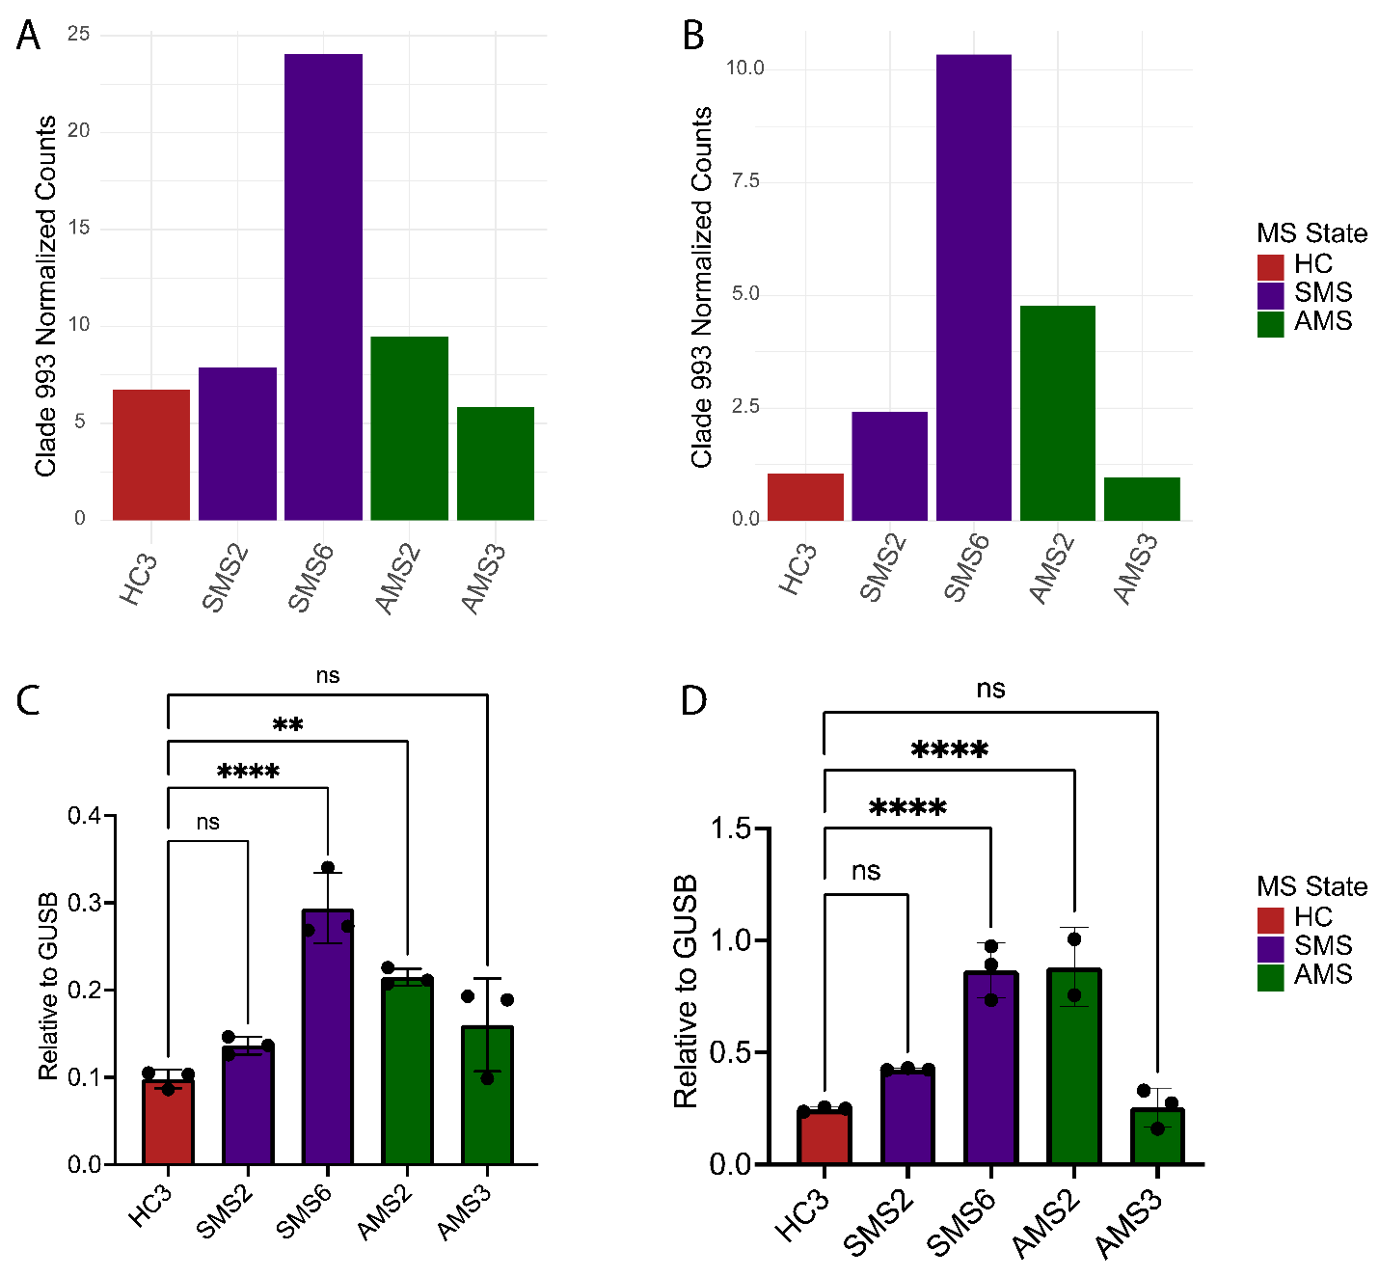
Fig. S4. Technical validation of an expression-variable ERV3 clade through RT-qPCR in the MS or control cell lines. (A) ERVmancer normalized counts for ERV3 Clade 993 containing ERV_3731545. (B) minimap2 expression patterns for ERV3 Clade 993. (C) qPCR expression for the first primer for ERV_3731545 relative to GUSB. (D) qPCR expression for a second primer for ERV_3731545 relative to GUSB.

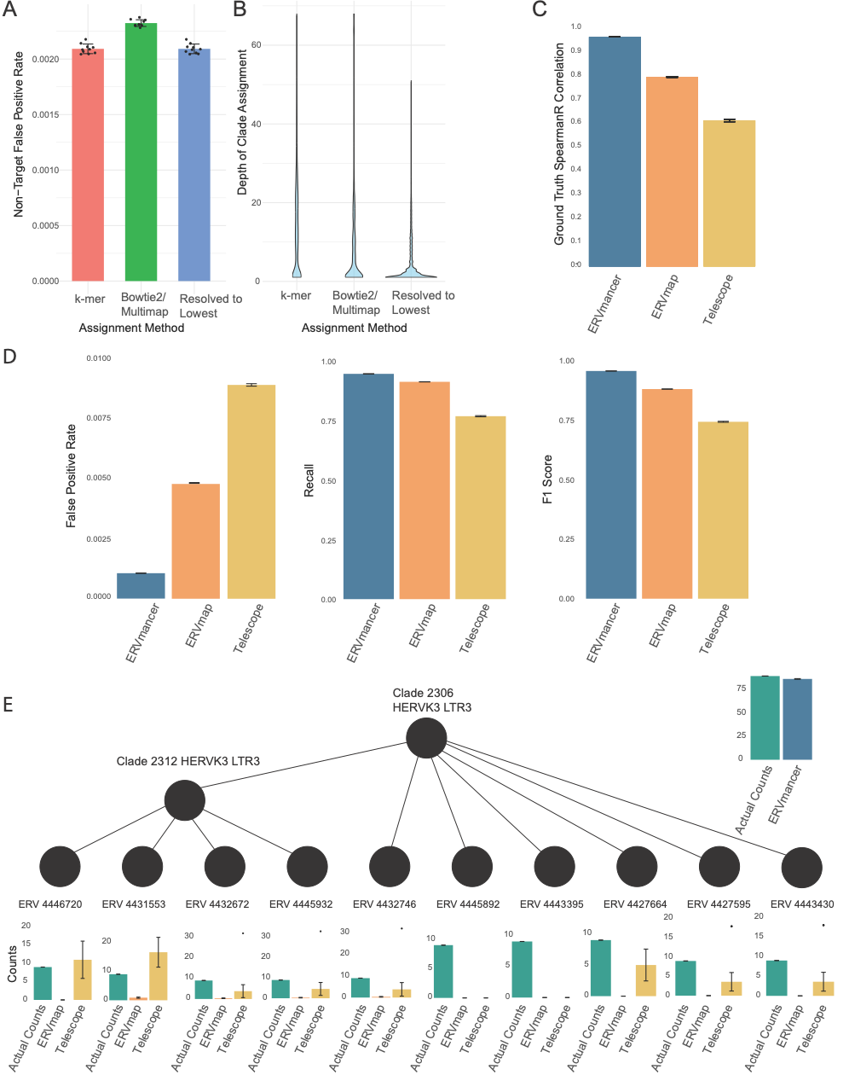
Fig. S5. Performance evaluation using simulated sequencing data (A),(B) Comparison of the k-mer or Bowtie2 multimapping steps of ERVmancer in isolation, versus the final combined approach mapping to the lowest clade across the two methods. (A) Non-target false positive rate for the k-mer approach, the Bowtie2 multimapping approach, and the final ERVmancer method. (B) The depth of the clade assignment between the k-mer, Bowtie2, and final ERVmancer method. (C) Spearman correlation coefficients between ground-truth counts and short-read quantification estimates generated by ERVmancer (blue), ERVmap (orange), and Telescope (yellow), using assigned counts rather than exact per-read assignments. (D) False positive rate (left), recall (middle), and F1 score (right) for ERVmancer, ERVmap, and Telescope, calculated using assigned counts rather than exact per-read assignments. (E) Comparison of the different methods in quantifying the HERVs in Clade 2306. ERVmancer assigns reads correctly to Clade 2306, while the other methods either over filter, as in the case of ERVmap, or misassign within the clades, as seen in Telescope. For clarity, only representative clades are shown.

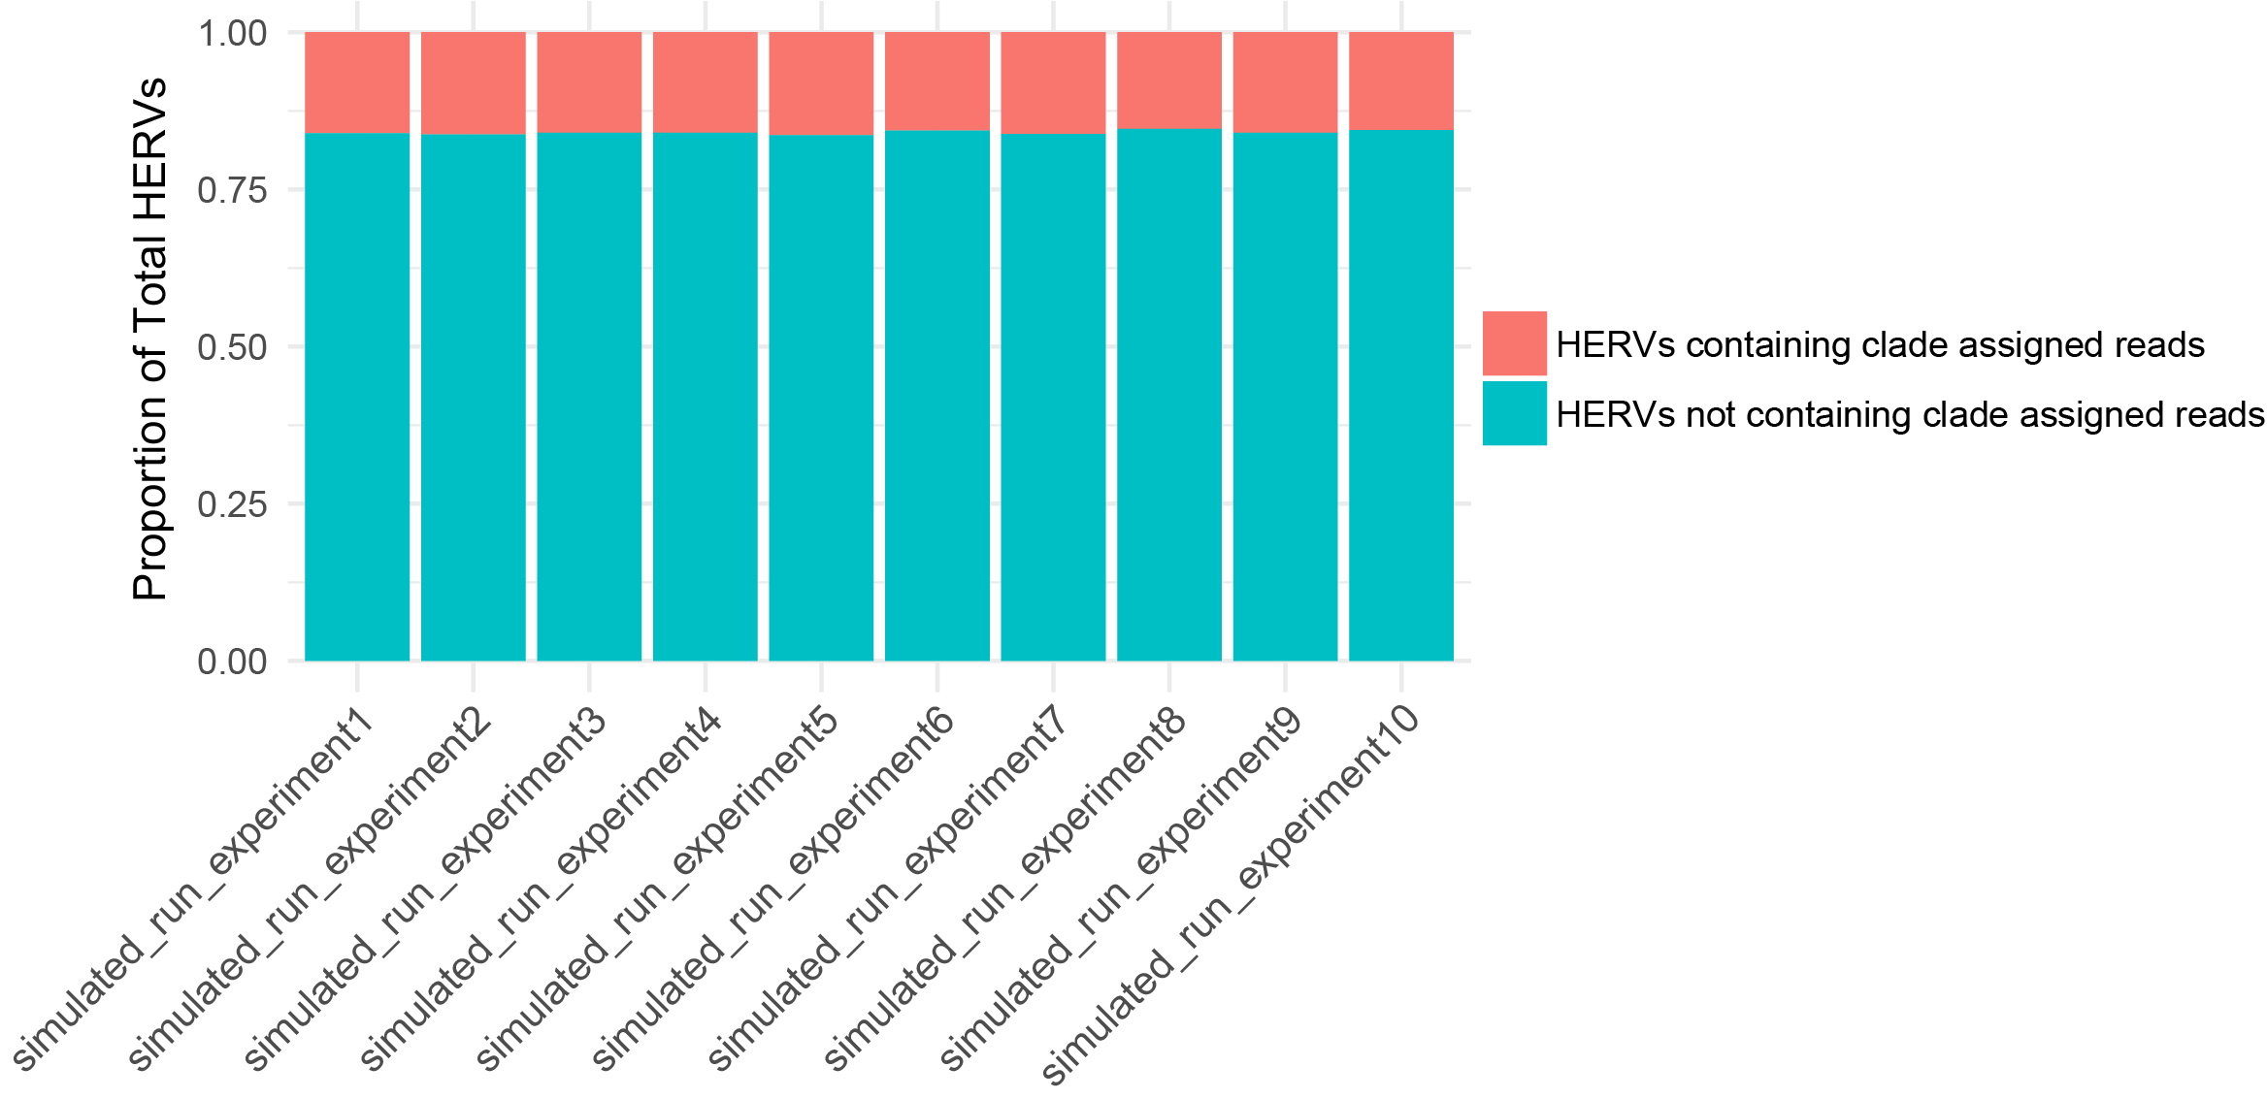
Fig. S6. Proportion of HERVs generating reads assigned to an internal phylogenetic clade in the simulated datasets. A HERV was classified as requiring clade-level assignment if at least one simulated read was assigned to an internal phylogenetic clade rather than uniquely to the HERV leaf node. This analysis quantifies mapping ambiguity across the HERV reference set.
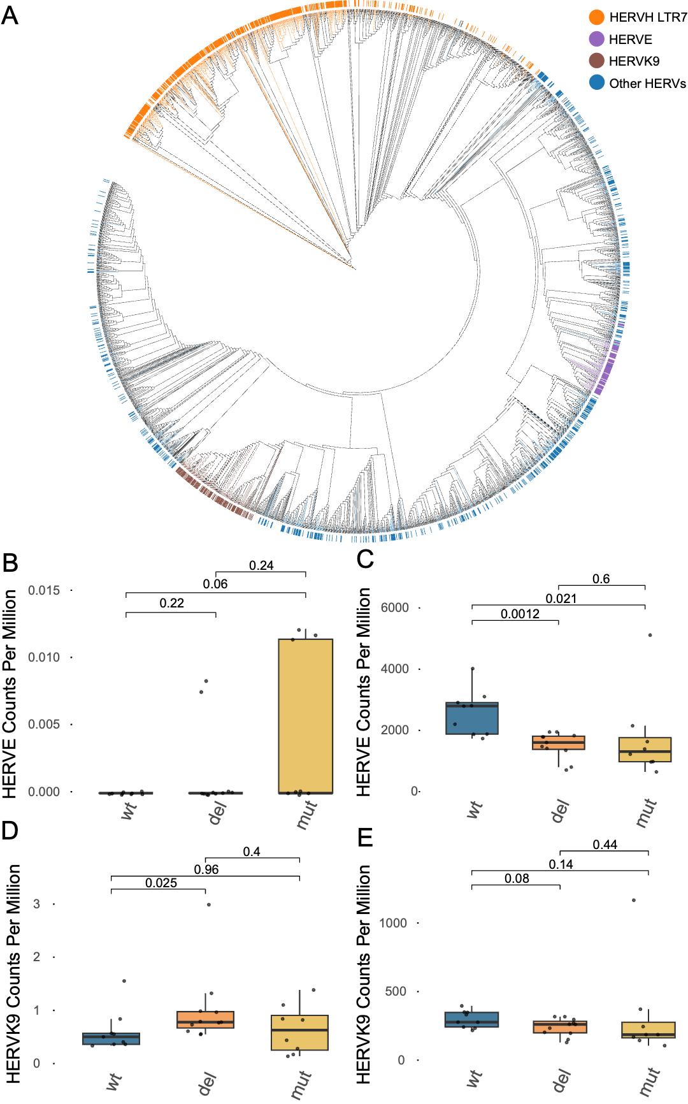
Fig. S7. p53 binding sites across diverse HERV clades and families. (A) The phylogenetic tree colored by different HERV clades with p53 binding sites. (B),(C) HERVE CPM for HERVEs with p53 binding sites that individually show higher (B) or lower (C) expression compared to WT samples (MWU unadjusted p-values are reported). (D),(E) HERVK9 CPM for HERVK9 with p53 binding sites which are individually evaluated for expression higher (D) or lower than (E) the WT samples (MWU unadjusted p-values are reported).

