Additional file 1
Identification of regulators of aryl hydrocarbon receptor signaling in human cells by genome-scale CRISPR screening

This file includes: Supplementary figures S1-S7

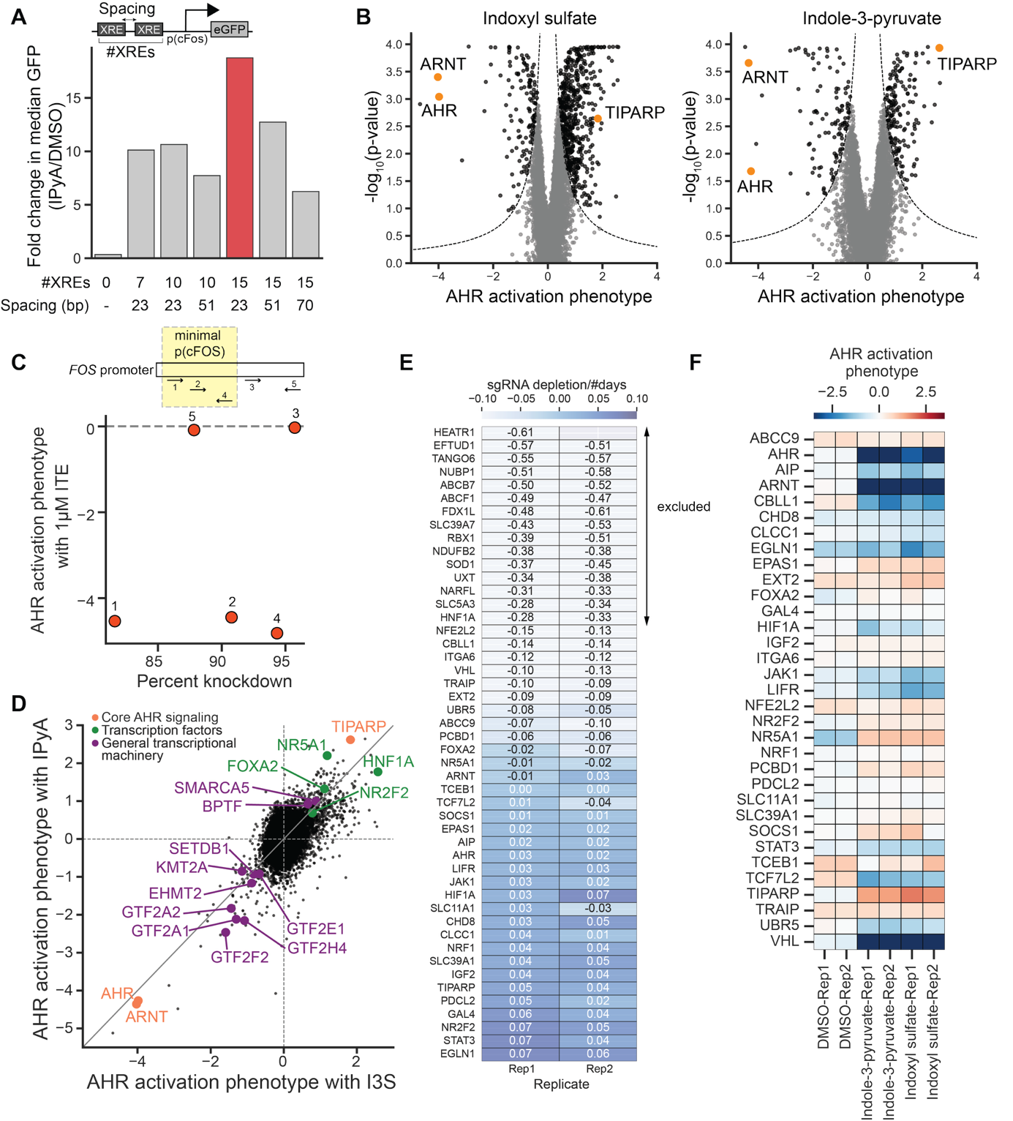
Fig. S1. Genome-scale CRISPRi screens reveal modulators of AHR signaling. (A) Schematic of GFP reporter designs showing the number of xenobiotic response elements (XREs) and spacing between consecutive XREs, and fold change in GFP signal upon induction with 100 µM IPyA for 24 h. The final reporter is highlighted in red. (B) Volcano plots for the genome-scale screens for AHR regulators with I3S and IPyA. Three positive control genes, AHR, ARNT and TIPARP (PARP7), are highlighted. Dashed line shows the threshold used for calling hits; gray points are not hits, black points are hits. (C) Top: schematic representation of FOS promoter with binding sites for the 5 sgRNAs targeting FOS indicating the p(cFOS) promoter used in the reporter. Bottom: effect of each of the 5 sgRNAs on AHR activation by 1 µM ITE plotted against the percent knockdown of the FOS gene measured by RT-qPCR. (D) AHR activation phenotypes for all genes in the IPyA and I3S CRISPRi screens. Categories of genes highlighted include core AHR signaling genes (orange), other transcription factors (green), and genes that are components of the general transcriptional machinery (purple). (E) Depletion of sgRNA-expressing cells over the 14-day period of the validation experiment as a proxy for gene essentiality. 15 genes excluded from analysis are highlighted. (F) AHR activation phenotypes calculated using the log₂ ratio of median GFP fluorescence in sgRNA-expressing cells relative to median GFP fluorescence for non-sgRNA-expressing cells in the same well after treatment with 100 µM I3S, 100 µM IPyA, or vehicle control for 24 h.
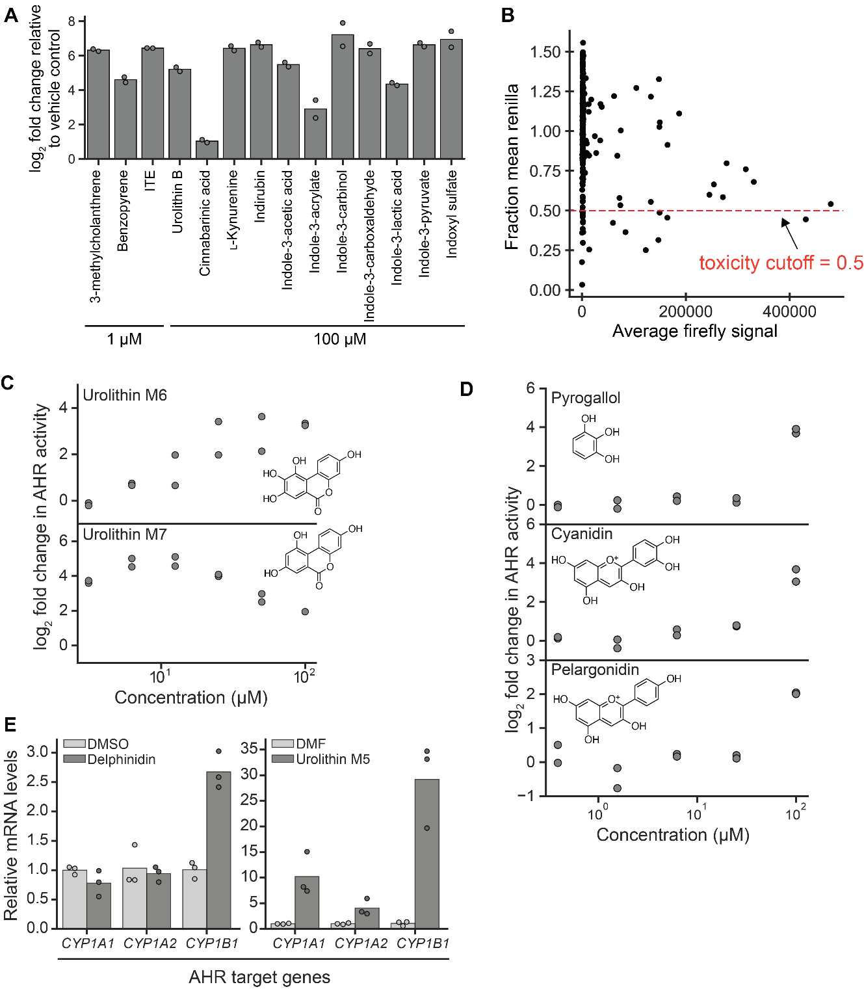
Fig. S2. Chemical screens identify novel AHR inducers. (A) log₂ fold change in luciferase signal after treatment with the indicated chemicals for 4 h relative to vehicle control. (B) Renilla relative luminescence units (RLUs, average of duplicate treatments) normalized to mean Renilla RLUs across the entire library plotted against firefly RLUs (average of duplicate treatments) for all chemicals in the 250-chemical library. All chemicals with fraction mean Renilla RLUs ≤ 0.5 are excluded from analysis. (C) Dose-response curves of the two additional urolithins that activate AHR, after treatment of the HepG2 luciferase reporter cells for 4 h. (D) Dose-response curves of 3 additional chemicals from the 250-chemical screen that induce AHR activation, after treatment of the HepG2 luciferase reporter cells for 4 h. Data represent treatment replicates (n=2). (E) mRNA levels of AHR target genes (CYP1A1, CYP1A2, CYP1B1) in HepG2 cells after treatment with 100 µM of either delphinidin (left) or urolithin M5 (right) for 4 h relative to vehicle-treated cells [DMSO (left) and DMF (right)], measured using RT-qPCR. Data represent treatment replicates (n=3).
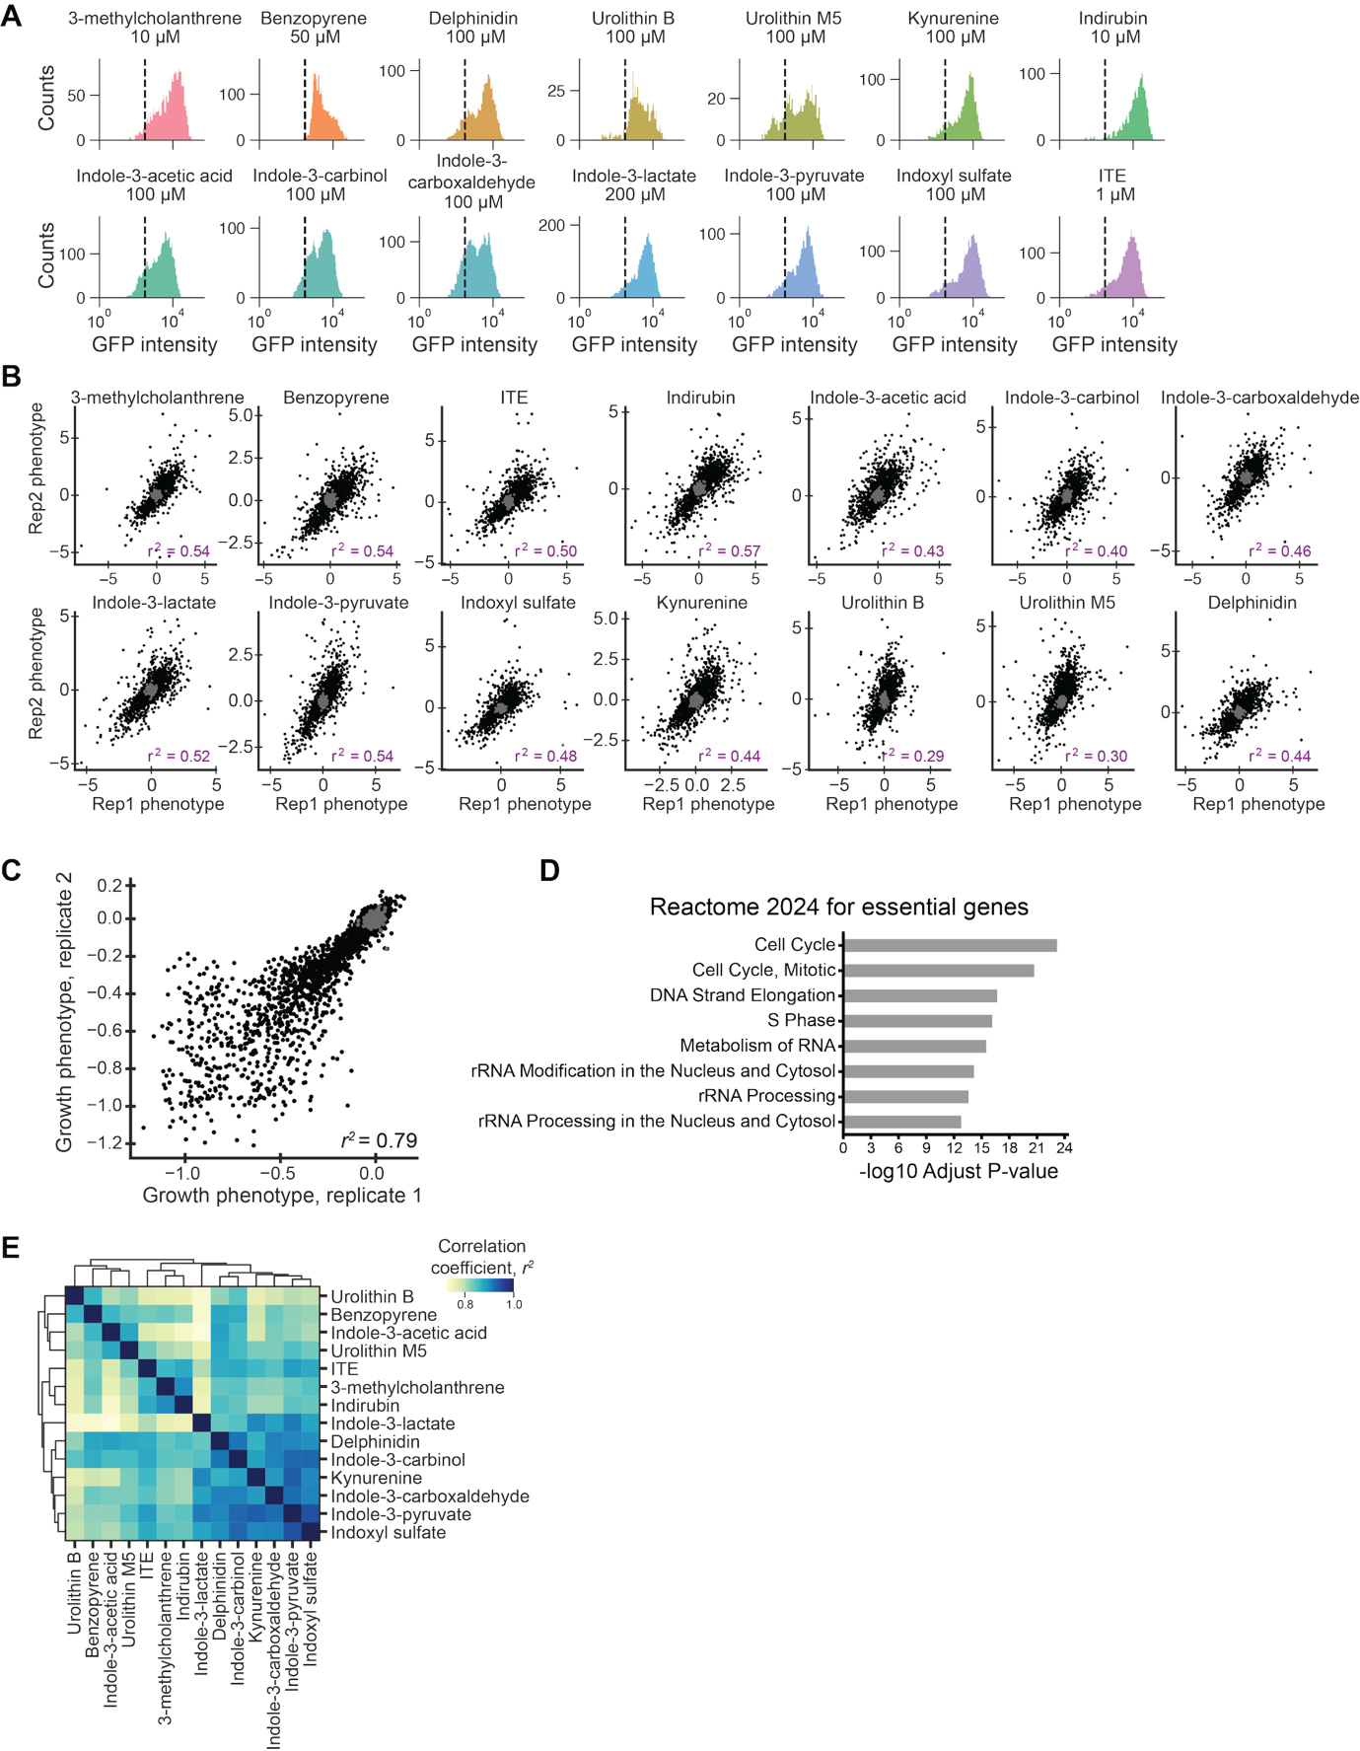
Fig. S3. Sublibrary CRISPRi screens reveal AHR regulatory networks across inducers. (A) GFP fluorescence distributions of the monoclonal CRISPRi GFP reporter cell line (cMV011) treated with indicated concentrations of the 14 chemicals used in the sublibrary screens. Dashed line indicates the median GFP fluorescence for vehicle-treated cells. (B) Replicate correlation for the FACS-based screens with all inducers for all targeting sgRNAs (black) and non-targeting control sgRNAs (gray). (C) Growth phenotypes from two biological replicates for all targeting sgRNAs (black) and non-targeting control sgRNAs (gray). (D) Gene set enrichment for all genes identified to be essential from the growth screen, using the Reactome 2024 dataset. (E) Pairwise correlations (squared Pearson correlation coefficient, r²) of gene-level AHR activation phenotypes for all inducers. Phenotype sets were clustered using Euclidean distance as indicated by the dendrograms.
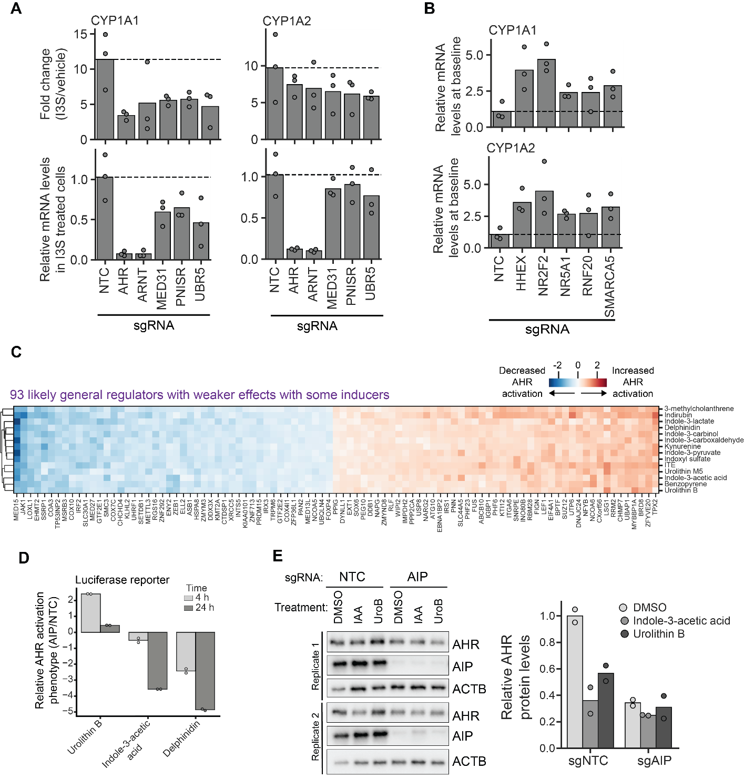
Fig. S4. Identification of general and inducer-specific regulators of AHR signaling. (A) CYP1A1 and CYP1A2 mRNA levels in HepG2 cells with knockdown of indicated positive AHR regulators after treatment with 10 µM I3S for 4 h, measured using RT-qPCR. Top: fold change in the presence of I3S relative to vehicle control; dashed line indicates fold change of cells with non-targeting control sgRNA (NTC). Bottom: mRNA levels in cells treated with I3S relative to NTC. All genes exhibited a knockdown of 95% or greater. (B) CYP1A1 and CYP1A2 mRNA levels in HepG2 cells with knockdown of indicated negative AHR regulators at baseline relative to cells with a non-targeting control sgRNA, indicated by the dashed line, measured using RT-qPCR. All genes exhibited a knockdown of 95% or greater. (C) AHR activation phenotypes for the 93 genes that are likely general regulators but have weaker effects with some inducers. (D) AHR activation phenotypes for AIP knockdown from HepG2 luciferase reporter cells. AHR luciferase reporter cells were transduced with either a non-targeting control sgRNA or a sgRNA targeting AIP, selected for sgRNA-expressing cells, and treated with 100 µM of the indicated chemicals for either 4 or 24 h. AHR activation phenotypes of AIP knockdown cells were normalized to phenotypes of cells with a non-targeting control sgRNA. (E) Left: Western blots for AHR and AIP for HepG2 CRISPRi cells transduced with either a non-targeting control or an sgRNA targeting AIP before 4 h treatment with 100 µM indole-3-acetic acid (IAA), 100 µM urolithin B (UroB), or vehicle control. Right: Quantification of AHR protein levels relative to the beta-actin loading control normalized to the negative control (sgNTC, vehicle control). Data in panels A, B, D, and E represent treatment replicates (n=2 or 3).
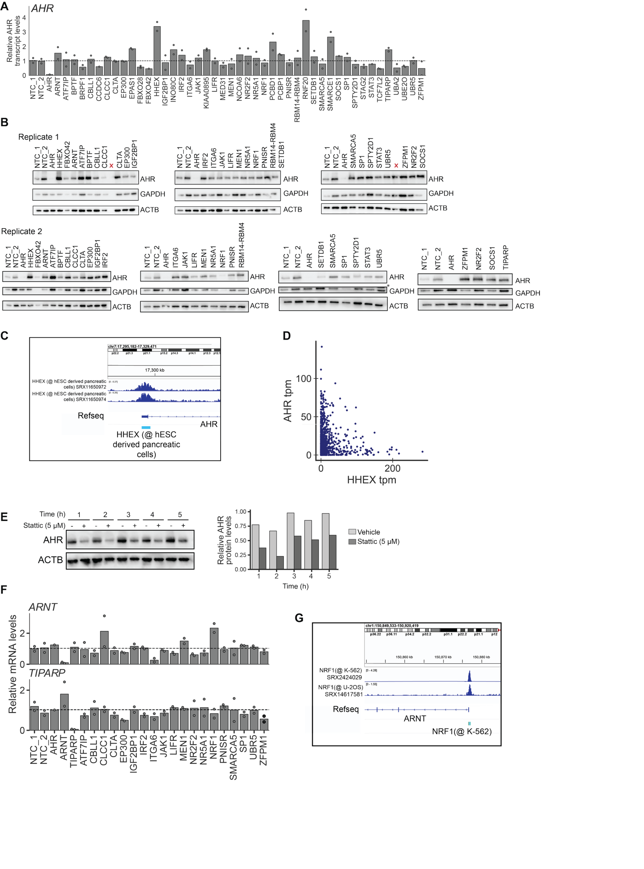Fig. S5. Functional classification of general regulators of AHR signaling. (A) AHR mRNA levels for all knockdown cells relative to the average level for cells with the two non-targeting control sgRNAs, shown by the dashed line, as measured using RT-qPCR. (B) Western blots for AHR and two loading controls of HepG2 CRISPRi cells transduced with sgRNAs targeting the general regulators not classified as regulators of AHR mRNA levels. The red crosses indicate lanes that were empty or re-loaded due to broken wells. The asterisk (*) denotes a lane with a non-specific band that appears due to incomplete stripping of ACTB before probing with the GAPDH antibody. (C) ChIP-seq tracks for HHEX in ESC-derived pancreatic cells⁷⁷ upstream of the AHR gene. (D) AHR and HHEX transcript per million (tpm) for all cell lines in the Human Protein Atlas. (E) Left: Western blots for AHR of HepG2 cells treated with 5 µM stattic, a STAT3 inhibitor, for the indicated times. Right: Quantification of AHR relative to beta-actin loading control. (F) ARNT (top) and TIPARP (PARP7) (bottom) mRNA levels for HepG2 cells transduced with sgRNAs against the indicated genes relative to the average levels for cells with the two non-targeting sgRNAs, indicated by the dashed line, as measured using RT-qPCR. (G) ChIP-seq tracks of NRF1 upstream of the ARNT gene from the ENCODE database in K-562 chronic myeloid leukemia cells and U-2OS osteosarcoma cells.
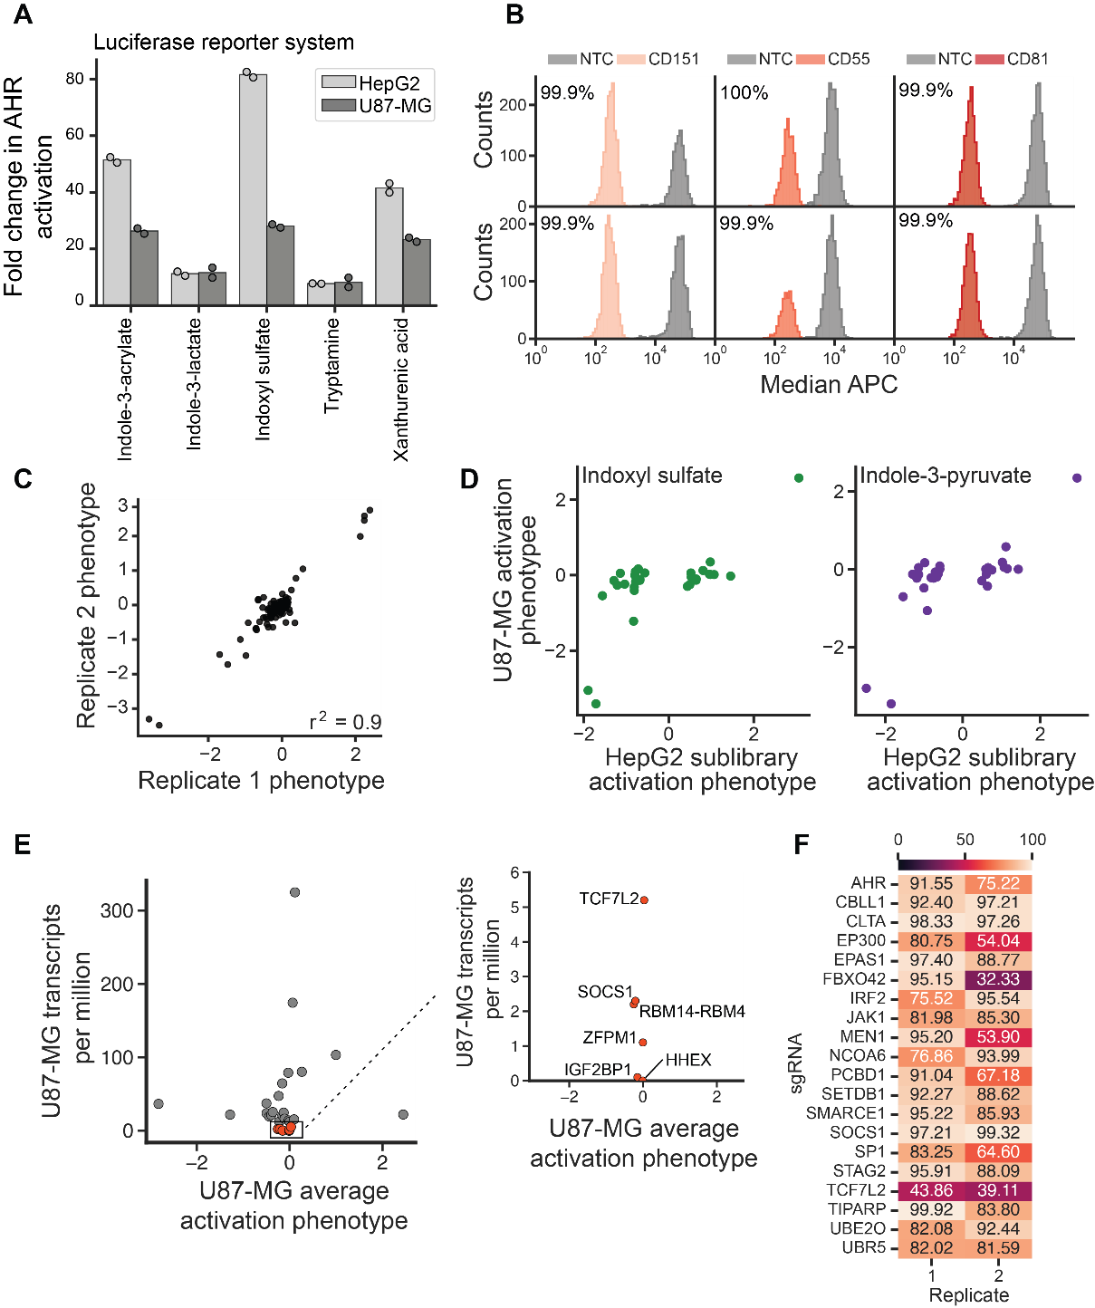
Fig. S6. Many general regulators of AHR signaling act in a cell type-specific manner. (A) Fold change in AHR luciferase reporter signal upon treatment with 100 µM of the indicated molecules for 4 h in HepG2 and U87-MG cells. (B) Distribution of anti-CD151, anti-CD55, and anti-CD81 signal intensities (APC) in cells with a targeting sgRNA or a non-targeting control sgRNA, for two independently transduced replicates. Knockdown was calculated as the ratio of median APC signal in cells transduced with targeting sgRNAs relative to cells transduced with a non-targeting control sgRNA. (C) Replicate correlation of AHR activation phenotypes for U87-MG cells transduced with sgRNAs targeting 27 general regulators, 3 positive control sgRNAs and 2 non-targeting control sgRNAs. (D) Comparison of AHR activation phenotypes for U87-MG and HepG2 cells for the selected sgRNAs for I3S and IPyA. (E) Transcripts per million of targeted genes in U87-MG cells from the Human Protein Atlas plotted against the U87-MG AHR activation phenotypes averaged for I3S and IPyA. Red points and inset indicate genes with < 6 transcript per million. (F) % knockdown for a subset of genes in the U87-MG cells for two independently transduced replicates, measured using RT-qPCR.
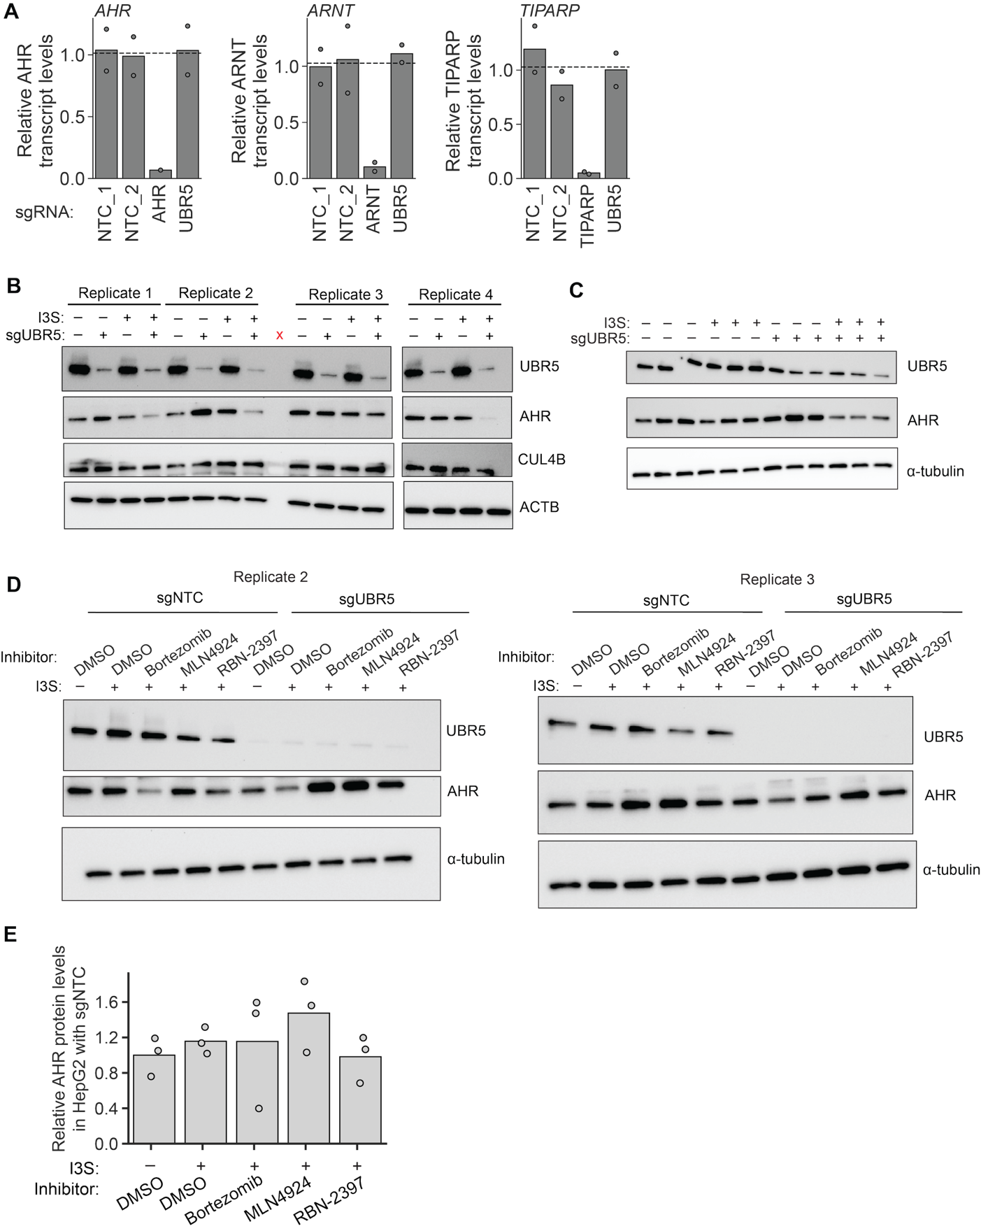
Fig. S7. The E3 ubiquitin ligase UBR5 is a regulator of AHR turnover. (A) Relative mRNA levels for AHR, ARNT, and TIPARP (PARP7) in HepG2 CRISPRi cells transduced with two non-targeting control sgRNAs, 1 positive control sgRNA, or an sgRNA targeting UBR5. (B) Western blots for AHR, UBR5, and CUL4B of HepG2 cells transduced with an sgRNA targeting UBR5 or a non-targeting control sgRNA and treated with 100 µM I3S for 4 h. Blots represent quadruplicate transductions. The red crosses indicate lanes that were empty. (C) Western blots for AHR and UBR5 of U87-MG cells transduced with sgRNA targeting UBR5 or a non-targeting control sgRNA and treated with 100 µM I3S for 4 h. Blots represent triplicate transductions. (D) Western blots for AHR and UBR5 of HepG2 cells transduced with an sgRNA targeting UBR5 or a non-targeting sgRNA and treated with 100 µM I3S or vehicle control for 4 h after a 2 h pretreatment with 500 nM bortezomib, 1 µM MLN4924, 1 µM RBN-2397, or vehicle control. Blots indicate triplicate treatments. (E) Quantification of relative AHR protein levels from western blots of HepG2 cells with NTC sgRNA.

