BioSIFTR: functional inference from shallow shotgun sequencing using biome-specific genome catalogues benchmarked in gut microbiomes – Supplementary Figures

Alejandra Escobar-Zepeda^{a†}, Matti O. Ruuskanen^{b,c†}*, Martin Beracocheaª, Jennifer Luª, Dattatray Mongad^{b}, Lorna Richardsonª, Robert D. Finn^{a‡}, Leo Lahti^{b‡}*

†A. Escobar-Zepeda and M.O. Ruuskanen contributed equally to this work.
‡R. D. Finn and L. Lahti contributed equally and jointly supervised this work.
ª EMBL-EBI, Microbiome Informatics Team, Wellcome Genome Campus, Hinxton, Cambridge CB10 1SA, United Kingdom
^{b} Department of Computing, University of Turku, Vesilinnantie 5, 20500, Finland
^{c} Department of Life Technologies, University of Turku, Itäinen Pitkäkatu 4, 20500, Finland
*Corresponding authors: Matti Ruuskanen, matti.ruuskanen@utu.fi; Leo Lahti, leo.lahti@utu.fi

Keywords: microbiome, metagenomics, bioinformatics, shallow shotgun sequencing, 16S rRNA gene, benchmark, functional prediction, human gut, chicken gut, mouse gut

1. Supplementary Figures
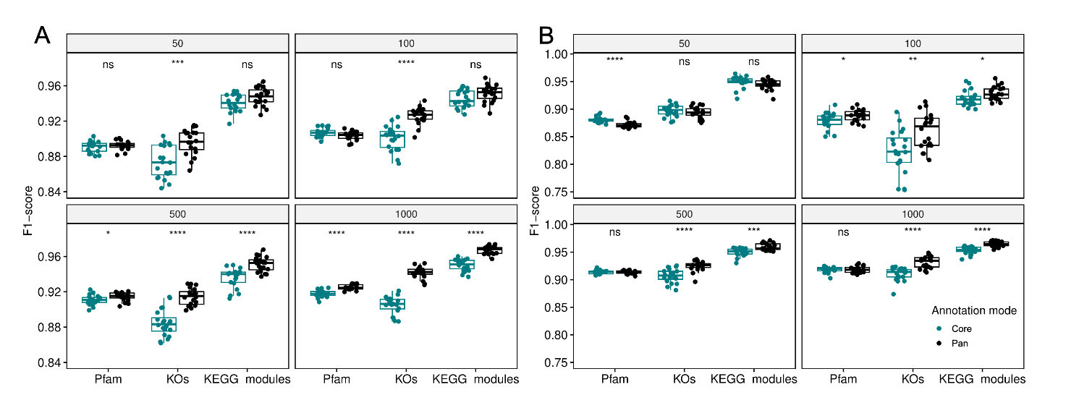
Figure S1. Functional inference performance across annotation types and modes for BioSIFTR parameter optimisation. F1-score distributions across 20 synthetic community replicates are shown for core (teal) and pan (black) inference modes, comparing three annotation types (Pfam, KOs, and KEGG modules) across four species richness levels (50, 100, 500, and 1,000 species). Results are shown for (A) Sourmash with k-mer size 21 and (B) bwa-mem2 with dynamic coverage threshold optimisation (0.1 for richness ≤150 species; 0.01 for richness >150 species). Significance labels above each annotation type indicate pairwise Wilcoxon test results comparing core vs. pan mode: ns = not significant, * = 0.01 < p ≤ 0.05, ** = 0.001 < p ≤ 0.01, *** = 0.0001 < p ≤ 0.001, **** = p ≤ 0.0001.
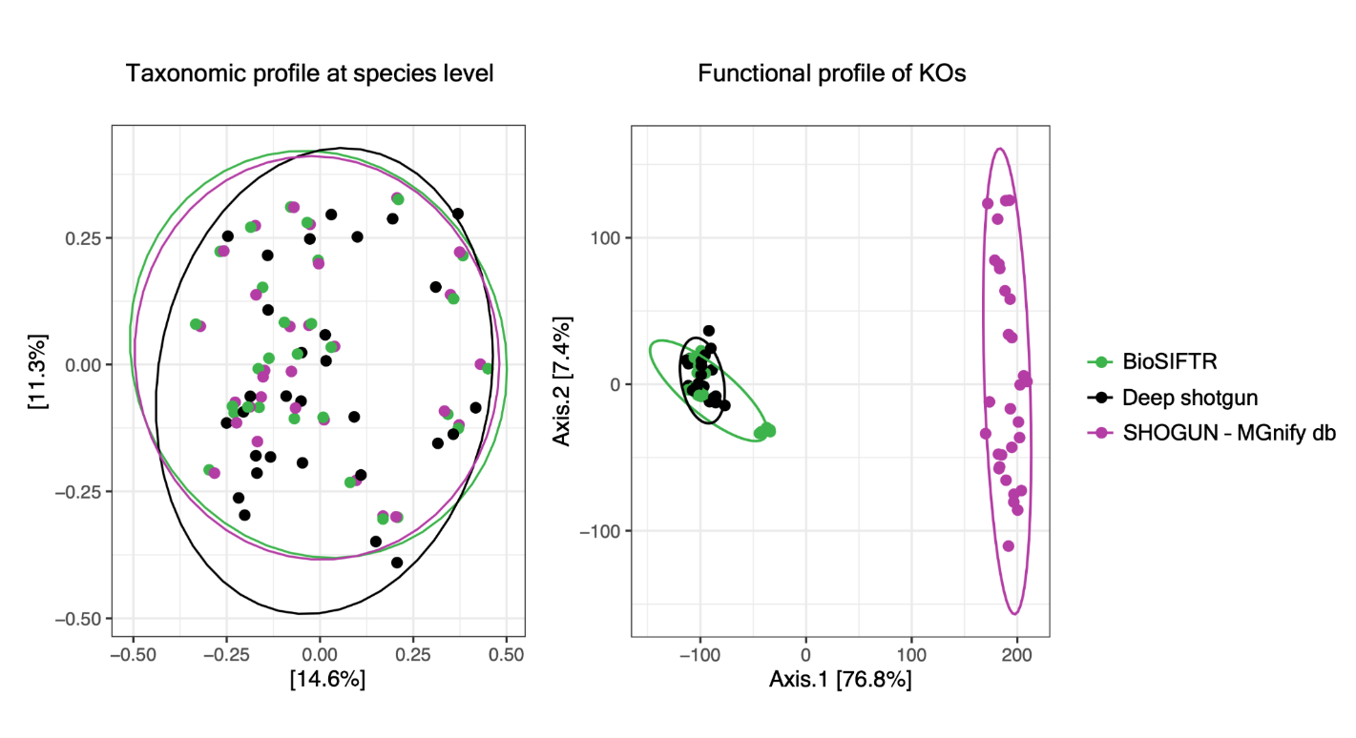
Figure S2. Comparison of taxonomic and functional profiles between BioSIFTR and SHOGUN using a matched reference database. To address the potential confounding effect of database choice on method comparisons, a custom SHOGUN database was constructed from the same MGnify Human Gut Genome Catalogue (v2.0.2, 4,744 representative genomes) used by BioSIFTR, ensuring that differences between methods reflect algorithmic and inference strategy differences rather than reference composition. Human gut samples (n = 30, PRJDB11444) were processed at 1 M reads using both tools under this matched-database framework, and results were compared against deep-shotgun assembly-based profiles as the gold standard.

(Left) PCoA of species-level taxonomic profiles based on Bray-Curtis dissimilarity computed on relative abundances. BioSIFTR (green) and SHOGUN (red) show highly overlapping ordination patterns with no significant separation between methods (pairwise ANOSIM R = 0.038, p = 0.052), confirming that when operating on the same reference database, both tools produce concordant taxonomic profiles. Both methods differ modestly but significantly from the deep-shotgun reference (ANOSIM R ≈ 0.31–0.35, p = 0.001), with method explaining only ~9.1% of variance (PERMANOVA R² = 0.091). Ellipses represent 90% confidence intervals.

(Right) PCoA of KO-level functional profiles based on Euclidean distances on CLR-transformed counts. In contrast to taxonomy, functional profiles show strong method-dependent separation (global ANOSIM R = 0.691, p = 0.001; PERMANOVA R² = 0.768). SHOGUN forms a distinct cluster entirely separated from both BioSIFTR and the deep-shotgun reference (pairwise ANOSIM R ≈ 0.999–1.000), whereas BioSIFTR profiles closely overlap with the gold standard (pairwise ANOSIM R = 0.611). Since the same reference database was used for both tools, these functional differences are attributable to methodological differences in functional inference: SHOGUN assigns functions based on individual reference genomes, whereas BioSIFTR leverages pangenome annotations that incorporate both core and accessory gene content, enabling more complete reconstruction of community functional potential. Ellipses represent 90% confidence intervals.
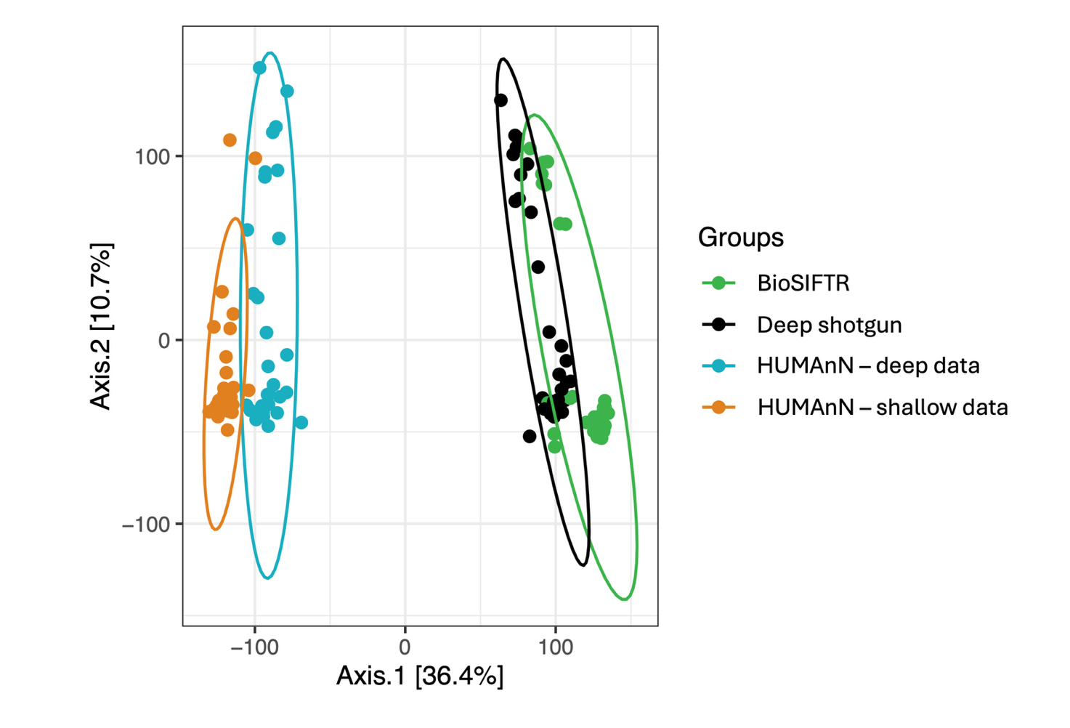
Figure S3. Comparison of KO-level functional profiles across read-based and pangenome-based inference strategies under deep and shallow sequencing conditions. To directly address whether functional annotation performed on shallow shotgun reads can approximate deep-sequenced functional profiles, KO functional profiles were generated using four approaches applied to human gut samples (n = 30, PRJDB11444): assembly-based annotation of deep shotgun data (Deep shotgun, black), used as the gold-standard reference; BioSIFTR pangenome-aware inference applied to shallow shotgun data (1 M reads, green); HUMAnN read-based functional profiling applied to deep shotgun data (HUMAnN – deep data, blue); and HUMAnN applied to the same shallow subsampled reads (HUMAnN – shallow data, orange). KO count profiles were normalised by relative abundance and CLR-transformed prior to ordination.
PCoA based on Euclidean distances of CLR-transformed profiles reveals a clear separation between read-based (HUMAnN) and gene-centric approaches along the first axis (36.4% variance explained). HUMAnN shallow profiles form the most divergent cluster, completely separated from the assembly-based reference (pairwise ANOSIM R ≈ 1.000) and substantially separated even from HUMAnN deep profiles (R = 0.282), demonstrating that read-based functional inference is highly sensitive to sequencing depth. HUMAnN deep profiles also remain strongly separated from the assembly-based reference (R = 0.986), reflecting systematic differences between read-level and gene-centric functional profiling strategies even at high sequencing depth. In contrast, BioSIFTR profiles are substantially closer to the assembly-based reference (R = 0.439) than either HUMAnN approach, despite operating on the same shallow data. Global separation across all groups was significant (ANOSIM R = 0.779, p = 0.001; PERMANOVA R² = 0.427, p = 0.001) with no significant differences in dispersion between groups (betadisper p = 0.066), indicating that observed differences reflect compositional shifts rather than heterogeneous within-group variance. Ellipses represent 90% confidence intervals. These results demonstrate that pangenome-aware functional projection in BioSIFTR recovers community functional potential more effectively from shallow sequencing data than direct read-level annotation.

