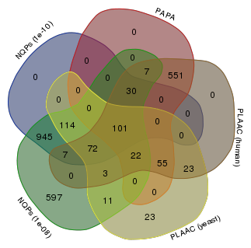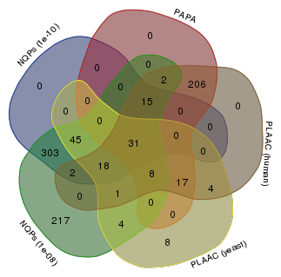

PROTEINS GENES

Set | # of proteins | # of genes
NQPs (threshold 1e-08) | 1909 | 646
NQPs (threshold 1e-10) | 1269 | 414
PAPA | 766 | 276
PLAAC (yeast background) | 424 | 134
PLAAC (human background) | 871 | 304

