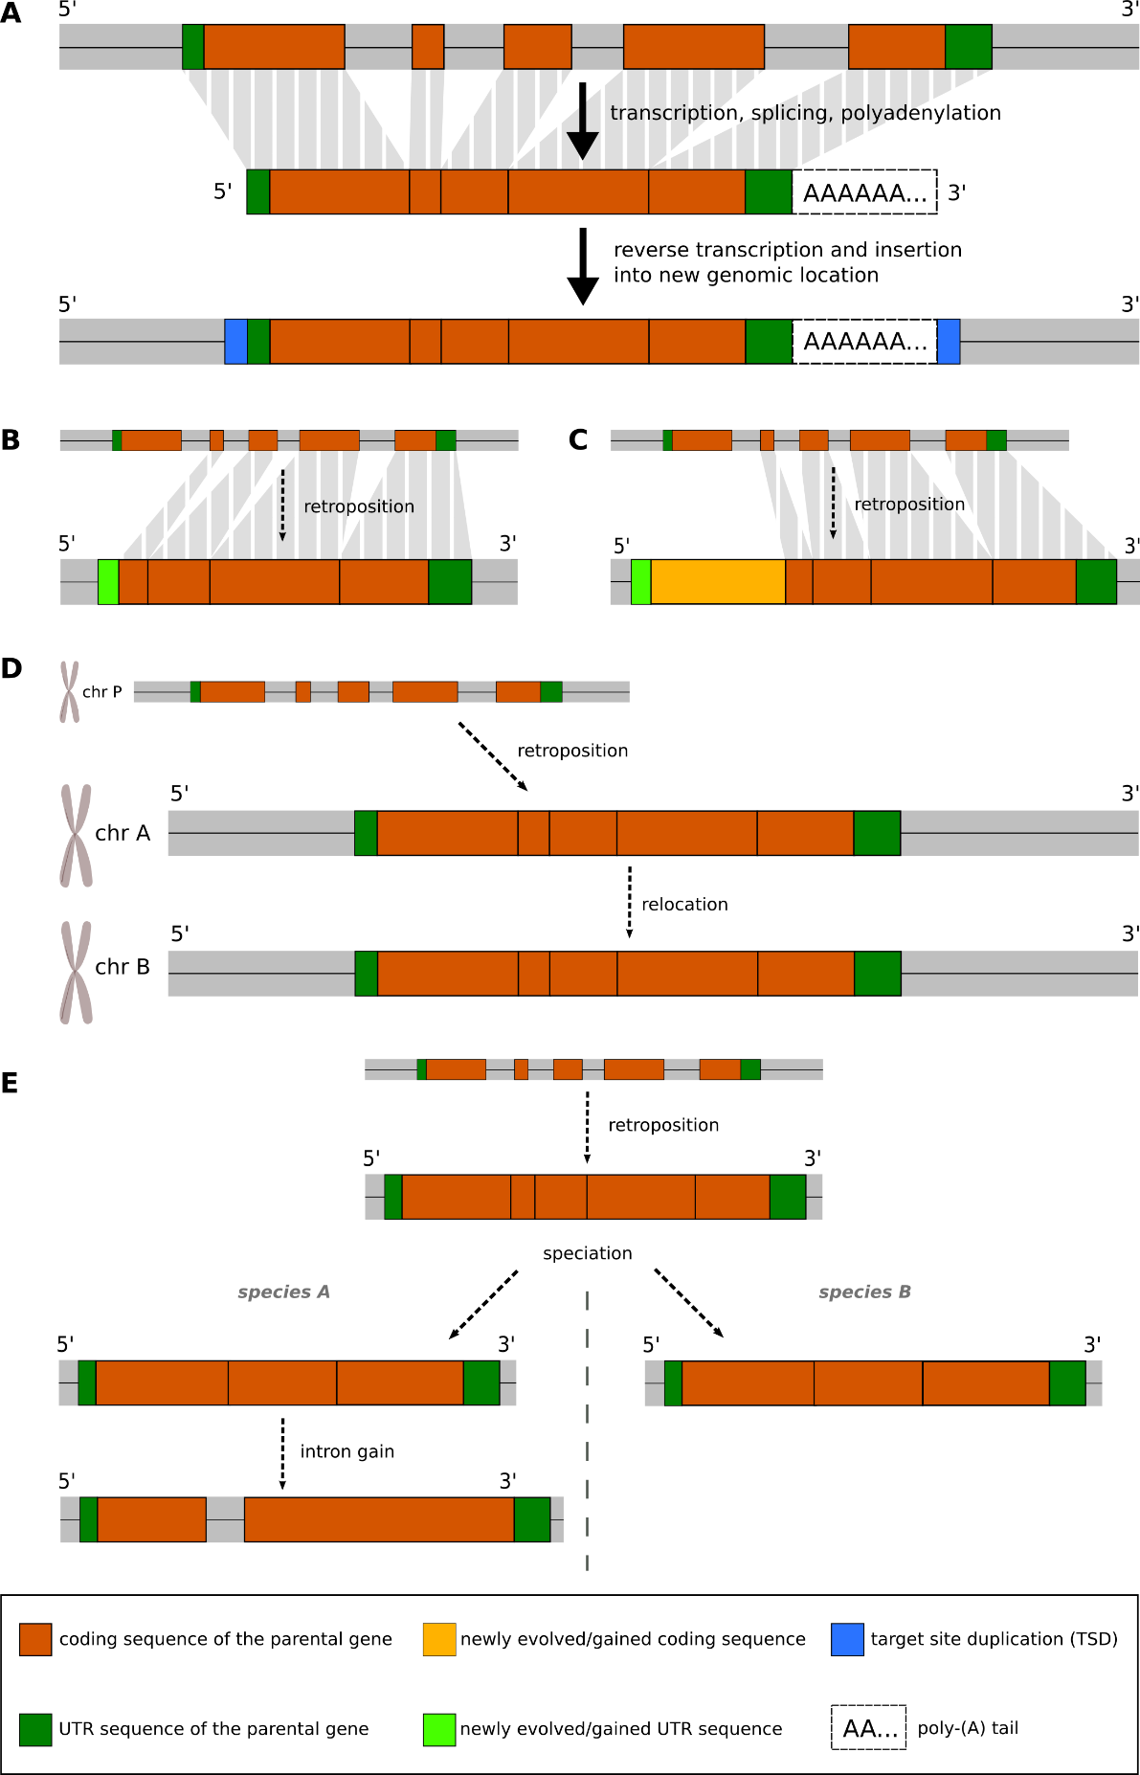
Figure S1. Various scenarios of retroposed genes. A. basic mechanism of retroposition, B. incomplete retroposition with truncation at the 5' site, C. incomplete retroposition with truncation of parental sequence at the 5' site; gain of new coding sequence and UTR sequence at 5' site, D. retroposition followed by relocation of retroposed gene, E. retroposition followed by intron gain in retrogene.
group_37
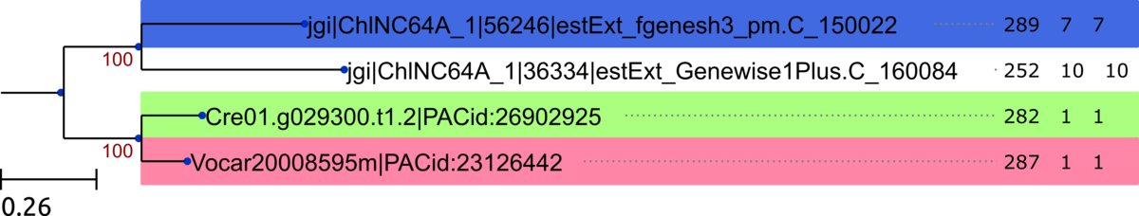
group_38
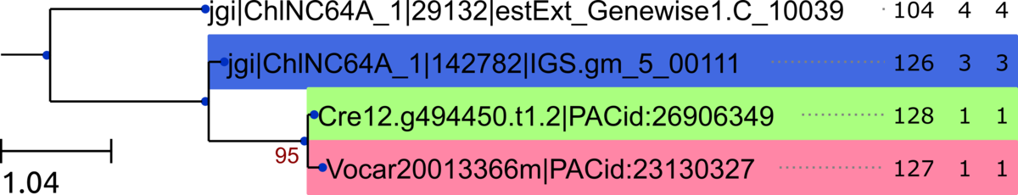
group_39
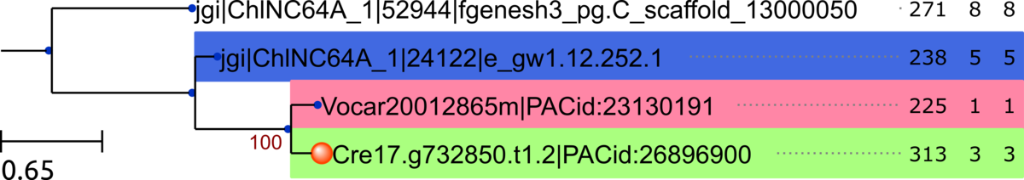

group_40
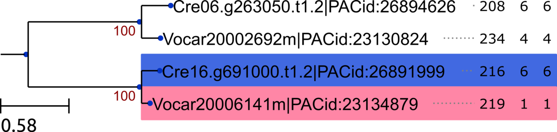

group_41
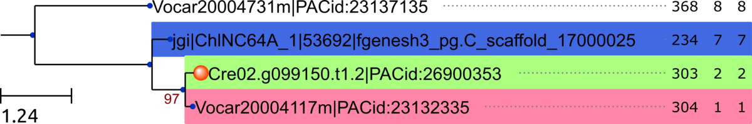

group_42
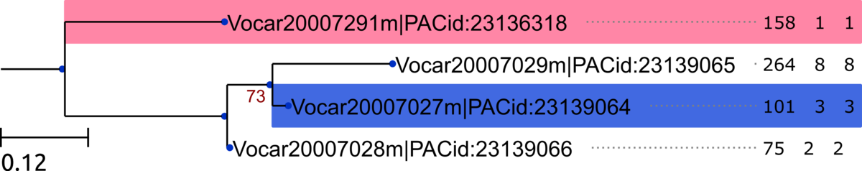
group_43
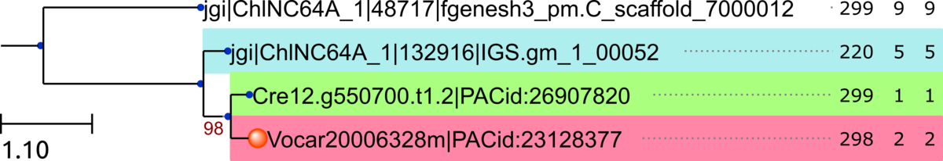

group_44
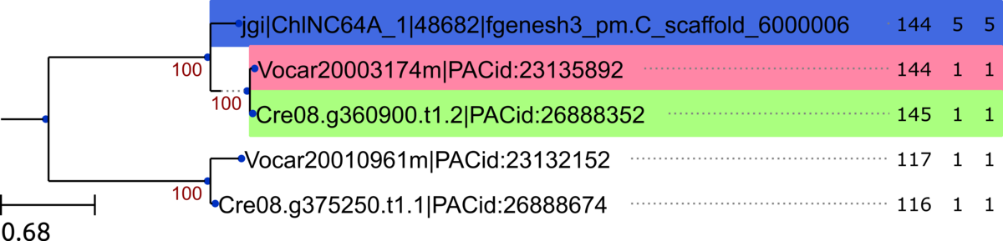

group_45
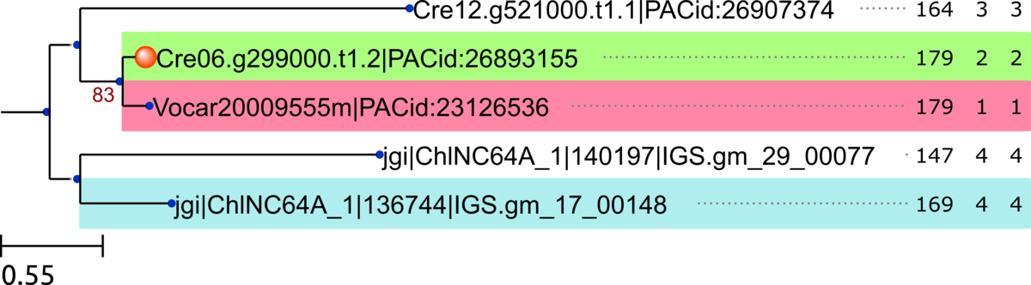

group_46
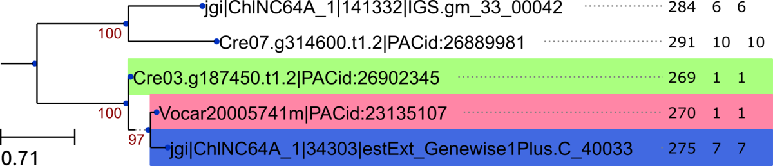

group_47
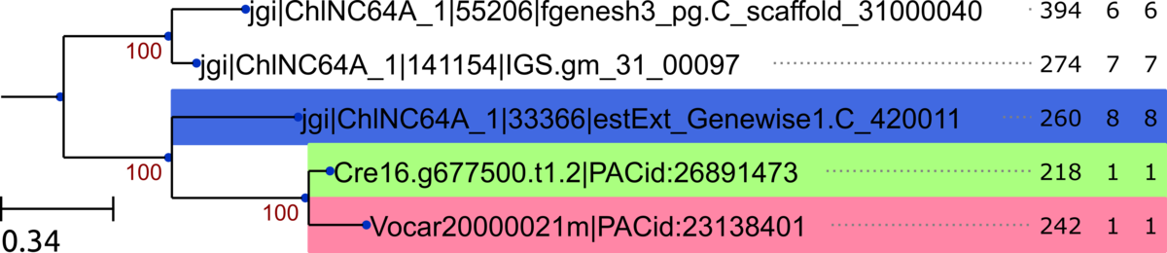

group_48
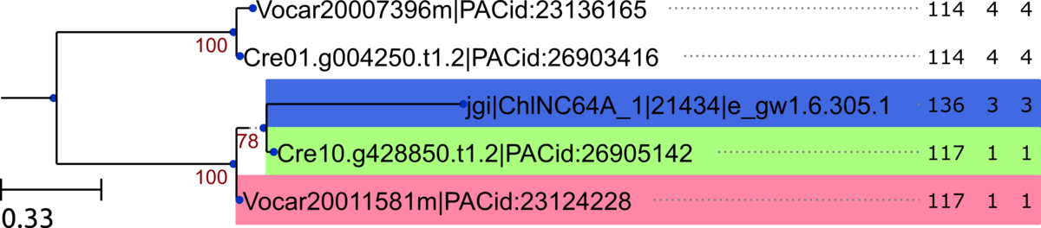

group_49
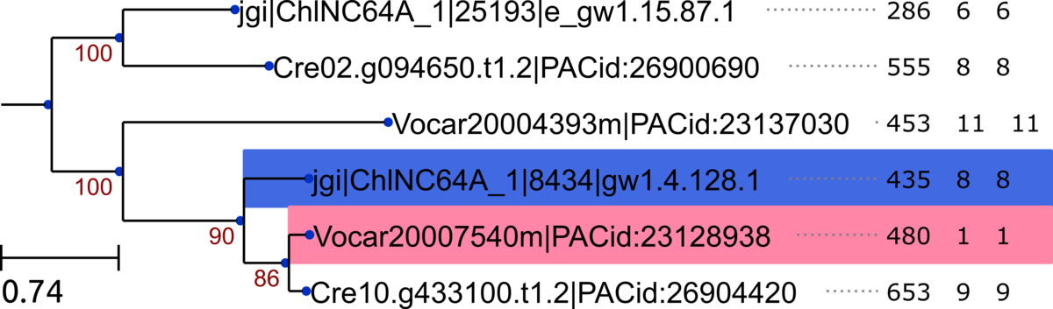

group_50
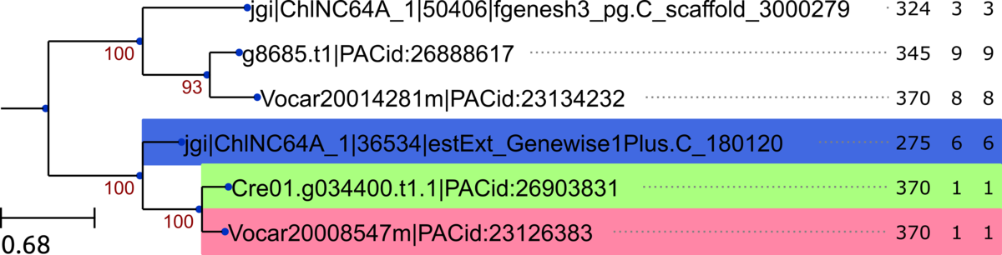
group_51
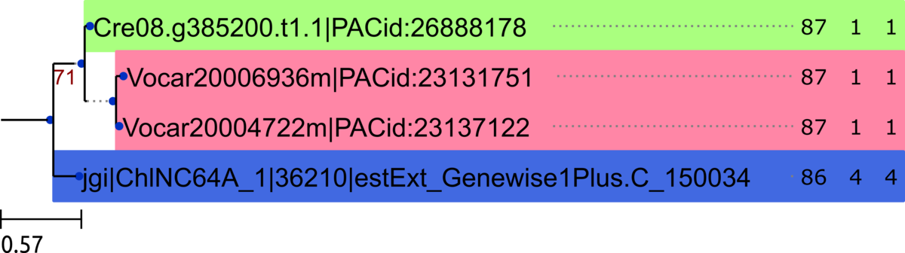
group_53
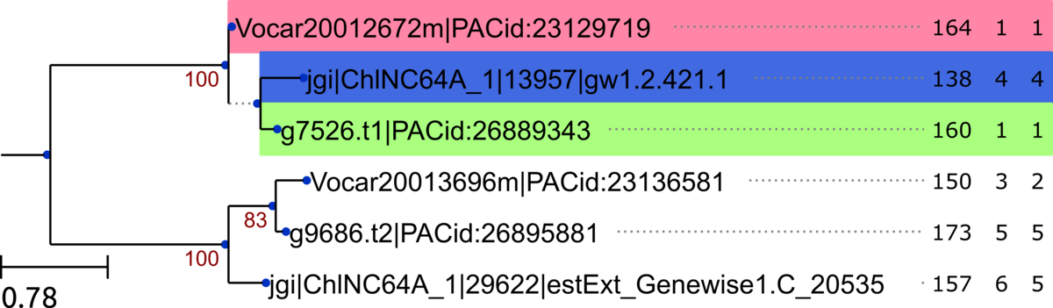
group_54
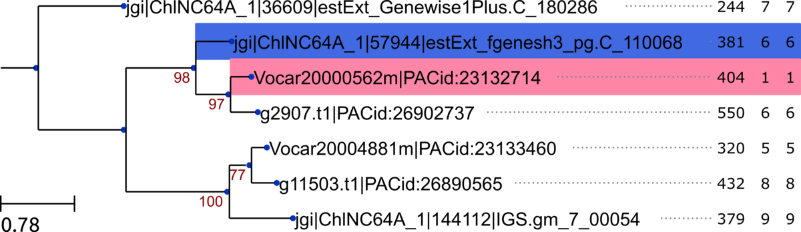

group_55
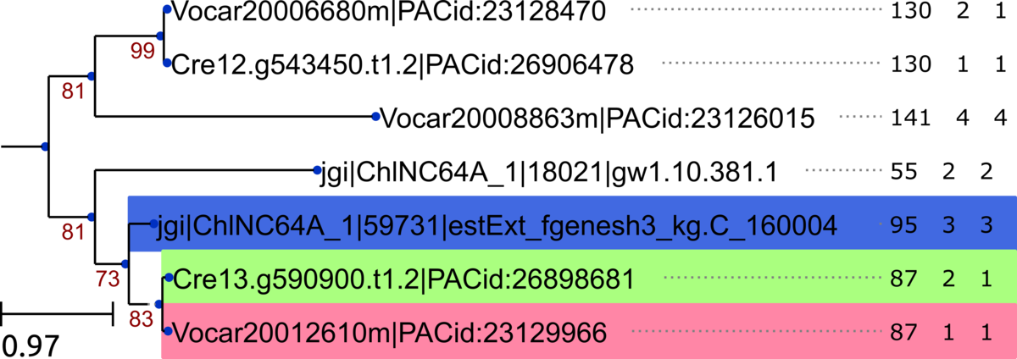

group_56
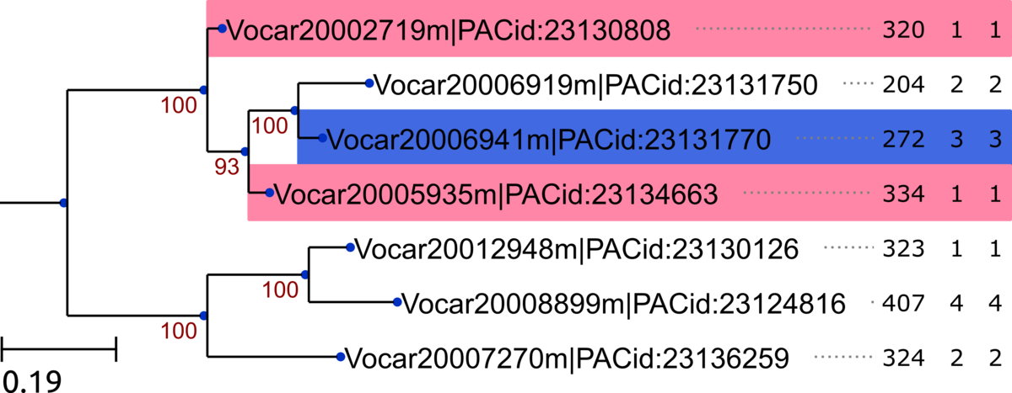

group_57
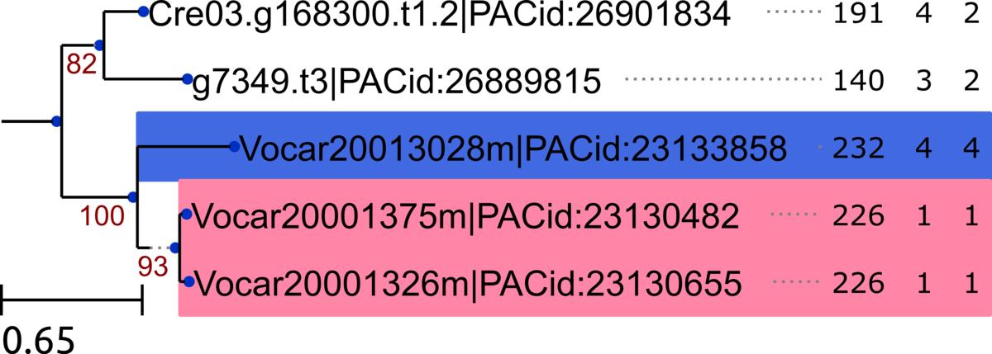
group_58
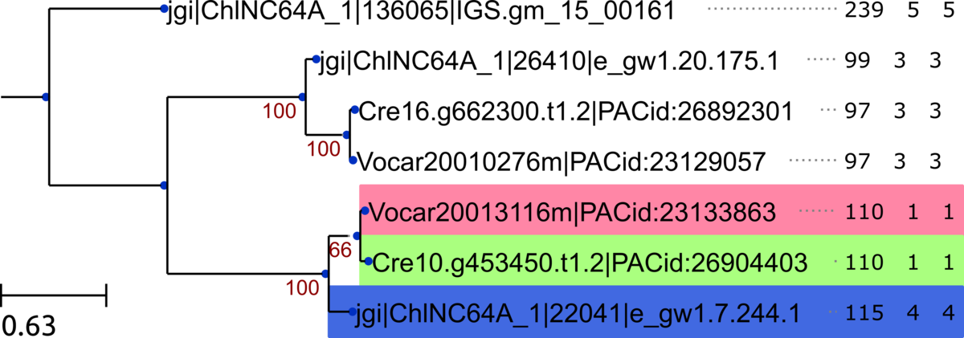

group_59
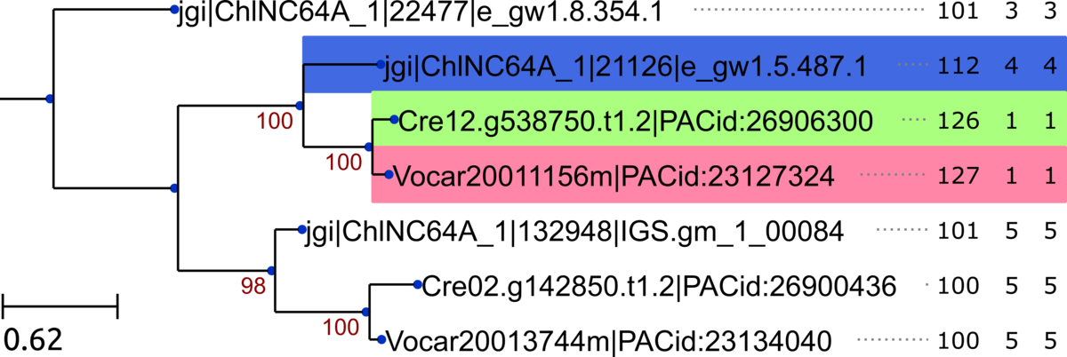

group_60
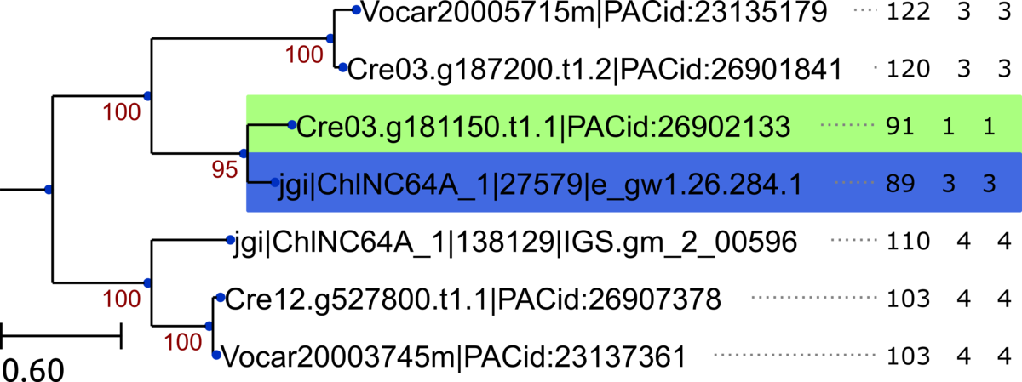

group_61
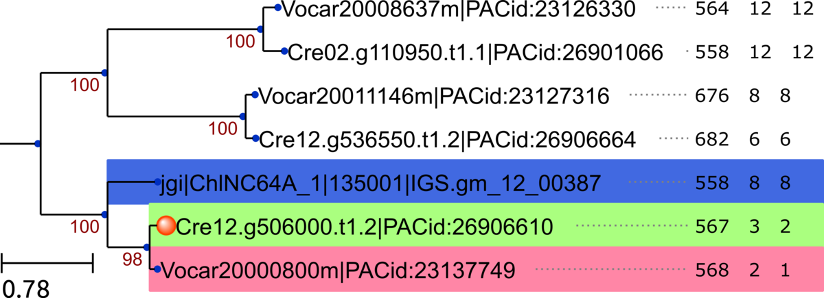
group_62
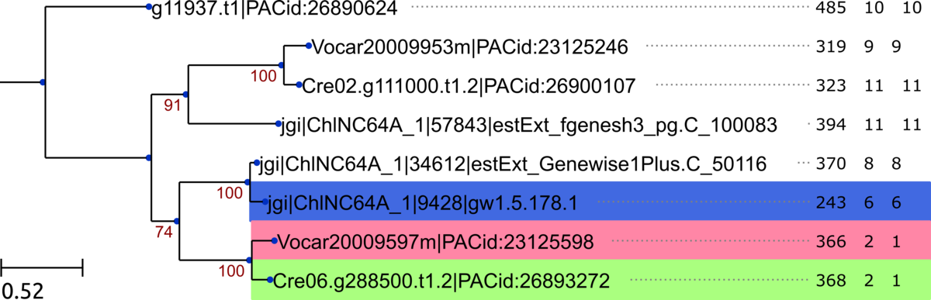

group_63
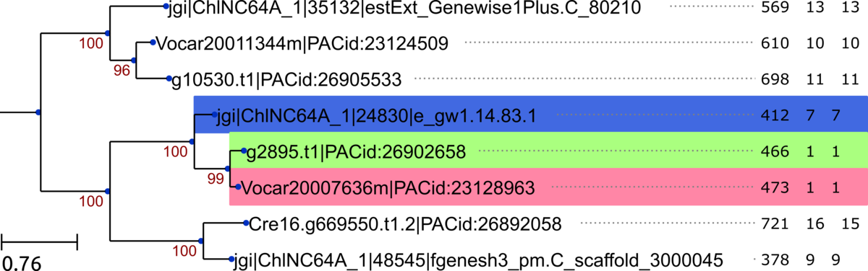

group_64
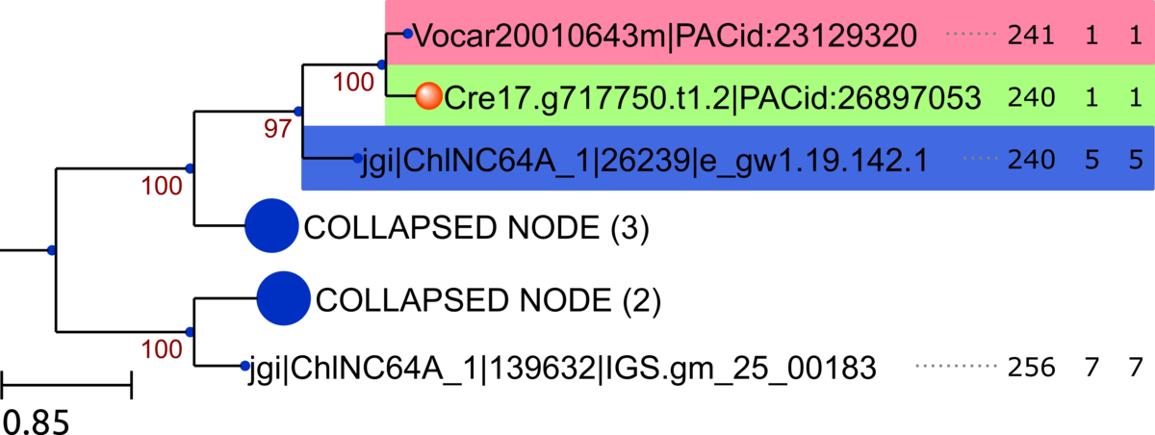

group_65
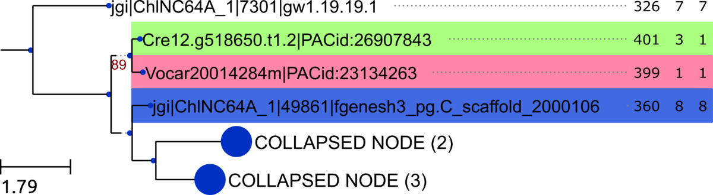
group_66
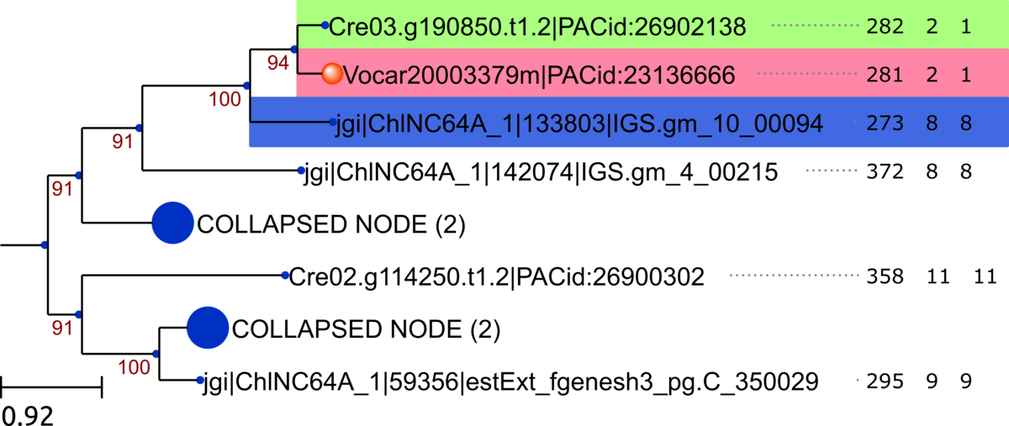

group_67
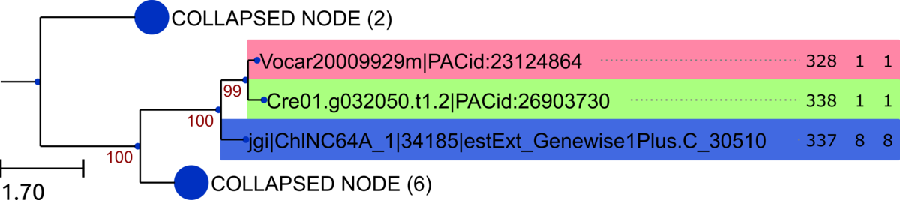

group_68
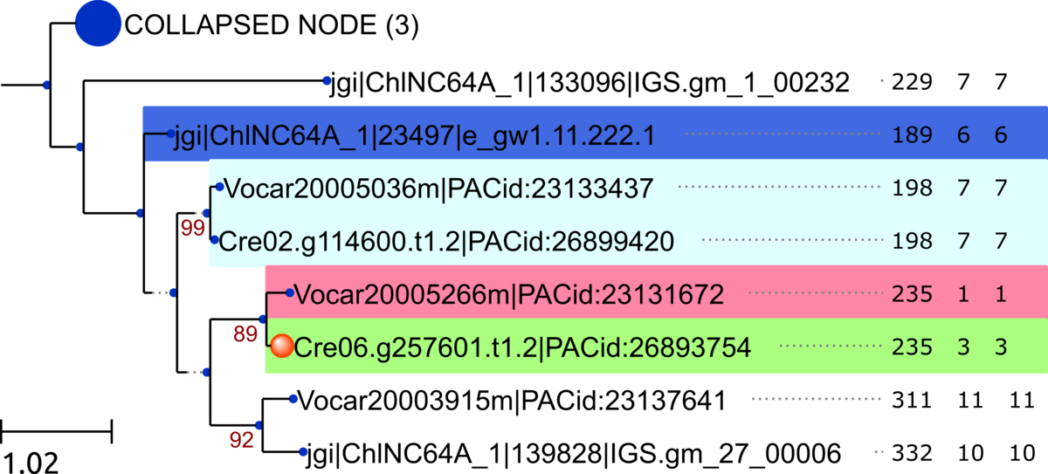
group_69
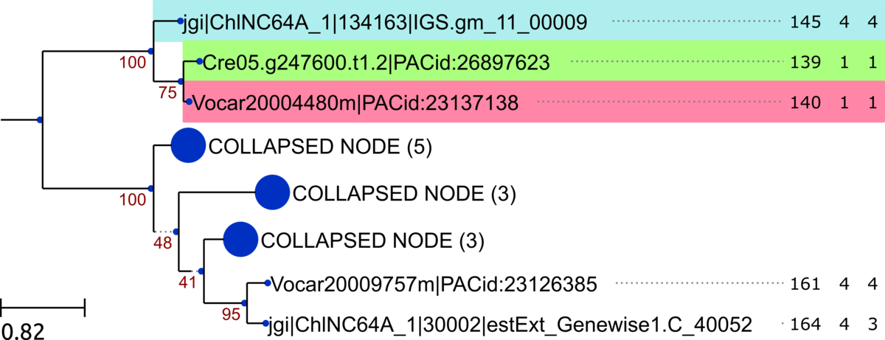
group_71
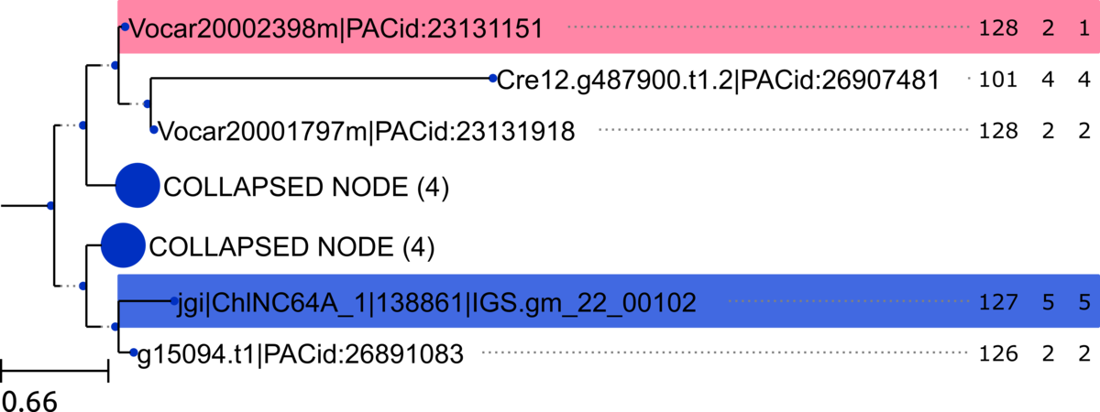
group_72
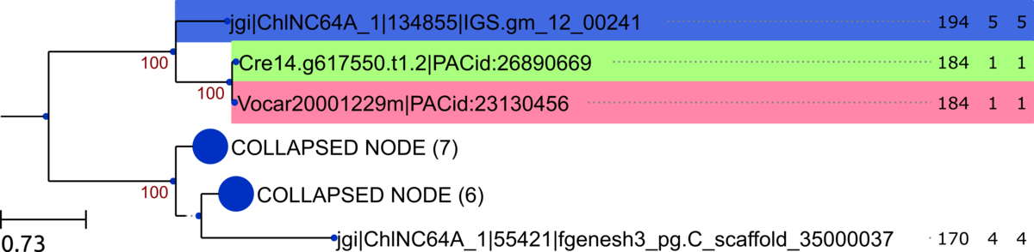

group_73
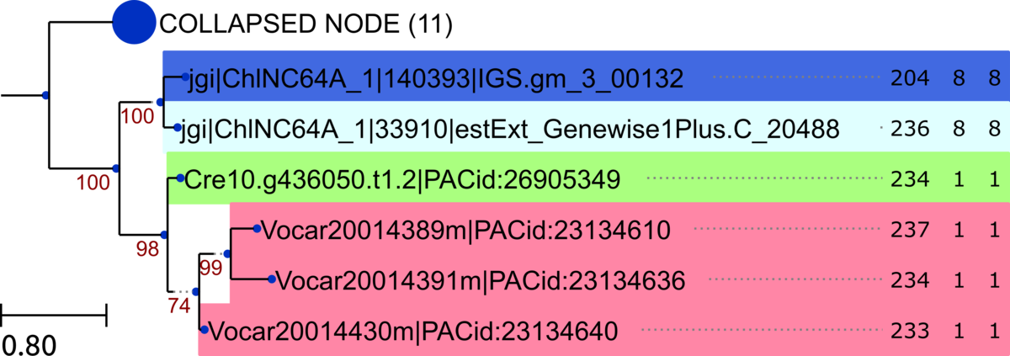

group_74
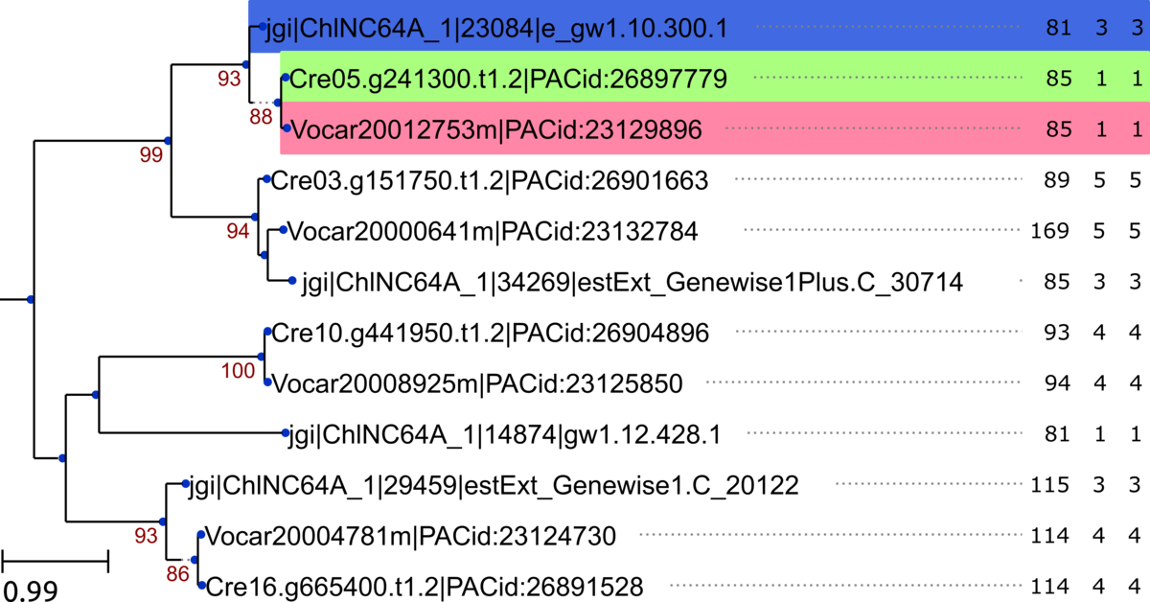
group_77
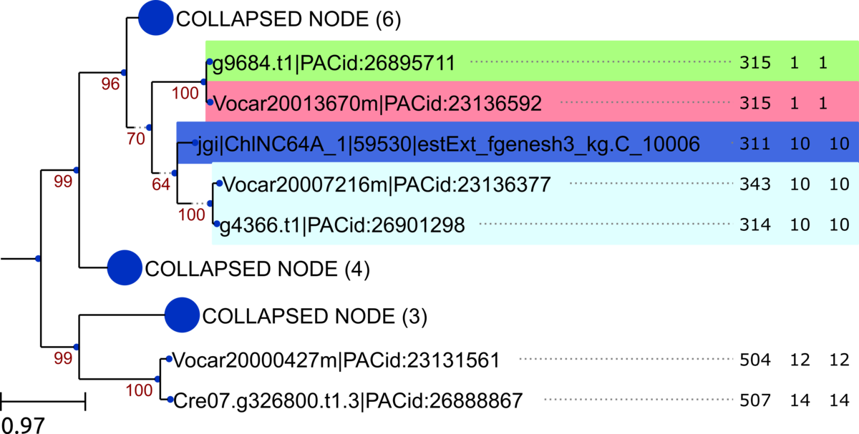

group_78
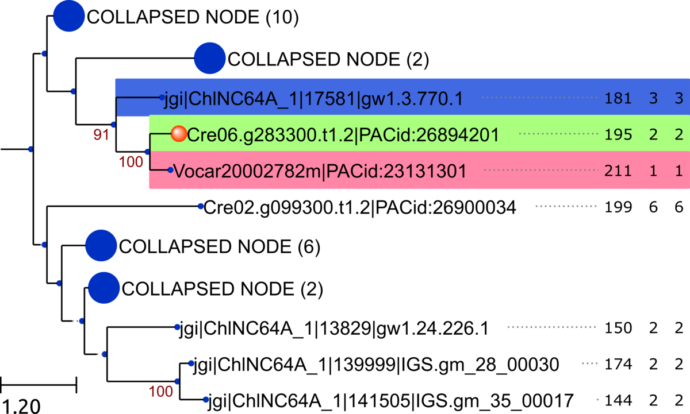

group_79
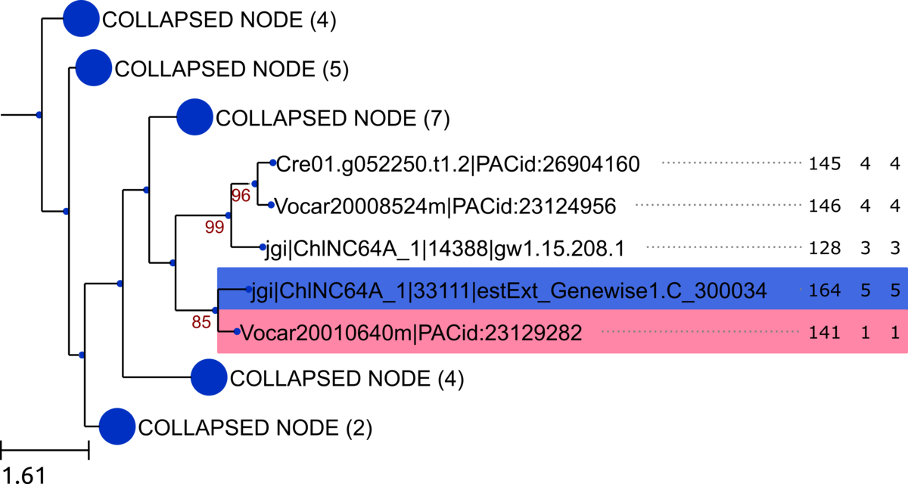
group_80
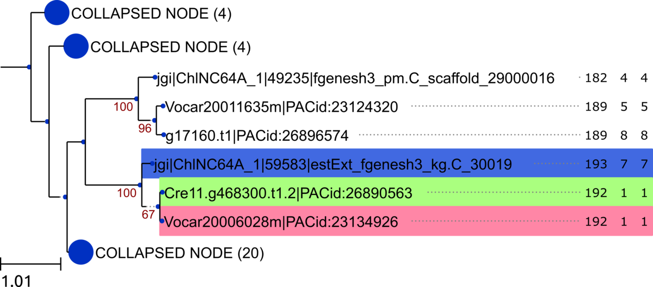

group_81
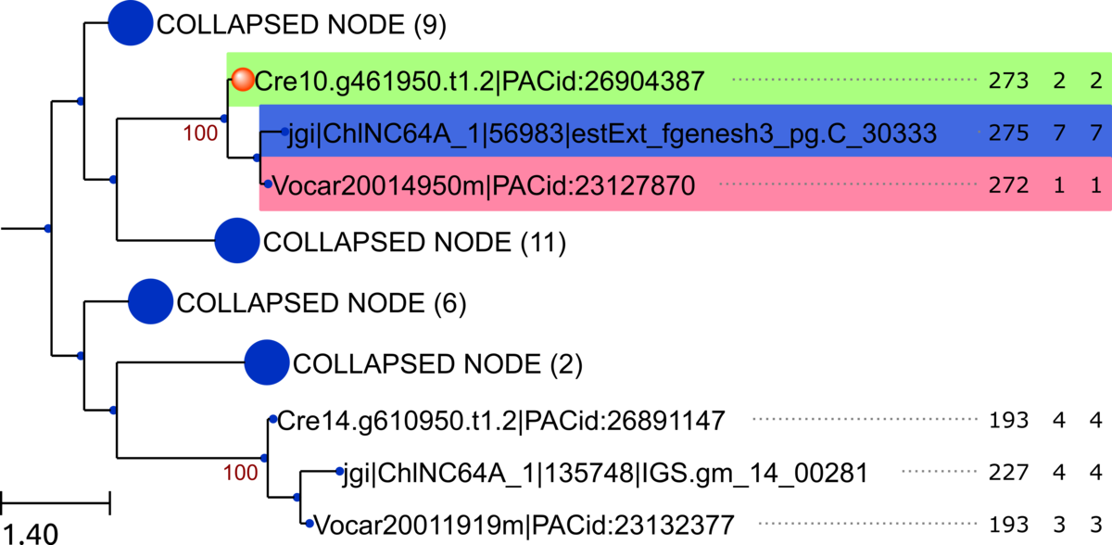

group_82
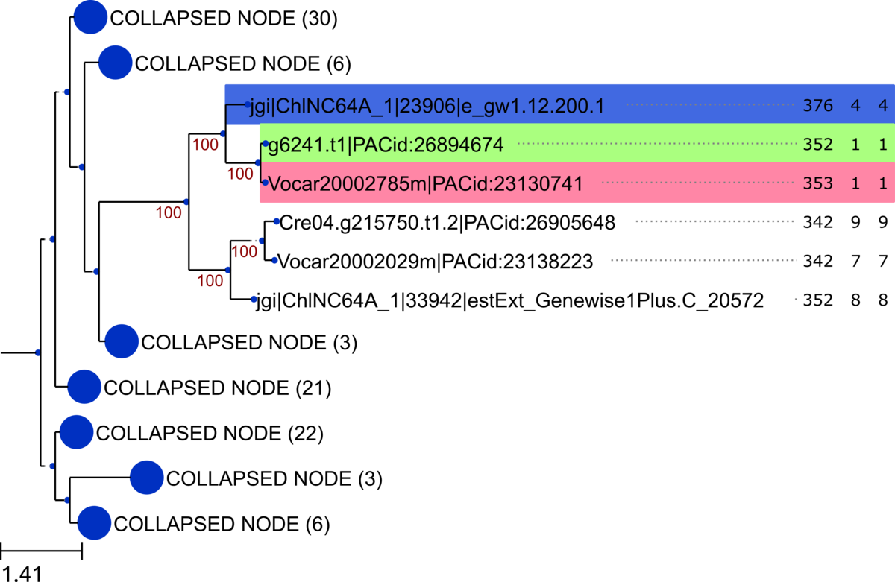
Figure S2. Maximum likelihood trees of the multi-species clusters containing retrogene candidates constructed with InParanoid. Phylogenetic relationships calculated with RAxML, based on alignments of amino acid sequences. Color code: light red – Volvox retrogene candidate, light green – Chlamydomonas retrogene candidate, blue – predicted parental gene. Orange circles indicate retrogene candidates identified manually, e.g. intronized, thus escaping the retrogene-finding strategy. Values in each OTU indicate length of encoded protein, number of exons, and number of coding exons. Support bootstrap values ≥ 50 for the calculated ML tree are shown on branches. The scale bars indicate the average number of amino acid substitutions per site. In case of large InParanoid-based homologous groups, distantly related clades were collapsed. Number of members of each collapsed clade is shown in brackets. All trees rooted with midpoint rooting approach.
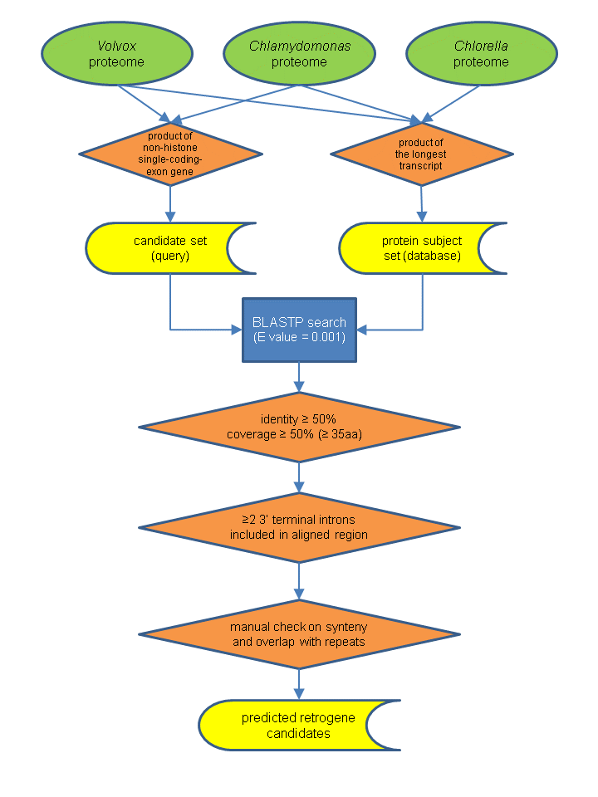
Figure S3. Identification of retrogene candidates in Volvox and Chlamydomonas genomes.
Table S1. Composition of multi-species homologous genes clusters containing the predicted retrogene candidates, constructed using InParanoid.
Group | # of members | Retrogenes | Cre retrogenes | Vca retrogenes
group_1 | 2 | Cre06.g296600 | 1
group_2 | 2 | Vocar20002551m.g |  | 1
group_3 | 2 | Vocar20003468m.g |  | 1
group_4 | 2 | Vocar20004839m.g |  | 1
group_5 | 2 | Vocar20000505m.g |  | 1
group_6 | 2 | Cre12.g545650 | 1
group_7 | 2 | Vocar20007587m.g |  | 1
group_8 | 2 | Vocar20010753m.g |  | 1
group_9 | 2 | Vocar20001040m.g |  | 1
group_10 | 3 | Vocar20012302m.g | 1 | 1
group_11 | 3 | Cre13.g585150, Vocar20009827m.g | 1 | 1
group_12 | 3 | Vocar20011030m.g, Cre08.g382500 | 1 | 1
group_13 | 3 | Cre01.g028150 | 1 | 1
group_14 | 3 | Cre16.g692750 | 1 | 1
group_15 | 3 | Vocar20014754m.g |  | 1
group_16 | 3 | g8321, Vocar20012009m.g | 1 | 1
group_17 | 3 | Vocar20006486m.g |  | 1
group_18 | 3 | Vocar20003066m.g, Cre14.g620350 | 1 | 1
group_19 | 3 | Vocar20011569m.g, g10494 | 1 | 1
group_20 | 3 | g5356, Vocar20004414m.g | 1 | 1
group_21 | 3 | Vocar20009258m.g | 1 | 1
group_22 | 3 | Vocar20011462m.g, Cre17.g712400 | 1 | 1
group_23 | 3 | Vocar20001853m.g | 1 | 1
group_24 | 3 | Cre17.g735950 | 1 | 1
group_25 | 3 | g5492, Vocar20000483m.g | 1 | 1
group_26 | 3 | g15174 | 1
group_27 | 3 | Vocar20002191m.g, g11264 | 1 | 1
group_28 | 3 | Vocar20010236m.g | 1 | 1
group_29 | 3 | Vocar20013082m.g, Cre02.g077300 | 1 | 1
group_30 | 3 | Cre11.g481450 | 1 | 1
group_31 | 3 | g15805.t1|PACid:26892585 | 1
group_32 | 3 | Vocar20009994m.g | 1 | 1
group_33 | 3 | Vocar20003435m.g |  | 1
group_34 | 3 | Vocar20013455m.g | 1 | 1
group_35 | 3 | Vocar20011468m.g |  | 1
group_36 | 3 | Vocar20004273m.g |  | 1
group_37 | 4 | Vocar20008595m.g, Cre01.g029300 | 1 | 1
group_38 | 4 | Vocar20013366m.g, Cre12.g494450 | 1 | 1
group_39 | 4 | Vocar20012865m.g | 1 | 1
group_40 | 4 | Vocar20006141m.g |  | 1
group_41 | 4 | Vocar20004117m.g | 1 | 1
group_42 | 4 | Vocar20007291m.g |  | 1
group_43 | 4 | Cre12.g550700 | 1 | 1
group_44 | 5 | Vocar20003174m.g, Cre08.g360900 | 1 | 1
group_45 | 5 | Vocar20009555m.g | 1 | 1
group_46 | 5 | Vocar20005741m.g, Cre03.g187450 | 1 | 1
group_47 | 5 | Vocar20000021m.g, Cre16.g677500 | 1 | 1
group_48 | 5 | Vocar20011581m.g, Cre10.g428850 | 1 | 1
group_49 | 6 | Vocar20007540m.g |  | 1
group_50 | 6 | Cre01.g034400, Vocar20008547m.g | 1 | 1
group_51 | 4 | Vocar20004722m.g, Vocar20006936m.g, Cre08.g385200 | 1 | 2
group_52 | 2 | Vocar20000705m.g |  | 1
group_53 | 6 | Vocar20012672m.g, g7526 | 1 | 1
group_54 | 7 | Vocar20000562m.g |  | 1
group_55 | 7 | Cre13.g590900, Vocar20012610m.g | 1 | 1
group_56 | 7 | Vocar20002719m.g, Vocar20005935m.g |  | 2
group_57 | 5 | Vocar20001375m.g, Vocar20001326m.g |  | 2
group_58 | 7 | Cre10.g453450, Vocar20013116m.g | 1 | 1
group_59 | 7 | Vocar20011156m.g, Cre12.g538750 | 1 | 1
group_60 | 7 | Cre03.g181150 | 1
group_61 | 7 | Vocar20000800m.g | 1 | 1
group_62 | 8 | Vocar20009597m.g, Cre06.g288500 | 1 | 1
group_63 | 8 | Vocar20007636m.g, g2895 | 1 | 1
group_64 | 9 | Vocar20010643m.g | 1 | 1
group_65 | 9 | Vocar20014284m.g, Cre12.g518650 | 1 | 1
group_66 | 10 | Cre03.g190850 | 1 | 1
group_67 | 11 | Cre01.g032050, Vocar20009929m.g | 1 | 1
group_68 | 11 | Vocar20005266m.g | 1 | 1
group_69 | 16 | Cre05.g247600, Vocar20004480m.g | 1 | 1
group_70 | 2 | Cre06.g306350 | 1
group_71 | 14 | Vocar20002398m.g |  | 1
group_72 | 17 | Vocar20001229m.g, Cre14.g617550 | 1 | 1
group_73 | 17 | Vocar20014430m.g, Vocar20014389m.g, Vocar20014391m.g, Cre10.g436050 | 1 | 3
group_74 | 18 | Vocar20012753m.g, Cre05.g241300 | 1 | 1
group_75 | 3 | Vocar20008048m.g, Cre10.g455300 | 1 | 1
group_76 | 3 | Vocar20002263m.g |  | 1
group_77 | 20 | g9684, Vocar20013670m.g | 1 | 1
group_78 | 27 | Vocar20002782m.g | 1 | 1
group_79 | 27 | Vocar20010640m.g |  | 1
group_80 | 34 | Cre11.g468300, Vocar20006028m.g | 1 | 1
group_81 | 34 | Vocar20014950m.g | 1 | 1
group_82 | 97 | Vocar20002785m.g, g6241 | 1 | 1
TOTAL | 82 | 141 | 60 | 81

Table S2. Identified retrogene candidates and their homologs that are most likely retrogenes that underwent intron gain events.
Predicted retrogene candidate | Exons/CDSs | Parent | Exons/CDSs | Homologous retrogene candidate with intron gain | Exons/CDSs | Comment
Cre12.g550700 | 1/1 | jgi|ChlNC64A_1|132916|IGS.gm_1_00052 | 5/5 | Vocar20006328m.g | 2/2 | Syntenic to its Chlamydomonas homolog
Vocar20000800m.g | 2/1 | jgi|ChlNC64A_1|135001|IGS.gm_12_00387 | 8/8 | Cre12.g506000.t1.2 | 3/2 | Syntenic to its Volvox homolg
Vocar20009555m.g | 1/1 | jgi|ChlNC64A_1|136744|IGS.gm_17_00148 | 4/4 | Cre06.g299000.t1.2 | 2/2 | Syntenic to its Volvox homolg
Vocar20013455m.g | 1/1 | jgi|ChlNC64A_1|17245|gw1.14.448.1 | 4/4 | Cre06.g290000.t1.1 | 2/2 | Syntenic to its Volvox homolg
Vocar20002782m.g | 1/1 | jgi|ChlNC64A_1|17581|gw1.3.770.1 | 3/3 | Cre06.g283300.t1.2 | 2.2 | Syntenic to its Volvox homolg
Vocar20001853m.g | 1/1 | jgi|ChlNC64A_1|19181|e_gw1.2.429.1 | 3/3 | Cre05.g246800.t1.2 | 2/2 | No synteny (possible relocation)
Vocar20005266m.g | 1/1 | jgi|ChlNC64A_1|23497|e_gw1.11.222.1 | 6/6 | Cre06.g257601.t1.2 | 3/3 | No synteny (possible relocation)
Vocar20012865m.g | 1/1 | jgi|ChlNC64A_1|24122|e_gw1.12.252.1 | 5/5 | Cre17.g732850.t1.2 | 3.3 | Syntenic to its Volvox homolg
Vocar20009258m.g | 1/1 | jgi|ChlNC64A_1|32279|estExt_Genewise1.C_180247 | 3/3 | Cre01.g040450.t1.2 | 2/2 | No synteny (possible relocation)
Vocar20009994m.g | 1/1 | jgi|ChlNC64A_1|32442|estExt_Genewise1.C_210068 | 4/4 | Cre06.g288750.t1.2 | 2/2 | Syntenic to its Volvox homolg
Vocar20012302m.g | 1/1 | jgi|ChlNC64A_1|48524|fgenesh3_pm.C_scaffold_3000024 | 6/6 | Cre16.g692050.t1.1 | 2/2 | No synteny (possible relocation)
Vocar20010236m.g | 1/1 | jgi|ChlNC64A_1|49159|fgenesh3_pm.C_scaffold_26000005 | 8/8 | Cre16.g663100.t1.1 | 2/2 | No synteny (possible relocation)
Vocar20004117m.g | 1/1 | jgi|ChlNC64A_1|53692|fgenesh3_pg.C_scaffold_17000025 | 7/7 | Cre02.g099150.t1.2 | 2/2 | No synteny (possible relocation)
Vocar20014950m.g | 1/1 | jgi|ChlNC64A_1|56983|estExt_fgenesh3_pg.C_30333 | 7/7 | Cre10.g461950.t1.2 | 2/2 | Syntenic to its Volvox homolg

