Additional file 4
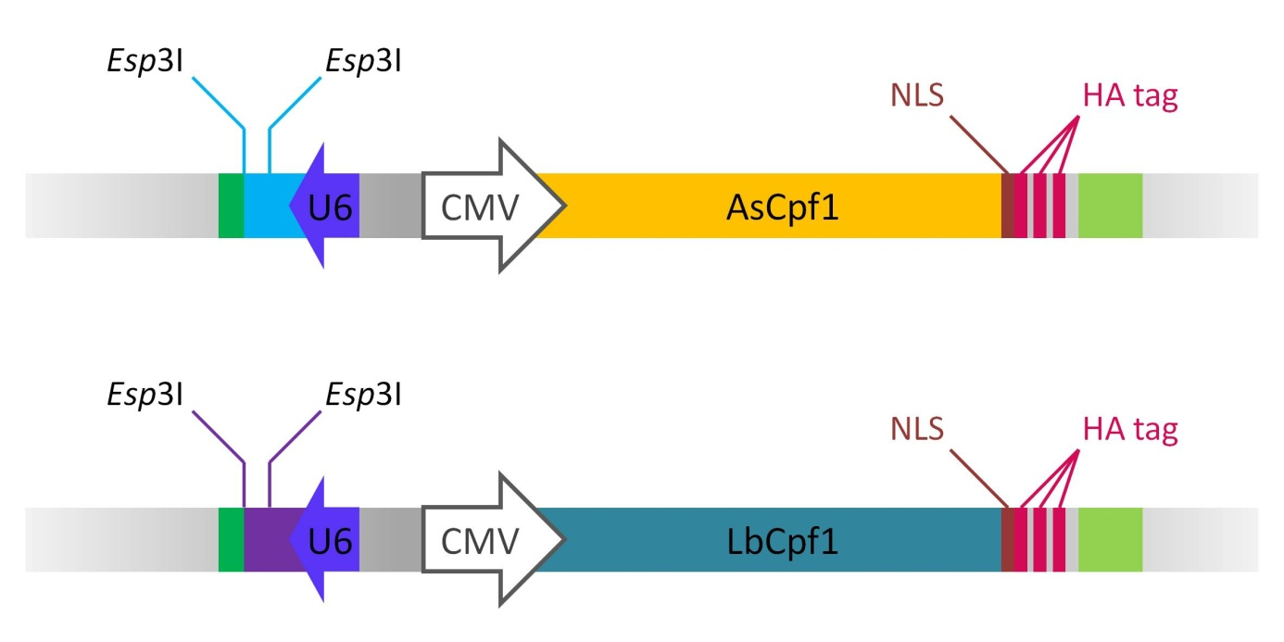
Figure S3. Schematic structure of As- (pTE4396) and LbCpf1 (pTE4398) expression plasmids with crRNA expression cassettes
green: RNA polymerase III terminator, light blue or purple: As- or LbCpf1 crRNAs (spacer can be introduced between Esp3I restriction enzyme sites), blue: human U6 promoter, white: CMV enhancer and promoter, orange or dark blue: As- or LbCpf1, scarlet: nuclear localization signal sequence (NLS), pink: three consecutive HA tags, light green: bGH poly(A) signal

