Supplementary Methods:

Cost on bacterial detox: To investigate the effects of detox cost to individual bacterium, we redefined the survival probability of bacteria as follows:
(2’) P_{B} = (1 - N_{B} /2K_{B}) exp(-S_{B}) exp(- C_{B} y_{B})
where C_{B} is a fixed coefficient providing a scale for the cost of detox secretion. The remaining components of the model were unchanged.

Supplementary Figures:
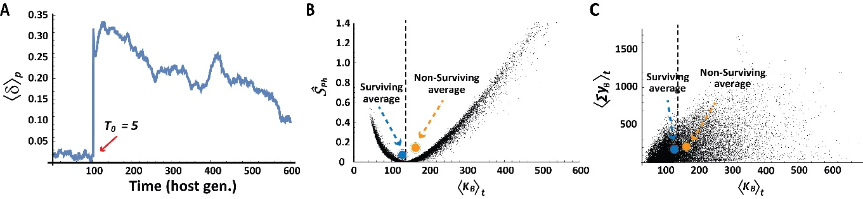
Figure S1: (A) Rapid selection of hosts with large δ under exposure to a pulse of toxin (T₀ =5), applied at the initial time step, t ∈ [0, Δt] (red arrow). (B) Host physiological stress over a host generation, Ŝ _{ph} = ln (<N_{B} > _{t} /K_{B}⁰) + (1 - <N_{B} > _{t} /K_{B}⁰), versus time average of K_{B} (Same as Fig. 1E, except for the exclusion of hosts which lost their bacteria). Blue and orange circles mark population averages for surviving and non-surviving hosts, respectively. Dotted line marks the K_{B} value which minimizes the physiological stress. (C) Same as (B) for the time average of total bacterial detox versus bacterial carrying capacity.

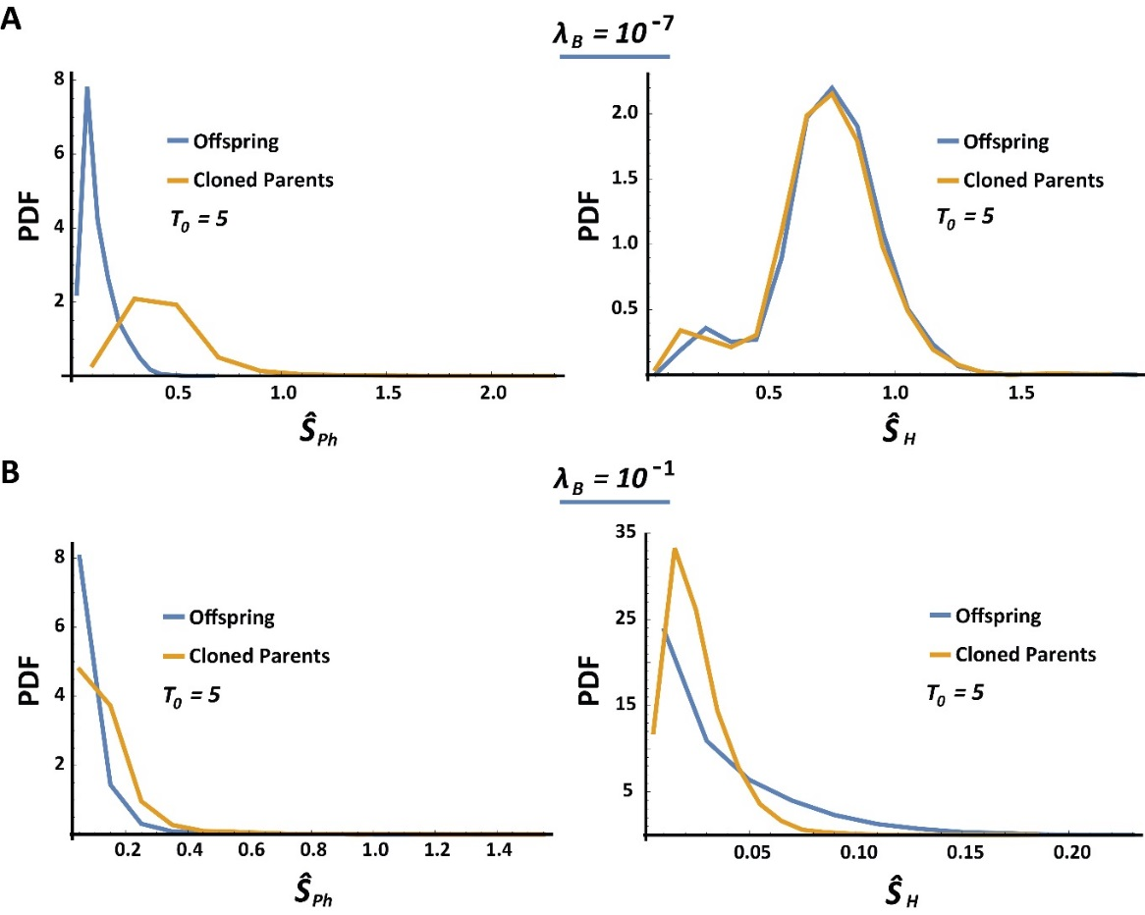
Figure S2: Distributions of physiological (Ŝ _{Ph}) and toxic stress (Ŝ _{H}) experienced by cloned parents and their offspring, following exposure to a toxin pulse (T₀ =5) applied at the initial time step. (A) Case of low detox coefficient, λ_{B} =10⁻⁷. (B) Case of high detox coefficient, λ_{B} =10⁻¹.

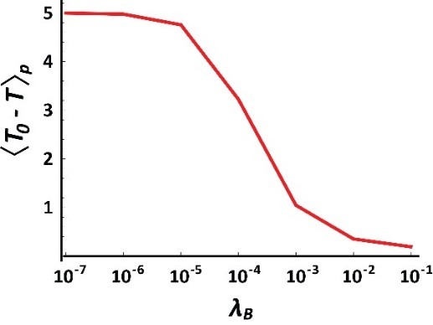
Figure S3: Average level of active toxin at the end of one host generation as a function of bacterial detox coefficient.

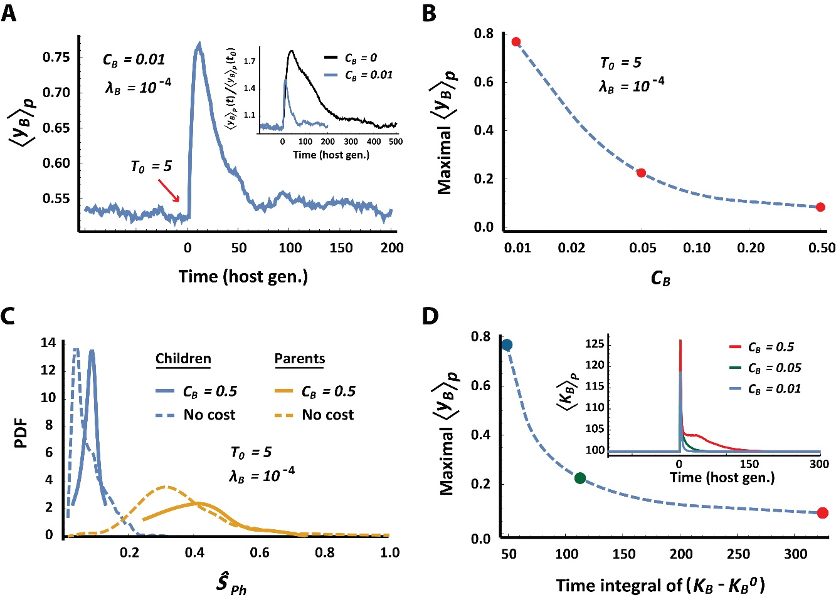
Figure S4: Detox cost weakens the selection of hosts with more detox per bacterium while increasing the selection of hosts that accommodate more bacteria. A population of hosts with vertically-transmitted bacteria was exposed to an influx of toxin, T₀ = 5, at t₀ = 0. (A) Temporal kinetics of the population average of detox secretion per bacterium, with a cost coefficient, C_{B} = 0.01 and detox capacity of λ_{B} =10⁻⁴. Inset displays the effect of detox cost (C_{B} = 0.01 vs. C_{B} = 0) on the change in the average detox relative to the respective levels at t₀ = 0. (B) Maximal level of detox secretion per bacteria that is achieved following selection with different choices of cost coefficients. (C) Distributions of the physiological stress (Ŝ _{Ph}) to host offspring and their cloned parents (blue and yellow, respectively), with and without cost on detox secretion (solid vs. dotted lines). (D) Trade-off between selection of hosts with higher detox per bacterium and selection of hosts which accommodate more bacteria under exposure to toxin. The latter is indicated by integrated increase in K_{B} over time and by monotonic, cost-dependent extension in the duration of selection for higher K_{B} (inset).

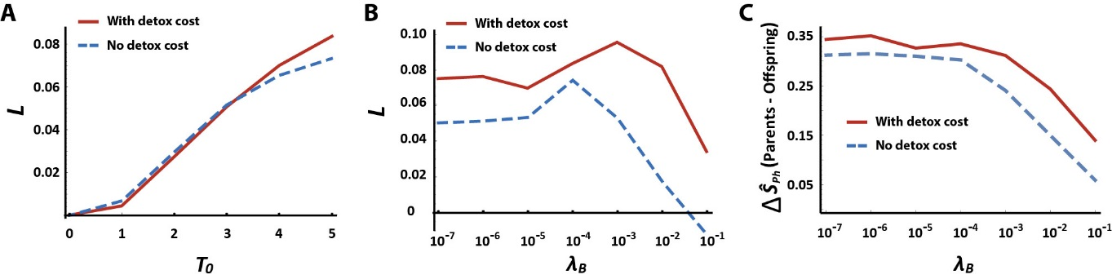
Figure S5: The Lamarckian is not compromised by cost on bacterial detox. (A, B) The Lamarckian as a function of toxin influx, T₀ (A) and detox capacity, λ_{B} (B), with and without detox cost. (C) Effect of detox cost on the difference between cloned parents and their offspring with respect to the physiological stress, Ŝ _{ph}. Shown for different choice of λ_{B}.

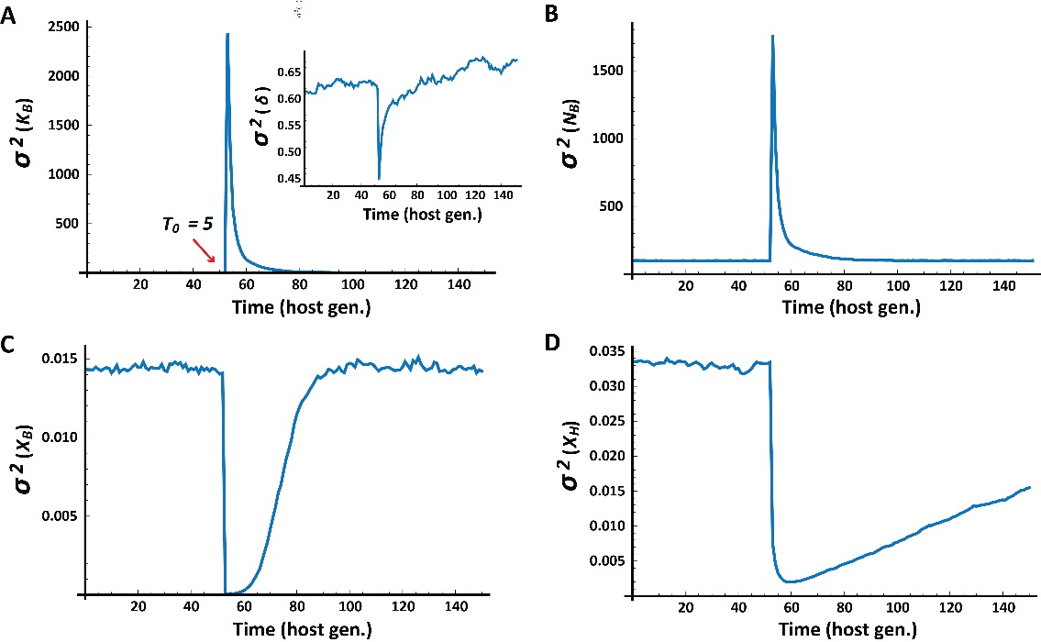
Figure S6: Temporal kinetics of phenotypic variability in response to toxic exposure. The population of host-microbiome systems is exposed to a toxin pulse (T₀ =5) at generation 50 (red arrow in A). Shown are instantaneous variability between hosts with respect to: the bacterial carrying capacity (A), host δ (A, inset), size of the bacterial population (B), average sensitivity of resident bacteria (C) and average host sensitivity (D).

