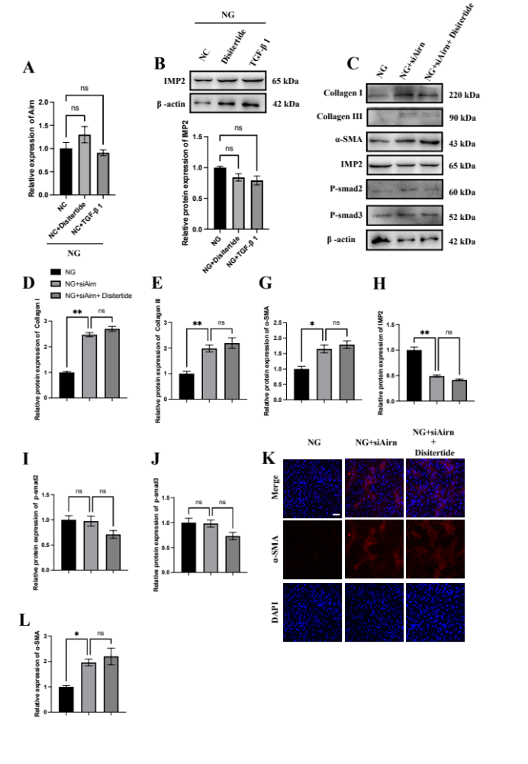
Fig. S3 Airn effected the fibrotic progress independent of TGF-β/smads signaling pathway in HG-treated CFs. (a) qRT-PCR analysis of Airn expression in CFs. (b) Representative blot images and the quantitative analysis of IMP2 in CFs. (c) Representative blot images. (d-j) The quantitative analysis of proteins expression. (k and l) Representative images and the quantitative analysis of immunofluorescence staining for α-SMA (red) and DAPI (blue); Scale bar = 50 μm. Data are presented as means ± SEM. *p < 0.05, **p < 0.01. n=3 wells.

