SUPPLEMENTARY DATA

M2 macrophages-derived exosomes promote angiogenesis and improve cardiac function after myocardial infarction

Table S1. Primer oligonucleotide sequences.
Gene | Primers
Arg1 | F: TGGACAGACTAGGAATTGGCA
 | R: CCAGTCCGTCAACATCAAAACT
CD206 | F: GGGTTGCTATCACTCTCTATGC
 | R: TTTCTTGTCTGTTGCCGTAGTT
IL-10 | F: GACTTTAAGGGTTACCTGGGTTG
 | R: TCACATGCGCCTTGATGTCTG
THBS1  hsa-miR-132-3p  hsa-miR-221-3p  hsa-miR-222-3p  U6  GAPDH | AGACTCCGCATCGCAAAGG  TCACCACGTTGTTGTCAAGGG  F: ACACTCCAGCTGGGTAACAGTCTACAGCCA  R: TGGTGTCGTGGAGTCG  F: ACACTCCAGCTGGGAGCTACATTGTCTGCTG  R: TGGTGTCGTGGAGTCG  F: ACACTCCAGCTGGGAGCTACATCTGGCTA  R: TGGTGTCGTGGAGTCG  F: AAAGCAAATCATCGGACGACC  R: GTACAACACATTGTTTCCTCGGA  F: GGAGCGAGATCCCTCCAAAAT  R: GGCTGTTGTCATACTTCTCATGG

miRNA | p Value | Log (FC)
miR-4539 | 0.000214 | 4.6507
miR-548f | 0.000237 | 5.51911
miR-708-5p | 0.000652 | 6.25732
miR-1911-5p | 0.001523 | 6.70128
miR-135b-3p | 0.003422 | 5.4381
miR-503-5p | 0.007761 | 6.06577
miR-939-3p | 0.00839 | 4.22962
miR-132-3p | 0.022509 | 6.15258
miR-542-5p | 0.022509 | 5.45268
miR-222-3p | 0.027651 | 4.77063
miR-302c-5p | 0.03109 | 3.69201
miR-186-5p | 0.03109 | 3.71041
miR-221-3p | 0.03873 | 6.71738
Table S2. Top 13 upregulated miRNAs in GSE97467

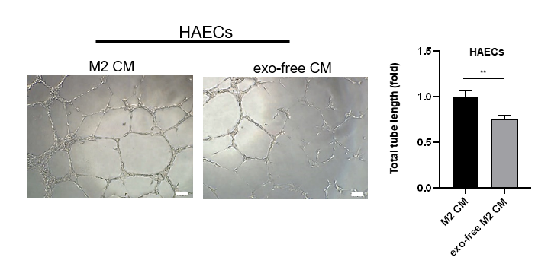
Figure S1. The effect of M2 macrophages on angiogenesis was attenuated in the absence of exosomes, scale bar=100μm, **P<0.01.
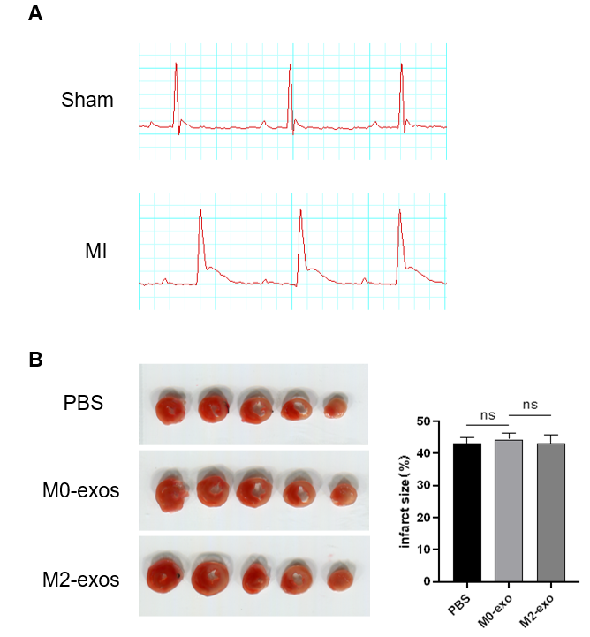
Figure S2. Establishment of MI model. (A) ST-segment elevation in ECG after left anterior descending ligation. (B) Consistency of infarct size among groups.

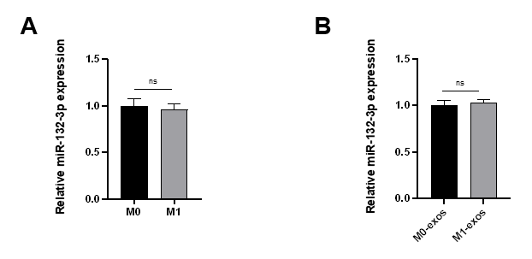
Figure S3. Relative miR-132-3p expression in M1 macrophages (A) and their derived exosomes (B).
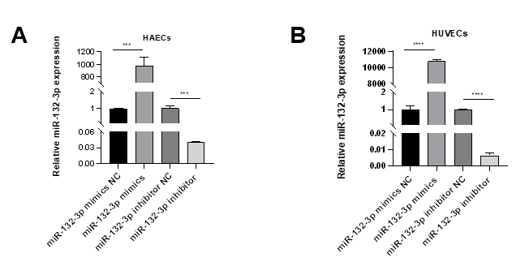
Figure S4. miR-132-3p level was detected in the transfected HAECs (A) and HUVECs (B), ***P<0.001, ****P<0.0001.

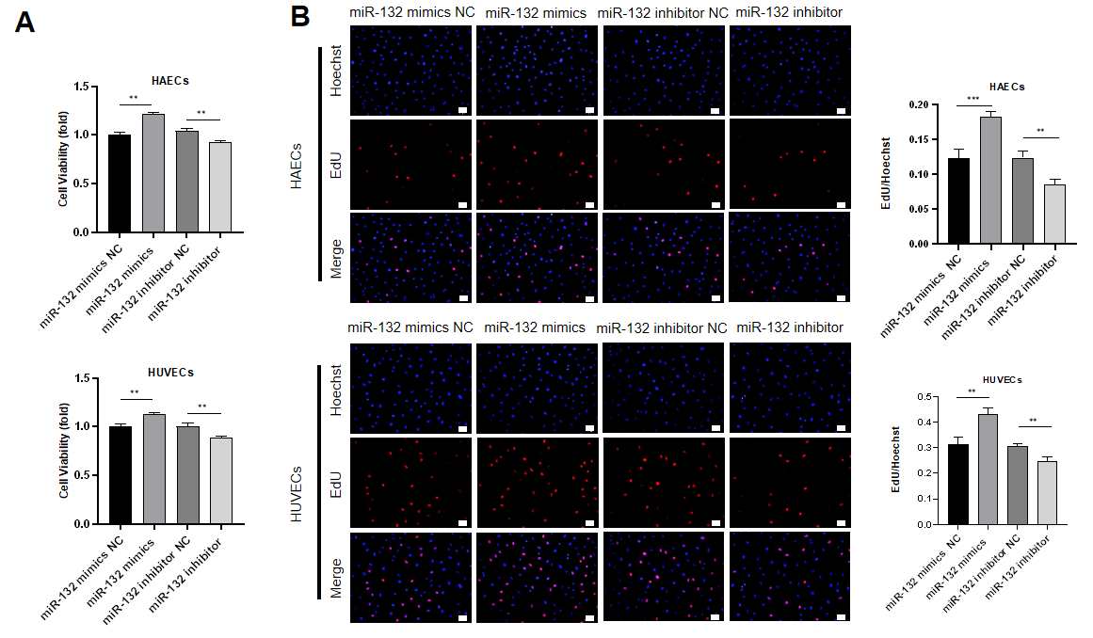
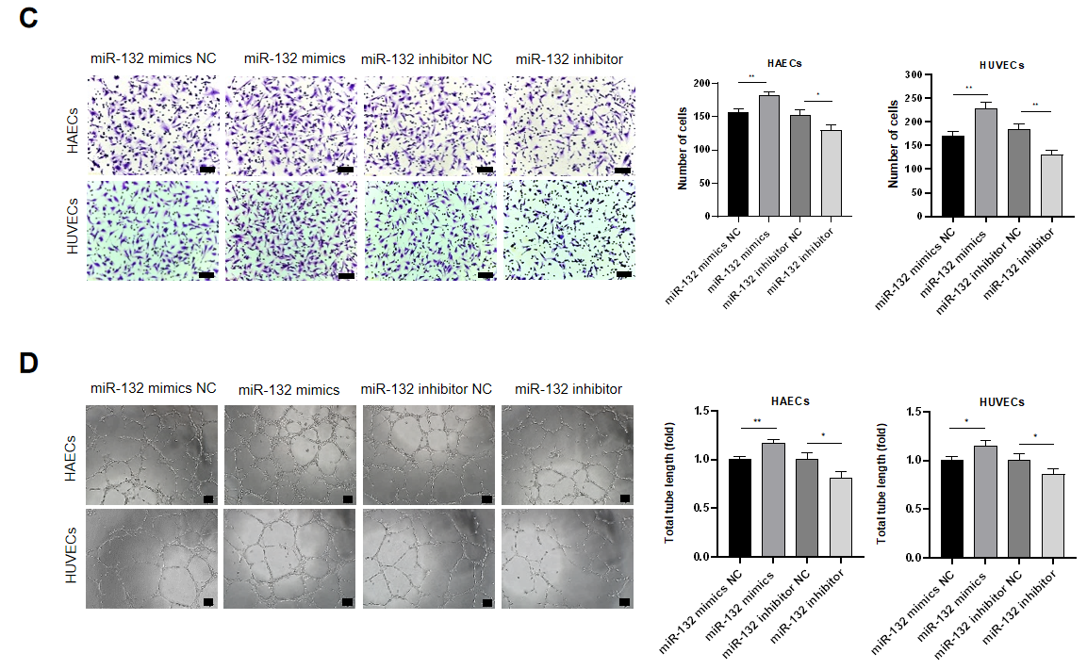
Figure S5. Mir-132-3p promoted the angiogenic ability of ECs. HAECs and HUVECs were transfected with miR-132-3p mimics or inhibitors for 48 h (A) MTS assay was used to evaluate the viability of transfected HAECs and HUVECs. (B) EdU assay was used to measure the proliferation of transfected HAECs and HUVECs, scale bar=50 μm. (C) Transwell assay was used to evaluate the migration of transfected HAECs and HUVECs, scale bar=50 μm. (D) Tube formation assay of transfected HAECs and HUVECs, scale bar=100 μm. (Data are presented as mean±SD; n=3; *P<0.05, **P<0.01, ***P<0.001.
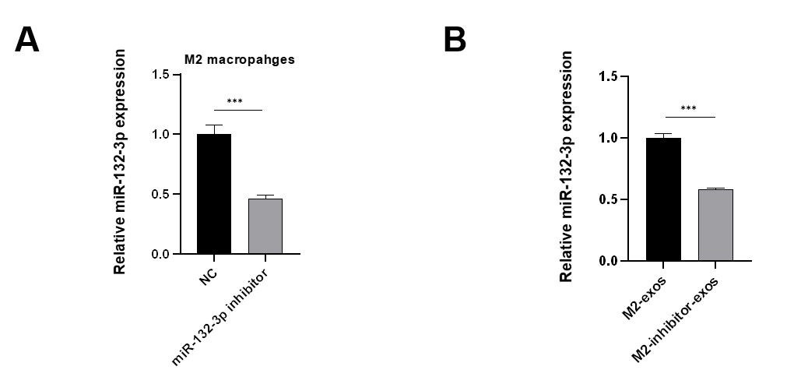
Figure S6. miR-132-3p level was detected in M2 macrophages (A) and their derived exosomes (B) after transfected with miR-132-3p inhibitor, ***P<0.001.

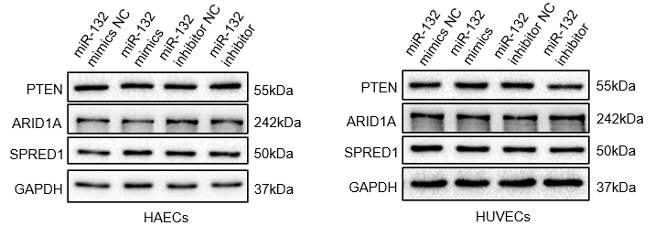
Figure S7. Western blot analysis was used to assess the expression of potential target genes after transfecting ECs with miR-132-3p mimics or inhibitors.

