SUPPLEMENTARY DATA

Supplementary Data Files

Figure 1S. Schematic diagram of CpFTSY gene and position of sgRNA complementary sequences (T1 and T2) in exon 4 and 6, respectively.
Figure 2S. Schematic diagram showing the position of primers (C5_fw; CP_fw; CP_fw2; CP_rv; C3_rv; C3_rv2) on CpFTSY gene coding sequence, used for PCR amplification of target sequences.
Figure 3S. PCR amplification of CpFTSY gene and CAO genes from CW15 wild-type strain and transformants obtained from +/- P transformation.
Figure 4S. Sequencing data output collected for CpFTSY modification in T1 and T2 locus.
Figure 5S. Growth curves of C. r. CW15 in either TAP or TA (medium devoid of phosphate).
Figure 6S. Sequencing data output collected for CpFTSY modification in T1 and T2 locus from transformation under P starvation.
Figure 7S. Schematic diagram showing the position of primers (PS_T1_fw; PS_T1_rv; PS_T2_fw; PS_T2_rv) on PSR1 gene coding sequence, used for PCR amplification of target sequences.
Figure 8S. Schematic diagram of PSR1 gene and position of sgRNA complementary sequences (T1 and T2) in exon 1 and 3, respectively.
Figure 9S. PCR amplification of CpFTSY, psr1 and cao genes from CW15 wild-type strain and transformants obtained from co-targeting transformation.
Figure 10S. Sequencing data output collected for PSR1 modification in T1 and T2 locus and relative cpftsy knock-out confirmation.

Table 1S. Sequences of oligonucleotides used for sgRNA production (5‘ -> 3‘).
Table 2S: Sequences of oligonucleotides used for PCR gene-amplification (5‘ -> 3‘).
Table 3S. Raw data collected upon 6 individual transformations (R1-R6), and selection under phosphate supplementation (+P) or starvation (-P).
Table 4S. Raw data collected upon 6 individual transformations (R1-R6) for co-targeting CpFTSY and PSR1.

Figure 1S. Schematic diagram of CpFTSY gene and position of sgRNA complementary sequences (T1 and T2) in exon 4 and 6, respectively. T1 sequence: CGCACTGCTCTGAAGATCG + (PAM sequence) TGG (in Exon 4); T2 sequence: ATCGCGTACAAGTACGGCA + (PAM sequence) AGG (in Exon 6).

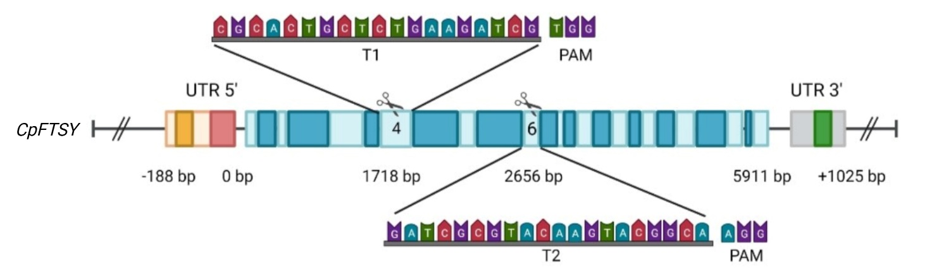

Figure 2S. Schematic diagram showing the position of primers (C5_fw; CP_fw; CP_fw2; CP_rv; C3_rv; C3_rv2) on CpFTSY gene coding sequence, used for PCR amplification of target sequences. Sequences of the oligonucleotides used are shown in Table 1S.

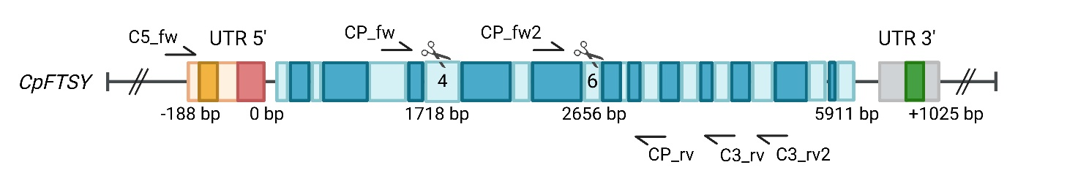

Figure 3S. PCR amplification of CpFTSY gene and CAO genes from CW15 wild-type strain and transformants obtained from +/- P transformation. PCR analysis was carried out by amplifying CpFTSY and CAO targets, from CW15 wild-type strain and transformants from different transformation approaches (1, 15, 21, 23, 61, 103, 108, 111, 4E, 5B and 5C). Amplifications were performed for locus CpFTSY with (A) CP_fw2 and CP_rv primers, and (B) C5_fw and C3_rv2 primers. (C) PCR analysis for locus CAO was performed with Cao_fw and Cao_rv primers. In each panel, the expected band size is reported. Sequences of the oligonucleotides used are shown in Table 2S.

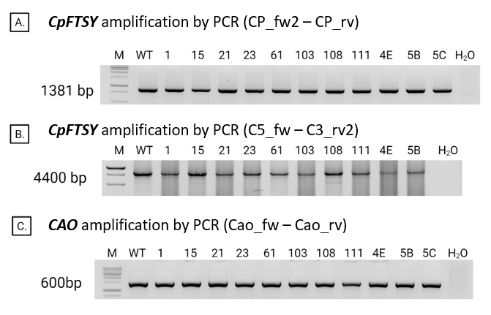

Figure 4S. Sequencing data output collected for CpFTSY modification in T1 and T2 locus. Genomic sequence of CpFTSY target regions T1 and T2, from WT (CW15) and 17 pale-green lines, obtained upon transformation under optimal P supply. T1 and T2 native sequences (5’-3’) amplified from CW15 are highlighted in blue, Cas9 specific PAM motif in yellow, and nucleotide substitution in green. Missing nucleotides are indicated as “-”.

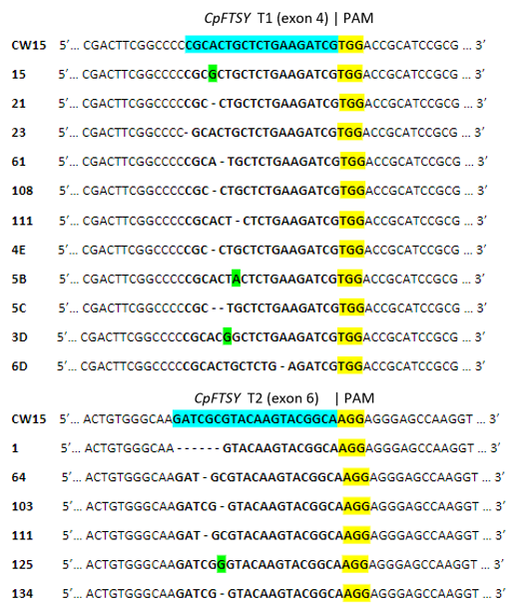

Figure 5S. Growth curves of C. r. CW15 in either TAP or TA (medium devoid of phosphate). The number of cells grown under continuous light (100 μmol photons m⁻² s⁻¹) for 4 days (78h) was determined using a cell counter (Countess II FL cell counter, Life Technologies). Data are expressed as mean ± SD, n=3. The initial inoculum was ~5 · 10⁵ cells/ml. Lower part: pictures of the flasks, showing growth stage on TAP (right side) or TP (left side) at t₀ and after one and four days from initial inoculum.

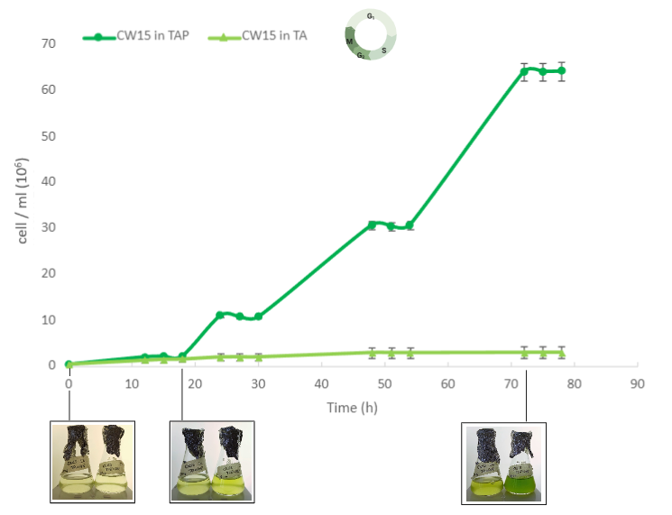

Figure 6S. Sequencing data output collected for CpFTSY modification in T1 and T2 locus from transformation under P starvation. Genomic sequence of CpFTSY target regions T1 and T2, from WT (CW15) and 22 pale-green lines, obtained upon transformation under P starvation. T1 and T2 native sequences (5’-3’) amplified from CW15 are highlighted in blue, Cas9 specific PAM motif in yellow, and nucleotide substitution in green. Missing nucleotides are indicated as “-”.
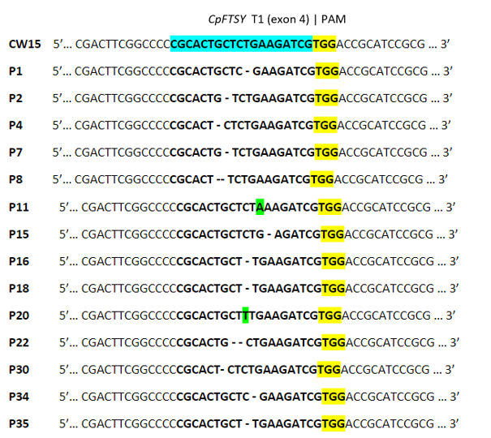
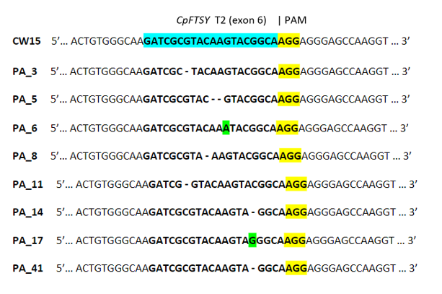

Figure 7S. Schematic diagram showing the position of primers (PS_T1_fw; PS_T1_rv; PS_T2_fw; PS_T2_rv) on PSR1 gene coding sequence, used for PCR amplification of target sequences. Sequences of the oligonucleotides used are shown in Table 1S.
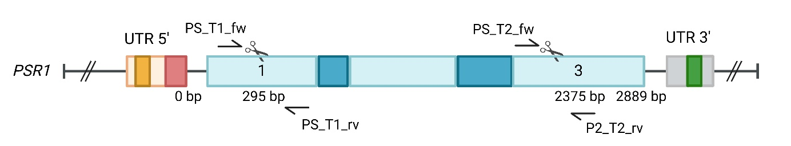

Figure 8S. Schematic diagram of PSR1 gene and position of sgRNA complementary sequences (T1 and T2) in exon 1 and 3, respectively. T1 sequence: CCCAGCGCGCCTCCACCGA + (PAM sequence) CGG (in Exon 1); T2 sequence: GGCCGGCGGGGCGGCGCACT + (PAM sequence) TGG (in Exon 3).

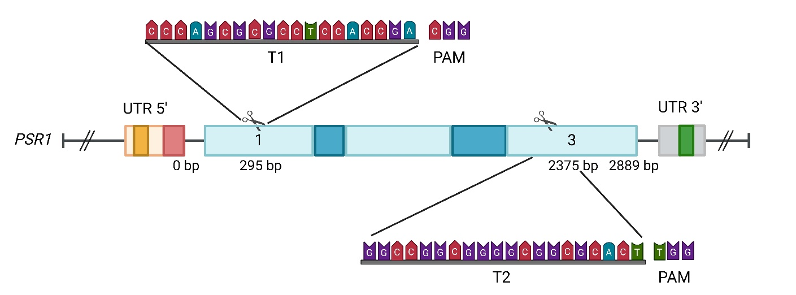

Figure 9S. PCR amplification of CpFTSY, psr1 and cao genes from CW15 wild-type strain and transformants obtained from co-targeting transformation. PCR analysis was conducted by amplifying CpFTSY, PSR1 and CAO targets, from CW15 wild type strain and transformants from different transformation approaches (A1, A2, A3, A4, A4 and A6). Amplifications were performed for locus CpFTSY with (A) CP_fw2 and CP_rv primers, for locus PSR1 with (B) PS_T1_fw and PS_T2_rv primers, and for locus CAO with (C) with Cao_fw and Cao_rv primers. In each panel, the expected band size is reported. Sequences of the oligonucleotides used are shown in Table 2S.

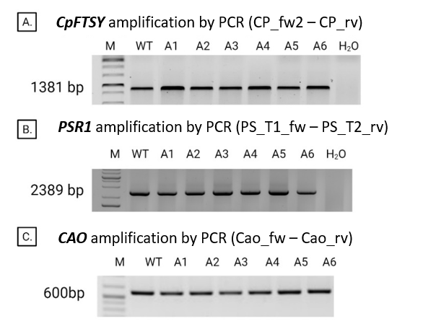

Figure 10S. Sequencing data output collected for PSR1 modification in T1 and T2 locus and relative cpftsy knock-out confirmation. Genomic sequence of PSR1 target regions T1 and T2, and CpFTSY target region T1 from WT (CW15) and two pale-green lines (A1 and A6). T1 and T2 native sequences (5’-3’) amplified from CW15 are highlighted in blue, Cas9 specific PAM motif in yellow, and nucleotide substitution in green. Missing nucleotides are indicated as “-”.

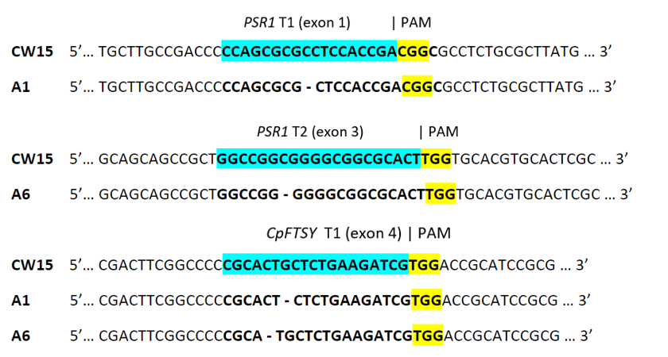

Table 1S. Sequences of oligonucleotides used for sgRNA production (5‘ -> 3‘).
Name | Oligo sequence
sg_CP_fw1 | CGATCTTCAGAGCAGTGCGGGTTTTAGAGCTAGAAATAGCAAG
T7_CP_fw1 | TAATACGACTCACTATAGCGATCTTCAGAGCAGTGCG
sg_CP_fw2 | GATCGCGTACAAGTACGGCAGTTTTAGAGCTAGAAATAGCAAG
T7_CP_fw2 | TAATACGACTCACTATAGGATCGCGTACAAGTACGGCA
Cas9_rv | AAAAAAAGCACCGACTCGGTGCCAC
sg_Psr1_fw1 | CCCAGCGCGCCTCCACCGACGTTTTAGAGCTAGAAATAGCA
T7_Psr1_fw1 | TAATACGACTCACTATAGGGCCCAGCGCGCCTCCACCGAC
sg_Psr1_fw2 | GGCCGGCGGGGCGGCGCACTGTTTTAGAGCTAGAAATAGCA
T7_Psr1_fw2 | TAATACGACTCACTATAGGGGGCCGGCGGGGCGGCGCACT

Table 2S. Sequences of oligonucleotides used for PCR gene-amplification (5‘ -> 3‘)
Name | Oligo sequence | Name | Oligo sequence
CP_fw | GTCACCTCGAATCACACAC | 3F_fw | TATAGCTAGCACCGCATCCGCGAGGG
CP_fw2 | GAAGGAGTGAGATGACTTGGAC | 3F_rv | CGTCTAGAGTGGTAGTTGGTGTACG
CP_rv | CTCCTCCACCTCTTCTGCTC | Cao_fw | TGTTACCGCATAGAGCAGCC
C5_fw | TGGAGATCCAGGTCGGTTGC | Cao_rv | CGCTACTCACCGCTGAGAAC
C5_fw2 | TTGTAAAGTGAGGTCCAGAGGAGC | PS_T1_fw | GGGTGGATATGGTCTCACGCAGC
C3_rv | CCAGGTTCTGTTGGTTGGC | PS_T1_rv | CGTAGATGATCGTGGCTCGCAAC
C3_rv2 | TGCCGTGTCTACCAGAATGAGGTC | PS_T2_fw | AGCATGCAGCAGCTTCAGGC
5F_fw | GCGAATTCCGCTTGAGGAACACATAC | PS_T2_rv | CAGTGTAAGCGTGGACGAGGGTC
5F_rv | GCTCTAGATTAGCCGAAGTCGGCGGACTG

Table 3S. Raw data collected upon 6 individual transformations (R1-R6), and selection under phosphate supplementation (+P) or starvation (-P). The data collected has been summarized as follows: (1st column) the growth conditions, either under optimal phosphate supplementation (+P) or phosphate starvation (-P) and the list of experimental units (R1-R6); (2nd column) the transformation target to knock-out (CpFTSY); (3rd, 4th and 5th column) the number of CFU (N _{CFU}), of viable cells (N _{viable cells}), of pale-green colonies (N _{pale-green colonies}); (6th column) the GE frequency (%F _{GE}), namely N _{pale-green colonies} over N _{CFU}; (7th column) the N of pale-green colonies normalized to D; (8th column) the genome editing efficiency (Y _{GE}) calculated by the total number of edited colonies (7th column) and considering the whole cell population which underwent electroporation (10⁶ cells); (9th column) the enhancement in GE efficiency with respect to that reported in [13] with antibiotic selection. For each column, mean ± SD are reported. Each experiment was performed with 6 biological replicates (n=6, R1-R6), 10 plates were used in each replicate. Statistical analysis (Student’s t test) was carried out by comparing data from transformation under optimal phosphate supplementation (+P) vs. phosphate starvation (–P) (p*) or transformation through DNA insertion and antibiotic selection (p**) [13].

Table 4S. Raw data collected upon 6 individual transformations (R1-R6) for co-targeting CpFTSY and PSR1. The data collected has been summarized as follows: (1st column) the list of experimental units (R1-R6); (2nd column) the transformation targets to knock-out (CpFTSY and PSR1); (3rd and 4th column) the number of CFU (N _{CFU}) and of viable cells (N _{viable} _{cells}); (5th and 6th columns) the number of pale-green/CpFTSY edited colonies (N _{pale-green colonies}) and the number of PSR1 (N _{PSR1 edited colonies}) edited colonies; (7th and 8th columns) the GE frequency (%F _{GE}) of CpFTSY or PSR1 loci, namely N _{edited colonies} over N _{CFU} ; (9th and 10th columns) the number of pale-green colonies or co-edited colonies, normalized to D; (11th and 12th columns) the genome editing efficiency (Y _{GE}) calculated by the total number of edited colonies (9th and 10th columns) and considering the whole cell population which underwent electroporation (10⁶ cells). For each column, values of mean ± SD are reported. Each experiment was performed with 6 biological replicates (n=6, R1-R6), 10 plates were used in each replicate. Statistical analysis (Student’s t test) was carried out by comparing data from transformation under optimal phosphate supplementation (+P) vs. phosphate starvation (–P) transformations (p*) or transformation through DNA insertion and antibiotic selection (p**) [13].

