Additional file legends
- Supplementary Tables S1-S9
Table S1. CRC TMB-related genes.
Table S2. Intersection of CRC TMB-related genes with large gene panels of MSK-IMPACT and F1CDx.
Table S3. Dataset information for the five independent study cohorts in use.
Table S4. Characteristics of the patients in the data sets included in this study.
Table S5. Genes and corresponding parameters or importance used in the eight TMB estimation models constructed using the 20 genes.
Table S6. Evaluation metrics for TMB estimation models with different algorithms
Table S7. The proportion of patients with high-TMB and low-TMB in different datasets.
Table S8. Correlating clinicopathological characteristics of patients with CRC with high-TMB and low-TMB groups.
Table S9. Correlation of clinicopathological characteristics in patients with TMB^{high} DNAH5^{wild} and TMB^{high} DNAH5^{mut}.
Table S10. Results of a GSEA enrichment analysis in patients with a high TMB.
Table S11. Results of GSEA enrichment analysis of patients with high TMB and co-existing DNAH5 mutations.
- Supplementary Figures S1-S5
Supplementary Fig. S1. Flowchart of the algorithm for patient selection.
Supplementary Fig. S2. Evaluating the performance of eight TMB estimating models at different gene numbers.
Supplementary Fig. S3. Testing and comparing the diagnostic performance of 20-gene TMB.
Supplementary Fig. S4. 20 genes mutated in patients with high TMB.
Supplementary Fig. S5. Comparison of the expression of immune checkpoint genes in the TMB^{low}, TMB^{high} DNAH5^{wild}, and TMB^{high} DNAH5^{mut} groups.

- Supplementary Tables
Table S1. Colorectal cancer TMB-related genes.
A2M | ASTN2 | CNTNAP4 | DOCK3 | GLI3 | LRP1B | NEXMIF | PKHD1L1 | SCN9A | TNS1
A2ML1 | ATM | CNTNAP5 | DOCK5 | GPR158 | LRP2 | NFASC | PLCE1 | SDK1 | TNXB
ABCA1 | ATP10A | COL11A1 | DOCK8 | GPR179 | LRRC7 | NIPBL | PLCG2 | SDK2 | TPO
ABCA12 | ATP8A2 | COL12A1 | DSCAM | GREB1 | LRRIQ1 | NLRP7 | PLEC | SETX | TRHDE
ABCA13 | ATRX | COL14A1 | DSCAML1 | GRIA1 | LRRK1 | NOS1 | PLXNA1 | SFMBT2 | TRIO
ABCA2 | BCL9 | COL1A2 | DSEL | GRIA2 | LRRK2 | NOTCH3 | PLXNA4 | SHANK1 | TRIOBP
ABCA4 | BIRC6 | COL22A1 | DSP | GRIK2 | LYST | NPAP1 | PLXND1 | SIPA1L1 | TRPC4
ABCC1 | BMPR2 | COL27A1 | DST | GRIK3 | MACF1 | NRXN1 | POLE | SLIT1 | TRPM3
ACACA | BNC2 | COL4A5 | DYNC1H1 | GRIN2A | MAGEC1 | NRXN2 | POLQ | SLIT2 | TRPM6
ACACB | BRAF | COL5A1 | DYNC2H1 | GRM5 | MAP1A | NSD1 | PPFIA2 | SLITRK1 | TRPS1
ACAN | BRCA2 | COL5A2 | DYSF | GRM7 | MAP1B | NUP205 | PRDM9 | SLITRK5 | TRRAP
ADAMTS12 | BRINP3 | COL6A3 | EP400 | HDAC9 | MAP2 | NYAP2 | PREX2 | SOGA3 | TSHZ3
ADAMTS16 | BRWD3 | COL6A6 | EPG5 | HECTD4 | MAP3K4 | OBSCN | PRKDC | SORCS1 | TTN
ADAMTS18 | BSN | COL7A1 | EPHA3 | HECW1 | MDN1 | OTOGL | PRUNE2 | SPAG17 | TULP4
ADAMTS2 | CACNA1A | CREBBP | EPHA5 | HELZ2 | MED12 | PAPPA | PTPN13 | SPEF2 | UBR4
ADAMTS20 | CACNA1B | CSMD1 | EPHB1 | HERC1 | MED12L | PAPPA2 | PTPN14 | SPEG | UGGT2
ADAMTS9 | CACNA1C | CSMD2 | ERBB4 | HERC2 | MEGF8 | PCDH10 | PTPRC | SPHKAP | UNC13C
ADAMTSL1 | CACNA1E | CSMD3 | ERICH3 | HMCN1 | MGAM | PCDH11X | PTPRK | SPTA1 | UNC79
ADAMTSL3 | CACNA1F | CTNNA2 | EVC2 | HRNR | MKI67 | PCDH15 | PTPRM | SPTB | USH2A
ADCY2 | CACNA1G | CTNNB1 | F8 | HSPG2 | MPDZ | PCDH17 | PTPRS | SPTBN1 | USP34
ADCY8 | CACNA1H | CUBN | FAM135B | HUWE1 | MTOR | PCDH18 | PTPRT | SPTBN2 | USP9X
ADGRB1 | CACNA1S | CUL9 | FAM47C | HYDIN | MTUS2 | PCDH19 | PTPRZ1 | SRCAP | UTRN
ADGRB3 | CADPS | CUX2 | FASN | IGF2R | MUC16 | PCDH9 | PXDN | SRRM2 | VCAN
ADGRG4 | CARD11 | DAAM2 | FAT1 | IGSF10 | MUC17 | PCDHA11 | PXDNL | STAB1 | VPS13A
ADGRL2 | CASZ1 | DCAF4L2 | FAT2 | IGSF9B | MUC5B | PCDHA12 | RELN | STAB2 | VPS13B
ADGRL3 | CDH10 | DCC | FAT3 | ITPR1 | MXRA5 | PCDHA13 | RIF1 | SVEP1 | VPS13C
ADGRV1 | CDH12 | DCHS1 | FAT4 | ITPR2 | MYCBP2 | PCDHA2 | RIMBP2 | SYNE1 | VPS13D
AFF2 | CDH18 | DCLK1 | FBN1 | ITPR3 | MYH11 | PCDHA3 | RIMS1 | SYNE2 | VWF
AHNAK | CDH2 | DIDO1 | FBN2 | KALRN | MYH13 | PCDHA4 | RIMS2 | TAF1L | WDFY3
AHNAK2 | CDH23 | DISP3 | FBN3 | KCNB2 | MYH14 | PCDHA5 | RNF213 | TCHH | WNK3
AKAP12 | CDH8 | DLC1 | FBXW7 | KCNH7 | MYH2 | PCDHA6 | ROBO1 | TECTA | WWC3
AKAP13 | CDH9 | DLG2 | FCGBP | KCNQ5 | MYH6 | PCDHA8 | ROBO2 | TENM1 | XIRP2
AKAP6 | CELSR1 | DLGAP2 | FILIP1 | KDR | MYH7 | PCDHA9 | ROS1 | TENM2 | ZAN
AKAP9 | CELSR2 | DMD | FLG | KIAA1109 | MYH8 | PCDHB2 | RP1 | TENM3 | ZC3H13
ALK | CENPF | DMXL1 | FLNA | KIF26B | MYH9 | PCDHB7 | RP1L1 | TENM4 | ZDBF2
ALMS1 | CEP170 | DMXL2 | FLNC | KMT2A | MYO15A | PCDHB8 | RYR1 | TET1 | ZEB2
AMER1 | CHD4 | DNAH1 | FLRT2 | KMT2B | MYO16 | PCDHGA2 | RYR2 | TEX15 | ZFHX3
ANK1 | CHD5 | DNAH10 | FMN2 | KMT2C | MYO18B | PCDHGB3 | RYR3 | TG | ZFHX4
ANK2 | CHD6 | DNAH11 | FN1 | KMT2D | MYO3A | PCLO | SACS | THBS2 | ZNF292
ANK3 | CHD7 | DNAH17 | FNDC1 | LAMA1 | MYO5A | PCNT | SALL1 | THSD7A | ZNF423
ANKRD11 | CHD8 | DNAH2 | FRAS1 | LAMA2 | NALCN | PDZD2 | SCN11A | THSD7B | ZNF521
APOB | CHL1 | DNAH3 | FREM2 | LAMA3 | NAV2 | PEG3 | SCN1A | TIAM1 | ZNF536
ARAP2 | CMYA5 | DNAH5 | FRMPD1 | LAMA4 | NAV3 | PIK3CA | SCN2A | TMEM132D | ZNF804A
ARHGAP21 | CNOT1 | DNAH7 | FRY | LAMA5 | NBEA | PKD1 | SCN3A | TNC | ZNF804B
ASH1L | CNTN5 | DNAH8 | FRYL | LIFR | NBEAL2 | PKD1L1 | SCN4A | TNN | ZNF831
ASPM | CNTN6 | DNAH9 | GABRA5 | LPA | NCKAP5 | PKDREJ | SCN5A | TNR
ASTN1 | CNTNAP2 | DOCK2 | GALNT17 | LRP1 | NEB | PKHD1 | SCN7A | TNRC6B

Table S2. Intersection of colorectal cancer TMB-related genes with large gene panels of MSK-IMPACT and F1CDx.
AMER1 | ATM | ATRX | BRAF | BRCA2 | CARD11 | CREBBP | CTNNB1 | EPHA3 | EPHB1
ERBB4 | FBXW7 | KDR | MED12 | MTOR | NOTCH3 | PIK3CA | POLE | ROS1

Table S3. Dataset information for the five independent study cohorts in use.
Cohorts | Patients (No.) | WES (No.) | RNA (No.) | Clinical (No.) | OS&PFS (No.) | HLA info (No.)
TCGA cohort | 586 | 586 | 521 | 510 | 510 | 471
ICGC cohort | 322 | 322 |  | 321 | 279
Jessica cohort | 281 | 281 |  | 281 | 281
DFCI cohort | 619 | 619 |  | 563
FAHNU cohort | 148 | 148 | 148 | 148 |  | 148
ALL | 1956 | 1956 | 669 | 1823 | 1070
Clinical, Patients with only partial clinical information available.
OS&PFS, Patients for whom complete overall survival and progression-free survival data are available.

Table S4. Characteristics of the patients in the data sets included in this study.
Variable | TCGA | ICGC | Jessica | DFCI | FAHNU | All
Age (No.)
＜ 65 years | 219 (43%) | 201 (63%) | 89 (32%) | 123 (22%) | 74 (50%) | 706 (39%)
≥ 65 years | 291 (57%) | 120 (37%) | 192 (68%) | 440 (78%) | 74 (50%) | 1117 (61%)
Sex (No.)
Male | 269 (53%) | 192 (60%) | 147 (52%) | 193 (34%) | 95 (64%) | 896 (49%)
Female | 241 (47%) | 129 (40%) | 134 (48%) | 370 (66%) | 53 (36%) | 927 (51%)
Stage (No.)
I | 94 (18%) | 39 (12%) | 13 (4.6%) | 152 (27%) | 15 (10%) | 313 (17%)
II | 186 (36%) | 93 (29%) | 48 (17%) | 187 (33%) | 54 (37%) | 568 (31%)
III | 150 (29%) | 130 (40%) | 193 (69%) | 159 (28%) | 68 (47%) | 700 (38%)
IV | 80 (16%) | 59 (18%) | 27 (9.6%) | 65 (12%) | 8 (5.5%) | 239 (13%)

Table S5. Genes and corresponding parameters or importance used in the eight TMB estimating models constructed using the 20 genes.
ElasticNetCV |  | Lasso |  | LinearRegression |  | RandomForest
Gene | Parameter | Gene | Parameter | Gene | Parameter | Gene | Importance
TTN | 59.5159324 | DNAH1 | 130.935502 | DNAH2 | 281.248251 | TTN | 0.21859572
FAT4 | 57.7092193 | FCGBP | 91.1533928 | DYNC2H1 | 262.817336 | SETX | 0.10718759
DST | 53.8964811 | MDN1 | 81.856966 | SCN3A | 257.807775 | XIRP2 | 0.09989013
DNAH8 | 44.3363049 | DYNC1H1 | 77.3538831 | TRRAP | 254.211556 | FRY | 0.07026161
ADGRV1 | 43.0480541 | DNAH17 | 70.868077 | BMPR2 | 205.623456 | LRP2 | 0.06587604
NEB | 40.280588 | TENM3 | 70.193281 | RIF1 | 197.98394 | IGSF10 | 0.05777059
LRP1B | 40.0198915 | MKI67 | 64.7147277 | PCDHA8 | 196.356152 | SYNE1 | 0.04897299
SYNE1 | 36.6266501 | TTN | 64.6738365 | ALK | 190.85657 | MUC16 | 0.04645289
FAT2 | 36.5626702 | LRP1 | 53.1414246 | BRWD3 | 175.685466 | DNAH8 | 0.0400698
MACF1 | 35.808254 | OBSCN | 50.2398648 | GRIK3 | 174.069616 | TRHDE | 0.03671925
ANK3 | 35.464982 | NEB | 50.0445603 | IGSF9B | 170.248942 | RYR3 | 0.03465833
CSMD3 | 34.1311318 | CREBBP | 47.9974412 | ZEB2 | 159.392524 | ATRX | 0.02998917
OBSCN | 32.7523952 | ADGRV1 | 45.8355222 | EVC2 | 136.800802 | USH2A | 0.02523305
BIRC6 | 32.2136304 | FAT1 | 42.2791396 | CACNA1E | 113.735486 | PCDH15 | 0.02383502
RYR3 | 30.3516183 | MUC16 | 40.6114092 | PCDHB2 | 109.972747 | DMD | 0.0230064
DNAH5 | 29.8582299 | FLNC | 39.9714513 | DCC | 104.91856 | ITPR2 | 0.01956965
FAT1 | 29.2330154 | FAT4 | 39.4617073 | STAB2 | 100.78641 | UNC13C | 0.01955352
PCLO | 27.5054144 | DNAH5 | 35.9185847 | CNTNAP5 | 41.0931406 | PCLO | 0.01410493
RYR2 | 21.9608189 | MUC5B | 33.6256669 | KIF26B | 8.5549804 | SCN1A | 0.00948557
MUC16 | 20.743868 | DNAH3 | 25.5711782 | NLRP7 | 4.85878649 | HMCN1 | 0.00876776

RFE |  | Ridge |  | SVR |  | XGBoost
Gene | Parameter | Gene | Parameter | Gene | Parameter | Gene | Importance
ITPR1 | 284.057631 | SPAG17 | 232.558302 | DST | 113 | IGSF10 | 0.19579025
CACNA1C | 241.77564 | NEB | 207.472492 | NEB | 110 | CACNA1S | 0.1756568
ZAN | 227.296256 | PCNT | 202.233491 | DNAH10 | 84 | UGGT2 | 0.14256245
DYNC1H1 | 226.303563 | CACNA1A | 176.086469 | DNAH8 | 80 | MACF1 | 0.08963408
BIRC6 | 198.408692 | PKHD1L1 | 146.966034 | MDN1 | 67 | FAT3 | 0.07901848
CHD8 | 195.229021 | PDZD2 | 142.565157 | ADGRV1 | 66 | UNC13C | 0.06874534
PDZD2 | 185.423976 | SCN7A | 134.962684 | OBSCN | 64 | USH2A | 0.06462446
PTPN14 | 174.808545 | ADGRV1 | 121.162396 | DNAH1 | 50 | SETX | 0.04225168
PLCE1 | 157.084269 | TCHH | 112.469744 | LRP1 | 49 | CDH9 | 0.02711884
ZNF292 | 148.157478 | SCN2A | 109.825596 | IGF2R | 45 | TULP4 | 0.01820497
PCDHB8 | 146.350656 | CELSR2 | 104.799012 | HERC2 | 40 | ACACA | 0.01657694
ADGRL2 | 142.300495 | DOCK5 | 96.8841162 | SCN2A | 37 | MKI67 | 0.01466706
DSP | 142.043176 | CMYA5 | 92.637727 | DYNC1H1 | 37 | DST | 0.01382052
DOCK5 | 138.256091 | IGF2R | 64.5379827 | UBR4 | 36 | CUBN | 0.01361526
ATP8A2 | 131.407151 | ABCA2 | 53.2118967 | VPS13D | 35 | ASPM | 0.01081632
DNAH2 | 120.831508 | CHD4 | 47.4134314 | MYO15A | 34 | SYNE1 | 0.01039745
DIDO1 | 96.7302571 | DYNC1H1 | 43.7162935 | BRWD3 | 34 | BIRC6 | 0.00646502
EP400 | 87.2401638 | VPS13D | 40.0629211 | TRIOBP | 28 | ITPR2 | 0.00347061
FLNC | 76.164152 | FLNA | 34.554109 | CELSR2 | 24 | SACS | 0.00341736
PAPPA | 74.3627762 | PKD1 | 24.3059645 | PKD1 | 23 | SALL1 | 0.00314617

Table S6. Evaluation metrics for TMB estimation models with different algorithms
Model | R² | RMSE | MAE | Cohort
ElasticNetCV | 0.96465174 | 204.293061 | 98.8215487 | TCGA
Lasso | 0.96700955 | 197.362081 | 82.3192868 | TCGA
LinearRegression | 0.94494116 | 254.966487 | 132.572409 | TCGA
RandomForest | 0.91654592 | 313.901477 | 86.2839149 | TCGA
RFE | 0.95583349 | 228.357954 | 93.294112 | TCGA
Ridge | 0.96206164 | 211.645411 | 108.399302 | TCGA
SVR | 0.87342568 | 386.582675 | 135.651877 | TCGA
XGBoost | 0.90192099 | 340.296606 | 115.809912 | TCGA
ElasticNetCV | 0.86335833 | 594.312082 | 174.102561 | ICGC
Lasso | 0.98463037 | 199.321749 | 103.347416 | ICGC
LinearRegression | 0.64910191 | 952.387058 | 243.18183 | ICGC
RandomForest | 0.66796341 | 926.437137 | 230.676765 | ICGC
RFE | 0.74737705 | 808.089363 | 208.369128 | ICGC
Ridge | 0.91307896 | 474.00775 | 158.944312 | ICGC
SVR | 0.73131346 | 833.385504 | 219.319876 | ICGC
XGBoost | 0.70520197 | 872.94177 | 224.137581 | ICGC
ElasticNetCV | 0.85062468 | 333.53197 | 152.00787 | Jessica et al.
Lasso | 0.93340285 | 222.702896 | 122.55349 | Jessica et al.
LinearRegression | 0.78811269 | 397.237764 | 210.067001 | Jessica et al.
RandomForest | 0.83162816 | 354.105591 | 154.295659 | Jessica et al.
RFE | 0.87717124 | 302.446171 | 168.202504 | Jessica et al.
Ridge | 0.86321961 | 319.161118 | 165.790327 | Jessica et al.
SVR | 0.65497723 | 506.899578 | 200.97331 | Jessica et al.
XGBoost | 0.79480459 | 390.91458 | 187.879875 | Jessica et al.
ElasticNetCV | 0.77257687 | 225.088073 | 118.744233 | DFCI
Lasso | 0.8592296 | 177.088697 | 106.410535 | DFCI
LinearRegression | 0.73643325 | 242.315096 | 156.379086 | DFCI
RandomForest | 0.72984644 | 245.324267 | 131.658579 | DFCI
RFE | 0.78510867 | 218.798638 | 138.299293 | DFCI
Ridge | 0.73161662 | 244.519202 | 131.411062 | DFCI
SVR | 0.68147628 | 266.382724 | 132.48546 | DFCI
XGBoost | 0.70352615 | 256.99718 | 150.603107 | DFCI
ElasticNetCV | 0.9737538 | 129.083934 | 76.5895738 | FAHNU
Lasso | 0.9874604 | 89.2239622 | 64.6709126 | FAHNU
LinearRegression | 0.8788794 | 277.298772 | 136.617696 | FAHNU
RandomForest | 0.8923887 | 261.377338 | 102.083266 | FAHNU
RFE | 0.8690855 | 288.292161 | 127.925495 | FAHNU
Ridge | 0.9007961 | 250.959414 | 126.722494 | FAHNU
SVR | 0.8235703 | 334.676224 | 114.303738 | FAHNU
XGBoost | 0.8064851 | 350.506649 | 144.642659 | FAHNU

R-Squared (R²), A statistical measure in regression modelling that indicates how well the data fits the regression model. A higher R² value signifies a better fit of the model to the data.
Mean Absolute Error (MAE), A linear score that indicates equal weighting of all individual differences from the mean. A smaller MAE indicates a better model.
Root Mean Squared Error (RMSE), A quadratic scoring rule that measures the average magnitude of errors in predictions, indicating how much error is produced in the model's predictions. A smaller RMSE indicates a better model.

Table S7. The proportion of patients with high-TMB and low-TMB in different datasets.
Variable | TCGA | ICGC | Jessica | DFCI | FAHNU | All
20 gene TMB (No.)
Low | 425 (83%) | 262 (82%) | 205 (73%) | 430 (76%) | 125 (86%) | 1447 (79%)
High | 85 (17%) | 59 (18%) | 76 (27%) | 133 (24%) | 23 (14%) | 376 (21%)

Table S8. Correlating clinicopathological characteristics of patients with CRC with high-TMB and low-TMB groups.
Variable | TMB^{low} (N = 854) | TMB^{high}, N = 216 | p-value
Age |  |  | 0.770
< 65 years | 393 (46%) | 97 (45%)
≥ 65years | 461 (54%) | 119 (55%)
Sex |  |  | 0.351
Male | 473 (55%) | 112 (52%)
Female | 381 (45%) | 104 (48%)
Stage |  |  | 0.002
I | 114 (13%) | 26 (12%)
II | 229 (27%) | 85 (39%)
III | 374 (44%) | 84 (39%)
IV | 137 (16%) | 21 (9.7%)
MSI status |  |  | < 0.001
MSS | 414 (99%) | 23 (27%)
MSI | 5 (1.2%) | 61 (73%)
Unknown | 435 | 132

Table S9. Correlation of clinicopathological characteristics in patients with TMB^{high} DNAH5^{wild} and TMB^{high} DNAH5^{mut}.
Variable | TMB^{high} DNAH5^{wild} | TMB^{high} DNAH5^{mut} | p-value
Age |  |  | 0.641
< 65 years | 54 (44%) | 43 (47%)
≥ 65 years | 70 (56%) | 49 (53%)
Sex |  |  | < 0.001
Male | 52 (42%) | 60 (65%)
Female | 72 (58%) | 32 (35%)
Stage |  |  | 0.190
I | 18 (15%) | 8 (8.7%)
II | 50 (40%) | 35 (38%)
III | 48 (39%) | 36 (39%)
IV | 8 (6.5%) | 13 (14%)

- Supplementary Figures
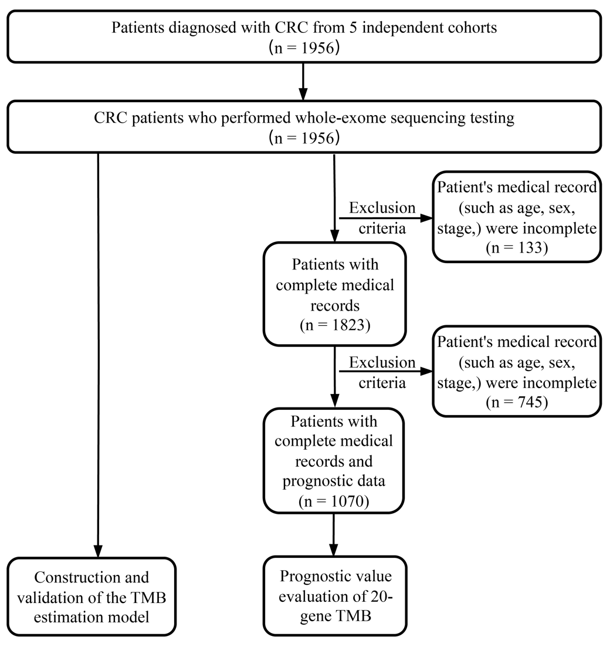
Supplementary Fig. S1. Flowchart of the algorithm for patient selection.

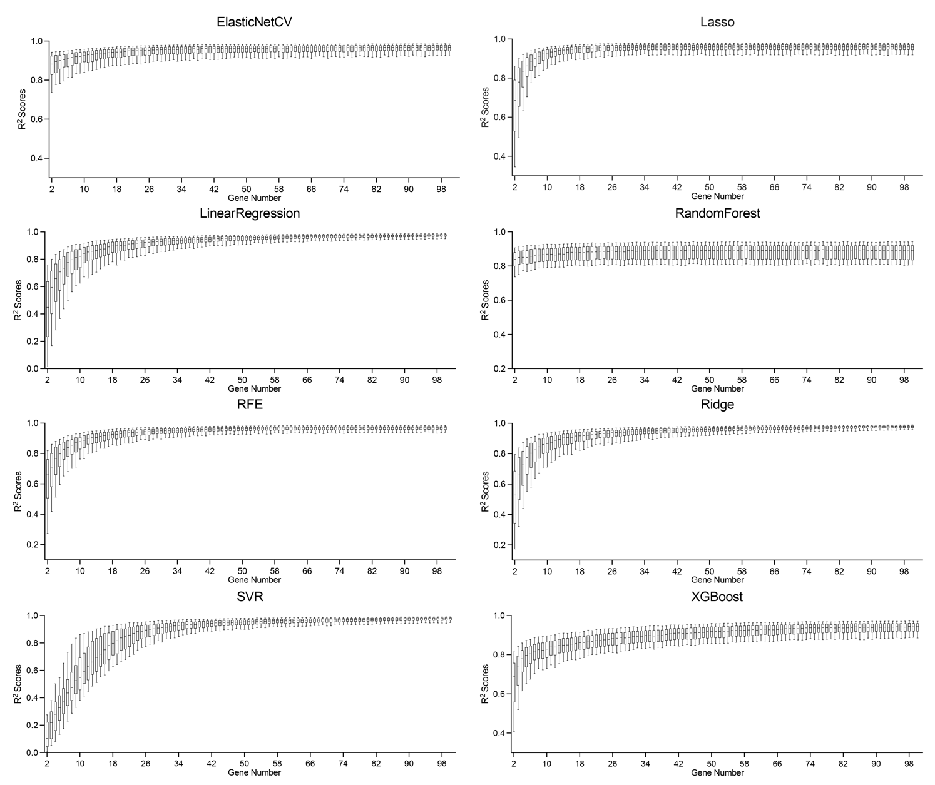
Supplementary Fig. S2. Evaluating the performance of eight TMB estimation models at different gene numbers. Box plots show the selected number of genes and corresponding R² scores for the different models, with models ElasticNetCV, Lasso, LinearRegression, RandomForest, RFE, Ridge, SVR, and XGBoost sequentially.

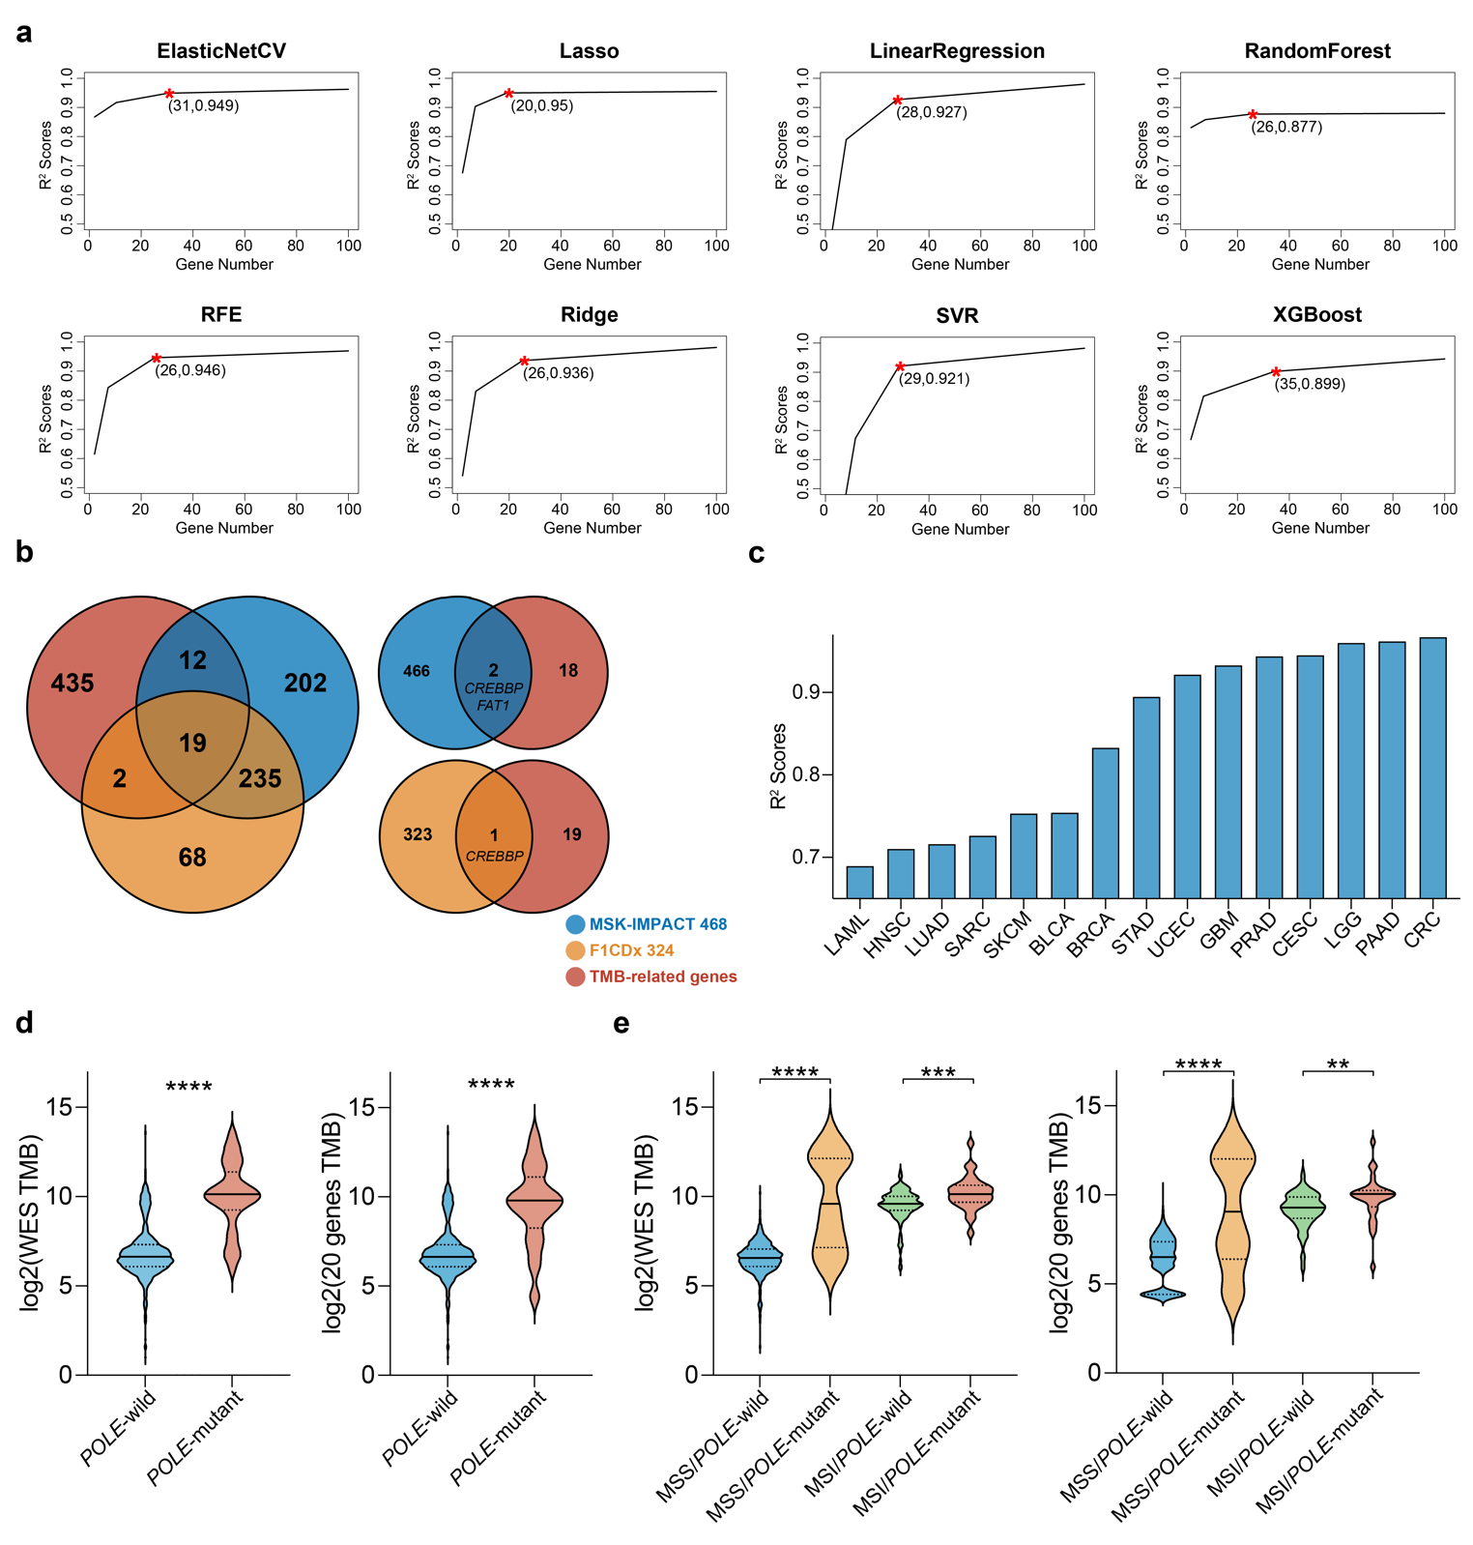
Supplementary Fig. S3 Testing and comparing the diagnostic performance of 20-gene TMB. (a) Segmented linear regression and split points of the R² scores of the mean curves for eight TMB estimation models. (b) Venn diagram showing the intersection of CRC TMB-related genes with the large gene panel for MSK-IMPACT and F1CDx (left). The intersection of 20 genes based on the Lasso TMB estimation model with the large gene panel (right). (c) The bar chart illustrates the TMB diagnostic performance of the 20-gene Panel in other cancer types. (d) Differences in WES-TMB and 20-gene TMB between POLE mutant and wild groups. (e) Differences in WES-TMB and 20-gene TMB between POLE mutants and wild group at different MSI states. **p < 0.01; ***p < 0.001; ****p < 0.0001, the p-value was determined using unpaired t-tests.
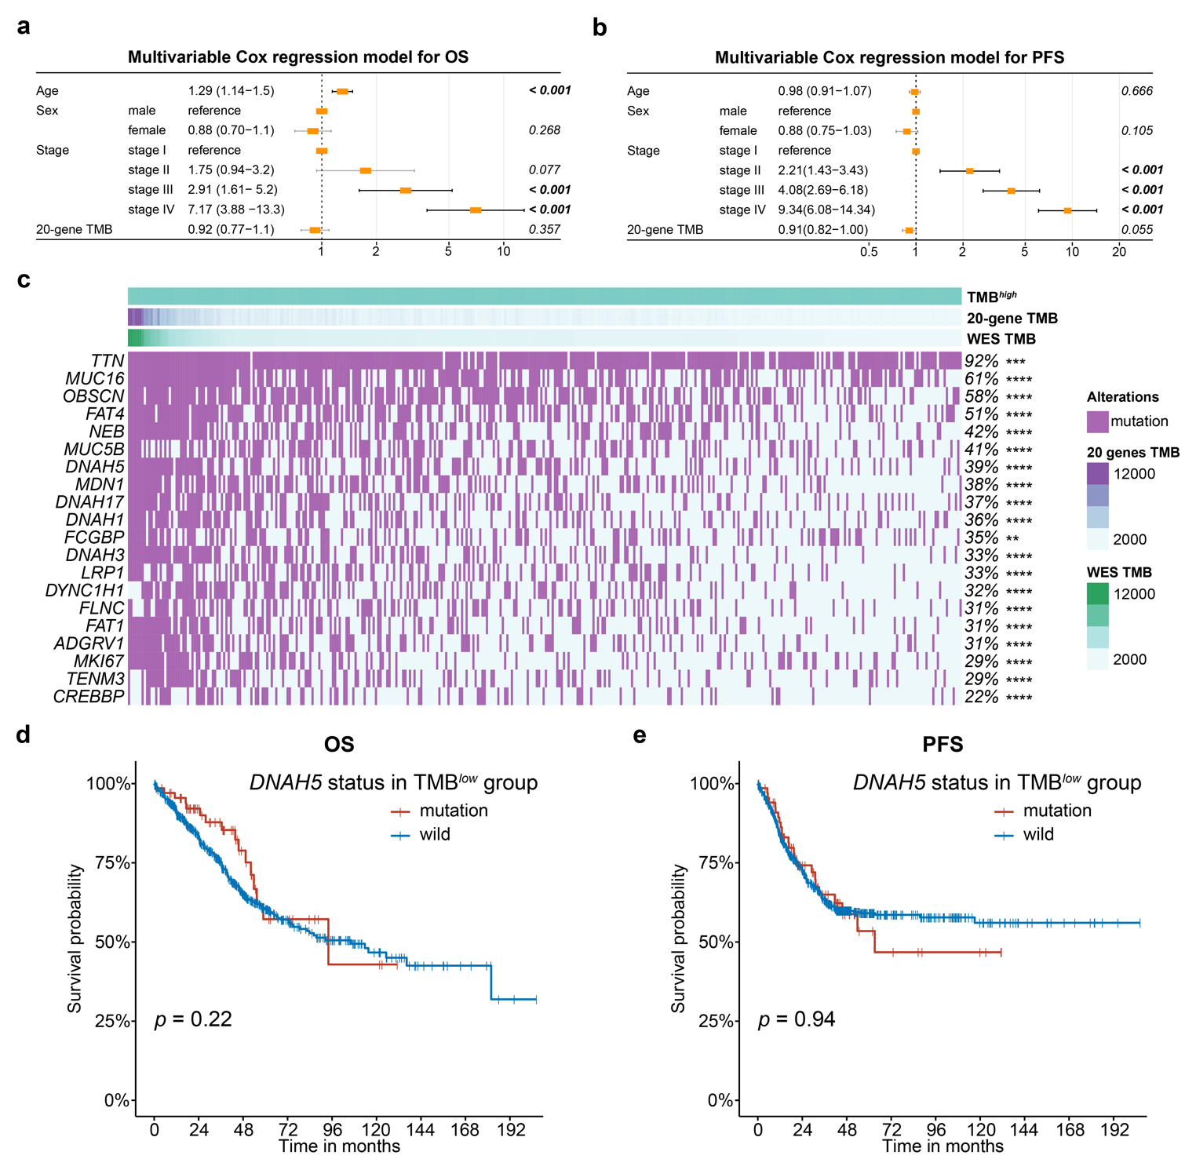
Supplementary Fig. S4. 20 genes mutated in patients with high TMB. (a, b) When 20-gene TMB is a continuous variable, forest plot summarising prognostic impact of 20-gene TMB on OS (a) and PFS (b) by multivariate Cox regression. (c) Mutation waterfall plots and mutation rates of 20 genes in patients with high TMB, and correlation of 20 genes with TMB in patients with high TMB were analysed. **p < 0.01; ***p < 0.001; ****p < 0.0001, the p-value was determined using unpaired t-tests. (d) Kaplan–Meier curves showing the effect of DNAH5 mutations on OS in the TMB^{low} group. (e) Kaplan–Meier curves showing the effect of DNAH5 mutations on PFS in the TMB^{low} group.

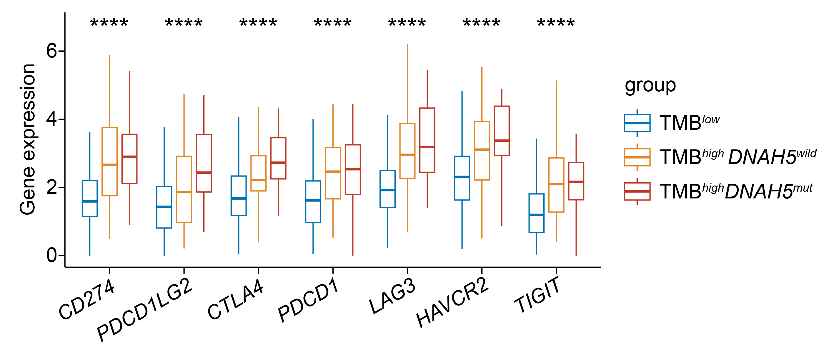
Supplementary Fig. S5. Comparison of the expression of immune checkpoint genes in the TMB^{low}, TMB^{high} DNAH5^{wild}, and TMB^{high} DNAH5^{mut} group.

