Supplementary Material figures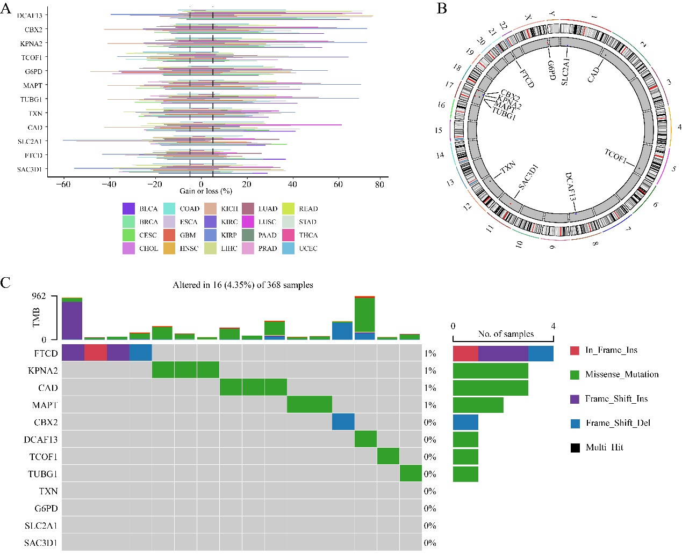
Figure S1. Variation and Chromosomal Distribution of LLPS Prognosis-Related Genes in HCC. (A) Copy number variation (CNV) values of LLPS prognosis-related genes across various cancers as per TCGA database. (B) Chromosomal distribution of LLPS prognosis-related genes. (C) Somatic mutations in LLPS prognosis-related genes according to TCGA data.
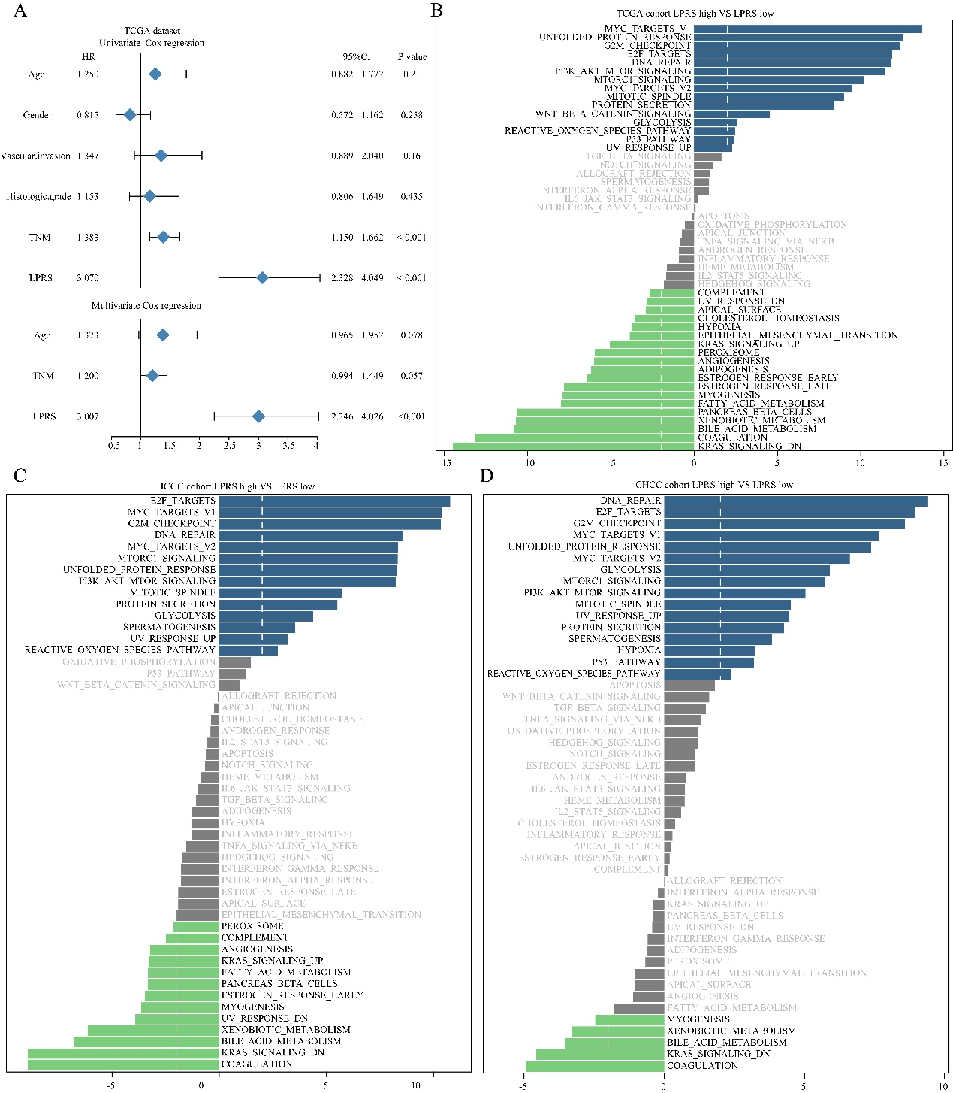
Figure S2. Prognostic and Pathway Characteristics of LPRS. (A) Univariate and multivariate Cox analyses of clinicopathological characteristics and LPRS in the TCGA cohort. (B-D) Gene Set Variation Analysis (GSVA) comparing high- and low-LPRS patients.

