Supplementary figure S1

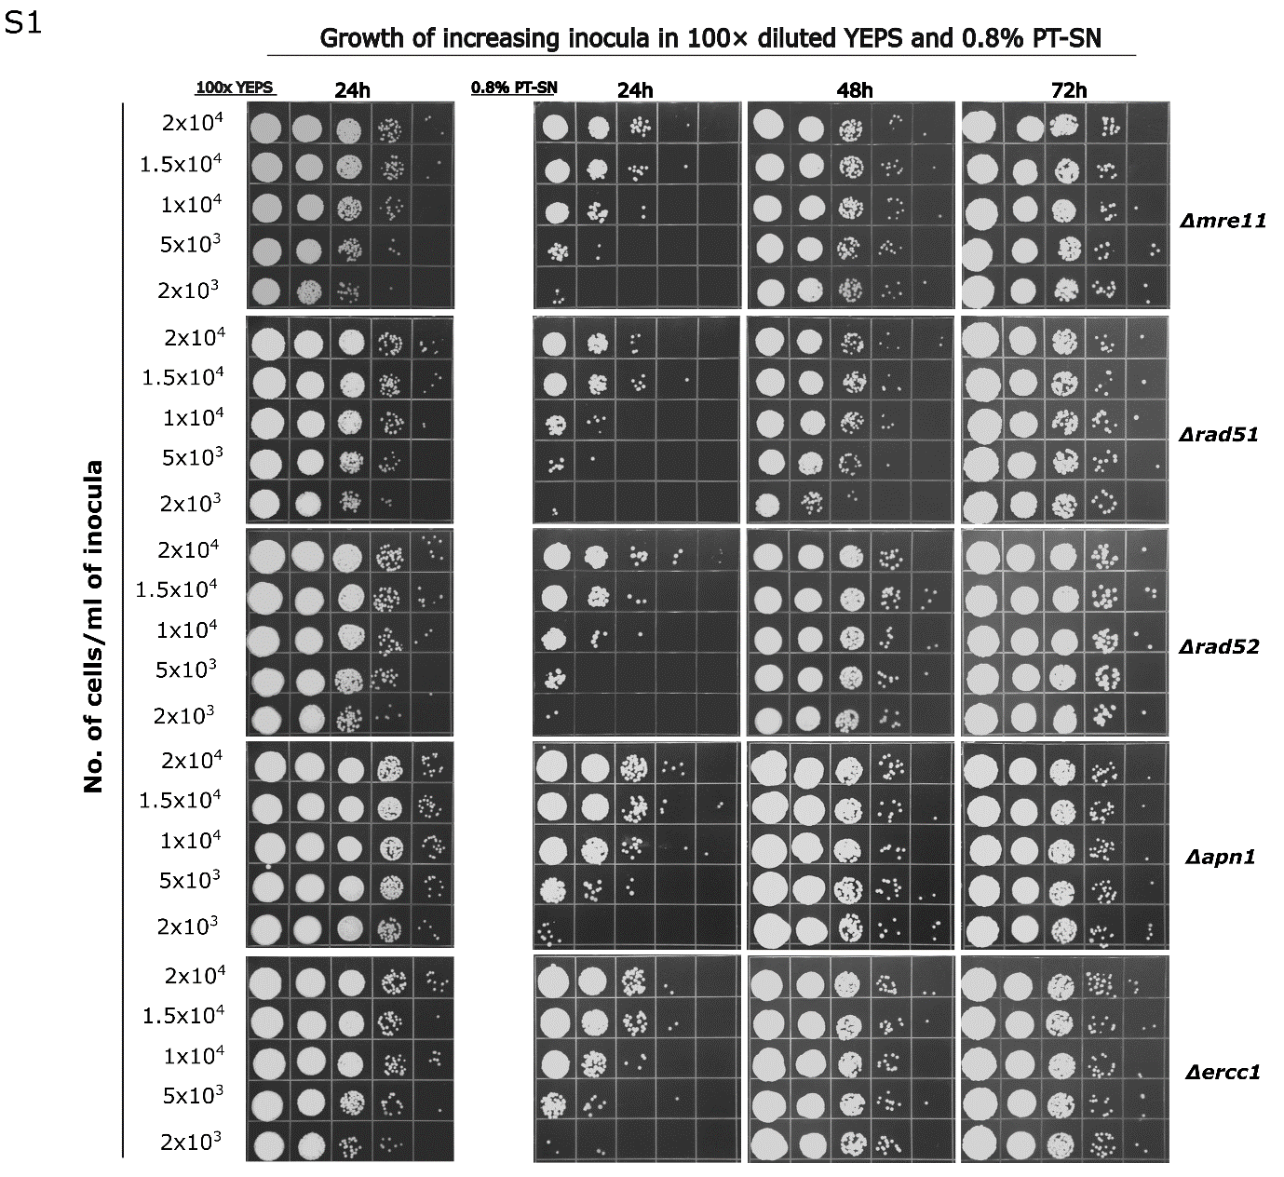

Figure S1. Growth of deletion mutants involved in DNA repair and genome stability was monitored at increasing inoculum densities (2 × 10³, 5 × 10³, 1 × 10⁴, 1.5 × 10⁴, and 2 × 10⁴ cells/mL) in supernatants derived from cell suspensions treated with 0.8% H₂O₂ (0.8% PT-SN). Growth was assessed after 24, 48, and 72 h of incubation at 30 °C by plating on YEPS-agar plates. As a control for intrinsic growth capacity, the same mutants were grown for 24 h in 100× diluted YEPS medium under identical conditions. The testing was performed two times and representative results are shown.

