Supplementary Figures
Supplementary Fig. 1
Supplementary Fig. 1. Screening of HIF-1α and HIF-2α protein expression and nuclear localization in several HCC cell lines, with split and merge confocal images. A Representative Western blot comparing normoxic (Nx) and hypoxic (Hx 24 h and 48 h) conditions from HCC cell lines are shown. Quantification of HIF-1α and HIF-2α expression was performed relative to the corresponding normoxic control for each cell line. Data are presented as mean values of a.u. ± SD (n = 3), showing a representative immunoblot. Independent gels were run in parallel using the same lysates for the detection of different targets; therefore, separate β-actin blots are shown. **P < 0.01, ***P < 0.001 and ****P < 0.0001 vs. Nx for each condition. B Representative images for both HIF-1α and HIF-2α nuclear expression in normoxia (Nx), 24-hour hypoxia (Hx) or 48-hour hypoxia. Magnification 63X, scale bar 50 µm. Split and merge images from Fig. 2.

Supplementary Fig. 2
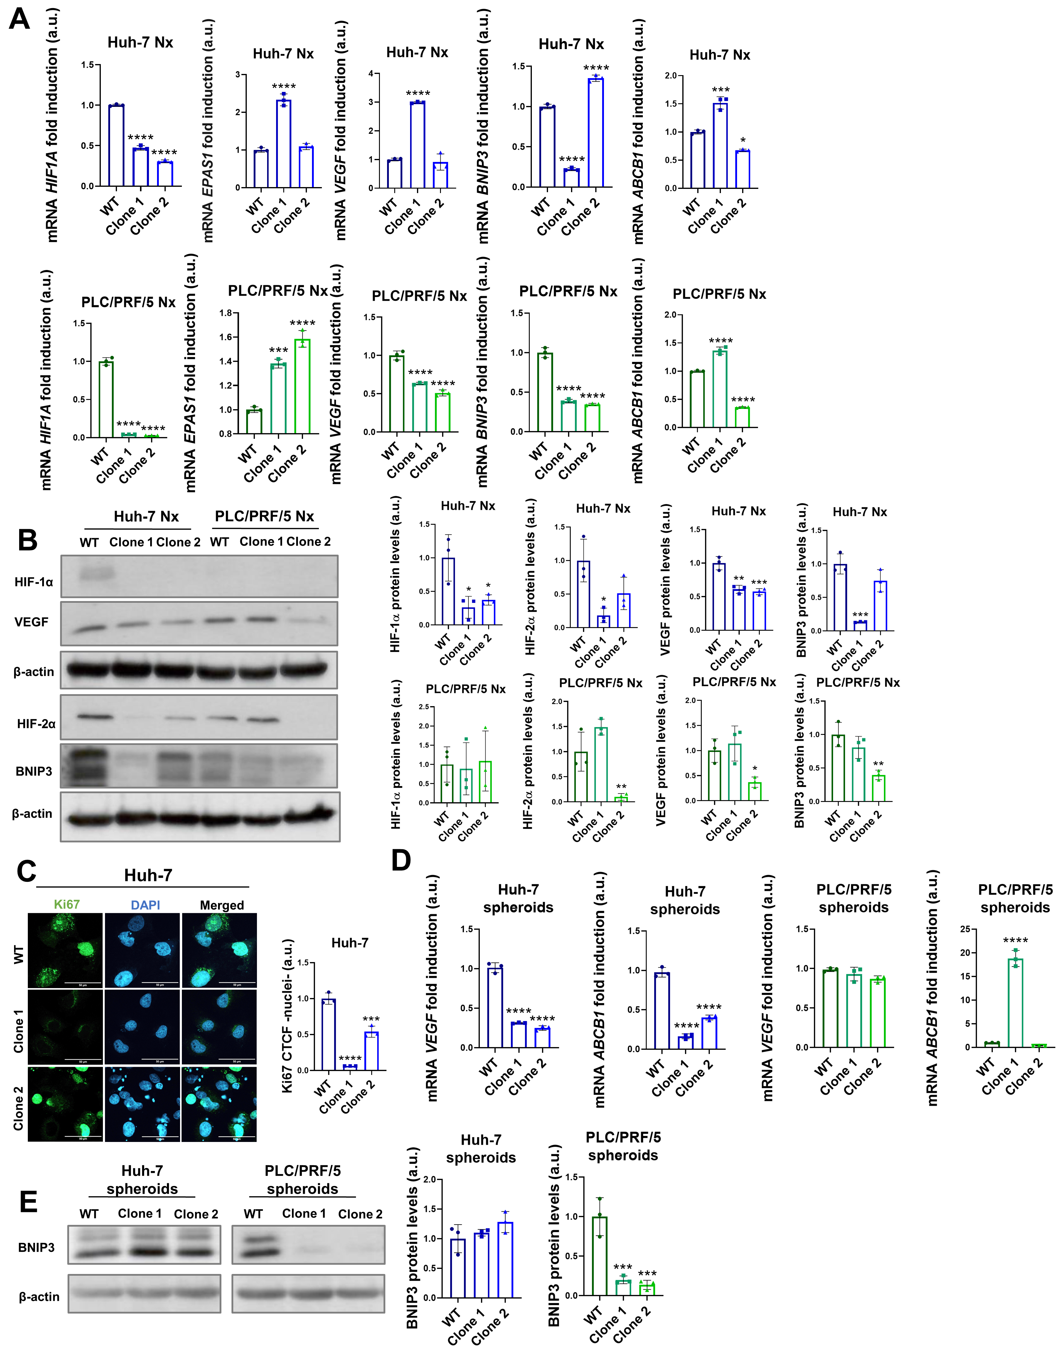
Supplementary Fig. 2. Determination of the baseline expression of several markers under normoxic conditions in all cell lines, evaluation of HIFs-target markers in spheroids from both Huh-7 and PLC/PRF/5 wild-type (WT) and knockout (KO) clones, and analysis of cell proliferation on Huh-7 WT and KO cells. Analysis of (A) gene and (B) protein expression of HIF-1α, HIF-2α, VEGF, BNIP3 or ABCB1 under normoxic (Nx) conditions. C Determination of cell proliferation capacity by Ki67 nuclear levels analysis by immunofluorescence with confocal microscopy after 48-hour hypoxia. Magnification 63X, scale bar 50 µm. Bar graphs represent the nuclear corrected total cell fluorescence (CTCF). D Evaluation of gene expression of VEGF and ABCB1 by RT-qPCR on all HCC seven-days-old spheroids with an initial seeding of 2,000 cells for Huh-7 and 5,000 cells for PLC/PRF/5. E Assessment of BNIP3 protein levels by Western blot in all Huh-7 and PLC/PRF/5 spheroids. A representative immunoblot along with the quantification of the corresponding triplicates is shown. Data are represented as mean values of arbitrary units (a.u.) ± SD (n = 3). *P < 0.05, **P < 0.01, ***P < 0.001 and ****P < 0.0001 vs. WT.

Supplementary Fig. 3
Supplementary Fig. 3. Representative full-length immunoblots from Supplementary Fig. 1A of HepG2, Hep3B, Huh-7, PLC/PRF/5, SNU-387, SNU-423, SNU-449 and SNU-475 cell lines for HIF-1α under hypoxic conditions (Hx, 24 h or 48 h). Independent gels were run in parallel using the same lysates for the detection of different targets; therefore, separate β-actin blots are shown.

Supplementary Fig. 4
Supplementary Fig. 4. Representative full-length immunoblots from Supplementary Fig. 1A of HepG2, Hep3B, Huh-7, PLC/PRF/5, SNU-387, SNU-423, SNU-449 and SNU-475 cell lines for HIF-2α under hypoxic conditions (Hx, 24 h or 48 h). Independent gels were run in parallel using the same lysates for the detection of different targets; therefore, separate β-actin blots are shown.

Supplementary Fig. 5
Supplementary Fig. 5. Representative full-length immunoblots from Supplementary Fig. 2B of the Huh-7 and PLC/PRF/5 wild-type (WT) and KO cell lines for HIF-1α, HIF-2α, VEGF and BNIP3 proteins in normoxic conditions. Independent gels were run in parallel using the same lysates for the detection of different targets; therefore, separate β-actin blots are shown.

Supplementary Fig. 6
Supplementary Fig. 6. Representative full-length immunoblots from Fig. 2A of the HepG2, Hep3B, Huh-7, PLC/PRF/5, SNU-387, SNU-423, SNU-449 and SNU-475 cell lines for HIF-1α and HIF-2α proteins in hypoxic conditions for (A) 24 h and (B) 48 h. Independent gels were run in parallel using the same lysates for the detection of different targets; therefore, separate β-actin blots are shown.

Supplementary Fig. 7
Supplementary Fig. 7. Representative full-length immunoblots from Fig. 2F of the Huh-7 cell line for HIF-1α, HIF-2α, VEGF and BNIP3 proteins, after HIF1A and/or EPAS1 gene knockdown. Independent gels were run in parallel using the same lysates for the detection of different targets; therefore, separate β-actin blots are shown.
Supplementary Fig. 8
Supplementary Fig. 8. Representative full-length immunoblots from Fig. 2F of the PLC/PRF/5 cell line for HIF-1α, HIF-2α, VEGF and BNIP3 proteins, after HIF1A and/or EPAS1 gene knockdown. Independent gels were run in parallel using the same lysates for the detection of different targets; therefore, separate β-actin blots are shown.
Supplementary Fig. 9
Supplementary Fig. 9. Representative full-length immunoblots from Fig. 3D and Supplementary Fig. 2B of the (A) Huh-7 and (B) PLC/PRF/5 wild-type (WT) and HIF1A knockout (KO) cell lines for HIF-1α, HIF-2α, VEGF and BNIP3 proteins. Independent gels were run in parallel using the same lysates for the detection of different targets; therefore, separate β-actin blots are shown.

Supplementary Fig. 10
Supplementary Fig. 10. Representative full-length immunoblots from Fig. 6A and Supplementary Fig. 2E of all Huh-7 cell lines-derived spheroids for HIF-1α, HIF-2α, VEGF and BNIP3 proteins. Independent gels were run in parallel using the same lysates for the detection of different targets; therefore, separate β-actin blots are shown.

Supplementary Fig. 11
Supplementary Fig. 11. Representative full-length immunoblots from Fig. 6A and Supplementary Fig. 2E of spheroids generated from PLC/PRF/5 wild-type (WT) and HIF1A knockout (KO) cell lines for HIF-1α, HIF-2α, VEGF and BNIP3 proteins. Independent gels were run in parallel using the same lysates for the detection of different targets; therefore, separate β-actin blots are shown.

