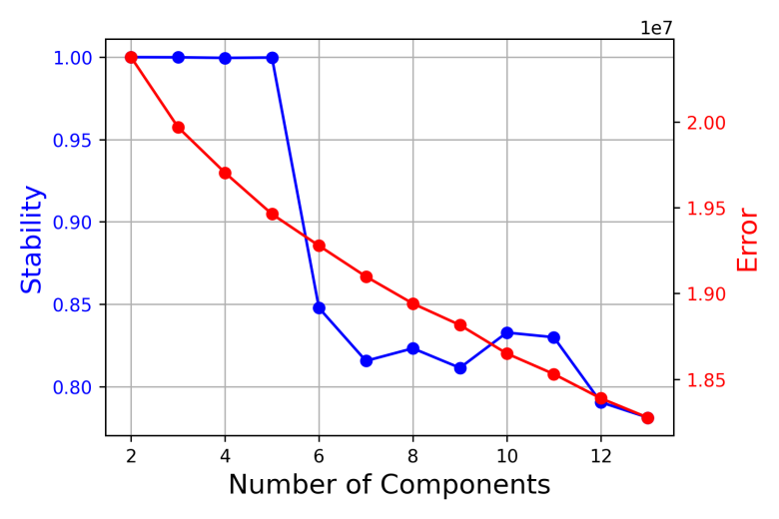
Figure S1. cNMF rank selection in malignant osteosarcoma cells.
Candidate ranks (k = 2-13) were evaluated by stability and reconstruction error. Based on the balance between robustness, model fit, and biological interpretability, k = 5 was selected for downstream analysis.
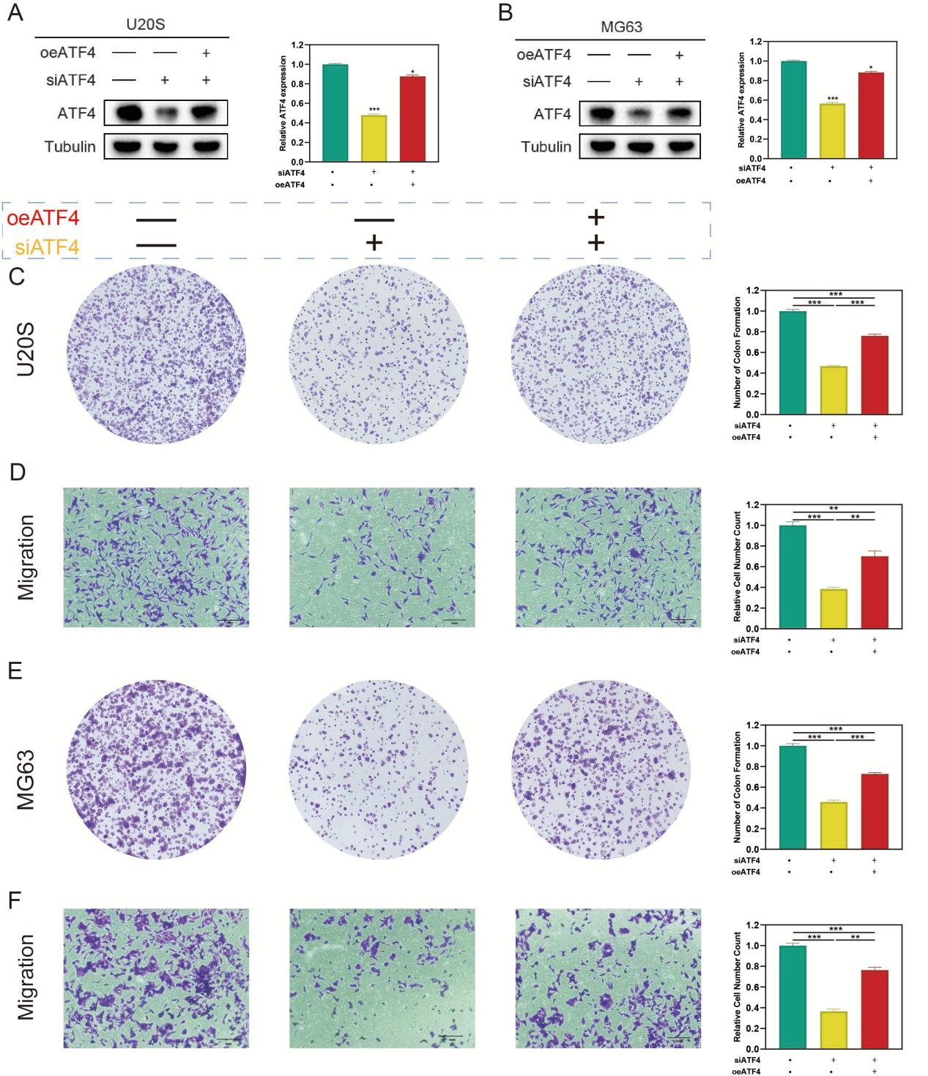
Figure S2. Re-expression of ATF4 partially rescues the suppressive effects of ATF4 knockdown on clonogenicity and migration in OS cells
(A,B) Western blot validation of rescue efficiency in U2OS (A) and MG63 (B) cells. ATF4 protein expression was reduced by siATF4 and partially restored by co-transfection with the ATF4 overexpression construct; Tubulin served as a loading control. (C,E) Colony formation assays and quantification showing that ATF4 re-expression partially rescued the reduction in clonogenicity induced by ATF4 knockdown in U2OS (C) and MG63 (E) cells. (D,F) Transwell migration assays and quantification demonstrating that ATF4 re-expression partially restored the migratory capacity suppressed by ATF4 silencing in U2OS (D) and MG63 (F) cells. Data are presented as mean ± SD from three independent experiments. Statistical significance was determined by one-way ANOVA followed by Tukey’s multiple-comparison test.

