Supplementary Materials

Integrative satellitomics reveals distinct patterns of organization, transcription and evolution of satellite DNAs in Tenebrio molitor

Patrik Majcen ¹, Antonio Sermek ¹, Đurđica Ugarković ¹, Brenda Oppert ^{2,3},
Miroslav Plohl ¹, Eva Šatović-Vukšić ¹*
¹ Ruđer Bošković Institute, Bijenička 54, 10000 Zagreb, Croatia
² Kansas State University, Manhattan, KS 66502, USA
³ Entovations LLC, Manhattan, KS 66503, USA
*correspondence: esatovic@irb.hr

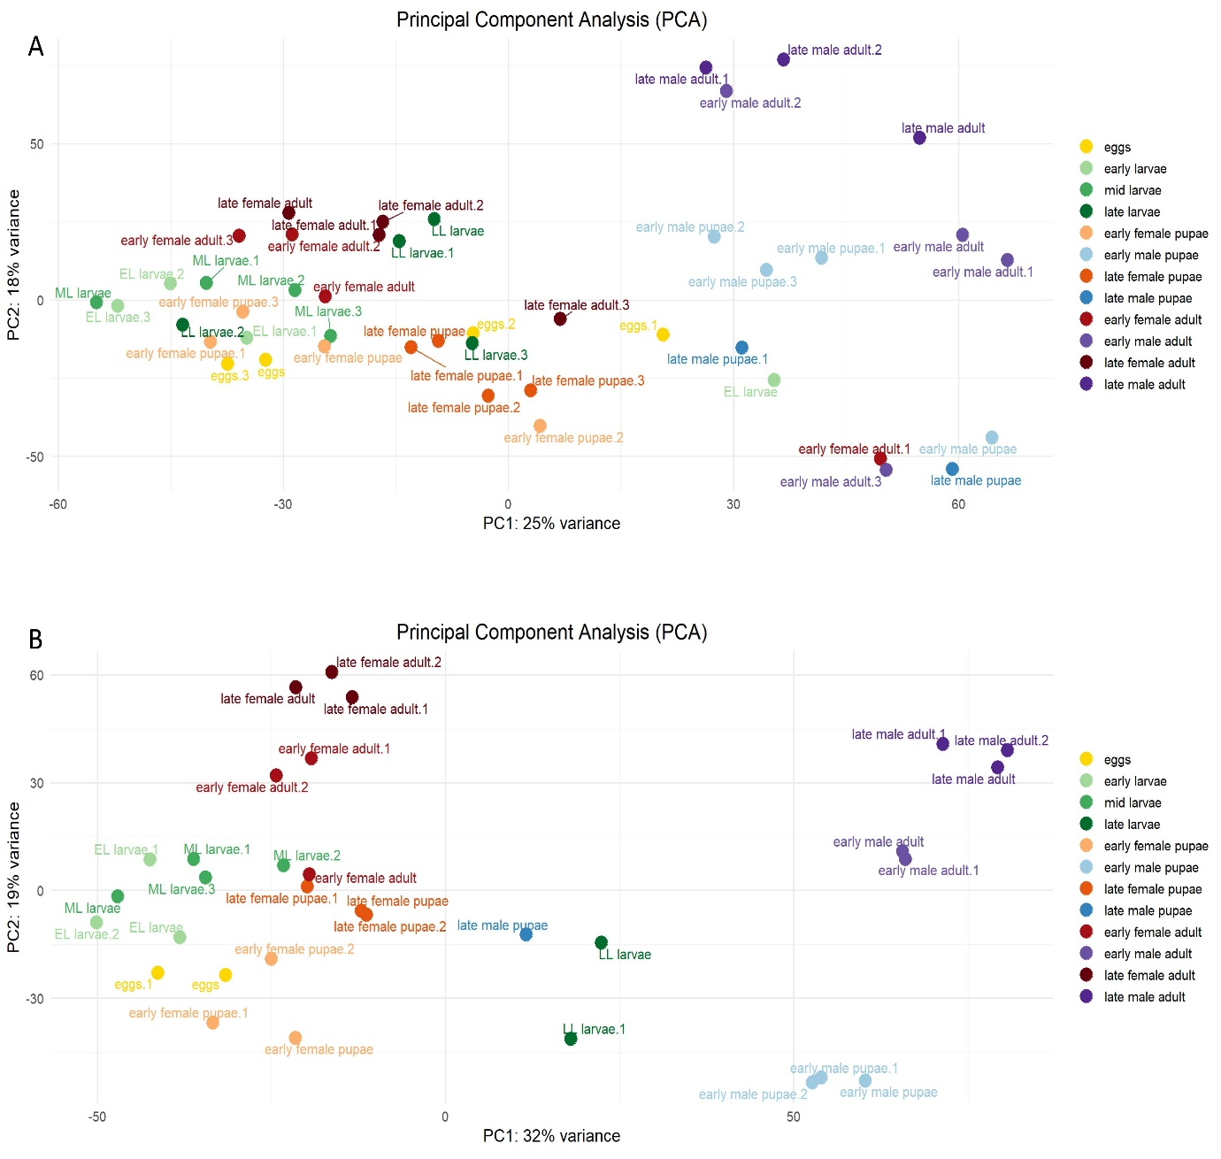
Supplementary Figure S1. Principal component analyses of RNA-Seq datasets belonging to different developmental stages of T. molitor before (a) and after (b) outlier removal.

Supplementary Figure S2. Nucleotide alignments of sequence segments preceding (A) and following (B) TmSat06 arrays. Blue arrows in represent the first (A) or the last (B) monomer of TmSat06 arrays. Highly conserved segment of 1,013 bp directly preceding TmSat06 arrays is marked with a red box with the extraction of the nucleotide sequences alignment displayed below.

Supplementary Figure S3. Nucleotide alignments of sequence segments preceding (A) and following (B) TmSat07 arrays. Pink arrows in represent the first (A) or the last (B) monomer of TmSat07 arrays. Green arrows represent TmSat05 monomers in one of the sequence segments.

Supplementary Figure S4. The output of de novo detection of satDNAs in the T. molitor reference genome assembly using TideHunter. Information for tandem repeat clusters (TRCs) identified from the genome assembly is shown. Seven satDNAs (TmSat01, TmSat02, TmSat03, TmSat04, TmSat05, TmSat08, and TmSat11) were recovered within the main TRCs (A). Additional clusters contained sequences corresponding to TmSat08, TmSat09, TmSat10, and additional repeats predominantly present in one array (B).

Supplementary Table S1. Primers and parameters used for PCR labelling of FISH probes.

Primer | Sequence (5’ – 3’) | Initial denaturation | Amplification (35 cycles) | Final extension
TmSat01_F  TmSat01_R | GAATTCTGTAGTTCTTGCG  CAGGTTCCAAGACGC | 94°C 5' | 94°C 30''  48 °C 30''  72°C 20'' | 72°C 5'
TmSat02_F  TmSat02_R | CGTAAGTTTCAATTATAACTCG  AGAATTTCCTGCCCAAAC | 94°C 5' | 94°C 30''  48 °C 30''  72°C 20'' | 72°C 5'
TmSat03_F  TmSat03_R | CCATAGCTCCCTTATTAAG  GCGTTTAAATGATTTTCCG | 94°C 5' | 94°C 30''  48 °C 30''  72°C 20'' | 72°C 5'
TmSat04_F  TmSat04_R | CTACGGCAATGAATTTTAC  CTTGCTTAATAACGGAGC | 94°C 5' | 94°C 30''  48 °C 30''  72°C 20'' | 72°C 5'
TmSat05_F TmSat05_R | ATTTCCAATAGAACATACCC  GATGTTACAGACTATGCTG | 94°C 5' | 94°C 30''  48 °C 30''  72°C 20'' | 72°C 5'
TmSat06_F  TmSat06_R | GATGATGTTGAACTAGACG  AGTAGAGCCAACGACC | 94°C 5' | 94°C 30''  48 °C 30''  72°C 20'' | 72°C 5'
TmSat07_F  TmSat07_R | CGTGCCCTTACGAAC  AATATTATTTTGGAAACGGC | 94°C 5' | 94°C 30''  48 °C 30''  72°C 20'' | 72°C 5'
TmSat08_F  TmSat08_R | ATGTTTGTGGGTGAAATC  AAACATCTTCCTATCGAC | 94°C 5' | 94°C 30''  48 °C 30''  72°C 20'' | 72°C 5'
TmSat09_F  TmSat09_R | CAAGTTGTTGGATGTCAG  TAATTGATCCTGGAACCC | 94°C 5' | 94°C 30''  48 °C 30''  72°C 20'' | 72°C 5'
TmSat10_F  TmSat10_R | CTTCAGTTTTGAGTTTAATTTC  TTGTCGTAAAAGAGAAAAC | 94°C 5' | 94°C 30''  48 °C 30''  72°C 20'' | 72°C 5'
TmSat11_F  TmSat11_R | GGAGCTCGAAGTTTCG  ACTGAATCTACCACTCC | 94°C 5' | 94°C 30''  48 °C 30''  72°C 20'' | 72°C 5'

Supplementary Table S2. Overview of insect orders with available genomic data, including families for Coleoptera.

Order | Family | No of seq. genomes
Archaeognatha |  | 1
Blattodea (cockroaches & termites) |  | 23
Coleoptera (beetles) |  | 790
 | Acanthocnemidae | 0
 | Aderidae | 0
 | Agapythidae | 0
 | Agyrtidae | 0
 | Alexiidae | 0
 | Amphizoidae (trout-stream beetles) | 0
 | Anamorphidae | 0
 | Anischiidae | 0
 | Anthicidae (ant beetles) | 2
 | Anthribidae (fungus weevils) | 5
 | Apionidae | 6
 | Archeocrypticidae | 0
 | Artematopodidae | 0
 | Aspidytidae | 0
 | Attelabidae (leaf-rolling weevils) | 2
 | Belidae | 0
 | Belohinidae | 0
 | Biphyllidae (false skin beetles) | 2
 | Boganiidae | 0
 | Bolboceratidae | 0
 | Boridae | 0
 | Bostrichidae (horned powder-post beetles) | 1
 | Bothrideridae (dry bark beetles) | 1
 | Brachyceridae | 0
 | Brachypsectridae | 0
 | Brentidae (straight-snouted weevils) | 2
 | Buprestidae (jewel beetles) | 7
 | Byrrhidae (pill beetles) | 0
 | Byturidae (fruitworm beetles) | 0
 | Callirhipidae | 0
 | Cantharidae (soldier beetles) | 30
 | Carabidae (ground beetles) | 60
 | Caridae | 0
 | Cavognathidae | 0
 | Cebrionidae | 0
 | Cephaloidae | 0
 | Cerambycidae (long-horned beetles) | 39
 | Cerasommatidiidae | 0
 | Cerophytidae | 0
 | Cerylonidae (minute bark beetles) | 0
 | Chaetosomatidae | 0
 | Chalcodryidae | 0
 | Chelonariidae | 0
 | Chrysomelidae (leaf beetles) | 124
 | Ciidae | 0
 | Clambidae | 0
 | Cleridae (checkered beetles) | 4
 | Cneoglossidae | 0
 | Coccinellidae (ladybird beetles) | 46
 | Corylophidae (minute fungus beetles) | 0
 | Cryptophagidae (silken fungus beetles) | 2
 | Cucujidae (flat bark beetles) | 2
 | Cupedidae (reticulated beetles) | 1
 | Curculionidae (weevils) | 95
 | Cyclaxyridae | 0
 | Dascillidae | 2
 | Decliniidae | 0
 | Dermestidae (skin and larder beetles) | 2
 | Derodontidae | 0
 | Diphyllostomatidae | 0
 | Discolomatidae | 0
 | Dryopidae | 0
 | Dytiscidae (predacious diving beetles) | 2
 | Elateridae (click beetles) | 38
 | Elmidae (riffle beetles) | 2
 | Endecatomidae | 0
 | Endomychidae (handsome fungus beetles) | 2
 | Epimetopidae | 0
 | Erirhinidae | 2
 | Erotylidae (pleasing fungus beetles) | 0
 | Eucinetidae | 0
 | Eucnemidae | 2
 | Eulichadidae | 0
 | Georissidae | 0
 | Geotrupidae (earth-boring dung beetles) | 5
 | Glaphyridae | 0
 | Glaresidae | 0
 | Gyrinidae (whirligig beetles) | 0
 | Haliplidae (crawling water beetles) | 0
 | Helophoridae | 0
 | Helotidae | 0
 | Heteroceridae | 0
 | Histeridae (clown beetles) | 2
 | Hobartiidae | 0
 | Hybosoridae | 0
 | Hydraenidae | 0
 | Hydrochidae | 1
 | Hydrophilidae (water scavenger beetles) | 8
 | Hydroscaphidae | 0
 | Hygrobiidae (diving beetles) | 0
 | Iberobaeniidae | 0
 | Ithyceridae | 0
 | Jacobsoniidae | 0
 | Jurasaidae | 0
 | Kateretidae (short-wingedflower beetles) | 2
 | Laemophloeidae (lined flat bark beetles) | 0
 | Lampyridae (fireflies) | 8
 | Latridiidae (minute brown scavenger beetles) | 2
 | Leiodidae (round fungus beetles) | 5
 | Lepiceridae | 0
 | Limnichidae | 0
 | Lophocateridae | 0
 | Lucanidae (stag beetles) | 7
 | Lutrochidae | 0
 | Lycidae (net-winged beetles) | 1
 | Lymexylidae (ship timber beetles) | 0
 | Mauroniscidae | 0
 | Melandryidae | 2
 | Meloidae (blister beetles) | 12
 | Melyridae (soft-winged flower beetles) | 4
 | Meruidae | 0
 | Metaxinidae | 0
 | Micromalthidae | 0
 | Monommidae | 0
 | Monotomidae (root-eating beetles) | 0
 | Mordellidae (tumbling flower beetles) | 0
 | Mycetophagidae | 4
 | Mycteridae | 0
 | Myraboliidae | 0
 | Nemonychidae | 0
 | Nitidulidae (sap-feeding beetles) | 5
 | Nosodendridae | 0
 | Noteridae (burrowing water beetles) | 0
 | Ochodaeidae | 0
 | Oedemeridae | 2
 | Omalisidae | 0
 | Omethidae | 0
 | Ommatidae | 0
 | Orsodacnidae | 0
 | Passalidae | 0
 | Passandridae (parasitic flat bark beetles) | 0
 | Peltidae | 0
 | Perimylopidae | 0
 | Phalacridae (shining flower beetles) | 0
 | Phengodidae (glowworms) | 1
 | Phloeostichidae | 0
 | Phloiophilidae | 0
 | Phycosecidae | 0
 | Plastoceridae | 0
 | Pleocomidae | 0
 | Podabrocephalidae | 0
 | Priasilphidae | 0
 | Prionoceridae | 0
 | Promecheilidae | 0
 | Propalticidae | 0
 | Prostomidae (jugular-horned beetles) | 0
 | Protelmidae | 0
 | Protocucujidae | 0
 | Protopeltidae | 0
 | Psephenidae | 0
 | Pterogeniidae | 0
 | Ptiliidae (featherwing beetles) | 0
 | Ptilodactylidae | 0
 | Ptinidae | 4
 | Pyrochroidae | 4
 | Pythidae | 0
 | Rentoniidae | 0
 | Rhadalidae | 0
 | Rhagophthalmidae | 1
 | Rhinorhipidae | 0
 | Rhipiceridae | 0
 | Ripiphoridae | 2
 | Salpingidae | 2
 | Scarabaeidae (scarab beetles) | 71
 | Schizopodidae | 0
 | Scirtidae (marsh beetles) | 3
 | Scraptiidae | 6
 | Silphidae (carrion beetles) | 8
 | Silvanidae (silvanid flat bark beetles) | 6
 | Smicripidae (palmetto beetles) | 0
 | Spercheidae | 0
 | Sphaeritidae (false clown beetles) | 0
 | Sphaeriusidae (minute bog beetles) | 0
 | Sphindidae (dry-fungus beetles) | 0
 | Staphylinidae (rove beetles) | 74
 | Stenotrachelidae | 0
 | Synchroidae | 0
 | Synteliidae | 0
 | Telegeusidae | 0
 | Tenebrionidae (darkling ground beetles) | 45
 | Tetratomidae | 2
 | Thanerocleridae | 0
 | Throscidae | 0
 | Thymalidae | 0
 | Torridincolidae | 0
 | Trachelostenidae | 0
 | Trachypachidae | 0
 | Trictenotomidae | 0
 | Trogidae | 0
 | Trogossitidae | 0
 | Ulodidae | 0
 | Vesperidae | 0
 | Zeugophoridae | 0
 | Zopheridae (ironclad beetles) | 8
Dermaptera (earwigs) |  | 8
Diptera (flies) |  | 1.666
Embioptera (web-spinners) |  | 1
Ephemeroptera (mayflies) |  | 14
Grylloblattodea (rock crawlers) |  | 0
Hemiptera (true bugs) |  | 325
Hymenoptera (hymenopterans) |  | 1.099
Lepidoptera (moths & butterflies) |  | 3.468
Mantodea (mantids) |  | 8
Mantophasmatodea (heelwalkers) |  | 0
Mecoptera (scorpionflies) |  | 4
Megaloptera |  | 8
Neuroptera (net-winged insects) |  | 15
Odonata (dragonflies & damselflies) |  | 34
Orthoptera (grasshoppers. crickets & katydids) |  | 48
Phasmatodea (walking sticks) |  | 22
Plecoptera (stoneflies) |  | 23
Psocodea (booklice. barklice & lice) |  | 19
Raphidioptera (snakeflies) |  | 4
Siphonaptera (fleas) |  | 3
Strepsiptera (twisted-wing parasites) |  | 4
Thysanoptera (thrips) |  | 15
Trichoptera (caddisflies) |  | 73
Zoraptera (angel insects) |  | 0
Zygentoma |  | 3

Supplementary Table S3. Results of NCBI databases searches against WGS insecta and nucleotide collection with 11 satDNAs of T. molitor. The table includes the values for the hit with the highest identity and query coverage.

 | NCBI WGS insecta |  |  |  | NCBI nucleotide collection
satDNA | species | order | Query cover (%) | Identity (%) | species | order | Query cover (%) | Identity (%)
TmSat1 (142 bp) | Cataglyphis bombycina | Hymenoptera | 100 | 100 | Tenebrio obscurus | Coleoptera | 99 | 78.3
TmSat1 (142 bp) | Cataglyphis mauritanica | Hymenoptera | 100 | 100
TmSat1 (142 bp) | Achroia grisella | Lepidoptera | 100 | 100
TmSat1 (142 bp) | Zophobas morio | Coleoptera | 100 | 100
TmSat1 (142 bp) | Solenopsis invicta | Hymenoptera | 100 | 100
TmSat1 (142 bp) | Cataglyphis hellenicus | Hymenoptera | 100 | 99.30
TmSat1 (142 bp) | Periplaneta americana | Blattodea | 100 | 98.59
TmSat1 (142 bp) | Cataglyphis cursor | Hymenoptera | 100 | 97.89
TmSat1 (142 bp) | Cataglyphis holgerseni | Hymenoptera | 100 | 100
TmSat1 (142 bp) | Cataglyphis italica | Hymenoptera | 100 | 100
TmSat1 (142 bp) | Cataglyphis velox | Hymenoptera | 100 | 100
TmSat1 (142 bp) | Cataglyphis albicans | Hymenoptera | 100 | 99.12
TmSat2 (180 bp) | Cataglyphis albicans | Hymenoptera | 100 | 100
TmSat2 (180 bp) | Cataglyphis bombycina | Hymenoptera | 100 | 96.58
TmSat3 (325 bp) | Phosphuga atrata | Coleoptera | 28 | 77.6 | Phosphuga atrata | Coleoptera | 29 | 78.7
TmSat3 (325 bp) | Drosophila melanica | Diptera | 11 | 97.3 | Aelia acuminata | Hemiptera | 12 | 90.0
TmSat3 (325 bp) | Drosophila micromelanica | Diptera | 10 | 100
TmSat3 (325 bp) | Cataglyphis albicans | Hymenoptera | 100 | 95.44
TmSat4 (245 bp) | Podabrus alpinus | Coleoptera | 36 | 76.6 | Podabrus alpinus | Coleoptera | 64 | 75.5
TmSat4 (245 bp) | Cataglyphis albicans | Hymenoptera | 100 | 99.52 | Cantharis rustica | Coleoptera | 25 | 90.0
TmSat4 (245 bp) | Cataglyphis bombycina | Hymenoptera | 89 | 97.46 | Bemisia tabaci | Hemiptera | 15 | 89.5
TmSat4 (245 bp) | Hydrotaea cyrtoneurina | Diptera | 25 | 91.11 | Rhagonycha fulva | Coleoptera | 17 | 88.1
TmSat4 (245 bp) | Arthaldeus pascuellus | Hemiptera | 22 | 84.91 | Hydrotaea cyrtoneurina | Diptera | 22 | 88
TmSat4 (245 bp) |  |  |  |  | Phlebotomus argentipes | Diptera | 26 | 79.37
TmSat4 (245 bp) |  |  |  |  | Anaspis frontalis | Coleoptera | 18 | 86.36
TmSat5 (364 bp) | Cataglyphis albicans | Hymenoptera | 100 | 92.86 | Miltochrista miniata | Lepidoptera | 11 | 88.4
TmSat5 (364 bp) | Prionychus ater | Coleoptera | 53 | 86.84 | Prionychus ater | Coleoptera | 53 | 87.50
TmSat5 (364 bp) | Heliconius aoede | Lepidoptera | 18 | 83.08
TmSat6 (227 bp) | Achroia grisella | Leptidopera | 100 | 100 | Melinaea menophilus | Lepidoptera | 17 | 92.7
TmSat6 (227 bp) | Periplaneta americana | Blattodea | 95 | 93.52 | Synanthedon formicaeformis | Lepidoptera | 22 | 82.7
TmSat6 (227 bp) | Cataglyphis albicans | Hymenoptera | 97 | 93.40 | Chloroclysta siterata | Lepidoptera | 19 | 84.4
TmSat6 (227 bp) |  |  |  |  | Melinaea marsaeus rileyi | Lepidoptera | 16 | 89.7
TmSat7 (189 bp) | Dinoponera quadriceps | Hymenoptera | 100 | 100
TmSat7 (189 bp) | Cataglyphis albicans | Hymenoptera | 100 | 99.47
TmSat7 (189 bp) | Achroia grisella | Leptidopera | 100 | 98.94
TmSat7 (189 bp) | Periplaneta americana | Blattodea | 88 | 97.06
TmSat8 (735 bp) | Zophobas atratus | Coleoptera | 18 | 82.35 | Prionychus ater | Coleoptera | 13 | 86.52
TmSat8 (735 bp) | Tribolium madens | Coleoptera | 16 | 75.6 | Dendarus foraminosus | Coleoptera | 13 | 81.91
TmSat8 (735 bp) | Tribolium freemani | Coleoptera | 13 | 73.9
TmSat8 (735 bp) | Cataglyphis albicans | Hymenoptera | 74 | 95.18
TmSat8 (735 bp) | Zophobas morio | Coleoptera | 16 | 79.82
TmSat8 (735 bp) | Prionychus ater | Coleoptera | 15 | 85.39
TmSat8 (735 bp) | Blaps rhynchoptera | Coleoptera | 12 | 77.42
TmSat9 (108 bp) | Cataglyphis albicans | Hymenoptera | 100 | 93.33
TmSat10 (150 bp) | Cataglyphis albicans | Hymenoptera | 100 | 88.24 | Tribolium freemani | Coleoptera | 54 | 76.8
TmSat10 (150 bp) | Zophobas morio | Coleoptera | 79 | 85.71 | Vespula vulgaris | Hymenoptera | 30 | 86.7
TmSat10 (150 bp) | Tribolium confusum | Coleoptera | 78 | 73.7 | Thymelicus sylvestris | Lepidoptera | 30 | 87.0
TmSat10 (150 bp) | Tribolium freemani | Coleoptera | 54 | 76.8 | Dailognatha quadricollis | Coleoptera | 96 | 72.37
TmSat10 (150 bp) | Zophobas atratus | Coleoptera | 57 | 85.71 | Tribolium castaneum | Coleoptera | 42 | 80.95
TmSat10 (150 bp) | Asbolus verrucosus | Coleoptera | 77 | 75.56 | Tribolium freemani | Coleoptera | 45 | 80.30
TmSat10 (150 bp) | Blaps rhynchoptera | Coleoptera | 61 | 81.82 | Tribolium madens | Coleoptera | 43 | 78.12
TmSat10 (150 bp) | Gnatocerus cornotus | Coleoptera | 77 | 73.83 | Ligdia adustata | Lepidoptera | 25 | 89.47
TmSat10 (150 bp) | Latheticus oryzae | Coleoptera | 52 | 79.49
TmSat10 (150 bp) | Tribolium castaneum | Coleoptera | 55 | 76.83
TmSat10 (150 bp) | Cynaeus angustus | Coleoptera | 49 | 78.08
TmSat11 (93 bp) | No positive results

