Supplementary material
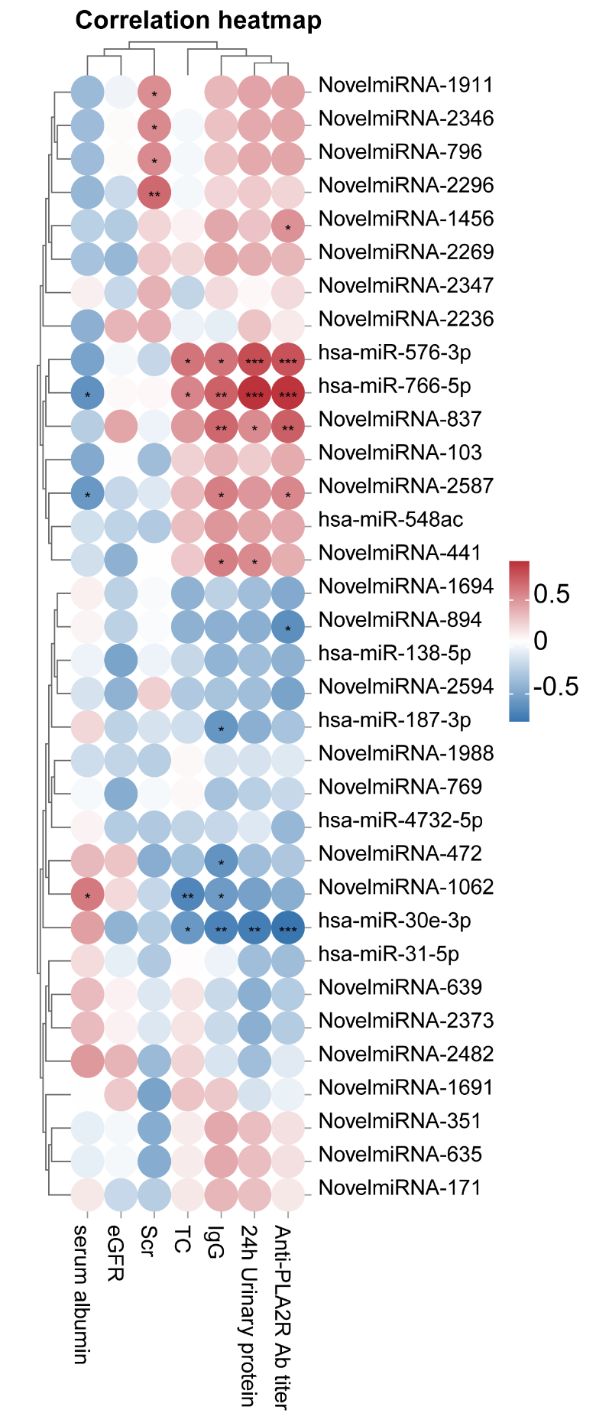
Supplementary figure 1 Heat map of spearman correlation analysis between differentially expressed miRNAs and clinical biochemical data
Red indicates positive correlation; blue indicates negative correlation. *p<0.05, **p<0.01, ***p<0.05: correlation is significant. This analysis was performed using OmicShare tool (Spearman’s correlation method), a free online platform for data analysis (https://www.omicshare.com/tools, accessed on 13 August 2025). Abbreviation: anti-PLA2R Ab titer: Antibody Titer against Phospholipase A2 Receptor; eGFR: estimated glomerular filtration rate; IgG: immunoglobulin G; Scr: serum creatinine; TC: total cholesterol.

Supplementary figure 2 ROC curve of candidate miRNAs for IMN
ROC curve is made by SPSS software (IBM, USA).

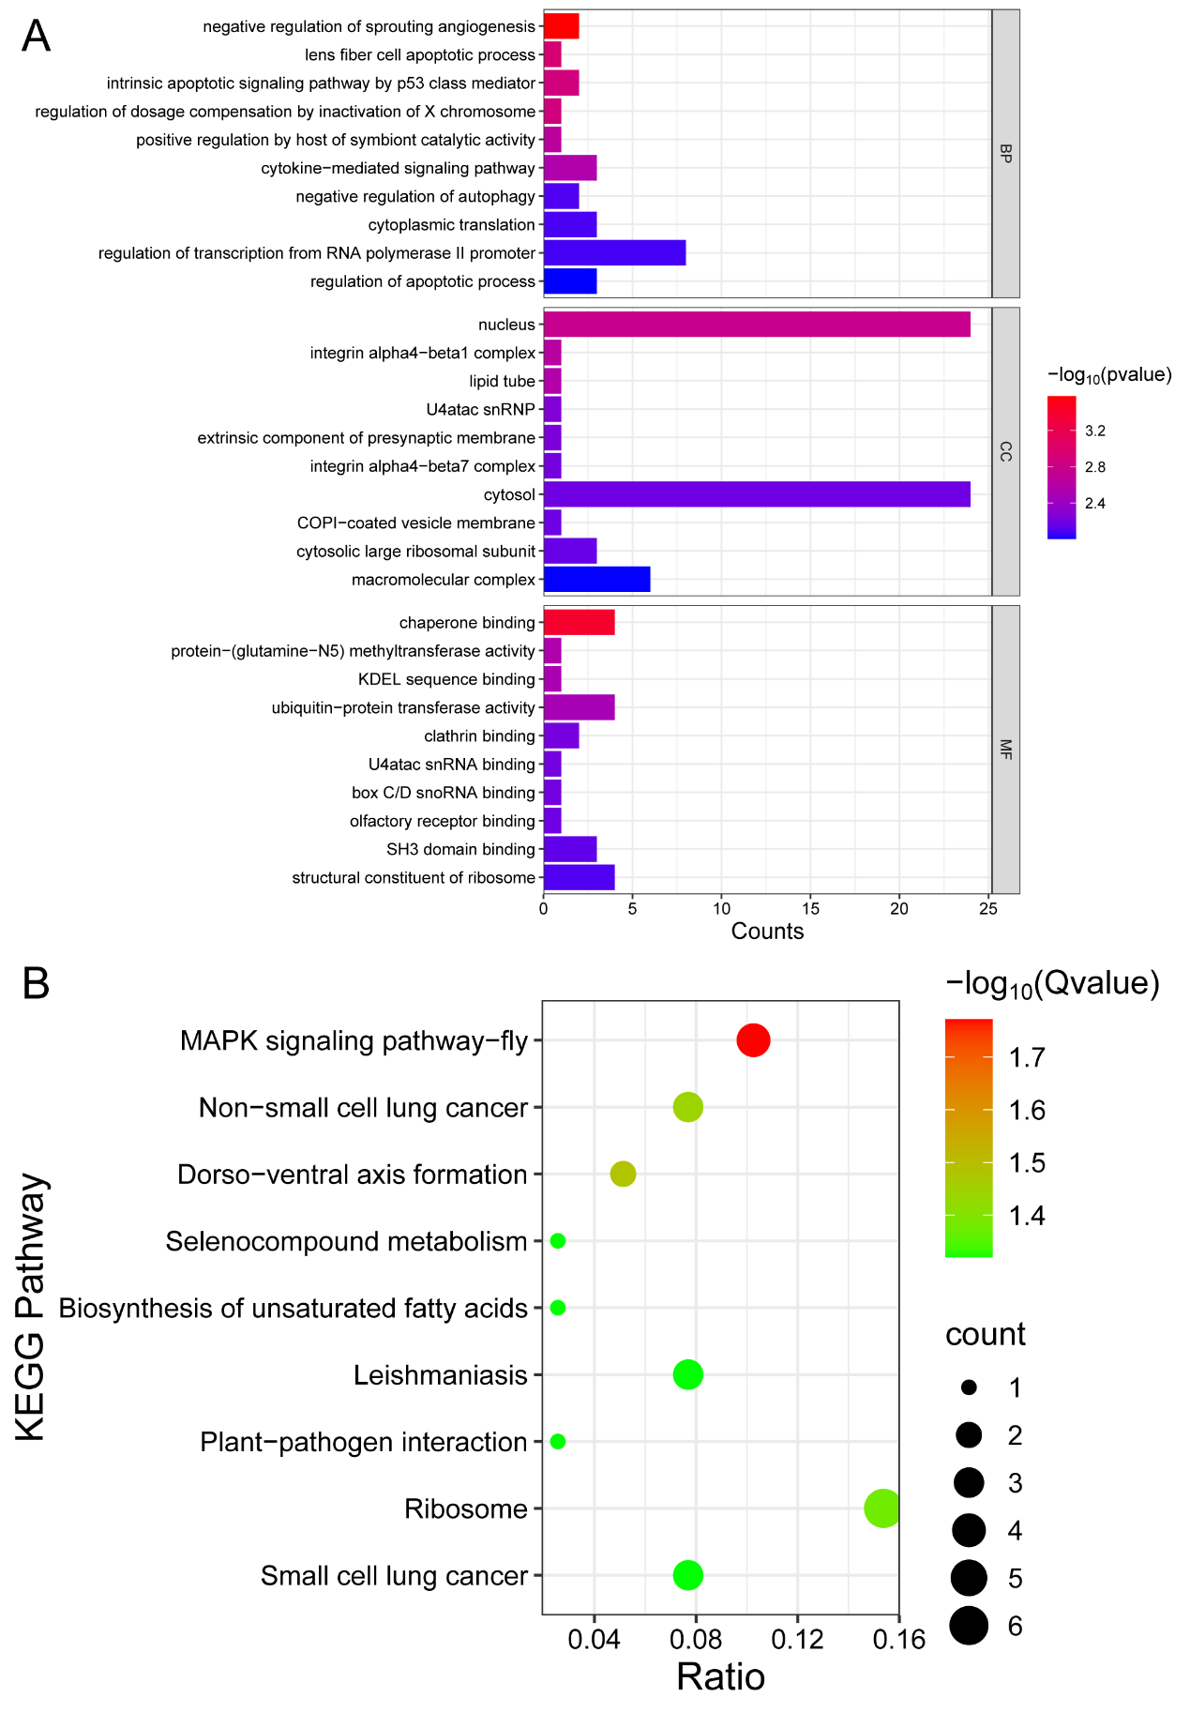
Supplementary figure 3 GO and KEGG enrichment results from mRNA transcriptomics
GO and KEGG enrichment were performed by Goseq and Wallenius non-central hyper-geometric distribution. (A) Top 10 of Counts in results of GO enrichment was showed. (B) All KEGG pathways with Q-value less than 0.05 are shown. GO and KEGG items are sorted from small to large according to the adjusted P value or Q-value. The histogram and bubble chart were made by SRplot (https://www.bioinformatics.com.cn, last accessed on 14 August 2025), an online platform for data analysis and visualization.

