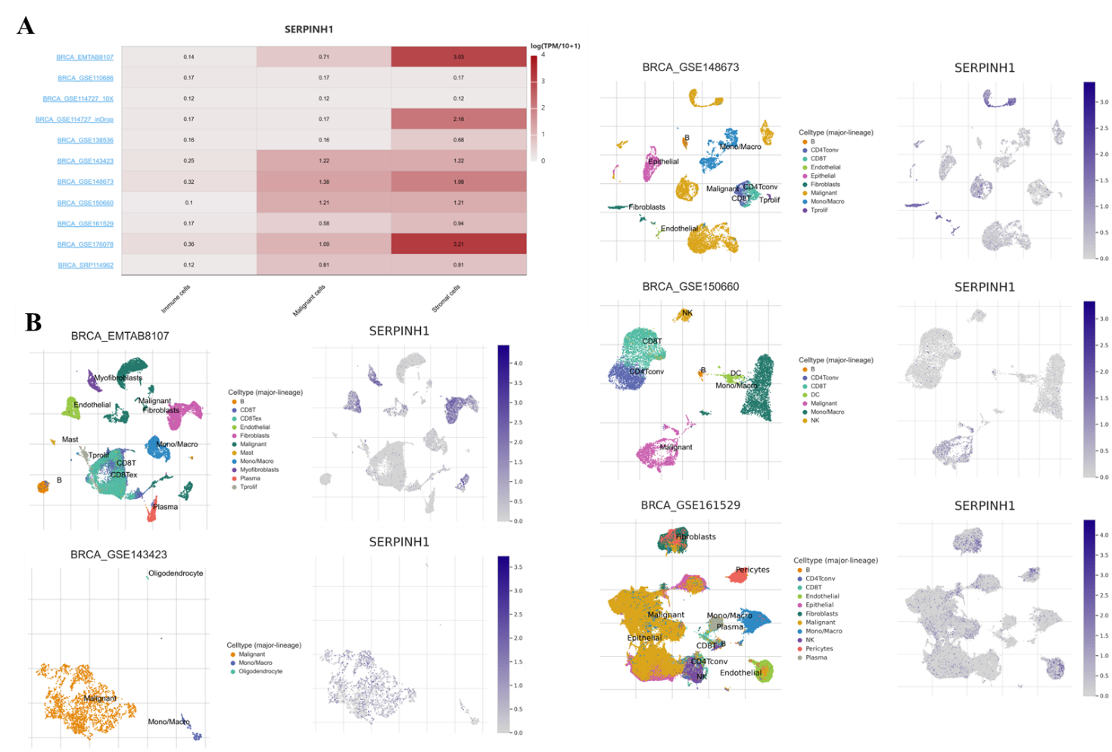

Supplementary Figure 1 SERPINH1 expression across bulk and single-cell breast cancer datasets.
A) Heatmap of SERPINH1 expression across multiple bulk RNA-seq breast cancer cohorts, showing consistently higher levels in tumour tissue compared with normal breast across independent datasets.
B) Single-cell RNA-seq from diverse breast cancer datasets (EMTAB8107, GSE148673, GSE150660, GSE143423, GSE161529) showing the distribution of major tumour and stromal cell lineages (left panels) and corresponding SERPINH1 expression patterns (right panels). SERPINH1 expression is predominantly enriched in stromal fibroblasts and malignant epithelial clusters, with lower or negligible expression in most immune cell populations. Colour scales indicate normalised SERPINH1 expression levels.

