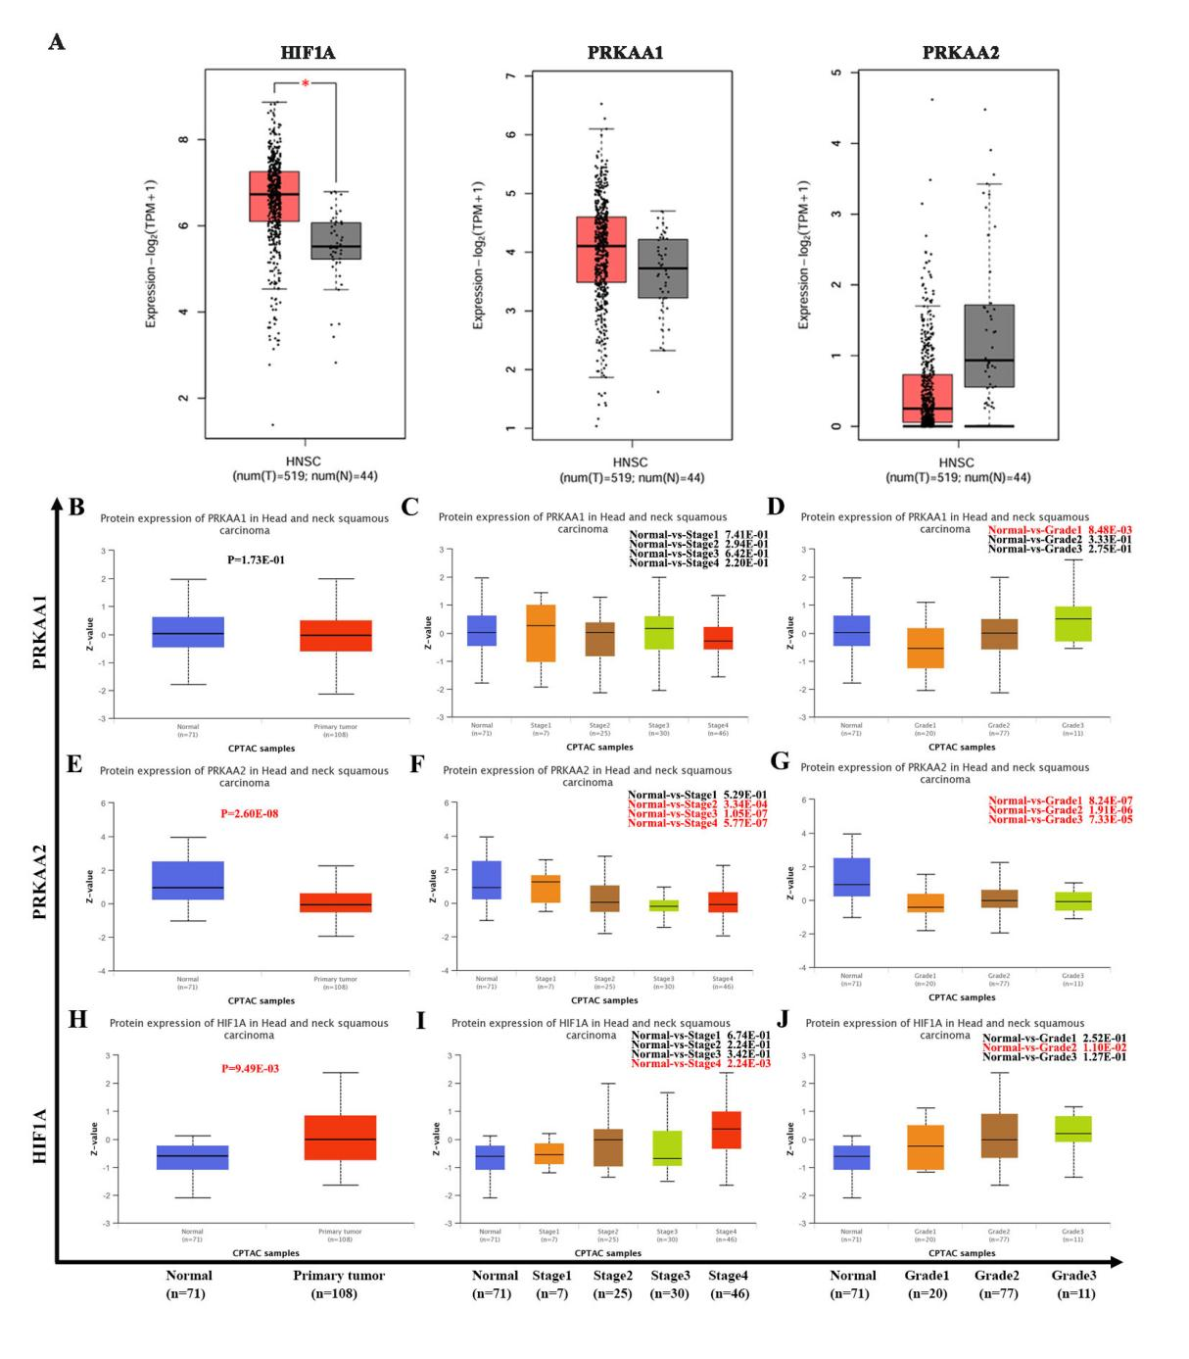
Fig. S1. Analysis of HIF-1α and AMPK expression based on public databases (A) The mRNA levels of HIF1A, PRKAA1, and PRKAA2 were analyzed in tumor and normal tissues using the GEPIA database. (B-J) Changes in AMPKα1 (PRKAA1), AMPKα2 (PRKAA2), and HIF-1α (HIF1A) protein expression in HNSCC were analyzed using the CPTAC database.Statistical significance is denoted by *P < 0.05 vs. Normal group.

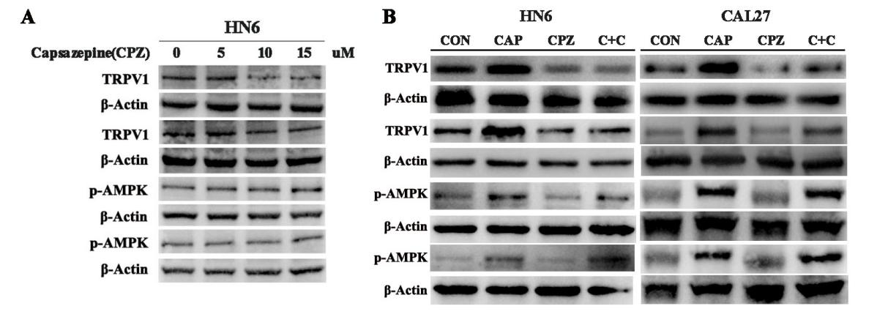
Fig.S2. Pharmacological inhibition of TRPV1 fails to block CAP-triggered AMPK activation. (A) HN6 cells were treated with gradient concentrations of CPZ (0, 5, 10, 15 μM) to determine the optimal intervention condition. (B) HN6 and CAL27 cells were subjected to CAP, CPZ, or combined CAP and CPZ treatment. TRPV1 and p-AMPK protein expression were analyzed by western blot. Shown are representative blots from two independent biological replicates.

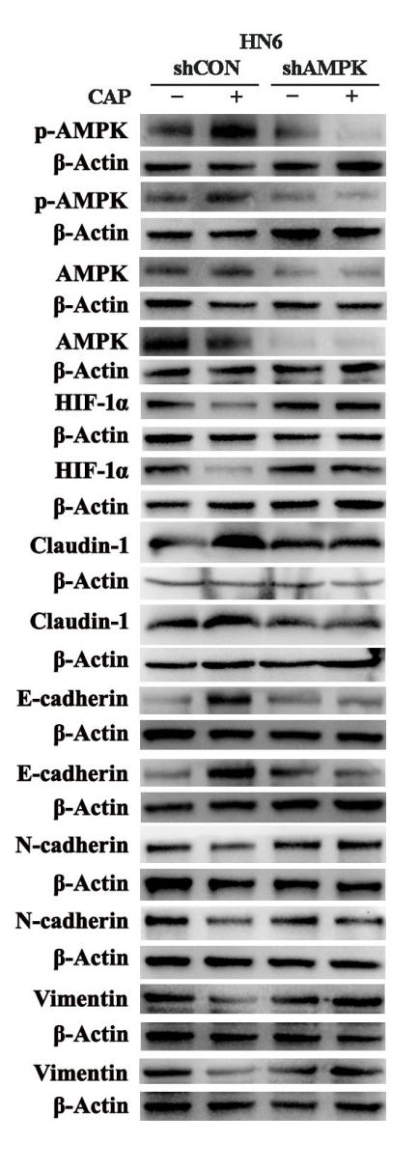
Fig. S3. Effects of AMPK knockdown on CAP-induced expression of HIF-1α, Claudin-1, and EMT-related proteins in TSCC cells. The HN6 cell were transfected with shAMPK (5'-GCTTGATGCACACATGAATGC-3') or shCON (control) and then treated with CAP or left untreated (control). Protein expression levels of p-AMPK, total AMPK, HIF-1α, Claudin-1, E-cadherin, N-cadherin, and Vimentin were analyzed by western blot. β-Actin served as a loading control. The results demonstrate that AMPK knockdown abrogates CAP-induced HIF-1α suppression, Claudin-1 upregulation, and the subsequent EMT phenotype (i.e., restoration of E-cadherin and reduction of N-cadherin and Vimentin). Representative blots from two independent biological replicates (n=2) are shown.

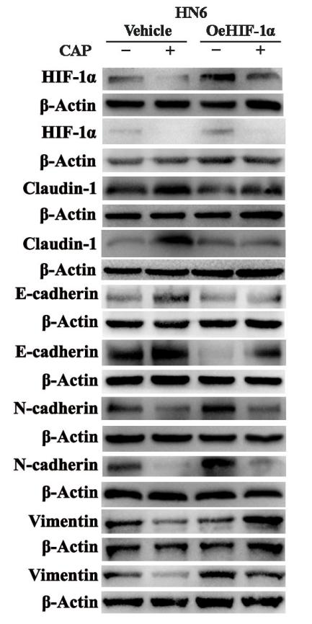
Fig. S4. The protein expression levels of HIF-1α, Claudin-1, and EMT-related markers in HN6 cells transfected with a HIF-1α overexpression vector and treated with CAP were analyzed by western blot. Experiments were performed with two independent biological replicates (n=2).

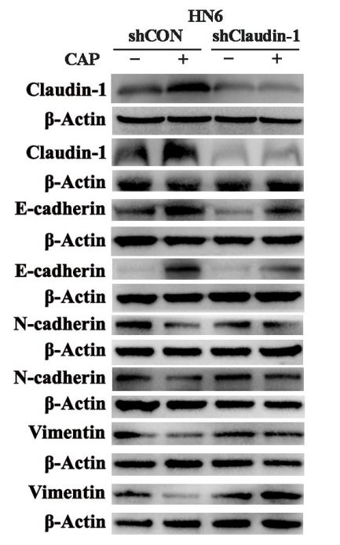
Fig.S5. Claudin-1 knockdown reverses CAP-mediated EMT suppression. The HN6 cell were transfected with shClaudin-1(5'-GTCTTTGACTCCTTGCTGA-3') or shCON and treated with CAP. Protein expression was analyzed by western blot. β-Actin was used as loading control. Claudin-1 deficiency abolished CAP-induced upregulation of E-cadherin and downregulation of N-cadherin and Vimentin. Shown are representative blots from two independent biological replicates.

