Additional file 1

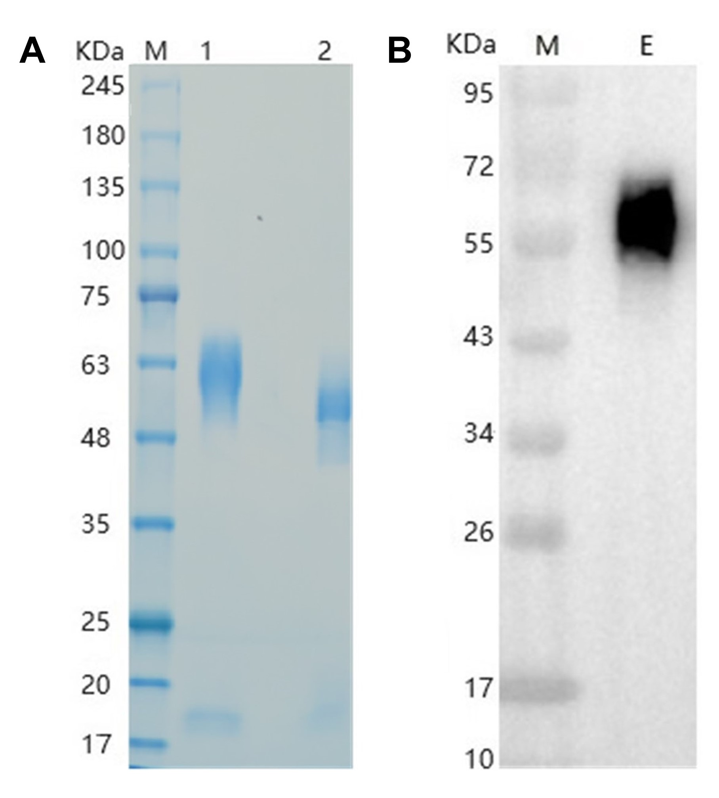

Supplementary Figure S1. Characterization of recombinant ZP3-6×His protein. (A) SDS-PAGE analysis of purified recombinant ZP3-6×His protein under reducing and non-reducing conditions with Coomassie blue staining. (B) Western blot detection of His-tagged ZP3 using anti-His tag antibody. Lane M: Protein marker; Lane 1: Reduced sample; Lane 2: Non-reduced sample.

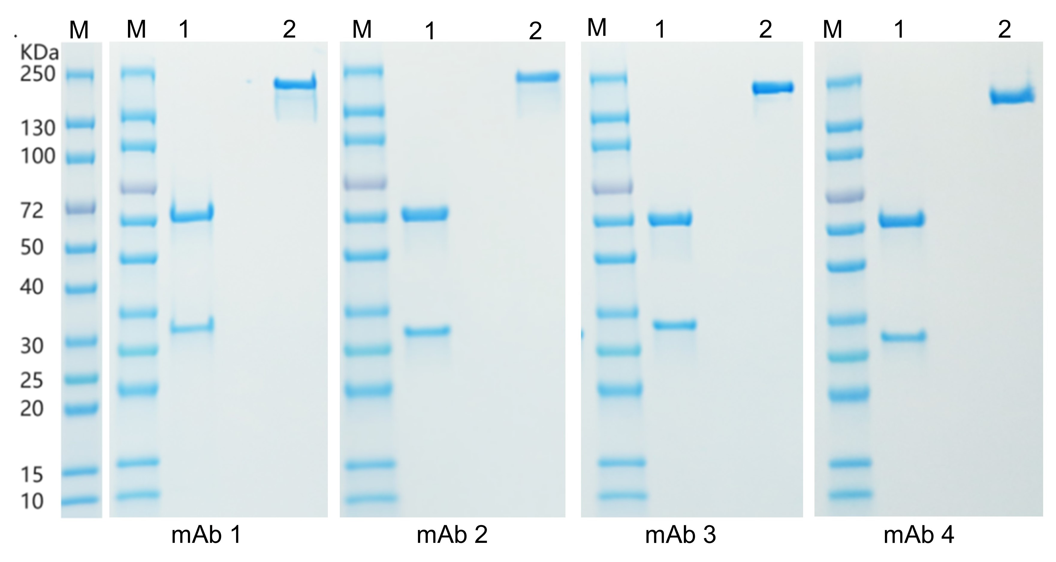
Supplementary Figure S2. SDS-PAGE analysis of purified anti-ZP3 monoclonal antibodies. Purified mAb1–mAb4 were analyzed by SDS-PAGE under reducing and non-reducing conditions. Under reducing conditions, bands corresponding to the heavy chain, approximately 50 kDa, and light chain, approximately 25 kDa, were observed. Under non-reducing conditions, intact IgG appeared as a major band at approximately 150 kDa. Lane M: Protein marker; Lane 1: Reduced sample; Lane 2: Non-reduced sample.

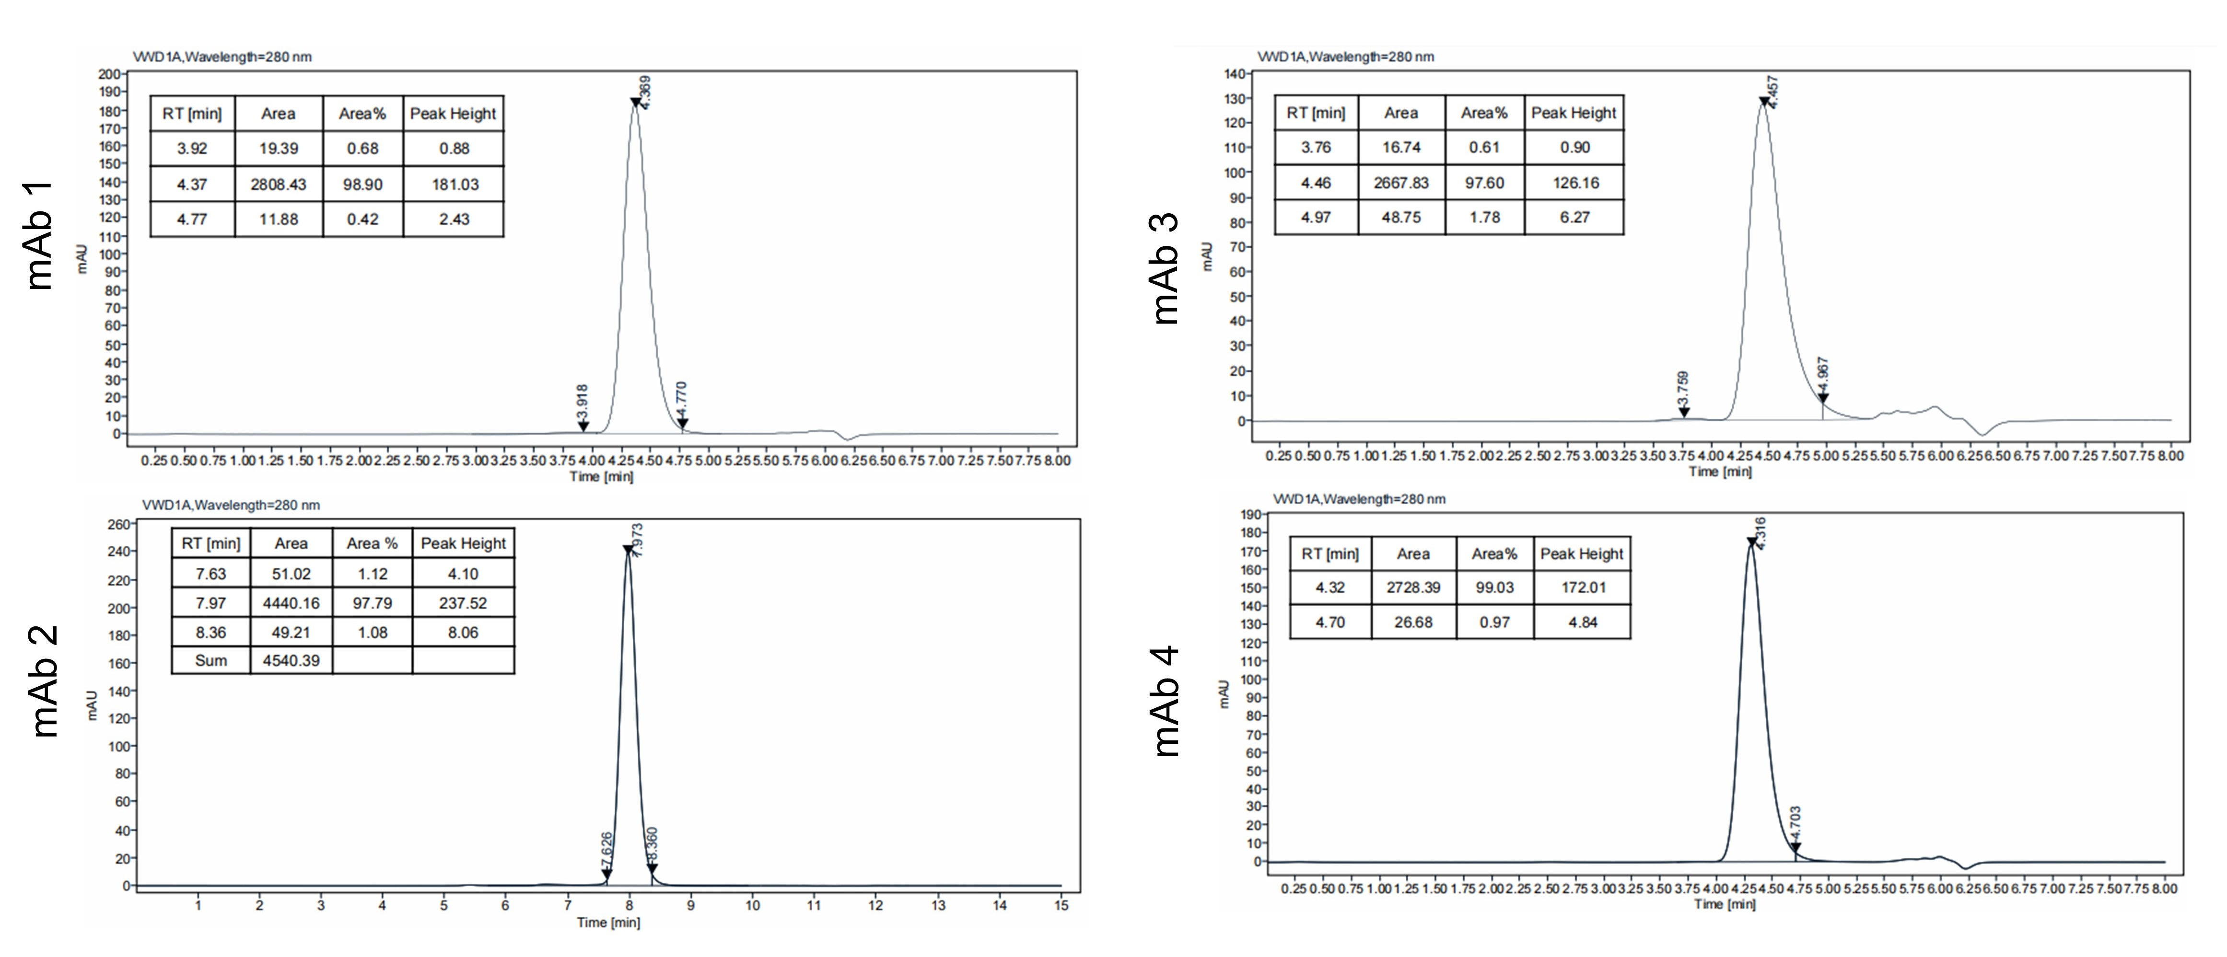
Supplementary Figure S3. SEC-HPLC analysis of anti-ZP3 monoclonal antibodies. SEC-HPLC chromatograms of purified mAb1–mAb4 showing single symmetric main peaks with monomeric purity exceeding 95%.

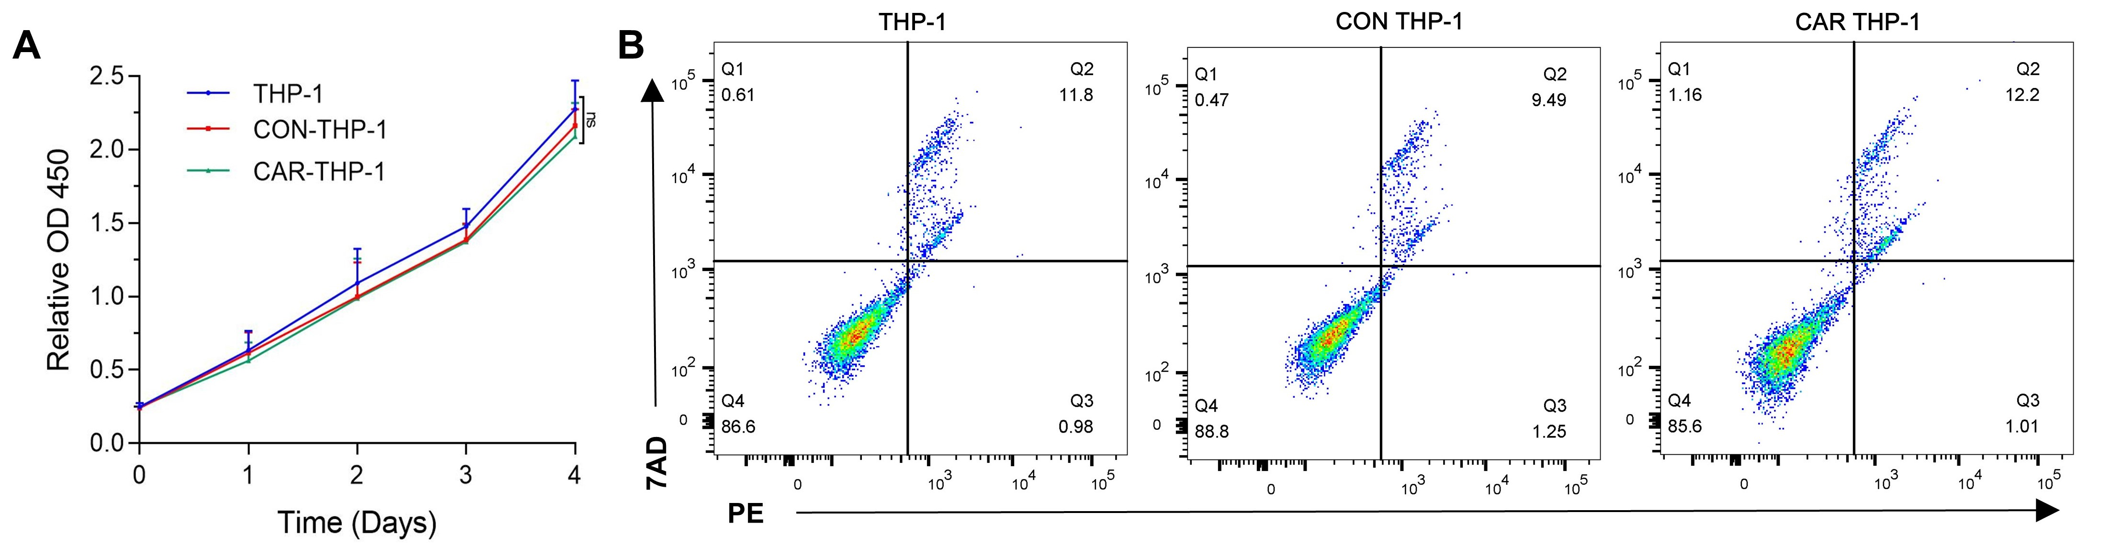
Supplementary Figure S4. Effects of lentiviral transduction on THP-1 cell viability and apoptosis. (A) CCK-8 proliferation assay comparing untransduced THP-1 cells with CAR1-THP-1 and CAR4-THP-1 cells at the indicated time points after transduction. (B) Flow cytometric apoptosis analysis of THP-1 cells stained with Annexin V-FITC and propidium iodide at 72 h after transduction. No significant differences in viability or apoptosis were observed between transduced and control cells.

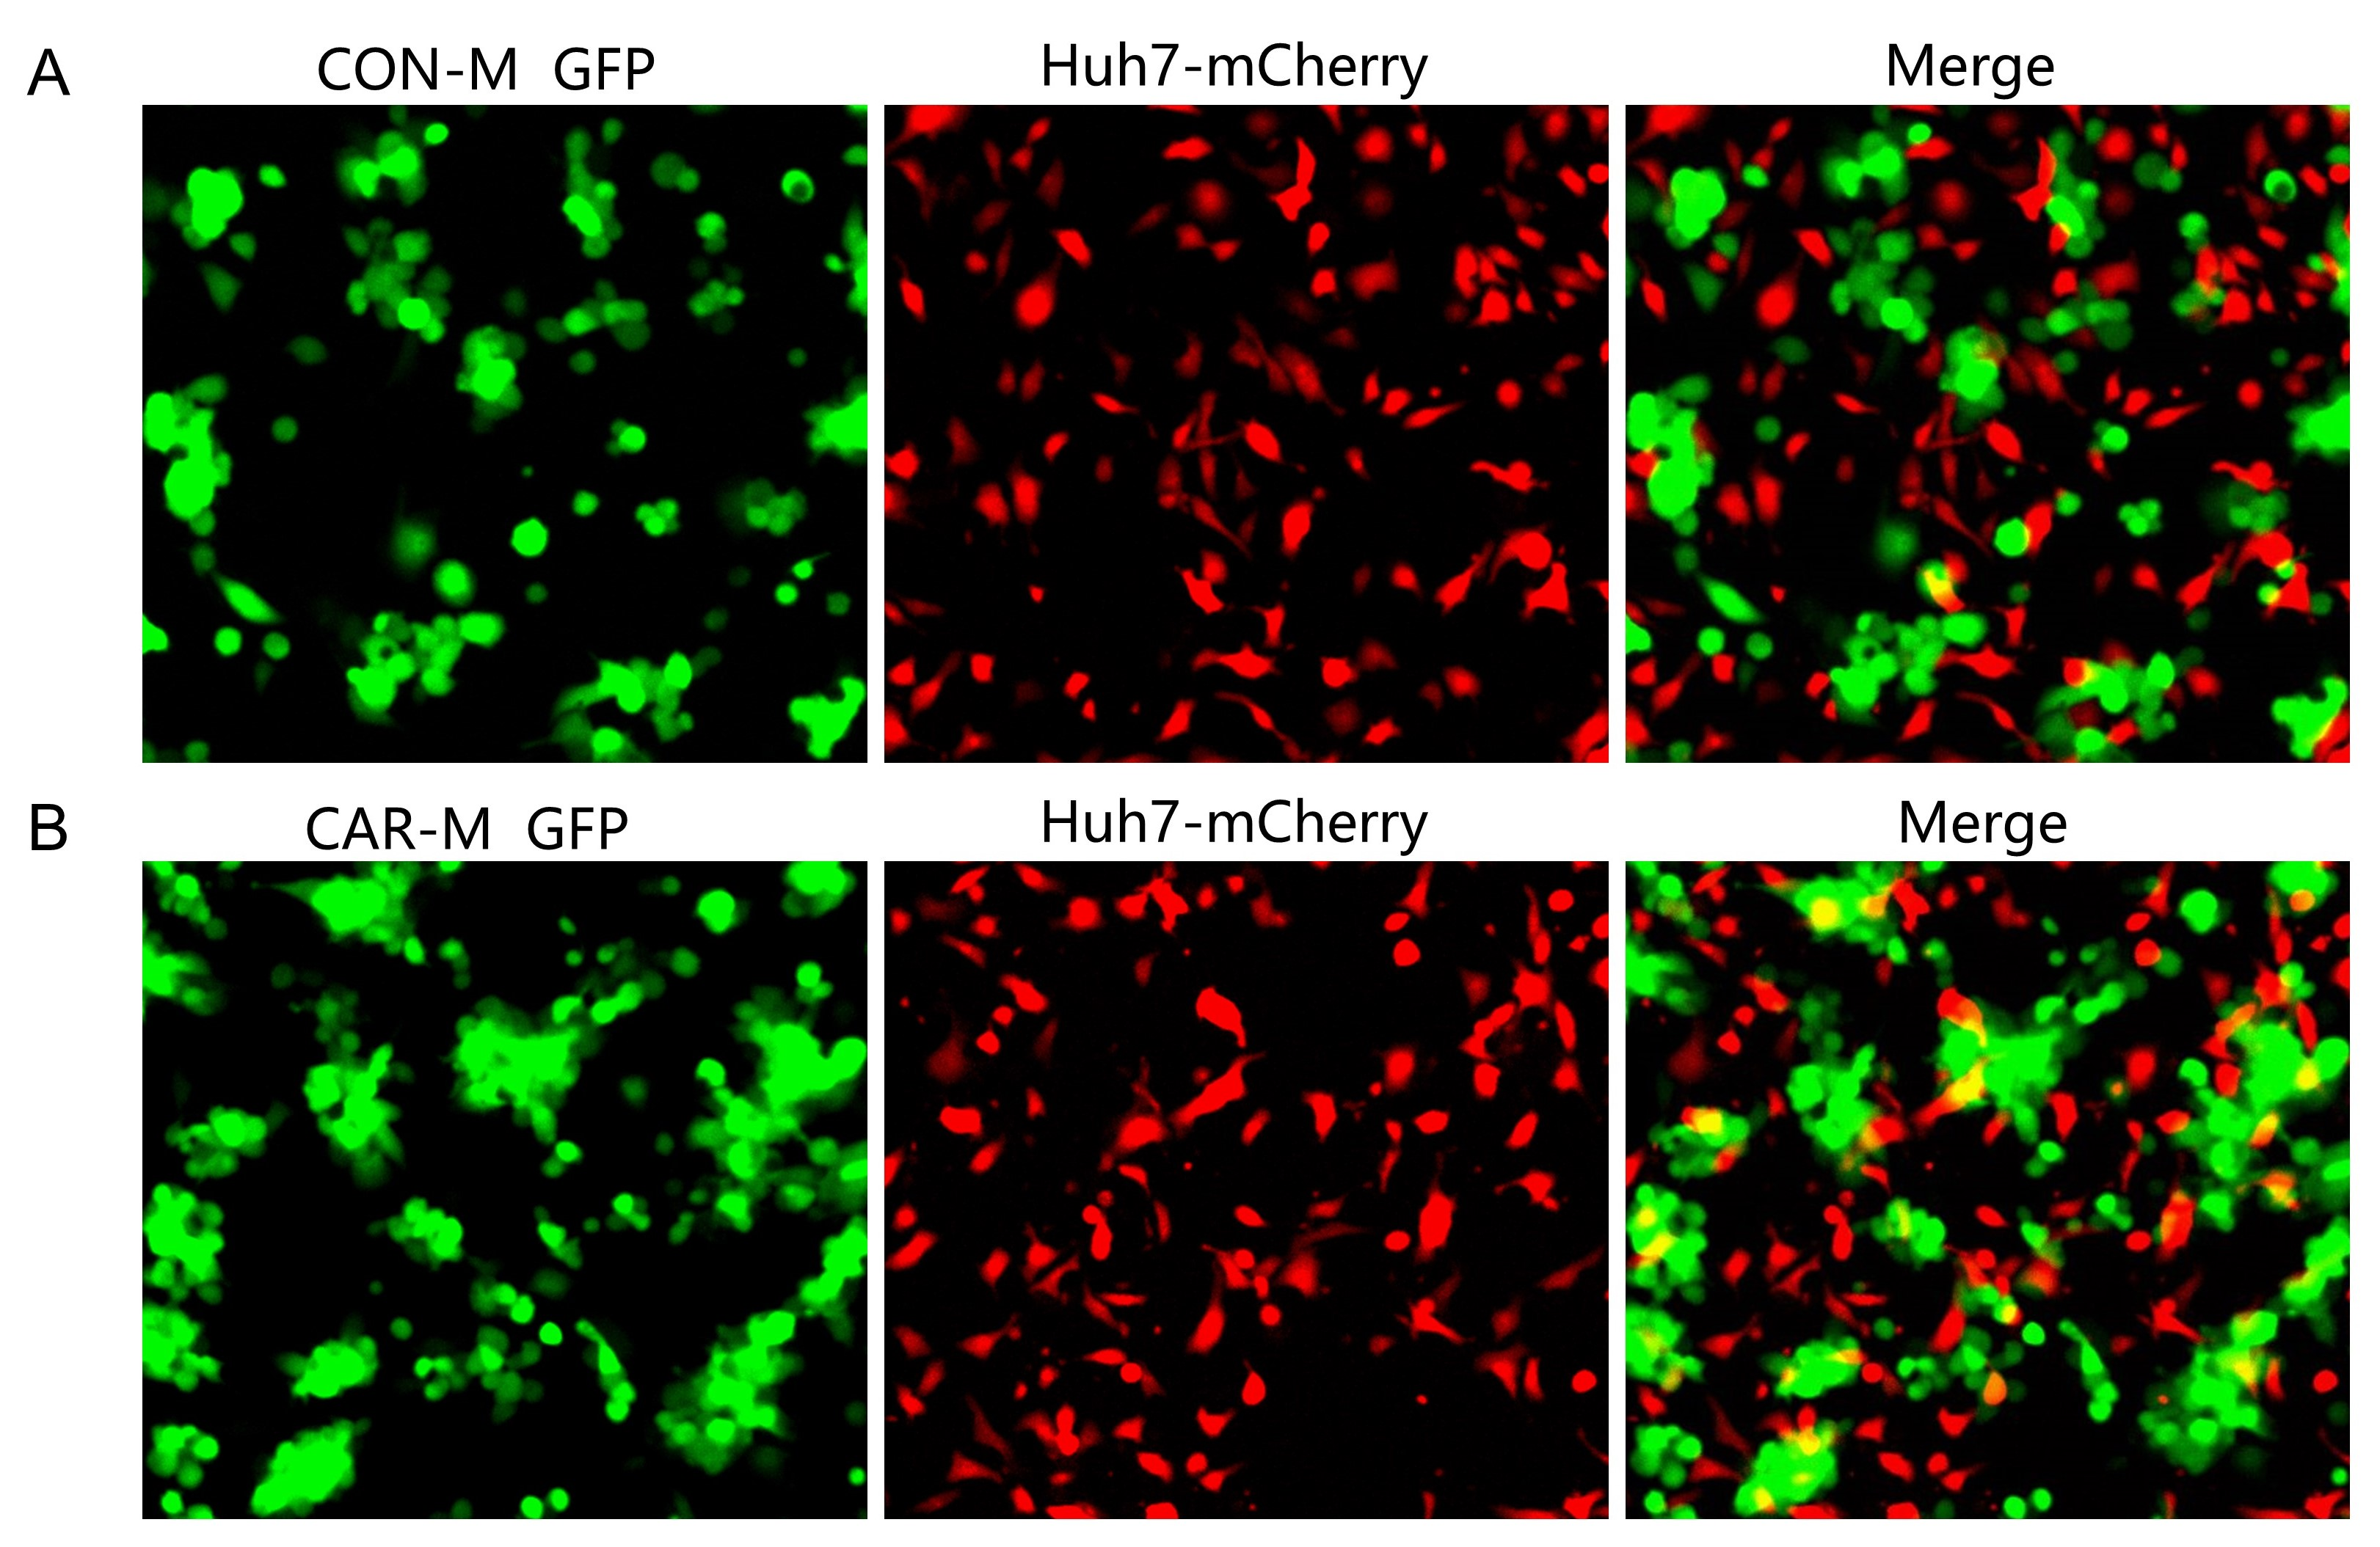
Supplementary Figure S5. Fluorescence microscopy analysis of CAR-M-mediated phagocytosis. (A, B) CON-M or CAR-M cells were co-cultured with Huh7-mCherry target cells at an effector-to-target ratio of 5:1 for 24 h. Representative fluorescence images show macrophage and target-cell morphology. Red fluorescence indicates mCherry-labeled target cells, whereas green fluorescence indicates eGFP-expressing macrophages.

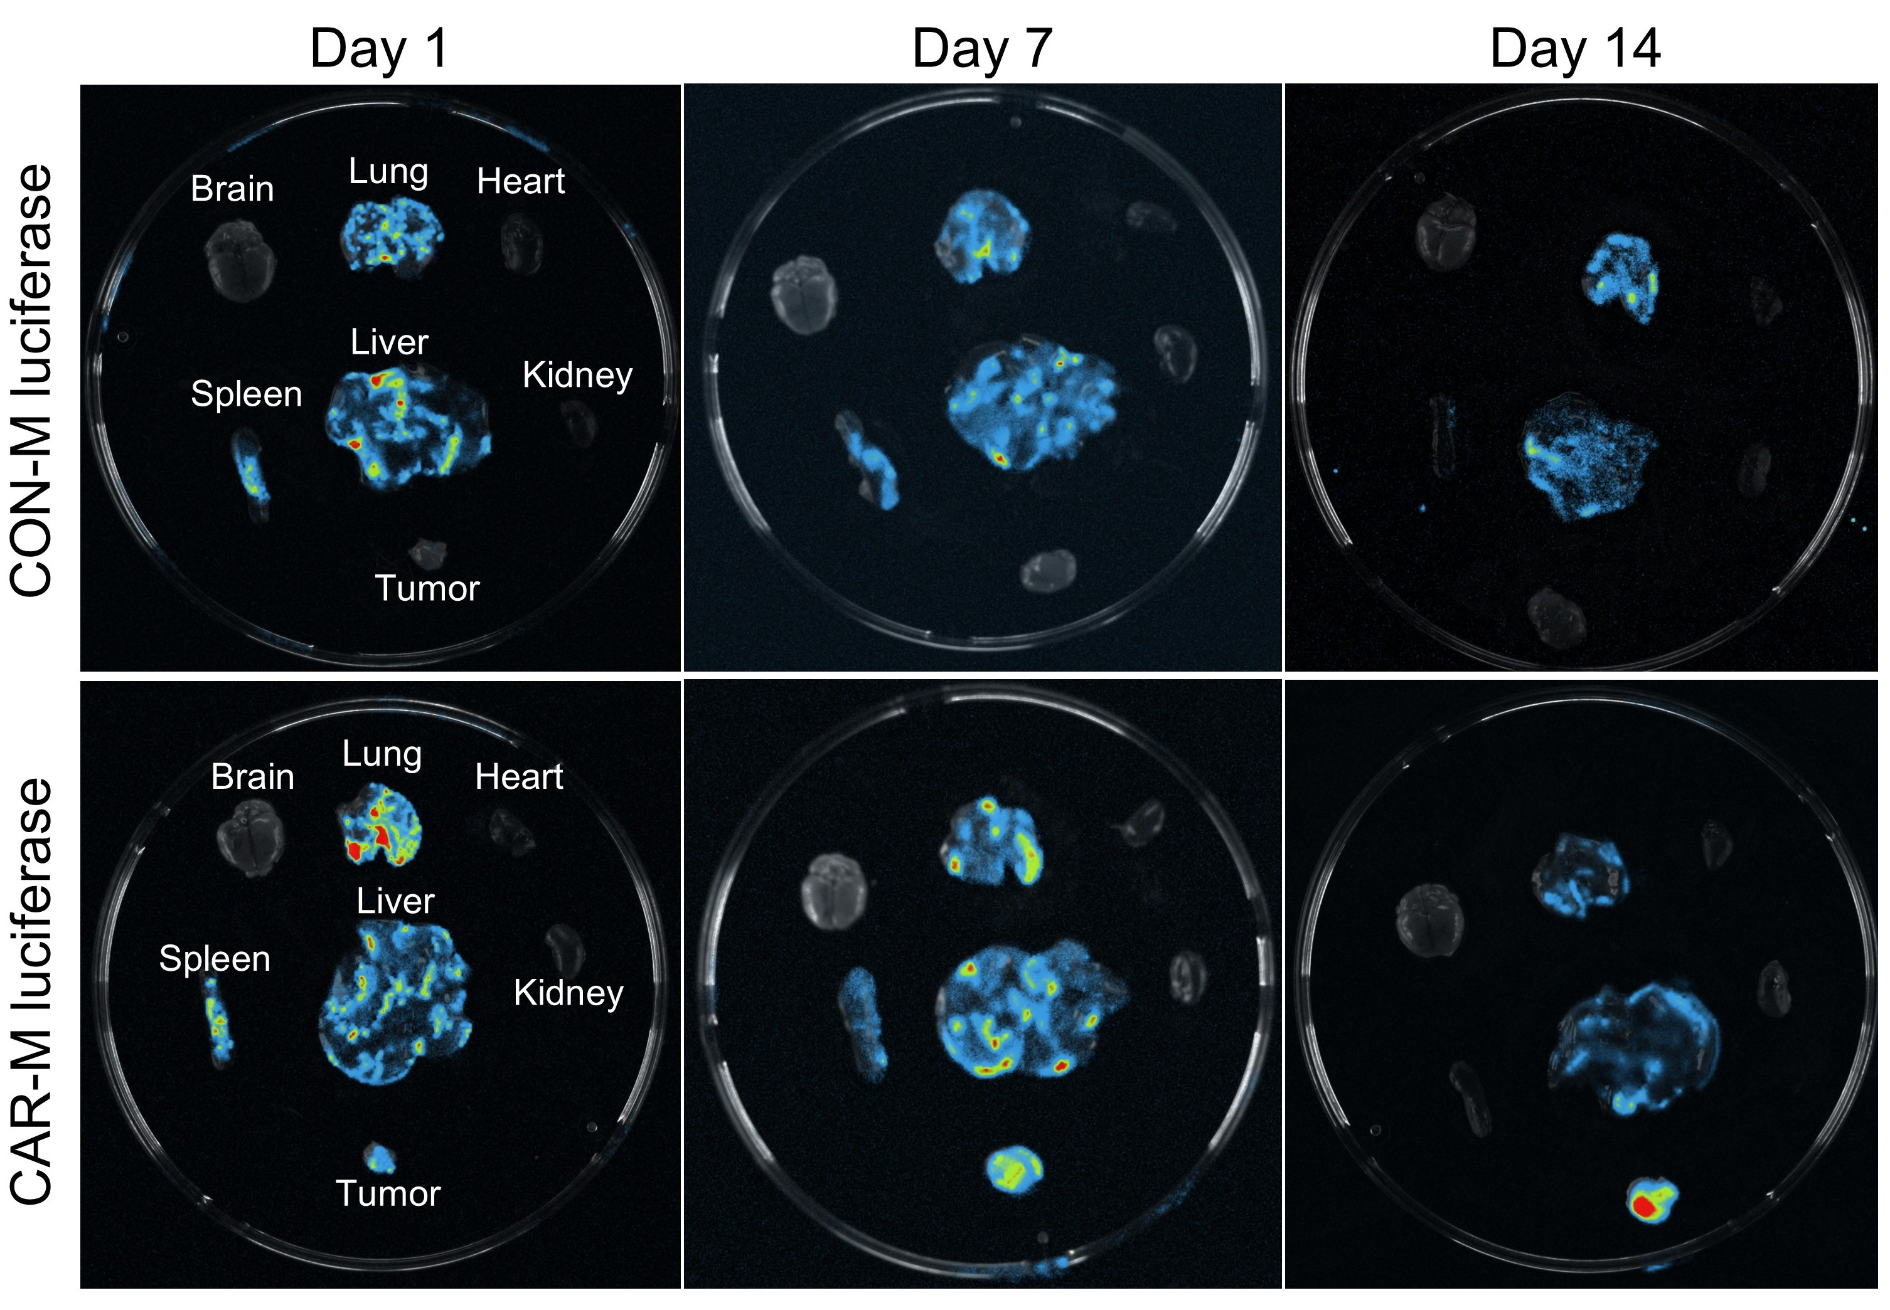
Supplementary Figure S6. Biodistribution of CAR-M and CON-M macrophages. Ex vivo bioluminescence imaging of tumors and major organs on days 1, 7, and 14 after intravenous injection of CAR-M-Luci or CON-M-Luci cells.

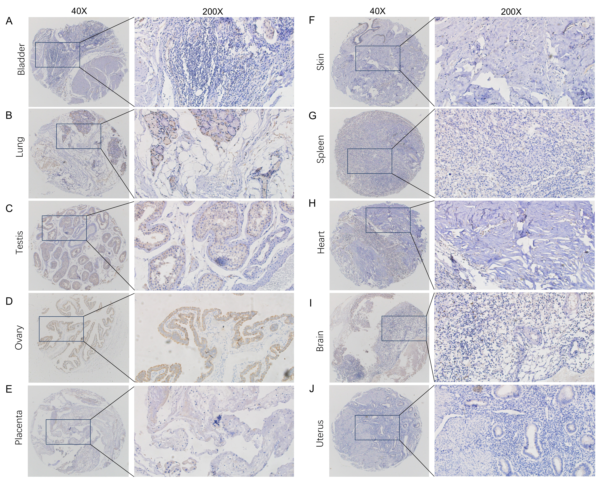
Supplementary Figure S7. Expression levels of ZP3 in normal tissues. (A) Bladder; (B) Lung; (C) Testis; (D) Ovary; (E) Placenta; (F) Skin; (G) Spleen; (H) Heart; (I) Brain; (J) Uterus.

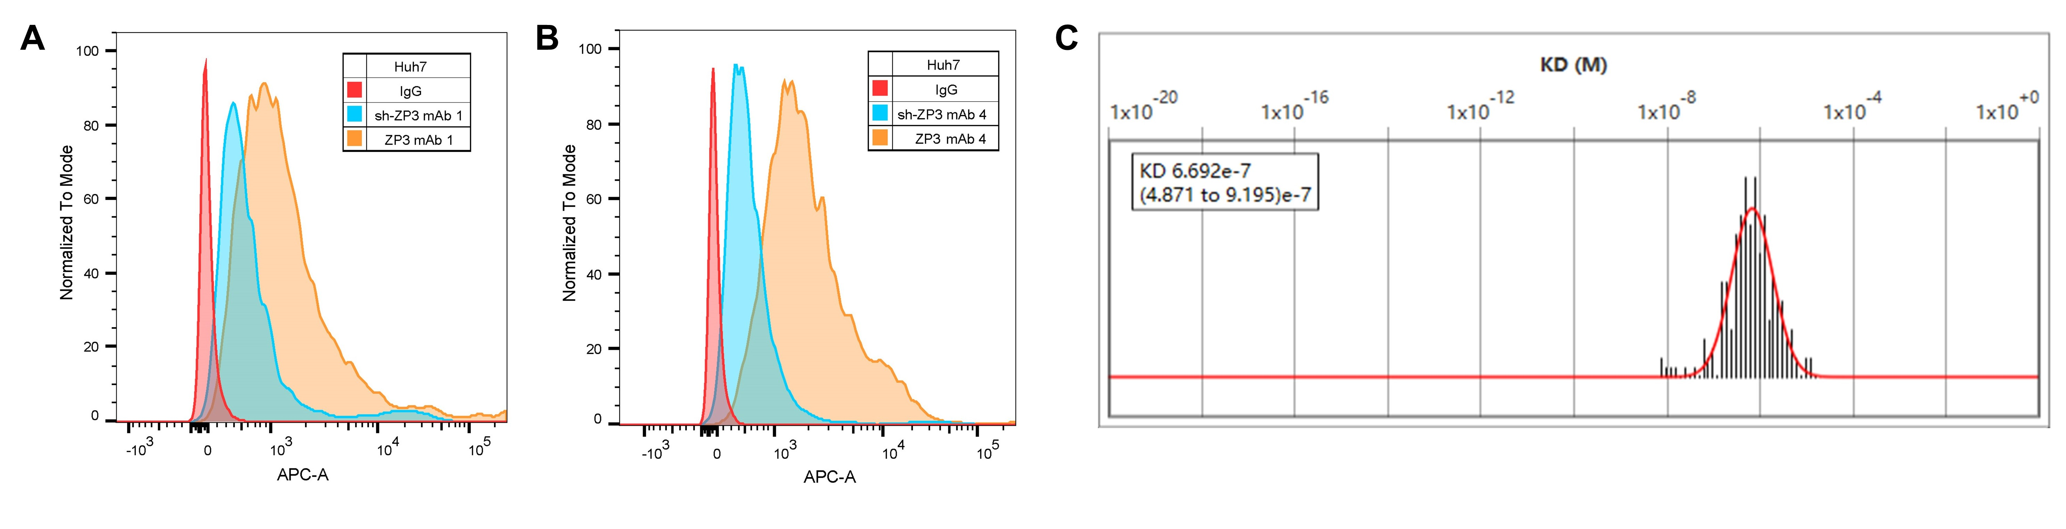
Supplementary Fig. S8. Binding affinity of anti‑ZP3 monoclonal antibodies to Huh7 cells. (A-B) Flow cytometric analysis of mAb1 (A) and mAb4 (B) binding to Huh7‑NC (control) and ZP3‑knockdown (Huh7‑ZP3‑sh) cells, demonstrating ZP3‑specific recognition. (C) Equilibrium dissociation constant (KD) distribution obtained from global fitting of SPR binding data for mAb1 to Huh7 cells.

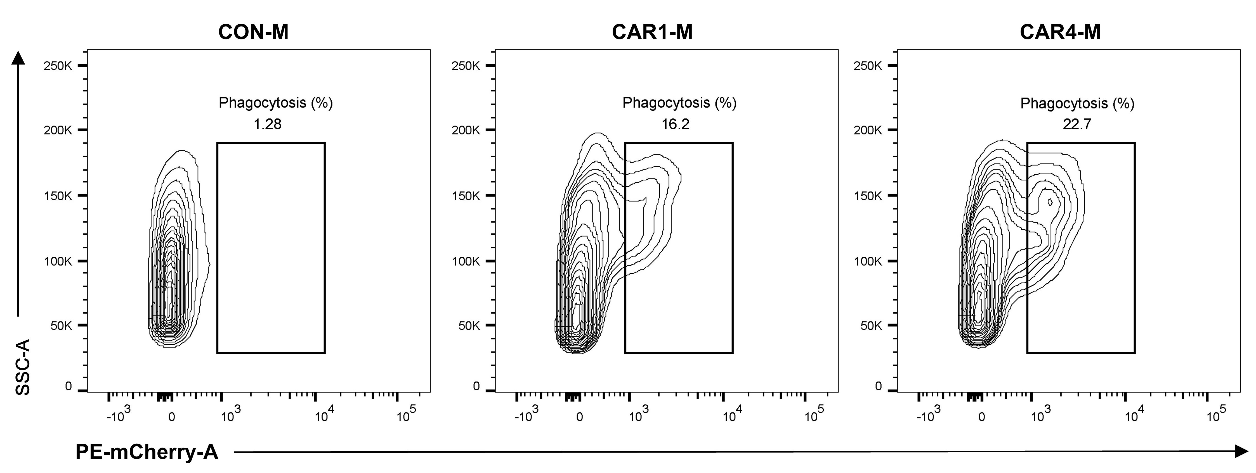
Supplementary Fig. S9. Phagocytic efficiency of the two CAR‑M constructs against Huh7 cells was evaluated by flow cytometry, quantifying the proportion of mCherry⁺ target cells within the GFP⁺ macrophage population.

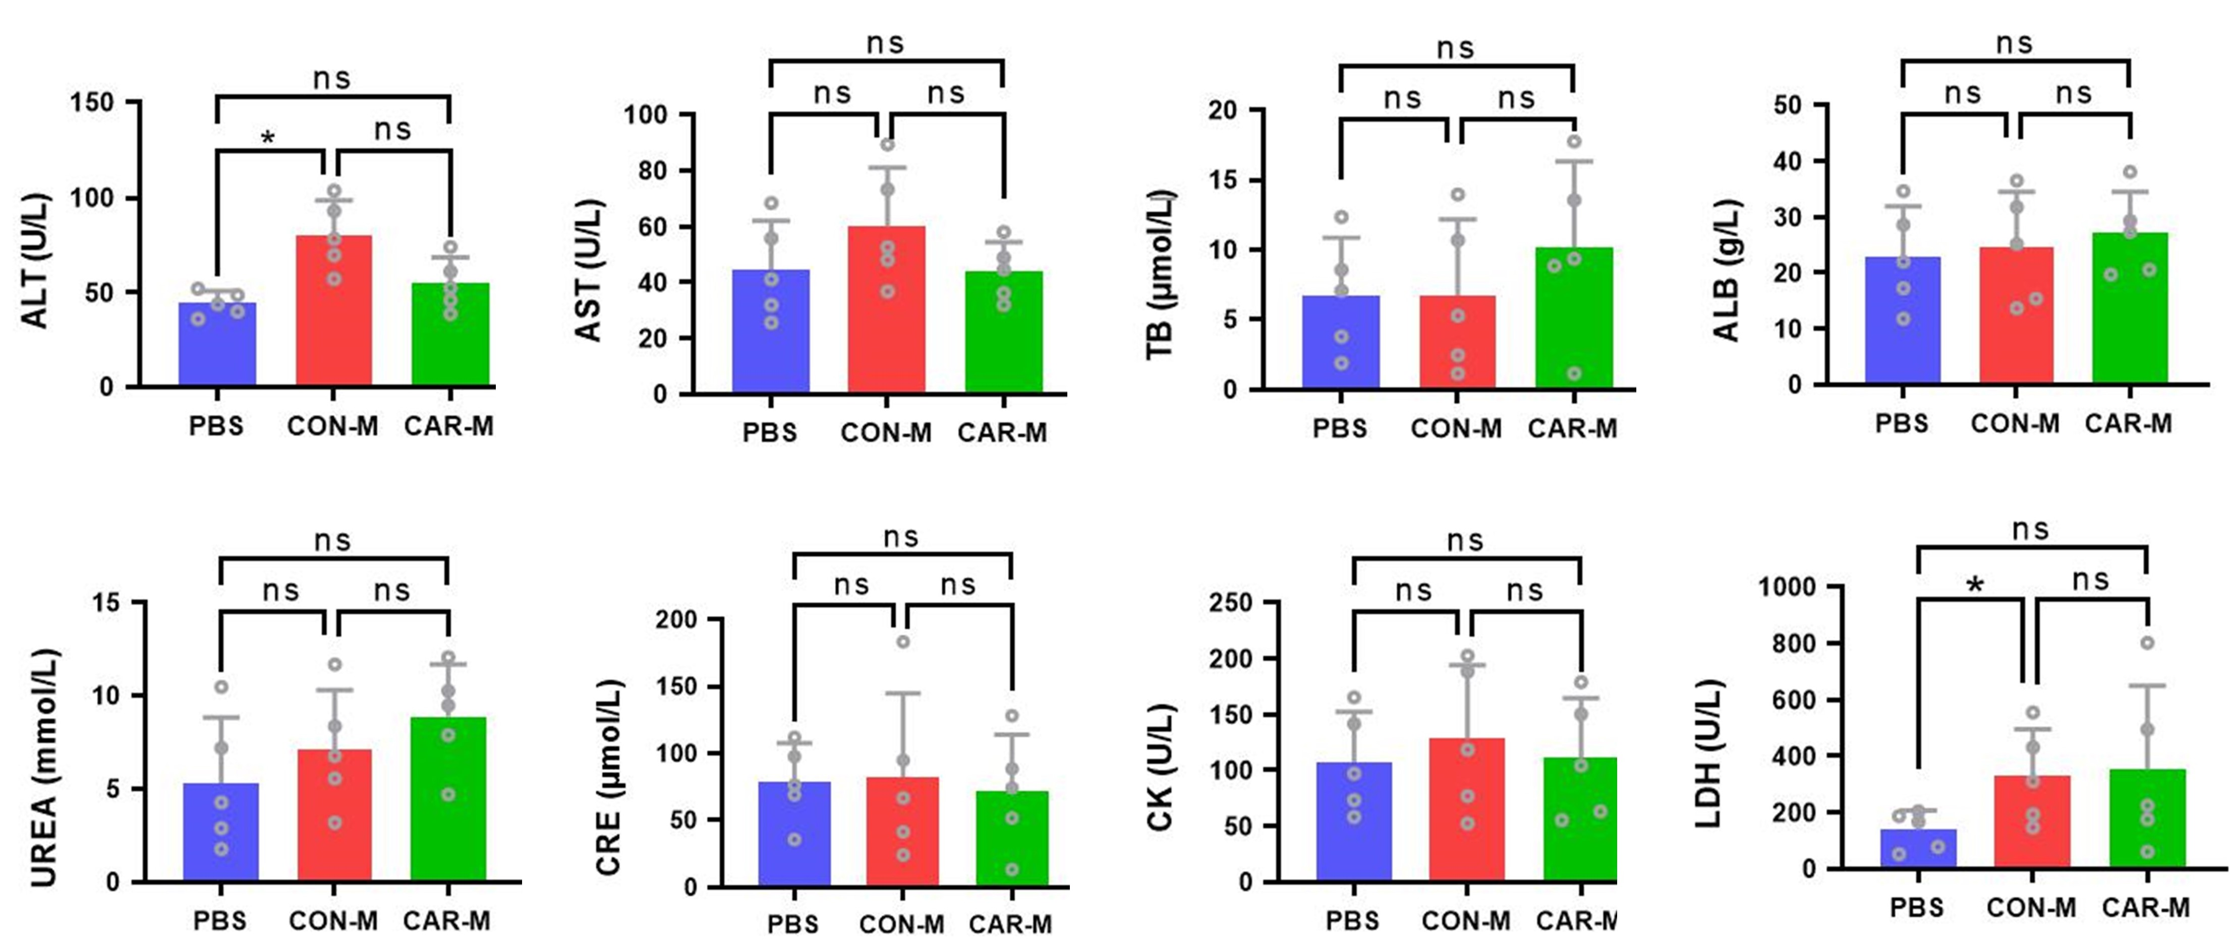
Supplementary Fig. S10. Serum biochemical parameters in PBS, CON‑M, and CAR‑M treatment groups. Liver function markers (ALT, AST, ALB, TB), renal function indices (UREA, CRE), and cardiac enzyme markers (LDH, CK) were measured. No significant differences were observed between the CAR‑M group and the PBS or CON‑M control groups. Data are shown as mean ± SD. Statistical analysis was performed using one‑way ANOVA. n = 5 mice per group. *p<0.05,^{ns} p>0.05.

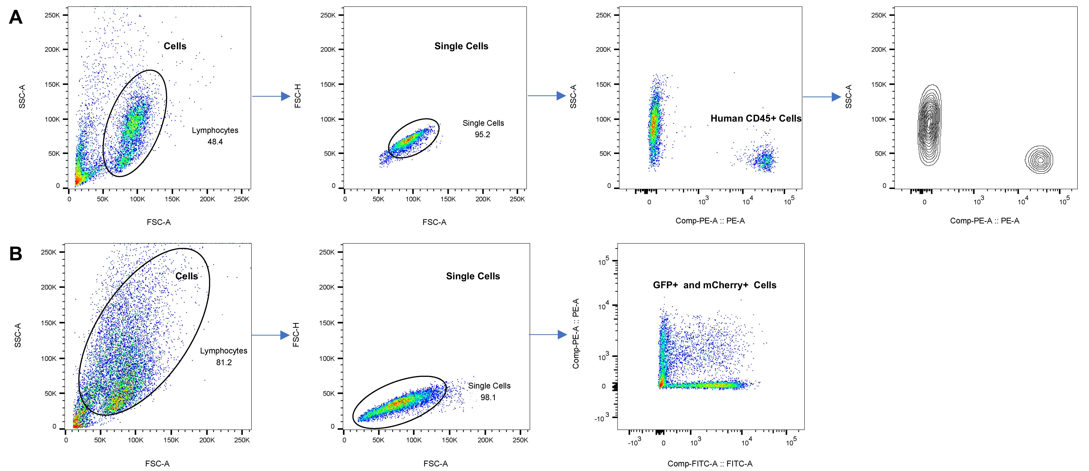
Supplementary Fig. S11. Gating strategy for flow cytometry analyses. (A) Gating strategy for analyses in Fig.3 E. (B) Gating strategy for analyses in Fig.5 A.

