- Antibody
Name | Brand | Cat.
COL1A1 | Abclonal | A1352
α-SMA | Abclonal | A1399
β-Tubulin | Proteintech | 10094-1-AP
p-SMAD2 | CST | 138D4
SMAD2 | CST | D43B4
p-SMAD3 | CST | C25A9
SMAD3 | CST | C67H9
p-SMAD2/3 | CST | D27F4
SMAD2/3 | CST | D6G7
SMAD4 | Abclonal | A5657
HSP90α | Abclonal | A0365
pan-AcK | Abclonal | A1525
LaminB1 | Abclonal | A11495
β-actin | Abclonal | AC206
HDAC1 | Abclonal | A26492
HA-tag | CST | C29F4
Flag-tag | Abclonal | AE092
Col1a1 | Abclonal | A27820
Acta2 | Abclonal | A17910
Actb | Abclonal | AC038
AKT | CST | 9272
p-AKT | CST | D9E
Rabbit anti-IgG | CST | 3900
Mouse anti-IgG | CST | 5415S
HRP-conjugated goat anti-rabbit | Abclonal | AS029
HRP-conjugated goat anti-mouse | Abclonal | AS014

2. Primers for plasmids
Name | Sequence
HDAC1 | F: cttggtaccgagctcggatccATGGCGCAGACGCAGGGC  R: tgctggatatctgcagaattcGGCCAACTTGACCTCCTCCT
HDAC2 | F: cttggtaccgagctcggatccATGGCGTACAGTCAAGGAGGC  R: tgctggatatctgcagaattcGGGGTTGCTGAGCTGTTCTG
HDAC3 | F: cttggtaccgagctcggatccATGGCCAAGACCGTGGCC  R: tgctggatatctgcagaattcAACTAATACCTTCCCATTTACTTTTTCC
HDAC10 | F: cttggtaccgagctcggatccATGGGGACCGCGCTTGTG  R: tgctggatatctgcagaattcAGCCACCAGGTGAGGATGG
HDAC11 | F: cttggtaccgagctcggatccATGGGCCTGGAGAAGCTGC  R: tgctggatatctgcagaattcTCAGGGCACTGCAGGGGG
SMAD2 | F: cttggtaccgagctcggatccATGTCGTCCATCTTGCCATTCA  R: tgctggatatctgcagaattcTGACATGCTTGAGCAACGCA
SMAD3 | F: cttggtaccgagctcggatccATGGAGCTGTGTGAGTTCGCC  R: tgctggatatctgcagaattcAGACACACTGGAACAGCGGATG
SMAD4 | F: cttggtaccgagctcggatccATGGACAATATGTCTATTACGAATACACC  R: tgctggatatctgcagaattcGTCTAAAGGTTGTGGGTCTGCAA
SMAD4-K45R | F: GTTTGGTAAgGAAGCTGAAGGAGAAAAAAGATGAA  R: CAGCTTCcTTACCAAACTTTCAATTGCTCTTTTT
SMAD4-K428R | F: GTTCATAgGATCTACCCAAGTGCATATATAAAGGTC  R: GGGTAGATCcTATGAACAGCATCTCCAGGTGC
HDAC1-H141A | F: CCTGCACgATGCAAAGAAGTCCGAGGCATCTG  R: TCTTTGCATcGTGCAGGCCCCCAGCCCAATTC
Note: The lowercase letters represent the homologous arm parts of the plasmid vector.

- Primers for qPCR
COL1A1 | F: GAGGGCCAAGACGAAGACATC  R: CAGATCACGTCATCGCACAAC
ACTA2 | F: GCGGACCATCATAGGTTCCTT  R: ACTGGCTTGTCTAACAGGATTCT

- Reagents
Name | Brand | Cat
TGF-β1 | PeproTech | 100-21
CUDC-907 | MCE | HY-13522
HDACi | MCE | HY-K0030
LY294002 | MCE | HY-10108
Anti-Pulmonary Fibrosis Compound Library (Targeted HDAC) | MCE | HY-L125

- Sequence of si-RNA
HDAC1 | CGTTCTTAACTTTGAACCATA
SMAD4 | TACCATACAGAGAACATTGGA

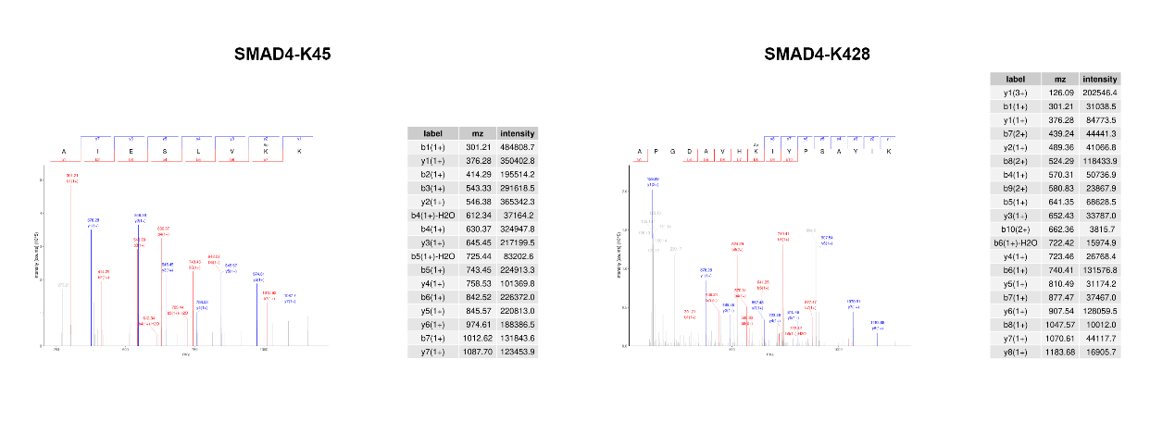
- MS spectra

