Supplementary Table S1. Sequences of the primers used in real time quantitative PCR.
Gene | Forward primer | Reverse primer
OTUD1 | AGAGGCAGGACAAGTACCTGA |  | CCCGTACACAGTCTTGCTGAC
NPPa | GCTTCCAGGCCATATTGGAG |  | GGGGGCATGACCTCATCTT
NPPb | TCCTTAATCTGTCGCCGCTG |  | AGGCGCTGTCTTGAGACCTA
Acta2 | TCAGCGTTCAGCCTCC |  | CCAGAGCCATTGTCGC
Col1a1 | CTGGCAAGAAGGGAGATGA |  | CACCATCCAAACCACTGAAA
Col3a1 | ACAGCAAATTCACTTACACAGTTC |  | CTCATTGCCTTGCGTGTTT
Fn1 | AAGGTTCGGGAAGAGGTTGT |  | ACTCCTCTCCAATGGCGTAA
GAPDH | CCCTTATTGACCTCAACTACA |  | TGGTGAGGGGCCATCCACAGTCTTCTG

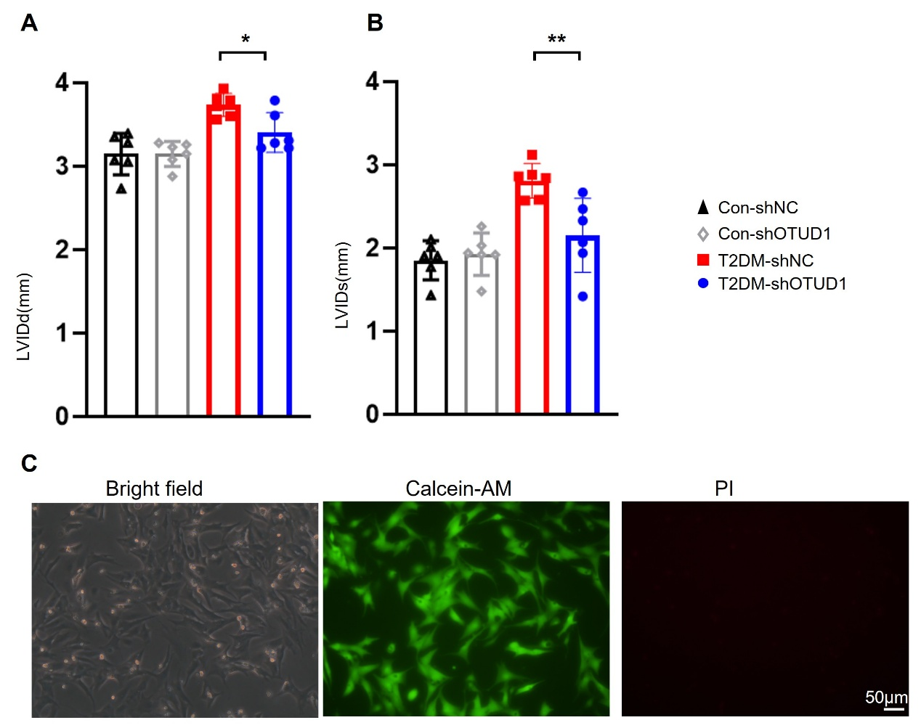
Supplementary Figure S1
Figure S1 Effects of OTUD1 knockdown on left ventricular dimensions and NMCMs viability. (A) Quantification of LVIDd (mm). (B) Quantification of LVIDs (mm). (C) Cell viability assay of NMCMs, scale bar = 50 μm. Data are shown as mean ± SD (n = 6 per group). P values were determined by one-way ANOVA followed by Tukey post hoc tests. * p < 0.05; ** p < 0.01.

