Table S1. Sequences of siRNAs used in this study.
Gene | Sense (5’-3’) | Antisense (5’-3’)
BMP8B siRNA-1 | GUGCUCUACUAUGACAGCATT | UGCUGUCAUAGUAGAGCACTT
BMP8B siRNA-2 | CCUGAUGAUGCCAGACGCATT | UGCGUCUGGCAUCAUCAGGTT
BMP8B siRNA-3 | UGGGCCUGGCGCUAUGCGCTT | GCGCAUAGCGCCAGGCCCATT
SULF2 siRNA-1 | GGUUCCAUGCAGGUGAUGATT | UCAUCACCUGCAUGGAACCTT
SULF2 siRNA-2 | GCCAACCCCAUUAAAGUGATT | UCACUUUAAUGGGGUUGGCTT
SULF2 siRNA-3 | GGACAAACACUGGAUCAUGTT | CAUGAUCCAGUGUUUGUCCTT
ALK4 siRNA-1 | GACCCUUCCAUUGAGGAAATT | UUUCCUCAAUGGAAGGGUCTT
ALK4 siRNA-2 | GGCUUGUAUAUUGGGAGAUTT | AUCUCCCAAUAUACAAGCCTT
ALK4 siRNA-3 | GAAGCCUGGAAUUGCUCAUTT | AUGAGCAAUUCCAGGCUUCTT
ALK5 siRNA-1 | GGGUCUGUGACUACAACAUTT | AUGUUGUAGUCACAGACCCTT
ALK5 siRNA-2 | GUGGAAUUCAUGAAGAUUATT | UAAUCUUCAUGAAUUCCACTT
ALK5 siRNA-3 | CUCGAUGAUUCCAUAAAUATT | UAUUUAUGGAAUCAUCGAGTT
ACVR2A siRNA-1 | ACUGCUAUGACAGGACUGATT | UCAGUCCUGUCAUAGCAGUTT
ACVR2A siRNA-2 | AGUUGCUUAACGAAUAUGUTT | ACAUAUUCGUUAAGCAACUTT
ACVR2A siRNA-3 | GGUGCCACUUAUGUUAAUUTT | AAUUAACAUAAGUGGCACCTT
ACVR2B siRNA-1 | ACACGGGAGUGCAUCUACUTT | AGUAGAUGCACUCCCGUGUTT
ACVR2B siRNA-2 | GUAGCAGAGACGAUGUCACTT | GUGACAUCGUCUCUGCUACTT
ACVR2B siRNA-3 | GCUCCAACCUCGAAGUAGATT | UCUACUUCGAGGUUGGAGCTT
BMPR2 siRNA-1 | GCCGAACUAAUUCCAAUAATT | UUAUUGGAAUUAGUUCGGCTT
BMPR2 siRNA-2 | CUCUCUUGAUCUAGAUAAUTT | AUUAUCUAGAUCAAGAGAGTT
BMPR2 siRNA-3 | GGAGUUGCCAAGAUGAAUATT | UAUUCAUCUUGGCAACUCCTT
Negative control siRNA | UUCUCCGAACGUGUCACGUTT | ACGUGACACGUUCGGAGAATT

Table S2. Primer sequences for RT–qPCR.
Gene | Primer Sequence (5’-3’)
Gene | Forward | Reverse
BMP8B | CTATGTGGAGACTGAGGACGG | AGAAAGTGACCACGAAAGGC
SULF2 | CGGAACGGGGTGAAAGAGAA | AAGCTCACGCTGTCATTGGT
ALK4 | TCCCAACATCCCCAACTGGT | ACCAACACTCTCGCATCATCT
ALK5 | AACAAAAAGGTACATGGCCCC | CCACCAATGGAACATCGTCG
ALK7 | GTGACCGTGGCTGGAATGAT | AGCCAACCCTAAGTCCGCTA
ACVR2A | CCGGAGATGGAAGTCACACA | GCACAAATGACAATCCCCGC
ACVR2B | CTCCTCTGGGGATCGCTGT | CTCCCAGTTGGCGTTGTAGT
BMPR2 | AGACCCAAGTTCCCAGAAGC | GCCATCCTTTCCTCAGCACA
CGB | ACCCCTTGACCTGTGAT | CTTTATTGTGGGAGGATCGG
ERVW-1 | GTTAATGACATCAAAGGCACCC | CCCCATCTCAACAGGAAAACC
ERVFRD-1 | CCTCCCATTTTCGGACCCAT | GGAATCTTGGTTGATGGCGG
GCM1 | AACAGCTACGTCCAGTCTCC | TGCTCTTGCTTGGCAGTGAA
BMP8A | GGTGTCAGGACAAGTCCCC | ATGGCAGATAGGCCCCAAGT
GAPDH | GGAGCGAGATCCCTCCAAAAT | GGCTGTTGTCATACTTCTCATGG

Table S3. Summary of primary antibodies used in this study.
Antibody | Host Species | Manufacturer | Catalog Number | Dilution
BMP8B | Rabbit | Abnova | PAB25185 | 1:1000 (WB)  1:200 (IHC)
BMP8B | Rabbit | Abcam | ab181253 | 1:1000 (WB)  1:200 (IF)
Phospho-AKT | Rabbit | CST | 9271 | 1:1000 (WB)
AKT | Rabbit | CST | 9272 | 1:1000 (WB)
Phospho- Erk1/2 | Rabbit | CST | 4370 | 1:1000 (WB)
Erk1/2 | Rabbit | CST | 9102 | 1:1000 (WB)
Phospho-FAK | Rabbit | CST | 8556 | 1:1000 (WB)
FAK | Rabbit | CST | 3285 | 1:1000 (WB)
Phospho-SMAD1/5/9 | Rabbit | CST | 13820 | 1:1000 (WB)
SMAD1/5/9 | Rabbit | CST | 12534 | 1:1000 (WB)
Phospho-SMAD2 | Rabbit | CST | 18338 | 1:1000 (WB)
SMAD2 | Rabbit | CST | 5339 | 1:1000 (WB)
Phospho-SMAD3 | Rabbit | CST | 9520 | 1:1000 (WB)
SMAD3 | Rabbit | CST | 9523 | 1:1000 (WB)
ALK4 | Rabbit | Proteintech | 10086-1-AP | 1:1000 (WB)
ALK5 | Rabbit | Abcam | ab235578 | 1:1000 (WB)
ACVR2A | Rabbit | Abcam | ab134082 | 1:1000 (WB)
ACVR2B | Rabbit | Abcam | ab180185 | 1:1000 (WB)
BMPR2 | Rabbit | Abcam | ab96826 | 1:1000 (WB)
Cytokeratin 7 | Rabbit | Proteintech | 17513-1-AP | 1:400 (IF)
HLA-G | Mouse | Proteintech | 66447-1-Ig | 1:400 (IF)
SULF2 | Rabbit | Proteintech | 12260-1-AP | 1:1000 (WB)
hCG-β | Rabbit | Proteintech | 11615-1-AP | 1:400 (IF)
hCG-β | Rabbit | Abcam | ab317567 | 1:1000 (WB)
E-cadherin | Mouse | Proteintech | 60335-1-Ig | 1:400 (IF)
HRP-conjugated β-Actin | Mouse | Proteintech | HRP-60008 | 1:5000 (WB)
HRP-conjugated GAPDH | Mouse | Proteintech | HRP-60004 | 1:10000 (WB)

Table S4. Multiple linear regression for placental BMP8B expression adjusted for gestational age (GA).
Measurement | Variable | β (regression coefficient) | P value
BMP8B mRNA  (RT–qPCR) | Group (PE vs NP) | -0.499 | 0.026
BMP8B mRNA  (RT–qPCR) | GA | 0.024 | 0.360
BMP8B protein  (western blot) | Group (PE vs NP) | -0.356 | 0.008
BMP8B protein  (western blot) | GA | -0.023 | 0.126

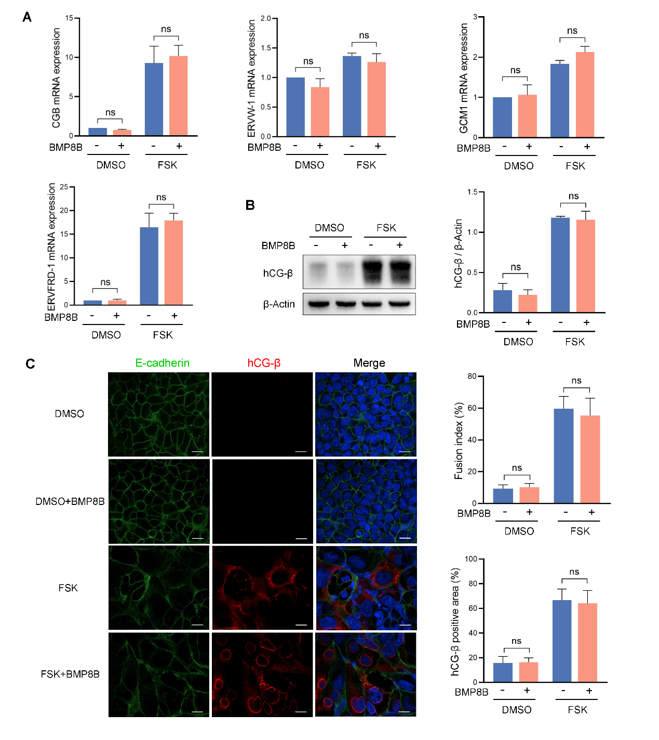
Fig. S1. BMP8B treatment exerts no impact on trophoblast cell syncytialization.
(A-C) BeWo cells were exposed to DMSO, FSK, DMSO supplemented with BMP8B, or FSK supplemented with BMP8B for a duration of 48 h. (A) Relative mRNA levels of CGB, ERVW-1, GCM1, and ERVFRD-1 (Syncytin 2) were measured by RT–qPCR, with GAPDH as the internal loading control. (B) The protein levels of hCG-β were assayed by Western blot analysis. β-Actin was used as the internal loading control. (C) Representative immunofluorescence images of hCG-β (red) and E-cadherin (green) in BeWo cells. Cell nuclei were labeled using DAPI staining. The right panel displays the quantitative analysis results of trophoblast fusion and the hCG-β-positive area. Scale bars, 20 µm. n = 3 biological replicates. Quantitative data are presented as mean ± SEM. ns = not significance.

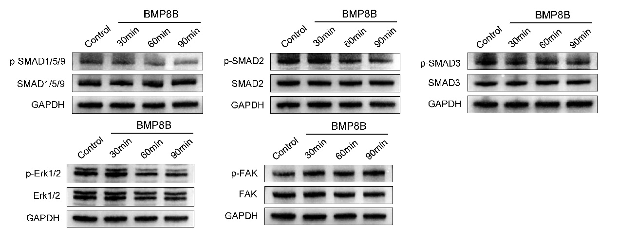
Fig. S2. BMP8B failed to induce phosphorylation in canonical and non-canonical pathways other than PI3K-AKT in HTR8/SVneo cells.
Western blot analysis showing the phosphorylation status of SMAD1/5/9, SMAD2, SMAD3, Erk 1/2, and FAK in HTR8/SVneo cells at 30, 60, and 90 minutes after BMP8B stimulation. GAPDH was used as the internal loading control. n = 4 biological replicates.

Fig. S3. BMP8B-targeting siRNAs do not change BMP8A mRNA expression in HTR8/SVneo cells and primary EVTs.
HTR8/SVneo cells and primary EVTs were transfected with siNC or siBMP8B for 24 h. Relative mRNA expression levels of BMP8A were measured by RT–qPCR. GAPDH was used as the internal loading control to normalize the results. n = 3 biological replicates. Quantitative data are presented as mean ± SEM. ns = not significance.

