Supplementary Table S1. The siRNA and shRNA sequences used in this study.
siRNA | Sequence (5’-3’)
siZNF366-1 | UUUAUGCAUUGCCAGUAUAAUTT
siZNF366-2 | CGUCAAGCAGGAACCCAUUAATT
siZNF366-3 | CUGACGUGAAGCCUUUCAAAUTT
shHK2-1 | ACTGAGTGTGAGGAGATTCT
shHK2-2 | CTGTGAAGTTGGCCTCATTC
shUBE3A-1 | CGGAATACTCAAGCAAAGAAA
shUBE3A-2 | GCCCAGACACAGAAAGGTTAC

Supplementary Table S2. The primer sequences
primer sequences | Sequence (5’-3’)
ZNF366 Forward | 5’-GCTGAAGAGACACCTCACCA-3’
ZNF366 Reverse | 5’-CCACAAATCCCACACTTATGCT-3’
GAPDH Forward | 5’-ATCTTCCAGGAGCGAGATCCC-3’
GAPDH Reverse | 5′-TGAGTCCTTCCACGATACCAA-3′

Supplementary Table S3：Relationship between ZNF366 expression and the CRC patients’ clinicopathological features
Patients' characteristics | No.of patients | ZNF366(%) |  | χ2 | P
Patients' characteristics | No.of patients | Downregulated expression | Upregulated expression group | χ2 | P
All cases | 50 | 25(50.0%) | 25(50.0%)
Gender
female | 26(52.0%) | 14 | 12 | 0.321 | 0.571
male | 24(48.0%) | 11 | 13 | 0.321 | 0.571
Age
＞60 | 32(64.0%) | 14 | 18 | 1.389 | 0.239
≤60 | 18(36.0%) | 11 | 7 | 1.389 | 0.239
Tumor location
Rectum | 26(52.0%) | 16 | 10 | 2.885 | 0.089
Colon | 24(48.0%) | 9 | 15 | 2.885 | 0.089
T stage
T1-T2 | 20(40.0%) | 6 | 14 | 5.333 | 0.021*
T3-T4 | 30(60.0%) | 19 | 11 | 5.333 | 0.021*
N stage
N0 | 26(52.0%) | 12 | 14 | - | 0.826ª
N1 | 21(42.00%) | 11 | 10 | - | 0.826ª
N2 | 3(6.00%) | 2 | 1 | - | 0.826ª
Clinical stage
I | 12(24.0%) | 4 | 8 | 1.786 | 0.409
II | 14(28.0%) | 8 | 6 | 1.786 | 0.409
III | 24(48.0%) | 13 | 11 | 1.786 | 0.409
Tumor differentiation grade
Well to moderately differentiated | 22(44.0%) | 10 | 12 | 0.325 | 0.569
Poorly differentiated | 28(56.0%) | 15 | 13 | 0.325 | 0.569
vascular invasion
Positive | 12(24.0%) | 4 | 8 | 1.754 | 0.185
Negative | 38(76.0%) | 21 | 17 | 1.754 | 0.185
perineural invasion
Positive | 13(26.0%) | 8 | 5 | 0.936 | 0.333
Negative | 37(74.0%) | 17 | 20 | 0.936 | 0.333
*：P<0.05
ª：P values were derived from Fisher's exact test due to more than 20% of cells having an expected count less than 5.

Supplementary Table S4. Binary logistic regression analysis for advanced T stage
Variables | Univariate analysis |  | Multivariate analysis
Variables | OR (95% CI) | P value | OR (95% CI) | P value
ZNF366 Upregulated expression  (Reference: downregulated expression) | 0.248 (0.074-0.833) | 0.024 | 0.253(0.068-0.935) | 0.039
Age  (Reference: ≤60) | 0.436 (0.126-1.511) | 0.191
Male  (Reference: female) | 0.444 (0.14-1.411) | 0.169
Tumor differentiation grade  (Reference: Well to moderately differentiated) | 0.762 (0.242-2.398) | 0.642
Tumor location  (Reference: Colon) | 1.598 (0.512-4.993) | 0.42
vascular invasion  (Reference: negative) | 1.455 (0.373-5.679) | 0.59
perineural invasion  (Reference: negative) | 12.667 (1.491-107.599) | 0.02 | 12.446(1.393-111.182) | 0.024
N stage  (Reference: N0 stage) | 1.714 (0.545-5.396) | 0.357
Statistically significant values are identified in boldface.
Hosmer-Lemeshow goodness-of-fit test: χ² = 0.533, df = 2, P = 0.766

Supplementary Table S5. Correlation between ZNF366 and HK2 expression and HK2 as an independent predictor of ZNF366 expression.
Multiple linear regression analysis |  | Coefficients(a)
 |  | Unstandardized Coefficients |  | Standardized Coefficients
Model |  | B | Std.Error | Beta | t | Sig.
Model | (Constant) | 4.993 | 0.549 |  | 9.098 | 0
Model | HK2IRS | -0.226 | 0.082 | -0.337 | -2.74 | 0.009
Model | Perineural invasion (positive) | 0.974 | 0.61 | 0.227 | 1.598 | 0.117
Model | Perineural invasion (Negative) | 0
Model | Stage (III) | -0.748 | 0.526 | -0.198 | 1.421 | 0.162
Model | Stage (I+II) | 0
a. Dependent Variable: ZNF366 IRS R²=0.170, F=3.148, P=0.034
Supplementary Table S5: Spearman correlation analysis revealed a significant negative correlation between the expression of ZNF366 and HK2 (rs=-0.338, P<0.05). Multiple linear regression analysis, after controlling for relevant clinicopathological confounding factors, confirmed that HK2 expression level remains an independent predictor of ZNF366 expression level (B=-0.226, Beta=-0.377, P=0.009).

Supplementary Table S6. Key molecular characteristics of CRC cell lines and experimental usage
Cell line | MSI status | APC | P53 status | KRAS | Endogenous HK2 | Endogenous ZNF366 | Experimental usage
HCT116 | MSI-H | Wild-type | Wild-type | Mutant | Moderate | High | ZNF366-knockdown  (loss-of-function)
HT29 | MSS | Mutant | Mutant | Wild | High | Low | ZNF366-overexpression  (gain-of-function)
Caco-2 | MSS | Mutant | Mutant | Wild | High | Low | ZNF366 overexpression, (gain-of-function)
Molecular profiles and experimental applications of the CRC cell lines used in this study. Summary of the MSI status, APC, TP53, and KRAS mutation backgrounds, endogenous expression levels of HK2 and ZNF366, and corresponding experimental usage of HCT116, HT29, and Caco-2 cell lines.

Supplementary Figure S1
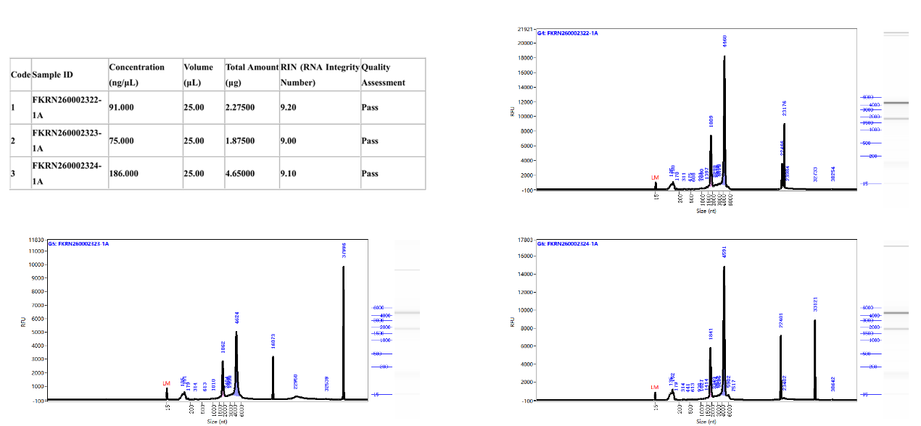
Supplementary Figure S1：Quality assessment of RNA integrity from cryopreserved tumor samples
Evaluation of RNA integrity. Representative electrophoretograms (generated by Agilent 2100 Bioanalyzer) and the corresponding RNA Integrity Number (RIN) values for randomly selected samples are shown. All tested samples exhibited RIN values > 9.0, indicating high-quality RNA suitable for downstream molecular analyses.

Supplementary Figure S2
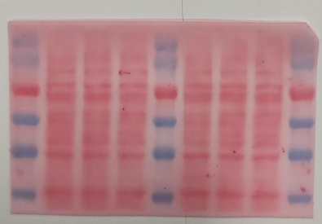
Loading control: Ponceau S staining. The red boxes indicate the total protein regions corresponding to GAPDH. Each lane was loaded with 40 μg of total protein.

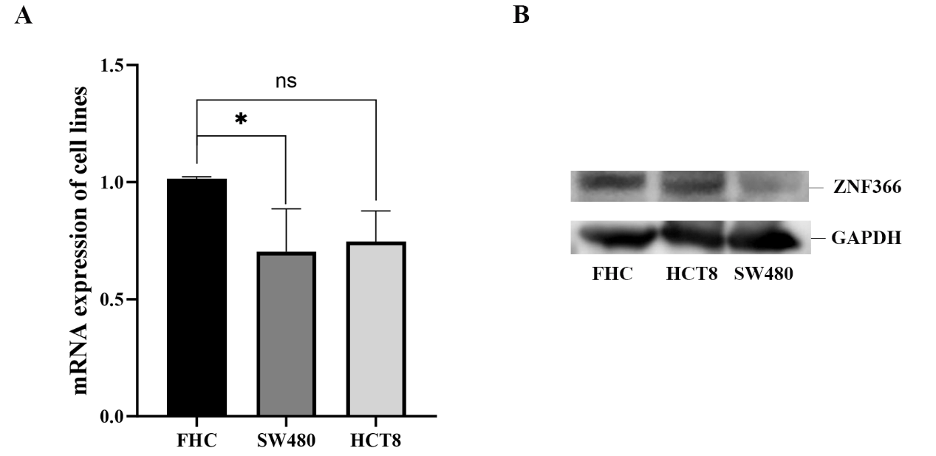
Supplementary Figure S3
Supplementary Figure S3：ZNF366 expression is decreased in HCT8 and SW480 cells. (A) The relative mRNA levels of ZNF366 were analyzed HCT8 and SW480 cells. (B) Expression of ZNF366 proteins in HCT8 and SW480 cells were analyzed via immunoblotting. Data shown are the mean ± SD (n = 3). ns stands for not significant, P > 0.05, *P < 0.05.

Supplementary Figure S4
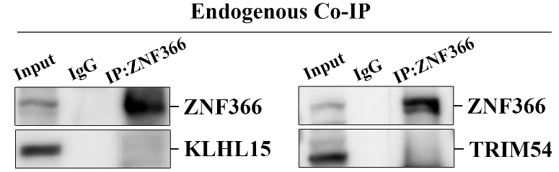
Supplementary Figure S4: Endogenous Co-IP validation of KLHL15 and TRIM54 interaction with ZNF366. Endogenous co-immunoprecipitation assays were performed in HT29 cells to examine the binding between ZNF366 and two candidate E3 ligases, KLHL15 and TRIM54. No obvious physical interaction between ZNF366 and KLHL15 or TRIM54 was detected. IgG served as the negative control.

Supplementary Figure S5
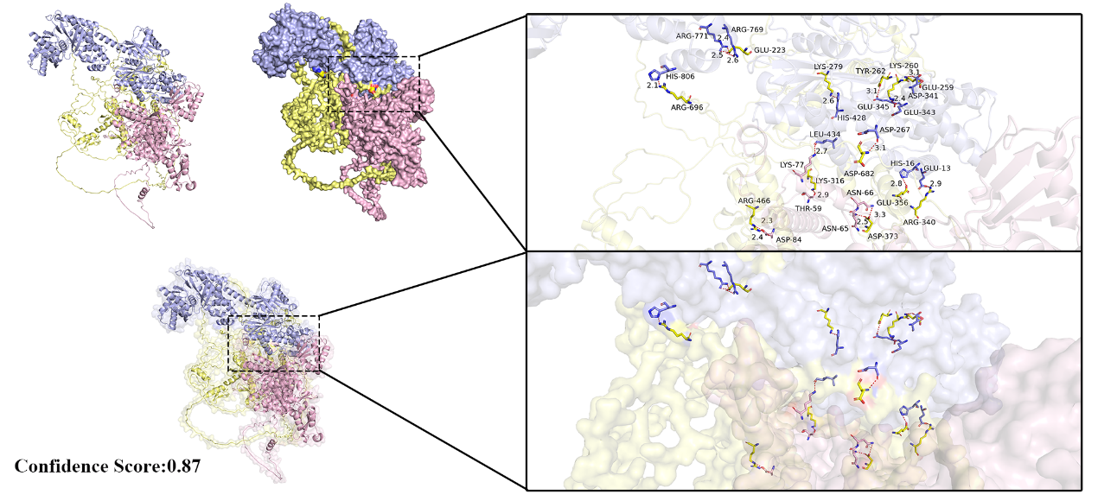
Supplementary Figure S5: Structural modeling of the HK2-UBE3A-ZNF366 ternary complex. The hypothetical ternary complex model was constructed using the HDOCK server by docking the AlphaFold-predicted ZNF366 model (yellow) with the X-ray crystal structures of HK2 (purple) and UBE3A (pink). The left panel depicts the overall docking conformation, showing a compact triangular arrangement with a confidence score of 0.87. The right panels provide magnified views (ribbon and surface representations) of the putative interaction interface, highlighting the candidate key residues (e.g., HK2-Arg769/Arg771, ZNF366-Glu223, and UBE3A-Asp267/Glu13) and their potential hydrogen bond/salt bridge networks (dashed red lines). This model provides a structural feasibility framework suggesting that HK2 acts as a molecular scaffold to bring ZNF366 and UBE3A into close spatial proximity.
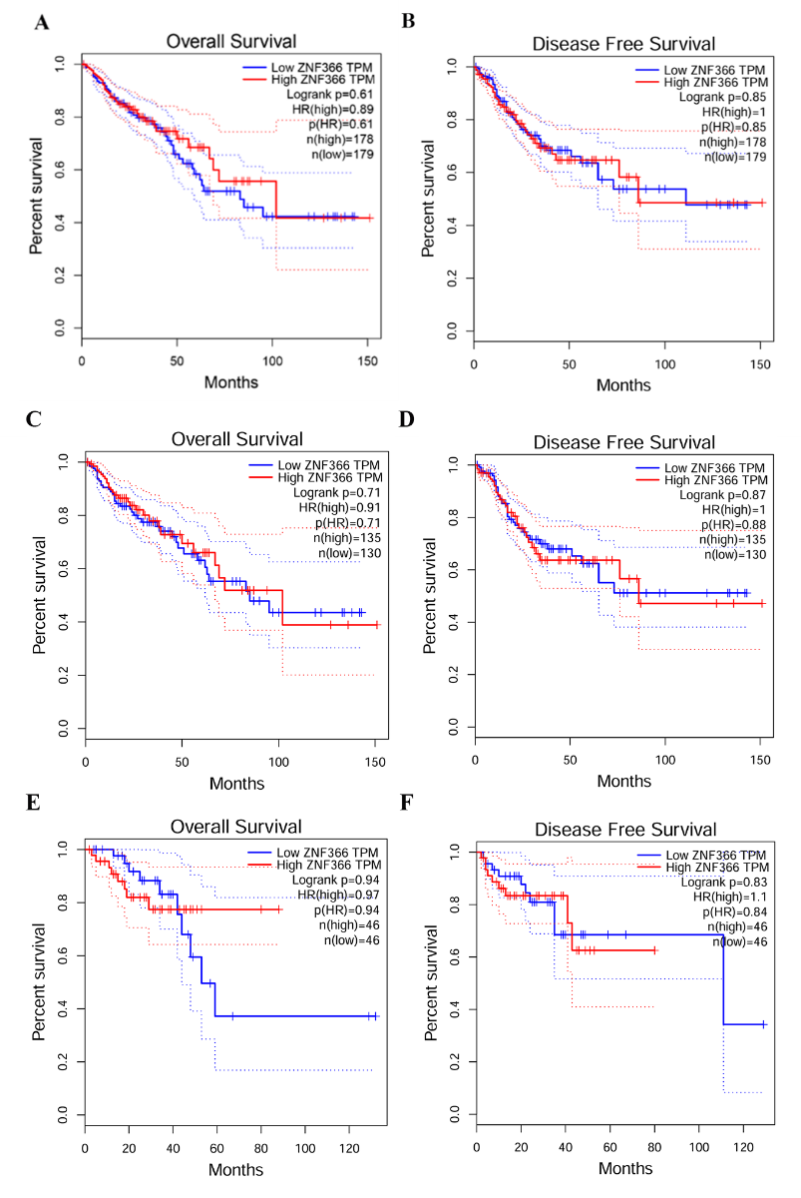
Supplementary Figure S6
Supplementary FigureS6: Kaplan-Meier survival analysis of ZNF366 expression in colorectal cancer. (A-B) Kaplan-Meier survival curve analysis showed no statistically significant difference between the ZNF366 mRNA high-expression and low-expression groups in the CRC patient cohort for either overall survival (OS) (Log-rank P=0.61; HR=0.89) or disease-free survival (DFS) (Log-rank P=0.85; HR=1.00). (C-D) Kaplan-Meier survival analysis of ZNF366 mRNA expression in colon adenocarcinoma (COAD). No statistically significant difference was observed between the high- and low-expression groups for either overall survival (OS) (Log-rank P=0.71; HR= 0.91) or disease-free survival (DFS) (Log-rank P=0.87; HR=1.00). (E-F) Kaplan-Meier survival analysis of ZNF366 mRNA expression in rectal adenocarcinoma (READ). Similarly, the survival curves revealed no significant difference between the ZNF366 high- and low-expression groups for OS (Log-rank P=0.94; HR=0.97) or DFS (Log-rank P=0.83; HR=1.10).

