Supplementary Material
Comprehensive multi-omics analysis reveals a robust transcriptomic signature for biochemical recurrence prediction and identifies SPAG5 as a targetable oncogene with small-molecule compounds in prostate cancer

Xianzi Zeng^{1, 2, #}, Minjia Pan^{1, #}, Qiuqiu Qiu^{3, #}, Yaying Hong^{4, #}, Jiawei Zhou⁵, Yangshu Zhou⁶, Baiheng Zhu¹, Zichun Zeng¹, Mingkun Chen^{5,} *, Shan-Chao Zhao^{1,}*, Jinpeng Cen^{1,} *

Material and Methods

Nomogram Construction and Evaluation
A nomogram integrating clinicopathological factors (age, clinical T stage,pathological T stage, PSA level, Gleason score) and the risk score was constructed using the RMS R package to predict 1-, 3-, and 5-year BCRFS probabilities. Calibration curves were plotted to assess the agreement between predicted and observed survival rates.

Functional and Immune Infiltration Analysis of the Risk Score
To explore the biological mechanisms associated with the risk score, Spearman correlation analysis was performed between the expression of each gene and the risk score in the TCGA cohort. Genes were ranked by correlation coefficient, and Gene Set Enrichment Analysis (GSEA) was conducted on the MSigDB "Hallmark" gene sets (thresholds: FDR <0.05). The relative abundance of 22 immune cell types in high- and low-risk groups was quantified using the CIBERSORT algorithm. Differences in immune cell infiltration between groups were analyzed, and significantly altered immune cells were subjected to Kaplan-Meier survival analysis.

Clinical Correlation Analysis of Hub Genes
The correlations between the expression levels of the four hub genes (SPAG5, LPL, ASPN, THBS2) and clinicopathological variables (age, PSA level, Gleason score, pathological T stage, clinical T stage) were analyzed. The association of the risk score with these clinical variables was also evaluated.

RNA Isolation and Real‑Time Quantitative PCR
Total RNA was isolated using TRIzol® reagent (Invitrogen, Shanghai, China) according to the manufacturer’s instructions. Reverse transcription was performed to obtain cDNA, followed by qRT‑PCR using TB Green Premix Ex Taq II (TaKaRa) on a real‑PCR system. All primers used in this study are listed in Supplementary Table S1.

RNA Interference and Overexpression
To modulate SPAG5 expression, transient knockdown, stable knockdown, and overexpression experiments were performed. For transient knockdown, two siRNAs targeting SPAG5 (si-SPAG5#1, si-SPAG5#2) and a negative control (si-NC) were synthesized by GenePharma. Transfection was performed using Lipofectamine 3000 (Invitrogen, L3000008) in PC3 and DU145 cells, and knockdown efficiency was verified by Western blot. For stable knockdown, a short hairpin RNA targeting SPAG5 (sh-SPAG5) was constructed using the targeting sequence listed in Supplementary Table S2, which was cloned into the pLKO.1 lentiviral vector. PC3 and DU145 cells were infected with lentivirus carrying sh-SPAG5 or sh-NC and selected with puromycin (2 μg/mL) for 7 days, and knockdown efficiency was confirmed by Western blot. For overexpression, the full-length coding sequence (CDS) of SPAG5 was cloned into the pLV3-CMV-MCS-3×FLAG-CopGFP-Puro lentiviral vector. PC3 and DU145 cells were infected with lentivirus carrying SPAG5 (SPAG5-OE) or the empty vector (VC) and selected with puromycin (2 μg/mL), and overexpression efficiency was validated by Western blot.
For rescue experiments, a shRNA-resistant SPAG5 CDS was generated by introducing nine synonymous substitutions (G1534A, T1537C, C1538T, T1540G, G1546A, A1547T, G1548C, C1549A, T1552C) into the sh-SPAG5 target site (nt 1534–1554; NM_006461.4), leaving the protein sequence unchanged. The shRNA-resistant SPAG5 CDS was cloned into pLVX-IRES-Neo and stably expressed in PC3/sh-SPAG5 and DU145/sh-SPAG5 cells, followed by G418 selection, with puromycin maintenance to preserve sh-SPAG5 knockdown. The constructs were verified by Sanger sequencing. All siRNA and shRNA targeting sequences are listed in Supplementary Table S2.

Cell Cycle Analysis
Cells were harvested, rinsed with cold PBS, and then fixed overnight at 4°C in 70% ethanol. After a wash step, the cells were stained with propidium iodide (PI) containing RNase A and incubated for 30 minutes at 37°C in the dark. Flow cytometry was used to determine cell cycle distribution. Each experiment was performed in triplicate.

Structure-Based Virtual Screening
To identify potential small-molecule inhibitors targeting SPAG5, the protein structure was obtained from the AlphaFold Database (UniProt ID: Q96R06). The protein was prepared using Schrödinger Maestro 14.0 with the Protein Preparation Wizard (hydrogen addition, water removal, energy minimization with OPLS4 force field to RMSD 0.30 Å). A 20 Å × 20 Å × 20 Å docking grid was generated centered on the predicted binding site. Approximately 27,000 small molecules from the Bioactive Compound Library Plus (HY-L001P, MedChemExpress) were prepared as 3D structures using LigPrep at physiological pH. A multi-stage virtual screening cascade was performed with Glide: initial screening with HTVS (retaining the top 30%), followed by SP (retaining the top 10%), and final high-precision docking with XP. Compounds were ranked by Glide XP GScore, and top-ranked compounds were selected for validation.

Supplementary Figure

Supplementary Figure S1. Forest plot of univariate Cox regression analysis for 20 core DEGs, identifying 13 genes significantly associated with biochemical recurrence (P<0.01).

Supplementary Figure S2. Validation of the four-gene prognostic model in two GEO cohorts.(A-C) Validation in the GSE46602 cohort. (A) Risk score distribution with patients stratified into high-risk and low-risk groups based on the median risk score. (B) Kaplan-Meier survival curves of biochemical recurrence-free survival (BCRFS) in high-risk and low-risk groups. (C) Time-dependent ROC curves showing AUC values of 0.67, 0.81, and 0.85 for 1, 3, and 5 years BCRFS prediction, respectively. (D-F) Validation in the GSE21032 cohort. (D) Risk score distribution with patients stratified into high-risk and low-risk groups based on the median risk score. (E) Kaplan-Meier survival curves of BCRFS in high-risk and low-risk groups. (F) Time-dependent ROC curves showing AUC values of 0.79, 0.82, and 0.80 for 1, 3, and 5 years BCRFS prediction, respectively.

Supplementary Figure S3. Biological functions and immune infiltration characteristics of the risk score. (A, B) GSEA showing enrichment of oncogenic pathways in the high-risk group. (C) CIBERSORT analysis revealing significant differences in immune cell infiltration between high- and low-risk groups. (D) Kaplan-Meier analysis demonstrating that high M2 macrophage infiltration is associated with poorer prognosis (P<0.01). (E-I) Correlation between core gene expression and clinicopathological features. SPAG5, LPL, ASPN, and THBS2 expression positively correlated with advanced pathological T stage, clinical T stage, age, PSA level, and Gleason score. *P<0.05, **P<0.01, ***P<0.001, ****P<0.0001, ns, not significant.

Supplementary Figure S4. Association between SPAG5 expression and somatic mutation landscape in TCGA-PRAD. (A) Mutation profiles of SPAG5-low and SPAG5-high groups. (B) SPAG5 expression in tumors with wild-type or mutant forms of the indicated genes.

Supplementary Figure S5. Quantitative analysis of SPAG5 expression in BPH and PCa tissues. IRS, immunoreactivity score. Data are presented as mean ± SD (BPH, n = 3; PCa, n = 3). Statistical analysis was performed using an unpaired two-tailed Student’s t-test. *P<0.05, **P<0.01, ***P<0.001, ****P<0.0001, ns, not significant.

Supplementary Figure S6. SPAG5 promotes PCa cell growth in vivo. (A) Western blot confirming SPAG5 knockdown in stable PC3/sh‑SPAG5 cells. PC3/sh-NC served as control. β-Tubulin was used as loading control. (B) Schematic of in vivo experimental design. PC3/sh-SPAG5 or PC3/sh-NC cells (2×10⁶ cells/mouse) were injected subcutaneously into the right anterior thigh of nude mice (n = 5 per group). Tumor volumes were measured every 2 days. (C) Tumor growth curves of PC3/sh‑SPAG5 and PC3/sh‑NC xenografts. (D) Representative images of excised tumors at endpoint. (E) Quantification of tumor weights. (F) Representative H&E staining and immunohistochemical images of SPAG5 and Ki‑67 in tumor sections. Scale bars: 100 μm; 50 μm (inset). (G) Quantification of SPAG5 and Ki‑67 expression using immunoreactivity scores (IRS). All data are presented as mean ± SD (n = 5 mice per group). *P<0.05,**P<0.01,***P<0.001,****P<0.0001, ns, not significant.

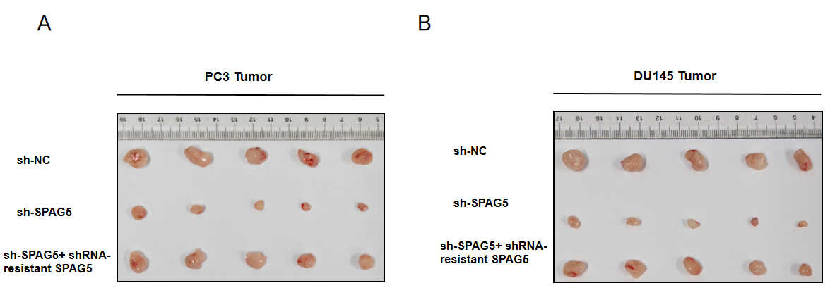

Supplementary Figure S7. Representative images of excised tumors at endpoint.
(A) Representative images of excised PC3 tumors from mice injected with sh-NC, sh-SPAG5, and sh-SPAG5 plus shRNA-resistant SPAG5 (rescue) cells (n = 5 per group). (B) Representative images of excised DU145 tumors from mice injected with sh-NC, sh-SPAG5, and sh-SPAG5 plus shRNA-resistant SPAG5 (rescue) cells (n = 5 per group).

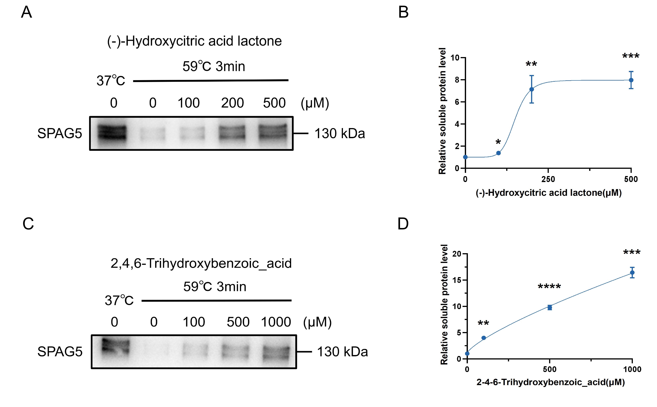

Supplementary Figure S8. Concentration-dependent thermal stabilization of SPAG5 by candidate compounds at a fixed temperature. (A) Representative Western blot showing soluble SPAG5 levels in PC3 cell lysates treated with increasing concentrations of (-)-Hydroxycitric acid lactone. (B) Densitometric quantification of soluble SPAG5 levels from (A). (C) Representative Western blot showing soluble SPAG5 levels in PC3 cell lysates treated with increasing concentrations of 2,4,6-Trihydroxybenzoic_acid. (D) Densitometric quantification of soluble SPAG5 levels from (C). Data are presented as mean ± SD from three independent experiments. *P < 0.05, **P < 0.01, ***P < 0.001,****P<0.0001; ns, not significant.

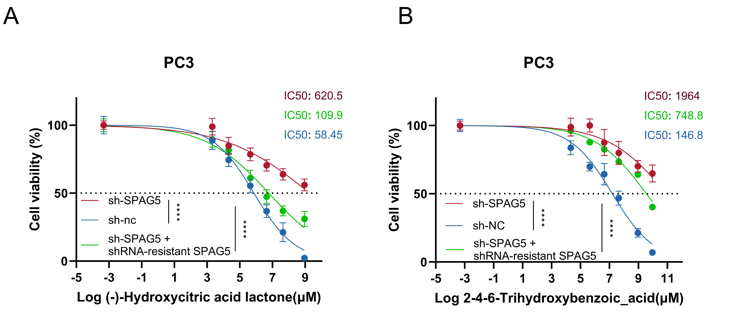
Supplementary Figure S9. CCK-8 assays evaluating the sensitivity of PC3 cells expressing sh-NC, sh-SPAG5, and sh-SPAG5 plus shRNA-resistant SPAG5 (rescue) to candidate compounds. (A) Dose-response curves for (-)-Hydroxycitric acid lactone in PC3 cells expressing sh-NC, sh-SPAG5, and rescue, with IC50 values of 58.45, 620.5, and 109.9 μM, respectively. (B) Dose-response curves for 2,4,6-Trihydroxybenzoic_acid in the same cells, with IC50 values of 146.8, 1964, and 748.8 μM, respectively. Data are presented as mean ± SD from three independent experiments, *P < 0.05, **P < 0.01, ***P < 0.001, ****P < 0.0001; ns, not significant.

Supplementary Table
Supplementary Table S1: Sequences of Primers Used for RT-qPCR
Gene Name | Forward (F) Primer (5'-3') | Reverse (R) Primer (5'-3')
SPAG5 (human) | CATCTCACAGTGGGATAACTAATAAAC | CAGGGATAGGTGAAGCAAGGATA
GAPDH (human) | CCAGGTGGTCTCCTCTGACTTC | GTGGTCGTTGAGGGCAATG

Supplementary Table S2:SPAG5 siRNA/shRNA Fragment Sequences
siRNA/shRNA | Sequence (5'-3')
si-SPAG5#1 | GGAGGAAAUUGUAGAGCAUTT
si-SPAG5#2 | CCUUGUCUCGACAUGACUUTT
sh-SPAG5 | GCATCTTAAGGAGAGCCATGATTCAAGAGATCATGGCTCTCCTTAAGATGC

